1.Click On File And Click New And Select Java Project If Not Then Select Other And Select Java Project

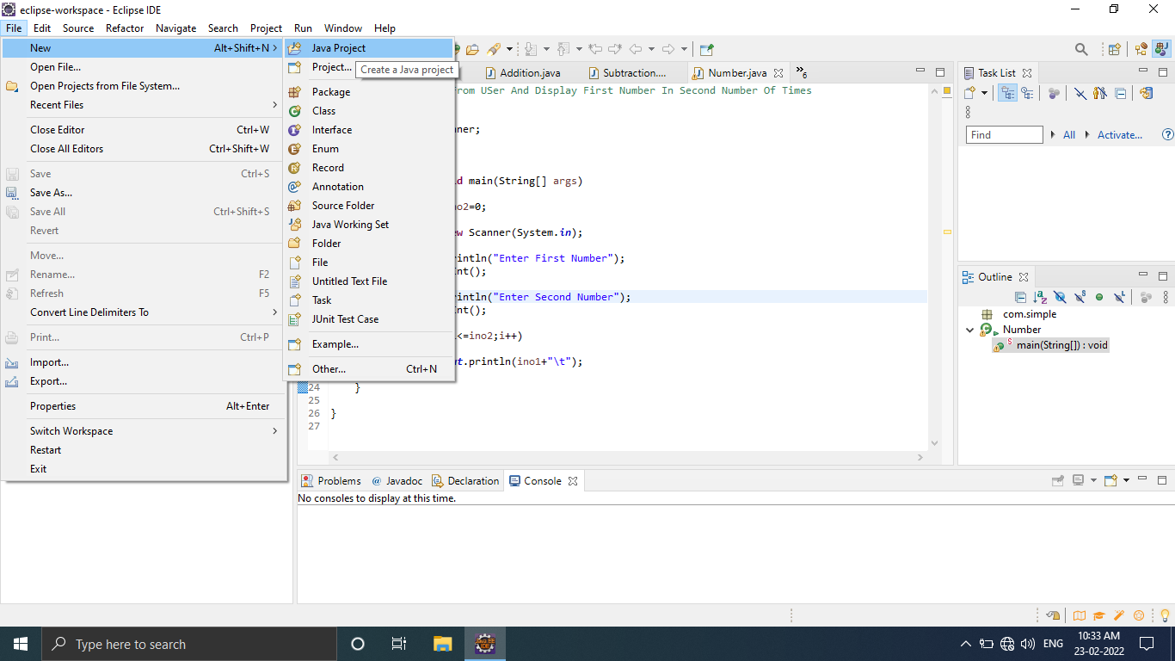

2.After That Give Name To The Project. E.g. ProjectJava and Click on Finish Button.

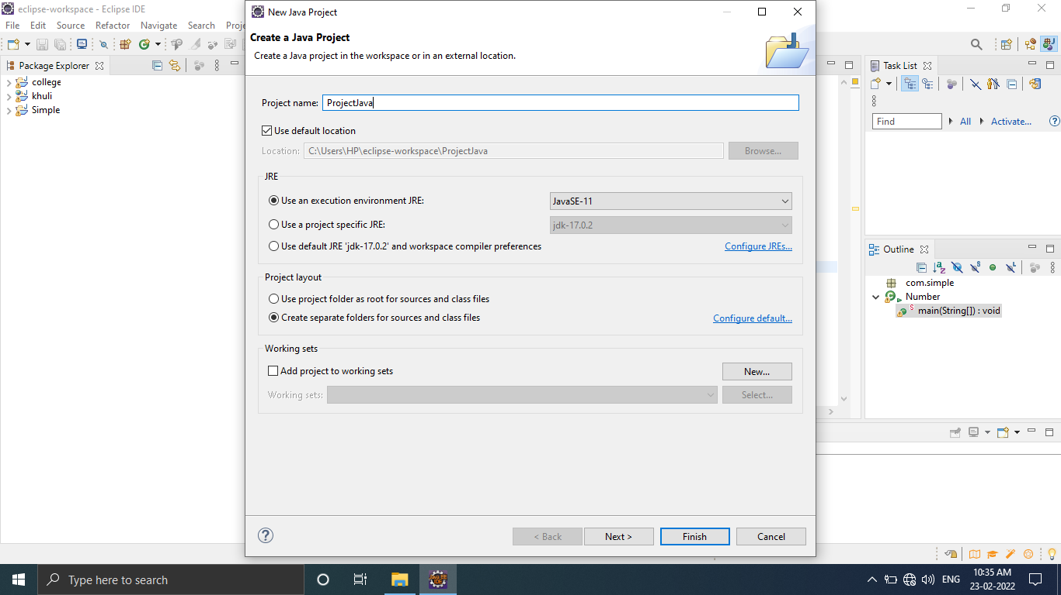

3. Click On Finish Button.

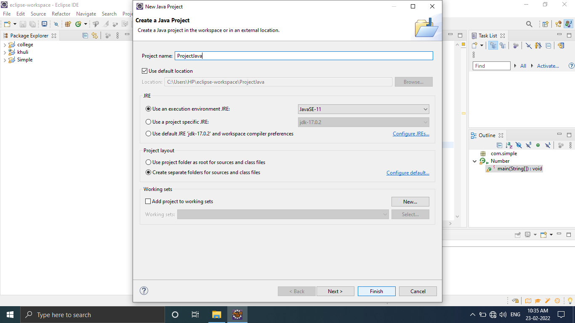

4.Do not Create Module.

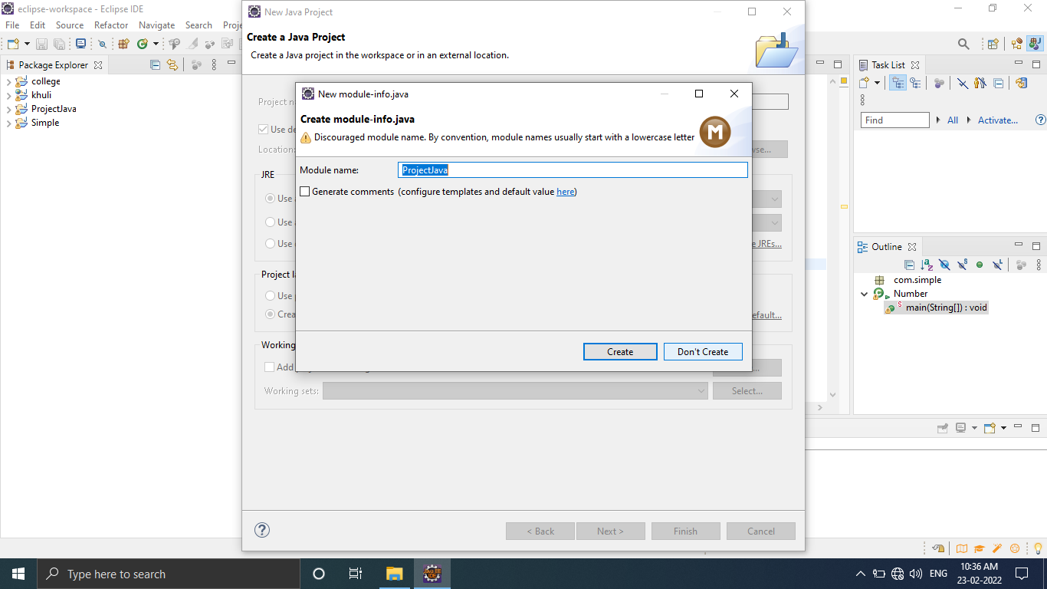

5. Right Click on src Folder And Select Package And Create Package And Give The Name To Package.

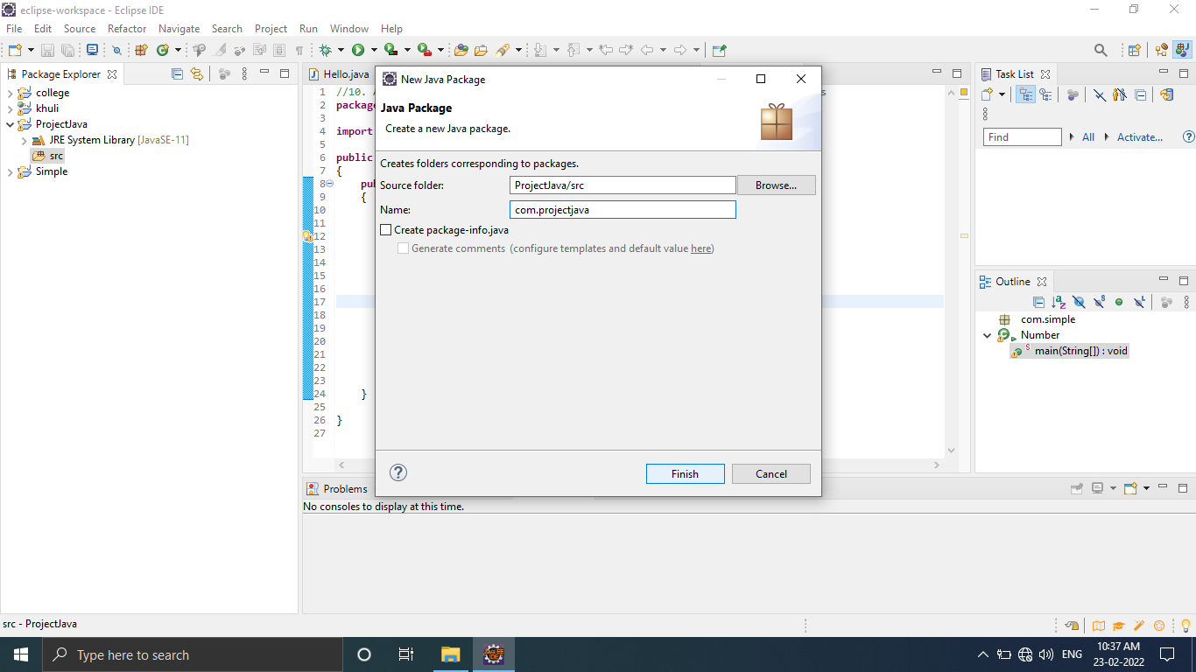

6.Give Name TO package.and Finish



7.Right Click On created package And Create Class

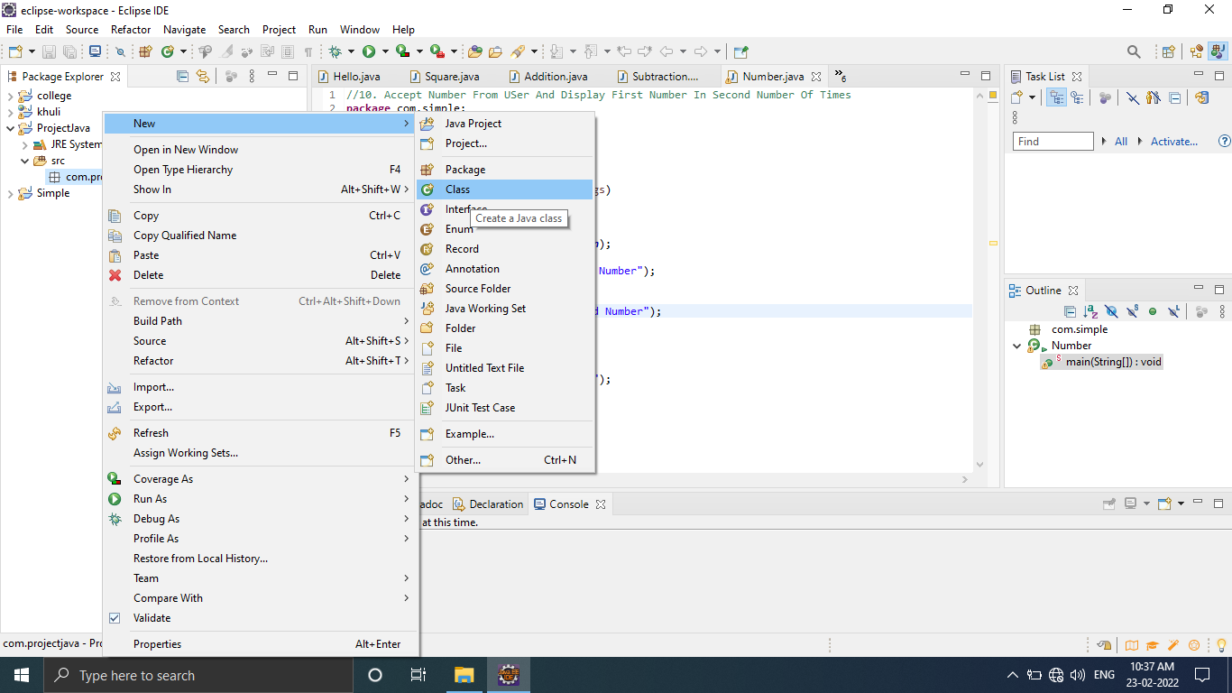

8.Give Apporiate name To The Class.And Finish.

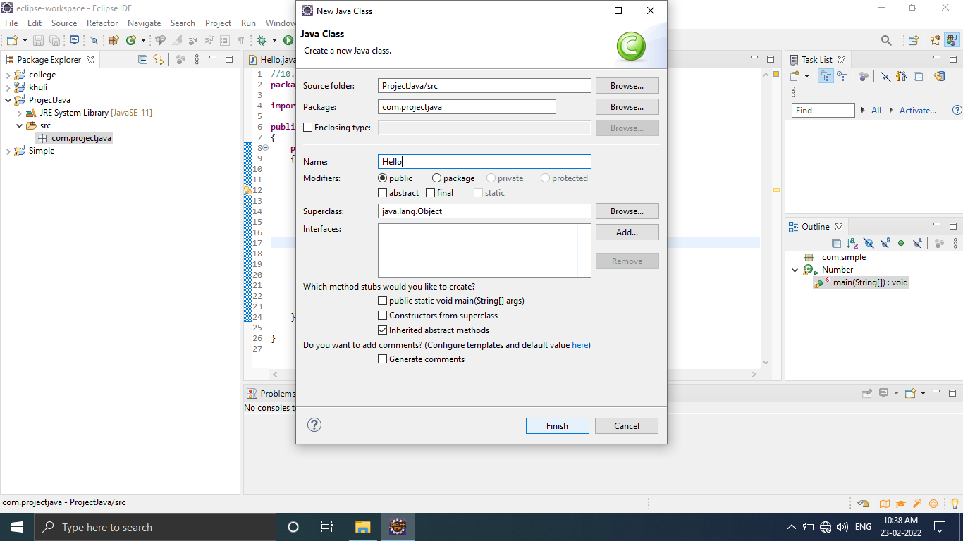

9.Start Programming.

