SCHOOL OF COMPUTER SCIENCE AND ARTIFICIAL INTELLIGENCE |  |  |  |  | DEPARTMENT OF COMPUTER SCIENCE ENGINEERING
Program Name: M. Tech/MCA |  |  |  | Assignment Type: Lab |  |  | AcademicYear:2025-2026
Course Coordinator Name |  |  |  | Venkataramana Veeramsetty
Course Code |  |  |  | Course Title |  | AI Assisted Problem Solving Using Python
Year/Sem |  |  | I/I | Regulation |  | R24
Date and Day  of Assignment |  |  | Week1 - TUESDAY | Time(s)
Duration |  |  | 2 Hours | Applicable to  Batches |  | M. Tech/MCA
AssignmentNumber:2.3(Present assignment number)/24(Total number of assignments)
 | Q.No. | Question |  |  |  |  |  | Expected Time  to complete
 | 1 | Lab 2: Exploring Additional AI Coding Tools – Gemini (Colab) and Cursor AI  Lab Objectives:  - To explore and evaluate the functionality of Google Gemini for AI-assisted coding within Google Colab.  - To understand and use Cursor AI for code generation, explanation, and refactoring.  - To compare outputs and usability between Gemini, GitHub Copilot, and Cursor AI.  - To perform code optimization and documentation using AI tools.  Lab Outcomes (LOs):  After completing this lab, students will be able to:  - Generate Python code using Google Gemini in Google Colab.  - Analyze the effectiveness of code explanations and suggestions by Gemini.  - Set up and use Cursor AI for AI-powered coding assistance.  - Evaluate and refactor code using Cursor AI features.  - Compare AI tool behavior and code quality across different platforms.  Task Description#1  - Use Google Gemini in Colab to write a function that reads a CSV file and calculates mean, min, max.  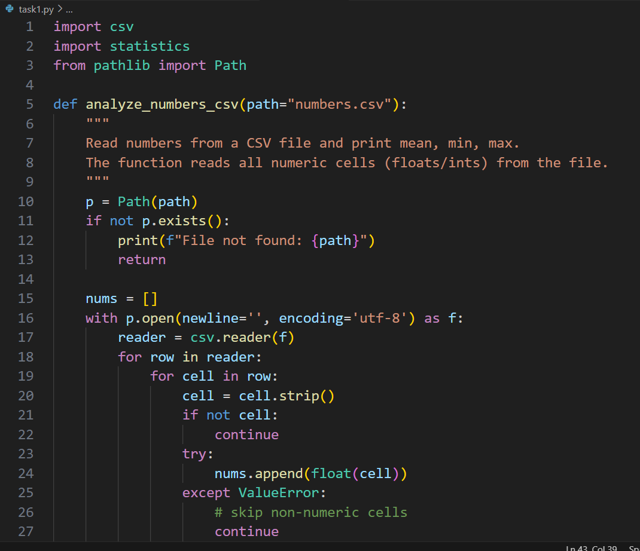  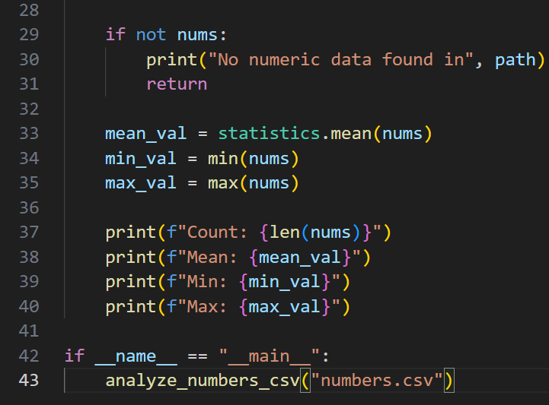  Expected Output#1  - Functional code with output and screenshot  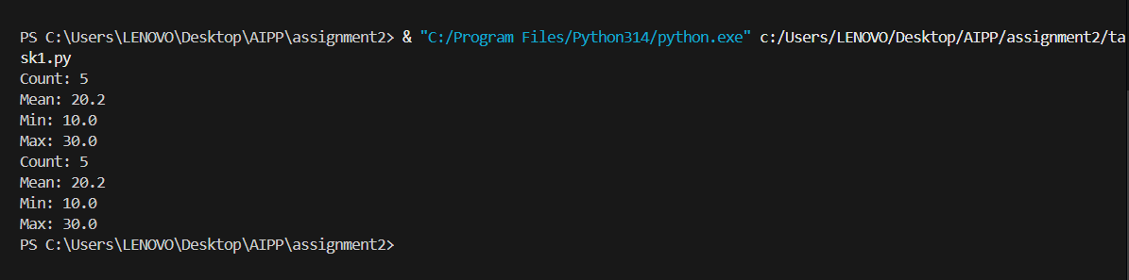  Task Description#2  - Compare Gemini and Copilot outputs for a palindrome check function.  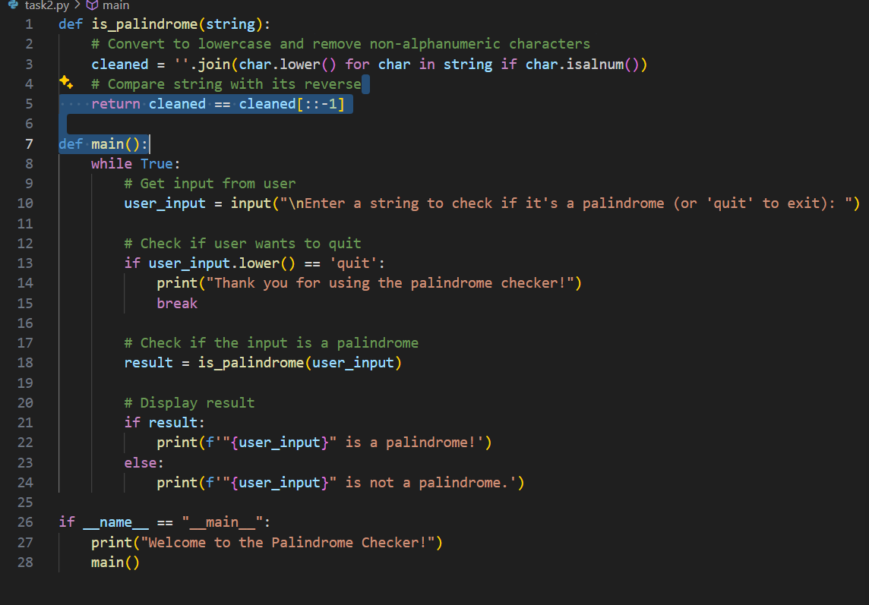  Expected Output#2  - Side-by-side comparison and observations  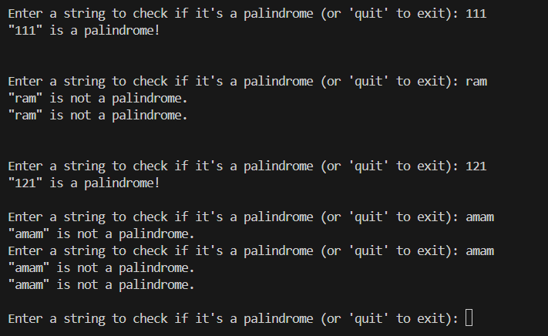  Task Description#3  - Ask Gemini to explain a Python function (to calculate area of various shapes) line by line..  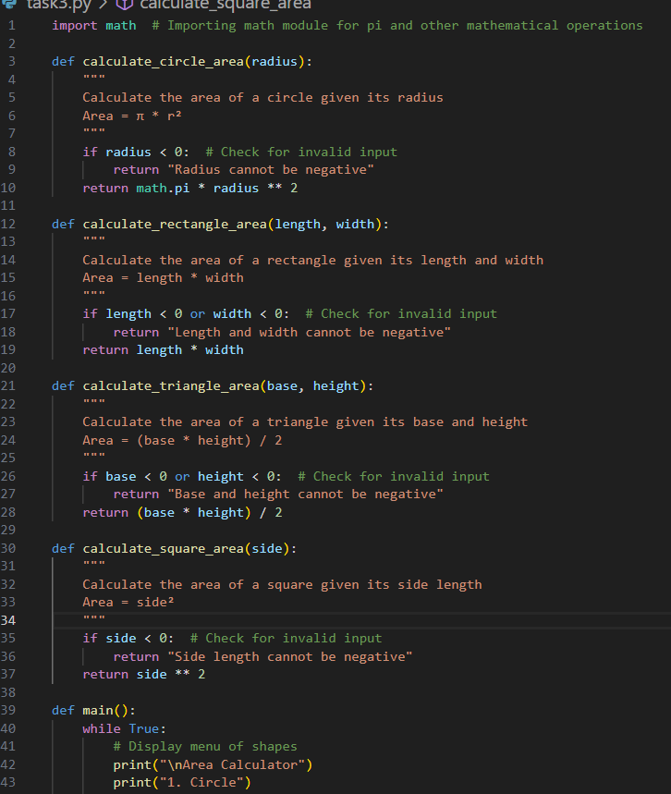  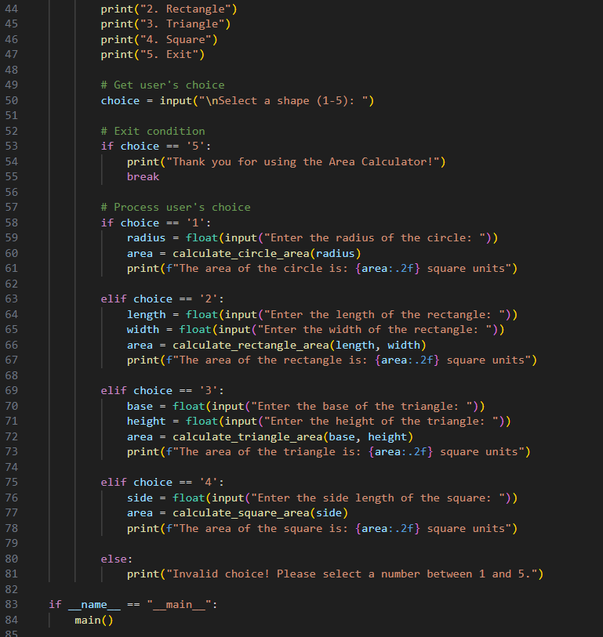  Expected Output#3  - Detailed explanation with code snippet  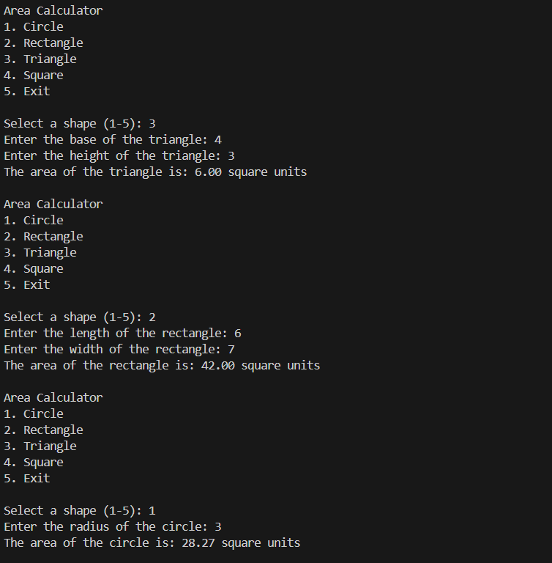  Task Description#4  - Install and configure Cursor AI. Use it to generate a Python function (e.g., sum of squares).  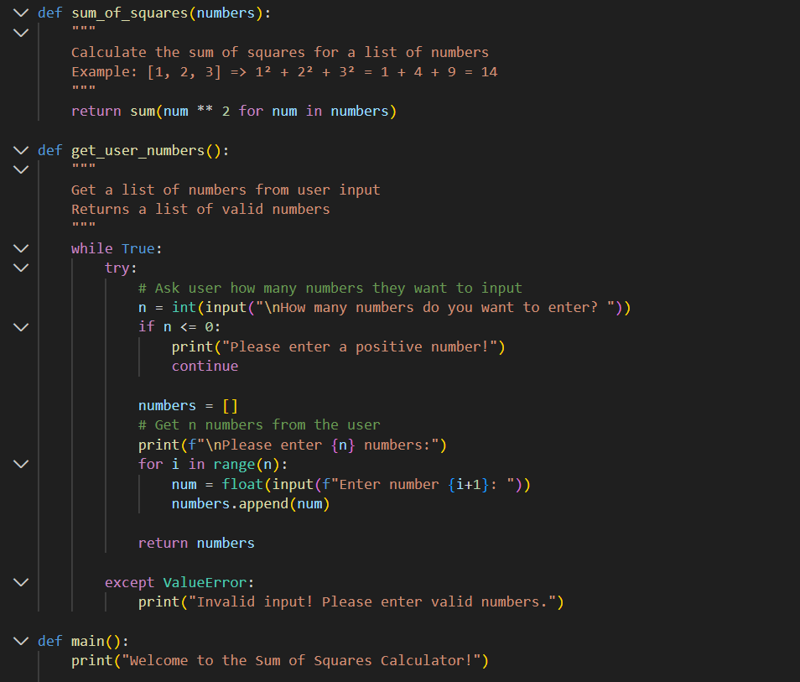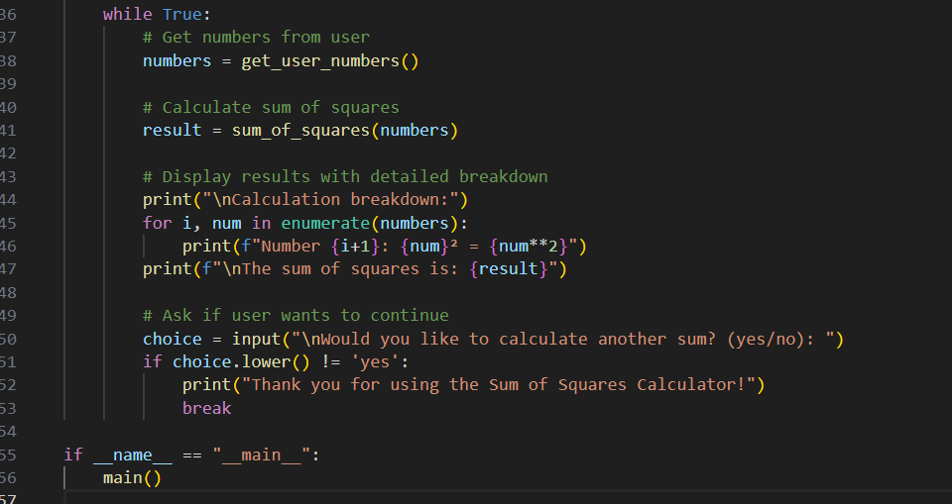  Expected Output#4  - Screenshots of working environments with few prompts to generate python code  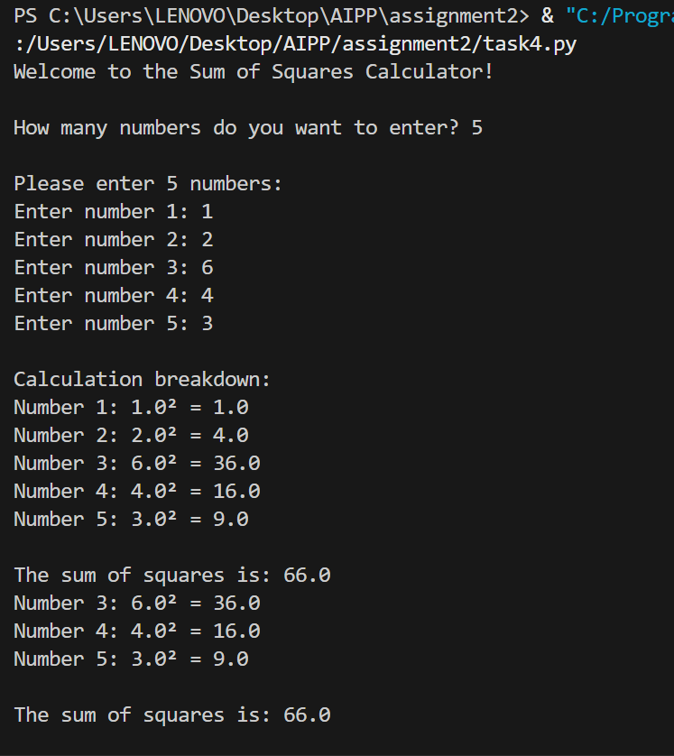  Task Description#5  - Student need to write code to calculate sum of add number and even numbers in the list  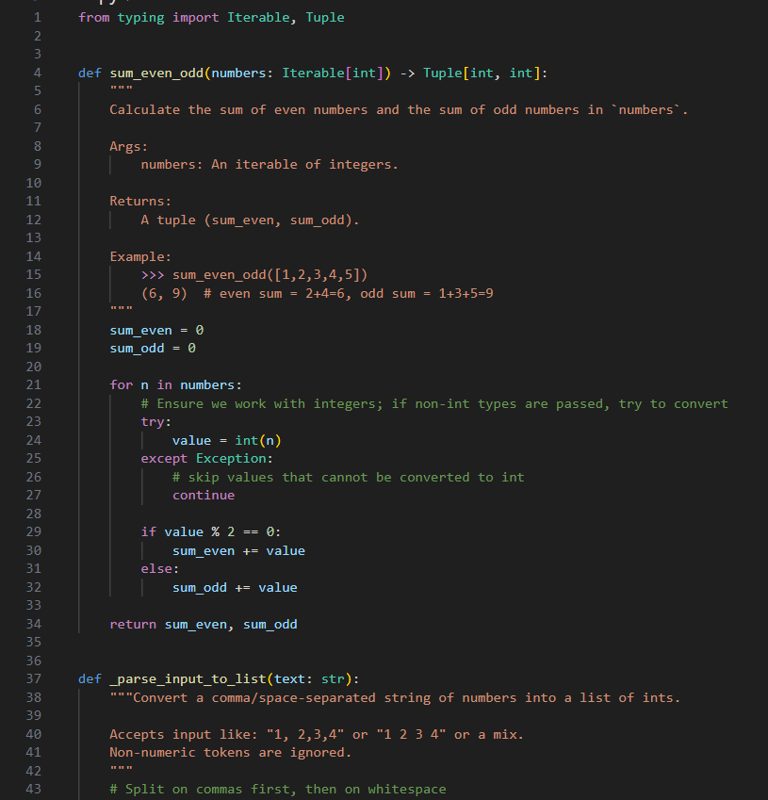  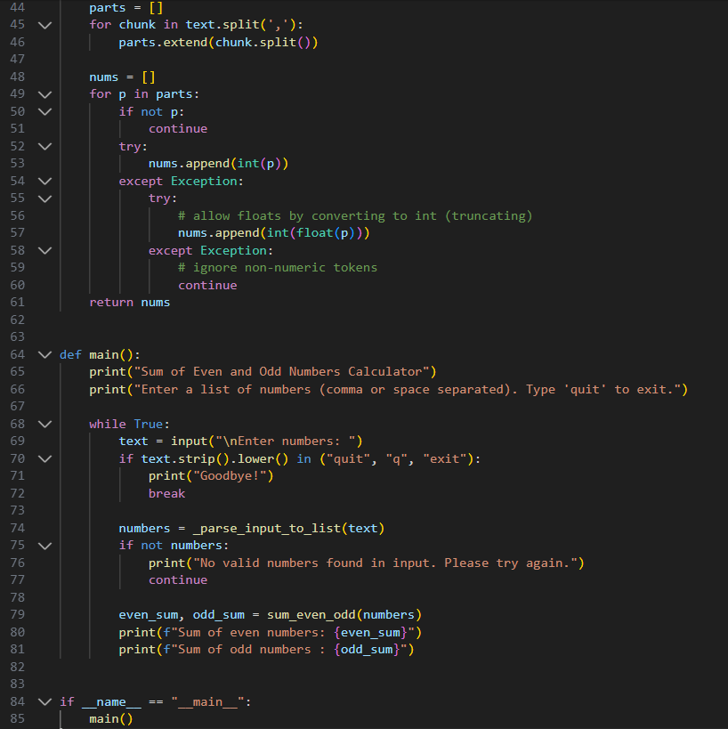  Expected Output#5  - Refactored code written by student with improved logic  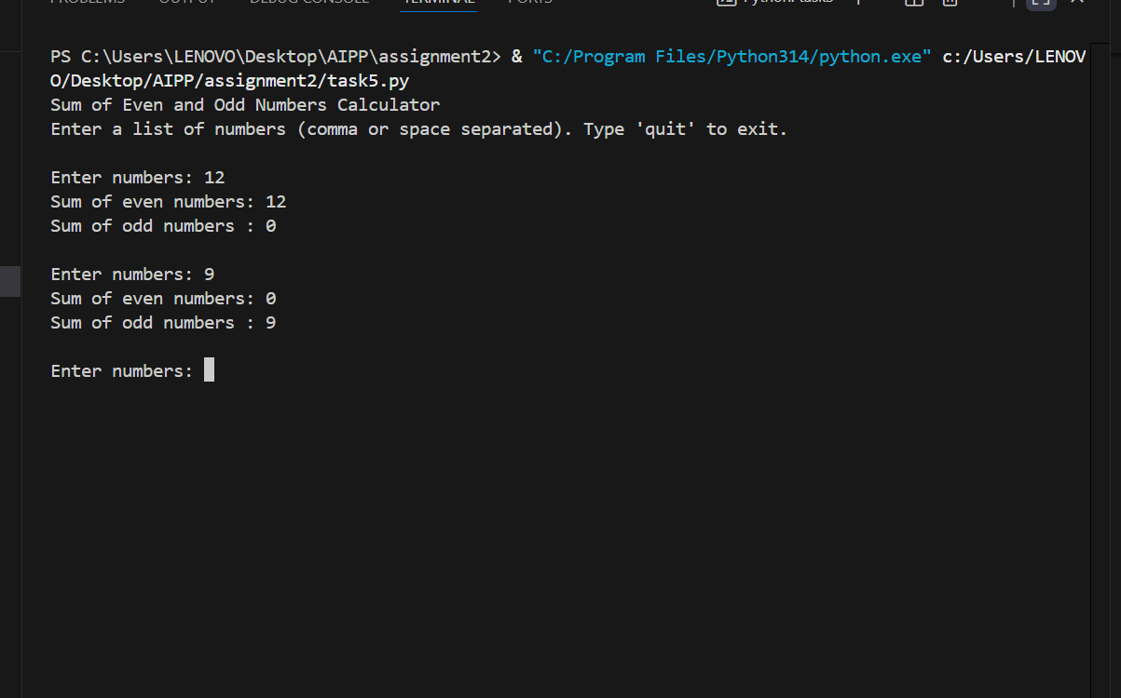  Note: Report should be submitted a word document for all tasks in a single document with prompts, comments & code explanation, and output and if required, screenshots  Evaluation Criteria: |  |  |  |  |  | Week1 - TuesDay
  Criteria | Max Marks
  Successful Use of Gemini in Colab (Task#1 & #2) | 2.5
  Code Explanation Accuracy (Gemini) (Task#3) | 2.5
  Cursor AI Setup and Usage (Task#4) | 2.5
  Refactoring and Improvement Analysis (Task#5) | 2.5
  Total | 10 Marks

