SCHOOL OF COMPUTER SCIENCE AND ARTIFICIAL INTELLIGENCE |  |  |  |  | DEPARTMENT OF COMPUTER SCIENCE ENGINEERING
Program Name: M.Tech. and MCA |  |  |  | Assignment Type: Lab |  |  | AcademicYear:2025-2026
Course Coordinator Name |  |  |  | Venkataramana Veeramsetty
Course Code |  |  |  | Course Title |  | AI Assisted Problem Solving Using Python
Year/Sem |  |  | I/I | Regulation |  | R24
Date and Day  of Assignment |  |  | Week3 - Monday | Time(s)
Duration |  |  | 2 Hours | Applicable to  Batches |  | M.Tech. and MCA
AssignmentNumber:4.3(Present assignment number)/24(Total number of assignments)
 | Q.No. | Question |  |  |  |  |  | Expected Time  to complete
 | 1 | Lab 4: Advanced Prompt Engineering – Zero-shot, One-shot, and Few-shot Techniques  Lab Objectives:  - To explore and apply different levels of prompt examples in AI-assisted code generation.  - To understand how zero-shot, one-shot, and few-shot prompting affect AI output quality.  - To evaluate the impact of context richness and example quantity on AI performance.  - To build awareness of prompt strategy effectiveness for different problem types.  Lab Outcomes (LOs):  After completing this lab, students will be able to:  - Use zero-shot prompting to instruct AI with minimal context.  - Use one-shot prompting with a single example to guide AI code generation.  - Apply few-shot prompting using multiple examples to improve AI responses.  - Compare AI outputs across the three prompting strategies.  Task Description#1  - Zero-shot: Prompt AI to write a function that checks whether a given year is a leap year.  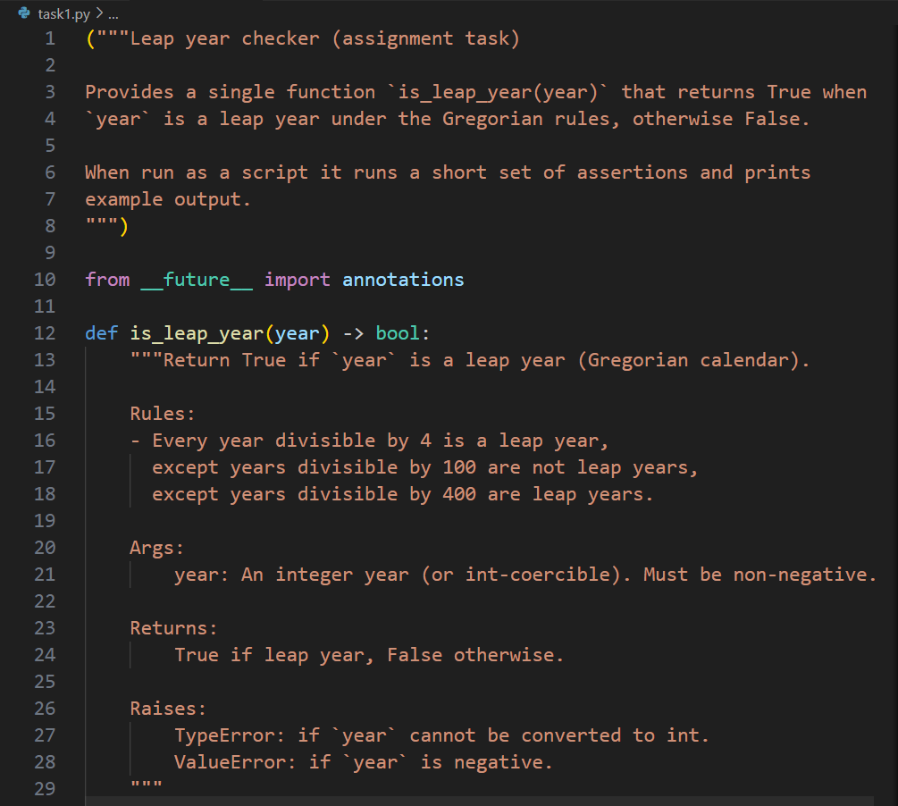  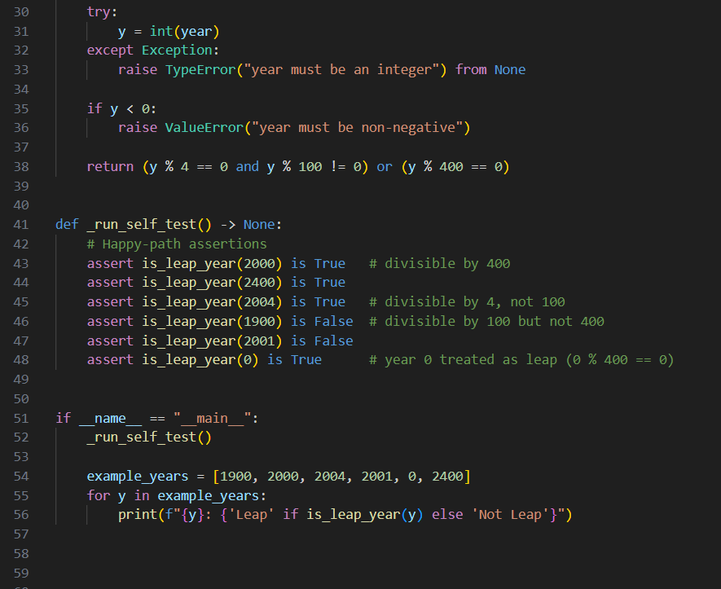  Expected Output#1  - AI-generated function with no examples provided  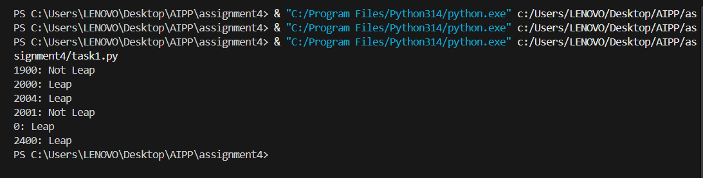  Task Description#2  - One-shot: Give one input-output example to guide AI in writing a function that converts centimeters to inches.  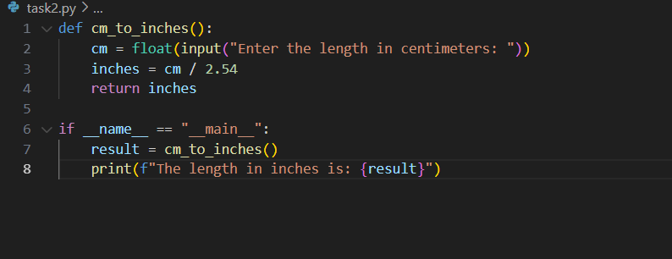  Expected Output#2  - Function with correct conversion logic  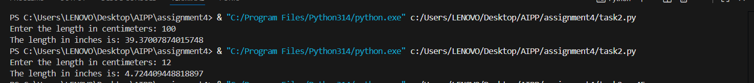  Task Description#3  - Few-shot: Provide 2–3 examples to generate a function that formats full names as “Last, First”.  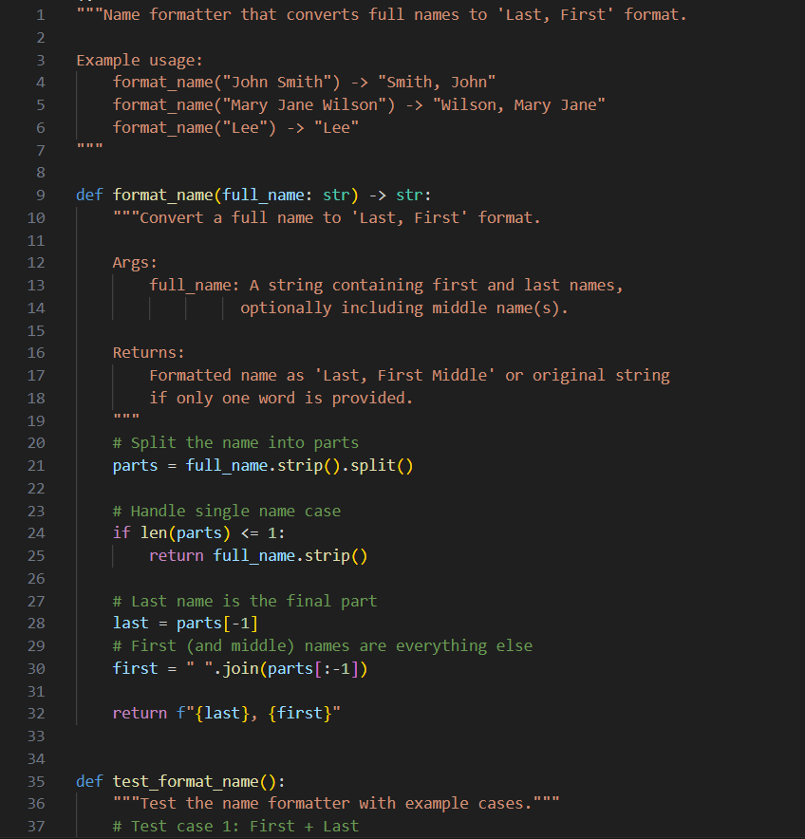  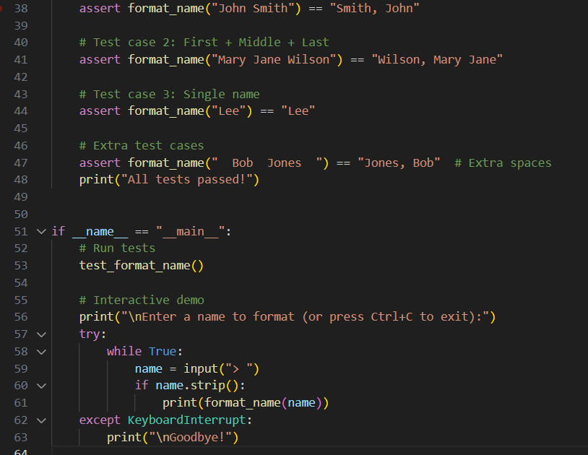  Expected Output#3  - Well-structured function respecting the examples  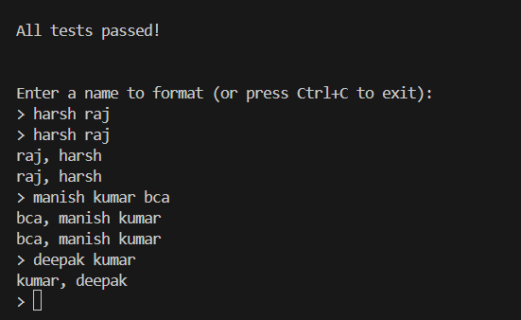  Task Description#4  - Compare zero-shot and few-shot prompts for writing a function that counts the number of vowels in a string.  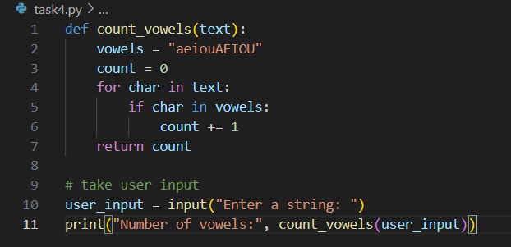  Expected Output#4  - Functional output and comparative reflection  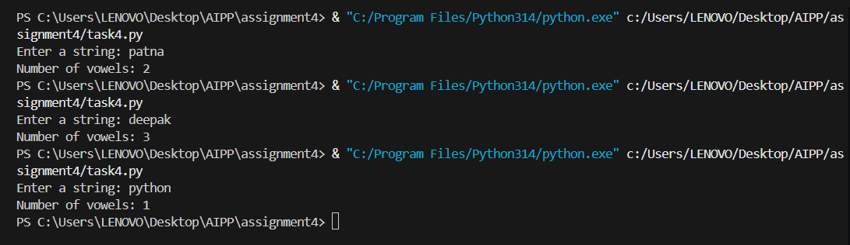  Task Description#5  - Use few-shot prompting to generate a function that reads a .txt file and returns the number of lines.  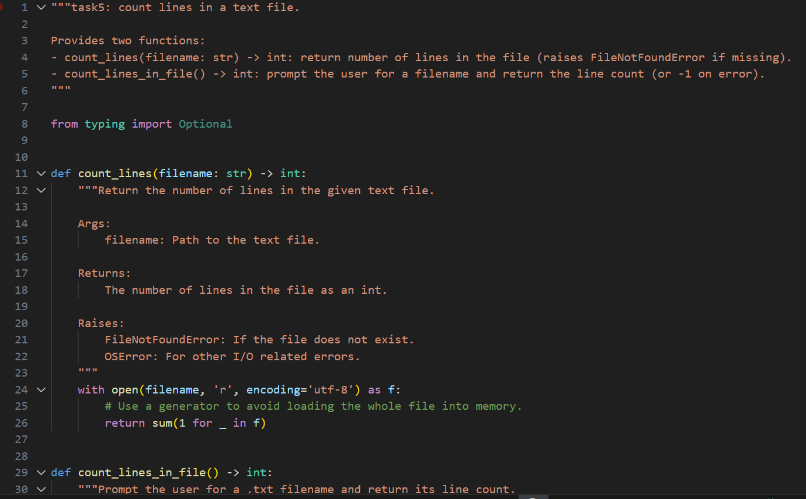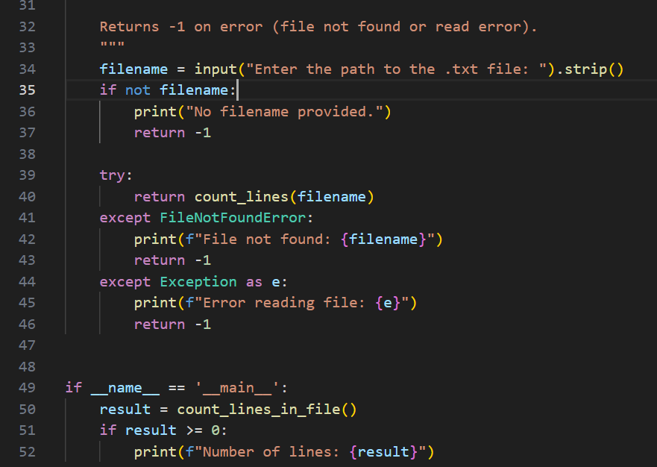  Expected Output#5  - Working file-processing function with AI-guided logic  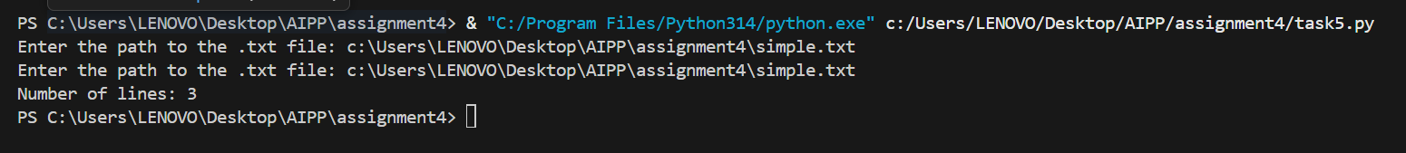  Note: Report should be submitted a word document for all tasks in a single document with prompts, comments & code explanation, and output and if required, screenshots  Evaluation Criteria: |  |  |  |  |  | Week3 - Monday
  Criteria | Max Marks
  Zero Shot (Task #1) | 2.5
  One Shot (Task#2) | 2.5
  Few Shot (Task#3 & Task #5) | 2.5
  Comparison (Task#4) | 2.5
  Total | 10 Marks

