 | 1 |  | Task Description #1 – Stack class implementation  Task: Ask AI to implement a stack class with push(), pop(), peek() and is_empty() methods  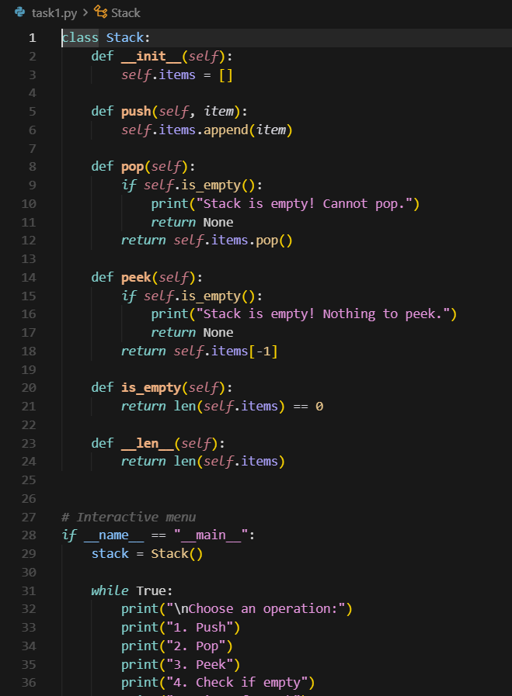  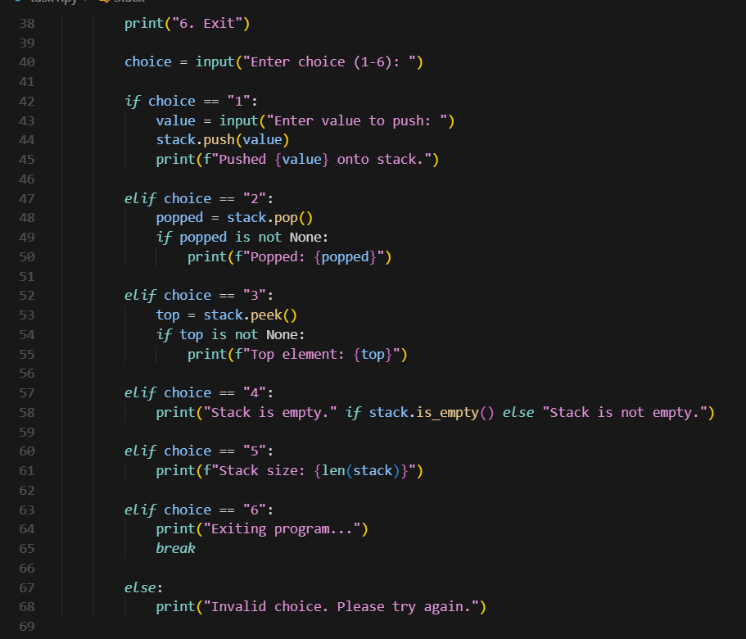  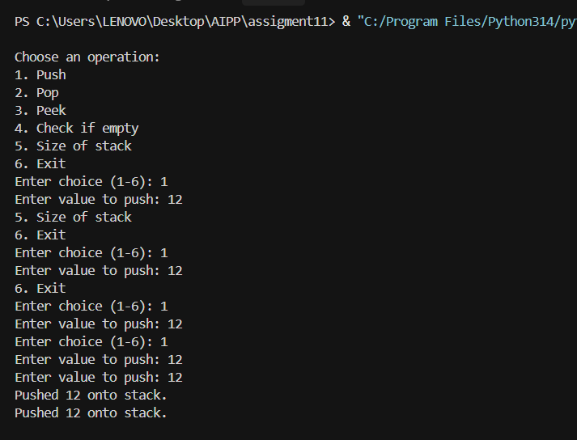  Task Description #2 – Queue Implementation  Task: Use AI to generate a Queue class with enqueue(), dequeue(), and is_empty().  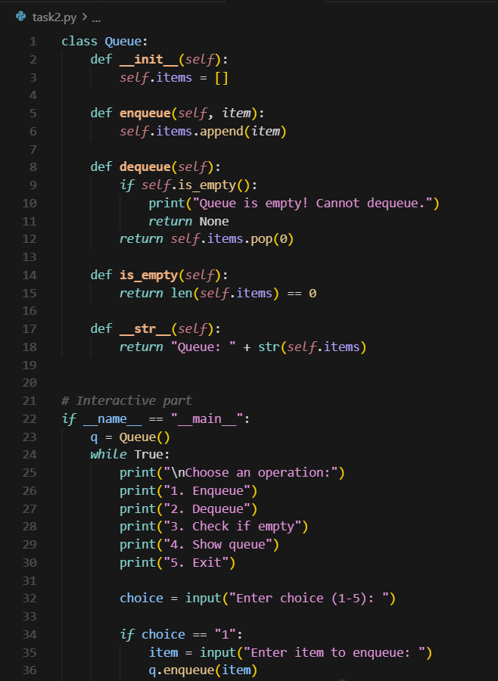  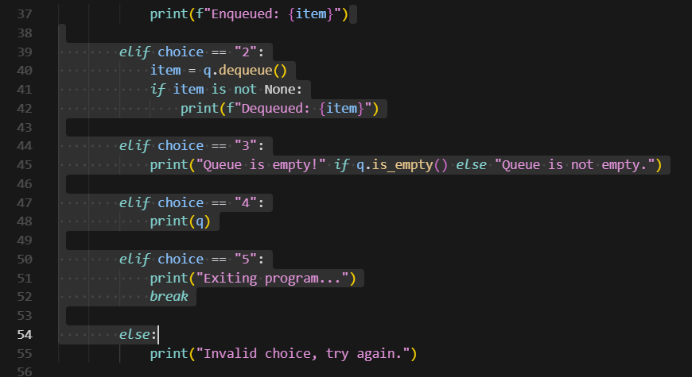  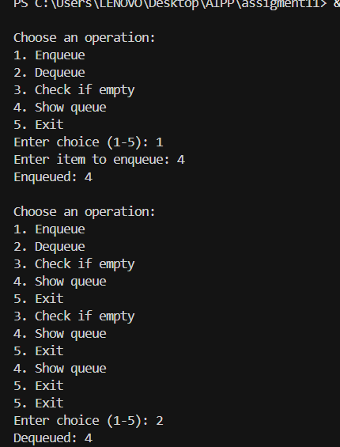  Task Description #3 – Linked List Implementation  Task: Ask AI to create a singly linked list with insert_at_end(), insert_at_beginning(), and display().  class Node:  def __init__(self, data):  self.data = data  self.next = None  class SinglyLinkedList:  def __init__(self):  self.head = None  def insert_at_beginning(self, data):  """Insert a new node at the beginning of the list."""  new_node = Node(data)  new_node.next = self.head  self.head = new_node  def insert_at_end(self, data):  """Insert a new node at the end of the list."""  new_node = Node(data)  if self.head is None:  self.head = new_node  return  temp = self.head  while temp.next:  temp = temp.next  temp.next = new_node  def delete_node(self, key):  """Delete the first occurrence of a node with given data."""  temp = self.head  # If head node itself holds the key  if temp is not None and temp.data == key:  self.head = temp.next  temp = None  return  # Search for the key  prev = None  while temp is not None and temp.data != key:  prev = temp  temp = temp.next  # If key not found  if temp is None:  print(f"Value {key} not found in list.")  return  # Unlink the node  prev.next = temp.next  temp = None  def display(self):  """Display the linked list."""  if self.head is None:  print("List is empty")  return  temp = self.head  while temp:  print(temp.data, end=" -> ")  temp = temp.next  print("None")  # Interactive menu  if __name__ == "__main__":  sll = SinglyLinkedList()  while True:  print("\nChoose an operation:")  print("1. Insert at beginning")  print("2. Insert at end")  print("3. Delete a node")  print("4. Display list")  print("5. Exit")  choice = input("Enter choice (1-5): ")  if choice == "1":  val = input("Enter value to insert at beginning: ")  sll.insert_at_beginning(val)  print(f"Inserted {val} at beginning.")  elif choice == "2":  val = input("Enter value to insert at end: ")  sll.insert_at_end(val)  print(f"Inserted {val} at end.")  elif choice == "3":  val = input("Enter value to delete: ")  sll.delete_node(val)  elif choice == "4":  print("Linked List contents:")  sll.display()  elif choice == "5":  print("Exiting program...")  break  else:  print("Invalid choice, try again.")  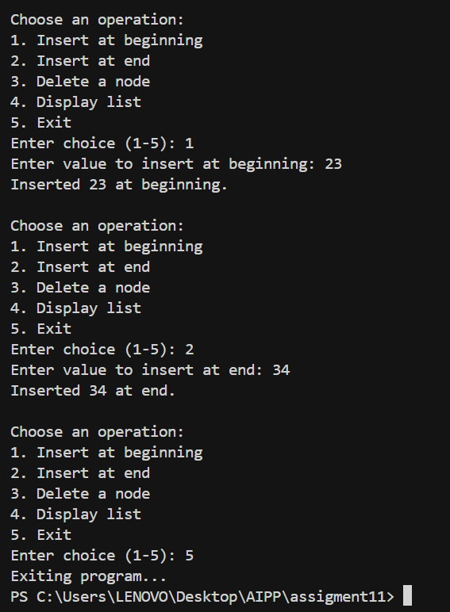  Task Description #4 – Binary Search Tree (BST)  Task: Ask AI to generate a simple BST with insert() and inorder_traversal().  class Node:  def __init__(self, key):  self.key = key  self.left = None  self.right = None  class BST:  def __init__(self):  self.root = None  def insert(self, key):  """Insert a new key into the BST."""  if self.root is None:  self.root = Node(key)  else:  self._insert(self.root, key)  def _insert(self, root, key):  if key < root.key:  if root.left is None:  root.left = Node(key)  else:  self._insert(root.left, key)  elif key > root.key:  if root.right is None:  root.right = Node(key)  else:  self._insert(root.right, key)  # Ignore duplicates  def search(self, key):  """Search for a key in the BST."""  return self._search(self.root, key)  def _search(self, root, key):  if root is None or root.key == key:  return root  if key < root.key:  return self._search(root.left, key)  else:  return self._search(root.right, key)  def delete(self, key):  """Delete a key from the BST."""  self.root = self._delete(self.root, key)  def _delete(self, root, key):  if root is None:  return root  if key < root.key:  root.left = self._delete(root.left, key)  elif key > root.key:  root.right = self._delete(root.right, key)  else:  # Node with one child or no child  if root.left is None:  return root.right  elif root.right is None:  return root.left  # Node with two children: find inorder successor  temp = self._min_value_node(root.right)  root.key = temp.key  root.right = self._delete(root.right, temp.key)  return root  def _min_value_node(self, node):  current = node  while current.left:  current = current.left  return current  def inorder_traversal(self):  self._inorder(self.root)  print()  def _inorder(self, root):  if root:  self._inorder(root.left)  print(root.key, end=" ")  self._inorder(root.right)  def preorder_traversal(self):  self._preorder(self.root)  print()  def _preorder(self, root):  if root:  print(root.key, end=" ")  self._preorder(root.left)  self._preorder(root.right)  def postorder_traversal(self):  self._postorder(self.root)  print()  def _postorder(self, root):  if root:  self._postorder(root.left)  self._postorder(root.right)  print(root.key, end=" ")  if __name__ == "__main__":  bst = BST()  while True:  print("\nChoose an operation:")  print("1. Insert a value")  print("2. Search a value")  print("3. Delete a value")  print("4. Inorder Traversal")  print("5. Preorder Traversal")  print("6. Postorder Traversal")  print("7. Exit")  choice = input("Enter choice (1-7): ")  if choice == "1":  val = int(input("Enter value to insert: "))  bst.insert(val)  print(f"Inserted {val} into BST.")  elif choice == "2":  val = int(input("Enter value to search: "))  node = bst.search(val)  if node:  print(f"Value {val} found in BST.")  else:  print(f"Value {val} not found.")  elif choice == "3":  val = int(input("Enter value to delete: "))  bst.delete(val)  print(f"Deleted {val} from BST (if it existed).")  elif choice == "4":  print("Inorder Traversal:")  bst.inorder_traversal()  elif choice == "5":  print("Preorder Traversal:")  bst.preorder_traversal()  elif choice == "6":  print("Postorder Traversal:")  bst.postorder_traversal()  elif choice == "7":  print("Exiting program...")  break  else:  print("Invalid choice, try again.")  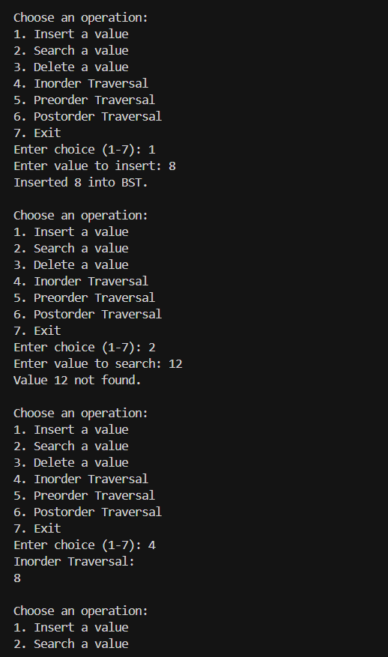 | Week5 - Monday

