1. Using any TCP simulation method (Python / ns2 ), simulate TCP Reno behavior for the following three network conditions:
Packet Loss Cases:
- 0.5% loss
- 1% loss
- 3% loss
For each loss case, perform the following tasks:

Task 1: Plot cwnd vs Time
Simulate a TCP Reno connection for 15 seconds (instead of 20 for simplicity) and plot:
- Congestion Window (cwnd) on Y-axis
- Time (seconds) on X-axis

Task 2: Calculate Throughput
For each packet-loss rate:
- Compute the average throughput in MSS/second or Mbps
- Use any formula (simulation-based or Mathis formula)

Task 3: Explain TCP Reno Behavior
For each loss level, explain what happened in terms of:
- Slow Start
- Congestion Avoidance
- Multiplicative Decrease (cwnd halving) after packet loss

Task 4: Compare the Three Cases
Write a short conclusion comparing the results:
- How does increasing loss reduce cwnd?
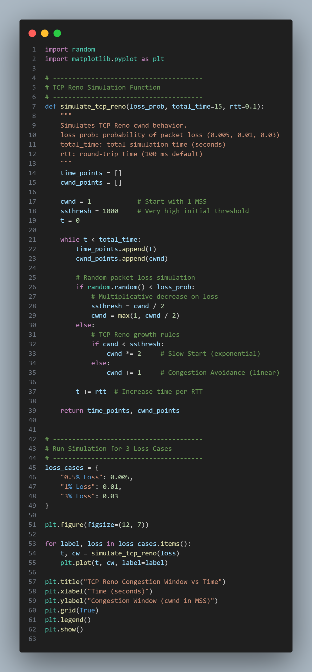
Output
