QUERY 1
SELECT CASE
WHEN MONTH(HireDate) = 1 THEN 'JANUARY'

WHEN MONTH(HireDate) = 2 THEN 'FEBRUARY'

WHEN MONTH(HireDate) = 3 THEN 'MARCH'

WHEN MONTH(HireDate) = 4 THEN 'APRIL'

WHEN MONTH(HireDate) = 5 THEN 'MAY'

WHEN MONTH(HireDate) = 6 THEN 'JUNE'

WHEN MONTH(HireDate) = 7 THEN 'JULY'

WHEN MONTH(HireDate) = 8 THEN 'AUGUST'

WHEN MONTH(HireDate) = 9 THEN 'SEPTEMBER'

WHEN MONTH(HireDate) = 10 THEN 'OCTOBER'

WHEN MONTH(HireDate) = 11 THEN 'NOVEMBER'

WHEN MONTH(HireDate) = 12 THEN 'DECEMBER'

END MONTH_NAME, COUNT(BusinessEntityID) AS EMPLOYEE_COUNT FROM HumanResources.Employee GROUP BY MONTH(HireDate);

OUTPUT:
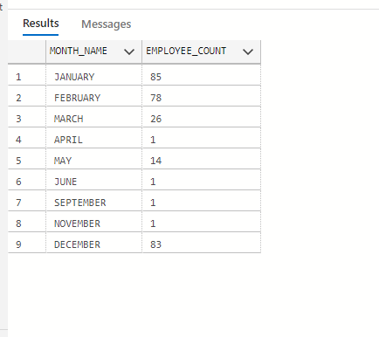

QUERY 2
SELECT (SELECT Name from HumanResources.Department DD WHERE DD.DepartmentID = D.DepartmentID) AS DEPARTMENT,
YEAR(DH.StartDate) AS YEAR, COUNT(DH.BusinessEntityID) AS EMPLOYEE_HIRED
FROM HumanResources.Department D, HumanResources.EmployeeDepartmentHistory DH WHERE D.DepartmentID = DH.DepartmentID
GROUP BY D.DepartmentID, YEAR(DH.StartDate);

OUTPUT:
