Lab 5 | COMP3123|

Student ID: 101428605

Name: Harsh Chaudhary

1. Localhost:8081/home  
   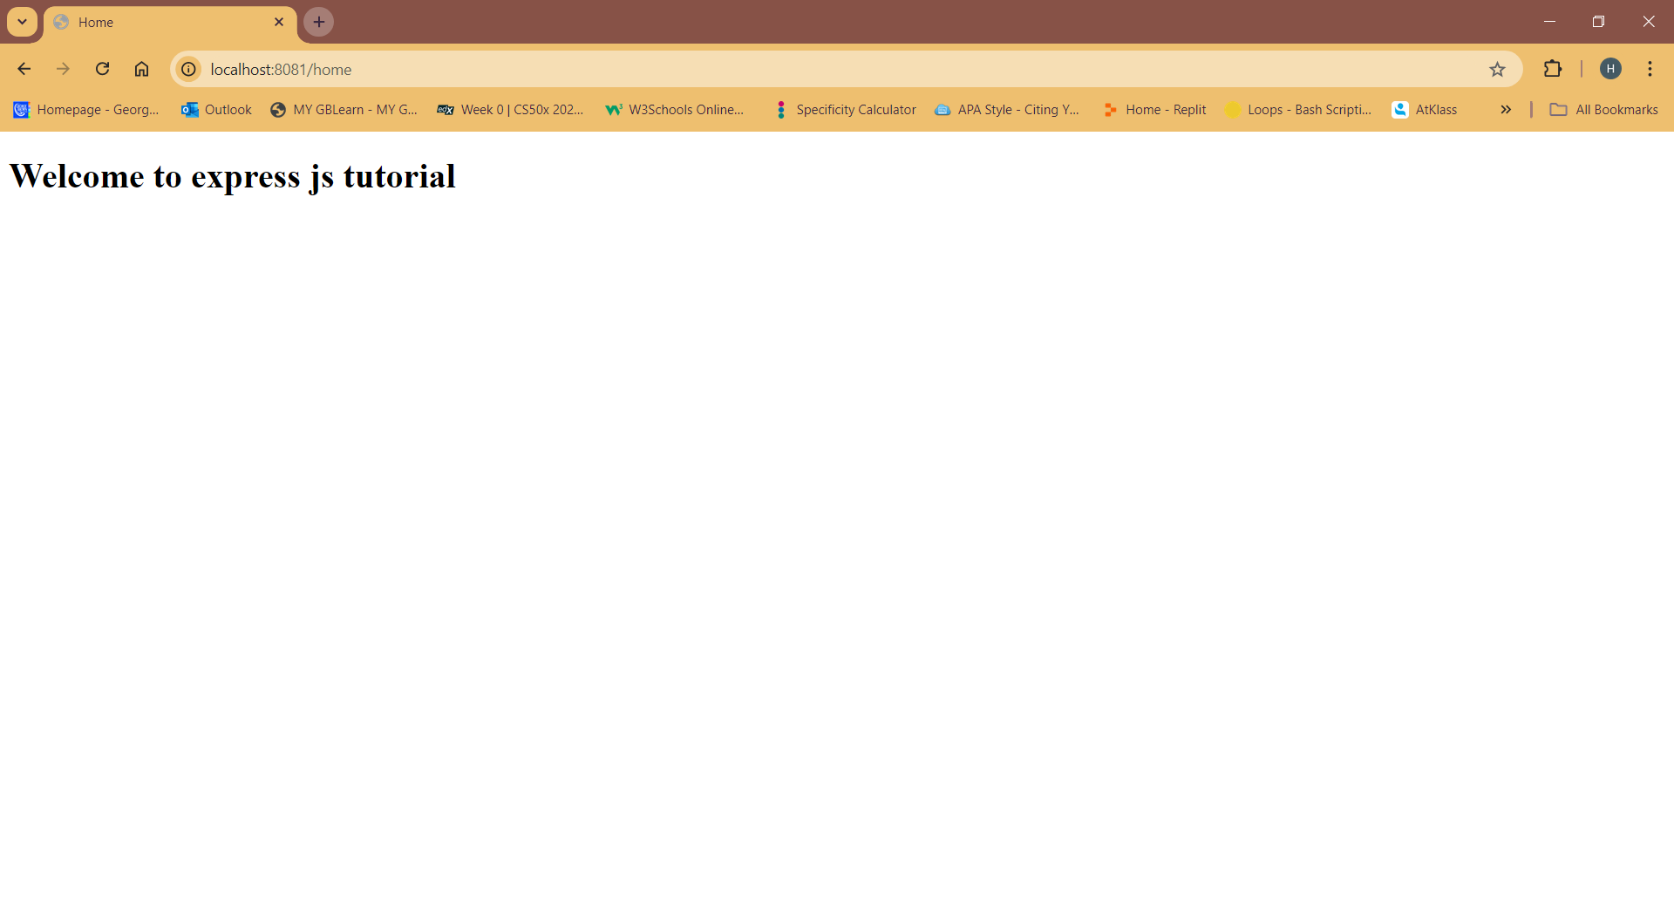
2. Localhost:8081/logout

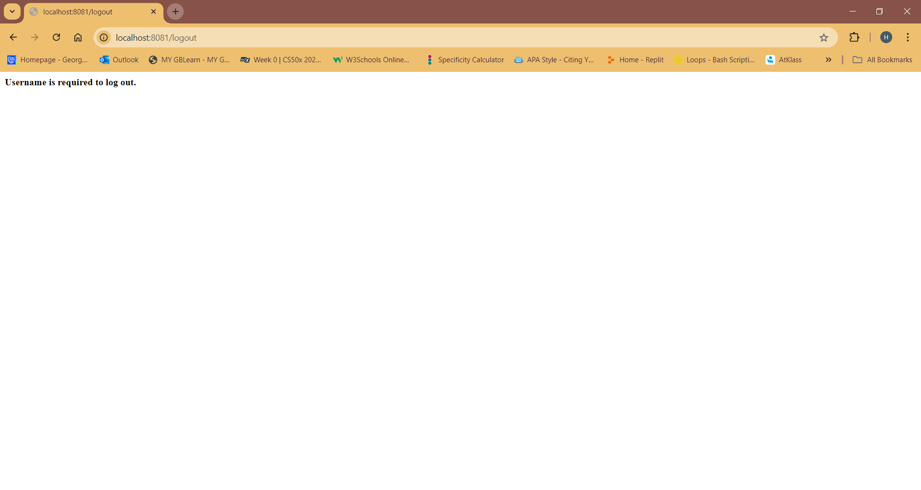

1. Localhost:8081/profile

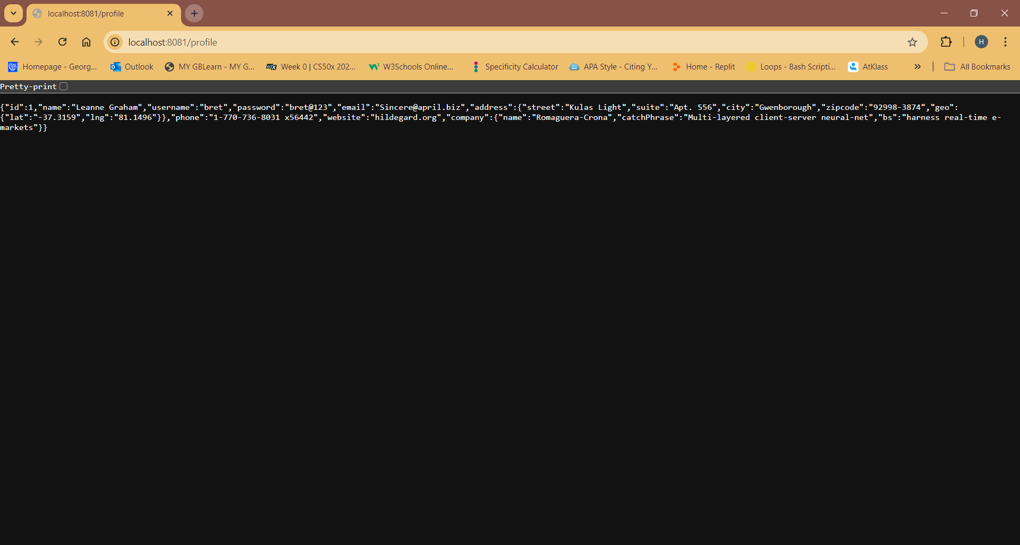

POSTMAN SCREENSHOTS

1. Localhost:8081/home ( GET)

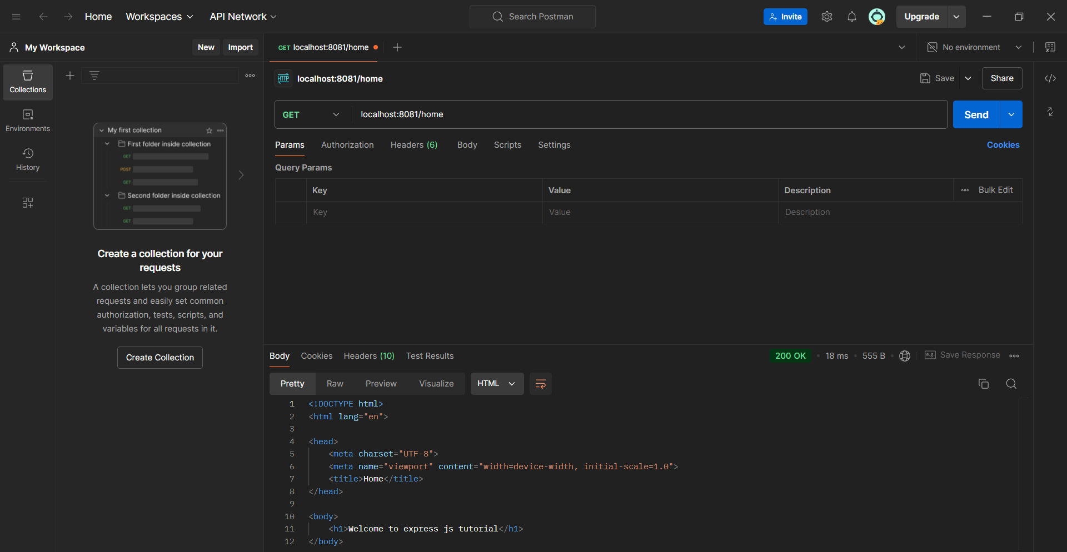

2.)Localhost:8081/profile (GET)

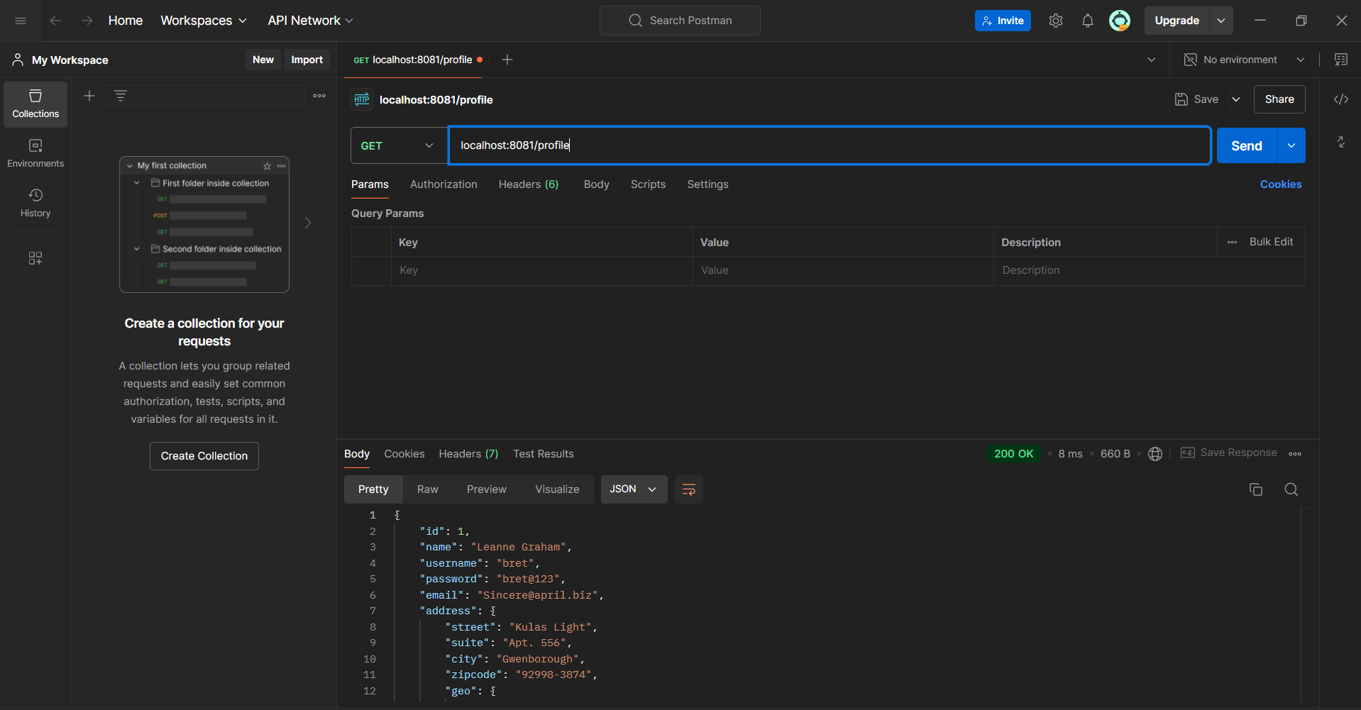

3.)Localhost:8081/logout (GET)

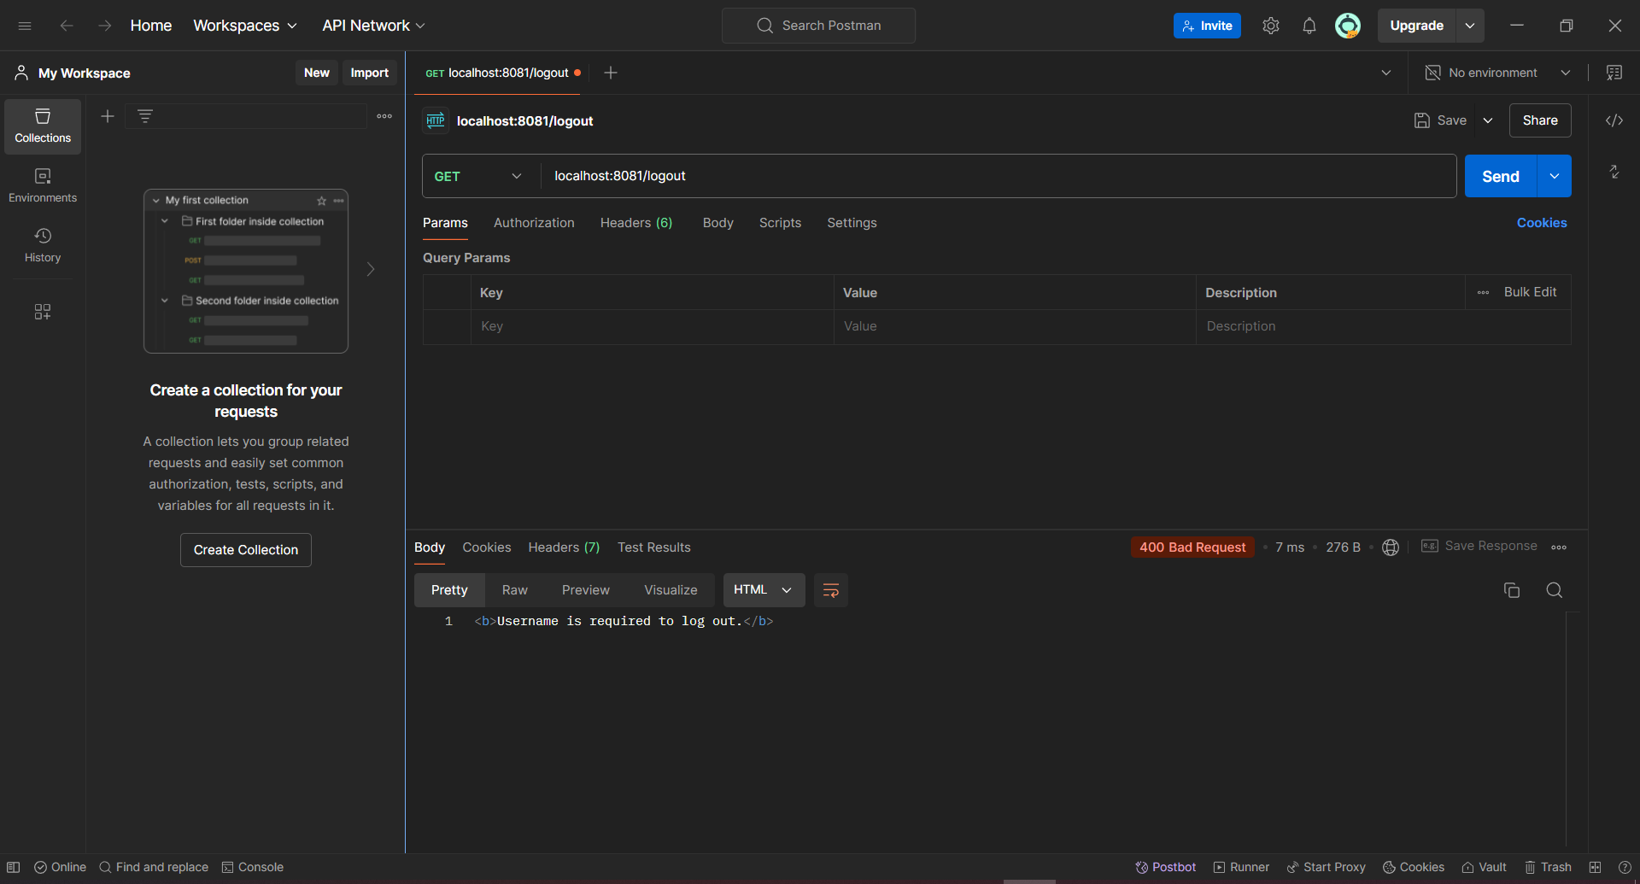

4.)Localhost:8081/login (POST)

