**Project Plan**

**Power - Match**

|  |  |
| --- | --- |
| Primary Instructor | Anjana Shah |
| Team Member | Anthony Aristy |
| Team Member | Damanpreet Singh |
| Team Member | Harsh Chaudhary |
| Team Member | Vansh Kumar |

Document Revision History

|  |  |
| --- | --- |
| Revision # | Date |
| 1.0 | October 7, 2024 |

**Table of Contents**

1 Executive Summary 3

2 Project Approvers, Reviews and Distribution List 3

3 Scope 4

4 Deliverables 4

5 Assumptions 5

6 Dependencies 5

7 Risk Management 6

8 Communication 7

9 Task Listing 7-8

10 Gantt Chart 8

11 Milestones 8

12 RAM 9

13 Approval 9

**1. Executive Summary**

The following describes the project to be executed.

|  |  |
| --- | --- |
| Objective | Developing **Power Match**, a social fitness platform that connects gym-goers based on their workout preferences, locations, and schedules, fostering a community of motivated fitness enthusiasts. The platform will enable users to build gym activity streaks by uploading gym selfies, utilize filters to search for workout partners based on location, availability, and weightlifting statistics, and offer optional features like post-workout user ratings. |
| Corporate Goals Addressed | **Corporate Goals Addressed:**   1. **Enhancing User Engagement and Community Building**: Power Match aims to create a supportive fitness community by connecting like-minded gym-goers, which fosters long-term user engagement and active participation. 2. **Increasing App Retention and User Loyalty**: By incorporating features such as workout streak tracking, and user ratings, the platform promotes consistency and healthy competition, encouraging users to stay committed and use the app regularly. 3. **Improving Market Position as a Fitness-Focused Platform**: Power Match differentiates itself through unique features like location-based filters, workout-specific matching, and equipment education. 4. **Creating Monetization Opportunities**: Optional add-on features, such as premium filters, advanced matching options, and equipment tutorials, provide potential monetization paths through subscriptions or in-app purchases. 5. **Establishing a Data-Driven Approach for User Personalization**: By collecting user preferences, activity patterns, and feedback, Power Match will leverage data analytics to enhance matching accuracy, personalized recommendations, and user satisfaction, aligning with long-term strategic growth. |
| Planned Start Date | September 2024 |
| Planned End Date | March 2025 |

**2. Project Approvers, Reviews and Distribution List**

|  |  |  |  |
| --- | --- | --- | --- |
| Project Role | Name | E-mail | Date |
| Project Lead | Anthony Aristy | [101420011@georgebrown.ca](mailto:101420011@georgebrown.ca) | October 7, 2024 |
| Business Analyst | Damanpreet Singh | <101415046@georgebrown.ca> | October 7, 2024 |
| UI/UX Designer | Harsh Chaudhary | [101428605@georgebrown.ca](mailto:101428605@georgebrown.ca) | October 7, 2024 |
| Developer | Vansh Kumar | [101402651@georgebrown.ca](mailto:101402651@georgebrown.ca) | October 7, 2024 |

**3. Scope**

|  |  |
| --- | --- |
| In Scope | Out of Scope |
| **User Connections**: Match users with gym partners or trainers based on shared fitness objectives, preferred locations, and personal preferences. | **Interactive Content Sharing**: Users can post stories, comment, and share media. |
| **Review System**: Allow users to provide feedback on workout partners, trainers, and venues to help others find trustworthy partners and suitable exercise spots. | **Casual Conversations**: Engage in discussions not focused on fitness or workouts. |
| **Location Search**: Discover local gyms, parks, and fitness centers. | **Enhanced Social Features**: Includes creating friend groups, participating in general chatrooms, and networking beyond fitness-related topics. |
| **Consistency Tracker**: Monitor workout streaks to inspire users to stay consistent, meet like-minded individuals, and strengthen workout relationships. |  |

**4. Deliverables**

This project will deliver the following.

|  |  |
| --- | --- |
| Deliverable | Description |
| |  |  | | --- | --- | | **User Profile Setup** |  | | Create a user profile setup feature that includes basic details and workout goals. |
| |  |  | | --- | --- | | **Matching Algorithm** |  | | Implement a matching algorithm to pair users based on workout level and goals. |
| |  |  | | --- | --- | | **UI/UX Design** |  | | |  |  | | --- | --- | |  | Develop intuitive screens for login, profile, and matching features. | |
| |  |  | | --- | --- | | **Backend Functionality** |  | | Build and integrate API for user authentication, profile management, and matching. |
| **Database Design** | Design a scalable database to store user data, preferences, and match history. |

**5. Assumptions**

This project makes the following assumptions;

* **Reliable Internet Access**: Ensure users have a consistent internet connection for seamless app functionality.
* **Verification of Gyms and Trainers**: Partner facilities and trainers will undergo a thorough vetting process to guarantee authenticity and quality services before being listed on the platform.
* **Accurate User Profiles**: Users are required to provide precise profile details to improve matching accuracy, trustworthiness, and overall experience within the community. This ensures that connections are meaningful and suited to individual fitness goals and preferences.
* **Privacy and Security Measures**: All user data, including profile information and gym preferences, will be securely stored and handled according to industry standards.

**6. Dependencies**

The following are the internal and external dependencies that will have to be acknowledged and addressed;

**Internal Dependencies:**

1. **Frontend & Backend Development:** Utilizing React for building a responsive frontend and Node.js for creating a robust backend with efficient server-side operations.
2. **Database Setup:** Employing MongoDB for storing user information, product listings, and communication logs, with emphasis on secure management and structural integrity.

**External Dependencies:**

1. **Cloud Hosting:** Using a scalable cloud service like AWS for reliable hosting.
2. **File Storage:** Utilizing cloud storage for managing large file uploads.
3. **Security Frameworks:** Integrating third-party libraries for user authentication and secure session management.

**7. Risk Management**

|  |  |  |  |
| --- | --- | --- | --- |
| Potential Risk | Severity (H/M/L) | Likelihood (H/M/L) | Management Strategy |
| User Adoption and Retention | M | M | Create a user-friendly interface and conduct beta testing to gather feedback. Implement personalized engagement strategies to encourage long-term use. |
| Technological Challenges | H | M | Allocate additional development resources and prioritize testing for the matching algorithms and communication modules. Regularly update the app to optimize performance and address potential technical bottlenecks to ensure a smooth user experience. |
| Monetization Difficulties | M | M | Conduct thorough market research to identify the most suitable revenue model. Implement user surveys and A/B testing to evaluate reactions before rolling out changes broadly. Focus on balancing monetization and user experience to avoid alienating the existing user base. |

**8. Communication**

**Reporting**

The following reports will be produced;

|  |  |  |
| --- | --- | --- |
| Report | Audience | Frequency |
| Project Status Report | Project team and instructor | Weekly |
| Project Progress Update | Project Team | Weekly |

**Meetings**

The following meetings/communication will be established;

|  |  |  |  |
| --- | --- | --- | --- |
| Meeting | Purpose | Attendees | Frequency |
| Project Progress | Project Status | Project Team and instructor | Weekly |
| Project Report | Feedback | Project Team | Twice in a week |

**9. Task Listing (WBS- Work Breakdown Structure)**

The following resource proposal template summarizes the resource hours committed to this project, upon final approval of this document.

|  |  |  |  |
| --- | --- | --- | --- |
| Reference | Tasks | Duration | Dependency |
| A | Project Initiation and Planning | 1 week | None |
| B | Identifying Key Requirements and Setting Objectives | 2 weeks | A |
| C | Architecture Blueprint and Design Specifications | 4 weeks | B |
| D | Coding and Implementation Phase | 10 weeks | C |
| E | Testing and Quality Assurance | 4 weeks | D |
| F | Launching the System in the Production Environment | 3 weeks | E |
| G | Providing End-User Training and Support | 2 weeks | F |
| H | Monitoring, Maintenance, and Performance Optimization | 2 weeks | G |
| I | Final Review, Documentation, and Project Sign-Off | 2 weeks | H |

**10. Gantt Chart**

Create a detailed Gantt Chart from your Task Listing(Use any software tool and paste the image or upload as a separate file that can be opened as pdf/doc/xls)

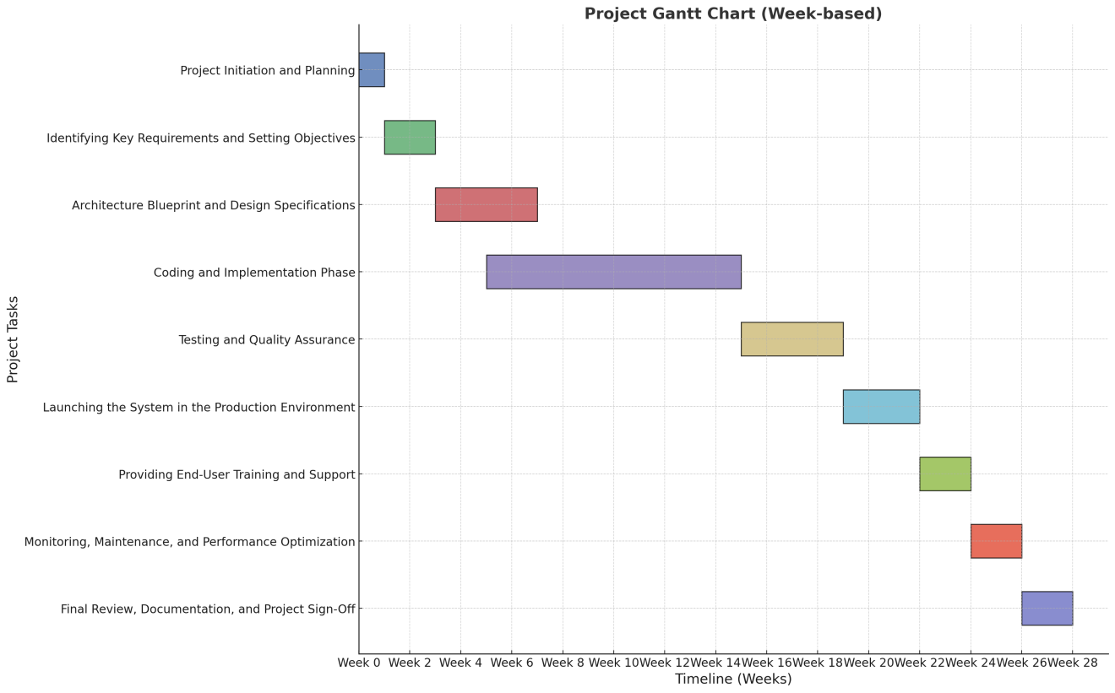

**11. Milestones**

|  |  |  |
| --- | --- | --- |
| Major Activity or Milestone | Estimated Milestone Target date | Owner/Reviewer Team Members |
| **Initial Project Planning:** Initial meeting to define project scope, team roles, and timelines. | October 1, 2024 | All team members |
| **Requirement Gathering:** Identify and document functional and non-functional requirements. | October 7, 2024 | All team members |
| **System Design:** Develop system architecture, UI wireframes, and database schema. | November 1,2024 | Vansh Kumar |
| **Backend and Frontend Development:** Implement core features and integrate front-end with back-end. | January 31,2025 | All team members |
| **Testing and Quality Assurance :** Conduct thorough system testing and fix critical bugs | February 15, 2025 | Damanpreet Singh and Harsh Chaudhary |
| **Deployment and User Training:** Launch the system and provide end-user training and support resources. | March 1, 2025 | Harsh Chaudhary |
| **Post-Launch Optimization :** Monitor, maintain, and optimize system performance. | March 20, 2025 | All team members |

.

**12. RAM – Responsibility Assignment Matrix**

**Project Name : Power - Match**

**Project Lead : Anthony Aristy**

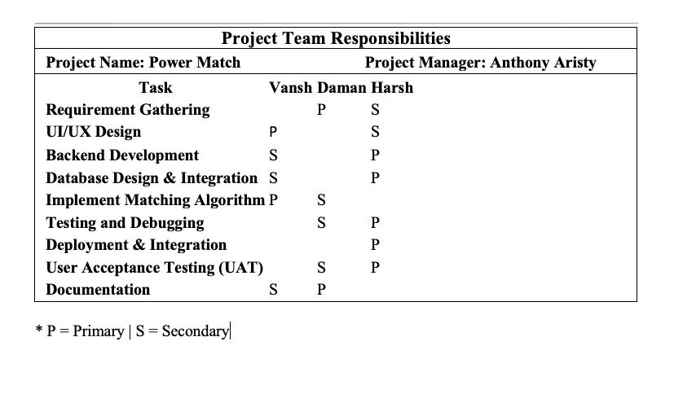

**13. Approval**

The signatures below indicate their approval of the contents of this document.

|  |  |  |  |
| --- | --- | --- | --- |
| Project Role | Name | Signature | Date |
| Project Lead | Anthony Aristy | A.A. | October 7th, 2024 |
| Business Analyst | Damanpreet Singh | D.S. | October 7th, 2024 |
| UI/UX Designer | Harsh Chaudhary | H.C. | October 7th, 2024 |
| Developer | Vansh Kumar | V.K. | October 7th, 2024 |