The Protective Power of Friendship: Peer Support and Depression Across Socioeconomic Groups

Introduction
Adolescent mental health remains a critical public health concern, with rising rates of depression reported among young people across socioeconomic backgrounds. While the role of economic disadvantage in shaping mental health outcomes is well documented, growing attention is being paid to the social support structures that may help buffer these effects. Among these, peer relationships and friendships are emerging as potential protective factors during adolescence.
This project investigates whether close peer support can mitigate the risk of depression for adolescents from lower-income households. Using data from Wave III of the National Longitudinal Study of Adolescent to Adult Health (Add Health), the analysis explores how varying levels of peer interaction relate to reported diagnoses of depression, and how this relationship may differ across socioeconomic groups.
Prior research provides the foundation for this investigation. Eisenberg et al. (2007) highlight that students with stronger social connections exhibit significantly lower levels of depressive symptoms, suggesting that perceived support from friends can foster emotional resilience during stressful periods. Their work emphasizes the need for integrating social context into mental health assessments among youth.
Goodman et al. (2003) demonstrate a clear gradient between household income and the prevalence of emotional disorders in adolescents, with those from lower-income families being disproportionately affected. This underscores the relevance of socioeconomic status as both a risk factor and a context for interpreting adolescent health outcomes.
Hammack et al. (2018) explore how peer relationships can serve as a critical buffer for youth facing systemic or interpersonal adversity. Their findings show that emotionally supportive friendships significantly reduce psychological distress, especially among marginalized or high-risk populations.
While these studies underscore the role of social support, they often overlook whether its protective effect differs across socioeconomic groups. This analysis addresses that gap by examining if peer support buffers against depression specifically for adolescents from lower-income households. By focusing on interaction effects and subgroup analyses, it offers insights into how friendship shapes mental health trajectories across different socioeconomic backgrounds.
Descriptive Statistics
This analysis focuses on Diagnosed Depression, a binary variable indicating whether a respondent reported a formal diagnosis of depression. This measure offers a concrete health outcome with relevance for both clinical and public health perspectives.

A total of 4,288 observations from Wave III of the National Longitudinal Study of Adolescent to Adult Health (Add Health) were included, covering adolescents aged 18 to 26. Depression diagnosis was chosen due to its critical importance in mental health research, particularly during young adulthood which is a period marked by significant social and emotional development.

A total of 17 explanatory variables were selected based on theoretical relevance and consistency with prior literature. These include:

- Demographic characteristics:
  - Gender (male/female)
  - Race/ethnicity (White, Other)
- Socioeconomic indicators (both parental and respondent-based):
  - Parental income at Wave I (categorised ranges)
  - Respondent’s perceived household income at Wave III
  - Education support from family and education aspiration
- Peer support metrics:
  - Time spent with friends (Never, Sometimes, Most of the time)
  - Perceived influence of friends versus family on decisions
  - Closeness to best male and female friends
- Family dynamics:
  - Closeness to mother and father
  - Whether parents discussed important matters
  - Household composition (living with both parents)
- Mental health and behaviour controls:
  - History of being diagnosed with a mental health issue
  - Past depressive symptoms (e.g., feeling sad in the past week)

Each variable was recoded into interpretable categories and reviewed for missingness. Observations with missing values on the dependent variable or critical covariates were excluded from the regression sample.
Figure 1 below illustrates the association between closeness to friends and diagnosed depression, disaggregated by gender and welfare status. Adolescents who reported being less emotionally close to their friends exhibited higher rates of depression, particularly among females and low-income groups. The trend suggests that peer closeness may serve as a protective factor, though its strength appears to vary by both gender and socioeconomic background.
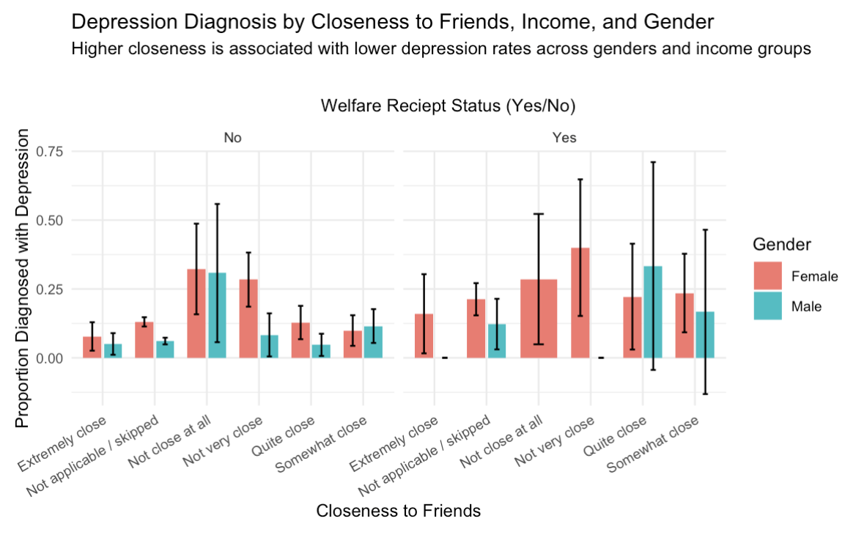
Figure 1. Depression Diagnosis by Closeness to Friends, Gender, and Welfare Status

Additional visualisations, including depression rates by household income, gender, and family closeness, are provided in the appendix. Together, these descriptive statistics offer preliminary evidence that social and economic factors jointly shape adolescent mental health outcomes.

Regression Analysis

To assess the association between social support and adolescent depression, a series of logistic regression models were estimated using Wave III of the Add Health dataset. The outcome variable is a binary indicator denoting whether the adolescent has ever been diagnosed with depression by a medical professional. The explanatory variables include peer and parental support indicators, along with demographic and socioeconomic controls.

Baseline Model - The baseline model incorporates only socio-demographic and behavioural predictors. Findings indicate that male adolescents and those identifying as White exhibit significantly lower odds of reporting depression. Not being economically well off and distant from family is strongly associated with higher depression rates. However, income-related variables do not show consistent effects, underscoring the need to incorporate social interaction indicators.

Full Model with Peer and Family Support - The full specification introduces peer-related variables (e.g., time spent with peers, whose opinion matters more) and parent-child closeness. The results suggest that weaker peer engagement and lack of emotional closeness with friends and family are associated with higher odds of depression. For instance, adolescents who “never or rarely” spent time with school peers were significantly more likely to report a depression diagnosis

Stepwise Model - A stepwise selection procedure was used to identify a more parsimonious model while retaining key explanatory power. This model achieves a lower AIC (2728.8) compared to the full model (2752.2), suggesting improved model fit. Importantly, peer and parental support variables remain significant, reinforcing the hypothesis that social connectedness is a more consistent predictor of adolescent mental health than economic status.

Model | AIC | Key Predictors | Insights
Baseline | 2878.2 | Gender, race, substance use | Income effects limited
Full | 2752.2 | Peer/family support, closeness | Strong support for core hypothesis
Stepwise | 2728.8 | Peer interaction, family closeness | Best-fitting, interpretable model
Table 1. Comparison of regression models based on AIC and key predictors
Based on the model comparison table, the stepwise model demonstrated the best overall fit. This reinforces that peer interaction and family closeness, together with socioeconomic variables, are key predictors of adolescent mental health.

Additional Models
1. Gender-Specific Models - Separate regressions were run for males and females to test for gender heterogeneity. In both groups, lower peer engagement and weak emotional closeness were linked to higher depression rates.
2. Peer Support × Low-Income Interaction - An interaction model assessed whether the effect of peer interaction varies by socioeconomic status. While lower interaction was linked to higher depression, the interaction term with low-income status was not significant, suggesting that peer support has a similarly protective effect across income groups.
Model | Key Finding
Gender-stratified | Stronger peer effects for males; peer support significant in both
Peer × Income | No differential effect by income; support matters across SES
Table 2. Summary of additional models exploring gender differences and income interactions
These findings strengthen the case for peer-based interventions across diverse adolescent populations.
Limitations

This analysis provides relevant insights into how peer and social factors relate to adolescent depression, though a few considerations should be kept in mind. The cross-sectional design limits the ability to assess changes over time. Some variables are self-reported, which may affect measurement precision. While important controls were included, there may be other unobserved influences, such as school environment or personality traits, that could also play a role. Lastly, the definitions used for income and closeness provide broad patterns but may not reflect every nuance of adolescents' lived experiences.

Use of Weights

The Add Health dataset is derived from a complex survey design that includes clustering, stratification, and unequal probabilities of selection. In this analysis, weights were not applied. As a result, findings should be interpreted as sample-specific associations rather than population-level inferences.
While unweighted models offer valid insights into the relationships between depression and peer support within this sample, applying weights could improve generalizability. Given the project’s focus on key factors that affect mental health rather than estimation at the population level, the decision to omit weights was deemed appropriate.

Conclusion

This project investigated the relationship between peer and family support and adolescent depression using Wave III of the Add Health dataset. The findings consistently point to the protective role of social connectedness particularly strong friendships and frequent peer interactions in reducing the likelihood of depressive symptoms. These associations remain robust across different model specifications and subgroups, providing evidence for the relevance of social support in adolescent mental health.
While the study does not make causal claims, the insights are highly informative. They reveal clear patterns that can inform school based interventions, youth mental health initiatives, and future research. By focusing on a adolescent sample, this analysis contributes to a growing body of evidence for stronger social integration and support systems during adolescence.
Future work could build on this foundation using longitudinal or causal techniques, but the current results already underline the importance of considering peer dynamics in mental health policy and program design.

END
Appendix
Appendix A1: Variable Definitions
Variable Name | Description | Type | Recoding | Measurement Unit / Categories
Diagnosed Depression | Self-reported diagnosis by a healthcare professional | Binary | Yes = 1, No = 0 | Yes/No
Gender | Respondent's biological sex | Categorical | Male/Female | Nominal
Race/Ethnicity | White vs. Other | Binary | White = 1, Other = 0 | Nominal
Parental Income (Wave I) | Parental income reported at Wave I | Categorical | Grouped into 7 income brackets | Nominal
Household Income (Wave III) | Respondent's perception of household income | Categorical | Grouped into 7 income brackets | Nominal
Education Support | Parental support for education | Categorical | Levels of family education support | Ordinal
Education Aspiration | Respondent‚Äôs level of educational aspiration | Categorical | Scale of aspirations | Ordinal
Time with Peers | Frequency of spending time with school peers | Categorical | Never, Sometimes, Most/all of the time | Ordinal
Influence on Decisions | Whether friends or family are more influential in decisions | Categorical | Friends vs. Family | Nominal
Closeness to Best Friend (Male/Female) | Emotional closeness with best friends | Categorical | 5-point closeness scale | Ordinal
Closeness to Mother | Emotional closeness with mother | Categorical | 5-point closeness scale | Ordinal
Closeness to Father | Emotional closeness with father | Categorical | 5-point closeness scale | Ordinal
Parental Discussion of Important Matters | Did parents discuss important matters with respondent? | Binary | Yes/No | Yes/No
Living with Both Parents | Household composition including both biological parents | Binary | Yes/No | Yes/No
ADD/ADHD Diagnosis | Diagnosed with ADD/ADHD (Wave III) | Binary | Yes = 1, No = 0 | Yes/No
Recent Depressive Feelings | Felt sad or low during the past week | Binary | Yes = 1, No = 0 | Yes/No

Appendix A2: Summary Statistics
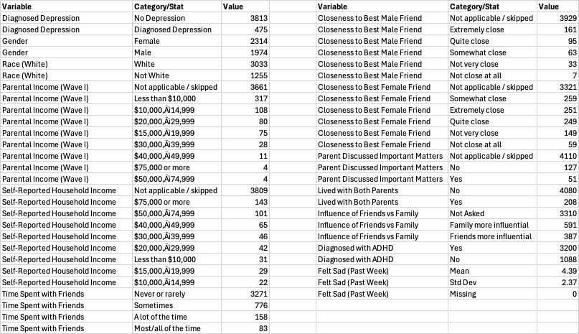
Appendix A3: Additional Graphs & Visuals

- Heatmap – Depression Rate by Gender & Income

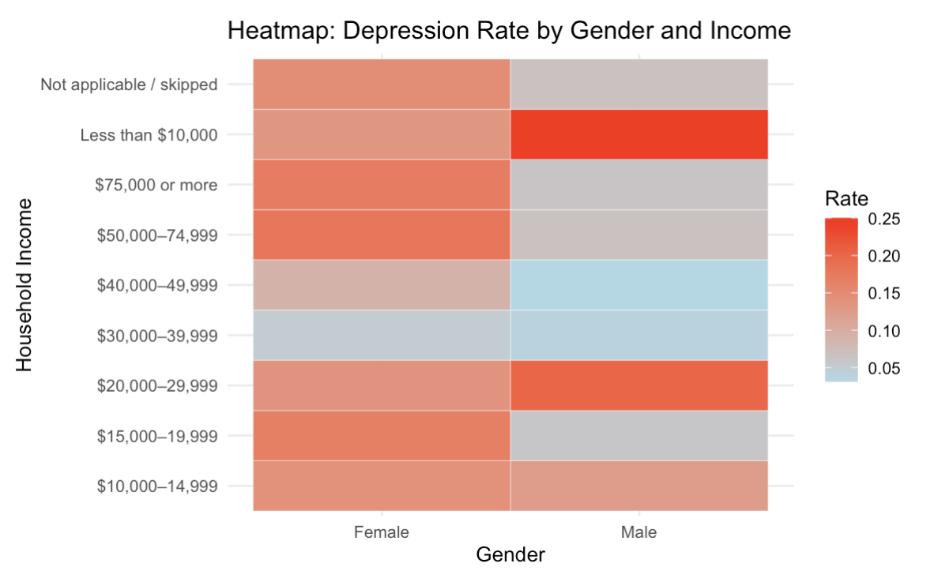

- Depression Rate by Peer Interaction and Sadness

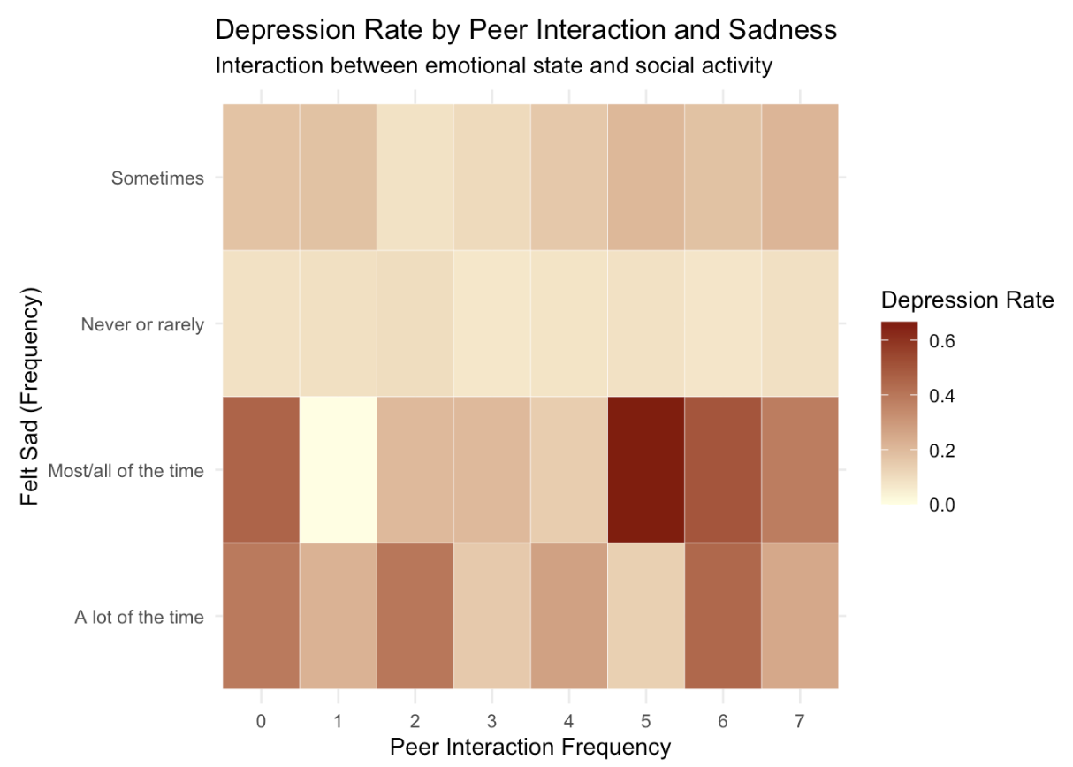

- Correlation Plot
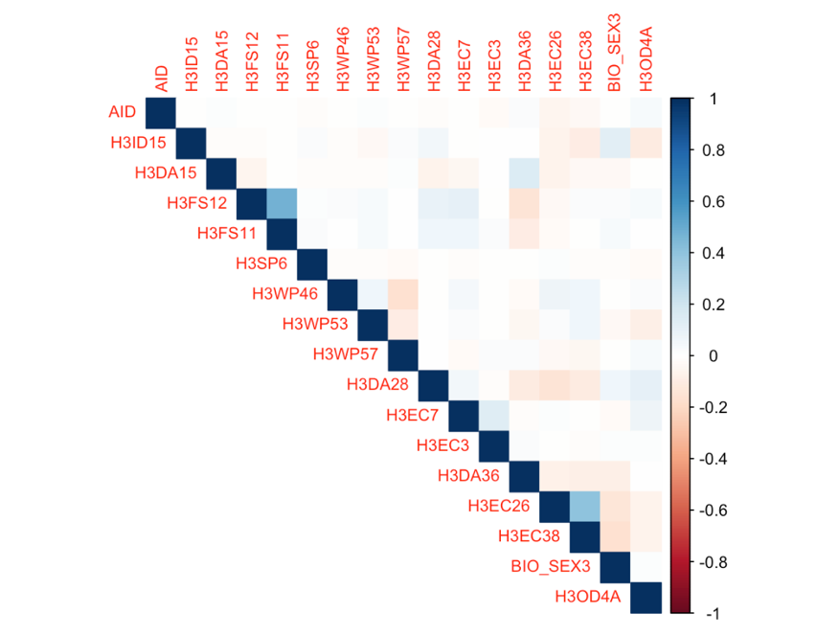

- Depression by Peer Interaction and Welfare Status
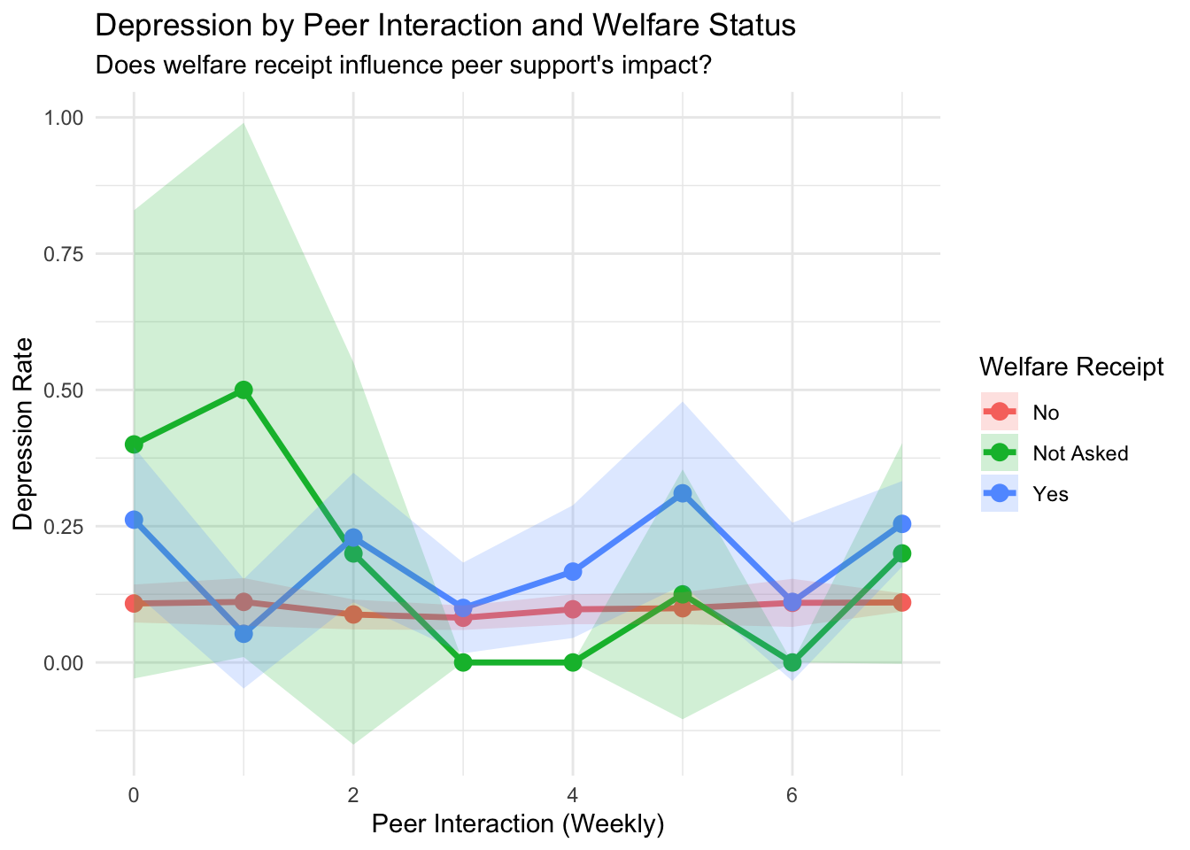

- Depression by Employment Status:
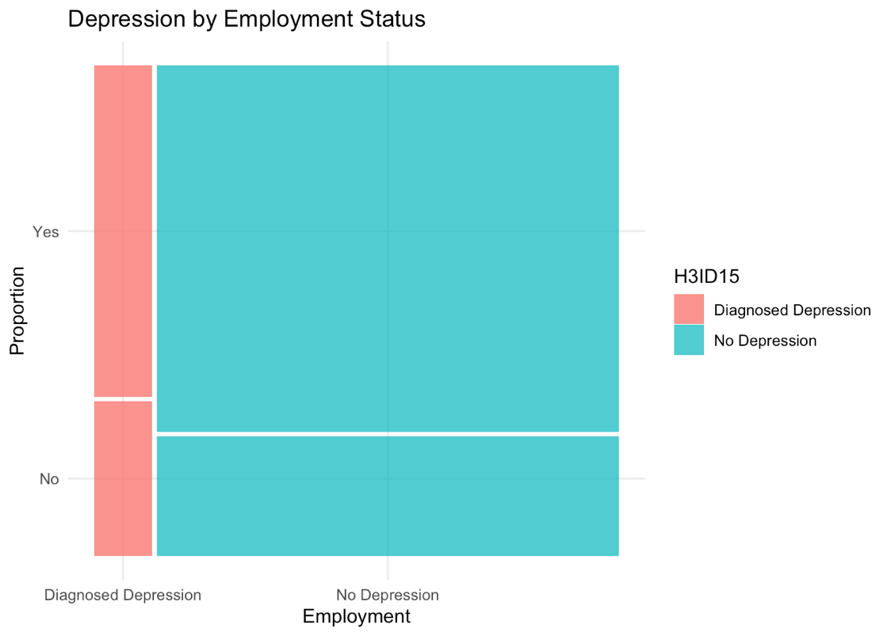

- Frequency of Hanging Out with Friends by Depression Diagnosis
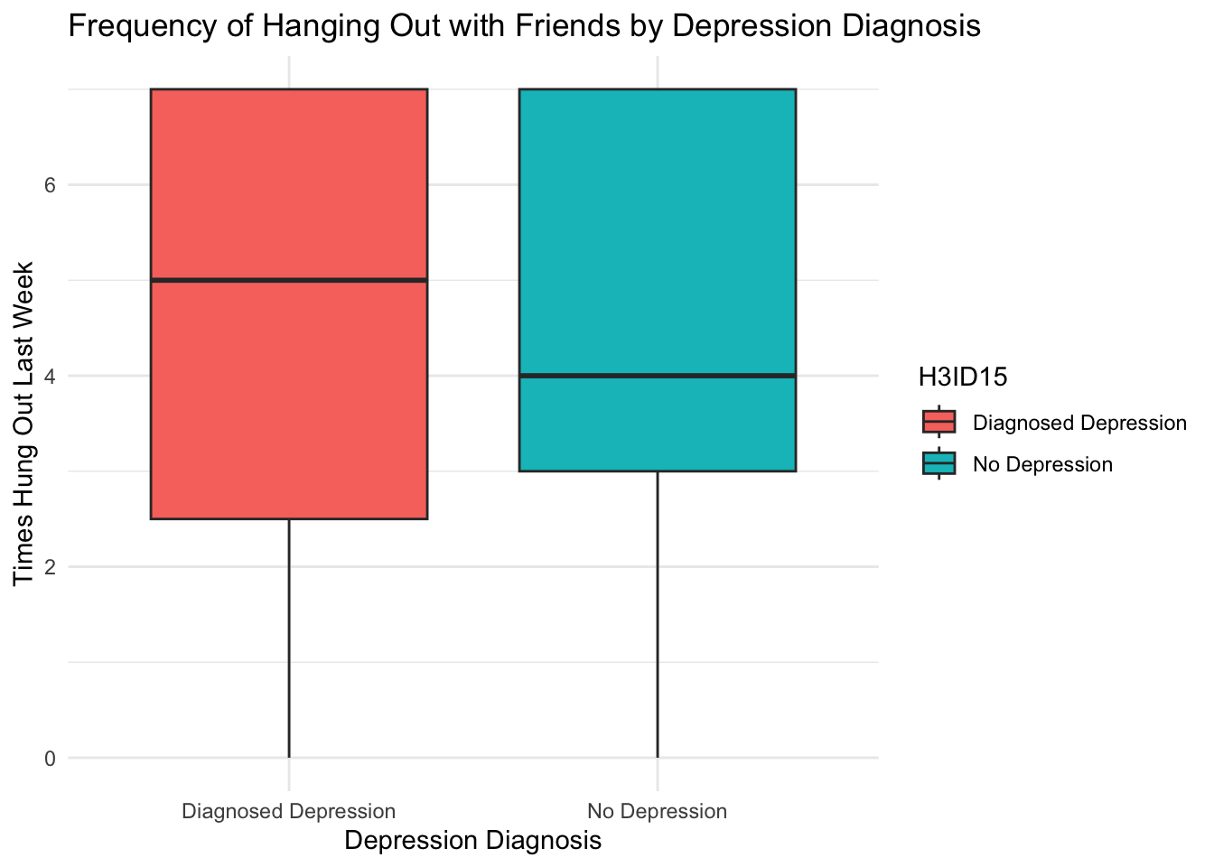
- Peer Interaction and Depression: Gender and Welfare Status
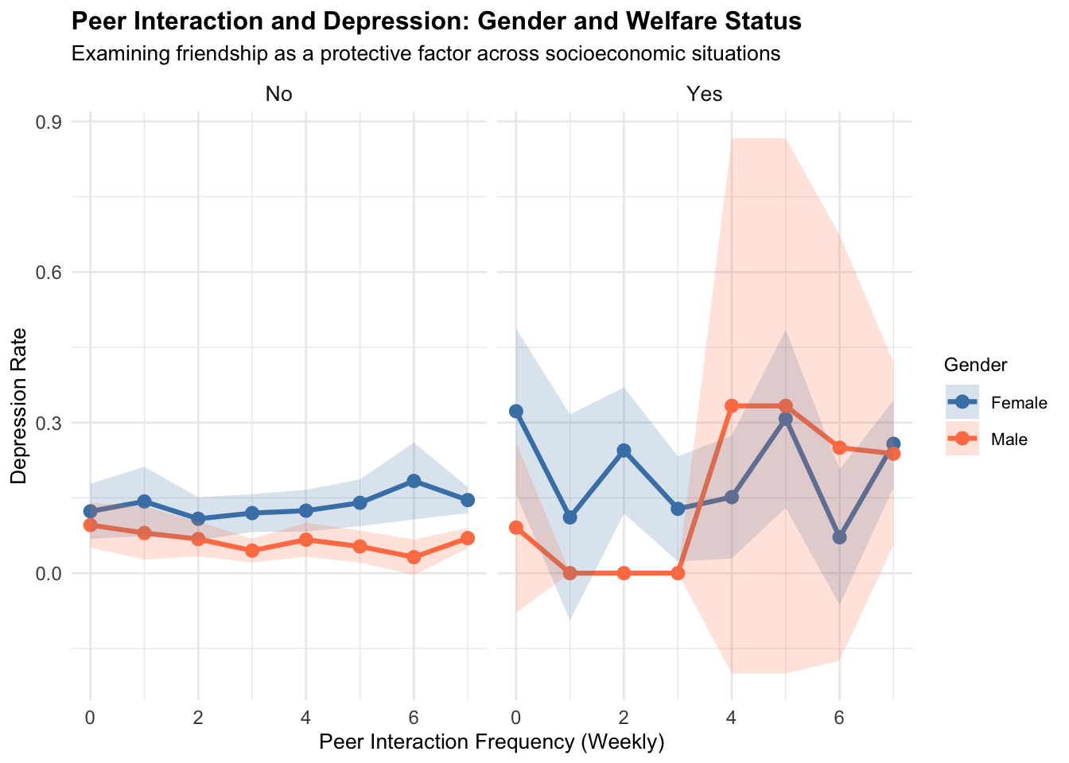

Appendix A4: Regression Output Tables

- Baseline Regression Model Output
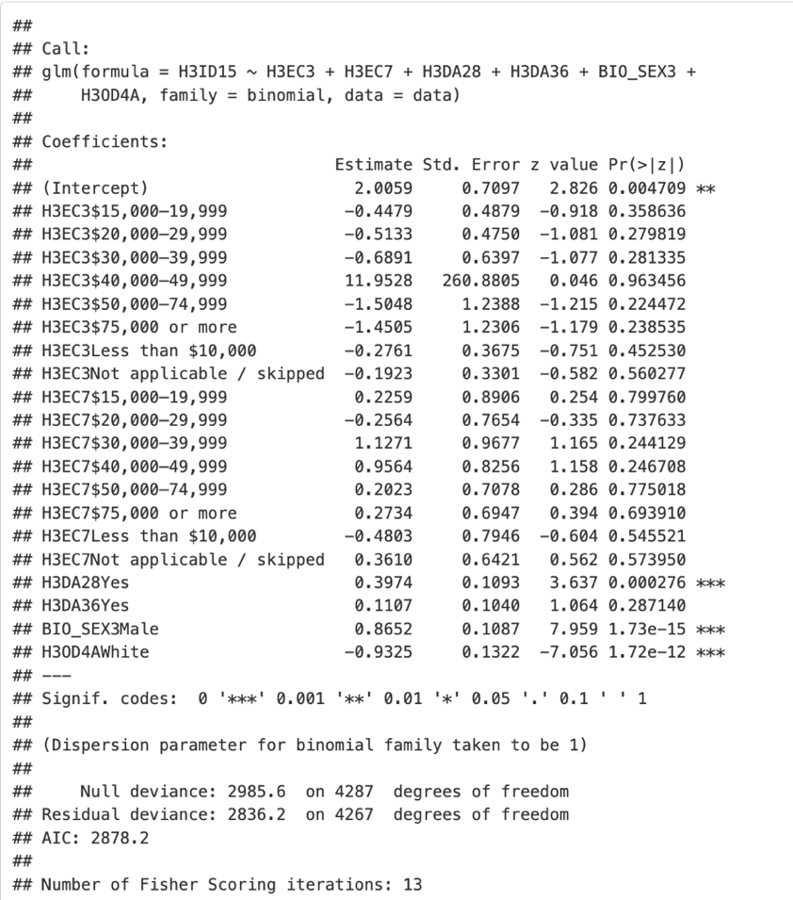
- Full Regression Model Output:
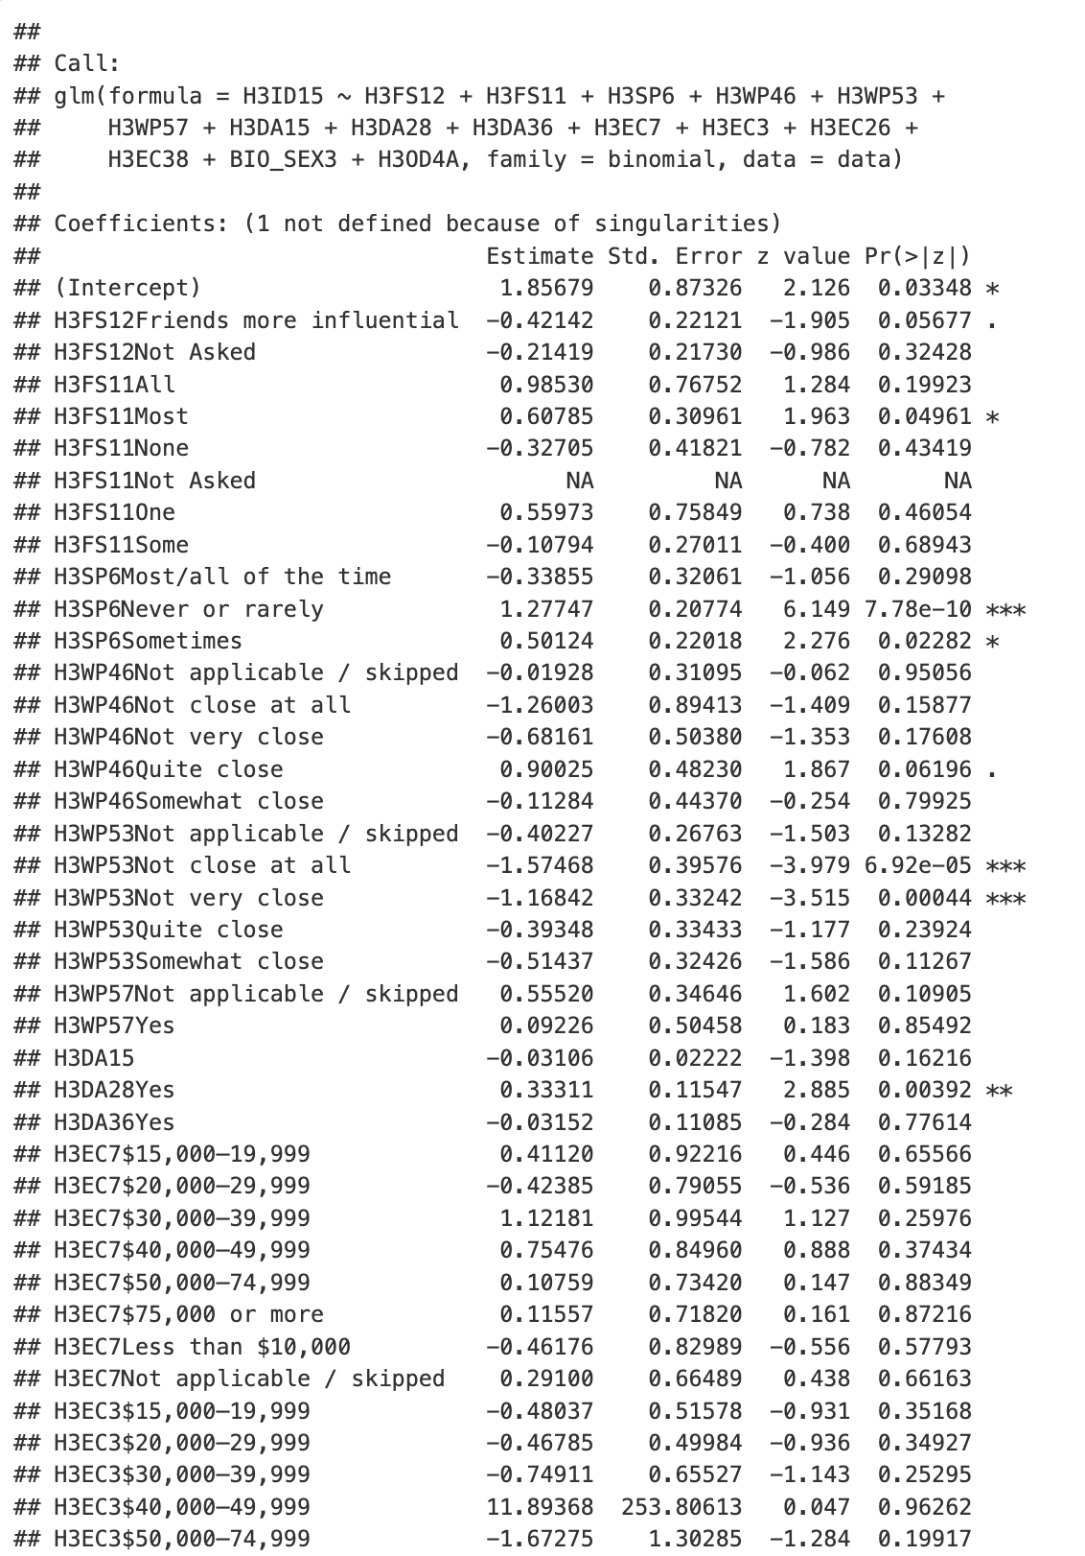
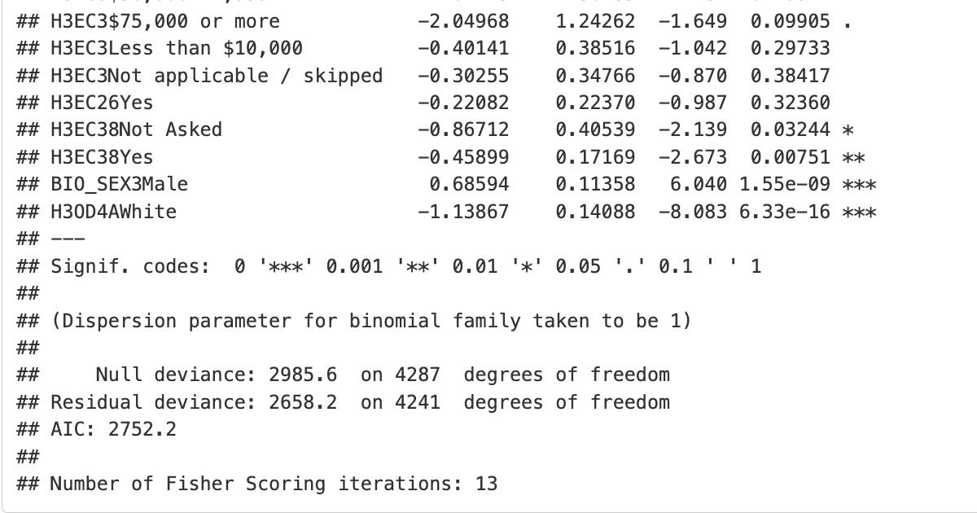

- Stepwise Regression Output: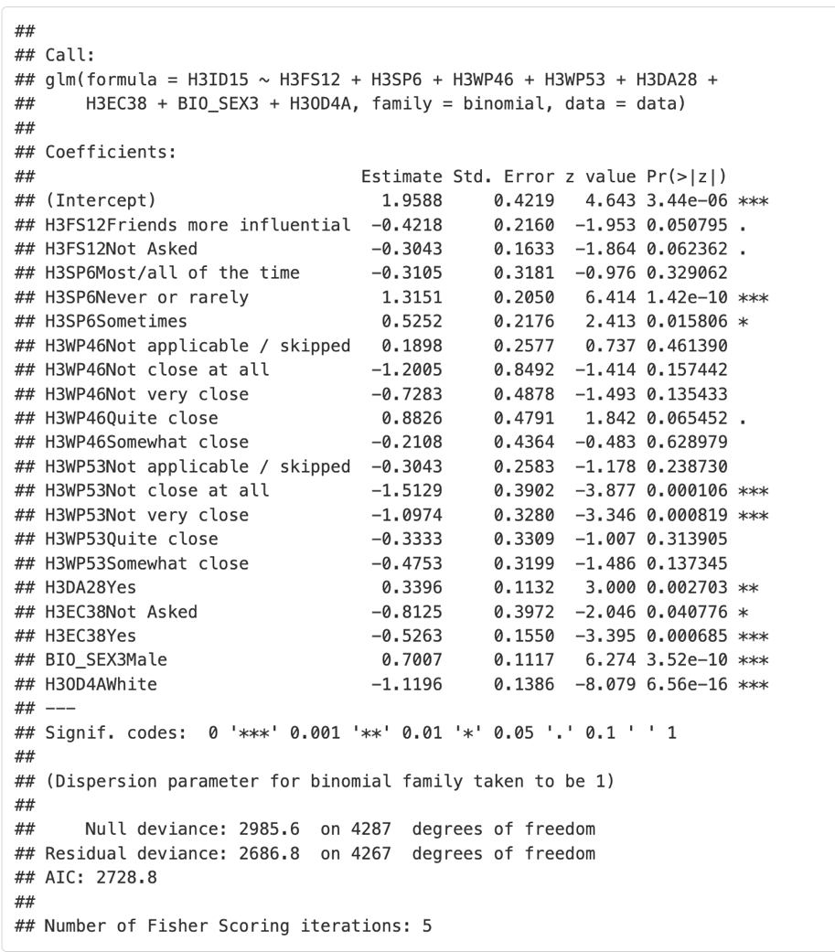

- Regression By Income Output: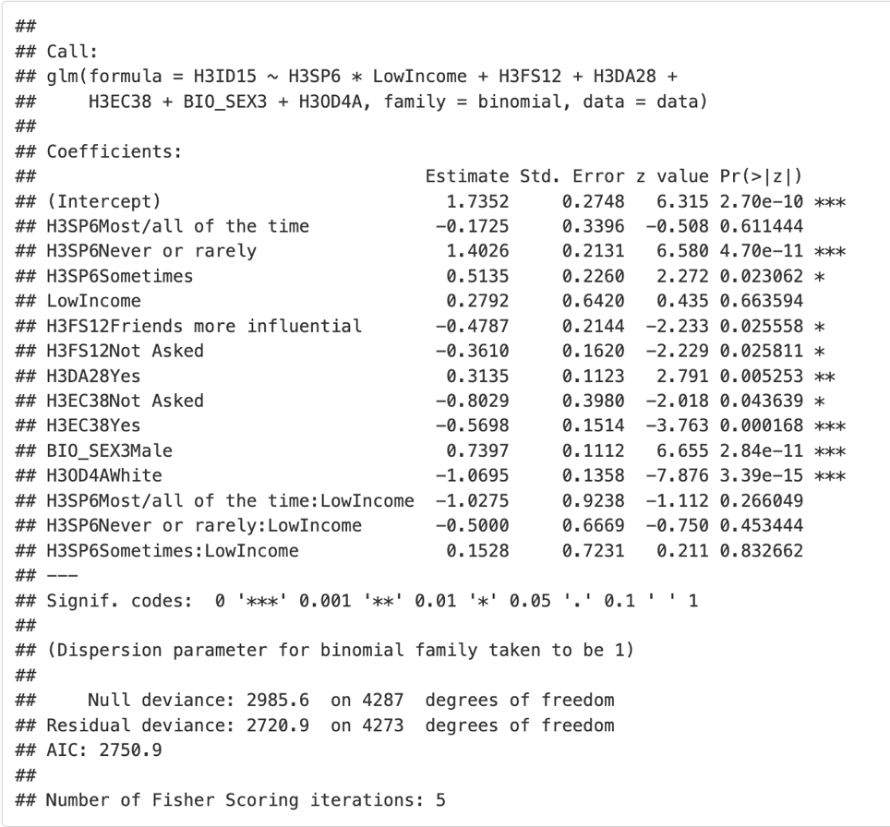
- Regression By Gender (Male) Output:
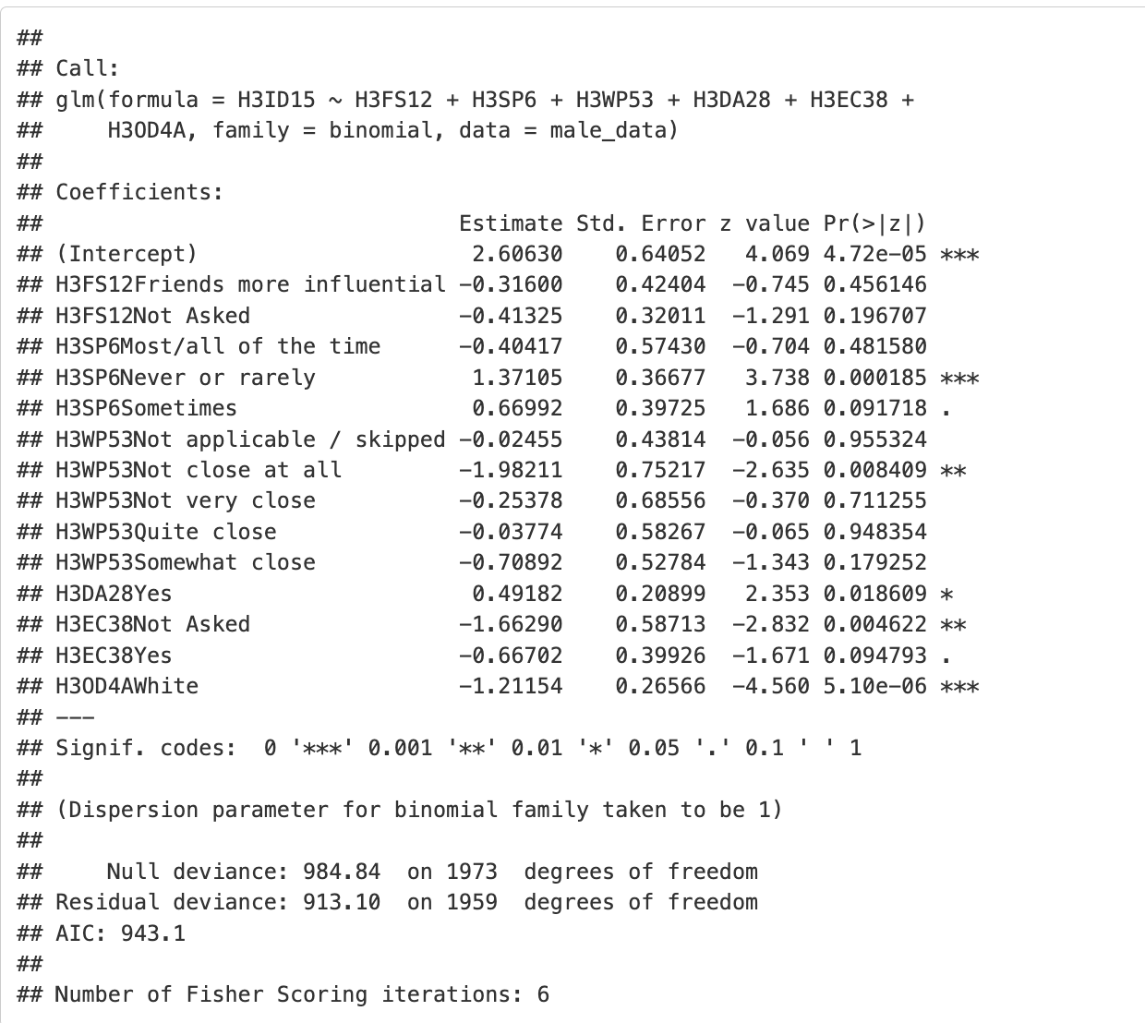

- Regression By Gender (Female) Output:
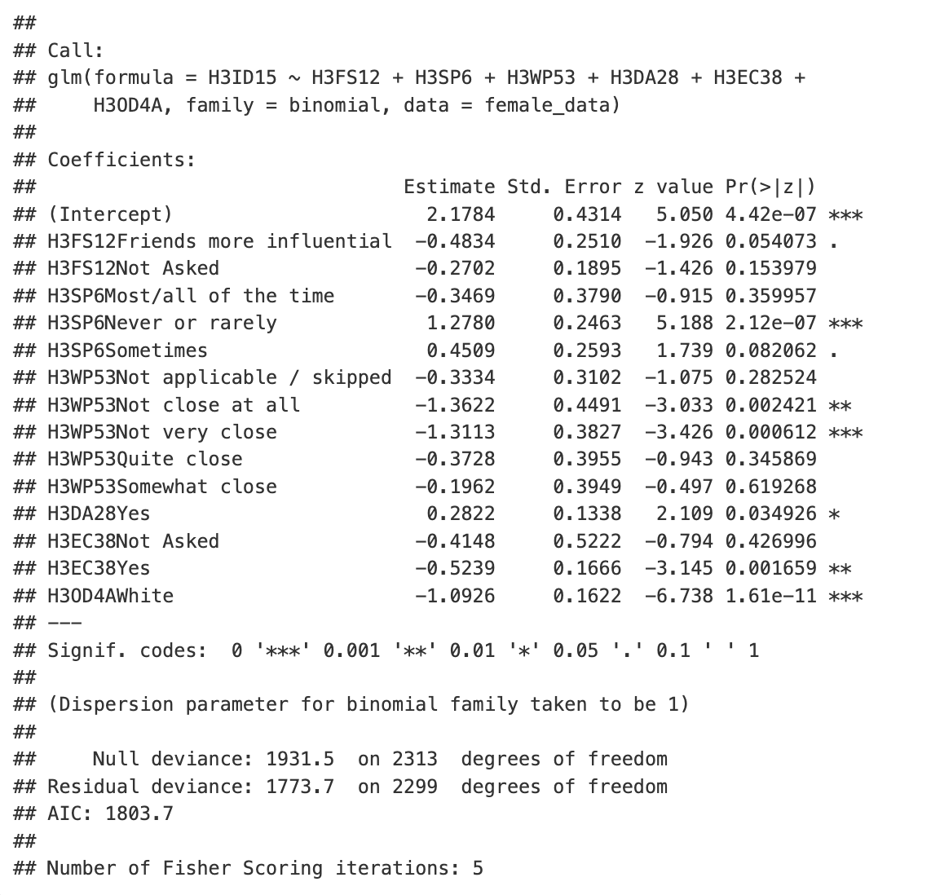

Appendix A5: Final Variable Selection From Add-Health Data
Category | Variable Code | Label | Source
Target Variable | H3ID15 | Have you ever been diagnosed with depression? | DS0008
Friends & Family | H3DA15 | Times hung out with friends or talked > 5 min in past 7 days | DS0008
Friends & Family | H3FS12 | Friends influenced more than family or vice versa (past 5 years) | DS0008
Friends & Family | H3FS11 | Still friends with high school friends? | DS0008
Friends & Family | H3SP6 | Could not shake the blues, even with help (past 7 days) | DS0008
Friends & Family | H3WP46 | Closeness to biological mother | DS0008
Friends & Family | H3WP53 | Closeness to biological father | DS0008
Friends & Family | H3WP57 | Do biological parents live together? | DS0008
Socioeconomic Factors | H3DA28 | Do you currently have a job? | DS0008
Socioeconomic Factors | H3EC7 | Total household income before taxes (self-reported) | DS0008
Socioeconomic Factors | H3EC3 | Total personal income before taxes (self-reported) | DS0008
Socioeconomic Factors | H3DA36 | Currently enrolled in school/training? | DS0008
Socioeconomic Factors | H3EC26 | Receiving AFDC/public assistance/welfare? | DS0008
Socioeconomic Factors | H3EC38 | Ever received other public assistance/welfare? | DS0008
Demographics | BIO_SEX3 | Respondent's Gender | DS0008
Demographics | H3OD4A | Race: White | DS0008

