Markdown to PDF

Your words, ready for paper.
Paste your Markdown, check the preview, and choose Print to PDF. This sample shows what your document can include. Replace it with your own text whenever you are ready.

Text & structure
Write bold, italic, bold italic, strikethrough and inline code. Add useful links, paragraphs and horizontal rules.
A good document keeps the focus on the content.
Everything you see here is editable Markdown.
- Notes, reports and study guides
- Nested ideas stay grouped together
- ☑ Paste or open a Markdown file
- ☑ Preview tables, equations and diagrams
- ☐ Print and choose Save as PDF
- Open Page settings if you want a different paper size.
- Choose A4 or Letter, portrait or landscape, and your margins.
- Try Compact for denser notes. The same styling is used in print.

Tables
Feature | Markdown | Result
Strong emphasis | **bold** | Bold
Inline equations | $a^2+b^2=c^2$ | 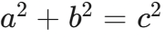
Task lists | - [x] Done | Completed

Code
function makeDocument(markdown) {
const steps = ['Paste', 'Preview', 'Print'];
return { markdown, steps };
}
Code stays selectable in your PDF. Long lines wrap to fit the page.

Equations
Inline math fits naturally into a sentence: 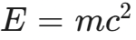. Escaped currency stays literal: $25 and $50.
Display equations have space of their own:


Diagrams
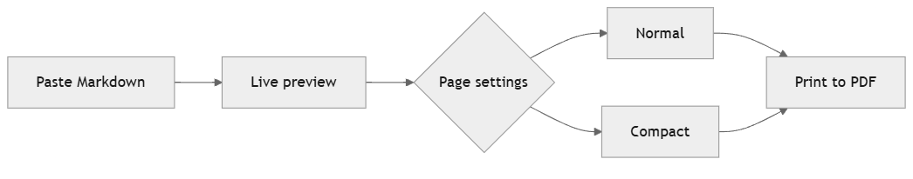
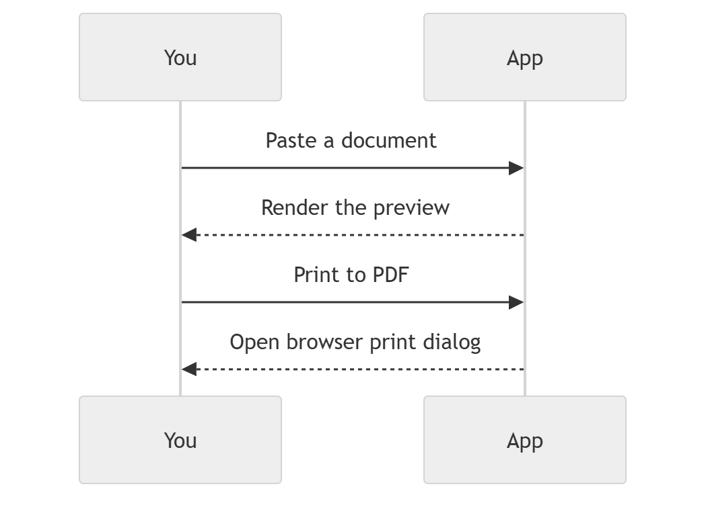

Images
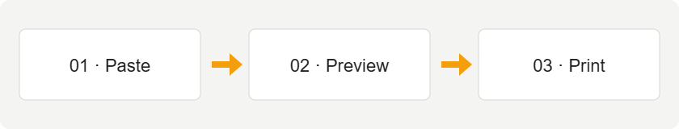
Images scale to the document width. This example is bundled with the app; remote images need an internet connection.

Small conveniences
Your draft is saved in this browser and restored when you return. Clear gives you a blank editor; Undo replacement restores the previous text after clearing, opening a file or loading this sample.

Printing tips
Turn off browser headers and footers for a clean document. The browser print preview shows the final pagination; its settings can override your selections here.

Explicit page breaks
The next section starts on a new printed page using this Markdown-compatible HTML:
<div class="page-break-before"></div>

A fresh page
This section demonstrates an explicit print page break. On screen, the preview remains one continuous document.

Ready to make it yours
Select the sample text, paste your own Markdown, and print.

Links and screenshots
Jump to Equations, Diagrams, or A fresh page. External links, such as the Markdown guide, open separately.
Paste a screenshot directly into the editor to insert it. The image is saved locally in this browser, not uploaded. Local image references only work in the browser where you pasted them.
Fenced code with a language name is now highlighted:
def greet(name):
# A small, readable example
return f"Hello, {name}!"
print(greet("reader"))
The print layout check flags wide content and large diagrams. Diagrams are reduced to fit one printable page; landscape can make large diagrams easier to read. Use the browser print preview to confirm final pagination.

