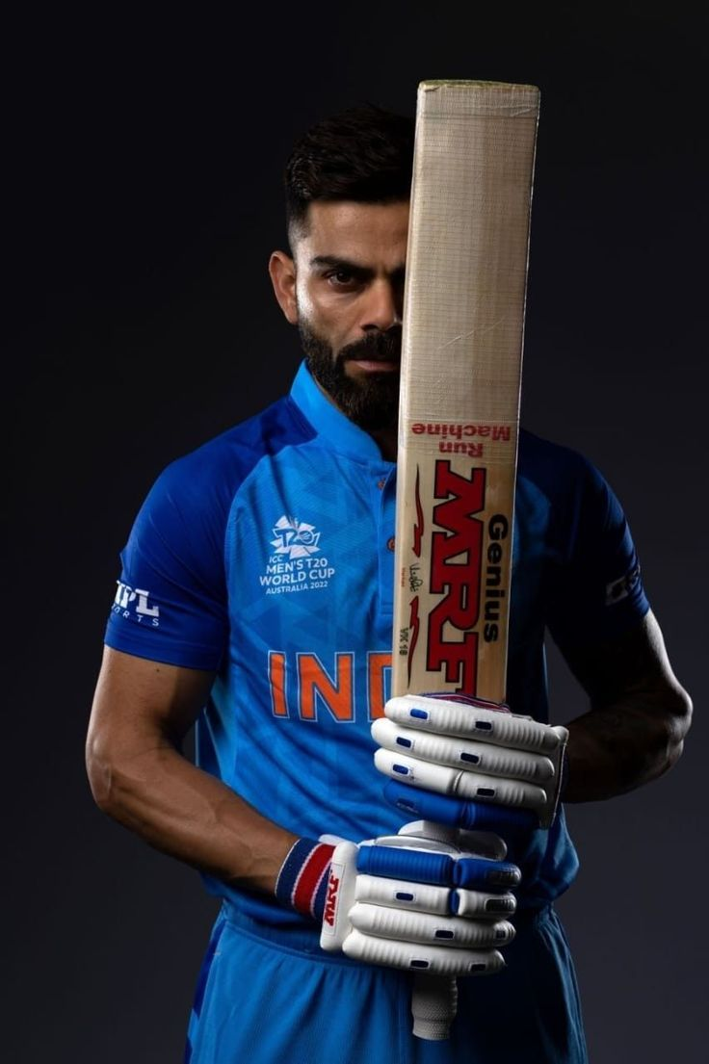

**Player Performance Report (Virat Kohli)**

Virat Kohli Performance Analysis: A Comprehensive Report on Runs, Matches, and Milestones

# Introduction

This report looks at Virat Kohli's cricket performance using insights from a Power BI dashboard. The dashboard has filters and visualizations that help explore his performance in different formats and over time.

**Dashboard Overview:**

1. Filters:

**Year-wise:** Choose a specific year to see how Virat Kohli performed.

**Format-wise:** Filter by match format (ODI, T20, Test) to focus on one type of game.

1. Key Metrics:

**Total Runs, Total Matches, 50s, 100s, 200s (Cards):** These show the main achievements of Kohli, like how many runs he scored and the milestones he reached.

1. Performance Over Time:

**Runs by Year, Quarter, Month, Day (Line Chart):** This chart lets you see Kohli's runs over different time periods, with buttons to switch between year, quarter, month, and day views.

1. Performance by Format:

**Runs by Format (Pie Chart):** This chart shows how many runs Kohli scored in ODIs, Tests, and T20s, as a percentage of his total runs.

1. Performance by Opponent:

**Runs by Opponent Team (Matrix):** This table shows how many runs Kohli scored against different teams in ODIs, Tests, and T20s.

1. Performance by Ground:

**Runs by Ground (Clustered Bar Chart and Matrix):**

**Clustered Bar Chart:** The first bar shows total runs, and the second bar shows total matches at each ground. You can hover over or drill down to see how many runs Kohli scored against different teams at each ground.

**Matrix:** This table gives a clear view of the number of runs Kohli scored at different grounds.

# Key Insights

1. Best Year for Virat Kohli:

**Overall**: 2017 was Kohli's best year with a total of 2,818 runs.

**ODI**: His best year in ODI cricket was 2017, where he scored 1,460 runs.

**T20**: In T20 cricket, his best year was 2016 with 641 runs.

**Test**: Kohli's best year in Test cricket was 2018, where he scored 1,322 runs.

1. Top Format for Runs:

**ODI Cricket**: Kohli has scored the most runs in ODI cricket, with a total of 12,327 runs, making up 51.99% of his overall runs.

1. Favorite Ground:

**Mirpur**: Kohli has scored the most runs at Mirpur, with a total of 1,258 runs. He particularly excelled against Bangladesh at this ground, scoring 513 runs.

1. Top Grounds for 50’s:

**Overall:** Kohli has hit the most fifties at Mirpur, with 8 fifties.

**ODI:** He has the most fifties in ODIs at Birmingham, with 3 fifties.

**T20:** In T20s, he has the most fifties at Mirpur, with 5 fifties.

**Test:** In Test cricket, he has the most fifties at Wankhede, with 3 fifties.

1. Top Grounds for 100’s:

**Overall:** Kohli has scored the most hundreds at Adelaide, with 5 hundreds.

**ODI:** His highest number of hundreds in ODIs is at Mirpur, with 4 hundreds.

**Test:** In Test cricket, Kohli has the most hundreds at Adelaide, with 3

hundreds.

1. Top Grounds for 200’s:

**Overall and Test:** Kohli has scored a double hundred at Delhi, Hyderabad, Indore, Nagpur, North Sound, Pune, and Wankhede, with 1 double hundred each.

1. Top Opponents:

**Overall:** Kohli has scored the most runs against Australia, with a total of 4,483 runs (ODI: 2,083, T20: 718, Test: 1,682).

**ODI:** His top ODI opponent is West Indies, with 2,261 runs.

**T20:** In T20s, his top opponent is Australia, with 718 runs.

**Test:** In Test cricket, Kohli has scored the most runs against England, with 1,991 runs.

1. Max 50’s:

**Overall:** Kohli has hit the most fifties against Australia, England, and West Indies, with a total of 22 fifties.

**ODI:** He has scored the most fifties in ODIs against Sri Lanka and West Indies, with 11 fifties each.

**T20:** In T20s, he has scored the most fifties against Australia, with 7 fifties.

**Test:** In Test cricket, he has the most fifties against England, with 9 fifties.

1. Max 100’s:

**Overall:** Kohli has hit the most hundreds against Australia, with a total of 15 hundreds.

**ODI:** His highest number of hundreds in ODIs is against West Indies, with 9 hundreds.

**Test:** In Test cricket, Kohli has scored the most hundreds against Australia, with 7 hundreds.

1. Max 200’s:

**Overall and Test:** Kohli has scored the most double hundreds against Sri Lanka, with 2 double hundreds.