
Post pro
AI Simulated Caption, Hashtag and Song Generator



A

PROJECT REPORT

ON

POSTPRO

Submitted to

BHAVAN’S SHREE H.J. DOSHI IT INSTITUTE, JAMNAGAR

[Affiliated to Saurashtra University, Rajkot]



For the course of
BACHELOR OF COMPUTER APPLICATION
(5th semester)
SUBMITTED BY:
Pithva Harsh
Jani Heer
Under the guidance of:
Joshi Jignesh Sir

Index Page

No. | Title | Page No.
1. | Title page (Project Profile) | 4
2. | Certificate | 3
3. | Acknowledgment | 6
4. | Introduction & Objective | 7
5. | System Analysis | 12
6. | System Design  (Data–Flow Diagram, E-R Diagram) | 15
7. | Data Dictionary | 22
8. | Implementation  (Screenshots, Code Explanation) | 29
9. | Testing (Test cases and results) | 27
10. | Conclusion & Future Scope | 53

Project profile

Project Title: PostPro - AI Simulated Caption, Hashtag and Song generator.

Project Type: Web-Based Application

Front End: HTML,CSS,JavaScript

Back End: PHP,MySQL

Server Used: WAMPP/Apache Server

Development tool: Visual Studio Code

Guidance By: Joshi Jignesh Sir

Submitted By: Pithva Harsh, Jani Heer

Submitted To: Bhavan’s Shree H.J. Doshi ,
Information Technology
Institute , Jamnagar
Acknowledgement

We would like to express our sincere gratitude to Joshi Jignesh Sir, our project guide, for his invaluable guidance, constant encouragement, and expert advice throughout the development of our project PostPro - AI Simulated Caption, Hashtag and Song generator. His continuous support and insightful suggestions have been Instrumental in the successful completion of this project.

We also wish to thank our faculty members of
"Bhavan's Shree H.J. Doshi info Technology Institute" and the department for providing us With the necessary facilities, resources, and opportunities to carry out This work successfully.

Our heartfelt thanks to our friends and classmates for their cooperation, constructive feedback, and motivation during various stages of development and testing.

Finally, we would like to extend our gratitude to everyone who directly or indirectly supported us in completing this project.
Introduction & objective

In the era of social media, captions, hashtags, and background music Play a vital role in enhancing user engagement and expression. However, many users struggle to come up with creative and relevant Captions or hashtags that match their photos and moods.

To Over come this challenge, PostPro has been developed as a PHP-based AI Simulated Caption, Hashtag and Song generator. that assists users in generating appropriate content based on their selected mood.

The system allows users to select a mood and instantly receive Suitable captions, hashtags, and song recommendations that reflect That mood.

Users can also upload a photo, and the system will provide Suggestions accordingly, making the process more personalized and interactive. Additional features such as copy, favorite, and feedback Functionalities make PostPro not only efficient but also user-friendly and engaging.

PostPro aims to simplify the creative process for social media users, influencers, and content creators by providing them with smart suggestions that save time and enhance their online presence.The system demonstrates practical implementation of PHP, MySQL, HTML, CSS, and JavaScript, show casing integration of front-end and back-end technologies in a real-world application.

Objectives
The main objectives of the PostPro project areas follows:

- To develop a web-based system that suggests appropriate captions, hashtags, and songs based on the user’s selected mood.

- To enable users to upload photos and receive mood- based suggestions dynamically.

- To provide options for users to copy or mark their favorite captions, hashtags, or songs for future use.

- To collect user feedback through a feedback page for continuous System improvement.

- To create a simple, responsive, and user-friendly interface using PHP and MySQL for seamless performance.
6. To enhance creativity and social media engagement by automating the process of generating mood- relevant suggestions.
Scope

The scope of the PostPro - AI Simulated Caption, Hashtag and Song generator. defines the range, potential, and limitations of the system. The system is designed to assist users in generating creative content for social media by providing mood-based captions, hashtags, and song suggestions.

- Mood-Based Suggestions: The system allows users to select their mood and automatically generates relevant captions, hashtags, and songs.

- Photo Integration: Users can upload photos, and the system will provide suggestions tailored to the uploaded
Image.

- User Interaction: Users can copy and favorite captions, hashtags, and songs for future use.

- Feedback System: The system includes a feedback page to collect user opinions and suggestions for future improvements.

- Database-Driven Management: All moods, captions, hashtags, and songs are stored in a MySQL database, allowing easy updates and management.

- Ease of Use: Designed to be simple and user-friendly, the system requires no technical expertise, making it accessible to a wide range of social media users.

- Web-Based Platform: Being a web-based application, PostPro can be accessed from any device with an internet connection.

System Analysis

1. Problem Definition
In today's digital age, social media users constantly seek creative and relevant content to enhance their posts and engage their audience. However, many users struggle to come up with fitting captions, hashtags, and background songs that match the mood or theme of their photos. This often leads to repetitive, uninspired posts and increased time spent searching for appropriate content.

PostPro aims to solve this problem by providing an AI-driven static suggestion system where users can select a mood and receive curated captions, hashtags, and songs that match their selected mood. Additionally, users can upload photos, which, combined with the chosen mood, allow the system to generate tailored content suggestions automatically. Features like shuffling suggestions, copying, and adding favorites streamline the user experience, making social media content creation faster, easier, and more personalized.

2. Feasibility Study

To ensure that PostPro is viable and practical, a feasibility study has been conducted, focusing on the following aspects:

- Technical Feasibility

- Technology Stack: PostrPro is developed using PHP, a robust and widely-used server-side scripting language, suitable for web applications.

- AI Suggestion System: Although the AI is static (predefined suggestions based on mood), it leverages a structured database of captions, hashtags, and songs mapped to moods.

- User Interaction: The system supports mood selection, photo uploads, suggestion shuffling, copying, and favorites, all manageable within PHP and supported frontend technologies.

- Scalability: The system design supports easy addition of new moods, captions, hashtags, and songs without major changes to the core architecture.

- Operational Feasibility

- User Experience: The application simplifies content creation for social media users, improving satisfaction and engagement.

- User Base: Target users include social media enthusiasts, influencers and casual users seeking creative post enhancements.

- Maintenance: With straightforward content management (adding/modifying suggestions), the system is easy to maintain by the developers or content managers.
- Economic Feasibility

- Development Cost: Using PHP and existing AI/static content minimizes development expenses.

- Hosting: The application can be hosted on affordable web servers with PHP support.

- Potential Revenue: Monetization opportunities include premium features (advanced suggestions, personalized AI), advertising, or subscription models.

- ROI: By addressing a common pain point in social media content creation, PostrPro has strong potential for user adoption and return on investment.

- Schedule Feasibility

- The project scope is well-defined with clear functionalities.

- Development, testing, and deployment timelines are achievable within a standard software development cycle (e.g., 2-3 months).

- Incremental improvements can be added post-launch based on user feedback.

System Design

- Context-level Diagram

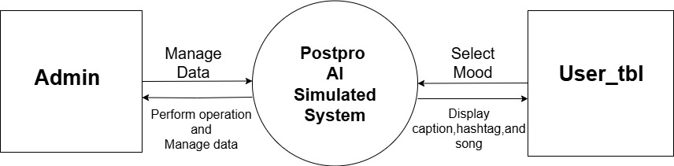

- Zero-level Diagram

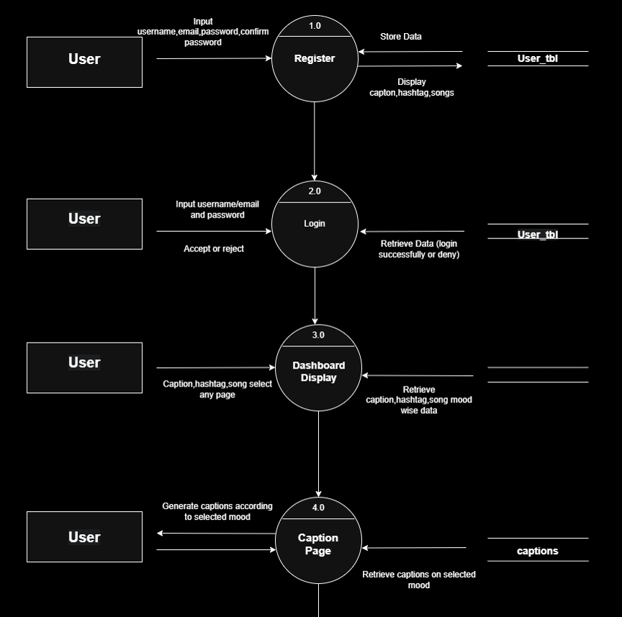

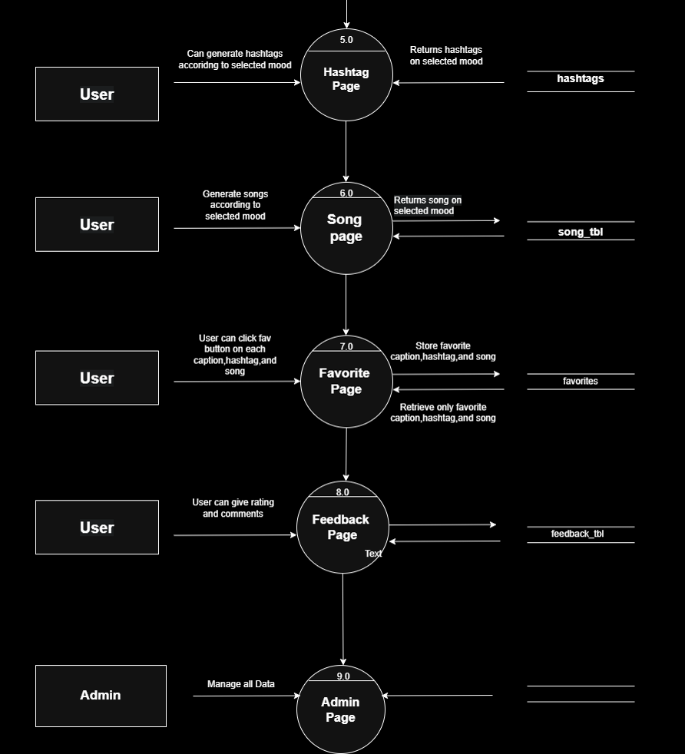

- First-level Diagram

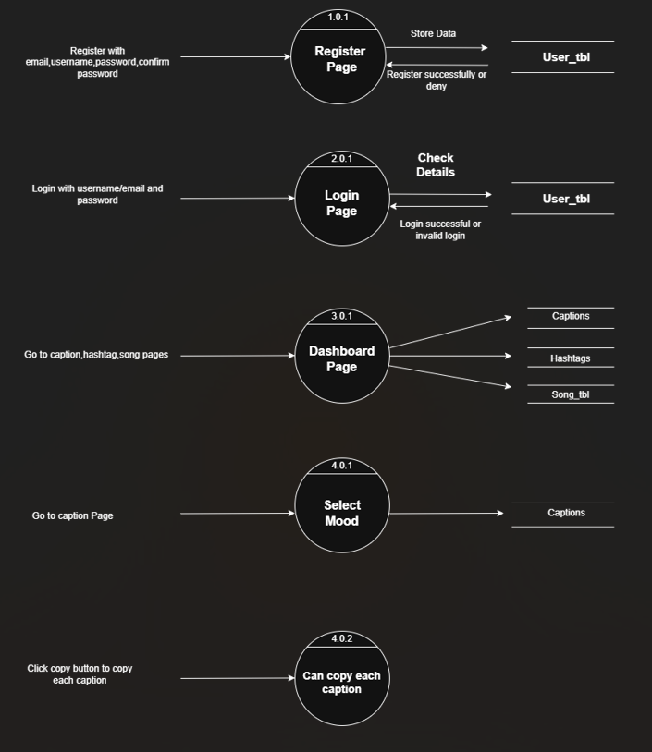

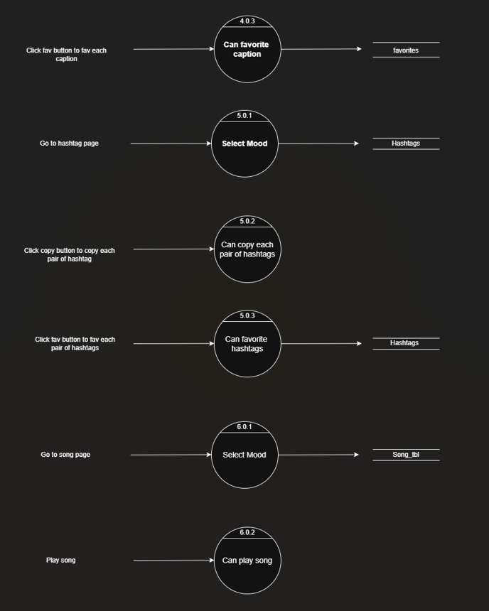

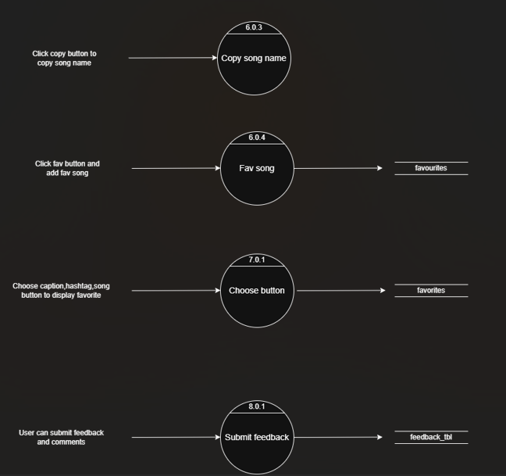

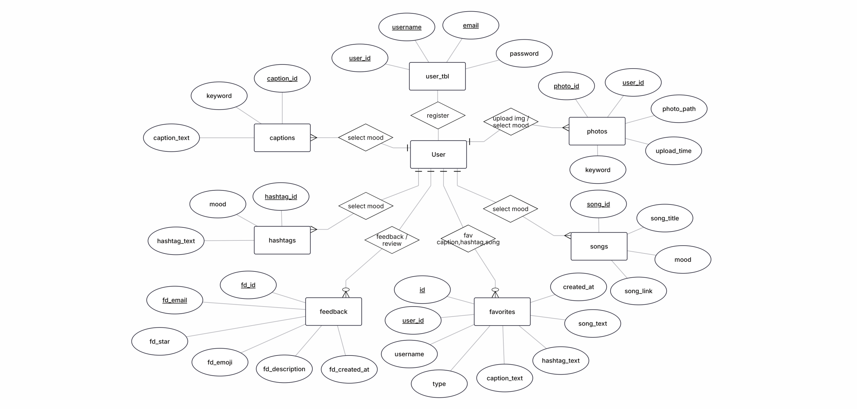
- E-R Diagram
Data Dictionary

DataBase Name : Social

TABLES

No. | Table Names
1. | user_tbl
2. | captions
3. | hashtags
4. | song_tbl
5. | photos
6. | feedback_tbl
7. | favorites

- user_tbl
Field Name | Type | Size | Constraints
user_id | int | 11 | PK
email | varchar | 255 | -
username | varchar | 255 | -
password | varchar | 255 | -

- captions
Field Name | Type | Size | Constraints
caption_id | int | 11 | PK
keyword | varchar | 50 | -
caption_text | varchar | 255 | -

- hashtags
Field Name | Type | Size | Constraints
hashtag_id | int | 11 | PK
mood | varchar | 100 | -
hashtag_text | varchar | 255 | -

- song_tbl
Field Name | Type | Size | Constraints
song_id | int | 11 | PK
song_title | varchar | 250 | -
mood | varchar | 50 | -
song_link | varchar | 250 | -

- photos
Field Name | Type | Size | Constraints
photo_id | int | 10 | PK
user_id | int | 10 | FK
photo_path | varchar | 255 | -
upload_time | datetime | - | -
keyword | varchar | 50 | -

6. feedback_tbl
Field Name | Type | Size | Constraints
fd_id | int | 11 | PK
fd_email | varchar | 250 | -
fd_star | varchar | 50 | -
fd_emoji | varchar | 50 | -
fd_description | varchar | 250 | -
fd_created_at | date | - | -

7. favorites
Field Name | Type | Size | Constraints
id | int | 11 | PK
user_id | int | 11 | FK
username | varchar | 255 | FK
type | enum (‘caption’, ‘hashtag’, ’song’) | - | -
caption_text | varchar | - | -
hashtag_text | varchar | - | -
song_text | varchar | - | -
created_at | timestamp | - | -

Testing (Test cases and results)
Testing is crucial to ensure that the PostrPro system functions correctly and meets user expectations. Below are key test cases designed to verify the core features of the system along with their expected outcomes and actual results.

Test Case ID | Test Scenario | Test Steps | Expected Result | Actual Result | Status
TC01 | Mood Selection Suggestion | 1. Open the website  2. Select a mood from the list | System displays captions, hashtags, and songs relevant to the selected mood | Suggestions matched to the selected mood are displayed correctly | Passed
TC02 | Photo Upload and Suggestion | 1. Select a mood  2. Upload a photo  3. Submit | System generates captions, hashtags, and songs relevant to both the mood and photo (mood-driven) | Suggestions based on mood are shown, photo upload accepted without error | Passed
TC03 | Generate another | 1. Select a mood  2. View suggestions  3. Click shuffle button | Suggestions (captions, hashtags, songs) change to a different set of mood-related content | Generate another and new content appears on each shuffle | Passed

TC04 | Copy Suggestion to Clipboard | 1. Select a suggestion (caption, hashtag, or song)  2. Click copy button | The selected text or song information is copied to the clipboard | Text copies correctly and can be pasted elsewhere | Passed
TC05 | Add Suggestion to Favorites | 1. Select a suggestion  2. Click "Add to Favorites" | The suggestion is saved to the user's favorites list | Suggestion successfully added to favorites and appears in the favorites section | Passed
TC06 | Invalid File Upload | 1. Upload a file that is not an image (e.g., .txt or .exe) | System rejects the upload and displays an error message | Upload is blocked and error message shown | Passed
TC07 | Empty Mood Selection | 1. Do not select a mood  2. Try to get suggestions | System prompts user to select a mood before proceeding | User is prompted to select a mood | Passed
TC08 | User Interface Responsiveness | 1. Access the application on desktop and mobile browsers | UI adjusts appropriately to different screen sizes and remains functional | Application is responsive and UI elements are accessible on various devices | Passed

Implementation
(Screenshots & Code Explanation)

Admin Side

- Admin Login

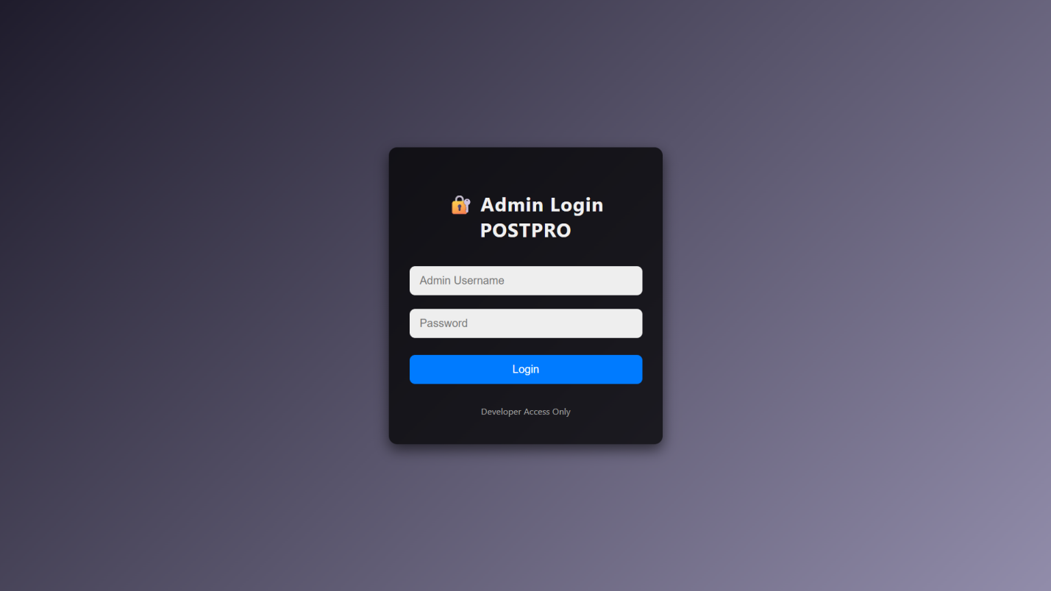

- The admin panel is secured by a login system that requires valid credentials (username and password). When an admin enters the correct login details.

- The dashboard provides access to various administrative functions and system controls.

- Admin Dashboard



- The Admin Dashboard provides a centralized interface for managing the Website’s content.

- Administrators can add new captions, hashtags, and songs directly from this panel.

- It also includes a quick logout option for secure access control.

- Add Caption

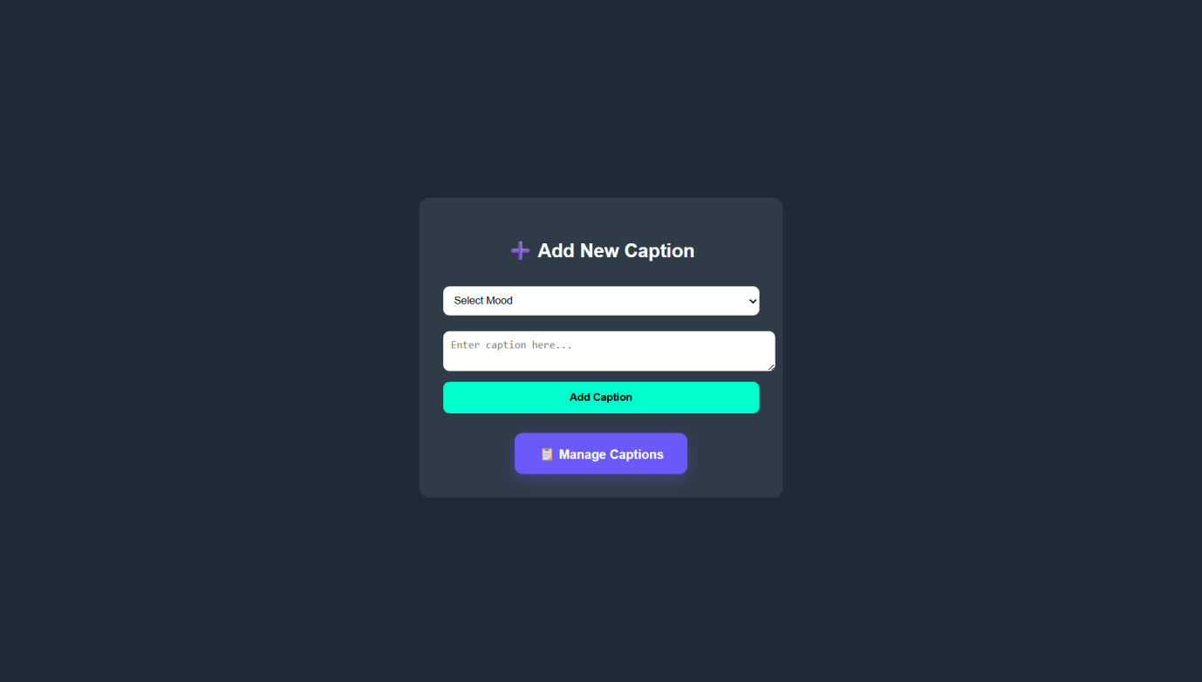

- The Add New Caption page allows admins to create new captions by selecting a mood category and entering the caption text.

- After submission, the caption is saved to the database for use within the website.

- A quick link to manage existing captions is also provided.
- Manage Caption

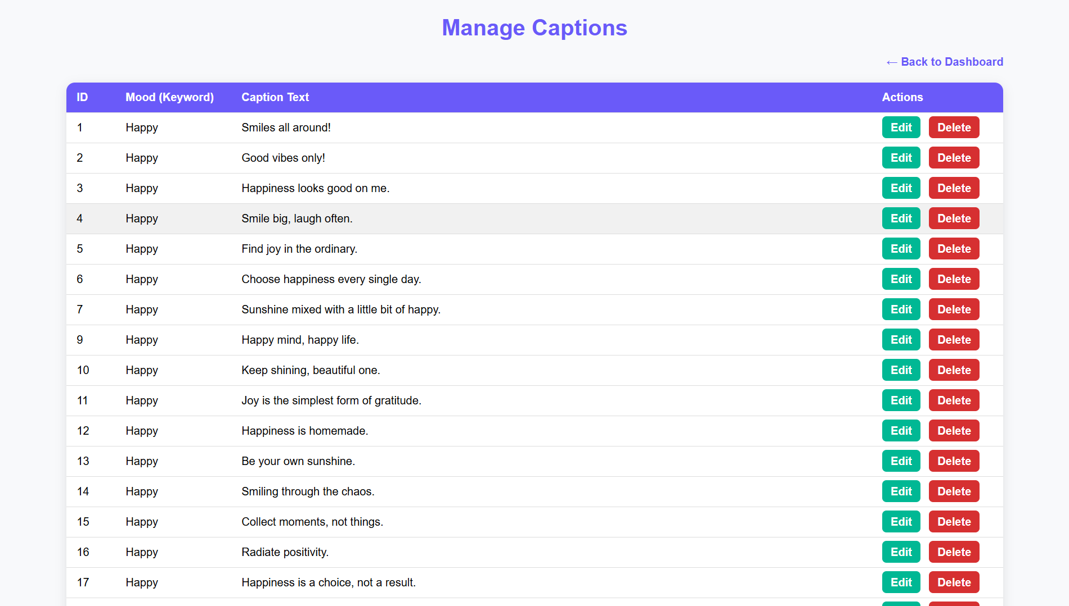

- This page lets you manage all your captions in one place.

- You can see each caption, edit it, or delete it whenever you need.

- It helps you keep your caption list organized and up to date.

- Add Hashtag

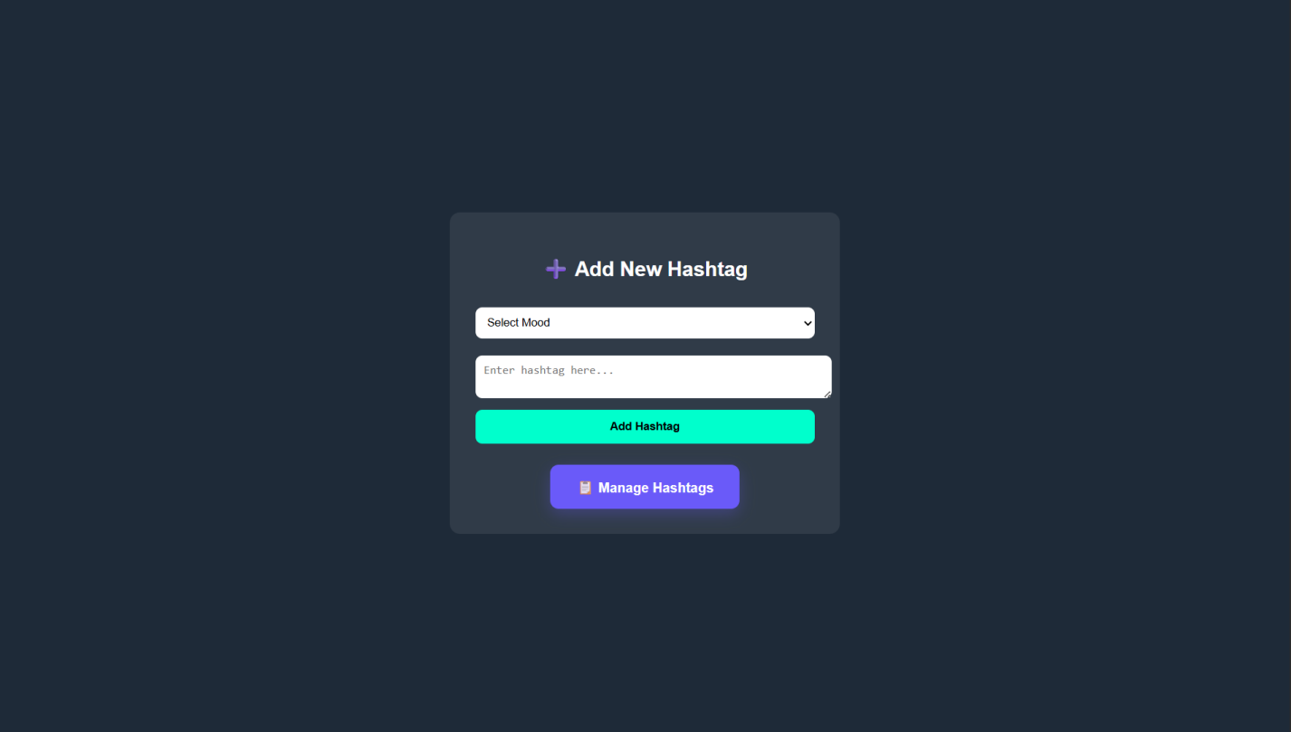

- This page lets you add new hashtags based on a selected mood. Just choose a mood, type your hashtag, and save it.

- It helps you quickly create and organize hashtags for your content.
- Manage Hashtag

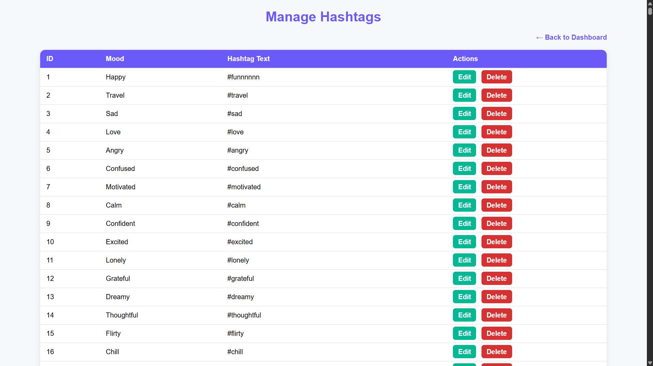

- This page helps you manage all your saved hashtags in one place.

- You can view each hashtag by mood and easily edit or delete them whenever needed. It keeps your hashtag list organized and easy to update.

- Add Song

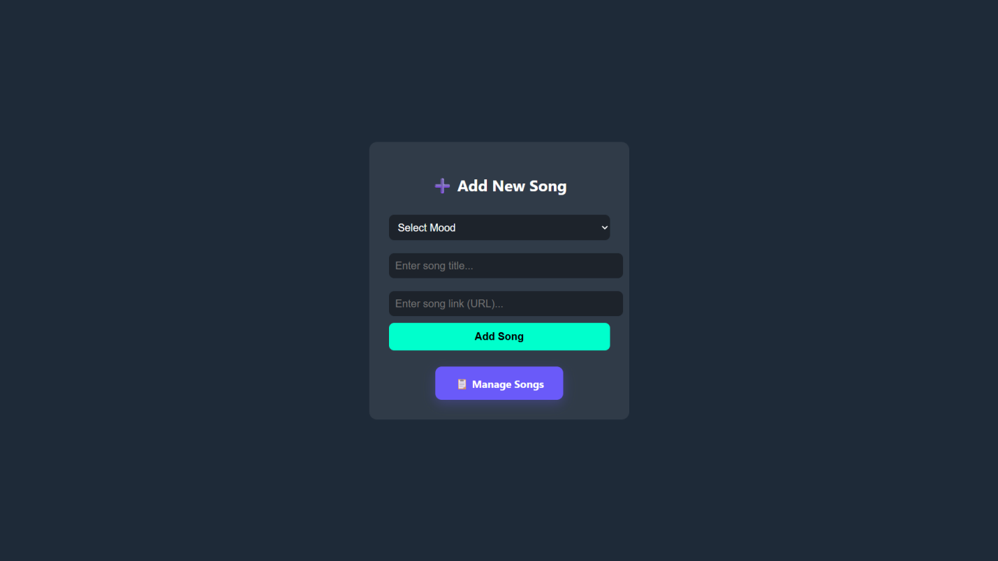

- This page lets you add new songs based on the mood you choose.

- You can enter the song title and a link, then save it with one click.

- It helps you quickly build and organize your mood-based song collection.

- Manage Song

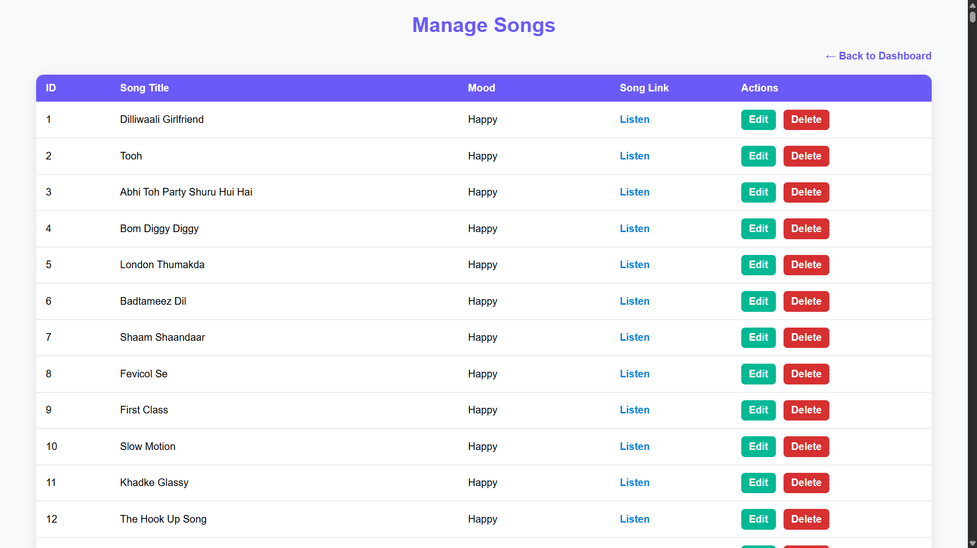

- This page allows you to view all the songs you’ve added for different moods.

- You can easily edit or delete any song to keep your list updated.

- It helps you organize your mood-based music collection in one place.

User Interface

- Register Page

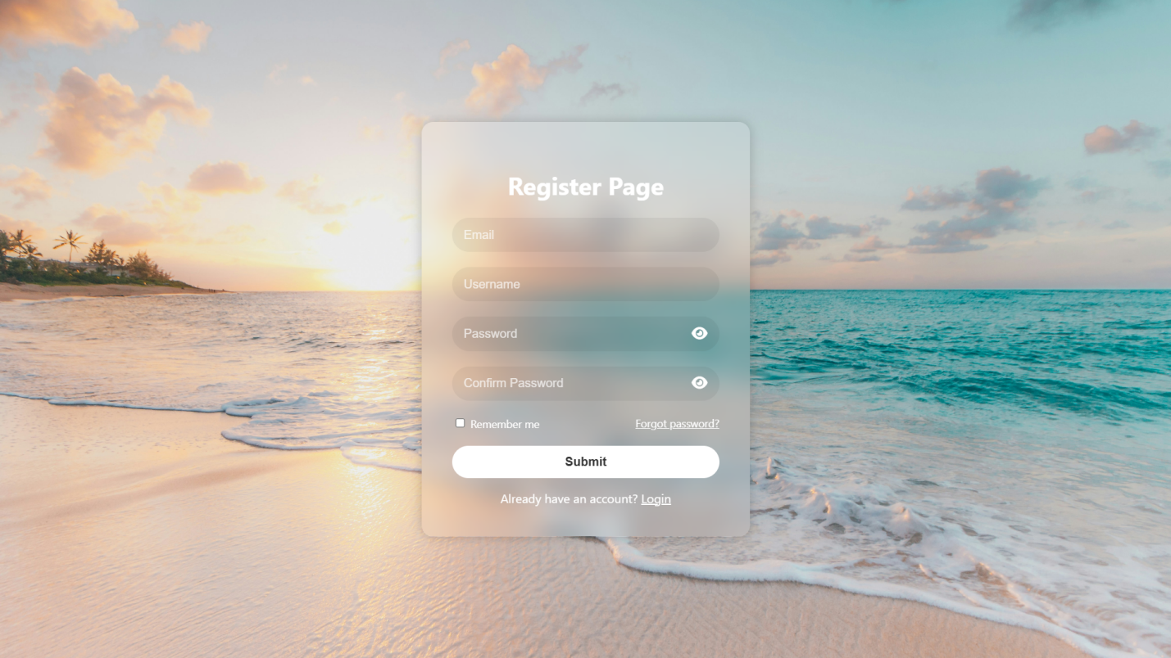

- This registration page lets users create an account by entering their details.

- The password must be exactly 6 characters, and duplicate usernames or emails are not allowed.

- Once the form is valid, the user can successfully sign up.

- Login Page

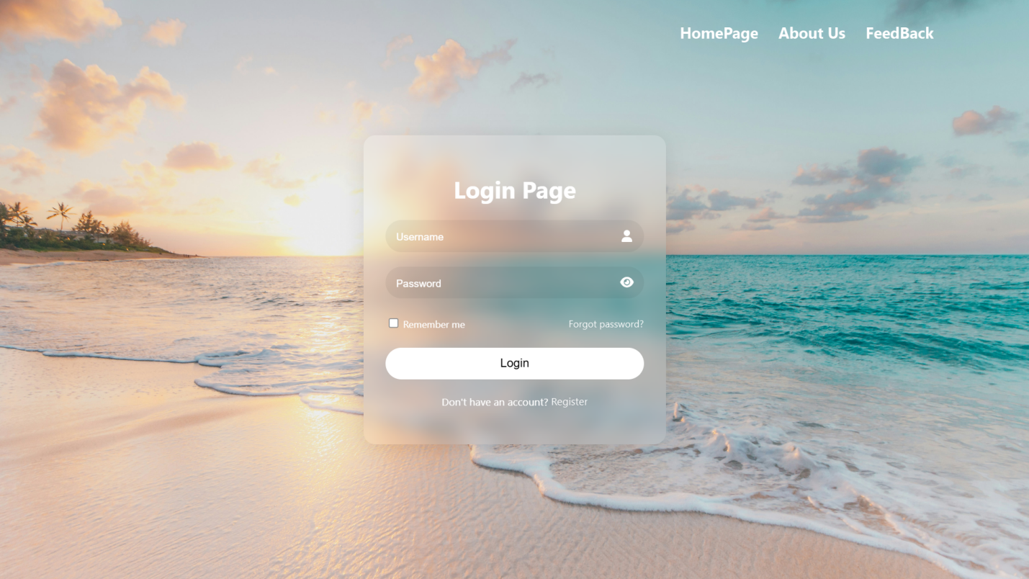

- This login page allows users to access their account by entering a valid username and password.

- Only correct and registered credentials are accepted.

- Invalid login details will not be allowed.

- Forgot Page

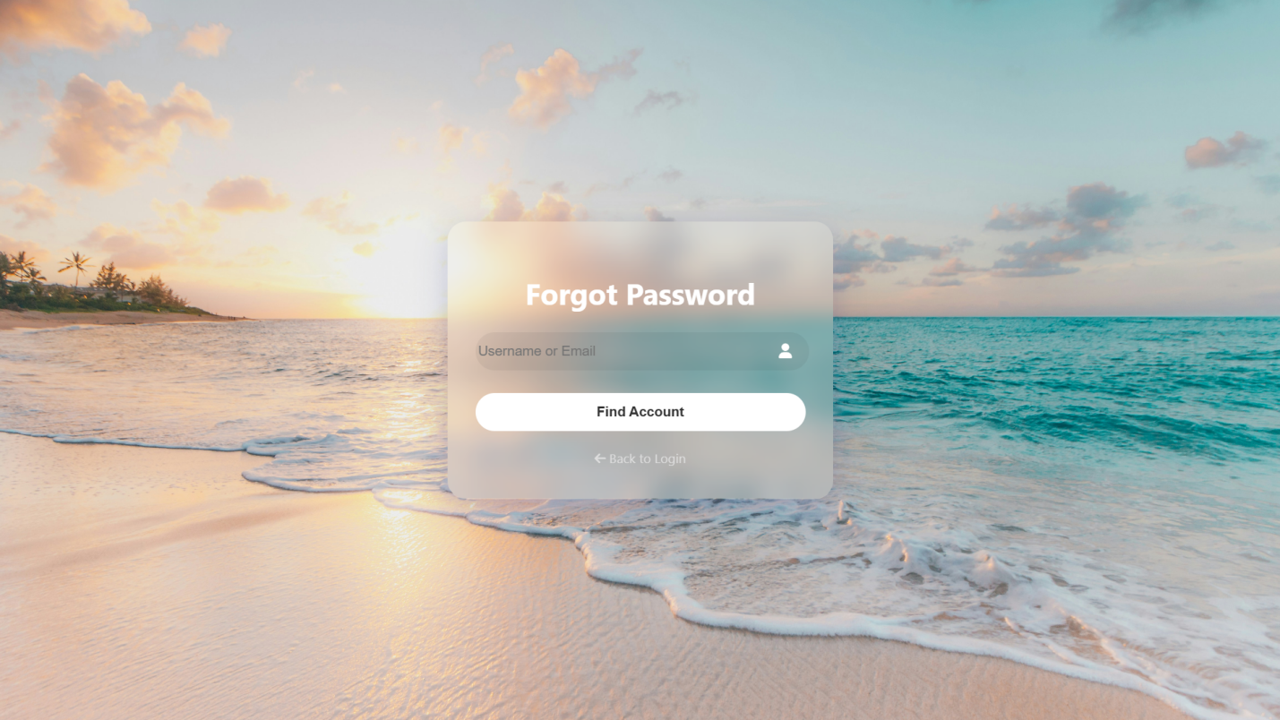

- This page helps users find their account when they forget their password.

- They can enter their username or email and click the “Find Account” button.

- The system will then guide them to reset their password.
- Reset Password Page

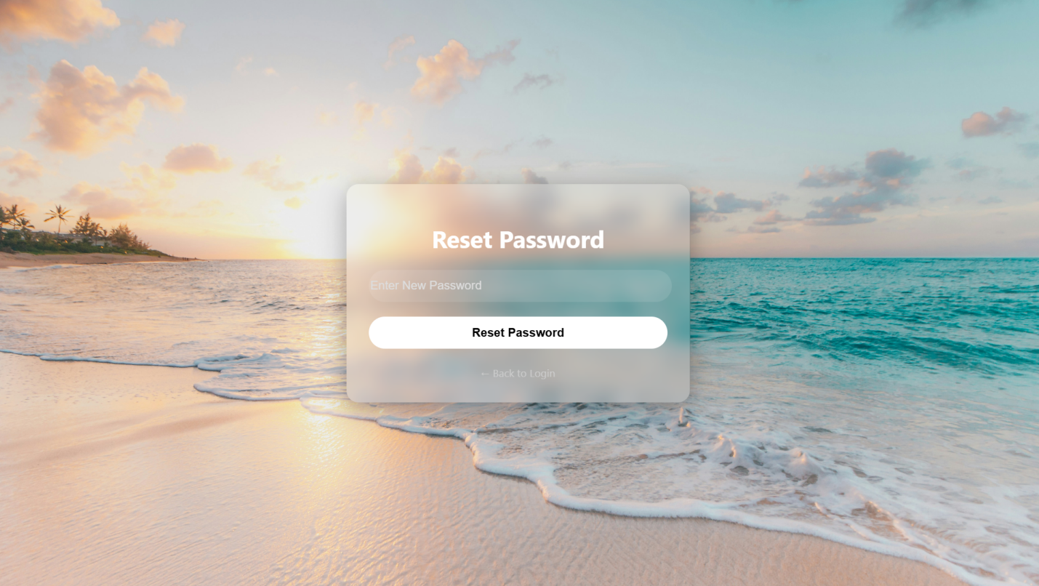

- This page allows users to create a new password for their account.

- They must enter the new password and confirm it to ensure accuracy.

- Once submitted, their password will be successfully updated

- Home Page

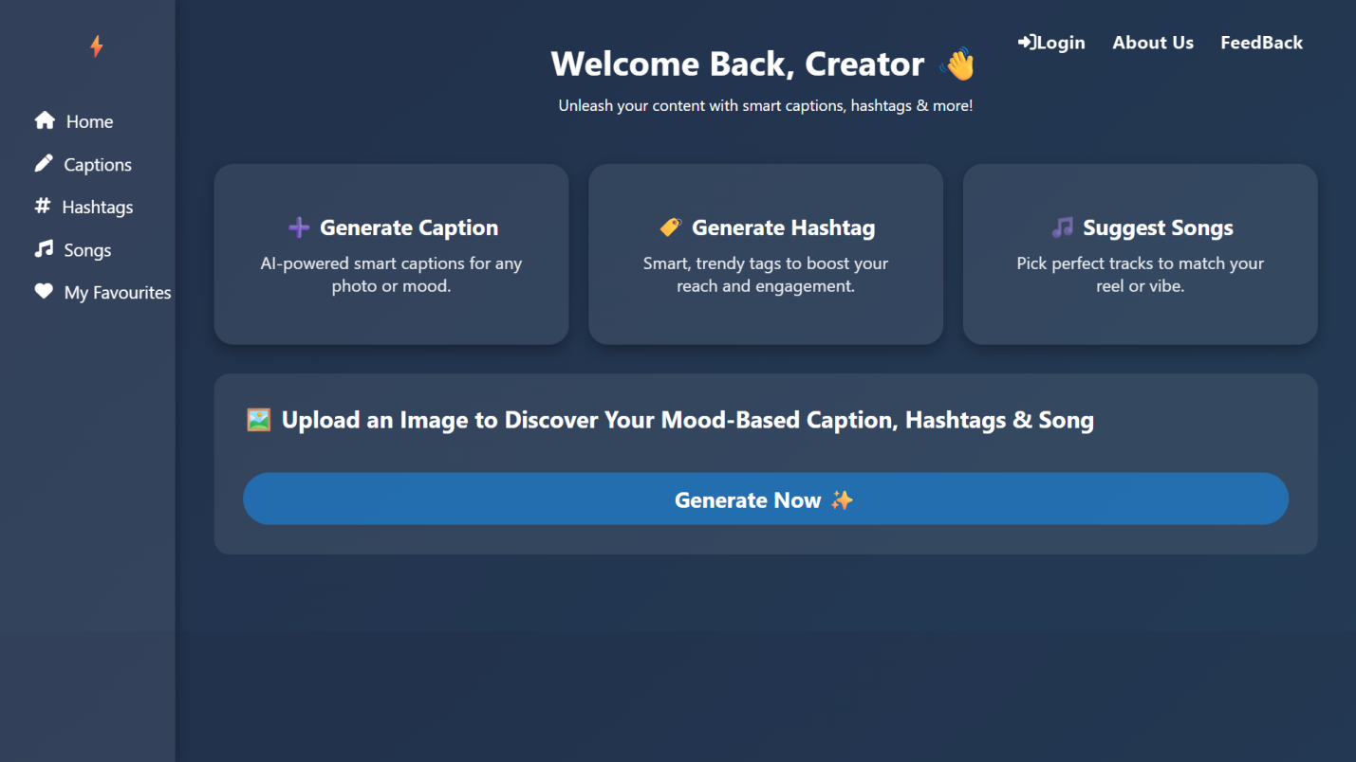

- This page allows you to quickly get captions, hashtags, and song suggestions for your posts.

- You can upload a photo, and the website will understand it and give you the best ideas.

- The side menu helps you move between captions, hashtags, songs, and your saved items.

- It makes creating social media content simple and fast.

- Caption Page

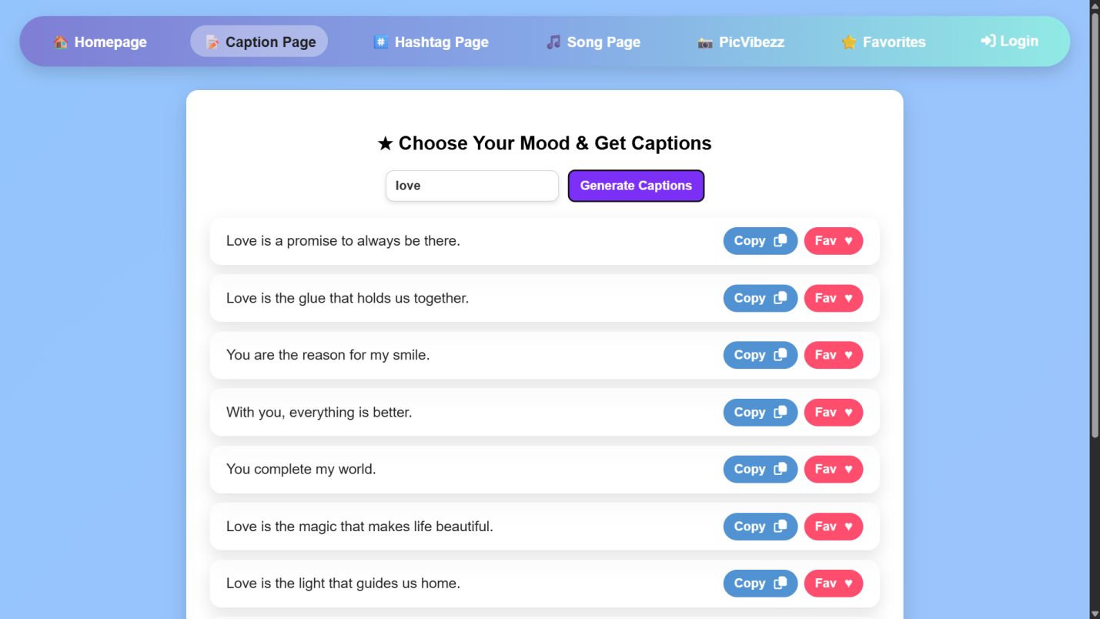

- This page allows you to get captions based on your mood or keyword.

- You just type a word like “love” and click Generate Captions, and the website shows a list of ready-to-use captions.

- Each caption can be copied instantly or saved to your favorites.

- This makes it easy to find perfect lines for your posts in seconds.

- Hashtag Page

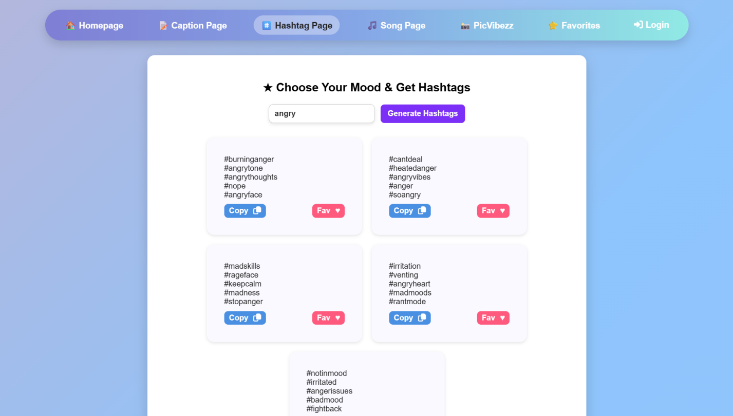

- This page allows you to generate hashtags based on any mood or keyword you enter.

- Just type a word and click Generate Hashtags, and the website will show a list of useful and trendy tags for your posts.

- You can copy any hashtag instantly or save it to your favorites. It helps you quickly find the best tags to increase your reach and engagement.
- Song Page

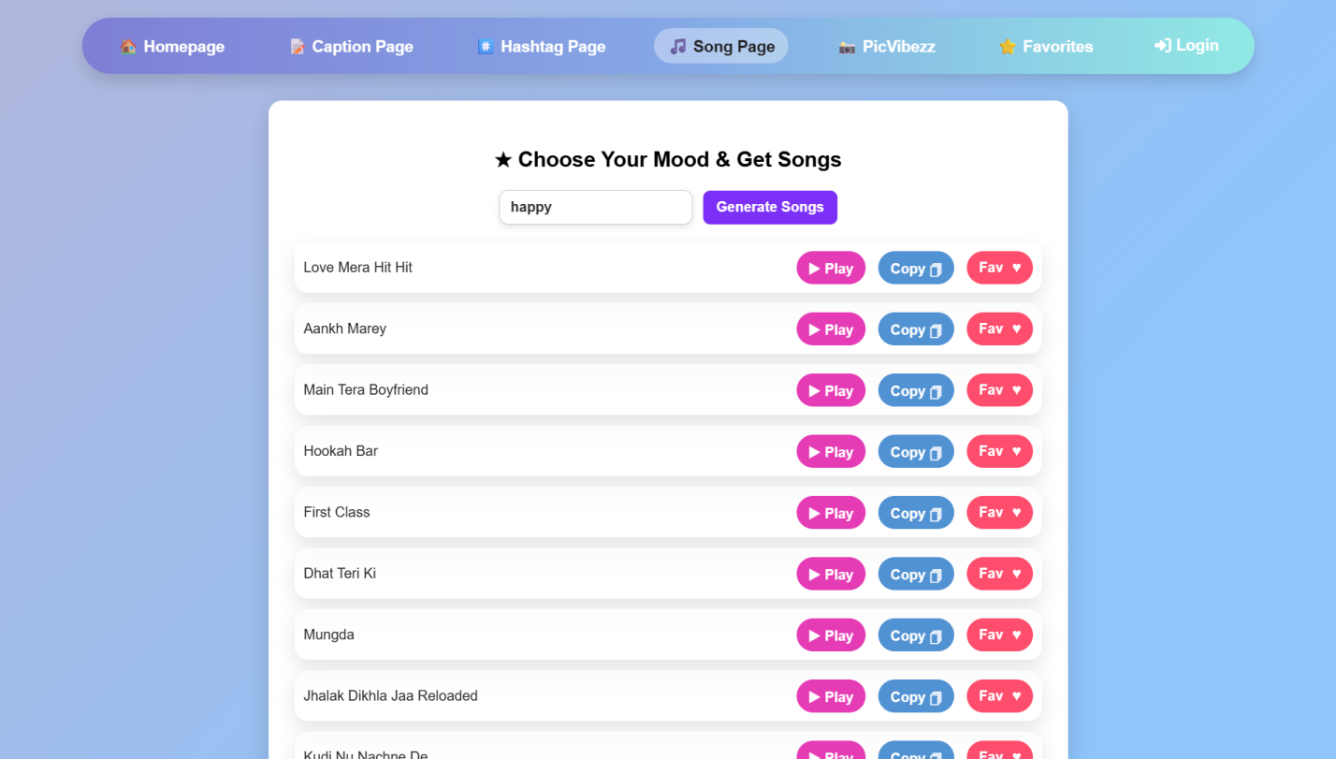

- This page allows you to get song suggestions based on your mood or the keyword you enter.

- Just type a word and click Generate Songs, and the website will show a list of songs that match your vibe.

- You can copy the song name or save it to your favorites for later.

- It makes finding the perfect music for your reels, videos, or posts quick and easy.

- Photo Upload Page

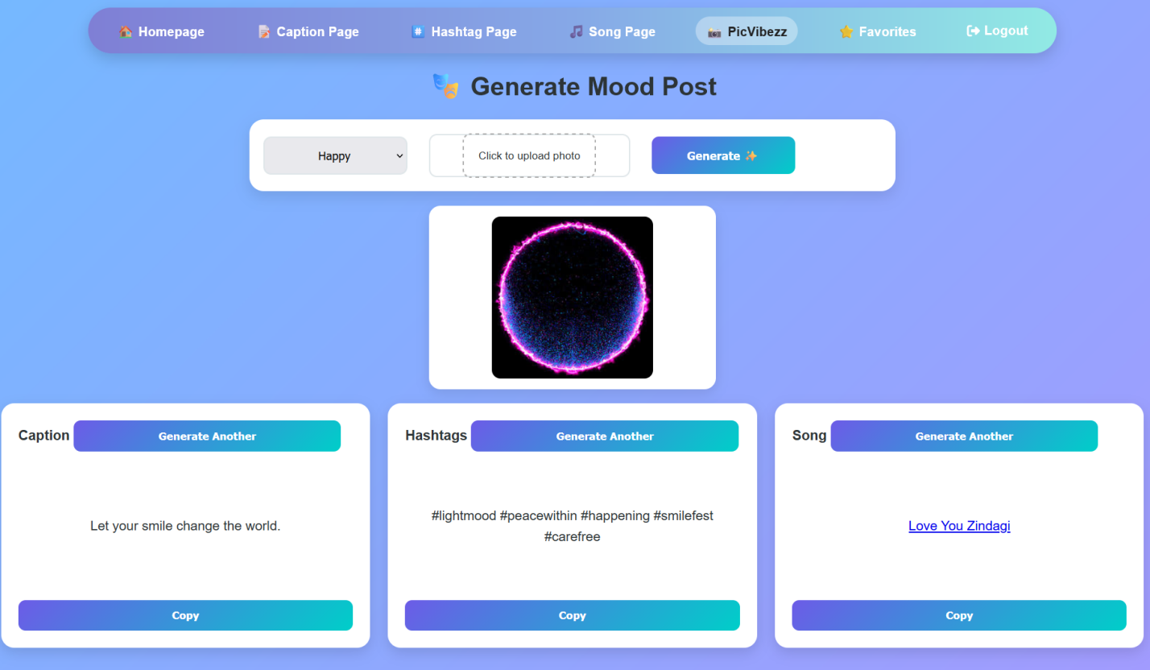

- This page allows you to create a full mood-based post by choosing your mood and uploading a photo.

- After you click Generate, the website instantly gives you a matching caption, hashtags, and a song suggestion based on your image and mood.

- You can generate new options if you want different results and easily copy them. This page makes it super quick to create a complete, ready-to-post social media update.
- Favorite Page (Caption)

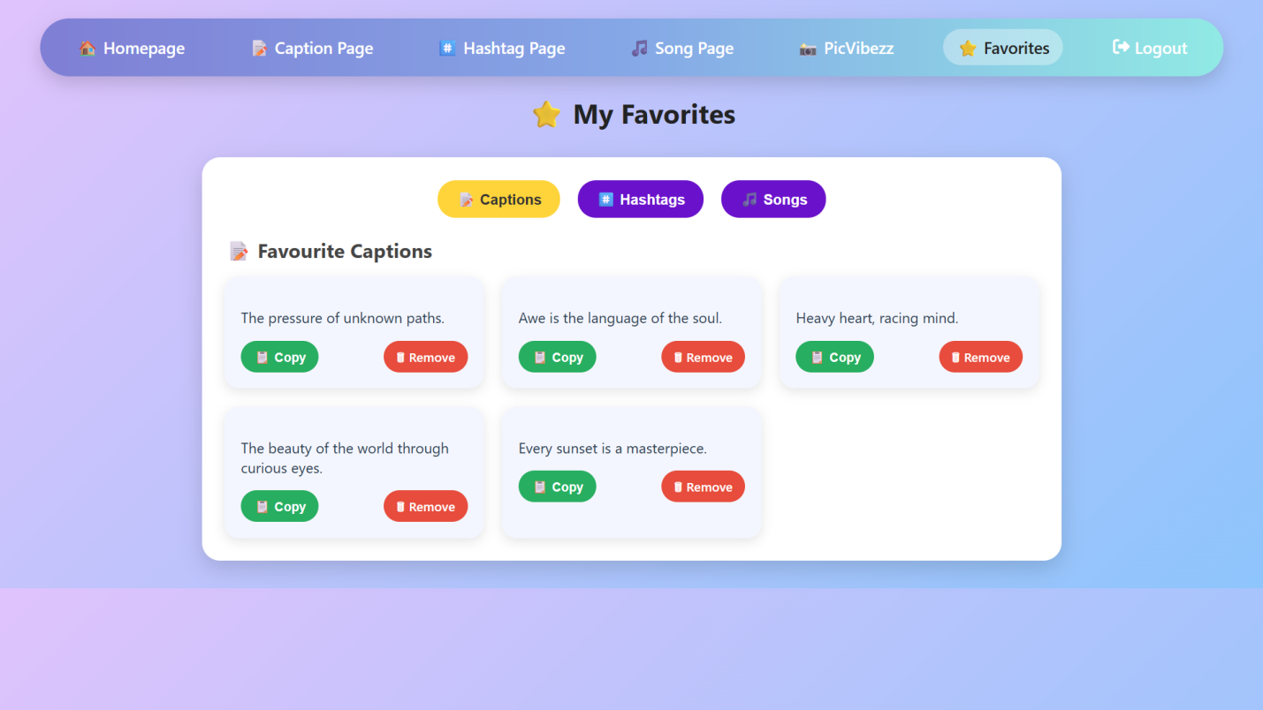

- This section displays all the captions the user has marked as favorites.

- They can copy any caption instantly for their posts or remove ones they no longer want.

- Favorite Page (Hashtag)

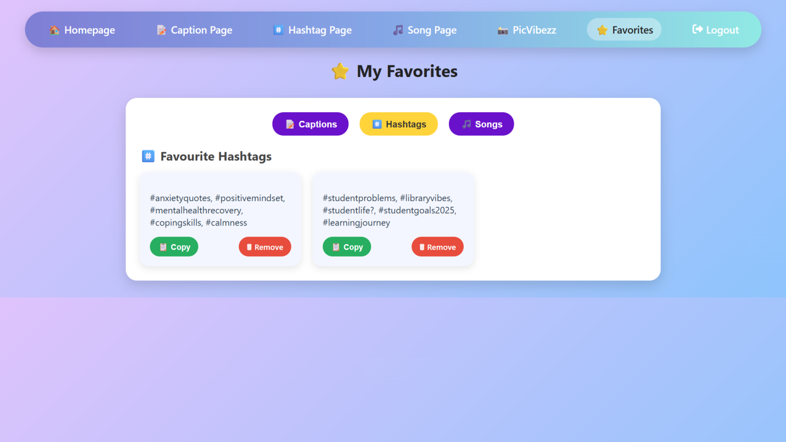

- This section lists all the hashtags the user has marked as favorites.

- They can easily copy hashtags for their posts or remove them to update their collection.
- Favorite Page (Song)

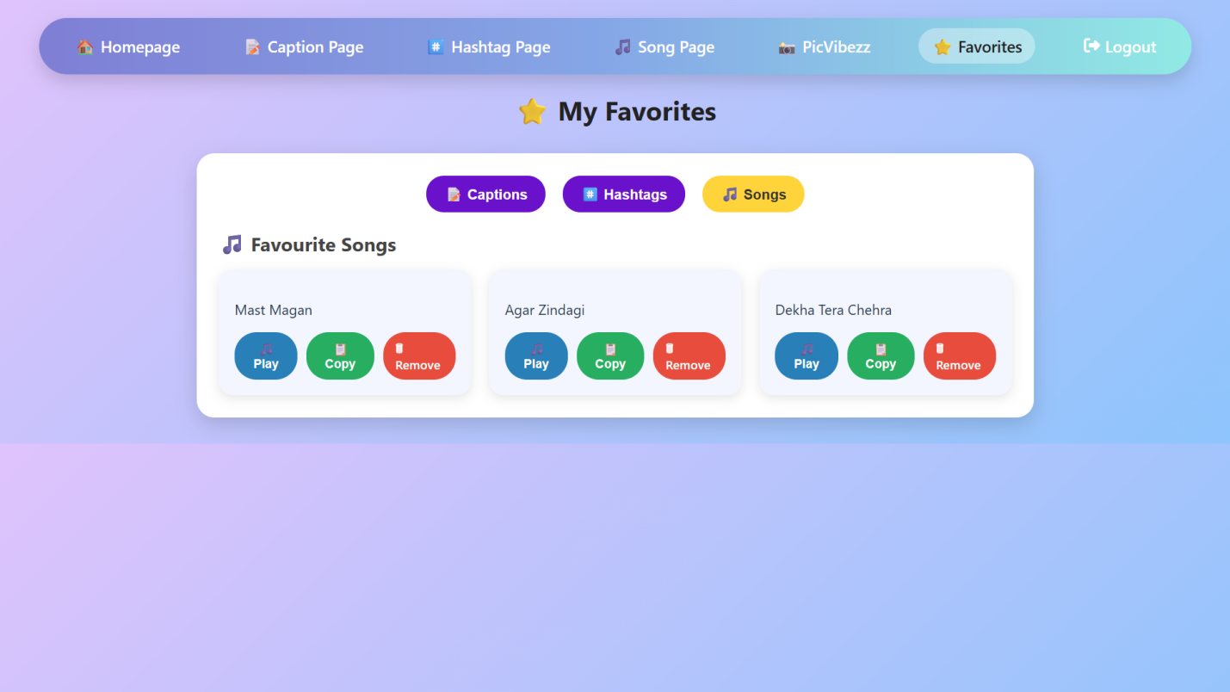

- This section contains all the song ideas the user has marked as favorites.

- Users can copy the song names for their posts or remove any they no longer need.

- About Us (Our Mission)

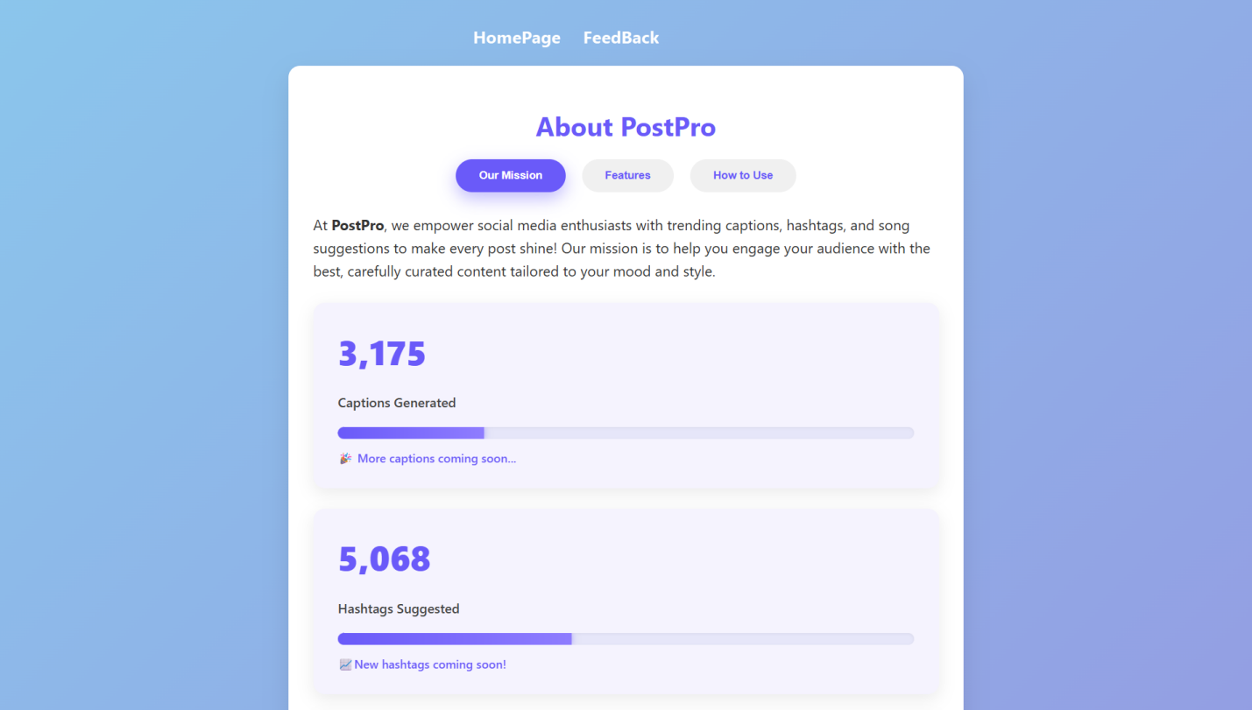

- This page allows you to learn what PostPro is all about and what it offers.

- It explains the mission of the website—to help users create better social media posts with captions, hashtags, and song suggestions.

- The page also shows stats like how many captions and hashtags have been generated so far, giving you an idea of the platform’s growth.

- Overall, it helps users understand the purpose and features of the website.

- About Us (Features)

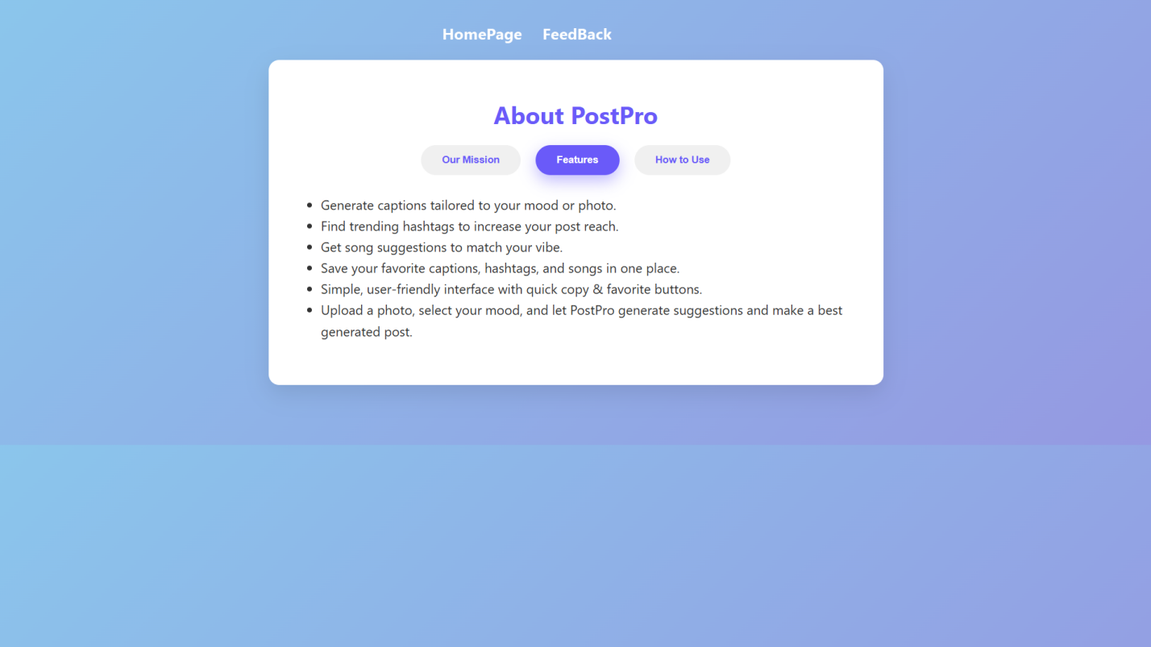

- This page allows you to see all the main features of PostPro in one place.

- It explains what the website can do, such as generating captions, hashtags, and songs based on your mood or photo, and saving your favorites.

- It also highlights how simple and user-friendly the platform is, with quick copy and favourite buttons.

- Overall, this page gives users a clear idea of the tools and benefits the website offers.

- About Us (How to Use)

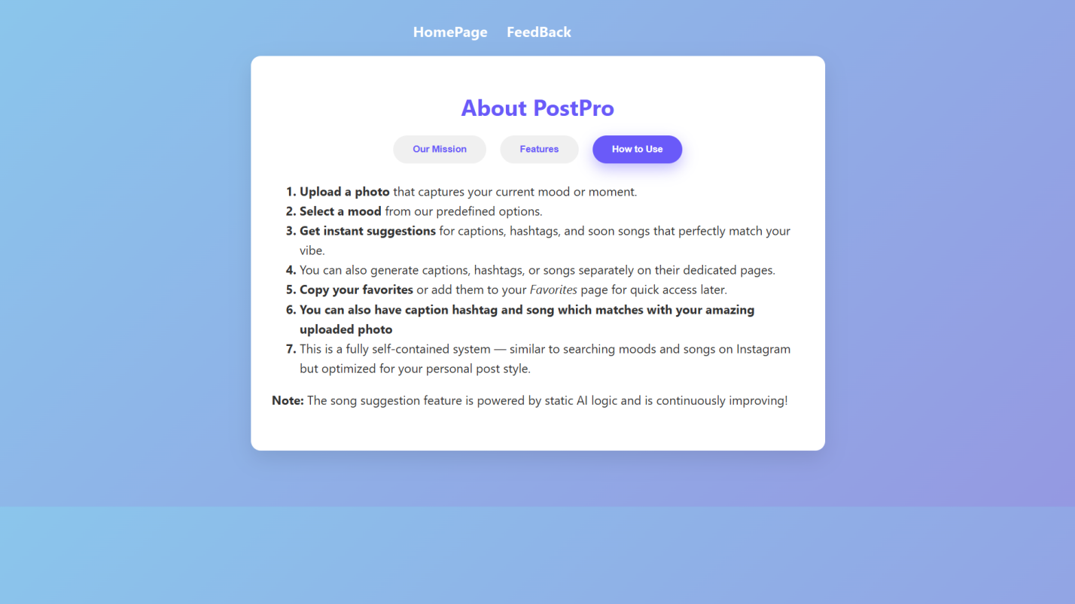

- This page explains how PostPro works users upload a photo, choose a mood, and instantly receive AI-generated captions, hashtags, and song suggestions that match the vibe of their image.

- It also lets users save favorites and generate each type of content separately for personalized social-media posts.

- Feedback

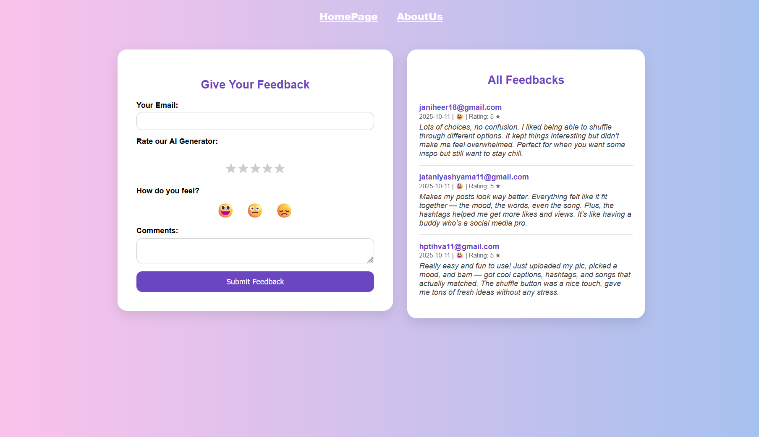

- This page lets users submit feedback by sharing their email, rating the suggestion tool, selecting their mood, and adding comments.

- It also displays all previously submitted feedback so users can see others’ experiences and reviews.
Conclusion & Future Scope

The PostPro system is an innovative web-based application
Developed to enhance social media content creation through
mood-based suggestions. It allows users to generate suitable
captions, hashtags, and songs according to their selected
mood, helping them express their feelings more effectively.

The system also includes a feature named PicVibezz, where users can upload a photo, select a mood, and receive personalized suggestions with options to shuffle and copy them.

The project successfully integrates user interaction, mood based
Content generation and database connectivity to deliver a creative and user-friendly experience. Additionally, feature like login-based favorites and feedback collection make the system more interactive and reliable.

Overall, PostPro achieves its objective of providing an intelligent and Engaging platform for users to generate mood-based social media. Content efficiently. With future enhancements such as AI-based Caption generation, automatic mood detection, and personalized Recommendations, the system holds great potential for further Development and real world use.
Future Scope

In the future, the PostPro system can be enhanced with several Advanced features to improve user experience and engagement. Some possible enhancements are:

1. AI-Based Caption and Hashtag Generation

Instead of fetching predefined data from the database, the system can use Artificial Intelligence and Natural Language Processing(NLP)to Automatically generate unique captions and hashtags based on the uploaded photo and mood.

2. Personalized Recommendations

The system can analyze user preferences and previously liked or favorited content to suggest personalized captions, hashtags, and songs.

3. Social Media Integration

Users can directly share generated captions, hashtags, and songs to their social media platforms such as Instagram, Facebook , or twitter with a single click.

4. Advanced Image Analysis

Using AI image recognition, the system can automatically detect the Mood of an uploaded photo and suggest matching captions and Songs without the user manually selecting a mood.

5. Mobile Application

A mobile app version of PostPro can be developed for Android and iOS to make the service more accessible and user-friendly.

6. Dark and Light Themes

The interface can include theme customization options to improve visual comfort and personalization.

7. Multilingual Support

The system can be expanded to support multiple languages so users from different regions can use the application easily.

