Super Store Sales Forecast and Dashboard Analysis
This report provides a detailed analysis of Super Store sales performance and forecasting. The analysis focuses on sales trends, profit distribution, regional performance, and forecasted sales for the next 15 days. Data visualizations are used to highlight key insights and patterns over time.

1. Sales Forecast Visualization
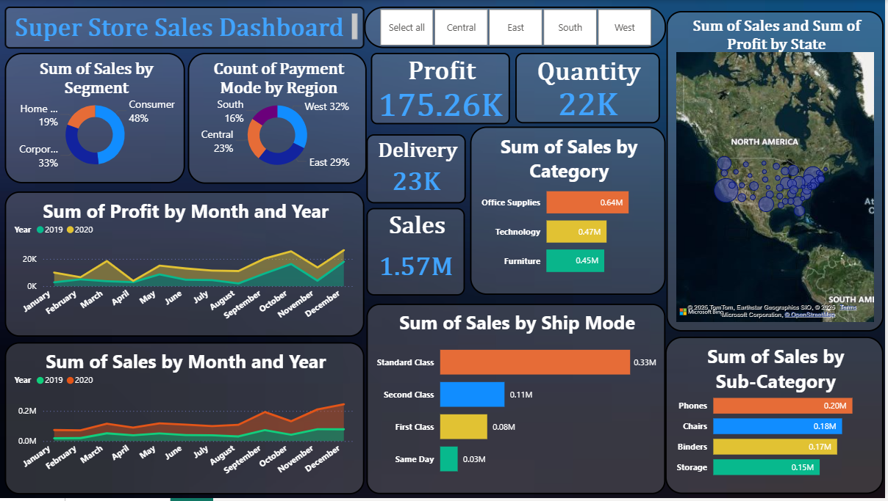
The above visualization represents the Super Store Sales Forecast for the next 15 days. It displays the sum of sales by order date from 2019 to early 2021, highlighting seasonal variations and increasing sales patterns toward the end of 2020. California leads significantly in sales, followed by New York and Texas, indicating strong market presence in these states.

2. Sales Dashboard Analysis
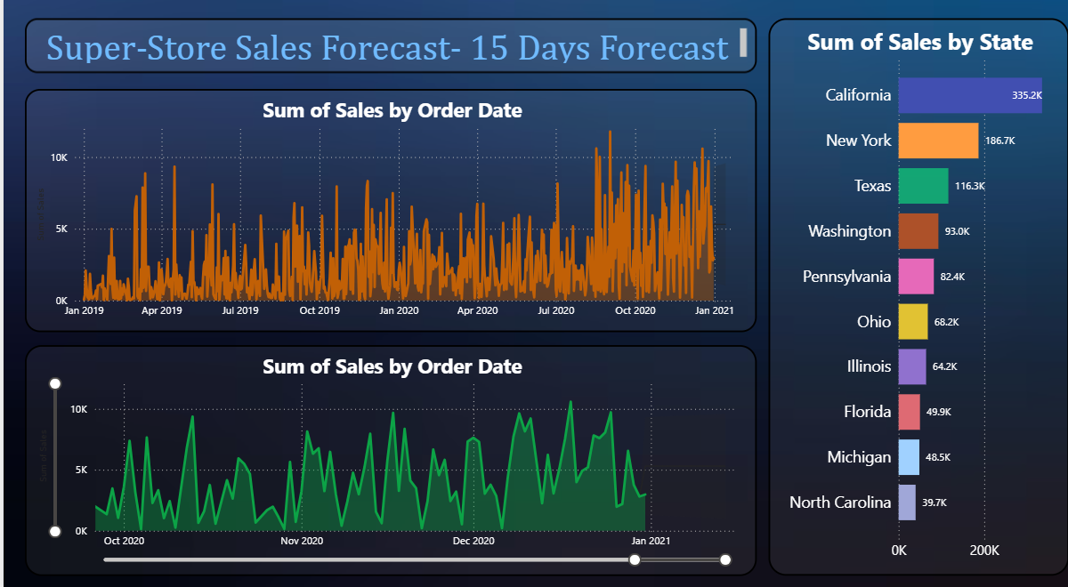
The Super Store Sales Dashboard provides an overall summary of performance indicators, including total profit, sales, quantity, and delivery statistics. The total profit recorded is approximately 175.26K, with overall sales reaching 1.57M. The Consumer segment contributes the highest share (48%) of sales, followed by Corporate and Home Office segments. Standard Class shipping mode dominates sales, indicating its preference due to cost-effectiveness. Technology and Office Supplies are top-performing categories, with phones, chairs, and binders as top sub-categories. Regional distribution shows strong performance in the West and East, aligning with major urban markets.

Conclusion
Based on the analysis of historical sales data and forecasted trends, the Super Store demonstrates a consistent upward sales trend with notable peaks during the last quarters of each year. California, New York, and Texas remain the top-performing states, contributing significantly to overall revenue. The Consumer segment remains the largest contributor to sales, and standard shipping continues to be the preferred delivery method. The forecast suggests stable growth in upcoming periods, with potential for further optimization in underperforming regions like Michigan and North Carolina. Overall, the store’s performance reflects strong operational efficiency and promising future sales potential.

