Work on the tasks in the portfolio project.

- Create the 5 collections (using mongosh, take screenshot) 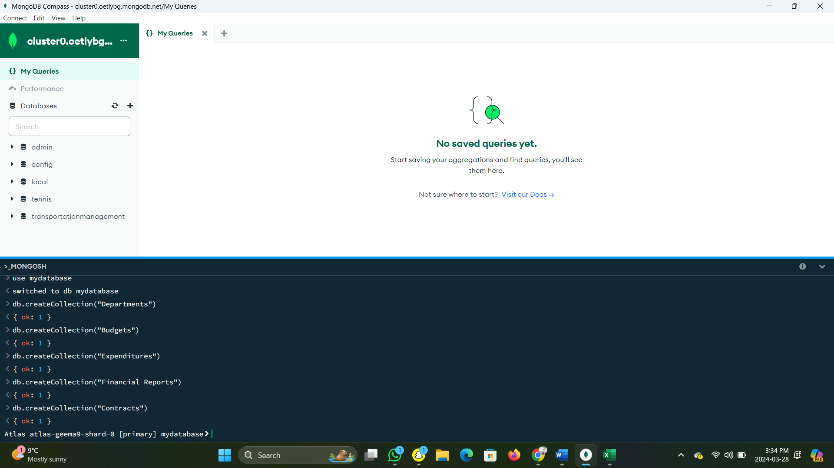

- Create an excel file - give it same fields as your collection. Populate the excel and upload to the collection using mongoimport command. (show this to me in class for 1 bonus mark) - please specify fields and data types

- Create Excel file called workload.xlxs. Write down list of common queries (atleast 5). Identify Workloads on excel file. (USE THIS TUTORIAL - https://learn.mongodb.com/courses/identifying-database-workloads)

- Create indexes based on the workload excel file.

- check execution stats again for each listed query ((using mongosh, take screenshot))

- Show implementation of 7 different mongodb aggregation functions.

- Show at least 3 different aggregation pipelines using MongoDB - show a chain of at least 3 different functions in each pipeline