Q2 .

mkdir harsh

mv harsh naman

mkdir newlocation

mv naman newlocation/

cd newlocation

rmdir naman

cd ..

cat >> File.txt

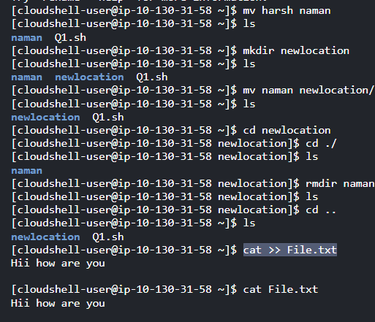

Q3.

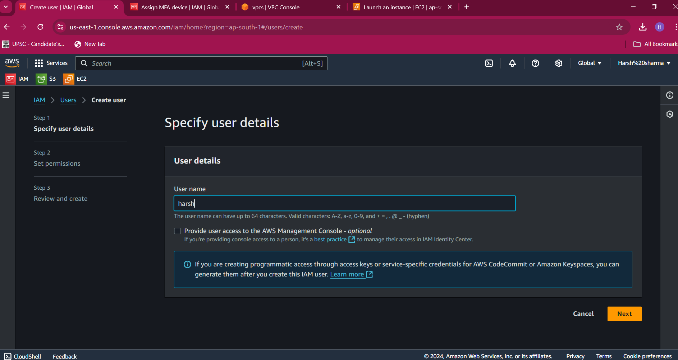

After go to the new linke and create the EC2 instance and I am successfully make it

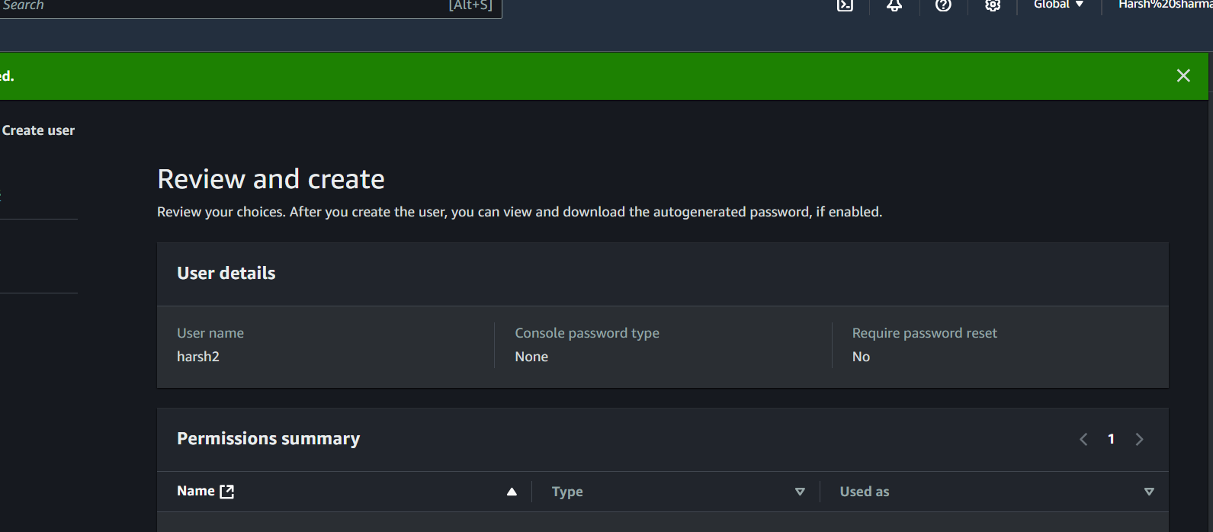

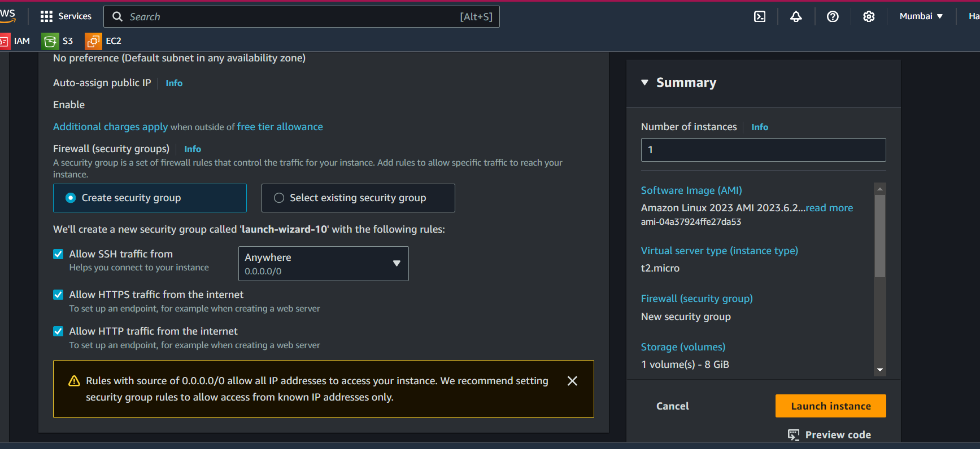

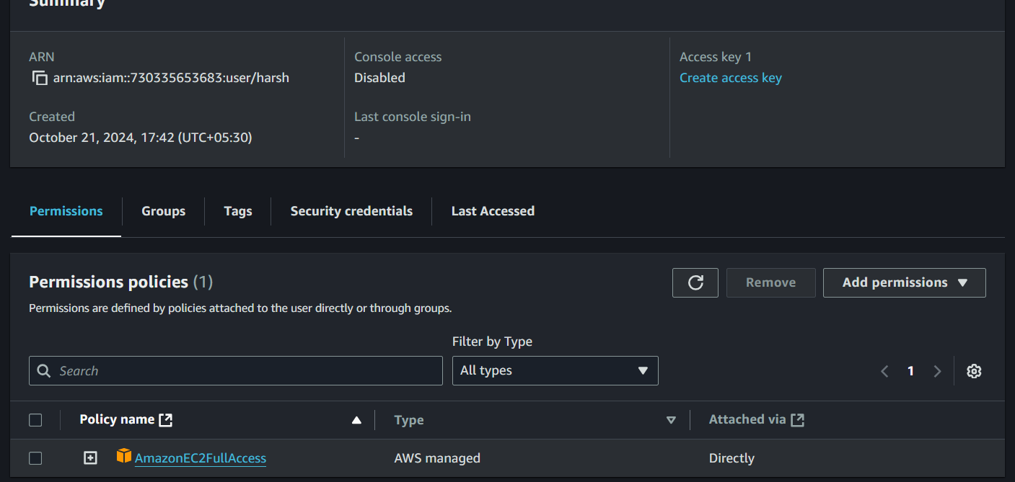

Html file containing message

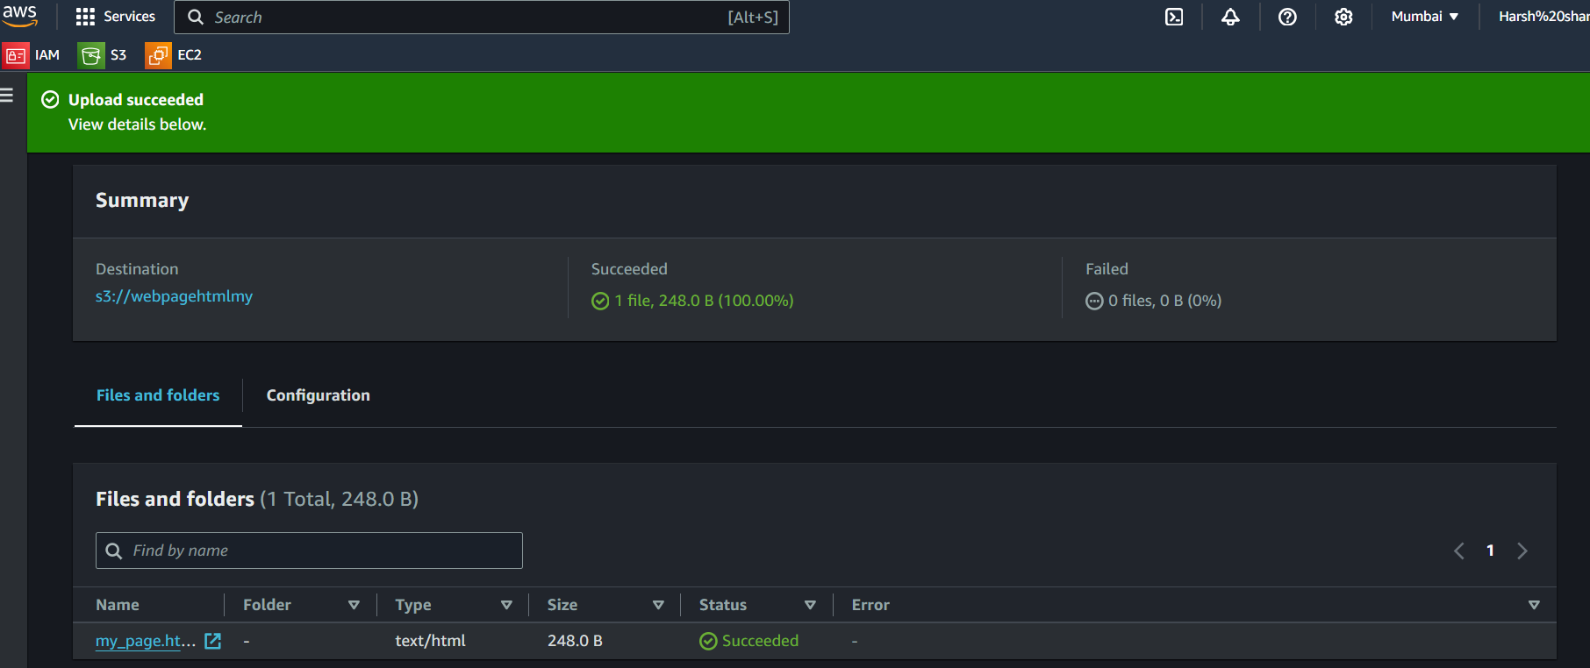

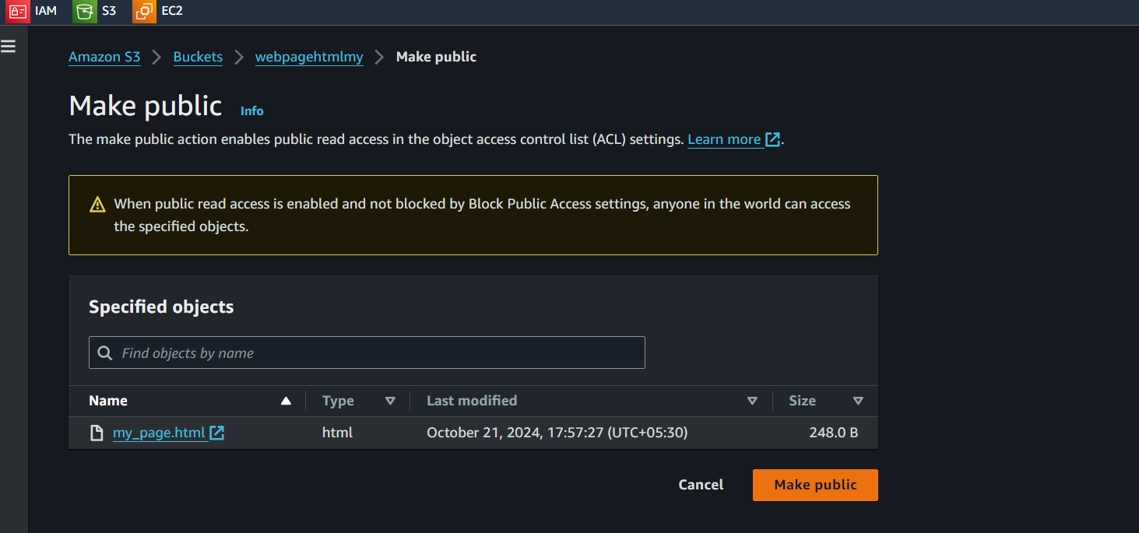

Static page uploaded in the s3 bucket and it is public so the file is

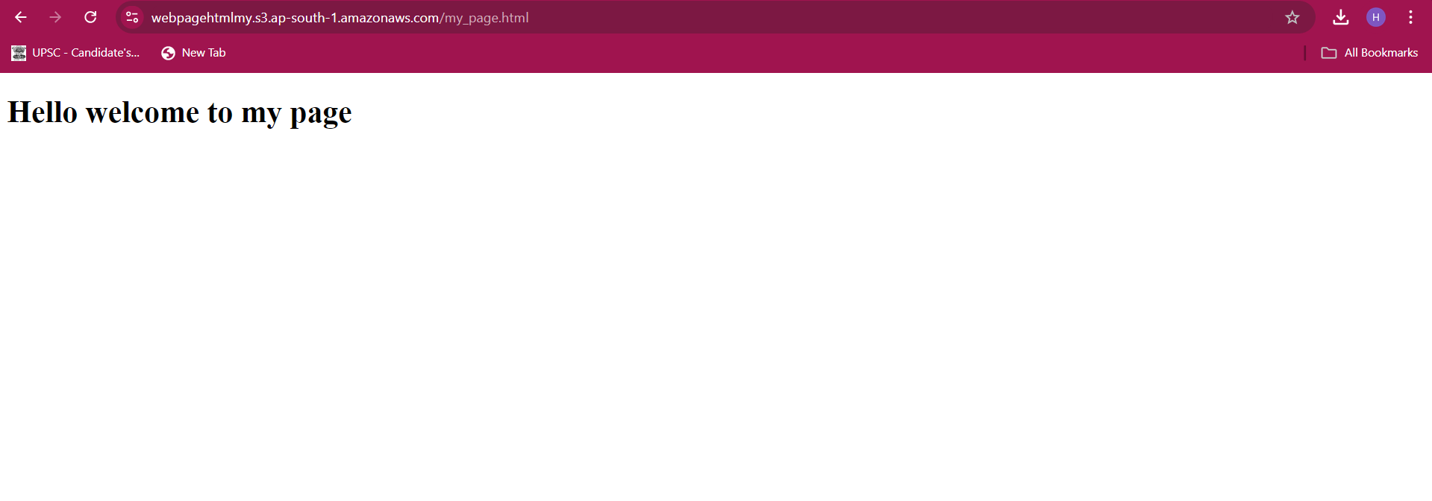

Q1.