Q3.

Create Ec2 instance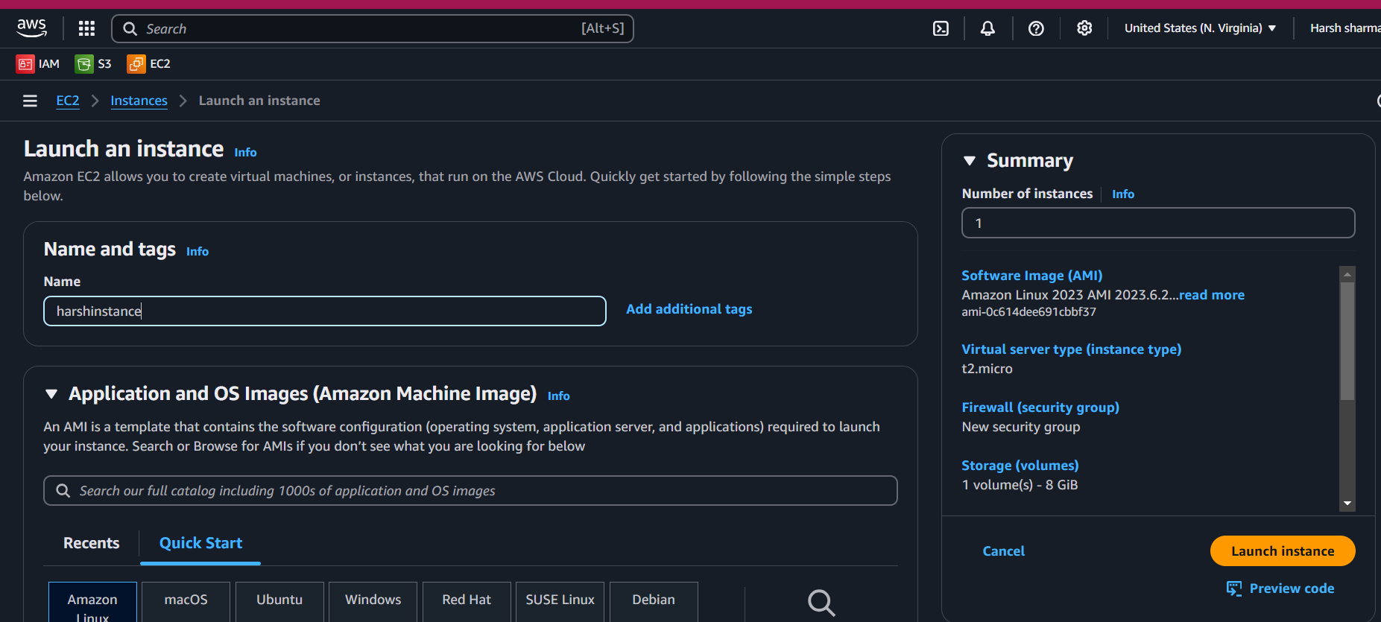

Key pair

Allow ssh and https traffic

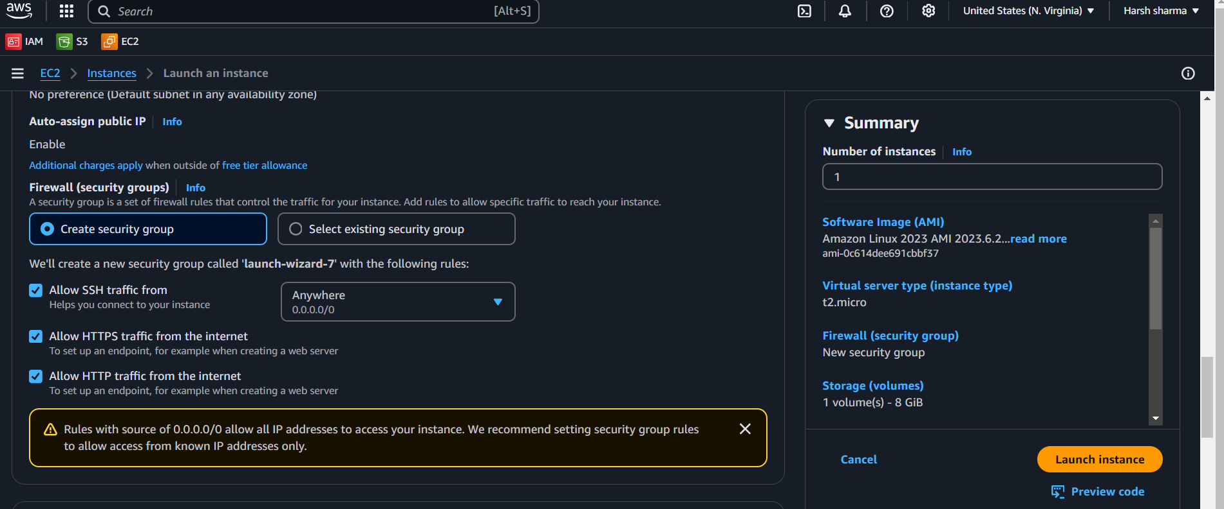

Launch instance

connect

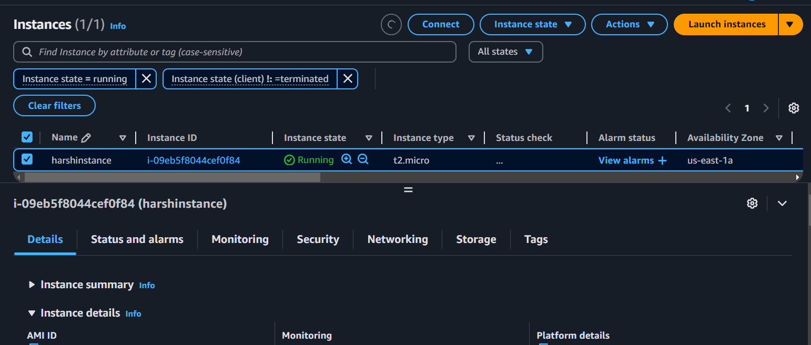

sudo yum update -y

sudo yum inatall -y httpd

sudo systemctl start httpd

sudo systemctl enable httpd

echo "<h1> Apache web server Running on AWS EC2 </h1> "

Sudo systemctl restart httpd

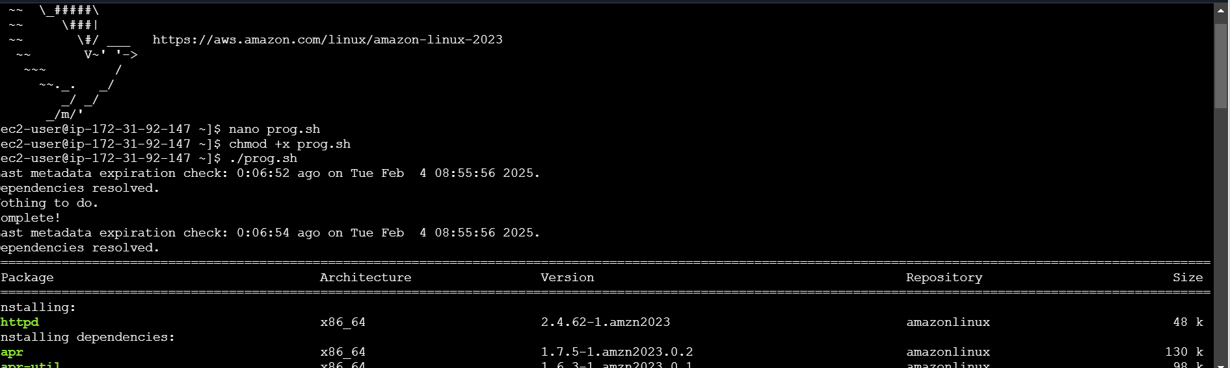

This is html file



Copy the public id

QQ

Q 4.

Create s3 bucket

ACLs enable

Unblock the public access

Bucket vesioning enable

Create bucket

Bucket is created

Upload the image

Add the file

Give public read access

Object url and click

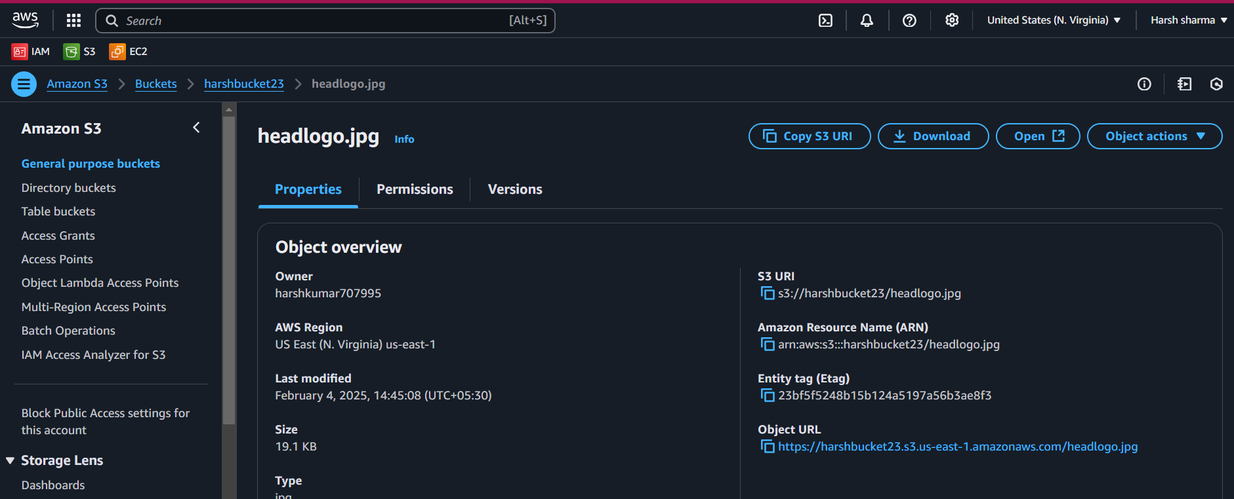

Image I get id

Q1.

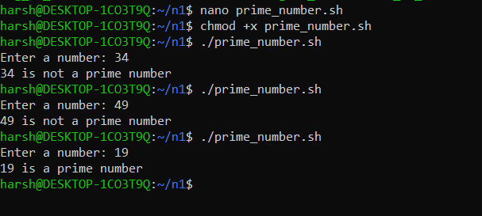

read -p "Enter a number: " num

if (( num < 2 )); then

echo "$num is not a prime number"

exit 0

fi

for (( i=2; i\*i<=num; i++ )); do

if (( num % i == 0 )); then

echo "$num is not a prime number"

exit 0

fi

done

echo "$num is a prime number"

Q2.

Create new user

Sudo adduser harsh

Create new group

Sudo addgrp dvs



nano test.txt

. for changing the mode of the file

>>chmod +r test.txt