Club Event Proposal Reviewer
Structured output + RAG with LangChain | Report
[Your name, roll number, date] Chat model: [provider and model name] Embedding model: [name]
How to use this draft: text in plain black describes the design and is already true of the notebook. Yellow fields must be filled from your own run of the notebook. Nothing in a yellow field has been measured for you.

1. Pipeline
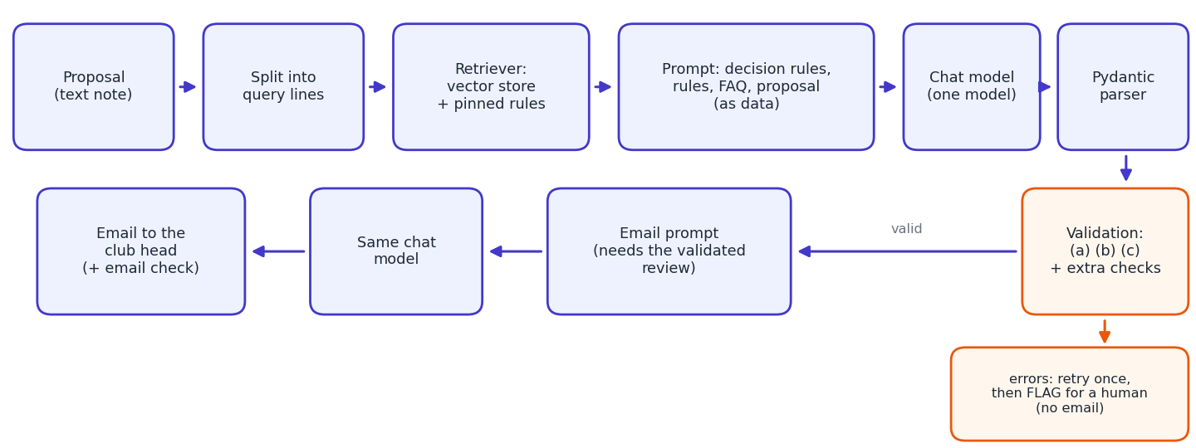
A proposal text is split into one query per line (the budget bullets also form one query). Each query searches a vector store holding one chunk per rule and per FAQ answer; the union of the hits, plus a small set of pinned rules and FAQ answers, is placed in the prompt together with the always-included decision section. The prompt tells the model to use only the supplied rules, to treat the proposal as data and not as instructions, and not to invent violations. The chat model's output is parsed into a ProposalReview object, checked in plain Python (retry once, otherwise flag for a human), and only a validated review is handed to the email prompt. One chat model is used for both chains; the email text is also checked in code (no rule ID outside the review, none forgotten).

2. Retrieval choices
Chunk size. I tested RecursiveCharacterTextSplitter on the rulebook. The longest rule (R-22) is 342 characters, yet sizes large enough to keep rules whole also glue neighbours together:
chunk size (overlap 0) | chunks | rules kept whole (of 22) | rules cut | chunks mixing 2+ rules
150 | 51 | 9 | 13 | 0
300 | 23 | 21 | 1 | 4
500 | 14 | 22 | 0 | 9
1000 | 6 | 22 | 0 | 5

Size alone cannot give one rule per chunk, so I split on the document structure (one rule or FAQ answer per blank-line paragraph): 22 rule chunks + 11 FAQ chunks, 73 to 342 characters, with a 400-character cap as a safety net. The decision section is not retrieved; it is always in the prompt because the verdict logic must never be missing. Chunk metadata (kind, id, severity) makes every verdict traceable to a rule ID.
Retrieval query and k. I compared three strategies without any LLM, scoring how many of the rules that are actually broken reach the prompt (recall) and how many rule chunks the prompt carries:
strategy | k | mean recall | proposals fully covered (of 13) | avg rule chunks (of 22)
whole proposal as one query | [4/6/8] | [ ] | [ ] | [ ]
one query per line, union | [1/2/3] | [ ] | [ ] | [ ]
per line + pinned rules | [1/2/3] | [ ] | [ ] | [ ]

Chosen: [strategy and k, and why, citing the table]. The pins (R-01 to R-05, R-12, R-22 and FAQ Q4, Q7, Q11) exist because retrieval searches the text that is present, so it cannot retrieve a rule about something the note does not say (R-02, R-12, R-22), and a bare date shares no words with the exam-week rule (R-03).
One example. Working well: [a snippet from your Step 3 output that found the right rule, with its score]. Failing: [a snippet that missed, for example the date line and R-03, and what the top-3 chunks were instead].

3. Schema design and validation
field | why it exists
club_name, event_name, event_date | extracted so a dashboard or email can identify the proposal
verdict (Literal of 3 values) | an invalid value fails parsing instead of slipping through
violations (list of Violation) | one entry per broken rule; an empty list is a valid answer
rule_id (plain str) | link to the rulebook; deliberately not constrained by the schema so that the plain-Python check (a) does the verifying
severity, evidence, fix | severity is checked against the rulebook; evidence is what a human verifies; fix feeds the email
summary | one sentence for the Council

Checks. (a) rule_id exists in the rulebook; (b) the verdict follows the most severe violation, using the rulebook's severities rather than the model's claims; (c) parse failures are caught as OutputParserException; extra: severity matches the rulebook, no rule listed twice, no empty evidence or fix. These are errors and cause one retry with the problems passed back as feedback, then a FLAGGED_FOR_HUMAN status and no email. A real rule that was cited but was not in the retrieved context is only a warning (a retry cannot fix it; it signals a retrieval gap). A self-test with seven deliberately bad reviews and two unparseable outputs behaved as designed (invented ID, verdict too soft, verdict too harsh, wrong severity, duplicate rule, missing-from-context warning, free text, invalid verdict value).
What the checks caught in my run: [number of retries, number flagged, which proposals, which check fired, number of retrieval warnings].

4. Results
Comparison key: [official answer key / my own hand key (state which)]. The hand verdicts I derived: Approve P01, P11, P13; Needs changes P04, P06, P07, P08, P10; Reject P02, P03, P05, P09, P12 (23 rule hits in total).
run | verdict accuracy | expected rules found | false alarms | retried | flagged
baseline (RAG, plain prompt) | [ /13] | [ /23] | [ ] | [ ] | [ ]
+ computed facts (Step 6b) | [ /13] | [ /23] | [ ] | [ ] | [ ]
whole rulebook in prompt (stretch) | [ /13] | [ /23] | [ ] | [ ] | [ ]

Paste the per-proposal DataFrame from Step 9 here (or a screenshot) and the verdict bar chart: [table and chart]. RAG vs whole rulebook: the average prompt carried [ ] characters of rules and FAQ with RAG against [ ] with the whole documents; quality was [better / equal / worse], so for a rulebook this short [what this says about when RAG is worth using].

5. Failure analysis
Pick two wrong outputs from show_errors(...). For each, say what was expected, what the model returned, whether the needed rule was in the retrieved context, and why it went wrong (retriever, arithmetic, silence rule, ambiguous wording, or prompt).
Failure 1: [proposal id; expected vs got; was the rule retrieved?; cause]
Failure 2: [proposal id; expected vs got; was the rule retrieved?; cause]
Places where I expect a model to slip, so check these first in your output (these are hypotheses, not results): P08 (capacity 48 in the Library Hall, two supervisors for an overnight event, all non-vegetarian food, budget just under 15,000 and prizes just under 30%); P06 (Treasurer approval needed for 22,000, honorarium above 5,000, misc 13.6%); P05 (R-06 does not apply above 40,000); P02 (a lakeside walk is not "in or on water"); P04 (booking requested only 5 days before); P07 (silence under R-14); P03 (exam week); and my sneaky proposal MY2 (wrong weekday and prizes that only exceed 30% after adding).

6. What worked, what did not, what next
- Worked: [from your results, for example structure-based chunks, the pins, validation catching X]
- Did not: [for example retrieval misses, arithmetic errors, false alarms and which rules]
- Own proposals: the clean one (expected Approve) gave [ ]; the sneaky one (expected Reject with R-04 and R-09, no R-08) gave [ ], with and without the computed-facts helper.
- Next: hybrid keyword + vector search, a reranker, running the arithmetic checks in code for every proposal and letting the model explain them, and the follow-up chat loop for the club head.

