Reframing the Assignment Submission System to Prevent Internal Plagiarism

1. Community and Stakeholder Identification

Background of the Problem
In the previous semester, an issue occurred in one subject where several students were penalized due to plagiarism. A student shared their completed assignment with friends for reference purposes. Those friends submitted the assignment without modification. As a result, when plagiarism was detected, both the students who copied and the original student who created the work received zero marks and were penalized equally.
This incident highlighted a structural weakness in the existing submission system. Currently, plagiarism detection occurs after submission, typically through external platforms such as Turnitin. Faculty members must manually upload submissions and review similarity reports. This process is time-consuming, costly, and reactive rather than preventive.
Additionally, in some cases, students copied content but submitted it in handwritten form as images. Detecting plagiarism in such cases becomes more difficult if the system does not process image-based content.

Affected Community
The primary community affected includes undergraduate students who submit assignments through the institutional platform. Faculty members responsible for evaluating assignments are also significantly impacted.

Stakeholders
Students are directly affected because they may face penalties even when their intention was not to facilitate cheating. Faculty members are affected due to the additional workload of manually verifying plagiarism reports. The institution is affected in terms of fairness, academic integrity, and financial costs associated with paid plagiarism detection services.

2. User Research and Empathy Mapping
The research is based on the real case that occurred in the previous semester. Observations and discussions with students and faculty revealed the following:
Students expressed concern about being penalized without a warning system in place. There is currently no mechanism that informs a student at the time of submission if their work closely matches another submission. The absence of preventive measures results in punishment after submission rather than correction before submission.
Faculty members indicated that manually checking assignments through external tools consumes significant time, especially during deadlines when many submissions must be reviewed. Image-based plagiarism further increases complexity.

Empathy Mapping Insights
From the student perspective, the main concerns are fairness and transparency. A student who completes original work may still be penalized if another student submits the same file first. There is no real-time alert or similarity threshold warning during submission.
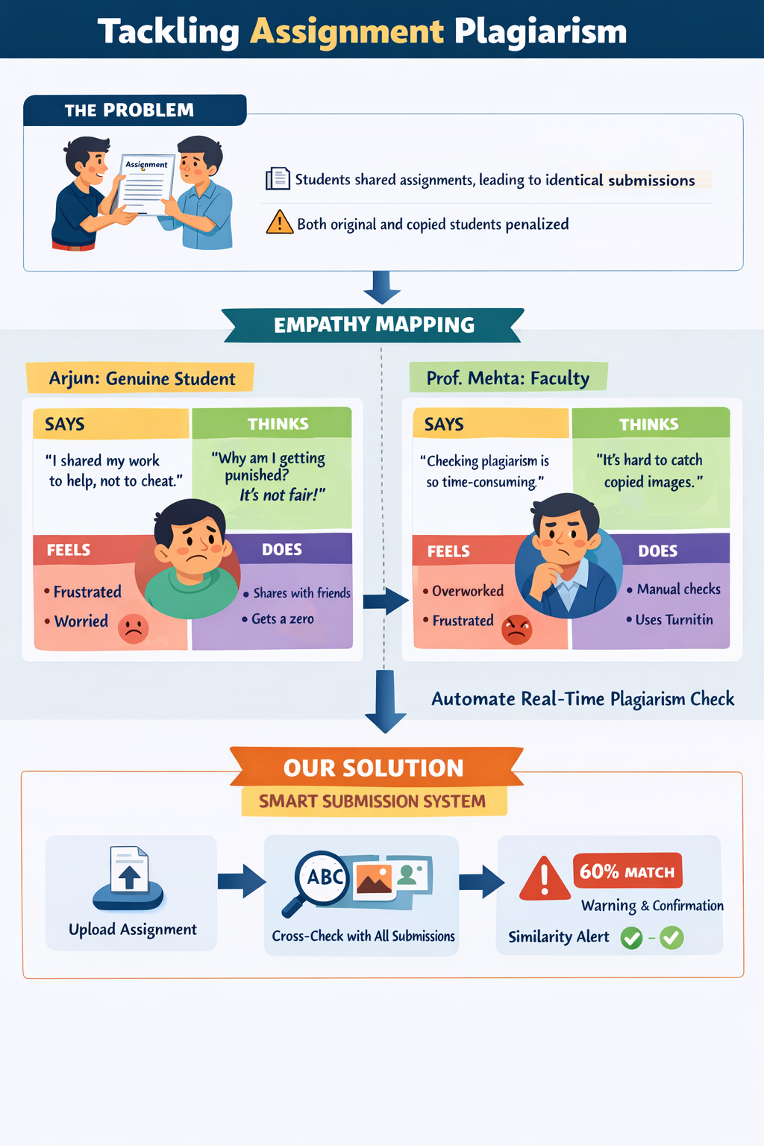
From the faculty perspective, the key concerns are efficiency and workload. Faculty require an automated mechanism that compares submissions internally without requiring repeated manual uploads to external platforms.

Key insights derived from empathy mapping:
- The current system detects plagiarism after submission instead of preventing it.
- There is no real-time internal cross-comparison among submitted files.
- Image-based copied content is not effectively handled.
- Faculty workload and dependency on paid tools increase operational costs.

3. Problem Framing
Based on the research findings, the core issue is not merely plagiarism but the absence of a preventive and automated internal verification mechanism at the time of submission.
This leads to the following framing:
How can the assignment submission system be redesigned so that plagiarism is detected and prevented at the time of upload, rather than after evaluation?

4. Proposed Solution: Smart Assignment Submission Platform
The proposed solution is a redesigned assignment submission platform with the following operational structure:
When a student uploads an assignment, the system automatically compares the document against all previously submitted files for that specific assignment. The comparison includes both textual content and image-based submissions. For image files, text extraction is performed before similarity comparison.
A predefined similarity threshold is set. If the similarity score exceeds this threshold, the submission is automatically rejected.
Upon rejection, the system displays a clear message indicating that similarity has been found beyond the acceptable limit and identifies the matched file reference (for example, “Rejected: Similarity found with File 1”).
Students are given a limited number of submission attempts. Each attempt is recorded in the system database. If a student exceeds the maximum allowed attempts, further submissions are locked for that assignment.
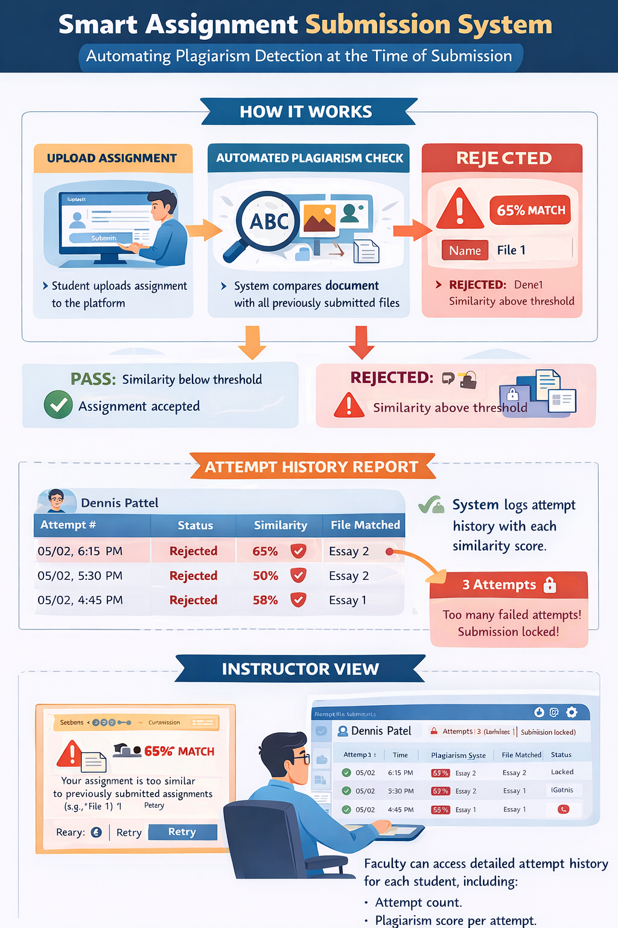

For every attempt, the following details are stored:
- Student identification
- Attempt number
- Timestamp
- Similarity percentage
- Matched file reference
- Submission status (Accepted/Rejected)
Faculty members have access to an instructor dashboard where they can view:
- Total number of attempts per student
- Similarity score for each attempt
- Matched file details
- Final submission status
If the similarity score remains below the threshold, the submission is accepted and finalized.

5. Final Problem Statement
The current assignment submission system lacks a real-time internal plagiarism detection mechanism, resulting in unfair penalties for students and increased workload for faculty. There is a need for an automated submission platform that compares each upload with previously submitted files, detects both textual and image-based plagiarism at the time of submission, enforces similarity thresholds with limited attempts, and maintains detailed attempt histories accessible to faculty.

6. Expected Impact
This system introduces a preventive model rather than a reactive one. It ensures fairness by providing students with immediate feedback before final submission. It reduces dependency on external paid plagiarism detection tools. It decreases faculty workload by automating internal cross-comparisons. It strengthens academic integrity by discouraging copying before evaluation occurs.

