Report

Harsh Patel

Email:- [hp9995.hp@gmail.com](mailto:hp9995.hp@gmail.com)

Phone:- 437-770-4879

Solution with React-Native with NodeJS

Technologies: -

Front-end – React Native

Backend – NodeJS

Database – SQLite(Local Database)

Server – npm (Node Package Manager) which is default for the JavaScript Runtime Environment

Emulator – Android Studio API Version:- 28 and SDK is minimum 33

Third party app – expo (It’s a toolchain app)

How to run:

**npm install**

**expo start**

Screenshots:-

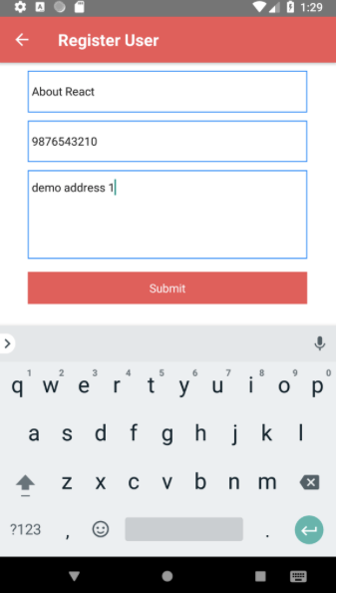

Solution with Android (JAVA)

Technologies: -

Android with JAVA

Database – SQLite(Local Database)

Server – Local Emulator

Emulator – Android Studio API Version:- 26 and SDK is minimum 25

How to run:

**Open in Android studio and hit**  **this button**

Screen Shots:-

