University of Mumbai

PRACTICAL JOURNAL – ELECTIVE I



PSIT3P2a

Applied Artificial Intelligence

SUBMITTED BY

Karkera Prateek Ramesh

SEAT NO 30102

SUBMITTED IN PARTIAL FULFILLMENT OF THE REQUIREMENTS FOR QUALIFYING M.Sc. (I.T.) PART-II (SEMESTER – III) EXAMINATION

2022-2023

Department of Information Technology

3RD FLOOR, DR. SHANKAR DAYAL SHARMA BHAVAN, IDOL BUILDING, VIDYANAGRI,

SANTACRUZ (E), MUMBAI – 400098.

**University of Mumbai**



# Department of Information Technology

**CERTIFICATE**

This is to certify that Mr. **Karkera Prateek Ramesh Seat No. 30102** studying in **Master of Science** in **Information Technology Part II Semester III** has satisfactorily completed the Practical of **PSIT3P2a Applied Artificial Intelligence** as prescribed by University of Mumbai, during the academic year **2022-23**.

|  |  |  |
| --- | --- | --- |
| Signature | Signature | Signature |
| Guide | External Examiner Examined By | Head of the Department Certified by |

College Seal Date:

# INDEX

|  |  |  |  |  |
| --- | --- | --- | --- | --- |
| Practical No. | Date | Name of Practical | Page No. | Signature |
| 1 | 06/10/2022 | Design a bot using AIML | 3 |  |
| 2 | 13/10/2022 | Design an Expert system using AIML | 7 |  |
| 3 | 20/10/2022 | Implement Bayes Theorem using Python | 11 |  |
| 4 | 27/10/2022 | Implement Conditional Probability and joint probability using Python. | 12 |  |
| 5 | 03/11/2022 | Write a program for to implement Rule based system. (Prolog) | 14 |  |
| 6 | 10/11/2022 | Design a Fuzzy based application using Python / R | 18 |  |
| 7 | 17/11/2022  24/11/2022 | 1. Write an application to stimulate supervised learning model. 2. Write an application to stimulate unsupervised learning model. | 24  26 |  |
| 8 | 01/12/2022 | Write an application to implement clustering algorithm. | 28 |  |
| 9 | 08/12/2022 | Write an application to implement support vector machine algorithm. | 30 |  |
| 10 | 15/12/2022 | Simulate artificial neural network model with both feedforward and backpropagation approach. | 34 |  |

**PRACTICAL 1**

**AIM:** Design a bot using AIML.

**CODE:**

**Step 1:** Create the XML file.

Open the notepad, write the following code, and save it as std-startup.xml

<aiml version="1.0.1" encoding="UTF-8">

<!-- std-startup.xml -->

<!-- Category is an atomic AIML unit -->

<category>

<!-- Pattern to match in user input -->

<!-- If user enters "LOAD AIML B" -->

<pattern>LOAD AIML B</pattern>

<!-- Template is the response to the pattern -->

<!-- This learn an aiml file -->

<template>

<learn>basic_chat.aiml</learn>

<!-- You can add more aiml files here -->

<!--<learn>more_aiml.aiml</learn>-->

</template>

</category>

</aiml>

**Step 2:** Create the aiml file.

Open the notepad, write the following code, and save it as basic_chat.aiml

<aiml version="1.0.1" encoding="UTF-8">

<!-- basic_chat.aiml -->

<category>

<pattern>HELLO</pattern>

<template> Well, hello!

</template>

</category>

<category>

<pattern>WHAT ARE YOU</pattern>

<template> I'm a bot, silly! </template>

</category>

<category>

<pattern>MY NAME IS *</pattern>

<template>

<set name = "username">

<star/>

</set> is the nice name.

</template>

</category>

<category>

<pattern>I LIKE *</pattern>

<template>

<set name = "liking">

<star/>

</set> is also my favourite.

</template>

</category>

<category>

<pattern>MY DOG NAME IS *</pattern>

<template>

THAT IS INTERESTING THAT YOU HAVE A DOG NAMED

<set name ="dog">

<star/>

</set> .

</template>

</category>

<category>

<pattern>BYE</pattern>

<template>

Bye!!!

<get name = "username"/> Thanks for talking with me.

</template>

</category>

</aiml>

**Step 3:** Install aiml packages

pip install aiml

pip install aimlbotkernel or

pip3 install aiml

pip3 install aimlbotkernel

**Step 4:** Create chatbot.py file

import aiml # Create the kernel and learn AIML files kernel = aiml.Kernel()

kernel.learn("std-startup.xml")

kernel.respond("load aiml b") # Press CTRL-C to break this loop while True:

message = input("Enter your message to the bot: ") if message == "quit":

break else:

bot_response = kernel.respond(message) print(bot_response)

**OUTPUT:**

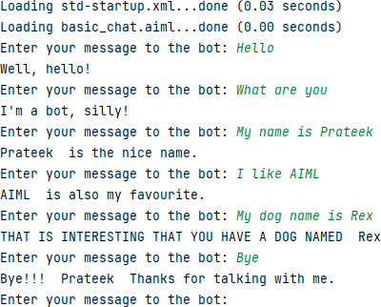

# PRACTICAL 2

**AIM:** Design an Expert system using AIML.

**CODE:**

**Step 1:** Create the XML file

Open the notepad, write the following code, and save it as std-startup.xml

<aiml version="1.0.1" encoding="UTF-8">

<!-- std-startup.xml -->

<!-- Category is an atomic AIML unit -->

<category>

<!-- Pattern to match in user input -->

<!-- If user enters "LOAD AIML B" -->

<pattern>LOAD AIML B</pattern>

<!-- Template is the response to the pattern -->

<!-- This learn an aiml file -->

<template>

<learn>basic_chat.aiml</learn>

<!-- You can add more aiml files here -->

<!--<learn>more_aiml.aiml</learn>-->

</template>

</category>

</aiml>

**Step 2:** Create the aiml file

Open the notepad, write the following code, and save it as basic_chat.aiml

<aiml version="1.0.1" encoding="UTF-8">

<!-- basic_chat.aiml -->

<category>

<pattern>HELLO</pattern>

<template>

WHAT WOULD YOU LIKE TO DISCUSS? : HEALTH, MOVIES

</template>

</category>

<category>

<pattern>MOVIES</pattern>

<template>

YES <set name = "topic">MOVIES</set>

</template>

</category>

<category>

<pattern>HEALTH</pattern>

<template> YES <set name = "topic">HEALTH</set> </template>

</category>

<topic name ="MOVIES">

<category>

<pattern>*</pattern>

<template>

DO YOU LIKE COMEDY MOVIES?

</template>

</category>

<category> <pattern>YES</pattern>

<template>

I TOO LIKE COMEDY MOVIES

</template>

</category>

<category>

<pattern>NO</pattern>

<template>

BUT I LIKE COMEDY MOVIES

</template>

</category>

</topic>

<topic name ="HEALTH">

<category>

<pattern>*</pattern>

<template>

DO YOU HAVE FEVER?

</template>

</category>

<category>

<pattern>YES</pattern>

<template>

PLEASE TAKE MEDICINES AND PROPER REST

</template>

</category>

<category>

<pattern>NO</pattern>

<template>

GO OUT FOR A WALK AND LISTEN MUSIC

</template>

</category>

</topic>

<category>

<pattern>NICE TALKING TO YOU</pattern>

<template> SAME HERE...!!

</template>

</category>

</aiml>

**Step 3:** Install aiml packages

pip install aiml

pip install aimlbotkernel or

pip3 install aiml

pip3 install aimlbotkernel

**Step 4:** Create chatbot.py file and run chatbot.py

import aiml

# Create the kernel and learn AIML files kernel = aiml.Kernel()

kernel.learn("std-startup.xml") kernel.respond("load aiml b")

# Press CTRL-C to break this loop while True:

message = input("Enter your message to the bot: ") if message == "quit":

break else:

bot_response = kernel.respond(message) print(bot_response)

**OUTPUT:**

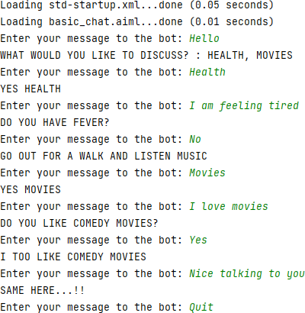

# PRACTICAL 3

**AIM:** Implement Bayes Theorem using Python.

**CODE:**

# calculate the probability of cancer patient and diagnostic test # calculate P(A|B) given P(A), P(B|A), P(B|not A)

def bayes_theorem(p_a, p_b_given_a, p_b_given_not_a): # calculate P(not A)

not_a = 1 - p_a # calculate P(B)

p_b = p_b_given_a * p_a + p_b_given_not_a * not_a # calculate P(A|B)

p_a_given_b = (p_b_given_a * p_a) / p_b return p_a_given_b

# P(A)

p_a = 0.0002 # P(B|A)

p_b_given_a = 0.85 # P(B|not A)

p_b_given_not_a = 0.05 # calculate P(A|B)

result = bayes_theorem(p_a, p_b_given_a, p_b_given_not_a) # summarize

print('P(A|B) = %.3f%%' % (result * 100))

**OUTPUT:**



# PRACTICAL 4

**AIM:** Implement Conditional Probability and joint probability using Python.

**CODE:**

import enum, random class Kid(enum.Enum):

BOY = 0

GIRL = 1

def random_kid() -> Kid:

return random.choice([Kid.BOY, Kid.GIRL]) both_girls = 0

older_girl = 0

either_girl = 0 random.seed(0)

for _ in range(10000): younger = random_kid() older = random_kid() if older == Kid.GIRL:

older_girl += 1

if older == Kid.GIRL and younger == Kid.GIRL: both_girls += 1

if older == Kid.GIRL or younger == Kid.GIRL: either_girl += 1

print("older girl: ", older_girl) print("both girl: ", both_girls) print("either girl: ", either_girl)

print("P(both | older):", both_girls / older_girl)

print("P(both | either):", both_girls / either_girl)

**OUTPUT:**

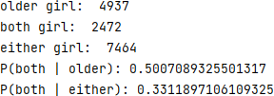

# PRACTICAL 5

**AIM:** Write a program for to implement Rule based system. (Prolog).

**CODE:**

go:- hypothesis(Disease),

write('I believe that the patient have '), write(Disease),

nl,

write('TAKE CARE '),

undo.

/*Hypothesis that should be tested*/ hypothesis(cold) :- cold, !. hypothesis(flu) :- flu, !. hypothesis(typhoid) :- typhoid, !. hypothesis(measles) :- measles, !. hypothesis(malaria) :- malaria, !. hypothesis(unknown). /* no diagnosis*/

/*Hypothesis Identification Rules*/ cold :-

verify(headache), verify(runny_nose), verify(sneezing), verify(sore_throat), write('Advices and Sugestions:'), nl,

write('1: Tylenol/tab'), nl,

write('2: panadol/tab'), nl,

write('3: Nasal spray'), nl,

write('Please wear warm cloths Because'), nl.

flu :- verify(fever),

verify(headache), verify(chills), verify(body_ache),

write('Advices and Sugestions:'), nl,

write('1: Tamiflu/tab'), nl,

write('2: panadol/tab'), nl,

write('3: Zanamivir/tab'), nl,

write('Please take a warm bath and do salt gargling Because'), nl.

typhoid :- verify(headache), verify(abdominal_pain), verify(poor_appetite), verify(fever),

write('Advices and Sugestions:'), nl,

write('1: Chloramphenicol/tab'), nl,

write('2: Amoxicillin/tab'), nl,

write('3: Ciprofloxacin/tab'), nl,

write('4: Azithromycin/tab'), nl,

write('Please do complete bed rest and take soft Diet Because'), nl.

measles :- verify(fever), verify(runny_nose), verify(rash), verify(conjunctivitis),

write('Advices and Sugestions:'), nl,

write('1: Tylenol/tab'), nl,

write('2: Aleve/tab'), nl,

write('3: Advil/tab'), nl,

write('4: Vitamin A'), nl,

write('Please Get rest and use more liquid Because'), nl.

malaria :- verify(fever), verify(sweating), verify(headache), verify(nausea), verify(vomiting), verify(diarrhea),

write('Advices and Sugestions:'), nl,

write('1: Aralen/tab'), nl,

write('2: Qualaquin/tab'), nl,

write('3: Plaquenil/tab'), nl,

write('4: Mefloquine'), nl,

write('Please do not sleep in open air and cover your full skin Because'), nl.

/* how to ask questions */ ask(Question) :-

write('Does the patient have following symptom:'), write(Question),

write('? '), read(Response), nl,

( (Response == yes ; Response == y)

->

assert(yes(Question)) ; assert(no(Question)), fail).

:- dynamic yes/1,no/1.

/*How to verify something */ verify(S) :-

(yes(S)

->

true ; (no(S)

->

fail ; ask(S))).

/* undo all yes/no assertions*/ undo :- retract(yes(_)),fail. undo :- retract(no(_)),fail. undo.

**OUTPUT:**

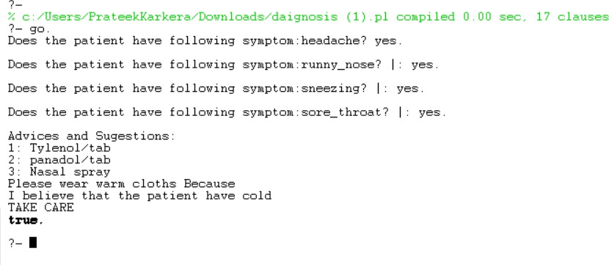

# PRACTICAL 6

**AIM:** Design a Fuzzy based application using Python/ R.

**CODE:**

import numpy as np import skfuzzy as fuzz

import matplotlib.pyplot as plt from skfuzzy import control as ctrl

from mpl_toolkits.mplot3d import Axes3D # Required for 3D plotting

# New Antecedent/Consequent objects hold universe variables and membership # functions

quality = ctrl.Antecedent(np.arange(0, 10, 0.1), 'quality')

service = ctrl.Antecedent(np.arange(0, 10, 0.1), 'service')

tip = ctrl.Consequent(np.arange(0, 25, 0.1), 'tip')

quality['poor'] = fuzz.zmf(quality.universe, 0,5) quality['average'] = fuzz.gaussmf(quality.universe,5,1) quality['good'] = fuzz.smf(quality.universe,5,10)

service['poor'] = fuzz.zmf(service.universe, 0,5) service['average'] = fuzz.gaussmf(service.universe,5,1) service['good'] = fuzz.smf(service.universe,5,10)

tip['low'] = fuzz.trimf(tip.universe, [0, 0, 13])

tip['medium'] = fuzz.trimf(tip.universe, [0, 13, 25])

tip['high'] = fuzz.trimf(tip.universe, [13, 25, 25])

quality['average'].view()

plt.title('Quality')

service['poor'].view()

plt.title('Service')

tip['medium'].view()

plt.title('Tip Medium')

rule1 = ctrl.Rule(quality['poor'] | service['poor'], tip['low'])

rule2 = ctrl.Rule(service['average'], tip['medium'])

rule3 = ctrl.Rule(service['good'] | quality['good'], tip['high'])

rule1.view()

plt.title('Rule 1')

rule2.view()

plt.title('Rule 2')

rule3.view()

plt.title('Rule 3')tipping_ctrl = ctrl.ControlSystem([rule1, rule2, rule3])

tipping = ctrl.ControlSystemSimulation(tipping_ctrl)

tipping.input['quality'] = 6.5

tipping.input['service'] = 9.8

tipping.compute()

print(tipping.output['tip'])

tip.view(sim=tipping)

plt.title('Result')

plt.show(block=True)

**OUTPUT:**

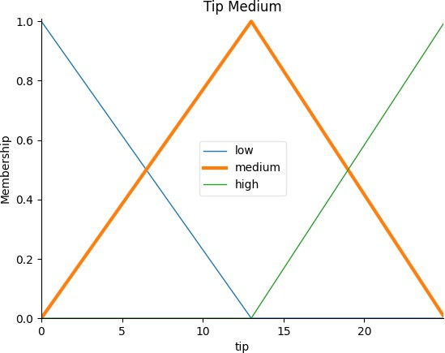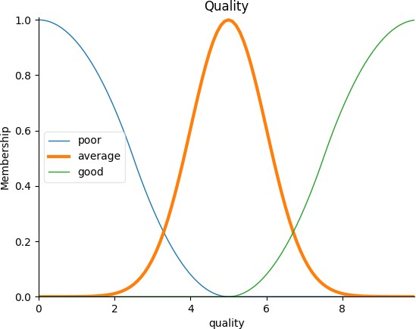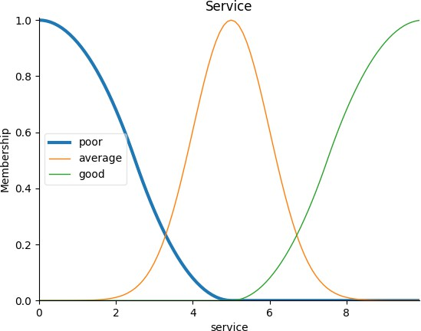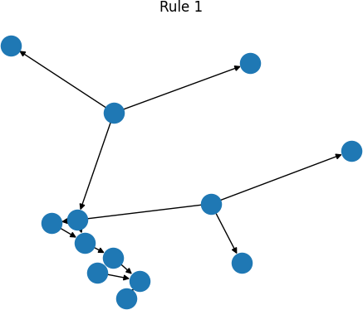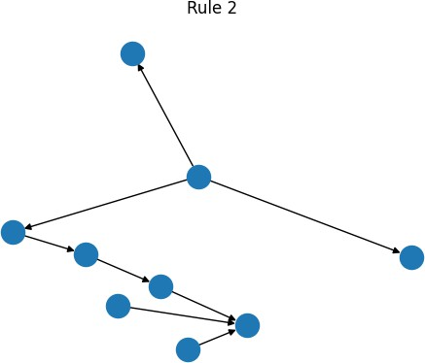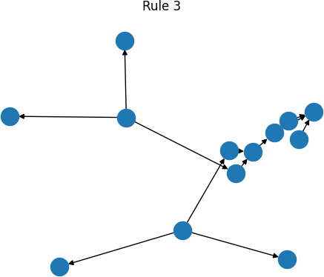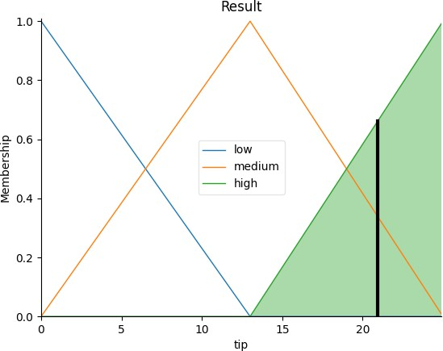

# PRACTICAL 7

1. **AIM:** Write an application to stimulate supervised learning model.

**CODE:**

from sklearn.model_selection import train_test_split from sklearn.neighbors import KNeighborsClassifier

from sklearn.metrics import classification_report, confusion_matrix from sklearn import datasets

iris=datasets.load_iris() x = iris.data

y = iris.target

print ('sepal-length', 'sepal-width', 'petal-length', 'petal-width') print(x)

print('class: 0-Iris-Setosa, 1- Iris-Versicolour, 2- Iris-Virginica') print(y)

x_train, x_test, y_train, y_test = train_test_split(x,y,test_size=0.3) #To Training the model and Nearest nighbors K=5

classifier = KNeighborsClassifier(n_neighbors=5) classifier.fit(x_train, y_train)

#To make predictions on our test data y_pred=classifier.predict(x_test) print('Confusion Matrix') print(confusion_matrix(y_test,y_pred)) print('Accuracy Metrics')

print(classification_report(y_test,y_pred))

**OUTPUT:**

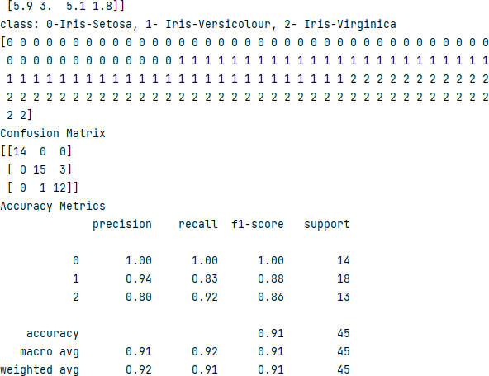

1. **AIM:** Write an application to stimulate unsupervised learning model.

**CODE:**

# Importing Modules

from scipy.cluster.hierarchy import linkage, dendrogram import matplotlib.pyplot as plt

import pandas as pd

# Reading the DataFrame

seeds_df = pd.read_csv("seeds-less-rows.csv")

# Remove the grain species from the DataFrame, save for later varieties = list(seeds_df.pop('grain_variety'))

# Extract the measurements as a NumPy array samples = seeds_df.values

"""

Perform hierarchical clustering on samples using the

linkage() function with the method='complete' keyword argument. Assign the result to mergings.

"""

mergings = linkage(samples, method='complete')

"""

Plot a dendrogram using the dendrogram() function on mergings, specifying the keyword arguments labels=varieties, leaf_rotation=90, and leaf_font_size=6.

"""

dendrogram(mergings,

labels=varieties, leaf_rotation=90, leaf_font_size=6,

)

plt.show()

**OUTPUT:**

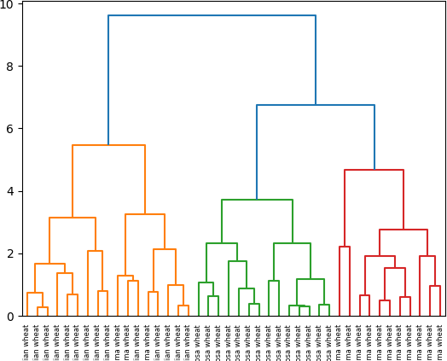

# PRACTICAL 8

**AIM:** Write an application to implement clustering algorithm.

**CODE:**

import matplotlib.pyplot as plt from sklearn import datasets

from sklearn.cluster import KMeans import sklearn.metrics as sm import pandas as pd

import numpy as np

iris = datasets.load_iris()

X = pd.DataFrame(iris.data)

X.columns = ['Sepal_Length','Sepal_Width','Petal_Length','Petal_Width'] y = pd.DataFrame(iris.target)

y.columns = ['Targets'] model = KMeans(n_clusters=3) model.fit(X) plt.figure(figsize=(14,7))

colormap = np.array(['red', 'lime', 'black']) # Plot the Original Classifications plt.subplot(1, 2, 1) plt.scatter(X.Petal_Length, X.Petal_Width, c=colormap[y.Targets], s=40)

plt.title('Real Classification') plt.xlabel('Petal Length') plt.ylabel('Petal Width')

# Plot the Models Classifications plt.subplot(1, 2, 2) plt.scatter(X.Petal_Length, X.Petal_Width, c=colormap[model.labels_], s=40) plt.title('K Mean Classification') plt.xlabel('Petal Length') plt.ylabel('Petal Width')

plt.show()

print('The accuracy score of K-Mean: ',sm.accuracy_score(y, model.labels_))

print('The

Confusion

matrix

of

K-Mean:

',sm.confusion_matrix(y,

model.labels_))

**OUTPUT:**

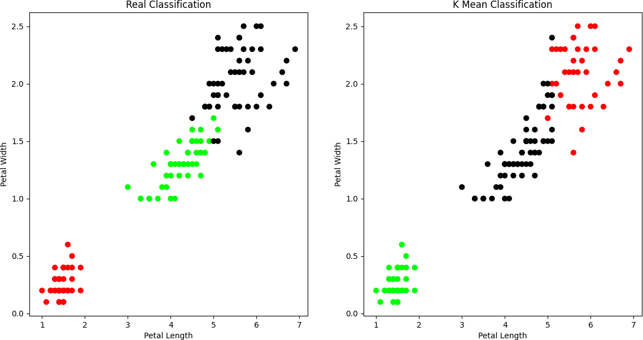

# PRACTICAL 9

**AIM:** Write an application to implement support vector machine algorithm.

**CODE:**

#Import scikit-learn dataset library from sklearn import datasets

#Import svm model

from sklearn import svm

# Import train_test_split function

from sklearn.model_selection import train_test_split

#Import scikit-learn metrics module for accuracy calculation from sklearn import metrics

#Load dataset

cancer = datasets.load_breast_cancer()

# print the names of the 13 features print("Features: ", cancer.feature_names)

# print the label type of cancer('malignant' 'benign') print("Labels: ", cancer.target_names)

# print data(feature)shape

cancer.data.shape

# print the cancer data features (top 5 records)

print(cancer.data[0:5])

# print the cancer labels (0:malignant, 1:benign)

print(cancer.target)

# Split dataset into training set and test set

X_train, X_test, y_train, y_test = train_test_split(cancer.data, cancer.target, test_size=0.3,random_state=109) # 70% training and 30% test

#Create a svm Classifier

clf = svm.SVC(kernel='linear') # Linear Kernel

#Train the model using the training sets

clf.fit(X_train, y_train)

#Predict the response for test dataset

y_pred = clf.predict(X_test)

# Model Accuracy: how often is the classifier correct?

print("Accuracy:",metrics.accuracy_score(y_test, y_pred))

# Model Precision: what percentage of positive tuples are labeled as such?

print("Precision:",metrics.precision_score(y_test, y_pred))

# Model Recall: what percentage of positive tuples are labelled as such? print("Recall:",metrics.recall_score(y_test, y_pred))

**OUTPUT:**

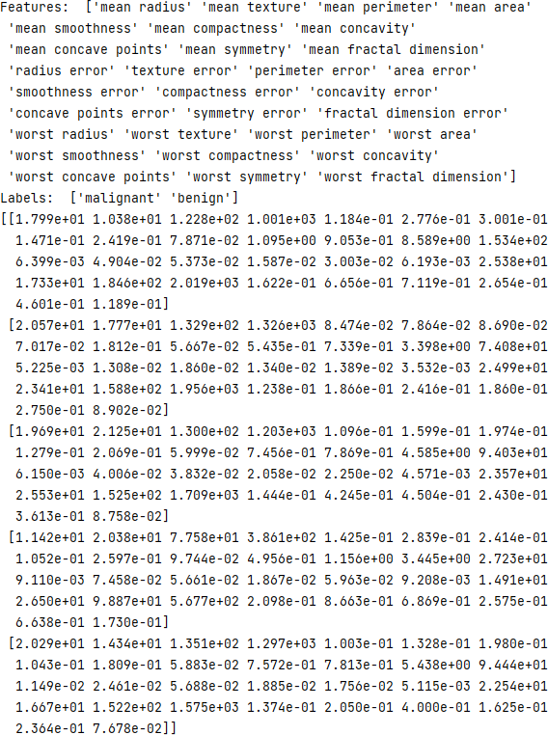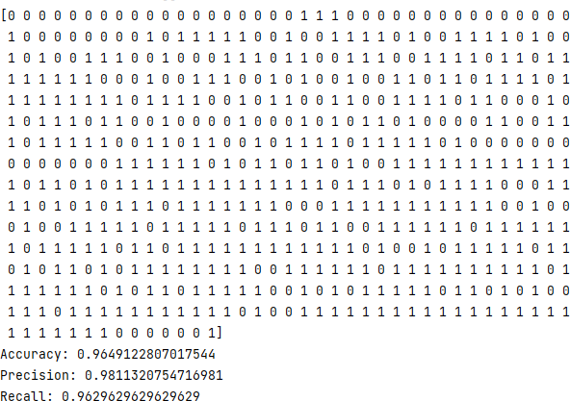

# PRACTICAL 10

**AIM:** Simulate artificial neural network model with both feedforward and backpropagation approach.

**CODE:**

import numpy as np

X = np.array(([2, 9], [1, 5], [3, 6]), dtype=float) [sleep,study]

# two inputs

y = np.array(([92], [86], [89]), dtype=float) # one output [Expected % in Exams]

X = X / np.amax(X, axis=0) # maximum of X array longitudinally

y = y / 100

# Sigmoid Function def sigmoid(x):

return 1 / (1 + np.exp(-x))

# Derivative of Sigmoid Function def derivatives_sigmoid(x):

return x * (1 - x)

# Variable initialization

epoch = 5000 # Setting training iterations lr = 0.1 # Setting learning rate

inputlayer_neurons = 2 # number of features in data set

hiddenlayer_neurons = 3 # number of hidden layers neurons output_neurons = 1 # number of neurons at output layer

# weight and bias initialization

wh = np.random.uniform(size=(inputlayer_neurons, hiddenlayer_neurons)) # weight of the link from input node to hidden node

bh = np.random.uniform(size=(1, hiddenlayer_neurons)) # bias of the link from input node to hidden node

wout = np.random.uniform(size=(hiddenlayer_neurons, output_neurons)) # weight of the link from hidden node to output node

bout = np.random.uniform(size=(1, output_neurons)) # bias of the link from hidden node to output node

# draws a random range of numbers uniformly of dim x*y

for i in range(epoch):

# Forward Propogation

hinp1 = np.dot(X, wh)

hinp = hinp1 + bh

hlayer_act = sigmoid(hinp)

outinp1 = np.dot(hlayer_act, wout)

outinp = outinp1 + bout

output = sigmoid(outinp)

# Backpropagation

EO = y - output

outgrad = derivatives_sigmoid(output)

d_output = EO * outgrad

EH = d_output.dot(wout.T)

# how much hidden layer weights contributed to error

hiddengrad = derivatives_sigmoid(hlayer_act)

d_hiddenlayer = EH * hiddengrad

# dotproduct of nextlayererror and currentlayerop

wout += hlayer_act.T.dot(d_output) * lr

wh += X.T.dot(d_hiddenlayer) * lr print("Input: \n" + str(X)) print("Actual Output: \n" + str(y))

print("Predicted Output: \n", output)

**OUTPUT:**

