Progressive Education Society's



**Modern College of Engineering, Pune**

**MCA Department**

**A.Y.2022-23**

**(410907)** **Software Testing Laboratory**

*****************************************************************************************

Class: SY-MCA Shift / Div : S1/ B Roll Number : 52119

Name: Harsh Ghodke Assignment No : 4 Date of Implementation : 05/10/24

***************************************************************************************** **Q1. Install Selenium IDE in Mozilla Firefox/ Google Chrome**

**Using “https://accounts.google.com” Test Gmail Login Logout functionality in**

**IDE( Record and Replay)**

 **Test Gmail login functionality with incorrect username and correct password.**

* **Test Gmail login functionality with incorrect username and incorrect password.**

**Test Gmail login functionality with correct username and correct password.**

Output:

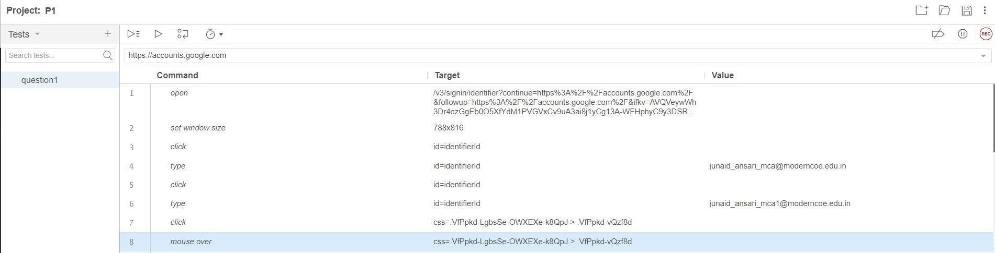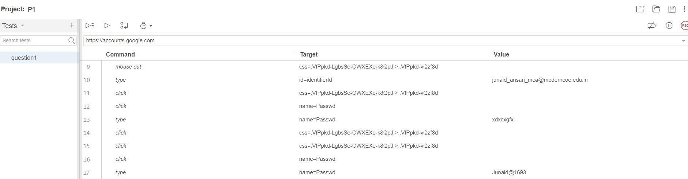

**Q2. Test following scenario in Selenium IDE using record and replay Invoke Google Chrome browser.**

 **Open URL: www.google.com**

* **Click on the Google Search text box.**
* **Type the value &quot;java tutorials&quot;**

**Click on any of java tutorial link**

Output:

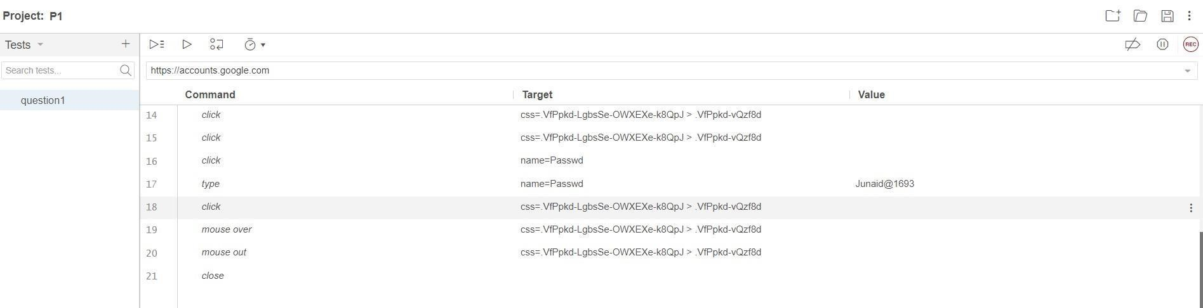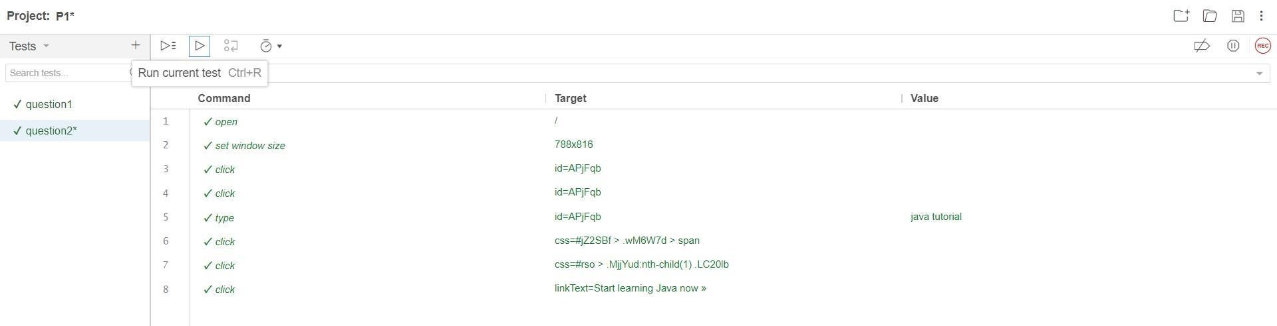

**Q3. Automate Gmail/Rediffmail/Hotmail login flow using Selenium Web Driver Code:**

package l;

import org.openqa.selenium.WebDriver; import org.openqa.selenium.WebElement; import org.openqa.selenium.chrome.ChromeDriver; import org.openqa.selenium.firefox.FirefoxDriver; import org.openqa.selenium.support.ui.ExpectedConditions; import org.openqa.selenium.support.ui.WebDriverWait; //import java.util.concurrent.TimeUnit; import

org.openqa.selenium.By; public class GmailLogin{

public static void main(String[] args) {

System.setProperty("webdriver.gecko.driver",

"D:\\installers\\driver\\geckodriver.exe");

WebDriver driver = new FirefoxDriver(); driver.get("https://www.gmail.com");

// Find the email input field and enter your email

WebElement emailInput = driver.findElement(By.id("identifierId")); emailInput.sendKeys("junaid_ansari_mca@moderncoe.edu.in"); // Click the "Next" button

WebElement nextButton = driver.findElement(By.id("identifierNext")); nextButton.click();

// Wait for the password input field to be visible

// (You may need to add proper waits for your specific scenario)

// For simplicity, we use a sleep here, but it's not recommended for production code try {

Thread.sleep(20000);

} catch (InterruptedException e) { e.printStackTrace();

}

// WebElement nextButton = driver.findElement(By.id("identifierNext")); nextButton.click(); //selectioni7 driver.quit();

}

}

**Q4. Handle multiple windows using Selenium. (use site naukri.com) using Selenium Web Driver Code:**

package l; import org.openqa.selenium.By; import org.openqa.selenium.WebDriver; import org.openqa.selenium.WebElement; import org.openqa.selenium.firefox.FirefoxDriver; import org.zeromq.ZStar.Set;

public class multiplePage

{

public static void main(String[] args) {

System.setProperty("webdriver.gecko.driver",

"D:\\installers\\driver\\geckodriver.exe");

WebDriver driver = new FirefoxDriver(); driver.get("https://www.naukri.com/");

// Get the current window handle

String mainHandle = driver.getWindowHandle();

// Click on a link that opens a new window

WebElement newWindowLink = driver.findElement(By.linkText("Register")); newWindowLink.click();

WebElement newWindowLink1 = driver.findElement(By.linkText("Login")); newWindowLink1.click();

// Get all window handles

// Close the main window driver.quit();

}

}