Progressive Education Society's

Modern College of Engineering, Pune

**MCA Department A.Y.2024-25**

**(410907) Internet of Things**

******************************************************************************

Class: FY-MCA Shift / Div : B Roll Number : 52119

Name: Harsh Ghodke Assignment No: 2 Date of Implementation: 02-08-2024

******************************************************************************

**Q.1) Interfacing temperature sensor with Arduino board and program to display temperature.**

**Code:**

#include <LiquidCrystal.h>

LiquidCrystal lcd(12, 11, 5, 4, 3, 2);

const int sensorPin = A0;

void setup() {

Serial.begin(9600);

lcd.begin(16, 2);

lcd.print("Temp: ");

}

void loop() {

int sensorValue = analogRead(sensorPin);

float voltage = sensorValue * (5.0 / 1023.0);

float temperatureC = (voltage - 0.5) * 100.0;

Serial.print("Temperature: ");

Serial.print(temperatureC);

Serial.println(" C");

lcd.setCursor(6, 0);

lcd.print(temperatureC);

lcd.print((char)223);

lcd.print("C");

delay(1000);

}

**Output:**

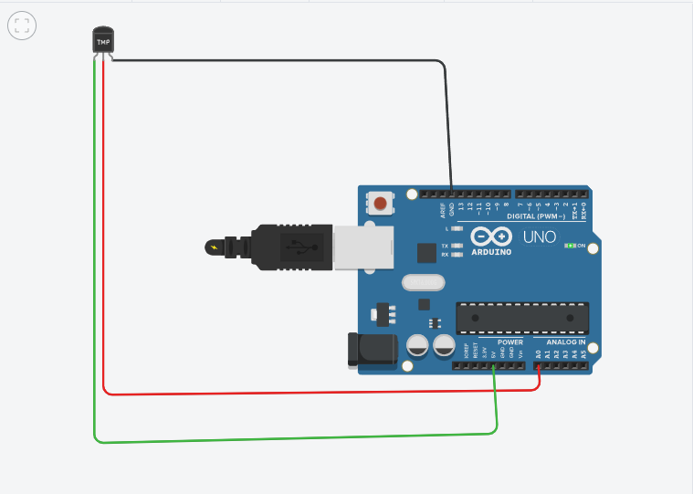

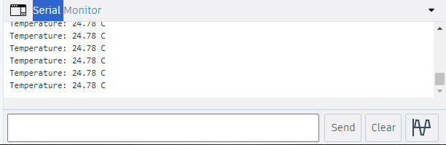

**Q.2)** **Interfacing PIR sensor with Arduino board and program to turn on buzzer when motion detected**

**Code:**

const int pirPin = 2;

const int buzzerPin = 8;

void setup() {

pinMode(pirPin, INPUT);

pinMode(buzzerPin, OUTPUT);

Serial.begin(9600);

}

void loop() {

int motionDetected = digitalRead(pirPin);

if (motionDetected == HIGH) {

digitalWrite(buzzerPin, HIGH);

Serial.println("Motion detected! Buzzer ON.");

} else {

digitalWrite(buzzerPin, LOW);

Serial.println("No motion. Buzzer OFF.");

}

delay(500);

}

**Output:**

