Progressive Education Society's

Modern College of Engineering, Pune

**MCA Department A.Y.2024-25**

**(410907) Internet of Things**

******************************************************************************

Class: FY-MCA Shift / Div : A Roll Number : 52119

Name: Harsh Ghodke Assignment No: 3 Date of Implementation: 20-08-2024

******************************************************************************

**Q.1)** **Interface RGB LED with Arduino board and program to display all possible color**

**Code:**

const int redPin = 9;

const int greenPin = 10;

const int bluePin = 11;

void setup() {

pinMode(redPin, OUTPUT);

pinMode(greenPin, OUTPUT);

pinMode(bluePin, OUTPUT);

}

void loop() {

setColor(255, 0, 0); // Red

delay(1000);

setColor(0, 255, 0); // Green

delay(1000);

setColor(0, 0, 255); // Blue

delay(1000);

setColor(255, 255, 0); // Yellow

delay(1000);

setColor(0, 255, 255); // Cyan

delay(1000);

setColor(255, 0, 255); // Magenta

delay(1000);

setColor(255, 255, 255); // White

delay(1000);

setColor(0, 0, 0);

delay(1000);

}

void setColor(int redValue, int greenValue, int blueValue) {

analogWrite(redPin, redValue);

analogWrite(greenPin, greenValue);

analogWrite(bluePin, blueValue);

}

**Output:**

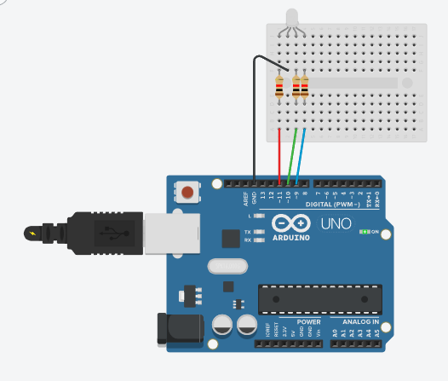

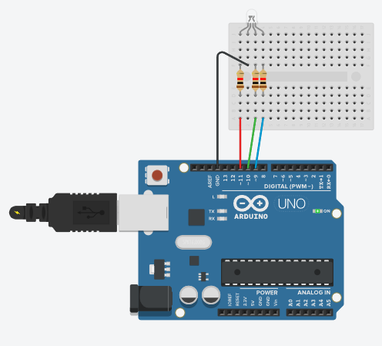

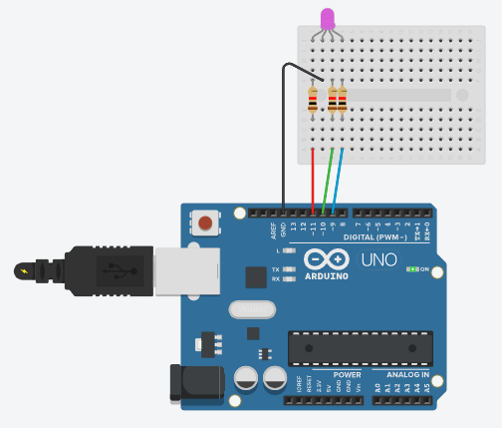

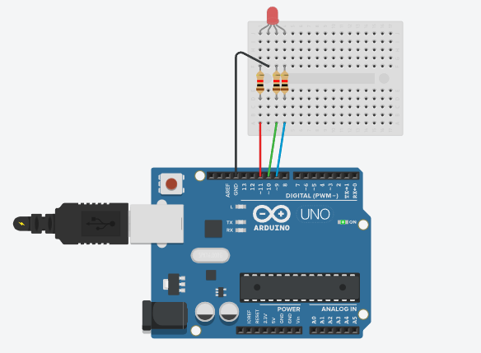

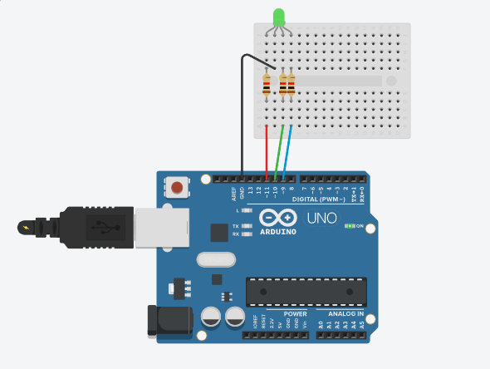

**Q.2)** **Understanding the connectivity of Arduino board circuit with temperature sensor. Write an application to read the environment temperature. If temperature crosses a threshold value, the application indicated user using LEDSs**

**Code:**

int baselineTemp = 0;

int celsius = 0;

void setup()

{

pinMode(A0, INPUT);

Serial.begin(9600);

pinMode(2, OUTPUT);

pinMode(3, OUTPUT);

digitalWrite(2, LOW);

digitalWrite(3, LOW);

}

void loop()

{

baselineTemp = 20;

celsius = map(((analogRead(A0) - 20) * 3.04), 0, 1023, -40, 125);

Serial.print(celsius);

Serial.println(" C, ");

if (celsius < baselineTemp) {

digitalWrite(2, LOW);

digitalWrite(3, LOW);

}

if (celsius >= baselineTemp && celsius < baselineTemp + 20) {

digitalWrite(2, HIGH);

digitalWrite(3, LOW);

}

if (celsius >= baselineTemp + 20 && celsius < baselineTemp + 40) {

digitalWrite(2, LOW);

digitalWrite(3, HIGH);

}

if (celsius >= baselineTemp + 40) {

digitalWrite(2, HIGH);

digitalWrite(3, HIGH);

}

delay(1000);

}

**Output:**

