Aim: Using Code Pipeline to automate the hosting of Static web game with S3

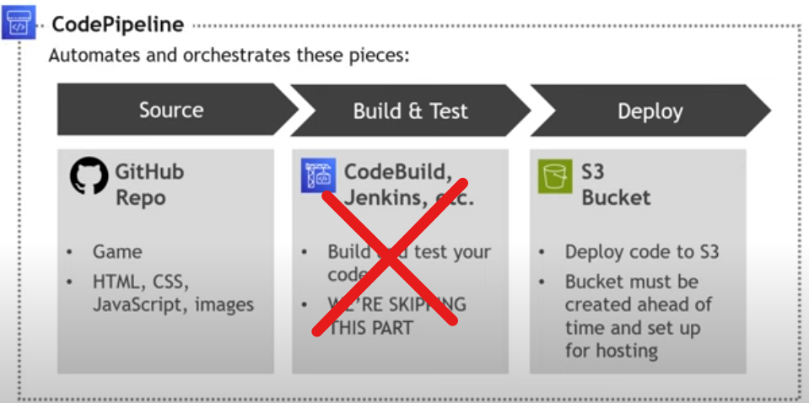

The code for the game is in my Github Reopsitory

Firstly lets set up s3 bucket > navigate to s3



Create a bucket

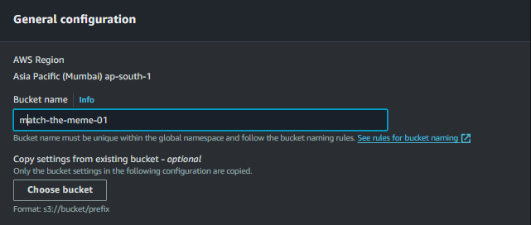



Rest all as default

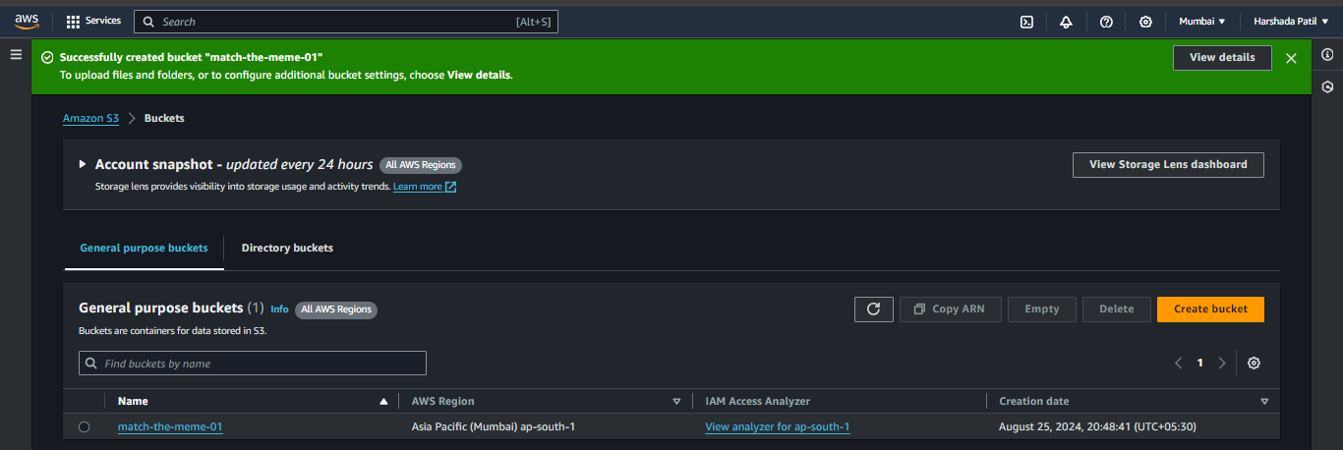

Open the bucket by clicking on the bucket name > properties > static website hosting

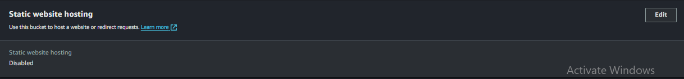

Edit > Static web hosting (enable) > index document(index.html) > rest all default > save changes

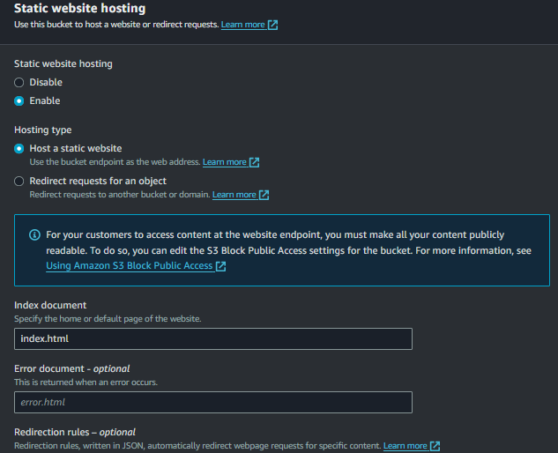

Permissions > Bucket policy > edit > add your bucket name there in the policy

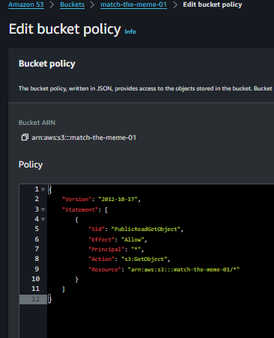

Now let’s set up a code pipeline > navigate to code pipeline

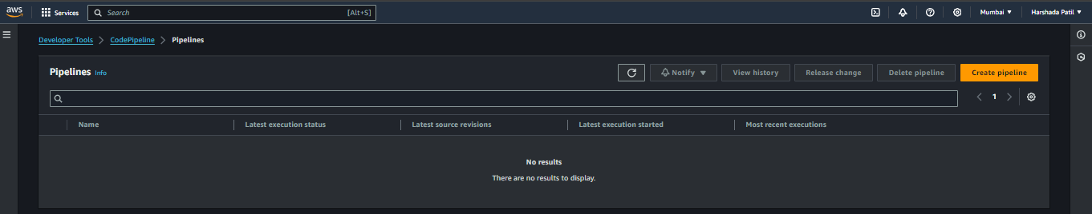

Create pipeline > name the pipeline (matchthememe-pipeline > execution mode ( Superseded If you want a behavior similar to V1, this is the closest match.) > next

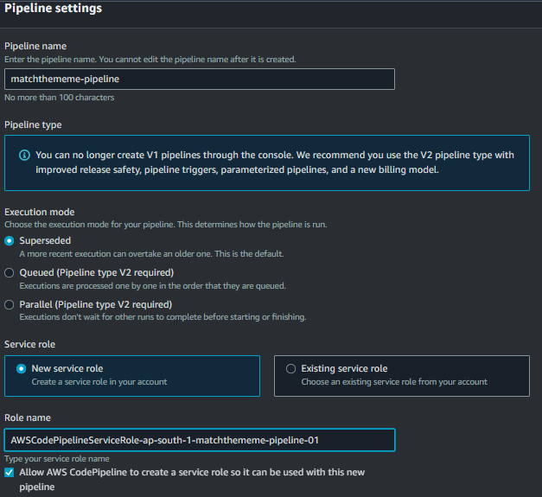

Source provider (Github version-2) > connect to github

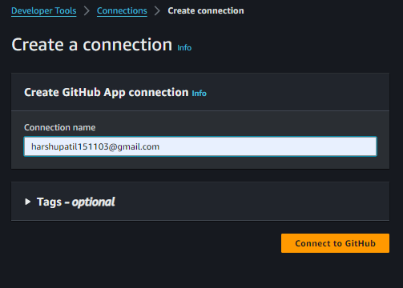

Authorize it

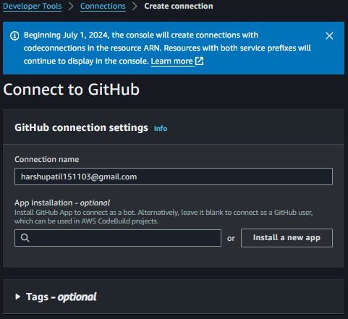

Install a new app

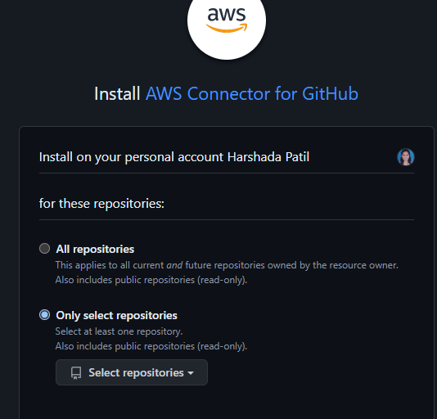

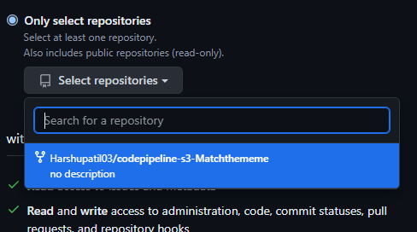

Install

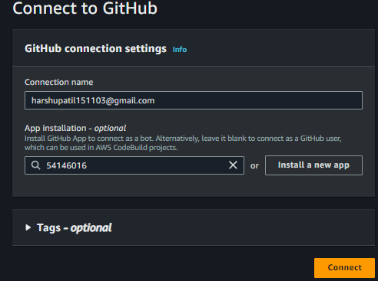

After connecting back to main page > you can see the connection has been established > select the repo name > default branch (main)

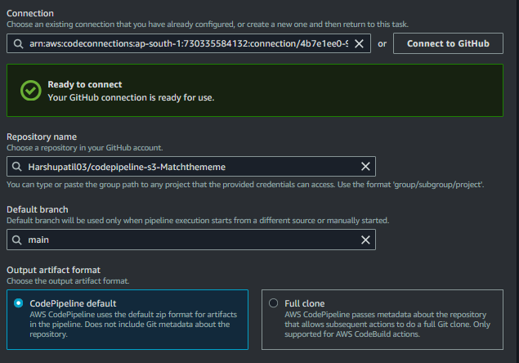

Trigger type > specify trigger > event type ( push) > filter type ( branch) > branches ( main) > next

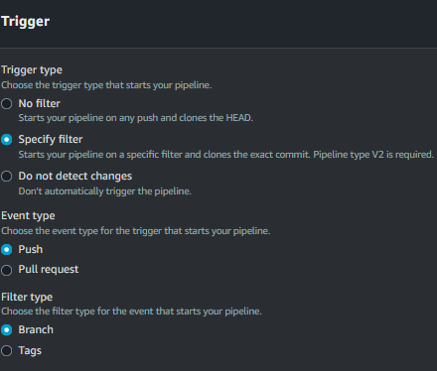

Skip the above step

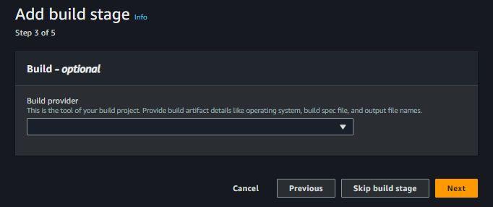

Deploy provider S3 > region Mumbai > input artefact source artefact > bucket (our bucket) > enable extract file before deploy > next

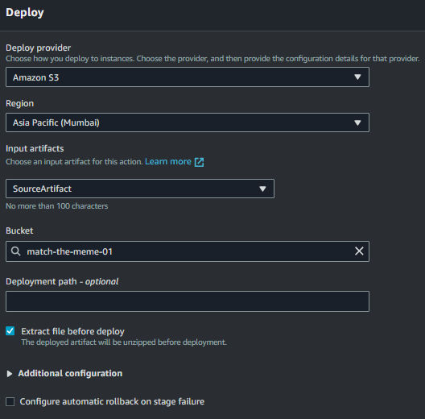

Review > create pipeline.

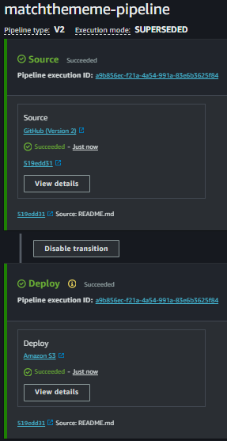

Go to s3 > bucket > properties > static website 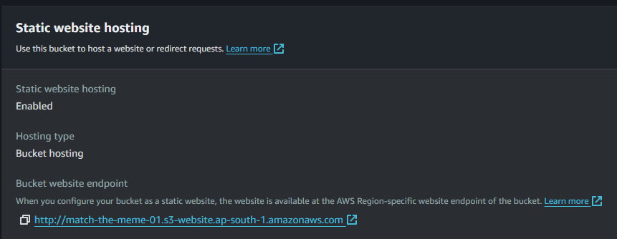

Click on the bucket website endpoint link > you will our game is successfully hosted>

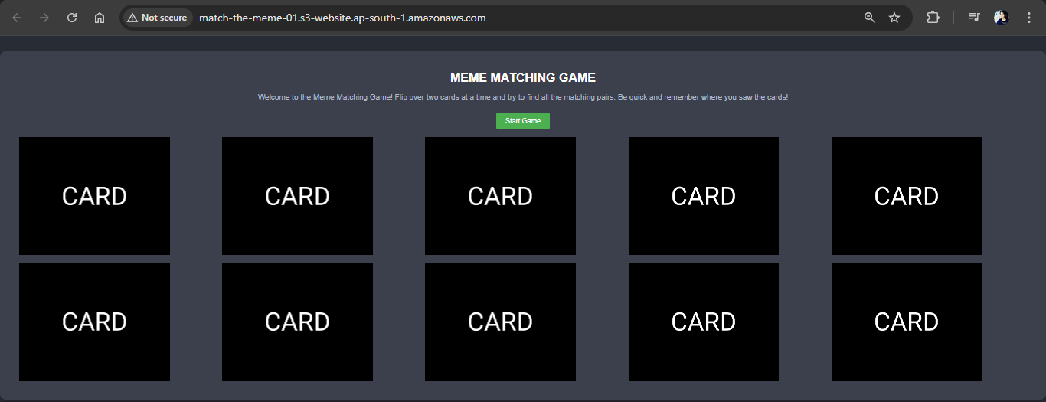

Let’s do some changes to our code to see if the code pipeline is automating the changes done to the game or not

Go to our repo

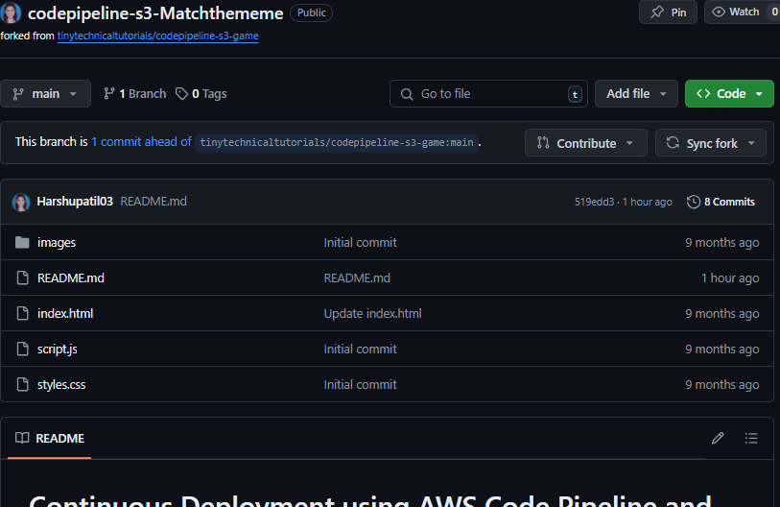

In index in html

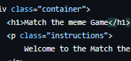 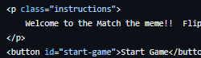

> commit changes.



We can see the changes have been done.



# Match the me

**Match the meme Game**