Exercise No: 1

Date: 10/10/2020

**Aim:**

To create a python program to display calendar of the month from user’s input of year and month, if the year is not in 4 digits and month is not valid, then Invalid input statement in printed.

**Program:**

import calendar as cal

y=int(input("Enter the year:"))

m=int(input("Enter the month:"))

if((y>999 and y<10000) and (m>0 and m<13)):

print(cal.month(y,m))

else:

print("Invalid Input")

**Link:**

<http://103.53.53.18/mod/vpl/forms/edit.php?id=229&userid=1657#>

**Output:**

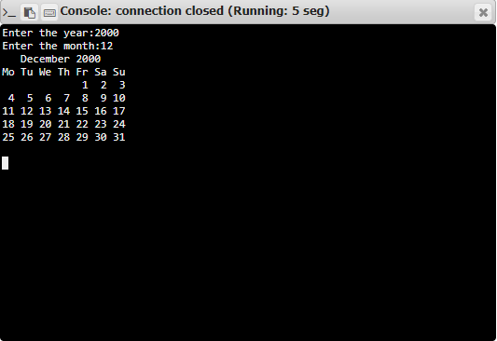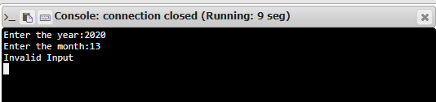

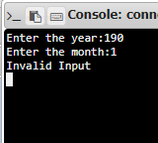

**Result:**

Thus, the program is executed, and required output is obtained.