Exercise No: 10

Date: 21/11/2020

**Aim:**

To create a python program to count the number of lower case and upper case characters in the given input string.

**Program:**

def casecount(s):

c={"Upper Case":0, "Lower Case":0}

for i in range(len(s)):

if(s[i].isupper()):

c["Upper Case"]+=1

elif(s[i].islower()):

c["Lower Case"]+=1

print("No. of Upper case characters :",c["Upper Case"])

print("No. of Lower case characters :",c["Lower Case"])

s=input()

p=casecount(s)

**Link:**

<http://103.53.53.18/mod/vpl/forms/submissionview.php?id=325&userid=1657>

**Output:**

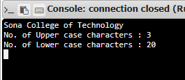

**Result:**

Thus, the program for obtaining count of lowercase and uppercase characters in a string is successfully executed and the output is obtained.