Exercise No: 11

Date: 21/11/2020

**Aim:**

To create a python program to display the greatest common divisor of two numbers taken as input.

**Program:**

def gcd(x,y):

if(x==0):

return x

elif(y==0):

return y

elif(x==y):

return x

elif(x>y):

return(gcd(x-y,y))

else:

return(gcd(x,y-x))

a=int(input("Enter First number:"))

b=int(input("Enter Second number:"))

GCD=gcd(a,b)

print("GCD is: ")

print(GCD)

**Link:**

<http://103.53.53.18/mod/vpl/forms/submissionview.php?id=326&userid=1657>

**Output:**

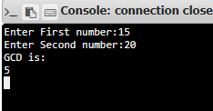

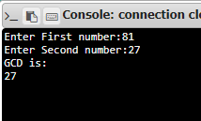

**Result:**

Thus, the program for obtaining Greatest Common Divisor of two numbers is successfully executed and the GCD is obtained.