Exercise No: 14

Date: 23/11/2020

**Aim:**

To create a python program to check whether all brackets, square brackets and parenthesis are properly balanced in a string.

**Program:**

def BalanceCheck(expr):

stack=[]

openers=['{','[','(']

for i in range(len(expr)):

if(expr[i] in openers):

stack.append(expr[i])

else:

if not stack:

return False

cursor=stack.pop()

if(cursor == '{' and expr[i]!='}'):

return False

if(cursor == '[' and expr[i]!=']'):

return False

if(cursor == '(' and expr[i]!=')'):

return False

if stack:

return False

else:

return True

str1=input()

if(BalanceCheck(str1)):

print("valid")

else:

print("invalid")

**Link:**

<http://103.53.53.18/mod/vpl/forms/submissionview.php?id=327&userid=1657>

**Output:**

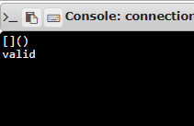

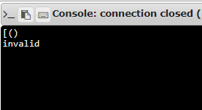

**Result:**

Thus, the program for checking the balance of all types of opening and closing brackets, square brackets and parenthesis is successfully executed and the output is obtained.