Exercise No: 2

Date: 10/10/2020

**Aim:**

To create a python program to find the occurrences of an element in the list.

**Program:**

def countX(lst,X):

c=0

for ele in lst:

if(x==ele):

c=c+1

return c

n=int(input("Enter the number of elements in list:"))

print("Enter elements of list:")

list1=[]

for i in range(0,n):

temp=int(input())

list1.append(temp)

x=int(input("Enter the element to be searched:"))

count=countX(list1,x)

print("No.of occurrences: ",count)

**Link:**

<http://103.53.53.18/mod/vpl/forms/edit.php?id=230&userid=1657#>

**Output:**

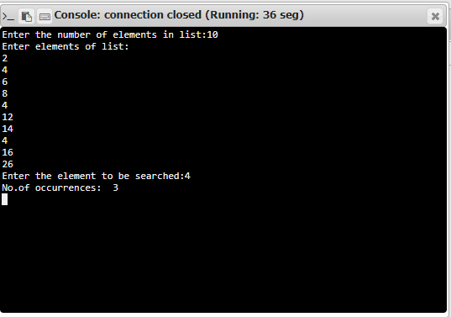

**Result:**

Thus, the program is executed and output of occurrence count Is obtained.