Exercise No: 3

Date: 10/10/2020

**Aim:**

To create a python program to print every second element in a list until the list becomes empty.

**Program:**

def removeThirdNumber(int_list):

pos=1

index=0

l=(len(int_list))

while l>0:

index = (pos+index)%l

print(int_list.pop(index))

l-=1

list1=[]

n=int(input("Enter size of list:"))

print(“Enter elements in the list:”)

for i in range(0,n):

t=int(input())

list1.append(t)

print("Order of removed elements")

removeThirdNumber(list1)

**Link:**

<http://103.53.53.18/mod/vpl/forms/edit.php?id=231&userid=1657#>

**Output:**

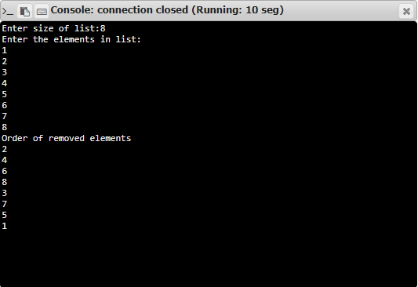

**Result:**

Thus, the program for printing and removing every second number from the list is successfully executed and required output is obtained.