Exercise No: 4

Date: 14/10/2020

**Aim:**

To create a python program to take two string inputs, swap the first two letters and print as a single string.

**Program:**

def strfun(s1,s2):

t1 = s2[:2]+s1[2:]

t2 = s1[:2]+s2[2:]

return t1+' '+t2

str1=str(input()).strip()

str2=str(input()).strip()

l1=len(str1)

l2=len(str2)

if(l1<2 or l2<2):

print("Invalid")

else:

res=strfun(str1,str2)

print(res)

**Link:**

http://103.53.53.18/mod/vpl/forms/edit.php?id=234&userid=1657#

**Output:**

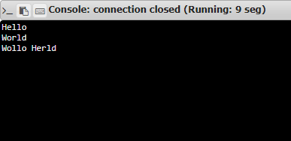

**Result:**

Thus, the program for swapping first two letters and printing as single string is successfully executed and the output is obtained.