Exercise No: 5

Date: 17/10/2020

**Aim:**

To create a python program to take a input string and verify whether it is a pangram or not.

**Program:**

def pangram(s):

alphabets="abcdefghijklmnopqrtsuvwxyz"

y=[i for i in alphabets if i in s]

n=[j for j in alphabets if j not in s]

if(len(y)==26):

res="Yes it is a Pangram, as all alphabets are included"

return res

else:

res="".join([str(i) for i in n])

print("Alphabets required to make it a pangram are:")

return res

s1=str(input())

s1=s1.lower()

#for avoiding case errors

s2=pangram(s1)

print(s2)

**Link:**

http://103.53.53.18/mod/vpl/forms/edit.php?id=235&userid=1657#

**Output:**

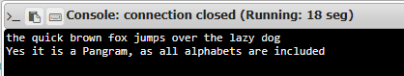

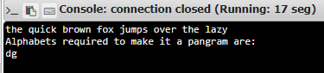

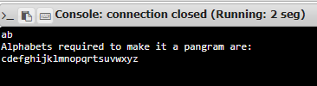

**Result:**

Thus, the program for finding missing alphabets to make the string pangram is successfully executed and the required output is obtained.