Exercise No: 8

Date: 23/11/2020

**Aim:**

To create a python program to get a tuples input with numbers, print the numbers paired with its cube in the tuple, and finally display it in sorted manner.

**Program:**

def sort(list1):

return sorted(list1,key=last)

def last(n):

return n[-1]

n=int(input())

mlist=[]

clist=[]

for i in range(n):

num=int(input())

mlist.append(num)

clist.append(num*num*num)

tuples_list=list(zip(mlist,clist))

print(tuples_list)

print(sort(tuples_list))

**Link:**

<http://103.53.53.18/mod/vpl/forms/submissionview.php?id=317&userid=1657>

**Output:**

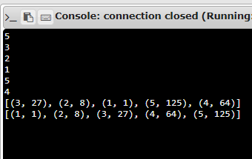

**Result:**

Thus, the program for obtaining a tuple list with numbers and its cube values, and a sorted tuple list is successfully executed and the output is obtained.