1965 to 1999 STM Model

Charles J. Gomez, Harshvardhan Singh

2023-08-29

library(stringr)  
library(ggplot2)  
library(wordcloud)

## Loading required package: RColorBrewer

library(stm)

## stm v1.3.6 successfully loaded. See ?stm for help.   
## Papers, resources, and other materials at structuraltopicmodel.com

#Read csv file  
data = read.csv("preprocessed_data_Jul14.csv")  
  
# Define the publication intervals  
pub_intervals <- c("pub_interval_1995_1999",  
 "pub_interval_1985_1994", "pub_interval_1975_1984", "pub_interval_1965_1974") #,"pub_interval_1900_1964", "pub_interval_1824_1899")  
  
  
# Define K values for each interval  
K_values <- c(44, 45, 43, 40) #16,2  
  
# Loop over each publication interval  
for (idx in seq_along(pub_intervals)) {  
 pub_interval <- pub_intervals[idx]  
 print(paste("Processing interval:", pub_interval))  
   
 # Filter data for the current publication interval  
 data_filtered <- data[data[[pub_interval]] == 1, ]  
  
# Save the original title data for future use  
data_filtered$original_concatenated_title_abstract <- data_filtered$concatenated_title_abstract  
  
#pre-processing the titles using textProcessor from the stm package  
processed_text <- textProcessor(data_filtered$concatenated_title_abstract, metadata = data_filtered)   
  
# Further prepare the data by removing low-frequency terms  
out_text <- prepDocuments(processed_text$documents, processed_text$vocab, processed_text$meta)  
docs_text <- out_text$documents  
vocab_text <- out_text$vocab  
meta_text <- out_text$meta  
  
  
#Prepare data  
plotRemoved(processed_text$documents, lower.thresh = seq(1, 200, by = 100))  
out_text <- prepDocuments(processed_text$documents, processed_text$vocab, processed_text$meta, lower.thresh = 15)  
  
  
# Initialize an empty formula string  
prevalence_formula_str <- "~US "  
  
  
# Add each country variable to the formula string  
for (i in 10:27) {  
 prevalence_formula_str <- paste(prevalence_formula_str, "+", names(data)[i])  
}  
  
  
# Convert the string to a formula  
prevalence_formula <- as.formula(prevalence_formula_str)  
print(prevalence_formula)  
  
# Run STM model  
Research_topics <- stm(documents = out_text$documents,   
 vocab = out_text$vocab,   
 K = K_values[idx],   
 prevalence = prevalence_formula,   
 data = out_text$meta,   
 init.type = "Spectral",  
 max.em.its = 1000,  
 gamma.prior = 'L1')  
  
  
# Plot the STM model summary  
plot(Research_topics, type = "summary", xlim = c(0, 0.3))  
  
# Print the top 10 labels for each topic  
topic_labels <- labelTopics(Research_topics, n=10)  
print(topic_labels)  
  
# Match the processed documents with the original titles  
matched_titles <- out_text$meta$original_concatenated_title_abstract  
  
# Print top 5 documents for each topic  
top_docs <- findThoughts(Research_topics, texts = matched_titles, n = 5)$docs[[1]]  
print(top_docs)  
  
# Find and plot the key "thoughts" or documents for selected topics  
thoughts6 <- findThoughts(Research_topics, texts = matched_titles, n = 3, topics = 6)$docs[[1]]  
thoughts18 <- findThoughts(Research_topics, texts = matched_titles, n = 3, topics = 18)$docs[[1]]  
par(mfrow = c(1, 2), mar = c(0.5, 0.5, 1, 0.5))  
plotQuote(thoughts6, width = 30, main = "Topic 6")  
plotQuote(thoughts18, width = 30, main = "Topic 18")  
  
# Calculate and plot the correlation between topics  
mod.out.corr <- topicCorr(Research_topics)  
plot(mod.out.corr, cex = 1.5)  
  
  
# For each topic  
for (topic_num in 1:K_values[idx]) {  
 # Plot the word cloud  
 cloud(Research_topics, topic = topic_num, scale = c(2, 0.25))  
 Sys.sleep(2)  
}  
  
# Get the topic proportions for each document  
topic_proportions <- Research_topics$theta  
  
# Find the index of the topic with the highest proportion for each document  
# This will be the topic that each document is most likely to belong to  
max_topic_idx <- apply(topic_proportions, 1, which.max)  
  
# Add this as a new column to your data  
data_filtered$topic <- max_topic_idx  
  
  
# Define the countries  
countries <- c("US", "GB", "DE", "IT", "AU", "CA", "JP", "CN", "NL", "FR", "RU", "ES", "IN", "IL", "CH", "Americas", "Europe", "Africa", "AsiaAndOceania")  
  
  
  
# Create function to generate histogram  
make_histogram <- function(country_code) {  
   
 # Filter data for country with contribution of 100  
 data_100 <- data_filtered[data_filtered[[country_code]] == 100,]  
   
 # Filter data for country with contribution not equal to 0  
 data_not_0 <- data_filtered[data_filtered[[country_code]] != 0,]  
   
 # Make the first histogram  
 hist_100 <- ggplot(data_100, aes(x = topic)) +  
 geom_histogram(binwidth = 1, fill = "blue", color = "black") +  
 xlab("Topic") +  
 ylab("Count") +  
 ggtitle(paste(country_code, "Independent Contribution"))  
   
 # Make the second histogram  
 hist_not_0 <- ggplot(data_not_0, aes(x = topic)) +  
 geom_histogram(binwidth = 1, fill = "blue", color = "black") +  
 xlab("Topic") +  
 ylab("Count") +  
 ggtitle(paste(country_code, "Contributions (with collaboration)"))  
   
 # Return list of plots  
 return(list(hist_100, hist_not_0))  
}  
  
# Loop over country codes and generate plots  
for (country in countries) {  
 plots <- make_histogram(country)  
   
 # Print the plots  
 print(plots[[1]])  
 print(plots[[2]])  
}  
}

## [1] "Processing interval: pub_interval_1995_1999"  
## Building corpus...   
## Converting to Lower Case...   
## Removing punctuation...   
## Removing stopwords...   
## Removing numbers...   
## Stemming...   
## Creating Output...   
## Removing 4825 of 17035 terms (4825 of 597903 tokens) due to frequency   
## Your corpus now has 7217 documents, 12210 terms and 593078 tokens.

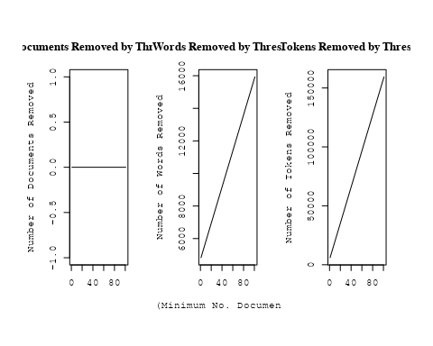

## Removing 14162 of 17035 terms (42995 of 597903 tokens) due to frequency   
## Your corpus now has 7217 documents, 2873 terms and 554908 tokens.~US + IN + DE + CH + GB + CN + FR + IT + RU + CA + NL + AU +   
## JP + ES + IL + Americas + Europe + Africa + AsiaAndOceania  
## Beginning Spectral Initialization   
## Calculating the gram matrix...  
## Finding anchor words...  
## ............................................  
## Recovering initialization...  
## ............................  
## Initialization complete.  
## ....................................................................................................  
## Completed E-Step (9 seconds).   
## Completed M-Step.   
## Completing Iteration 1 (approx. per word bound = -6.628)   
## ....................................................................................................  
## Completed E-Step (8 seconds).   
## Completed M-Step.   
## Completing Iteration 2 (approx. per word bound = -6.435, relative change = 2.905e-02)   
## ....................................................................................................  
## Completed E-Step (7 seconds).   
## Completed M-Step.   
## Completing Iteration 3 (approx. per word bound = -6.382, relative change = 8.230e-03)   
## ....................................................................................................  
## Completed E-Step (7 seconds).   
## Completed M-Step.   
## Completing Iteration 4 (approx. per word bound = -6.360, relative change = 3.525e-03)   
## ....................................................................................................  
## Completed E-Step (7 seconds).   
## Completed M-Step.   
## Completing Iteration 5 (approx. per word bound = -6.347, relative change = 1.919e-03)   
## Topic 1: model, evolut, halo, galaxi, observ   
## Topic 2: accret, rate, disc, hole, black   
## Topic 3: galaxi, dwarf, hole, black, interstellar   
## Topic 4: planet, comet, survey, planetari, sourc   
## Topic 5: star, format, galaxi, rate, massiv   
## Topic 6: spectrum, power, solar, measur, data   
## Topic 7: variabl, distanc, binari, project, direct   
## Topic 8: burst, galact, gamma-ray, γray, observ   
## Topic 9: emiss, molecular, line, observ, region   
## Topic 10: orbit, companion, system, object, mass   
## Topic 11: dwarf, white, cool, mass, model   
## Topic 12: galaxi, cluster, ellipt, format, spiral   
## Topic 13: energi, observ, x-ray, emiss, ray   
## Topic 14: dwarf, mass, object, brown, star   
## Topic 15: star, neutron, binari, mass, system   
## Topic 16: line, absorpt, emiss, ioniz, observ   
## Topic 17: pulsar, puls, observ, millisecond, radio   
## Topic 18: wind, shock, nebula, star, veloc   
## Topic 19: cluster, age, globular, star, ngc   
## Topic 20: dust, emiss, background, map, infrar   
## Topic 21: cosmolog, univers, densiti, matter, redshift   
## Topic 22: burst, gamma-ray, grb, energi, afterglow   
## Topic 23: imag, bar, ring, ngc, telescop   
## Topic 24: star, distanc, lmc, hipparco, magellan   
## Topic 25: energi, rate, neutrino, electron, model   
## Topic 26: galaxi, redshift, luminos, survey, function   
## Topic 27: sourc, radio, flux, observ, model   
## Topic 28: period, star, rotat, frequenc, mode   
## Topic 29: abund, grain, element, ratio, solar   
## Topic 30: field, magnet, cloud, polar, turbul   
## Topic 31: galaxi, group, ngc, seyfert, gas   
## Topic 32: disk, mass, rotat, orbit, system   
## Topic 33: type, light, curv, supernova, sne   
## Topic 34: relat, distanc, metal, use, mag   
## Topic 35: lens, len, gravit, event, imag   
## Topic 36: flare, solar, observ, coron, magnet   
## Topic 37: mass, variabl, nova, secondari, observ   
## Topic 38: method, use, calcul, model, result   
## Topic 39: radio, jet, quasar, observ, emiss   
## Topic 40: model, spectra, spectral, atmospher, stellar   
## Topic 41: mass, cluster, dark, halo, matter   
## Topic 42: x-ray, remnant, supernova, emiss, rosat   
## Topic 43: x-ray, hole, black, observ, state   
## Topic 44: ratio, observ, densiti, model, region   
## ....................................................................................................  
## Completed E-Step (7 seconds).   
## Completed M-Step.   
## Completing Iteration 6 (approx. per word bound = -6.340, relative change = 1.160e-03)   
## ....................................................................................................  
## Completed E-Step (7 seconds).   
## Completed M-Step.   
## Completing Iteration 7 (approx. per word bound = -6.335, relative change = 7.906e-04)   
## ....................................................................................................  
## Completed E-Step (7 seconds).   
## Completed M-Step.   
## Completing Iteration 8 (approx. per word bound = -6.332, relative change = 5.664e-04)   
## ....................................................................................................  
## Completed E-Step (7 seconds).   
## Completed M-Step.   
## Completing Iteration 9 (approx. per word bound = -6.329, relative change = 4.366e-04)   
## ....................................................................................................  
## Completed E-Step (7 seconds).   
## Completed M-Step.   
## Completing Iteration 10 (approx. per word bound = -6.326, relative change = 3.614e-04)   
## Topic 1: model, evolut, halo, observ, galaxi   
## Topic 2: accret, rate, disc, hole, black   
## Topic 3: galaxi, gas, dwarf, interstellar, medium   
## Topic 4: planet, planetari, comet, giant, jupit   
## Topic 5: star, format, galaxi, rate, massiv   
## Topic 6: spectrum, power, measur, data, solar   
## Topic 7: variabl, distanc, project, direct, cepheid   
## Topic 8: burst, gamma-ray, galact, observ, bats   
## Topic 9: molecular, emiss, cloud, region, line   
## Topic 10: orbit, companion, system, mass, object   
## Topic 11: dwarf, white, cool, mass, helium   
## Topic 12: galaxi, cluster, group, ellipt, spiral   
## Topic 13: energi, observ, ray, emiss, photon   
## Topic 14: dwarf, mass, object, brown, star   
## Topic 15: star, binari, neutron, mass, system   
## Topic 16: line, absorpt, emiss, ioniz, observ   
## Topic 17: pulsar, puls, psr, observ, radio   
## Topic 18: wind, shock, nebula, outflow, shell   
## Topic 19: cluster, age, globular, star, popul   
## Topic 20: dust, emiss, map, background, infrar   
## Topic 21: cosmolog, univers, densiti, background, redshift   
## Topic 22: burst, gamma-ray, grb, afterglow, energi   
## Topic 23: imag, bar, ngc, ring, telescop   
## Topic 24: star, distanc, veloc, lmc, galact   
## Topic 25: energi, rate, radiat, electron, neutrino   
## Topic 26: galaxi, redshift, survey, luminos, sampl   
## Topic 27: sourc, radio, flux, observ, optic   
## Topic 28: period, rotat, star, frequenc, mode   
## Topic 29: abund, grain, element, ratio, solar   
## Topic 30: field, magnet, polar, cloud, turbul   
## Topic 31: galaxi, seyfert, ngc, activ, nuclei   
## Topic 32: disk, rotat, mass, dynam, format   
## Topic 33: type, light, curv, supernova, sne   
## Topic 34: distanc, relat, use, metal, mag   
## Topic 35: lens, len, gravit, event, imag   
## Topic 36: flare, solar, observ, coron, region   
## Topic 37: nova, mass, secondari, variabl, observ   
## Topic 38: use, method, result, calcul, paramet   
## Topic 39: radio, quasar, jet, observ, emiss   
## Topic 40: model, spectra, spectral, atmospher, stellar   
## Topic 41: mass, cluster, dark, matter, gas   
## Topic 42: x-ray, remnant, emiss, supernova, rosat   
## Topic 43: x-ray, hole, black, observ, state   
## Topic 44: ratio, gas, cloud, densiti, observ   
## ....................................................................................................  
## Completed E-Step (7 seconds).   
## Completed M-Step.   
## Completing Iteration 11 (approx. per word bound = -6.325, relative change = 2.908e-04)   
## ....................................................................................................  
## Completed E-Step (7 seconds).   
## Completed M-Step.   
## Completing Iteration 12 (approx. per word bound = -6.323, relative change = 2.309e-04)   
## ....................................................................................................  
## Completed E-Step (7 seconds).   
## Completed M-Step.   
## Completing Iteration 13 (approx. per word bound = -6.322, relative change = 1.968e-04)   
## ....................................................................................................  
## Completed E-Step (7 seconds).   
## Completed M-Step.   
## Completing Iteration 14 (approx. per word bound = -6.321, relative change = 1.734e-04)   
## ....................................................................................................  
## Completed E-Step (7 seconds).   
## Completed M-Step.   
## Completing Iteration 15 (approx. per word bound = -6.320, relative change = 1.660e-04)   
## Topic 1: model, evolut, observ, predict, halo   
## Topic 2: accret, rate, disc, hole, black   
## Topic 3: galaxi, gas, merger, dwarf, medium   
## Topic 4: planet, planetari, giant, comet, jupit   
## Topic 5: star, format, rate, galaxi, massiv   
## Topic 6: spectrum, power, data, measur, scale   
## Topic 7: variabl, project, distanc, direct, cepheid   
## Topic 8: burst, gamma-ray, galact, observ, event   
## Topic 9: molecular, cloud, emiss, region, observ   
## Topic 10: orbit, companion, system, mass, eccentr   
## Topic 11: dwarf, white, cool, mass, helium   
## Topic 12: galaxi, cluster, group, ellipt, spiral   
## Topic 13: energi, observ, ray, emiss, photon   
## Topic 14: dwarf, object, mass, star, brown   
## Topic 15: star, binari, neutron, mass, system   
## Topic 16: line, absorpt, emiss, ioniz, spectra   
## Topic 17: pulsar, puls, psr, emiss, radio   
## Topic 18: wind, shock, shell, nebula, outflow   
## Topic 19: cluster, age, globular, star, popul   
## Topic 20: dust, emiss, map, infrar, background   
## Topic 21: cosmolog, univers, densiti, background, cosmic   
## Topic 22: burst, gamma-ray, grb, afterglow, energi   
## Topic 23: imag, ngc, bar, ring, telescop   
## Topic 24: star, distanc, veloc, galact, lmc   
## Topic 25: energi, radiat, electron, particl, rate   
## Topic 26: galaxi, redshift, survey, luminos, sampl   
## Topic 27: sourc, radio, flux, optic, detect   
## Topic 28: period, rotat, frequenc, star, mode   
## Topic 29: abund, element, grain, ratio, solar   
## Topic 30: field, magnet, polar, turbul, wave   
## Topic 31: galaxi, seyfert, activ, nuclei, starburst   
## Topic 32: disk, rotat, surfac, mass, dynam   
## Topic 33: type, light, supernova, curv, sne   
## Topic 34: distanc, use, relat, mag, determin   
## Topic 35: lens, len, gravit, event, imag   
## Topic 36: flare, solar, observ, coron, region   
## Topic 37: nova, secondari, observ, variabl, mass   
## Topic 38: use, method, result, calcul, paramet   
## Topic 39: radio, quasar, jet, observ, emiss   
## Topic 40: model, spectra, spectral, featur, atmospher   
## Topic 41: mass, cluster, dark, halo, matter   
## Topic 42: x-ray, remnant, emiss, supernova, rosat   
## Topic 43: x-ray, hole, black, observ, state   
## Topic 44: cloud, ioniz, ratio, gas, densiti   
## ....................................................................................................  
## Completed E-Step (7 seconds).   
## Completed M-Step.   
## Completing Iteration 16 (approx. per word bound = -6.319, relative change = 1.517e-04)   
## ....................................................................................................  
## Completed E-Step (7 seconds).   
## Completed M-Step.   
## Completing Iteration 17 (approx. per word bound = -6.318, relative change = 1.291e-04)   
## ....................................................................................................  
## Completed E-Step (7 seconds).   
## Completed M-Step.   
## Completing Iteration 18 (approx. per word bound = -6.317, relative change = 1.208e-04)   
## ....................................................................................................  
## Completed E-Step (7 seconds).   
## Completed M-Step.   
## Completing Iteration 19 (approx. per word bound = -6.317, relative change = 1.047e-04)   
## ....................................................................................................  
## Completed E-Step (7 seconds).   
## Completed M-Step.   
## Completing Iteration 20 (approx. per word bound = -6.316, relative change = 9.024e-05)   
## Topic 1: model, evolut, observ, predict, halo   
## Topic 2: accret, rate, disc, hole, black   
## Topic 3: galaxi, gas, merger, dwarf, medium   
## Topic 4: planet, planetari, giant, comet, jupit   
## Topic 5: star, format, rate, galaxi, massiv   
## Topic 6: power, spectrum, data, measur, scale   
## Topic 7: variabl, project, distanc, cepheid, direct   
## Topic 8: burst, gamma-ray, observ, event, galact   
## Topic 9: molecular, emiss, cloud, observ, region   
## Topic 10: orbit, companion, system, mass, eccentr   
## Topic 11: dwarf, white, cool, mass, helium   
## Topic 12: galaxi, cluster, group, ellipt, spiral   
## Topic 13: energi, ray, observ, emiss, photon   
## Topic 14: dwarf, object, star, mass, brown   
## Topic 15: star, binari, neutron, mass, system   
## Topic 16: line, absorpt, emiss, spectra, width   
## Topic 17: pulsar, puls, psr, millisecond, emiss   
## Topic 18: wind, shock, shell, nebula, outflow   
## Topic 19: cluster, age, globular, star, popul   
## Topic 20: dust, emiss, infrar, map, background   
## Topic 21: cosmolog, univers, densiti, background, cosmic   
## Topic 22: burst, gamma-ray, grb, afterglow, energi   
## Topic 23: imag, ngc, bar, ring, telescop   
## Topic 24: star, veloc, distanc, galact, lmc   
## Topic 25: energi, radiat, particl, electron, rate   
## Topic 26: galaxi, redshift, survey, luminos, sampl   
## Topic 27: sourc, radio, flux, optic, detect   
## Topic 28: rotat, period, frequenc, star, mode   
## Topic 29: abund, element, grain, metal, ratio   
## Topic 30: field, magnet, polar, turbul, wave   
## Topic 31: galaxi, seyfert, activ, nuclei, starburst   
## Topic 32: disk, rotat, surfac, mass, dynam   
## Topic 33: type, supernova, light, curv, sne   
## Topic 34: use, distanc, relat, mag, determin   
## Topic 35: lens, len, gravit, event, imag   
## Topic 36: flare, solar, observ, coron, activ   
## Topic 37: nova, observ, secondari, outburst, variabl   
## Topic 38: use, method, result, calcul, paramet   
## Topic 39: radio, quasar, jet, observ, emiss   
## Topic 40: model, spectra, spectral, featur, atmospher   
## Topic 41: mass, cluster, dark, halo, matter   
## Topic 42: x-ray, remnant, emiss, supernova, rosat   
## Topic 43: x-ray, hole, black, observ, state   
## Topic 44: cloud, ioniz, gas, densiti, ratio   
## ....................................................................................................  
## Completed E-Step (7 seconds).   
## Completed M-Step.   
## Completing Iteration 21 (approx. per word bound = -6.316, relative change = 7.693e-05)   
## ....................................................................................................  
## Completed E-Step (6 seconds).   
## Completed M-Step.   
## Completing Iteration 22 (approx. per word bound = -6.315, relative change = 6.573e-05)   
## ....................................................................................................  
## Completed E-Step (6 seconds).   
## Completed M-Step.   
## Completing Iteration 23 (approx. per word bound = -6.315, relative change = 6.190e-05)   
## ....................................................................................................  
## Completed E-Step (6 seconds).   
## Completed M-Step.   
## Completing Iteration 24 (approx. per word bound = -6.314, relative change = 5.911e-05)   
## ....................................................................................................  
## Completed E-Step (6 seconds).   
## Completed M-Step.   
## Completing Iteration 25 (approx. per word bound = -6.314, relative change = 4.452e-05)   
## Topic 1: model, evolut, observ, predict, distribut   
## Topic 2: accret, hole, rate, black, disc   
## Topic 3: galaxi, gas, merger, dwarf, medium   
## Topic 4: planet, planetari, giant, comet, jupit   
## Topic 5: star, format, rate, galaxi, massiv   
## Topic 6: power, spectrum, data, measur, scale   
## Topic 7: variabl, cepheid, distanc, project, direct   
## Topic 8: burst, gamma-ray, observ, event, bats   
## Topic 9: molecular, emiss, observ, line, core   
## Topic 10: orbit, companion, system, mass, eccentr   
## Topic 11: dwarf, white, cool, mass, helium   
## Topic 12: galaxi, cluster, group, ellipt, spiral   
## Topic 13: energi, ray, observ, emiss, photon   
## Topic 14: dwarf, star, object, mass, young   
## Topic 15: star, binari, neutron, mass, system   
## Topic 16: line, absorpt, emiss, spectra, width   
## Topic 17: pulsar, puls, millisecond, psr, emiss   
## Topic 18: wind, shock, shell, nebula, outflow   
## Topic 19: cluster, age, globular, star, popul   
## Topic 20: dust, emiss, infrar, map, background   
## Topic 21: cosmolog, univers, background, densiti, cosmic   
## Topic 22: burst, gamma-ray, grb, afterglow, energi   
## Topic 23: imag, ngc, bar, ring, telescop   
## Topic 24: star, veloc, distanc, galact, lmc   
## Topic 25: energi, radiat, particl, electron, thermal   
## Topic 26: galaxi, redshift, survey, luminos, sampl   
## Topic 27: sourc, radio, flux, detect, optic   
## Topic 28: rotat, period, frequenc, star, mode   
## Topic 29: abund, metal, element, grain, ratio   
## Topic 30: field, magnet, polar, turbul, wave   
## Topic 31: galaxi, seyfert, activ, nuclei, starburst   
## Topic 32: disk, rotat, surfac, mass, dynam   
## Topic 33: type, supernova, light, curv, sne   
## Topic 34: use, distanc, relat, mag, determin   
## Topic 35: lens, len, gravit, event, imag   
## Topic 36: solar, flare, observ, coron, activ   
## Topic 37: nova, outburst, observ, variabl, secondari   
## Topic 38: use, method, result, calcul, paramet   
## Topic 39: radio, quasar, jet, observ, emiss   
## Topic 40: spectra, model, spectral, featur, atmospher   
## Topic 41: mass, cluster, halo, dark, matter   
## Topic 42: x-ray, remnant, emiss, supernova, rosat   
## Topic 43: x-ray, hole, black, observ, hard   
## Topic 44: cloud, ioniz, gas, densiti, region   
## ....................................................................................................  
## Completed E-Step (6 seconds).   
## Completed M-Step.   
## Completing Iteration 26 (approx. per word bound = -6.314, relative change = 7.806e-05)   
## ....................................................................................................  
## Completed E-Step (6 seconds).   
## Completed M-Step.   
## Completing Iteration 27 (approx. per word bound = -6.313, relative change = 5.140e-05)   
## ....................................................................................................  
## Completed E-Step (6 seconds).   
## Completed M-Step.   
## Completing Iteration 28 (approx. per word bound = -6.313, relative change = 7.188e-05)   
## ....................................................................................................  
## Completed E-Step (6 seconds).   
## Completed M-Step.   
## Completing Iteration 29 (approx. per word bound = -6.312, relative change = 5.005e-05)   
## ....................................................................................................  
## Completed E-Step (6 seconds).   
## Completed M-Step.   
## Completing Iteration 30 (approx. per word bound = -6.312, relative change = 6.079e-05)   
## Topic 1: model, evolut, observ, predict, distribut   
## Topic 2: accret, hole, black, rate, disc   
## Topic 3: galaxi, gas, merger, dwarf, medium   
## Topic 4: planet, planetari, giant, comet, jupit   
## Topic 5: star, format, rate, massiv, stellar   
## Topic 6: data, power, spectrum, measur, scale   
## Topic 7: variabl, cepheid, distanc, direct, project   
## Topic 8: burst, gamma-ray, event, observ, bats   
## Topic 9: emiss, molecular, observ, core, line   
## Topic 10: orbit, companion, system, mass, eccentr   
## Topic 11: dwarf, white, cool, mass, helium   
## Topic 12: galaxi, cluster, group, ellipt, spiral   
## Topic 13: energi, ray, observ, emiss, photon   
## Topic 14: star, dwarf, mass, object, young   
## Topic 15: star, binari, neutron, mass, system   
## Topic 16: line, absorpt, emiss, spectra, width   
## Topic 17: pulsar, puls, millisecond, emiss, psr   
## Topic 18: wind, shock, shell, nebula, outflow   
## Topic 19: cluster, age, globular, star, popul   
## Topic 20: dust, emiss, infrar, map, background   
## Topic 21: cosmolog, univers, background, densiti, cosmic   
## Topic 22: burst, gamma-ray, grb, afterglow, energi   
## Topic 23: imag, ngc, bar, ring, telescop   
## Topic 24: star, veloc, galact, distanc, kpc   
## Topic 25: energi, radiat, particl, thermal, rate   
## Topic 26: galaxi, redshift, survey, luminos, sampl   
## Topic 27: sourc, radio, flux, detect, optic   
## Topic 28: rotat, period, frequenc, mode, star   
## Topic 29: abund, metal, element, grain, ratio   
## Topic 30: magnet, field, polar, turbul, wave   
## Topic 31: galaxi, activ, seyfert, nuclei, starburst   
## Topic 32: disk, rotat, surfac, mass, form   
## Topic 33: type, supernova, light, curv, sne   
## Topic 34: use, distanc, relat, determin, mag   
## Topic 35: lens, len, gravit, event, imag   
## Topic 36: solar, flare, observ, coron, activ   
## Topic 37: nova, observ, outburst, variabl, secondari   
## Topic 38: use, method, result, calcul, present   
## Topic 39: radio, quasar, jet, observ, emiss   
## Topic 40: spectra, model, spectral, featur, atmospher   
## Topic 41: mass, cluster, halo, dark, matter   
## Topic 42: x-ray, remnant, emiss, supernova, rosat   
## Topic 43: x-ray, observ, hard, soft, variabl   
## Topic 44: cloud, ioniz, gas, densiti, region   
## ....................................................................................................  
## Completed E-Step (6 seconds).   
## Completed M-Step.   
## Completing Iteration 31 (approx. per word bound = -6.312, relative change = 5.147e-05)   
## ....................................................................................................  
## Completed E-Step (6 seconds).   
## Completed M-Step.   
## Completing Iteration 32 (approx. per word bound = -6.311, relative change = 4.768e-05)   
## ....................................................................................................  
## Completed E-Step (6 seconds).   
## Completed M-Step.   
## Completing Iteration 33 (approx. per word bound = -6.311, relative change = 4.071e-05)   
## ....................................................................................................  
## Completed E-Step (6 seconds).   
## Completed M-Step.   
## Completing Iteration 34 (approx. per word bound = -6.311, relative change = 2.035e-05)   
## ....................................................................................................  
## Completed E-Step (6 seconds).   
## Completed M-Step.   
## Completing Iteration 35 (approx. per word bound = -6.311, relative change = 5.387e-05)   
## Topic 1: model, evolut, observ, predict, distribut   
## Topic 2: accret, hole, black, rate, disc   
## Topic 3: galaxi, gas, merger, dwarf, tidal   
## Topic 4: planet, planetari, giant, comet, jupit   
## Topic 5: star, format, rate, massiv, stellar   
## Topic 6: data, power, spectrum, measur, scale   
## Topic 7: variabl, cepheid, distanc, obtain, direct   
## Topic 8: burst, gamma-ray, event, observ, bats   
## Topic 9: emiss, molecular, core, observ, line   
## Topic 10: orbit, companion, system, mass, eccentr   
## Topic 11: dwarf, white, cool, mass, helium   
## Topic 12: galaxi, cluster, group, ellipt, spiral   
## Topic 13: energi, ray, observ, emiss, photon   
## Topic 14: star, dwarf, mass, object, young   
## Topic 15: star, binari, neutron, mass, system   
## Topic 16: line, absorpt, emiss, spectra, width   
## Topic 17: pulsar, puls, millisecond, emiss, psr   
## Topic 18: wind, shock, shell, nebula, outflow   
## Topic 19: cluster, age, globular, giant, popul   
## Topic 20: dust, emiss, infrar, map, background   
## Topic 21: cosmolog, univers, background, densiti, cosmic   
## Topic 22: burst, gamma-ray, grb, afterglow, energi   
## Topic 23: imag, ngc, bar, ring, telescop   
## Topic 24: star, veloc, galact, distanc, kpc   
## Topic 25: energi, radiat, rate, thermal, particl   
## Topic 26: galaxi, redshift, survey, luminos, sampl   
## Topic 27: sourc, radio, flux, detect, optic   
## Topic 28: rotat, period, frequenc, mode, star   
## Topic 29: abund, metal, element, ratio, grain   
## Topic 30: magnet, field, polar, turbul, wave   
## Topic 31: galaxi, activ, seyfert, nuclei, starburst   
## Topic 32: disk, rotat, surfac, mass, form   
## Topic 33: supernova, type, light, curv, sne   
## Topic 34: use, distanc, relat, determin, mag   
## Topic 35: lens, len, gravit, event, imag   
## Topic 36: solar, flare, observ, coron, activ   
## Topic 37: nova, observ, variabl, outburst, secondari   
## Topic 38: use, method, result, calcul, present   
## Topic 39: radio, quasar, jet, observ, emiss   
## Topic 40: spectra, spectral, featur, model, atmospher   
## Topic 41: mass, cluster, halo, dark, matter   
## Topic 42: x-ray, remnant, emiss, supernova, rosat   
## Topic 43: x-ray, observ, hard, soft, variabl   
## Topic 44: cloud, ioniz, gas, densiti, region   
## ....................................................................................................  
## Completed E-Step (6 seconds).   
## Completed M-Step.   
## Completing Iteration 36 (approx. per word bound = -6.311, relative change = 3.437e-05)   
## ....................................................................................................  
## Completed E-Step (6 seconds).   
## Completed M-Step.   
## Completing Iteration 37 (approx. per word bound = -6.310, relative change = 3.183e-05)   
## ....................................................................................................  
## Completed E-Step (6 seconds).   
## Completed M-Step.   
## Completing Iteration 38 (approx. per word bound = -6.310, relative change = 3.044e-05)   
## ....................................................................................................  
## Completed E-Step (5 seconds).   
## Completed M-Step.   
## Completing Iteration 39 (approx. per word bound = -6.310, relative change = 3.053e-05)   
## ....................................................................................................  
## Completed E-Step (5 seconds).   
## Completed M-Step.   
## Completing Iteration 40 (approx. per word bound = -6.310, relative change = 3.203e-05)   
## Topic 1: model, observ, evolut, predict, distribut   
## Topic 2: accret, hole, black, rate, disc   
## Topic 3: galaxi, gas, merger, dwarf, tidal   
## Topic 4: planet, giant, planetari, comet, jupit   
## Topic 5: star, format, rate, massiv, stellar   
## Topic 6: data, power, spectrum, measur, distribut   
## Topic 7: variabl, cepheid, distanc, direct, obtain   
## Topic 8: burst, gamma-ray, event, observ, detect   
## Topic 9: emiss, molecular, core, observ, line   
## Topic 10: orbit, companion, system, mass, veloc   
## Topic 11: dwarf, white, cool, mass, helium   
## Topic 12: galaxi, cluster, group, ellipt, spiral   
## Topic 13: energi, ray, observ, emiss, electron   
## Topic 14: star, dwarf, mass, object, young   
## Topic 15: star, binari, neutron, mass, system   
## Topic 16: line, absorpt, emiss, spectra, width   
## Topic 17: pulsar, puls, millisecond, emiss, psr   
## Topic 18: wind, shock, shell, outflow, nebula   
## Topic 19: cluster, age, globular, giant, popul   
## Topic 20: dust, emiss, infrar, map, background   
## Topic 21: cosmolog, univers, background, densiti, cosmic   
## Topic 22: burst, gamma-ray, grb, afterglow, energi   
## Topic 23: imag, ngc, bar, telescop, ring   
## Topic 24: star, veloc, galact, distanc, kpc   
## Topic 25: energi, radiat, rate, thermal, particl   
## Topic 26: galaxi, redshift, survey, luminos, sampl   
## Topic 27: sourc, radio, flux, detect, optic   
## Topic 28: rotat, period, frequenc, mode, star   
## Topic 29: abund, metal, element, ratio, grain   
## Topic 30: magnet, field, polar, turbul, wave   
## Topic 31: galaxi, activ, seyfert, nuclei, starburst   
## Topic 32: disk, rotat, surfac, mass, spiral   
## Topic 33: supernova, type, light, curv, sne   
## Topic 34: use, distanc, determin, relat, measur   
## Topic 35: lens, len, gravit, event, imag   
## Topic 36: solar, flare, observ, coron, activ   
## Topic 37: nova, observ, variabl, outburst, secondari   
## Topic 38: use, result, method, calcul, present   
## Topic 39: radio, quasar, jet, observ, emiss   
## Topic 40: spectra, spectral, featur, atmospher, model   
## Topic 41: mass, cluster, halo, dark, matter   
## Topic 42: x-ray, remnant, emiss, supernova, rosat   
## Topic 43: x-ray, observ, hard, soft, variabl   
## Topic 44: cloud, ioniz, gas, densiti, region   
## ....................................................................................................  
## Completed E-Step (5 seconds).   
## Completed M-Step.   
## Completing Iteration 41 (approx. per word bound = -6.310, relative change = 2.127e-05)   
## ....................................................................................................  
## Completed E-Step (5 seconds).   
## Completed M-Step.   
## Completing Iteration 42 (approx. per word bound = -6.309, relative change = 3.414e-05)   
## ....................................................................................................  
## Completed E-Step (5 seconds).   
## Completed M-Step.   
## Completing Iteration 43 (approx. per word bound = -6.309, relative change = 1.301e-05)   
## ....................................................................................................  
## Completed E-Step (5 seconds).   
## Completed M-Step.   
## Completing Iteration 44 (approx. per word bound = -6.309, relative change = 3.289e-05)   
## ....................................................................................................  
## Completed E-Step (5 seconds).   
## Completed M-Step.   
## Completing Iteration 45 (approx. per word bound = -6.309, relative change = 2.483e-05)   
## Topic 1: model, observ, evolut, predict, fit   
## Topic 2: accret, hole, black, rate, disc   
## Topic 3: galaxi, gas, merger, dwarf, tidal   
## Topic 4: planet, giant, planetari, comet, jupit   
## Topic 5: star, format, rate, massiv, stellar   
## Topic 6: data, power, spectrum, measur, distribut   
## Topic 7: variabl, cepheid, distanc, direct, obtain   
## Topic 8: burst, gamma-ray, event, observ, detector   
## Topic 9: emiss, molecular, core, observ, line   
## Topic 10: orbit, companion, system, mass, veloc   
## Topic 11: dwarf, white, cool, mass, helium   
## Topic 12: galaxi, cluster, group, ellipt, spiral   
## Topic 13: energi, ray, observ, emiss, electron   
## Topic 14: star, dwarf, mass, object, young   
## Topic 15: star, binari, neutron, mass, system   
## Topic 16: line, absorpt, emiss, spectra, width   
## Topic 17: pulsar, puls, millisecond, emiss, radio   
## Topic 18: wind, shock, shell, outflow, nebula   
## Topic 19: cluster, age, globular, giant, metal   
## Topic 20: dust, emiss, infrar, map, background   
## Topic 21: cosmolog, univers, background, densiti, cosmic   
## Topic 22: burst, gamma-ray, grb, afterglow, energi   
## Topic 23: imag, ngc, bar, telescop, ring   
## Topic 24: star, veloc, galact, distanc, kpc   
## Topic 25: energi, radiat, rate, thermal, core   
## Topic 26: galaxi, redshift, survey, luminos, sampl   
## Topic 27: sourc, radio, flux, detect, optic   
## Topic 28: rotat, period, frequenc, mode, star   
## Topic 29: abund, metal, element, ratio, grain   
## Topic 30: magnet, field, polar, turbul, wave   
## Topic 31: galaxi, activ, seyfert, nuclei, starburst   
## Topic 32: disk, rotat, surfac, spiral, mass   
## Topic 33: supernova, type, light, curv, sne   
## Topic 34: use, distanc, determin, measur, relat   
## Topic 35: lens, len, gravit, event, imag   
## Topic 36: solar, flare, observ, coron, activ   
## Topic 37: nova, observ, variabl, outburst, variat   
## Topic 38: use, result, method, present, calcul   
## Topic 39: radio, quasar, jet, observ, emiss   
## Topic 40: spectra, spectral, featur, atmospher, stellar   
## Topic 41: mass, cluster, halo, dark, matter   
## Topic 42: x-ray, remnant, emiss, supernova, rosat   
## Topic 43: x-ray, observ, hard, soft, variabl   
## Topic 44: cloud, ioniz, gas, densiti, region   
## ....................................................................................................  
## Completed E-Step (5 seconds).   
## Completed M-Step.   
## Completing Iteration 46 (approx. per word bound = -6.309, relative change = 1.721e-05)   
## ....................................................................................................  
## Completed E-Step (5 seconds).   
## Completed M-Step.   
## Completing Iteration 47 (approx. per word bound = -6.309, relative change = 1.795e-05)   
## ....................................................................................................  
## Completed E-Step (5 seconds).   
## Completed M-Step.   
## Completing Iteration 48 (approx. per word bound = -6.309, relative change = 3.045e-05)   
## ....................................................................................................  
## Completed E-Step (5 seconds).   
## Completed M-Step.   
## Completing Iteration 49 (approx. per word bound = -6.308, relative change = 1.777e-05)   
## ....................................................................................................  
## Completed E-Step (5 seconds).   
## Completed M-Step.   
## Completing Iteration 50 (approx. per word bound = -6.308, relative change = 1.988e-05)   
## Topic 1: model, observ, evolut, predict, fit   
## Topic 2: accret, hole, black, rate, disc   
## Topic 3: galaxi, gas, merger, dwarf, tidal   
## Topic 4: planet, giant, planetari, comet, jupit   
## Topic 5: star, format, rate, massiv, stellar   
## Topic 6: data, power, spectrum, distribut, measur   
## Topic 7: variabl, cepheid, distanc, direct, obtain   
## Topic 8: burst, gamma-ray, observ, event, detector   
## Topic 9: emiss, molecular, core, observ, line   
## Topic 10: orbit, companion, system, mass, veloc   
## Topic 11: dwarf, white, cool, mass, helium   
## Topic 12: galaxi, cluster, group, ellipt, spiral   
## Topic 13: energi, ray, observ, emiss, electron   
## Topic 14: star, dwarf, mass, object, young   
## Topic 15: star, binari, neutron, mass, system   
## Topic 16: line, absorpt, emiss, spectra, width   
## Topic 17: pulsar, puls, millisecond, emiss, radio   
## Topic 18: wind, shock, shell, outflow, nebula   
## Topic 19: cluster, age, globular, giant, metal   
## Topic 20: dust, emiss, infrar, map, background   
## Topic 21: cosmolog, univers, background, densiti, cosmic   
## Topic 22: burst, gamma-ray, grb, afterglow, energi   
## Topic 23: imag, ngc, bar, telescop, ring   
## Topic 24: star, veloc, galact, distanc, kpc   
## Topic 25: energi, radiat, core, rate, thermal   
## Topic 26: galaxi, redshift, survey, luminos, function   
## Topic 27: sourc, radio, flux, detect, optic   
## Topic 28: rotat, period, frequenc, mode, star   
## Topic 29: abund, metal, element, ratio, grain   
## Topic 30: magnet, field, polar, turbul, wave   
## Topic 31: galaxi, activ, seyfert, starburst, nuclei   
## Topic 32: disk, rotat, surfac, spiral, mass   
## Topic 33: supernova, type, light, curv, explos   
## Topic 34: use, distanc, measur, determin, relat   
## Topic 35: lens, len, gravit, event, imag   
## Topic 36: solar, flare, observ, coron, activ   
## Topic 37: nova, observ, variabl, outburst, optic   
## Topic 38: use, result, method, present, calcul   
## Topic 39: radio, quasar, jet, observ, emiss   
## Topic 40: spectra, spectral, featur, atmospher, stellar   
## Topic 41: mass, cluster, halo, dark, matter   
## Topic 42: x-ray, remnant, emiss, supernova, rosat   
## Topic 43: x-ray, observ, hard, soft, kev   
## Topic 44: cloud, ioniz, gas, densiti, region   
## ....................................................................................................  
## Completed E-Step (5 seconds).   
## Completed M-Step.   
## Completing Iteration 51 (approx. per word bound = -6.308, relative change = 2.089e-05)   
## ....................................................................................................  
## Completed E-Step (5 seconds).   
## Completed M-Step.   
## Completing Iteration 52 (approx. per word bound = -6.308, relative change = 2.194e-05)   
## ....................................................................................................  
## Completed E-Step (5 seconds).   
## Completed M-Step.   
## Completing Iteration 53 (approx. per word bound = -6.308, relative change = 2.432e-05)   
## ....................................................................................................  
## Completed E-Step (5 seconds).   
## Completed M-Step.   
## Completing Iteration 54 (approx. per word bound = -6.308, relative change = 2.116e-05)   
## ....................................................................................................  
## Completed E-Step (5 seconds).   
## Completed M-Step.   
## Completing Iteration 55 (approx. per word bound = -6.308, relative change = 1.989e-05)   
## Topic 1: model, observ, predict, evolut, fit   
## Topic 2: accret, hole, black, rate, disc   
## Topic 3: galaxi, gas, merger, dwarf, tidal   
## Topic 4: planet, giant, planetari, comet, star   
## Topic 5: star, format, rate, massiv, stellar   
## Topic 6: power, data, spectrum, distribut, scale   
## Topic 7: variabl, cepheid, distanc, direct, obtain   
## Topic 8: burst, gamma-ray, observ, event, detector   
## Topic 9: emiss, molecular, core, observ, line   
## Topic 10: orbit, companion, system, veloc, mass   
## Topic 11: dwarf, white, cool, mass, helium   
## Topic 12: galaxi, cluster, group, ellipt, spiral   
## Topic 13: energi, ray, electron, observ, emiss   
## Topic 14: star, dwarf, mass, object, young   
## Topic 15: star, binari, neutron, mass, system   
## Topic 16: line, absorpt, emiss, spectra, width   
## Topic 17: pulsar, puls, millisecond, emiss, radio   
## Topic 18: wind, shock, shell, outflow, nebula   
## Topic 19: cluster, age, globular, giant, metal   
## Topic 20: dust, emiss, infrar, map, extinct   
## Topic 21: cosmolog, univers, background, densiti, cosmic   
## Topic 22: burst, gamma-ray, grb, afterglow, energi   
## Topic 23: imag, ngc, bar, telescop, ring   
## Topic 24: star, veloc, galact, distanc, kpc   
## Topic 25: energi, radiat, core, rate, heat   
## Topic 26: galaxi, redshift, survey, luminos, function   
## Topic 27: sourc, radio, flux, detect, optic   
## Topic 28: rotat, period, frequenc, mode, star   
## Topic 29: abund, metal, element, ratio, grain   
## Topic 30: magnet, field, polar, turbul, wave   
## Topic 31: galaxi, activ, seyfert, starburst, nuclei   
## Topic 32: disk, rotat, surfac, spiral, mass   
## Topic 33: supernova, type, light, curv, explos   
## Topic 34: use, distanc, measur, determin, deriv   
## Topic 35: lens, len, gravit, event, imag   
## Topic 36: solar, flare, observ, coron, activ   
## Topic 37: nova, variabl, observ, outburst, light   
## Topic 38: use, result, method, present, calcul   
## Topic 39: radio, quasar, jet, observ, emiss   
## Topic 40: spectra, spectral, featur, atmospher, spectrum   
## Topic 41: mass, cluster, halo, dark, matter   
## Topic 42: x-ray, remnant, emiss, supernova, rosat   
## Topic 43: x-ray, observ, hard, soft, kev   
## Topic 44: cloud, ioniz, gas, densiti, region   
## ....................................................................................................  
## Completed E-Step (5 seconds).   
## Completed M-Step.   
## Completing Iteration 56 (approx. per word bound = -6.307, relative change = 1.952e-05)   
## ....................................................................................................  
## Completed E-Step (5 seconds).   
## Completed M-Step.   
## Completing Iteration 57 (approx. per word bound = -6.307, relative change = 1.998e-05)   
## ....................................................................................................  
## Completed E-Step (5 seconds).   
## Completed M-Step.   
## Completing Iteration 58 (approx. per word bound = -6.307, relative change = 1.848e-05)   
## ....................................................................................................  
## Completed E-Step (6 seconds).   
## Completed M-Step.   
## Completing Iteration 59 (approx. per word bound = -6.307, relative change = 1.198e-05)   
## ....................................................................................................  
## Completed E-Step (5 seconds).   
## Completed M-Step.   
## Completing Iteration 60 (approx. per word bound = -6.307, relative change = 2.208e-05)   
## Topic 1: model, observ, predict, evolut, fit   
## Topic 2: accret, hole, black, rate, disc   
## Topic 3: galaxi, gas, merger, dwarf, tidal   
## Topic 4: planet, giant, planetari, comet, star   
## Topic 5: star, format, rate, massiv, stellar   
## Topic 6: power, data, distribut, spectrum, scale   
## Topic 7: variabl, cepheid, distanc, direct, obtain   
## Topic 8: burst, gamma-ray, observ, event, detector   
## Topic 9: emiss, molecular, core, observ, line   
## Topic 10: orbit, companion, system, veloc, eccentr   
## Topic 11: dwarf, white, cool, mass, helium   
## Topic 12: galaxi, cluster, group, ellipt, spiral   
## Topic 13: energi, ray, electron, observ, emiss   
## Topic 14: star, dwarf, object, mass, young   
## Topic 15: star, binari, neutron, mass, system   
## Topic 16: line, absorpt, emiss, spectra, width   
## Topic 17: pulsar, puls, millisecond, emiss, radio   
## Topic 18: wind, shock, shell, outflow, nebula   
## Topic 19: cluster, age, globular, giant, metal   
## Topic 20: dust, emiss, infrar, map, extinct   
## Topic 21: cosmolog, univers, background, densiti, cosmic   
## Topic 22: burst, gamma-ray, grb, afterglow, energi   
## Topic 23: imag, ngc, bar, telescop, ring   
## Topic 24: star, veloc, galact, distanc, kpc   
## Topic 25: energi, radiat, core, heat, rate   
## Topic 26: galaxi, redshift, survey, luminos, function   
## Topic 27: sourc, radio, detect, flux, optic   
## Topic 28: rotat, period, frequenc, mode, star   
## Topic 29: abund, metal, element, ratio, solar   
## Topic 30: magnet, field, polar, turbul, wave   
## Topic 31: galaxi, activ, seyfert, starburst, nuclei   
## Topic 32: disk, rotat, surfac, spiral, radius   
## Topic 33: supernova, type, light, curv, explos   
## Topic 34: use, distanc, measur, determin, deriv   
## Topic 35: lens, len, gravit, event, imag   
## Topic 36: solar, flare, observ, coron, activ   
## Topic 37: nova, variabl, observ, outburst, light   
## Topic 38: use, result, present, method, calcul   
## Topic 39: radio, quasar, jet, observ, emiss   
## Topic 40: spectra, spectral, featur, atmospher, spectrum   
## Topic 41: mass, cluster, halo, dark, matter   
## Topic 42: x-ray, remnant, emiss, supernova, rosat   
## Topic 43: x-ray, observ, hard, soft, kev   
## Topic 44: cloud, ioniz, gas, densiti, region   
## ....................................................................................................  
## Completed E-Step (5 seconds).   
## Completed M-Step.   
## Completing Iteration 61 (approx. per word bound = -6.307, relative change = 1.611e-05)   
## ....................................................................................................  
## Completed E-Step (5 seconds).   
## Completed M-Step.   
## Completing Iteration 62 (approx. per word bound = -6.307, relative change = 1.571e-05)   
## ....................................................................................................  
## Completed E-Step (5 seconds).   
## Completed M-Step.   
## Completing Iteration 63 (approx. per word bound = -6.307, relative change = 1.542e-05)   
## ....................................................................................................  
## Completed E-Step (5 seconds).   
## Completed M-Step.   
## Completing Iteration 64 (approx. per word bound = -6.307, relative change = 1.713e-05)   
## ....................................................................................................  
## Completed E-Step (5 seconds).   
## Completed M-Step.   
## Completing Iteration 65 (approx. per word bound = -6.307, relative change = 1.636e-05)   
## Topic 1: model, observ, predict, evolut, fit   
## Topic 2: accret, hole, black, rate, disc   
## Topic 3: galaxi, gas, merger, dwarf, tidal   
## Topic 4: planet, giant, planetari, comet, star   
## Topic 5: star, format, rate, massiv, stellar   
## Topic 6: distribut, power, data, spectrum, scale   
## Topic 7: variabl, cepheid, distanc, direct, obtain   
## Topic 8: burst, gamma-ray, observ, event, detector   
## Topic 9: emiss, molecular, core, observ, line   
## Topic 10: orbit, companion, system, veloc, eccentr   
## Topic 11: dwarf, white, cool, mass, helium   
## Topic 12: galaxi, cluster, group, ellipt, spiral   
## Topic 13: energi, ray, electron, observ, emiss   
## Topic 14: star, dwarf, object, mass, young   
## Topic 15: star, binari, neutron, mass, system   
## Topic 16: line, absorpt, emiss, spectra, width   
## Topic 17: pulsar, puls, millisecond, emiss, radio   
## Topic 18: wind, shock, shell, outflow, nebula   
## Topic 19: cluster, age, globular, giant, metal   
## Topic 20: dust, emiss, infrar, map, extinct   
## Topic 21: cosmolog, univers, background, densiti, cosmic   
## Topic 22: burst, gamma-ray, grb, afterglow, energi   
## Topic 23: imag, ngc, bar, telescop, ring   
## Topic 24: star, veloc, galact, distanc, kpc   
## Topic 25: energi, core, radiat, heat, rate   
## Topic 26: galaxi, redshift, survey, luminos, function   
## Topic 27: sourc, radio, detect, flux, optic   
## Topic 28: rotat, period, frequenc, mode, star   
## Topic 29: abund, metal, element, ratio, solar   
## Topic 30: magnet, field, polar, turbul, wave   
## Topic 31: galaxi, activ, seyfert, starburst, nuclei   
## Topic 32: disk, rotat, surfac, spiral, radius   
## Topic 33: supernova, type, light, curv, explos   
## Topic 34: use, distanc, measur, determin, deriv   
## Topic 35: lens, len, gravit, event, microlens   
## Topic 36: solar, flare, observ, coron, activ   
## Topic 37: nova, variabl, observ, outburst, light   
## Topic 38: use, result, present, calcul, method   
## Topic 39: radio, quasar, jet, observ, emiss   
## Topic 40: spectra, spectral, featur, atmospher, spectrum   
## Topic 41: mass, cluster, halo, dark, matter   
## Topic 42: x-ray, remnant, emiss, supernova, rosat   
## Topic 43: x-ray, observ, hard, soft, kev   
## Topic 44: cloud, ioniz, gas, densiti, region   
## ....................................................................................................  
## Completed E-Step (5 seconds).   
## Completed M-Step.   
## Completing Iteration 66 (approx. per word bound = -6.306, relative change = 1.525e-05)   
## ....................................................................................................  
## Completed E-Step (5 seconds).   
## Completed M-Step.   
## Completing Iteration 67 (approx. per word bound = -6.306, relative change = 1.385e-05)   
## ....................................................................................................  
## Completed E-Step (5 seconds).   
## Completed M-Step.   
## Completing Iteration 68 (approx. per word bound = -6.306, relative change = 1.403e-05)   
## ....................................................................................................  
## Completed E-Step (5 seconds).   
## Completed M-Step.   
## Completing Iteration 69 (approx. per word bound = -6.306, relative change = 1.395e-05)   
## ....................................................................................................  
## Completed E-Step (5 seconds).   
## Completed M-Step.   
## Completing Iteration 70 (approx. per word bound = -6.306, relative change = 1.411e-05)   
## Topic 1: model, observ, predict, evolut, fit   
## Topic 2: accret, hole, black, rate, disc   
## Topic 3: galaxi, gas, merger, dwarf, tidal   
## Topic 4: planet, giant, planetari, comet, star   
## Topic 5: star, format, rate, massiv, mass   
## Topic 6: distribut, power, data, spectrum, scale   
## Topic 7: variabl, cepheid, distanc, direct, obtain   
## Topic 8: burst, gamma-ray, observ, event, time   
## Topic 9: emiss, molecular, observ, core, line   
## Topic 10: orbit, companion, system, veloc, eccentr   
## Topic 11: dwarf, white, cool, mass, helium   
## Topic 12: galaxi, cluster, group, ellipt, spiral   
## Topic 13: energi, ray, electron, emiss, observ   
## Topic 14: star, dwarf, object, mass, young   
## Topic 15: star, binari, neutron, mass, system   
## Topic 16: line, absorpt, emiss, spectra, width   
## Topic 17: pulsar, puls, millisecond, radio, emiss   
## Topic 18: wind, shock, shell, outflow, nebula   
## Topic 19: cluster, age, globular, giant, metal   
## Topic 20: dust, emiss, infrar, map, extinct   
## Topic 21: cosmolog, univers, background, densiti, cosmic   
## Topic 22: burst, gamma-ray, grb, afterglow, energi   
## Topic 23: imag, ngc, bar, telescop, ring   
## Topic 24: star, veloc, galact, distanc, kpc   
## Topic 25: energi, core, radiat, heat, rate   
## Topic 26: galaxi, redshift, survey, luminos, function   
## Topic 27: sourc, radio, detect, flux, optic   
## Topic 28: rotat, frequenc, period, mode, star   
## Topic 29: abund, metal, element, ratio, solar   
## Topic 30: magnet, field, polar, turbul, wave   
## Topic 31: galaxi, activ, seyfert, starburst, nuclei   
## Topic 32: disk, rotat, surfac, spiral, radius   
## Topic 33: supernova, type, light, curv, explos   
## Topic 34: use, measur, distanc, determin, deriv   
## Topic 35: lens, len, gravit, event, microlens   
## Topic 36: solar, flare, observ, coron, activ   
## Topic 37: nova, variabl, observ, outburst, light   
## Topic 38: use, result, present, calcul, method   
## Topic 39: radio, quasar, jet, observ, emiss   
## Topic 40: spectra, spectral, featur, atmospher, spectrum   
## Topic 41: mass, cluster, halo, dark, matter   
## Topic 42: x-ray, remnant, emiss, supernova, rosat   
## Topic 43: x-ray, observ, hard, soft, kev   
## Topic 44: cloud, gas, ioniz, densiti, region   
## ....................................................................................................  
## Completed E-Step (5 seconds).   
## Completed M-Step.   
## Model Converged

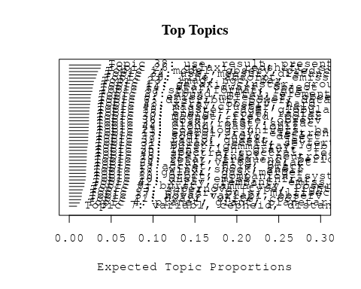

## Topic 1 Top Words:  
## Highest Prob: model, observ, predict, evolut, fit, data, distribut, paramet, simpl, can   
## FREX: model, predict, reproduc, simpl, fit, evolut, agreement, match, construct, reason   
## Lift: disentangl, model, predict, reproduc, ingredi, nonstandard, sitter, incompat, match, simpl   
## Score: model, evolut, predict, reproduc, disentangl, fit, observ, agreement, data, paramet   
## Topic 2 Top Words:  
## Highest Prob: accret, hole, black, rate, disc, mass, flow, solut, around, radiat   
## FREX: black, hole, accret, disc, advection-domin, adaf, solut, kerr, viscos, flow   
## Lift: adaf, kerr, advection-domin, nonmagnet, black, bhs, hole, disc, accret, schwarzschild   
## Score: black, accret, hole, disc, advection-domin, adaf, nonmagnet, viscos, flow, kerr   
## Topic 3 Top Words:  
## Highest Prob: galaxi, gas, merger, dwarf, tidal, merg, system, observ, interact, galact   
## FREX: merger, merg, tidal, tail, gas, strip, ugc, galaxi, irregular, gas-rich   
## Lift: articl, supershel, gas-rich, superbubbl, merger, starburst-driven, ugc, merg, ram, consumpt   
## Score: galaxi, merger, gas, dwarf, tidal, articl, merg, ugc, gas-rich, starburst   
## Topic 4 Top Words:  
## Highest Prob: planet, giant, planetari, comet, star, mass, jupit, detect, around, orbit   
## FREX: planet, jupit, comet, extrasolar, planetari, migrat, peg, des, protoplanetari, giant   
## Lift: peg, extrasolar, jovian, des, saturn, jupit, planet, auror, pegasi, comet   
## Score: planet, comet, des, jupit, planetari, extrasolar, peg, migrat, protoplanetari, giant   
## Topic 5 Top Words:  
## Highest Prob: star, format, rate, massiv, mass, stellar, form, histori, time, galaxi   
## FREX: format, histori, massiv, imf, star, rate, star-form, earli, ital, form   
## Lift: copyright, sfr, sfrs, imf, salpet, format, histori, environment, society«, ital   
## Score: format, star, copyright, imf, massiv, sfr, ital, star-form, histori, starburst   
## Topic 6 Top Words:  
## Highest Prob: distribut, power, data, spectrum, scale, correl, measur, analysi, function, use   
## FREX: nois, power, fluctuat, bias, random, gaussian, statist, pixel, scale, techniqu   
## Lift: dmr, photograph, bayesian, pixel, nois, cross-correl, optim, two-point, quadrat, non-gaussian   
## Score: photograph, pixel, microwav, spectrum, nois, power, bias, dmr, fluctuat, cobe   
## Topic 7 Top Words:  
## Highest Prob: variabl, cepheid, distanc, direct, project, obtain, catalog, telescop, avail, binari   
## FREX: cepheid, deb, variabl, catalog, frame, project, refer, eclips, program, ccd   
## Lift: deb, fullparti, michigan-dartmouth-mit, ladder—m, m—use, nonperiod, ftp, anonym, web, request   
## Score: cepheid, deb, variabl, eclips, catalog, ladder—m, fullparti, michigan-dartmouth-mit, night, m—use   
## Topic 8 Top Words:  
## Highest Prob: burst, gamma-ray, observ, event, time, detector, bats, γray, detect, energi   
## FREX: detector, bats, burst, box, γray, astronomi, experi, counterpart, instrument, transient   
## Lift: nation, bats, box, detector, comptel, astronomi, eye, burster, overview, cgro   
## Score: burst, gamma-ray, bats, grb, γray, nation, detector, box, gamma, cgro   
## Topic 9 Top Words:  
## Highest Prob: emiss, molecular, observ, core, line, maser, region, veloc, continuum, cloud   
## FREX: maser, molecular, hcn, hco, water, ghz, ice, core, protostar, embed   
## Lift: hcn, choh, maser, single-dish, methanol, ophiuchus, ultracompact, hco, co-, nobeyama   
## Score: maser, molecular, methanol, hco, ghz, hcn, emiss, core, line, water   
## Topic 10 Top Words:  
## Highest Prob: orbit, companion, system, veloc, eccentr, mass, object, tidal, solar, period   
## FREX: eccentr, companion, orbit, belt, kuiper, bodi, planetesim, tidal, neptun, circular   
## Lift: neptun, buri, eccentr, planetesim, belt, pericent, periastron, kuiper, companion, asteroid   
## Score: orbit, companion, eccentr, belt, planetesim, neptun, kuiper, tidal, buri, asteroid   
## Topic 11 Top Words:  
## Highest Prob: dwarf, white, cool, mass, helium, hydrogen, burn, phase, core, effect   
## FREX: white, burn, helium, dwarf, cool, crystal, deton, wds, hydrogen, mix   
## Lift: king, deton, deflagr, wds, white, dot, crystal, ignit, burn, hydrogen-rich   
## Score: white, dwarf, king, helium, burn, deton, wds, cool, crystal, deflagr   
## Topic 12 Top Words:  
## Highest Prob: galaxi, cluster, group, ellipt, spiral, correl, environ, morpholog, early-typ, properti   
## FREX: group, early-typ, ellipt, environ, rich, galaxi, spiral, cluster, abel, virgo   
## Lift: harass, virgo, intermediate-redshift, group, abel, early-typ, galaxy-galaxi, coma, rich, ellipt   
## Score: galaxi, cluster, group, ellipt, harass, spiral, early-typ, abel, environ, coma   
## Topic 13 Top Words:  
## Highest Prob: energi, ray, electron, emiss, observ, acceler, cosmic, photon, gamma-ray, spectrum   
## FREX: ray, tev, gev, cosmic-ray, mev, acceler, electron, gamma, high-energi, compton   
## Lift: gev, tev, vhe, pion, ultra-high-energi, positron, cosmic-ray, mev, shower, ray   
## Score: ray, tev, vhe, gamma-ray, gev, compton, mev, blazar, gamma, cosmic-ray   
## Topic 14 Top Words:  
## Highest Prob: star, dwarf, object, mass, young, age, brown, tauri, myr, cluster   
## FREX: tauri, brown, date, pleiad, myr, tau, young, substellar, member, lithium   
## Lift: lithium, dantona, date, substellar, taurus-auriga, pre-main-sequ, tau, tauri, coolest, persei   
## Score: date, dwarf, brown, star, tauri, pleiad, substellar, lithium, young, age   
## Topic 15 Top Words:  
## Highest Prob: star, binari, neutron, mass, system, low-mass, evolut, envelop, close, ratio   
## FREX: neutron, binari, low-mass, kick, crust, transfer, lmxbs, envelop, coalesc, star   
## Lift: strang, crust, lmxbs, lmxb, accretion-induc, neutron, coalesc, kick, donor, binari   
## Score: neutron, binari, star, strang, kick, lmxbs, mass, crust, envelop, low-mass   
## Topic 16 Top Words:  
## Highest Prob: line, absorpt, emiss, spectra, width, absorb, profil, compon, lyα, iii   
## FREX: absorpt, absorb, width, line, sight, lyα, lyman, iii, broad, equival   
## Lift: hopkin, goddard, ghrs, absorb, high-ion, lyman, absorpt, viii, sight, lambda   
## Score: line, absorpt, lyα, absorb, hopkin, emiss, lyman, width, column, spectrograph   
## Topic 17 Top Words:  
## Highest Prob: pulsar, puls, millisecond, radio, emiss, psr, observ, scintil, profil, period   
## FREX: pulsar, psr, millisecond, puls, scintil, drift, spin-, magnetospher, cap, crab   
## Lift: arecibo, psr, refract, pulsar, geminga, millisecond, puls, cap, scintil, drift   
## Score: pulsar, millisecond, psr, puls, scintil, arecibo, radio, magnetospher, drift, spin-   
## Topic 18 Top Words:  
## Highest Prob: wind, shock, shell, outflow, nebula, flow, veloc, interact, expand, structur   
## FREX: wind, shell, outflow, shock, bipolar, nebula, expand, mass-loss, bubbl, fast   
## Lift: bow, pns, wind, rayleigh-taylor, bubbl, shell, termin, mass-loss, bipolar, equatori   
## Score: wind, bow, shock, shell, outflow, nebula, bipolar, collim, flow, agb   
## Topic 19 Top Words:  
## Highest Prob: cluster, age, globular, giant, metal, popul, ngc, branch, gyr, star   
## FREX: globular, branch, gyr, age, metal-rich, feh, metal-poor, color-magnitud, gcs, cluster   
## Lift: baad, cmd, cmds, rgb, globular, fornax, gcs, intermediate-ag, upturn, metal-rich   
## Score: cluster, globular, age, metal, feh, branch, ngc, gyr, metal-poor, color-magnitud   
## Topic 20 Top Words:  
## Highest Prob: dust, emiss, infrar, extinct, map, background, observ, grain, detect, ira   
## FREX: dust, extinct, dirb, far-infrar, ira, infrar, foreground, cib, submillimet, map   
## Lift: zodiac, bolomet, common-us, dirb, fira, cib, scuba, sr-, submillimetr, dust   
## Score: dust, cib, dirb, grain, extinct, infrar, ira, far-infrar, map, submillimet   
## Topic 21 Top Words:  
## Highest Prob: cosmolog, univers, background, densiti, cosmic, redshift, matter, structur, baryon, forest   
## FREX: forest, univers, cosmolog, reioniz, baryon, intergalact, cdm, cmb, background, void   
## Lift: reioniz, scienc, gunn-peterson, underdens, forest, λcdm, lya, void, cdm, protogalact   
## Score: cosmolog, forest, univers, reioniz, cmb, cosmic, baryon, cdm, scienc, intergalact   
## Topic 22 Top Words:  
## Highest Prob: burst, gamma-ray, grb, afterglow, energi, grbs, shock, observ, relativist, radiat   
## FREX: afterglow, grb, grbs, firebal, gamma-ray, lorentz, beam, relativist, burst, blast   
## Lift: afterglow, right, firebal, blast-wav, lorentz, grbs, blast, grb, prompt, self-absorpt   
## Score: afterglow, grb, gamma-ray, burst, grbs, firebal, lorentz, relativist, right, blast   
## Topic 23 Top Words:  
## Highest Prob: imag, ngc, bar, telescop, ring, space, hubbl, structur, central, region   
## FREX: bar, ring, imag, camera, ngc, hst, wfpc, nuclear, hubbl, space   
## Lift: oval, nebulos, stis, nicmo, bar, lane, lindblad, ring, mosaic, long-slit   
## Score: ngc, bar, imag, ring, oval, hubbl, camera, planetari, wfpc, hst   
## Topic 24 Top Words:  
## Highest Prob: star, veloc, galact, distanc, kpc, lmc, center, magellan, motion, clump   
## FREX: magellan, lmc, hipparco, clump, milki, sgr, kpc, smc, proper, parallax   
## Lift: paczynski, smc, sagittarius, ogl, magellan, galactocentr, lsr, lmc, hipparco, phase-spac   
## Score: lmc, hipparco, magellan, sgr, parallax, star, clump, smc, kpc, paczynski   
## Topic 25 Top Words:  
## Highest Prob: energi, core, radiat, heat, rate, thermal, initi, collaps, approxim, neutrino   
## FREX: neutrino, collaps, transport, heat, convect, reaction, thermal, core, entropi, section   
## Lift: screen, entropi, one-dimension, transport, deposit, gain, parabol, neutrino, reaction, lepton   
## Score: screen, neutrino, convect, collaps, heat, core, reaction, energi, transport, radiat   
## Topic 26 Top Words:  
## Highest Prob: galaxi, redshift, survey, luminos, function, sampl, field, deep, densiti, object   
## FREX: survey, redshift, deep, count, select, faint, function, luminos, rest-fram, hdf   
## Lift: cfrs, schechter, -evolut, canada-fr, faint-end, hdf, lyman-break, sloan, rest-fram, campana   
## Score: redshift, galaxi, survey, schechter, luminos, hdf, count, sampl, high-redshift, lyman-break   
## Topic 27 Top Words:  
## Highest Prob: sourc, radio, detect, flux, optic, object, compact, identifi, galact, previous   
## FREX: sourc, mji, identif, radio, compact, ghz, identifi, counterpart, flux, candid   
## Lift: intermitt, mji, sourc, flat-spectrum, beam-, unidentifi, inact, -ghz, identif, lac   
## Score: sourc, radio, intermitt, ghz, mji, egret, flux, flat-spectrum, lac, compact   
## Topic 28 Top Words:  
## Highest Prob: rotat, frequenc, period, mode, star, oscil, pulsat, amplitud, spin, observ   
## FREX: mode, oscil, qpos, frequenc, pulsat, qpo, rotat, quasi-period, period, spin   
## Lift: g-mode, asteroseismolog, beat, kilohertz, r-mode, p-mode, qpos, herculi, qpo, oscil   
## Score: oscil, mode, rotat, pulsat, qpos, qpo, frequenc, period, r-mode, beat   
## Topic 29 Top Words:  
## Highest Prob: abund, metal, element, ratio, solar, grain, chemic, isotop, enrich, dust   
## FREX: abund, isotop, element, heavi, enrich, chemic, oxygen, nucleosynthesi, grain, metal   
## Lift: meteorit, isotop, presolar, refractori, s-process, sic, heh, graphit, gas-phas, abund   
## Score: abund, grain, metal, isotop, chemic, element, sic, enrich, nucleosynthesi, oxygen   
## Topic 30 Top Words:  
## Highest Prob: magnet, field, polar, turbul, wave, instabl, plasma, strong, strength, flow   
## FREX: magnet, polar, mhd, turbul, field, alfven, magnetohydrodynam, thread, wave, strength   
## Lift: poloid, thread, zeeman, mhd, magnetohydrodynam, alfven, electr, magnet, resist, stoke   
## Score: magnet, polar, field, turbul, zeeman, mhd, alfven, thread, magnetohydrodynam, plasma   
## Topic 31 Top Words:  
## Highest Prob: galaxi, activ, seyfert, starburst, nuclei, agn, luminos, emiss, ngc, sampl   
## FREX: seyfert, agn, nuclei, starburst, liner, activ, nucleus, ultralumin, emission-lin, nuclear   
## Lift: ulig, hickson, lir, ultralumin, liner, ulirg, arp, seyfert, agn, nuclei   
## Score: seyfert, agn, galaxi, starburst, liner, nuclei, ultralumin, ulig, ngc, nucleus   
## Topic 32 Top Words:  
## Highest Prob: disk, rotat, surfac, spiral, radius, mass, outer, dynam, inner, angular   
## FREX: disk, warp, spiral, outer, momentum, vortic, asymmetri, rotat, surfac, infal   
## Lift: vortic, disk, disklik, warp, nonaxisymmetr, midplan, self-gravit, sph, misalign, oblat   
## Score: disk, vortic, warp, rotat, spiral, momentum, infal, torqu, lsb, perturb   
## Topic 33 Top Words:  
## Highest Prob: supernova, type, light, curv, explos, sne, progenitor, rate, maximum, two   
## FREX: sne, type, supernova, explos, light, curv, progenitor, declin, colour, maximum   
## Lift: bvri, sne, woosley, breakout, homolog, explos, type, supernova, nomoto, light-curv   
## Score: supernova, sne, type, curv, explos, light, bvri, progenitor, light-curv, colour   
## Topic 34 Top Words:  
## Highest Prob: use, measur, distanc, determin, deriv, valu, estim, relat, mag, data   
## FREX: mag, error, calibr, systemat, absolut, uncertainti, correct, deriv, determin, distanc   
## Lift: period-luminos, moduli, zero-point, calibr, absolut, johnson, mag, error, systemat, quot   
## Score: mag, period-luminos, calibr, cepheid, error, moduli, distanc, absolut, modulus, parallax   
## Topic 35 Top Words:  
## Highest Prob: lens, len, gravit, event, microlens, imag, can, mass, detect, system   
## FREX: lens, len, microlens, gravit, macho, magnif, arc, degeneraci, event, astrometr   
## Lift: lens, magnifi, len, microlens, magnif, psf, macho, degeneraci, caustic, astrometri   
## Score: lens, len, microlens, macho, gravit, magnif, event, imag, arc, magnifi   
## Topic 36 Top Words:  
## Highest Prob: solar, flare, observ, coron, activ, region, flux, sun, loop, event   
## FREX: coron, flare, loop, corona, tube, solar, heliospher, sun, chromospher, euv   
## Lift: soho, sumer, yohkoh, cme, cmes, tube, heliospher, coron, sunspot, footpoint   
## Score: flare, coron, loop, solar, tube, cmes, reconnect, corona, heliospher, sun   
## Topic 37 Top Words:  
## Highest Prob: nova, variabl, observ, outburst, light, curv, day, variat, period, time   
## FREX: nova, outburst, cataclysm, secondari, eclips, cycl, cyg, carina, day, uma   
## Lift: nova-lik, sge, uma, cvs, carina, cataclysm, nova, mon, double-peak, orioni   
## Score: nova, nova-lik, outburst, eclips, variabl, cataclysm, curv, carina, uma, cvs   
## Topic 38 Top Words:  
## Highest Prob: use, result, present, calcul, method, studi, effect, paramet, simul, paper   
## FREX: code, comput, analyt, method, problem, approach, equat, numer, solut, formula   
## Lift: modern, formula, implicit, spacetim, implement, algorithm, code, analyt, arbitrari, solv   
## Score: method, modern, equat, simul, code, analyt, solut, numer, comput, formula   
## Topic 39 Top Words:  
## Highest Prob: radio, quasar, jet, observ, emiss, optic, compon, two, vla, correl   
## FREX: quasar, jet, radio, vla, radio-quiet, radio-loud, vlbi, align, vlba, pair   
## Lift: merlin, parsec-scal, vlba, radio-loud, radio-quiet, jet, quasar, vlbi, one-sid, unifi   
## Score: jet, radio, quasar, merlin, vla, radio-loud, vlba, radio-quiet, vlbi, parsec-scal   
## Topic 40 Top Words:  
## Highest Prob: spectra, spectral, featur, atmospher, spectrum, stellar, line, temperatur, band, star   
## FREX: atmospher, non-lt, silic, featur, w-r, pah, synthet, spectra, spectral, band   
## Lift: librari, non-lt, w-r, astro-, tsub, micromet, kurucz, bond, pah, aromat   
## Score: librari, atmospher, w-r, silic, non-lt, pah, albedo, spectral, spectra, line   
## Topic 41 Top Words:  
## Highest Prob: mass, cluster, halo, dark, matter, profil, veloc, galaxi, within, densiti   
## FREX: dark, halo, virial, matter, n-bodi, mass--light, profil, cluster, substructur, cold   
## Lift: modot, navarro, dissipationless, n-bodi, virial, frenk, dark, halo, mass--light, segreg   
## Score: cluster, halo, dark, matter, modot, mass, virial, n-bodi, mass--light, galaxi   
## Topic 42 Top Words:  
## Highest Prob: x-ray, remnant, emiss, supernova, rosat, temperatur, observ, asca, kev, erg   
## FREX: remnant, rosat, snr, snrs, asca, pspc, x-ray, erg, kev, hri   
## Lift: snrs, categori, snr, rosat, pspc, remnant, cassiopeia, hri, equilibr, cas   
## Score: x-ray, remnant, rosat, supernova, snr, snrs, asca, kev, pspc, categori   
## Topic 43 Top Words:  
## Highest Prob: x-ray, observ, hard, soft, kev, variabl, time, spectral, state, spectrum   
## FREX: hard, soft, kev, x-ray, state, rossi, grs, lag, quiescent, rxte   
## Lift: grs, stand, pca, rossi, rxte, hard, gro, sax, soft, ginga   
## Score: x-ray, kev, hard, soft, variabl, rossi, grs, asca, lag, stand   
## Topic 44 Top Words:  
## Highest Prob: cloud, gas, ioniz, densiti, region, ratio, molecular, interstellar, cm-, observ   
## FREX: ioniz, cloud, cm-, photoion, neutral, column, gas, interstellar, atom, molecular   
## Lift: pdr, dissoci, fine-structur, photodissoci, ioniz, photoion, cloud, cm-, neutral, intercloud   
## Score: cloud, ioniz, pdr, gas, molecular, cm-, column, photoion, interstellar, hydrogen   
## [1] "Chemo-spectrophotometric evolution of spiral galaxies — I. The model and the Milky Way ABSTRA C T The chemical and spectrophotometric evolution of spiral galaxies is investigated with detailed models, making use of up-to-date ingredients (like metallicity-dependent stellar properties) and a prescription for the star formation rate (SFR) justified both empirically and theoretically. As a first application, the model is used to describe the evolution of the Milky Way. The role of the adopted scheme of disc formation (‘inside-out’) in shaping the various chemical and colour profiles is investigated, as well as the role of extinction. It is shown that the Solar neighbourhood does not evolve like the Milky Way as a whole and that one-zone models with a non-linear SFR prescription cannot be used to study the evolution of our Galaxy. Our model average SFR is shown to match well observations of external spirals."   
## [2] "Chemo-spectrophotometric evolution of spiral galaxies — I. The model and the Milky Way ABSTRA C T The chemical and spectrophotometric evolution of spiral galaxies is investigated with detailed models, making use of up-to-date ingredients (like metallicity-dependent stellar properties) and a prescription for the star formation rate (SFR) justified both empirically and theoretically. As a first application, the model is used to describe the evolution of the Milky Way. The role of the adopted scheme of disc formation (‘inside-out’) in shaping the various chemical and colour profiles is investigated, as well as the role of extinction. It is shown that the Solar neighbourhood does not evolve like the Milky Way as a whole and that one-zone models with a non-linear SFR prescription cannot be used to study the evolution of our Galaxy. Our model average SFR is shown to match well observations of external spirals."   
## [3] "Chemo-spectrophotometric evolution of spiral galaxies: I. The model and the Milky Way ABSTRA C T The chemical and spectrophotometric evolution of spiral galaxies is investigated with detailed models, making use of up-to-date ingredients (like metallicity-dependent stellar properties) and a prescription for the star formation rate (SFR) justified both empirically and theoretically. As a first application, the model is used to describe the evolution of the Milky Way. The role of the adopted scheme of disc formation (‘inside-out’) in shaping the various chemical and colour profiles is investigated, as well as the role of extinction. It is shown that the Solar neighbourhood does not evolve like the Milky Way as a whole and that one-zone models with a non-linear SFR prescription cannot be used to study the evolution of our Galaxy. Our model average SFR is shown to match well observations of external spirals."   
## [4] "Chemo-spectrophotometric evolution of spiral galaxies: I. The model and the Milky Way ABSTRA C T The chemical and spectrophotometric evolution of spiral galaxies is investigated with detailed models, making use of up-to-date ingredients (like metallicity-dependent stellar properties) and a prescription for the star formation rate (SFR) justified both empirically and theoretically. As a first application, the model is used to describe the evolution of the Milky Way. The role of the adopted scheme of disc formation (‘inside-out’) in shaping the various chemical and colour profiles is investigated, as well as the role of extinction. It is shown that the Solar neighbourhood does not evolve like the Milky Way as a whole and that one-zone models with a non-linear SFR prescription cannot be used to study the evolution of our Galaxy. Our model average SFR is shown to match well observations of external spirals."   
## [5] "Inside-out Infall Formation of Disk Galaxies: Do Predictions Differ from Models without Size Evolution? We develop an idealized inside-out formation model for disk galaxies to include a realistic mix of galaxy types and luminosities that provides a fair match to the traditional observables. The predictions of our infall models are compared against identical models with no-size evolution by generating fully realistic simulations of the Hubble Deep Field, from which we recover the angular size distributions. We find that our infall models produce angular size distributions that are nearly identical to those of our no-size evolution models in the case of a ?=0 geometry but produce slightly smaller sizes in the case of a ?=1 geometry, a difference we associate with the different amounts of cosmic time in our two models for evolving to relatively low redshifts (z ? 1-2). Our infall models also predict a slightly smaller (11%-29%) number of large (disk scale lengths greater than 4 h -->50?1 kpc) galaxies at z ? 0.7 for the Canada France Redshift Survey, as well as different increases in the central surface brightness of the disks for early-type spirals, the infall model predicting an increase by 1.2 mag out to z ? 2(?=0) and z ? 1(?=1), while our no-size evolution models predict an increase of only 0.5 mag. This result suggests that infall models could be important for explaining the 1.2-1.6 mag increase in surface brightness reported by Schade and coworkers."

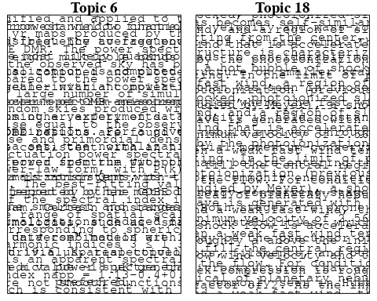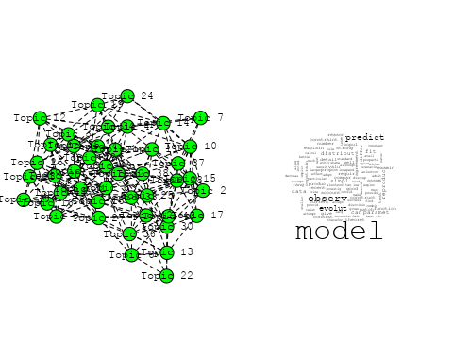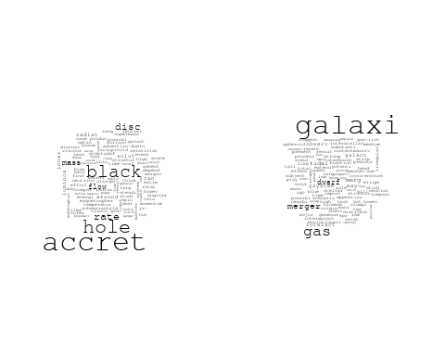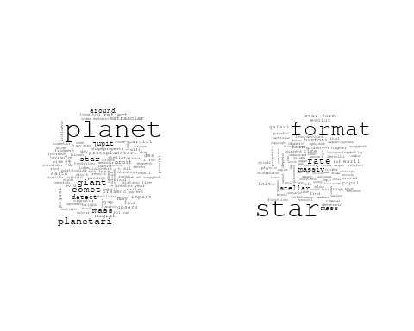

## Warning in wordcloud::wordcloud(words = vocab, freq = vec, max.words =  
## max.words, : function could not be fit on page. It will not be plotted.

## Warning in wordcloud::wordcloud(words = vocab, freq = vec, max.words =  
## max.words, : measur could not be fit on page. It will not be plotted.

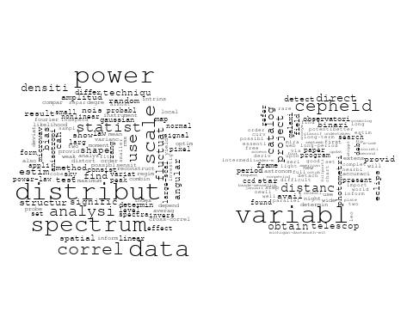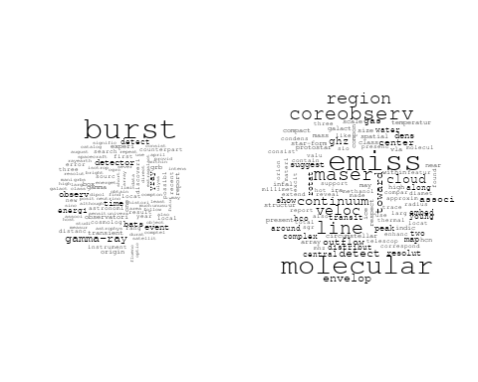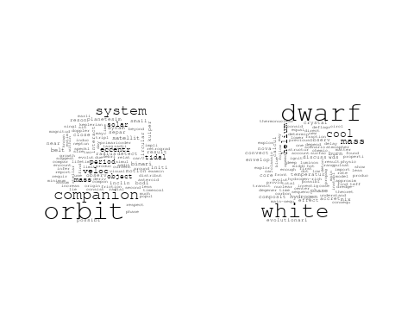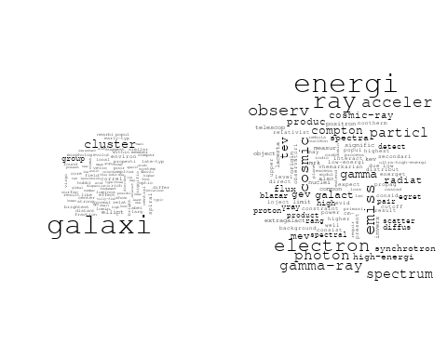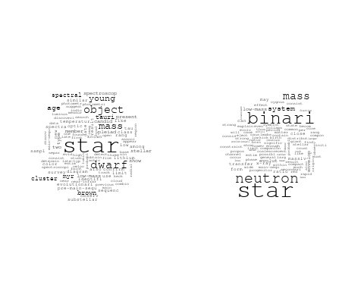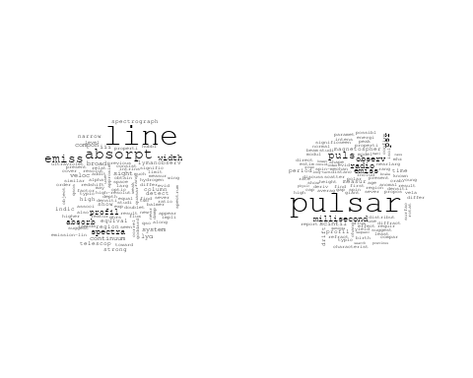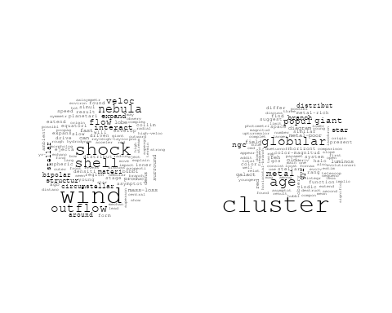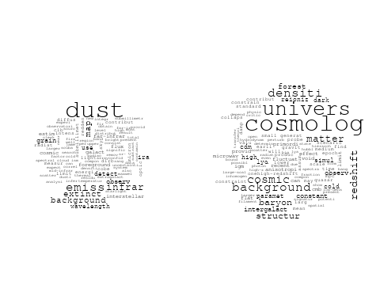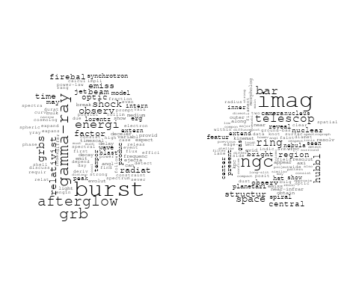

## Warning in wordcloud::wordcloud(words = vocab, freq = vec, max.words =  
## max.words, : energi could not be fit on page. It will not be plotted.

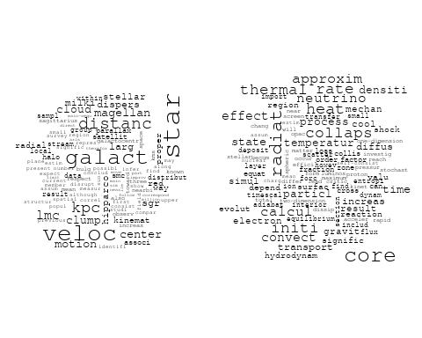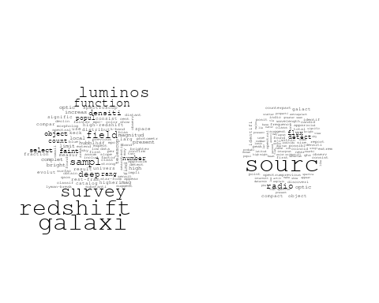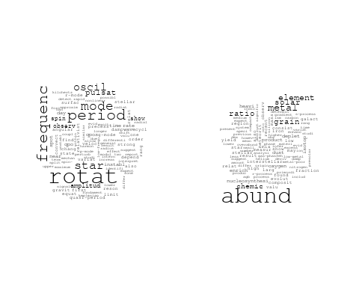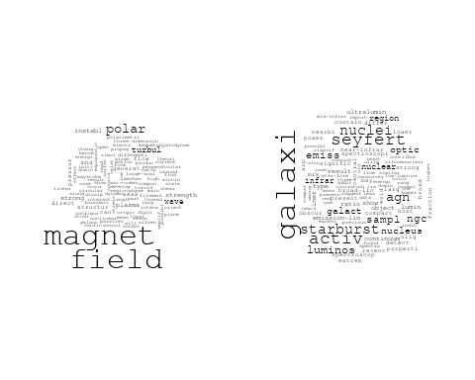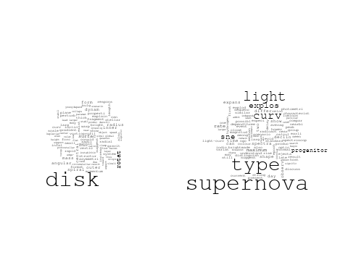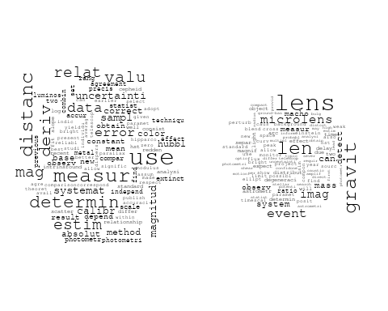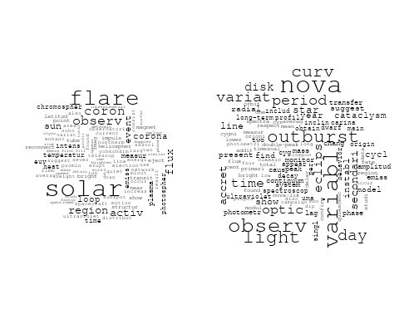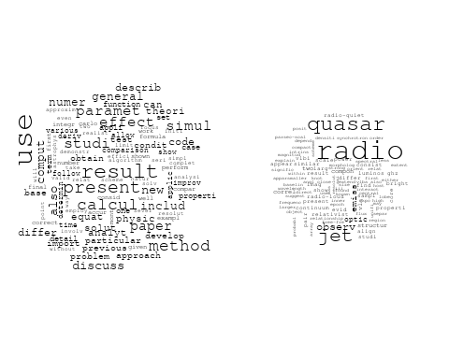

## Warning in wordcloud::wordcloud(words = vocab, freq = vec, max.words =  
## max.words, : atmospher could not be fit on page. It will not be plotted.

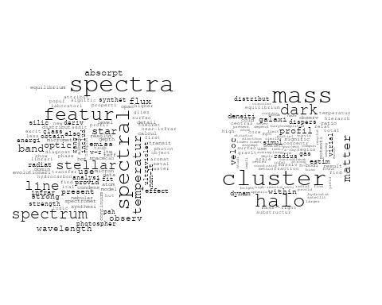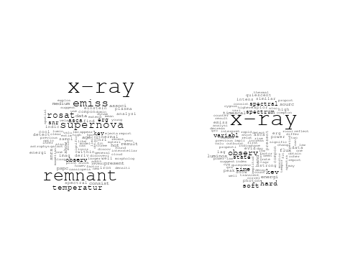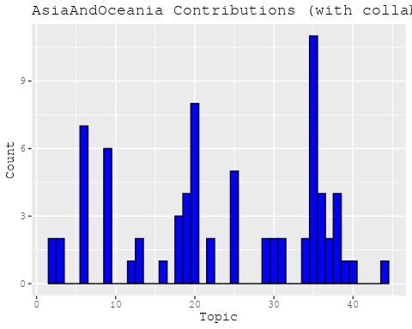

## [1] "Processing interval: pub_interval_1985_1994"  
## Building corpus...   
## Converting to Lower Case...   
## Removing punctuation...   
## Removing stopwords...   
## Removing numbers...   
## Stemming...   
## Creating Output...   
## Removing 3813 of 11037 terms (3813 of 210117 tokens) due to frequency   
## Your corpus now has 3398 documents, 7224 terms and 206304 tokens.

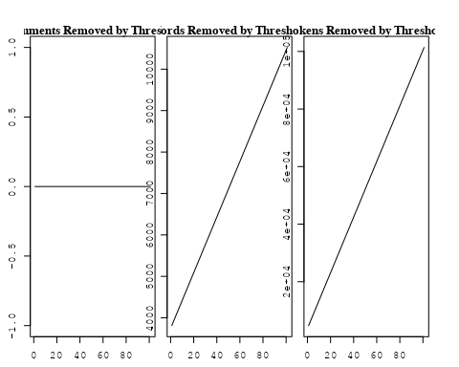

## Removing 9273 of 11037 terms (26281 of 210117 tokens) due to frequency   
## Your corpus now has 3398 documents, 1764 terms and 183836 tokens.~US + IN + DE + CH + GB + CN + FR + IT + RU + CA + NL + AU +   
## JP + ES + IL + Americas + Europe + Africa + AsiaAndOceania  
## Beginning Spectral Initialization   
## Calculating the gram matrix...  
## Finding anchor words...  
## .............................................  
## Recovering initialization...  
## .................  
## Initialization complete.  
## ......................................................................................................  
## Completed E-Step (4 seconds).   
## Completed M-Step.   
## Completing Iteration 1 (approx. per word bound = -6.429)   
## ......................................................................................................  
## Completed E-Step (3 seconds).   
## Completed M-Step.   
## Completing Iteration 2 (approx. per word bound = -6.259, relative change = 2.641e-02)   
## ......................................................................................................  
## Completed E-Step (3 seconds).   
## Completed M-Step.   
## Completing Iteration 3 (approx. per word bound = -6.208, relative change = 8.269e-03)   
## ......................................................................................................  
## Completed E-Step (3 seconds).   
## Completed M-Step.   
## Completing Iteration 4 (approx. per word bound = -6.185, relative change = 3.553e-03)   
## ......................................................................................................  
## Completed E-Step (3 seconds).   
## Completed M-Step.   
## Completing Iteration 5 (approx. per word bound = -6.174, relative change = 1.801e-03)   
## Topic 1: ray, cosmic, gamma, univers, energi   
## Topic 2: star, ngc, format, massiv, region   
## Topic 3: dwarf, variabl, white, period, star   
## Topic 4: les, des, maser, dan, sont   
## Topic 5: rate, star, observ, model, discuss   
## Topic 6: cluster, galaxi, globular, ellipt, core   
## Topic 7: x-ray, observ, remnant, supernova, data   
## Topic 8: cloud, molecular, sourc, outflow, star   
## Topic 9: model, galaxi, scale, densiti, structur   
## Topic 10: limit, observ, rate, upper, neptun   
## Topic 11: imag, time, observ, measur, object   
## Topic 12: binari, star, system, mass, neutron   
## Topic 13: veloc, star, radial, kms, line   
## Topic 14: mode, oscil, frequenc, equat, convect   
## Topic 15: color, sun, measur, activ, differ   
## Topic 16: burst, gamma-ray, flare, energi, time   
## Topic 17: polar, ring, astronom, astronomi, observatori   
## Topic 18: disk, accret, model, wind, rate   
## Topic 19: distanc, method, type, deriv, use   
## Topic 20: emiss, micron, band, featur, dust   
## Topic 21: mass, supernova, nova, explos, shell   
## Topic 22: line, region, observ, ioniz, densiti   
## Topic 23: galaxi, star, number, popul, bright   
## Topic 24: field, magnet, hole, black, rotat   
## Topic 25: sourc, radio, observ, emiss, optic   
## Topic 26: physic, astrophys, theori, first, neutron   
## Topic 27: orbit, pulsar, system, companion, period   
## Topic 28: observ, telescop, system, star, compon   
## Topic 29: region, structur, distribut, center, map   
## Topic 30: comet, nucleus, observ, dust, cometari   
## Topic 31: star, x-ray, mass, rotat, dwarf   
## Topic 32: galaxi, spiral, gas, region, galact   
## Topic 33: galaxi, luminos, sampl, ira, seyfert   
## Topic 34: solar, mass, event, flare, coron   
## Topic 35: line, emiss, star, observ, iii   
## Topic 36: interstellar, medium, cloud, gas, densiti   
## Topic 37: cluster, galaxi, veloc, distribut, model   
## Topic 38: model, abund, star, observ, element   
## Topic 39: shock, magnet, wind, field, wave   
## Topic 40: background, measur, microwav, deg, spectrum   
## Topic 41: evolut, star, nebula, planetari, central   
## Topic 42: pulsar, x-ray, emiss, model, soft   
## Topic 43: quasar, object, redshift, gravit, lens   
## Topic 44: spectra, detect, atmospher, absorpt, line   
## Topic 45: dynamo, field, magnet, flux, turbul   
## ......................................................................................................  
## Completed E-Step (2 seconds).   
## Completed M-Step.   
## Completing Iteration 6 (approx. per word bound = -6.168, relative change = 1.083e-03)   
## ......................................................................................................  
## Completed E-Step (2 seconds).   
## Completed M-Step.   
## Completing Iteration 7 (approx. per word bound = -6.163, relative change = 7.234e-04)   
## ......................................................................................................  
## Completed E-Step (3 seconds).   
## Completed M-Step.   
## Completing Iteration 8 (approx. per word bound = -6.160, relative change = 5.212e-04)   
## ......................................................................................................  
## Completed E-Step (2 seconds).   
## Completed M-Step.   
## Completing Iteration 9 (approx. per word bound = -6.158, relative change = 3.867e-04)   
## ......................................................................................................  
## Completed E-Step (2 seconds).   
## Completed M-Step.   
## Completing Iteration 10 (approx. per word bound = -6.156, relative change = 3.318e-04)   
## Topic 1: ray, cosmic, gamma, energi, particl   
## Topic 2: star, ngc, format, massiv, rate   
## Topic 3: dwarf, variabl, white, period, star   
## Topic 4: les, des, maser, dan, sont   
## Topic 5: rate, star, model, observ, neutron   
## Topic 6: cluster, galaxi, globular, ellipt, core   
## Topic 7: x-ray, observ, remnant, supernova, emiss   
## Topic 8: cloud, molecular, sourc, outflow, gas   
## Topic 9: model, densiti, univers, scale, galaxi   
## Topic 10: limit, upper, observ, neptun, per   
## Topic 11: imag, time, observ, measur, data   
## Topic 12: binari, star, neutron, mass, system   
## Topic 13: veloc, kms, radial, star, dispers   
## Topic 14: mode, oscil, frequenc, equat, wave   
## Topic 15: color, measur, sun, activ, observ   
## Topic 16: burst, gamma-ray, time, flare, energi   
## Topic 17: polar, ring, astronom, astronomi, observ   
## Topic 18: disk, accret, model, wind, rate   
## Topic 19: distanc, method, use, determin, deriv   
## Topic 20: emiss, micron, dust, infrar, band   
## Topic 21: mass, supernova, envelop, explos, nova   
## Topic 22: line, region, ioniz, observ, densiti   
## Topic 23: galaxi, star, number, popul, bright   
## Topic 24: field, magnet, hole, rotat, black   
## Topic 25: sourc, radio, observ, optic, emiss   
## Topic 26: physic, astrophys, will, theori, first   
## Topic 27: orbit, pulsar, system, companion, period   
## Topic 28: telescop, observ, imag, space, system   
## Topic 29: region, structur, center, map, spatial   
## Topic 30: comet, nucleus, observ, cometari, dust   
## Topic 31: star, mass, rotat, dwarf, luminos   
## Topic 32: galaxi, spiral, gas, nucleus, region   
## Topic 33: galaxi, luminos, sampl, ira, seyfert   
## Topic 34: solar, mass, event, flare, coron   
## Topic 35: line, emiss, spectra, iii, star   
## Topic 36: interstellar, medium, gas, cloud, densiti   
## Topic 37: cluster, galaxi, distribut, mass, veloc   
## Topic 38: model, abund, star, observ, element   
## Topic 39: shock, magnet, wind, field, wave   
## Topic 40: background, measur, deg, microwav, spectrum   
## Topic 41: evolut, nebula, star, planetari, central   
## Topic 42: pulsar, emiss, model, x-ray, soft   
## Topic 43: quasar, object, redshift, gravit, lens   
## Topic 44: detect, spectra, absorpt, transit, atmospher   
## Topic 45: dynamo, magnet, field, flux, generat   
## ......................................................................................................  
## Completed E-Step (2 seconds).   
## Completed M-Step.   
## Completing Iteration 11 (approx. per word bound = -6.154, relative change = 2.941e-04)   
## ......................................................................................................  
## Completed E-Step (2 seconds).   
## Completed M-Step.   
## Completing Iteration 12 (approx. per word bound = -6.152, relative change = 2.566e-04)   
## ......................................................................................................  
## Completed E-Step (3 seconds).   
## Completed M-Step.   
## Completing Iteration 13 (approx. per word bound = -6.151, relative change = 2.148e-04)   
## ......................................................................................................  
## Completed E-Step (3 seconds).   
## Completed M-Step.   
## Completing Iteration 14 (approx. per word bound = -6.150, relative change = 1.928e-04)   
## ......................................................................................................  
## Completed E-Step (2 seconds).   
## Completed M-Step.   
## Completing Iteration 15 (approx. per word bound = -6.149, relative change = 1.729e-04)   
## Topic 1: ray, energi, cosmic, gamma, particl   
## Topic 2: star, format, ngc, massiv, rate   
## Topic 3: dwarf, variabl, period, white, star   
## Topic 4: les, des, maser, dan, sont   
## Topic 5: rate, star, neutron, model, observ   
## Topic 6: cluster, galaxi, globular, ellipt, core   
## Topic 7: x-ray, emiss, observ, remnant, supernova   
## Topic 8: cloud, molecular, outflow, sourc, gas   
## Topic 9: model, univers, densiti, scale, matter   
## Topic 10: limit, upper, neptun, observ, per   
## Topic 11: imag, time, arcsec, observ, measur   
## Topic 12: binari, star, neutron, mass, system   
## Topic 13: veloc, kms, radial, star, dispers   
## Topic 14: mode, oscil, equat, frequenc, wave   
## Topic 15: color, measur, activ, sun, observ   
## Topic 16: burst, gamma-ray, time, distribut, hard   
## Topic 17: polar, ring, astronom, astronomi, observ   
## Topic 18: disk, accret, model, wind, rate   
## Topic 19: distanc, method, use, determin, deriv   
## Topic 20: micron, emiss, dust, infrar, band   
## Topic 21: supernova, mass, envelop, type, explos   
## Topic 22: line, region, ioniz, observ, densiti   
## Topic 23: galaxi, star, number, popul, survey   
## Topic 24: field, magnet, rotat, hole, black   
## Topic 25: sourc, radio, observ, optic, posit   
## Topic 26: physic, astrophys, will, theori, problem   
## Topic 27: orbit, pulsar, system, companion, period   
## Topic 28: telescop, observ, imag, space, system   
## Topic 29: region, structur, center, spatial, map   
## Topic 30: comet, nucleus, observ, cometari, ice   
## Topic 31: star, mass, luminos, dwarf, rotat   
## Topic 32: galaxi, spiral, gas, ngc, nucleus   
## Topic 33: galaxi, luminos, sampl, ira, seyfert   
## Topic 34: solar, flare, mass, event, coron   
## Topic 35: line, emiss, spectra, optic, iii   
## Topic 36: interstellar, medium, gas, cloud, densiti   
## Topic 37: cluster, galaxi, mass, distribut, model   
## Topic 38: model, abund, observ, element, star   
## Topic 39: shock, wind, magnet, acceler, wave   
## Topic 40: background, deg, measur, microwav, galact   
## Topic 41: evolut, nebula, star, planetari, central   
## Topic 42: model, pulsar, emiss, spectrum, spectral   
## Topic 43: quasar, object, redshift, gravit, lens   
## Topic 44: absorpt, transit, detect, spectra, toward   
## Topic 45: dynamo, flux, magnet, field, generat   
## ......................................................................................................  
## Completed E-Step (3 seconds).   
## Completed M-Step.   
## Completing Iteration 16 (approx. per word bound = -6.148, relative change = 1.657e-04)   
## ......................................................................................................  
## Completed E-Step (3 seconds).   
## Completed M-Step.   
## Completing Iteration 17 (approx. per word bound = -6.147, relative change = 1.543e-04)   
## ......................................................................................................  
## Completed E-Step (2 seconds).   
## Completed M-Step.   
## Completing Iteration 18 (approx. per word bound = -6.146, relative change = 1.323e-04)   
## ......................................................................................................  
## Completed E-Step (2 seconds).   
## Completed M-Step.   
## Completing Iteration 19 (approx. per word bound = -6.145, relative change = 1.195e-04)   
## ......................................................................................................  
## Completed E-Step (2 seconds).   
## Completed M-Step.   
## Completing Iteration 20 (approx. per word bound = -6.144, relative change = 1.154e-04)   
## Topic 1: ray, energi, cosmic, gamma, particl   
## Topic 2: star, format, ngc, massiv, rate   
## Topic 3: dwarf, variabl, period, white, star   
## Topic 4: les, des, maser, dan, sont   
## Topic 5: star, rate, neutron, model, observ   
## Topic 6: cluster, galaxi, globular, ellipt, core   
## Topic 7: x-ray, emiss, observ, remnant, supernova   
## Topic 8: cloud, molecular, outflow, sourc, gas   
## Topic 9: model, univers, densiti, matter, scale   
## Topic 10: limit, upper, neptun, per, observ   
## Topic 11: imag, time, arcsec, measur, observ   
## Topic 12: binari, star, mass, system, neutron   
## Topic 13: veloc, kms, radial, dispers, star   
## Topic 14: mode, oscil, equat, frequenc, instabl   
## Topic 15: color, measur, activ, observ, differ   
## Topic 16: burst, gamma-ray, time, distribut, hard   
## Topic 17: polar, ring, astronom, astronomi, observ   
## Topic 18: disk, accret, model, wind, mass   
## Topic 19: use, determin, distanc, method, deriv   
## Topic 20: micron, dust, emiss, infrar, band   
## Topic 21: supernova, mass, envelop, type, explos   
## Topic 22: line, ioniz, region, observ, densiti   
## Topic 23: galaxi, star, survey, number, catalog   
## Topic 24: field, magnet, hole, rotat, black   
## Topic 25: sourc, radio, observ, optic, posit   
## Topic 26: physic, astrophys, will, theori, problem   
## Topic 27: orbit, pulsar, system, companion, period   
## Topic 28: telescop, observ, imag, space, light   
## Topic 29: region, structur, center, spatial, map   
## Topic 30: comet, nucleus, observ, cometari, ice   
## Topic 31: star, mass, luminos, dwarf, rotat   
## Topic 32: galaxi, spiral, gas, ngc, nucleus   
## Topic 33: galaxi, luminos, sampl, ira, seyfert   
## Topic 34: solar, flare, event, mass, observ   
## Topic 35: line, emiss, spectra, optic, iii   
## Topic 36: interstellar, gas, medium, densiti, cloud   
## Topic 37: cluster, galaxi, mass, distribut, model   
## Topic 38: model, abund, observ, element, temperatur   
## Topic 39: shock, wind, magnet, wave, acceler   
## Topic 40: background, deg, measur, galact, microwav   
## Topic 41: evolut, nebula, star, planetari, mass   
## Topic 42: model, emiss, pulsar, spectrum, spectral   
## Topic 43: quasar, object, redshift, gravit, lens   
## Topic 44: absorpt, transit, detect, spectra, toward   
## Topic 45: flux, dynamo, magnet, field, turbul   
## ......................................................................................................  
## Completed E-Step (2 seconds).   
## Completed M-Step.   
## Completing Iteration 21 (approx. per word bound = -6.144, relative change = 1.070e-04)   
## ......................................................................................................  
## Completed E-Step (2 seconds).   
## Completed M-Step.   
## Completing Iteration 22 (approx. per word bound = -6.143, relative change = 9.692e-05)   
## ......................................................................................................  
## Completed E-Step (2 seconds).   
## Completed M-Step.   
## Completing Iteration 23 (approx. per word bound = -6.143, relative change = 9.656e-05)   
## ......................................................................................................  
## Completed E-Step (2 seconds).   
## Completed M-Step.   
## Completing Iteration 24 (approx. per word bound = -6.142, relative change = 8.392e-05)   
## ......................................................................................................  
## Completed E-Step (2 seconds).   
## Completed M-Step.   
## Completing Iteration 25 (approx. per word bound = -6.141, relative change = 8.768e-05)   
## Topic 1: ray, energi, particl, cosmic, gamma   
## Topic 2: star, format, ngc, massiv, rate   
## Topic 3: dwarf, variabl, period, white, star   
## Topic 4: les, des, maser, dan, sont   
## Topic 5: star, rate, neutron, model, observ   
## Topic 6: cluster, galaxi, globular, ellipt, core   
## Topic 7: x-ray, emiss, observ, remnant, supernova   
## Topic 8: cloud, molecular, outflow, sourc, gas   
## Topic 9: model, univers, densiti, scale, matter   
## Topic 10: neptun, atmospher, per, observ, voyag   
## Topic 11: imag, time, arcsec, observ, measur   
## Topic 12: binari, star, mass, system, gravit   
## Topic 13: veloc, kms, radial, dispers, star   
## Topic 14: mode, equat, oscil, frequenc, instabl   
## Topic 15: color, measur, activ, differ, observ   
## Topic 16: burst, gamma-ray, time, hard, distribut   
## Topic 17: polar, astronom, ring, astronomi, observ   
## Topic 18: disk, accret, model, wind, mass   
## Topic 19: use, determin, distanc, method, deriv   
## Topic 20: micron, dust, emiss, infrar, band   
## Topic 21: supernova, mass, envelop, type, explos   
## Topic 22: line, ioniz, region, observ, extinct   
## Topic 23: galaxi, star, survey, catalog, number   
## Topic 24: field, magnet, hole, rotat, black   
## Topic 25: sourc, radio, observ, optic, posit   
## Topic 26: physic, astrophys, will, problem, theori   
## Topic 27: orbit, pulsar, system, companion, period   
## Topic 28: telescop, observ, space, imag, light   
## Topic 29: region, structur, center, map, spatial   
## Topic 30: comet, nucleus, observ, cometari, ice   
## Topic 31: star, mass, dwarf, luminos, stellar   
## Topic 32: galaxi, spiral, ngc, gas, nucleus   
## Topic 33: galaxi, luminos, sampl, ira, activ   
## Topic 34: solar, flare, event, observ, mass   
## Topic 35: line, emiss, spectra, optic, continuum   
## Topic 36: interstellar, gas, medium, densiti, radiat   
## Topic 37: cluster, galaxi, mass, distribut, model   
## Topic 38: model, abund, observ, element, temperatur   
## Topic 39: shock, wind, wave, acceler, magnet   
## Topic 40: background, deg, measur, galact, limit   
## Topic 41: evolut, nebula, star, planetari, mass   
## Topic 42: model, spectral, spectra, emiss, spectrum   
## Topic 43: quasar, object, redshift, gravit, lens   
## Topic 44: absorpt, transit, detect, spectra, toward   
## Topic 45: flux, convect, turbul, magnet, diffus   
## ......................................................................................................  
## Completed E-Step (2 seconds).   
## Completed M-Step.   
## Completing Iteration 26 (approx. per word bound = -6.141, relative change = 8.789e-05)   
## ......................................................................................................  
## Completed E-Step (2 seconds).   
## Completed M-Step.   
## Completing Iteration 27 (approx. per word bound = -6.140, relative change = 8.160e-05)   
## ......................................................................................................  
## Completed E-Step (2 seconds).   
## Completed M-Step.   
## Completing Iteration 28 (approx. per word bound = -6.140, relative change = 7.911e-05)   
## ......................................................................................................  
## Completed E-Step (2 seconds).   
## Completed M-Step.   
## Completing Iteration 29 (approx. per word bound = -6.140, relative change = 5.277e-05)   
## ......................................................................................................  
## Completed E-Step (2 seconds).   
## Completed M-Step.   
## Completing Iteration 30 (approx. per word bound = -6.139, relative change = 8.530e-05)   
## Topic 1: ray, energi, particl, cosmic, gamma   
## Topic 2: star, format, ngc, massiv, rate   
## Topic 3: dwarf, variabl, period, white, star   
## Topic 4: les, des, maser, dan, sont   
## Topic 5: star, rate, neutron, model, larg   
## Topic 6: cluster, galaxi, ellipt, globular, core   
## Topic 7: x-ray, emiss, observ, remnant, supernova   
## Topic 8: cloud, molecular, outflow, gas, sourc   
## Topic 9: model, univers, densiti, scale, matter   
## Topic 10: neptun, atmospher, observ, jupit, voyag   
## Topic 11: imag, time, arcsec, observ, measur   
## Topic 12: binari, star, system, mass, gravit   
## Topic 13: veloc, kms, radial, dispers, motion   
## Topic 14: mode, equat, oscil, frequenc, instabl   
## Topic 15: color, measur, activ, differ, observ   
## Topic 16: burst, gamma-ray, time, hard, distribut   
## Topic 17: polar, astronom, ring, astronomi, observ   
## Topic 18: disk, accret, model, mass, wind   
## Topic 19: use, determin, distanc, method, deriv   
## Topic 20: dust, micron, emiss, infrar, band   
## Topic 21: supernova, mass, envelop, type, explos   
## Topic 22: line, ioniz, region, observ, model   
## Topic 23: galaxi, survey, star, catalog, popul   
## Topic 24: field, magnet, hole, rotat, black   
## Topic 25: sourc, radio, optic, observ, posit   
## Topic 26: physic, astrophys, problem, will, theori   
## Topic 27: orbit, pulsar, system, companion, period   
## Topic 28: telescop, observ, space, imag, hst   
## Topic 29: region, structur, center, map, bright   
## Topic 30: comet, nucleus, observ, cometari, ice   
## Topic 31: star, mass, dwarf, luminos, stellar   
## Topic 32: galaxi, spiral, ngc, gas, nucleus   
## Topic 33: galaxi, luminos, sampl, ira, activ   
## Topic 34: solar, flare, event, observ, coron   
## Topic 35: line, emiss, spectra, optic, continuum   
## Topic 36: interstellar, gas, medium, densiti, radiat   
## Topic 37: cluster, galaxi, mass, distribut, model   
## Topic 38: model, abund, observ, element, temperatur   
## Topic 39: shock, wind, wave, acceler, flow   
## Topic 40: background, deg, measur, limit, galact   
## Topic 41: evolut, nebula, star, planetari, mass   
## Topic 42: model, spectral, spectra, emiss, energi   
## Topic 43: quasar, object, redshift, gravit, lens   
## Topic 44: absorpt, transit, detect, spectra, hydrogen   
## Topic 45: flux, convect, turbul, magnet, diffus   
## ......................................................................................................  
## Completed E-Step (2 seconds).   
## Completed M-Step.   
## Completing Iteration 31 (approx. per word bound = -6.139, relative change = 6.565e-05)   
## ......................................................................................................  
## Completed E-Step (2 seconds).   
## Completed M-Step.   
## Completing Iteration 32 (approx. per word bound = -6.138, relative change = 6.113e-05)   
## ......................................................................................................  
## Completed E-Step (2 seconds).   
## Completed M-Step.   
## Completing Iteration 33 (approx. per word bound = -6.138, relative change = 5.359e-05)   
## ......................................................................................................  
## Completed E-Step (2 seconds).   
## Completed M-Step.   
## Completing Iteration 34 (approx. per word bound = -6.138, relative change = 4.992e-05)   
## ......................................................................................................  
## Completed E-Step (2 seconds).   
## Completed M-Step.   
## Completing Iteration 35 (approx. per word bound = -6.137, relative change = 5.204e-05)   
## Topic 1: ray, energi, particl, cosmic, gamma   
## Topic 2: star, format, ngc, massiv, rate   
## Topic 3: dwarf, variabl, period, white, star   
## Topic 4: les, des, maser, dan, sont   
## Topic 5: star, neutron, rate, model, matter   
## Topic 6: cluster, galaxi, ellipt, globular, core   
## Topic 7: x-ray, emiss, observ, remnant, data   
## Topic 8: cloud, molecular, outflow, gas, sourc   
## Topic 9: model, univers, densiti, scale, matter   
## Topic 10: neptun, atmospher, jupit, observ, voyag   
## Topic 11: imag, time, arcsec, observ, measur   
## Topic 12: binari, system, star, mass, log   
## Topic 13: veloc, kms, radial, dispers, motion   
## Topic 14: mode, equat, oscil, frequenc, wave   
## Topic 15: color, measur, activ, differ, indic   
## Topic 16: burst, gamma-ray, time, hard, distribut   
## Topic 17: polar, astronom, ring, astronomi, observ   
## Topic 18: disk, accret, model, mass, wind   
## Topic 19: use, determin, deriv, method, distanc   
## Topic 20: dust, micron, emiss, infrar, band   
## Topic 21: supernova, mass, envelop, type, explos   
## Topic 22: line, ioniz, region, observ, model   
## Topic 23: galaxi, survey, star, catalog, popul   
## Topic 24: field, magnet, hole, rotat, black   
## Topic 25: sourc, radio, optic, observ, posit   
## Topic 26: physic, astrophys, problem, will, theori   
## Topic 27: orbit, pulsar, companion, system, period   
## Topic 28: telescop, observ, space, imag, hst   
## Topic 29: region, structur, center, bright, map   
## Topic 30: comet, nucleus, observ, cometari, ice   
## Topic 31: star, mass, dwarf, luminos, stellar   
## Topic 32: galaxi, spiral, ngc, gas, nucleus   
## Topic 33: galaxi, luminos, sampl, activ, ira   
## Topic 34: solar, flare, event, observ, coron   
## Topic 35: line, emiss, spectra, continuum, optic   
## Topic 36: gas, interstellar, medium, densiti, radiat   
## Topic 37: cluster, galaxi, mass, distribut, model   
## Topic 38: model, abund, observ, element, temperatur   
## Topic 39: shock, wind, wave, acceler, flow   
## Topic 40: background, deg, limit, measur, galact   
## Topic 41: evolut, nebula, star, planetari, mass   
## Topic 42: model, spectral, spectra, energi, emiss   
## Topic 43: quasar, object, redshift, gravit, lens   
## Topic 44: absorpt, transit, detect, spectra, hydrogen   
## Topic 45: flux, convect, turbul, zone, magnet   
## ......................................................................................................  
## Completed E-Step (2 seconds).   
## Completed M-Step.   
## Completing Iteration 36 (approx. per word bound = -6.137, relative change = 4.861e-05)   
## ......................................................................................................  
## Completed E-Step (2 seconds).   
## Completed M-Step.   
## Completing Iteration 37 (approx. per word bound = -6.137, relative change = 2.827e-05)   
## ......................................................................................................  
## Completed E-Step (2 seconds).   
## Completed M-Step.   
## Completing Iteration 38 (approx. per word bound = -6.137, relative change = 6.232e-05)   
## ......................................................................................................  
## Completed E-Step (2 seconds).   
## Completed M-Step.   
## Completing Iteration 39 (approx. per word bound = -6.136, relative change = 2.327e-05)   
## ......................................................................................................  
## Completed E-Step (2 seconds).   
## Completed M-Step.   
## Completing Iteration 40 (approx. per word bound = -6.136, relative change = 6.204e-05)   
## Topic 1: ray, energi, particl, cosmic, gamma   
## Topic 2: star, format, ngc, massiv, rate   
## Topic 3: dwarf, variabl, period, white, variat   
## Topic 4: les, des, maser, dan, sont   
## Topic 5: star, neutron, rate, model, surfac   
## Topic 6: cluster, galaxi, ellipt, globular, core   
## Topic 7: x-ray, emiss, observ, remnant, data   
## Topic 8: cloud, molecular, outflow, gas, sourc   
## Topic 9: model, univers, densiti, scale, matter   
## Topic 10: neptun, atmospher, jupit, observ, voyag   
## Topic 11: imag, time, arcsec, observ, measur   
## Topic 12: binari, system, mass, star, log   
## Topic 13: veloc, kms, radial, dispers, motion   
## Topic 14: mode, equat, oscil, frequenc, wave   
## Topic 15: color, measur, activ, differ, photometri   
## Topic 16: burst, gamma-ray, time, hard, distribut   
## Topic 17: polar, astronom, ring, astronomi, observ   
## Topic 18: disk, accret, model, mass, wind   
## Topic 19: use, determin, deriv, method, distanc   
## Topic 20: dust, micron, emiss, infrar, band   
## Topic 21: supernova, mass, envelop, type, explos   
## Topic 22: line, ioniz, region, observ, model   
## Topic 23: galaxi, survey, star, catalog, popul   
## Topic 24: field, magnet, hole, rotat, black   
## Topic 25: sourc, radio, optic, observ, posit   
## Topic 26: physic, astrophys, problem, will, theori   
## Topic 27: orbit, pulsar, companion, system, period   
## Topic 28: telescop, observ, imag, space, hst   
## Topic 29: region, structur, center, bright, map   
## Topic 30: comet, nucleus, observ, cometari, ice   
## Topic 31: star, mass, dwarf, luminos, stellar   
## Topic 32: galaxi, spiral, ngc, gas, nucleus   
## Topic 33: galaxi, luminos, sampl, activ, ira   
## Topic 34: solar, flare, event, observ, coron   
## Topic 35: line, emiss, spectra, continuum, optic   
## Topic 36: gas, medium, interstellar, densiti, radiat   
## Topic 37: cluster, galaxi, mass, distribut, model   
## Topic 38: model, abund, observ, element, temperatur   
## Topic 39: shock, wind, wave, flow, acceler   
## Topic 40: background, deg, limit, measur, galact   
## Topic 41: evolut, nebula, star, planetari, mass   
## Topic 42: model, spectral, spectra, energi, emiss   
## Topic 43: quasar, object, redshift, gravit, lens   
## Topic 44: absorpt, transit, detect, hydrogen, spectra   
## Topic 45: flux, convect, turbul, zone, magnet   
## ......................................................................................................  
## Completed E-Step (2 seconds).   
## Completed M-Step.   
## Completing Iteration 41 (approx. per word bound = -6.136, relative change = 3.937e-05)   
## ......................................................................................................  
## Completed E-Step (2 seconds).   
## Completed M-Step.   
## Completing Iteration 42 (approx. per word bound = -6.136, relative change = 3.815e-05)   
## ......................................................................................................  
## Completed E-Step (2 seconds).   
## Completed M-Step.   
## Completing Iteration 43 (approx. per word bound = -6.135, relative change = 3.926e-05)   
## ......................................................................................................  
## Completed E-Step (2 seconds).   
## Completed M-Step.   
## Completing Iteration 44 (approx. per word bound = -6.135, relative change = 4.032e-05)   
## ......................................................................................................  
## Completed E-Step (2 seconds).   
## Completed M-Step.   
## Completing Iteration 45 (approx. per word bound = -6.135, relative change = 4.069e-05)   
## Topic 1: ray, particl, energi, cosmic, gamma   
## Topic 2: star, format, ngc, massiv, rate   
## Topic 3: dwarf, variabl, period, white, variat   
## Topic 4: les, des, maser, dan, sont   
## Topic 5: star, neutron, rate, surfac, model   
## Topic 6: cluster, galaxi, ellipt, globular, core   
## Topic 7: x-ray, emiss, observ, remnant, data   
## Topic 8: cloud, molecular, outflow, gas, sourc   
## Topic 9: model, univers, densiti, scale, matter   
## Topic 10: neptun, atmospher, jupit, observ, voyag   
## Topic 11: imag, time, arcsec, observ, measur   
## Topic 12: binari, system, mass, star, log   
## Topic 13: veloc, kms, radial, dispers, motion   
## Topic 14: mode, equat, oscil, wave, frequenc   
## Topic 15: color, measur, differ, activ, photometri   
## Topic 16: burst, gamma-ray, time, hard, distribut   
## Topic 17: polar, astronom, ring, observ, astronomi   
## Topic 18: disk, accret, model, mass, wind   
## Topic 19: use, determin, deriv, method, distanc   
## Topic 20: dust, micron, emiss, infrar, band   
## Topic 21: supernova, mass, type, envelop, explos   
## Topic 22: line, ioniz, region, observ, model   
## Topic 23: galaxi, survey, catalog, star, popul   
## Topic 24: field, magnet, hole, rotat, black   
## Topic 25: sourc, radio, optic, observ, posit   
## Topic 26: physic, astrophys, will, problem, theori   
## Topic 27: orbit, pulsar, companion, system, period   
## Topic 28: telescop, observ, imag, space, hst   
## Topic 29: region, structur, center, bright, map   
## Topic 30: comet, nucleus, observ, cometari, ice   
## Topic 31: star, mass, dwarf, luminos, stellar   
## Topic 32: galaxi, ngc, spiral, gas, nucleus   
## Topic 33: galaxi, luminos, sampl, activ, ira   
## Topic 34: solar, flare, event, observ, coron   
## Topic 35: line, emiss, spectra, continuum, optic   
## Topic 36: gas, medium, interstellar, densiti, radiat   
## Topic 37: cluster, galaxi, mass, distribut, model   
## Topic 38: model, abund, observ, element, temperatur   
## Topic 39: shock, wind, wave, flow, acceler   
## Topic 40: background, deg, limit, measur, galact   
## Topic 41: nebula, evolut, star, planetari, mass   
## Topic 42: model, spectral, energi, spectra, emiss   
## Topic 43: quasar, object, redshift, gravit, lens   
## Topic 44: absorpt, transit, detect, hydrogen, densiti   
## Topic 45: flux, convect, turbul, zone, magnet   
## ......................................................................................................  
## Completed E-Step (2 seconds).   
## Completed M-Step.   
## Completing Iteration 46 (approx. per word bound = -6.135, relative change = 3.560e-05)   
## ......................................................................................................  
## Completed E-Step (2 seconds).   
## Completed M-Step.   
## Completing Iteration 47 (approx. per word bound = -6.134, relative change = 3.680e-05)   
## ......................................................................................................  
## Completed E-Step (3 seconds).   
## Completed M-Step.   
## Completing Iteration 48 (approx. per word bound = -6.134, relative change = 5.059e-05)   
## ......................................................................................................  
## Completed E-Step (2 seconds).   
## Completed M-Step.   
## Model Converged

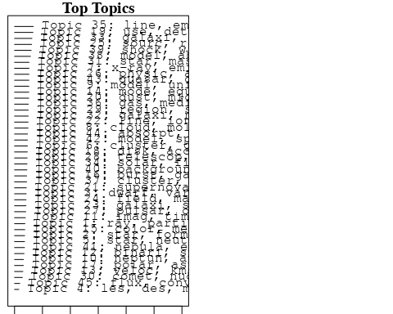

## Topic 1 Top Words:  
## Highest Prob: ray, particl, energi, cosmic, gamma, sourc, galact, halo, cosmic-ray, observ   
## FREX: ray, gamma, particl, cosmic-ray, cosmic, mev, proton, charg, energet, halo   
## Lift: unseen, tev, ray, cosmic-ray, gamma, gev, mev, charg, balloon, proton   
## Score: ray, unseen, gamma, cosmic, particl, cosmic-ray, gamma-ray, proton, mev, halo   
## Topic 2 Top Words:  
## Highest Prob: star, format, ngc, massiv, rate, galaxi, number, observ, region, interact   
## FREX: format, ngc, star-form, massiv, lmc, million, star, wolf-rayet, magellan, interact   
## Lift: violent, format, star-form, wolf-rayet, ago, lmc, inflow, imf, ngc, million   
## Score: ngc, format, violent, star, star-form, wolf-rayet, massiv, galaxi, lmc, rate   
## Topic 3 Top Words:  
## Highest Prob: dwarf, variabl, period, white, variat, observ, pulsat, star, day, chang   
## FREX: white, variabl, dwarf, pulsat, period, cataclysm, variat, day, amplitud, nova   
## Lift: secular, white, cataclysm, pulsat, variabl, dwarf, fourier, period, convent, modul   
## Score: white, dwarf, secular, variabl, period, cataclysm, pulsat, nova, day, outburst   
## Topic 4 Top Words:  
## Highest Prob: les, des, maser, dan, sont, est, pour, rest, une, plus   
## FREX: les, des, dan, sont, est, pour, maser, une, rest, plus   
## Lift: est, des, sont, dan, les, pour, une, maser, rest, plus   
## Score: dan, les, des, sont, est, pour, une, maser, plus, rest   
## Topic 5 Top Words:  
## Highest Prob: star, neutron, rate, surfac, matter, model, larg, shown, possibl, observ   
## FREX: neutron, rate, flash, matter, star, shown, crust, surfac, superfluid, normal   
## Lift: flash, crust, neutron, superfluid, exot, moment, erg, rate, collect, eddington   
## Score: flash, neutron, star, rate, crust, matter, superfluid, surfac, erg, rotat   
## Topic 6 Top Words:  
## Highest Prob: cluster, galaxi, ellipt, globular, core, stellar, blue, central, metal, merger   
## FREX: ellipt, globular, merger, cluster, metal, blue, fornax, core, horizont, bulg   
## Lift: fornax, metal-rich, globular, ellipt, isophot, merger, horizont, color-magnitud, lyra, bulg   
## Score: fornax, cluster, globular, ellipt, galaxi, merger, metal, dwarf, virgo, blue   
## Topic 7 Top Words:  
## Highest Prob: x-ray, emiss, observ, remnant, data, supernova, kev, einstein, soft, optic   
## FREX: x-ray, einstein, remnant, rosat, kev, soft, emiss, snr, supernova, observatori   
## Lift: photoelectr, ipc, einstein, x-ray, rosat, snr, counter, snrs, remnant, ergss   
## Score: x-ray, photoelectr, remnant, kev, einstein, soft, rosat, emiss, supernova, snrs   
## Topic 8 Top Words:  
## Highest Prob: cloud, molecular, gas, outflow, sourc, associ, observ, suggest, mass, emiss   
## FREX: molecular, cloud, outflow, high-veloc, dens, associ, bipolar, embed, clump, orion   
## Lift: opaqu, molecular, high-veloc, cloud, outflow, bipolar, orion, protostar, embed, clump   
## Score: molecular, cloud, opaqu, outflow, gas, high-veloc, orion, bipolar, ira, clump   
## Topic 9 Top Words:  
## Highest Prob: model, univers, densiti, scale, matter, distribut, cosmolog, structur, cosmic, observ   
## FREX: univers, cosmolog, omega, string, large-scal, matter, anisotropi, merg, fluctuat, dark   
## Lift: string, omega, hierarch, cdm, univers, merg, small-scal, cell, cosmolog, insensit   
## Score: string, univers, cosmolog, omega, cosmic, anisotropi, cdm, matter, primordi, merg   
## Topic 10 Top Words:  
## Highest Prob: neptun, atmospher, jupit, observ, voyag, ring, plasma, uranus, occult, magnetospher   
## FREX: neptun, voyag, jupit, uranus, occult, saturn, june, magnetospher, atmospher, planet   
## Lift: june, neptun, saturn, jovian, occult, voyag, uranus, kilomet, jupit, cubic   
## Score: june, neptun, uranus, voyag, jupit, occult, saturn, ring, magnetospher, planet   
## Topic 11 Top Words:  
## Highest Prob: imag, time, observ, arcsec, measur, obtain, data, frequenc, diamet, present   
## FREX: arcsec, diamet, asteroid, imag, precis, correspond, mhz, time, frequenc, ccd   
## Lift: asteroid, arcsec, diamet, narrow-band, broadband, mhz, arriv, scintil, precis, terrestri   
## Score: asteroid, imag, arcsec, diamet, mhz, frequenc, ccd, scintil, precis, day   
## Topic 12 Top Words:  
## Highest Prob: binari, system, mass, star, log, will, gravit, observ, close, can   
## FREX: binari, log, system, will, coalesc, singl, degener, close, gravit, spin   
## Lift: log, binari, coalesc, degener, spin, conserv, illumin, segreg, disrupt, wolf-rayet   
## Score: log, binari, system, coalesc, mass, star, neutron, gravit, black, degener   
## Topic 13 Top Words:  
## Highest Prob: veloc, kms, radial, dispers, motion, profil, kinemat, radius, show, secondari   
## FREX: kms, veloc, radial, dispers, kinemat, motion, secondari, approx, tsub, radius   
## Lift: time-resolv, kms, veloc, radial, tsub, kmsec, dispers, kinemat, ensembl, doppler   
## Score: veloc, time-resolv, kms, radial, dispers, kinemat, motion, secondari, tsub, approx   
## Topic 14 Top Words:  
## Highest Prob: mode, equat, oscil, wave, frequenc, instabl, effect, energi, solut, scatter   
## FREX: equat, mode, oscil, instabl, reson, solut, nonlinear, acoust, p-mode, wave   
## Lift: acoust, axial, p-mode, mode, equat, oscil, formul, azimuth, high-frequ, nonlinear   
## Score: mode, axial, oscil, equat, wave, instabl, p-mode, acoust, frequenc, damp   
## Topic 15 Top Words:  
## Highest Prob: color, measur, photometri, activ, differ, indic, observ, photometr, present, stellar   
## FREX: color, photometri, photometr, redden, classif, differ, activ, anomali, calibr, program   
## Lift: b-v, classif, anomali, cvn, color, redden, photometr, check, reduct, photometri   
## Score: b-v, color, photometri, photometr, redden, classif, activ, cvn, measur, calibr   
## Topic 16 Top Words:  
## Highest Prob: burst, gamma-ray, time, hard, distribut, transient, event, observ, sourc, cosmolog   
## FREX: burst, gamma-ray, transient, burster, bats, hard, delay, microwav, durat, cosmolog   
## Lift: bats, burst, burster, transient, gamma-ray, fluenc, repeat, lorentz, box, smm   
## Score: burst, bats, gamma-ray, burster, hard, microwav, transient, cosmolog, event, kev   
## Topic 17 Top Words:  
## Highest Prob: polar, astronom, ring, observ, astronomi, angl, paper, observatori, posit, year   
## FREX: polar, astronom, astronomi, advanc, ring, angl, centuri, research, longitud, figur   
## Lift: advanc, polarimetri, polar, centuri, astronomi, figur, astronom, ring, draw, longitud   
## Score: advanc, polar, astronom, astronomi, ring, centuri, angl, figur, polarimetri, research   
## Topic 18 Top Words:  
## Highest Prob: disk, accret, model, mass, rate, wind, object, exp, solar, inner   
## FREX: disk, accret, protostellar, orioni, inner, onto, infal, massyr, wind, thick   
## Lift: stress, orioni, protostellar, disk, accret, keplerian, massyr, innermost, viscous, viscos   
## Score: disk, accret, stress, protostellar, orioni, wind, massyr, viscos, infal, outburst   
## Topic 19 Top Words:  
## Highest Prob: use, determin, deriv, method, distanc, valu, paramet, estim, relat, function   
## FREX: method, determin, distanc, deriv, valu, techniqu, agreement, paramet, mean, error   
## Lift: dilut, method, cepheid, reliabl, techniqu, carlo, mont, cross-correl, agreement, distanc   
## Score: dilut, method, cepheid, distanc, error, techniqu, determin, deriv, paramet, function   
## Topic 20 Top Words:  
## Highest Prob: dust, micron, emiss, infrar, band, featur, grain, interstellar, micromet, wavelength   
## FREX: micron, dust, micromet, infrar, pah, grain, band, -micron, featur, near-infrar   
## Lift: aromat, polycycl, pah, silic, micromet, micron, hydrocarbon, dust, -micron, grain   
## Score: micron, dust, polycycl, micromet, grain, infrar, pah, ira, -micron, emiss   
## Topic 21 Top Words:  
## Highest Prob: supernova, mass, type, envelop, explos, shell, core, collaps, light, nova   
## FREX: explos, envelop, supernova, ejecta, shell, burn, collaps, nova, type, eject   
## Lift: avec, explos, ejecta, burn, radioact, envelop, captur, co-, supernova, shell   
## Score: supernova, avec, explos, nova, envelop, shell, ejecta, burn, collaps, mass   
## Topic 22 Top Words:  
## Highest Prob: line, ioniz, region, observ, model, extinct, forbidden, densiti, emiss, optic   
## FREX: ioniz, extinct, line, forbidden, photoion, bump, fine-structur, sight, photodissoci, region   
## Lift: fuv, fine-structur, photodissoci, photoion, bump, extinct, ioniz, forbidden, sight, diagnost   
## Score: fuv, line, ioniz, forbidden, extinct, fine-structur, photodissoci, photoion, bump, sight   
## Topic 23 Top Words:  
## Highest Prob: galaxi, survey, catalog, popul, faint, number, nearbi, present, redshift, star   
## FREX: catalog, survey, faint, catalogu, list, nearbi, popul, coordin, revis, sky   
## Lift: catalogu, revis, list, catalog, survey, coordin, atlas, faint, percentag, name   
## Score: catalogu, galaxi, survey, catalog, faint, redshift, nearbi, list, popul, sky   
## Topic 24 Top Words:  
## Highest Prob: field, magnet, hole, rotat, black, format, strength, initi, dynam, strong   
## FREX: field, hole, magnet, black, strength, rotat, collaps, three-dimension, momentum, potenti   
## Lift: violat, field, hole, magnet, black, jean, three-dimension, lose, prevent, disrupt   
## Score: magnet, field, hole, violat, black, rotat, collaps, format, strength, momentum   
## Topic 25 Top Words:  
## Highest Prob: sourc, radio, optic, observ, posit, compact, vla, ghz, detect, emiss   
## FREX: radio, sourc, vla, vlbi, ghz, compact, posit, extragalact, counterpart, optic   
## Lift: baselin, vlbi, radio, gyrosynchrotron, vla, mji, free-fre, ghz, sourc, mas   
## Score: radio, baselin, sourc, vla, vlbi, ghz, compact, mji, extragalact, map   
## Topic 26 Top Words:  
## Highest Prob: physic, astrophys, discuss, will, theori, problem, studi, mani, new, provid   
## FREX: astrophys, physic, problem, understand, section, theori, review, work, mani, role   
## Lift: book, astrophys, question, concern, understand, phenomena, section, technolog, problem, physic   
## Score: book, astrophys, physic, section, problem, review, understand, theori, technolog, concern   
## Topic 27 Top Words:  
## Highest Prob: pulsar, orbit, companion, system, period, puls, eclips, satellit, psr, time   
## FREX: pulsar, orbit, puls, companion, psr, eclips, millisecond, satellit, inclin, period   
## Lift: corot, pulsar, orbit, eccentr, psr, spin-, millisecond, puls, inclin, companion   
## Score: pulsar, orbit, corot, puls, psr, companion, eclips, millisecond, binari, period   
## Topic 28 Top Words:  
## Highest Prob: telescop, observ, imag, space, hst, approxim, hubbl, resolut, eclips, light   
## FREX: telescop, hst, space, hubbl, sec, camera, eclips, euv, primari, resolut   
## Lift: kitt, sec, telescop, hst, goddard, euv, camera, mirror, space, ground-bas   
## Score: telescop, kitt, hst, imag, eclips, hubbl, camera, sec, euv, space   
## Topic 29 Top Words:  
## Highest Prob: region, structur, center, bright, map, resolut, spatial, near, show, seen   
## FREX: center, region, map, spatial, filament, structur, resolut, seen, sgr, bright   
## Lift: left, filament, sgr, across, lobe, center, spatial, map, arc, region   
## Score: left, map, region, filament, sgr, center, structur, resolut, bright, spatial   
## Topic 30 Top Words:  
## Highest Prob: comet, nucleus, observ, cometari, ice, coma, halley, chang, dust, tail   
## FREX: comet, cometari, halley, coma, ice, nucleus, tail, perihelion, heliocentr, chang   
## Lift: comet, perihelion, halley, cometari, heliocentr, coma, ice, passag, tail, albedo   
## Score: comet, perihelion, halley, cometari, ice, coma, nucleus, heliocentr, albedo, grain   
## Topic 31 Top Words:  
## Highest Prob: star, mass, dwarf, luminos, stellar, rotat, cluster, sequenc, age, tauri   
## FREX: sequenc, member, tauri, brown, hyad, pleiad, star, age, candid, low-mass   
## Lift: pleiad, hyad, brown, member, taurus-auriga, sequenc, tauri, target, solar-typ, h-r   
## Score: pleiad, star, hyad, tauri, dwarf, cluster, brown, sequenc, member, age   
## Topic 32 Top Words:  
## Highest Prob: galaxi, ngc, spiral, gas, nucleus, kpc, nuclear, starburst, central, extend   
## FREX: spiral, kpc, starburst, ngc, nucleus, arm, nuclear, galaxi, gas, arp   
## Lift: arp, arm, spiral, kpc, nucleus, cone, long-slit, starburst, torus, nuclear   
## Score: arm, galaxi, ngc, spiral, nucleus, starburst, gas, kpc, arp, nuclear   
## Topic 33 Top Words:  
## Highest Prob: galaxi, luminos, sampl, activ, ira, seyfert, nuclei, correl, galact, flux   
## FREX: luminos, seyfert, sampl, agn, nuclei, ira, far-infrar, activ, galaxi, correl   
## Lift: flux-limit, low-luminos, agn, seyfert, luminos, obscur, sampl, high-luminos, nuclei, far-infrar   
## Score: galaxi, seyfert, flux-limit, luminos, ira, sampl, agn, far-infrar, nuclei, fir   
## Topic 34 Top Words:  
## Highest Prob: solar, flare, event, observ, coron, sun, electron, maximum, impuls, chromospher   
## FREX: flare, solar, event, impuls, coron, sun, interplanetari, chromospher, loop, energet   
## Lift: link, flare, impuls, interplanetari, solar, quiet, event, coron, sun, irradi   
## Score: flare, solar, link, coron, event, impuls, interplanetari, sun, chromospher, proton   
## Topic 35 Top Words:  
## Highest Prob: line, emiss, spectra, continuum, optic, absorpt, ultraviolet, profil, iii, broad   
## FREX: h-alpha, iue, broad, continuum, iii, ultraviolet, emission-lin, line, spectra, absorpt   
## Lift: symbiot, iue, balmer, h-alpha, emission-lin, ori, broad, blueshift, low-resolut, broad-lin   
## Score: symbiot, line, emiss, h-alpha, iue, spectra, continuum, ultraviolet, emission-lin, absorpt   
## Topic 36 Top Words:  
## Highest Prob: gas, medium, interstellar, densiti, radiat, cool, can, hot, pressur, approxim   
## FREX: medium, interstellar, cool, pressur, gas, reaction, ism, hot, positron, radiat   
## Lift: positron, blast, ism, medium, reaction, collision, extern, destroy, pressur, intergalact   
## Score: positron, gas, interstellar, medium, reaction, shock, pressur, ism, cool, ion   
## Topic 37 Top Words:  
## Highest Prob: cluster, galaxi, mass, distribut, model, dark, group, halo, veloc, matter   
## FREX: cluster, group, dark, virgo, mpc, abel, halo, galaxi, rich, matter   
## Lift: abel, virial, n-bodi, median, virgo, cluster, rich, group, isotherm, mpc   
## Score: cluster, abel, galaxi, virgo, group, mass, halo, mpc, dark, lens   
## Topic 38 Top Words:  
## Highest Prob: model, abund, observ, element, temperatur, differ, predict, ratio, cool, chemic   
## FREX: abund, element, deplet, chemic, lithium, isotop, helium, nucleosynthesi, standard, model   
## Lift: lithium, deplet, bang, abund, isotop, element, teff, defici, metal-poor, opac   
## Score: lithium, abund, element, nucleosynthesi, deplet, chemic, isotop, helium, neutrino, metal   
## Topic 39 Top Words:  
## Highest Prob: shock, wind, wave, flow, acceler, heat, plasma, energi, model, jet   
## FREX: shock, wind, flow, acceler, alfven, bow, wave, heat, plasma, mhd   
## Lift: upstream, alfven, mhd, bow, magnetohydrodynam, electr, superson, shock, diverg, termin   
## Score: shock, wind, upstream, wave, acceler, plasma, flow, alfven, bow, mhd   
## Topic 40 Top Words:  
## Highest Prob: background, deg, limit, measur, galact, cosmic, exp, microwav, radiat, spectrum   
## FREX: background, deg, microwav, nois, cobe, anisotropi, upper, cosmic, sky, fluctuat   
## Lift: radiomet, cobe, nois, autocorrel, background, deg, cmb, likelihood, microwav, eclipt   
## Score: radiomet, background, deg, microwav, cobe, cosmic, anisotropi, nois, cmb, fluctuat   
## Topic 41 Top Words:  
## Highest Prob: nebula, evolut, star, planetari, mass, giant, central, solar, stellar, phase   
## FREX: nebula, planetari, evolut, nebular, giant, evolv, evolutionari, stage, analys, supergi   
## Lift: analys, nebular, nebula, supergi, planetari, asymptot, stage, evolv, evolutionari, giant   
## Score: analys, nebula, planetari, evolut, nebular, star, giant, evolutionari, branch, mass   
## Topic 42 Top Words:  
## Highest Prob: model, spectral, energi, spectra, emiss, spectrum, electron, radiat, distribut, observ   
## FREX: synchrotron, index, power-law, spectral, compton, relativist, nontherm, electron, spectrum, spectra   
## Lift: crab, synchrotron, bremsstrahlung, power-law, index, low-energi, compton, steeper, blackbodi, break   
## Score: crab, synchrotron, compton, electron, relativist, spectra, index, spectral, kev, nontherm   
## Topic 43 Top Words:  
## Highest Prob: quasar, object, redshift, gravit, lens, len, microlens, qso, imag, galaxi   
## FREX: quasar, len, qso, lens, microlens, lac, redshift, object, gravit, distant   
## Lift: superlumin, lacerta, qso, len, lac, quasar, microlens, lens, high-redshift, amplif   
## Score: quasar, superlumin, lens, len, microlens, redshift, qso, lac, gravit, object   
## Topic 44 Top Words:  
## Highest Prob: absorpt, transit, detect, hydrogen, densiti, column, toward, interstellar, line, spectra   
## FREX: transit, column, hydrogen, absorpt, absorb, atom, toward, ly-alpha, speci, molecul   
## Lift: methan, absorb, transit, column, speci, molecul, ly-alpha, hydrogen, atom, vibrat   
## Score: methan, absorpt, transit, column, ly-alpha, hydrogen, damp, molecul, absorb, speci   
## Topic 45 Top Words:  
## Highest Prob: flux, convect, turbul, zone, magnet, diffus, dynamo, scale, generat, tube   
## FREX: turbul, convect, dynamo, zone, flux, tube, emerg, diffus, mix, generat   
## Lift: dynamo, tube, turbul, convect, zone, action, emerg, suppress, restrict, mix   
## Score: dynamo, convect, turbul, zone, tube, flux, magnet, diffus, mix, action   
## [1] "The Dark Matter in the Universe and the Origin of Cosmic Radiation In 1912, the Austrian physicist Victor Hess, using data on cosmic rays from balloon flights, proved conclusively that these rays are not generated in the earth or in the earths atmosphere but originate in outer space.' Hess won the Nobel Prize for his discovery, but this was just the beginning of cosmic ray research, which then grew r a ~ i d l y . ~ , ~ By the 1940s, the body of cosmic ray observations taken at high altitudes over the entire surface of the earth had proved conclusively that the primary cosmic rays are charged particles, mostly protons, with a small heavy nuclei component. In the early 1930s, Serge Korff had done experimental work in optics and had published a basic paper on optical dispersion with Gregory Breit4; that paper is a tribute to Korff and a mark of his skill as a theoretician as well as an experimentalist. It also marked the end of his work in optics, for at about that time, he launched his career as a cosmic ray physicist, a fruitful and happy choice for Korff, who contributed significantly to this branch of physics. At this point, the rapidly growing body of cosmic ray data gave no hint as to the correct theory, or indeed to any theory, of the origin of cosmic rays. The field has remained much the same since then, for in spite of a vast amount of data, there is no adequate theory of their origin. We therefore dedicate this paper, in which we present a model for the origin of cosmic rays, to the memory of Serge Korff. An acceptable theory of the origin of cosmic rays must account for the following observed features5:"   
## [2] "The Dark Matter in the Universe and the Origin of Cosmic Radiation In 1912, the Austrian physicist Victor Hess, using data on cosmic rays from balloon flights, proved conclusively that these rays are not generated in the earth or in the earths atmosphere but originate in outer space.' Hess won the Nobel Prize for his discovery, but this was just the beginning of cosmic ray research, which then grew r a ~ i d l y . ~ , ~ By the 1940s, the body of cosmic ray observations taken at high altitudes over the entire surface of the earth had proved conclusively that the primary cosmic rays are charged particles, mostly protons, with a small heavy nuclei component. In the early 1930s, Serge Korff had done experimental work in optics and had published a basic paper on optical dispersion with Gregory Breit4; that paper is a tribute to Korff and a mark of his skill as a theoretician as well as an experimentalist. It also marked the end of his work in optics, for at about that time, he launched his career as a cosmic ray physicist, a fruitful and happy choice for Korff, who contributed significantly to this branch of physics. At this point, the rapidly growing body of cosmic ray data gave no hint as to the correct theory, or indeed to any theory, of the origin of cosmic rays. The field has remained much the same since then, for in spite of a vast amount of data, there is no adequate theory of their origin. We therefore dedicate this paper, in which we present a model for the origin of cosmic rays, to the memory of Serge Korff. An acceptable theory of the origin of cosmic rays must account for the following observed features5:"   
## [3] "Ultra‐High‐Energy Astronomy and Cosmic Rays Cosmic rays provide us with beams of particles with energies beyond those currently available at accelerators or colliders. There are (1) energetic nuclei and electrons, which are called cosmic rays, (2) highenergy gamma rays which are produced by the interaction of nuclear cosmic rays with matter or background photons, or electromagnetic interactions of high-energy electrons, and (3) high-energy neutrinos produced in energetic astrophysical sources. Cosmic ray nuclei have a spectrum extending to energies as large as 1000 TeV in the center of mass of their collision with atmospheric nuclei. Energetic astrophysical sources, such as x-ray binaries, appear to be emitting neutral particles up to EeV (10l8 eV) energies in the lab system, sometimes phase locked with known motions in the system so that one can determine their mass. Earth-based experiments study the properties of such beams and their interactions in the atmosphere. Observational approaches consist of the study of air showers produced by these beams, the study of jets from local atmospheric collisions of these particles (A-jets) detected in large emulsion chambers (EC) at mountain altitudes, and the study of high-energy muons and neutrinos detected in large underground detectors. These different experiments provide opportunities to examine the asymptotic behavior of particle interactions at high energy and the high-energy composition of cosmic rays. A detailed summary of the experimental status can be found in several reviews.'-' This paper discusses the current status of selected studies of cosmic ray interactions and of observations of Ultra-High-Energy gamma rays with particular reference to possible anomalous production of muons at high energies."   
## [4] "Ultra‐High‐Energy Astronomy and Cosmic Rays Cosmic rays provide us with beams of particles with energies beyond those currently available at accelerators or colliders. There are (1) energetic nuclei and electrons, which are called cosmic rays, (2) highenergy gamma rays which are produced by the interaction of nuclear cosmic rays with matter or background photons, or electromagnetic interactions of high-energy electrons, and (3) high-energy neutrinos produced in energetic astrophysical sources. Cosmic ray nuclei have a spectrum extending to energies as large as 1000 TeV in the center of mass of their collision with atmospheric nuclei. Energetic astrophysical sources, such as x-ray binaries, appear to be emitting neutral particles up to EeV (10l8 eV) energies in the lab system, sometimes phase locked with known motions in the system so that one can determine their mass. Earth-based experiments study the properties of such beams and their interactions in the atmosphere. Observational approaches consist of the study of air showers produced by these beams, the study of jets from local atmospheric collisions of these particles (A-jets) detected in large emulsion chambers (EC) at mountain altitudes, and the study of high-energy muons and neutrinos detected in large underground detectors. These different experiments provide opportunities to examine the asymptotic behavior of particle interactions at high energy and the high-energy composition of cosmic rays. A detailed summary of the experimental status can be found in several reviews.'-' This paper discusses the current status of selected studies of cosmic ray interactions and of observations of Ultra-High-Energy gamma rays with particular reference to possible anomalous production of muons at high energies."   
## [5] "Gamma Ray Astrophysics: Development and Future Prospects Serge Korff's broad research activities did not include an active involvement in gamma ray astrophysics. However, his work did have tremendous influence on the field. Several of his students became active researchers in the field, including Bob Haymes, Steve Holt, Bill Reidy and Bill Sandie. Bob Haymes was one of the pioneers of observational gamma ray astronomy. His group at Rice University achieved many of the initial detections of gamma ray sources, and also provided a training ground for a large number of students and research associates who have continued active careers in the field. Korff's research was related to the successful development of gamma ray astrophysics in other ways. Since gamma rays can penetrate only the upper fraction of a percent of the atmosphere, almost all of the initial results in the nascent field came from balloon-borne experiments. The success of these early observations were due in large part to the development of high-altitude ballooning techniques pioneered by the cosmicray physics community, and to the experimental techniques which were also developed there, many of which were quickly adopted by the early gamma ray researchers. Early results obtained in the midto late 1960s were remarkable indeed, and included observations of galactic sources such as the Crab nebula1j2 and its pulsar3 and Cygnus X-l,e5 the black hole candidate, whose variability was first recognized from a series of hard x-ray balloon observations.6 Early results also included the detection of hard x-rays from Centaurus A? and observations of the diffuse background in hard x-rays8 and lower energy gamma rays? Many of the results obtained by Korff and his colleagues were of great importance to the gamma ray community. These included the latitudinal variation of the cosmic rays, which suggested that gamma ray measurements be undertaken from high rigidity sites. Also, the understanding of the production of neutrons in the atmosphere and in instruments was important, for these were and remain a major source of background in gamma ray instrumentation. The early observations of the diffuse back-"

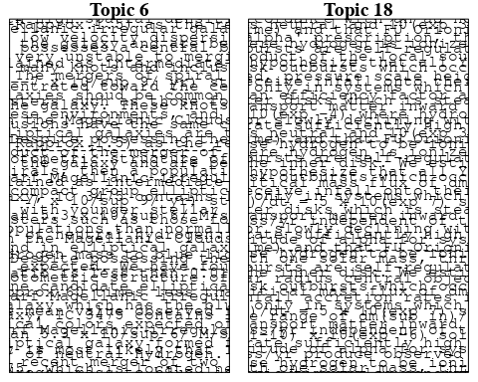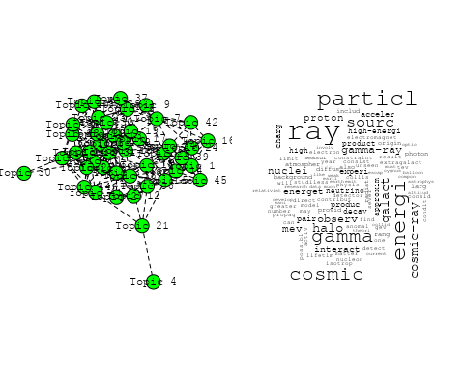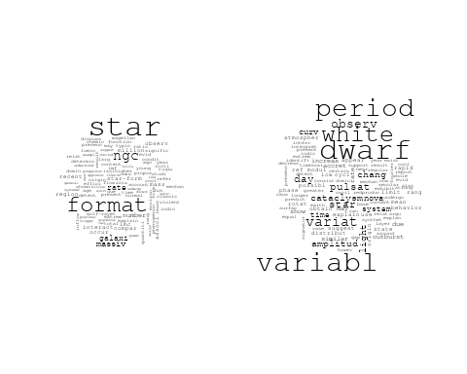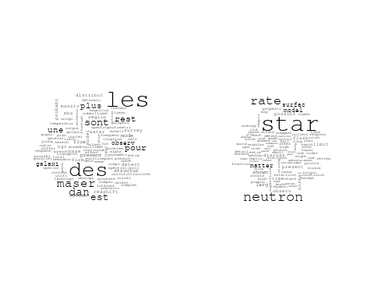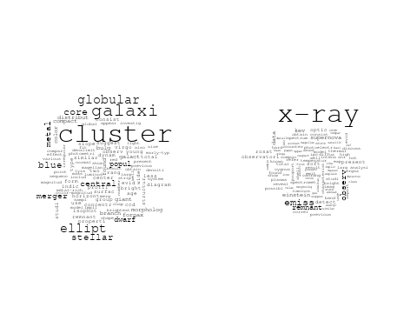

## Warning in wordcloud::wordcloud(words = vocab, freq = vec, max.words =  
## max.words, : cosmolog could not be fit on page. It will not be plotted.

## Warning in wordcloud::wordcloud(words = vocab, freq = vec, max.words =  
## max.words, : distribut could not be fit on page. It will not be plotted.

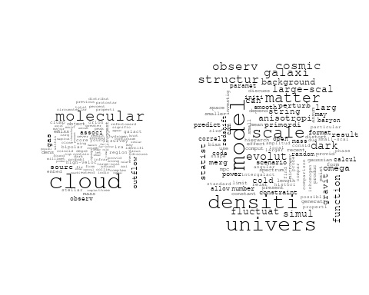

## Warning in wordcloud::wordcloud(words = vocab, freq = vec, max.words =  
## max.words, : neptun could not be fit on page. It will not be plotted.

## Warning in wordcloud::wordcloud(words = vocab, freq = vec, max.words =  
## max.words, : planet could not be fit on page. It will not be plotted.

## Warning in wordcloud::wordcloud(words = vocab, freq = vec, max.words =  
## max.words, : system could not be fit on page. It will not be plotted.

## Warning in wordcloud::wordcloud(words = vocab, freq = vec, max.words =  
## max.words, : uranus could not be fit on page. It will not be plotted.

## Warning in wordcloud::wordcloud(words = vocab, freq = vec, max.words =  
## max.words, : spacecraft could not be fit on page. It will not be plotted.

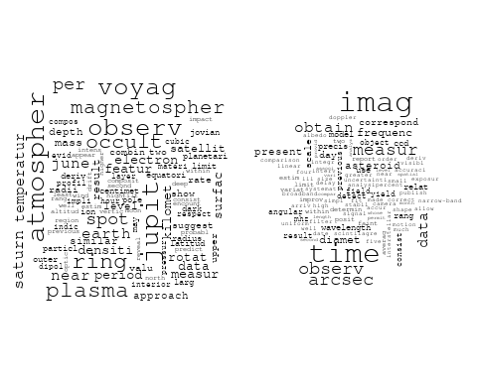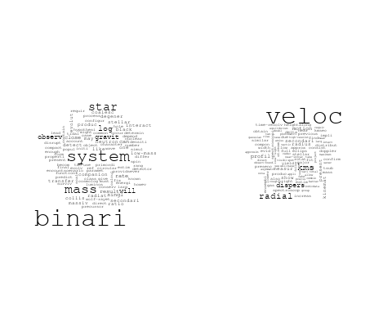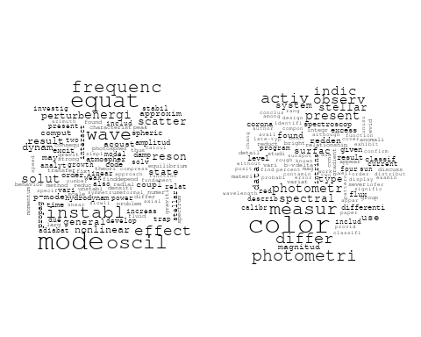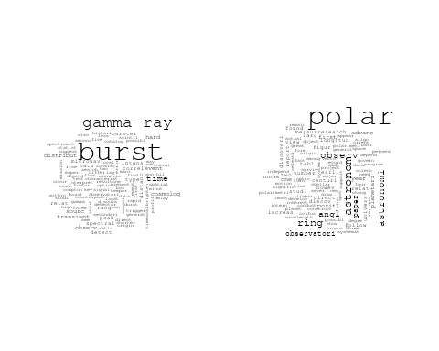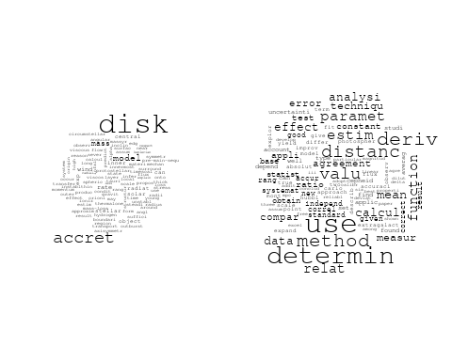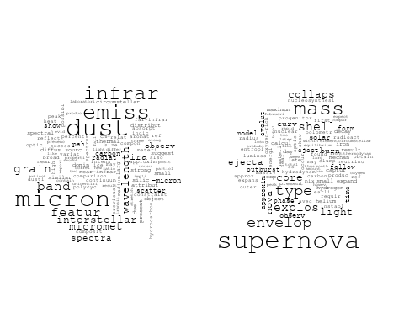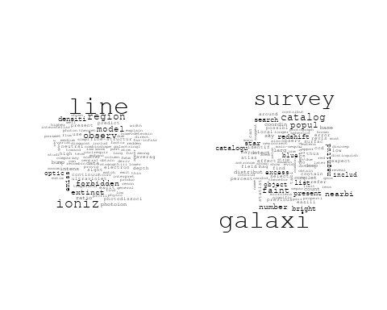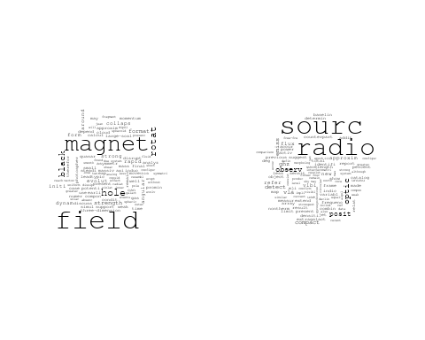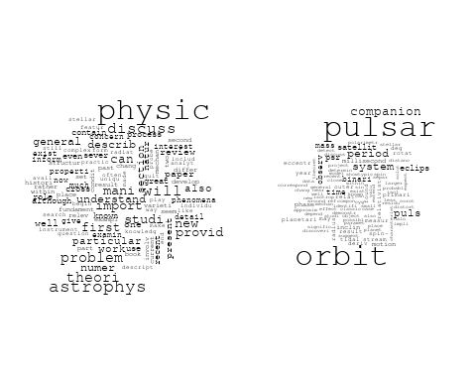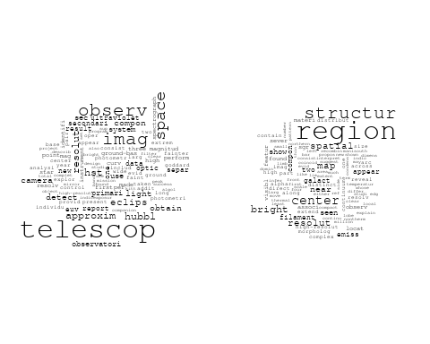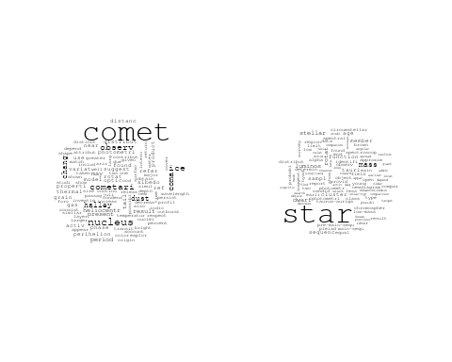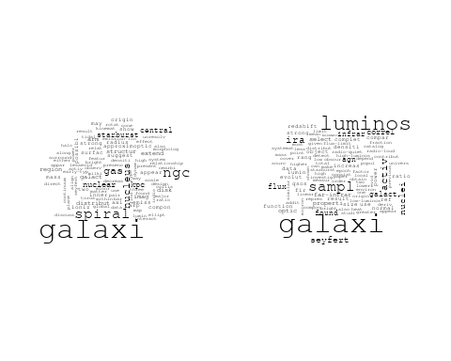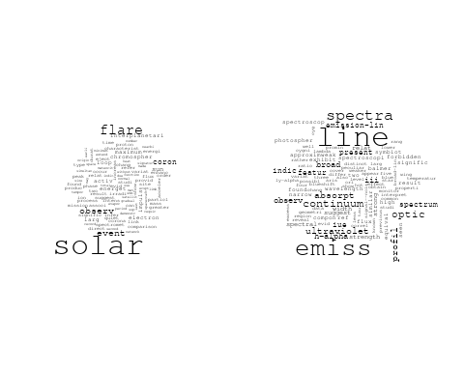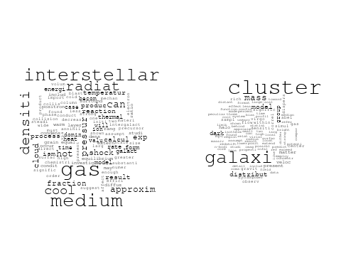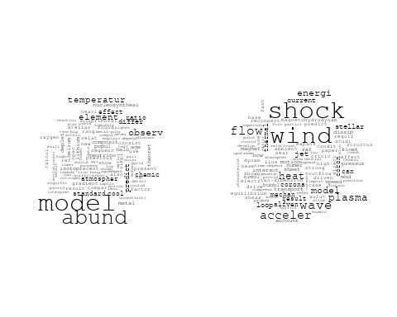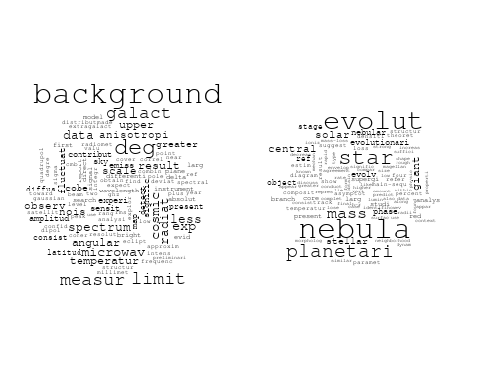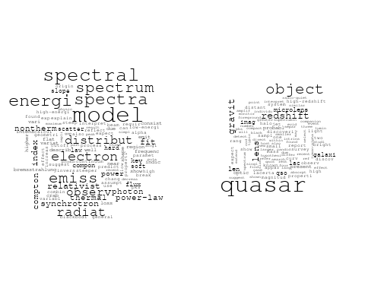

## Warning in wordcloud::wordcloud(words = vocab, freq = vec, max.words =  
## max.words, : absorpt could not be fit on page. It will not be plotted.

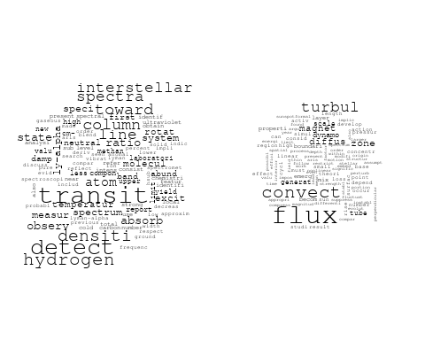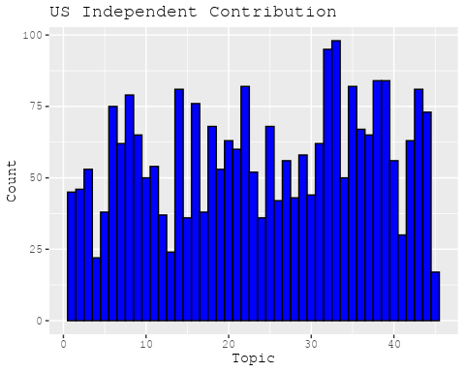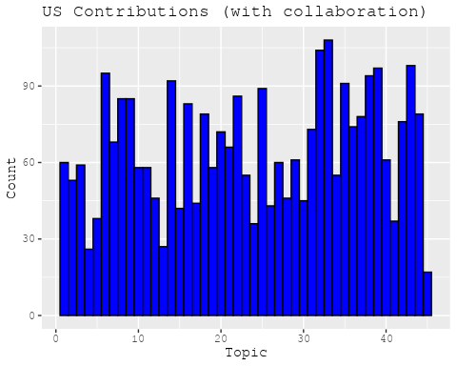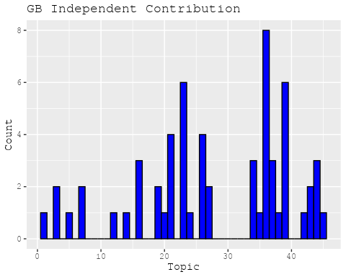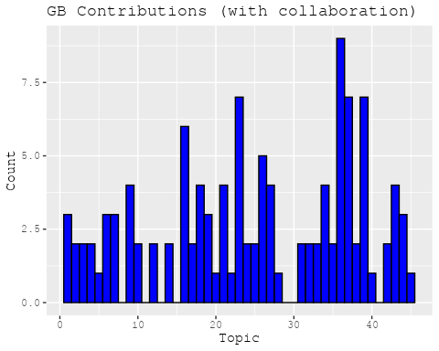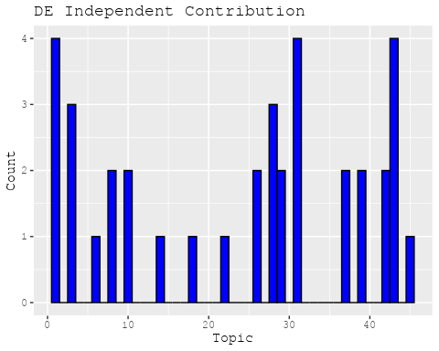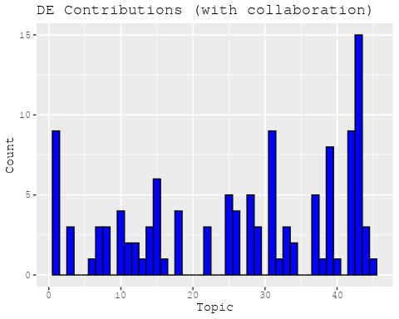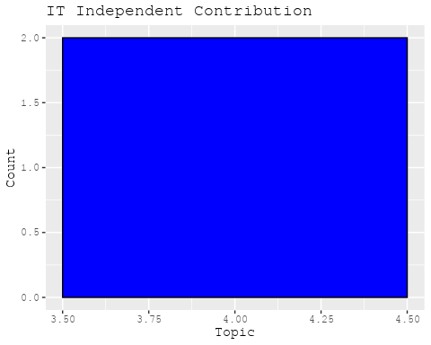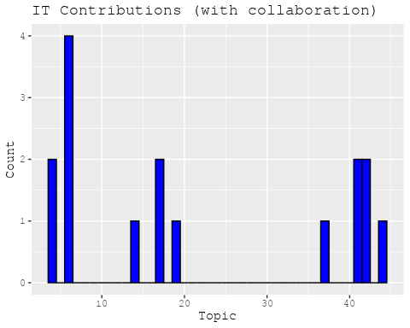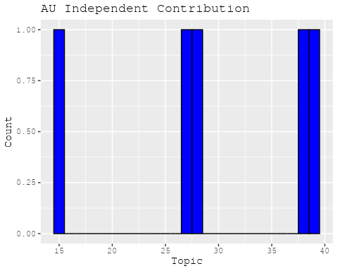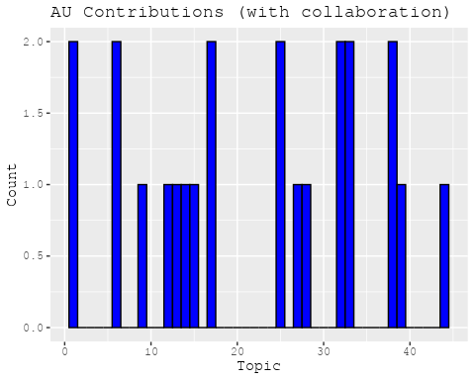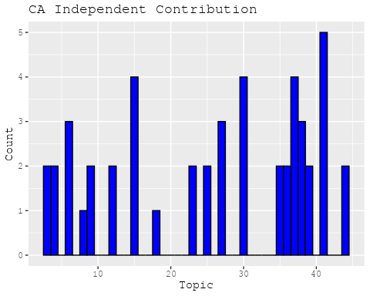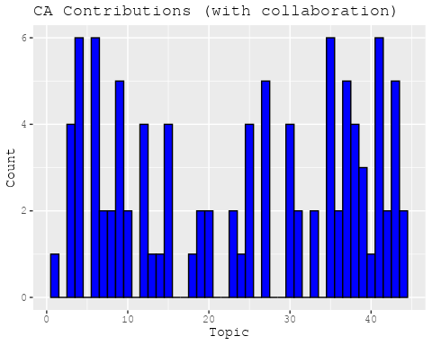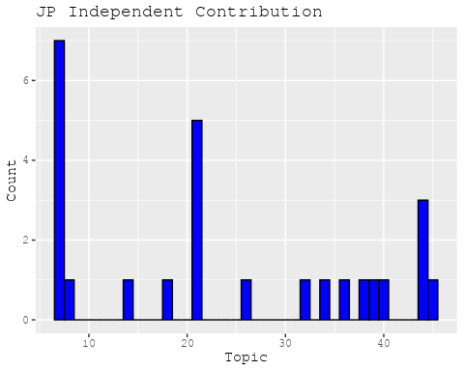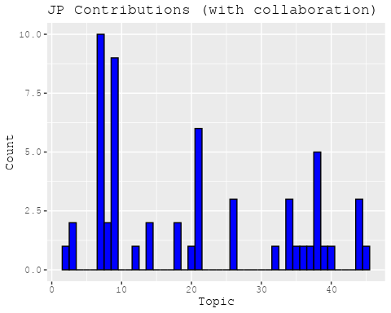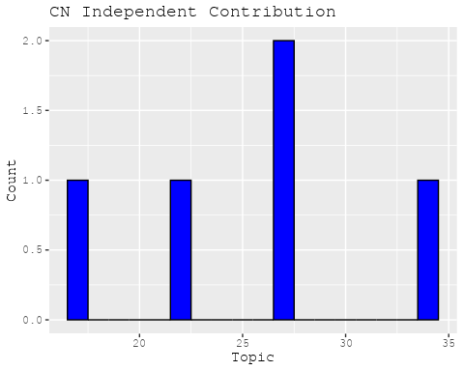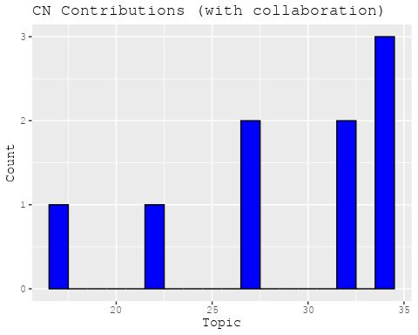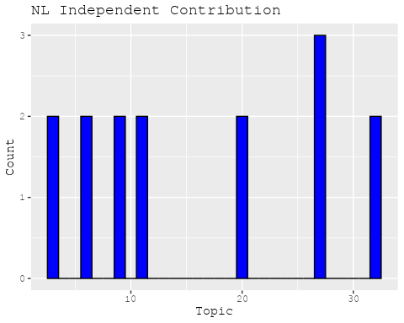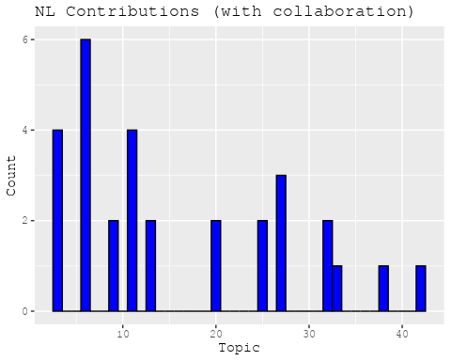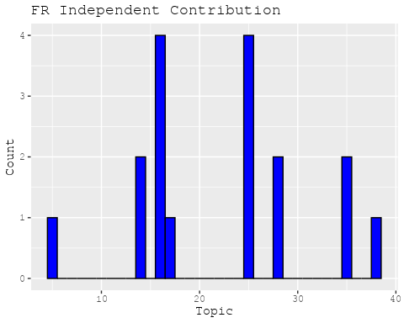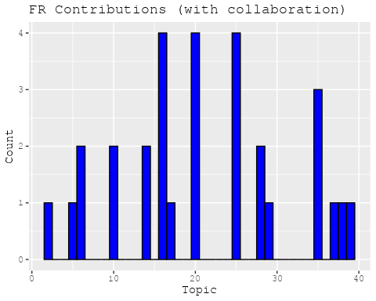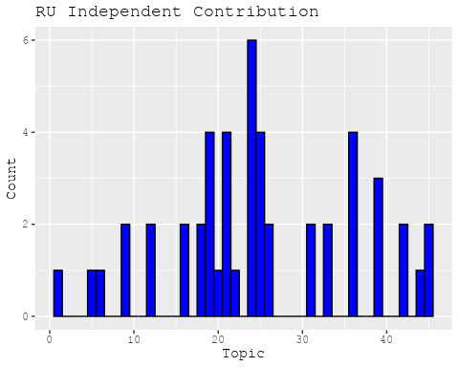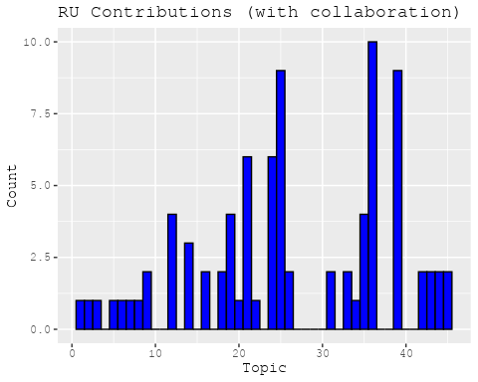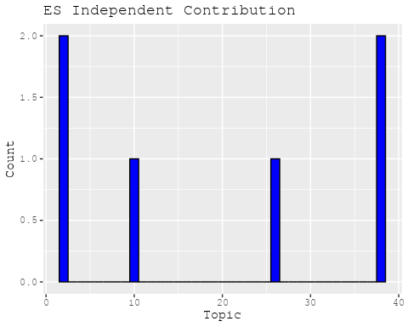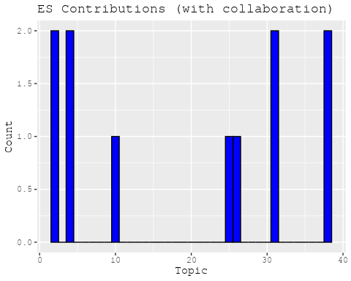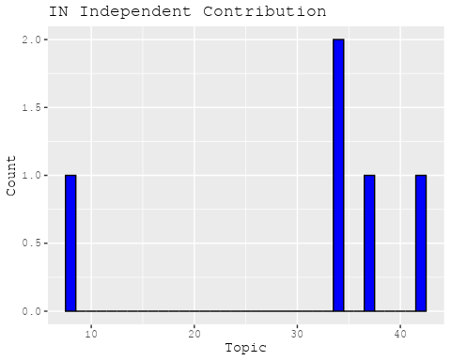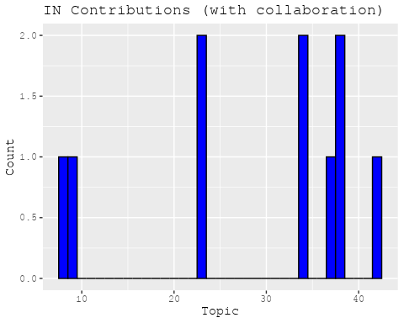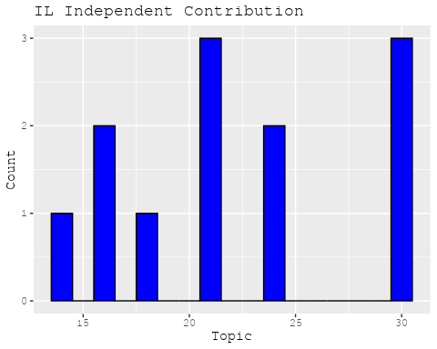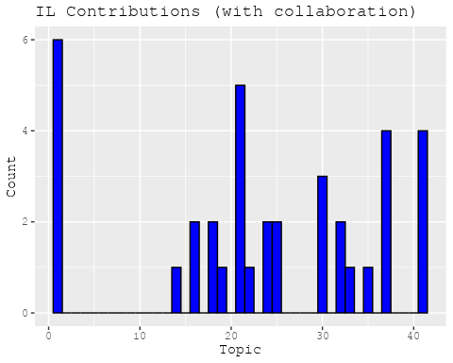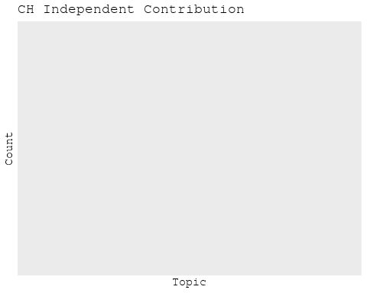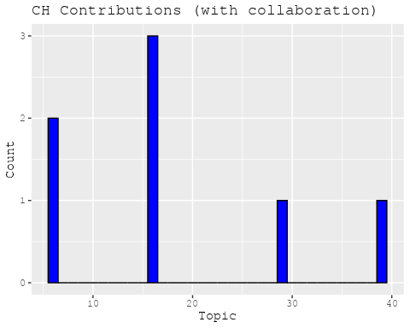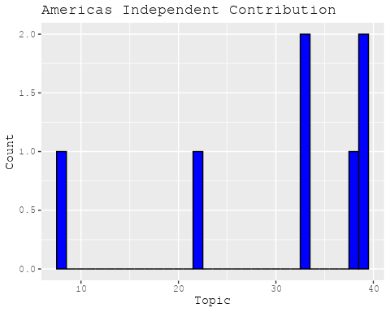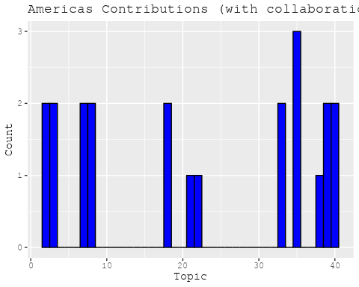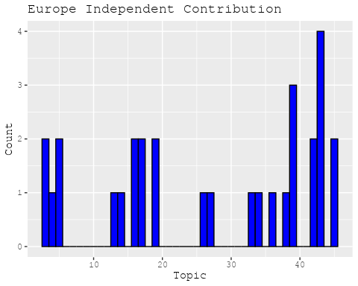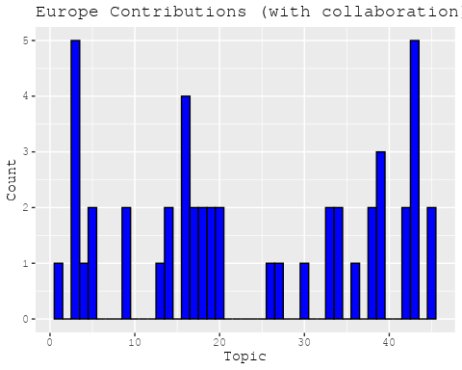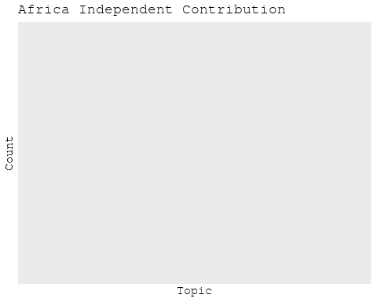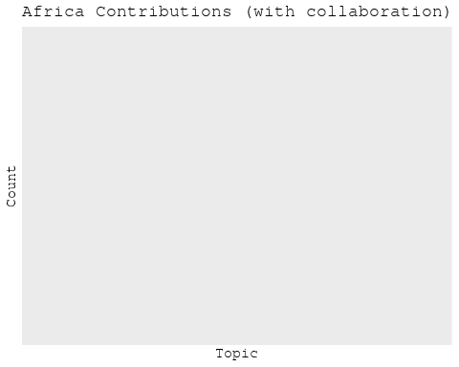

## [1] "Processing interval: pub_interval_1975_1984"  
## Building corpus...   
## Converting to Lower Case...   
## Removing punctuation...   
## Removing stopwords...   
## Removing numbers...   
## Stemming...   
## Creating Output...   
## Removing 2783 of 7936 terms (2783 of 113428 tokens) due to frequency   
## Your corpus now has 1842 documents, 5153 terms and 110645 tokens.

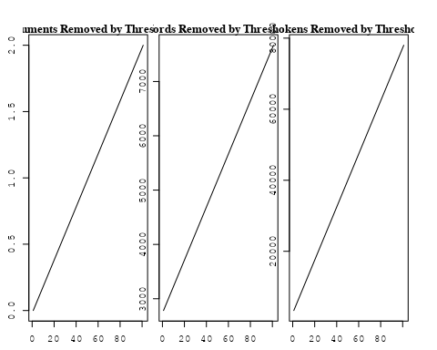

## Removing 6664 of 7936 terms (19038 of 113428 tokens) due to frequency   
## Your corpus now has 1842 documents, 1272 terms and 94390 tokens.~US + IN + DE + CH + GB + CN + FR + IT + RU + CA + NL + AU +   
## JP + ES + IL + Americas + Europe + Africa + AsiaAndOceania  
## Beginning Spectral Initialization   
## Calculating the gram matrix...  
## Finding anchor words...  
## ...........................................  
## Recovering initialization...  
## ............  
## Initialization complete.  
## ......................................................................................................  
## Completed E-Step (2 seconds).   
## Completed M-Step.   
## Completing Iteration 1 (approx. per word bound = -6.227)   
## ......................................................................................................  
## Completed E-Step (2 seconds).   
## Completed M-Step.   
## Completing Iteration 2 (approx. per word bound = -6.053, relative change = 2.793e-02)   
## ......................................................................................................  
## Completed E-Step (1 seconds).   
## Completed M-Step.   
## Completing Iteration 3 (approx. per word bound = -5.990, relative change = 1.038e-02)   
## ......................................................................................................  
## Completed E-Step (1 seconds).   
## Completed M-Step.   
## Completing Iteration 4 (approx. per word bound = -5.961, relative change = 4.855e-03)   
## ......................................................................................................  
## Completed E-Step (1 seconds).   
## Completed M-Step.   
## Completing Iteration 5 (approx. per word bound = -5.945, relative change = 2.688e-03)   
## Topic 1: nebula, uniqu, amount, motion, satellit   
## Topic 2: relat, ratio, veloc, valu, abund   
## Topic 3: cloud, transit, interstellar, molecular, hsub   
## Topic 4: planet, matter, system, solar, orbit   
## Topic 5: quasar, cosmolog, model, galaxi, redshift   
## Topic 6: data, present, predict, previous, occult   
## Topic 7: star, neutron, physic, accret, rotat   
## Topic 8: astronomi, astronom, telescop, new, work   
## Topic 9: implic, microwav, flare, radiat, x-ray   
## Topic 10: radio, sourc, observ, emiss, optic   
## Topic 11: star, interstellar, spectra, observ, format   
## Topic 12: observ, ray, flare, gamma, gamma-ray   
## Topic 13: binari, system, x-ray, observ, period   
## Topic 14: magnet, coron, field, energi, flux   
## Topic 15: observ, jupit, saturn, voyag, emiss   
## Topic 16: variabl, spectrum, energi, spectra, spectral   
## Topic 17: cluster, galaxi, x-ray, group, globular   
## Topic 18: sup, approx, sun, msub, cmsup   
## Topic 19: comet, dust, observ, product, tail   
## Topic 20: shock, particl, electron, energi, acceler   
## Topic 21: surfac, associ, asteroid, reflect, photometri   
## Topic 22: x-ray, sourc, emiss, observ, luminos   
## Topic 23: nebula, region, emiss, orion, sourc   
## Topic 24: solar, rotat, period, observ, sun   
## Topic 25: burst, x-ray, sourc, observ, flare   
## Topic 26: alpha, temperatur, observ, solar, densiti   
## Topic 27: ring, disk, structur, boundari, cloud   
## Topic 28: pulsar, period, puls, time, observ   
## Topic 29: star, spot, light, activ, one   
## Topic 30: supernova, wave, radiat, explos, hole   
## Topic 31: star, mass, stellar, loss, wind   
## Topic 32: kev, observ, polar, x-ray, measur   
## Topic 33: model, electron, flare, emiss, distribut   
## Topic 34: galaxi, object, optic, observ, radio   
## Topic 35: background, radiat, gas, x-ray, temperatur   
## Topic 36: line, emiss, observ, iii, intens   
## Topic 37: atom, observ, bright, band, variat   
## Topic 38: plane, orbit, veloc, galact, mass   
## Topic 39: galaxi, luminos, disk, format, star   
## Topic 40: field, magnet, magnetospher, rotat, result   
## Topic 41: star, ultraviolet, emiss, line, observ   
## Topic 42: shell, mass, nova, observ, supernova   
## Topic 43: galaxi, summari, astrophys, general, present   
## ......................................................................................................  
## Completed E-Step (1 seconds).   
## Completed M-Step.   
## Completing Iteration 6 (approx. per word bound = -5.935, relative change = 1.578e-03)   
## ......................................................................................................  
## Completed E-Step (1 seconds).   
## Completed M-Step.   
## Completing Iteration 7 (approx. per word bound = -5.929, relative change = 1.053e-03)   
## ......................................................................................................  
## Completed E-Step (1 seconds).   
## Completed M-Step.   
## Completing Iteration 8 (approx. per word bound = -5.925, relative change = 7.439e-04)   
## ......................................................................................................  
## Completed E-Step (1 seconds).   
## Completed M-Step.   
## Completing Iteration 9 (approx. per word bound = -5.921, relative change = 5.678e-04)   
## ......................................................................................................  
## Completed E-Step (1 seconds).   
## Completed M-Step.   
## Completing Iteration 10 (approx. per word bound = -5.918, relative change = 5.075e-04)   
## Topic 1: nebula, uniqu, motion, satellit, amount   
## Topic 2: valu, ratio, relat, calcul, use   
## Topic 3: cloud, interstellar, molecular, densiti, transit   
## Topic 4: planet, system, orbit, matter, solar   
## Topic 5: quasar, cosmolog, redshift, model, evolut   
## Topic 6: data, present, previous, predict, standard   
## Topic 7: star, neutron, accret, physic, will   
## Topic 8: astronomi, astronom, telescop, work, time   
## Topic 9: microwav, implic, flare, radiat, observ   
## Topic 10: radio, sourc, observ, emiss, optic   
## Topic 11: star, interstellar, element, spectra, format   
## Topic 12: observ, flare, ray, gamma, event   
## Topic 13: binari, system, observ, x-ray, period   
## Topic 14: coron, magnet, energi, field, corona   
## Topic 15: saturn, jupit, observ, voyag, plasma   
## Topic 16: variabl, spectrum, energi, spectral, observ   
## Topic 17: cluster, galaxi, group, globular, abel   
## Topic 18: sup, approx, ssup, cmsup, sun   
## Topic 19: comet, dust, observ, tail, product   
## Topic 20: shock, particl, acceler, cosmic, energi   
## Topic 21: surfac, associ, reflect, asteroid, light   
## Topic 22: x-ray, sourc, emiss, luminos, einstein   
## Topic 23: region, emiss, nebula, orion, cloud   
## Topic 24: solar, rotat, period, observ, sun   
## Topic 25: burst, x-ray, sourc, flare, time   
## Topic 26: alpha, temperatur, observ, solar, region   
## Topic 27: disk, ring, structur, model, jet   
## Topic 28: pulsar, period, puls, time, observ   
## Topic 29: star, spot, light, activ, type   
## Topic 30: wave, supernova, explos, collaps, gravit   
## Topic 31: star, mass, stellar, wind, loss   
## Topic 32: kev, observ, polar, energi, x-ray   
## Topic 33: model, electron, flare, emiss, distribut   
## Topic 34: galaxi, object, optic, observ, radio   
## Topic 35: radiat, background, gas, temperatur, emiss   
## Topic 36: line, observ, iii, intens, emiss   
## Topic 37: bright, observ, band, atom, variat   
## Topic 38: plane, veloc, mass, galact, orbit   
## Topic 39: galaxi, disk, luminos, format, star   
## Topic 40: field, magnet, magnetospher, result, gauss   
## Topic 41: star, ultraviolet, emiss, line, spectra   
## Topic 42: shell, nova, mass, observ, supernova   
## Topic 43: astrophys, theori, problem, galaxi, general   
## ......................................................................................................  
## Completed E-Step (1 seconds).   
## Completed M-Step.   
## Completing Iteration 11 (approx. per word bound = -5.916, relative change = 4.433e-04)   
## ......................................................................................................  
## Completed E-Step (1 seconds).   
## Completed M-Step.   
## Completing Iteration 12 (approx. per word bound = -5.913, relative change = 3.808e-04)   
## ......................................................................................................  
## Completed E-Step (1 seconds).   
## Completed M-Step.   
## Completing Iteration 13 (approx. per word bound = -5.911, relative change = 3.472e-04)   
## ......................................................................................................  
## Completed E-Step (1 seconds).   
## Completed M-Step.   
## Completing Iteration 14 (approx. per word bound = -5.910, relative change = 3.048e-04)   
## ......................................................................................................  
## Completed E-Step (1 seconds).   
## Completed M-Step.   
## Completing Iteration 15 (approx. per word bound = -5.908, relative change = 2.782e-04)   
## Topic 1: nebula, planetari, uniqu, spiral, satellit   
## Topic 2: valu, ratio, calcul, use, rate   
## Topic 3: cloud, interstellar, densiti, molecular, gas   
## Topic 4: planet, system, orbit, solar, matter   
## Topic 5: quasar, cosmolog, redshift, model, sampl   
## Topic 6: data, present, previous, predict, standard   
## Topic 7: star, neutron, accret, discuss, physic   
## Topic 8: astronomi, astronom, telescop, time, work   
## Topic 9: microwav, implic, flare, radiat, observ   
## Topic 10: radio, sourc, observ, emiss, optic   
## Topic 11: star, interstellar, element, spectra, redden   
## Topic 12: observ, flare, ray, gamma, solar   
## Topic 13: binari, system, observ, period, x-ray   
## Topic 14: coron, magnet, energi, corona, convect   
## Topic 15: saturn, jupit, voyag, observ, plasma   
## Topic 16: variabl, spectrum, spectral, observ, energi   
## Topic 17: cluster, galaxi, group, globular, abel   
## Topic 18: sup, approx, ssup, cmsup, sun   
## Topic 19: comet, dust, observ, grain, tail   
## Topic 20: shock, particl, acceler, cosmic, ray   
## Topic 21: surfac, reflect, asteroid, light, associ   
## Topic 22: x-ray, sourc, emiss, luminos, einstein   
## Topic 23: emiss, region, orion, infrar, sourc   
## Topic 24: solar, rotat, period, observ, sun   
## Topic 25: burst, x-ray, sourc, flare, time   
## Topic 26: alpha, temperatur, observ, solar, chromospher   
## Topic 27: disk, ring, structur, model, rotat   
## Topic 28: pulsar, period, puls, time, observ   
## Topic 29: star, spot, light, activ, luminos   
## Topic 30: supernova, wave, collaps, gravit, remnant   
## Topic 31: star, mass, stellar, loss, wind   
## Topic 32: kev, energi, observ, polar, spectrum   
## Topic 33: electron, model, flare, plasma, energi   
## Topic 34: galaxi, object, optic, observ, radio   
## Topic 35: radiat, background, gas, temperatur, emiss   
## Topic 36: line, observ, iii, intens, region   
## Topic 37: bright, band, observ, variat, atom   
## Topic 38: plane, veloc, galact, mass, orbit   
## Topic 39: galaxi, disk, luminos, format, star   
## Topic 40: field, magnet, magnetospher, polar, result   
## Topic 41: star, ultraviolet, emiss, line, spectra   
## Topic 42: shell, nova, observ, envelop, supernova   
## Topic 43: theori, astrophys, problem, general, galaxi   
## ......................................................................................................  
## Completed E-Step (1 seconds).   
## Completed M-Step.   
## Completing Iteration 16 (approx. per word bound = -5.906, relative change = 2.450e-04)   
## ......................................................................................................  
## Completed E-Step (1 seconds).   
## Completed M-Step.   
## Completing Iteration 17 (approx. per word bound = -5.905, relative change = 2.315e-04)   
## ......................................................................................................  
## Completed E-Step (1 seconds).   
## Completed M-Step.   
## Completing Iteration 18 (approx. per word bound = -5.904, relative change = 2.095e-04)   
## ......................................................................................................  
## Completed E-Step (1 seconds).   
## Completed M-Step.   
## Completing Iteration 19 (approx. per word bound = -5.903, relative change = 2.176e-04)   
## ......................................................................................................  
## Completed E-Step (1 seconds).   
## Completed M-Step.   
## Completing Iteration 20 (approx. per word bound = -5.901, relative change = 1.852e-04)   
## Topic 1: nebula, planetari, uniqu, spiral, motion   
## Topic 2: valu, ratio, calcul, use, rate   
## Topic 3: cloud, interstellar, gas, densiti, molecular   
## Topic 4: planet, orbit, system, solar, matter   
## Topic 5: quasar, cosmolog, redshift, observ, sampl   
## Topic 6: data, present, previous, predict, standard   
## Topic 7: star, neutron, accret, discuss, will   
## Topic 8: astronomi, astronom, telescop, time, work   
## Topic 9: microwav, implic, flare, radiat, imag   
## Topic 10: radio, sourc, observ, emiss, optic   
## Topic 11: star, interstellar, element, spectra, redden   
## Topic 12: observ, ray, flare, gamma, gamma-ray   
## Topic 13: binari, system, observ, period, dwarf   
## Topic 14: coron, energi, convect, magnet, corona   
## Topic 15: saturn, jupit, voyag, observ, plasma   
## Topic 16: variabl, spectrum, observ, spectral, time   
## Topic 17: cluster, galaxi, globular, group, abel   
## Topic 18: sup, approx, ssup, cmsup, sun   
## Topic 19: comet, dust, observ, grain, tail   
## Topic 20: shock, particl, acceler, cosmic, ray   
## Topic 21: surfac, reflect, asteroid, photometri, light   
## Topic 22: x-ray, sourc, emiss, luminos, einstein   
## Topic 23: emiss, region, orion, infrar, sourc   
## Topic 24: solar, rotat, period, observ, sun   
## Topic 25: burst, x-ray, flare, sourc, time   
## Topic 26: alpha, temperatur, solar, observ, chromospher   
## Topic 27: disk, structur, model, ring, turbul   
## Topic 28: pulsar, period, puls, time, observ   
## Topic 29: star, spot, light, luminos, type   
## Topic 30: supernova, wave, collaps, gravit, remnant   
## Topic 31: star, mass, stellar, wind, loss   
## Topic 32: kev, energi, observ, spectrum, measur   
## Topic 33: electron, model, flare, plasma, energi   
## Topic 34: galaxi, object, optic, observ, radio   
## Topic 35: radiat, background, gas, temperatur, emiss   
## Topic 36: line, observ, intens, iii, region   
## Topic 37: bright, band, observ, variat, atom   
## Topic 38: plane, veloc, galact, mass, radial   
## Topic 39: galaxi, disk, format, luminos, star   
## Topic 40: field, magnet, magnetospher, polar, result   
## Topic 41: ultraviolet, star, emiss, line, spectra   
## Topic 42: shell, nova, envelop, observ, supernova   
## Topic 43: theori, problem, astrophys, general, galaxi   
## ......................................................................................................  
## Completed E-Step (1 seconds).   
## Completed M-Step.   
## Completing Iteration 21 (approx. per word bound = -5.901, relative change = 1.618e-04)   
## ......................................................................................................  
## Completed E-Step (1 seconds).   
## Completed M-Step.   
## Completing Iteration 22 (approx. per word bound = -5.900, relative change = 1.598e-04)   
## ......................................................................................................  
## Completed E-Step (1 seconds).   
## Completed M-Step.   
## Completing Iteration 23 (approx. per word bound = -5.899, relative change = 1.563e-04)   
## ......................................................................................................  
## Completed E-Step (1 seconds).   
## Completed M-Step.   
## Completing Iteration 24 (approx. per word bound = -5.898, relative change = 1.512e-04)   
## ......................................................................................................  
## Completed E-Step (1 seconds).   
## Completed M-Step.   
## Completing Iteration 25 (approx. per word bound = -5.897, relative change = 1.356e-04)   
## Topic 1: nebula, planetari, uniqu, spiral, motion   
## Topic 2: valu, ratio, calcul, use, rate   
## Topic 3: cloud, interstellar, gas, densiti, molecular   
## Topic 4: orbit, planet, system, solar, matter   
## Topic 5: quasar, cosmolog, redshift, observ, sampl   
## Topic 6: data, present, previous, standard, predict   
## Topic 7: star, neutron, accret, discuss, will   
## Topic 8: astronomi, telescop, astronom, time, one   
## Topic 9: microwav, implic, flare, radiat, observ   
## Topic 10: radio, sourc, observ, emiss, jet   
## Topic 11: star, interstellar, element, spectra, studi   
## Topic 12: observ, ray, gamma, flare, gamma-ray   
## Topic 13: binari, system, observ, dwarf, period   
## Topic 14: coron, energi, convect, corona, flow   
## Topic 15: saturn, jupit, voyag, observ, plasma   
## Topic 16: variabl, observ, spectrum, spectral, ngc   
## Topic 17: cluster, galaxi, group, globular, distanc   
## Topic 18: sup, approx, ssup, cmsup, sun   
## Topic 19: comet, dust, observ, grain, tail   
## Topic 20: shock, particl, cosmic, acceler, ray   
## Topic 21: surfac, reflect, asteroid, photometri, light   
## Topic 22: x-ray, sourc, emiss, luminos, einstein   
## Topic 23: emiss, region, orion, infrar, sourc   
## Topic 24: solar, rotat, period, observ, sun   
## Topic 25: burst, x-ray, flare, time, event   
## Topic 26: alpha, temperatur, solar, observ, chromospher   
## Topic 27: disk, model, structur, turbul, rotat   
## Topic 28: pulsar, period, puls, time, observ   
## Topic 29: star, spot, luminos, light, type   
## Topic 30: supernova, wave, gravit, collaps, remnant   
## Topic 31: star, mass, stellar, wind, loss   
## Topic 32: kev, energi, observ, spectrum, measur   
## Topic 33: electron, model, flare, plasma, energi   
## Topic 34: galaxi, object, optic, observ, radio   
## Topic 35: radiat, background, gas, temperatur, emiss   
## Topic 36: line, observ, intens, iii, region   
## Topic 37: bright, band, observ, variat, correl   
## Topic 38: plane, veloc, galact, mass, distribut   
## Topic 39: galaxi, format, disk, luminos, star   
## Topic 40: field, magnet, polar, magnetospher, result   
## Topic 41: ultraviolet, star, emiss, line, observ   
## Topic 42: shell, nova, envelop, observ, supernova   
## Topic 43: theori, astrophys, problem, general, will   
## ......................................................................................................  
## Completed E-Step (1 seconds).   
## Completed M-Step.   
## Completing Iteration 26 (approx. per word bound = -5.896, relative change = 1.014e-04)   
## ......................................................................................................  
## Completed E-Step (1 seconds).   
## Completed M-Step.   
## Completing Iteration 27 (approx. per word bound = -5.896, relative change = 1.350e-04)   
## ......................................................................................................  
## Completed E-Step (1 seconds).   
## Completed M-Step.   
## Completing Iteration 28 (approx. per word bound = -5.895, relative change = 1.093e-04)   
## ......................................................................................................  
## Completed E-Step (1 seconds).   
## Completed M-Step.   
## Completing Iteration 29 (approx. per word bound = -5.894, relative change = 1.061e-04)   
## ......................................................................................................  
## Completed E-Step (1 seconds).   
## Completed M-Step.   
## Completing Iteration 30 (approx. per word bound = -5.894, relative change = 1.020e-04)   
## Topic 1: nebula, planetari, uniqu, spiral, motion   
## Topic 2: ratio, calcul, valu, use, model   
## Topic 3: cloud, interstellar, gas, densiti, molecular   
## Topic 4: orbit, planet, system, solar, satellit   
## Topic 5: quasar, cosmolog, redshift, observ, sampl   
## Topic 6: data, present, previous, set, new   
## Topic 7: star, neutron, accret, discuss, may   
## Topic 8: astronomi, telescop, astronom, one, time   
## Topic 9: microwav, implic, flare, emiss, observ   
## Topic 10: radio, sourc, observ, emiss, jet   
## Topic 11: star, interstellar, element, spectra, studi   
## Topic 12: observ, ray, gamma, gamma-ray, flare   
## Topic 13: binari, system, dwarf, observ, period   
## Topic 14: coron, energi, convect, corona, flow   
## Topic 15: jupit, saturn, voyag, observ, plasma   
## Topic 16: variabl, observ, ngc, spectrum, spectral   
## Topic 17: cluster, galaxi, group, globular, distanc   
## Topic 18: sup, approx, ssup, cmsup, densiti   
## Topic 19: comet, dust, observ, grain, tail   
## Topic 20: shock, particl, cosmic, acceler, ray   
## Topic 21: surfac, reflect, asteroid, photometri, light   
## Topic 22: x-ray, sourc, emiss, luminos, einstein   
## Topic 23: emiss, region, orion, infrar, sourc   
## Topic 24: solar, rotat, period, observ, sun   
## Topic 25: burst, x-ray, flare, time, event   
## Topic 26: alpha, temperatur, solar, observ, chromospher   
## Topic 27: disk, model, structur, rotat, turbul   
## Topic 28: pulsar, period, puls, time, observ   
## Topic 29: star, luminos, spot, type, light   
## Topic 30: supernova, wave, gravit, collaps, remnant   
## Topic 31: star, mass, stellar, wind, loss   
## Topic 32: kev, energi, observ, spectrum, measur   
## Topic 33: electron, flare, model, plasma, energi   
## Topic 34: galaxi, object, optic, observ, radio   
## Topic 35: radiat, background, gas, temperatur, emiss   
## Topic 36: line, observ, intens, iii, region   
## Topic 37: band, bright, observ, variat, correl   
## Topic 38: veloc, plane, galact, mass, distribut   
## Topic 39: galaxi, format, luminos, disk, star   
## Topic 40: field, magnet, polar, result, magnetospher   
## Topic 41: ultraviolet, star, emiss, line, observ   
## Topic 42: shell, nova, envelop, observ, supernova   
## Topic 43: theori, astrophys, general, problem, paper   
## ......................................................................................................  
## Completed E-Step (1 seconds).   
## Completed M-Step.   
## Completing Iteration 31 (approx. per word bound = -5.893, relative change = 9.493e-05)   
## ......................................................................................................  
## Completed E-Step (1 seconds).   
## Completed M-Step.   
## Completing Iteration 32 (approx. per word bound = -5.893, relative change = 8.480e-05)   
## ......................................................................................................  
## Completed E-Step (1 seconds).   
## Completed M-Step.   
## Completing Iteration 33 (approx. per word bound = -5.892, relative change = 8.480e-05)   
## ......................................................................................................  
## Completed E-Step (1 seconds).   
## Completed M-Step.   
## Completing Iteration 34 (approx. per word bound = -5.892, relative change = 8.912e-05)   
## ......................................................................................................  
## Completed E-Step (1 seconds).   
## Completed M-Step.   
## Completing Iteration 35 (approx. per word bound = -5.891, relative change = 8.308e-05)   
## Topic 1: nebula, planetari, uniqu, spiral, motion   
## Topic 2: ratio, calcul, valu, use, model   
## Topic 3: cloud, interstellar, densiti, gas, molecular   
## Topic 4: orbit, planet, system, satellit, solar   
## Topic 5: quasar, cosmolog, observ, redshift, sampl   
## Topic 6: data, present, previous, set, new   
## Topic 7: star, neutron, accret, black, hole   
## Topic 8: astronomi, telescop, astronom, one, time   
## Topic 9: microwav, implic, flare, emiss, observ   
## Topic 10: radio, sourc, observ, emiss, jet   
## Topic 11: star, element, interstellar, spectra, studi   
## Topic 12: observ, ray, gamma, gamma-ray, flare   
## Topic 13: binari, system, dwarf, observ, orbit   
## Topic 14: coron, energi, convect, corona, flow   
## Topic 15: jupit, saturn, voyag, observ, plasma   
## Topic 16: variabl, ngc, observ, spectral, time   
## Topic 17: cluster, galaxi, group, globular, distanc   
## Topic 18: sup, approx, ssup, cmsup, densiti   
## Topic 19: comet, dust, observ, grain, tail   
## Topic 20: shock, particl, cosmic, acceler, ray   
## Topic 21: surfac, reflect, asteroid, photometri, light   
## Topic 22: x-ray, sourc, emiss, einstein, luminos   
## Topic 23: emiss, region, orion, infrar, sourc   
## Topic 24: solar, rotat, period, observ, sun   
## Topic 25: burst, x-ray, flare, time, event   
## Topic 26: alpha, temperatur, solar, observ, chromospher   
## Topic 27: disk, rotat, model, structur, turbul   
## Topic 28: pulsar, period, puls, time, observ   
## Topic 29: star, luminos, spot, type, light   
## Topic 30: supernova, wave, collaps, gravit, remnant   
## Topic 31: star, mass, stellar, wind, loss   
## Topic 32: kev, energi, observ, spectrum, measur   
## Topic 33: electron, flare, model, plasma, energi   
## Topic 34: galaxi, object, optic, observ, radio   
## Topic 35: radiat, background, gas, temperatur, emiss   
## Topic 36: line, observ, intens, iii, region   
## Topic 37: band, bright, observ, variat, correl   
## Topic 38: veloc, plane, galact, mass, distribut   
## Topic 39: galaxi, format, luminos, disk, star   
## Topic 40: field, magnet, polar, gauss, result   
## Topic 41: ultraviolet, emiss, star, observ, line   
## Topic 42: shell, nova, envelop, observ, supernova   
## Topic 43: theori, general, astrophys, problem, paper   
## ......................................................................................................  
## Completed E-Step (1 seconds).   
## Completed M-Step.   
## Completing Iteration 36 (approx. per word bound = -5.891, relative change = 7.802e-05)   
## ......................................................................................................  
## Completed E-Step (1 seconds).   
## Completed M-Step.   
## Completing Iteration 37 (approx. per word bound = -5.890, relative change = 7.537e-05)   
## ......................................................................................................  
## Completed E-Step (1 seconds).   
## Completed M-Step.   
## Completing Iteration 38 (approx. per word bound = -5.890, relative change = 6.359e-05)   
## ......................................................................................................  
## Completed E-Step (1 seconds).   
## Completed M-Step.   
## Completing Iteration 39 (approx. per word bound = -5.889, relative change = 6.129e-05)   
## ......................................................................................................  
## Completed E-Step (1 seconds).   
## Completed M-Step.   
## Completing Iteration 40 (approx. per word bound = -5.889, relative change = 5.308e-05)   
## Topic 1: nebula, planetari, uniqu, photograph, spiral   
## Topic 2: ratio, calcul, valu, use, model   
## Topic 3: cloud, interstellar, densiti, gas, molecular   
## Topic 4: orbit, planet, system, satellit, solar   
## Topic 5: quasar, observ, redshift, cosmolog, sampl   
## Topic 6: data, present, previous, set, new   
## Topic 7: star, neutron, accret, black, hole   
## Topic 8: astronomi, telescop, astronom, one, time   
## Topic 9: microwav, implic, flare, emiss, observ   
## Topic 10: radio, sourc, observ, emiss, jet   
## Topic 11: star, element, spectra, studi, interstellar   
## Topic 12: observ, ray, gamma-ray, gamma, line   
## Topic 13: binari, system, dwarf, observ, orbit   
## Topic 14: coron, energi, convect, corona, flow   
## Topic 15: jupit, saturn, voyag, observ, plasma   
## Topic 16: variabl, ngc, observ, time, spectral   
## Topic 17: cluster, galaxi, group, globular, distanc   
## Topic 18: sup, approx, ssup, cmsup, densiti   
## Topic 19: comet, dust, observ, grain, product   
## Topic 20: shock, particl, cosmic, acceler, ray   
## Topic 21: surfac, reflect, asteroid, photometri, magnitud   
## Topic 22: x-ray, sourc, emiss, einstein, luminos   
## Topic 23: emiss, region, orion, sourc, infrar   
## Topic 24: solar, rotat, period, observ, sun   
## Topic 25: burst, x-ray, event, flare, time   
## Topic 26: alpha, temperatur, solar, observ, chromospher   
## Topic 27: disk, rotat, model, structur, effect   
## Topic 28: pulsar, period, puls, time, observ   
## Topic 29: star, luminos, spot, type, activ   
## Topic 30: supernova, wave, remnant, collaps, gravit   
## Topic 31: star, mass, stellar, wind, loss   
## Topic 32: kev, energi, observ, spectrum, flux   
## Topic 33: electron, flare, plasma, model, energi   
## Topic 34: galaxi, object, optic, observ, radio   
## Topic 35: radiat, background, gas, temperatur, emiss   
## Topic 36: line, intens, observ, iii, region   
## Topic 37: band, bright, variat, observ, correl   
## Topic 38: veloc, plane, galact, distribut, mass   
## Topic 39: galaxi, format, luminos, disk, star   
## Topic 40: field, magnet, polar, gauss, result   
## Topic 41: ultraviolet, emiss, star, line, observ   
## Topic 42: shell, nova, envelop, observ, supernova   
## Topic 43: theori, general, astrophys, paper, problem   
## ......................................................................................................  
## Completed E-Step (1 seconds).   
## Completed M-Step.   
## Completing Iteration 41 (approx. per word bound = -5.889, relative change = 1.847e-05)   
## ......................................................................................................  
## Completed E-Step (1 seconds).   
## Completed M-Step.   
## Completing Iteration 42 (approx. per word bound = -5.889, relative change = 5.471e-05)   
## ......................................................................................................  
## Completed E-Step (1 seconds).   
## Completed M-Step.   
## Completing Iteration 43 (approx. per word bound = -5.888, relative change = 8.010e-05)   
## ......................................................................................................  
## Completed E-Step (1 seconds).   
## Completed M-Step.   
## Completing Iteration 44 (approx. per word bound = -5.888, relative change = 5.202e-05)   
## ......................................................................................................  
## Completed E-Step (1 seconds).   
## Completed M-Step.   
## Completing Iteration 45 (approx. per word bound = -5.888, relative change = 4.868e-05)   
## Topic 1: nebula, planetari, uniqu, photograph, ngc   
## Topic 2: ratio, calcul, valu, use, model   
## Topic 3: cloud, interstellar, densiti, gas, molecular   
## Topic 4: orbit, planet, system, satellit, solar   
## Topic 5: quasar, observ, redshift, cosmolog, sampl   
## Topic 6: data, present, previous, set, new   
## Topic 7: star, neutron, accret, black, hole   
## Topic 8: astronomi, telescop, astronom, one, time   
## Topic 9: microwav, implic, flare, emiss, observ   
## Topic 10: radio, sourc, observ, emiss, jet   
## Topic 11: star, element, spectra, studi, atmospher   
## Topic 12: observ, ray, gamma-ray, gamma, line   
## Topic 13: binari, system, dwarf, observ, orbit   
## Topic 14: coron, energi, convect, flow, corona   
## Topic 15: jupit, saturn, voyag, observ, plasma   
## Topic 16: variabl, ngc, observ, time, spectral   
## Topic 17: cluster, galaxi, globular, group, distanc   
## Topic 18: sup, approx, ssup, cmsup, densiti   
## Topic 19: comet, dust, observ, grain, product   
## Topic 20: shock, particl, cosmic, acceler, ray   
## Topic 21: surfac, reflect, asteroid, magnitud, radius   
## Topic 22: x-ray, sourc, emiss, einstein, luminos   
## Topic 23: emiss, region, orion, sourc, infrar   
## Topic 24: solar, rotat, period, observ, sun   
## Topic 25: burst, x-ray, event, time, flare   
## Topic 26: alpha, temperatur, solar, observ, chromospher   
## Topic 27: disk, rotat, model, structur, effect   
## Topic 28: pulsar, period, puls, time, observ   
## Topic 29: star, luminos, spot, type, activ   
## Topic 30: supernova, wave, remnant, collaps, gravit   
## Topic 31: star, mass, stellar, wind, loss   
## Topic 32: kev, energi, observ, spectrum, flux   
## Topic 33: electron, flare, plasma, energi, model   
## Topic 34: galaxi, object, optic, observ, radio   
## Topic 35: radiat, background, gas, temperatur, emiss   
## Topic 36: line, intens, observ, iii, region   
## Topic 37: band, bright, variat, observ, correl   
## Topic 38: veloc, plane, galact, distribut, mass   
## Topic 39: galaxi, format, luminos, disk, star   
## Topic 40: field, magnet, polar, gauss, result   
## Topic 41: ultraviolet, emiss, star, line, observ   
## Topic 42: shell, nova, envelop, observ, supernova   
## Topic 43: theori, general, paper, astrophys, problem   
## ......................................................................................................  
## Completed E-Step (1 seconds).   
## Completed M-Step.   
## Completing Iteration 46 (approx. per word bound = -5.887, relative change = 4.676e-05)   
## ......................................................................................................  
## Completed E-Step (1 seconds).   
## Completed M-Step.   
## Completing Iteration 47 (approx. per word bound = -5.887, relative change = 4.723e-05)   
## ......................................................................................................  
## Completed E-Step (1 seconds).   
## Completed M-Step.   
## Completing Iteration 48 (approx. per word bound = -5.887, relative change = 4.671e-05)   
## ......................................................................................................  
## Completed E-Step (1 seconds).   
## Completed M-Step.   
## Completing Iteration 49 (approx. per word bound = -5.887, relative change = 4.474e-05)   
## ......................................................................................................  
## Completed E-Step (1 seconds).   
## Completed M-Step.   
## Completing Iteration 50 (approx. per word bound = -5.886, relative change = 4.308e-05)   
## Topic 1: nebula, planetari, ngc, uniqu, photograph   
## Topic 2: ratio, calcul, valu, model, use   
## Topic 3: cloud, interstellar, densiti, gas, molecular   
## Topic 4: orbit, planet, satellit, system, solar   
## Topic 5: quasar, observ, redshift, cosmolog, distribut   
## Topic 6: data, present, previous, new, set   
## Topic 7: star, neutron, accret, black, hole   
## Topic 8: astronomi, star, telescop, astronom, one   
## Topic 9: microwav, implic, flare, emiss, observ   
## Topic 10: radio, sourc, observ, emiss, jet   
## Topic 11: star, studi, spectra, element, atmospher   
## Topic 12: observ, gamma-ray, ray, gamma, line   
## Topic 13: binari, system, dwarf, observ, orbit   
## Topic 14: coron, energi, convect, flow, corona   
## Topic 15: jupit, saturn, voyag, observ, magnetospher   
## Topic 16: variabl, observ, ngc, time, spectral   
## Topic 17: cluster, galaxi, globular, group, distanc   
## Topic 18: sup, approx, ssup, cmsup, densiti   
## Topic 19: comet, dust, observ, grain, product   
## Topic 20: shock, cosmic, acceler, particl, ray   
## Topic 21: surfac, reflect, asteroid, studi, magnitud   
## Topic 22: x-ray, sourc, emiss, einstein, optic   
## Topic 23: emiss, region, orion, sourc, infrar   
## Topic 24: solar, period, rotat, observ, sun   
## Topic 25: burst, x-ray, event, time, flare   
## Topic 26: alpha, temperatur, solar, observ, chromospher   
## Topic 27: disk, rotat, model, structur, effect   
## Topic 28: pulsar, puls, period, time, observ   
## Topic 29: star, luminos, spot, type, veloc   
## Topic 30: supernova, wave, remnant, shock, collaps   
## Topic 31: star, mass, stellar, wind, loss   
## Topic 32: kev, energi, observ, spectrum, flux   
## Topic 33: electron, flare, plasma, energi, model   
## Topic 34: galaxi, object, optic, observ, radio   
## Topic 35: radiat, background, gas, temperatur, emiss   
## Topic 36: line, intens, observ, iii, region   
## Topic 37: band, bright, variat, observ, correl   
## Topic 38: veloc, plane, galact, distribut, mass   
## Topic 39: galaxi, format, luminos, disk, star   
## Topic 40: field, magnet, polar, gauss, result   
## Topic 41: ultraviolet, emiss, star, line, observ   
## Topic 42: shell, nova, envelop, observ, supernova   
## Topic 43: theori, general, paper, astrophys, problem   
## ......................................................................................................  
## Completed E-Step (1 seconds).   
## Completed M-Step.   
## Completing Iteration 51 (approx. per word bound = -5.886, relative change = 3.716e-05)   
## ......................................................................................................  
## Completed E-Step (1 seconds).   
## Completed M-Step.   
## Completing Iteration 52 (approx. per word bound = -5.886, relative change = 3.489e-05)   
## ......................................................................................................  
## Completed E-Step (1 seconds).   
## Completed M-Step.   
## Completing Iteration 53 (approx. per word bound = -5.886, relative change = 3.363e-05)   
## ......................................................................................................  
## Completed E-Step (1 seconds).   
## Completed M-Step.   
## Completing Iteration 54 (approx. per word bound = -5.885, relative change = 3.695e-05)   
## ......................................................................................................  
## Completed E-Step (1 seconds).   
## Completed M-Step.   
## Completing Iteration 55 (approx. per word bound = -5.885, relative change = 3.132e-05)   
## Topic 1: nebula, planetari, ngc, uniqu, photograph   
## Topic 2: ratio, model, calcul, valu, use   
## Topic 3: interstellar, cloud, densiti, gas, hydrogen   
## Topic 4: orbit, planet, system, satellit, solar   
## Topic 5: quasar, observ, redshift, cosmolog, distribut   
## Topic 6: data, present, previous, set, new   
## Topic 7: star, neutron, accret, black, hole   
## Topic 8: astronomi, star, telescop, astronom, one   
## Topic 9: implic, flare, microwav, emiss, x-ray   
## Topic 10: radio, sourc, observ, emiss, jet   
## Topic 11: star, studi, atmospher, spectra, element   
## Topic 12: observ, gamma-ray, ray, gamma, line   
## Topic 13: binari, system, dwarf, orbit, observ   
## Topic 14: coron, energi, convect, flow, corona   
## Topic 15: jupit, saturn, voyag, observ, magnetospher   
## Topic 16: variabl, observ, ngc, time, two   
## Topic 17: cluster, galaxi, globular, group, distanc   
## Topic 18: sup, approx, ssup, cmsup, densiti   
## Topic 19: comet, dust, observ, grain, product   
## Topic 20: shock, cosmic, acceler, particl, ray   
## Topic 21: surfac, reflect, asteroid, studi, magnitud   
## Topic 22: x-ray, sourc, emiss, einstein, optic   
## Topic 23: emiss, region, orion, infrar, sourc   
## Topic 24: solar, period, rotat, observ, sun   
## Topic 25: burst, x-ray, event, time, flare   
## Topic 26: alpha, temperatur, solar, observ, chromospher   
## Topic 27: disk, rotat, model, effect, structur   
## Topic 28: pulsar, puls, period, time, observ   
## Topic 29: star, luminos, spot, type, veloc   
## Topic 30: supernova, wave, remnant, shock, collaps   
## Topic 31: star, mass, stellar, wind, loss   
## Topic 32: kev, energi, observ, spectrum, flux   
## Topic 33: electron, flare, plasma, energi, model   
## Topic 34: galaxi, object, optic, observ, radio   
## Topic 35: radiat, background, gas, emiss, temperatur   
## Topic 36: line, intens, observ, region, iii   
## Topic 37: band, bright, variat, observ, correl   
## Topic 38: veloc, plane, galact, distribut, mass   
## Topic 39: galaxi, format, luminos, disk, star   
## Topic 40: field, magnet, polar, gauss, result   
## Topic 41: ultraviolet, emiss, star, line, observ   
## Topic 42: shell, nova, envelop, observ, supernova   
## Topic 43: theori, general, paper, astrophys, problem   
## ......................................................................................................  
## Completed E-Step (1 seconds).   
## Completed M-Step.   
## Completing Iteration 56 (approx. per word bound = -5.885, relative change = 3.672e-05)   
## ......................................................................................................  
## Completed E-Step (1 seconds).   
## Completed M-Step.   
## Completing Iteration 57 (approx. per word bound = -5.885, relative change = 3.540e-05)   
## ......................................................................................................  
## Completed E-Step (1 seconds).   
## Completed M-Step.   
## Model Converged

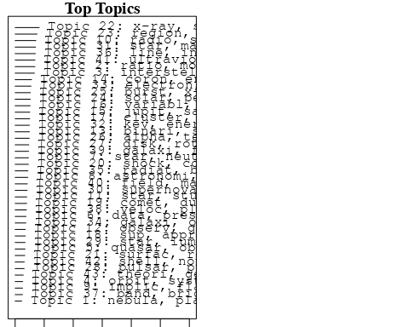

## Topic 1 Top Words:  
## Highest Prob: nebula, planetari, ngc, uniqu, photograph, spiral, motion, central, detect, intern   
## FREX: nebula, planetari, uniqu, ngc, photograph, spiral, intern, central, carbon, motion   
## Lift: uniqu, nebula, planetari, photograph, ngc, nucleosynthesi, phenomenon, surpris, perhap, spiral   
## Score: nebula, uniqu, planetari, ngc, spiral, photograph, carbon, ring, motion, nsub   
## Topic 2 Top Words:  
## Highest Prob: ratio, model, calcul, valu, use, rate, measur, estim, determin, abund   
## FREX: ratio, calcul, valu, estim, method, rate, abund, use, paramet, agreement   
## Lift: deviat, ratio, valu, discrep, calcul, method, agre, mass-loss, coeffici, estim   
## Score: deviat, ratio, calcul, valu, abund, method, coeffici, estim, rate, agreement   
## Topic 3 Top Words:  
## Highest Prob: interstellar, cloud, densiti, hydrogen, gas, abund, molecular, observ, column, atom   
## FREX: interstellar, cloud, hsub, molecul, sub, column, hydrogen, molecular, deplet, carbon   
## Lift: sub, molecul, hsub, deplet, interstellar, carbon, column, zeta, sight, cloud   
## Score: sub, interstellar, cloud, molecular, hsub, molecul, abund, carbon, deplet, hydrogen   
## Topic 4 Top Words:  
## Highest Prob: orbit, system, planet, satellit, solar, matter, isotop, halo, particl, meteorit   
## FREX: planet, orbit, satellit, meteorit, isotop, track, halo, system, matter, anomali   
## Lift: planet, meteorit, anomali, orbit, track, isotop, satellit, halo, histori, bodi   
## Score: planet, orbit, meteorit, isotop, satellit, halo, track, system, anomali, planetari   
## Topic 5 Top Words:  
## Highest Prob: quasar, observ, cosmolog, redshift, distribut, sampl, magnitud, evolut, luminos, model   
## FREX: quasar, cosmolog, redshift, sampl, evolut, magnitud, count, size, distribut, correl   
## Lift: cosmolog, quasar, count, redshift, sampl, doubl, extrapol, select, inde, probe   
## Score: cosmolog, quasar, redshift, sampl, count, evolut, luminos, doubl, correl, distribut   
## Topic 6 Top Words:  
## Highest Prob: data, present, previous, set, new, standard, observ, ring, analysi, occult   
## FREX: standard, set, occult, uncertainti, opac, previous, data, error, section, ring   
## Lift: occult, section, harmon, standard, opac, set, uncertainti, classic, filter, revis   
## Score: occult, ring, opac, standard, data, solut, harmon, error, uncertainti, comput   
## Topic 7 Top Words:  
## Highest Prob: star, neutron, accret, black, hole, object, sourc, may, observ, can   
## FREX: neutron, black, accret, hole, matter, review, understand, encount, process, star   
## Lift: neutron, black, hole, onto, accret, understand, proceed, convers, review, encount   
## Score: neutron, accret, star, black, hole, matter, understand, will, review, object   
## Topic 8 Top Words:  
## Highest Prob: astronomi, star, telescop, astronom, one, year, work, first, time, new   
## FREX: astronomi, astronom, telescop, work, centuri, figur, tabl, see, now, research   
## Lift: astronomi, centuri, research, ago, astronom, work, decad, see, launch, publish   
## Score: astronomi, centuri, astronom, telescop, work, tabl, research, see, star, figur   
## Topic 9 Top Words:  
## Highest Prob: implic, flare, microwav, emiss, x-ray, observ, radiat, suggest, imag, data   
## FREX: implic, microwav, flare, spatial, impuls, imag, skylab, august, loop, homogen   
## Lift: implic, microwav, august, altitud, tau, inhomogen, versus, coverag, homogen, context   
## Score: implic, microwav, flare, x-ray, impuls, loop, hard, skylab, imag, emiss   
## Topic 10 Top Words:  
## Highest Prob: radio, sourc, observ, emiss, jet, optic, structur, ghz, extend, compon   
## FREX: radio, jet, ghz, mhz, sourc, extragalact, vla, vlbi, synchrotron, extend   
## Lift: vlbi, mji, jet, mhz, vla, ghz, radio, array, lobe, synchrotron   
## Score: radio, vlbi, jet, sourc, ghz, mhz, vla, synchrotron, lobe, nucleus   
## Topic 11 Top Words:  
## Highest Prob: star, studi, atmospher, spectra, element, stellar, temperatur, investig, absolut, redden   
## FREX: element, redden, atmospher, absolut, spectrophotometri, star, investig, key, color, studi   
## Lift: key, redden, spectrophotometri, element, qualit, absolut, attent, aid, quantit, calibr   
## Score: key, star, redden, element, spectrophotometri, absolut, atmospher, color, photometri, abund   
## Topic 12 Top Words:  
## Highest Prob: observ, gamma-ray, ray, gamma, line, flare, solar, transient, mev, event   
## FREX: gamma-ray, gamma, mev, ray, high-energi, transient, centr, y-ray, gammaray, instrument   
## Lift: centr, gamma-ray, high-energi, gamma, y-ray, gammaray, mev, june, flown, launch   
## Score: centr, gamma-ray, ray, gamma, mev, flare, transient, y-ray, high-energi, gammaray   
## Topic 13 Top Words:  
## Highest Prob: binari, system, dwarf, orbit, observ, period, companion, accret, x-ray, white   
## FREX: binari, dwarf, companion, eclips, system, white, accret, orbit, transfer, outburst   
## Lift: eclips, companion, binari, cataclysm, lmc, outburst, white, dwarf, secondari, centaurus   
## Score: eclips, binari, companion, dwarf, orbit, accret, system, x-ray, white, period   
## Topic 14 Top Words:  
## Highest Prob: coron, energi, convect, flow, corona, wave, flux, region, solar, loop   
## FREX: convect, coron, corona, flow, zone, loop, wave, tube, sunspot, heat   
## Lift: tube, convect, two-dimension, deposit, corona, coron, zone, damp, stationari, input   
## Score: tube, coron, convect, loop, corona, sunspot, wave, flow, chromospher, zone   
## Topic 15 Top Words:  
## Highest Prob: jupit, saturn, voyag, observ, magnetospher, plasma, near, uranus, ring, jovian   
## FREX: saturn, jupit, voyag, uranus, magnetospher, jovian, torus, pioneer, ring, plasma   
## Lift: uranus, torus, saturn, voyag, jupit, jovian, kilomet, bow, pioneer, magnetospher   
## Score: uranus, saturn, jupit, voyag, jovian, magnetospher, ring, torus, plasma, pioneer   
## Topic 16 Top Words:  
## Highest Prob: variabl, observ, ngc, time, two, spectral, object, compon, show, data   
## FREX: variabl, ngc, spectral, power, compon, law, chang, scale, hour, two   
## Lift: week, variabl, break, rest, absent, frame, slope, shorter, eight, ngc   
## Score: week, variabl, ngc, seyfert, micron, spectral, object, hour, photometr, power   
## Topic 17 Top Words:  
## Highest Prob: cluster, galaxi, globular, distanc, group, abel, superclust, type, sampl, virgo   
## FREX: cluster, abel, globular, superclust, virgo, group, rich, hubbl, mpc, distanc   
## Lift: abel, virgo, superclust, cluster, globular, rich, hubbl, mpc, billion, group   
## Score: cluster, abel, galaxi, globular, superclust, virgo, hubbl, mpc, group, rich   
## Topic 18 Top Words:  
## Highest Prob: sup, approx, ssup, cmsup, densiti, sun, erg, less, approxsup, distribut   
## FREX: sup, ssup, approx, cmsup, approxsup, yrsup, erg, msub, lsub, sun   
## Lift: yrsup, sup, ssup, approxsup, approx, cmsup, lsub, erg, sigma, msub   
## Score: sup, yrsup, approx, cmsup, ssup, approxsup, msub, lsub, erg, sun   
## Topic 19 Top Words:  
## Highest Prob: comet, dust, observ, grain, product, tail, nucleus, cometari, near, distanc   
## FREX: comet, cometari, grain, tail, dust, product, nucleus, coma, heliocentr, speci   
## Lift: comet, cometari, coma, heliocentr, tail, product, grain, west, parent, passag   
## Score: comet, cometari, dust, grain, tail, nucleus, coma, heliocentr, product, speci   
## Topic 20 Top Words:  
## Highest Prob: shock, cosmic, acceler, particl, ray, energi, cosmic-ray, drift, solar, observ   
## FREX: acceler, cosmic, shock, drift, cosmic-ray, ray, nucleon, particl, propag, modul   
## Lift: drift, nucleon, cosmic-ray, acceler, cosmic, charg, ray, shock, propag, isotop   
## Score: drift, ray, cosmic, shock, nucleon, cosmic-ray, acceler, particl, mev, interplanetari   
## Topic 21 Top Words:  
## Highest Prob: surfac, reflect, asteroid, studi, magnitud, radius, radii, light, data, bright   
## FREX: asteroid, reflect, surfac, solid, radii, photometri, radius, minor, profil, bodi   
## Lift: asteroid, solid, reflect, minor, ubv, bodi, negat, branch, surfac, radii   
## Score: asteroid, reflect, surfac, photometri, minor, albedo, micron, ubv, radii, solid   
## Topic 22 Top Words:  
## Highest Prob: x-ray, sourc, emiss, einstein, optic, luminos, detect, observatori, observ, survey   
## FREX: einstein, x-ray, sourc, observatori, heao, counterpart, survey, cygnus, soft, posit   
## Lift: cygnus, einstein, counterpart, collim, x-ray, heao, observatori, oso-, sourc, display   
## Score: x-ray, cygnus, sourc, einstein, heao, counterpart, observatori, emiss, soft, kev   
## Topic 23 Top Words:  
## Highest Prob: region, emiss, orion, infrar, sourc, observ, molecular, cloud, micron, maser   
## FREX: orion, far-infrar, maser, infrar, molecular, micron, region, map, irc, cloud   
## Lift: far-infrar, trapezium, maser, irc, airborn, orion, -micron, mum, arcmin, high-veloc   
## Score: trapezium, orion, far-infrar, molecular, maser, micron, infrar, dust, cloud, emiss   
## Topic 24 Top Words:  
## Highest Prob: solar, period, rotat, observ, sun, time, cycl, oscil, variat, chang   
## FREX: cycl, oscil, period, rotat, solar, sun, frequenc, amplitud, day, sunspot   
## Lift: draw, oscil, cycl, oper, mode, amplitud, period, sunspot, emerg, frequenc   
## Score: draw, period, oscil, rotat, solar, cycl, sunspot, sun, day, frequenc   
## Topic 25 Top Words:  
## Highest Prob: burst, x-ray, event, time, flare, observ, sourc, hard, type, flux   
## FREX: burst, event, hard, durat, flare, burster, rise, time, maximum, peak   
## Lift: burster, burst, durat, event, sas, persist, flash, hard, fast, impuls   
## Score: burst, burster, flare, x-ray, event, hard, durat, impuls, flash, persist   
## Topic 26 Top Words:  
## Highest Prob: alpha, temperatur, solar, observ, chromospher, sun, region, measur, model, hydrogen   
## FREX: alpha, chromospher, lcap, quiet, euv, temperatur, high-resolut, hydrogen, sun, coron   
## Lift: lcap, euv, alpha, redistribut, quiet, high-resolut, network, chromospher, diagnost, partial   
## Score: lcap, alpha, chromospher, euv, quiet, coron, temperatur, hole, sun, solar   
## Topic 27 Top Words:  
## Highest Prob: disk, rotat, model, effect, structur, equat, result, turbul, format, cloud   
## FREX: disk, equat, turbul, stabil, momentum, rotat, align, solut, instabl, layer   
## Lift: align, stabil, momentum, self-consist, fluid, turbul, match, equat, disk, solut   
## Score: align, rotat, disk, ring, momentum, stabil, equat, turbul, instabl, solut   
## Topic 28 Top Words:  
## Highest Prob: pulsar, puls, period, time, observ, supernova, crab, measur, pulsat, data   
## FREX: pulsar, puls, arriv, crab, pulsat, psr, period, supernova, vela, remnant   
## Lift: arriv, pulsar, puls, psr, pulsat, vela, crab, span, antenna, easili   
## Score: pulsar, arriv, puls, crab, psr, supernova, pulsat, period, vela, remnant   
## Topic 29 Top Words:  
## Highest Prob: star, luminos, spot, veloc, type, activ, light, stellar, red, shift   
## FREX: spot, shift, cvn, red, late, wing, luminos, type, activ, light   
## Lift: spot, cvn, wing, shift, quiescent, true, proper, late, difficulti, though   
## Score: spot, cvn, wing, star, luminos, shift, red, quiescent, activ, curv   
## Topic 30 Top Words:  
## Highest Prob: supernova, wave, shock, remnant, collaps, explos, gravit, initi, pressur, densiti   
## FREX: explos, supernova, collaps, remnant, wave, neutrino, shock, hydrodynam, gravit, adiabat   
## Lift: neutrino, infal, hydrodynam, explos, adiabat, collaps, remnant, unstabl, supernova, complic   
## Score: neutrino, supernova, shock, explos, remnant, wave, collaps, hydrodynam, adiabat, gravit   
## Topic 31 Top Words:  
## Highest Prob: star, mass, stellar, wind, loss, evolut, model, giant, red, massiv   
## FREX: loss, mass, wind, supergi, sequenc, evolv, red, giant, evolut, stellar   
## Lift: tauri, evolv, supergi, main-sequ, loss, burn, sequenc, evolutionari, mass, wind   
## Score: tauri, star, mass, loss, wind, supergi, msub, main-sequ, stellar, evolut   
## Topic 32 Top Words:  
## Highest Prob: kev, energi, observ, spectrum, flux, measur, cosmic, spectral, report, data   
## FREX: kev, detector, crab, spectrum, energi, cosmic, plus, minus, deg, power   
## Lift: minus, kev, crystal, plus, detector, exposur, counter, march, fwhm, crab   
## Score: kev, minus, crab, cosmic, energi, heao, detector, x-ray, crystal, hard   
## Topic 33 Top Words:  
## Highest Prob: electron, flare, plasma, energi, model, emiss, distribut, heat, temperatur, solar   
## FREX: electron, plasma, flare, heat, loop, conduct, hard, energi, releas, numer   
## Lift: output, electron, plasma, conduct, inject, compton, releas, flare, channel, loop   
## Score: output, flare, electron, plasma, loop, hard, energi, heat, relativist, impuls   
## Topic 34 Top Words:  
## Highest Prob: galaxi, object, optic, observ, radio, qsos, emiss, line, redshift, qso   
## FREX: qsos, object, qso, narrow, seyfert, galaxi, redshift, lambda, broad, optic   
## Lift: qsos, qso, seyfert, narrow, plate, name, lambda, spectrophotometr, redshift, broad   
## Score: qsos, galaxi, qso, seyfert, redshift, object, radio, lambda, ellipt, optic   
## Topic 35 Top Words:  
## Highest Prob: radiat, background, gas, emiss, temperatur, thermal, limit, model, hot, ioniz   
## FREX: background, radiat, gas, hot, cool, ioniz, thermal, diffus, iron, state   
## Lift: background, symmetr, isotherm, iron, bulk, compton, cool, emerg, absorb, hot   
## Score: background, gas, ioniz, radiat, cool, hot, thermal, plasma, iron, diffus   
## Topic 36 Top Words:  
## Highest Prob: line, intens, region, observ, iii, transit, spectra, ion, width, optic   
## FREX: iii, line, width, ion, forbidden, intens, transit, excit, limb, cell   
## Lift: forbidden, width, balmer, recombin, cell, iii, ion, line, excit, limb   
## Score: forbidden, line, iii, ion, transit, width, limb, cell, intens, excit   
## Topic 37 Top Words:  
## Highest Prob: band, bright, variat, observ, correl, albedo, night, increas, data, sinc   
## FREX: band, albedo, night, variat, extinct, bright, titan, percent, sinc, correl   
## Lift: night, albedo, band, photoelectr, titan, delta, transform, far-ultraviolet, geometr, brighten   
## Score: night, albedo, band, titan, extinct, delta, mission, variat, photoelectr, far-ultraviolet   
## Topic 38 Top Words:  
## Highest Prob: veloc, plane, galact, distribut, mass, radial, gas, rotat, densiti, observ   
## FREX: plane, radial, veloc, galact, kpc, inner, large-scal, distribut, axi, decreas   
## Lift: plane, focus, most, radial, large-scal, million, kinemat, twice, kpc, inner   
## Score: plane, veloc, galact, radial, gas, spiral, mass, interplanetari, rotat, inner   
## Topic 39 Top Words:  
## Highest Prob: galaxi, format, luminos, disk, star, spiral, observ, galact, ngc, model   
## FREX: galaxi, format, disk, spiral, popul, massiv, luminos, ellipt, near-infrar, nucleus   
## Lift: near-infrar, ellipt, galaxi, popul, spiral, content, format, metal, nuclear, disk   
## Score: galaxi, near-infrar, format, spiral, disk, nucleus, luminos, ellipt, ngc, sampl   
## Topic 40 Top Words:  
## Highest Prob: field, magnet, polar, gauss, result, dipol, surfac, strength, current, show   
## FREX: magnet, field, gauss, dipol, azimuth, strength, polar, magnetospher, electr, sheet   
## Lift: azimuth, gauss, field, magnet, electr, dipol, sheet, configur, quadrupol, moment   
## Score: magnet, field, azimuth, gauss, dipol, magnetospher, electr, polar, moment, configur   
## Topic 41 Top Words:  
## Highest Prob: ultraviolet, emiss, star, line, observ, absorpt, spectra, featur, iue, show   
## FREX: ultraviolet, iue, absorpt, featur, continuum, dwarf, spectra, explor, copernicus, doublet   
## Lift: doublet, iue, ultraviolet, photoion, sharp, explor, absorpt, asymmetri, balloon-born, blackbodi   
## Score: doublet, ultraviolet, iue, absorpt, emiss, chromospher, star, dwarf, line, spectra   
## Topic 42 Top Words:  
## Highest Prob: shell, nova, envelop, observ, supernova, light, type, circumstellar, maximum, optic   
## FREX: nova, shell, envelop, circumstellar, cygni, supernova, maximum, expand, day, expans   
## Lift: nova, shell, cygni, envelop, circumstellar, expand, expans, accompani, eject, doubt   
## Score: nova, shell, circumstellar, envelop, supernova, cygni, dust, day, infrar, curv   
## Topic 43 Top Words:  
## Highest Prob: theori, general, paper, astrophys, problem, discuss, will, univers, relat, current   
## FREX: theori, astrophys, paper, problem, general, fluctuat, phenomena, univers, summari, develop   
## Lift: summari, astrophys, theori, problem, paper, phenomena, fluctuat, relev, general, summar   
## Score: summari, theori, astrophys, problem, univers, paper, fluctuat, general, will, phenomena   
## [1] "The Simultaneous 'Discovery' of Internal Motions in Spiral Nebulae The long debate over the nature of the spiral nebulae begun in the eighteenth century with Immanuel Kant's speculations about island universes, came to a climax early in the twentieth century with the measurement of internal motions in spiral nebulae by Adriaan van Maanen and the detection of Cepheid variables a few years later by Edwin Hubble.' Hubble's work showed conclusively that the spiral nebulae were indeed island universes far beyond the boundary of our own galaxy.s and that van Maanen's reported measurement of internal motions in several spirals, used as evidence against the extragalactic nature of the spirals,\" could not be relied upon. The spurious nature of van Maanen's results has long been recognized; the question remains of what factors could have led him astray. Important in attempts to explain why van Maanen mistakenly reported having detected internal motions in spiral nebulae from a comparison of photographic plates of the same nebula taken at different times is the question of to what extent his researches may have been effected by preconceptions. There are numerous reasons why van Maanen might have expected to find internal motions, including Kant's analogy between the nebulae and the solar system,' the third Earl of Rosse's observations of the spiral form of nebulae and what appeared to him to be internal motion in a resisting medium,\" the planetesimal hypothesis of Thomas Chamberlain and Forest Moulton according to which the spiral nebulae were the result of dynamic encounters between nebulae,\" and the spectroscopic discovery of the rotation of spiral nebulae by Vesto M. Slipher at the Lowell Observatory.\" The expectation of internal motions in spiral nebulae furnished motivation for attempts to discover the motions. There was also opportunity. The rapid development of photography as an astronomical tool following the introduction of the vastly more sensitive dry plate in the late l870s and early 1880s made possible the photographic study of nebulae. 8 Andrew Ainslie Common, an English amateur astronomer,\" successfully obtained a photograph of the Orion nebula in 1882 and believed that evidence of any change of form or brightness in a nebula would have to come from a comparison of photographs taken over some interval of time.l\" Earlier drawings of nebulae were of little use in the search for changes in nebulae because of varying atmospheric conditions and abilities of the artists, but photography offered hope of objective evidence. And evidence of internal motions from a comparison of photographs taken at different times was anticipated. We should, therefore, scarcely be surprised to find that van Maanen's work was not unique, because simultaneous discovery often characterizes that discovery for which the time is ripe. There were attempts other than van Maanen's to detect internal motions in spiral nebulae, some supposedly successful and reported in astronomical journals and perhaps others more"  
## [2] "The Simultaneous 'Discovery' of Internal Motions in Spiral Nebulae The long debate over the nature of the spiral nebulae begun in the eighteenth century with Immanuel Kant's speculations about island universes, came to a climax early in the twentieth century with the measurement of internal motions in spiral nebulae by Adriaan van Maanen and the detection of Cepheid variables a few years later by Edwin Hubble.' Hubble's work showed conclusively that the spiral nebulae were indeed island universes far beyond the boundary of our own galaxy.s and that van Maanen's reported measurement of internal motions in several spirals, used as evidence against the extragalactic nature of the spirals,\" could not be relied upon. The spurious nature of van Maanen's results has long been recognized; the question remains of what factors could have led him astray. Important in attempts to explain why van Maanen mistakenly reported having detected internal motions in spiral nebulae from a comparison of photographic plates of the same nebula taken at different times is the question of to what extent his researches may have been effected by preconceptions. There are numerous reasons why van Maanen might have expected to find internal motions, including Kant's analogy between the nebulae and the solar system,' the third Earl of Rosse's observations of the spiral form of nebulae and what appeared to him to be internal motion in a resisting medium,\" the planetesimal hypothesis of Thomas Chamberlain and Forest Moulton according to which the spiral nebulae were the result of dynamic encounters between nebulae,\" and the spectroscopic discovery of the rotation of spiral nebulae by Vesto M. Slipher at the Lowell Observatory.\" The expectation of internal motions in spiral nebulae furnished motivation for attempts to discover the motions. There was also opportunity. The rapid development of photography as an astronomical tool following the introduction of the vastly more sensitive dry plate in the late l870s and early 1880s made possible the photographic study of nebulae. 8 Andrew Ainslie Common, an English amateur astronomer,\" successfully obtained a photograph of the Orion nebula in 1882 and believed that evidence of any change of form or brightness in a nebula would have to come from a comparison of photographs taken over some interval of time.l\" Earlier drawings of nebulae were of little use in the search for changes in nebulae because of varying atmospheric conditions and abilities of the artists, but photography offered hope of objective evidence. And evidence of internal motions from a comparison of photographs taken at different times was anticipated. We should, therefore, scarcely be surprised to find that van Maanen's work was not unique, because simultaneous discovery often characterizes that discovery for which the time is ripe. There were attempts other than van Maanen's to detect internal motions in spiral nebulae, some supposedly successful and reported in astronomical journals and perhaps others more"  
## [3] "Kinetic inhibition of CO and N2 reduction in circumplanetary nebulae - Implications for satellite composition In constrast to the solar nebula, the conversion of CO to CH/sub 4/ and of N/sub 2/ to NH/sub 3/ in the circumplanetary nebulae of the Jovian planets is fast enough relative to radial mixing and nebula cooling rates that CO and N/sub 2/ are minor constituents in the circumplanetary nebulae. Thus, although the Jovian planets may have accreted carbon and nitrogen from the solar nebula mainly in the form of CO and N/sub 2/, these species were then reprocessed within the circumplanetary nebulae to form mainly CH/sub 4/ and NH/sub 3/. Satellites of the Jovian planets which accreted in sufficiently cool parts of their circumplanetary nebulae are therefore predicted to retain large amounts of NH/sub 3/ and CH/sub 4/ in the form of clathrate hydrates and also very small but chemical important amounts of HCN."   
## [4] "Kinetic inhibition of CO and N2 reduction in the solar nebula It is shown that the conversion of CO to methane and of N/sub 2/ to ammonia in the primitive solar nebula was probably so slow relative to radial mixing rates or nebula evolutionary rates that only small amounts of NH/sub 3/ and CH/sub 4/ could have been present. Thus most of the nitrogen was present as N/sub 2/ and most ot the carbon as CO and CO/sub 2/ throughout the nebula. The consequences of this kinetic effect upon the composition of cometary ices and of the Jovian planets, the melting and outgassing behavior of ice-rich planetary satellites, and the abundance of carbon in the terrestrial planets are briefly discussed."   
## [5] "The rings of Uranus: nature and origin. The extremely narrow widths and sharply defined edges of the rings of Uranus imply that a critical phenomenon is responsible, and we suggest that orbital resonance is involved. We now suppose that each ring contains a small satellite which maintains particles in horseshoe orbits about the Lagrangian equilibrium points, L/sub 3/, L/sub 4/, and L/sub 5/. The radius of the synchronous orbit of Uranus is thought to be much greater than Roche's limit for satellite formation. In consequence, satellites formed close to the planet will be brought closer due to tidal dissipation (probably arising in the planet's solid core). The satellites that are now in the ''Roche zone'' in which part of their surfaces are subjected to an outward gravitational force, are gradually spilling material. The particles leave each satellite with low relative speeds and must enter orbits closely similar to that of the satellite (which can be both eccentric and inclined to the equatorial plane of the planet). It is the gravitational force of the satellite in a resonance with the ring particles which provides the critical phenomenon needed to define a narrow, sharp-edged ring."

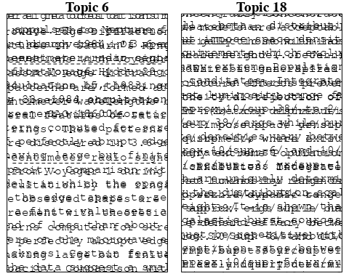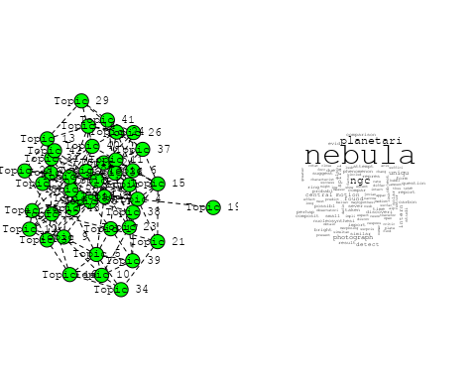

## Warning in wordcloud::wordcloud(words = vocab, freq = vec, max.words =  
## max.words, : interstellar could not be fit on page. It will not be plotted.

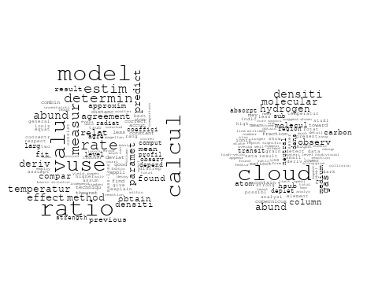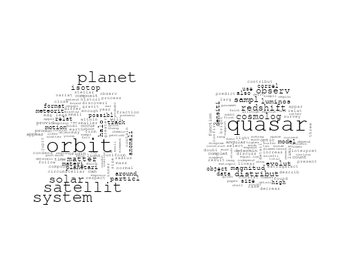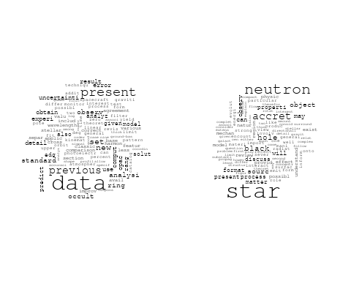

## Warning in wordcloud::wordcloud(words = vocab, freq = vec, max.words =  
## max.words, : star could not be fit on page. It will not be plotted.

## Warning in wordcloud::wordcloud(words = vocab, freq = vec, max.words =  
## max.words, : telescop could not be fit on page. It will not be plotted.

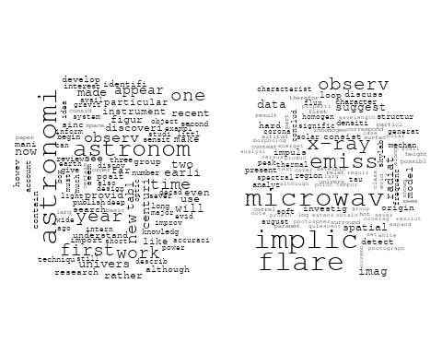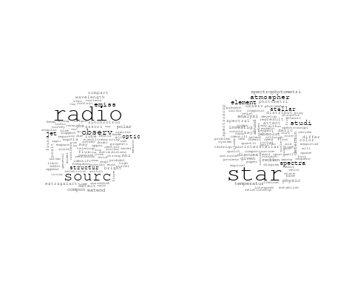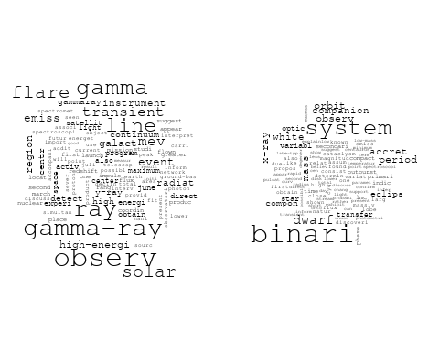

## Warning in wordcloud::wordcloud(words = vocab, freq = vec, max.words =  
## max.words, : saturn could not be fit on page. It will not be plotted.

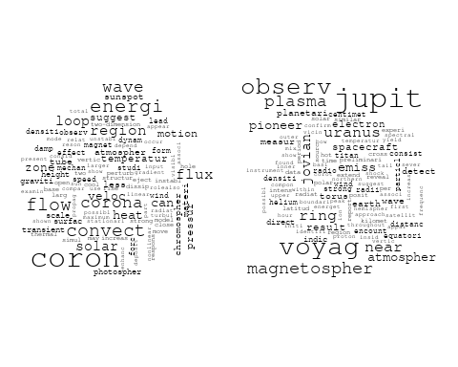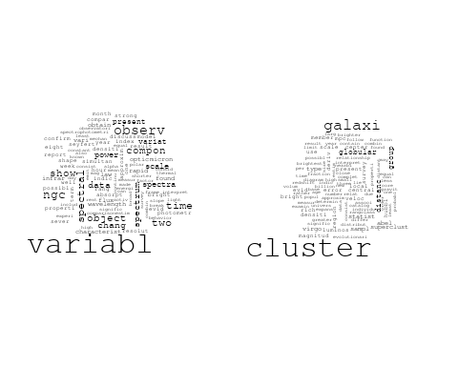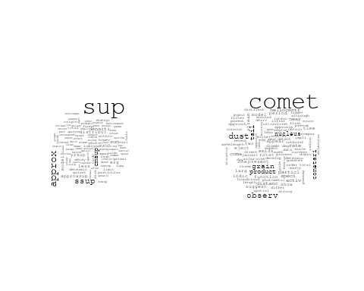

## Warning in wordcloud::wordcloud(words = vocab, freq = vec, max.words =  
## max.words, : shock could not be fit on page. It will not be plotted.

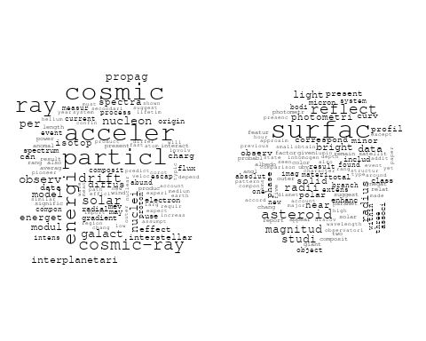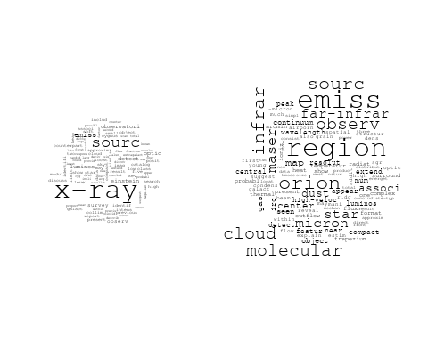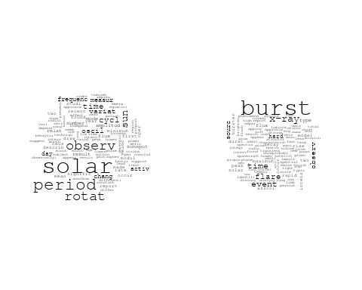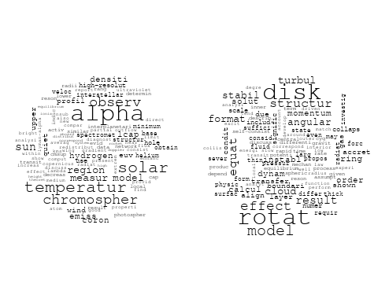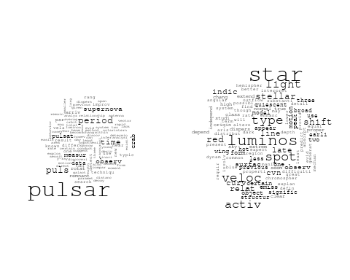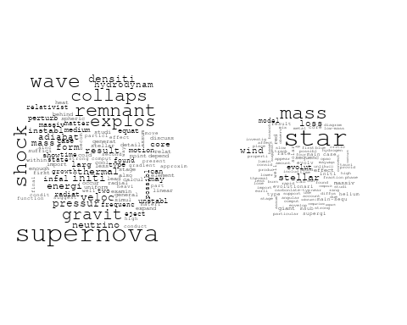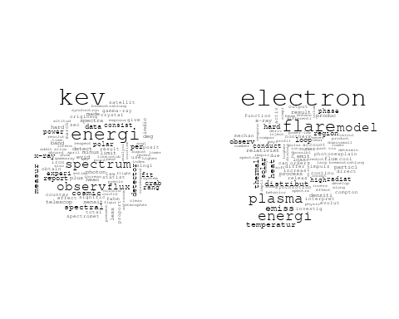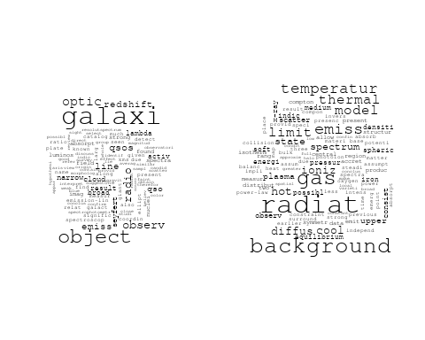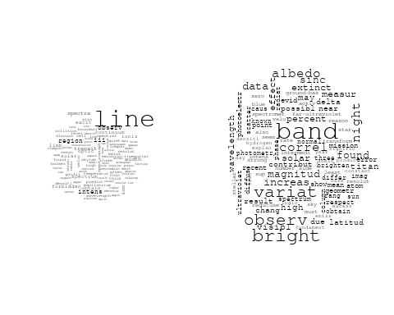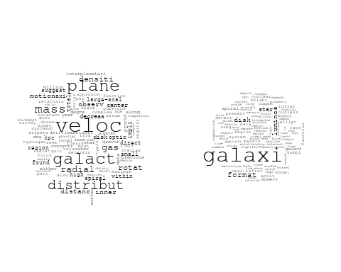

## Warning in wordcloud::wordcloud(words = vocab, freq = vec, max.words =  
## max.words, : ultraviolet could not be fit on page. It will not be plotted.

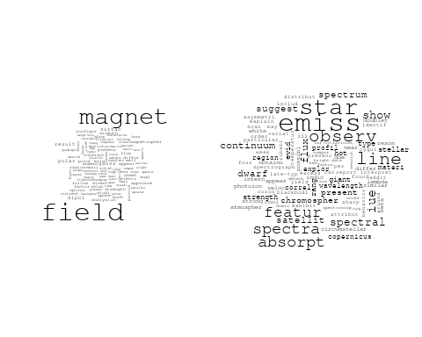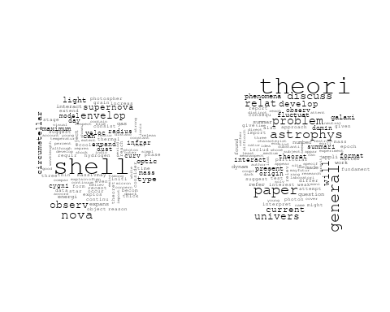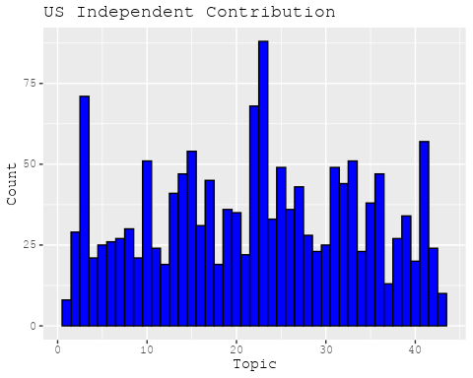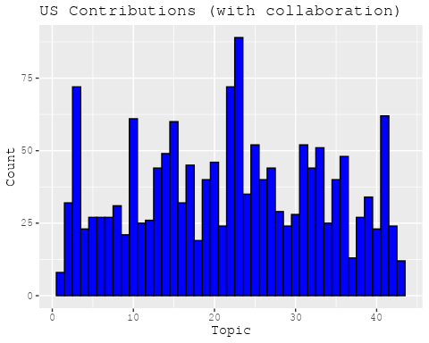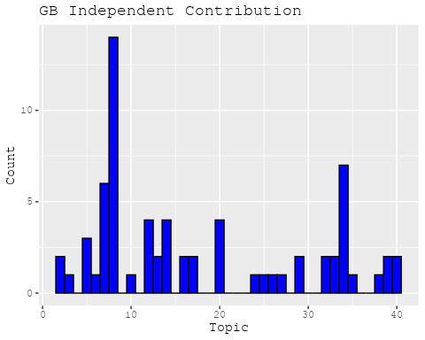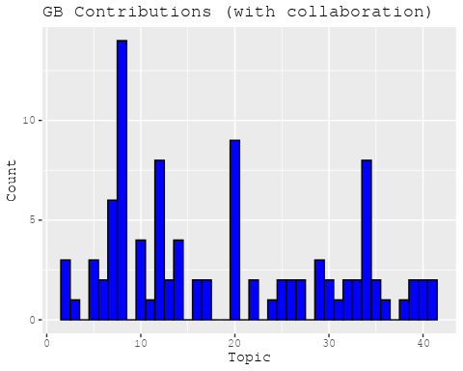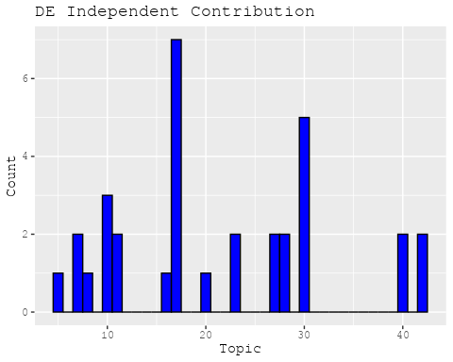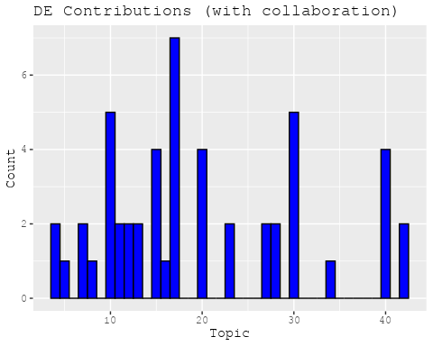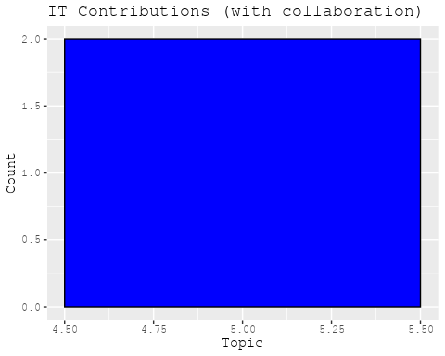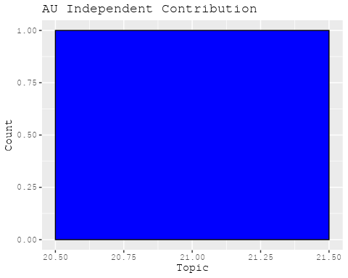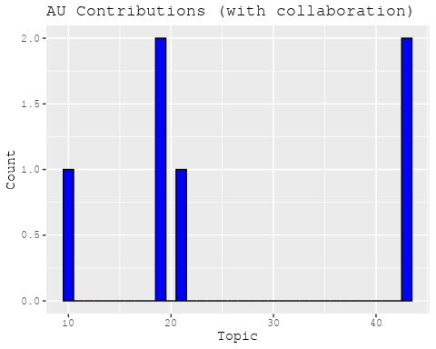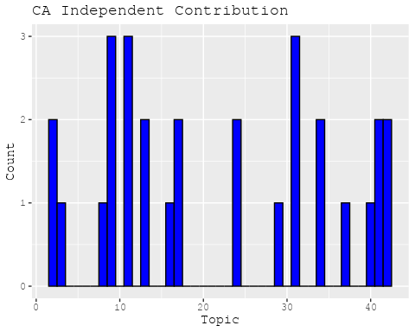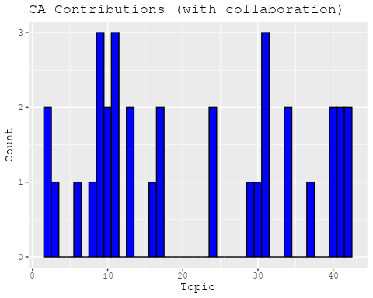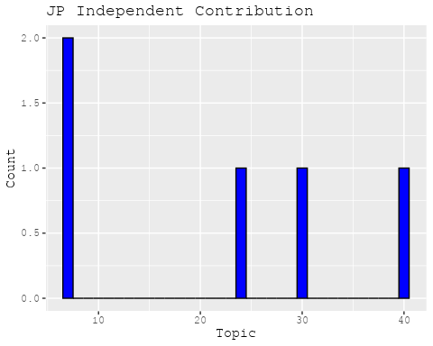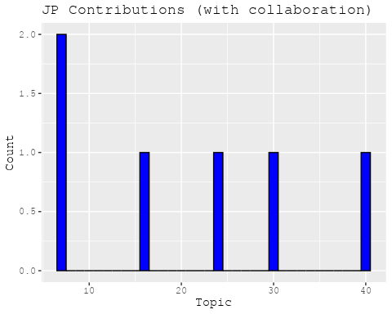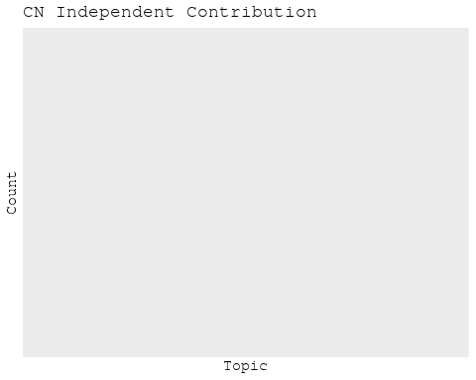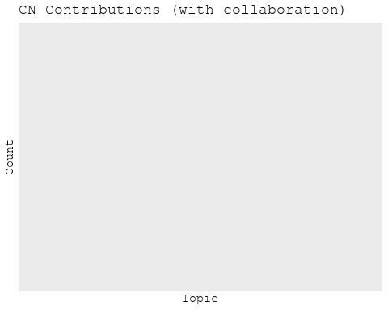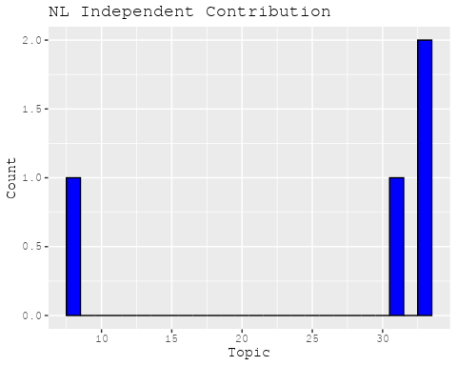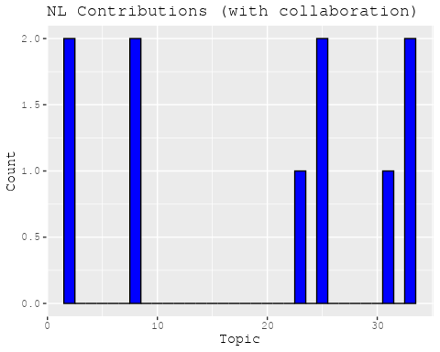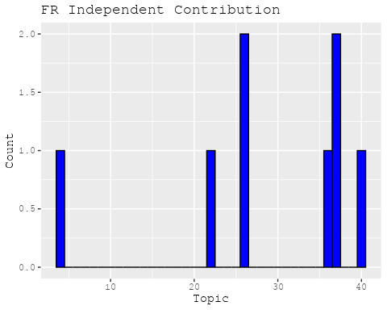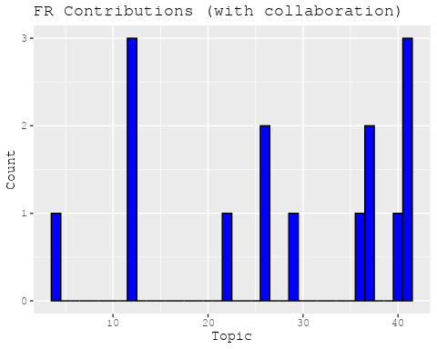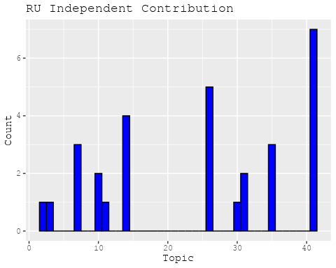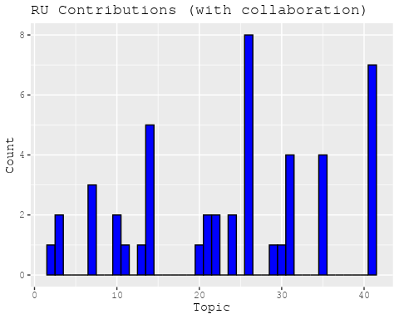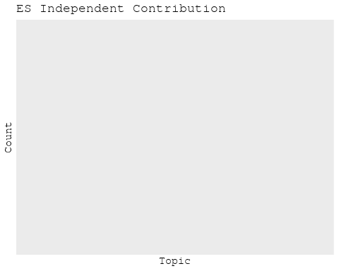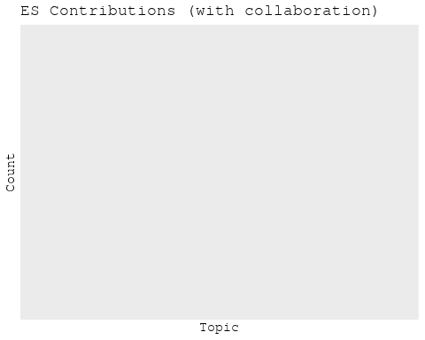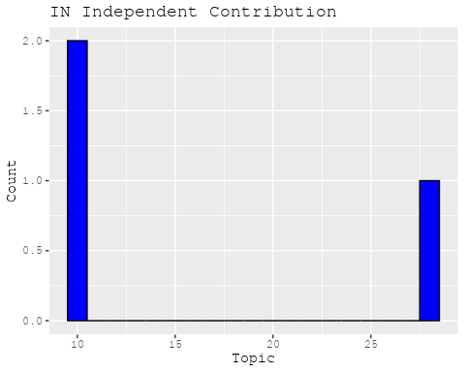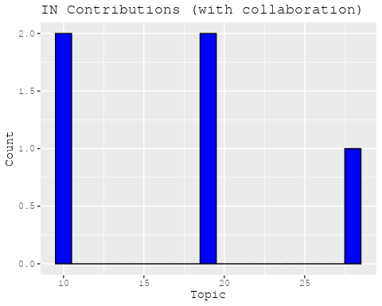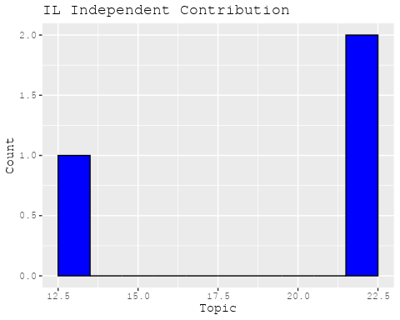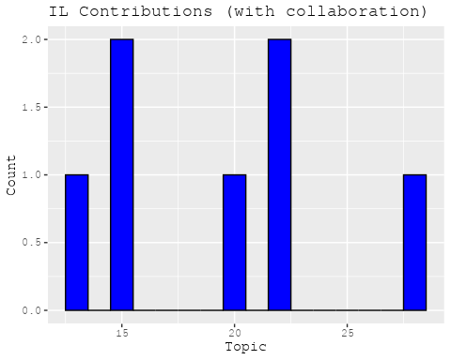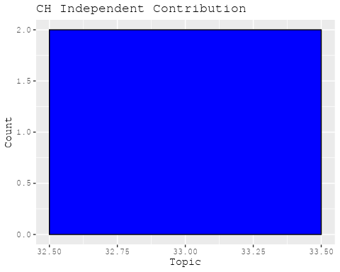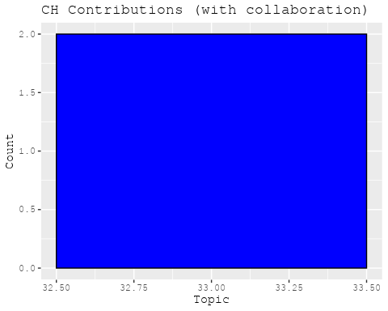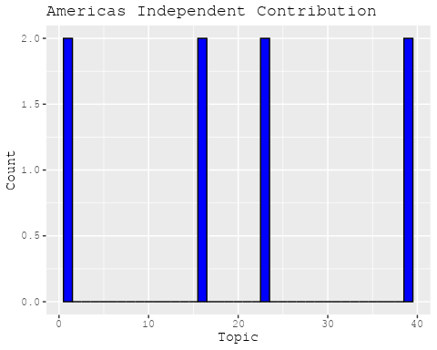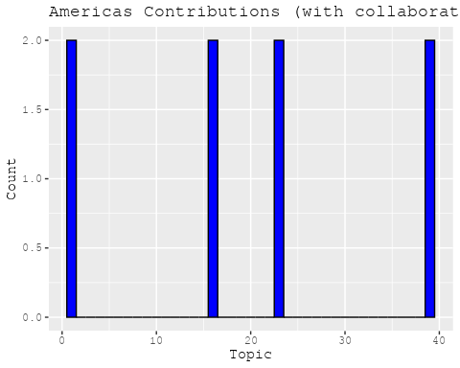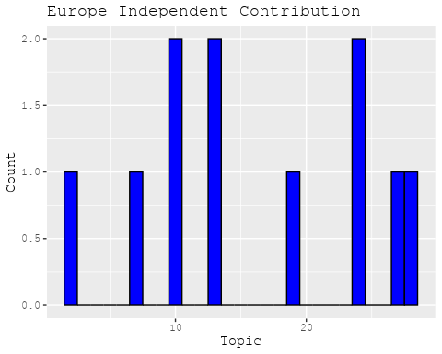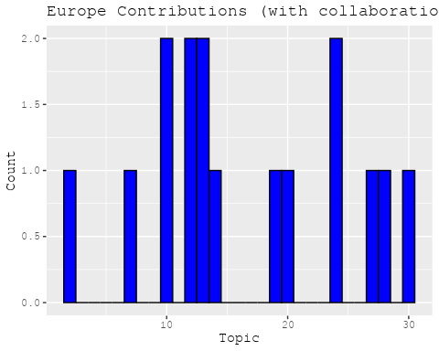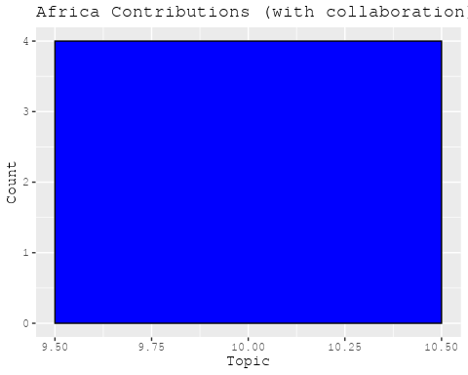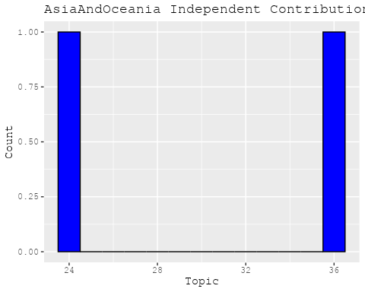

## [1] "Processing interval: pub_interval_1965_1974"  
## Building corpus...   
## Converting to Lower Case...   
## Removing punctuation...   
## Removing stopwords...   
## Removing numbers...   
## Stemming...   
## Creating Output...   
## Removing 1761 of 4484 terms (1761 of 27729 tokens) due to frequency   
## Your corpus now has 472 documents, 2723 terms and 25968 tokens.

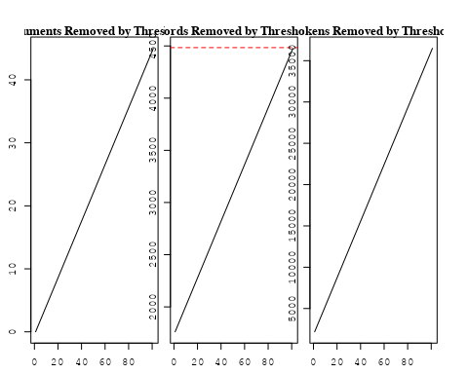

## Removing 4033 of 4484 terms (12038 of 27729 tokens) due to frequency   
## Your corpus now has 472 documents, 451 terms and 15691 tokens.~US + IN + DE + CH + GB + CN + FR + IT + RU + CA + NL + AU +   
## JP + ES + IL + Americas + Europe + Africa + AsiaAndOceania  
## Beginning Spectral Initialization   
## Calculating the gram matrix...  
## Finding anchor words...  
## ........................................  
## Recovering initialization...  
## ....  
## Initialization complete.  
## ......................................................................................................................  
## Completed E-Step (0 seconds).   
## Completed M-Step.   
## Completing Iteration 1 (approx. per word bound = -5.477)   
## ......................................................................................................................  
## Completed E-Step (0 seconds).   
## Completed M-Step.   
## Completing Iteration 2 (approx. per word bound = -5.330, relative change = 2.686e-02)   
## ......................................................................................................................  
## Completed E-Step (0 seconds).   
## Completed M-Step.   
## Completing Iteration 3 (approx. per word bound = -5.262, relative change = 1.272e-02)   
## ......................................................................................................................  
## Completed E-Step (0 seconds).   
## Completed M-Step.   
## Completing Iteration 4 (approx. per word bound = -5.224, relative change = 7.319e-03)   
## ......................................................................................................................  
## Completed E-Step (0 seconds).   
## Completed M-Step.   
## Completing Iteration 5 (approx. per word bound = -5.199, relative change = 4.781e-03)   
## Topic 1: solar, corona, sun, observ, time   
## Topic 2: star, massiv, pulsat, stellar, hydrogen   
## Topic 3: line, emiss, x-ray, spectrum, region   
## Topic 4: binari, effect, eclips, small, variat   
## Topic 5: atom, observ, hydrogen, interstellar, rate   
## Topic 6: mass, loss, star, outer, effect   
## Topic 7: cosmic, galact, ray, lead, event   
## Topic 8: rotat, pulsar, neutron, support, observ   
## Topic 9: gas, densiti, cloud, produc, hydrogen   
## Topic 10: star, stellar, helium, low, matter   
## Topic 11: astronomi, astronom, one, way, natur   
## Topic 12: sourc, x-ray, observ, period, intens   
## Topic 13: nebula, ioniz, radiat, particl, temperatur   
## Topic 14: compon, map, radio, measur, emiss   
## Topic 15: profil, motion, mechan, differ, present   
## Topic 16: variabl, red, hypothesi, due, correct   
## Topic 17: star, interstellar, format, galaxi, distanc   
## Topic 18: model, calcul, present, repres, deriv   
## Topic 19: energi, spectra, nuclei, element, composit   
## Topic 20: galaxi, quasar, object, evid, associ   
## Topic 21: nebula, crab, x-ray, supernova, pulsar   
## Topic 22: magnet, field, observ, surfac, region   
## Topic 23: galaxi, cluster, analysi, distribut, veloc   
## Topic 24: observ, jupit, atmospher, temperatur, wavelength   
## Topic 25: variat, stellar, astrophys, studi, theori   
## Topic 26: gravit, field, magnet, radiat, wave   
## Topic 27: establish, observ, can, flux, featur   
## Topic 28: sourc, observ, time, appar, radio   
## Topic 29: will, possibl, might, progress, matter   
## Topic 30: radio, x-ray, sourc, emiss, detect   
## Topic 31: research, space, will, basic, seem   
## Topic 32: system, direct, sky, first, refer   
## Topic 33: galact, measur, background, excess, possibl   
## Topic 34: valu, obtain, use, ratio, planet   
## Topic 35: evolut, function, convect, close, mass   
## Topic 36: object, sampl, process, neutron, year   
## Topic 37: observ, infrar, review, micron, data   
## Topic 38: pulsar, optic, puls, possibl, make   
## Topic 39: black, energi, disk, contain, may   
## Topic 40: iii, luminos, stellar, sinc, detail   
## ......................................................................................................................  
## Completed E-Step (0 seconds).   
## Completed M-Step.   
## Completing Iteration 6 (approx. per word bound = -5.181, relative change = 3.407e-03)   
## ......................................................................................................................  
## Completed E-Step (0 seconds).   
## Completed M-Step.   
## Completing Iteration 7 (approx. per word bound = -5.167, relative change = 2.613e-03)   
## ......................................................................................................................  
## Completed E-Step (0 seconds).   
## Completed M-Step.   
## Completing Iteration 8 (approx. per word bound = -5.157, relative change = 2.113e-03)   
## ......................................................................................................................  
## Completed E-Step (0 seconds).   
## Completed M-Step.   
## Completing Iteration 9 (approx. per word bound = -5.147, relative change = 1.908e-03)   
## ......................................................................................................................  
## Completed E-Step (0 seconds).   
## Completed M-Step.   
## Completing Iteration 10 (approx. per word bound = -5.139, relative change = 1.590e-03)   
## Topic 1: solar, sun, corona, observ, time   
## Topic 2: star, massiv, object, pulsat, emiss   
## Topic 3: line, emiss, x-ray, spectrum, region   
## Topic 4: binari, effect, eclips, small, variat   
## Topic 5: atom, observ, hydrogen, interstellar, rate   
## Topic 6: mass, loss, star, outer, constant   
## Topic 7: cosmic, galact, ray, time, survey   
## Topic 8: rotat, pulsar, neutron, observ, support   
## Topic 9: gas, cloud, densiti, produc, hydrogen   
## Topic 10: star, stellar, helium, low, matter   
## Topic 11: astronomi, astronom, one, way, natur   
## Topic 12: sourc, x-ray, observ, period, intens   
## Topic 13: nebula, ioniz, radiat, particl, temperatur   
## Topic 14: compon, map, measur, emiss, radio   
## Topic 15: profil, diffus, motion, mechan, scale   
## Topic 16: hypothesi, red, variabl, luminos, appar   
## Topic 17: star, interstellar, galaxi, format, distanc   
## Topic 18: model, calcul, present, repres, rate   
## Topic 19: energi, per, composit, spectra, nuclei   
## Topic 20: galaxi, quasar, object, evid, associ   
## Topic 21: nebula, crab, x-ray, supernova, pulsar   
## Topic 22: field, magnet, observ, surfac, region   
## Topic 23: cluster, galaxi, distribut, analysi, veloc   
## Topic 24: observ, jupit, atmospher, absorpt, temperatur   
## Topic 25: stellar, astrophys, theori, studi, definit   
## Topic 26: gravit, radiat, wave, field, electron   
## Topic 27: establish, can, observ, featur, instrument   
## Topic 28: sourc, observ, two, time, arc   
## Topic 29: will, possibl, progress, might, matter   
## Topic 30: radio, sourc, x-ray, emiss, detect   
## Topic 31: research, space, will, seem, basic   
## Topic 32: system, direct, sky, first, refer   
## Topic 33: galact, measur, background, excess, possibl   
## Topic 34: obtain, use, valu, planet, limit   
## Topic 35: evolut, function, convect, close, mass   
## Topic 36: object, sampl, process, neutron, distanc   
## Topic 37: observ, infrar, variat, review, micron   
## Topic 38: pulsar, optic, puls, possibl, make   
## Topic 39: black, disk, energi, contain, system   
## Topic 40: iii, luminos, detail, compar, discuss   
## ......................................................................................................................  
## Completed E-Step (0 seconds).   
## Completed M-Step.   
## Completing Iteration 11 (approx. per word bound = -5.132, relative change = 1.358e-03)   
## ......................................................................................................................  
## Completed E-Step (0 seconds).   
## Completed M-Step.   
## Completing Iteration 12 (approx. per word bound = -5.125, relative change = 1.274e-03)   
## ......................................................................................................................  
## Completed E-Step (0 seconds).   
## Completed M-Step.   
## Completing Iteration 13 (approx. per word bound = -5.119, relative change = 1.169e-03)   
## ......................................................................................................................  
## Completed E-Step (0 seconds).   
## Completed M-Step.   
## Completing Iteration 14 (approx. per word bound = -5.114, relative change = 1.054e-03)   
## ......................................................................................................................  
## Completed E-Step (0 seconds).   
## Completed M-Step.   
## Completing Iteration 15 (approx. per word bound = -5.109, relative change = 9.076e-04)   
## Topic 1: solar, sun, corona, time, atmospher   
## Topic 2: star, massiv, variabl, object, pulsat   
## Topic 3: line, emiss, x-ray, spectrum, observ   
## Topic 4: binari, eclips, effect, small, radius   
## Topic 5: atom, interstellar, observ, hydrogen, rate   
## Topic 6: mass, loss, constant, effect, star   
## Topic 7: cosmic, galact, ray, time, event   
## Topic 8: rotat, pulsar, neutron, observ, star   
## Topic 9: gas, cloud, densiti, abund, equilibrium   
## Topic 10: star, stellar, helium, low, matter   
## Topic 11: astronomi, astronom, one, way, physic   
## Topic 12: sourc, x-ray, observ, period, uhuru   
## Topic 13: nebula, ioniz, radiat, particl, case   
## Topic 14: compon, map, measur, emiss, sourc   
## Topic 15: profil, diffus, motion, scale, present   
## Topic 16: hypothesi, red, magnitud, appar, luminos   
## Topic 17: star, galaxi, interstellar, format, distanc   
## Topic 18: model, calcul, present, repres, rate   
## Topic 19: energi, composit, per, spectra, rang   
## Topic 20: galaxi, quasar, object, associ, evid   
## Topic 21: nebula, x-ray, crab, supernova, remnant   
## Topic 22: field, magnet, observ, surfac, region   
## Topic 23: cluster, galaxi, distribut, veloc, analysi   
## Topic 24: observ, jupit, absorpt, atmospher, wavelength   
## Topic 25: stellar, theori, astrophys, studi, definit   
## Topic 26: gravit, radiat, wave, field, equat   
## Topic 27: instrument, establish, can, observ, featur   
## Topic 28: sourc, observ, two, arc, densiti   
## Topic 29: will, possibl, progress, might, import   
## Topic 30: radio, sourc, x-ray, search, detect   
## Topic 31: research, space, will, seem, basic   
## Topic 32: direct, system, sky, first, refer   
## Topic 33: galact, measur, background, excess, observ   
## Topic 34: use, obtain, planet, valu, demonstr   
## Topic 35: evolut, function, convect, close, stellar   
## Topic 36: object, sampl, process, neutron, distanc   
## Topic 37: observ, infrar, variat, review, show   
## Topic 38: pulsar, optic, puls, identif, possibl   
## Topic 39: black, system, energi, disk, contain   
## Topic 40: iii, luminos, detail, compar, found   
## ......................................................................................................................  
## Completed E-Step (0 seconds).   
## Completed M-Step.   
## Completing Iteration 16 (approx. per word bound = -5.105, relative change = 7.788e-04)   
## ......................................................................................................................  
## Completed E-Step (0 seconds).   
## Completed M-Step.   
## Completing Iteration 17 (approx. per word bound = -5.101, relative change = 7.314e-04)   
## ......................................................................................................................  
## Completed E-Step (0 seconds).   
## Completed M-Step.   
## Completing Iteration 18 (approx. per word bound = -5.098, relative change = 6.554e-04)   
## ......................................................................................................................  
## Completed E-Step (0 seconds).   
## Completed M-Step.   
## Completing Iteration 19 (approx. per word bound = -5.095, relative change = 5.851e-04)   
## ......................................................................................................................  
## Completed E-Step (0 seconds).   
## Completed M-Step.   
## Completing Iteration 20 (approx. per word bound = -5.092, relative change = 5.215e-04)   
## Topic 1: solar, sun, corona, atmospher, structur   
## Topic 2: star, variabl, object, massiv, pulsat   
## Topic 3: line, emiss, x-ray, spectrum, observ   
## Topic 4: binari, eclips, effect, small, radius   
## Topic 5: atom, interstellar, observ, hydrogen, rate   
## Topic 6: mass, loss, constant, solar, hot   
## Topic 7: cosmic, galact, ray, time, year   
## Topic 8: pulsar, rotat, neutron, star, observ   
## Topic 9: gas, cloud, temperatur, densiti, abund   
## Topic 10: star, stellar, helium, low, matter   
## Topic 11: astronomi, astronom, way, one, earli   
## Topic 12: sourc, x-ray, observ, period, uhuru   
## Topic 13: nebula, ioniz, radiat, particl, case   
## Topic 14: compon, map, measur, emiss, sourc   
## Topic 15: profil, diffus, scale, motion, differ   
## Topic 16: hypothesi, magnitud, appar, red, luminos   
## Topic 17: star, galaxi, interstellar, format, distanc   
## Topic 18: model, calcul, present, repres, rate   
## Topic 19: energi, rang, composit, spectra, nuclei   
## Topic 20: galaxi, quasar, object, associ, evid   
## Topic 21: nebula, x-ray, crab, supernova, remnant   
## Topic 22: field, magnet, observ, surfac, region   
## Topic 23: cluster, galaxi, distribut, veloc, structur   
## Topic 24: observ, jupit, absorpt, atmospher, wavelength   
## Topic 25: stellar, theori, astrophys, studi, definit   
## Topic 26: gravit, radiat, wave, sourc, field   
## Topic 27: instrument, establish, can, observ, featur   
## Topic 28: sourc, two, arc, observ, flux   
## Topic 29: will, progress, might, possibl, import   
## Topic 30: radio, sourc, x-ray, search, detect   
## Topic 31: research, space, will, basic, seem   
## Topic 32: direct, sky, system, first, refer   
## Topic 33: galact, measur, excess, background, possibl   
## Topic 34: use, obtain, planet, demonstr, valu   
## Topic 35: evolut, function, convect, close, stellar   
## Topic 36: object, sampl, process, neutron, distanc   
## Topic 37: observ, infrar, variat, review, show   
## Topic 38: optic, pulsar, puls, identif, possibl   
## Topic 39: black, system, energi, disk, contain   
## Topic 40: luminos, iii, detail, compar, estim   
## ......................................................................................................................  
## Completed E-Step (0 seconds).   
## Completed M-Step.   
## Completing Iteration 21 (approx. per word bound = -5.090, relative change = 4.806e-04)   
## ......................................................................................................................  
## Completed E-Step (0 seconds).   
## Completed M-Step.   
## Completing Iteration 22 (approx. per word bound = -5.087, relative change = 4.794e-04)   
## ......................................................................................................................  
## Completed E-Step (0 seconds).   
## Completed M-Step.   
## Completing Iteration 23 (approx. per word bound = -5.085, relative change = 4.302e-04)   
## ......................................................................................................................  
## Completed E-Step (0 seconds).   
## Completed M-Step.   
## Completing Iteration 24 (approx. per word bound = -5.083, relative change = 3.820e-04)   
## ......................................................................................................................  
## Completed E-Step (0 seconds).   
## Completed M-Step.   
## Completing Iteration 25 (approx. per word bound = -5.081, relative change = 3.569e-04)   
## Topic 1: solar, sun, corona, atmospher, structur   
## Topic 2: star, variabl, object, massiv, pulsat   
## Topic 3: line, emiss, x-ray, spectrum, observ   
## Topic 4: binari, eclips, effect, variat, radius   
## Topic 5: atom, interstellar, observ, hydrogen, rate   
## Topic 6: mass, loss, solar, constant, hot   
## Topic 7: cosmic, galact, ray, time, year   
## Topic 8: pulsar, neutron, rotat, star, observ   
## Topic 9: gas, cloud, temperatur, abund, densiti   
## Topic 10: star, stellar, helium, low, matter   
## Topic 11: astronomi, astronom, way, one, earli   
## Topic 12: sourc, x-ray, observ, period, uhuru   
## Topic 13: nebula, ioniz, radiat, particl, case   
## Topic 14: compon, map, measur, emiss, sourc   
## Topic 15: profil, diffus, scale, motion, differ   
## Topic 16: magnitud, hypothesi, appar, red, luminos   
## Topic 17: star, galaxi, interstellar, format, materi   
## Topic 18: model, calcul, present, repres, occur   
## Topic 19: energi, rang, composit, spectra, element   
## Topic 20: galaxi, quasar, object, associ, result   
## Topic 21: nebula, x-ray, crab, supernova, remnant   
## Topic 22: field, magnet, observ, surfac, region   
## Topic 23: cluster, galaxi, distribut, veloc, structur   
## Topic 24: observ, jupit, absorpt, atmospher, wavelength   
## Topic 25: stellar, theori, astrophys, studi, definit   
## Topic 26: gravit, radiat, wave, sourc, field   
## Topic 27: instrument, establish, can, observ, featur   
## Topic 28: sourc, two, flux, arc, observ   
## Topic 29: will, progress, might, import, possibl   
## Topic 30: radio, sourc, x-ray, search, detect   
## Topic 31: research, space, will, basic, near   
## Topic 32: direct, sky, system, first, refer   
## Topic 33: galact, measur, excess, background, region   
## Topic 34: use, obtain, planet, one, demonstr   
## Topic 35: evolut, function, convect, close, stellar   
## Topic 36: object, sampl, distanc, neutron, process   
## Topic 37: infrar, observ, variat, review, show   
## Topic 38: optic, pulsar, puls, identif, possibl   
## Topic 39: black, system, energi, disk, contain   
## Topic 40: luminos, iii, estim, compar, detail   
## ......................................................................................................................  
## Completed E-Step (0 seconds).   
## Completed M-Step.   
## Completing Iteration 26 (approx. per word bound = -5.080, relative change = 3.356e-04)   
## ......................................................................................................................  
## Completed E-Step (0 seconds).   
## Completed M-Step.   
## Completing Iteration 27 (approx. per word bound = -5.078, relative change = 3.149e-04)   
## ......................................................................................................................  
## Completed E-Step (0 seconds).   
## Completed M-Step.   
## Completing Iteration 28 (approx. per word bound = -5.077, relative change = 2.982e-04)   
## ......................................................................................................................  
## Completed E-Step (0 seconds).   
## Completed M-Step.   
## Completing Iteration 29 (approx. per word bound = -5.075, relative change = 2.846e-04)   
## ......................................................................................................................  
## Completed E-Step (0 seconds).   
## Completed M-Step.   
## Completing Iteration 30 (approx. per word bound = -5.074, relative change = 2.890e-04)   
## Topic 1: solar, sun, corona, atmospher, structur   
## Topic 2: star, variabl, object, massiv, pulsat   
## Topic 3: line, emiss, x-ray, spectrum, observ   
## Topic 4: binari, eclips, variat, effect, radius   
## Topic 5: atom, interstellar, observ, hydrogen, rate   
## Topic 6: mass, loss, solar, constant, hot   
## Topic 7: cosmic, galact, ray, time, year   
## Topic 8: pulsar, neutron, rotat, star, observ   
## Topic 9: gas, cloud, temperatur, abund, densiti   
## Topic 10: star, stellar, helium, low, matter   
## Topic 11: astronomi, astronom, way, one, earli   
## Topic 12: sourc, x-ray, observ, period, uhuru   
## Topic 13: nebula, ioniz, radiat, particl, case   
## Topic 14: compon, map, emiss, measur, sourc   
## Topic 15: profil, diffus, scale, differ, present   
## Topic 16: magnitud, appar, hypothesi, red, luminos   
## Topic 17: star, galaxi, interstellar, format, materi   
## Topic 18: model, calcul, present, repres, occur   
## Topic 19: energi, rang, composit, spectra, element   
## Topic 20: galaxi, quasar, object, associ, result   
## Topic 21: nebula, x-ray, crab, supernova, remnant   
## Topic 22: field, magnet, observ, surfac, region   
## Topic 23: cluster, galaxi, distribut, veloc, structur   
## Topic 24: observ, jupit, absorpt, atmospher, wavelength   
## Topic 25: stellar, theori, astrophys, studi, definit   
## Topic 26: gravit, radiat, wave, sourc, field   
## Topic 27: instrument, establish, can, observ, featur   
## Topic 28: sourc, two, flux, arc, observ   
## Topic 29: will, progress, might, import, discuss   
## Topic 30: radio, sourc, x-ray, search, detect   
## Topic 31: research, space, will, major, basic   
## Topic 32: direct, sky, system, refer, first   
## Topic 33: galact, measur, excess, background, region   
## Topic 34: use, obtain, planet, one, demonstr   
## Topic 35: evolut, function, convect, close, stellar   
## Topic 36: object, sampl, distanc, neutron, point   
## Topic 37: infrar, observ, variat, type, review   
## Topic 38: optic, pulsar, puls, identif, possibl   
## Topic 39: black, system, energi, disk, contain   
## Topic 40: luminos, iii, estim, compar, found   
## ......................................................................................................................  
## Completed E-Step (0 seconds).   
## Completed M-Step.   
## Completing Iteration 31 (approx. per word bound = -5.072, relative change = 2.751e-04)   
## ......................................................................................................................  
## Completed E-Step (0 seconds).   
## Completed M-Step.   
## Completing Iteration 32 (approx. per word bound = -5.071, relative change = 2.407e-04)   
## ......................................................................................................................  
## Completed E-Step (0 seconds).   
## Completed M-Step.   
## Completing Iteration 33 (approx. per word bound = -5.070, relative change = 2.241e-04)   
## ......................................................................................................................  
## Completed E-Step (0 seconds).   
## Completed M-Step.   
## Completing Iteration 34 (approx. per word bound = -5.069, relative change = 2.169e-04)   
## ......................................................................................................................  
## Completed E-Step (0 seconds).   
## Completed M-Step.   
## Completing Iteration 35 (approx. per word bound = -5.068, relative change = 2.146e-04)   
## Topic 1: solar, sun, corona, structur, atmospher   
## Topic 2: star, variabl, object, massiv, emiss   
## Topic 3: line, emiss, x-ray, spectrum, observ   
## Topic 4: binari, eclips, variat, effect, radius   
## Topic 5: atom, interstellar, observ, hydrogen, rate   
## Topic 6: mass, solar, loss, constant, hot   
## Topic 7: cosmic, galact, ray, year, time   
## Topic 8: pulsar, neutron, rotat, star, observ   
## Topic 9: gas, cloud, temperatur, abund, densiti   
## Topic 10: star, stellar, helium, low, problem   
## Topic 11: astronomi, astronom, way, one, earli   
## Topic 12: sourc, x-ray, observ, period, uhuru   
## Topic 13: nebula, ioniz, radiat, particl, case   
## Topic 14: compon, map, emiss, sourc, measur   
## Topic 15: profil, diffus, scale, differ, present   
## Topic 16: magnitud, appar, hypothesi, red, luminos   
## Topic 17: star, galaxi, interstellar, format, materi   
## Topic 18: model, calcul, present, repres, rate   
## Topic 19: energi, rang, composit, spectra, element   
## Topic 20: galaxi, quasar, object, result, associ   
## Topic 21: nebula, x-ray, crab, supernova, remnant   
## Topic 22: field, magnet, observ, surfac, region   
## Topic 23: cluster, galaxi, distribut, veloc, spiral   
## Topic 24: observ, jupit, absorpt, atmospher, wavelength   
## Topic 25: stellar, theori, astrophys, studi, definit   
## Topic 26: gravit, radiat, wave, sourc, field   
## Topic 27: instrument, establish, can, observ, featur   
## Topic 28: sourc, flux, two, arc, observ   
## Topic 29: will, progress, might, import, discuss   
## Topic 30: radio, sourc, x-ray, search, detect   
## Topic 31: research, space, will, major, basic   
## Topic 32: sky, direct, system, refer, first   
## Topic 33: galact, measur, excess, background, region   
## Topic 34: use, obtain, planet, one, demonstr   
## Topic 35: evolut, function, convect, close, stellar   
## Topic 36: object, sampl, distanc, neutron, point   
## Topic 37: infrar, observ, variat, type, review   
## Topic 38: optic, pulsar, puls, identif, possibl   
## Topic 39: black, system, energi, disk, contain   
## Topic 40: luminos, estim, iii, appear, compar   
## ......................................................................................................................  
## Completed E-Step (0 seconds).   
## Completed M-Step.   
## Completing Iteration 36 (approx. per word bound = -5.067, relative change = 2.161e-04)   
## ......................................................................................................................  
## Completed E-Step (0 seconds).   
## Completed M-Step.   
## Completing Iteration 37 (approx. per word bound = -5.066, relative change = 2.033e-04)   
## ......................................................................................................................  
## Completed E-Step (0 seconds).   
## Completed M-Step.   
## Completing Iteration 38 (approx. per word bound = -5.065, relative change = 1.958e-04)   
## ......................................................................................................................  
## Completed E-Step (0 seconds).   
## Completed M-Step.   
## Completing Iteration 39 (approx. per word bound = -5.064, relative change = 2.018e-04)   
## ......................................................................................................................  
## Completed E-Step (0 seconds).   
## Completed M-Step.   
## Completing Iteration 40 (approx. per word bound = -5.063, relative change = 2.146e-04)   
## Topic 1: solar, sun, corona, structur, atmospher   
## Topic 2: star, variabl, massiv, object, emiss   
## Topic 3: line, emiss, x-ray, spectrum, observ   
## Topic 4: binari, eclips, variat, effect, radius   
## Topic 5: atom, interstellar, observ, hydrogen, rate   
## Topic 6: mass, solar, loss, constant, hot   
## Topic 7: cosmic, galact, ray, year, time   
## Topic 8: pulsar, neutron, rotat, star, observ   
## Topic 9: gas, cloud, temperatur, abund, densiti   
## Topic 10: star, stellar, helium, low, will   
## Topic 11: astronomi, astronom, way, one, earli   
## Topic 12: sourc, x-ray, observ, period, uhuru   
## Topic 13: nebula, ioniz, radiat, particl, case   
## Topic 14: compon, map, emiss, sourc, measur   
## Topic 15: profil, diffus, scale, differ, present   
## Topic 16: magnitud, hypothesi, appar, red, luminos   
## Topic 17: star, galaxi, interstellar, format, materi   
## Topic 18: model, calcul, present, repres, rate   
## Topic 19: energi, rang, spectra, composit, element   
## Topic 20: galaxi, quasar, object, associ, result   
## Topic 21: nebula, x-ray, crab, supernova, remnant   
## Topic 22: field, magnet, observ, surfac, region   
## Topic 23: cluster, galaxi, distribut, veloc, mass   
## Topic 24: observ, jupit, absorpt, atmospher, wavelength   
## Topic 25: stellar, theori, astrophys, studi, definit   
## Topic 26: gravit, radiat, wave, sourc, field   
## Topic 27: instrument, establish, can, observ, featur   
## Topic 28: sourc, flux, two, arc, observ   
## Topic 29: will, progress, import, might, discuss   
## Topic 30: radio, sourc, x-ray, search, detect   
## Topic 31: research, space, will, major, basic   
## Topic 32: sky, direct, system, refer, first   
## Topic 33: galact, measur, excess, background, region   
## Topic 34: use, obtain, planet, one, demonstr   
## Topic 35: evolut, function, convect, close, stellar   
## Topic 36: object, sampl, distanc, point, neutron   
## Topic 37: infrar, observ, variat, type, review   
## Topic 38: optic, pulsar, puls, identif, possibl   
## Topic 39: black, system, energi, disk, contain   
## Topic 40: luminos, estim, iii, appear, found   
## ......................................................................................................................  
## Completed E-Step (0 seconds).   
## Completed M-Step.   
## Completing Iteration 41 (approx. per word bound = -5.062, relative change = 2.090e-04)   
## ......................................................................................................................  
## Completed E-Step (0 seconds).   
## Completed M-Step.   
## Completing Iteration 42 (approx. per word bound = -5.060, relative change = 2.316e-04)   
## ......................................................................................................................  
## Completed E-Step (0 seconds).   
## Completed M-Step.   
## Completing Iteration 43 (approx. per word bound = -5.059, relative change = 2.503e-04)   
## ......................................................................................................................  
## Completed E-Step (0 seconds).   
## Completed M-Step.   
## Completing Iteration 44 (approx. per word bound = -5.058, relative change = 2.282e-04)   
## ......................................................................................................................  
## Completed E-Step (0 seconds).   
## Completed M-Step.   
## Completing Iteration 45 (approx. per word bound = -5.057, relative change = 1.991e-04)   
## Topic 1: solar, sun, corona, structur, atmospher   
## Topic 2: star, variabl, massiv, emiss, pulsat   
## Topic 3: line, emiss, x-ray, spectrum, observ   
## Topic 4: binari, eclips, variat, effect, radius   
## Topic 5: atom, interstellar, observ, hydrogen, rate   
## Topic 6: mass, solar, loss, constant, hot   
## Topic 7: cosmic, galact, ray, time, year   
## Topic 8: neutron, pulsar, rotat, star, observ   
## Topic 9: gas, cloud, temperatur, abund, densiti   
## Topic 10: star, stellar, helium, will, low   
## Topic 11: astronomi, astronom, way, one, observatori   
## Topic 12: sourc, x-ray, observ, period, uhuru   
## Topic 13: nebula, ioniz, radiat, particl, case   
## Topic 14: compon, map, emiss, sourc, measur   
## Topic 15: profil, diffus, scale, differ, present   
## Topic 16: hypothesi, magnitud, appar, red, luminos   
## Topic 17: star, galaxi, interstellar, format, materi   
## Topic 18: model, calcul, present, repres, rate   
## Topic 19: energi, rang, element, spectra, composit   
## Topic 20: galaxi, quasar, object, associ, result   
## Topic 21: nebula, x-ray, crab, supernova, remnant   
## Topic 22: field, magnet, observ, surfac, region   
## Topic 23: cluster, galaxi, distribut, veloc, mass   
## Topic 24: observ, jupit, absorpt, atmospher, wavelength   
## Topic 25: stellar, theori, astrophys, studi, definit   
## Topic 26: gravit, radiat, wave, sourc, field   
## Topic 27: instrument, establish, observ, can, flux   
## Topic 28: sourc, flux, two, arc, observ   
## Topic 29: will, progress, import, might, discuss   
## Topic 30: radio, sourc, x-ray, search, detect   
## Topic 31: research, space, will, major, basic   
## Topic 32: sky, system, direct, first, refer   
## Topic 33: galact, measur, excess, background, region   
## Topic 34: use, obtain, planet, one, demonstr   
## Topic 35: evolut, function, convect, close, stellar   
## Topic 36: object, sampl, distanc, point, valu   
## Topic 37: infrar, observ, variat, type, review   
## Topic 38: pulsar, optic, puls, identif, possibl   
## Topic 39: black, system, energi, disk, contain   
## Topic 40: luminos, estim, iii, appear, found   
## ......................................................................................................................  
## Completed E-Step (0 seconds).   
## Completed M-Step.   
## Completing Iteration 46 (approx. per word bound = -5.056, relative change = 1.901e-04)   
## ......................................................................................................................  
## Completed E-Step (0 seconds).   
## Completed M-Step.   
## Completing Iteration 47 (approx. per word bound = -5.055, relative change = 1.757e-04)   
## ......................................................................................................................  
## Completed E-Step (0 seconds).   
## Completed M-Step.   
## Completing Iteration 48 (approx. per word bound = -5.054, relative change = 1.796e-04)   
## ......................................................................................................................  
## Completed E-Step (0 seconds).   
## Completed M-Step.   
## Completing Iteration 49 (approx. per word bound = -5.053, relative change = 1.655e-04)   
## ......................................................................................................................  
## Completed E-Step (0 seconds).   
## Completed M-Step.   
## Completing Iteration 50 (approx. per word bound = -5.053, relative change = 1.592e-04)   
## Topic 1: solar, sun, corona, structur, atmospher   
## Topic 2: star, variabl, massiv, emiss, pulsat   
## Topic 3: line, emiss, x-ray, spectrum, observ   
## Topic 4: binari, eclips, variat, effect, radius   
## Topic 5: interstellar, atom, observ, hydrogen, rate   
## Topic 6: mass, solar, loss, constant, hot   
## Topic 7: cosmic, galact, ray, time, year   
## Topic 8: neutron, pulsar, rotat, star, observ   
## Topic 9: gas, cloud, temperatur, abund, densiti   
## Topic 10: star, stellar, helium, low, will   
## Topic 11: astronomi, astronom, way, one, observatori   
## Topic 12: sourc, x-ray, observ, period, uhuru   
## Topic 13: nebula, ioniz, radiat, particl, case   
## Topic 14: compon, map, emiss, measur, sourc   
## Topic 15: profil, diffus, scale, differ, possibl   
## Topic 16: hypothesi, magnitud, appar, red, luminos   
## Topic 17: galaxi, star, interstellar, format, materi   
## Topic 18: model, calcul, present, repres, rate   
## Topic 19: energi, rang, spectra, composit, element   
## Topic 20: galaxi, quasar, object, associ, result   
## Topic 21: x-ray, nebula, crab, supernova, remnant   
## Topic 22: field, magnet, observ, surfac, region   
## Topic 23: cluster, galaxi, distribut, veloc, mass   
## Topic 24: observ, jupit, absorpt, atmospher, wavelength   
## Topic 25: stellar, theori, astrophys, studi, definit   
## Topic 26: gravit, radiat, wave, sourc, field   
## Topic 27: instrument, establish, observ, can, flux   
## Topic 28: sourc, flux, two, arc, time   
## Topic 29: will, progress, import, might, discuss   
## Topic 30: radio, sourc, x-ray, search, detect   
## Topic 31: research, space, will, basic, surfac   
## Topic 32: sky, system, direct, structur, first   
## Topic 33: galact, excess, measur, background, region   
## Topic 34: use, obtain, planet, one, demonstr   
## Topic 35: evolut, function, convect, stellar, close   
## Topic 36: object, sampl, distanc, point, statist   
## Topic 37: infrar, observ, variat, type, review   
## Topic 38: pulsar, optic, identif, puls, possibl   
## Topic 39: black, system, energi, disk, contain   
## Topic 40: luminos, estim, iii, appear, found   
## ......................................................................................................................  
## Completed E-Step (0 seconds).   
## Completed M-Step.   
## Completing Iteration 51 (approx. per word bound = -5.052, relative change = 1.840e-04)   
## ......................................................................................................................  
## Completed E-Step (0 seconds).   
## Completed M-Step.   
## Completing Iteration 52 (approx. per word bound = -5.051, relative change = 1.997e-04)   
## ......................................................................................................................  
## Completed E-Step (0 seconds).   
## Completed M-Step.   
## Completing Iteration 53 (approx. per word bound = -5.050, relative change = 1.728e-04)   
## ......................................................................................................................  
## Completed E-Step (0 seconds).   
## Completed M-Step.   
## Completing Iteration 54 (approx. per word bound = -5.049, relative change = 1.463e-04)   
## ......................................................................................................................  
## Completed E-Step (0 seconds).   
## Completed M-Step.   
## Completing Iteration 55 (approx. per word bound = -5.048, relative change = 1.374e-04)   
## Topic 1: solar, sun, corona, structur, atmospher   
## Topic 2: star, variabl, massiv, emiss, pulsat   
## Topic 3: line, emiss, x-ray, observ, spectrum   
## Topic 4: binari, eclips, variat, effect, radius   
## Topic 5: interstellar, atom, observ, hydrogen, rate   
## Topic 6: mass, solar, loss, constant, hot   
## Topic 7: cosmic, galact, ray, year, time   
## Topic 8: neutron, pulsar, rotat, star, observ   
## Topic 9: gas, cloud, temperatur, abund, densiti   
## Topic 10: star, stellar, helium, low, problem   
## Topic 11: astronomi, astronom, way, one, earli   
## Topic 12: sourc, x-ray, observ, period, uhuru   
## Topic 13: nebula, ioniz, radiat, particl, requir   
## Topic 14: compon, map, emiss, measur, radio   
## Topic 15: profil, diffus, scale, differ, possibl   
## Topic 16: hypothesi, magnitud, appar, red, luminos   
## Topic 17: galaxi, star, interstellar, format, materi   
## Topic 18: model, calcul, present, repres, rate   
## Topic 19: energi, rang, spectra, composit, element   
## Topic 20: galaxi, quasar, object, result, associ   
## Topic 21: x-ray, nebula, crab, supernova, remnant   
## Topic 22: field, magnet, observ, surfac, region   
## Topic 23: cluster, galaxi, distribut, veloc, mass   
## Topic 24: observ, absorpt, jupit, atmospher, wavelength   
## Topic 25: stellar, theori, astrophys, studi, definit   
## Topic 26: gravit, radiat, wave, sourc, small   
## Topic 27: instrument, establish, observ, can, flux   
## Topic 28: sourc, flux, two, arc, observ   
## Topic 29: will, progress, import, might, discuss   
## Topic 30: radio, sourc, x-ray, search, detect   
## Topic 31: research, space, will, surfac, basic   
## Topic 32: sky, system, direct, structur, refer   
## Topic 33: galact, excess, measur, background, region   
## Topic 34: use, obtain, planet, one, demonstr   
## Topic 35: evolut, function, convect, stellar, close   
## Topic 36: object, sampl, distanc, statist, point   
## Topic 37: infrar, observ, variat, type, review   
## Topic 38: pulsar, optic, identif, puls, possibl   
## Topic 39: black, system, energi, disk, contain   
## Topic 40: luminos, estim, iii, appear, predict   
## ......................................................................................................................  
## Completed E-Step (0 seconds).   
## Completed M-Step.   
## Completing Iteration 56 (approx. per word bound = -5.048, relative change = 1.359e-04)   
## ......................................................................................................................  
## Completed E-Step (0 seconds).   
## Completed M-Step.   
## Completing Iteration 57 (approx. per word bound = -5.047, relative change = 1.452e-04)   
## ......................................................................................................................  
## Completed E-Step (0 seconds).   
## Completed M-Step.   
## Completing Iteration 58 (approx. per word bound = -5.046, relative change = 1.433e-04)   
## ......................................................................................................................  
## Completed E-Step (0 seconds).   
## Completed M-Step.   
## Completing Iteration 59 (approx. per word bound = -5.046, relative change = 1.240e-04)   
## ......................................................................................................................  
## Completed E-Step (0 seconds).   
## Completed M-Step.   
## Completing Iteration 60 (approx. per word bound = -5.045, relative change = 1.163e-04)   
## Topic 1: solar, sun, corona, structur, atmospher   
## Topic 2: star, variabl, massiv, emiss, pulsat   
## Topic 3: line, emiss, x-ray, observ, spectrum   
## Topic 4: binari, eclips, variat, effect, radius   
## Topic 5: interstellar, atom, observ, hydrogen, rate   
## Topic 6: mass, solar, loss, constant, hot   
## Topic 7: cosmic, galact, ray, year, time   
## Topic 8: neutron, pulsar, rotat, star, observ   
## Topic 9: gas, cloud, temperatur, abund, densiti   
## Topic 10: star, stellar, helium, low, problem   
## Topic 11: astronomi, astronom, way, one, observatori   
## Topic 12: sourc, x-ray, observ, period, uhuru   
## Topic 13: nebula, ioniz, radiat, particl, requir   
## Topic 14: compon, map, emiss, measur, radio   
## Topic 15: profil, diffus, scale, differ, possibl   
## Topic 16: hypothesi, magnitud, appar, red, luminos   
## Topic 17: galaxi, star, interstellar, format, materi   
## Topic 18: model, calcul, present, repres, rate   
## Topic 19: energi, rang, spectra, composit, element   
## Topic 20: galaxi, quasar, object, result, associ   
## Topic 21: x-ray, nebula, crab, supernova, remnant   
## Topic 22: field, magnet, observ, surfac, region   
## Topic 23: cluster, galaxi, distribut, veloc, mass   
## Topic 24: observ, absorpt, jupit, atmospher, wavelength   
## Topic 25: stellar, theori, astrophys, studi, definit   
## Topic 26: gravit, radiat, wave, sourc, small   
## Topic 27: instrument, establish, observ, can, flux   
## Topic 28: sourc, flux, two, arc, observ   
## Topic 29: will, progress, import, might, discuss   
## Topic 30: radio, sourc, x-ray, search, detect   
## Topic 31: research, space, will, surfac, basic   
## Topic 32: sky, system, direct, structur, refer   
## Topic 33: galact, excess, background, measur, region   
## Topic 34: use, planet, obtain, one, demonstr   
## Topic 35: evolut, function, convect, stellar, close   
## Topic 36: object, sampl, distanc, statist, point   
## Topic 37: infrar, observ, variat, type, review   
## Topic 38: pulsar, optic, identif, puls, possibl   
## Topic 39: black, system, energi, disk, contain   
## Topic 40: luminos, estim, iii, appear, predict   
## ......................................................................................................................  
## Completed E-Step (0 seconds).   
## Completed M-Step.   
## Completing Iteration 61 (approx. per word bound = -5.044, relative change = 1.226e-04)   
## ......................................................................................................................  
## Completed E-Step (0 seconds).   
## Completed M-Step.   
## Completing Iteration 62 (approx. per word bound = -5.044, relative change = 1.245e-04)   
## ......................................................................................................................  
## Completed E-Step (0 seconds).   
## Completed M-Step.   
## Completing Iteration 63 (approx. per word bound = -5.043, relative change = 1.286e-04)   
## ......................................................................................................................  
## Completed E-Step (0 seconds).   
## Completed M-Step.   
## Completing Iteration 64 (approx. per word bound = -5.042, relative change = 1.235e-04)   
## ......................................................................................................................  
## Completed E-Step (0 seconds).   
## Completed M-Step.   
## Completing Iteration 65 (approx. per word bound = -5.042, relative change = 1.111e-04)   
## Topic 1: solar, sun, corona, structur, atmospher   
## Topic 2: star, variabl, massiv, emiss, pulsat   
## Topic 3: line, emiss, x-ray, observ, spectrum   
## Topic 4: binari, eclips, variat, effect, radius   
## Topic 5: interstellar, atom, observ, hydrogen, rate   
## Topic 6: mass, solar, loss, constant, abund   
## Topic 7: cosmic, galact, ray, year, time   
## Topic 8: neutron, pulsar, rotat, star, observ   
## Topic 9: gas, cloud, temperatur, abund, equilibrium   
## Topic 10: star, stellar, helium, low, problem   
## Topic 11: astronomi, astronom, way, one, observatori   
## Topic 12: sourc, x-ray, observ, period, uhuru   
## Topic 13: nebula, ioniz, radiat, particl, requir   
## Topic 14: compon, map, emiss, measur, radio   
## Topic 15: profil, diffus, scale, differ, possibl   
## Topic 16: hypothesi, magnitud, appar, red, luminos   
## Topic 17: galaxi, star, interstellar, format, materi   
## Topic 18: model, calcul, present, repres, rate   
## Topic 19: energi, rang, spectra, composit, element   
## Topic 20: galaxi, quasar, object, result, associ   
## Topic 21: x-ray, nebula, crab, supernova, remnant   
## Topic 22: field, magnet, observ, surfac, region   
## Topic 23: cluster, distribut, galaxi, veloc, mass   
## Topic 24: observ, absorpt, jupit, atmospher, wavelength   
## Topic 25: stellar, theori, astrophys, studi, definit   
## Topic 26: gravit, radiat, wave, sourc, small   
## Topic 27: instrument, establish, observ, can, flux   
## Topic 28: sourc, flux, arc, two, observ   
## Topic 29: will, progress, import, might, discuss   
## Topic 30: radio, sourc, x-ray, search, detect   
## Topic 31: research, space, will, surfac, basic   
## Topic 32: sky, system, direct, structur, refer   
## Topic 33: galact, excess, background, measur, region   
## Topic 34: use, planet, obtain, one, demonstr   
## Topic 35: evolut, function, convect, stellar, close   
## Topic 36: object, sampl, distanc, statist, point   
## Topic 37: infrar, observ, variat, type, review   
## Topic 38: pulsar, optic, identif, puls, possibl   
## Topic 39: black, system, energi, disk, contain   
## Topic 40: luminos, estim, iii, appear, predict   
## ......................................................................................................................  
## Completed E-Step (0 seconds).   
## Completed M-Step.   
## Completing Iteration 66 (approx. per word bound = -5.041, relative change = 1.080e-04)   
## ......................................................................................................................  
## Completed E-Step (0 seconds).   
## Completed M-Step.   
## Completing Iteration 67 (approx. per word bound = -5.041, relative change = 1.083e-04)   
## ......................................................................................................................  
## Completed E-Step (0 seconds).   
## Completed M-Step.   
## Completing Iteration 68 (approx. per word bound = -5.040, relative change = 1.003e-04)   
## ......................................................................................................................  
## Completed E-Step (0 seconds).   
## Completed M-Step.   
## Completing Iteration 69 (approx. per word bound = -5.040, relative change = 8.973e-05)   
## ......................................................................................................................  
## Completed E-Step (0 seconds).   
## Completed M-Step.   
## Completing Iteration 70 (approx. per word bound = -5.039, relative change = 7.592e-05)   
## Topic 1: solar, sun, corona, structur, atmospher   
## Topic 2: star, emiss, variabl, massiv, pulsat   
## Topic 3: line, emiss, x-ray, observ, spectrum   
## Topic 4: binari, eclips, variat, effect, radius   
## Topic 5: interstellar, atom, observ, hydrogen, rate   
## Topic 6: mass, solar, loss, constant, abund   
## Topic 7: cosmic, galact, ray, year, time   
## Topic 8: neutron, pulsar, rotat, star, support   
## Topic 9: gas, cloud, temperatur, abund, equilibrium   
## Topic 10: star, stellar, helium, low, problem   
## Topic 11: astronomi, astronom, way, one, observatori   
## Topic 12: sourc, x-ray, observ, period, uhuru   
## Topic 13: nebula, ioniz, radiat, particl, requir   
## Topic 14: compon, map, emiss, measur, radio   
## Topic 15: profil, diffus, scale, possibl, differ   
## Topic 16: hypothesi, magnitud, appar, red, luminos   
## Topic 17: galaxi, star, interstellar, format, materi   
## Topic 18: model, calcul, present, repres, rate   
## Topic 19: energi, rang, spectra, composit, element   
## Topic 20: galaxi, quasar, object, result, associ   
## Topic 21: x-ray, nebula, crab, supernova, remnant   
## Topic 22: field, magnet, observ, region, surfac   
## Topic 23: cluster, galaxi, distribut, veloc, mass   
## Topic 24: observ, absorpt, jupit, atmospher, wavelength   
## Topic 25: stellar, theori, astrophys, studi, definit   
## Topic 26: gravit, radiat, wave, sourc, equat   
## Topic 27: instrument, establish, observ, can, flux   
## Topic 28: sourc, flux, arc, two, observ   
## Topic 29: will, progress, import, might, discuss   
## Topic 30: radio, sourc, x-ray, search, detect   
## Topic 31: research, space, will, surfac, basic   
## Topic 32: sky, system, direct, structur, refer   
## Topic 33: galact, background, excess, measur, region   
## Topic 34: use, planet, obtain, one, demonstr   
## Topic 35: evolut, function, convect, stellar, close   
## Topic 36: object, sampl, distanc, statist, point   
## Topic 37: infrar, observ, variat, type, review   
## Topic 38: pulsar, optic, identif, puls, possibl   
## Topic 39: black, system, energi, disk, stellar   
## Topic 40: luminos, estim, iii, appear, predict   
## ......................................................................................................................  
## Completed E-Step (0 seconds).   
## Completed M-Step.   
## Completing Iteration 71 (approx. per word bound = -5.039, relative change = 8.560e-05)   
## ......................................................................................................................  
## Completed E-Step (0 seconds).   
## Completed M-Step.   
## Completing Iteration 72 (approx. per word bound = -5.039, relative change = 8.264e-05)   
## ......................................................................................................................  
## Completed E-Step (0 seconds).   
## Completed M-Step.   
## Completing Iteration 73 (approx. per word bound = -5.038, relative change = 6.875e-05)   
## ......................................................................................................................  
## Completed E-Step (0 seconds).   
## Completed M-Step.   
## Completing Iteration 74 (approx. per word bound = -5.038, relative change = 7.254e-05)   
## ......................................................................................................................  
## Completed E-Step (0 seconds).   
## Completed M-Step.   
## Completing Iteration 75 (approx. per word bound = -5.037, relative change = 7.810e-05)   
## Topic 1: solar, sun, corona, structur, atmospher   
## Topic 2: star, emiss, variabl, massiv, pulsat   
## Topic 3: line, emiss, x-ray, observ, spectrum   
## Topic 4: binari, eclips, variat, effect, may   
## Topic 5: interstellar, atom, observ, hydrogen, rate   
## Topic 6: mass, solar, loss, constant, abund   
## Topic 7: cosmic, galact, ray, year, time   
## Topic 8: neutron, pulsar, rotat, star, support   
## Topic 9: gas, cloud, temperatur, abund, equilibrium   
## Topic 10: star, stellar, helium, low, problem   
## Topic 11: astronomi, astronom, way, observatori, one   
## Topic 12: sourc, x-ray, observ, period, uhuru   
## Topic 13: nebula, ioniz, radiat, particl, requir   
## Topic 14: compon, map, emiss, measur, radio   
## Topic 15: profil, diffus, scale, possibl, differ   
## Topic 16: magnitud, hypothesi, red, appar, luminos   
## Topic 17: galaxi, star, format, interstellar, materi   
## Topic 18: model, calcul, present, repres, rate   
## Topic 19: energi, rang, spectra, composit, element   
## Topic 20: galaxi, quasar, object, result, associ   
## Topic 21: x-ray, nebula, crab, supernova, remnant   
## Topic 22: field, magnet, observ, region, surfac   
## Topic 23: cluster, galaxi, distribut, veloc, mass   
## Topic 24: observ, absorpt, jupit, atmospher, wavelength   
## Topic 25: stellar, theori, astrophys, studi, definit   
## Topic 26: gravit, radiat, wave, sourc, equat   
## Topic 27: instrument, establish, observ, can, flux   
## Topic 28: sourc, flux, arc, two, observ   
## Topic 29: will, import, progress, discuss, might   
## Topic 30: radio, sourc, x-ray, search, detect   
## Topic 31: research, space, will, surfac, basic   
## Topic 32: sky, system, direct, structur, refer   
## Topic 33: galact, background, excess, measur, region   
## Topic 34: use, planet, obtain, one, demonstr   
## Topic 35: evolut, function, convect, stellar, close   
## Topic 36: object, sampl, distanc, statist, point   
## Topic 37: infrar, observ, variat, type, review   
## Topic 38: pulsar, optic, identif, puls, possibl   
## Topic 39: black, system, energi, disk, stellar   
## Topic 40: luminos, iii, estim, appear, predict   
## ......................................................................................................................  
## Completed E-Step (0 seconds).   
## Completed M-Step.   
## Completing Iteration 76 (approx. per word bound = -5.037, relative change = 8.762e-05)   
## ......................................................................................................................  
## Completed E-Step (0 seconds).   
## Completed M-Step.   
## Completing Iteration 77 (approx. per word bound = -5.037, relative change = 8.393e-05)   
## ......................................................................................................................  
## Completed E-Step (0 seconds).   
## Completed M-Step.   
## Completing Iteration 78 (approx. per word bound = -5.036, relative change = 7.107e-05)   
## ......................................................................................................................  
## Completed E-Step (0 seconds).   
## Completed M-Step.   
## Completing Iteration 79 (approx. per word bound = -5.036, relative change = 6.804e-05)   
## ......................................................................................................................  
## Completed E-Step (0 seconds).   
## Completed M-Step.   
## Completing Iteration 80 (approx. per word bound = -5.036, relative change = 7.194e-05)   
## Topic 1: solar, sun, corona, structur, atmospher   
## Topic 2: star, emiss, variabl, massiv, pulsat   
## Topic 3: line, emiss, x-ray, observ, radiat   
## Topic 4: binari, eclips, variat, effect, small   
## Topic 5: interstellar, atom, observ, hydrogen, rate   
## Topic 6: mass, solar, loss, constant, abund   
## Topic 7: cosmic, galact, ray, year, time   
## Topic 8: neutron, pulsar, rotat, star, support   
## Topic 9: gas, cloud, temperatur, abund, equilibrium   
## Topic 10: star, stellar, helium, low, problem   
## Topic 11: astronomi, astronom, way, observatori, one   
## Topic 12: sourc, x-ray, observ, period, uhuru   
## Topic 13: nebula, ioniz, radiat, particl, requir   
## Topic 14: compon, map, measur, emiss, radio   
## Topic 15: profil, diffus, scale, possibl, differ   
## Topic 16: magnitud, hypothesi, red, appar, luminos   
## Topic 17: galaxi, star, format, interstellar, materi   
## Topic 18: model, calcul, present, repres, rate   
## Topic 19: energi, rang, spectra, composit, element   
## Topic 20: galaxi, quasar, object, result, associ   
## Topic 21: x-ray, nebula, crab, supernova, remnant   
## Topic 22: magnet, field, observ, region, surfac   
## Topic 23: cluster, galaxi, distribut, veloc, mass   
## Topic 24: observ, absorpt, jupit, atmospher, wavelength   
## Topic 25: stellar, theori, astrophys, studi, definit   
## Topic 26: gravit, radiat, wave, sourc, equat   
## Topic 27: instrument, establish, observ, can, flux   
## Topic 28: sourc, flux, arc, observ, two   
## Topic 29: will, import, progress, discuss, might   
## Topic 30: radio, sourc, x-ray, search, detect   
## Topic 31: research, space, will, surfac, basic   
## Topic 32: sky, system, direct, structur, refer   
## Topic 33: galact, background, excess, region, measur   
## Topic 34: use, planet, obtain, one, demonstr   
## Topic 35: evolut, function, convect, stellar, close   
## Topic 36: object, sampl, distanc, statist, valu   
## Topic 37: infrar, observ, variat, type, review   
## Topic 38: pulsar, optic, identif, puls, possibl   
## Topic 39: black, system, energi, disk, stellar   
## Topic 40: luminos, iii, estim, appear, predict   
## ......................................................................................................................  
## Completed E-Step (0 seconds).   
## Completed M-Step.   
## Completing Iteration 81 (approx. per word bound = -5.035, relative change = 8.217e-05)   
## ......................................................................................................................  
## Completed E-Step (0 seconds).   
## Completed M-Step.   
## Completing Iteration 82 (approx. per word bound = -5.035, relative change = 7.940e-05)   
## ......................................................................................................................  
## Completed E-Step (0 seconds).   
## Completed M-Step.   
## Completing Iteration 83 (approx. per word bound = -5.034, relative change = 6.669e-05)   
## ......................................................................................................................  
## Completed E-Step (0 seconds).   
## Completed M-Step.   
## Completing Iteration 84 (approx. per word bound = -5.034, relative change = 6.362e-05)   
## ......................................................................................................................  
## Completed E-Step (0 seconds).   
## Completed M-Step.   
## Completing Iteration 85 (approx. per word bound = -5.034, relative change = 6.473e-05)   
## Topic 1: solar, sun, corona, structur, atmospher   
## Topic 2: star, emiss, variabl, massiv, pulsat   
## Topic 3: line, emiss, x-ray, observ, radiat   
## Topic 4: binari, eclips, variat, effect, due   
## Topic 5: interstellar, atom, observ, hydrogen, rate   
## Topic 6: mass, solar, loss, constant, abund   
## Topic 7: cosmic, galact, ray, year, time   
## Topic 8: neutron, pulsar, rotat, star, support   
## Topic 9: gas, cloud, temperatur, abund, equilibrium   
## Topic 10: star, stellar, helium, low, problem   
## Topic 11: astronomi, astronom, way, observatori, one   
## Topic 12: sourc, x-ray, observ, period, uhuru   
## Topic 13: nebula, ioniz, radiat, particl, requir   
## Topic 14: compon, map, measur, radio, emiss   
## Topic 15: profil, diffus, scale, possibl, differ   
## Topic 16: magnitud, hypothesi, red, appar, luminos   
## Topic 17: galaxi, star, format, interstellar, materi   
## Topic 18: model, calcul, present, repres, rate   
## Topic 19: energi, rang, spectra, composit, element   
## Topic 20: galaxi, quasar, object, result, associ   
## Topic 21: x-ray, nebula, crab, supernova, remnant   
## Topic 22: magnet, field, observ, region, surfac   
## Topic 23: cluster, galaxi, distribut, veloc, mass   
## Topic 24: observ, absorpt, jupit, atmospher, wavelength   
## Topic 25: stellar, theori, astrophys, studi, definit   
## Topic 26: gravit, radiat, wave, sourc, equat   
## Topic 27: instrument, establish, observ, can, flux   
## Topic 28: sourc, flux, arc, observ, two   
## Topic 29: will, import, progress, discuss, interest   
## Topic 30: radio, sourc, x-ray, search, detect   
## Topic 31: research, space, will, surfac, basic   
## Topic 32: sky, system, direct, structur, refer   
## Topic 33: galact, background, excess, region, measur   
## Topic 34: use, planet, one, obtain, demonstr   
## Topic 35: evolut, convect, stellar, function, close   
## Topic 36: object, sampl, distanc, statist, valu   
## Topic 37: infrar, observ, variat, type, review   
## Topic 38: pulsar, optic, identif, puls, possibl   
## Topic 39: black, system, energi, disk, stellar   
## Topic 40: luminos, iii, estim, appear, predict   
## ......................................................................................................................  
## Completed E-Step (0 seconds).   
## Completed M-Step.   
## Completing Iteration 86 (approx. per word bound = -5.033, relative change = 7.100e-05)   
## ......................................................................................................................  
## Completed E-Step (0 seconds).   
## Completed M-Step.   
## Completing Iteration 87 (approx. per word bound = -5.033, relative change = 7.919e-05)   
## ......................................................................................................................  
## Completed E-Step (0 seconds).   
## Completed M-Step.   
## Completing Iteration 88 (approx. per word bound = -5.033, relative change = 8.473e-05)   
## ......................................................................................................................  
## Completed E-Step (0 seconds).   
## Completed M-Step.   
## Completing Iteration 89 (approx. per word bound = -5.032, relative change = 9.056e-05)   
## ......................................................................................................................  
## Completed E-Step (0 seconds).   
## Completed M-Step.   
## Completing Iteration 90 (approx. per word bound = -5.032, relative change = 8.576e-05)   
## Topic 1: solar, sun, corona, structur, atmospher   
## Topic 2: star, emiss, variabl, massiv, pulsat   
## Topic 3: line, emiss, x-ray, observ, radiat   
## Topic 4: binari, eclips, variat, effect, due   
## Topic 5: interstellar, atom, observ, hydrogen, rate   
## Topic 6: mass, solar, loss, constant, abund   
## Topic 7: cosmic, galact, ray, year, time   
## Topic 8: neutron, pulsar, rotat, star, support   
## Topic 9: gas, cloud, abund, temperatur, equilibrium   
## Topic 10: star, stellar, helium, low, problem   
## Topic 11: astronomi, astronom, way, observatori, one   
## Topic 12: sourc, x-ray, observ, period, uhuru   
## Topic 13: nebula, ioniz, radiat, particl, requir   
## Topic 14: compon, map, measur, radio, emiss   
## Topic 15: profil, diffus, scale, possibl, differ   
## Topic 16: magnitud, hypothesi, red, appar, luminos   
## Topic 17: galaxi, star, format, interstellar, materi   
## Topic 18: model, calcul, present, repres, rate   
## Topic 19: energi, rang, spectra, composit, element   
## Topic 20: galaxi, quasar, object, result, associ   
## Topic 21: x-ray, nebula, crab, supernova, remnant   
## Topic 22: magnet, field, observ, region, surfac   
## Topic 23: cluster, galaxi, distribut, veloc, mass   
## Topic 24: observ, absorpt, jupit, wavelength, atmospher   
## Topic 25: stellar, theori, astrophys, studi, definit   
## Topic 26: gravit, radiat, wave, sourc, equat   
## Topic 27: instrument, establish, observ, can, flux   
## Topic 28: sourc, flux, arc, observ, two   
## Topic 29: will, import, progress, discuss, interest   
## Topic 30: radio, sourc, x-ray, search, detect   
## Topic 31: research, space, will, surfac, basic   
## Topic 32: sky, system, direct, structur, refer   
## Topic 33: galact, background, excess, region, measur   
## Topic 34: use, planet, one, obtain, demonstr   
## Topic 35: evolut, convect, stellar, function, close   
## Topic 36: object, sampl, distanc, statist, valu   
## Topic 37: infrar, observ, variat, type, review   
## Topic 38: pulsar, optic, identif, puls, possibl   
## Topic 39: black, system, energi, disk, stellar   
## Topic 40: luminos, iii, estim, appear, predict   
## ......................................................................................................................  
## Completed E-Step (0 seconds).   
## Completed M-Step.   
## Completing Iteration 91 (approx. per word bound = -5.031, relative change = 7.872e-05)   
## ......................................................................................................................  
## Completed E-Step (0 seconds).   
## Completed M-Step.   
## Completing Iteration 92 (approx. per word bound = -5.031, relative change = 6.764e-05)   
## ......................................................................................................................  
## Completed E-Step (0 seconds).   
## Completed M-Step.   
## Completing Iteration 93 (approx. per word bound = -5.031, relative change = 5.538e-05)   
## ......................................................................................................................  
## Completed E-Step (0 seconds).   
## Completed M-Step.   
## Completing Iteration 94 (approx. per word bound = -5.030, relative change = 4.878e-05)   
## ......................................................................................................................  
## Completed E-Step (0 seconds).   
## Completed M-Step.   
## Completing Iteration 95 (approx. per word bound = -5.030, relative change = 4.696e-05)   
## Topic 1: solar, sun, corona, structur, atmospher   
## Topic 2: star, emiss, variabl, massiv, pulsat   
## Topic 3: line, emiss, x-ray, observ, radiat   
## Topic 4: binari, eclips, variat, effect, due   
## Topic 5: interstellar, atom, observ, hydrogen, rate   
## Topic 6: mass, solar, loss, constant, abund   
## Topic 7: cosmic, galact, ray, year, time   
## Topic 8: neutron, pulsar, rotat, star, support   
## Topic 9: gas, cloud, abund, temperatur, equilibrium   
## Topic 10: star, stellar, helium, low, problem   
## Topic 11: astronomi, astronom, way, observatori, one   
## Topic 12: sourc, x-ray, observ, period, uhuru   
## Topic 13: nebula, ioniz, radiat, particl, requir   
## Topic 14: compon, map, measur, radio, emiss   
## Topic 15: profil, diffus, scale, possibl, differ   
## Topic 16: magnitud, hypothesi, red, appar, luminos   
## Topic 17: galaxi, star, format, interstellar, materi   
## Topic 18: model, calcul, present, repres, rate   
## Topic 19: energi, rang, spectra, composit, nuclei   
## Topic 20: galaxi, quasar, object, result, associ   
## Topic 21: x-ray, nebula, crab, supernova, remnant   
## Topic 22: magnet, field, observ, region, surfac   
## Topic 23: cluster, galaxi, distribut, veloc, mass   
## Topic 24: observ, absorpt, jupit, atmospher, wavelength   
## Topic 25: stellar, theori, astrophys, studi, definit   
## Topic 26: gravit, radiat, wave, sourc, equat   
## Topic 27: instrument, establish, observ, can, flux   
## Topic 28: sourc, flux, arc, observ, two   
## Topic 29: will, import, progress, discuss, interest   
## Topic 30: radio, sourc, x-ray, search, detect   
## Topic 31: research, space, will, surfac, basic   
## Topic 32: sky, system, direct, structur, refer   
## Topic 33: galact, background, excess, region, measur   
## Topic 34: use, planet, one, obtain, demonstr   
## Topic 35: evolut, convect, stellar, function, close   
## Topic 36: object, sampl, distanc, statist, valu   
## Topic 37: infrar, observ, variat, type, review   
## Topic 38: pulsar, optic, identif, puls, possibl   
## Topic 39: black, system, energi, disk, stellar   
## Topic 40: luminos, iii, estim, appear, predict   
## ......................................................................................................................  
## Completed E-Step (0 seconds).   
## Completed M-Step.   
## Completing Iteration 96 (approx. per word bound = -5.030, relative change = 4.537e-05)   
## ......................................................................................................................  
## Completed E-Step (0 seconds).   
## Completed M-Step.   
## Completing Iteration 97 (approx. per word bound = -5.030, relative change = 4.967e-05)   
## ......................................................................................................................  
## Completed E-Step (0 seconds).   
## Completed M-Step.   
## Completing Iteration 98 (approx. per word bound = -5.029, relative change = 4.966e-05)   
## ......................................................................................................................  
## Completed E-Step (0 seconds).   
## Completed M-Step.   
## Completing Iteration 99 (approx. per word bound = -5.029, relative change = 4.467e-05)   
## ......................................................................................................................  
## Completed E-Step (0 seconds).   
## Completed M-Step.   
## Completing Iteration 100 (approx. per word bound = -5.029, relative change = 4.337e-05)   
## Topic 1: solar, sun, corona, structur, atmospher   
## Topic 2: star, emiss, variabl, massiv, pulsat   
## Topic 3: line, emiss, x-ray, observ, radiat   
## Topic 4: binari, eclips, variat, effect, due   
## Topic 5: interstellar, atom, observ, rate, hydrogen   
## Topic 6: mass, solar, loss, constant, abund   
## Topic 7: cosmic, galact, ray, year, time   
## Topic 8: neutron, pulsar, rotat, star, support   
## Topic 9: gas, cloud, abund, temperatur, equilibrium   
## Topic 10: star, stellar, helium, low, problem   
## Topic 11: astronomi, astronom, way, observatori, one   
## Topic 12: sourc, x-ray, observ, period, uhuru   
## Topic 13: nebula, ioniz, radiat, particl, requir   
## Topic 14: compon, map, measur, radio, emiss   
## Topic 15: profil, diffus, scale, possibl, differ   
## Topic 16: magnitud, hypothesi, red, appar, luminos   
## Topic 17: galaxi, star, format, interstellar, materi   
## Topic 18: model, calcul, present, repres, rate   
## Topic 19: energi, rang, spectra, composit, nuclei   
## Topic 20: galaxi, quasar, object, result, associ   
## Topic 21: x-ray, nebula, crab, supernova, remnant   
## Topic 22: magnet, field, observ, region, surfac   
## Topic 23: cluster, galaxi, distribut, veloc, mass   
## Topic 24: observ, absorpt, jupit, wavelength, atmospher   
## Topic 25: stellar, theori, astrophys, studi, definit   
## Topic 26: gravit, radiat, wave, sourc, equat   
## Topic 27: instrument, establish, observ, can, flux   
## Topic 28: sourc, flux, arc, observ, two   
## Topic 29: will, import, progress, discuss, interest   
## Topic 30: radio, sourc, x-ray, search, detect   
## Topic 31: research, space, will, surfac, basic   
## Topic 32: sky, system, direct, structur, refer   
## Topic 33: galact, background, excess, region, observ   
## Topic 34: use, planet, one, obtain, demonstr   
## Topic 35: evolut, convect, function, stellar, close   
## Topic 36: object, sampl, distanc, statist, valu   
## Topic 37: infrar, observ, variat, type, review   
## Topic 38: pulsar, optic, identif, puls, possibl   
## Topic 39: black, system, energi, disk, stellar   
## Topic 40: luminos, iii, estim, appear, predict   
## ......................................................................................................................  
## Completed E-Step (0 seconds).   
## Completed M-Step.   
## Completing Iteration 101 (approx. per word bound = -5.029, relative change = 4.717e-05)   
## ......................................................................................................................  
## Completed E-Step (0 seconds).   
## Completed M-Step.   
## Completing Iteration 102 (approx. per word bound = -5.029, relative change = 5.057e-05)   
## ......................................................................................................................  
## Completed E-Step (0 seconds).   
## Completed M-Step.   
## Completing Iteration 103 (approx. per word bound = -5.028, relative change = 5.285e-05)   
## ......................................................................................................................  
## Completed E-Step (0 seconds).   
## Completed M-Step.   
## Completing Iteration 104 (approx. per word bound = -5.028, relative change = 5.350e-05)   
## ......................................................................................................................  
## Completed E-Step (0 seconds).   
## Completed M-Step.   
## Completing Iteration 105 (approx. per word bound = -5.028, relative change = 5.588e-05)   
## Topic 1: solar, sun, corona, structur, atmospher   
## Topic 2: star, emiss, variabl, massiv, pulsat   
## Topic 3: line, emiss, x-ray, observ, radiat   
## Topic 4: binari, eclips, variat, effect, due   
## Topic 5: interstellar, atom, observ, rate, hydrogen   
## Topic 6: mass, solar, loss, constant, abund   
## Topic 7: cosmic, galact, ray, year, time   
## Topic 8: neutron, pulsar, rotat, star, support   
## Topic 9: gas, cloud, abund, temperatur, equilibrium   
## Topic 10: star, stellar, helium, low, problem   
## Topic 11: astronomi, astronom, way, observatori, one   
## Topic 12: sourc, x-ray, observ, period, uhuru   
## Topic 13: nebula, ioniz, radiat, particl, requir   
## Topic 14: compon, map, measur, radio, emiss   
## Topic 15: profil, diffus, scale, possibl, differ   
## Topic 16: magnitud, hypothesi, red, appar, luminos   
## Topic 17: galaxi, star, format, interstellar, materi   
## Topic 18: model, calcul, present, repres, rate   
## Topic 19: energi, rang, spectra, composit, nuclei   
## Topic 20: galaxi, quasar, object, result, associ   
## Topic 21: x-ray, nebula, crab, supernova, pulsar   
## Topic 22: magnet, field, observ, region, surfac   
## Topic 23: cluster, galaxi, distribut, veloc, mass   
## Topic 24: observ, absorpt, jupit, wavelength, atmospher   
## Topic 25: stellar, theori, astrophys, studi, definit   
## Topic 26: gravit, radiat, wave, sourc, equat   
## Topic 27: instrument, establish, observ, can, flux   
## Topic 28: sourc, flux, arc, observ, time   
## Topic 29: will, import, progress, discuss, interest   
## Topic 30: radio, sourc, x-ray, search, detect   
## Topic 31: research, space, will, surfac, basic   
## Topic 32: sky, system, direct, structur, refer   
## Topic 33: galact, background, excess, region, x-ray   
## Topic 34: use, planet, one, obtain, demonstr   
## Topic 35: evolut, convect, function, stellar, close   
## Topic 36: object, sampl, distanc, statist, valu   
## Topic 37: infrar, observ, variat, type, review   
## Topic 38: pulsar, optic, identif, puls, possibl   
## Topic 39: black, system, energi, disk, stellar   
## Topic 40: luminos, iii, estim, appear, predict   
## ......................................................................................................................  
## Completed E-Step (0 seconds).   
## Completed M-Step.   
## Completing Iteration 106 (approx. per word bound = -5.027, relative change = 5.558e-05)   
## ......................................................................................................................  
## Completed E-Step (0 seconds).   
## Completed M-Step.   
## Completing Iteration 107 (approx. per word bound = -5.027, relative change = 7.117e-05)   
## ......................................................................................................................  
## Completed E-Step (0 seconds).   
## Completed M-Step.   
## Completing Iteration 108 (approx. per word bound = -5.027, relative change = 6.248e-05)   
## ......................................................................................................................  
## Completed E-Step (0 seconds).   
## Completed M-Step.   
## Completing Iteration 109 (approx. per word bound = -5.027, relative change = 4.542e-05)   
## ......................................................................................................................  
## Completed E-Step (0 seconds).   
## Completed M-Step.   
## Completing Iteration 110 (approx. per word bound = -5.026, relative change = 4.292e-05)   
## Topic 1: solar, sun, corona, structur, atmospher   
## Topic 2: star, emiss, variabl, massiv, pulsat   
## Topic 3: line, emiss, x-ray, observ, radiat   
## Topic 4: binari, eclips, variat, effect, observ   
## Topic 5: interstellar, atom, observ, rate, hydrogen   
## Topic 6: mass, solar, loss, constant, model   
## Topic 7: cosmic, galact, ray, year, time   
## Topic 8: neutron, pulsar, rotat, star, support   
## Topic 9: gas, cloud, abund, temperatur, equilibrium   
## Topic 10: star, stellar, helium, low, problem   
## Topic 11: astronomi, astronom, way, observatori, one   
## Topic 12: sourc, x-ray, observ, uhuru, period   
## Topic 13: nebula, ioniz, radiat, particl, requir   
## Topic 14: compon, map, measur, radio, emiss   
## Topic 15: profil, diffus, scale, possibl, differ   
## Topic 16: magnitud, hypothesi, red, appar, luminos   
## Topic 17: galaxi, star, format, interstellar, materi   
## Topic 18: model, calcul, present, repres, rate   
## Topic 19: energi, rang, spectra, composit, nuclei   
## Topic 20: galaxi, quasar, object, result, associ   
## Topic 21: x-ray, nebula, crab, supernova, pulsar   
## Topic 22: magnet, field, observ, region, surfac   
## Topic 23: cluster, galaxi, distribut, veloc, mass   
## Topic 24: observ, absorpt, jupit, wavelength, atmospher   
## Topic 25: stellar, theori, astrophys, studi, definit   
## Topic 26: gravit, radiat, wave, sourc, equat   
## Topic 27: instrument, establish, observ, can, flux   
## Topic 28: sourc, flux, arc, observ, time   
## Topic 29: will, import, progress, discuss, interest   
## Topic 30: radio, sourc, x-ray, search, detect   
## Topic 31: research, space, will, surfac, basic   
## Topic 32: sky, system, direct, structur, refer   
## Topic 33: galact, background, excess, region, x-ray   
## Topic 34: use, planet, one, obtain, demonstr   
## Topic 35: evolut, convect, function, stellar, close   
## Topic 36: object, sampl, distanc, statist, valu   
## Topic 37: infrar, observ, variat, type, review   
## Topic 38: pulsar, optic, identif, puls, possibl   
## Topic 39: black, system, energi, disk, stellar   
## Topic 40: luminos, iii, estim, appear, predict   
## ......................................................................................................................  
## Completed E-Step (0 seconds).   
## Completed M-Step.   
## Completing Iteration 111 (approx. per word bound = -5.026, relative change = 4.042e-05)   
## ......................................................................................................................  
## Completed E-Step (0 seconds).   
## Completed M-Step.   
## Completing Iteration 112 (approx. per word bound = -5.026, relative change = 3.937e-05)   
## ......................................................................................................................  
## Completed E-Step (0 seconds).   
## Completed M-Step.   
## Completing Iteration 113 (approx. per word bound = -5.026, relative change = 3.842e-05)   
## ......................................................................................................................  
## Completed E-Step (0 seconds).   
## Completed M-Step.   
## Completing Iteration 114 (approx. per word bound = -5.026, relative change = 3.864e-05)   
## ......................................................................................................................  
## Completed E-Step (0 seconds).   
## Completed M-Step.   
## Completing Iteration 115 (approx. per word bound = -5.025, relative change = 4.094e-05)   
## Topic 1: solar, sun, corona, structur, atmospher   
## Topic 2: star, emiss, massiv, variabl, pulsat   
## Topic 3: line, emiss, x-ray, observ, radiat   
## Topic 4: binari, eclips, variat, effect, due   
## Topic 5: atom, interstellar, observ, rate, hydrogen   
## Topic 6: mass, solar, loss, constant, model   
## Topic 7: cosmic, galact, ray, year, time   
## Topic 8: neutron, pulsar, rotat, star, support   
## Topic 9: gas, cloud, abund, temperatur, equilibrium   
## Topic 10: star, stellar, helium, low, problem   
## Topic 11: astronomi, astronom, way, observatori, one   
## Topic 12: sourc, x-ray, observ, uhuru, intens   
## Topic 13: nebula, ioniz, radiat, particl, requir   
## Topic 14: compon, map, measur, radio, emiss   
## Topic 15: profil, diffus, scale, possibl, differ   
## Topic 16: magnitud, red, hypothesi, appar, luminos   
## Topic 17: galaxi, star, format, interstellar, materi   
## Topic 18: model, calcul, present, repres, rate   
## Topic 19: energi, rang, spectra, composit, nuclei   
## Topic 20: galaxi, quasar, object, result, associ   
## Topic 21: x-ray, nebula, crab, supernova, pulsar   
## Topic 22: magnet, field, observ, region, surfac   
## Topic 23: cluster, galaxi, distribut, veloc, mass   
## Topic 24: observ, absorpt, jupit, wavelength, atmospher   
## Topic 25: stellar, theori, astrophys, studi, definit   
## Topic 26: gravit, radiat, wave, sourc, equat   
## Topic 27: instrument, establish, observ, can, flux   
## Topic 28: sourc, flux, arc, observ, time   
## Topic 29: will, import, progress, discuss, interest   
## Topic 30: radio, sourc, x-ray, detect, search   
## Topic 31: research, space, will, surfac, basic   
## Topic 32: sky, system, direct, structur, refer   
## Topic 33: galact, background, excess, region, x-ray   
## Topic 34: use, planet, one, obtain, demonstr   
## Topic 35: evolut, convect, stellar, function, close   
## Topic 36: object, sampl, distanc, statist, valu   
## Topic 37: infrar, observ, variat, type, review   
## Topic 38: pulsar, optic, identif, puls, possibl   
## Topic 39: black, system, energi, disk, stellar   
## Topic 40: luminos, iii, estim, appear, predict   
## ......................................................................................................................  
## Completed E-Step (0 seconds).   
## Completed M-Step.   
## Completing Iteration 116 (approx. per word bound = -5.025, relative change = 4.430e-05)   
## ......................................................................................................................  
## Completed E-Step (0 seconds).   
## Completed M-Step.   
## Completing Iteration 117 (approx. per word bound = -5.025, relative change = 4.727e-05)   
## ......................................................................................................................  
## Completed E-Step (0 seconds).   
## Completed M-Step.   
## Completing Iteration 118 (approx. per word bound = -5.025, relative change = 4.699e-05)   
## ......................................................................................................................  
## Completed E-Step (0 seconds).   
## Completed M-Step.   
## Completing Iteration 119 (approx. per word bound = -5.024, relative change = 4.768e-05)   
## ......................................................................................................................  
## Completed E-Step (0 seconds).   
## Completed M-Step.   
## Completing Iteration 120 (approx. per word bound = -5.024, relative change = 4.047e-05)   
## Topic 1: solar, sun, corona, structur, atmospher   
## Topic 2: star, emiss, massiv, variabl, pulsat   
## Topic 3: line, emiss, x-ray, observ, radiat   
## Topic 4: binari, eclips, variat, effect, due   
## Topic 5: atom, interstellar, observ, rate, hydrogen   
## Topic 6: mass, solar, loss, model, constant   
## Topic 7: cosmic, galact, ray, year, time   
## Topic 8: neutron, pulsar, rotat, star, support   
## Topic 9: gas, cloud, abund, temperatur, equilibrium   
## Topic 10: star, stellar, helium, low, problem   
## Topic 11: astronomi, astronom, way, observatori, one   
## Topic 12: sourc, x-ray, observ, uhuru, intens   
## Topic 13: nebula, ioniz, radiat, particl, requir   
## Topic 14: compon, map, measur, radio, emiss   
## Topic 15: profil, diffus, scale, possibl, differ   
## Topic 16: magnitud, red, appar, hypothesi, luminos   
## Topic 17: galaxi, star, format, interstellar, materi   
## Topic 18: model, calcul, present, repres, rate   
## Topic 19: energi, rang, spectra, composit, nuclei   
## Topic 20: galaxi, quasar, object, result, associ   
## Topic 21: x-ray, nebula, crab, supernova, pulsar   
## Topic 22: magnet, field, observ, region, surfac   
## Topic 23: cluster, galaxi, distribut, veloc, mass   
## Topic 24: observ, absorpt, jupit, wavelength, atmospher   
## Topic 25: stellar, theori, astrophys, studi, definit   
## Topic 26: gravit, radiat, wave, sourc, equat   
## Topic 27: instrument, establish, observ, can, flux   
## Topic 28: sourc, arc, observ, flux, two   
## Topic 29: will, import, progress, discuss, interest   
## Topic 30: radio, sourc, x-ray, detect, search   
## Topic 31: research, space, will, surfac, near   
## Topic 32: sky, system, direct, structur, refer   
## Topic 33: galact, background, excess, region, x-ray   
## Topic 34: use, planet, one, demonstr, obtain   
## Topic 35: evolut, convect, stellar, close, function   
## Topic 36: object, sampl, distanc, statist, valu   
## Topic 37: infrar, observ, variat, type, review   
## Topic 38: pulsar, optic, identif, puls, possibl   
## Topic 39: black, system, energi, disk, stellar   
## Topic 40: luminos, iii, estim, appear, predict   
## ......................................................................................................................  
## Completed E-Step (0 seconds).   
## Completed M-Step.   
## Completing Iteration 121 (approx. per word bound = -5.024, relative change = 3.604e-05)   
## ......................................................................................................................  
## Completed E-Step (0 seconds).   
## Completed M-Step.   
## Completing Iteration 122 (approx. per word bound = -5.024, relative change = 3.286e-05)   
## ......................................................................................................................  
## Completed E-Step (0 seconds).   
## Completed M-Step.   
## Completing Iteration 123 (approx. per word bound = -5.024, relative change = 3.376e-05)   
## ......................................................................................................................  
## Completed E-Step (0 seconds).   
## Completed M-Step.   
## Completing Iteration 124 (approx. per word bound = -5.023, relative change = 3.490e-05)   
## ......................................................................................................................  
## Completed E-Step (0 seconds).   
## Completed M-Step.   
## Completing Iteration 125 (approx. per word bound = -5.023, relative change = 4.025e-05)   
## Topic 1: solar, sun, corona, structur, atmospher   
## Topic 2: star, emiss, variabl, massiv, pulsat   
## Topic 3: line, emiss, x-ray, observ, radiat   
## Topic 4: binari, eclips, variat, effect, due   
## Topic 5: atom, interstellar, observ, rate, hydrogen   
## Topic 6: mass, solar, loss, model, constant   
## Topic 7: cosmic, galact, ray, year, time   
## Topic 8: neutron, pulsar, rotat, star, support   
## Topic 9: gas, cloud, abund, temperatur, equilibrium   
## Topic 10: star, stellar, helium, low, problem   
## Topic 11: astronomi, astronom, way, observatori, one   
## Topic 12: sourc, x-ray, observ, uhuru, intens   
## Topic 13: nebula, ioniz, radiat, particl, requir   
## Topic 14: compon, map, measur, radio, emiss   
## Topic 15: profil, diffus, scale, possibl, differ   
## Topic 16: magnitud, red, appar, hypothesi, luminos   
## Topic 17: galaxi, star, format, interstellar, materi   
## Topic 18: model, calcul, present, repres, rate   
## Topic 19: energi, rang, spectra, composit, nuclei   
## Topic 20: galaxi, quasar, object, result, associ   
## Topic 21: x-ray, nebula, crab, supernova, pulsar   
## Topic 22: field, magnet, observ, region, surfac   
## Topic 23: cluster, distribut, galaxi, veloc, mass   
## Topic 24: observ, absorpt, jupit, wavelength, atmospher   
## Topic 25: stellar, theori, astrophys, studi, definit   
## Topic 26: gravit, radiat, wave, sourc, equat   
## Topic 27: instrument, establish, observ, can, flux   
## Topic 28: sourc, arc, observ, flux, two   
## Topic 29: will, import, progress, discuss, well   
## Topic 30: radio, sourc, x-ray, detect, search   
## Topic 31: research, space, will, surfac, near   
## Topic 32: sky, system, direct, structur, refer   
## Topic 33: galact, background, excess, region, x-ray   
## Topic 34: use, planet, one, demonstr, obtain   
## Topic 35: evolut, convect, stellar, close, function   
## Topic 36: object, sampl, distanc, statist, valu   
## Topic 37: infrar, observ, variat, type, review   
## Topic 38: pulsar, optic, identif, puls, possibl   
## Topic 39: black, system, energi, disk, stellar   
## Topic 40: luminos, estim, iii, appear, predict   
## ......................................................................................................................  
## Completed E-Step (0 seconds).   
## Completed M-Step.   
## Completing Iteration 126 (approx. per word bound = -5.023, relative change = 4.414e-05)   
## ......................................................................................................................  
## Completed E-Step (0 seconds).   
## Completed M-Step.   
## Completing Iteration 127 (approx. per word bound = -5.023, relative change = 4.885e-05)   
## ......................................................................................................................  
## Completed E-Step (0 seconds).   
## Completed M-Step.   
## Completing Iteration 128 (approx. per word bound = -5.023, relative change = 5.236e-05)   
## ......................................................................................................................  
## Completed E-Step (0 seconds).   
## Completed M-Step.   
## Completing Iteration 129 (approx. per word bound = -5.022, relative change = 5.329e-05)   
## ......................................................................................................................  
## Completed E-Step (0 seconds).   
## Completed M-Step.   
## Completing Iteration 130 (approx. per word bound = -5.022, relative change = 4.718e-05)   
## Topic 1: solar, sun, corona, structur, atmospher   
## Topic 2: star, emiss, variabl, massiv, pulsat   
## Topic 3: line, emiss, x-ray, observ, radiat   
## Topic 4: binari, eclips, variat, effect, period   
## Topic 5: atom, interstellar, observ, rate, hydrogen   
## Topic 6: mass, solar, loss, model, constant   
## Topic 7: cosmic, galact, ray, year, time   
## Topic 8: neutron, pulsar, rotat, star, support   
## Topic 9: gas, cloud, abund, temperatur, equilibrium   
## Topic 10: star, stellar, helium, low, problem   
## Topic 11: astronomi, astronom, way, observatori, one   
## Topic 12: sourc, x-ray, observ, uhuru, intens   
## Topic 13: nebula, ioniz, radiat, particl, requir   
## Topic 14: compon, map, measur, radio, emiss   
## Topic 15: profil, diffus, scale, possibl, differ   
## Topic 16: magnitud, red, appar, hypothesi, luminos   
## Topic 17: galaxi, star, format, interstellar, materi   
## Topic 18: model, calcul, present, repres, rate   
## Topic 19: energi, rang, spectra, composit, nuclei   
## Topic 20: galaxi, quasar, object, result, associ   
## Topic 21: x-ray, nebula, crab, supernova, pulsar   
## Topic 22: field, magnet, observ, region, surfac   
## Topic 23: cluster, distribut, galaxi, veloc, mass   
## Topic 24: observ, absorpt, jupit, wavelength, line   
## Topic 25: stellar, theori, astrophys, studi, definit   
## Topic 26: gravit, radiat, wave, sourc, equat   
## Topic 27: instrument, establish, observ, can, flux   
## Topic 28: sourc, arc, observ, flux, two   
## Topic 29: will, import, progress, discuss, well   
## Topic 30: radio, sourc, x-ray, detect, search   
## Topic 31: research, space, will, surfac, near   
## Topic 32: sky, system, direct, structur, refer   
## Topic 33: galact, background, excess, region, distribut   
## Topic 34: use, planet, one, demonstr, obtain   
## Topic 35: evolut, convect, stellar, close, radius   
## Topic 36: object, sampl, distanc, statist, valu   
## Topic 37: infrar, observ, variat, type, review   
## Topic 38: pulsar, optic, identif, puls, possibl   
## Topic 39: black, system, energi, disk, stellar   
## Topic 40: luminos, iii, estim, function, appear   
## ......................................................................................................................  
## Completed E-Step (0 seconds).   
## Completed M-Step.   
## Completing Iteration 131 (approx. per word bound = -5.022, relative change = 4.343e-05)   
## ......................................................................................................................  
## Completed E-Step (0 seconds).   
## Completed M-Step.   
## Completing Iteration 132 (approx. per word bound = -5.022, relative change = 3.609e-05)   
## ......................................................................................................................  
## Completed E-Step (0 seconds).   
## Completed M-Step.   
## Completing Iteration 133 (approx. per word bound = -5.021, relative change = 5.288e-05)   
## ......................................................................................................................  
## Completed E-Step (0 seconds).   
## Completed M-Step.   
## Completing Iteration 134 (approx. per word bound = -5.021, relative change = 4.589e-05)   
## ......................................................................................................................  
## Completed E-Step (0 seconds).   
## Completed M-Step.   
## Completing Iteration 135 (approx. per word bound = -5.021, relative change = 3.766e-05)   
## Topic 1: solar, sun, corona, structur, atmospher   
## Topic 2: star, emiss, variabl, massiv, pulsat   
## Topic 3: line, emiss, x-ray, observ, radiat   
## Topic 4: binari, eclips, variat, period, effect   
## Topic 5: atom, interstellar, observ, rate, hydrogen   
## Topic 6: mass, solar, loss, model, constant   
## Topic 7: cosmic, galact, ray, year, time   
## Topic 8: neutron, pulsar, rotat, star, support   
## Topic 9: gas, cloud, abund, temperatur, equilibrium   
## Topic 10: star, stellar, helium, low, problem   
## Topic 11: astronomi, astronom, way, observatori, one   
## Topic 12: sourc, x-ray, observ, uhuru, intens   
## Topic 13: nebula, ioniz, radiat, particl, requir   
## Topic 14: compon, map, measur, radio, densiti   
## Topic 15: profil, diffus, scale, differ, possibl   
## Topic 16: magnitud, red, appar, hypothesi, luminos   
## Topic 17: galaxi, star, format, interstellar, materi   
## Topic 18: model, calcul, present, repres, rate   
## Topic 19: energi, rang, spectra, composit, nuclei   
## Topic 20: galaxi, quasar, object, result, associ   
## Topic 21: x-ray, nebula, crab, supernova, pulsar   
## Topic 22: field, magnet, observ, region, surfac   
## Topic 23: cluster, distribut, galaxi, veloc, mass   
## Topic 24: observ, absorpt, jupit, line, wavelength   
## Topic 25: stellar, theori, astrophys, studi, definit   
## Topic 26: gravit, radiat, wave, sourc, equat   
## Topic 27: instrument, establish, observ, can, flux   
## Topic 28: sourc, arc, observ, flux, two   
## Topic 29: will, import, progress, discuss, well   
## Topic 30: radio, sourc, x-ray, detect, search   
## Topic 31: research, space, will, surfac, near   
## Topic 32: sky, system, direct, structur, refer   
## Topic 33: galact, background, excess, region, distribut   
## Topic 34: use, planet, one, obtain, demonstr   
## Topic 35: evolut, convect, close, stellar, radius   
## Topic 36: object, sampl, distanc, statist, valu   
## Topic 37: infrar, observ, variat, type, review   
## Topic 38: pulsar, optic, identif, puls, possibl   
## Topic 39: black, system, energi, disk, star   
## Topic 40: function, luminos, iii, estim, appear   
## ......................................................................................................................  
## Completed E-Step (0 seconds).   
## Completed M-Step.   
## Completing Iteration 136 (approx. per word bound = -5.021, relative change = 3.108e-05)   
## ......................................................................................................................  
## Completed E-Step (0 seconds).   
## Completed M-Step.   
## Completing Iteration 137 (approx. per word bound = -5.021, relative change = 2.641e-05)   
## ......................................................................................................................  
## Completed E-Step (0 seconds).   
## Completed M-Step.   
## Completing Iteration 138 (approx. per word bound = -5.021, relative change = 2.146e-05)   
## ......................................................................................................................  
## Completed E-Step (0 seconds).   
## Completed M-Step.   
## Completing Iteration 139 (approx. per word bound = -5.020, relative change = 2.189e-05)   
## ......................................................................................................................  
## Completed E-Step (0 seconds).   
## Completed M-Step.   
## Completing Iteration 140 (approx. per word bound = -5.020, relative change = 1.853e-05)   
## Topic 1: solar, sun, corona, structur, atmospher   
## Topic 2: star, emiss, variabl, massiv, pulsat   
## Topic 3: line, emiss, x-ray, observ, radiat   
## Topic 4: binari, eclips, variat, period, pulsat   
## Topic 5: atom, interstellar, observ, rate, hydrogen   
## Topic 6: mass, solar, loss, model, constant   
## Topic 7: cosmic, galact, ray, year, time   
## Topic 8: neutron, pulsar, rotat, star, support   
## Topic 9: gas, cloud, abund, temperatur, equilibrium   
## Topic 10: star, stellar, helium, low, problem   
## Topic 11: astronomi, astronom, way, observatori, one   
## Topic 12: sourc, x-ray, observ, uhuru, intens   
## Topic 13: nebula, ioniz, radiat, particl, requir   
## Topic 14: compon, map, measur, radio, densiti   
## Topic 15: profil, diffus, scale, differ, possibl   
## Topic 16: magnitud, red, appar, hypothesi, luminos   
## Topic 17: galaxi, star, format, interstellar, materi   
## Topic 18: model, calcul, present, repres, rate   
## Topic 19: energi, rang, spectra, composit, nuclei   
## Topic 20: galaxi, quasar, object, result, associ   
## Topic 21: x-ray, nebula, crab, supernova, pulsar   
## Topic 22: field, magnet, observ, region, surfac   
## Topic 23: cluster, distribut, galaxi, veloc, mass   
## Topic 24: observ, absorpt, jupit, line, wavelength   
## Topic 25: stellar, theori, astrophys, studi, definit   
## Topic 26: gravit, radiat, wave, sourc, equat   
## Topic 27: instrument, establish, observ, can, flux   
## Topic 28: sourc, arc, observ, flux, two   
## Topic 29: will, import, progress, discuss, interest   
## Topic 30: radio, sourc, x-ray, detect, search   
## Topic 31: research, space, will, surfac, near   
## Topic 32: sky, system, direct, structur, refer   
## Topic 33: galact, background, excess, region, distribut   
## Topic 34: use, planet, one, obtain, demonstr   
## Topic 35: evolut, convect, close, stellar, radius   
## Topic 36: object, sampl, distanc, statist, valu   
## Topic 37: infrar, observ, variat, type, review   
## Topic 38: pulsar, optic, identif, puls, possibl   
## Topic 39: black, system, energi, disk, star   
## Topic 40: function, luminos, iii, estim, appear   
## ......................................................................................................................  
## Completed E-Step (0 seconds).   
## Completed M-Step.   
## Completing Iteration 141 (approx. per word bound = -5.020, relative change = 1.613e-05)   
## ......................................................................................................................  
## Completed E-Step (0 seconds).   
## Completed M-Step.   
## Completing Iteration 142 (approx. per word bound = -5.020, relative change = 1.737e-05)   
## ......................................................................................................................  
## Completed E-Step (0 seconds).   
## Completed M-Step.   
## Completing Iteration 143 (approx. per word bound = -5.020, relative change = 1.506e-05)   
## ......................................................................................................................  
## Completed E-Step (0 seconds).   
## Completed M-Step.   
## Completing Iteration 144 (approx. per word bound = -5.020, relative change = 1.377e-05)   
## ......................................................................................................................  
## Completed E-Step (0 seconds).   
## Completed M-Step.   
## Completing Iteration 145 (approx. per word bound = -5.020, relative change = 1.441e-05)   
## Topic 1: solar, sun, corona, structur, atmospher   
## Topic 2: star, emiss, variabl, massiv, pulsat   
## Topic 3: line, emiss, x-ray, observ, radiat   
## Topic 4: binari, eclips, variat, pulsat, period   
## Topic 5: atom, interstellar, observ, rate, hydrogen   
## Topic 6: mass, solar, loss, model, constant   
## Topic 7: cosmic, galact, ray, year, time   
## Topic 8: neutron, pulsar, rotat, star, support   
## Topic 9: gas, cloud, abund, temperatur, equilibrium   
## Topic 10: star, stellar, helium, low, problem   
## Topic 11: astronomi, astronom, way, observatori, one   
## Topic 12: sourc, x-ray, observ, uhuru, intens   
## Topic 13: nebula, ioniz, radiat, particl, requir   
## Topic 14: compon, map, measur, radio, densiti   
## Topic 15: profil, diffus, scale, differ, possibl   
## Topic 16: magnitud, red, appar, hypothesi, luminos   
## Topic 17: galaxi, star, format, interstellar, materi   
## Topic 18: model, calcul, present, repres, rate   
## Topic 19: energi, rang, spectra, composit, nuclei   
## Topic 20: galaxi, quasar, object, result, associ   
## Topic 21: x-ray, nebula, crab, supernova, pulsar   
## Topic 22: field, magnet, observ, region, surfac   
## Topic 23: cluster, distribut, galaxi, veloc, mass   
## Topic 24: observ, absorpt, jupit, line, wavelength   
## Topic 25: stellar, theori, astrophys, studi, definit   
## Topic 26: gravit, radiat, wave, sourc, equat   
## Topic 27: instrument, establish, observ, can, flux   
## Topic 28: sourc, arc, observ, flux, two   
## Topic 29: will, import, progress, discuss, interest   
## Topic 30: radio, sourc, x-ray, detect, search   
## Topic 31: research, space, will, surfac, near   
## Topic 32: sky, system, direct, structur, refer   
## Topic 33: galact, background, excess, region, distribut   
## Topic 34: use, planet, one, obtain, demonstr   
## Topic 35: evolut, convect, close, stellar, radius   
## Topic 36: object, sampl, distanc, statist, valu   
## Topic 37: infrar, observ, variat, type, review   
## Topic 38: pulsar, optic, identif, puls, possibl   
## Topic 39: black, system, energi, disk, star   
## Topic 40: function, luminos, iii, estim, appear   
## ......................................................................................................................  
## Completed E-Step (0 seconds).   
## Completed M-Step.   
## Completing Iteration 146 (approx. per word bound = -5.020, relative change = 1.442e-05)   
## ......................................................................................................................  
## Completed E-Step (0 seconds).   
## Completed M-Step.   
## Completing Iteration 147 (approx. per word bound = -5.020, relative change = 1.591e-05)   
## ......................................................................................................................  
## Completed E-Step (0 seconds).   
## Completed M-Step.   
## Completing Iteration 148 (approx. per word bound = -5.020, relative change = 1.629e-05)   
## ......................................................................................................................  
## Completed E-Step (0 seconds).   
## Completed M-Step.   
## Completing Iteration 149 (approx. per word bound = -5.020, relative change = 1.600e-05)   
## ......................................................................................................................  
## Completed E-Step (0 seconds).   
## Completed M-Step.   
## Completing Iteration 150 (approx. per word bound = -5.020, relative change = 1.660e-05)   
## Topic 1: solar, sun, corona, structur, atmospher   
## Topic 2: star, emiss, variabl, massiv, pulsat   
## Topic 3: line, emiss, x-ray, observ, radiat   
## Topic 4: binari, eclips, variat, pulsat, period   
## Topic 5: atom, interstellar, observ, rate, hydrogen   
## Topic 6: mass, solar, loss, model, constant   
## Topic 7: cosmic, galact, ray, year, time   
## Topic 8: neutron, pulsar, rotat, star, support   
## Topic 9: gas, cloud, abund, temperatur, equilibrium   
## Topic 10: star, stellar, helium, low, problem   
## Topic 11: astronomi, astronom, way, observatori, one   
## Topic 12: sourc, x-ray, observ, uhuru, intens   
## Topic 13: nebula, ioniz, radiat, particl, requir   
## Topic 14: compon, map, measur, radio, densiti   
## Topic 15: profil, diffus, scale, differ, present   
## Topic 16: magnitud, red, appar, hypothesi, luminos   
## Topic 17: galaxi, star, format, interstellar, materi   
## Topic 18: model, calcul, present, repres, rate   
## Topic 19: energi, rang, spectra, composit, nuclei   
## Topic 20: galaxi, quasar, object, associ, result   
## Topic 21: x-ray, nebula, crab, supernova, pulsar   
## Topic 22: field, magnet, observ, region, surfac   
## Topic 23: cluster, distribut, galaxi, veloc, mass   
## Topic 24: observ, absorpt, jupit, line, wavelength   
## Topic 25: stellar, theori, astrophys, studi, definit   
## Topic 26: gravit, radiat, wave, sourc, equat   
## Topic 27: instrument, establish, observ, can, flux   
## Topic 28: sourc, arc, observ, flux, time   
## Topic 29: will, import, progress, discuss, interest   
## Topic 30: radio, sourc, x-ray, detect, search   
## Topic 31: research, space, will, surfac, near   
## Topic 32: sky, system, direct, structur, refer   
## Topic 33: galact, background, excess, region, distribut   
## Topic 34: use, planet, one, obtain, demonstr   
## Topic 35: evolut, convect, close, stellar, radius   
## Topic 36: object, sampl, distanc, statist, valu   
## Topic 37: infrar, observ, variat, type, review   
## Topic 38: pulsar, optic, identif, puls, star   
## Topic 39: black, system, energi, disk, star   
## Topic 40: function, luminos, iii, estim, appear   
## ......................................................................................................................  
## Completed E-Step (0 seconds).   
## Completed M-Step.   
## Completing Iteration 151 (approx. per word bound = -5.019, relative change = 1.671e-05)   
## ......................................................................................................................  
## Completed E-Step (0 seconds).   
## Completed M-Step.   
## Completing Iteration 152 (approx. per word bound = -5.019, relative change = 1.612e-05)   
## ......................................................................................................................  
## Completed E-Step (0 seconds).   
## Completed M-Step.   
## Completing Iteration 153 (approx. per word bound = -5.019, relative change = 1.405e-05)   
## ......................................................................................................................  
## Completed E-Step (0 seconds).   
## Completed M-Step.   
## Completing Iteration 154 (approx. per word bound = -5.019, relative change = 1.443e-05)   
## ......................................................................................................................  
## Completed E-Step (0 seconds).   
## Completed M-Step.   
## Completing Iteration 155 (approx. per word bound = -5.019, relative change = 1.317e-05)   
## Topic 1: solar, sun, corona, structur, atmospher   
## Topic 2: star, emiss, variabl, massiv, pulsat   
## Topic 3: line, emiss, x-ray, observ, radiat   
## Topic 4: binari, eclips, variat, period, pulsat   
## Topic 5: atom, interstellar, observ, rate, hydrogen   
## Topic 6: mass, solar, loss, model, constant   
## Topic 7: cosmic, galact, ray, year, time   
## Topic 8: neutron, pulsar, rotat, star, support   
## Topic 9: gas, cloud, abund, temperatur, equilibrium   
## Topic 10: star, stellar, helium, low, problem   
## Topic 11: astronomi, astronom, way, observatori, one   
## Topic 12: sourc, x-ray, observ, uhuru, intens   
## Topic 13: nebula, ioniz, radiat, particl, requir   
## Topic 14: compon, map, measur, radio, densiti   
## Topic 15: profil, diffus, scale, differ, present   
## Topic 16: magnitud, red, appar, hypothesi, effect   
## Topic 17: galaxi, star, format, interstellar, materi   
## Topic 18: model, calcul, present, repres, rate   
## Topic 19: energi, rang, spectra, composit, nuclei   
## Topic 20: galaxi, quasar, object, associ, result   
## Topic 21: x-ray, nebula, crab, supernova, pulsar   
## Topic 22: field, magnet, observ, region, surfac   
## Topic 23: cluster, distribut, galaxi, veloc, mass   
## Topic 24: observ, absorpt, jupit, line, atmospher   
## Topic 25: stellar, theori, astrophys, studi, definit   
## Topic 26: gravit, radiat, wave, sourc, equat   
## Topic 27: instrument, establish, observ, can, flux   
## Topic 28: sourc, arc, observ, flux, time   
## Topic 29: will, import, progress, discuss, interest   
## Topic 30: radio, sourc, x-ray, detect, search   
## Topic 31: research, space, will, surfac, near   
## Topic 32: sky, system, direct, structur, refer   
## Topic 33: galact, background, excess, region, distribut   
## Topic 34: use, planet, one, obtain, demonstr   
## Topic 35: evolut, convect, close, stellar, radius   
## Topic 36: object, sampl, distanc, statist, valu   
## Topic 37: infrar, observ, variat, type, review   
## Topic 38: pulsar, optic, identif, puls, star   
## Topic 39: black, system, energi, disk, star   
## Topic 40: function, luminos, iii, estim, appear   
## ......................................................................................................................  
## Completed E-Step (0 seconds).   
## Completed M-Step.   
## Completing Iteration 156 (approx. per word bound = -5.019, relative change = 1.311e-05)   
## ......................................................................................................................  
## Completed E-Step (0 seconds).   
## Completed M-Step.   
## Completing Iteration 157 (approx. per word bound = -5.019, relative change = 1.170e-05)   
## ......................................................................................................................  
## Completed E-Step (0 seconds).   
## Completed M-Step.   
## Completing Iteration 158 (approx. per word bound = -5.019, relative change = 1.266e-05)   
## ......................................................................................................................  
## Completed E-Step (0 seconds).   
## Completed M-Step.   
## Completing Iteration 159 (approx. per word bound = -5.019, relative change = 1.230e-05)   
## ......................................................................................................................  
## Completed E-Step (0 seconds).   
## Completed M-Step.   
## Completing Iteration 160 (approx. per word bound = -5.019, relative change = 1.313e-05)   
## Topic 1: solar, sun, corona, structur, atmospher   
## Topic 2: star, emiss, variabl, massiv, pulsat   
## Topic 3: line, emiss, x-ray, observ, radiat   
## Topic 4: binari, eclips, variat, period, pulsat   
## Topic 5: atom, interstellar, observ, rate, hydrogen   
## Topic 6: mass, solar, loss, model, constant   
## Topic 7: cosmic, galact, ray, year, time   
## Topic 8: neutron, pulsar, rotat, star, support   
## Topic 9: gas, cloud, abund, temperatur, equilibrium   
## Topic 10: star, stellar, helium, low, problem   
## Topic 11: astronomi, astronom, way, observatori, one   
## Topic 12: sourc, x-ray, observ, uhuru, intens   
## Topic 13: nebula, ioniz, radiat, particl, requir   
## Topic 14: compon, map, measur, radio, densiti   
## Topic 15: profil, diffus, scale, differ, present   
## Topic 16: magnitud, red, appar, hypothesi, effect   
## Topic 17: galaxi, star, format, interstellar, materi   
## Topic 18: model, calcul, present, repres, rate   
## Topic 19: energi, rang, spectra, composit, nuclei   
## Topic 20: galaxi, quasar, object, associ, result   
## Topic 21: x-ray, nebula, crab, supernova, pulsar   
## Topic 22: magnet, field, observ, region, surfac   
## Topic 23: cluster, distribut, galaxi, veloc, mass   
## Topic 24: observ, absorpt, jupit, line, atmospher   
## Topic 25: stellar, theori, astrophys, studi, definit   
## Topic 26: gravit, radiat, wave, sourc, equat   
## Topic 27: instrument, establish, observ, flux, can   
## Topic 28: sourc, arc, observ, flux, time   
## Topic 29: will, import, progress, discuss, interest   
## Topic 30: radio, sourc, x-ray, detect, search   
## Topic 31: research, space, will, surfac, near   
## Topic 32: sky, system, direct, structur, refer   
## Topic 33: galact, background, excess, region, distribut   
## Topic 34: use, planet, one, obtain, demonstr   
## Topic 35: evolut, convect, close, stellar, radius   
## Topic 36: object, sampl, distanc, statist, valu   
## Topic 37: infrar, observ, variat, type, review   
## Topic 38: pulsar, optic, identif, puls, star   
## Topic 39: black, system, energi, disk, star   
## Topic 40: function, luminos, iii, estim, appear   
## ......................................................................................................................  
## Completed E-Step (0 seconds).   
## Completed M-Step.   
## Completing Iteration 161 (approx. per word bound = -5.019, relative change = 1.429e-05)   
## ......................................................................................................................  
## Completed E-Step (0 seconds).   
## Completed M-Step.   
## Completing Iteration 162 (approx. per word bound = -5.019, relative change = 1.605e-05)   
## ......................................................................................................................  
## Completed E-Step (0 seconds).   
## Completed M-Step.   
## Completing Iteration 163 (approx. per word bound = -5.019, relative change = 1.790e-05)   
## ......................................................................................................................  
## Completed E-Step (0 seconds).   
## Completed M-Step.   
## Completing Iteration 164 (approx. per word bound = -5.019, relative change = 1.942e-05)   
## ......................................................................................................................  
## Completed E-Step (0 seconds).   
## Completed M-Step.   
## Completing Iteration 165 (approx. per word bound = -5.018, relative change = 2.253e-05)   
## Topic 1: solar, sun, corona, structur, atmospher   
## Topic 2: star, emiss, variabl, massiv, pulsat   
## Topic 3: line, emiss, x-ray, observ, radiat   
## Topic 4: binari, eclips, variat, period, pulsat   
## Topic 5: atom, interstellar, observ, rate, hydrogen   
## Topic 6: mass, solar, loss, model, constant   
## Topic 7: cosmic, galact, ray, year, time   
## Topic 8: neutron, pulsar, rotat, star, support   
## Topic 9: gas, cloud, abund, temperatur, densiti   
## Topic 10: star, stellar, helium, low, problem   
## Topic 11: astronomi, astronom, way, observatori, one   
## Topic 12: sourc, x-ray, observ, uhuru, intens   
## Topic 13: nebula, ioniz, radiat, particl, requir   
## Topic 14: compon, map, measur, radio, densiti   
## Topic 15: profil, diffus, scale, differ, present   
## Topic 16: magnitud, red, appar, hypothesi, effect   
## Topic 17: galaxi, star, format, interstellar, materi   
## Topic 18: model, calcul, present, repres, rate   
## Topic 19: energi, rang, spectra, composit, nuclei   
## Topic 20: galaxi, quasar, object, associ, result   
## Topic 21: x-ray, nebula, crab, supernova, pulsar   
## Topic 22: magnet, field, observ, region, surfac   
## Topic 23: cluster, distribut, galaxi, veloc, mass   
## Topic 24: observ, absorpt, jupit, line, atmospher   
## Topic 25: stellar, theori, astrophys, studi, definit   
## Topic 26: gravit, radiat, wave, sourc, equat   
## Topic 27: instrument, establish, observ, flux, can   
## Topic 28: sourc, arc, observ, flux, radio   
## Topic 29: will, import, progress, discuss, interest   
## Topic 30: radio, sourc, x-ray, detect, search   
## Topic 31: research, space, will, surfac, near   
## Topic 32: sky, system, direct, structur, refer   
## Topic 33: galact, background, excess, region, distribut   
## Topic 34: use, planet, one, demonstr, obtain   
## Topic 35: evolut, convect, close, stellar, radius   
## Topic 36: object, sampl, distanc, statist, valu   
## Topic 37: infrar, observ, variat, type, review   
## Topic 38: pulsar, optic, identif, puls, star   
## Topic 39: black, system, energi, disk, star   
## Topic 40: function, luminos, iii, estim, appear   
## ......................................................................................................................  
## Completed E-Step (0 seconds).   
## Completed M-Step.   
## Completing Iteration 166 (approx. per word bound = -5.018, relative change = 2.037e-05)   
## ......................................................................................................................  
## Completed E-Step (0 seconds).   
## Completed M-Step.   
## Completing Iteration 167 (approx. per word bound = -5.018, relative change = 1.846e-05)   
## ......................................................................................................................  
## Completed E-Step (0 seconds).   
## Completed M-Step.   
## Completing Iteration 168 (approx. per word bound = -5.018, relative change = 1.515e-05)   
## ......................................................................................................................  
## Completed E-Step (0 seconds).   
## Completed M-Step.   
## Completing Iteration 169 (approx. per word bound = -5.018, relative change = 1.309e-05)   
## ......................................................................................................................  
## Completed E-Step (0 seconds).   
## Completed M-Step.   
## Completing Iteration 170 (approx. per word bound = -5.018, relative change = 1.089e-05)   
## Topic 1: solar, sun, corona, structur, atmospher   
## Topic 2: star, emiss, variabl, massiv, pulsat   
## Topic 3: line, emiss, x-ray, observ, radiat   
## Topic 4: binari, eclips, variat, period, pulsat   
## Topic 5: atom, interstellar, observ, rate, hydrogen   
## Topic 6: mass, solar, loss, model, constant   
## Topic 7: cosmic, galact, ray, year, time   
## Topic 8: neutron, pulsar, rotat, star, support   
## Topic 9: gas, cloud, abund, temperatur, densiti   
## Topic 10: star, stellar, helium, low, problem   
## Topic 11: astronomi, astronom, way, observatori, one   
## Topic 12: sourc, x-ray, observ, uhuru, intens   
## Topic 13: nebula, ioniz, radiat, particl, requir   
## Topic 14: compon, map, measur, radio, densiti   
## Topic 15: profil, diffus, scale, differ, present   
## Topic 16: magnitud, red, appar, hypothesi, effect   
## Topic 17: galaxi, star, format, interstellar, materi   
## Topic 18: model, calcul, present, repres, rate   
## Topic 19: energi, rang, spectra, composit, nuclei   
## Topic 20: galaxi, quasar, object, associ, result   
## Topic 21: x-ray, nebula, crab, supernova, pulsar   
## Topic 22: field, magnet, observ, region, surfac   
## Topic 23: cluster, distribut, galaxi, veloc, mass   
## Topic 24: observ, absorpt, jupit, line, atmospher   
## Topic 25: stellar, theori, astrophys, studi, definit   
## Topic 26: gravit, radiat, wave, sourc, equat   
## Topic 27: instrument, establish, observ, flux, can   
## Topic 28: sourc, arc, observ, flux, radio   
## Topic 29: will, import, progress, discuss, interest   
## Topic 30: radio, sourc, x-ray, detect, search   
## Topic 31: research, space, will, surfac, near   
## Topic 32: sky, system, direct, structur, refer   
## Topic 33: galact, background, excess, region, distribut   
## Topic 34: use, planet, one, demonstr, obtain   
## Topic 35: evolut, convect, close, stellar, radius   
## Topic 36: object, sampl, distanc, statist, valu   
## Topic 37: infrar, observ, variat, type, review   
## Topic 38: pulsar, optic, identif, puls, star   
## Topic 39: black, system, energi, disk, star   
## Topic 40: function, luminos, iii, estim, appear   
## ......................................................................................................................  
## Completed E-Step (0 seconds).   
## Completed M-Step.   
## Completing Iteration 171 (approx. per word bound = -5.018, relative change = 1.027e-05)   
## ......................................................................................................................  
## Completed E-Step (0 seconds).   
## Completed M-Step.   
## Model Converged

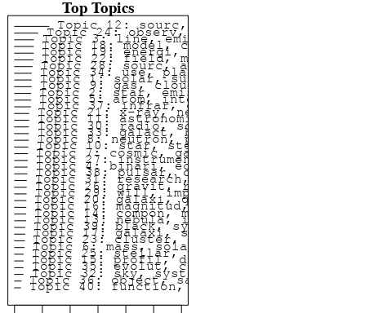

## Topic 1 Top Words:  
## Highest Prob: solar, sun, corona, structur, atmospher, temperatur, larg, data, time, can   
## FREX: sun, corona, solar, atmospher, structur, diamet, correspond, planet, temperatur, amount   
## Lift: corona, solar, sun, amount, correspond, diamet, depend, atmospher, structur, planet   
## Score: corona, solar, sun, planet, atmospher, structur, temperatur, correspond, diamet, size   
## Topic 2 Top Words:  
## Highest Prob: star, emiss, variabl, massiv, pulsat, line, normal, object, use, studi   
## FREX: star, massiv, variabl, emiss, pulsat, normal, class, mani, characterist, averag   
## Lift: massiv, star, normal, variabl, pulsat, class, emiss, characterist, expect, averag   
## Score: star, massiv, pulsat, variabl, emiss, ultraviolet, line, normal, class, characterist   
## Topic 3 Top Words:  
## Highest Prob: line, emiss, x-ray, observ, radiat, emit, spectrum, object, hot, temperatur   
## FREX: line, emit, emiss, hot, plasma, spectrum, five, x-ray, sun, high   
## Lift: emit, hot, plasma, five, line, transit, spectromet, emiss, seen, clear   
## Score: emit, x-ray, line, hot, emiss, plasma, spectrum, spectromet, spectral, five   
## Topic 4 Top Words:  
## Highest Prob: binari, eclips, variat, period, pulsat, effect, observ, due, small, system   
## FREX: binari, eclips, period, pulsat, variat, effect, due, small, exist, system   
## Lift: eclips, binari, pulsat, variat, due, period, auth, small, effect, exist   
## Score: binari, eclips, pulsat, variat, period, effect, due, system, small, x-ray   
## Topic 5 Top Words:  
## Highest Prob: atom, interstellar, observ, rate, hydrogen, carbon, level, rocket, electron, spectral   
## FREX: atom, carbon, interstellar, rate, level, rocket, hydrogen, spectral, electron, ultraviolet   
## Lift: atom, carbon, level, rocket, rate, hydrogen, survey, interstellar, upper, ultraviolet   
## Score: atom, interstellar, carbon, hydrogen, rocket, rate, ultraviolet, level, spectral, electron   
## Topic 6 Top Words:  
## Highest Prob: mass, solar, loss, model, constant, effect, abund, evolut, compar, lower   
## FREX: mass, loss, constant, solar, abund, model, hot, still, effect, lower   
## Lift: loss, mass, constant, still, exceed, lower, outer, abund, initi, hot   
## Score: loss, mass, constant, solar, abund, model, still, hot, effect, evolut   
## Topic 7 Top Words:  
## Highest Prob: cosmic, galact, ray, year, time, event, function, total, interact, data   
## FREX: cosmic, ray, galact, event, year, total, interact, past, orbit, function   
## Lift: ray, cosmic, event, galact, past, interact, comparison, total, function, lead   
## Score: ray, cosmic, galact, interact, event, function, year, total, past, galaxi   
## Topic 8 Top Words:  
## Highest Prob: neutron, pulsar, rotat, star, support, observ, stellar, structur, provid, strong   
## FREX: neutron, rotat, pulsar, support, structur, outer, provid, theoret, supernova, strong   
## Lift: support, neutron, rotat, pulsar, outer, accord, remnant, remain, provid, theoret   
## Score: support, neutron, pulsar, rotat, star, stellar, outer, remnant, supernova, accord   
## Topic 9 Top Words:  
## Highest Prob: gas, cloud, abund, temperatur, densiti, line, equilibrium, hydrogen, region, result   
## FREX: cloud, gas, abund, temperatur, equilibrium, hydrogen, densiti, ratio, line, analysi   
## Lift: cloud, gas, equilibrium, abund, lower, ratio, factor, hydrogen, analysi, temperatur   
## Score: cloud, gas, abund, equilibrium, hydrogen, temperatur, ratio, line, densiti, interstellar   
## Topic 10 Top Words:  
## Highest Prob: star, stellar, helium, low, problem, will, matter, observ, mass, shall   
## FREX: helium, low, stellar, problem, matter, shall, will, properti, star, valu   
## Lift: helium, low, problem, shall, properti, matter, stellar, final, contribut, basi   
## Score: helium, star, stellar, problem, low, matter, hydrogen, mass, shall, will   
## Topic 11 Top Words:  
## Highest Prob: astronomi, astronom, way, observatori, one, first, earli, mani, use, made   
## FREX: astronomi, astronom, way, observatori, earli, centuri, work, univers, mani, attempt   
## Lift: astronomi, astronom, way, observatori, centuri, yet, thus, attempt, histori, earli   
## Score: astronomi, astronom, way, observatori, centuri, work, earli, refer, develop, univers   
## Topic 12 Top Words:  
## Highest Prob: sourc, x-ray, observ, uhuru, intens, day, posit, variabl, period, new   
## FREX: sourc, uhuru, x-ray, day, intens, posit, error, variabl, state, locat   
## Lift: uhuru, day, sourc, posit, x-ray, locat, error, intens, cyg, state   
## Score: x-ray, uhuru, sourc, day, cyg, intens, variabl, puls, posit, kev   
## Topic 13 Top Words:  
## Highest Prob: nebula, ioniz, radiat, particl, requir, signific, use, natur, spiral, observ   
## FREX: ioniz, nebula, particl, requir, spiral, radiat, planetari, signific, natur, describ   
## Lift: ioniz, nebula, particl, planetari, spiral, requir, class, long, describ, signific   
## Score: ioniz, nebula, spiral, particl, planetari, radiat, galact, signific, requir, distanc   
## Topic 14 Top Words:  
## Highest Prob: compon, map, measur, radio, densiti, emiss, two, band, nebula, region   
## FREX: compon, map, band, measur, method, follow, basic, higher, radio, extend   
## Lift: map, compon, basic, band, method, extend, conclud, higher, vari, maximum   
## Score: map, compon, band, radio, basic, nebula, method, perhap, extend, flux   
## Topic 15 Top Words:  
## Highest Prob: profil, diffus, scale, differ, present, possibl, motion, relationship, studi, case   
## FREX: profil, diffus, scale, motion, relationship, differ, reason, case, although, conclus   
## Lift: profil, relationship, motion, diffus, scale, reason, earlier, conclus, differ, although   
## Score: profil, relationship, scale, diffus, motion, differ, reason, conclus, constant, case   
## Topic 16 Top Words:  
## Highest Prob: magnitud, red, appar, hypothesi, effect, luminos, correct, absorpt, one, due   
## FREX: red, magnitud, appar, hypothesi, correct, absorpt, describ, consid, effect, appli   
## Lift: red, hypothesi, magnitud, appar, correct, appli, linear, color, conclus, five   
## Score: red, hypothesi, appar, magnitud, correct, absorpt, luminos, effect, distanc, color   
## Topic 17 Top Words:  
## Highest Prob: galaxi, star, format, interstellar, materi, medium, distanc, model, place, field   
## FREX: format, galaxi, interstellar, materi, medium, minus, place, distanc, plus, interact   
## Lift: format, materi, medium, interstellar, believ, minus, galaxi, plus, place, interact   
## Score: format, galaxi, interstellar, star, materi, plus, minus, medium, distanc, interact   
## Topic 18 Top Words:  
## Highest Prob: model, calcul, present, repres, rate, occur, process, solar, continu, result   
## FREX: calcul, model, repres, occur, rate, continu, process, paramet, present, interact   
## Lift: repres, calcul, model, continu, occur, involv, rate, propos, paramet, rapid   
## Score: repres, model, calcul, rate, continu, occur, interact, solar, process, neutron   
## Topic 19 Top Words:  
## Highest Prob: energi, rang, spectra, composit, nuclei, electron, measur, spectrum, cosmic, element   
## FREX: energi, composit, nuclei, spectra, rang, element, electron, spectrum, spectral, cosmic   
## Lift: composit, nuclei, energi, detector, element, spectra, electron, rang, discov, last   
## Score: composit, energi, nuclei, cosmic, spectra, electron, element, spectrum, rang, spectral   
## Topic 20 Top Words:  
## Highest Prob: galaxi, quasar, object, associ, result, evid, size, present, seen, will   
## FREX: quasar, galaxi, size, associ, seen, relationship, evid, object, final, see   
## Lift: quasar, galaxi, size, relationship, associ, final, seen, select, examin, see   
## Score: quasar, galaxi, size, relationship, associ, evid, nuclei, see, object, final   
## Topic 21 Top Words:  
## Highest Prob: x-ray, nebula, crab, supernova, sourc, pulsar, pulsat, puls, radio, remnant   
## FREX: crab, nebula, supernova, remnant, x-ray, pulsat, puls, pulsar, intens, plus   
## Lift: crab, remnant, nebula, supernova, plus, pulsat, minus, kev, puls, along   
## Score: crab, nebula, x-ray, pulsat, pulsar, remnant, supernova, puls, plus, radio   
## Topic 22 Top Words:  
## Highest Prob: field, magnet, observ, region, surfac, solar, smaller, may, effect, produc   
## FREX: magnet, field, smaller, surfac, region, plasma, presenc, local, activ, mechan   
## Lift: smaller, magnet, field, local, plasma, presenc, surfac, activ, higher, probabl   
## Score: magnet, field, smaller, plasma, solar, surfac, region, effect, earth, local   
## Topic 23 Top Words:  
## Highest Prob: cluster, distribut, galaxi, veloc, mass, observ, give, rang, present, group   
## FREX: cluster, distribut, veloc, galaxi, give, medium, group, appli, analysi, minus   
## Lift: cluster, veloc, distribut, appli, minus, fraction, medium, plus, give, group   
## Score: cluster, distribut, veloc, galaxi, mass, minus, plus, group, spiral, appli   
## Topic 24 Top Words:  
## Highest Prob: observ, absorpt, jupit, line, atmospher, wavelength, temperatur, ultraviolet, spectra, orbit   
## FREX: absorpt, jupit, ultraviolet, wavelength, atmospher, alpha, line, orbit, spectra, spectromet   
## Lift: jupit, absorpt, alpha, ultraviolet, wavelength, preliminari, spectromet, combin, atmospher, satellit   
## Score: jupit, absorpt, ultraviolet, wavelength, alpha, line, atmospher, spectromet, observatori, spectra   
## Topic 25 Top Words:  
## Highest Prob: stellar, theori, astrophys, studi, definit, develop, star, interest, theoret, subject   
## FREX: astrophys, theori, definit, develop, stellar, interest, subject, theoret, great, astronom   
## Lift: definit, astrophys, theori, subject, centuri, taken, interest, develop, theoret, great   
## Score: definit, astrophys, theori, stellar, develop, centuri, interest, astronom, subject, element   
## Topic 26 Top Words:  
## Highest Prob: gravit, radiat, wave, sourc, equat, small, astrophys, field, describ, puls   
## FREX: gravit, wave, equat, radiat, astrophys, describ, various, linear, detector, particl   
## Lift: gravit, wave, equat, linear, detector, various, astrophys, describ, find, radiat   
## Score: gravit, wave, astrophys, equat, radiat, puls, detector, linear, frequenc, particl   
## Topic 27 Top Words:  
## Highest Prob: instrument, establish, observ, flux, can, limit, radiat, featur, upper, possibl   
## FREX: establish, instrument, limit, upper, featur, flux, can, detail, background, resolut   
## Lift: establish, instrument, upper, sensit, limit, featur, resolut, set, flux, micron   
## Score: establish, instrument, flux, micron, upper, resolut, featur, background, sensit, radiat   
## Topic 28 Top Words:  
## Highest Prob: sourc, arc, observ, flux, radio, time, two, appar, second, can   
## FREX: arc, appar, flux, second, frequenc, chang, two, curv, separ, time   
## Lift: arc, appar, frequenc, second, chang, agre, curv, angular, separ, flux   
## Score: arc, radio, flux, appar, frequenc, curv, veloc, second, sourc, chang   
## Topic 29 Top Words:  
## Highest Prob: will, import, progress, discuss, interest, matter, consider, discoveri, order, interstellar   
## FREX: import, progress, will, discoveri, interest, consider, expect, well, order, question   
## Lift: progress, import, view, will, approach, consider, discoveri, expect, interest, clear   
## Score: progress, will, import, interest, discoveri, matter, expect, paper, question, view   
## Topic 30 Top Words:  
## Highest Prob: radio, sourc, x-ray, detect, search, emiss, power, cygnus, may, luminos   
## FREX: radio, search, detect, power, cygnus, sourc, x-ray, center, survey, emiss   
## Lift: search, radio, cygnus, power, sensit, survey, center, detect, exceed, weak   
## Score: search, radio, x-ray, cygnus, sourc, power, center, detect, survey, emiss   
## Topic 31 Top Words:  
## Highest Prob: research, space, will, surfac, near, major, earth, present, problem, seem   
## FREX: research, space, major, earth, will, problem, seem, basic, near, surfac   
## Lift: research, space, major, basic, ten, decad, past, understand, problem, earth   
## Score: research, space, basic, will, major, earth, problem, planet, surfac, develop   
## Topic 32 Top Words:  
## Highest Prob: sky, system, direct, structur, refer, observ, first, rotat, general, studi   
## FREX: sky, direct, refer, group, system, structur, first, motion, develop, spiral   
## Lift: sky, extens, direct, refer, group, visual, exampl, test, select, led   
## Score: sky, refer, system, spiral, rotat, group, direct, work, galact, test   
## Topic 33 Top Words:  
## Highest Prob: galact, background, excess, region, distribut, x-ray, observ, present, possibl, diffus   
## FREX: background, excess, galact, region, distribut, diffus, center, auth, origin, paramet   
## Lift: excess, background, galact, auth, center, togeth, paramet, exceed, diffus, consid   
## Score: excess, galact, background, center, region, x-ray, distribut, auth, diffus, rocket   
## Topic 34 Top Words:  
## Highest Prob: use, planet, one, demonstr, obtain, studi, system, planetari, two, result   
## FREX: planet, demonstr, planetari, ratio, obtain, error, earth, averag, basi, mean   
## Lift: demonstr, planet, planetari, basi, inform, essenti, error, ratio, averag, extrem   
## Score: demonstr, planet, planetari, ratio, earth, system, error, averag, obtain, valu   
## Topic 35 Top Words:  
## Highest Prob: evolut, convect, close, stellar, radius, base, compon, rate, like, surfac   
## FREX: convect, evolut, close, radius, base, stellar, like, rate, main, compon   
## Lift: convect, evolut, close, radius, like, main, base, phase, larger, rate   
## Score: convect, evolut, radius, close, stellar, base, rate, compon, mass, theori   
## Topic 36 Top Words:  
## Highest Prob: object, sampl, distanc, statist, valu, point, interpret, given, number, approxim   
## FREX: sampl, object, statist, distanc, valu, interpret, point, given, approxim, number   
## Lift: sampl, statist, object, distanc, list, interpret, valu, constant, contribut, must   
## Score: sampl, object, distanc, statist, valu, radio, constant, interpret, point, number   
## Topic 37 Top Words:  
## Highest Prob: infrar, observ, variat, type, review, show, micron, period, data, emiss   
## FREX: infrar, review, type, micron, variat, correl, period, show, variabl, least   
## Lift: review, infrar, micron, type, cyg, correl, color, variat, least, visibl   
## Score: infrar, review, micron, type, cyg, variat, correl, period, color, spectral   
## Topic 38 Top Words:  
## Highest Prob: pulsar, optic, identif, puls, star, possibl, allow, mass, make, light   
## FREX: identif, optic, pulsar, allow, puls, light, make, supernova, frequenc, phase   
## Lift: allow, identif, optic, pulsar, puls, make, supernova, phase, light, frequenc   
## Score: pulsar, allow, optic, puls, identif, neutron, supernova, frequenc, mass, make   
## Topic 39 Top Words:  
## Highest Prob: black, system, energi, disk, star, stellar, averag, contain, sourc, may   
## FREX: black, system, disk, energi, averag, contain, carbon, certain, around, condit   
## Lift: black, disk, system, condit, averag, carbon, contain, energi, come, certain   
## Score: black, disk, energi, system, carbon, star, spiral, stellar, neutron, cyg   
## Topic 40 Top Words:  
## Highest Prob: function, luminos, iii, estim, appear, predict, number, use, indic, signific   
## FREX: function, iii, luminos, estim, predict, appear, number, indic, signific, use   
## Lift: iii, function, predict, estim, luminos, appear, local, number, indic, agreement   
## Score: iii, function, luminos, predict, estim, appear, number, signific, indic, hydrogen   
## [1] "The outer solar corona as observed from Skylab - Preliminary results The white-light coronagraph experiment has made frequent, periodic observations of the solar corona from 1.5 to 6.0 solar radii during the Skylab mission, and these observations will permit the determination of the three-dimensional extent of coronal forms. There are several time scales on which visual changes in coronal structures occur, ranging from approximately one-half rotation to less than hours. A number of events corresponding to the shortest time scale - coronal transients - cause major restructuring of the corona."   
## [2] "The outer solar corona as observed from Skylab - Preliminary results The white-light coronagraph experiment has made frequent, periodic observations of the solar corona from 1.5 to 6.0 solar radii during the Skylab mission, and these observations will permit the determination of the three-dimensional extent of coronal forms. There are several time scales on which visual changes in coronal structures occur, ranging from approximately one-half rotation to less than hours. A number of events corresponding to the shortest time scale - coronal transients - cause major restructuring of the corona."   
## [3] "Conductive heating of the solar wind, ii- the inner corona Coupling between solar wind and exosphere - conductive heating of solar wind and inner corona"   
## [4] "The temperature gradient in the solar nebula. The available compositional data on planets and satellites can be used to place stringent limits on the thermal environment in the solar nebula. The densities of the terrestrial planets, Ceres and Vesta, the Galilean satellites, and Titan; the atmospheric compositions of several of these bodies; and geochemical and geophysical data on the earth combine to define a strong dependence of formation temperature on heliocentric distance. The pressure and temperature dependences of the condensation process are separable in the sense that the variation of the deduced formation temperatures with heliocentric distance is insensitive to even very diverse assumptions regarding the pressure profile in the nebula. It is impossible to reconcile the available compositional data with any model in which the formation temperatures of these bodies are determined by radiative equilibrium with the sun, regardless of the sun's luminosity. Rather, the data support Cameron's hypothesis of a dense, convective solar nebula, opaque to solar radiation, with an adiabatic temperature-pressure profile."  
## [5] "The temperature gradient in the solar nebula. The available compositional data on planets and satellites can be used to place stringent limits on the thermal environment in the solar nebula. The densities of the terrestrial planets, Ceres and Vesta, the Galilean satellites, and Titan; the atmospheric compositions of several of these bodies; and geochemical and geophysical data on the earth combine to define a strong dependence of formation temperature on heliocentric distance. The pressure and temperature dependences of the condensation process are separable in the sense that the variation of the deduced formation temperatures with heliocentric distance is insensitive to even very diverse assumptions regarding the pressure profile in the nebula. It is impossible to reconcile the available compositional data with any model in which the formation temperatures of these bodies are determined by radiative equilibrium with the sun, regardless of the sun's luminosity. Rather, the data support Cameron's hypothesis of a dense, convective solar nebula, opaque to solar radiation, with an adiabatic temperature-pressure profile."

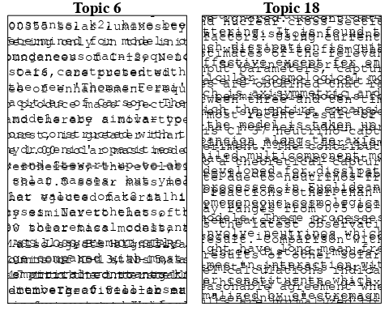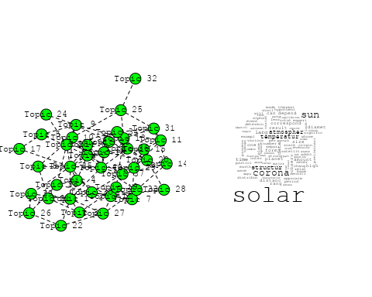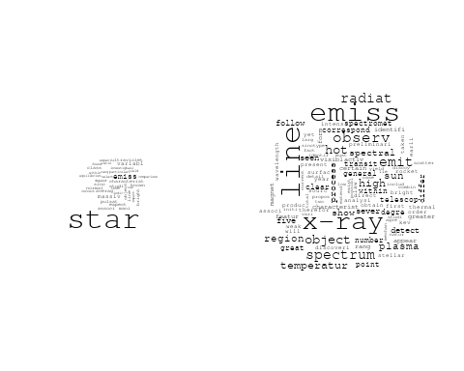

## Warning in wordcloud::wordcloud(words = vocab, freq = vec, max.words =  
## max.words, : interstellar could not be fit on page. It will not be plotted.

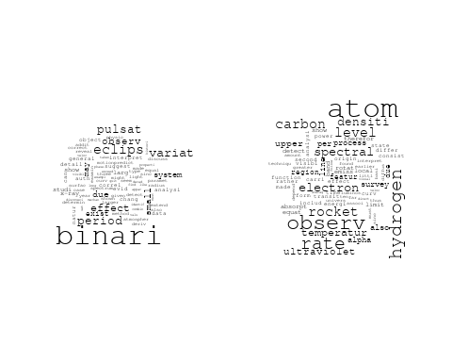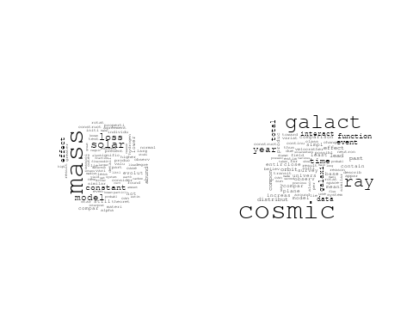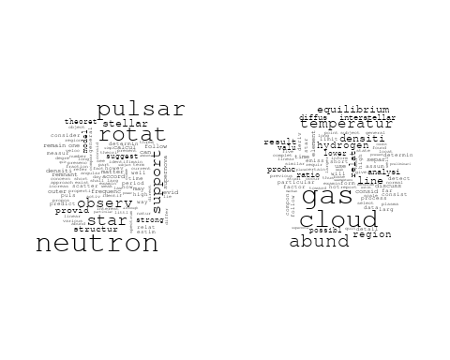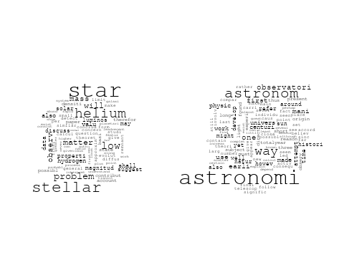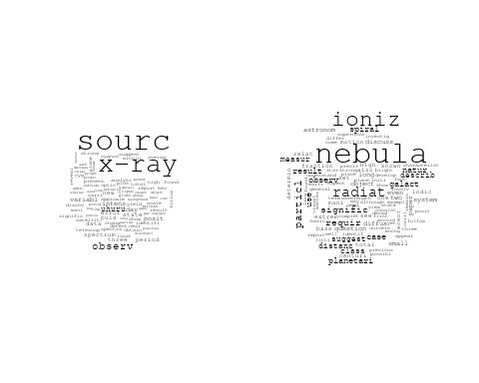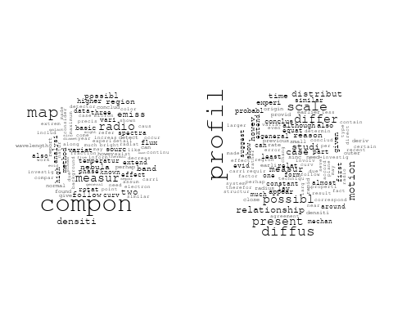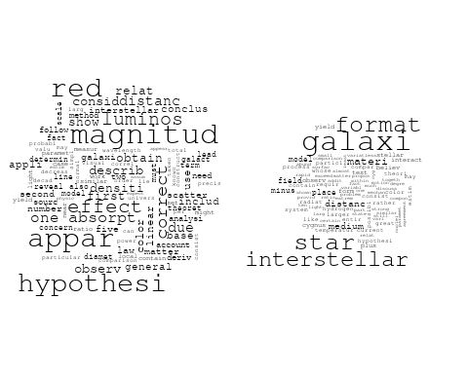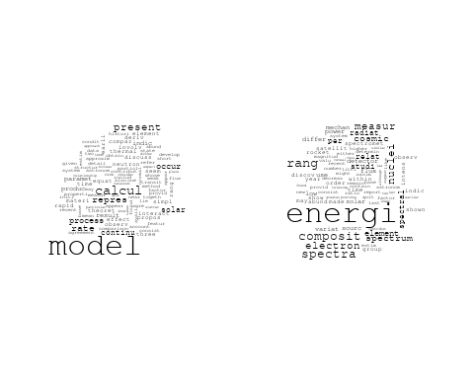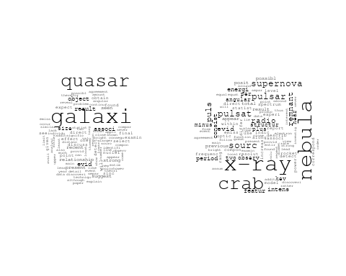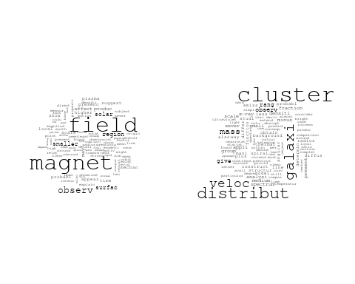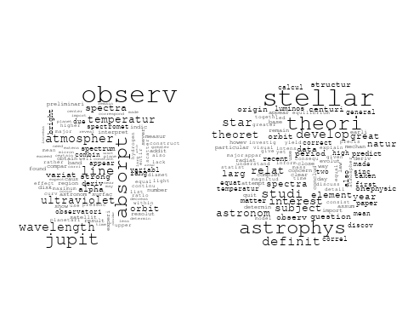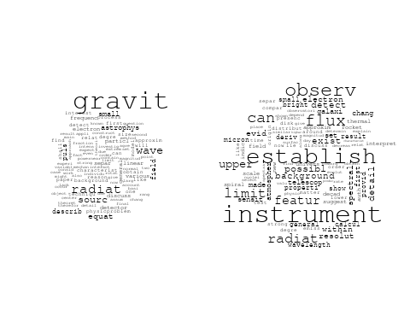

## Warning in wordcloud::wordcloud(words = vocab, freq = vec, max.words =  
## max.words, : flux could not be fit on page. It will not be plotted.

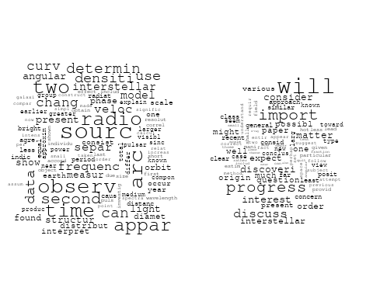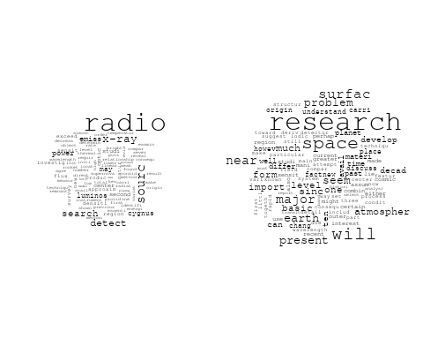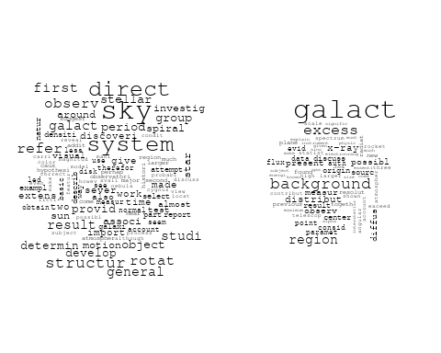

## Warning in wordcloud::wordcloud(words = vocab, freq = vec, max.words =  
## max.words, : demonstr could not be fit on page. It will not be plotted.

## Warning in wordcloud::wordcloud(words = vocab, freq = vec, max.words =  
## max.words, : planetari could not be fit on page. It will not be plotted.

## Warning in wordcloud::wordcloud(words = vocab, freq = vec, max.words =  
## max.words, : system could not be fit on page. It will not be plotted.

## Warning in wordcloud::wordcloud(words = vocab, freq = vec, max.words =  
## max.words, : planet could not be fit on page. It will not be plotted.

## Warning in wordcloud::wordcloud(words = vocab, freq = vec, max.words =  
## max.words, : studi could not be fit on page. It will not be plotted.

