AU topic models

Charlie J. Gomez, Harshvardhan Singh

2023-08-29

library('stm')

## stm v1.3.6 successfully loaded. See ?stm for help.   
## Papers, resources, and other materials at structuraltopicmodel.com

library(dplyr)

##   
## Attaching package: 'dplyr'

## The following objects are masked from 'package:stats':  
##   
## filter, lag

## The following objects are masked from 'package:base':  
##   
## intersect, setdiff, setequal, union

library(stringr)  
library(wordcloud)

## Loading required package: RColorBrewer

#Read csv file  
data = read.csv("preprocessed_data_Jul14.csv")  
  
##Topic generation for AU (in collaboration) publications  
  
data_collab <- data[data[["AU"]] != 0,]  
  
# Save the original title data for future use  
data_collab$original_concatenated_title_abstract <- data_collab$concatenated_title_abstract  
  
#pre-processing the titles using textProcessor from the stm package  
processed_text <- textProcessor(data_collab$concatenated_title_abstract, metadata = data_collab)

## Building corpus...   
## Converting to Lower Case...   
## Removing punctuation...   
## Removing stopwords...   
## Removing numbers...   
## Stemming...   
## Creating Output...

# Further prepare the data by removing low-frequency terms  
out_text <- prepDocuments(processed_text$documents, processed_text$vocab, processed_text$meta)

## Removing 2131 of 9442 terms (2131 of 215077 tokens) due to frequency   
## Your corpus now has 2590 documents, 7311 terms and 212946 tokens.

docs_text <- out_text$documents  
vocab_text <- out_text$vocab  
meta_text <- out_text$meta  
  
  
#Prepare data  
plotRemoved(processed_text$documents, lower.thresh = seq(1, 200, by = 100))

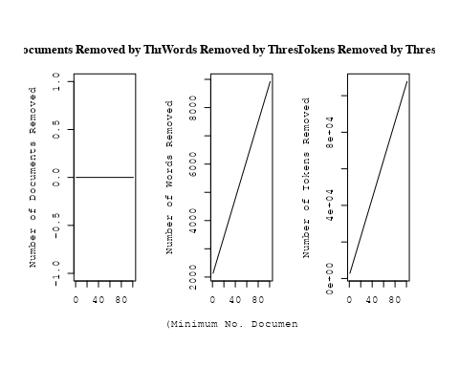

out_text <- prepDocuments(processed_text$documents, processed_text$vocab, processed_text$meta, lower.thresh = 8)

## Removing 7011 of 9442 terms (18830 of 215077 tokens) due to frequency   
## Your corpus now has 2590 documents, 2431 terms and 196247 tokens.

str(out_text$meta)

## 'data.frame': 2590 obs. of 39 variables:  
## $ concept_id : chr "https://openalex.org/C1276947" "https://openalex.org/C1276947" "https://openalex.org/C44870925" "https://openalex.org/C44870925" ...  
## $ work_id : chr "https://openalex.org/W3100822581" "https://openalex.org/W3140362863" "https://openalex.org/W2019918353" "https://openalex.org/W2089705336" ...  
## $ publication_year : int 2007 2021 1998 2001 2008 1999 2005 2001 1998 2014 ...  
## $ title : chr "Revealing Substructure in the Galactic Halo - The SEKBO RR Lyrae Survey" "Evidence for an intermediate-mass black hole from a gravitationally lensed gamma-ray burst" "The Nature of Bilateral Supernova Remnants" "NEW CLASS II METHANOL MASERS IN W3(OH)" ...  
## $ paperabstract : chr "We present a search for RR Lyrae variable stars from archival observations of the Southern Edgeworth-Kuiper Bel"| __truncated__ "If gamma-ray bursts are at cosmological distances, they must be gravitationally lensed occasionally [1, 2]. The"| __truncated__ "We present high-resolution radio images at 1.4 GHz of two Galactic supernova remnants (SNRs), G003.8–00.3 (form"| __truncated__ "We report interferometric observations of nine class II methanol maser candidate lines toward W3(OH). Narrow ma"| __truncated__ ...  
## $ country : chr "AU AU AU AU" "AU AU AU AU" "AU AU AU AU" "AU US AU US" ...  
## $ year_concept : chr "2007+https://openalex.org/C1276947" "2021+https://openalex.org/C1276947" "1998+https://openalex.org/C44870925" "2001+https://openalex.org/C44870925" ...  
## $ concatenated_title_abstract : chr "Revealing Substructure in the Galactic Halo - The SEKBO RR Lyrae Survey We present a search for RR Lyrae variab"| __truncated__ "Evidence for an intermediate-mass black hole from a gravitationally lensed gamma-ray burst If gamma-ray bursts "| __truncated__ "The Nature of Bilateral Supernova Remnants We present high-resolution radio images at 1.4 GHz of two Galactic s"| __truncated__ "NEW CLASS II METHANOL MASERS IN W3(OH) We report interferometric observations of nine class II methanol maser c"| __truncated__ ...  
## $ US : num 0 0 0 50 0 ...  
## $ IN : num 0 0 0 0 0 0 0 0 0 0 ...  
## $ DE : num 0 0 0 0 0 0 50 0 0 0 ...  
## $ CH : num 0 0 0 0 0 0 0 0 0 0 ...  
## $ GB : num 0 0 0 0 0 0 0 0 0 0 ...  
## $ CN : num 0 0 0 0 0 0 0 0 0 0 ...  
## $ FR : num 0 0 0 0 0 0 0 0 0 0 ...  
## $ IT : num 0 0 0 0 0 0 0 0 0 0 ...  
## $ RU : num 0 0 0 0 0 0 0 0 0 0 ...  
## $ CA : num 0 0 0 0 0 0 0 0 0 0 ...  
## $ NL : num 0 0 0 0 0 0 0 0 0 0 ...  
## $ AU : num 100 100 100 50 100 ...  
## $ JP : num 0 0 0 0 0 0 0 0 0 0 ...  
## $ ES : num 0 0 0 0 0 0 0 0 0 0 ...  
## $ IL : num 0 0 0 0 0 0 0 0 0 0 ...  
## $ Americas : num 0 0 0 0 0 0 0 0 0 0 ...  
## $ Europe : num 0 0 0 0 0 0 0 0 0 0 ...  
## $ Africa : num 0 0 0 0 0 0 0 0 0 0 ...  
## $ AsiaAndOceania : num 0 0 0 0 0 0 0 0 0 0 ...  
## $ pub_interval_2020_2022 : int 0 1 0 0 0 0 0 0 0 0 ...  
## $ pub_interval_2015_2019 : int 0 0 0 0 0 0 0 0 0 0 ...  
## $ pub_interval_2010_2014 : int 0 0 0 0 0 0 0 0 0 1 ...  
## $ pub_interval_2005_2009 : int 1 0 0 0 1 0 1 0 0 0 ...  
## $ pub_interval_2000_2004 : int 0 0 0 1 0 0 0 1 0 0 ...  
## $ pub_interval_1995_1999 : int 0 0 1 0 0 1 0 0 1 0 ...  
## $ pub_interval_1985_1994 : int 0 0 0 0 0 0 0 0 0 0 ...  
## $ pub_interval_1975_1984 : int 0 0 0 0 0 0 0 0 0 0 ...  
## $ pub_interval_1965_1974 : int 0 0 0 0 0 0 0 0 0 0 ...  
## $ pub_interval_1900_1964 : int 0 0 0 0 0 0 0 0 0 0 ...  
## $ pub_interval_1824_1899 : int 0 0 0 0 0 0 0 0 0 0 ...  
## $ original_concatenated_title_abstract: chr "Revealing Substructure in the Galactic Halo - The SEKBO RR Lyrae Survey We present a search for RR Lyrae variab"| __truncated__ "Evidence for an intermediate-mass black hole from a gravitationally lensed gamma-ray burst If gamma-ray bursts "| __truncated__ "The Nature of Bilateral Supernova Remnants We present high-resolution radio images at 1.4 GHz of two Galactic s"| __truncated__ "NEW CLASS II METHANOL MASERS IN W3(OH) We report interferometric observations of nine class II methanol maser c"| __truncated__ ...

# Initialize an empty formula string  
prevalence_formula_str <- "~"  
  
# Define the publication intervals  
pub_intervals <- c("pub_interval_2020_2022", "pub_interval_2015_2019", "pub_interval_2010_2014",   
 "pub_interval_2005_2009", "pub_interval_2000_2004", "pub_interval_1995_1999",  
 "pub_interval_1985_1994", "pub_interval_1975_1984", "pub_interval_1965_1974",  
 "pub_interval_1900_1964", "pub_interval_1824_1899")  
  
# Add each publication interval to the formula string  
for (interval in pub_intervals) {  
 # add an if statement to handle the first addition (without '+')  
 if (prevalence_formula_str == "~") {  
 prevalence_formula_str <- paste(prevalence_formula_str, interval)  
 } else {  
 prevalence_formula_str <- paste(prevalence_formula_str, "+", interval)  
 }  
}  
  
  
# Convert the string to a formula  
prevalence_formula <- as.formula(prevalence_formula_str)  
print(prevalence_formula)

## ~pub_interval_2020_2022 + pub_interval_2015_2019 + pub_interval_2010_2014 +   
## pub_interval_2005_2009 + pub_interval_2000_2004 + pub_interval_1995_1999 +   
## pub_interval_1985_1994 + pub_interval_1975_1984 + pub_interval_1965_1974 +   
## pub_interval_1900_1964 + pub_interval_1824_1899

# Run STM model  
Research_topics <- stm(documents = out_text$documents,   
 vocab = out_text$vocab,   
 K = 44,   
 prevalence = prevalence_formula,   
 data = out_text$meta,   
 init.type = "Spectral",  
 max.em.its = 1000,  
 gamma.prior = 'L1')

## Beginning Spectral Initialization   
## Calculating the gram matrix...  
## Finding anchor words...  
## ............................................  
## Recovering initialization...  
## ........................  
## Initialization complete.  
## .......................................................................................................  
## Completed E-Step (3 seconds).   
## Completed M-Step.   
## Completing Iteration 1 (approx. per word bound = -6.419)   
## .......................................................................................................  
## Completed E-Step (2 seconds).   
## Completed M-Step.   
## Completing Iteration 2 (approx. per word bound = -6.156, relative change = 4.094e-02)   
## .......................................................................................................  
## Completed E-Step (2 seconds).   
## Completed M-Step.   
## Completing Iteration 3 (approx. per word bound = -6.095, relative change = 9.954e-03)   
## .......................................................................................................  
## Completed E-Step (2 seconds).   
## Completed M-Step.   
## Completing Iteration 4 (approx. per word bound = -6.071, relative change = 3.924e-03)   
## .......................................................................................................  
## Completed E-Step (2 seconds).   
## Completed M-Step.   
## Completing Iteration 5 (approx. per word bound = -6.059, relative change = 1.993e-03)   
## Topic 1: star, galaxi, format, rate, form   
## Topic 2: radio, galaxi, burst, sourc, host   
## Topic 3: galact, plane, survey, catalogu, region   
## Topic 4: pulsar, time, observ, psr, radio   
## Topic 5: dark, halo, dwarf, matter, format   
## Topic 6: sourc, radio, survey, ghz, compact   
## Topic 7: survey, sky, data, per, will   
## Topic 8: distanc, hubbl, use, observ, space   
## Topic 9: remnant, emiss, radio, supernova, region   
## Topic 10: galaxi, cluster, gcs, globular, system   
## Topic 11: nebula, jet, wind, shock, pulsar   
## Topic 12: star, cluster, ngc, abund, globular   
## Topic 13: galaxi, redshift, survey, sampl, absorpt   
## Topic 14: radio, will, jet, astronomi, univers   
## Topic 15: halo, simul, model, dark, matter   
## Topic 16: maser, methanol, emiss, detect, sourc   
## Topic 17: quasar, microlens, region, reioniz, observ   
## Topic 18: binari, star, mass, system, dwarf   
## Topic 19: oscil, star, amplitud, sequenc, period   
## Topic 20: pulsar, model, observ, motion, distribut   
## Topic 21: line, model, densiti, use, region   
## Topic 22: x-ray, burst, observ, emiss, time   
## Topic 23: supernova, neutrino, produc, solar, sourc   
## Topic 24: gravit, wave, detect, background, observ   
## Topic 25: array, observ, data, use, frequenc   
## Topic 26: planet, orbit, veloc, star, system   
## Topic 27: magnet, field, star, rotat, observ   
## Topic 28: cluster, galaxi, gas, relic, region   
## Topic 29: distribut, flare, energi, solar, emiss   
## Topic 30: star, model, ratio, mass, supernova   
## Topic 31: galaxi, rotat, model, profil, bar   
## Topic 32: mass, star, stellar, cluster, model   
## Topic 33: polar, field, magnet, diffus, turbul   
## Topic 34: galaxi, group, mass, gas, luminos   
## Topic 35: stream, veloc, star, cloud, magellan   
## Topic 36: light, event, curv, periastron, observ   
## Topic 37: puls, pulsar, giant, emiss, profil   
## Topic 38: galaxi, dwarf, group, fornax, sampl   
## Topic 39: star, observ, imag, use, pulsat   
## Topic 40: galaxi, dust, emiss, radio, optic   
## Topic 41: disc, accret, can, use, extend   
## Topic 42: glitch, pulsar, neutron, time, star   
## Topic 43: hole, black, mass, accret, jet   
## Topic 44: object, sourc, percent, observ, various   
## .......................................................................................................  
## Completed E-Step (2 seconds).   
## Completed M-Step.   
## Completing Iteration 6 (approx. per word bound = -6.052, relative change = 1.184e-03)   
## .......................................................................................................  
## Completed E-Step (2 seconds).   
## Completed M-Step.   
## Completing Iteration 7 (approx. per word bound = -6.047, relative change = 7.859e-04)   
## .......................................................................................................  
## Completed E-Step (2 seconds).   
## Completed M-Step.   
## Completing Iteration 8 (approx. per word bound = -6.044, relative change = 5.378e-04)   
## .......................................................................................................  
## Completed E-Step (2 seconds).   
## Completed M-Step.   
## Completing Iteration 9 (approx. per word bound = -6.041, relative change = 4.235e-04)   
## .......................................................................................................  
## Completed E-Step (2 seconds).   
## Completed M-Step.   
## Completing Iteration 10 (approx. per word bound = -6.039, relative change = 3.597e-04)   
## Topic 1: star, galaxi, format, rate, form   
## Topic 2: radio, galaxi, sourc, burst, host   
## Topic 3: galact, survey, plane, catalogu, data   
## Topic 4: pulsar, time, observ, psr, radio   
## Topic 5: format, star, halo, dwarf, can   
## Topic 6: sourc, radio, survey, ghz, compact   
## Topic 7: survey, sky, galaxi, data, per   
## Topic 8: distanc, hubbl, use, space, measur   
## Topic 9: remnant, emiss, radio, supernova, region   
## Topic 10: galaxi, cluster, gcs, globular, system   
## Topic 11: jet, nebula, wind, shock, pulsar   
## Topic 12: star, cluster, abund, ngc, globular   
## Topic 13: galaxi, redshift, survey, sampl, absorpt   
## Topic 14: will, radio, review, astronomi, provid   
## Topic 15: halo, simul, dark, matter, model   
## Topic 16: maser, methanol, emiss, detect, sourc   
## Topic 17: quasar, reioniz, microlens, region, observ   
## Topic 18: binari, star, system, mass, dwarf   
## Topic 19: oscil, star, sequenc, amplitud, period   
## Topic 20: pulsar, model, observ, motion, distribut   
## Topic 21: line, model, use, region, densiti   
## Topic 22: x-ray, burst, observ, emiss, sourc   
## Topic 23: supernova, neutrino, produc, solar, cosmic   
## Topic 24: gravit, wave, detect, background, observ   
## Topic 25: array, observ, data, use, frequenc   
## Topic 26: planet, orbit, star, veloc, system   
## Topic 27: magnet, field, star, rotat, observ   
## Topic 28: cluster, galaxi, relic, region, field   
## Topic 29: flare, distribut, emiss, energi, solar   
## Topic 30: star, model, ratio, mass, supernova   
## Topic 31: galaxi, rotat, profil, model, mass   
## Topic 32: mass, star, stellar, cluster, model   
## Topic 33: polar, field, magnet, turbul, diffus   
## Topic 34: galaxi, group, mass, gas, luminos   
## Topic 35: stream, cloud, magellan, veloc, star   
## Topic 36: light, curv, event, observ, periastron   
## Topic 37: puls, pulsar, emiss, giant, profil   
## Topic 38: galaxi, dwarf, group, fornax, sampl   
## Topic 39: star, observ, imag, pulsat, use   
## Topic 40: galaxi, dust, emiss, radio, optic   
## Topic 41: disc, accret, can, differ, extend   
## Topic 42: glitch, pulsar, time, neutron, star   
## Topic 43: hole, black, mass, accret, jet   
## Topic 44: object, catalog, observ, various, result   
## .......................................................................................................  
## Completed E-Step (2 seconds).   
## Completed M-Step.   
## Completing Iteration 11 (approx. per word bound = -6.037, relative change = 3.254e-04)   
## .......................................................................................................  
## Completed E-Step (2 seconds).   
## Completed M-Step.   
## Completing Iteration 12 (approx. per word bound = -6.036, relative change = 2.845e-04)   
## .......................................................................................................  
## Completed E-Step (2 seconds).   
## Completed M-Step.   
## Completing Iteration 13 (approx. per word bound = -6.034, relative change = 2.340e-04)   
## .......................................................................................................  
## Completed E-Step (2 seconds).   
## Completed M-Step.   
## Completing Iteration 14 (approx. per word bound = -6.033, relative change = 2.162e-04)   
## .......................................................................................................  
## Completed E-Step (2 seconds).   
## Completed M-Step.   
## Completing Iteration 15 (approx. per word bound = -6.032, relative change = 2.159e-04)   
## Topic 1: star, galaxi, format, rate, gas   
## Topic 2: radio, galaxi, sourc, burst, host   
## Topic 3: galact, survey, plane, data, catalogu   
## Topic 4: pulsar, time, observ, psr, radio   
## Topic 5: star, format, can, form, dwarf   
## Topic 6: sourc, radio, survey, ghz, compact   
## Topic 7: survey, galaxi, per, sky, cent   
## Topic 8: distanc, hubbl, use, space, measur   
## Topic 9: remnant, radio, emiss, supernova, region   
## Topic 10: galaxi, cluster, gcs, globular, system   
## Topic 11: jet, nebula, wind, shock, pulsar   
## Topic 12: star, cluster, abund, ngc, metal   
## Topic 13: galaxi, redshift, sampl, survey, absorpt   
## Topic 14: will, radio, review, provid, astronomi   
## Topic 15: halo, dark, matter, simul, model   
## Topic 16: maser, methanol, emiss, detect, sourc   
## Topic 17: quasar, reioniz, microlens, observ, sourc   
## Topic 18: binari, star, system, mass, companion   
## Topic 19: oscil, star, amplitud, sequenc, period   
## Topic 20: pulsar, model, observ, motion, distribut   
## Topic 21: line, model, use, region, densiti   
## Topic 22: x-ray, burst, observ, emiss, sourc   
## Topic 23: supernova, neutrino, produc, cosmic, ray   
## Topic 24: gravit, wave, detect, background, observ   
## Topic 25: array, data, observ, use, frequenc   
## Topic 26: planet, orbit, star, veloc, eccentr   
## Topic 27: magnet, field, star, rotat, polar   
## Topic 28: cluster, galaxi, field, relic, find   
## Topic 29: emiss, flare, energi, distribut, solar   
## Topic 30: star, model, ratio, mass, supernova   
## Topic 31: galaxi, rotat, profil, model, kinemat   
## Topic 32: mass, star, stellar, model, cluster   
## Topic 33: polar, field, magnet, turbul, diffus   
## Topic 34: galaxi, mass, group, gas, luminos   
## Topic 35: stream, cloud, magellan, veloc, star   
## Topic 36: light, curv, event, observ, periastron   
## Topic 37: puls, pulsar, emiss, giant, profil   
## Topic 38: galaxi, dwarf, group, fornax, sampl   
## Topic 39: star, observ, imag, pulsat, use   
## Topic 40: galaxi, dust, ngc, emiss, optic   
## Topic 41: disc, accret, can, extend, use   
## Topic 42: glitch, pulsar, time, neutron, star   
## Topic 43: hole, black, mass, accret, jet   
## Topic 44: object, catalog, known, observ, present   
## .......................................................................................................  
## Completed E-Step (2 seconds).   
## Completed M-Step.   
## Completing Iteration 16 (approx. per word bound = -6.030, relative change = 1.904e-04)   
## .......................................................................................................  
## Completed E-Step (2 seconds).   
## Completed M-Step.   
## Completing Iteration 17 (approx. per word bound = -6.029, relative change = 1.691e-04)   
## .......................................................................................................  
## Completed E-Step (2 seconds).   
## Completed M-Step.   
## Completing Iteration 18 (approx. per word bound = -6.028, relative change = 1.468e-04)   
## .......................................................................................................  
## Completed E-Step (2 seconds).   
## Completed M-Step.   
## Completing Iteration 19 (approx. per word bound = -6.028, relative change = 1.351e-04)   
## .......................................................................................................  
## Completed E-Step (2 seconds).   
## Completed M-Step.   
## Completing Iteration 20 (approx. per word bound = -6.027, relative change = 1.270e-04)   
## Topic 1: galaxi, star, format, gas, rate   
## Topic 2: radio, galaxi, sourc, burst, host   
## Topic 3: galact, survey, plane, data, catalogu   
## Topic 4: pulsar, time, observ, psr, radio   
## Topic 5: star, format, can, form, stellar   
## Topic 6: sourc, radio, survey, ghz, compact   
## Topic 7: survey, galaxi, per, redshift, sky   
## Topic 8: distanc, hubbl, space, use, measur   
## Topic 9: remnant, emiss, radio, supernova, region   
## Topic 10: galaxi, cluster, gcs, globular, system   
## Topic 11: jet, nebula, wind, shock, pulsar   
## Topic 12: star, abund, cluster, ngc, metal   
## Topic 13: galaxi, redshift, sampl, absorpt, survey   
## Topic 14: will, radio, review, provid, survey   
## Topic 15: halo, dark, matter, simul, mass   
## Topic 16: maser, methanol, emiss, detect, sourc   
## Topic 17: quasar, reioniz, microlens, observ, sourc   
## Topic 18: binari, star, system, mass, companion   
## Topic 19: oscil, star, period, sequenc, amplitud   
## Topic 20: pulsar, model, observ, motion, distribut   
## Topic 21: line, model, use, region, densiti   
## Topic 22: x-ray, burst, observ, sourc, time   
## Topic 23: supernova, neutrino, produc, cosmic, ray   
## Topic 24: gravit, wave, detect, background, observ   
## Topic 25: array, data, observ, use, frequenc   
## Topic 26: planet, orbit, star, veloc, eccentr   
## Topic 27: magnet, field, star, rotat, polar   
## Topic 28: cluster, galaxi, relic, core, field   
## Topic 29: emiss, flare, energi, distribut, solar   
## Topic 30: star, model, ratio, mass, supernova   
## Topic 31: galaxi, rotat, profil, model, kinemat   
## Topic 32: mass, star, stellar, model, use   
## Topic 33: polar, field, magnet, turbul, diffus   
## Topic 34: galaxi, mass, gas, group, luminos   
## Topic 35: stream, cloud, magellan, star, veloc   
## Topic 36: light, event, curv, observ, periastron   
## Topic 37: puls, pulsar, emiss, giant, profil   
## Topic 38: galaxi, dwarf, group, fornax, sampl   
## Topic 39: star, observ, imag, pulsat, use   
## Topic 40: galaxi, dust, ngc, emiss, optic   
## Topic 41: disc, accret, can, use, extend   
## Topic 42: glitch, pulsar, time, neutron, star   
## Topic 43: hole, black, mass, accret, jet   
## Topic 44: object, catalog, present, known, observ   
## .......................................................................................................  
## Completed E-Step (2 seconds).   
## Completed M-Step.   
## Completing Iteration 21 (approx. per word bound = -6.026, relative change = 1.247e-04)   
## .......................................................................................................  
## Completed E-Step (2 seconds).   
## Completed M-Step.   
## Completing Iteration 22 (approx. per word bound = -6.025, relative change = 1.104e-04)   
## .......................................................................................................  
## Completed E-Step (2 seconds).   
## Completed M-Step.   
## Completing Iteration 23 (approx. per word bound = -6.025, relative change = 1.321e-04)   
## .......................................................................................................  
## Completed E-Step (2 seconds).   
## Completed M-Step.   
## Completing Iteration 24 (approx. per word bound = -6.024, relative change = 1.141e-04)   
## .......................................................................................................  
## Completed E-Step (2 seconds).   
## Completed M-Step.   
## Completing Iteration 25 (approx. per word bound = -6.023, relative change = 1.004e-04)   
## Topic 1: galaxi, star, format, gas, rate   
## Topic 2: radio, galaxi, sourc, burst, host   
## Topic 3: galact, survey, plane, data, region   
## Topic 4: pulsar, time, observ, radio, psr   
## Topic 5: star, format, can, form, stellar   
## Topic 6: sourc, radio, survey, ghz, compact   
## Topic 7: survey, galaxi, per, redshift, cent   
## Topic 8: distanc, hubbl, space, supernova, use   
## Topic 9: remnant, emiss, supernova, radio, region   
## Topic 10: galaxi, cluster, globular, gcs, system   
## Topic 11: jet, nebula, wind, shock, pulsar   
## Topic 12: star, abund, cluster, ngc, metal   
## Topic 13: galaxi, redshift, absorpt, sampl, survey   
## Topic 14: will, radio, review, survey, provid   
## Topic 15: halo, dark, matter, simul, mass   
## Topic 16: maser, methanol, emiss, detect, sourc   
## Topic 17: quasar, reioniz, microlens, sourc, observ   
## Topic 18: binari, star, system, mass, companion   
## Topic 19: oscil, star, variat, period, red   
## Topic 20: pulsar, model, observ, motion, distribut   
## Topic 21: line, model, use, region, emiss   
## Topic 22: x-ray, burst, observ, sourc, time   
## Topic 23: supernova, neutrino, cosmic, ray, produc   
## Topic 24: gravit, wave, detect, background, observ   
## Topic 25: array, data, use, observ, frequenc   
## Topic 26: planet, orbit, star, veloc, eccentr   
## Topic 27: magnet, field, star, rotat, polar   
## Topic 28: cluster, galaxi, core, relic, find   
## Topic 29: emiss, flare, energi, distribut, solar   
## Topic 30: star, model, ratio, mass, supernova   
## Topic 31: galaxi, rotat, profil, model, kinemat   
## Topic 32: mass, star, stellar, model, use   
## Topic 33: polar, field, magnet, turbul, diffus   
## Topic 34: galaxi, mass, gas, group, luminos   
## Topic 35: stream, cloud, magellan, veloc, star   
## Topic 36: light, event, curv, observ, periastron   
## Topic 37: puls, pulsar, emiss, giant, profil   
## Topic 38: galaxi, dwarf, group, fornax, sampl   
## Topic 39: star, observ, imag, pulsat, use   
## Topic 40: galaxi, dust, ngc, emiss, optic   
## Topic 41: disc, accret, can, use, extend   
## Topic 42: glitch, pulsar, time, neutron, star   
## Topic 43: hole, black, mass, accret, supermass   
## Topic 44: object, catalog, select, present, known   
## .......................................................................................................  
## Completed E-Step (2 seconds).   
## Completed M-Step.   
## Completing Iteration 26 (approx. per word bound = -6.023, relative change = 9.138e-05)   
## .......................................................................................................  
## Completed E-Step (2 seconds).   
## Completed M-Step.   
## Completing Iteration 27 (approx. per word bound = -6.022, relative change = 7.809e-05)   
## .......................................................................................................  
## Completed E-Step (2 seconds).   
## Completed M-Step.   
## Completing Iteration 28 (approx. per word bound = -6.022, relative change = 7.795e-05)   
## .......................................................................................................  
## Completed E-Step (2 seconds).   
## Completed M-Step.   
## Completing Iteration 29 (approx. per word bound = -6.022, relative change = 6.139e-05)   
## .......................................................................................................  
## Completed E-Step (2 seconds).   
## Completed M-Step.   
## Completing Iteration 30 (approx. per word bound = -6.021, relative change = 6.213e-05)   
## Topic 1: galaxi, format, star, gas, rate   
## Topic 2: radio, galaxi, sourc, burst, host   
## Topic 3: survey, galact, plane, data, region   
## Topic 4: pulsar, time, observ, radio, psr   
## Topic 5: star, format, can, form, stellar   
## Topic 6: sourc, radio, survey, ghz, compact   
## Topic 7: survey, galaxi, per, redshift, cent   
## Topic 8: distanc, hubbl, supernova, space, use   
## Topic 9: remnant, emiss, supernova, radio, region   
## Topic 10: galaxi, cluster, globular, gcs, system   
## Topic 11: jet, wind, nebula, shock, pulsar   
## Topic 12: star, abund, cluster, ngc, metal   
## Topic 13: galaxi, redshift, absorpt, sampl, survey   
## Topic 14: will, radio, review, survey, provid   
## Topic 15: halo, dark, matter, simul, mass   
## Topic 16: maser, methanol, emiss, detect, sourc   
## Topic 17: quasar, reioniz, microlens, sourc, observ   
## Topic 18: binari, star, system, mass, companion   
## Topic 19: star, oscil, variat, period, red   
## Topic 20: pulsar, model, observ, motion, distribut   
## Topic 21: line, model, use, region, emiss   
## Topic 22: x-ray, burst, observ, sourc, time   
## Topic 23: supernova, neutrino, ray, produc, cosmic   
## Topic 24: gravit, wave, detect, background, observ   
## Topic 25: array, data, use, frequenc, imag   
## Topic 26: planet, orbit, star, eccentr, veloc   
## Topic 27: magnet, field, star, rotat, polar   
## Topic 28: cluster, galaxi, core, relic, find   
## Topic 29: emiss, flare, solar, energi, distribut   
## Topic 30: star, model, ratio, supernova, mass   
## Topic 31: galaxi, rotat, profil, model, kinemat   
## Topic 32: mass, stellar, star, model, use   
## Topic 33: field, polar, magnet, turbul, diffus   
## Topic 34: galaxi, mass, gas, group, luminos   
## Topic 35: stream, cloud, magellan, veloc, star   
## Topic 36: light, curv, event, observ, periastron   
## Topic 37: puls, pulsar, emiss, giant, profil   
## Topic 38: galaxi, dwarf, group, fornax, sampl   
## Topic 39: star, observ, variabl, imag, pulsat   
## Topic 40: galaxi, dust, ngc, emiss, optic   
## Topic 41: disc, accret, can, use, differ   
## Topic 42: glitch, pulsar, time, neutron, star   
## Topic 43: hole, black, mass, accret, supermass   
## Topic 44: object, catalog, select, present, size   
## .......................................................................................................  
## Completed E-Step (2 seconds).   
## Completed M-Step.   
## Completing Iteration 31 (approx. per word bound = -6.021, relative change = 6.042e-05)   
## .......................................................................................................  
## Completed E-Step (2 seconds).   
## Completed M-Step.   
## Completing Iteration 32 (approx. per word bound = -6.020, relative change = 6.053e-05)   
## .......................................................................................................  
## Completed E-Step (2 seconds).   
## Completed M-Step.   
## Completing Iteration 33 (approx. per word bound = -6.020, relative change = 5.189e-05)   
## .......................................................................................................  
## Completed E-Step (2 seconds).   
## Completed M-Step.   
## Completing Iteration 34 (approx. per word bound = -6.020, relative change = 4.826e-05)   
## .......................................................................................................  
## Completed E-Step (2 seconds).   
## Completed M-Step.   
## Completing Iteration 35 (approx. per word bound = -6.019, relative change = 5.232e-05)   
## Topic 1: galaxi, format, star, gas, rate   
## Topic 2: radio, galaxi, sourc, burst, host   
## Topic 3: survey, galact, plane, data, region   
## Topic 4: pulsar, time, observ, radio, psr   
## Topic 5: star, can, format, form, stellar   
## Topic 6: sourc, radio, survey, ghz, compact   
## Topic 7: survey, galaxi, per, redshift, cent   
## Topic 8: distanc, hubbl, supernova, space, measur   
## Topic 9: remnant, emiss, supernova, radio, snr   
## Topic 10: galaxi, cluster, gcs, globular, system   
## Topic 11: jet, wind, nebula, shock, pulsar   
## Topic 12: star, abund, cluster, ngc, metal   
## Topic 13: galaxi, redshift, absorpt, sampl, survey   
## Topic 14: will, radio, review, survey, provid   
## Topic 15: halo, dark, matter, simul, mass   
## Topic 16: maser, methanol, emiss, detect, sourc   
## Topic 17: quasar, reioniz, microlens, sourc, observ   
## Topic 18: binari, star, system, mass, companion   
## Topic 19: star, oscil, variat, period, red   
## Topic 20: pulsar, model, observ, motion, distribut   
## Topic 21: line, model, use, region, emiss   
## Topic 22: x-ray, burst, observ, sourc, time   
## Topic 23: supernova, neutrino, ray, cosmic, produc   
## Topic 24: gravit, wave, detect, background, observ   
## Topic 25: array, data, use, frequenc, imag   
## Topic 26: planet, orbit, star, eccentr, veloc   
## Topic 27: magnet, field, star, rotat, polar   
## Topic 28: cluster, galaxi, core, relic, find   
## Topic 29: emiss, solar, flare, energi, distribut   
## Topic 30: star, model, ratio, supernova, element   
## Topic 31: galaxi, rotat, profil, model, kinemat   
## Topic 32: mass, stellar, star, model, use   
## Topic 33: field, polar, magnet, turbul, diffus   
## Topic 34: galaxi, mass, group, luminos, gas   
## Topic 35: stream, cloud, magellan, veloc, star   
## Topic 36: light, curv, event, observ, periastron   
## Topic 37: puls, pulsar, emiss, giant, profil   
## Topic 38: galaxi, dwarf, group, fornax, sampl   
## Topic 39: star, observ, variabl, imag, pulsat   
## Topic 40: galaxi, dust, ngc, emiss, gas   
## Topic 41: disc, accret, can, use, differ   
## Topic 42: glitch, pulsar, time, neutron, star   
## Topic 43: hole, black, mass, accret, supermass   
## Topic 44: object, catalog, optic, select, satellit   
## .......................................................................................................  
## Completed E-Step (2 seconds).   
## Completed M-Step.   
## Completing Iteration 36 (approx. per word bound = -6.019, relative change = 5.213e-05)   
## .......................................................................................................  
## Completed E-Step (2 seconds).   
## Completed M-Step.   
## Completing Iteration 37 (approx. per word bound = -6.019, relative change = 5.138e-05)   
## .......................................................................................................  
## Completed E-Step (2 seconds).   
## Completed M-Step.   
## Completing Iteration 38 (approx. per word bound = -6.019, relative change = 4.382e-05)   
## .......................................................................................................  
## Completed E-Step (2 seconds).   
## Completed M-Step.   
## Completing Iteration 39 (approx. per word bound = -6.018, relative change = 3.705e-05)   
## .......................................................................................................  
## Completed E-Step (2 seconds).   
## Completed M-Step.   
## Completing Iteration 40 (approx. per word bound = -6.018, relative change = 3.678e-05)   
## Topic 1: galaxi, format, star, gas, rate   
## Topic 2: radio, galaxi, sourc, burst, host   
## Topic 3: survey, galact, plane, data, region   
## Topic 4: pulsar, time, observ, radio, psr   
## Topic 5: star, can, format, form, stellar   
## Topic 6: sourc, radio, survey, ghz, compact   
## Topic 7: survey, galaxi, per, redshift, cent   
## Topic 8: distanc, hubbl, supernova, space, measur   
## Topic 9: remnant, emiss, supernova, radio, snr   
## Topic 10: galaxi, cluster, gcs, globular, system   
## Topic 11: jet, wind, nebula, shock, pulsar   
## Topic 12: star, abund, cluster, ngc, metal   
## Topic 13: galaxi, redshift, absorpt, sampl, survey   
## Topic 14: will, radio, review, survey, provid   
## Topic 15: halo, dark, matter, simul, mass   
## Topic 16: maser, methanol, emiss, detect, sourc   
## Topic 17: quasar, reioniz, microlens, sourc, observ   
## Topic 18: binari, star, system, mass, dwarf   
## Topic 19: star, oscil, variat, period, red   
## Topic 20: pulsar, model, observ, motion, distribut   
## Topic 21: line, use, model, region, emiss   
## Topic 22: x-ray, burst, observ, sourc, time   
## Topic 23: supernova, neutrino, ray, cosmic, energi   
## Topic 24: gravit, wave, detect, background, observ   
## Topic 25: array, data, use, frequenc, imag   
## Topic 26: planet, orbit, star, eccentr, veloc   
## Topic 27: magnet, field, star, rotat, polar   
## Topic 28: cluster, galaxi, core, relic, find   
## Topic 29: emiss, solar, flare, energi, distribut   
## Topic 30: star, model, ratio, supernova, element   
## Topic 31: galaxi, rotat, profil, model, kinemat   
## Topic 32: mass, stellar, star, model, use   
## Topic 33: field, polar, magnet, turbul, diffus   
## Topic 34: galaxi, mass, luminos, group, gas   
## Topic 35: stream, cloud, magellan, veloc, star   
## Topic 36: light, curv, event, observ, periastron   
## Topic 37: puls, pulsar, emiss, giant, profil   
## Topic 38: galaxi, dwarf, group, fornax, sampl   
## Topic 39: star, observ, variabl, imag, pulsat   
## Topic 40: galaxi, dust, ngc, emiss, gas   
## Topic 41: disc, accret, can, use, differ   
## Topic 42: glitch, pulsar, time, neutron, star   
## Topic 43: hole, black, mass, accret, supermass   
## Topic 44: object, optic, select, catalog, satellit   
## .......................................................................................................  
## Completed E-Step (2 seconds).   
## Completed M-Step.   
## Completing Iteration 41 (approx. per word bound = -6.018, relative change = 3.586e-05)   
## .......................................................................................................  
## Completed E-Step (2 seconds).   
## Completed M-Step.   
## Completing Iteration 42 (approx. per word bound = -6.018, relative change = 3.535e-05)   
## .......................................................................................................  
## Completed E-Step (2 seconds).   
## Completed M-Step.   
## Completing Iteration 43 (approx. per word bound = -6.018, relative change = 3.275e-05)   
## .......................................................................................................  
## Completed E-Step (2 seconds).   
## Completed M-Step.   
## Completing Iteration 44 (approx. per word bound = -6.017, relative change = 3.283e-05)   
## .......................................................................................................  
## Completed E-Step (2 seconds).   
## Completed M-Step.   
## Completing Iteration 45 (approx. per word bound = -6.017, relative change = 2.876e-05)   
## Topic 1: galaxi, format, star, gas, rate   
## Topic 2: radio, galaxi, sourc, burst, host   
## Topic 3: survey, galact, plane, data, region   
## Topic 4: pulsar, time, observ, radio, psr   
## Topic 5: star, can, format, form, stellar   
## Topic 6: sourc, radio, survey, ghz, compact   
## Topic 7: survey, galaxi, per, redshift, cent   
## Topic 8: distanc, hubbl, supernova, space, measur   
## Topic 9: remnant, supernova, emiss, radio, snr   
## Topic 10: galaxi, cluster, gcs, globular, system   
## Topic 11: jet, wind, nebula, shock, pulsar   
## Topic 12: star, abund, cluster, ngc, metal   
## Topic 13: galaxi, redshift, absorpt, sampl, survey   
## Topic 14: will, radio, review, survey, provid   
## Topic 15: halo, dark, matter, simul, mass   
## Topic 16: maser, methanol, emiss, detect, sourc   
## Topic 17: quasar, reioniz, microlens, sourc, observ   
## Topic 18: binari, star, system, mass, dwarf   
## Topic 19: variat, star, oscil, period, red   
## Topic 20: pulsar, model, observ, motion, distribut   
## Topic 21: line, use, region, model, emiss   
## Topic 22: x-ray, burst, observ, sourc, time   
## Topic 23: supernova, neutrino, ray, cosmic, energi   
## Topic 24: gravit, wave, detect, background, observ   
## Topic 25: array, data, use, frequenc, imag   
## Topic 26: planet, orbit, eccentr, star, veloc   
## Topic 27: magnet, field, star, rotat, polar   
## Topic 28: cluster, galaxi, core, relic, find   
## Topic 29: emiss, solar, flare, energi, distribut   
## Topic 30: star, model, ratio, element, supernova   
## Topic 31: galaxi, rotat, profil, model, kinemat   
## Topic 32: mass, stellar, star, model, use   
## Topic 33: field, magnet, polar, turbul, diffus   
## Topic 34: galaxi, mass, luminos, group, gas   
## Topic 35: stream, cloud, magellan, veloc, star   
## Topic 36: light, event, curv, periastron, observ   
## Topic 37: puls, pulsar, emiss, giant, profil   
## Topic 38: galaxi, dwarf, group, fornax, sampl   
## Topic 39: star, observ, variabl, imag, pulsat   
## Topic 40: galaxi, dust, ngc, emiss, gas   
## Topic 41: disc, accret, can, use, differ   
## Topic 42: glitch, pulsar, neutron, time, star   
## Topic 43: hole, black, mass, accret, supermass   
## Topic 44: object, optic, select, search, catalog   
## .......................................................................................................  
## Completed E-Step (2 seconds).   
## Completed M-Step.   
## Completing Iteration 46 (approx. per word bound = -6.017, relative change = 2.780e-05)   
## .......................................................................................................  
## Completed E-Step (2 seconds).   
## Completed M-Step.   
## Completing Iteration 47 (approx. per word bound = -6.017, relative change = 3.633e-05)   
## .......................................................................................................  
## Completed E-Step (2 seconds).   
## Completed M-Step.   
## Completing Iteration 48 (approx. per word bound = -6.017, relative change = 3.814e-05)   
## .......................................................................................................  
## Completed E-Step (2 seconds).   
## Completed M-Step.   
## Completing Iteration 49 (approx. per word bound = -6.016, relative change = 3.699e-05)   
## .......................................................................................................  
## Completed E-Step (2 seconds).   
## Completed M-Step.   
## Completing Iteration 50 (approx. per word bound = -6.016, relative change = 1.604e-05)   
## Topic 1: galaxi, format, star, gas, rate   
## Topic 2: radio, galaxi, sourc, burst, host   
## Topic 3: survey, galact, plane, data, region   
## Topic 4: pulsar, time, observ, radio, psr   
## Topic 5: star, format, can, form, stellar   
## Topic 6: sourc, radio, survey, ghz, compact   
## Topic 7: survey, galaxi, per, redshift, cent   
## Topic 8: distanc, hubbl, supernova, space, measur   
## Topic 9: remnant, supernova, emiss, radio, snr   
## Topic 10: galaxi, cluster, gcs, globular, system   
## Topic 11: jet, wind, nebula, shock, pulsar   
## Topic 12: star, abund, cluster, ngc, metal   
## Topic 13: galaxi, redshift, absorpt, sampl, -cm   
## Topic 14: will, radio, review, survey, provid   
## Topic 15: halo, dark, matter, simul, mass   
## Topic 16: maser, methanol, emiss, detect, sourc   
## Topic 17: quasar, reioniz, microlens, sourc, observ   
## Topic 18: binari, star, system, mass, dwarf   
## Topic 19: variat, star, oscil, period, red   
## Topic 20: pulsar, model, observ, motion, distribut   
## Topic 21: line, use, region, emiss, model   
## Topic 22: x-ray, burst, observ, sourc, time   
## Topic 23: neutrino, supernova, ray, cosmic, energi   
## Topic 24: gravit, wave, detect, background, observ   
## Topic 25: array, data, use, frequenc, imag   
## Topic 26: planet, orbit, eccentr, star, veloc   
## Topic 27: magnet, field, star, rotat, polar   
## Topic 28: cluster, galaxi, core, relic, find   
## Topic 29: emiss, solar, flare, energi, distribut   
## Topic 30: star, model, ratio, element, supernova   
## Topic 31: galaxi, rotat, profil, model, kinemat   
## Topic 32: mass, stellar, star, model, use   
## Topic 33: field, magnet, turbul, polar, diffus   
## Topic 34: galaxi, mass, luminos, group, gas   
## Topic 35: stream, cloud, magellan, veloc, star   
## Topic 36: light, event, curv, periastron, observ   
## Topic 37: puls, pulsar, emiss, giant, polar   
## Topic 38: galaxi, dwarf, group, fornax, sampl   
## Topic 39: star, observ, variabl, imag, pulsat   
## Topic 40: galaxi, dust, ngc, emiss, gas   
## Topic 41: disc, accret, can, use, differ   
## Topic 42: glitch, pulsar, neutron, time, star   
## Topic 43: hole, black, mass, accret, supermass   
## Topic 44: object, optic, select, candid, present   
## .......................................................................................................  
## Completed E-Step (2 seconds).   
## Completed M-Step.   
## Completing Iteration 51 (approx. per word bound = -6.016, relative change = 4.461e-05)   
## .......................................................................................................  
## Completed E-Step (2 seconds).   
## Completed M-Step.   
## Completing Iteration 52 (approx. per word bound = -6.016, relative change = 2.972e-05)   
## .......................................................................................................  
## Completed E-Step (2 seconds).   
## Completed M-Step.   
## Completing Iteration 53 (approx. per word bound = -6.016, relative change = 2.752e-05)   
## .......................................................................................................  
## Completed E-Step (2 seconds).   
## Completed M-Step.   
## Completing Iteration 54 (approx. per word bound = -6.015, relative change = 2.451e-05)   
## .......................................................................................................  
## Completed E-Step (1 seconds).   
## Completed M-Step.   
## Completing Iteration 55 (approx. per word bound = -6.015, relative change = 2.173e-05)   
## Topic 1: galaxi, format, star, gas, rate   
## Topic 2: radio, galaxi, sourc, burst, host   
## Topic 3: survey, galact, plane, data, region   
## Topic 4: pulsar, time, observ, radio, psr   
## Topic 5: star, format, can, form, stellar   
## Topic 6: sourc, radio, survey, ghz, compact   
## Topic 7: survey, galaxi, redshift, per, cent   
## Topic 8: distanc, hubbl, supernova, space, measur   
## Topic 9: remnant, supernova, emiss, radio, snr   
## Topic 10: galaxi, cluster, gcs, globular, system   
## Topic 11: jet, wind, nebula, shock, pulsar   
## Topic 12: star, abund, cluster, ngc, metal   
## Topic 13: galaxi, redshift, absorpt, sampl, -cm   
## Topic 14: will, radio, review, survey, provid   
## Topic 15: halo, dark, matter, simul, mass   
## Topic 16: maser, methanol, emiss, detect, sourc   
## Topic 17: quasar, reioniz, microlens, sourc, observ   
## Topic 18: binari, star, system, mass, dwarf   
## Topic 19: variat, star, oscil, period, sequenc   
## Topic 20: pulsar, model, observ, motion, distribut   
## Topic 21: line, use, region, emiss, model   
## Topic 22: x-ray, burst, observ, sourc, time   
## Topic 23: neutrino, supernova, ray, cosmic, energi   
## Topic 24: gravit, wave, detect, background, observ   
## Topic 25: array, data, use, imag, frequenc   
## Topic 26: planet, orbit, eccentr, star, veloc   
## Topic 27: magnet, field, star, rotat, polar   
## Topic 28: cluster, galaxi, core, relic, find   
## Topic 29: emiss, solar, flare, energi, distribut   
## Topic 30: star, model, ratio, element, supernova   
## Topic 31: galaxi, rotat, profil, model, kinemat   
## Topic 32: mass, stellar, star, model, use   
## Topic 33: field, magnet, turbul, diffus, scale   
## Topic 34: galaxi, mass, luminos, group, densiti   
## Topic 35: stream, cloud, magellan, veloc, star   
## Topic 36: light, event, curv, periastron, observ   
## Topic 37: puls, pulsar, emiss, polar, giant   
## Topic 38: galaxi, dwarf, group, fornax, sampl   
## Topic 39: star, observ, variabl, imag, pulsat   
## Topic 40: galaxi, ngc, dust, emiss, gas   
## Topic 41: disc, accret, can, use, differ   
## Topic 42: glitch, pulsar, neutron, time, star   
## Topic 43: hole, black, mass, accret, supermass   
## Topic 44: object, optic, candid, select, present   
## .......................................................................................................  
## Completed E-Step (1 seconds).   
## Completed M-Step.   
## Completing Iteration 56 (approx. per word bound = -6.015, relative change = 2.144e-05)   
## .......................................................................................................  
## Completed E-Step (1 seconds).   
## Completed M-Step.   
## Completing Iteration 57 (approx. per word bound = -6.015, relative change = 2.188e-05)   
## .......................................................................................................  
## Completed E-Step (1 seconds).   
## Completed M-Step.   
## Completing Iteration 58 (approx. per word bound = -6.015, relative change = 2.054e-05)   
## .......................................................................................................  
## Completed E-Step (1 seconds).   
## Completed M-Step.   
## Completing Iteration 59 (approx. per word bound = -6.015, relative change = 2.544e-05)   
## .......................................................................................................  
## Completed E-Step (1 seconds).   
## Completed M-Step.   
## Model Converged

# Plot the STM model summary  
plot(Research_topics, type = "summary", xlim = c(0, 0.3))

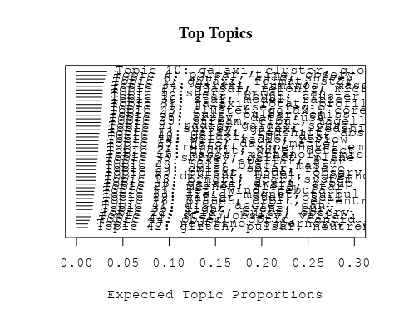

# Print the top 10 labels for each topic  
topic_labels <- labelTopics(Research_topics, n=10)  
print(topic_labels)

## Topic 1 Top Words:  
## Highest Prob: galaxi, format, star, gas, rate, form, star-form, massiv, observ, disk   
## FREX: format, star-form, earli, form, gas, ring, rate, univers, disk, process   
## Lift: guid, collision, reservoir, build-, oldest, fuel, pathway, notion, galaxy—, quick   
## Score: galaxi, format, gas, star, guid, star-form, disk, molecular, redshift, ring   
## Topic 2 Top Words:  
## Highest Prob: radio, galaxi, sourc, burst, host, agn, observ, sampl, activ, emiss   
## FREX: agn, radio, fast, lobe, gpscss, host, radio-loud, baryon, gps, burst   
## Lift: johnston, gpscss, edge-brighten, low-pow, gps, radio-quiet, gigahertz, css, filamentari, radio-loud   
## Score: radio, agn, galaxi, burst, johnston, gpscss, gps, radio-loud, sourc, lobe   
## Topic 3 Top Words:  
## Highest Prob: survey, galact, plane, data, region, resolut, catalogu, southern, cover, imag   
## FREX: plane, arm, cover, galact, longitud, sgps, catalogu, southern, map, survey   
## Lift: sgps, copyright, quadrant, beam-, circ, longitud, royal, latitud, fourth, arm   
## Score: survey, sgps, galact, plane, catalogu, longitud, copyright, arm, multibeam, circ   
## Topic 4 Top Words:  
## Highest Prob: pulsar, time, observ, radio, psr, system, millisecond, park, period, measur   
## FREX: pulsar, park, millisecond, psr, time, multibeam, residu, receiv, precis, discov   
## Lift: solitari, redetect, multi-beam, interfac, frame, pulsar, drag, park, verif, multibeam   
## Score: pulsar, psr, millisecond, puls, park, solitari, radio, glitch, multibeam, period   
## Topic 5 Top Words:  
## Highest Prob: star, format, can, form, stellar, dwarf, cloud, tidal, halo, simul   
## FREX: tidal, merg, form, strip, interact, simul, clump, cloud, dissip, numer   
## Lift: putat, retain, collid, nucleat, ancient, convert, ultra-compact, dissip, tidal, strip   
## Score: tidal, halo, dwarf, gcs, merg, cloud, strip, putat, format, gas   
## Topic 6 Top Words:  
## Highest Prob: sourc, radio, survey, ghz, compact, telescop, flux, observ, sky, sampl   
## FREX: mji, ghz, sourc, molonglo, australia, vlbi, vla, sky, baselin, compact   
## Lift: atg, sumss, uss, molonglo, nvss, nrao, mji, faintest, vla, non-therm   
## Score: atg, radio, sourc, ghz, mji, molonglo, uss, survey, catalogu, vlbi   
## Topic 7 Top Words:  
## Highest Prob: survey, galaxi, redshift, per, cent, sky, measur, data, function, power   
## FREX: releas, digit, sloan, wigglez, acoust, sky, dfgs, bao, cent, per   
## Lift: fibr, wigglez, antarct, bao, gpc, skymapp, mpc−, distance–redshift, dfgs, quasi-stellar   
## Score: survey, redshift, dfgs, wigglez, bao, acoust, sky, antarct, galaxi, sloan   
## Topic 8 Top Words:  
## Highest Prob: distanc, hubbl, supernova, space, measur, use, telescop, mag, observ, constant   
## FREX: hubbl, space, cepheid, comet, distanc, constant, mag, hst, sne, supernova   
## Lift: comet, extinction-correct, hst, long-period, hubbl, sne, cepheid, wfpc, period-luminos, modulus   
## Score: comet, hubbl, cepheid, mag, supernova, hst, sne, distanc, calibr, period-luminos   
## Topic 9 Top Words:  
## Highest Prob: remnant, supernova, emiss, radio, snr, observ, region, compact, snrs, telescop   
## FREX: snr, remnant, snrs, shell, bilater, supernova, australia, continuum, atca, compact   
## Lift: bilater, snr, snrs, rcw, quasi-perpendicular, puppi, remnant, beamwidth, asca, tendenc   
## Score: bilater, snr, snrs, remnant, supernova, radio, shell, australia, emiss, continuum   
## Topic 10 Top Words:  
## Highest Prob: galaxi, cluster, globular, gcs, system, ngc, ellipt, metal, popul, milki   
## FREX: gcs, globular, subpopul, ellipt, metal-rich, colour, milki, old, metal, ngc   
## Lift: cani, subpopul, gcs, andromeda, galactocentr, situ, leo, spectrophotometr, inside-, globular   
## Score: gcs, globular, subpopul, cani, cluster, ngc, metal, ellipt, metal-rich, colour   
## Topic 11 Top Words:  
## Highest Prob: jet, wind, nebula, shock, pulsar, structur, radio, relativist, observ, compon   
## FREX: jet, knot, relativist, nebula, bow, shock, wind, pwn, wisp, chandra   
## Lift: wisp, knot, pwn, termin, bow, jet, collim, parsec-scal, deceler, relativist   
## Score: jet, wisp, pulsar, knot, shock, nebula, pwn, bow, relativist, wind   
## Topic 12 Top Words:  
## Highest Prob: star, abund, cluster, ngc, metal, globular, giant, metal-poor, chemic, element   
## FREX: abund, feh, metal-poor, globular, chemic, element, metal, ngc, cluster, dex   
## Lift: supersolar, star--star, lick, mdf, intermediate-ag, cfe, overabund, triplet, αelement, calcium   
## Score: abund, globular, ngc, cluster, metal-poor, star--star, feh, metal, chemic, element   
## Topic 13 Top Words:  
## Highest Prob: galaxi, redshift, absorpt, sampl, -cm, system, survey, line, detect, use   
## FREX: -cm, absorpt, damp, dlas, redshift, absorb, qso, qsos, dla, high-redshift   
## Lift: dlas, gmrt, zab, metrewav, dla, -cm, absorption-lin, qsos, heavili, damp   
## Score: redshift, absorpt, -cm, gmrt, dlas, galaxi, qso, quasar, dla, qsos   
## Topic 14 Top Words:  
## Highest Prob: will, radio, review, survey, provid, univers, astronomi, observ, new, cosmic   
## FREX: astronomi, ska, askap, review, will, australian, question, detector, astronom, insight   
## Lift: school, pathfind, askap, wife, topic, innov, answer, ska, next-gener, built   
## Score: ska, school, review, astronomi, askap, detector, radio, cosmic, ray, scienc   
## Topic 15 Top Words:  
## Highest Prob: halo, dark, matter, simul, mass, model, galaxi, distribut, satellit, cosmolog   
## FREX: dark, halo, matter, simul, tree, n-bodi, satellit, baryon, cdm, cosmolog   
## Lift: tree, subhalo, cdm, anti-correl, cut, bayesian, matter, dark, n-bodi, mirror   
## Score: tree, halo, dark, matter, simul, cdm, satellit, cosmolog, n-bodi, merger   
## Topic 16 Top Words:  
## Highest Prob: maser, methanol, emiss, detect, sourc, -ghz, associ, toward, region, observ   
## FREX: maser, methanol, -ghz, water, high-mass, toward, transit, site, clump, associ   
## Lift: hydroxyl, glimps, methanol, maser, ground-stat, water, -ghz, ammonia, ira, -mhz   
## Score: maser, methanol, -ghz, glimps, water, emiss, ammonia, high-mass, transit, hydroxyl   
## Topic 17 Top Words:  
## Highest Prob: quasar, reioniz, microlens, sourc, observ, lens, mass, region, size, lyα   
## FREX: reioniz, quasar, lyα, microlens, igm, lens, size, depth, intergalact, neutral   
## Lift: chile, broad-lin, microlen, forest, reioniz, linewidth, lyα, high-magnif, campana, igm   
## Score: quasar, microlens, reioniz, igm, lyα, lens, chile, intergalact, broad-lin, forest   
## Topic 18 Top Words:  
## Highest Prob: binari, star, system, mass, dwarf, companion, orbit, observ, stellar, brown   
## FREX: binari, brown, companion, pne, primari, white, planetari, system, close, orbit   
## Lift: brown, analogu, binari, engulf, destroy, dri, sun-lik, companion, jupiter-mass, belief   
## Score: brown, binari, pne, companion, sun-lik, dwarf, planet, orbit, white, planetari   
## Topic 19 Top Words:  
## Highest Prob: variat, star, oscil, period, sequenc, red, variabl, giant, amplitud, data   
## FREX: oscil, variat, sequenc, amplitud, campaign, pulsat, solar-lik, creation, red, ellipsoid   
## Lift: creation, solar-lik, semiregular, oscil, campaign, roch, laboratori, ellipsoid, ensembl, ambiti   
## Score: creation, oscil, pulsat, solar-lik, ellipsoid, variat, red, amplitud, sequenc, variabl   
## Topic 20 Top Words:  
## Highest Prob: pulsar, model, observ, motion, distribut, neutron, popul, use, data, veloc   
## FREX: null, motion, proper, birth, scintil, doubl, msps, parallax, spin, align   
## Lift: birthrat, null, kick, birth, subtract, scintil, parallax, msps, proper, mas   
## Score: pulsar, birthrat, null, msps, neutron, scintil, birth, vector, parallax, proper   
## Topic 21 Top Words:  
## Highest Prob: line, use, region, emiss, model, densiti, ioniz, absorpt, observ, temperatur   
## FREX: line, diagnost, ioniz, warm, temperatur, absorpt, ionis, pks, outflow, broad   
## Lift: lte, recombin, warm, ionis, diagnost, photoionis, nebular, m-circl, fine-structur, line   
## Score: line, lte, ioniz, absorpt, diagnost, warm, ionis, nebular, abund, pks   
## Topic 22 Top Words:  
## Highest Prob: x-ray, burst, observ, time, sourc, outburst, accret, emiss, may, flux   
## FREX: outburst, burst, x-ray, thermonuclear, rossi, kev, accretion-pow, transient, burn, radius-expans   
## Lift: radius-expans, rossi, sax, rxte, accretion-pow, recurr, thermonuclear, june, rosat, steadi   
## Score: x-ray, burst, rxte, outburst, thermonuclear, radius-expans, accretion-pow, rossi, millisecond, xte   
## Topic 23 Top Words:  
## Highest Prob: neutrino, supernova, ray, cosmic, energi, produc, origin, emiss, background, γray   
## FREX: neutrino, ray, γray, positron, radioact, earth, r-process, million, cosmic, tev   
## Lift: positron, cosmic-ray, radioact, neutrino, r-process, γray, penetr, tev, ray, pion   
## Score: positron, neutrino, ray, radioact, r-process, γray, meteorit, cosmic, tev, supernova   
## Topic 24 Top Words:  
## Highest Prob: gravit, wave, detect, background, observ, gravitational-wav, merger, burst, gamma-ray, rate   
## FREX: gravitational-wav, gravit, wave, background, coalesc, gamma-ray, ligo, detector, stochast, smbh   
## Lift: ligo, gravitational-wav, smbh, grbs, travers, electromagnet, coalesc, laser, spacetim, gravit   
## Score: wave, smbh, gravitational-wav, gravit, ligo, coalesc, detector, gamma-ray, merger, lens   
## Topic 25 Top Words:  
## Highest Prob: array, data, use, imag, frequenc, murchison, mhz, widefield, observ, mwa   
## FREX: murchison, widefield, mwa, low-frequ, array, mhz, -ski, polaris, gleam, interfer   
## Lift: mwa, reionis, widefield, field--view, murchison, radio-frequ, gleam, eor, ppta, pipelin   
## Score: murchison, mwa, widefield, radio-frequ, mhz, array, gleam, low-frequ, -ski, calibr   
## Topic 26 Top Words:  
## Highest Prob: planet, orbit, eccentr, star, veloc, system, companion, dispers, effect, light   
## FREX: planet, eccentr, orbit, short-period, companion, exoplanet, reson, ring, dispers, jupit   
## Lift: inflat, eccentr, planet, maxima, comment, short-period, reson, extrasolar, synchron, non-zero   
## Score: planet, eccentr, orbit, inflat, short-period, exoplanet, companion, sun-lik, extrasolar, jupit   
## Topic 27 Top Words:  
## Highest Prob: magnet, field, star, rotat, polar, observ, accret, period, white, use   
## FREX: magnet, spot, mountain, zeeman, field, tauri, white, faraday, differenti, confin   
## Lift: spectropolarimetri, spectropolarimetr, tauri, zeeman, mountain, spot, pre-main, dynamo, hydromagnet, cap   
## Score: magnet, mountain, polar, spectropolarimetri, zeeman, spot, field, white, rotat, faraday   
## Topic 28 Top Words:  
## Highest Prob: cluster, galaxi, core, relic, find, central, region, field, sampl, luminos   
## FREX: relic, cluster, intraclust, infal, cool, rich, caviti, abel, virgo, core   
## Lift: abel, x-ray-lumin, caviti, icm, outskirt, relic, intraclust, oppos, blank, regul   
## Score: cluster, abel, relic, galaxi, intraclust, infal, caviti, virgo, shock, x-ray   
## Topic 29 Top Words:  
## Highest Prob: emiss, solar, flare, energi, distribut, radio, x-ray, sourc, observ, state   
## FREX: flare, plasma, solar, coron, state, xte, hard, corona, energi, sunspot   
## Lift: flare, poisson, sunspot, coron, loop, spacecraft, corona, limb, harmon, hard   
## Score: flare, xte, poisson, coron, emiss, solar, x-ray, plasma, wave, sunspot   
## Topic 30 Top Words:  
## Highest Prob: star, model, ratio, element, supernova, abund, solar, mass, evolut, chemic   
## FREX: isotop, agb, nucleosynthesi, element, explos, mix, carbon, asymptot, convect, chemic   
## Lift: dredge-, hydrostat, carbon-rich, nitrogen, lithium, reaction, primit, isotop, nucleosynthesi, explos   
## Score: isotop, agb, nucleosynthesi, element, chemic, hydrostat, branch, abund, convect, grain   
## Topic 31 Top Words:  
## Highest Prob: galaxi, rotat, profil, model, kinemat, mass, bar, disk, spiral, veloc   
## FREX: bar, bulg, spiral, kinemat, profil, rotat, edge-, len, disk, ellipt   
## Lift: twist, edge-, contour, decomposit, bar, two-dimension, cuspi, deficit, inward, sersic   
## Score: bar, galaxi, bulg, kinemat, spiral, profil, edge-, twist, len, disk   
## Topic 32 Top Words:  
## Highest Prob: mass, stellar, star, model, use, format, determin, metal, find, method   
## FREX: imf, stellar, collis, redden, discrep, mass, indirect, temperatur, method, underestim   
## Lift: segreg, asteroseismolog, imf, protostar, half-mass, bolometr, overestim, densest, librari, indirect   
## Score: segreg, mass, imf, metal, stellar, redden, cepheid, asteroseismolog, star, indirect   
## Topic 33 Top Words:  
## Highest Prob: field, magnet, turbul, diffus, scale, hall, effect, cloud, polar, fluctuat   
## FREX: turbul, hall, grain, stoke, fluctuat, diffus, ambipolar, protostellar, vector, vertic   
## Lift: ambipolar, hall, thread, turbul, amplif, tabl, protostellar, midplan, cascad, ion   
## Score: hall, magnet, turbul, ambipolar, thread, stoke, grain, diffus, vector, vertic   
## Topic 34 Top Words:  
## Highest Prob: galaxi, luminos, mass, group, densiti, gas, function, find, local, similar   
## FREX: hipass, gama, luminos, group, blue, function, sfr, isol, assembl, environ   
## Lift: strangul, dip, hipass, lfs, gama, schechter, ram, environment, ram-pressur, millennium   
## Score: galaxi, hipass, gama, group, strangul, gas, sfr, luminos, blue, red   
## Topic 35 Top Words:  
## Highest Prob: stream, cloud, magellan, veloc, star, halo, galact, lmc, survey, group   
## FREX: stream, magellan, lyra, lmc, rave, substructur, cloud, overdens, smc, member   
## Lift: rave, helmi, stream, lyra, high-veloc, neighborhood, ukst, outlier, discrimin, prograd   
## Score: stream, rave, magellan, pne, lmc, lyra, halo, smc, cloud, helmi   
## Topic 36 Top Words:  
## Highest Prob: light, event, curv, periastron, observ, period, microlens, afterglow, grb, show   
## FREX: periastron, afterglow, curv, light, grb, event, microlens, passag, smc, ogl   
## Lift: brighten, periastron, passag, afterglow, ogl, caustic, brief, node, season, macho   
## Score: periastron, brighten, microlens, afterglow, curv, grb, event, light, passag, smc   
## Topic 37 Top Words:  
## Highest Prob: puls, pulsar, emiss, polar, giant, profil, psr, observ, radio, compon   
## FREX: puls, polar, psr, profil, giant, vela, phase, ghz, magnetospher, intens   
## Lift: micropuls, cylind, puls, magnetospher, orthogon, jitter, swing, window, nonlinear, single-puls   
## Score: puls, pulsar, psr, polar, micropuls, giant, vela, emiss, profil, millisecond   
## Topic 38 Top Words:  
## Highest Prob: galaxi, dwarf, group, fornax, sampl, bright, surfac, mag, magnitud, two   
## FREX: fornax, spheroid, b-band, group, near-infrar, mag, brightest, cen, early-typ, dwarf   
## Lift: dsph, b-band, j-band, h-band, regress, fornax, extratid, nir, r-band, k-band   
## Score: dsph, fornax, galaxi, dwarf, cen, spheroid, b-band, group, mag, nir   
## Topic 39 Top Words:  
## Highest Prob: star, observ, variabl, imag, pulsat, binari, use, compon, determin, new   
## FREX: eclips, interferometri, pulsat, ejecta, long-baselin, interferometr, flash, doradus, variabl, main-sequ   
## Lift: speckl, long-baselin, kepler, radial-veloc, suspect, nova, hipparco, doradus, defici, eclips   
## Score: long-baselin, pulsat, eclips, speckl, binari, interferometri, variabl, star, ejecta, exoplanet   
## Topic 40 Top Words:  
## Highest Prob: galaxi, ngc, dust, emiss, gas, starburst, optic, show, radio, region   
## FREX: starburst, dust, nucleus, ngc, seyfert, lane, agn, ioniz, infrar, control   
## Lift: lane, silic, nlr, seyfert, ridg, x-shape, starburst, narrow-lin, dust, mrc   
## Score: lane, ngc, dust, starburst, seyfert, agn, galaxi, nucleus, ioniz, gas   
## Topic 41 Top Words:  
## Highest Prob: disc, accret, can, use, differ, ratio, extend, result, numer, simul   
## FREX: disc, problem, numer, tilt, smooth, attenu, solut, regim, hemispher, equat   
## Lift: scalelength, tilt, disc, viscos, two-compon, attenu, treat, coeffici, inhibit, sph   
## Score: disc, tilt, warp, accret, numer, attenu, coeffici, hemispher, scalelength, solut   
## Topic 42 Top Words:  
## Highest Prob: glitch, pulsar, neutron, time, star, observ, nuclear, radio, fraction, previous   
## FREX: glitch, superfluid, recoveri, neutron, crust, delta, nuclear, relax, januari, vela   
## Lift: delta, superfluid, glitch, crust, post-glitch, recoveri, happen, januari, torqu, relax   
## Score: glitch, pulsar, delta, neutron, superfluid, crust, vela, recoveri, nuclear, post-glitch   
## Topic 43 Top Words:  
## Highest Prob: hole, black, mass, accret, supermass, galact, relat, outflow, activ, nuclei   
## FREX: hole, black, supermass, nuclei, outflow, accret, mbh, nuclear, photon, cygnus   
## Lift: super-eddington, hole, black, supermass, stellar-mass, mbh, stall, cygnus, trap, eddington   
## Score: black, hole, supermass, accret, super-eddington, quasar, mbh, outflow, jet, mass   
## Topic 44 Top Words:  
## Highest Prob: object, optic, candid, select, present, search, survey, catalog, satellit, dwarf   
## FREX: object, candid, select, catalog, optic, satellit, counterpart, search, discov, confirm   
## Lift: percent, catalog, object, candid, counterpart, criteria, select, void, optic, satellit   
## Score: percent, catalog, object, optic, candid, satellit, select, photometri, search, survey

# Match the processed documents with the original titles  
matched_titles <- out_text$meta$original_concatenated_title_abstract  
  
# Print top 5 documents for each topic  
top_docs <- findThoughts(Research_topics, texts = matched_titles, n = 5)$docs[[1]]  
print(top_docs)

## [1] "A giant galaxy in the young Universe with a massive ring In the local (redshift z  ≈ 0) Universe, collisional ring galaxies make up only ~0.01% of galaxies 1 and are formed by head-on galactic collisions that trigger radially propagating density waves 2 – 4 . These striking systems provide key snapshots for dissecting galactic disks and are studied extensively in the local Universe 5 – 9 . However, not much is known about distant ( z  > 0.1) collisional rings 10 – 14 . Here we present a detailed study of a ring galaxy at a look-back time of 10.8 Gyr ( z  = 2.19). Compared with our Milky Way, this galaxy has a similar stellar mass, but has a stellar half-light radius that is 1.5–2.2 times larger and is forming stars 50 times faster. The extended, diffuse stellar light outside the star-forming ring, combined with a radial velocity on the ring and an intruder galaxy nearby, provides evidence for this galaxy hosting a collisional ring. If the ring is secularly evolved 15 , 16 , the implied large bar in a giant disk would be inconsistent with the current understanding of the earliest formation of barred spirals 17 – 21 . Contrary to previous predictions 10 – 12 , this work suggests that massive collisional rings were as rare 11 Gyr ago as they are today. Our discovery offers a unique pathway for studying density waves in young galaxies, as well as constraining the cosmic evolution of spiral disks and galaxy groups. A ring galaxy is found at a look-back time of 10.8 Gyr. The diffuse stellar light outside the star-forming ring, the ring’s radial velocity and a nearby intruder galaxy indicate that this is a collisional ring galaxy."  
## [2] "A giant galaxy in the young Universe with a massive ring In the local (redshift z  ≈ 0) Universe, collisional ring galaxies make up only ~0.01% of galaxies 1 and are formed by head-on galactic collisions that trigger radially propagating density waves 2 – 4 . These striking systems provide key snapshots for dissecting galactic disks and are studied extensively in the local Universe 5 – 9 . However, not much is known about distant ( z  > 0.1) collisional rings 10 – 14 . Here we present a detailed study of a ring galaxy at a look-back time of 10.8 Gyr ( z  = 2.19). Compared with our Milky Way, this galaxy has a similar stellar mass, but has a stellar half-light radius that is 1.5–2.2 times larger and is forming stars 50 times faster. The extended, diffuse stellar light outside the star-forming ring, combined with a radial velocity on the ring and an intruder galaxy nearby, provides evidence for this galaxy hosting a collisional ring. If the ring is secularly evolved 15 , 16 , the implied large bar in a giant disk would be inconsistent with the current understanding of the earliest formation of barred spirals 17 – 21 . Contrary to previous predictions 10 – 12 , this work suggests that massive collisional rings were as rare 11 Gyr ago as they are today. Our discovery offers a unique pathway for studying density waves in young galaxies, as well as constraining the cosmic evolution of spiral disks and galaxy groups. A ring galaxy is found at a look-back time of 10.8 Gyr. The diffuse stellar light outside the star-forming ring, the ring’s radial velocity and a nearby intruder galaxy indicate that this is a collisional ring galaxy."  
## [3] "A giant galaxy in the young Universe with a massive ring In the local (redshift z  ≈ 0) Universe, collisional ring galaxies make up only ~0.01% of galaxies 1 and are formed by head-on galactic collisions that trigger radially propagating density waves 2 – 4 . These striking systems provide key snapshots for dissecting galactic disks and are studied extensively in the local Universe 5 – 9 . However, not much is known about distant ( z  > 0.1) collisional rings 10 – 14 . Here we present a detailed study of a ring galaxy at a look-back time of 10.8 Gyr ( z  = 2.19). Compared with our Milky Way, this galaxy has a similar stellar mass, but has a stellar half-light radius that is 1.5–2.2 times larger and is forming stars 50 times faster. The extended, diffuse stellar light outside the star-forming ring, combined with a radial velocity on the ring and an intruder galaxy nearby, provides evidence for this galaxy hosting a collisional ring. If the ring is secularly evolved 15 , 16 , the implied large bar in a giant disk would be inconsistent with the current understanding of the earliest formation of barred spirals 17 – 21 . Contrary to previous predictions 10 – 12 , this work suggests that massive collisional rings were as rare 11 Gyr ago as they are today. Our discovery offers a unique pathway for studying density waves in young galaxies, as well as constraining the cosmic evolution of spiral disks and galaxy groups. A ring galaxy is found at a look-back time of 10.8 Gyr. The diffuse stellar light outside the star-forming ring, the ring’s radial velocity and a nearby intruder galaxy indicate that this is a collisional ring galaxy."  
## [4] "A giant galaxy in the young Universe with a massive ring In the local (redshift z  ≈ 0) Universe, collisional ring galaxies make up only ~0.01% of galaxies 1 and are formed by head-on galactic collisions that trigger radially propagating density waves 2 – 4 . These striking systems provide key snapshots for dissecting galactic disks and are studied extensively in the local Universe 5 – 9 . However, not much is known about distant ( z  > 0.1) collisional rings 10 – 14 . Here we present a detailed study of a ring galaxy at a look-back time of 10.8 Gyr ( z  = 2.19). Compared with our Milky Way, this galaxy has a similar stellar mass, but has a stellar half-light radius that is 1.5–2.2 times larger and is forming stars 50 times faster. The extended, diffuse stellar light outside the star-forming ring, combined with a radial velocity on the ring and an intruder galaxy nearby, provides evidence for this galaxy hosting a collisional ring. If the ring is secularly evolved 15 , 16 , the implied large bar in a giant disk would be inconsistent with the current understanding of the earliest formation of barred spirals 17 – 21 . Contrary to previous predictions 10 – 12 , this work suggests that massive collisional rings were as rare 11 Gyr ago as they are today. Our discovery offers a unique pathway for studying density waves in young galaxies, as well as constraining the cosmic evolution of spiral disks and galaxy groups. A ring galaxy is found at a look-back time of 10.8 Gyr. The diffuse stellar light outside the star-forming ring, the ring’s radial velocity and a nearby intruder galaxy indicate that this is a collisional ring galaxy."  
## [5] "The New Galaxy: Signatures of its Formation ▪ Abstract The formation and evolution of galaxies is one of the great outstanding problems of astrophysics. Within the broad context of hierachical structure formation, we have only a crude picture of how galaxies like our own came into existence. A detailed physical picture where individual stellar populations can be associated with (tagged to) elements of the protocloud is far beyond our current understanding. Important clues have begun to emerge from both the Galaxy (near-field cosmology) and the high redshift universe (far-field cosmology). Here we focus on the fossil evidence provided by the Galaxy. Detailed studies of the Galaxy lie at the core of understanding the complex processes involved in baryon dissipation. This is a necessary first step toward achieving a successful theory of galaxy formation."

# Find and plot the key "thoughts" or documents for selected topics  
thoughts6 <- findThoughts(Research_topics, texts = matched_titles, n = 3, topics = 6)$docs[[1]]  
thoughts18 <- findThoughts(Research_topics, texts = matched_titles, n = 3, topics = 18)$docs[[1]]  
par(mfrow = c(1, 2), mar = c(0.5, 0.5, 1, 0.5))  
plotQuote(thoughts6, width = 30, main = "Topic 6")  
plotQuote(thoughts18, width = 30, main = "Topic 18")

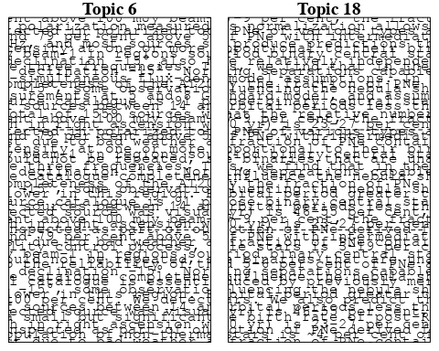

# Calculate and plot the correlation between topics  
mod.out.corr <- topicCorr(Research_topics)  
plot(mod.out.corr, cex = 1.5)  
  
  
# For each topic  
for (topic_num in 1:44) {  
 # Plot the word cloud  
 cloud(Research_topics, topic = topic_num, scale = c(2, 0.25))  
 Sys.sleep(2)  
}

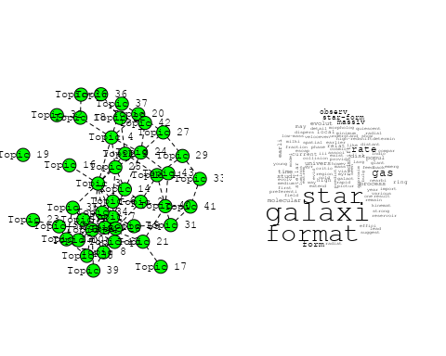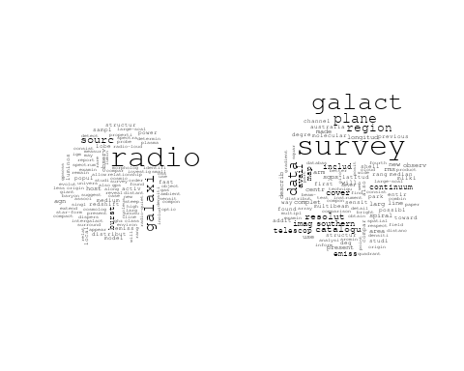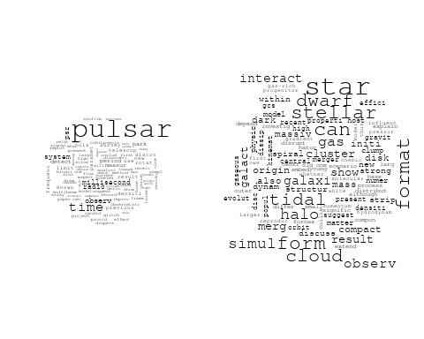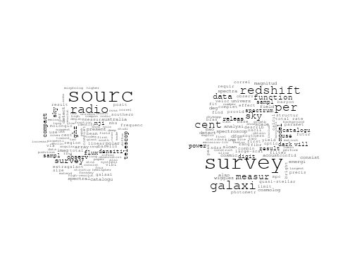

## Warning in wordcloud::wordcloud(words = vocab, freq = vec, max.words =  
## max.words, : distanc could not be fit on page. It will not be plotted.

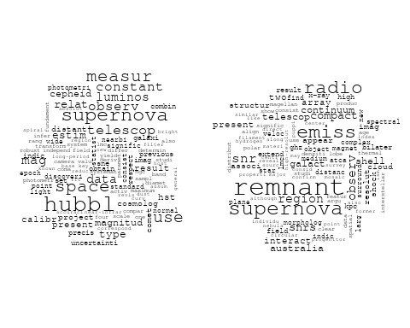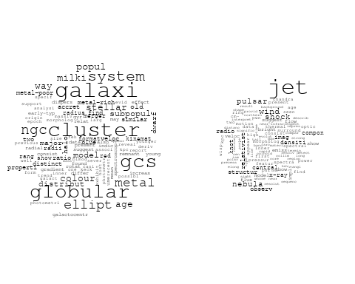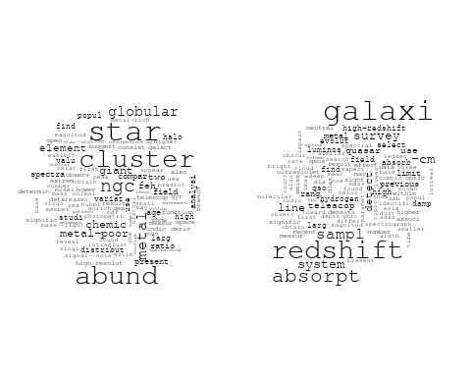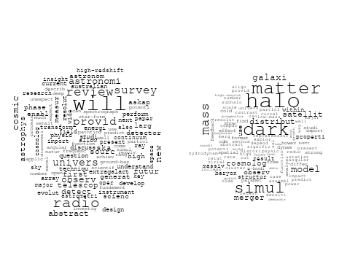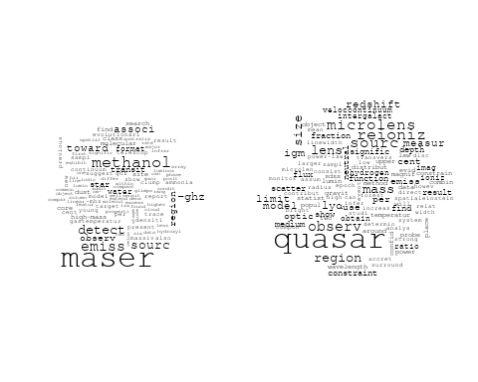

## Warning in wordcloud::wordcloud(words = vocab, freq = vec, max.words =  
## max.words, : variat could not be fit on page. It will not be plotted.

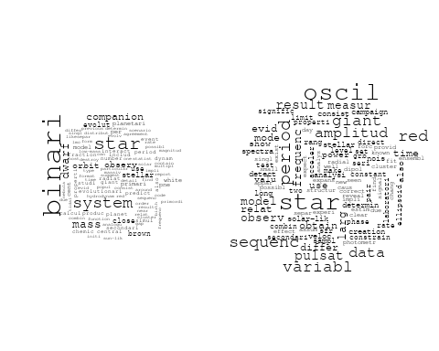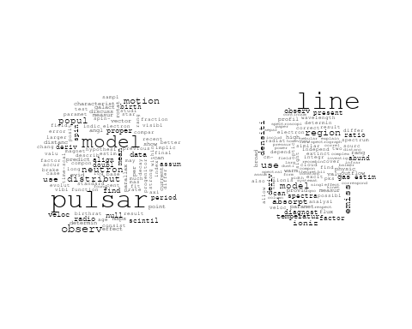

## Warning in wordcloud::wordcloud(words = vocab, freq = vec, max.words =  
## max.words, : supernova could not be fit on page. It will not be plotted.

## Warning in wordcloud::wordcloud(words = vocab, freq = vec, max.words =  
## max.words, : neutrino could not be fit on page. It will not be plotted.

## Warning in wordcloud::wordcloud(words = vocab, freq = vec, max.words =  
## max.words, : synchrotron could not be fit on page. It will not be plotted.

## Warning in wordcloud::wordcloud(words = vocab, freq = vec, max.words =  
## max.words, : cosmic-ray could not be fit on page. It will not be plotted.

## Warning in wordcloud::wordcloud(words = vocab, freq = vec, max.words =  
## max.words, : system could not be fit on page. It will not be plotted.

## Warning in wordcloud::wordcloud(words = vocab, freq = vec, max.words =  
## max.words, : earth could not be fit on page. It will not be plotted.

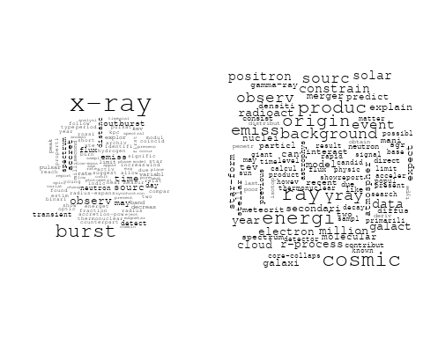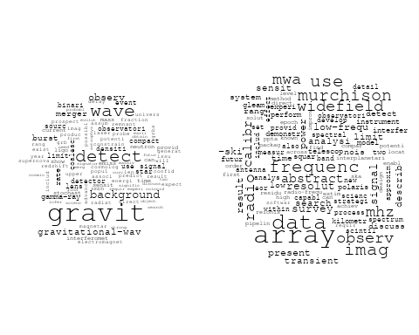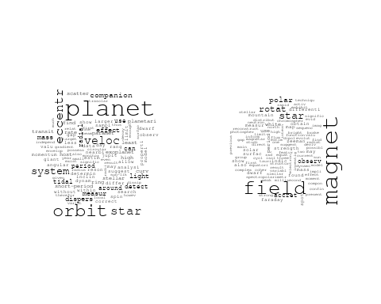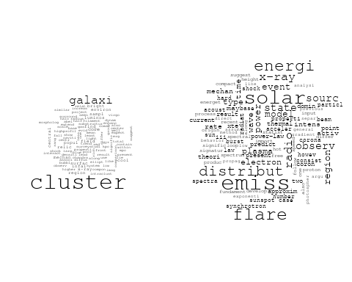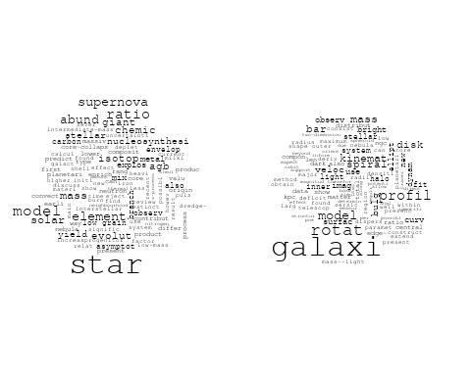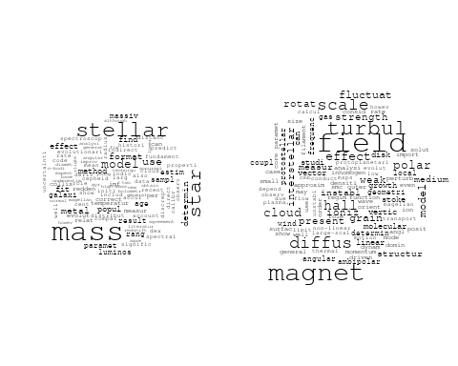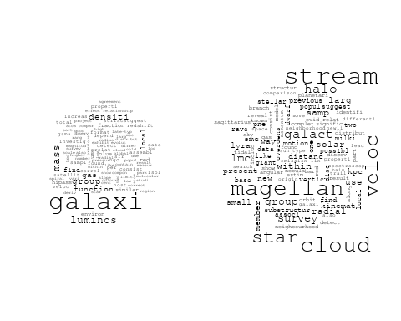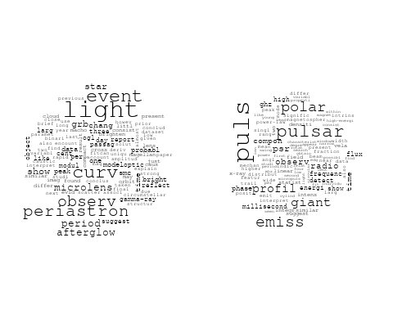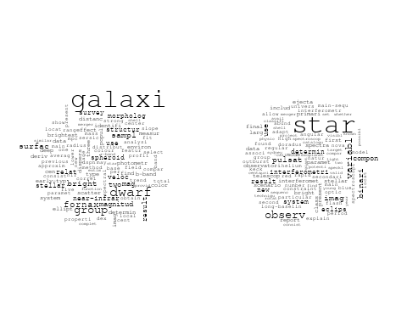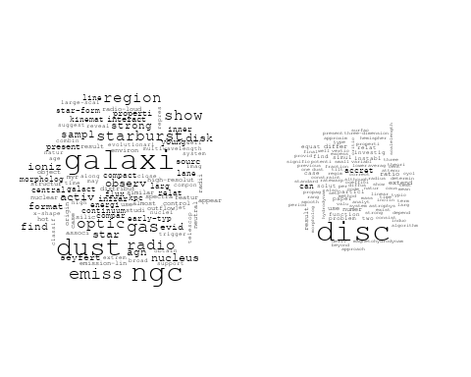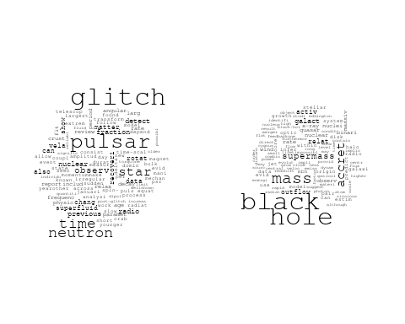

# Get the topic proportions for each document  
topic_proportions <- Research_topics$theta  
  
# Find the index of the topic with the highest proportion for each document  
# This will be the topic that each document is most likely to belong to  
max_topic_idx <- apply(topic_proportions, 1, which.max)  
  
# Add this as a new column to your data  
data_collab$topic <- max_topic_idx  
  
library(ggplot2)  
  
# Define the intervals  
intervals <- c('1824_1899', '1900_1964', '1965_1974', '1975_1984', '1985_1994', '1995_1999', '2000_2004', '2005_2009', '2010_2014', '2015_2019', '2020_2022')  
colors <- c('pink', 'blue', 'purple', 'yellow', 'green', 'pink', 'orange', 'violet', 'green', 'blue', 'pink')  
  
# Loop through the intervals and plot  
for(i in seq_along(intervals)){  
 # Filter data for when the pub_interval is equal to 1  
 data_filtered <- data_collab[data_collab[[paste0('pub_interval_', intervals[i])]] == 1,]  
   
 # Make the histogram  
   
 p <- ggplot(data_filtered, aes(x = topic)) +  
 geom_histogram(binwidth = 1, fill = colors[i], color = "black") +  
 xlab("Topic") +  
 ylab("Count") +  
 ggtitle(paste0("Topics from year ", gsub("_", " to ", intervals[i])))  
   
 print(p)  
}  
  
  
##Topic generation for AU (independent) publications  
  
data_independent <- data[data[["AU"]] == 100,]  
  
# Save the original title data for future use  
data_independent$original_concatenated_title_abstract <- data_independent$concatenated_title_abstract  
  
#pre-processing the titles using textProcessor from the stm package  
processed_text <- textProcessor(data_independent$concatenated_title_abstract, metadata = data_independent)

## Building corpus...   
## Converting to Lower Case...   
## Removing punctuation...   
## Removing stopwords...   
## Removing numbers...   
## Stemming...   
## Creating Output...

# Further prepare the data by removing low-frequency terms  
out_text <- prepDocuments(processed_text$documents, processed_text$vocab, processed_text$meta)

## Removing 1437 of 6057 terms (1437 of 85420 tokens) due to frequency   
## Your corpus now has 1028 documents, 4620 terms and 83983 tokens.

docs_text <- out_text$documents  
vocab_text <- out_text$vocab  
meta_text <- out_text$meta  
  
  
#Prepare data  
plotRemoved(processed_text$documents, lower.thresh = seq(1, 200, by = 100))

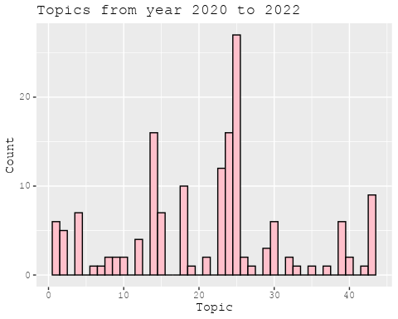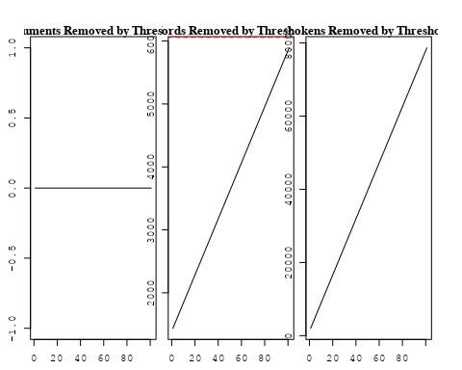

out_text <- prepDocuments(processed_text$documents, processed_text$vocab, processed_text$meta, lower.thresh = 8)

## Removing 4519 of 6057 terms (12103 of 85420 tokens) due to frequency   
## Your corpus now has 1028 documents, 1538 terms and 73317 tokens.

str(out_text$meta)

## 'data.frame': 1028 obs. of 39 variables:  
## $ concept_id : chr "https://openalex.org/C1276947" "https://openalex.org/C1276947" "https://openalex.org/C44870925" "https://openalex.org/C44870925" ...  
## $ work_id : chr "https://openalex.org/W3100822581" "https://openalex.org/W3140362863" "https://openalex.org/W2019918353" "https://openalex.org/W3104653637" ...  
## $ publication_year : int 2007 2021 1998 2008 2014 2014 2009 2004 2020 2010 ...  
## $ title : chr "Revealing Substructure in the Galactic Halo - The SEKBO RR Lyrae Survey" "Evidence for an intermediate-mass black hole from a gravitationally lensed gamma-ray burst" "The Nature of Bilateral Supernova Remnants" "The early-type galaxies NGC 1407 and NGC 1400 - II: star formation and chemical evolutionary history" ...  
## $ paperabstract : chr "We present a search for RR Lyrae variable stars from archival observations of the Southern Edgeworth-Kuiper Bel"| __truncated__ "If gamma-ray bursts are at cosmological distances, they must be gravitationally lensed occasionally [1, 2]. The"| __truncated__ "We present high-resolution radio images at 1.4 GHz of two Galactic supernova remnants (SNRs), G003.8–00.3 (form"| __truncated__ "We present a possible star formation and chemical evolutionary history for two early-type galaxies NGC 1407 and"| __truncated__ ...  
## $ country : chr "AU AU AU AU" "AU AU AU AU" "AU AU AU AU" "AU AU" ...  
## $ year_concept : chr "2007+https://openalex.org/C1276947" "2021+https://openalex.org/C1276947" "1998+https://openalex.org/C44870925" "2008+https://openalex.org/C44870925" ...  
## $ concatenated_title_abstract : chr "Revealing Substructure in the Galactic Halo - The SEKBO RR Lyrae Survey We present a search for RR Lyrae variab"| __truncated__ "Evidence for an intermediate-mass black hole from a gravitationally lensed gamma-ray burst If gamma-ray bursts "| __truncated__ "The Nature of Bilateral Supernova Remnants We present high-resolution radio images at 1.4 GHz of two Galactic s"| __truncated__ "The early-type galaxies NGC 1407 and NGC 1400 - II: star formation and chemical evolutionary history We present"| __truncated__ ...  
## $ US : num 0 0 0 0 0 0 0 0 0 0 ...  
## $ IN : num 0 0 0 0 0 0 0 0 0 0 ...  
## $ DE : num 0 0 0 0 0 0 0 0 0 0 ...  
## $ CH : num 0 0 0 0 0 0 0 0 0 0 ...  
## $ GB : num 0 0 0 0 0 0 0 0 0 0 ...  
## $ CN : num 0 0 0 0 0 0 0 0 0 0 ...  
## $ FR : num 0 0 0 0 0 0 0 0 0 0 ...  
## $ IT : num 0 0 0 0 0 0 0 0 0 0 ...  
## $ RU : num 0 0 0 0 0 0 0 0 0 0 ...  
## $ CA : num 0 0 0 0 0 0 0 0 0 0 ...  
## $ NL : num 0 0 0 0 0 0 0 0 0 0 ...  
## $ AU : num 100 100 100 100 100 100 100 100 100 100 ...  
## $ JP : num 0 0 0 0 0 0 0 0 0 0 ...  
## $ ES : num 0 0 0 0 0 0 0 0 0 0 ...  
## $ IL : num 0 0 0 0 0 0 0 0 0 0 ...  
## $ Americas : num 0 0 0 0 0 0 0 0 0 0 ...  
## $ Europe : num 0 0 0 0 0 0 0 0 0 0 ...  
## $ Africa : num 0 0 0 0 0 0 0 0 0 0 ...  
## $ AsiaAndOceania : num 0 0 0 0 0 0 0 0 0 0 ...  
## $ pub_interval_2020_2022 : int 0 1 0 0 0 0 0 0 1 0 ...  
## $ pub_interval_2015_2019 : int 0 0 0 0 0 0 0 0 0 0 ...  
## $ pub_interval_2010_2014 : int 0 0 0 0 1 1 0 0 0 1 ...  
## $ pub_interval_2005_2009 : int 1 0 0 1 0 0 1 0 0 0 ...  
## $ pub_interval_2000_2004 : int 0 0 0 0 0 0 0 1 0 0 ...  
## $ pub_interval_1995_1999 : int 0 0 1 0 0 0 0 0 0 0 ...  
## $ pub_interval_1985_1994 : int 0 0 0 0 0 0 0 0 0 0 ...  
## $ pub_interval_1975_1984 : int 0 0 0 0 0 0 0 0 0 0 ...  
## $ pub_interval_1965_1974 : int 0 0 0 0 0 0 0 0 0 0 ...  
## $ pub_interval_1900_1964 : int 0 0 0 0 0 0 0 0 0 0 ...  
## $ pub_interval_1824_1899 : int 0 0 0 0 0 0 0 0 0 0 ...  
## $ original_concatenated_title_abstract: chr "Revealing Substructure in the Galactic Halo - The SEKBO RR Lyrae Survey We present a search for RR Lyrae variab"| __truncated__ "Evidence for an intermediate-mass black hole from a gravitationally lensed gamma-ray burst If gamma-ray bursts "| __truncated__ "The Nature of Bilateral Supernova Remnants We present high-resolution radio images at 1.4 GHz of two Galactic s"| __truncated__ "The early-type galaxies NGC 1407 and NGC 1400 - II: star formation and chemical evolutionary history We present"| __truncated__ ...

# Initialize an empty formula string  
prevalence_formula_str <- "~"  
  
# Define the publication intervals  
pub_intervals <- c("pub_interval_2020_2022", "pub_interval_2015_2019", "pub_interval_2010_2014",   
 "pub_interval_2005_2009", "pub_interval_2000_2004", "pub_interval_1995_1999",  
 "pub_interval_1985_1994", "pub_interval_1975_1984", "pub_interval_1965_1974",  
 "pub_interval_1900_1964", "pub_interval_1824_1899")  
  
# Add each publication interval to the formula string  
for (interval in pub_intervals) {  
 # add an if statement to handle the first addition (without '+')  
 if (prevalence_formula_str == "~") {  
 prevalence_formula_str <- paste(prevalence_formula_str, interval)  
 } else {  
 prevalence_formula_str <- paste(prevalence_formula_str, "+", interval)  
 }  
}  
  
  
# Convert the string to a formula  
prevalence_formula <- as.formula(prevalence_formula_str)  
print(prevalence_formula)

## ~pub_interval_2020_2022 + pub_interval_2015_2019 + pub_interval_2010_2014 +   
## pub_interval_2005_2009 + pub_interval_2000_2004 + pub_interval_1995_1999 +   
## pub_interval_1985_1994 + pub_interval_1975_1984 + pub_interval_1965_1974 +   
## pub_interval_1900_1964 + pub_interval_1824_1899

# Run STM model  
Research_topics <- stm(documents = out_text$documents,   
 vocab = out_text$vocab,   
 K = 44,   
 prevalence = prevalence_formula,   
 data = out_text$meta,   
 init.type = "Spectral",  
 max.em.its = 1000,  
 gamma.prior = 'L1')

## Beginning Spectral Initialization   
## Calculating the gram matrix...  
## Finding anchor words...  
## ............................................  
## Recovering initialization...  
## ...............  
## Initialization complete.  
## ......................................................................................................  
## Completed E-Step (1 seconds).   
## Completed M-Step.   
## Completing Iteration 1 (approx. per word bound = -6.101)   
## ......................................................................................................  
## Completed E-Step (1 seconds).   
## Completed M-Step.   
## Completing Iteration 2 (approx. per word bound = -5.822, relative change = 4.577e-02)   
## ......................................................................................................  
## Completed E-Step (0 seconds).   
## Completed M-Step.   
## Completing Iteration 3 (approx. per word bound = -5.738, relative change = 1.437e-02)   
## ......................................................................................................  
## Completed E-Step (1 seconds).   
## Completed M-Step.   
## Completing Iteration 4 (approx. per word bound = -5.701, relative change = 6.471e-03)   
## ......................................................................................................  
## Completed E-Step (1 seconds).   
## Completed M-Step.   
## Completing Iteration 5 (approx. per word bound = -5.679, relative change = 3.764e-03)   
## Topic 1: sourc, catalogu, ghz, south, survey   
## Topic 2: galaxi, cluster, environ, host, satellit   
## Topic 3: galaxi, star, format, univers, critic   
## Topic 4: flare, distribut, energi, solar, region   
## Topic 5: halo, merger, dark, matter, simul   
## Topic 6: binari, star, observ, period, system   
## Topic 7: gravit, wave, neutron, star, detect   
## Topic 8: magnet, field, star, white, dwarf   
## Topic 9: remnant, supernova, galact, snrs, bilater   
## Topic 10: observ, telescop, field, will, optic   
## Topic 11: star, giant, branch, stellar, mix   
## Topic 12: system, metal, galaxi, redshift, damp   
## Topic 13: pulsar, model, magnet, rotat, field   
## Topic 14: maser, emiss, detect, transit, site   
## Topic 15: mass, stellar, relat, lmc, magellan   
## Topic 16: quasar, region, emiss, model, observ   
## Topic 17: cluster, globular, galaxi, metal, ngc   
## Topic 18: dwarf, mass, companion, star, stellar   
## Topic 19: data, calibr, new, databas, mwa   
## Topic 20: ngc, star, cluster, abund, redden   
## Topic 21: model, use, galaxi, line, starburst   
## Topic 22: radio, sourc, survey, galaxi, compact   
## Topic 23: galaxi, group, cloud, gas, mass   
## Topic 24: supernova, star, mass, yield, explos   
## Topic 25: veloc, galaxi, dispers, kinemat, rotat   
## Topic 26: maser, methanol, associ, sourc, -ghz   
## Topic 27: hole, black, mass, accret, binari   
## Topic 28: puls, profil, pulsar, compon, emiss   
## Topic 29: jet, radio, accret, disk, interact   
## Topic 30: mass, lens, gravit, len, matter   
## Topic 31: emiss, radio, x-ray, observ, synchrotron   
## Topic 32: galaxi, bar, disk, ring, spiral   
## Topic 33: pulsar, observ, null, time, survey   
## Topic 34: per, cent, catalogu, survey, releas   
## Topic 35: survey, radio, sourc, will, mhz   
## Topic 36: galaxi, optic, extinct, emiss, sky   
## Topic 37: spectra, variabl, optic, flux, pulsar   
## Topic 38: fornax, star, galaxi, shell, survey   
## Topic 39: array, murchison, frequenc, widefield, detect   
## Topic 40: simul, format, gas, cloud, can   
## Topic 41: pulsar, time, vela, glitch, motion   
## Topic 42: diffus, instabl, hall, disc, effect   
## Topic 43: survey, star, pne, lmc, previous   
## Topic 44: qso, redshift, object, survey, luminos   
## ......................................................................................................  
## Completed E-Step (1 seconds).   
## Completed M-Step.   
## Completing Iteration 6 (approx. per word bound = -5.666, relative change = 2.269e-03)   
## ......................................................................................................  
## Completed E-Step (1 seconds).   
## Completed M-Step.   
## Completing Iteration 7 (approx. per word bound = -5.658, relative change = 1.481e-03)   
## ......................................................................................................  
## Completed E-Step (1 seconds).   
## Completed M-Step.   
## Completing Iteration 8 (approx. per word bound = -5.652, relative change = 1.107e-03)   
## ......................................................................................................  
## Completed E-Step (0 seconds).   
## Completed M-Step.   
## Completing Iteration 9 (approx. per word bound = -5.646, relative change = 9.243e-04)   
## ......................................................................................................  
## Completed E-Step (0 seconds).   
## Completed M-Step.   
## Completing Iteration 10 (approx. per word bound = -5.643, relative change = 6.851e-04)   
## Topic 1: sourc, catalogu, ghz, survey, south   
## Topic 2: galaxi, cluster, environ, function, host   
## Topic 3: galaxi, star, format, univers, critic   
## Topic 4: flare, distribut, energi, solar, region   
## Topic 5: halo, merger, simul, dark, matter   
## Topic 6: binari, star, observ, system, light   
## Topic 7: gravit, wave, neutron, star, detect   
## Topic 8: magnet, field, star, white, dwarf   
## Topic 9: remnant, supernova, galact, snrs, radio   
## Topic 10: will, observ, telescop, field, optic   
## Topic 11: star, giant, branch, stellar, mix   
## Topic 12: galaxi, system, metal, redshift, abund   
## Topic 13: pulsar, model, magnet, rotat, polar   
## Topic 14: maser, emiss, detect, methanol, transit   
## Topic 15: mass, stellar, relat, lmc, magellan   
## Topic 16: quasar, region, emiss, observ, model   
## Topic 17: cluster, globular, galaxi, metal, ngc   
## Topic 18: dwarf, mass, companion, star, planet   
## Topic 19: data, calibr, new, mwa, use   
## Topic 20: ngc, star, cluster, abund, redden   
## Topic 21: model, use, galaxi, starburst, line   
## Topic 22: radio, sourc, survey, galaxi, compact   
## Topic 23: galaxi, cloud, group, gas, ngc   
## Topic 24: supernova, mass, star, explos, yield   
## Topic 25: veloc, galaxi, dispers, rotat, kinemat   
## Topic 26: maser, methanol, associ, sourc, -ghz   
## Topic 27: hole, black, mass, accret, binari   
## Topic 28: puls, profil, pulsar, compon, emiss   
## Topic 29: jet, radio, accret, disk, interact   
## Topic 30: lens, mass, gravit, len, matter   
## Topic 31: emiss, radio, observ, burst, synchrotron   
## Topic 32: galaxi, bar, ring, disk, spiral   
## Topic 33: pulsar, observ, null, time, survey   
## Topic 34: per, cent, survey, catalogu, releas   
## Topic 35: survey, radio, will, sourc, mhz   
## Topic 36: galaxi, extinct, emiss, line, optic   
## Topic 37: spectra, optic, may, flux, variabl   
## Topic 38: fornax, star, galaxi, dwarf, shell   
## Topic 39: array, murchison, frequenc, widefield, radio   
## Topic 40: format, gas, simul, can, cloud   
## Topic 41: pulsar, time, glitch, motion, vela   
## Topic 42: diffus, instabl, hall, disc, effect   
## Topic 43: survey, star, pne, magnitud, previous   
## Topic 44: qso, redshift, object, luminos, survey   
## ......................................................................................................  
## Completed E-Step (0 seconds).   
## Completed M-Step.   
## Completing Iteration 11 (approx. per word bound = -5.640, relative change = 5.165e-04)   
## ......................................................................................................  
## Completed E-Step (0 seconds).   
## Completed M-Step.   
## Completing Iteration 12 (approx. per word bound = -5.637, relative change = 5.428e-04)   
## ......................................................................................................  
## Completed E-Step (0 seconds).   
## Completed M-Step.   
## Completing Iteration 13 (approx. per word bound = -5.634, relative change = 4.529e-04)   
## ......................................................................................................  
## Completed E-Step (0 seconds).   
## Completed M-Step.   
## Completing Iteration 14 (approx. per word bound = -5.632, relative change = 4.117e-04)   
## ......................................................................................................  
## Completed E-Step (0 seconds).   
## Completed M-Step.   
## Completing Iteration 15 (approx. per word bound = -5.630, relative change = 3.740e-04)   
## Topic 1: sourc, catalogu, ghz, survey, flux   
## Topic 2: galaxi, cluster, environ, function, group   
## Topic 3: galaxi, star, format, critic, univers   
## Topic 4: flare, distribut, energi, solar, region   
## Topic 5: halo, simul, merger, dark, matter   
## Topic 6: binari, star, observ, system, light   
## Topic 7: gravit, wave, detect, star, neutron   
## Topic 8: magnet, field, star, white, dwarf   
## Topic 9: remnant, supernova, galact, radio, snrs   
## Topic 10: will, observ, telescop, field, first   
## Topic 11: star, giant, branch, stellar, mix   
## Topic 12: galaxi, metal, system, redshift, abund   
## Topic 13: pulsar, model, magnet, rotat, polar   
## Topic 14: maser, emiss, detect, methanol, transit   
## Topic 15: mass, stellar, relat, lmc, magellan   
## Topic 16: quasar, region, emiss, observ, model   
## Topic 17: cluster, globular, galaxi, metal, ngc   
## Topic 18: dwarf, mass, companion, planet, star   
## Topic 19: data, calibr, new, use, mwa   
## Topic 20: ngc, star, cluster, abund, redden   
## Topic 21: model, use, galaxi, starburst, optic   
## Topic 22: radio, sourc, survey, galaxi, compact   
## Topic 23: galaxi, cloud, gas, group, ngc   
## Topic 24: supernova, mass, star, explos, solar   
## Topic 25: veloc, galaxi, dispers, mass, rotat   
## Topic 26: maser, methanol, associ, sourc, -ghz   
## Topic 27: hole, black, mass, accret, binari   
## Topic 28: puls, profil, pulsar, emiss, compon   
## Topic 29: jet, radio, disk, accret, interact   
## Topic 30: lens, mass, gravit, len, sourc   
## Topic 31: emiss, radio, burst, observ, electron   
## Topic 32: galaxi, bar, ring, spiral, disk   
## Topic 33: pulsar, observ, null, time, survey   
## Topic 34: per, cent, survey, galaxi, catalogu   
## Topic 35: radio, survey, will, sourc, continuum   
## Topic 36: extinct, galaxi, emiss, line, use   
## Topic 37: spectra, optic, may, x-ray, flux   
## Topic 38: fornax, star, galaxi, dwarf, shell   
## Topic 39: array, frequenc, murchison, widefield, radio   
## Topic 40: format, gas, can, simul, cloud   
## Topic 41: pulsar, time, glitch, motion, vela   
## Topic 42: diffus, disc, hall, instabl, effect   
## Topic 43: survey, magnitud, star, pne, previous   
## Topic 44: object, qso, redshift, luminos, survey   
## ......................................................................................................  
## Completed E-Step (0 seconds).   
## Completed M-Step.   
## Completing Iteration 16 (approx. per word bound = -5.628, relative change = 3.059e-04)   
## ......................................................................................................  
## Completed E-Step (0 seconds).   
## Completed M-Step.   
## Completing Iteration 17 (approx. per word bound = -5.627, relative change = 2.481e-04)   
## ......................................................................................................  
## Completed E-Step (0 seconds).   
## Completed M-Step.   
## Completing Iteration 18 (approx. per word bound = -5.625, relative change = 2.263e-04)   
## ......................................................................................................  
## Completed E-Step (0 seconds).   
## Completed M-Step.   
## Completing Iteration 19 (approx. per word bound = -5.624, relative change = 1.993e-04)   
## ......................................................................................................  
## Completed E-Step (0 seconds).   
## Completed M-Step.   
## Completing Iteration 20 (approx. per word bound = -5.623, relative change = 1.833e-04)   
## Topic 1: sourc, catalogu, ghz, survey, sky   
## Topic 2: galaxi, cluster, group, environ, function   
## Topic 3: galaxi, star, format, critic, early-typ   
## Topic 4: flare, distribut, energi, solar, region   
## Topic 5: halo, simul, merger, dark, matter   
## Topic 6: binari, star, observ, system, periastron   
## Topic 7: gravit, wave, detect, star, neutron   
## Topic 8: magnet, field, star, white, dwarf   
## Topic 9: remnant, supernova, galact, radio, snrs   
## Topic 10: will, observ, telescop, provid, field   
## Topic 11: star, giant, stellar, branch, mix   
## Topic 12: galaxi, metal, system, redshift, abund   
## Topic 13: pulsar, model, magnet, rotat, polar   
## Topic 14: maser, emiss, methanol, detect, transit   
## Topic 15: mass, stellar, relat, lmc, magellan   
## Topic 16: quasar, region, observ, model, emiss   
## Topic 17: cluster, globular, galaxi, metal, ngc   
## Topic 18: dwarf, mass, companion, planet, star   
## Topic 19: data, calibr, new, model, use   
## Topic 20: ngc, star, cluster, abund, redden   
## Topic 21: model, use, galaxi, starburst, optic   
## Topic 22: radio, sourc, survey, galaxi, compact   
## Topic 23: galaxi, cloud, gas, ngc, magellan   
## Topic 24: supernova, mass, star, explos, solar   
## Topic 25: veloc, galaxi, dispers, mass, use   
## Topic 26: maser, methanol, associ, sourc, -ghz   
## Topic 27: hole, black, accret, mass, binari   
## Topic 28: puls, profil, pulsar, emiss, compon   
## Topic 29: jet, radio, disk, accret, interact   
## Topic 30: lens, mass, gravit, len, sourc   
## Topic 31: emiss, radio, burst, observ, electron   
## Topic 32: galaxi, bar, spiral, ring, disk   
## Topic 33: pulsar, observ, null, time, survey   
## Topic 34: per, survey, galaxi, cent, redshift   
## Topic 35: radio, survey, will, continuum, sourc   
## Topic 36: extinct, galaxi, emiss, line, use   
## Topic 37: spectra, optic, may, x-ray, flux   
## Topic 38: fornax, star, galaxi, dwarf, shell   
## Topic 39: array, frequenc, murchison, widefield, radio   
## Topic 40: format, gas, can, simul, galaxi   
## Topic 41: pulsar, time, glitch, motion, vela   
## Topic 42: diffus, disc, hall, effect, instabl   
## Topic 43: survey, magnitud, star, previous, pne   
## Topic 44: object, qso, redshift, survey, luminos   
## ......................................................................................................  
## Completed E-Step (0 seconds).   
## Completed M-Step.   
## Completing Iteration 21 (approx. per word bound = -5.622, relative change = 1.688e-04)   
## ......................................................................................................  
## Completed E-Step (0 seconds).   
## Completed M-Step.   
## Completing Iteration 22 (approx. per word bound = -5.621, relative change = 1.612e-04)   
## ......................................................................................................  
## Completed E-Step (0 seconds).   
## Completed M-Step.   
## Completing Iteration 23 (approx. per word bound = -5.620, relative change = 1.463e-04)   
## ......................................................................................................  
## Completed E-Step (0 seconds).   
## Completed M-Step.   
## Completing Iteration 24 (approx. per word bound = -5.620, relative change = 1.304e-04)   
## ......................................................................................................  
## Completed E-Step (0 seconds).   
## Completed M-Step.   
## Completing Iteration 25 (approx. per word bound = -5.619, relative change = 1.255e-04)   
## Topic 1: sourc, catalogu, survey, ghz, sky   
## Topic 2: galaxi, cluster, group, environ, function   
## Topic 3: galaxi, star, format, critic, dust   
## Topic 4: flare, distribut, energi, solar, region   
## Topic 5: halo, simul, merger, dark, matter   
## Topic 6: binari, star, observ, system, periastron   
## Topic 7: gravit, wave, detect, star, neutron   
## Topic 8: magnet, field, star, white, dwarf   
## Topic 9: remnant, supernova, galact, radio, snrs   
## Topic 10: will, observ, telescop, field, provid   
## Topic 11: star, giant, stellar, branch, mix   
## Topic 12: galaxi, metal, system, redshift, abund   
## Topic 13: pulsar, model, magnet, polar, rotat   
## Topic 14: maser, emiss, methanol, detect, transit   
## Topic 15: mass, stellar, relat, lmc, magellan   
## Topic 16: quasar, region, absorpt, observ, model   
## Topic 17: cluster, globular, galaxi, metal, ngc   
## Topic 18: dwarf, mass, companion, planet, star   
## Topic 19: data, calibr, new, model, use   
## Topic 20: ngc, star, cluster, abund, redden   
## Topic 21: model, use, galaxi, starburst, optic   
## Topic 22: radio, sourc, survey, galaxi, compact   
## Topic 23: galaxi, cloud, gas, ngc, magellan   
## Topic 24: supernova, mass, star, explos, solar   
## Topic 25: veloc, galaxi, dispers, mass, use   
## Topic 26: maser, methanol, associ, sourc, -ghz   
## Topic 27: hole, black, accret, mass, binari   
## Topic 28: puls, profil, pulsar, emiss, compon   
## Topic 29: jet, radio, disk, accret, interact   
## Topic 30: lens, mass, gravit, len, sourc   
## Topic 31: emiss, radio, observ, burst, electron   
## Topic 32: galaxi, bar, spiral, ring, disk   
## Topic 33: pulsar, observ, null, time, survey   
## Topic 34: per, survey, galaxi, cent, redshift   
## Topic 35: radio, survey, will, continuum, sourc   
## Topic 36: galaxi, extinct, emiss, line, use   
## Topic 37: optic, spectra, x-ray, may, flux   
## Topic 38: fornax, star, galaxi, dwarf, shell   
## Topic 39: array, frequenc, murchison, widefield, radio   
## Topic 40: format, gas, can, simul, cloud   
## Topic 41: pulsar, time, glitch, motion, vela   
## Topic 42: diffus, disc, hall, effect, magnet   
## Topic 43: survey, magnitud, star, previous, pne   
## Topic 44: object, qso, redshift, survey, luminos   
## ......................................................................................................  
## Completed E-Step (0 seconds).   
## Completed M-Step.   
## Completing Iteration 26 (approx. per word bound = -5.618, relative change = 1.151e-04)   
## ......................................................................................................  
## Completed E-Step (0 seconds).   
## Completed M-Step.   
## Completing Iteration 27 (approx. per word bound = -5.618, relative change = 1.204e-04)   
## ......................................................................................................  
## Completed E-Step (0 seconds).   
## Completed M-Step.   
## Completing Iteration 28 (approx. per word bound = -5.617, relative change = 1.097e-04)   
## ......................................................................................................  
## Completed E-Step (0 seconds).   
## Completed M-Step.   
## Completing Iteration 29 (approx. per word bound = -5.617, relative change = 9.913e-05)   
## ......................................................................................................  
## Completed E-Step (0 seconds).   
## Completed M-Step.   
## Completing Iteration 30 (approx. per word bound = -5.616, relative change = 9.430e-05)   
## Topic 1: sourc, catalogu, survey, ghz, sky   
## Topic 2: galaxi, cluster, group, environ, host   
## Topic 3: galaxi, star, format, critic, dust   
## Topic 4: flare, distribut, energi, solar, region   
## Topic 5: halo, simul, merger, dark, matter   
## Topic 6: binari, star, observ, system, periastron   
## Topic 7: gravit, wave, detect, star, neutron   
## Topic 8: magnet, field, star, white, dwarf   
## Topic 9: remnant, supernova, galact, radio, snrs   
## Topic 10: will, observ, telescop, field, provid   
## Topic 11: star, giant, stellar, branch, mix   
## Topic 12: galaxi, metal, system, redshift, abund   
## Topic 13: pulsar, model, magnet, polar, rotat   
## Topic 14: maser, emiss, methanol, detect, transit   
## Topic 15: mass, relat, stellar, lmc, magellan   
## Topic 16: quasar, region, absorpt, model, observ   
## Topic 17: cluster, globular, galaxi, metal, ngc   
## Topic 18: dwarf, mass, companion, planet, star   
## Topic 19: data, calibr, new, use, model   
## Topic 20: ngc, star, cluster, abund, redden   
## Topic 21: model, use, galaxi, starburst, optic   
## Topic 22: radio, sourc, survey, galaxi, compact   
## Topic 23: galaxi, cloud, gas, ngc, magellan   
## Topic 24: supernova, mass, star, explos, solar   
## Topic 25: veloc, galaxi, dispers, mass, use   
## Topic 26: maser, methanol, associ, sourc, -ghz   
## Topic 27: hole, black, accret, mass, binari   
## Topic 28: puls, profil, pulsar, emiss, compon   
## Topic 29: jet, radio, disk, accret, interact   
## Topic 30: lens, mass, gravit, len, sourc   
## Topic 31: emiss, radio, observ, burst, electron   
## Topic 32: galaxi, bar, spiral, ring, disk   
## Topic 33: pulsar, observ, null, time, survey   
## Topic 34: galaxi, survey, per, cent, redshift   
## Topic 35: radio, survey, will, continuum, burst   
## Topic 36: galaxi, emiss, line, extinct, use   
## Topic 37: optic, spectra, x-ray, may, flux   
## Topic 38: fornax, star, galaxi, dwarf, survey   
## Topic 39: array, murchison, frequenc, widefield, radio   
## Topic 40: format, gas, can, simul, galaxi   
## Topic 41: pulsar, time, glitch, motion, vela   
## Topic 42: diffus, disc, hall, effect, magnet   
## Topic 43: survey, magnitud, star, previous, pne   
## Topic 44: object, qso, redshift, survey, luminos   
## ......................................................................................................  
## Completed E-Step (0 seconds).   
## Completed M-Step.   
## Completing Iteration 31 (approx. per word bound = -5.615, relative change = 9.460e-05)   
## ......................................................................................................  
## Completed E-Step (0 seconds).   
## Completed M-Step.   
## Completing Iteration 32 (approx. per word bound = -5.615, relative change = 9.819e-05)   
## ......................................................................................................  
## Completed E-Step (0 seconds).   
## Completed M-Step.   
## Completing Iteration 33 (approx. per word bound = -5.614, relative change = 9.968e-05)   
## ......................................................................................................  
## Completed E-Step (0 seconds).   
## Completed M-Step.   
## Completing Iteration 34 (approx. per word bound = -5.614, relative change = 1.030e-04)   
## ......................................................................................................  
## Completed E-Step (0 seconds).   
## Completed M-Step.   
## Completing Iteration 35 (approx. per word bound = -5.613, relative change = 9.856e-05)   
## Topic 1: sourc, catalogu, survey, ghz, sky   
## Topic 2: galaxi, cluster, group, environ, find   
## Topic 3: galaxi, star, format, critic, dust   
## Topic 4: flare, distribut, energi, region, solar   
## Topic 5: halo, simul, merger, dark, matter   
## Topic 6: binari, star, observ, system, periastron   
## Topic 7: gravit, wave, detect, star, neutron   
## Topic 8: magnet, field, star, white, dwarf   
## Topic 9: remnant, supernova, galact, radio, snrs   
## Topic 10: will, observ, telescop, field, provid   
## Topic 11: star, giant, stellar, branch, mix   
## Topic 12: galaxi, metal, redshift, system, damp   
## Topic 13: pulsar, model, magnet, polar, rotat   
## Topic 14: maser, emiss, methanol, detect, transit   
## Topic 15: mass, relat, stellar, lmc, magellan   
## Topic 16: quasar, region, absorpt, model, observ   
## Topic 17: cluster, globular, galaxi, metal, ngc   
## Topic 18: mass, companion, dwarf, planet, star   
## Topic 19: data, calibr, new, use, model   
## Topic 20: ngc, star, cluster, abund, redden   
## Topic 21: model, use, galaxi, starburst, optic   
## Topic 22: radio, sourc, survey, galaxi, compact   
## Topic 23: galaxi, cloud, gas, ngc, magellan   
## Topic 24: supernova, mass, star, explos, solar   
## Topic 25: veloc, galaxi, dispers, mass, use   
## Topic 26: maser, methanol, associ, sourc, -ghz   
## Topic 27: hole, black, accret, mass, binari   
## Topic 28: puls, profil, pulsar, emiss, compon   
## Topic 29: jet, radio, disk, accret, interact   
## Topic 30: lens, mass, gravit, sourc, len   
## Topic 31: emiss, radio, observ, burst, electron   
## Topic 32: galaxi, bar, spiral, ring, disk   
## Topic 33: pulsar, observ, null, time, survey   
## Topic 34: galaxi, survey, per, cent, redshift   
## Topic 35: radio, survey, will, continuum, galaxi   
## Topic 36: galaxi, emiss, line, extinct, use   
## Topic 37: optic, spectra, x-ray, may, flux   
## Topic 38: fornax, star, dwarf, galaxi, survey   
## Topic 39: array, murchison, frequenc, widefield, radio   
## Topic 40: format, gas, can, simul, galaxi   
## Topic 41: pulsar, time, glitch, motion, vela   
## Topic 42: diffus, disc, hall, magnet, effect   
## Topic 43: survey, magnitud, star, previous, pne   
## Topic 44: object, qso, redshift, survey, luminos   
## ......................................................................................................  
## Completed E-Step (0 seconds).   
## Completed M-Step.   
## Completing Iteration 36 (approx. per word bound = -5.613, relative change = 9.252e-05)   
## ......................................................................................................  
## Completed E-Step (0 seconds).   
## Completed M-Step.   
## Completing Iteration 37 (approx. per word bound = -5.612, relative change = 9.730e-05)   
## ......................................................................................................  
## Completed E-Step (0 seconds).   
## Completed M-Step.   
## Completing Iteration 38 (approx. per word bound = -5.612, relative change = 9.800e-05)   
## ......................................................................................................  
## Completed E-Step (0 seconds).   
## Completed M-Step.   
## Completing Iteration 39 (approx. per word bound = -5.611, relative change = 1.027e-04)   
## ......................................................................................................  
## Completed E-Step (0 seconds).   
## Completed M-Step.   
## Completing Iteration 40 (approx. per word bound = -5.610, relative change = 1.032e-04)   
## Topic 1: sourc, catalogu, survey, ghz, sky   
## Topic 2: galaxi, cluster, group, environ, find   
## Topic 3: galaxi, star, format, critic, dust   
## Topic 4: flare, distribut, energi, region, solar   
## Topic 5: halo, simul, merger, dark, matter   
## Topic 6: binari, star, system, observ, periastron   
## Topic 7: gravit, wave, detect, star, neutron   
## Topic 8: magnet, field, star, white, dwarf   
## Topic 9: remnant, supernova, galact, radio, snrs   
## Topic 10: will, observ, telescop, field, provid   
## Topic 11: star, giant, stellar, branch, mix   
## Topic 12: galaxi, metal, redshift, system, damp   
## Topic 13: pulsar, model, magnet, polar, rotat   
## Topic 14: maser, emiss, methanol, detect, transit   
## Topic 15: mass, relat, stellar, lmc, magellan   
## Topic 16: quasar, region, absorpt, model, observ   
## Topic 17: cluster, globular, galaxi, metal, ngc   
## Topic 18: mass, companion, dwarf, planet, system   
## Topic 19: data, calibr, new, use, model   
## Topic 20: ngc, star, cluster, abund, redden   
## Topic 21: model, use, galaxi, starburst, optic   
## Topic 22: radio, sourc, survey, galaxi, compact   
## Topic 23: galaxi, cloud, gas, ngc, magellan   
## Topic 24: supernova, mass, star, explos, solar   
## Topic 25: veloc, galaxi, dispers, mass, use   
## Topic 26: maser, methanol, associ, sourc, -ghz   
## Topic 27: hole, black, accret, mass, binari   
## Topic 28: puls, profil, pulsar, emiss, compon   
## Topic 29: jet, radio, disk, accret, interact   
## Topic 30: lens, mass, gravit, sourc, len   
## Topic 31: emiss, radio, observ, burst, electron   
## Topic 32: galaxi, bar, spiral, ring, disk   
## Topic 33: pulsar, observ, null, time, survey   
## Topic 34: galaxi, survey, per, cent, redshift   
## Topic 35: radio, survey, will, continuum, galaxi   
## Topic 36: galaxi, line, emiss, extinct, use   
## Topic 37: optic, spectra, may, x-ray, flux   
## Topic 38: fornax, star, dwarf, galaxi, shell   
## Topic 39: array, murchison, frequenc, widefield, radio   
## Topic 40: format, gas, can, simul, galaxi   
## Topic 41: pulsar, time, glitch, motion, vela   
## Topic 42: diffus, disc, hall, magnet, effect   
## Topic 43: survey, magnitud, star, previous, pne   
## Topic 44: object, qso, redshift, survey, luminos   
## ......................................................................................................  
## Completed E-Step (0 seconds).   
## Completed M-Step.   
## Completing Iteration 41 (approx. per word bound = -5.610, relative change = 7.538e-05)   
## ......................................................................................................  
## Completed E-Step (0 seconds).   
## Completed M-Step.   
## Completing Iteration 42 (approx. per word bound = -5.610, relative change = 7.368e-05)   
## ......................................................................................................  
## Completed E-Step (0 seconds).   
## Completed M-Step.   
## Completing Iteration 43 (approx. per word bound = -5.609, relative change = 8.569e-05)   
## ......................................................................................................  
## Completed E-Step (0 seconds).   
## Completed M-Step.   
## Completing Iteration 44 (approx. per word bound = -5.609, relative change = 8.870e-05)   
## ......................................................................................................  
## Completed E-Step (0 seconds).   
## Completed M-Step.   
## Completing Iteration 45 (approx. per word bound = -5.608, relative change = 6.469e-05)   
## Topic 1: sourc, catalogu, survey, ghz, sky   
## Topic 2: galaxi, cluster, group, environ, find   
## Topic 3: galaxi, star, format, critic, dust   
## Topic 4: flare, distribut, energi, region, solar   
## Topic 5: halo, simul, merger, dark, matter   
## Topic 6: binari, star, system, observ, periastron   
## Topic 7: gravit, wave, detect, star, neutron   
## Topic 8: magnet, field, star, white, dwarf   
## Topic 9: remnant, supernova, galact, radio, snrs   
## Topic 10: will, observ, telescop, provid, field   
## Topic 11: star, giant, stellar, branch, mix   
## Topic 12: galaxi, metal, redshift, system, damp   
## Topic 13: pulsar, model, magnet, polar, emiss   
## Topic 14: maser, emiss, methanol, detect, transit   
## Topic 15: mass, relat, stellar, lmc, magellan   
## Topic 16: quasar, region, absorpt, model, observ   
## Topic 17: cluster, globular, galaxi, metal, ngc   
## Topic 18: mass, companion, dwarf, planet, system   
## Topic 19: data, calibr, new, use, model   
## Topic 20: ngc, star, cluster, abund, redden   
## Topic 21: model, use, galaxi, starburst, optic   
## Topic 22: radio, sourc, survey, galaxi, compact   
## Topic 23: galaxi, cloud, gas, ngc, magellan   
## Topic 24: supernova, mass, star, explos, solar   
## Topic 25: veloc, galaxi, dispers, mass, profil   
## Topic 26: maser, methanol, associ, sourc, -ghz   
## Topic 27: hole, black, accret, mass, binari   
## Topic 28: puls, profil, pulsar, emiss, compon   
## Topic 29: jet, radio, disk, accret, interact   
## Topic 30: lens, mass, gravit, len, sourc   
## Topic 31: emiss, radio, burst, observ, electron   
## Topic 32: galaxi, bar, ring, spiral, disk   
## Topic 33: pulsar, observ, null, time, survey   
## Topic 34: galaxi, survey, per, cent, redshift   
## Topic 35: radio, survey, will, continuum, galaxi   
## Topic 36: galaxi, line, emiss, extinct, use   
## Topic 37: optic, spectra, may, x-ray, flux   
## Topic 38: fornax, star, dwarf, galaxi, shell   
## Topic 39: array, murchison, frequenc, widefield, radio   
## Topic 40: format, gas, can, simul, galaxi   
## Topic 41: pulsar, time, glitch, motion, vela   
## Topic 42: diffus, disc, magnet, hall, effect   
## Topic 43: survey, magnitud, star, pne, previous   
## Topic 44: object, qso, redshift, survey, luminos   
## ......................................................................................................  
## Completed E-Step (0 seconds).   
## Completed M-Step.   
## Completing Iteration 46 (approx. per word bound = -5.608, relative change = 6.338e-05)   
## ......................................................................................................  
## Completed E-Step (0 seconds).   
## Completed M-Step.   
## Completing Iteration 47 (approx. per word bound = -5.608, relative change = 6.506e-05)   
## ......................................................................................................  
## Completed E-Step (0 seconds).   
## Completed M-Step.   
## Completing Iteration 48 (approx. per word bound = -5.607, relative change = 7.003e-05)   
## ......................................................................................................  
## Completed E-Step (0 seconds).   
## Completed M-Step.   
## Completing Iteration 49 (approx. per word bound = -5.607, relative change = 6.728e-05)   
## ......................................................................................................  
## Completed E-Step (0 seconds).   
## Completed M-Step.   
## Completing Iteration 50 (approx. per word bound = -5.606, relative change = 8.428e-05)   
## Topic 1: sourc, catalogu, survey, ghz, spectral   
## Topic 2: galaxi, cluster, group, environ, host   
## Topic 3: galaxi, star, format, critic, dust   
## Topic 4: flare, distribut, energi, region, solar   
## Topic 5: halo, simul, merger, dark, matter   
## Topic 6: binari, star, system, observ, periastron   
## Topic 7: gravit, wave, detect, star, neutron   
## Topic 8: magnet, field, star, white, dwarf   
## Topic 9: remnant, supernova, galact, radio, snrs   
## Topic 10: will, observ, telescop, provid, field   
## Topic 11: star, giant, stellar, branch, mix   
## Topic 12: galaxi, metal, redshift, system, damp   
## Topic 13: pulsar, model, magnet, polar, emiss   
## Topic 14: maser, emiss, methanol, detect, transit   
## Topic 15: mass, relat, stellar, lmc, magellan   
## Topic 16: quasar, region, absorpt, model, observ   
## Topic 17: cluster, globular, galaxi, metal, ngc   
## Topic 18: mass, companion, planet, dwarf, system   
## Topic 19: data, calibr, new, use, model   
## Topic 20: ngc, star, cluster, abund, redden   
## Topic 21: model, use, galaxi, starburst, optic   
## Topic 22: radio, sourc, survey, galaxi, compact   
## Topic 23: galaxi, cloud, gas, ngc, magellan   
## Topic 24: supernova, mass, star, explos, solar   
## Topic 25: veloc, galaxi, dispers, mass, use   
## Topic 26: maser, methanol, associ, sourc, -ghz   
## Topic 27: hole, black, accret, mass, binari   
## Topic 28: puls, profil, pulsar, emiss, compon   
## Topic 29: jet, radio, disk, accret, interact   
## Topic 30: lens, mass, gravit, sourc, len   
## Topic 31: emiss, radio, burst, observ, electron   
## Topic 32: galaxi, bar, ring, spiral, disk   
## Topic 33: pulsar, observ, null, time, survey   
## Topic 34: galaxi, survey, per, cent, redshift   
## Topic 35: radio, survey, will, continuum, emiss   
## Topic 36: galaxi, line, emiss, extinct, ioniz   
## Topic 37: optic, spectra, may, x-ray, flux   
## Topic 38: fornax, star, dwarf, galaxi, shell   
## Topic 39: array, murchison, frequenc, widefield, survey   
## Topic 40: format, gas, can, simul, galaxi   
## Topic 41: pulsar, time, glitch, motion, vela   
## Topic 42: diffus, disc, magnet, hall, effect   
## Topic 43: survey, star, magnitud, pne, previous   
## Topic 44: object, qso, redshift, survey, luminos   
## ......................................................................................................  
## Completed E-Step (0 seconds).   
## Completed M-Step.   
## Completing Iteration 51 (approx. per word bound = -5.606, relative change = 8.841e-05)   
## ......................................................................................................  
## Completed E-Step (0 seconds).   
## Completed M-Step.   
## Completing Iteration 52 (approx. per word bound = -5.605, relative change = 8.061e-05)   
## ......................................................................................................  
## Completed E-Step (0 seconds).   
## Completed M-Step.   
## Completing Iteration 53 (approx. per word bound = -5.605, relative change = 8.834e-05)   
## ......................................................................................................  
## Completed E-Step (0 seconds).   
## Completed M-Step.   
## Completing Iteration 54 (approx. per word bound = -5.605, relative change = 6.107e-05)   
## ......................................................................................................  
## Completed E-Step (0 seconds).   
## Completed M-Step.   
## Completing Iteration 55 (approx. per word bound = -5.604, relative change = 4.814e-05)   
## Topic 1: sourc, catalogu, ghz, survey, spectral   
## Topic 2: galaxi, cluster, group, environ, host   
## Topic 3: galaxi, star, format, critic, dust   
## Topic 4: flare, distribut, energi, region, solar   
## Topic 5: halo, simul, merger, dark, matter   
## Topic 6: binari, star, system, observ, periastron   
## Topic 7: gravit, wave, detect, star, neutron   
## Topic 8: magnet, field, star, white, dwarf   
## Topic 9: remnant, supernova, galact, radio, snrs   
## Topic 10: will, observ, telescop, provid, futur   
## Topic 11: star, giant, stellar, branch, mix   
## Topic 12: galaxi, metal, redshift, system, damp   
## Topic 13: pulsar, model, magnet, polar, emiss   
## Topic 14: maser, emiss, methanol, detect, transit   
## Topic 15: mass, relat, stellar, lmc, magellan   
## Topic 16: quasar, region, absorpt, model, observ   
## Topic 17: cluster, globular, galaxi, metal, ngc   
## Topic 18: mass, companion, planet, dwarf, system   
## Topic 19: data, calibr, new, use, model   
## Topic 20: ngc, star, cluster, abund, redden   
## Topic 21: model, use, galaxi, starburst, optic   
## Topic 22: radio, sourc, survey, galaxi, compact   
## Topic 23: galaxi, cloud, gas, ngc, magellan   
## Topic 24: supernova, mass, star, explos, solar   
## Topic 25: veloc, galaxi, dispers, mass, use   
## Topic 26: maser, methanol, associ, sourc, -ghz   
## Topic 27: hole, black, accret, mass, binari   
## Topic 28: puls, profil, compon, emiss, pulsar   
## Topic 29: jet, radio, disk, accret, interact   
## Topic 30: lens, mass, gravit, sourc, len   
## Topic 31: emiss, radio, burst, observ, electron   
## Topic 32: galaxi, bar, ring, spiral, disk   
## Topic 33: pulsar, observ, null, time, survey   
## Topic 34: galaxi, survey, per, cent, redshift   
## Topic 35: radio, survey, will, continuum, emiss   
## Topic 36: galaxi, line, emiss, extinct, ioniz   
## Topic 37: optic, spectra, may, x-ray, flux   
## Topic 38: fornax, star, dwarf, galaxi, shell   
## Topic 39: array, murchison, frequenc, widefield, survey   
## Topic 40: format, gas, can, simul, galaxi   
## Topic 41: pulsar, time, glitch, motion, vela   
## Topic 42: diffus, disc, magnet, hall, effect   
## Topic 43: survey, star, pne, magnitud, previous   
## Topic 44: object, qso, redshift, survey, luminos   
## ......................................................................................................  
## Completed E-Step (0 seconds).   
## Completed M-Step.   
## Completing Iteration 56 (approx. per word bound = -5.604, relative change = 4.309e-05)   
## ......................................................................................................  
## Completed E-Step (0 seconds).   
## Completed M-Step.   
## Completing Iteration 57 (approx. per word bound = -5.604, relative change = 4.539e-05)   
## ......................................................................................................  
## Completed E-Step (0 seconds).   
## Completed M-Step.   
## Completing Iteration 58 (approx. per word bound = -5.603, relative change = 4.738e-05)   
## ......................................................................................................  
## Completed E-Step (0 seconds).   
## Completed M-Step.   
## Completing Iteration 59 (approx. per word bound = -5.603, relative change = 4.108e-05)   
## ......................................................................................................  
## Completed E-Step (0 seconds).   
## Completed M-Step.   
## Completing Iteration 60 (approx. per word bound = -5.603, relative change = 2.940e-05)   
## Topic 1: sourc, catalogu, ghz, survey, radio   
## Topic 2: galaxi, cluster, group, environ, host   
## Topic 3: galaxi, star, format, critic, dust   
## Topic 4: flare, distribut, energi, region, solar   
## Topic 5: halo, simul, merger, dark, matter   
## Topic 6: binari, star, system, observ, periastron   
## Topic 7: gravit, wave, detect, star, neutron   
## Topic 8: magnet, field, star, white, dwarf   
## Topic 9: remnant, supernova, galact, radio, snrs   
## Topic 10: will, observ, telescop, provid, futur   
## Topic 11: star, giant, branch, stellar, mix   
## Topic 12: galaxi, metal, redshift, system, damp   
## Topic 13: pulsar, model, magnet, polar, emiss   
## Topic 14: maser, emiss, methanol, detect, transit   
## Topic 15: mass, relat, stellar, lmc, magellan   
## Topic 16: quasar, region, absorpt, model, observ   
## Topic 17: cluster, globular, galaxi, metal, ngc   
## Topic 18: mass, companion, planet, dwarf, system   
## Topic 19: data, calibr, new, use, model   
## Topic 20: ngc, star, cluster, abund, redden   
## Topic 21: model, use, galaxi, starburst, optic   
## Topic 22: radio, sourc, survey, galaxi, compact   
## Topic 23: galaxi, cloud, gas, ngc, magellan   
## Topic 24: supernova, mass, star, explos, solar   
## Topic 25: veloc, galaxi, dispers, mass, use   
## Topic 26: maser, methanol, associ, sourc, -ghz   
## Topic 27: hole, black, accret, mass, binari   
## Topic 28: puls, profil, compon, emiss, pulsar   
## Topic 29: jet, radio, disk, accret, interact   
## Topic 30: lens, mass, gravit, sourc, len   
## Topic 31: emiss, radio, burst, observ, electron   
## Topic 32: galaxi, bar, ring, spiral, disk   
## Topic 33: pulsar, observ, null, time, survey   
## Topic 34: galaxi, survey, per, cent, redshift   
## Topic 35: radio, survey, will, continuum, emiss   
## Topic 36: galaxi, line, emiss, extinct, ioniz   
## Topic 37: optic, spectra, may, x-ray, flux   
## Topic 38: fornax, star, dwarf, galaxi, shell   
## Topic 39: array, murchison, frequenc, widefield, survey   
## Topic 40: format, gas, can, simul, galaxi   
## Topic 41: pulsar, time, glitch, motion, vela   
## Topic 42: diffus, disc, magnet, hall, effect   
## Topic 43: survey, star, pne, magnitud, previous   
## Topic 44: object, qso, redshift, survey, luminos   
## ......................................................................................................  
## Completed E-Step (0 seconds).   
## Completed M-Step.   
## Completing Iteration 61 (approx. per word bound = -5.603, relative change = 2.480e-05)   
## ......................................................................................................  
## Completed E-Step (0 seconds).   
## Completed M-Step.   
## Completing Iteration 62 (approx. per word bound = -5.603, relative change = 2.363e-05)   
## ......................................................................................................  
## Completed E-Step (0 seconds).   
## Completed M-Step.   
## Completing Iteration 63 (approx. per word bound = -5.603, relative change = 2.556e-05)   
## ......................................................................................................  
## Completed E-Step (0 seconds).   
## Completed M-Step.   
## Completing Iteration 64 (approx. per word bound = -5.602, relative change = 3.377e-05)   
## ......................................................................................................  
## Completed E-Step (0 seconds).   
## Completed M-Step.   
## Completing Iteration 65 (approx. per word bound = -5.602, relative change = 4.099e-05)   
## Topic 1: sourc, catalogu, ghz, survey, radio   
## Topic 2: galaxi, cluster, group, environ, host   
## Topic 3: galaxi, star, format, critic, dust   
## Topic 4: flare, distribut, energi, region, solar   
## Topic 5: halo, simul, merger, dark, matter   
## Topic 6: binari, star, system, observ, periastron   
## Topic 7: gravit, wave, detect, star, neutron   
## Topic 8: magnet, field, star, white, dwarf   
## Topic 9: remnant, supernova, galact, radio, snrs   
## Topic 10: will, observ, telescop, provid, futur   
## Topic 11: star, giant, branch, stellar, mix   
## Topic 12: galaxi, metal, redshift, system, damp   
## Topic 13: pulsar, model, magnet, polar, emiss   
## Topic 14: maser, emiss, methanol, detect, transit   
## Topic 15: mass, relat, stellar, lmc, magellan   
## Topic 16: quasar, region, absorpt, model, observ   
## Topic 17: cluster, globular, galaxi, metal, ngc   
## Topic 18: mass, companion, planet, dwarf, system   
## Topic 19: data, calibr, new, use, model   
## Topic 20: ngc, star, cluster, abund, redden   
## Topic 21: model, use, galaxi, starburst, optic   
## Topic 22: radio, sourc, survey, galaxi, compact   
## Topic 23: galaxi, cloud, gas, ngc, magellan   
## Topic 24: supernova, mass, star, explos, solar   
## Topic 25: veloc, galaxi, dispers, mass, use   
## Topic 26: maser, methanol, associ, sourc, -ghz   
## Topic 27: hole, black, accret, mass, binari   
## Topic 28: puls, profil, compon, emiss, pulsar   
## Topic 29: jet, radio, disk, accret, interact   
## Topic 30: lens, mass, gravit, sourc, len   
## Topic 31: emiss, radio, burst, observ, electron   
## Topic 32: galaxi, bar, ring, spiral, disk   
## Topic 33: pulsar, observ, null, time, survey   
## Topic 34: galaxi, survey, per, cent, redshift   
## Topic 35: radio, survey, will, emiss, continuum   
## Topic 36: galaxi, line, emiss, extinct, ioniz   
## Topic 37: optic, spectra, may, x-ray, flux   
## Topic 38: fornax, star, dwarf, galaxi, shell   
## Topic 39: array, murchison, frequenc, widefield, survey   
## Topic 40: format, gas, can, galaxi, simul   
## Topic 41: pulsar, time, glitch, motion, vela   
## Topic 42: diffus, disc, magnet, hall, effect   
## Topic 43: survey, star, pne, magnitud, previous   
## Topic 44: object, qso, redshift, survey, luminos   
## ......................................................................................................  
## Completed E-Step (0 seconds).   
## Completed M-Step.   
## Completing Iteration 66 (approx. per word bound = -5.602, relative change = 3.830e-05)   
## ......................................................................................................  
## Completed E-Step (0 seconds).   
## Completed M-Step.   
## Completing Iteration 67 (approx. per word bound = -5.602, relative change = 3.115e-05)   
## ......................................................................................................  
## Completed E-Step (0 seconds).   
## Completed M-Step.   
## Completing Iteration 68 (approx. per word bound = -5.602, relative change = 2.512e-05)   
## ......................................................................................................  
## Completed E-Step (0 seconds).   
## Completed M-Step.   
## Completing Iteration 69 (approx. per word bound = -5.602, relative change = 2.936e-05)   
## ......................................................................................................  
## Completed E-Step (0 seconds).   
## Completed M-Step.   
## Completing Iteration 70 (approx. per word bound = -5.601, relative change = 3.746e-05)   
## Topic 1: sourc, catalogu, ghz, survey, radio   
## Topic 2: galaxi, cluster, group, environ, host   
## Topic 3: galaxi, star, format, critic, dust   
## Topic 4: flare, distribut, energi, region, solar   
## Topic 5: halo, simul, merger, dark, matter   
## Topic 6: binari, star, system, observ, periastron   
## Topic 7: gravit, wave, detect, star, neutron   
## Topic 8: magnet, field, star, white, dwarf   
## Topic 9: remnant, supernova, galact, radio, snrs   
## Topic 10: will, observ, telescop, futur, provid   
## Topic 11: star, giant, branch, stellar, mix   
## Topic 12: galaxi, metal, redshift, system, damp   
## Topic 13: pulsar, model, magnet, polar, emiss   
## Topic 14: maser, emiss, methanol, detect, transit   
## Topic 15: mass, relat, stellar, lmc, magellan   
## Topic 16: quasar, region, absorpt, model, observ   
## Topic 17: cluster, globular, galaxi, metal, ngc   
## Topic 18: mass, companion, planet, dwarf, system   
## Topic 19: data, calibr, new, use, model   
## Topic 20: ngc, star, cluster, abund, redden   
## Topic 21: model, use, galaxi, starburst, optic   
## Topic 22: radio, sourc, survey, galaxi, compact   
## Topic 23: galaxi, cloud, ngc, gas, magellan   
## Topic 24: supernova, mass, star, explos, solar   
## Topic 25: veloc, galaxi, dispers, mass, use   
## Topic 26: maser, methanol, associ, sourc, -ghz   
## Topic 27: hole, black, accret, mass, binari   
## Topic 28: puls, profil, compon, emiss, pulsar   
## Topic 29: jet, radio, disk, accret, interact   
## Topic 30: lens, mass, gravit, sourc, len   
## Topic 31: emiss, radio, burst, observ, electron   
## Topic 32: galaxi, bar, ring, spiral, disk   
## Topic 33: pulsar, observ, null, time, survey   
## Topic 34: galaxi, survey, per, cent, redshift   
## Topic 35: radio, survey, will, emiss, continuum   
## Topic 36: galaxi, line, emiss, extinct, ioniz   
## Topic 37: optic, spectra, may, x-ray, flux   
## Topic 38: fornax, star, dwarf, galaxi, shell   
## Topic 39: array, murchison, frequenc, widefield, survey   
## Topic 40: format, gas, can, galaxi, simul   
## Topic 41: pulsar, time, glitch, motion, vela   
## Topic 42: diffus, disc, magnet, hall, effect   
## Topic 43: survey, star, pne, previous, magnitud   
## Topic 44: object, qso, redshift, survey, luminos   
## ......................................................................................................  
## Completed E-Step (0 seconds).   
## Completed M-Step.   
## Completing Iteration 71 (approx. per word bound = -5.601, relative change = 3.660e-05)   
## ......................................................................................................  
## Completed E-Step (0 seconds).   
## Completed M-Step.   
## Completing Iteration 72 (approx. per word bound = -5.601, relative change = 3.454e-05)   
## ......................................................................................................  
## Completed E-Step (0 seconds).   
## Completed M-Step.   
## Completing Iteration 73 (approx. per word bound = -5.601, relative change = 3.561e-05)   
## ......................................................................................................  
## Completed E-Step (0 seconds).   
## Completed M-Step.   
## Completing Iteration 74 (approx. per word bound = -5.601, relative change = 3.387e-05)   
## ......................................................................................................  
## Completed E-Step (0 seconds).   
## Completed M-Step.   
## Completing Iteration 75 (approx. per word bound = -5.600, relative change = 3.373e-05)   
## Topic 1: sourc, catalogu, ghz, survey, radio   
## Topic 2: galaxi, cluster, group, environ, host   
## Topic 3: galaxi, star, format, critic, dust   
## Topic 4: flare, distribut, energi, region, solar   
## Topic 5: halo, simul, merger, dark, matter   
## Topic 6: binari, star, system, observ, periastron   
## Topic 7: gravit, wave, detect, star, neutron   
## Topic 8: magnet, field, star, white, dwarf   
## Topic 9: remnant, supernova, galact, radio, snrs   
## Topic 10: will, observ, telescop, futur, provid   
## Topic 11: star, giant, branch, stellar, mix   
## Topic 12: galaxi, metal, redshift, damp, system   
## Topic 13: pulsar, model, magnet, polar, emiss   
## Topic 14: maser, emiss, methanol, detect, transit   
## Topic 15: mass, relat, stellar, lmc, magellan   
## Topic 16: quasar, region, absorpt, model, observ   
## Topic 17: cluster, globular, galaxi, metal, ngc   
## Topic 18: mass, companion, planet, dwarf, system   
## Topic 19: data, calibr, new, use, model   
## Topic 20: ngc, star, cluster, abund, redden   
## Topic 21: model, use, galaxi, starburst, optic   
## Topic 22: radio, sourc, survey, galaxi, compact   
## Topic 23: galaxi, cloud, ngc, gas, magellan   
## Topic 24: supernova, mass, star, explos, solar   
## Topic 25: veloc, galaxi, dispers, mass, use   
## Topic 26: maser, methanol, associ, sourc, -ghz   
## Topic 27: hole, black, accret, mass, binari   
## Topic 28: puls, profil, compon, emiss, pulsar   
## Topic 29: jet, radio, disk, accret, interact   
## Topic 30: lens, mass, gravit, sourc, len   
## Topic 31: emiss, radio, burst, observ, electron   
## Topic 32: galaxi, bar, ring, spiral, disk   
## Topic 33: pulsar, observ, null, time, survey   
## Topic 34: galaxi, survey, per, cent, redshift   
## Topic 35: radio, survey, will, emiss, continuum   
## Topic 36: galaxi, line, emiss, extinct, ioniz   
## Topic 37: optic, spectra, may, x-ray, flux   
## Topic 38: fornax, star, dwarf, galaxi, shell   
## Topic 39: array, murchison, frequenc, widefield, survey   
## Topic 40: format, gas, can, galaxi, simul   
## Topic 41: pulsar, time, glitch, vela, motion   
## Topic 42: diffus, disc, magnet, hall, effect   
## Topic 43: survey, star, pne, previous, magnitud   
## Topic 44: object, qso, redshift, survey, luminos   
## ......................................................................................................  
## Completed E-Step (0 seconds).   
## Completed M-Step.   
## Completing Iteration 76 (approx. per word bound = -5.600, relative change = 3.803e-05)   
## ......................................................................................................  
## Completed E-Step (0 seconds).   
## Completed M-Step.   
## Completing Iteration 77 (approx. per word bound = -5.600, relative change = 4.673e-05)   
## ......................................................................................................  
## Completed E-Step (0 seconds).   
## Completed M-Step.   
## Completing Iteration 78 (approx. per word bound = -5.600, relative change = 4.860e-05)   
## ......................................................................................................  
## Completed E-Step (0 seconds).   
## Completed M-Step.   
## Completing Iteration 79 (approx. per word bound = -5.599, relative change = 2.920e-05)   
## ......................................................................................................  
## Completed E-Step (0 seconds).   
## Completed M-Step.   
## Completing Iteration 80 (approx. per word bound = -5.599, relative change = 2.021e-05)   
## Topic 1: sourc, catalogu, ghz, survey, radio   
## Topic 2: galaxi, cluster, group, environ, host   
## Topic 3: galaxi, star, format, critic, dust   
## Topic 4: flare, distribut, energi, region, solar   
## Topic 5: halo, simul, merger, dark, matter   
## Topic 6: binari, star, system, observ, periastron   
## Topic 7: gravit, wave, detect, star, neutron   
## Topic 8: magnet, field, star, white, dwarf   
## Topic 9: remnant, supernova, galact, radio, snrs   
## Topic 10: will, observ, futur, telescop, provid   
## Topic 11: star, giant, branch, stellar, mix   
## Topic 12: galaxi, metal, redshift, damp, system   
## Topic 13: pulsar, model, magnet, polar, emiss   
## Topic 14: maser, emiss, methanol, detect, transit   
## Topic 15: mass, relat, stellar, lmc, magellan   
## Topic 16: quasar, region, absorpt, model, observ   
## Topic 17: cluster, globular, galaxi, metal, ngc   
## Topic 18: mass, companion, planet, dwarf, system   
## Topic 19: data, calibr, new, use, model   
## Topic 20: ngc, star, cluster, abund, redden   
## Topic 21: model, use, galaxi, starburst, optic   
## Topic 22: radio, sourc, survey, galaxi, agn   
## Topic 23: galaxi, cloud, ngc, gas, magellan   
## Topic 24: supernova, mass, star, explos, solar   
## Topic 25: veloc, galaxi, dispers, mass, use   
## Topic 26: maser, methanol, associ, sourc, -ghz   
## Topic 27: hole, black, accret, mass, binari   
## Topic 28: puls, profil, compon, emiss, pulsar   
## Topic 29: jet, radio, disk, accret, interact   
## Topic 30: lens, mass, gravit, sourc, len   
## Topic 31: emiss, radio, burst, observ, electron   
## Topic 32: galaxi, bar, ring, spiral, disk   
## Topic 33: pulsar, observ, null, time, survey   
## Topic 34: galaxi, survey, per, cent, redshift   
## Topic 35: radio, survey, will, emiss, continuum   
## Topic 36: galaxi, line, emiss, extinct, ioniz   
## Topic 37: optic, spectra, may, x-ray, flux   
## Topic 38: fornax, star, dwarf, galaxi, shell   
## Topic 39: array, murchison, frequenc, widefield, survey   
## Topic 40: format, gas, can, galaxi, simul   
## Topic 41: pulsar, time, glitch, vela, motion   
## Topic 42: diffus, disc, magnet, hall, effect   
## Topic 43: survey, star, pne, previous, magnitud   
## Topic 44: object, redshift, qso, survey, luminos   
## ......................................................................................................  
## Completed E-Step (0 seconds).   
## Completed M-Step.   
## Completing Iteration 81 (approx. per word bound = -5.599, relative change = 1.935e-05)   
## ......................................................................................................  
## Completed E-Step (0 seconds).   
## Completed M-Step.   
## Completing Iteration 82 (approx. per word bound = -5.599, relative change = 1.924e-05)   
## ......................................................................................................  
## Completed E-Step (0 seconds).   
## Completed M-Step.   
## Completing Iteration 83 (approx. per word bound = -5.599, relative change = 1.891e-05)   
## ......................................................................................................  
## Completed E-Step (0 seconds).   
## Completed M-Step.   
## Completing Iteration 84 (approx. per word bound = -5.599, relative change = 1.975e-05)   
## ......................................................................................................  
## Completed E-Step (0 seconds).   
## Completed M-Step.   
## Completing Iteration 85 (approx. per word bound = -5.599, relative change = 1.884e-05)   
## Topic 1: sourc, catalogu, ghz, survey, radio   
## Topic 2: galaxi, cluster, group, environ, host   
## Topic 3: galaxi, star, format, critic, dust   
## Topic 4: flare, distribut, energi, region, solar   
## Topic 5: halo, simul, merger, dark, matter   
## Topic 6: binari, star, system, observ, periastron   
## Topic 7: gravit, wave, detect, star, neutron   
## Topic 8: magnet, field, star, white, dwarf   
## Topic 9: remnant, supernova, galact, radio, snrs   
## Topic 10: will, observ, futur, telescop, provid   
## Topic 11: star, giant, branch, stellar, mix   
## Topic 12: galaxi, metal, redshift, damp, system   
## Topic 13: pulsar, model, magnet, polar, emiss   
## Topic 14: maser, emiss, methanol, detect, transit   
## Topic 15: mass, relat, stellar, lmc, magellan   
## Topic 16: quasar, region, absorpt, model, observ   
## Topic 17: cluster, globular, galaxi, metal, ngc   
## Topic 18: mass, companion, planet, dwarf, system   
## Topic 19: data, calibr, new, use, model   
## Topic 20: ngc, star, cluster, abund, redden   
## Topic 21: model, use, galaxi, starburst, optic   
## Topic 22: radio, sourc, survey, galaxi, agn   
## Topic 23: galaxi, cloud, ngc, gas, magellan   
## Topic 24: supernova, mass, star, explos, solar   
## Topic 25: veloc, galaxi, dispers, mass, use   
## Topic 26: maser, methanol, associ, sourc, -ghz   
## Topic 27: hole, black, accret, mass, binari   
## Topic 28: puls, profil, compon, pulsar, emiss   
## Topic 29: jet, radio, disk, accret, interact   
## Topic 30: lens, mass, gravit, sourc, len   
## Topic 31: emiss, radio, burst, observ, electron   
## Topic 32: galaxi, bar, ring, spiral, disk   
## Topic 33: pulsar, observ, null, time, survey   
## Topic 34: galaxi, survey, per, cent, redshift   
## Topic 35: radio, survey, will, emiss, continuum   
## Topic 36: galaxi, line, emiss, extinct, ioniz   
## Topic 37: optic, spectra, may, x-ray, flux   
## Topic 38: fornax, star, dwarf, galaxi, shell   
## Topic 39: array, murchison, frequenc, widefield, survey   
## Topic 40: format, gas, can, galaxi, simul   
## Topic 41: pulsar, time, glitch, vela, motion   
## Topic 42: diffus, disc, magnet, hall, effect   
## Topic 43: survey, star, pne, previous, search   
## Topic 44: object, redshift, qso, survey, luminos   
## ......................................................................................................  
## Completed E-Step (0 seconds).   
## Completed M-Step.   
## Completing Iteration 86 (approx. per word bound = -5.599, relative change = 1.648e-05)   
## ......................................................................................................  
## Completed E-Step (0 seconds).   
## Completed M-Step.   
## Completing Iteration 87 (approx. per word bound = -5.599, relative change = 1.580e-05)   
## ......................................................................................................  
## Completed E-Step (0 seconds).   
## Completed M-Step.   
## Completing Iteration 88 (approx. per word bound = -5.599, relative change = 1.643e-05)   
## ......................................................................................................  
## Completed E-Step (0 seconds).   
## Completed M-Step.   
## Completing Iteration 89 (approx. per word bound = -5.598, relative change = 1.668e-05)   
## ......................................................................................................  
## Completed E-Step (0 seconds).   
## Completed M-Step.   
## Completing Iteration 90 (approx. per word bound = -5.598, relative change = 1.836e-05)   
## Topic 1: sourc, catalogu, ghz, survey, radio   
## Topic 2: galaxi, cluster, group, environ, host   
## Topic 3: galaxi, star, format, critic, dust   
## Topic 4: flare, distribut, energi, region, solar   
## Topic 5: halo, simul, merger, dark, matter   
## Topic 6: binari, star, system, observ, periastron   
## Topic 7: gravit, wave, detect, star, neutron   
## Topic 8: magnet, field, star, white, dwarf   
## Topic 9: remnant, supernova, galact, radio, snrs   
## Topic 10: will, observ, futur, telescop, provid   
## Topic 11: star, giant, branch, stellar, mix   
## Topic 12: galaxi, metal, redshift, damp, system   
## Topic 13: pulsar, model, magnet, polar, emiss   
## Topic 14: maser, emiss, methanol, detect, transit   
## Topic 15: mass, relat, stellar, lmc, magellan   
## Topic 16: quasar, region, absorpt, model, observ   
## Topic 17: cluster, globular, galaxi, metal, ngc   
## Topic 18: mass, companion, planet, dwarf, system   
## Topic 19: data, calibr, new, use, model   
## Topic 20: ngc, star, cluster, abund, redden   
## Topic 21: model, use, galaxi, starburst, optic   
## Topic 22: radio, sourc, survey, galaxi, agn   
## Topic 23: galaxi, cloud, ngc, gas, magellan   
## Topic 24: supernova, mass, star, explos, solar   
## Topic 25: veloc, galaxi, dispers, mass, use   
## Topic 26: maser, methanol, associ, sourc, -ghz   
## Topic 27: hole, black, accret, mass, binari   
## Topic 28: puls, profil, compon, pulsar, emiss   
## Topic 29: jet, radio, disk, accret, interact   
## Topic 30: lens, mass, gravit, sourc, black   
## Topic 31: emiss, radio, burst, observ, electron   
## Topic 32: galaxi, bar, ring, spiral, disk   
## Topic 33: pulsar, observ, null, time, survey   
## Topic 34: galaxi, survey, per, cent, redshift   
## Topic 35: radio, survey, will, emiss, continuum   
## Topic 36: galaxi, line, emiss, extinct, ioniz   
## Topic 37: optic, spectra, may, x-ray, flux   
## Topic 38: fornax, star, dwarf, galaxi, shell   
## Topic 39: array, murchison, frequenc, widefield, survey   
## Topic 40: format, gas, can, galaxi, simul   
## Topic 41: pulsar, time, glitch, vela, motion   
## Topic 42: diffus, disc, magnet, hall, effect   
## Topic 43: survey, star, pne, previous, search   
## Topic 44: object, redshift, qso, survey, luminos   
## ......................................................................................................  
## Completed E-Step (0 seconds).   
## Completed M-Step.   
## Completing Iteration 91 (approx. per word bound = -5.598, relative change = 1.908e-05)   
## ......................................................................................................  
## Completed E-Step (0 seconds).   
## Completed M-Step.   
## Completing Iteration 92 (approx. per word bound = -5.598, relative change = 1.955e-05)   
## ......................................................................................................  
## Completed E-Step (0 seconds).   
## Completed M-Step.   
## Completing Iteration 93 (approx. per word bound = -5.598, relative change = 1.649e-05)   
## ......................................................................................................  
## Completed E-Step (0 seconds).   
## Completed M-Step.   
## Completing Iteration 94 (approx. per word bound = -5.598, relative change = 1.297e-05)   
## ......................................................................................................  
## Completed E-Step (0 seconds).   
## Completed M-Step.   
## Completing Iteration 95 (approx. per word bound = -5.598, relative change = 1.204e-05)   
## Topic 1: sourc, catalogu, ghz, survey, radio   
## Topic 2: galaxi, cluster, group, environ, host   
## Topic 3: galaxi, star, format, critic, dust   
## Topic 4: flare, distribut, energi, region, solar   
## Topic 5: halo, simul, merger, dark, matter   
## Topic 6: binari, star, system, observ, periastron   
## Topic 7: gravit, wave, detect, star, neutron   
## Topic 8: magnet, field, star, white, dwarf   
## Topic 9: remnant, supernova, galact, radio, snrs   
## Topic 10: will, observ, futur, telescop, provid   
## Topic 11: star, giant, branch, stellar, mix   
## Topic 12: galaxi, metal, redshift, damp, system   
## Topic 13: pulsar, model, magnet, polar, emiss   
## Topic 14: maser, emiss, methanol, detect, transit   
## Topic 15: mass, relat, stellar, lmc, magellan   
## Topic 16: quasar, region, absorpt, model, observ   
## Topic 17: cluster, globular, galaxi, metal, ngc   
## Topic 18: mass, companion, planet, system, dwarf   
## Topic 19: data, calibr, new, use, model   
## Topic 20: ngc, star, cluster, abund, redden   
## Topic 21: model, use, galaxi, starburst, optic   
## Topic 22: radio, sourc, survey, galaxi, agn   
## Topic 23: galaxi, cloud, ngc, gas, magellan   
## Topic 24: supernova, mass, star, explos, solar   
## Topic 25: veloc, galaxi, dispers, mass, use   
## Topic 26: maser, methanol, associ, sourc, -ghz   
## Topic 27: hole, black, accret, mass, binari   
## Topic 28: puls, profil, compon, pulsar, emiss   
## Topic 29: jet, radio, disk, accret, interact   
## Topic 30: lens, mass, gravit, sourc, black   
## Topic 31: emiss, radio, burst, observ, electron   
## Topic 32: galaxi, bar, ring, spiral, disk   
## Topic 33: pulsar, observ, null, time, survey   
## Topic 34: galaxi, survey, per, cent, redshift   
## Topic 35: radio, survey, will, emiss, continuum   
## Topic 36: galaxi, line, emiss, extinct, ioniz   
## Topic 37: optic, spectra, may, x-ray, flux   
## Topic 38: fornax, star, dwarf, galaxi, shell   
## Topic 39: array, murchison, frequenc, widefield, survey   
## Topic 40: format, gas, can, galaxi, simul   
## Topic 41: pulsar, time, glitch, vela, motion   
## Topic 42: diffus, disc, magnet, hall, effect   
## Topic 43: survey, star, pne, previous, search   
## Topic 44: object, redshift, qso, survey, luminos   
## ......................................................................................................  
## Completed E-Step (0 seconds).   
## Completed M-Step.   
## Completing Iteration 96 (approx. per word bound = -5.598, relative change = 1.379e-05)   
## ......................................................................................................  
## Completed E-Step (0 seconds).   
## Completed M-Step.   
## Completing Iteration 97 (approx. per word bound = -5.598, relative change = 1.351e-05)   
## ......................................................................................................  
## Completed E-Step (0 seconds).   
## Completed M-Step.   
## Completing Iteration 98 (approx. per word bound = -5.598, relative change = 1.621e-05)   
## ......................................................................................................  
## Completed E-Step (0 seconds).   
## Completed M-Step.   
## Completing Iteration 99 (approx. per word bound = -5.598, relative change = 1.722e-05)   
## ......................................................................................................  
## Completed E-Step (0 seconds).   
## Completed M-Step.   
## Completing Iteration 100 (approx. per word bound = -5.597, relative change = 1.441e-05)   
## Topic 1: sourc, catalogu, survey, ghz, radio   
## Topic 2: galaxi, cluster, group, environ, host   
## Topic 3: galaxi, star, format, critic, dust   
## Topic 4: flare, distribut, energi, region, solar   
## Topic 5: halo, simul, merger, dark, matter   
## Topic 6: binari, star, system, observ, periastron   
## Topic 7: gravit, wave, detect, star, neutron   
## Topic 8: magnet, field, star, white, dwarf   
## Topic 9: remnant, supernova, galact, radio, snrs   
## Topic 10: will, observ, futur, telescop, provid   
## Topic 11: star, giant, branch, stellar, mix   
## Topic 12: galaxi, metal, redshift, damp, system   
## Topic 13: pulsar, model, magnet, polar, emiss   
## Topic 14: maser, emiss, methanol, detect, transit   
## Topic 15: mass, relat, stellar, lmc, magellan   
## Topic 16: quasar, region, absorpt, model, observ   
## Topic 17: cluster, globular, galaxi, metal, ngc   
## Topic 18: mass, companion, planet, system, dwarf   
## Topic 19: data, calibr, new, use, model   
## Topic 20: ngc, star, cluster, abund, redden   
## Topic 21: model, use, galaxi, starburst, optic   
## Topic 22: radio, sourc, survey, galaxi, agn   
## Topic 23: galaxi, cloud, ngc, gas, magellan   
## Topic 24: supernova, mass, star, explos, solar   
## Topic 25: veloc, galaxi, dispers, mass, use   
## Topic 26: maser, methanol, associ, sourc, -ghz   
## Topic 27: hole, black, accret, mass, binari   
## Topic 28: puls, profil, compon, pulsar, emiss   
## Topic 29: jet, radio, disk, accret, interact   
## Topic 30: lens, mass, gravit, sourc, black   
## Topic 31: emiss, radio, burst, observ, electron   
## Topic 32: galaxi, bar, ring, spiral, disk   
## Topic 33: pulsar, observ, null, time, survey   
## Topic 34: galaxi, survey, per, cent, redshift   
## Topic 35: radio, survey, will, emiss, continuum   
## Topic 36: galaxi, line, emiss, extinct, ioniz   
## Topic 37: optic, spectra, may, x-ray, flux   
## Topic 38: fornax, star, dwarf, galaxi, shell   
## Topic 39: array, frequenc, murchison, widefield, survey   
## Topic 40: format, gas, can, galaxi, simul   
## Topic 41: pulsar, time, glitch, vela, motion   
## Topic 42: diffus, disc, magnet, hall, effect   
## Topic 43: survey, star, pne, previous, search   
## Topic 44: object, redshift, qso, survey, luminos   
## ......................................................................................................  
## Completed E-Step (0 seconds).   
## Completed M-Step.   
## Completing Iteration 101 (approx. per word bound = -5.597, relative change = 1.891e-05)   
## ......................................................................................................  
## Completed E-Step (0 seconds).   
## Completed M-Step.   
## Completing Iteration 102 (approx. per word bound = -5.597, relative change = 1.913e-05)   
## ......................................................................................................  
## Completed E-Step (0 seconds).   
## Completed M-Step.   
## Completing Iteration 103 (approx. per word bound = -5.597, relative change = 1.513e-05)   
## ......................................................................................................  
## Completed E-Step (0 seconds).   
## Completed M-Step.   
## Completing Iteration 104 (approx. per word bound = -5.597, relative change = 1.399e-05)   
## ......................................................................................................  
## Completed E-Step (0 seconds).   
## Completed M-Step.   
## Completing Iteration 105 (approx. per word bound = -5.597, relative change = 1.297e-05)   
## Topic 1: sourc, catalogu, survey, ghz, radio   
## Topic 2: galaxi, cluster, group, environ, host   
## Topic 3: galaxi, star, format, critic, dust   
## Topic 4: flare, distribut, energi, region, solar   
## Topic 5: halo, simul, merger, dark, matter   
## Topic 6: binari, star, system, observ, periastron   
## Topic 7: gravit, wave, detect, star, neutron   
## Topic 8: magnet, field, star, white, dwarf   
## Topic 9: remnant, supernova, galact, radio, bilater   
## Topic 10: will, observ, futur, telescop, provid   
## Topic 11: star, giant, branch, stellar, mix   
## Topic 12: galaxi, metal, redshift, damp, system   
## Topic 13: pulsar, model, magnet, polar, emiss   
## Topic 14: maser, emiss, methanol, detect, transit   
## Topic 15: mass, relat, stellar, lmc, magellan   
## Topic 16: quasar, region, absorpt, model, observ   
## Topic 17: cluster, globular, galaxi, metal, ngc   
## Topic 18: mass, companion, planet, system, dwarf   
## Topic 19: data, calibr, new, use, model   
## Topic 20: ngc, star, cluster, abund, redden   
## Topic 21: model, use, galaxi, starburst, optic   
## Topic 22: radio, sourc, survey, galaxi, agn   
## Topic 23: galaxi, cloud, ngc, gas, magellan   
## Topic 24: supernova, mass, star, explos, solar   
## Topic 25: veloc, galaxi, dispers, mass, use   
## Topic 26: maser, methanol, associ, sourc, -ghz   
## Topic 27: hole, black, accret, mass, binari   
## Topic 28: puls, profil, compon, pulsar, emiss   
## Topic 29: jet, radio, disk, accret, interact   
## Topic 30: lens, mass, gravit, sourc, black   
## Topic 31: emiss, radio, burst, observ, electron   
## Topic 32: galaxi, bar, ring, spiral, disk   
## Topic 33: pulsar, observ, null, time, survey   
## Topic 34: galaxi, survey, per, cent, redshift   
## Topic 35: radio, survey, will, emiss, continuum   
## Topic 36: galaxi, line, emiss, extinct, ioniz   
## Topic 37: optic, spectra, may, x-ray, flux   
## Topic 38: fornax, star, dwarf, galaxi, shell   
## Topic 39: array, frequenc, murchison, widefield, survey   
## Topic 40: format, gas, can, galaxi, simul   
## Topic 41: pulsar, time, glitch, vela, motion   
## Topic 42: diffus, disc, magnet, hall, effect   
## Topic 43: star, survey, pne, previous, search   
## Topic 44: object, redshift, qso, survey, luminos   
## ......................................................................................................  
## Completed E-Step (0 seconds).   
## Completed M-Step.   
## Completing Iteration 106 (approx. per word bound = -5.597, relative change = 1.203e-05)   
## ......................................................................................................  
## Completed E-Step (0 seconds).   
## Completed M-Step.   
## Completing Iteration 107 (approx. per word bound = -5.597, relative change = 1.126e-05)   
## ......................................................................................................  
## Completed E-Step (0 seconds).   
## Completed M-Step.   
## Model Converged

# Plot the STM model summary  
plot(Research_topics, type = "summary", xlim = c(0, 0.3))  
  
# Print the top 10 labels for each topic  
topic_labels <- labelTopics(Research_topics, n=10)  
print(topic_labels)

## Topic 1 Top Words:  
## Highest Prob: sourc, catalogu, survey, ghz, radio, spectral, mhz, sky, polar, densiti   
## FREX: catalogu, ghz, mji, south, sourc, mhz, declin, index, spectral, faraday   
## Lift: definit, declin, faraday, south, multibeam, hemispher, catalogu, blind, polaris, nrao   
## Score: catalogu, ghz, mhz, sourc, mji, definit, polar, survey, declin, south   
## Topic 2 Top Words:  
## Highest Prob: galaxi, cluster, group, environ, host, found, satellit, find, popul, within   
## FREX: group, satellit, environ, cluster, host, colour, galaxi, infal, substructur, virial   
## Lift: abel, oppos, high-dens, satellit, -call, group, anisotropi, content, infal, pks   
## Score: cluster, galaxi, group, abel, environ, satellit, host, colour, substructur, infal   
## Topic 3 Top Words:  
## Highest Prob: galaxi, star, format, critic, dust, early-typ, observ, kinemat, univers, rate   
## FREX: critic, early-typ, format, quiescent, agn, kinemat, dust, gas-rich, control, feedback   
## Lift: critic, quiescent, minimum, unstabl, control, early-typ, feedback, varieti, non-detect, moreov   
## Score: critic, galaxi, early-typ, agn, dust, format, kinemat, quiescent, gas-rich, feedback   
## Topic 4 Top Words:  
## Highest Prob: flare, distribut, energi, region, solar, activ, sourc, time, emiss, rate   
## FREX: flare, energi, free, energet, activ, solar, power-law, input, law, speed   
## Lift: flare, free, experiment, energet, input, chromospher, refin, speed, life, exponenti   
## Score: flare, energi, solar, free, power-law, activ, input, solut, heat, energet   
## Topic 5 Top Words:  
## Highest Prob: halo, simul, merger, dark, matter, tree, use, mass, model, cut   
## FREX: tree, halo, cut, simul, merger, code, n-bodi, eject, dark, matter   
## Lift: tree, cut, mont, n-bodi, carlo, suppress, versus, eject, characteris, bayesian   
## Score: tree, halo, merger, cut, simul, dark, matter, n-bodi, merg, code   
## Topic 6 Top Words:  
## Highest Prob: binari, star, system, observ, periastron, light, period, orbit, curv, variabl   
## FREX: periastron, binari, eclips, curv, light, period, orbit, variabl, passag, reflect   
## Lift: periastron, eclips, passag, outburst, pass, curv, cross, twice, binari, just   
## Score: periastron, binari, eclips, passag, pulsar, orbit, period, light, psr, variabl   
## Topic 7 Top Words:  
## Highest Prob: gravit, wave, detect, star, neutron, pulsar, observ, accret, binari, magnet   
## FREX: wave, gravit, mountain, gravitational-wav, neutron, detector, ligo, signal, electromagnet, interferomet   
## Lift: quadrupol, spacetim, mountain, ligo, electromagnet, strain, moment, wave, relax, prospect   
## Score: wave, mountain, neutron, gravit, gravitational-wav, pulsar, detector, magnet, millisecond, binari   
## Topic 8 Top Words:  
## Highest Prob: magnet, field, star, white, dwarf, observ, model, distribut, msps, birth   
## FREX: white, magnet, birth, msps, field, spin, magnetar, hypothesi, progenitor, surfac   
## Lift: white, spectropolarimetr, birth, fossil, deduc, msps, magnet, spin-, conserv, radio-emit   
## Score: white, magnet, msps, birth, magnetar, neutron, pulsar, field, spin, deduc   
## Topic 9 Top Words:  
## Highest Prob: remnant, supernova, galact, radio, bilater, snrs, snr, appear, plane, field   
## FREX: bilater, remnant, snrs, snr, supernova, shock, former, plane, appear, australia   
## Lift: bilater, snrs, snr, former, stratif, apertur, indirect, remnant, parsec, axe   
## Score: bilater, snrs, snr, remnant, supernova, shock, radio, pulsar, australia, magnet   
## Topic 10 Top Words:  
## Highest Prob: will, observ, futur, telescop, provid, field, astronomi, optic, astronom, improv   
## FREX: next, astronomi, scientif, spectrograph, detector, improv, futur, astronom, perform, design   
## Lift: adapt, scientif, programm, wider, deliv, next, goal, hundr, unexpect, descript   
## Score: adapt, detector, scientif, next, astronomi, design, transient, astronom, scienc, pipelin   
## Topic 11 Top Words:  
## Highest Prob: star, giant, branch, stellar, mix, yield, element, low, nucleosynthesi, evolut   
## FREX: branch, mix, nucleosynthesi, asymptot, agb, giant, tip, element, metal-poor, yield   
## Lift: tip, asymptot, carbon, nucleosynthesi, branch, mix, mission, agb, outcom, govern   
## Score: branch, tip, nucleosynthesi, agb, giant, mix, intermediate-mass, asymptot, element, chemic   
## Topic 12 Top Words:  
## Highest Prob: galaxi, metal, redshift, damp, system, abund, dust, line, measur, onto   
## FREX: damp, onto, metal, deplet, deep, high-redshift, zab, dust, abund, absorpt   
## Lift: onto, zab, damp, deplet, most, drawn, broader, specul, routin, cross   
## Score: onto, damp, metal, abund, deplet, zab, redshift, dust, high-redshift, galaxi   
## Topic 13 Top Words:  
## Highest Prob: pulsar, model, magnet, polar, emiss, rotat, radio, field, stoke, measur   
## FREX: stoke, vector, tentat, polar, geometri, msps, magnetospher, corona, beam, visibl   
## Lift: magnetospher, tentat, stoke, cone, vector, corona, geometri, fill, anomali, height   
## Score: pulsar, magnet, stoke, tentat, msps, vector, polar, cone, magnetospher, psr   
## Topic 14 Top Words:  
## Highest Prob: maser, emiss, methanol, detect, transit, region, site, -ghz, observ, star   
## FREX: maser, transit, site, methanol, -mhz, -ghz, toward, target, search, detect   
## Lift: -mhz, molecul, orion, transit, site, maser, accompani, -ghz, split, methanol   
## Score: maser, methanol, -mhz, -ghz, transit, site, emiss, orion, toward, arm   
## Topic 15 Top Words:  
## Highest Prob: mass, relat, stellar, lmc, magellan, larg, use, cloud, determin, distanc   
## FREX: lmc, magellan, cepheid, relat, pulsat, dex, smc, oscil, discrep, distanc   
## Lift: cepheid, smc, main-sequ, dex, pulsat, lmc, oscil, discrep, alon, fix   
## Score: cepheid, lmc, magellan, smc, cloud, pulsat, dex, mass, discrep, convect   
## Topic 16 Top Words:  
## Highest Prob: quasar, region, absorpt, model, observ, emiss, use, result, variat, sampl   
## FREX: quasar, absorpt, wavelength, sdss, scatter, law, width, lumin, variat, microlens   
## Lift: chile, absorption-lin, sdss, quasar, absorb, word, keck, random, width, absorpt   
## Score: quasar, microlens, sdss, absorpt, lens, qso, chile, dipol, wavelength, synchrotron   
## Topic 17 Top Words:  
## Highest Prob: cluster, globular, galaxi, metal, ngc, system, gcs, popul, model, milki   
## FREX: globular, cluster, gcs, subpopul, colour, milki, metal, blue, metal-poor, way   
## Lift: subpopul, galactocentr, globular, bimod, feh, gcs, metal-rich, assign, colour, versus   
## Score: globular, cluster, subpopul, gcs, metal, ngc, colour, metal-rich, galaxi, halo   
## Topic 18 Top Words:  
## Highest Prob: mass, companion, planet, system, dwarf, stellar, star, ellipt, orbit, galaxi   
## FREX: companion, planet, eccentr, ellipt, dwarf, gcs, exoplanet, planetari, dri, possess   
## Lift: dri, planet, companion, jupit, migrat, unit, eccentr, inde, possess, exoplanet   
## Score: planet, companion, gcs, dwarf, dri, eccentr, ellipt, exoplanet, mass, planetari   
## Topic 19 Top Words:  
## Highest Prob: data, calibr, new, use, model, mwa, time, estim, access, system   
## FREX: access, calibr, packag, softwar, interfac, databas, mwa, catalog, develop, public   
## Lift: interfac, access, packag, user, softwar, databas, catalog, algorithm, pipelin, calibr   
## Score: access, interfac, mwa, calibr, databas, packag, softwar, pipelin, catalog, pulsar   
## Topic 20 Top Words:  
## Highest Prob: ngc, star, cluster, abund, redden, globular, format, high, can, new   
## FREX: ngc, redden, abund, agb, member, globular, cluster, element, chemic, disrupt   
## Lift: redden, agb, dilut, heavi, ordinari, ngc, build, member, gemini, high-dens   
## Score: redden, ngc, abund, cluster, globular, agb, gcs, chemic, element, metal   
## Topic 21 Top Words:  
## Highest Prob: model, use, galaxi, starburst, optic, abund, line, nebula, region, cool   
## FREX: starburst, cool, photoion, diagram, planetari, nebula, atmospher, inclus, diagnost, theoret   
## Lift: photoion, inclus, cool, starburst, isotop, warm, atmospher, big, diagram, treatment   
## Score: photoion, starburst, diagnost, abund, planetari, nebula, inclus, agn, metal-rich, cool   
## Topic 22 Top Words:  
## Highest Prob: radio, sourc, survey, galaxi, agn, compact, activ, observ, identifi, deep   
## FREX: agn, gpscss, radio, deep, activ, vlbi, ska, sourc, identifi, baselin   
## Lift: chandra, css, radio-loud, nvss, gpscss, vla, unbias, high-frequ, nrao, ska   
## Score: radio, gpscss, agn, sourc, chandra, survey, vlbi, ska, radio-loud, deep   
## Topic 23 Top Words:  
## Highest Prob: galaxi, cloud, ngc, gas, magellan, similar, stream, hipass, mass, interact   
## FREX: hipass, stream, magellan, cloud, atom, debri, ngc, gas, atca, interact   
## Lift: one-third, debri, atom, hipass, neighbour, stream, eso, fair, ram-pressur, intergalact   
## Score: ngc, hipass, cloud, magellan, interact, stream, gas, one-third, galaxi, tidal   
## Topic 24 Top Words:  
## Highest Prob: supernova, mass, star, explos, solar, model, burn, yield, abund, core-collaps   
## FREX: explos, burn, supernova, core-collaps, convect, yield, envelop, solar, phenomena, bulk   
## Lift: core-collaps, burn, explos, condens, convect, phenomena, quit, dilut, isotop, supernova   
## Score: core-collaps, burn, supernova, explos, convect, abund, shell, solar, phenomena, envelop   
## Topic 25 Top Words:  
## Highest Prob: veloc, galaxi, dispers, mass, use, model, rotat, kinemat, per, cent   
## FREX: dispers, veloc, slope, ellipt, correct, early-typ, kinemat, line--sight, near-infrar, bulg   
## Lift: line--sight, regress, k-band, dispers, slope, gamma, anisotrop, proxi, dot, flatten   
## Score: dispers, line--sight, veloc, galaxi, early-typ, bulg, ellipt, kinemat, spiral, merger   
## Topic 26 Top Words:  
## Highest Prob: maser, methanol, associ, sourc, -ghz, star, dust, class, clump, evolutionari   
## FREX: methanol, maser, -ghz, associ, glimps, high-mass, clump, class, evolutionari, dust   
## Lift: glimps, mid-infrar, high-mass, subgroup, methanol, micron, -ghz, maser, circumstellar, clump   
## Score: maser, methanol, -ghz, glimps, clump, dust, high-mass, associ, evolutionari, circumstellar   
## Topic 27 Top Words:  
## Highest Prob: hole, black, accret, mass, binari, supermass, star, doubl, rate, disc   
## FREX: hole, black, supermass, accret, doubl, binari, stall, nuclei, nuclear, pair   
## Lift: stall, hole, black, supermass, doubl, nuclei, radio-emit, refin, satisfi, accret   
## Score: black, hole, supermass, stall, accret, binari, doubl, jet, neutron, nuclei   
## Topic 28 Top Words:  
## Highest Prob: puls, profil, compon, pulsar, emiss, giant, observ, time, suggest, vela   
## FREX: puls, profil, compon, vela, giant, psr, singl, intens, millisecond, emit   
## Lift: orthogon, puls, chromospher, edg, nonlinear, profil, ordinari, normal, vela, emit   
## Score: puls, pulsar, psr, vela, orthogon, giant, profil, millisecond, emiss, polar   
## Topic 29 Top Words:  
## Highest Prob: jet, radio, disk, accret, interact, galaxi, nucleus, region, observ, veloc   
## FREX: jet, nucleus, bubbl, relativist, flow, interact, disk, seyfert, filament, ism   
## Lift: bubbl, collim, jet, seyfert, kinet, nucleus, filament, steep-spectrum, classic, flow   
## Score: jet, bubbl, nucleus, radio, interact, disk, relativist, accret, flow, seyfert   
## Topic 30 Top Words:  
## Highest Prob: lens, mass, gravit, sourc, black, len, hole, matter, compact, observ   
## FREX: lens, len, microlens, gravit, magnif, gamma-ray, black, matter, event, delay   
## Lift: magnif, lens, len, delay, microlens, einstein, claim, act, γray, arriv   
## Score: lens, microlens, len, magnif, black, hole, gamma-ray, gravit, burst, intermediate-mass   
## Topic 31 Top Words:  
## Highest Prob: emiss, radio, burst, observ, electron, result, associ, ray, cosmic, densiti   
## FREX: ray, electron, burst, synchrotron, gamma-ray, tev, coher, emiss, cosmic, prompt   
## Lift: tev, ray, instead, inject, prompt, driver, rad, favor, bremsstrahlung, persist   
## Score: tev, burst, emiss, gamma-ray, ray, synchrotron, electron, magnetar, mwa, murchison   
## Topic 32 Top Words:  
## Highest Prob: galaxi, bar, ring, spiral, disk, bulg, edge-, presenc, time, observ   
## FREX: bar, ring, spiral, edge-, bulg, disk, presenc, gyr, view, γray   
## Lift: ring, bar, edge-, look-back, two-dimension, spiral, bulg, γray, ime, disk   
## Score: ring, bar, spiral, edge-, bulg, disk, galaxi, γray, look-back, diagnost   
## Topic 33 Top Words:  
## Highest Prob: pulsar, observ, null, time, survey, puls, result, detect, radio, psr   
## FREX: null, pulsar, gravitational-wav, park, millisecond, psr, except, background, puls, term   
## Lift: null, verif, domain, single-puls, seven, postul, deliv, manifest, except, complic   
## Score: pulsar, null, gravitational-wav, millisecond, puls, psr, msps, park, survey, single-puls   
## Topic 34 Top Words:  
## Highest Prob: galaxi, survey, per, cent, redshift, data, catalogu, function, sky, optic   
## FREX: cent, per, releas, dfgs, version, catalogu, mag, southern, median, survey   
## Lift: version, releas, dfgs, legaci, autom, celesti, fainter, b-band, median, likelihood   
## Score: survey, dfgs, version, releas, galaxi, catalogu, cent, redshift, per, sky   
## Topic 35 Top Words:  
## Highest Prob: radio, survey, will, emiss, continuum, burst, sourc, observ, askap, studi   
## FREX: askap, molonglo, fast, mosaic, transform, astronomi, burst, continuum, will, pathfind   
## Lift: molonglo, mosaic, askap, pathfind, repeat, fast, web, discret, clean, flash   
## Score: molonglo, radio, askap, survey, burst, mosaic, astronomi, continuum, transform, fast   
## Topic 36 Top Words:  
## Highest Prob: galaxi, line, emiss, extinct, ioniz, diagnost, use, optic, model, review   
## FREX: extinct, diagnost, ioniz, coverag, review, rais, understand, littl, scatter, star-form   
## Lift: rais, extinct, coverag, diagnost, filter, benefit, summar, erg, hii, perspect   
## Score: extinct, diagnost, rais, ioniz, coverag, review, star-form, metal, line, sky   
## Topic 37 Top Words:  
## Highest Prob: optic, spectra, may, x-ray, flux, variabl, pulsar, knot, wind, emiss   
## FREX: knot, modul, arc, band, spectra, decreas, wind, cycl, seri, heat   
## Lift: knot, arc, modul, cycl, equatori, sinusoid, minut, crab, ccd, gemini   
## Score: knot, pulsar, variabl, x-ray, optic, wind, photometri, crab, scintil, spectra   
## Topic 38 Top Words:  
## Highest Prob: fornax, star, dwarf, galaxi, shell, survey, galact, arm, structur, lyra   
## FREX: fornax, lyra, arm, overdens, shell, spheroid, center, dwarf, trail, outer   
## Lift: lyra, overdens, fornax, arm, dimens, contamin, spheroid, shell, unseen, trail   
## Score: fornax, lyra, arm, shell, overdens, dwarf, spheroid, halo, trail, branch   
## Topic 39 Top Words:  
## Highest Prob: array, frequenc, murchison, widefield, survey, radio, mhz, imag, signal, abstract   
## FREX: murchison, widefield, array, low-frequ, frequenc, squar, signal, kilometr, instrument, scintil   
## Lift: status, murchison, widefield, interfer, kilometr, squar, era, scintil, residu, low-frequ   
## Score: murchison, array, widefield, mhz, frequenc, status, low-frequ, scintil, signal, mwa   
## Topic 40 Top Words:  
## Highest Prob: format, gas, can, galaxi, simul, star, cloud, form, stellar, disc   
## FREX: merg, gas, strip, simul, form, tidal, format, three-dimension, collis, pressur   
## Lift: three-dimension, hierarch, collid, older, owe, strip, ram-pressur, belt, merg, pictur   
## Score: three-dimension, strip, gas, cloud, tidal, merg, interact, disc, format, simul   
## Topic 41 Top Words:  
## Highest Prob: pulsar, time, glitch, vela, motion, deriv, distanc, parallax, rotat, measur   
## FREX: glitch, parallax, vela, motion, proper, acceler, vlbi, precis, brake, deriv   
## Lift: parallax, proper, glitch, superfluid, crust, crab, other, travel, motion, vela   
## Score: pulsar, glitch, proper, vela, parallax, vlbi, psr, brake, acceler, precis   
## Topic 42 Top Words:  
## Highest Prob: diffus, disc, magnet, hall, effect, field, instabl, turbul, ioniz, can   
## FREX: hall, turbul, instabl, diffus, regim, growth, grain, weak, role, protoplanetari   
## Lift: hall, pump, protoplanetari, coeffici, mhd, non-linear, vertic, perturb, exact, regim   
## Score: hall, diffus, magnet, pump, instabl, disc, turbul, grain, wave, ioniz   
## Topic 43 Top Words:  
## Highest Prob: star, survey, pne, previous, search, known, candid, lmc, use, discov   
## FREX: pne, candid, lmc, discov, emission-lin, search, exoplanet, known, spectroscop, planetari   
## Lift: pne, high-qual, uncov, exposur, transmiss, true, exoplanet, purpos, cross-correl, schmidt   
## Score: pne, lmc, exoplanet, mwa, emission-lin, shell, planetari, vela, survey, candid   
## Topic 44 Top Words:  
## Highest Prob: object, redshift, qso, survey, luminos, univers, quasi-stellar, gaia, evolut, sourc   
## FREX: qso, quasi-stellar, gaia, skymapp, object, unlik, redshift, luminos, highest, qsos   
## Lift: quasi-stellar, qso, skymapp, domain, gaia, atlas, highest, qsos, accept, anglo-australian   
## Score: quasi-stellar, qso, gaia, redshift, qsos, skymapp, atlas, survey, domain, luminos

# Match the processed documents with the original titles  
matched_titles <- out_text$meta$original_concatenated_title_abstract  
  
# Print top 5 documents for each topic  
top_docs <- findThoughts(Research_topics, texts = matched_titles, n = 5)$docs[[1]]  
print(top_docs)

## [1] "The Australia Telescope 20 GHz Survey: the source catalogue We present the full source catalogue from the Australia Telescope 20 GHz (AT20G) Survey. The AT20G is a blind radio survey carried out at 20 GHz with the Australia Telescope Compact Array (ATCA) from 2004 to 2008, and covers the whole sky south of declination 0°. The AT20G source catalogue presented here is an order of magnitude larger than any previous catalogue of high-frequency radio sources, and includes 5890 sources above a 20 GHz flux-density limit of 40 mJy. All AT20G sources have total intensity and polarization measured at 20 GHz, and most sources south of declination −15° also have near-simultaneous flux-density measurements at 5 and 8 GHz. A total of 1559 sources were detected in polarized total intensity at one or more of the three frequencies. \n \n \n \nThe completeness of the AT20G source catalogue is 91 per cent above 100 mJy beam−1 and 79 per cent above 50 mJy beam−1 in regions south of declination −15°. North of −15°, some observations of sources between 14 and 20 h in right ascension were lost due to bad weather and could not be repeated, so the catalogue completeness is lower in this region. Each detected source was visually inspected as part of our quality control process, and so the reliability of the final catalogue is essentially 100 per cent. \n \n \n \nWe detect a small but significant population of non-thermal sources that are either undetected or have only weak detections in low-frequency catalogues. We introduce the term Ultra-Inverted Spectrum to describe these radio sources, which have a spectral index α(5, 20) > +0.7 and which constitute roughly 1.2 per cent of the AT20G sample. \n \n \n \nThe 20 GHz flux densities measured for the strongest AT20G sources are in excellent agreement with the Wilkinson Microwave Anisotropy Probe (WMAP) 5-year source catalogue of Wright et al., and we find that the WMAP source catalogue is close to complete for sources stronger than 1.5 Jy at 23 GHz."  
## [2] "The Australia Telescope 20 GHz Survey: the source catalogue We present the full source catalogue from the Australia Telescope 20 GHz (AT20G) Survey. The AT20G is a blind radio survey carried out at 20 GHz with the Australia Telescope Compact Array (ATCA) from 2004 to 2008, and covers the whole sky south of declination 0°. The AT20G source catalogue presented here is an order of magnitude larger than any previous catalogue of high-frequency radio sources, and includes 5890 sources above a 20 GHz flux-density limit of 40 mJy. All AT20G sources have total intensity and polarization measured at 20 GHz, and most sources south of declination −15° also have near-simultaneous flux-density measurements at 5 and 8 GHz. A total of 1559 sources were detected in polarized total intensity at one or more of the three frequencies. \n \n \n \nThe completeness of the AT20G source catalogue is 91 per cent above 100 mJy beam−1 and 79 per cent above 50 mJy beam−1 in regions south of declination −15°. North of −15°, some observations of sources between 14 and 20 h in right ascension were lost due to bad weather and could not be repeated, so the catalogue completeness is lower in this region. Each detected source was visually inspected as part of our quality control process, and so the reliability of the final catalogue is essentially 100 per cent. \n \n \n \nWe detect a small but significant population of non-thermal sources that are either undetected or have only weak detections in low-frequency catalogues. We introduce the term Ultra-Inverted Spectrum to describe these radio sources, which have a spectral index α(5, 20) > +0.7 and which constitute roughly 1.2 per cent of the AT20G sample. \n \n \n \nThe 20 GHz flux densities measured for the strongest AT20G sources are in excellent agreement with the Wilkinson Microwave Anisotropy Probe (WMAP) 5-year source catalogue of Wright et al., and we find that the WMAP source catalogue is close to complete for sources stronger than 1.5 Jy at 23 GHz."  
## [3] "The Australia Telescope 20 GHz Survey: The Source Catalogue We present the full source catalogue from the Australia Telescope 20 GHz (AT20G) Survey. The AT20G is a blind radio survey carried out at 20 GHz with the Australia Telescope Compact Array (ATCA) from 2004 to 2008, and covers the whole sky south of declination 0°. The AT20G source catalogue presented here is an order of magnitude larger than any previous catalogue of high-frequency radio sources, and includes 5890 sources above a 20 GHz flux-density limit of 40 mJy. All AT20G sources have total intensity and polarization measured at 20 GHz, and most sources south of declination −15° also have near-simultaneous flux-density measurements at 5 and 8 GHz. A total of 1559 sources were detected in polarized total intensity at one or more of the three frequencies. \n \n \n \nThe completeness of the AT20G source catalogue is 91 per cent above 100 mJy beam−1 and 79 per cent above 50 mJy beam−1 in regions south of declination −15°. North of −15°, some observations of sources between 14 and 20 h in right ascension were lost due to bad weather and could not be repeated, so the catalogue completeness is lower in this region. Each detected source was visually inspected as part of our quality control process, and so the reliability of the final catalogue is essentially 100 per cent. \n \n \n \nWe detect a small but significant population of non-thermal sources that are either undetected or have only weak detections in low-frequency catalogues. We introduce the term Ultra-Inverted Spectrum to describe these radio sources, which have a spectral index α(5, 20) > +0.7 and which constitute roughly 1.2 per cent of the AT20G sample. \n \n \n \nThe 20 GHz flux densities measured for the strongest AT20G sources are in excellent agreement with the Wilkinson Microwave Anisotropy Probe (WMAP) 5-year source catalogue of Wright et al., and we find that the WMAP source catalogue is close to complete for sources stronger than 1.5 Jy at 23 GHz."  
## [4] "ATPMN: accurate positions and flux densities at 5 and 8 GHz for 8385 sources from the PMN survey We present a source catalogue of 9040 radio sources resulting from high-resolution observations of 8385 Parkes–MIT–NRAO (PMN) sources with the Australia Telescope Compact Array. The catalogue lists flux density and structural measurements at 4.8 and 8.6 GHz, derived from observations of all PMN sources in the declination range −87° < δ < −385 (exclusive of Galactic latitudes |b| < 2°) with flux density S4850≥ 70 mJy (50 mJy south of δ=−73°). We assess the quality of the data, which were gathered in 1992–1994, describe the population of catalogued sources and compare it to samples from complementary catalogues. In particular we find 127 radio sources with probable association with γ-ray sources observed by the orbiting Fermi Large Area Telescope."   
## [5] "A new search for distant radio galaxies in the Southern hemisphere – I. Sample definition and radio properties This paper introduces a new program to find high-redshift radio galaxies in the Southern hemisphere through ultrasteep spectrum (USS) selection. We define a sample of 234 USS radio sources with spectral indices α 843 408 ≤ -1.0 (S v oc v α ) and flux densities S 408 ≥ 200 mJy in a region of 0.35 sr, chosen by cross-correlating the revised 408 MHz Molonglo Reference Catalogue, the 843 MHz Sydney University Molonglo Sky Survey and the 1400 MHz NRAO VLA Sky Survey in the overlap region -40° < δ < -30°. We present Australia Telescope Compact Array (ATCA) high-resolution 1384 and 2368 MHz radio data for each source, which we use to analyse the morphological, spectral index and polarization properties of our sample. We find that 85 per cent of the sources have observed-frame spectral energy distributions that are straight over the frequency range 408-2368 MHz, and that, on average, sources with smaller angular sizes have slightly steeper spectral indices and lower fractional linear polarization. Fractional polarization is anticorrelated with flux density at both 1400 and 2368 MHz. We also use the ATCA data to determine observed-frame Faraday rotation measures for half of the sample."

# Find and plot the key "thoughts" or documents for selected topics  
thoughts6 <- findThoughts(Research_topics, texts = matched_titles, n = 3, topics = 6)$docs[[1]]  
thoughts18 <- findThoughts(Research_topics, texts = matched_titles, n = 3, topics = 18)$docs[[1]]  
par(mfrow = c(1, 2), mar = c(0.5, 0.5, 1, 0.5))

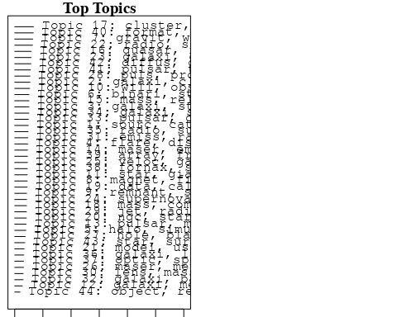

plotQuote(thoughts6, width = 30, main = "Topic 6")  
plotQuote(thoughts18, width = 30, main = "Topic 18")

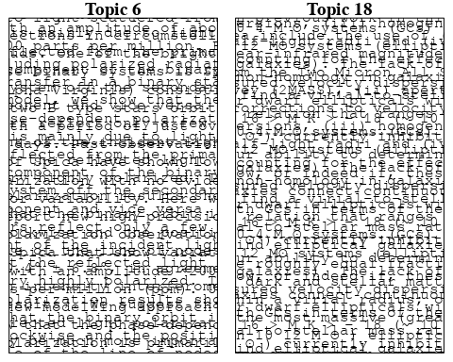

# Calculate and plot the correlation between topics  
mod.out.corr <- topicCorr(Research_topics)  
plot(mod.out.corr, cex = 1.5)  
  
  
# For each topic  
for (topic_num in 1:44) {  
 # Plot the word cloud  
 cloud(Research_topics, topic = topic_num, scale = c(2, 0.25))  
 Sys.sleep(2)  
}

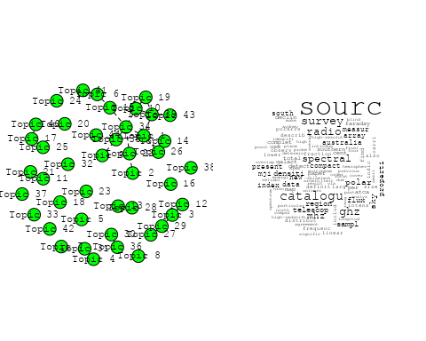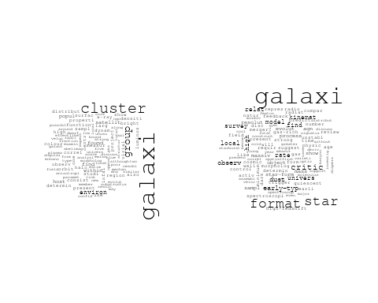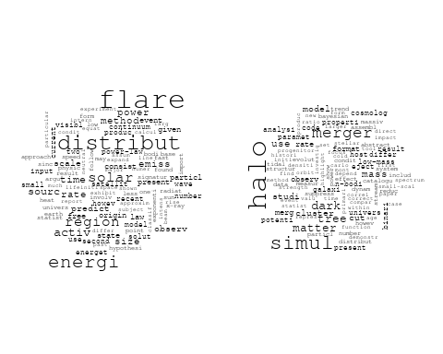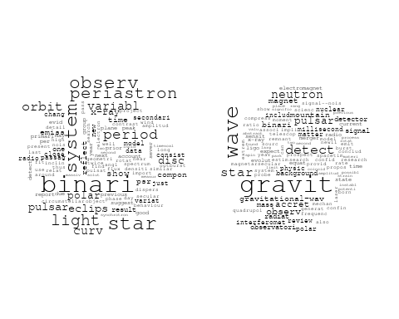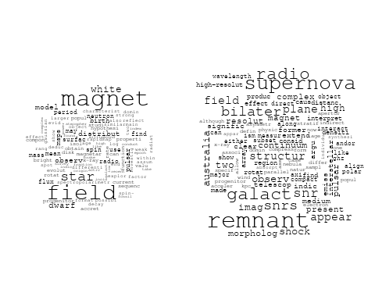

## Warning in wordcloud::wordcloud(words = vocab, freq = vec, max.words =  
## max.words, : instrument could not be fit on page. It will not be plotted.

## Warning in wordcloud::wordcloud(words = vocab, freq = vec, max.words =  
## max.words, : observatori could not be fit on page. It will not be plotted.

## Warning in wordcloud::wordcloud(words = vocab, freq = vec, max.words =  
## max.words, : observ could not be fit on page. It will not be plotted.

## Warning in wordcloud::wordcloud(words = vocab, freq = vec, max.words =  
## max.words, : discoveri could not be fit on page. It will not be plotted.

## Warning in wordcloud::wordcloud(words = vocab, freq = vec, max.words =  
## max.words, : detector could not be fit on page. It will not be plotted.

## Warning in wordcloud::wordcloud(words = vocab, freq = vec, max.words =  
## max.words, : will could not be fit on page. It will not be plotted.

## Warning in wordcloud::wordcloud(words = vocab, freq = vec, max.words =  
## max.words, : design could not be fit on page. It will not be plotted.

## Warning in wordcloud::wordcloud(words = vocab, freq = vec, max.words =  
## max.words, : survey could not be fit on page. It will not be plotted.

## Warning in wordcloud::wordcloud(words = vocab, freq = vec, max.words =  
## max.words, : telescop could not be fit on page. It will not be plotted.

## Warning in wordcloud::wordcloud(words = vocab, freq = vec, max.words =  
## max.words, : resolut could not be fit on page. It will not be plotted.

## Warning in wordcloud::wordcloud(words = vocab, freq = vec, max.words =  
## max.words, : capabl could not be fit on page. It will not be plotted.

## Warning in wordcloud::wordcloud(words = vocab, freq = vec, max.words =  
## max.words, : process could not be fit on page. It will not be plotted.

## Warning in wordcloud::wordcloud(words = vocab, freq = vec, max.words =  
## max.words, : futur could not be fit on page. It will not be plotted.

## Warning in wordcloud::wordcloud(words = vocab, freq = vec, max.words =  
## max.words, : includ could not be fit on page. It will not be plotted.

## Warning in wordcloud::wordcloud(words = vocab, freq = vec, max.words =  
## max.words, : sensit could not be fit on page. It will not be plotted.

## Warning in wordcloud::wordcloud(words = vocab, freq = vec, max.words =  
## max.words, : unexpect could not be fit on page. It will not be plotted.

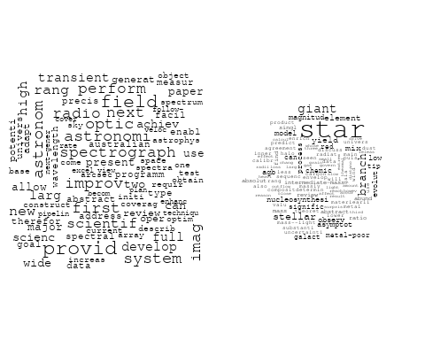

## Warning in wordcloud::wordcloud(words = vocab, freq = vec, max.words =  
## max.words, : system could not be fit on page. It will not be plotted.

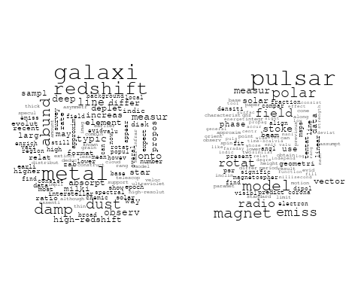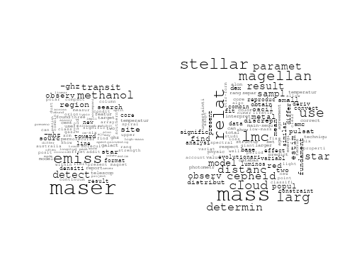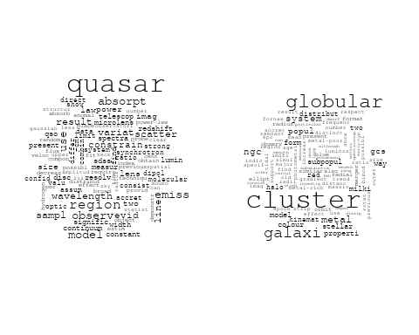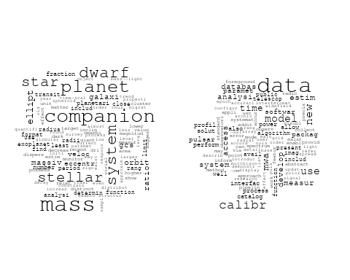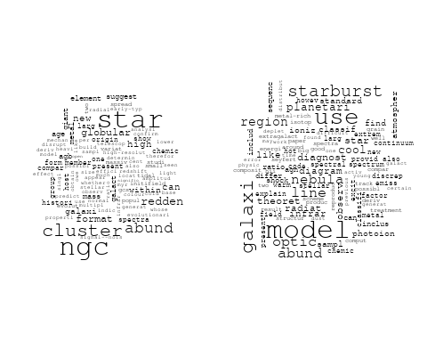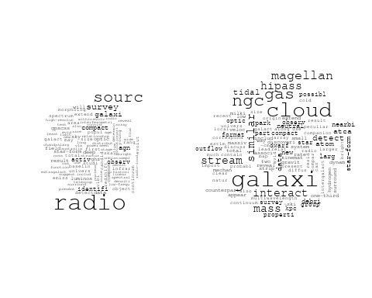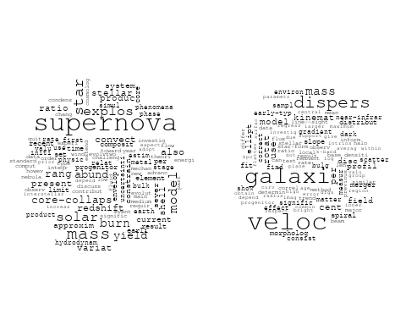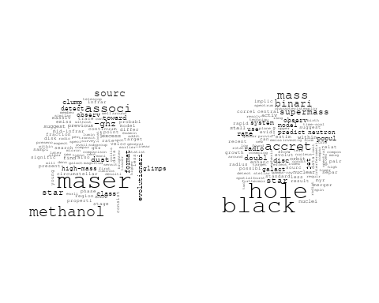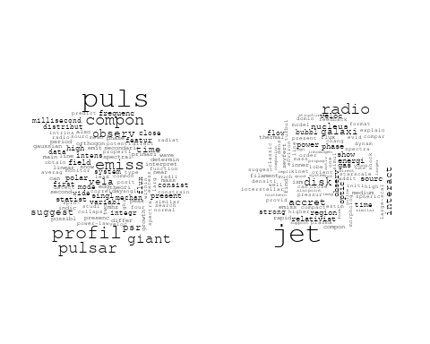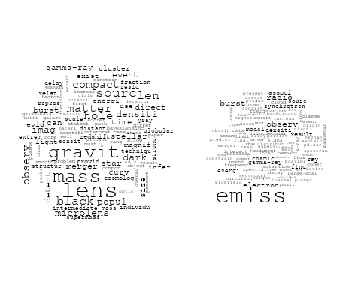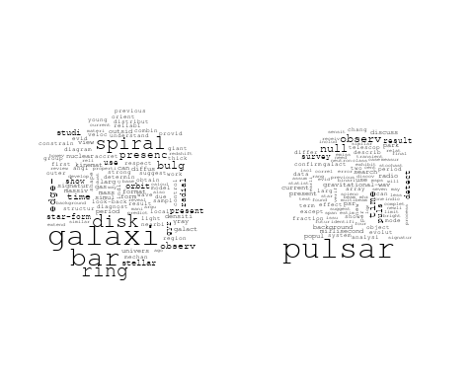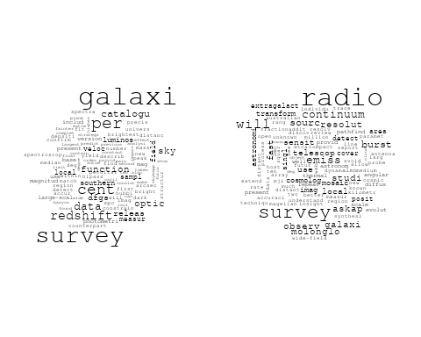

## Warning in wordcloud::wordcloud(words = vocab, freq = vec, max.words =  
## max.words, : ioniz could not be fit on page. It will not be plotted.

## Warning in wordcloud::wordcloud(words = vocab, freq = vec, max.words =  
## max.words, : spectroscopi could not be fit on page. It will not be plotted.

## Warning in wordcloud::wordcloud(words = vocab, freq = vec, max.words =  
## max.words, : galaxi could not be fit on page. It will not be plotted.

## Warning in wordcloud::wordcloud(words = vocab, freq = vec, max.words =  
## max.words, : line could not be fit on page. It will not be plotted.

## Warning in wordcloud::wordcloud(words = vocab, freq = vec, max.words =  
## max.words, : understand could not be fit on page. It will not be plotted.

## Warning in wordcloud::wordcloud(words = vocab, freq = vec, max.words =  
## max.words, : properti could not be fit on page. It will not be plotted.

## Warning in wordcloud::wordcloud(words = vocab, freq = vec, max.words =  
## max.words, : particular could not be fit on page. It will not be plotted.

## Warning in wordcloud::wordcloud(words = vocab, freq = vec, max.words =  
## max.words, : photometri could not be fit on page. It will not be plotted.

## Warning in wordcloud::wordcloud(words = vocab, freq = vec, max.words =  
## max.words, : optic could not be fit on page. It will not be plotted.

## Warning in wordcloud::wordcloud(words = vocab, freq = vec, max.words =  
## max.words, : variabl could not be fit on page. It will not be plotted.

## Warning in wordcloud::wordcloud(words = vocab, freq = vec, max.words =  
## max.words, : relativist could not be fit on page. It will not be plotted.

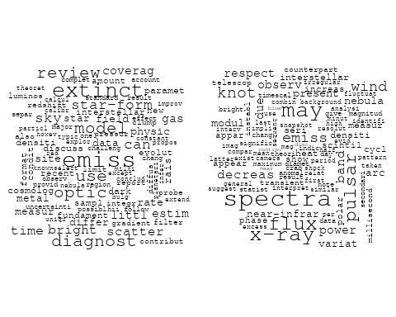

## Warning in wordcloud::wordcloud(words = vocab, freq = vec, max.words =  
## max.words, : galaxi could not be fit on page. It will not be plotted.

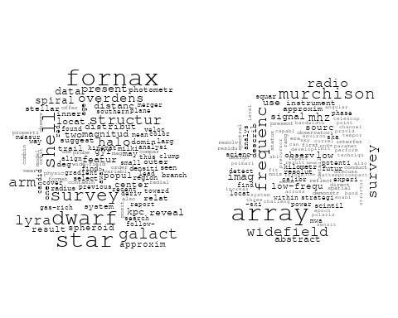

## Warning in wordcloud::wordcloud(words = vocab, freq = vec, max.words =  
## max.words, : format could not be fit on page. It will not be plotted.

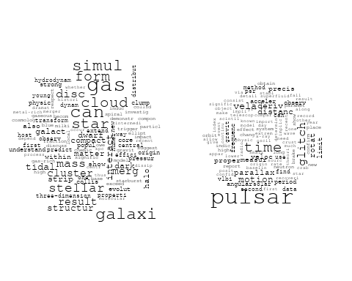

## Warning in wordcloud::wordcloud(words = vocab, freq = vec, max.words =  
## max.words, : protoplanetari could not be fit on page. It will not be plotted.

## Warning in wordcloud::wordcloud(words = vocab, freq = vec, max.words =  
## max.words, : disc could not be fit on page. It will not be plotted.

## Warning in wordcloud::wordcloud(words = vocab, freq = vec, max.words =  
## max.words, : effect could not be fit on page. It will not be plotted.

## Warning in wordcloud::wordcloud(words = vocab, freq = vec, max.words =  
## max.words, : emission-lin could not be fit on page. It will not be plotted.

## Warning in wordcloud::wordcloud(words = vocab, freq = vec, max.words =  
## max.words, : telescop could not be fit on page. It will not be plotted.

## Warning in wordcloud::wordcloud(words = vocab, freq = vec, max.words =  
## max.words, : emiss could not be fit on page. It will not be plotted.

## Warning in wordcloud::wordcloud(words = vocab, freq = vec, max.words =  
## max.words, : search could not be fit on page. It will not be plotted.

## Warning in wordcloud::wordcloud(words = vocab, freq = vec, max.words =  
## max.words, : pne could not be fit on page. It will not be plotted.

## Warning in wordcloud::wordcloud(words = vocab, freq = vec, max.words =  
## max.words, : planetari could not be fit on page. It will not be plotted.

## Warning in wordcloud::wordcloud(words = vocab, freq = vec, max.words =  
## max.words, : large-scal could not be fit on page. It will not be plotted.

## Warning in wordcloud::wordcloud(words = vocab, freq = vec, max.words =  
## max.words, : previous could not be fit on page. It will not be plotted.

## Warning in wordcloud::wordcloud(words = vocab, freq = vec, max.words =  
## max.words, : new could not be fit on page. It will not be plotted.

## Warning in wordcloud::wordcloud(words = vocab, freq = vec, max.words =  
## max.words, : base could not be fit on page. It will not be plotted.

## Warning in wordcloud::wordcloud(words = vocab, freq = vec, max.words =  
## max.words, : upper could not be fit on page. It will not be plotted.

## Warning in wordcloud::wordcloud(words = vocab, freq = vec, max.words =  
## max.words, : line could not be fit on page. It will not be plotted.

## Warning in wordcloud::wordcloud(words = vocab, freq = vec, max.words =  
## max.words, : classif could not be fit on page. It will not be plotted.

## Warning in wordcloud::wordcloud(words = vocab, freq = vec, max.words =  
## max.words, : shell could not be fit on page. It will not be plotted.

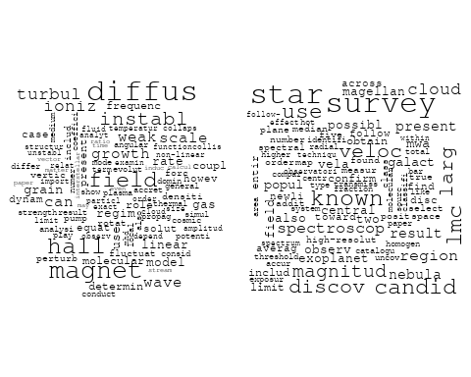

# Get the topic proportions for each document  
topic_proportions <- Research_topics$theta  
  
# Find the index of the topic with the highest proportion for each document  
# This will be the topic that each document is most likely to belong to  
max_topic_idx <- apply(topic_proportions, 1, which.max)  
  
# Add this as a new column to your data  
data_independent$topic <- max_topic_idx  
  
  
  
# Define the intervals  
intervals <- c('1824_1899', '1900_1964', '1965_1974', '1975_1984', '1985_1994', '1995_1999', '2000_2004', '2005_2009', '2010_2014', '2015_2019', '2020_2022')  
colors <- c('pink', 'blue', 'purple', 'yellow', 'green', 'pink', 'orange', 'violet', 'green', 'blue', 'pink')  
  
# Loop through the intervals and plot  
for(i in seq_along(intervals)){  
 # Filter data for when the pub_interval is equal to 1  
 data_filtered <- data_independent[data_independent[[paste0('pub_interval_', intervals[i])]] == 1,]  
   
 # Make the histogram  
   
 p <- ggplot(data_filtered, aes(x = topic)) +  
 geom_histogram(binwidth = 1, fill = colors[i], color = "black") +  
 xlab("Topic") +  
 ylab("Count") +  
 ggtitle(paste0("Topics from year ", gsub("_", " to ", intervals[i])))  
   
 print(p)  
}

