DE topic models

Charlie J. Gomez, Harshvardhan Singh

2023-08-29

library('stm')

## stm v1.3.6 successfully loaded. See ?stm for help.   
## Papers, resources, and other materials at structuraltopicmodel.com

library(dplyr)

##   
## Attaching package: 'dplyr'

## The following objects are masked from 'package:stats':  
##   
## filter, lag

## The following objects are masked from 'package:base':  
##   
## intersect, setdiff, setequal, union

library(stringr)  
library(wordcloud)

## Loading required package: RColorBrewer

#Read csv file  
data = read.csv("preprocessed_data_Jul14.csv")  
  
  
##Topic generation for DE (in collaboration) publications  
  
data_collab <- data[data[["DE"]] != 0,]  
  
# Save the original title data for future use  
data_collab$original_concatenated_title_abstract <- data_collab$concatenated_title_abstract  
  
#pre-processing the titles using textProcessor from the stm package  
processed_text <- textProcessor(data_collab$concatenated_title_abstract, metadata = data_collab)

## Building corpus...   
## Converting to Lower Case...   
## Removing punctuation...   
## Removing stopwords...   
## Removing numbers...   
## Stemming...   
## Creating Output...

# Further prepare the data by removing low-frequency terms  
out_text <- prepDocuments(processed_text$documents, processed_text$vocab, processed_text$meta)

## Removing 4638 of 16647 terms (4638 of 476346 tokens) due to frequency   
## Your corpus now has 5572 documents, 12009 terms and 471708 tokens.

docs_text <- out_text$documents  
vocab_text <- out_text$vocab  
meta_text <- out_text$meta  
  
  
#Prepare data  
plotRemoved(processed_text$documents, lower.thresh = seq(1, 200, by = 100))

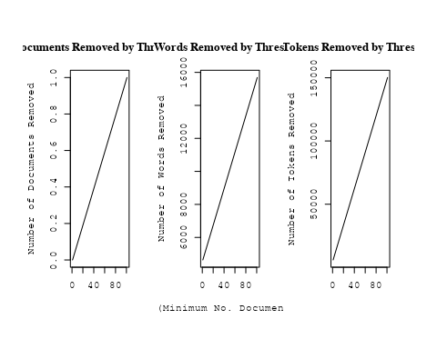

out_text <- prepDocuments(processed_text$documents, processed_text$vocab, processed_text$meta, lower.thresh = 8)

## Removing 13112 of 16647 terms (32265 of 476346 tokens) due to frequency   
## Your corpus now has 5572 documents, 3535 terms and 444081 tokens.

str(out_text$meta)

## 'data.frame': 5572 obs. of 39 variables:  
## $ concept_id : chr "https://openalex.org/C44870925" "https://openalex.org/C44870925" "https://openalex.org/C44870925" "https://openalex.org/C1276947" ...  
## $ work_id : chr "https://openalex.org/W2073719541" "https://openalex.org/W3102133339" "https://openalex.org/W3101291558" "https://openalex.org/W2153493790" ...  
## $ publication_year : int 1997 2006 2005 2011 1997 2014 2021 2005 2005 2017 ...  
## $ title : chr "Effects of Disks on Gravitational Lensing by Spiral Galaxies" "The hierarchical formation of the brightest cluster galaxies" "The Formation of Fossil Galaxy Groups in the hierarchical Universe" "Effects of the explosion asymmetry and viewing angle on the Type Ia supernova colour and luminosity calibration" ...  
## $ paperabstract : chr "Gravitational lensing of a quasar by a spiral galaxy should often be accompanied by damped Lyα absorption and d"| __truncated__ "We use semi-analytic techniques to study the formation and evolution of brightest cluster galaxies (BCGs). We s"| __truncated__ "We use a set of 12 high-resolution N-body/hydrodynamical simulations in the ΛCDM cosmology to investigate the o"| __truncated__ "Phenomenological relations exist between the peak luminosity and other observables of type Ia supernovae (SNe I"| __truncated__ ...  
## $ country : chr "US DE" "DE DE DE DE" "GB DE" "JP DE JP DE" ...  
## $ year_concept : chr "1997+https://openalex.org/C44870925" "2006+https://openalex.org/C44870925" "2005+https://openalex.org/C44870925" "2011+https://openalex.org/C1276947" ...  
## $ concatenated_title_abstract : chr "Effects of Disks on Gravitational Lensing by Spiral Galaxies Gravitational lensing of a quasar by a spiral gala"| __truncated__ "The hierarchical formation of the brightest cluster galaxies We use semi-analytic techniques to study the forma"| __truncated__ "The Formation of Fossil Galaxy Groups in the hierarchical Universe We use a set of 12 high-resolution N-body/hy"| __truncated__ "Effects of the explosion asymmetry and viewing angle on the Type Ia supernova colour and luminosity calibration"| __truncated__ ...  
## $ US : num 50 0 0 0 0 0 0 50 0 0 ...  
## $ IN : num 0 0 0 0 0 0 0 0 0 0 ...  
## $ DE : num 50 100 50 50 100 100 100 50 50 100 ...  
## $ CH : num 0 0 0 0 0 0 0 0 0 0 ...  
## $ GB : num 0 0 50 0 0 0 0 0 0 0 ...  
## $ CN : num 0 0 0 0 0 0 0 0 0 0 ...  
## $ FR : num 0 0 0 0 0 0 0 0 0 0 ...  
## $ IT : num 0 0 0 0 0 0 0 0 0 0 ...  
## $ RU : num 0 0 0 0 0 0 0 0 0 0 ...  
## $ CA : num 0 0 0 0 0 0 0 0 0 0 ...  
## $ NL : num 0 0 0 0 0 0 0 0 0 0 ...  
## $ AU : num 0 0 0 0 0 0 0 0 50 0 ...  
## $ JP : num 0 0 0 50 0 0 0 0 0 0 ...  
## $ ES : num 0 0 0 0 0 0 0 0 0 0 ...  
## $ IL : num 0 0 0 0 0 0 0 0 0 0 ...  
## $ Americas : num 0 0 0 0 0 0 0 0 0 0 ...  
## $ Europe : num 0 0 0 0 0 0 0 0 0 0 ...  
## $ Africa : num 0 0 0 0 0 0 0 0 0 0 ...  
## $ AsiaAndOceania : num 0 0 0 0 0 0 0 0 0 0 ...  
## $ pub_interval_2020_2022 : int 0 0 0 0 0 0 1 0 0 0 ...  
## $ pub_interval_2015_2019 : int 0 0 0 0 0 0 0 0 0 1 ...  
## $ pub_interval_2010_2014 : int 0 0 0 1 0 1 0 0 0 0 ...  
## $ pub_interval_2005_2009 : int 0 1 1 0 0 0 0 1 1 0 ...  
## $ pub_interval_2000_2004 : int 0 0 0 0 0 0 0 0 0 0 ...  
## $ pub_interval_1995_1999 : int 1 0 0 0 1 0 0 0 0 0 ...  
## $ pub_interval_1985_1994 : int 0 0 0 0 0 0 0 0 0 0 ...  
## $ pub_interval_1975_1984 : int 0 0 0 0 0 0 0 0 0 0 ...  
## $ pub_interval_1965_1974 : int 0 0 0 0 0 0 0 0 0 0 ...  
## $ pub_interval_1900_1964 : int 0 0 0 0 0 0 0 0 0 0 ...  
## $ pub_interval_1824_1899 : int 0 0 0 0 0 0 0 0 0 0 ...  
## $ original_concatenated_title_abstract: chr "Effects of Disks on Gravitational Lensing by Spiral Galaxies Gravitational lensing of a quasar by a spiral gala"| __truncated__ "The hierarchical formation of the brightest cluster galaxies We use semi-analytic techniques to study the forma"| __truncated__ "The Formation of Fossil Galaxy Groups in the hierarchical Universe We use a set of 12 high-resolution N-body/hy"| __truncated__ "Effects of the explosion asymmetry and viewing angle on the Type Ia supernova colour and luminosity calibration"| __truncated__ ...

# Initialize an empty formula string  
prevalence_formula_str <- "~"  
  
# Define the publication intervals  
pub_intervals <- c("pub_interval_2020_2022", "pub_interval_2015_2019", "pub_interval_2010_2014",   
 "pub_interval_2005_2009", "pub_interval_2000_2004", "pub_interval_1995_1999",  
 "pub_interval_1985_1994", "pub_interval_1975_1984", "pub_interval_1965_1974",  
 "pub_interval_1900_1964", "pub_interval_1824_1899")  
  
# Add each publication interval to the formula string  
for (interval in pub_intervals) {  
 # add an if statement to handle the first addition (without '+')  
 if (prevalence_formula_str == "~") {  
 prevalence_formula_str <- paste(prevalence_formula_str, interval)  
 } else {  
 prevalence_formula_str <- paste(prevalence_formula_str, "+", interval)  
 }  
}  
  
  
# Convert the string to a formula  
prevalence_formula <- as.formula(prevalence_formula_str)  
print(prevalence_formula)

## ~pub_interval_2020_2022 + pub_interval_2015_2019 + pub_interval_2010_2014 +   
## pub_interval_2005_2009 + pub_interval_2000_2004 + pub_interval_1995_1999 +   
## pub_interval_1985_1994 + pub_interval_1975_1984 + pub_interval_1965_1974 +   
## pub_interval_1900_1964 + pub_interval_1824_1899

# Run STM model  
Research_topics <- stm(documents = out_text$documents,   
 vocab = out_text$vocab,   
 K = 44,   
 prevalence = prevalence_formula,   
 data = out_text$meta,   
 init.type = "Spectral",  
 max.em.its = 1000,  
 gamma.prior = 'L1')

## Beginning Spectral Initialization   
## Calculating the gram matrix...  
## Finding anchor words...  
## ............................................  
## Recovering initialization...  
## ...................................  
## Initialization complete.  
## .....................................................................................................  
## Completed E-Step (6 seconds).   
## Completed M-Step.   
## Completing Iteration 1 (approx. per word bound = -6.742)   
## .....................................................................................................  
## Completed E-Step (6 seconds).   
## Completed M-Step.   
## Completing Iteration 2 (approx. per word bound = -6.495, relative change = 3.657e-02)   
## .....................................................................................................  
## Completed E-Step (5 seconds).   
## Completed M-Step.   
## Completing Iteration 3 (approx. per word bound = -6.431, relative change = 9.790e-03)   
## .....................................................................................................  
## Completed E-Step (5 seconds).   
## Completed M-Step.   
## Completing Iteration 4 (approx. per word bound = -6.405, relative change = 4.157e-03)   
## .....................................................................................................  
## Completed E-Step (5 seconds).   
## Completed M-Step.   
## Completing Iteration 5 (approx. per word bound = -6.390, relative change = 2.284e-03)   
## Topic 1: magnetospher, jupit, measur, ring, data   
## Topic 2: radiat, emiss, sourc, ioniz, photon   
## Topic 3: orbit, period, variabl, star, observ   
## Topic 4: hole, black, galaxi, supermass, host   
## Topic 5: region, use, method, estim, determin   
## Topic 6: per, cent, nova, fraction, mass   
## Topic 7: cluster, star, stellar, ngc, popul   
## Topic 8: supernova, explos, remnant, type, model   
## Topic 9: flare, neutrino, observ, flux, event   
## Topic 10: solar, scale, spectrum, measur, data   
## Topic 11: galaxi, emiss, imag, radio, seyfert   
## Topic 12: imf, initi, stellar, ucd, star   
## Topic 13: galaxi, format, star, massiv, popul   
## Topic 14: halo, dark, matter, mass, galaxi   
## Topic 15: star, dust, abund, giant, observ   
## Topic 16: turbul, pressur, field, time, gas   
## Topic 17: galact, way, milki, energi, spectrum   
## Topic 18: planet, format, system, disk, star   
## Topic 19: star, mass, binari, accret, neutron   
## Topic 20: gravit, wave, time, detect, observ   
## Topic 21: simul, model, dark, matter, cosmolog   
## Topic 22: pulsar, neutron, star, radio, magnet   
## Topic 23: galaxi, disc, rotat, kinemat, angular   
## Topic 24: field, magnet, observ, review, astrophys   
## Topic 25: x-ray, sourc, luminos, emiss, detect   
## Topic 26: dwarf, binari, system, companion, white   
## Topic 27: redshift, galaxi, quasar, survey, sampl   
## Topic 28: disk, accret, can, binari, rate   
## Topic 29: star, magnet, field, stellar, rotat   
## Topic 30: lens, imag, model, gravit, mass   
## Topic 31: type, light, observ, curv, luminos   
## Topic 32: radio, cluster, galaxi, x-ray, observ   
## Topic 33: agn, gas, feedback, galact, activ   
## Topic 34: metal, gas, medium, galaxi, enrich   
## Topic 35: galaxi, mass, stellar, function, relat   
## Topic 36: galaxi, satellit, spiral, veloc, kpc   
## Topic 37: line, veloc, abund, ratio, model   
## Topic 38: cluster, galaxi, mass, globular, function   
## Topic 39: cosmic, ray, energi, acceler, particl   
## Topic 40: gamma-ray, telescop, burst, grb, use   
## Topic 41: univers, year, galaxi, young, star   
## Topic 42: jet, radio, activ, nuclei, observ   
## Topic 43: molecular, cloud, emiss, gas, line   
## Topic 44: publish, astronom, first, structur, observ   
## .....................................................................................................  
## Completed E-Step (4 seconds).   
## Completed M-Step.   
## Completing Iteration 6 (approx. per word bound = -6.381, relative change = 1.462e-03)   
## .....................................................................................................  
## Completed E-Step (4 seconds).   
## Completed M-Step.   
## Completing Iteration 7 (approx. per word bound = -6.374, relative change = 1.012e-03)   
## .....................................................................................................  
## Completed E-Step (4 seconds).   
## Completed M-Step.   
## Completing Iteration 8 (approx. per word bound = -6.370, relative change = 7.397e-04)   
## .....................................................................................................  
## Completed E-Step (4 seconds).   
## Completed M-Step.   
## Completing Iteration 9 (approx. per word bound = -6.366, relative change = 5.626e-04)   
## .....................................................................................................  
## Completed E-Step (4 seconds).   
## Completed M-Step.   
## Completing Iteration 10 (approx. per word bound = -6.363, relative change = 4.794e-04)   
## Topic 1: magnetospher, measur, jupit, ring, data   
## Topic 2: radiat, emiss, ioniz, electron, photon   
## Topic 3: orbit, period, star, variabl, observ   
## Topic 4: hole, black, supermass, accret, galaxi   
## Topic 5: use, estim, method, region, determin   
## Topic 6: per, cent, fraction, nova, mass   
## Topic 7: star, cluster, ngc, stellar, popul   
## Topic 8: supernova, explos, remnant, type, ejecta   
## Topic 9: flare, neutrino, flux, observ, event   
## Topic 10: solar, data, spectrum, scale, measur   
## Topic 11: galaxi, emiss, imag, seyfert, ngc   
## Topic 12: imf, stellar, initi, mass, star   
## Topic 13: galaxi, format, star, popul, massiv   
## Topic 14: halo, dark, matter, mass, simul   
## Topic 15: star, dust, abund, giant, observ   
## Topic 16: turbul, field, pressur, collaps, magnet   
## Topic 17: galact, way, energi, milki, spectrum   
## Topic 18: planet, format, system, planetari, solar   
## Topic 19: star, binari, mass, neutron, accret   
## Topic 20: gravit, wave, detect, time, pulsar   
## Topic 21: simul, model, matter, dark, cosmolog   
## Topic 22: pulsar, neutron, star, rotat, radio   
## Topic 23: galaxi, disc, kinemat, rotat, angular   
## Topic 24: field, magnet, review, observ, astrophys   
## Topic 25: x-ray, sourc, luminos, kev, emiss   
## Topic 26: dwarf, system, binari, companion, white   
## Topic 27: redshift, galaxi, survey, quasar, sampl   
## Topic 28: disk, accret, can, rate, binari   
## Topic 29: star, magnet, field, stellar, rotat   
## Topic 30: lens, imag, model, gravit, galaxi   
## Topic 31: type, light, curv, observ, luminos   
## Topic 32: radio, cluster, galaxi, observ, relic   
## Topic 33: gas, agn, feedback, galact, cool   
## Topic 34: gas, metal, medium, format, observ   
## Topic 35: galaxi, mass, stellar, function, relat   
## Topic 36: galaxi, satellit, spiral, stream, kpc   
## Topic 37: line, veloc, ratio, abund, model   
## Topic 38: cluster, mass, galaxi, globular, function   
## Topic 39: cosmic, ray, acceler, particl, energi   
## Topic 40: burst, telescop, gamma-ray, grb, detect   
## Topic 41: univers, galaxi, year, report, star   
## Topic 42: radio, jet, activ, observ, nuclei   
## Topic 43: molecular, cloud, emiss, region, gas   
## Topic 44: publish, one, astronom, first, observ   
## .....................................................................................................  
## Completed E-Step (5 seconds).   
## Completed M-Step.   
## Completing Iteration 11 (approx. per word bound = -6.360, relative change = 4.060e-04)   
## .....................................................................................................  
## Completed E-Step (5 seconds).   
## Completed M-Step.   
## Completing Iteration 12 (approx. per word bound = -6.358, relative change = 3.583e-04)   
## .....................................................................................................  
## Completed E-Step (5 seconds).   
## Completed M-Step.   
## Completing Iteration 13 (approx. per word bound = -6.356, relative change = 3.215e-04)   
## .....................................................................................................  
## Completed E-Step (5 seconds).   
## Completed M-Step.   
## Completing Iteration 14 (approx. per word bound = -6.354, relative change = 2.979e-04)   
## .....................................................................................................  
## Completed E-Step (5 seconds).   
## Completed M-Step.   
## Completing Iteration 15 (approx. per word bound = -6.352, relative change = 2.628e-04)   
## Topic 1: dust, magnetospher, measur, ring, jupit   
## Topic 2: radiat, emiss, electron, ioniz, model   
## Topic 3: orbit, period, star, variabl, observ   
## Topic 4: hole, black, mass, supermass, accret   
## Topic 5: use, estim, method, measur, determin   
## Topic 6: per, cent, fraction, nova, mass   
## Topic 7: star, ngc, age, popul, stellar   
## Topic 8: supernova, explos, type, remnant, ejecta   
## Topic 9: flare, flux, neutrino, observ, event   
## Topic 10: solar, spectrum, scale, coron, data   
## Topic 11: galaxi, emiss, ngc, seyfert, starburst   
## Topic 12: imf, mass, stellar, initi, star   
## Topic 13: galaxi, format, star, popul, stellar   
## Topic 14: halo, dark, matter, mass, simul   
## Topic 15: star, abund, dust, chemic, element   
## Topic 16: turbul, field, magnet, pressur, instabl   
## Topic 17: galact, energi, spectrum, observ, gamma-ray   
## Topic 18: planet, format, system, planetari, solar   
## Topic 19: star, binari, mass, neutron, accret   
## Topic 20: gravit, wave, detect, time, pulsar   
## Topic 21: simul, model, cosmolog, densiti, energi   
## Topic 22: pulsar, neutron, star, spin, rotat   
## Topic 23: disc, galaxi, kinemat, rotat, bulg   
## Topic 24: field, magnet, review, observ, discuss   
## Topic 25: x-ray, sourc, luminos, kev, emiss   
## Topic 26: dwarf, system, binari, companion, white   
## Topic 27: redshift, galaxi, survey, sampl, quasar   
## Topic 28: disk, accret, rate, flow, can   
## Topic 29: star, magnet, field, stellar, rotat   
## Topic 30: lens, imag, gravit, model, galaxi   
## Topic 31: type, light, curv, observ, luminos   
## Topic 32: radio, galaxi, cluster, observ, relic   
## Topic 33: gas, feedback, agn, galact, cool   
## Topic 34: gas, metal, medium, format, densiti   
## Topic 35: galaxi, mass, stellar, relat, function   
## Topic 36: galaxi, satellit, way, milki, spiral   
## Topic 37: line, veloc, ratio, model, spectra   
## Topic 38: cluster, mass, globular, galaxi, function   
## Topic 39: cosmic, ray, acceler, particl, energi   
## Topic 40: burst, telescop, gamma-ray, grb, sky   
## Topic 41: univers, galaxi, year, report, object   
## Topic 42: radio, jet, activ, sourc, observ   
## Topic 43: molecular, cloud, emiss, region, core   
## Topic 44: observ, astronom, one, first, group   
## .....................................................................................................  
## Completed E-Step (5 seconds).   
## Completed M-Step.   
## Completing Iteration 16 (approx. per word bound = -6.351, relative change = 2.425e-04)   
## .....................................................................................................  
## Completed E-Step (5 seconds).   
## Completed M-Step.   
## Completing Iteration 17 (approx. per word bound = -6.349, relative change = 2.341e-04)   
## .....................................................................................................  
## Completed E-Step (5 seconds).   
## Completed M-Step.   
## Completing Iteration 18 (approx. per word bound = -6.348, relative change = 2.180e-04)   
## .....................................................................................................  
## Completed E-Step (5 seconds).   
## Completed M-Step.   
## Completing Iteration 19 (approx. per word bound = -6.347, relative change = 1.991e-04)   
## .....................................................................................................  
## Completed E-Step (5 seconds).   
## Completed M-Step.   
## Completing Iteration 20 (approx. per word bound = -6.346, relative change = 1.906e-04)   
## Topic 1: dust, measur, magnetospher, ring, impact   
## Topic 2: radiat, emiss, electron, ioniz, model   
## Topic 3: orbit, period, star, variabl, observ   
## Topic 4: hole, black, mass, accret, supermass   
## Topic 5: use, measur, estim, method, determin   
## Topic 6: per, cent, fraction, rate, nova   
## Topic 7: star, age, ngc, popul, stellar   
## Topic 8: supernova, explos, type, remnant, ejecta   
## Topic 9: flare, flux, neutrino, observ, event   
## Topic 10: solar, coron, spectrum, scale, data   
## Topic 11: galaxi, emiss, ngc, seyfert, starburst   
## Topic 12: mass, stellar, imf, function, initi   
## Topic 13: galaxi, format, star, popul, stellar   
## Topic 14: halo, dark, matter, mass, simul   
## Topic 15: abund, star, dust, chemic, element   
## Topic 16: field, turbul, magnet, instabl, pressur   
## Topic 17: galact, energi, spectrum, observ, gamma-ray   
## Topic 18: planet, format, system, planetari, solar   
## Topic 19: star, binari, mass, neutron, accret   
## Topic 20: gravit, wave, detect, time, pulsar   
## Topic 21: simul, model, densiti, cosmolog, energi   
## Topic 22: pulsar, neutron, star, spin, rotat   
## Topic 23: disc, galaxi, kinemat, rotat, bulg   
## Topic 24: field, review, physic, observ, discuss   
## Topic 25: x-ray, sourc, luminos, kev, emiss   
## Topic 26: dwarf, system, binari, companion, white   
## Topic 27: redshift, galaxi, sampl, survey, quasar   
## Topic 28: disk, accret, rate, can, flow   
## Topic 29: star, magnet, field, stellar, rotat   
## Topic 30: lens, imag, gravit, galaxi, model   
## Topic 31: type, light, curv, observ, spectra   
## Topic 32: radio, galaxi, cluster, observ, large-scal   
## Topic 33: gas, feedback, cool, galact, accret   
## Topic 34: gas, metal, medium, densiti, molecular   
## Topic 35: galaxi, mass, stellar, relat, function   
## Topic 36: galaxi, way, milki, satellit, galact   
## Topic 37: line, veloc, absorpt, ratio, profil   
## Topic 38: cluster, mass, globular, galaxi, distribut   
## Topic 39: cosmic, ray, acceler, particl, energi   
## Topic 40: telescop, burst, gamma-ray, grb, sky   
## Topic 41: galaxi, univers, year, report, discoveri   
## Topic 42: radio, jet, activ, sourc, observ   
## Topic 43: molecular, cloud, emiss, region, core   
## Topic 44: astronom, first, observ, group, one   
## .....................................................................................................  
## Completed E-Step (5 seconds).   
## Completed M-Step.   
## Completing Iteration 21 (approx. per word bound = -6.344, relative change = 1.714e-04)   
## .....................................................................................................  
## Completed E-Step (5 seconds).   
## Completed M-Step.   
## Completing Iteration 22 (approx. per word bound = -6.343, relative change = 1.608e-04)   
## .....................................................................................................  
## Completed E-Step (5 seconds).   
## Completed M-Step.   
## Completing Iteration 23 (approx. per word bound = -6.343, relative change = 1.462e-04)   
## .....................................................................................................  
## Completed E-Step (5 seconds).   
## Completed M-Step.   
## Completing Iteration 24 (approx. per word bound = -6.342, relative change = 1.376e-04)   
## .....................................................................................................  
## Completed E-Step (5 seconds).   
## Completed M-Step.   
## Completing Iteration 25 (approx. per word bound = -6.341, relative change = 1.383e-04)   
## Topic 1: dust, measur, magnetospher, observ, ring   
## Topic 2: radiat, emiss, electron, model, ioniz   
## Topic 3: orbit, star, period, variabl, observ   
## Topic 4: hole, black, mass, accret, supermass   
## Topic 5: use, measur, estim, method, determin   
## Topic 6: per, cent, fraction, rate, distribut   
## Topic 7: star, age, popul, ngc, stellar   
## Topic 8: supernova, explos, type, remnant, ejecta   
## Topic 9: flare, neutrino, flux, observ, event   
## Topic 10: solar, coron, scale, spectrum, region   
## Topic 11: galaxi, emiss, ngc, seyfert, dust   
## Topic 12: mass, function, stellar, initi, imf   
## Topic 13: galaxi, format, star, stellar, popul   
## Topic 14: halo, dark, matter, mass, simul   
## Topic 15: abund, star, chemic, metal, dust   
## Topic 16: field, turbul, magnet, instabl, pressur   
## Topic 17: energi, galact, spectrum, observ, gamma-ray   
## Topic 18: planet, format, system, planetari, exoplanet   
## Topic 19: star, binari, mass, neutron, observ   
## Topic 20: gravit, wave, detect, time, pulsar   
## Topic 21: model, simul, densiti, cosmolog, numer   
## Topic 22: pulsar, neutron, star, spin, rotat   
## Topic 23: disc, galaxi, kinemat, rotat, bulg   
## Topic 24: physic, review, discuss, observ, astrophys   
## Topic 25: x-ray, sourc, luminos, kev, emiss   
## Topic 26: dwarf, system, binari, companion, white   
## Topic 27: redshift, galaxi, sampl, survey, quasar   
## Topic 28: disk, accret, rate, can, inner   
## Topic 29: star, magnet, field, stellar, rotat   
## Topic 30: lens, imag, gravit, galaxi, len   
## Topic 31: type, light, spectra, curv, observ   
## Topic 32: radio, galaxi, cluster, observ, large-scal   
## Topic 33: gas, feedback, cool, star, galact   
## Topic 34: gas, metal, medium, densiti, molecular   
## Topic 35: galaxi, mass, stellar, relat, function   
## Topic 36: way, milki, galaxi, satellit, galact   
## Topic 37: line, veloc, absorpt, profil, ratio   
## Topic 38: cluster, globular, mass, galaxi, system   
## Topic 39: cosmic, ray, acceler, particl, energi   
## Topic 40: telescop, burst, gamma-ray, grb, imag   
## Topic 41: galaxi, univers, year, report, discoveri   
## Topic 42: radio, jet, activ, sourc, observ   
## Topic 43: molecular, cloud, emiss, region, core   
## Topic 44: astronom, first, group, observ, one   
## .....................................................................................................  
## Completed E-Step (5 seconds).   
## Completed M-Step.   
## Completing Iteration 26 (approx. per word bound = -6.340, relative change = 1.348e-04)   
## .....................................................................................................  
## Completed E-Step (5 seconds).   
## Completed M-Step.   
## Completing Iteration 27 (approx. per word bound = -6.339, relative change = 1.208e-04)   
## .....................................................................................................  
## Completed E-Step (4 seconds).   
## Completed M-Step.   
## Completing Iteration 28 (approx. per word bound = -6.338, relative change = 1.233e-04)   
## .....................................................................................................  
## Completed E-Step (5 seconds).   
## Completed M-Step.   
## Completing Iteration 29 (approx. per word bound = -6.338, relative change = 1.229e-04)   
## .....................................................................................................  
## Completed E-Step (4 seconds).   
## Completed M-Step.   
## Completing Iteration 30 (approx. per word bound = -6.337, relative change = 9.329e-05)   
## Topic 1: dust, comet, measur, magnetospher, observ   
## Topic 2: radiat, emiss, electron, model, ioniz   
## Topic 3: orbit, star, period, variabl, observ   
## Topic 4: hole, black, mass, accret, supermass   
## Topic 5: use, measur, estim, method, data   
## Topic 6: per, cent, fraction, rate, distribut   
## Topic 7: star, age, popul, ngc, stellar   
## Topic 8: supernova, explos, type, remnant, ejecta   
## Topic 9: flare, neutrino, flux, observ, event   
## Topic 10: solar, coron, scale, spectrum, region   
## Topic 11: galaxi, emiss, dust, ngc, seyfert   
## Topic 12: mass, function, stellar, star, initi   
## Topic 13: galaxi, format, star, stellar, popul   
## Topic 14: halo, dark, matter, mass, simul   
## Topic 15: abund, star, metal, chemic, element   
## Topic 16: turbul, field, magnet, pressur, instabl   
## Topic 17: energi, spectrum, gamma-ray, galact, observ   
## Topic 18: planet, format, planetari, system, star   
## Topic 19: star, binari, mass, neutron, observ   
## Topic 20: gravit, wave, detect, time, pulsar   
## Topic 21: model, simul, densiti, numer, energi   
## Topic 22: pulsar, neutron, star, spin, rotat   
## Topic 23: disc, kinemat, galaxi, rotat, bulg   
## Topic 24: physic, review, observ, discuss, astrophys   
## Topic 25: x-ray, sourc, luminos, kev, emiss   
## Topic 26: dwarf, system, companion, binari, white   
## Topic 27: redshift, galaxi, sampl, survey, quasar   
## Topic 28: disk, accret, rate, can, inner   
## Topic 29: star, magnet, field, stellar, rotat   
## Topic 30: lens, imag, gravit, galaxi, len   
## Topic 31: type, light, spectra, curv, observ   
## Topic 32: radio, galaxi, cluster, observ, large-scal   
## Topic 33: gas, feedback, cool, star, format   
## Topic 34: gas, metal, densiti, molecular, medium   
## Topic 35: galaxi, mass, stellar, relat, luminos   
## Topic 36: way, milki, galaxi, satellit, galact   
## Topic 37: line, veloc, absorpt, profil, model   
## Topic 38: cluster, globular, mass, system, galaxi   
## Topic 39: cosmic, ray, acceler, particl, energi   
## Topic 40: telescop, burst, imag, grb, gamma-ray   
## Topic 41: galaxi, univers, year, report, discoveri   
## Topic 42: radio, jet, sourc, activ, observ   
## Topic 43: molecular, region, cloud, emiss, core   
## Topic 44: group, astronom, first, one, observ   
## .....................................................................................................  
## Completed E-Step (4 seconds).   
## Completed M-Step.   
## Completing Iteration 31 (approx. per word bound = -6.336, relative change = 1.288e-04)   
## .....................................................................................................  
## Completed E-Step (5 seconds).   
## Completed M-Step.   
## Completing Iteration 32 (approx. per word bound = -6.336, relative change = 9.667e-05)   
## .....................................................................................................  
## Completed E-Step (5 seconds).   
## Completed M-Step.   
## Completing Iteration 33 (approx. per word bound = -6.335, relative change = 6.680e-05)   
## .....................................................................................................  
## Completed E-Step (5 seconds).   
## Completed M-Step.   
## Completing Iteration 34 (approx. per word bound = -6.334, relative change = 1.122e-04)   
## .....................................................................................................  
## Completed E-Step (5 seconds).   
## Completed M-Step.   
## Completing Iteration 35 (approx. per word bound = -6.334, relative change = 7.084e-05)   
## Topic 1: dust, comet, measur, observ, magnetospher   
## Topic 2: radiat, emiss, model, electron, temperatur   
## Topic 3: orbit, star, period, variabl, motion   
## Topic 4: hole, black, mass, accret, supermass   
## Topic 5: use, measur, estim, data, method   
## Topic 6: per, cent, fraction, rate, distribut   
## Topic 7: star, age, popul, ngc, stellar   
## Topic 8: supernova, explos, type, remnant, mass   
## Topic 9: flare, neutrino, flux, observ, event   
## Topic 10: solar, coron, spectrum, scale, region   
## Topic 11: galaxi, dust, emiss, ngc, seyfert   
## Topic 12: mass, function, stellar, star, initi   
## Topic 13: galaxi, format, star, stellar, popul   
## Topic 14: halo, dark, matter, mass, simul   
## Topic 15: abund, star, metal, chemic, element   
## Topic 16: turbul, field, pressur, instabl, magnet   
## Topic 17: energi, gamma-ray, spectrum, observ, galact   
## Topic 18: planet, format, planetari, system, star   
## Topic 19: star, binari, mass, neutron, observ   
## Topic 20: gravit, wave, detect, time, pulsar   
## Topic 21: model, simul, densiti, numer, energi   
## Topic 22: pulsar, neutron, star, spin, rotat   
## Topic 23: disc, kinemat, galaxi, rotat, bar   
## Topic 24: physic, review, observ, discuss, astrophys   
## Topic 25: x-ray, sourc, luminos, kev, emiss   
## Topic 26: dwarf, system, companion, white, mass   
## Topic 27: redshift, galaxi, sampl, survey, quasar   
## Topic 28: disk, accret, rate, inner, can   
## Topic 29: star, magnet, field, rotat, stellar   
## Topic 30: lens, imag, gravit, galaxi, len   
## Topic 31: type, light, spectra, curv, spectral   
## Topic 32: radio, galaxi, cluster, observ, large-scal   
## Topic 33: gas, feedback, star, format, cool   
## Topic 34: gas, metal, densiti, molecular, cloud   
## Topic 35: galaxi, mass, stellar, relat, luminos   
## Topic 36: way, milki, galaxi, satellit, galact   
## Topic 37: line, veloc, absorpt, profil, model   
## Topic 38: cluster, globular, mass, system, dynam   
## Topic 39: cosmic, ray, acceler, particl, energi   
## Topic 40: telescop, burst, imag, grb, gamma-ray   
## Topic 41: galaxi, univers, year, report, discoveri   
## Topic 42: radio, jet, sourc, activ, galaxi   
## Topic 43: molecular, region, cloud, core, emiss   
## Topic 44: group, first, astronom, one, observ   
## .....................................................................................................  
## Completed E-Step (5 seconds).   
## Completed M-Step.   
## Completing Iteration 36 (approx. per word bound = -6.333, relative change = 7.832e-05)   
## .....................................................................................................  
## Completed E-Step (5 seconds).   
## Completed M-Step.   
## Completing Iteration 37 (approx. per word bound = -6.333, relative change = 7.340e-05)   
## .....................................................................................................  
## Completed E-Step (4 seconds).   
## Completed M-Step.   
## Completing Iteration 38 (approx. per word bound = -6.333, relative change = 6.422e-05)   
## .....................................................................................................  
## Completed E-Step (4 seconds).   
## Completed M-Step.   
## Completing Iteration 39 (approx. per word bound = -6.332, relative change = 5.486e-05)   
## .....................................................................................................  
## Completed E-Step (4 seconds).   
## Completed M-Step.   
## Completing Iteration 40 (approx. per word bound = -6.332, relative change = 5.592e-05)   
## Topic 1: dust, comet, measur, observ, magnetospher   
## Topic 2: radiat, emiss, temperatur, model, electron   
## Topic 3: star, orbit, period, variabl, motion   
## Topic 4: hole, black, mass, accret, supermass   
## Topic 5: use, measur, estim, data, model   
## Topic 6: per, cent, fraction, distribut, rate   
## Topic 7: star, age, popul, ngc, stellar   
## Topic 8: supernova, explos, type, remnant, mass   
## Topic 9: flare, neutrino, flux, observ, event   
## Topic 10: solar, coron, spectrum, scale, region   
## Topic 11: galaxi, dust, emiss, ngc, seyfert   
## Topic 12: mass, function, stellar, star, initi   
## Topic 13: galaxi, format, star, stellar, popul   
## Topic 14: halo, dark, matter, mass, simul   
## Topic 15: abund, star, metal, chemic, element   
## Topic 16: turbul, pressur, instabl, collaps, flow   
## Topic 17: energi, gamma-ray, spectrum, observ, galact   
## Topic 18: planet, format, planetari, system, star   
## Topic 19: star, binari, mass, massiv, neutron   
## Topic 20: gravit, wave, detect, time, pulsar   
## Topic 21: model, simul, densiti, numer, energi   
## Topic 22: pulsar, neutron, star, spin, rotat   
## Topic 23: disc, kinemat, galaxi, rotat, bulg   
## Topic 24: physic, review, observ, discuss, astrophys   
## Topic 25: x-ray, sourc, luminos, kev, emiss   
## Topic 26: dwarf, system, companion, white, mass   
## Topic 27: redshift, galaxi, survey, sampl, luminos   
## Topic 28: disk, accret, rate, inner, can   
## Topic 29: magnet, star, field, rotat, activ   
## Topic 30: lens, imag, gravit, galaxi, len   
## Topic 31: type, spectra, light, curv, spectral   
## Topic 32: galaxi, radio, cluster, observ, large-scal   
## Topic 33: gas, feedback, star, format, cool   
## Topic 34: gas, densiti, metal, molecular, cloud   
## Topic 35: galaxi, mass, stellar, relat, luminos   
## Topic 36: way, milki, galaxi, satellit, galact   
## Topic 37: line, veloc, absorpt, emiss, profil   
## Topic 38: cluster, globular, system, mass, dynam   
## Topic 39: cosmic, ray, acceler, particl, energi   
## Topic 40: telescop, burst, imag, grb, instrument   
## Topic 41: galaxi, univers, year, report, discoveri   
## Topic 42: radio, jet, sourc, activ, galaxi   
## Topic 43: molecular, region, cloud, core, emiss   
## Topic 44: group, first, astronom, one, observ   
## .....................................................................................................  
## Completed E-Step (4 seconds).   
## Completed M-Step.   
## Completing Iteration 41 (approx. per word bound = -6.332, relative change = 5.681e-05)   
## .....................................................................................................  
## Completed E-Step (4 seconds).   
## Completed M-Step.   
## Completing Iteration 42 (approx. per word bound = -6.331, relative change = 5.387e-05)   
## .....................................................................................................  
## Completed E-Step (4 seconds).   
## Completed M-Step.   
## Completing Iteration 43 (approx. per word bound = -6.331, relative change = 4.885e-05)   
## .....................................................................................................  
## Completed E-Step (4 seconds).   
## Completed M-Step.   
## Completing Iteration 44 (approx. per word bound = -6.331, relative change = 5.015e-05)   
## .....................................................................................................  
## Completed E-Step (4 seconds).   
## Completed M-Step.   
## Completing Iteration 45 (approx. per word bound = -6.330, relative change = 4.892e-05)   
## Topic 1: dust, comet, measur, observ, grain   
## Topic 2: radiat, emiss, temperatur, model, electron   
## Topic 3: star, orbit, period, variabl, motion   
## Topic 4: hole, black, mass, accret, supermass   
## Topic 5: use, measur, estim, data, model   
## Topic 6: per, cent, fraction, distribut, rate   
## Topic 7: star, age, popul, ngc, stellar   
## Topic 8: supernova, explos, type, remnant, mass   
## Topic 9: flare, neutrino, flux, observ, event   
## Topic 10: solar, coron, spectrum, scale, region   
## Topic 11: galaxi, dust, emiss, ngc, seyfert   
## Topic 12: mass, function, stellar, star, initi   
## Topic 13: galaxi, format, star, stellar, popul   
## Topic 14: halo, dark, matter, mass, simul   
## Topic 15: abund, star, metal, chemic, element   
## Topic 16: turbul, pressur, instabl, collaps, flow   
## Topic 17: energi, gamma-ray, spectrum, observ, galact   
## Topic 18: planet, planetari, format, system, star   
## Topic 19: star, binari, mass, massiv, observ   
## Topic 20: gravit, wave, detect, time, binari   
## Topic 21: model, simul, densiti, numer, energi   
## Topic 22: pulsar, neutron, star, spin, rotat   
## Topic 23: disc, kinemat, galaxi, rotat, bulg   
## Topic 24: physic, observ, review, discuss, astrophys   
## Topic 25: x-ray, sourc, luminos, kev, emiss   
## Topic 26: dwarf, system, companion, white, mass   
## Topic 27: redshift, galaxi, survey, sampl, luminos   
## Topic 28: disk, accret, rate, inner, can   
## Topic 29: magnet, field, star, rotat, activ   
## Topic 30: lens, imag, gravit, galaxi, len   
## Topic 31: type, spectra, light, curv, spectral   
## Topic 32: galaxi, radio, cluster, observ, polar   
## Topic 33: gas, star, feedback, format, cool   
## Topic 34: gas, densiti, molecular, cloud, metal   
## Topic 35: galaxi, mass, stellar, relat, luminos   
## Topic 36: way, milki, galaxi, satellit, galact   
## Topic 37: line, veloc, absorpt, emiss, profil   
## Topic 38: cluster, globular, system, dynam, mass   
## Topic 39: cosmic, ray, acceler, particl, energi   
## Topic 40: telescop, imag, burst, instrument, observatori   
## Topic 41: galaxi, univers, year, report, discoveri   
## Topic 42: radio, jet, sourc, activ, galaxi   
## Topic 43: molecular, region, core, cloud, emiss   
## Topic 44: group, first, astronom, one, observ   
## .....................................................................................................  
## Completed E-Step (4 seconds).   
## Completed M-Step.   
## Completing Iteration 46 (approx. per word bound = -6.330, relative change = 4.030e-05)   
## .....................................................................................................  
## Completed E-Step (4 seconds).   
## Completed M-Step.   
## Completing Iteration 47 (approx. per word bound = -6.330, relative change = 5.258e-05)   
## .....................................................................................................  
## Completed E-Step (4 seconds).   
## Completed M-Step.   
## Completing Iteration 48 (approx. per word bound = -6.329, relative change = 4.347e-05)   
## .....................................................................................................  
## Completed E-Step (4 seconds).   
## Completed M-Step.   
## Completing Iteration 49 (approx. per word bound = -6.329, relative change = 1.437e-05)   
## .....................................................................................................  
## Completed E-Step (4 seconds).   
## Completed M-Step.   
## Completing Iteration 50 (approx. per word bound = -6.329, relative change = 6.404e-05)   
## Topic 1: dust, comet, measur, grain, observ   
## Topic 2: radiat, emiss, temperatur, model, electron   
## Topic 3: star, orbit, period, variabl, veloc   
## Topic 4: hole, black, mass, accret, supermass   
## Topic 5: use, measur, data, estim, model   
## Topic 6: per, cent, fraction, distribut, rate   
## Topic 7: star, age, popul, ngc, stellar   
## Topic 8: supernova, explos, type, remnant, mass   
## Topic 9: flare, neutrino, flux, event, observ   
## Topic 10: solar, coron, spectrum, scale, region   
## Topic 11: dust, galaxi, emiss, ngc, seyfert   
## Topic 12: mass, function, stellar, star, initi   
## Topic 13: galaxi, format, star, stellar, popul   
## Topic 14: halo, dark, matter, mass, simul   
## Topic 15: abund, star, metal, chemic, element   
## Topic 16: turbul, instabl, pressur, collaps, flow   
## Topic 17: energi, gamma-ray, spectrum, observ, galact   
## Topic 18: planet, planetari, format, system, star   
## Topic 19: star, binari, mass, massiv, observ   
## Topic 20: gravit, wave, detect, time, binari   
## Topic 21: model, simul, densiti, numer, energi   
## Topic 22: pulsar, neutron, star, spin, rotat   
## Topic 23: disc, kinemat, galaxi, rotat, bulg   
## Topic 24: physic, observ, discuss, review, astrophys   
## Topic 25: x-ray, sourc, luminos, kev, emiss   
## Topic 26: dwarf, system, companion, white, mass   
## Topic 27: redshift, galaxi, survey, sampl, luminos   
## Topic 28: disk, accret, rate, inner, can   
## Topic 29: magnet, field, star, rotat, activ   
## Topic 30: lens, imag, gravit, galaxi, len   
## Topic 31: type, spectra, light, spectral, curv   
## Topic 32: galaxi, radio, cluster, observ, polar   
## Topic 33: gas, star, format, feedback, cool   
## Topic 34: gas, densiti, molecular, cloud, medium   
## Topic 35: galaxi, mass, stellar, relat, luminos   
## Topic 36: way, milki, galaxi, satellit, galact   
## Topic 37: line, emiss, veloc, absorpt, profil   
## Topic 38: cluster, globular, system, dynam, veloc   
## Topic 39: cosmic, ray, acceler, particl, energi   
## Topic 40: telescop, imag, burst, instrument, observatori   
## Topic 41: galaxi, univers, year, report, discoveri   
## Topic 42: radio, jet, sourc, activ, galaxi   
## Topic 43: molecular, region, core, cloud, emiss   
## Topic 44: group, first, astronom, one, author   
## .....................................................................................................  
## Completed E-Step (4 seconds).   
## Completed M-Step.   
## Completing Iteration 51 (approx. per word bound = -6.329, relative change = 2.162e-05)   
## .....................................................................................................  
## Completed E-Step (4 seconds).   
## Completed M-Step.   
## Completing Iteration 52 (approx. per word bound = -6.329, relative change = 3.957e-05)   
## .....................................................................................................  
## Completed E-Step (4 seconds).   
## Completed M-Step.   
## Completing Iteration 53 (approx. per word bound = -6.328, relative change = 3.865e-05)   
## .....................................................................................................  
## Completed E-Step (4 seconds).   
## Completed M-Step.   
## Completing Iteration 54 (approx. per word bound = -6.328, relative change = 3.306e-05)   
## .....................................................................................................  
## Completed E-Step (4 seconds).   
## Completed M-Step.   
## Completing Iteration 55 (approx. per word bound = -6.328, relative change = 3.766e-05)   
## Topic 1: dust, comet, grain, measur, observ   
## Topic 2: radiat, temperatur, emiss, model, electron   
## Topic 3: star, orbit, period, veloc, motion   
## Topic 4: hole, black, mass, accret, supermass   
## Topic 5: use, measur, data, estim, model   
## Topic 6: per, cent, fraction, rate, distribut   
## Topic 7: star, age, popul, ngc, stellar   
## Topic 8: supernova, explos, type, remnant, ejecta   
## Topic 9: flare, neutrino, flux, event, observ   
## Topic 10: solar, coron, spectrum, region, scale   
## Topic 11: dust, galaxi, emiss, ngc, seyfert   
## Topic 12: mass, function, stellar, star, initi   
## Topic 13: galaxi, format, star, popul, stellar   
## Topic 14: halo, dark, matter, mass, simul   
## Topic 15: abund, metal, star, chemic, element   
## Topic 16: turbul, pressur, instabl, collaps, flow   
## Topic 17: energi, gamma-ray, spectrum, observ, galact   
## Topic 18: planet, planetari, format, system, star   
## Topic 19: star, binari, massiv, mass, observ   
## Topic 20: gravit, wave, detect, time, binari   
## Topic 21: model, simul, densiti, numer, energi   
## Topic 22: pulsar, neutron, star, spin, rotat   
## Topic 23: disc, kinemat, galaxi, rotat, bulg   
## Topic 24: physic, observ, discuss, review, astrophys   
## Topic 25: x-ray, sourc, luminos, kev, emiss   
## Topic 26: dwarf, companion, system, mass, white   
## Topic 27: redshift, galaxi, survey, sampl, luminos   
## Topic 28: disk, accret, rate, inner, can   
## Topic 29: magnet, field, star, rotat, activ   
## Topic 30: lens, imag, gravit, galaxi, len   
## Topic 31: type, spectra, light, spectral, curv   
## Topic 32: galaxi, radio, cluster, observ, emiss   
## Topic 33: gas, star, format, feedback, cool   
## Topic 34: gas, densiti, molecular, cloud, medium   
## Topic 35: galaxi, mass, stellar, relat, luminos   
## Topic 36: way, milki, galaxi, satellit, galact   
## Topic 37: line, emiss, veloc, absorpt, profil   
## Topic 38: cluster, globular, system, dynam, veloc   
## Topic 39: cosmic, ray, particl, acceler, energi   
## Topic 40: telescop, imag, burst, space, observatori   
## Topic 41: galaxi, univers, year, report, discoveri   
## Topic 42: radio, jet, sourc, activ, galaxi   
## Topic 43: molecular, region, core, cloud, emiss   
## Topic 44: group, first, astronom, one, author   
## .....................................................................................................  
## Completed E-Step (4 seconds).   
## Completed M-Step.   
## Completing Iteration 56 (approx. per word bound = -6.328, relative change = 4.356e-05)   
## .....................................................................................................  
## Completed E-Step (4 seconds).   
## Completed M-Step.   
## Completing Iteration 57 (approx. per word bound = -6.327, relative change = 3.981e-05)   
## .....................................................................................................  
## Completed E-Step (4 seconds).   
## Completed M-Step.   
## Completing Iteration 58 (approx. per word bound = -6.327, relative change = 3.849e-05)   
## .....................................................................................................  
## Completed E-Step (4 seconds).   
## Completed M-Step.   
## Completing Iteration 59 (approx. per word bound = -6.327, relative change = 4.074e-05)   
## .....................................................................................................  
## Completed E-Step (4 seconds).   
## Completed M-Step.   
## Completing Iteration 60 (approx. per word bound = -6.327, relative change = 4.083e-05)   
## Topic 1: dust, comet, grain, observ, measur   
## Topic 2: radiat, temperatur, emiss, model, electron   
## Topic 3: star, orbit, veloc, period, motion   
## Topic 4: hole, black, mass, accret, supermass   
## Topic 5: use, measur, data, estim, model   
## Topic 6: per, cent, fraction, rate, distribut   
## Topic 7: star, age, popul, ngc, stellar   
## Topic 8: supernova, explos, type, remnant, ejecta   
## Topic 9: flare, neutrino, flux, event, observ   
## Topic 10: solar, coron, spectrum, region, scale   
## Topic 11: dust, galaxi, emiss, ngc, seyfert   
## Topic 12: mass, function, stellar, star, initi   
## Topic 13: galaxi, format, star, popul, stellar   
## Topic 14: halo, dark, matter, mass, simul   
## Topic 15: abund, metal, star, chemic, element   
## Topic 16: turbul, pressur, instabl, collaps, flow   
## Topic 17: energi, gamma-ray, observ, spectrum, sourc   
## Topic 18: planet, planetari, format, system, star   
## Topic 19: star, binari, massiv, mass, observ   
## Topic 20: gravit, wave, detect, time, binari   
## Topic 21: model, simul, densiti, numer, energi   
## Topic 22: pulsar, neutron, star, spin, rotat   
## Topic 23: disc, kinemat, galaxi, rotat, stellar   
## Topic 24: physic, observ, discuss, review, astrophys   
## Topic 25: x-ray, sourc, luminos, kev, emiss   
## Topic 26: dwarf, companion, system, mass, white   
## Topic 27: redshift, galaxi, survey, sampl, luminos   
## Topic 28: disk, accret, rate, inner, can   
## Topic 29: magnet, field, star, rotat, activ   
## Topic 30: lens, imag, gravit, galaxi, len   
## Topic 31: spectra, type, light, spectral, curv   
## Topic 32: galaxi, radio, cluster, observ, gas   
## Topic 33: gas, star, format, feedback, cool   
## Topic 34: gas, densiti, molecular, cloud, system   
## Topic 35: galaxi, mass, stellar, relat, luminos   
## Topic 36: way, milki, galaxi, satellit, galact   
## Topic 37: line, emiss, veloc, absorpt, profil   
## Topic 38: cluster, globular, system, dynam, veloc   
## Topic 39: cosmic, ray, particl, acceler, energi   
## Topic 40: telescop, imag, space, observatori, instrument   
## Topic 41: galaxi, univers, year, report, discoveri   
## Topic 42: radio, jet, sourc, galaxi, activ   
## Topic 43: molecular, region, core, cloud, emiss   
## Topic 44: group, first, astronom, one, author   
## .....................................................................................................  
## Completed E-Step (4 seconds).   
## Completed M-Step.   
## Completing Iteration 61 (approx. per word bound = -6.326, relative change = 3.953e-05)   
## .....................................................................................................  
## Completed E-Step (4 seconds).   
## Completed M-Step.   
## Completing Iteration 62 (approx. per word bound = -6.326, relative change = 4.289e-05)   
## .....................................................................................................  
## Completed E-Step (4 seconds).   
## Completed M-Step.   
## Completing Iteration 63 (approx. per word bound = -6.326, relative change = 3.009e-05)   
## .....................................................................................................  
## Completed E-Step (4 seconds).   
## Completed M-Step.   
## Completing Iteration 64 (approx. per word bound = -6.325, relative change = 5.321e-05)   
## .....................................................................................................  
## Completed E-Step (4 seconds).   
## Completed M-Step.   
## Completing Iteration 65 (approx. per word bound = -6.325, relative change = 3.578e-05)   
## Topic 1: dust, comet, grain, observ, measur   
## Topic 2: radiat, temperatur, emiss, model, electron   
## Topic 3: star, orbit, veloc, motion, period   
## Topic 4: hole, black, mass, accret, supermass   
## Topic 5: use, measur, data, model, estim   
## Topic 6: per, cent, fraction, rate, distribut   
## Topic 7: star, age, popul, ngc, stellar   
## Topic 8: supernova, explos, type, remnant, ejecta   
## Topic 9: flare, neutrino, flux, event, observ   
## Topic 10: solar, coron, spectrum, region, scale   
## Topic 11: dust, galaxi, emiss, ngc, seyfert   
## Topic 12: mass, function, stellar, star, initi   
## Topic 13: galaxi, format, star, popul, merger   
## Topic 14: halo, dark, matter, mass, simul   
## Topic 15: abund, metal, star, chemic, element   
## Topic 16: turbul, pressur, instabl, collaps, flow   
## Topic 17: energi, gamma-ray, observ, spectrum, sourc   
## Topic 18: planet, planetari, format, star, system   
## Topic 19: star, binari, massiv, mass, observ   
## Topic 20: gravit, wave, detect, time, binari   
## Topic 21: model, simul, densiti, numer, energi   
## Topic 22: pulsar, neutron, star, spin, rotat   
## Topic 23: disc, kinemat, galaxi, rotat, stellar   
## Topic 24: physic, observ, discuss, review, astrophys   
## Topic 25: x-ray, sourc, luminos, kev, emiss   
## Topic 26: dwarf, companion, system, mass, white   
## Topic 27: redshift, galaxi, survey, sampl, luminos   
## Topic 28: disk, accret, rate, inner, can   
## Topic 29: magnet, field, star, rotat, activ   
## Topic 30: lens, imag, gravit, galaxi, len   
## Topic 31: spectra, type, light, spectral, curv   
## Topic 32: galaxi, radio, cluster, observ, gas   
## Topic 33: gas, star, format, feedback, cool   
## Topic 34: gas, densiti, molecular, cloud, system   
## Topic 35: galaxi, mass, stellar, relat, luminos   
## Topic 36: way, milki, satellit, galaxi, galact   
## Topic 37: line, emiss, veloc, absorpt, profil   
## Topic 38: cluster, globular, system, dynam, veloc   
## Topic 39: cosmic, ray, particl, acceler, energi   
## Topic 40: telescop, imag, space, observatori, instrument   
## Topic 41: galaxi, univers, year, report, discoveri   
## Topic 42: radio, jet, sourc, galaxi, activ   
## Topic 43: molecular, region, core, cloud, emiss   
## Topic 44: group, first, astronom, one, author   
## .....................................................................................................  
## Completed E-Step (4 seconds).   
## Completed M-Step.   
## Completing Iteration 66 (approx. per word bound = -6.325, relative change = 3.124e-05)   
## .....................................................................................................  
## Completed E-Step (4 seconds).   
## Completed M-Step.   
## Completing Iteration 67 (approx. per word bound = -6.325, relative change = 2.974e-05)   
## .....................................................................................................  
## Completed E-Step (4 seconds).   
## Completed M-Step.   
## Completing Iteration 68 (approx. per word bound = -6.325, relative change = 2.794e-05)   
## .....................................................................................................  
## Completed E-Step (4 seconds).   
## Completed M-Step.   
## Completing Iteration 69 (approx. per word bound = -6.324, relative change = 3.171e-05)   
## .....................................................................................................  
## Completed E-Step (4 seconds).   
## Completed M-Step.   
## Completing Iteration 70 (approx. per word bound = -6.324, relative change = 3.270e-05)   
## Topic 1: dust, comet, grain, observ, surfac   
## Topic 2: radiat, temperatur, emiss, model, electron   
## Topic 3: star, orbit, veloc, motion, period   
## Topic 4: hole, black, mass, accret, supermass   
## Topic 5: use, measur, data, model, estim   
## Topic 6: per, cent, fraction, rate, distribut   
## Topic 7: star, age, popul, ngc, stellar   
## Topic 8: supernova, explos, type, remnant, ejecta   
## Topic 9: flare, neutrino, event, flux, observ   
## Topic 10: solar, coron, spectrum, region, scale   
## Topic 11: dust, galaxi, emiss, ngc, seyfert   
## Topic 12: mass, function, stellar, initi, star   
## Topic 13: galaxi, format, star, popul, merger   
## Topic 14: halo, dark, matter, mass, simul   
## Topic 15: abund, metal, star, chemic, element   
## Topic 16: turbul, instabl, pressur, collaps, flow   
## Topic 17: gamma-ray, energi, observ, spectrum, sourc   
## Topic 18: planet, planetari, format, star, system   
## Topic 19: star, binari, massiv, mass, observ   
## Topic 20: gravit, wave, detect, time, binari   
## Topic 21: model, simul, densiti, numer, energi   
## Topic 22: pulsar, neutron, star, spin, rotat   
## Topic 23: disc, kinemat, galaxi, rotat, stellar   
## Topic 24: physic, observ, discuss, review, astrophys   
## Topic 25: x-ray, sourc, luminos, kev, emiss   
## Topic 26: dwarf, companion, system, mass, white   
## Topic 27: redshift, survey, galaxi, sampl, luminos   
## Topic 28: disk, accret, rate, inner, can   
## Topic 29: magnet, field, star, rotat, activ   
## Topic 30: lens, imag, gravit, galaxi, len   
## Topic 31: spectra, type, light, spectral, curv   
## Topic 32: galaxi, radio, cluster, observ, gas   
## Topic 33: gas, format, star, feedback, cool   
## Topic 34: gas, densiti, molecular, cloud, system   
## Topic 35: galaxi, mass, stellar, relat, luminos   
## Topic 36: way, milki, satellit, galaxi, galact   
## Topic 37: line, emiss, veloc, absorpt, profil   
## Topic 38: cluster, globular, system, veloc, dynam   
## Topic 39: cosmic, ray, particl, acceler, energi   
## Topic 40: telescop, imag, space, observatori, instrument   
## Topic 41: galaxi, univers, year, report, discoveri   
## Topic 42: radio, jet, sourc, galaxi, activ   
## Topic 43: molecular, region, core, cloud, emiss   
## Topic 44: group, first, astronom, one, author   
## .....................................................................................................  
## Completed E-Step (4 seconds).   
## Completed M-Step.   
## Completing Iteration 71 (approx. per word bound = -6.324, relative change = 3.200e-05)   
## .....................................................................................................  
## Completed E-Step (4 seconds).   
## Completed M-Step.   
## Completing Iteration 72 (approx. per word bound = -6.324, relative change = 3.128e-05)   
## .....................................................................................................  
## Completed E-Step (4 seconds).   
## Completed M-Step.   
## Completing Iteration 73 (approx. per word bound = -6.324, relative change = 2.791e-05)   
## .....................................................................................................  
## Completed E-Step (4 seconds).   
## Completed M-Step.   
## Completing Iteration 74 (approx. per word bound = -6.324, relative change = 2.769e-05)   
## .....................................................................................................  
## Completed E-Step (4 seconds).   
## Completed M-Step.   
## Completing Iteration 75 (approx. per word bound = -6.323, relative change = 2.783e-05)   
## Topic 1: dust, comet, grain, observ, surfac   
## Topic 2: radiat, temperatur, emiss, model, electron   
## Topic 3: star, orbit, veloc, motion, period   
## Topic 4: hole, black, mass, accret, supermass   
## Topic 5: use, measur, data, model, estim   
## Topic 6: per, cent, fraction, rate, distribut   
## Topic 7: star, age, popul, ngc, stellar   
## Topic 8: supernova, explos, type, remnant, ejecta   
## Topic 9: flare, neutrino, event, flux, observ   
## Topic 10: solar, coron, spectrum, region, power   
## Topic 11: dust, galaxi, emiss, ngc, seyfert   
## Topic 12: mass, function, stellar, initi, star   
## Topic 13: galaxi, format, star, popul, merger   
## Topic 14: halo, dark, matter, mass, simul   
## Topic 15: abund, metal, star, chemic, element   
## Topic 16: turbul, collaps, instabl, pressur, flow   
## Topic 17: gamma-ray, energi, observ, spectrum, sourc   
## Topic 18: planet, planetari, star, format, system   
## Topic 19: star, binari, massiv, mass, observ   
## Topic 20: gravit, wave, detect, time, binari   
## Topic 21: model, simul, densiti, numer, energi   
## Topic 22: pulsar, neutron, star, spin, rotat   
## Topic 23: disc, kinemat, galaxi, rotat, stellar   
## Topic 24: physic, observ, discuss, review, understand   
## Topic 25: x-ray, sourc, luminos, kev, emiss   
## Topic 26: dwarf, companion, system, mass, white   
## Topic 27: redshift, survey, galaxi, sampl, luminos   
## Topic 28: disk, accret, rate, inner, can   
## Topic 29: magnet, field, star, rotat, activ   
## Topic 30: lens, gravit, imag, galaxi, mass   
## Topic 31: spectra, type, light, spectral, curv   
## Topic 32: galaxi, radio, gas, observ, cluster   
## Topic 33: gas, format, star, feedback, cool   
## Topic 34: gas, densiti, molecular, cloud, system   
## Topic 35: galaxi, mass, stellar, relat, luminos   
## Topic 36: way, milki, satellit, galaxi, galact   
## Topic 37: line, emiss, veloc, absorpt, profil   
## Topic 38: cluster, globular, system, veloc, dynam   
## Topic 39: cosmic, ray, particl, acceler, energi   
## Topic 40: telescop, imag, space, observatori, instrument   
## Topic 41: galaxi, univers, year, report, discoveri   
## Topic 42: radio, jet, sourc, galaxi, activ   
## Topic 43: molecular, region, cloud, core, emiss   
## Topic 44: group, first, astronom, one, author   
## .....................................................................................................  
## Completed E-Step (4 seconds).   
## Completed M-Step.   
## Completing Iteration 76 (approx. per word bound = -6.323, relative change = 2.736e-05)   
## .....................................................................................................  
## Completed E-Step (4 seconds).   
## Completed M-Step.   
## Completing Iteration 77 (approx. per word bound = -6.323, relative change = 3.038e-05)   
## .....................................................................................................  
## Completed E-Step (4 seconds).   
## Completed M-Step.   
## Completing Iteration 78 (approx. per word bound = -6.323, relative change = 3.251e-05)   
## .....................................................................................................  
## Completed E-Step (4 seconds).   
## Completed M-Step.   
## Completing Iteration 79 (approx. per word bound = -6.323, relative change = 3.140e-05)   
## .....................................................................................................  
## Completed E-Step (4 seconds).   
## Completed M-Step.   
## Completing Iteration 80 (approx. per word bound = -6.322, relative change = 2.808e-05)   
## Topic 1: dust, comet, grain, observ, surfac   
## Topic 2: radiat, temperatur, model, emiss, electron   
## Topic 3: star, orbit, veloc, motion, period   
## Topic 4: hole, black, mass, accret, supermass   
## Topic 5: use, measur, data, model, estim   
## Topic 6: per, cent, fraction, rate, distribut   
## Topic 7: star, age, ngc, popul, stellar   
## Topic 8: supernova, explos, type, remnant, mass   
## Topic 9: flare, neutrino, event, flux, observ   
## Topic 10: solar, coron, spectrum, power, region   
## Topic 11: dust, galaxi, emiss, seyfert, starburst   
## Topic 12: mass, function, stellar, initi, star   
## Topic 13: galaxi, format, star, popul, merger   
## Topic 14: halo, dark, matter, mass, simul   
## Topic 15: abund, metal, star, chemic, element   
## Topic 16: turbul, collaps, instabl, pressur, flow   
## Topic 17: gamma-ray, energi, observ, sourc, spectrum   
## Topic 18: planet, planetari, star, format, system   
## Topic 19: star, binari, massiv, mass, observ   
## Topic 20: gravit, wave, detect, time, binari   
## Topic 21: model, simul, densiti, energi, numer   
## Topic 22: pulsar, neutron, star, spin, rotat   
## Topic 23: disc, kinemat, galaxi, rotat, stellar   
## Topic 24: physic, observ, discuss, review, studi   
## Topic 25: x-ray, sourc, luminos, kev, emiss   
## Topic 26: dwarf, companion, system, mass, white   
## Topic 27: redshift, survey, galaxi, sampl, luminos   
## Topic 28: disk, accret, rate, inner, can   
## Topic 29: magnet, field, star, rotat, activ   
## Topic 30: lens, gravit, imag, galaxi, mass   
## Topic 31: spectra, type, light, spectral, curv   
## Topic 32: galaxi, radio, gas, observ, cluster   
## Topic 33: gas, format, star, feedback, cool   
## Topic 34: gas, densiti, molecular, cloud, system   
## Topic 35: galaxi, mass, stellar, relat, luminos   
## Topic 36: way, milki, satellit, galaxi, galact   
## Topic 37: line, emiss, veloc, absorpt, profil   
## Topic 38: cluster, globular, system, veloc, dynam   
## Topic 39: cosmic, ray, particl, energi, acceler   
## Topic 40: telescop, imag, space, observatori, instrument   
## Topic 41: galaxi, univers, year, report, discoveri   
## Topic 42: radio, jet, sourc, galaxi, activ   
## Topic 43: region, molecular, cloud, core, emiss   
## Topic 44: group, first, astronom, one, author   
## .....................................................................................................  
## Completed E-Step (4 seconds).   
## Completed M-Step.   
## Model Converged

# Plot the STM model summary  
plot(Research_topics, type = "summary", xlim = c(0, 0.3))

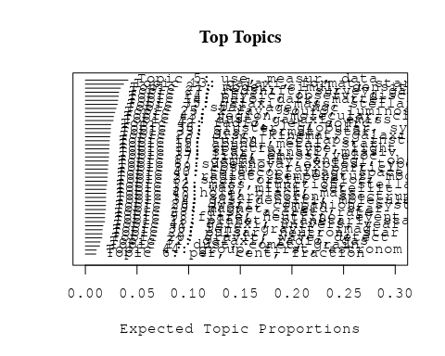

# Print the top 10 labels for each topic  
topic_labels <- labelTopics(Research_topics, n=10)  
print(topic_labels)

## Topic 1 Top Words:  
## Highest Prob: dust, comet, grain, observ, surfac, measur, magnetospher, activ, impact, particl   
## FREX: comet, cometari, saturn, magnetospher, belt, uranus, grain, ice, rosetta, asteroid   
## Lift: comet, saturn, cometari, die, magnetopaus, pchuryumov-gerasimenko, ptempel, perihelion, uranus, ici   
## Score: comet, dust, grain, magnetospher, saturn, cometari, die, belt, uranus, voyag   
## Topic 2 Top Words:  
## Highest Prob: radiat, temperatur, model, emiss, electron, ioniz, spectral, thermal, effect, photon   
## FREX: radiat, electron, photon, reioniz, thermal, ioniz, temperatur, scatter, synchrotron, compton   
## Lift: jupiter’, thomson, inverse-compton, recombin, ginga, bremsstrahlung, radiat, reioniz, opac, glast   
## Score: radiat, electron, reioniz, ioniz, photon, temperatur, synchrotron, compton, recombin, emiss   
## Topic 3 Top Words:  
## Highest Prob: star, orbit, veloc, motion, period, variabl, sgr, observ, radial, transit   
## FREX: sgr, motion, variabl, proper, lyra, radial, orbit, period, mas, parsec   
## Lift: con, kgaa, verlag, weinheim, wiley-vch, hip, gmbh, sgr, ephemeri, lyra   
## Score: sgr, orbit, lyra, motion, star, variabl, period, con, veloc, mas   
## Topic 4 Top Words:  
## Highest Prob: hole, black, mass, accret, supermass, central, agn, activ, quasar, galact   
## FREX: hole, black, supermass, smbh, mbh, eddington, nls, smbhs, horizon, bulg   
## Lift: mbh, american, black, black-hol, hole, smbh, supermass, coevolut, smbhs, nls   
## Score: black, hole, supermass, smbh, accret, agn, nls, quasar, mbh, bulg   
## Topic 5 Top Words:  
## Highest Prob: use, measur, data, model, estim, determin, method, paramet, obtain, result   
## FREX: method, error, uncertainti, determin, estim, accur, correct, systemat, use, paramet   
## Lift: focal, galfit, non-parametr, trigonometr, nonetheless, error, interpol, procedur, softwar, parallax   
## Score: method, parallax, error, focal, calibr, measur, uncertainti, accuraci, data, bias   
## Topic 6 Top Words:  
## Highest Prob: per, cent, fraction, rate, distribut, outburst, nova, model, peak, mass   
## FREX: cent, per, nova, outburst, fraction, post-starburst, intermedi, peak, synthesi, lfs   
## Lift: cent, grand, post-starburst, per, lfs, nova, one-half, bandwidth, euclid, percentag   
## Score: cent, per, grand, nova, outburst, post-starburst, lfs, psf, o-typ, fraction   
## Topic 7 Top Words:  
## Highest Prob: star, age, ngc, popul, stellar, giant, red, young, branch, myr   
## FREX: branch, age, diagram, ngc, mag, color-magnitud, red, myr, rgb, magellan   
## Lift: architectur, cmds, cmd, tip, straggler, pms, rgb, telescopeadvanc, scorpius, color-magnitud   
## Score: ngc, branch, star, age, architectur, rgb, color-magnitud, mag, red, diagram   
## Topic 8 Top Words:  
## Highest Prob: supernova, explos, type, remnant, mass, ejecta, progenitor, model, sne, time   
## FREX: explos, ejecta, supernova, core-collaps, thermonuclear, remnant, radioact, progenitor, csm, deton   
## Lift: breakout, deflagr, non-standard, stripped-envelop, csm, iib, neutrino-driven, pre-supernova, explos, thermonuclear   
## Score: supernova, explos, ejecta, deton, remnant, sne, csm, thermonuclear, progenitor, radioact   
## Topic 9 Top Words:  
## Highest Prob: flare, neutrino, event, flux, observ, burst, variabl, time, blazar, emiss   
## FREX: flare, blazar, lag, neutrino, cmes, high-energi, erupt, event, reconnect, burst   
## Lift: cmes, lag, recommend, cme, reconnect, icecub, sea, markarian, flare, erupt   
## Score: flare, neutrino, blazar, cmes, γray, high-energi, burst, reconnect, lag, recommend   
## Topic 10 Top Words:  
## Highest Prob: solar, coron, spectrum, power, region, scale, observ, structur, polar, measur   
## FREX: wmap, cmb, coron, corona, microwav, loop, non-gaussian, solar, sunspot, chromospher   
## Lift: helioseismolog, quiet-sun, recognit, represent, wmap, helioseism, cmb, magnetogram, soho, stoke   
## Score: coron, represent, wmap, cmb, sunspot, solar, chromospher, corona, limb, polar   
## Topic 11 Top Words:  
## Highest Prob: dust, galaxi, emiss, seyfert, starburst, ngc, infrar, luminos, nuclear, agn   
## FREX: seyfert, ulirg, spitzer, far-infrar, starburst, qsos, infrar, mid-infrar, ira, fir   
## Lift: pah, aromat, caltech, pdrs, sing, ulirg, polycycl, palomar-green, liner, seyfert   
## Score: seyfert, dust, starburst, ulirg, ngc, agn, pah, qsos, mid-infrar, spitzer   
## Topic 12 Top Words:  
## Highest Prob: mass, function, stellar, initi, star, imf, distribut, densiti, evolut, ratio   
## FREX: function, imf, ucd, initi, slope, law, power-law, germani, mass, top-heavi   
## Lift: top-heavi, usa, garch, heidelberg, max-planck-institut, ucd, germani, sfe, imf, für   
## Score: imf, function, ucd, mass, stellar, heidelberg, top-heavi, germani, mass--light, für   
## Topic 13 Top Words:  
## Highest Prob: galaxi, format, star, popul, merger, stellar, rate, evolut, massiv, histori   
## FREX: histori, sfr, format, merger, galaxi, assembl, star-form, merg, passiv, hierarch   
## Lift: consensus, dsc, smgs, morgana, bcgs, sfrs, dri, sfr, downsiz, uv-select   
## Score: galaxi, merger, format, star, sfr, dsc, star-form, bcgs, histori, smgs   
## Topic 14 Top Words:  
## Highest Prob: halo, dark, matter, mass, simul, cosmolog, model, predict, structur, distribut   
## FREX: dark, matter, halo, subhalo, cdm, cosmolog, λcdm, n-bodi, baryon, cold   
## Lift: aquarius, millennium-ii, quasi-stellar, self-interact, λcdm, subhalo, acdm, dark, cdm, galaxy-s   
## Score: halo, dark, matter, subhalo, cdm, cosmolog, substructur, n-bodi, cold, mass   
## Topic 15 Top Words:  
## Highest Prob: abund, metal, star, chemic, element, ratio, stellar, solar, enrich, observ   
## FREX: abund, chemic, metal, element, enrich, r-process, metal-poor, isotop, oxygen, agb   
## Lift: dredge-, presolar, r-process, amorph, dsphs, s-process, heh, low-metal, nitrogen, abund   
## Score: metal, abund, chemic, element, r-process, enrich, isotop, metal-poor, agb, grain   
## Topic 16 Top Words:  
## Highest Prob: turbul, collaps, instabl, pressur, flow, gravit, region, simul, cloud, shock   
## FREX: turbul, instabl, pressur, collaps, forc, viscos, flow, stabil, unstabl, hydrodynam   
## Lift: ask, turbul, subson, magnetorot, instabl, mach, viscos, self-grav, amplif, self-gravit   
## Score: turbul, instabl, pressur, viscos, collaps, flow, ask, hydrodynam, gravit, unstabl   
## Topic 17 Top Words:  
## Highest Prob: gamma-ray, energi, observ, sourc, spectrum, emiss, galact, tev, ray, high   
## FREX: gamma-ray, gev, positron, tev, gamma, annihil, egret, hess, magic, vhe   
## Lift: egret, stat, hegra, itali, tev-, positron, cms, vhe, cerenkov, magic   
## Score: gamma-ray, tev, gev, egret, magic, vhe, ray, positron, hess, γray   
## Topic 18 Top Words:  
## Highest Prob: planet, planetari, star, format, system, exoplanet, orbit, giant, around, solar   
## FREX: planet, exoplanet, planetari, extrasolar, habit, planetesim, migrat, super-earth, rocki, protoplanetari   
## Lift: extrasolar, melt, ozon, super-earth, lost, rocki, habit, earth-lik, planet, chondrit   
## Score: planet, exoplanet, planetari, lost, planetesim, habit, extrasolar, super-earth, protoplanetari, orbit   
## Topic 19 Top Words:  
## Highest Prob: star, binari, massiv, mass, observ, stellar, format, neutron, system, form   
## FREX: binari, bds, collis, eject, onc, massiv, neutron, star, protostar, fragment   
## Lift: bds, hyperon, onc, quark, galactic-field, chiral, pleiad, pre-main, sub-stellar, neutron-star   
## Score: binari, star, quark, neutron, onc, bds, merger, massiv, protostar, neutron-star   
## Topic 20 Top Words:  
## Highest Prob: gravit, wave, detect, time, binari, pulsar, will, array, use, gravitational-wav   
## FREX: gravitational-wav, wave, lisa, array, antenna, ligo, graviti, gravit, detector, interferomet   
## Lift: lisa, astron, ligo, usepackageamsfont, usepackageamsmath, usepackageamssymb, pta, ptas, navig, gravitational-wav   
## Score: pulsar, gravitational-wav, wave, lisa, gravit, binari, astron, detector, array, ligo   
## Topic 21 Top Words:  
## Highest Prob: model, simul, densiti, energi, numer, use, code, equat, differ, present   
## FREX: code, equat, analyt, numer, implement, approach, non-linear, solut, scheme, comput   
## Lift: gadget-, solver, focuss, eulerian, mesh, axion, gadget, non-linear, boson, code   
## Score: code, equat, simul, hydrodynam, analyt, non-linear, sph, numer, implement, energi   
## Topic 22 Top Words:  
## Highest Prob: pulsar, neutron, star, spin, rotat, millisecond, psr, period, time, puls   
## FREX: psr, pulsar, millisecond, neutron, spin-, puls, spin, magnetar, pulsat, crust   
## Lift: cyclotron, msps, pin, qpos, pulsar’, psr, effelsberg, spin-, magnetar, accretion-pow   
## Score: pulsar, neutron, millisecond, psr, puls, spin, spin-, msps, pulsat, pin   
## Topic 23 Top Words:  
## Highest Prob: disc, kinemat, galaxi, rotat, stellar, bulg, bar, spiral, veloc, angular   
## FREX: disc, kinemat, bar, bulg, momentum, gradient, warp, spiral, ellipt, angular   
## Lift: atlasd, boxi, axisymmetri, counter-rot, diski, scalelength, pseudo-bulg, sauron, warp, disc   
## Score: disc, kinemat, bulg, bar, rotat, spiral, momentum, atlasd, warp, boxi   
## Topic 24 Top Words:  
## Highest Prob: physic, observ, discuss, review, studi, understand, astrophys, properti, process, import   
## FREX: review, astrophys, understand, progress, futur, physic, key, question, research, knowledg   
## Lift: devic, eht, overview, review, art, technic, avenu, summaris, lesson, learn   
## Score: review, astrophys, devic, overview, understand, research, futur, progress, astronomi, learn   
## Topic 25 Top Words:  
## Highest Prob: x-ray, sourc, luminos, kev, emiss, detect, erg, flux, observ, optic   
## FREX: kev, x-ray, erg, rosat, chandra, hard, xmm-newton, sourc, counterpart, count   
## Lift: pspc, unabsorb, xlf, mcrab, -ks, lxlbol, rass, kev, serendipit, ibi   
## Score: x-ray, kev, sourc, chandra, rosat, erg, luminos, xmm-newton, hard, mcrab   
## Topic 26 Top Words:  
## Highest Prob: dwarf, companion, system, mass, white, binari, star, orbit, brown, secondari   
## FREX: companion, white, dwarf, brown, secondari, eclips, transfer, sdss, binari, system   
## Lift: subdwarf, shortest, carbon–oxygen, alto, calar, inth, ultracool, companion, wds, common-envelop   
## Score: dwarf, white, companion, binari, brown, sdss, orbit, eclips, shortest, secondari   
## Topic 27 Top Words:  
## Highest Prob: redshift, survey, galaxi, sampl, luminos, agn, quasar, select, sky, sdss   
## FREX: redshift, survey, select, sloan, digit, sampl, sdss, rest-fram, catalog, quasar   
## Lift: eb-v, flp, gama, lbg, udf, lyman-break, multicolor, unobscur, gem, lbgs   
## Score: redshift, agn, quasar, sdss, survey, galaxi, sloan, digit, sampl, lbgs   
## Topic 28 Top Words:  
## Highest Prob: disk, accret, rate, inner, can, system, region, mass, rotat, radius   
## FREX: disk, accret, thick, torqu, thin, inner, gap, outer, top, corot   
## Lift: top, disk, herbig, torqu, sub-parsec, kuiper, irac, mgii, pericent, settl   
## Score: disk, accret, top, protoplanetari, torqu, inner, rotat, corot, thick, circumstellar   
## Topic 29 Top Words:  
## Highest Prob: magnet, field, star, rotat, activ, stellar, surfac, strength, wind, dynamo   
## FREX: magnet, dynamo, field, imbh, runaway, convect, strength, mhd, rotat, hyad   
## Lift: polarimet, poloid, dynamo, imbh, seismic, tube, non-id, magnet, hyperveloc, hyad   
## Score: magnet, field, dynamo, rotat, imbh, runaway, star, polarimet, convect, chromospher   
## Topic 30 Top Words:  
## Highest Prob: lens, gravit, imag, galaxi, mass, len, model, weak, sourc, system   
## FREX: lens, len, microlens, magnif, shear, weak, gravit, distort, kernel, reconstruct   
## Lift: lens, magnif, quadrupl, microlens, pariti, len, weak-lens, multipli, kernel, strong-lens   
## Score: lens, len, microlens, gravit, magnif, quadrupl, quasar, imag, shear, galaxi   
## Topic 31 Top Words:  
## Highest Prob: spectra, type, light, spectral, curv, observ, sne, optic, maximum, featur   
## FREX: curv, spectra, sne, light, maximum, type, near-infrar, spectral, normal, declin   
## Lift: post-maximum, ii-p, well-observ, fluoresc, underlumin, iron-group, opticalnear-infrar, early-tim, ime, curv   
## Score: sne, spectra, curv, spectral, type, light, supernova, near-infrar, post-maximum, ii-p   
## Topic 32 Top Words:  
## Highest Prob: galaxi, radio, gas, observ, cluster, shock, emiss, diffus, region, medium   
## FREX: relic, intraclust, filament, subclust, bubbl, ram, abel, icm, front, large-scal   
## Lift: relic, invis, sunyaev-zeldovich, icm, subclust, superclust, ram, bubbl, abel, intraclust   
## Score: relic, radio, subclust, galaxi, cluster, intraclust, icm, ram, bubbl, shock   
## Topic 33 Top Words:  
## Highest Prob: gas, format, star, feedback, cool, wind, simul, model, rate, accret   
## FREX: feedback, cool, outflow, wind, gas, regul, effici, cold, format, drive   
## Lift: feedback, realiti, circumgalact, sam, blown, self-regul, regul, pop, multiphas, lab   
## Score: feedback, gas, wind, outflow, cool, star, accret, format, agn, cold   
## Topic 34 Top Words:  
## Highest Prob: gas, densiti, molecular, cloud, system, hydrogen, medium, column, interstellar, observ   
## FREX: column, lyα, ism, absorb, hydrogen, igm, molecular, atom, lyman, warm   
## Lift: contemporari, dla, dlas, whim, lyα, metal-fre, lya, igm, column, warm-hot   
## Score: molecular, gas, lyα, dla, ism, column, igm, whim, cloud, hydrogen   
## Topic 35 Top Words:  
## Highest Prob: galaxi, mass, stellar, relat, luminos, colour, group, correl, early-typ, find   
## FREX: colour, early-typ, dot, group, dispers, sloan, relat, fix, digit, red   
## Lift: light-weight, mass-siz, yang, gass, harass, overproduc, fire, mass-metal, disk-domin, arecibo   
## Score: galaxi, colour, early-typ, satellit, sloan, dot, sdss, mass, digit, stellar   
## Topic 36 Top Words:  
## Highest Prob: way, milki, satellit, galaxi, galact, tidal, stream, orbit, structur, dwarf   
## FREX: milki, way, stream, satellit, tidal, disrupt, strip, andromeda, sagittarius, tail   
## Lift: fuzzi, way’, apocentr, milki, andromeda, dos, ursa, stream, cluster-lik, way   
## Score: milki, satellit, fuzzi, stream, tidal, way, galaxi, halo, dwarf, orbit   
## Topic 37 Top Words:  
## Highest Prob: line, emiss, veloc, absorpt, profil, observ, ratio, model, width, compon   
## FREX: line, width, absorpt, broad, profil, iii, sight, balmer, narrow, intens   
## Lift: lvg, aur, underabund, line, blueshift, balmer, magnetocentrifug, eta, width, forbidden   
## Score: line, lvg, absorpt, emiss, width, balmer, blueshift, sight, profil, veloc   
## Topic 38 Top Words:  
## Highest Prob: cluster, globular, system, veloc, dynam, field, result, also, within, distribut   
## FREX: cluster, globular, virgo, gcs, relax, segreg, infal, des, dissolut, disrupt   
## Lift: blur, nucleat, self-enrich, cluster, segreg, dissolut, fractal, dissolv, globular, omega   
## Score: cluster, globular, gcs, virgo, dissolut, des, segreg, blur, perseus, half-mass   
## Topic 39 Top Words:  
## Highest Prob: cosmic, ray, particl, energi, acceler, shock, proton, cosmic-ray, galact, neutrino   
## FREX: proton, cosmic-ray, acceler, ray, cosmic, ion, charg, shower, particl, inject   
## Lift: keep, knee, pevatron, pierr, uhecr, crs, ultra-high-energi, shower, p-p, ultrarelativist   
## Score: ray, cosmic-ray, cosmic, acceler, proton, particl, neutrino, keep, shock, shower   
## Topic 40 Top Words:  
## Highest Prob: telescop, imag, space, observatori, instrument, resolut, system, optic, grb, data   
## FREX: grb, instrument, design, afterglow, telescop, program, pne, grbs, observatori, mission   
## Lift: comptel, erosita, fiber, academi, afterglow, microarcsecond, pne, leap, space-born, revolut   
## Score: grb, comptel, telescop, imag, afterglow, grbs, instrument, pne, mission, observatori   
## Topic 41 Top Words:  
## Highest Prob: galaxi, univers, year, report, discoveri, massiv, earli, reveal, star-form, solar   
## FREX: discoveri, distant, billion, big, year, million, bang, univers, star-form, rare   
## Lift: instituto, bang, lymanα, big, billion, deep-sea, constitu, protoclust, million, discoveri   
## Score: galaxi, billion, bang, quasar, star-form, big, discoveri, univers, year, starburst   
## Topic 42 Top Words:  
## Highest Prob: radio, jet, sourc, galaxi, activ, observ, emiss, nuclei, agn, ghz   
## FREX: jet, radio, radio-loud, ghz, lobe, collim, vlbi, relativist, nuclei, arcsec   
## Lift: label, microquasar, flat-spectrum, parsec-scal, high-pow, jet, radio-loud, satisfactorili, multifrequ, collim   
## Score: radio, jet, radio-loud, agn, ghz, lobe, sourc, vlbi, relativist, label   
## Topic 43 Top Words:  
## Highest Prob: region, molecular, cloud, core, emiss, sourc, gas, observ, star, massiv   
## FREX: maser, molecular, cloud, outflow, embed, protostar, millimet, core, toward, continuum   
## Lift: choh, irdc, pdbi, methanol, prestellar, bure, ammonia, subarcsecond, millimet, maser   
## Score: molecular, maser, methanol, irdc, cloud, protostar, outflow, core, emiss, polar   
## Topic 44 Top Words:  
## Highest Prob: group, first, astronom, one, author, observ, also, use, two, sever   
## FREX: author, astronom, figur, compil, tabl, version, draw, celesti, record, definit   
## Lift: journal, ras, royal, eye, manuscript, societi, draw, author, book, green   
## Score: sunspot, ras, astronom, royal, author, societi, aurora, figur, celesti, tabl

# Match the processed documents with the original titles  
matched_titles <- out_text$meta$original_concatenated_title_abstract  
  
# Print top 5 documents for each topic  
top_docs <- findThoughts(Research_topics, texts = matched_titles, n = 5)$docs[[1]]  
print(top_docs)

## [1] "Die Eismonde von Uranus, Neptun und Pluto Die Eismonde von Uranus, Neptun und Pluto wurden bislang nur von zwei Raumsonden erforscht: Voyager 2 und New Horizons. Ihre Aufnahmen zeigen eine große Vielfalt an Oberflächenformationen. Diese Eismonde weisen Ähnlichkeiten mit denen von Jupiter und Saturn auf. So gibt es offensichtlich auch im äußersten Bereich des Sonnensystems Kryovulkanismus. Auch Dehnungsstrukturen und mögliche Auswirkungen von planetaren Kollisionen sind erkennbar. Mehr als 50 Jahre nach Voyager 2 gibt es Pläne für eine neue Mission ins Uranus‐ und Neptunsystem. Noch weitgehend unerforscht sind die Zwergplaneten und kleineren Körper im Kuiper‐Gürtel. Der Vorbeiflug an Pluto und Charon im Juli 2015 war ein erster Blick in diese noch sehr fremde Welt. Entwürfe für weitere Missionen in den Kuiper‐Gürtel, zumindest seitens der NASA, existieren bereits auf dem Reißbrett für die Zeit nach 2040."   
## [2] "Eismonde von Jupiter und Saturn Seit 40 Jahren erforschen Sonden die Eismonde im äußeren Sonnensystem. Die Vielfalt dieser Körper, die mögliche Existenz von verborgenen Ozeanen und ihr Kryovulkanismus machen sie zu äußerst spannenden Himmelskörpern. Teil 1 dieses Zweiteilers stellt die Eismonde von Jupiter und Saturn vor. Jeder dieser Eismonde zeigt sich geologisch als eigene Welt. Bei den Jupitertrabanten ist die Oberfläche von Europa im Vergleich zu Ganymed geologisch sehr jung. Magnetfeldmessungen der Galileo‐Mission lassen unter der festen Eiskruste auf einen tiefen Ozean mit salzhaltigem Wasser schließen. Ein solcher Ozean existiert ebenfalls auf Callisto in größerer Tiefe, mutmaßlich auch auf Ganymed. Ganymed besitzt als einziger Eismond einen eisenhaltigen Kern, dessen starkes Magnetfeld das eines Ozeans überdeckt. Der Saturnmond Enceladus zeichnet sich durch aktiven Kryovulkanismus aus, der durch Gezeitenkräfte angetrieben ist."   
## [3] "Galileo in-situ dust measurements in Jupiter's gossamer rings Abstract Galileo was the first artificial satellite to orbit Jupiter. During its late orbital mission the spacecraft made two passages through the giant planet’s gossamer ring system. The impact-ionization dust detector on board successfully recorded dust impacts during both ring passages and provided the first in-situ measurements from a dusty planetary ring. During the first passage—on 5 November 2002 while Galileo was approaching Jupiter—dust measurements were collected until a spacecraft anomaly at 2.33 R J (Jupiter radii) just 16 min after a close flyby of Amalthea put the spacecraft into a safing mode. The second ring passage on 21 September 2003 provided ring dust measurements down to about 2.5 R J and the Galileo spacecraft was destroyed shortly thereafter in a planned impact with Jupiter. In all, a few thousand dust impacts were counted with the instrument accumulators during both ring passages, but only a total of 110 complete data sets of dust impacts were transmitted to Earth. Detected particle sizes range from about 0.2 to 5 μm, extending the known size distribution by an order of magnitude towards smaller particles than previously derived from optical imaging [Showalter, M.R., de Pater, I., Verbanac, G., Hamilton, D.P., Burns, J.A., 2008. Icarus 195, 361–377; de Pater, I., Showalter, M.R., Macintosh, B., 2008. Icarus 195, 348–360]. The grain size distribution increases towards smaller particles and shows an excess of these tiny motes in the Amalthea gossamer ring compared to the Thebe ring. The size distribution for the Amalthea ring derived from our in-situ measurements for the small grains agrees very well with the one obtained from images for large grains. Our analysis shows that particles contributing most to the optical cross-section are about 5 μm in radius, in agreement with imaging results. The measurements indicate a large drop in particle flux immediately interior to Thebe’s orbit and some detected particles seem to be on highly-tilted orbits with inclinations up to 20°. Finally, the faint Thebe ring extension was detected out to at least 5 R J , indicating that grains attain higher eccentricities than previously thought. The drop interior to Thebe, the excess of submicron grains at Amalthea, and the faint ring extension indicate that grain dynamics is strongly influenced by electromagnetic forces. These findings can all be explained by a shadow resonance as detailed by Hamilton and Kruger [Hamilton, D.P., Kruger, H., 2008. Nature 453, 72–75]."  
## [4] "A Dynamic, Rotating Ring Current Around Saturn The concept of an electrical current encircling the Earth at high altitudes was first proposed in 1917 to explain the depression of the horizontal component of the Earth’s magnetic field during geomagnetic storms. In situ measurements of the extent and composition of this current were made some 50 years later and an image was obtained in 2001 (ref. 6). Ring currents of a different nature were observed at Jupiter and their presence inferred at Saturn. Here we report images of the ring current at Saturn, together with a day–night pressure asymmetry and tilt of the planet’s plasma sheet, based on measurements using the magnetospheric imaging instrument (MIMI) on board Cassini. The ring current can be highly variable with strong longitudinal asymmetries that corotate nearly rigidly with the planet. This contrasts with the Earth’s ring current, where there is no rotational modulation and initial asymmetries are organized by local time effects."   
## [5] "A Dynamic, Rotating Ring Current Around Saturn The concept of an electrical current encircling the Earth at high altitudes was first proposed in 1917 to explain the depression of the horizontal component of the Earth’s magnetic field during geomagnetic storms. In situ measurements of the extent and composition of this current were made some 50 years later and an image was obtained in 2001 (ref. 6). Ring currents of a different nature were observed at Jupiter and their presence inferred at Saturn. Here we report images of the ring current at Saturn, together with a day–night pressure asymmetry and tilt of the planet’s plasma sheet, based on measurements using the magnetospheric imaging instrument (MIMI) on board Cassini. The ring current can be highly variable with strong longitudinal asymmetries that corotate nearly rigidly with the planet. This contrasts with the Earth’s ring current, where there is no rotational modulation and initial asymmetries are organized by local time effects."

# Find and plot the key "thoughts" or documents for selected topics  
thoughts6 <- findThoughts(Research_topics, texts = matched_titles, n = 3, topics = 6)$docs[[1]]  
thoughts18 <- findThoughts(Research_topics, texts = matched_titles, n = 3, topics = 18)$docs[[1]]  
par(mfrow = c(1, 2), mar = c(0.5, 0.5, 1, 0.5))  
plotQuote(thoughts6, width = 30, main = "Topic 6")  
plotQuote(thoughts18, width = 30, main = "Topic 18")

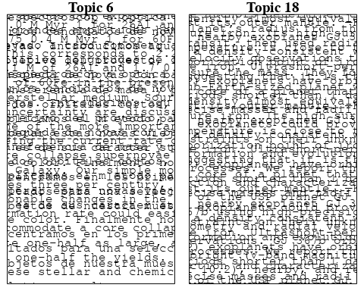

# Calculate and plot the correlation between topics  
mod.out.corr <- topicCorr(Research_topics)  
plot(mod.out.corr, cex = 1.5)  
  
  
# For each topic  
for (topic_num in 1:44) {  
 # Plot the word cloud  
 cloud(Research_topics, topic = topic_num, scale = c(2, 0.25))  
 Sys.sleep(2)  
}

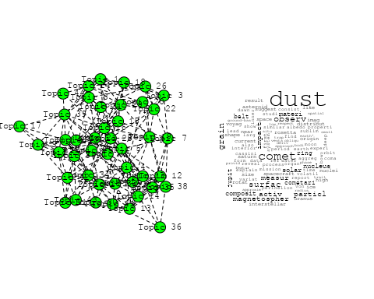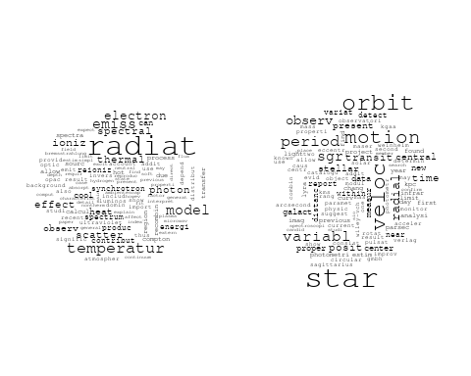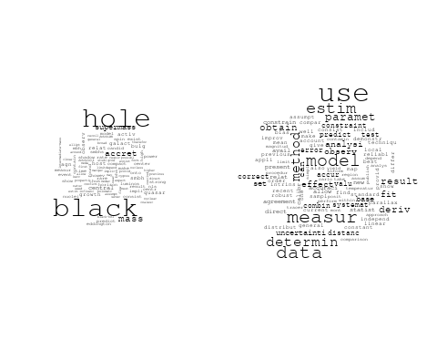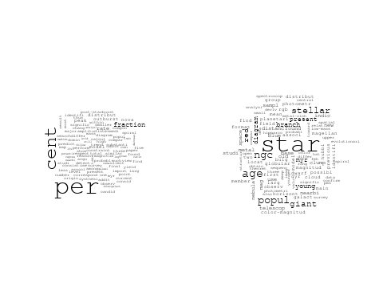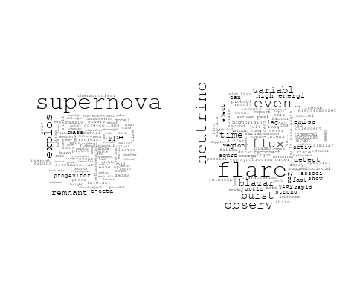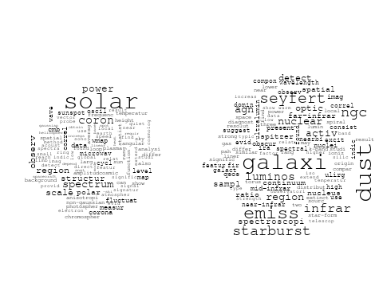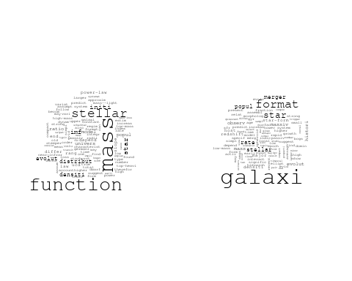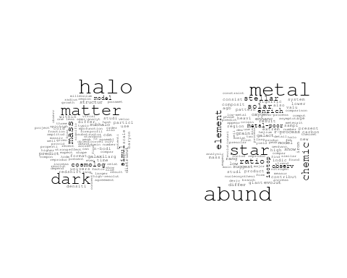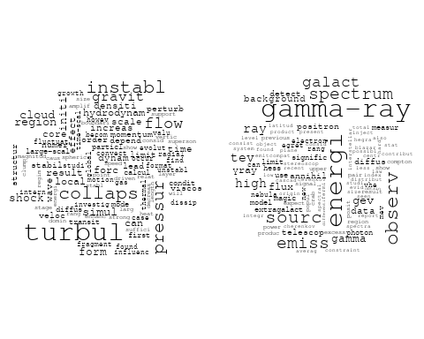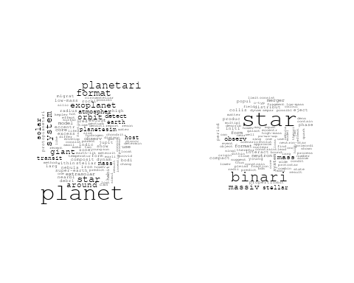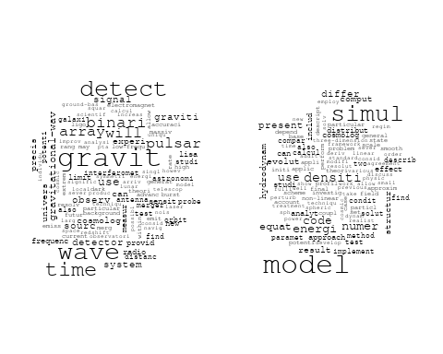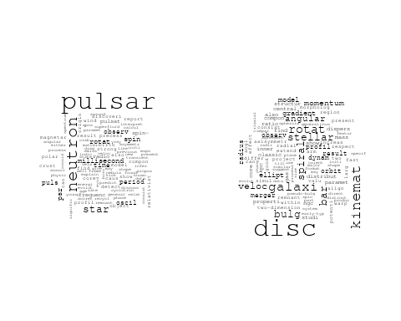

## Warning in wordcloud::wordcloud(words = vocab, freq = vec, max.words =  
## max.words, : physic could not be fit on page. It will not be plotted.

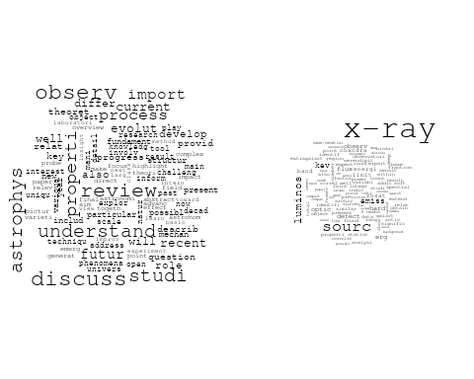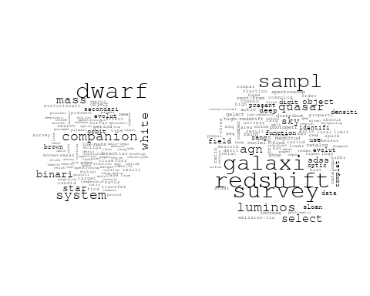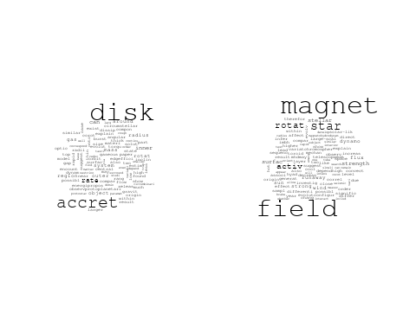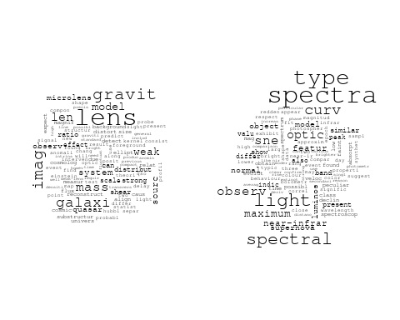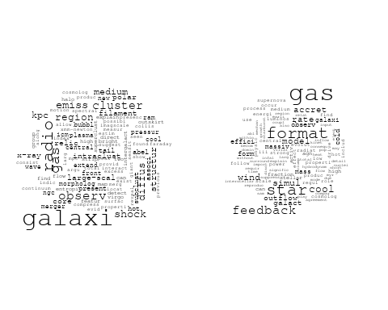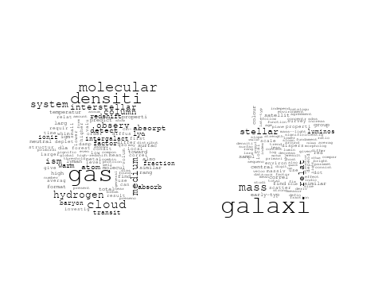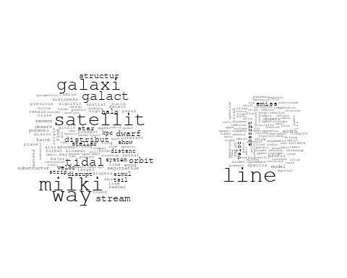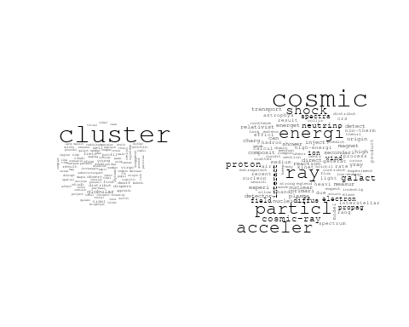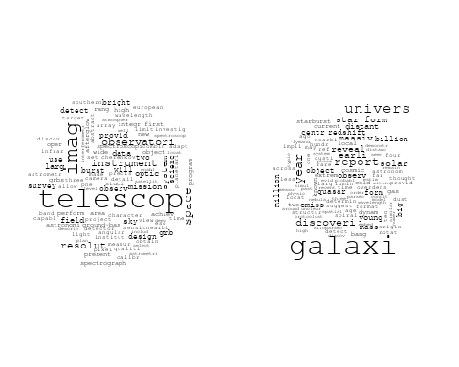

## Warning in wordcloud::wordcloud(words = vocab, freq = vec, max.words =  
## max.words, : core could not be fit on page. It will not be plotted.

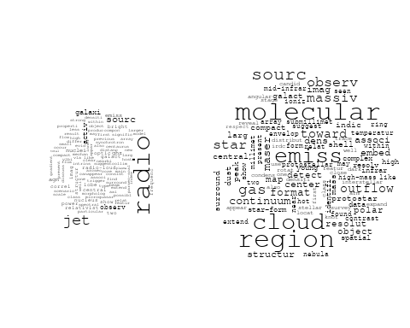

# Get the topic proportions for each document  
topic_proportions <- Research_topics$theta  
  
# Find the index of the topic with the highest proportion for each document  
# This will be the topic that each document is most likely to belong to  
max_topic_idx <- apply(topic_proportions, 1, which.max)  
  
# Add this as a new column to your data  
data_collab$topic <- max_topic_idx  
  
library(ggplot2)  
  
# Define the intervals  
intervals <- c('1824_1899', '1900_1964', '1965_1974', '1975_1984', '1985_1994', '1995_1999', '2000_2004', '2005_2009', '2010_2014', '2015_2019', '2020_2022')  
colors <- c('pink', 'blue', 'purple', 'yellow', 'green', 'pink', 'orange', 'violet', 'green', 'blue', 'pink')  
  
# Loop through the intervals and plot  
for(i in seq_along(intervals)){  
 # Filter data for when the pub_interval is equal to 1  
 data_filtered <- data_collab[data_collab[[paste0('pub_interval_', intervals[i])]] == 1,]  
   
 # Make the histogram  
   
 p <- ggplot(data_filtered, aes(x = topic)) +  
 geom_histogram(binwidth = 1, fill = colors[i], color = "black") +  
 xlab("Topic") +  
 ylab("Count") +  
 ggtitle(paste0("Topics from year ", gsub("_", " to ", intervals[i])))  
   
 print(p)  
}  
  
  
##Topic generation for DE (independent) publications  
  
data_independent <- data[data[["DE"]] == 100,]  
  
# Save the original title data for future use  
data_independent$original_concatenated_title_abstract <- data_independent$concatenated_title_abstract  
  
#pre-processing the titles using textProcessor from the stm package  
processed_text <- textProcessor(data_independent$concatenated_title_abstract, metadata = data_independent)

## Building corpus...   
## Converting to Lower Case...   
## Removing punctuation...   
## Removing stopwords...   
## Removing numbers...   
## Stemming...   
## Creating Output...

# Further prepare the data by removing low-frequency terms  
out_text <- prepDocuments(processed_text$documents, processed_text$vocab, processed_text$meta)

## Removing 2962 of 9574 terms (2962 of 162847 tokens) due to frequency   
## Your corpus now has 1901 documents, 6612 terms and 159885 tokens.

docs_text <- out_text$documents  
vocab_text <- out_text$vocab  
meta_text <- out_text$meta  
  
  
#Prepare data  
plotRemoved(processed_text$documents, lower.thresh = seq(1, 200, by = 100))

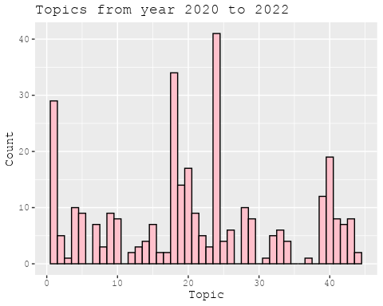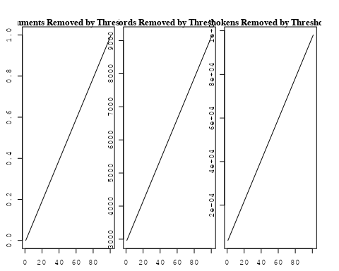

out_text <- prepDocuments(processed_text$documents, processed_text$vocab, processed_text$meta, lower.thresh = 8)

## Removing 7435 of 9574 terms (17734 of 162847 tokens) due to frequency   
## Your corpus now has 1901 documents, 2139 terms and 145113 tokens.

str(out_text$meta)

## 'data.frame': 1901 obs. of 39 variables:  
## $ concept_id : chr "https://openalex.org/C44870925" "https://openalex.org/C44870925" "https://openalex.org/C44870925" "https://openalex.org/C44870925" ...  
## $ work_id : chr "https://openalex.org/W3102133339" "https://openalex.org/W3102325152" "https://openalex.org/W3122713741" "https://openalex.org/W3114533047" ...  
## $ publication_year : int 2006 1997 2014 2021 2017 2020 2003 2005 2003 2011 ...  
## $ title : chr "The hierarchical formation of the brightest cluster galaxies" "Beyond genus statistics: a unifying approach to the morphology of cosmic structure" "Modelling the Magnetic Field Configuration of Neutron Stars" "Steady-state nucleosynthesis throughout the Galaxy" ...  
## $ paperabstract : chr "We use semi-analytic techniques to study the formation and evolution of brightest cluster galaxies (BCGs). We s"| __truncated__ "The genus statistics of isodensity contours has become a well-established tool in cosmology. In this Letter we "| __truncated__ "The properties of the extremely strong magnetic fields of neu tron stars affect in a unique way their evolution"| __truncated__ "Measurement and astrophysical interpretation of characteristic gamma-ray lines from nucleosynthesis was one of "| __truncated__ ...  
## $ country : chr "DE DE DE DE" "DE DE DE DE DE DE" "DE DE" "DE DE" ...  
## $ year_concept : chr "2006+https://openalex.org/C44870925" "1997+https://openalex.org/C44870925" "2014+https://openalex.org/C44870925" "2021+https://openalex.org/C44870925" ...  
## $ concatenated_title_abstract : chr "The hierarchical formation of the brightest cluster galaxies We use semi-analytic techniques to study the forma"| __truncated__ "Beyond genus statistics: a unifying approach to the morphology of cosmic structure The genus statistics of isod"| __truncated__ "Modelling the Magnetic Field Configuration of Neutron Stars The properties of the extremely strong magnetic fie"| __truncated__ "Steady-state nucleosynthesis throughout the Galaxy Measurement and astrophysical interpretation of characterist"| __truncated__ ...  
## $ US : num 0 0 0 0 0 0 0 0 0 0 ...  
## $ IN : num 0 0 0 0 0 0 0 0 0 0 ...  
## $ DE : num 100 100 100 100 100 100 100 100 100 100 ...  
## $ CH : num 0 0 0 0 0 0 0 0 0 0 ...  
## $ GB : num 0 0 0 0 0 0 0 0 0 0 ...  
## $ CN : num 0 0 0 0 0 0 0 0 0 0 ...  
## $ FR : num 0 0 0 0 0 0 0 0 0 0 ...  
## $ IT : num 0 0 0 0 0 0 0 0 0 0 ...  
## $ RU : num 0 0 0 0 0 0 0 0 0 0 ...  
## $ CA : num 0 0 0 0 0 0 0 0 0 0 ...  
## $ NL : num 0 0 0 0 0 0 0 0 0 0 ...  
## $ AU : num 0 0 0 0 0 0 0 0 0 0 ...  
## $ JP : num 0 0 0 0 0 0 0 0 0 0 ...  
## $ ES : num 0 0 0 0 0 0 0 0 0 0 ...  
## $ IL : num 0 0 0 0 0 0 0 0 0 0 ...  
## $ Americas : num 0 0 0 0 0 0 0 0 0 0 ...  
## $ Europe : num 0 0 0 0 0 0 0 0 0 0 ...  
## $ Africa : num 0 0 0 0 0 0 0 0 0 0 ...  
## $ AsiaAndOceania : num 0 0 0 0 0 0 0 0 0 0 ...  
## $ pub_interval_2020_2022 : int 0 0 0 1 0 1 0 0 0 0 ...  
## $ pub_interval_2015_2019 : int 0 0 0 0 1 0 0 0 0 0 ...  
## $ pub_interval_2010_2014 : int 0 0 1 0 0 0 0 0 0 1 ...  
## $ pub_interval_2005_2009 : int 1 0 0 0 0 0 0 1 0 0 ...  
## $ pub_interval_2000_2004 : int 0 0 0 0 0 0 1 0 1 0 ...  
## $ pub_interval_1995_1999 : int 0 1 0 0 0 0 0 0 0 0 ...  
## $ pub_interval_1985_1994 : int 0 0 0 0 0 0 0 0 0 0 ...  
## $ pub_interval_1975_1984 : int 0 0 0 0 0 0 0 0 0 0 ...  
## $ pub_interval_1965_1974 : int 0 0 0 0 0 0 0 0 0 0 ...  
## $ pub_interval_1900_1964 : int 0 0 0 0 0 0 0 0 0 0 ...  
## $ pub_interval_1824_1899 : int 0 0 0 0 0 0 0 0 0 0 ...  
## $ original_concatenated_title_abstract: chr "The hierarchical formation of the brightest cluster galaxies We use semi-analytic techniques to study the forma"| __truncated__ "Beyond genus statistics: a unifying approach to the morphology of cosmic structure The genus statistics of isod"| __truncated__ "Modelling the Magnetic Field Configuration of Neutron Stars The properties of the extremely strong magnetic fie"| __truncated__ "Steady-state nucleosynthesis throughout the Galaxy Measurement and astrophysical interpretation of characterist"| __truncated__ ...

# Initialize an empty formula string  
prevalence_formula_str <- "~"  
  
# Define the publication intervals  
pub_intervals <- c("pub_interval_2020_2022", "pub_interval_2015_2019", "pub_interval_2010_2014",   
 "pub_interval_2005_2009", "pub_interval_2000_2004", "pub_interval_1995_1999",  
 "pub_interval_1985_1994", "pub_interval_1975_1984", "pub_interval_1965_1974",  
 "pub_interval_1900_1964", "pub_interval_1824_1899")  
  
# Add each publication interval to the formula string  
for (interval in pub_intervals) {  
 # add an if statement to handle the first addition (without '+')  
 if (prevalence_formula_str == "~") {  
 prevalence_formula_str <- paste(prevalence_formula_str, interval)  
 } else {  
 prevalence_formula_str <- paste(prevalence_formula_str, "+", interval)  
 }  
}  
  
  
# Convert the string to a formula  
prevalence_formula <- as.formula(prevalence_formula_str)  
print(prevalence_formula)

## ~pub_interval_2020_2022 + pub_interval_2015_2019 + pub_interval_2010_2014 +   
## pub_interval_2005_2009 + pub_interval_2000_2004 + pub_interval_1995_1999 +   
## pub_interval_1985_1994 + pub_interval_1975_1984 + pub_interval_1965_1974 +   
## pub_interval_1900_1964 + pub_interval_1824_1899

# Run STM model  
Research_topics <- stm(documents = out_text$documents,   
 vocab = out_text$vocab,   
 K = 44,   
 prevalence = prevalence_formula,   
 data = out_text$meta,   
 init.type = "Spectral",  
 max.em.its = 1000,  
 gamma.prior = 'L1')

## Beginning Spectral Initialization   
## Calculating the gram matrix...  
## Finding anchor words...  
## ............................................  
## Recovering initialization...  
## .....................  
## Initialization complete.  
## ....................................................................................................  
## Completed E-Step (2 seconds).   
## Completed M-Step.   
## Completing Iteration 1 (approx. per word bound = -6.496)   
## ....................................................................................................  
## Completed E-Step (1 seconds).   
## Completed M-Step.   
## Completing Iteration 2 (approx. per word bound = -6.217, relative change = 4.300e-02)   
## ....................................................................................................  
## Completed E-Step (1 seconds).   
## Completed M-Step.   
## Completing Iteration 3 (approx. per word bound = -6.143, relative change = 1.191e-02)   
## ....................................................................................................  
## Completed E-Step (1 seconds).   
## Completed M-Step.   
## Completing Iteration 4 (approx. per word bound = -6.112, relative change = 5.048e-03)   
## ....................................................................................................  
## Completed E-Step (1 seconds).   
## Completed M-Step.   
## Completing Iteration 5 (approx. per word bound = -6.096, relative change = 2.617e-03)   
## Topic 1: des, ancient, der, juli, insight   
## Topic 2: orbit, variabl, time, period, transit   
## Topic 3: spectrum, solar, model, galact, electron   
## Topic 4: star, format, planet, system, metal   
## Topic 5: flare, observ, blazar, neutrino, γray   
## Topic 6: region, line, coron, gas, measur   
## Topic 7: supernova, type, sne, spectra, light   
## Topic 8: ray, cosmic, acceler, supernova, remnant   
## Topic 9: paper, neutron, strong, can, galaxi   
## Topic 10: dark, matter, halo, model, mass   
## Topic 11: physic, astrophys, univers, discuss, radiat   
## Topic 12: star, observ, neutron, massiv, stellar   
## Topic 13: observ, sunspot, present, calibr, veloc   
## Topic 14: galaxi, cluster, satellit, milki, star   
## Topic 15: mission, imag, observ, will, telescop   
## Topic 16: halo, model, use, simul, distribut   
## Topic 17: radio, sourc, galaxi, extragalact, emiss   
## Topic 18: agn, activ, nuclei, jet, galact   
## Topic 19: disc, mass, accret, jupit, rate   
## Topic 20: bulg, galaxi, bar, classic, disc   
## Topic 21: jet, wind, shock, emiss, x-ray   
## Topic 22: cluster, mass, star, stellar, function   
## Topic 23: chemic, abund, model, star, solar   
## Topic 24: galaxi, survey, sky, redshift, sdss   
## Topic 25: star, age, dwarf, veloc, new   
## Topic 26: sourc, x-ray, observ, emiss, correl   
## Topic 27: explos, burst, supernova, model, grb   
## Topic 28: x-ray, luminos, galaxi, cluster, sampl   
## Topic 29: disk, accret, star, dust, rotat   
## Topic 30: star, giant, metal, branch, observ   
## Topic 31: period, star, short, observ, variabl   
## Topic 32: galaxi, star, format, gas, feedback   
## Topic 33: galaxi, mass, stellar, metal, relat   
## Topic 34: dust, grain, ratio, abund, solar   
## Topic 35: mass, stellar, galaxi, format, star   
## Topic 36: field, magnet, model, observ, turbul   
## Topic 37: system, format, core, solar, planet   
## Topic 38: line, temperatur, model, emiss, hydrogen   
## Topic 39: hole, black, accret, mass, central   
## Topic 40: light, cloud, len, sky, use   
## Topic 41: gas, cluster, galaxi, pressur, simul   
## Topic 42: energi, neutrino, gamma-ray, tev, cosmic   
## Topic 43: pulsar, time, gravit, array, wave   
## Topic 44: potenti, minim, extern, mass, state   
## ....................................................................................................  
## Completed E-Step (1 seconds).   
## Completed M-Step.   
## Completing Iteration 6 (approx. per word bound = -6.086, relative change = 1.608e-03)   
## ....................................................................................................  
## Completed E-Step (1 seconds).   
## Completed M-Step.   
## Completing Iteration 7 (approx. per word bound = -6.079, relative change = 1.084e-03)   
## ....................................................................................................  
## Completed E-Step (1 seconds).   
## Completed M-Step.   
## Completing Iteration 8 (approx. per word bound = -6.074, relative change = 8.348e-04)   
## ....................................................................................................  
## Completed E-Step (1 seconds).   
## Completed M-Step.   
## Completing Iteration 9 (approx. per word bound = -6.070, relative change = 6.412e-04)   
## ....................................................................................................  
## Completed E-Step (1 seconds).   
## Completed M-Step.   
## Completing Iteration 10 (approx. per word bound = -6.067, relative change = 4.811e-04)   
## Topic 1: des, bodi, insight, ancient, radius   
## Topic 2: orbit, variabl, transit, time, chang   
## Topic 3: spectrum, model, electron, galact, energi   
## Topic 4: star, format, cloud, planet, metal   
## Topic 5: flare, observ, blazar, γray, neutrino   
## Topic 6: region, line, coron, spiral, measur   
## Topic 7: supernova, type, sne, spectra, light   
## Topic 8: ray, cosmic, acceler, supernova, energi   
## Topic 9: neutron, galaxi, strong, rotat, paper   
## Topic 10: dark, matter, halo, mass, model   
## Topic 11: physic, discuss, astrophys, review, radiat   
## Topic 12: star, galact, form, stellar, observ   
## Topic 13: observ, sunspot, profil, present, veloc   
## Topic 14: galaxi, cluster, satellit, way, milki   
## Topic 15: mission, imag, observ, will, telescop   
## Topic 16: model, use, simul, halo, distribut   
## Topic 17: radio, sourc, galaxi, extragalact, popul   
## Topic 18: agn, activ, nuclei, galact, jet   
## Topic 19: disc, accret, mass, rate, binari   
## Topic 20: bulg, galaxi, bar, host, classic   
## Topic 21: jet, wind, emiss, shock, x-ray   
## Topic 22: cluster, mass, star, stellar, function   
## Topic 23: solar, atmospher, abund, chemic, model   
## Topic 24: galaxi, survey, sky, redshift, sdss   
## Topic 25: star, age, dwarf, veloc, associ   
## Topic 26: sourc, x-ray, spectral, observ, emiss   
## Topic 27: explos, burst, supernova, grb, model   
## Topic 28: x-ray, luminos, galaxi, mass, cluster   
## Topic 29: disk, accret, star, dust, region   
## Topic 30: star, giant, cluster, branch, metal   
## Topic 31: star, period, short, activ, variabl   
## Topic 32: galaxi, format, star, gas, feedback   
## Topic 33: galaxi, mass, stellar, relat, metal   
## Topic 34: dust, grain, ratio, abund, solar   
## Topic 35: mass, galaxi, stellar, star, format   
## Topic 36: field, magnet, turbul, simul, strength   
## Topic 37: format, core, system, solar, form   
## Topic 38: line, temperatur, emiss, model, hydrogen   
## Topic 39: hole, black, mass, central, accret   
## Topic 40: light, imag, len, sky, night   
## Topic 41: gas, cluster, galaxi, pressur, simul   
## Topic 42: energi, neutrino, gamma-ray, tev, cosmic   
## Topic 43: pulsar, time, gravit, array, detect   
## Topic 44: potenti, studi, minim, state, case   
## ....................................................................................................  
## Completed E-Step (1 seconds).   
## Completed M-Step.   
## Completing Iteration 11 (approx. per word bound = -6.065, relative change = 3.989e-04)   
## ....................................................................................................  
## Completed E-Step (1 seconds).   
## Completed M-Step.   
## Completing Iteration 12 (approx. per word bound = -6.062, relative change = 3.957e-04)   
## ....................................................................................................  
## Completed E-Step (1 seconds).   
## Completed M-Step.   
## Completing Iteration 13 (approx. per word bound = -6.060, relative change = 3.412e-04)   
## ....................................................................................................  
## Completed E-Step (1 seconds).   
## Completed M-Step.   
## Completing Iteration 14 (approx. per word bound = -6.058, relative change = 3.379e-04)   
## ....................................................................................................  
## Completed E-Step (1 seconds).   
## Completed M-Step.   
## Completing Iteration 15 (approx. per word bound = -6.056, relative change = 3.364e-04)   
## Topic 1: bodi, des, main, metal, age   
## Topic 2: orbit, transit, variabl, time, chang   
## Topic 3: spectrum, electron, model, galact, energi   
## Topic 4: star, cloud, format, planet, molecular   
## Topic 5: flare, observ, blazar, γray, neutrino   
## Topic 6: region, coron, line, spiral, distanc   
## Topic 7: supernova, type, sne, curv, spectra   
## Topic 8: cosmic, ray, acceler, supernova, energi   
## Topic 9: neutron, galaxi, rotat, strong, solut   
## Topic 10: dark, matter, halo, mass, model   
## Topic 11: physic, discuss, review, astrophys, radiat   
## Topic 12: star, galact, stellar, form, observ   
## Topic 13: observ, sunspot, solar, veloc, galaxi   
## Topic 14: galaxi, cluster, satellit, way, milki   
## Topic 15: mission, imag, will, observ, telescop   
## Topic 16: model, use, simul, distribut, densiti   
## Topic 17: radio, sourc, galaxi, extragalact, popul   
## Topic 18: agn, activ, nuclei, galact, observ   
## Topic 19: disc, accret, mass, rate, binari   
## Topic 20: bulg, galaxi, bar, host, classic   
## Topic 21: jet, wind, emiss, x-ray, shock   
## Topic 22: cluster, mass, star, stellar, function   
## Topic 23: solar, atmospher, abund, chemic, model   
## Topic 24: galaxi, survey, sky, redshift, cluster   
## Topic 25: star, age, dwarf, veloc, associ   
## Topic 26: sourc, x-ray, spectral, observ, emiss   
## Topic 27: explos, supernova, burst, grb, model   
## Topic 28: x-ray, luminos, galaxi, mass, star   
## Topic 29: disk, accret, star, dust, region   
## Topic 30: star, giant, cluster, branch, ngc   
## Topic 31: star, period, short, activ, variabl   
## Topic 32: galaxi, format, gas, star, feedback   
## Topic 33: galaxi, mass, stellar, relat, merger   
## Topic 34: dust, grain, ratio, abund, solar   
## Topic 35: mass, galaxi, stellar, star, format   
## Topic 36: field, magnet, turbul, simul, strength   
## Topic 37: core, format, system, gas, form   
## Topic 38: line, emiss, temperatur, hydrogen, model   
## Topic 39: hole, black, mass, central, accret   
## Topic 40: light, imag, len, sky, night   
## Topic 41: gas, cluster, pressur, galaxi, simul   
## Topic 42: energi, neutrino, gamma-ray, tev, cosmic   
## Topic 43: pulsar, time, gravit, detect, array   
## Topic 44: potenti, model, studi, differ, surfac   
## ....................................................................................................  
## Completed E-Step (1 seconds).   
## Completed M-Step.   
## Completing Iteration 16 (approx. per word bound = -6.054, relative change = 2.929e-04)   
## ....................................................................................................  
## Completed E-Step (1 seconds).   
## Completed M-Step.   
## Completing Iteration 17 (approx. per word bound = -6.053, relative change = 2.728e-04)   
## ....................................................................................................  
## Completed E-Step (1 seconds).   
## Completed M-Step.   
## Completing Iteration 18 (approx. per word bound = -6.051, relative change = 2.454e-04)   
## ....................................................................................................  
## Completed E-Step (1 seconds).   
## Completed M-Step.   
## Completing Iteration 19 (approx. per word bound = -6.050, relative change = 2.217e-04)   
## ....................................................................................................  
## Completed E-Step (1 seconds).   
## Completed M-Step.   
## Completing Iteration 20 (approx. per word bound = -6.049, relative change = 2.201e-04)   
## Topic 1: metal, gradient, bodi, des, popul   
## Topic 2: orbit, transit, variabl, time, chang   
## Topic 3: spectrum, electron, model, galact, energi   
## Topic 4: star, cloud, format, planet, metal   
## Topic 5: flare, observ, blazar, γray, neutrino   
## Topic 6: region, coron, line, spiral, distanc   
## Topic 7: type, supernova, sne, curv, spectra   
## Topic 8: cosmic, ray, acceler, energi, supernova   
## Topic 9: rotat, neutron, galaxi, solut, strong   
## Topic 10: dark, matter, halo, mass, cosmolog   
## Topic 11: physic, discuss, review, astrophys, radiat   
## Topic 12: star, galact, form, stellar, observ   
## Topic 13: observ, sunspot, solar, two, veloc   
## Topic 14: galaxi, satellit, way, milki, cluster   
## Topic 15: mission, imag, will, observ, measur   
## Topic 16: use, model, simul, distribut, densiti   
## Topic 17: radio, sourc, galaxi, extragalact, main   
## Topic 18: agn, activ, nuclei, galact, observ   
## Topic 19: disc, accret, mass, rate, binari   
## Topic 20: bulg, galaxi, bar, ellipt, classic   
## Topic 21: jet, wind, emiss, x-ray, outflow   
## Topic 22: cluster, mass, star, stellar, function   
## Topic 23: solar, atmospher, abund, chemic, stellar   
## Topic 24: galaxi, survey, sky, cluster, redshift   
## Topic 25: star, age, dwarf, veloc, new   
## Topic 26: sourc, x-ray, spectral, observ, emiss   
## Topic 27: supernova, explos, burst, grb, model   
## Topic 28: x-ray, luminos, galaxi, mass, star   
## Topic 29: disk, accret, star, dust, protostar   
## Topic 30: star, giant, cluster, ngc, metal   
## Topic 31: star, period, short, activ, variabl   
## Topic 32: galaxi, format, gas, star, feedback   
## Topic 33: galaxi, mass, relat, stellar, merger   
## Topic 34: dust, grain, solar, ratio, abund   
## Topic 35: mass, galaxi, stellar, star, format   
## Topic 36: field, magnet, turbul, simul, strength   
## Topic 37: core, format, system, gas, molecular   
## Topic 38: line, emiss, hydrogen, model, absorpt   
## Topic 39: hole, black, mass, central, accret   
## Topic 40: light, imag, len, sky, gravit   
## Topic 41: gas, cluster, pressur, galaxi, simul   
## Topic 42: energi, neutrino, gamma-ray, tev, observ   
## Topic 43: pulsar, time, gravit, detect, array   
## Topic 44: model, potenti, differ, temperatur, surfac   
## ....................................................................................................  
## Completed E-Step (1 seconds).   
## Completed M-Step.   
## Completing Iteration 21 (approx. per word bound = -6.047, relative change = 2.048e-04)   
## ....................................................................................................  
## Completed E-Step (1 seconds).   
## Completed M-Step.   
## Completing Iteration 22 (approx. per word bound = -6.046, relative change = 1.825e-04)   
## ....................................................................................................  
## Completed E-Step (1 seconds).   
## Completed M-Step.   
## Completing Iteration 23 (approx. per word bound = -6.045, relative change = 1.688e-04)   
## ....................................................................................................  
## Completed E-Step (1 seconds).   
## Completed M-Step.   
## Completing Iteration 24 (approx. per word bound = -6.044, relative change = 1.579e-04)   
## ....................................................................................................  
## Completed E-Step (1 seconds).   
## Completed M-Step.   
## Completing Iteration 25 (approx. per word bound = -6.043, relative change = 1.815e-04)   
## Topic 1: metal, gradient, nuclei, bodi, des   
## Topic 2: orbit, transit, time, variabl, chang   
## Topic 3: spectrum, electron, model, galact, energi   
## Topic 4: star, cloud, format, planet, massiv   
## Topic 5: flare, observ, blazar, γray, neutrino   
## Topic 6: region, coron, line, spiral, distanc   
## Topic 7: type, supernova, sne, curv, spectra   
## Topic 8: cosmic, ray, acceler, energi, particl   
## Topic 9: neutron, rotat, galaxi, solut, strong   
## Topic 10: dark, halo, matter, mass, cosmolog   
## Topic 11: discuss, physic, review, astrophys, radiat   
## Topic 12: star, galact, form, binari, stellar   
## Topic 13: observ, sunspot, solar, two, veloc   
## Topic 14: galaxi, satellit, way, milki, cluster   
## Topic 15: mission, imag, will, measur, observ   
## Topic 16: use, simul, distribut, densiti, model   
## Topic 17: radio, sourc, galaxi, extragalact, main   
## Topic 18: agn, activ, nuclei, galact, observ   
## Topic 19: disc, accret, mass, rate, binari   
## Topic 20: bulg, galaxi, bar, ellipt, classic   
## Topic 21: jet, wind, emiss, x-ray, outflow   
## Topic 22: cluster, mass, star, stellar, function   
## Topic 23: solar, atmospher, abund, chemic, stellar   
## Topic 24: galaxi, survey, cluster, sky, sampl   
## Topic 25: star, age, dwarf, veloc, new   
## Topic 26: sourc, x-ray, spectral, observ, emiss   
## Topic 27: supernova, explos, burst, grb, type   
## Topic 28: x-ray, luminos, galaxi, mass, star   
## Topic 29: disk, accret, star, dust, protostar   
## Topic 30: star, giant, cluster, ngc, metal   
## Topic 31: star, period, short, activ, rotat   
## Topic 32: galaxi, gas, format, star, feedback   
## Topic 33: galaxi, mass, relat, stellar, merger   
## Topic 34: dust, grain, solar, ratio, system   
## Topic 35: mass, galaxi, stellar, star, format   
## Topic 36: field, magnet, turbul, simul, strength   
## Topic 37: core, format, gas, system, molecular   
## Topic 38: line, emiss, hydrogen, absorpt, model   
## Topic 39: hole, black, central, mass, accret   
## Topic 40: light, imag, len, sky, gravit   
## Topic 41: gas, cluster, pressur, galaxi, tail   
## Topic 42: energi, neutrino, gamma-ray, tev, detector   
## Topic 43: pulsar, time, gravit, detect, wave   
## Topic 44: model, potenti, differ, surfac, studi   
## ....................................................................................................  
## Completed E-Step (1 seconds).   
## Completed M-Step.   
## Completing Iteration 26 (approx. per word bound = -6.042, relative change = 1.443e-04)   
## ....................................................................................................  
## Completed E-Step (1 seconds).   
## Completed M-Step.   
## Completing Iteration 27 (approx. per word bound = -6.042, relative change = 1.192e-04)   
## ....................................................................................................  
## Completed E-Step (1 seconds).   
## Completed M-Step.   
## Completing Iteration 28 (approx. per word bound = -6.041, relative change = 1.092e-04)   
## ....................................................................................................  
## Completed E-Step (1 seconds).   
## Completed M-Step.   
## Completing Iteration 29 (approx. per word bound = -6.040, relative change = 1.082e-04)   
## ....................................................................................................  
## Completed E-Step (1 seconds).   
## Completed M-Step.   
## Completing Iteration 30 (approx. per word bound = -6.040, relative change = 1.224e-04)   
## Topic 1: metal, nuclei, gradient, bodi, popul   
## Topic 2: orbit, transit, time, variabl, observ   
## Topic 3: spectrum, electron, model, galact, energi   
## Topic 4: star, cloud, format, planet, massiv   
## Topic 5: flare, observ, blazar, neutrino, γray   
## Topic 6: region, coron, spiral, line, distanc   
## Topic 7: type, sne, supernova, curv, spectra   
## Topic 8: cosmic, ray, acceler, energi, particl   
## Topic 9: neutron, rotat, galaxi, solut, strong   
## Topic 10: dark, halo, matter, mass, cosmolog   
## Topic 11: discuss, physic, review, astrophys, radiat   
## Topic 12: star, galact, form, binari, stellar   
## Topic 13: observ, sunspot, solar, two, veloc   
## Topic 14: galaxi, satellit, way, milki, cluster   
## Topic 15: mission, imag, will, measur, observ   
## Topic 16: use, densiti, distribut, simul, scale   
## Topic 17: radio, sourc, galaxi, extragalact, main   
## Topic 18: agn, activ, nuclei, galact, observ   
## Topic 19: accret, disc, mass, rate, binari   
## Topic 20: bulg, galaxi, bar, ellipt, classic   
## Topic 21: jet, wind, emiss, x-ray, outflow   
## Topic 22: cluster, mass, star, stellar, function   
## Topic 23: solar, atmospher, abund, chemic, stellar   
## Topic 24: galaxi, survey, cluster, sky, sampl   
## Topic 25: star, age, dwarf, veloc, new   
## Topic 26: sourc, x-ray, spectral, observ, emiss   
## Topic 27: supernova, explos, burst, grb, type   
## Topic 28: x-ray, luminos, galaxi, mass, star   
## Topic 29: disk, accret, star, dust, protostar   
## Topic 30: star, giant, cluster, ngc, branch   
## Topic 31: star, period, short, activ, rotat   
## Topic 32: galaxi, gas, format, star, feedback   
## Topic 33: galaxi, mass, relat, stellar, merger   
## Topic 34: dust, grain, solar, ratio, system   
## Topic 35: mass, galaxi, stellar, star, format   
## Topic 36: field, magnet, turbul, simul, strength   
## Topic 37: core, format, gas, system, molecular   
## Topic 38: line, emiss, hydrogen, absorpt, temperatur   
## Topic 39: hole, black, central, mass, supermass   
## Topic 40: light, imag, len, sky, gravit   
## Topic 41: gas, cluster, pressur, galaxi, tail   
## Topic 42: energi, neutrino, gamma-ray, tev, detector   
## Topic 43: pulsar, time, gravit, wave, detect   
## Topic 44: model, differ, potenti, studi, effect   
## ....................................................................................................  
## Completed E-Step (1 seconds).   
## Completed M-Step.   
## Completing Iteration 31 (approx. per word bound = -6.039, relative change = 1.074e-04)   
## ....................................................................................................  
## Completed E-Step (1 seconds).   
## Completed M-Step.   
## Completing Iteration 32 (approx. per word bound = -6.038, relative change = 9.976e-05)   
## ....................................................................................................  
## Completed E-Step (1 seconds).   
## Completed M-Step.   
## Completing Iteration 33 (approx. per word bound = -6.038, relative change = 8.758e-05)   
## ....................................................................................................  
## Completed E-Step (1 seconds).   
## Completed M-Step.   
## Completing Iteration 34 (approx. per word bound = -6.037, relative change = 9.510e-05)   
## ....................................................................................................  
## Completed E-Step (1 seconds).   
## Completed M-Step.   
## Completing Iteration 35 (approx. per word bound = -6.037, relative change = 8.512e-05)   
## Topic 1: metal, nuclei, gradient, age, popul   
## Topic 2: orbit, transit, time, variabl, observ   
## Topic 3: spectrum, electron, model, galact, energi   
## Topic 4: star, format, cloud, planet, massiv   
## Topic 5: flare, observ, blazar, neutrino, γray   
## Topic 6: region, coron, spiral, line, distanc   
## Topic 7: type, sne, supernova, curv, spectra   
## Topic 8: cosmic, ray, acceler, energi, particl   
## Topic 9: neutron, rotat, galaxi, solut, strong   
## Topic 10: dark, halo, matter, mass, cosmolog   
## Topic 11: discuss, physic, review, astrophys, describ   
## Topic 12: star, galact, binari, form, stellar   
## Topic 13: observ, sunspot, two, veloc, calibr   
## Topic 14: galaxi, satellit, way, milki, cluster   
## Topic 15: mission, will, measur, imag, observ   
## Topic 16: use, densiti, distribut, simul, scale   
## Topic 17: radio, sourc, galaxi, extragalact, main   
## Topic 18: agn, activ, nuclei, galact, observ   
## Topic 19: accret, disc, mass, rate, binari   
## Topic 20: bulg, galaxi, bar, ellipt, host   
## Topic 21: jet, wind, emiss, x-ray, outflow   
## Topic 22: cluster, mass, star, stellar, function   
## Topic 23: solar, atmospher, abund, chemic, stellar   
## Topic 24: galaxi, survey, cluster, sky, sampl   
## Topic 25: star, age, veloc, dwarf, new   
## Topic 26: sourc, x-ray, spectral, observ, emiss   
## Topic 27: supernova, explos, burst, grb, type   
## Topic 28: x-ray, luminos, galaxi, mass, star   
## Topic 29: disk, accret, star, dust, protostar   
## Topic 30: star, giant, cluster, ngc, red   
## Topic 31: star, period, short, activ, rotat   
## Topic 32: galaxi, gas, format, star, feedback   
## Topic 33: galaxi, mass, relat, stellar, merger   
## Topic 34: dust, grain, solar, system, ratio   
## Topic 35: mass, galaxi, stellar, star, format   
## Topic 36: magnet, field, turbul, simul, strength   
## Topic 37: core, format, gas, molecular, system   
## Topic 38: line, emiss, hydrogen, absorpt, temperatur   
## Topic 39: hole, black, central, mass, supermass   
## Topic 40: light, imag, len, sky, gravit   
## Topic 41: cluster, gas, pressur, galaxi, tail   
## Topic 42: energi, neutrino, gamma-ray, tev, detector   
## Topic 43: pulsar, time, gravit, detect, wave   
## Topic 44: model, differ, potenti, effect, studi   
## ....................................................................................................  
## Completed E-Step (1 seconds).   
## Completed M-Step.   
## Completing Iteration 36 (approx. per word bound = -6.036, relative change = 7.575e-05)   
## ....................................................................................................  
## Completed E-Step (1 seconds).   
## Completed M-Step.   
## Completing Iteration 37 (approx. per word bound = -6.036, relative change = 7.140e-05)   
## ....................................................................................................  
## Completed E-Step (1 seconds).   
## Completed M-Step.   
## Completing Iteration 38 (approx. per word bound = -6.035, relative change = 6.322e-05)   
## ....................................................................................................  
## Completed E-Step (1 seconds).   
## Completed M-Step.   
## Completing Iteration 39 (approx. per word bound = -6.035, relative change = 6.746e-05)   
## ....................................................................................................  
## Completed E-Step (1 seconds).   
## Completed M-Step.   
## Completing Iteration 40 (approx. per word bound = -6.035, relative change = 8.050e-05)   
## Topic 1: metal, nuclei, gradient, age, popul   
## Topic 2: orbit, transit, time, variabl, observ   
## Topic 3: spectrum, electron, model, galact, energi   
## Topic 4: star, format, cloud, massiv, metal   
## Topic 5: flare, observ, blazar, neutrino, γray   
## Topic 6: region, coron, spiral, line, distanc   
## Topic 7: type, sne, supernova, curv, spectra   
## Topic 8: cosmic, ray, acceler, energi, particl   
## Topic 9: neutron, rotat, galaxi, solut, strong   
## Topic 10: dark, halo, matter, mass, cosmolog   
## Topic 11: discuss, physic, review, astrophys, describ   
## Topic 12: star, galact, binari, form, stellar   
## Topic 13: observ, sunspot, two, calibr, veloc   
## Topic 14: galaxi, satellit, way, milki, cluster   
## Topic 15: mission, will, measur, imag, observ   
## Topic 16: use, densiti, distribut, simul, scale   
## Topic 17: radio, sourc, galaxi, extragalact, main   
## Topic 18: agn, activ, nuclei, galact, observ   
## Topic 19: accret, disc, mass, rate, binari   
## Topic 20: bulg, galaxi, bar, ellipt, classic   
## Topic 21: jet, wind, emiss, x-ray, outflow   
## Topic 22: cluster, mass, stellar, star, function   
## Topic 23: solar, atmospher, abund, stellar, chemic   
## Topic 24: galaxi, survey, cluster, sky, sampl   
## Topic 25: star, age, veloc, dwarf, new   
## Topic 26: sourc, x-ray, spectral, observ, emiss   
## Topic 27: supernova, explos, burst, type, grb   
## Topic 28: x-ray, luminos, galaxi, mass, star   
## Topic 29: disk, accret, star, dust, protostar   
## Topic 30: star, giant, cluster, red, ngc   
## Topic 31: star, period, short, activ, rotat   
## Topic 32: galaxi, gas, format, feedback, star   
## Topic 33: galaxi, mass, relat, stellar, merger   
## Topic 34: dust, grain, system, solar, ratio   
## Topic 35: mass, galaxi, stellar, star, format   
## Topic 36: magnet, field, simul, turbul, strength   
## Topic 37: core, format, gas, molecular, system   
## Topic 38: line, emiss, hydrogen, absorpt, temperatur   
## Topic 39: hole, black, central, mass, supermass   
## Topic 40: light, imag, len, sky, gravit   
## Topic 41: cluster, gas, pressur, galaxi, tail   
## Topic 42: energi, neutrino, gamma-ray, tev, detector   
## Topic 43: pulsar, time, gravit, detect, wave   
## Topic 44: model, differ, potenti, effect, studi   
## ....................................................................................................  
## Completed E-Step (1 seconds).   
## Completed M-Step.   
## Completing Iteration 41 (approx. per word bound = -6.034, relative change = 8.170e-05)   
## ....................................................................................................  
## Completed E-Step (1 seconds).   
## Completed M-Step.   
## Completing Iteration 42 (approx. per word bound = -6.034, relative change = 6.589e-05)   
## ....................................................................................................  
## Completed E-Step (1 seconds).   
## Completed M-Step.   
## Completing Iteration 43 (approx. per word bound = -6.033, relative change = 6.304e-05)   
## ....................................................................................................  
## Completed E-Step (1 seconds).   
## Completed M-Step.   
## Completing Iteration 44 (approx. per word bound = -6.033, relative change = 6.227e-05)   
## ....................................................................................................  
## Completed E-Step (1 seconds).   
## Completed M-Step.   
## Completing Iteration 45 (approx. per word bound = -6.033, relative change = 5.591e-05)   
## Topic 1: metal, nuclei, age, gradient, popul   
## Topic 2: orbit, transit, time, planet, variabl   
## Topic 3: spectrum, electron, galact, model, energi   
## Topic 4: star, format, cloud, massiv, metal   
## Topic 5: flare, observ, blazar, neutrino, γray   
## Topic 6: region, coron, spiral, line, distanc   
## Topic 7: type, sne, supernova, curv, spectra   
## Topic 8: cosmic, ray, acceler, energi, particl   
## Topic 9: neutron, rotat, galaxi, solut, strong   
## Topic 10: dark, halo, matter, mass, cosmolog   
## Topic 11: discuss, physic, review, astrophys, describ   
## Topic 12: star, galact, binari, form, stellar   
## Topic 13: observ, sunspot, two, veloc, calibr   
## Topic 14: galaxi, satellit, way, milki, cluster   
## Topic 15: mission, will, measur, imag, observ   
## Topic 16: use, densiti, distribut, simul, scale   
## Topic 17: radio, sourc, galaxi, extragalact, main   
## Topic 18: agn, activ, nuclei, galact, observ   
## Topic 19: accret, disc, mass, rate, binari   
## Topic 20: bulg, galaxi, bar, ellipt, classic   
## Topic 21: jet, wind, x-ray, emiss, outflow   
## Topic 22: cluster, mass, stellar, star, function   
## Topic 23: solar, atmospher, abund, stellar, chemic   
## Topic 24: galaxi, survey, cluster, sampl, sky   
## Topic 25: star, age, veloc, dwarf, binari   
## Topic 26: sourc, x-ray, spectral, observ, emiss   
## Topic 27: supernova, explos, burst, type, grb   
## Topic 28: x-ray, luminos, galaxi, mass, star   
## Topic 29: disk, accret, star, dust, protostar   
## Topic 30: star, giant, cluster, red, ngc   
## Topic 31: star, period, short, activ, rotat   
## Topic 32: galaxi, gas, format, feedback, star   
## Topic 33: galaxi, mass, relat, stellar, merger   
## Topic 34: dust, grain, system, solar, abund   
## Topic 35: galaxi, mass, stellar, star, format   
## Topic 36: magnet, field, simul, turbul, strength   
## Topic 37: core, format, gas, molecular, system   
## Topic 38: line, emiss, hydrogen, absorpt, temperatur   
## Topic 39: hole, black, central, mass, supermass   
## Topic 40: light, imag, len, sky, gravit   
## Topic 41: cluster, gas, pressur, galaxi, tail   
## Topic 42: energi, neutrino, gamma-ray, tev, detector   
## Topic 43: pulsar, time, gravit, detect, wave   
## Topic 44: model, differ, potenti, effect, studi   
## ....................................................................................................  
## Completed E-Step (1 seconds).   
## Completed M-Step.   
## Completing Iteration 46 (approx. per word bound = -6.032, relative change = 4.416e-05)   
## ....................................................................................................  
## Completed E-Step (1 seconds).   
## Completed M-Step.   
## Completing Iteration 47 (approx. per word bound = -6.032, relative change = 3.937e-05)   
## ....................................................................................................  
## Completed E-Step (1 seconds).   
## Completed M-Step.   
## Completing Iteration 48 (approx. per word bound = -6.032, relative change = 3.934e-05)   
## ....................................................................................................  
## Completed E-Step (1 seconds).   
## Completed M-Step.   
## Completing Iteration 49 (approx. per word bound = -6.032, relative change = 4.358e-05)   
## ....................................................................................................  
## Completed E-Step (1 seconds).   
## Completed M-Step.   
## Completing Iteration 50 (approx. per word bound = -6.031, relative change = 4.717e-05)   
## Topic 1: metal, nuclei, age, gradient, popul   
## Topic 2: orbit, transit, planet, time, variabl   
## Topic 3: spectrum, electron, galact, model, energi   
## Topic 4: star, format, cloud, massiv, metal   
## Topic 5: flare, observ, blazar, neutrino, γray   
## Topic 6: region, coron, spiral, line, distanc   
## Topic 7: type, sne, supernova, curv, spectra   
## Topic 8: cosmic, ray, acceler, energi, particl   
## Topic 9: neutron, rotat, galaxi, solut, star   
## Topic 10: dark, halo, matter, mass, cosmolog   
## Topic 11: discuss, physic, review, astrophys, describ   
## Topic 12: star, galact, binari, form, stellar   
## Topic 13: observ, sunspot, two, veloc, calibr   
## Topic 14: galaxi, satellit, way, milki, cluster   
## Topic 15: will, measur, mission, imag, observ   
## Topic 16: use, distribut, densiti, simul, scale   
## Topic 17: radio, sourc, galaxi, extragalact, main   
## Topic 18: agn, activ, nuclei, galact, observ   
## Topic 19: accret, disc, mass, rate, binari   
## Topic 20: bulg, galaxi, bar, ellipt, classic   
## Topic 21: jet, wind, x-ray, emiss, outflow   
## Topic 22: cluster, mass, stellar, star, function   
## Topic 23: solar, atmospher, stellar, abund, chemic   
## Topic 24: galaxi, survey, cluster, sampl, sky   
## Topic 25: star, veloc, age, dwarf, binari   
## Topic 26: sourc, x-ray, spectral, observ, emiss   
## Topic 27: supernova, explos, burst, type, grb   
## Topic 28: x-ray, luminos, galaxi, mass, star   
## Topic 29: disk, accret, star, dust, protostar   
## Topic 30: star, giant, cluster, red, ngc   
## Topic 31: star, period, activ, short, rotat   
## Topic 32: galaxi, gas, format, feedback, star   
## Topic 33: galaxi, mass, relat, stellar, merger   
## Topic 34: dust, grain, system, solar, abund   
## Topic 35: galaxi, mass, stellar, star, format   
## Topic 36: magnet, field, simul, turbul, strength   
## Topic 37: core, format, gas, molecular, system   
## Topic 38: line, emiss, hydrogen, absorpt, temperatur   
## Topic 39: hole, black, central, mass, supermass   
## Topic 40: light, imag, len, sky, gravit   
## Topic 41: cluster, gas, pressur, galaxi, orbit   
## Topic 42: energi, neutrino, tev, gamma-ray, detector   
## Topic 43: pulsar, time, gravit, detect, wave   
## Topic 44: model, differ, potenti, effect, studi   
## ....................................................................................................  
## Completed E-Step (1 seconds).   
## Completed M-Step.   
## Completing Iteration 51 (approx. per word bound = -6.031, relative change = 4.568e-05)   
## ....................................................................................................  
## Completed E-Step (1 seconds).   
## Completed M-Step.   
## Completing Iteration 52 (approx. per word bound = -6.031, relative change = 4.515e-05)   
## ....................................................................................................  
## Completed E-Step (1 seconds).   
## Completed M-Step.   
## Completing Iteration 53 (approx. per word bound = -6.030, relative change = 4.347e-05)   
## ....................................................................................................  
## Completed E-Step (1 seconds).   
## Completed M-Step.   
## Completing Iteration 54 (approx. per word bound = -6.030, relative change = 4.857e-05)   
## ....................................................................................................  
## Completed E-Step (1 seconds).   
## Completed M-Step.   
## Completing Iteration 55 (approx. per word bound = -6.030, relative change = 4.689e-05)   
## Topic 1: metal, nuclei, gradient, age, popul   
## Topic 2: orbit, transit, planet, time, variabl   
## Topic 3: spectrum, electron, galact, model, energi   
## Topic 4: star, format, cloud, massiv, metal   
## Topic 5: flare, observ, blazar, neutrino, γray   
## Topic 6: region, coron, spiral, line, distanc   
## Topic 7: type, sne, supernova, curv, spectra   
## Topic 8: cosmic, ray, acceler, energi, particl   
## Topic 9: neutron, rotat, star, galaxi, solut   
## Topic 10: dark, halo, matter, mass, cosmolog   
## Topic 11: discuss, physic, review, astrophys, describ   
## Topic 12: star, galact, binari, form, stellar   
## Topic 13: observ, sunspot, two, veloc, present   
## Topic 14: galaxi, satellit, way, milki, cluster   
## Topic 15: will, measur, mission, imag, observ   
## Topic 16: use, distribut, densiti, simul, scale   
## Topic 17: radio, sourc, galaxi, extragalact, main   
## Topic 18: agn, activ, nuclei, galact, observ   
## Topic 19: accret, disc, mass, rate, binari   
## Topic 20: bulg, galaxi, bar, ellipt, classic   
## Topic 21: jet, wind, x-ray, emiss, outflow   
## Topic 22: cluster, mass, stellar, star, function   
## Topic 23: solar, atmospher, stellar, abund, chemic   
## Topic 24: galaxi, survey, cluster, sampl, sky   
## Topic 25: star, veloc, dwarf, age, binari   
## Topic 26: x-ray, sourc, spectral, observ, emiss   
## Topic 27: supernova, explos, burst, type, grb   
## Topic 28: x-ray, luminos, galaxi, mass, star   
## Topic 29: disk, accret, star, dust, protostar   
## Topic 30: star, giant, cluster, red, ngc   
## Topic 31: star, period, activ, short, rotat   
## Topic 32: galaxi, gas, format, feedback, star   
## Topic 33: galaxi, mass, relat, stellar, merger   
## Topic 34: dust, grain, system, solar, abund   
## Topic 35: galaxi, mass, stellar, star, format   
## Topic 36: magnet, field, turbul, simul, star   
## Topic 37: core, format, gas, molecular, system   
## Topic 38: line, emiss, hydrogen, absorpt, temperatur   
## Topic 39: hole, black, central, mass, supermass   
## Topic 40: light, imag, len, sky, gravit   
## Topic 41: cluster, gas, pressur, galaxi, orbit   
## Topic 42: energi, neutrino, tev, gamma-ray, detector   
## Topic 43: pulsar, time, gravit, detect, wave   
## Topic 44: model, differ, potenti, effect, profil   
## ....................................................................................................  
## Completed E-Step (1 seconds).   
## Completed M-Step.   
## Completing Iteration 56 (approx. per word bound = -6.030, relative change = 4.122e-05)   
## ....................................................................................................  
## Completed E-Step (1 seconds).   
## Completed M-Step.   
## Completing Iteration 57 (approx. per word bound = -6.030, relative change = 1.471e-05)   
## ....................................................................................................  
## Completed E-Step (1 seconds).   
## Completed M-Step.   
## Completing Iteration 58 (approx. per word bound = -6.029, relative change = 6.167e-05)   
## ....................................................................................................  
## Completed E-Step (1 seconds).   
## Completed M-Step.   
## Completing Iteration 59 (approx. per word bound = -6.029, relative change = 3.979e-05)   
## ....................................................................................................  
## Completed E-Step (1 seconds).   
## Completed M-Step.   
## Completing Iteration 60 (approx. per word bound = -6.029, relative change = 3.495e-05)   
## Topic 1: metal, nuclei, gradient, popul, age   
## Topic 2: orbit, planet, transit, time, observ   
## Topic 3: spectrum, electron, galact, model, energi   
## Topic 4: star, format, cloud, massiv, metal   
## Topic 5: flare, observ, blazar, neutrino, γray   
## Topic 6: region, coron, spiral, line, distanc   
## Topic 7: type, sne, supernova, curv, spectra   
## Topic 8: cosmic, ray, acceler, energi, particl   
## Topic 9: neutron, rotat, star, galaxi, solut   
## Topic 10: dark, halo, matter, mass, cosmolog   
## Topic 11: discuss, physic, review, astrophys, describ   
## Topic 12: star, galact, binari, form, stellar   
## Topic 13: observ, sunspot, two, veloc, present   
## Topic 14: galaxi, satellit, way, milki, cluster   
## Topic 15: will, measur, mission, imag, observ   
## Topic 16: distribut, use, densiti, simul, scale   
## Topic 17: radio, sourc, galaxi, extragalact, main   
## Topic 18: agn, activ, nuclei, galact, observ   
## Topic 19: accret, disc, mass, rate, binari   
## Topic 20: bulg, galaxi, bar, ellipt, classic   
## Topic 21: jet, wind, x-ray, emiss, outflow   
## Topic 22: cluster, mass, stellar, star, function   
## Topic 23: solar, atmospher, stellar, star, planet   
## Topic 24: galaxi, survey, cluster, sampl, sky   
## Topic 25: star, veloc, dwarf, age, binari   
## Topic 26: x-ray, sourc, spectral, observ, emiss   
## Topic 27: supernova, explos, burst, type, grb   
## Topic 28: x-ray, luminos, galaxi, mass, star   
## Topic 29: disk, accret, star, dust, protostar   
## Topic 30: star, giant, cluster, red, ngc   
## Topic 31: star, period, activ, short, rotat   
## Topic 32: galaxi, gas, format, feedback, star   
## Topic 33: galaxi, mass, relat, stellar, merger   
## Topic 34: dust, grain, system, solar, abund   
## Topic 35: galaxi, mass, stellar, star, format   
## Topic 36: magnet, field, turbul, simul, star   
## Topic 37: core, format, gas, molecular, system   
## Topic 38: line, emiss, hydrogen, absorpt, temperatur   
## Topic 39: hole, black, central, mass, supermass   
## Topic 40: light, imag, len, sky, gravit   
## Topic 41: cluster, gas, pressur, galaxi, orbit   
## Topic 42: energi, neutrino, tev, gamma-ray, detector   
## Topic 43: pulsar, time, gravit, detect, wave   
## Topic 44: model, differ, profil, use, potenti   
## ....................................................................................................  
## Completed E-Step (1 seconds).   
## Completed M-Step.   
## Completing Iteration 61 (approx. per word bound = -6.029, relative change = 3.447e-05)   
## ....................................................................................................  
## Completed E-Step (1 seconds).   
## Completed M-Step.   
## Completing Iteration 62 (approx. per word bound = -6.028, relative change = 3.982e-05)   
## ....................................................................................................  
## Completed E-Step (1 seconds).   
## Completed M-Step.   
## Completing Iteration 63 (approx. per word bound = -6.028, relative change = 4.082e-05)   
## ....................................................................................................  
## Completed E-Step (1 seconds).   
## Completed M-Step.   
## Completing Iteration 64 (approx. per word bound = -6.028, relative change = 4.263e-05)   
## ....................................................................................................  
## Completed E-Step (1 seconds).   
## Completed M-Step.   
## Completing Iteration 65 (approx. per word bound = -6.028, relative change = 4.103e-05)   
## Topic 1: metal, nuclei, popul, gradient, age   
## Topic 2: orbit, planet, transit, time, observ   
## Topic 3: spectrum, electron, galact, model, energi   
## Topic 4: star, format, cloud, massiv, metal   
## Topic 5: flare, observ, blazar, neutrino, γray   
## Topic 6: region, coron, line, spiral, distanc   
## Topic 7: type, sne, supernova, curv, spectra   
## Topic 8: cosmic, ray, acceler, energi, particl   
## Topic 9: neutron, star, rotat, galaxi, solut   
## Topic 10: dark, halo, matter, mass, cosmolog   
## Topic 11: discuss, physic, review, astrophys, describ   
## Topic 12: star, binari, galact, form, stellar   
## Topic 13: observ, sunspot, two, veloc, present   
## Topic 14: galaxi, satellit, way, milki, cluster   
## Topic 15: will, measur, mission, imag, observ   
## Topic 16: distribut, use, densiti, simul, scale   
## Topic 17: radio, sourc, galaxi, extragalact, main   
## Topic 18: agn, activ, nuclei, galact, observ   
## Topic 19: accret, disc, mass, rate, binari   
## Topic 20: bulg, galaxi, bar, ellipt, classic   
## Topic 21: jet, wind, x-ray, emiss, outflow   
## Topic 22: cluster, mass, stellar, star, function   
## Topic 23: solar, atmospher, stellar, star, planet   
## Topic 24: galaxi, survey, cluster, sampl, sky   
## Topic 25: star, veloc, dwarf, age, binari   
## Topic 26: x-ray, sourc, spectral, observ, emiss   
## Topic 27: supernova, explos, burst, type, grb   
## Topic 28: x-ray, luminos, galaxi, mass, star   
## Topic 29: disk, accret, star, dust, protostar   
## Topic 30: star, giant, cluster, red, ngc   
## Topic 31: star, period, activ, short, rotat   
## Topic 32: galaxi, gas, format, feedback, star   
## Topic 33: galaxi, mass, relat, stellar, merger   
## Topic 34: dust, grain, solar, abund, system   
## Topic 35: galaxi, mass, stellar, star, format   
## Topic 36: magnet, field, turbul, simul, star   
## Topic 37: core, format, gas, molecular, system   
## Topic 38: line, emiss, hydrogen, absorpt, detect   
## Topic 39: hole, black, central, mass, supermass   
## Topic 40: light, imag, len, sky, gravit   
## Topic 41: cluster, gas, pressur, galaxi, orbit   
## Topic 42: energi, neutrino, tev, gamma-ray, detector   
## Topic 43: pulsar, time, gravit, detect, wave   
## Topic 44: model, differ, use, profil, potenti   
## ....................................................................................................  
## Completed E-Step (1 seconds).   
## Completed M-Step.   
## Completing Iteration 66 (approx. per word bound = -6.027, relative change = 3.873e-05)   
## ....................................................................................................  
## Completed E-Step (1 seconds).   
## Completed M-Step.   
## Completing Iteration 67 (approx. per word bound = -6.027, relative change = 3.662e-05)   
## ....................................................................................................  
## Completed E-Step (1 seconds).   
## Completed M-Step.   
## Completing Iteration 68 (approx. per word bound = -6.027, relative change = 3.623e-05)   
## ....................................................................................................  
## Completed E-Step (1 seconds).   
## Completed M-Step.   
## Completing Iteration 69 (approx. per word bound = -6.027, relative change = 3.436e-05)   
## ....................................................................................................  
## Completed E-Step (1 seconds).   
## Completed M-Step.   
## Completing Iteration 70 (approx. per word bound = -6.026, relative change = 3.108e-05)   
## Topic 1: metal, popul, gradient, nuclei, stellar   
## Topic 2: orbit, planet, transit, time, observ   
## Topic 3: spectrum, electron, galact, model, energi   
## Topic 4: star, format, cloud, massiv, metal   
## Topic 5: flare, observ, blazar, neutrino, γray   
## Topic 6: region, coron, line, spiral, distanc   
## Topic 7: type, sne, supernova, curv, spectra   
## Topic 8: cosmic, ray, acceler, energi, particl   
## Topic 9: neutron, star, rotat, galaxi, solut   
## Topic 10: dark, halo, matter, mass, cosmolog   
## Topic 11: discuss, physic, review, astrophys, describ   
## Topic 12: star, binari, galact, form, stellar   
## Topic 13: observ, sunspot, two, veloc, present   
## Topic 14: galaxi, satellit, way, milki, cluster   
## Topic 15: will, measur, mission, imag, observ   
## Topic 16: distribut, use, densiti, simul, scale   
## Topic 17: radio, sourc, galaxi, extragalact, main   
## Topic 18: agn, activ, nuclei, galact, observ   
## Topic 19: accret, disc, mass, rate, angular   
## Topic 20: bulg, galaxi, bar, ellipt, classic   
## Topic 21: jet, wind, x-ray, emiss, outflow   
## Topic 22: cluster, mass, stellar, star, function   
## Topic 23: solar, atmospher, stellar, star, planet   
## Topic 24: galaxi, survey, cluster, sampl, sky   
## Topic 25: star, veloc, dwarf, age, companion   
## Topic 26: x-ray, sourc, spectral, observ, emiss   
## Topic 27: supernova, explos, burst, type, grb   
## Topic 28: x-ray, luminos, galaxi, mass, star   
## Topic 29: disk, accret, star, dust, protostar   
## Topic 30: star, giant, cluster, red, ngc   
## Topic 31: star, period, activ, short, rotat   
## Topic 32: galaxi, gas, format, feedback, star   
## Topic 33: galaxi, mass, relat, stellar, merger   
## Topic 34: dust, grain, solar, abund, system   
## Topic 35: galaxi, mass, stellar, star, format   
## Topic 36: magnet, field, turbul, simul, star   
## Topic 37: core, format, gas, molecular, system   
## Topic 38: line, emiss, hydrogen, absorpt, detect   
## Topic 39: hole, black, central, mass, supermass   
## Topic 40: light, imag, len, sky, gravit   
## Topic 41: cluster, gas, pressur, galaxi, orbit   
## Topic 42: energi, neutrino, tev, gamma-ray, detector   
## Topic 43: pulsar, time, gravit, detect, wave   
## Topic 44: model, use, differ, profil, densiti   
## ....................................................................................................  
## Completed E-Step (1 seconds).   
## Completed M-Step.   
## Completing Iteration 71 (approx. per word bound = -6.026, relative change = 2.852e-05)   
## ....................................................................................................  
## Completed E-Step (1 seconds).   
## Completed M-Step.   
## Completing Iteration 72 (approx. per word bound = -6.026, relative change = 2.755e-05)   
## ....................................................................................................  
## Completed E-Step (1 seconds).   
## Completed M-Step.   
## Completing Iteration 73 (approx. per word bound = -6.026, relative change = 2.917e-05)   
## ....................................................................................................  
## Completed E-Step (1 seconds).   
## Completed M-Step.   
## Completing Iteration 74 (approx. per word bound = -6.026, relative change = 3.220e-05)   
## ....................................................................................................  
## Completed E-Step (1 seconds).   
## Completed M-Step.   
## Completing Iteration 75 (approx. per word bound = -6.026, relative change = 3.321e-05)   
## Topic 1: metal, popul, stellar, gradient, age   
## Topic 2: orbit, planet, transit, time, observ   
## Topic 3: spectrum, electron, galact, model, energi   
## Topic 4: star, format, cloud, massiv, metal   
## Topic 5: flare, observ, blazar, neutrino, γray   
## Topic 6: region, coron, line, spiral, distanc   
## Topic 7: type, sne, supernova, curv, spectra   
## Topic 8: cosmic, ray, acceler, energi, particl   
## Topic 9: neutron, star, rotat, galaxi, solut   
## Topic 10: dark, halo, matter, mass, cosmolog   
## Topic 11: discuss, physic, review, astrophys, radiat   
## Topic 12: star, binari, galact, form, stellar   
## Topic 13: observ, sunspot, two, veloc, present   
## Topic 14: galaxi, satellit, way, milki, cluster   
## Topic 15: will, measur, mission, imag, observ   
## Topic 16: distribut, use, scale, densiti, simul   
## Topic 17: radio, sourc, galaxi, extragalact, sky   
## Topic 18: agn, activ, nuclei, galact, observ   
## Topic 19: accret, disc, mass, rate, angular   
## Topic 20: bulg, galaxi, bar, ellipt, classic   
## Topic 21: jet, wind, x-ray, emiss, outflow   
## Topic 22: cluster, mass, stellar, function, star   
## Topic 23: solar, atmospher, stellar, star, planet   
## Topic 24: galaxi, survey, cluster, sampl, sky   
## Topic 25: star, veloc, dwarf, age, companion   
## Topic 26: x-ray, sourc, spectral, observ, emiss   
## Topic 27: supernova, explos, burst, type, grb   
## Topic 28: x-ray, luminos, galaxi, mass, star   
## Topic 29: disk, accret, star, dust, protostar   
## Topic 30: star, giant, cluster, red, ngc   
## Topic 31: star, period, activ, short, rotat   
## Topic 32: galaxi, gas, format, feedback, star   
## Topic 33: galaxi, mass, relat, stellar, merger   
## Topic 34: dust, grain, abund, solar, system   
## Topic 35: galaxi, mass, stellar, star, format   
## Topic 36: magnet, field, turbul, simul, star   
## Topic 37: core, format, gas, molecular, system   
## Topic 38: line, emiss, hydrogen, absorpt, detect   
## Topic 39: hole, black, central, mass, supermass   
## Topic 40: light, imag, len, sky, gravit   
## Topic 41: cluster, gas, pressur, galaxi, orbit   
## Topic 42: energi, neutrino, tev, detector, gamma-ray   
## Topic 43: pulsar, time, gravit, detect, wave   
## Topic 44: model, use, profil, densiti, differ   
## ....................................................................................................  
## Completed E-Step (1 seconds).   
## Completed M-Step.   
## Completing Iteration 76 (approx. per word bound = -6.025, relative change = 2.882e-05)   
## ....................................................................................................  
## Completed E-Step (1 seconds).   
## Completed M-Step.   
## Completing Iteration 77 (approx. per word bound = -6.025, relative change = 2.746e-05)   
## ....................................................................................................  
## Completed E-Step (1 seconds).   
## Completed M-Step.   
## Completing Iteration 78 (approx. per word bound = -6.025, relative change = 2.764e-05)   
## ....................................................................................................  
## Completed E-Step (1 seconds).   
## Completed M-Step.   
## Completing Iteration 79 (approx. per word bound = -6.025, relative change = 2.236e-05)   
## ....................................................................................................  
## Completed E-Step (1 seconds).   
## Completed M-Step.   
## Completing Iteration 80 (approx. per word bound = -6.025, relative change = 2.253e-05)   
## Topic 1: metal, popul, stellar, age, nuclei   
## Topic 2: orbit, planet, transit, time, observ   
## Topic 3: spectrum, electron, galact, model, energi   
## Topic 4: star, format, cloud, massiv, metal   
## Topic 5: flare, observ, blazar, neutrino, γray   
## Topic 6: region, coron, line, spiral, distanc   
## Topic 7: type, sne, supernova, curv, spectra   
## Topic 8: cosmic, ray, acceler, energi, particl   
## Topic 9: neutron, star, rotat, galaxi, solut   
## Topic 10: dark, halo, matter, mass, cosmolog   
## Topic 11: discuss, physic, review, astrophys, radiat   
## Topic 12: star, binari, galact, form, stellar   
## Topic 13: observ, sunspot, two, veloc, present   
## Topic 14: galaxi, satellit, way, milki, cluster   
## Topic 15: will, measur, mission, imag, observ   
## Topic 16: distribut, use, scale, densiti, method   
## Topic 17: radio, sourc, galaxi, extragalact, sky   
## Topic 18: agn, activ, nuclei, galact, observ   
## Topic 19: accret, disc, mass, rate, angular   
## Topic 20: bulg, galaxi, bar, ellipt, classic   
## Topic 21: jet, wind, x-ray, emiss, outflow   
## Topic 22: cluster, mass, stellar, function, star   
## Topic 23: solar, atmospher, stellar, star, planet   
## Topic 24: galaxi, survey, cluster, sampl, sky   
## Topic 25: star, veloc, dwarf, age, companion   
## Topic 26: x-ray, sourc, spectral, observ, emiss   
## Topic 27: supernova, explos, burst, type, grb   
## Topic 28: x-ray, luminos, galaxi, mass, star   
## Topic 29: disk, accret, star, dust, region   
## Topic 30: star, giant, cluster, red, ngc   
## Topic 31: star, period, activ, short, rotat   
## Topic 32: galaxi, gas, format, feedback, simul   
## Topic 33: galaxi, mass, relat, stellar, merger   
## Topic 34: dust, grain, abund, solar, system   
## Topic 35: galaxi, mass, stellar, star, format   
## Topic 36: magnet, field, turbul, star, simul   
## Topic 37: core, format, gas, molecular, system   
## Topic 38: line, emiss, hydrogen, absorpt, detect   
## Topic 39: hole, black, central, mass, supermass   
## Topic 40: light, imag, len, sky, gravit   
## Topic 41: cluster, gas, pressur, galaxi, orbit   
## Topic 42: energi, neutrino, tev, detector, gamma-ray   
## Topic 43: pulsar, time, gravit, detect, wave   
## Topic 44: model, use, densiti, profil, differ   
## ....................................................................................................  
## Completed E-Step (1 seconds).   
## Completed M-Step.   
## Completing Iteration 81 (approx. per word bound = -6.025, relative change = 2.218e-05)   
## ....................................................................................................  
## Completed E-Step (1 seconds).   
## Completed M-Step.   
## Completing Iteration 82 (approx. per word bound = -6.025, relative change = 2.122e-05)   
## ....................................................................................................  
## Completed E-Step (1 seconds).   
## Completed M-Step.   
## Completing Iteration 83 (approx. per word bound = -6.024, relative change = 2.110e-05)   
## ....................................................................................................  
## Completed E-Step (1 seconds).   
## Completed M-Step.   
## Completing Iteration 84 (approx. per word bound = -6.024, relative change = 2.197e-05)   
## ....................................................................................................  
## Completed E-Step (1 seconds).   
## Completed M-Step.   
## Completing Iteration 85 (approx. per word bound = -6.024, relative change = 2.245e-05)   
## Topic 1: metal, popul, stellar, age, nuclei   
## Topic 2: orbit, planet, transit, time, observ   
## Topic 3: spectrum, electron, galact, model, energi   
## Topic 4: star, format, cloud, massiv, metal   
## Topic 5: flare, observ, blazar, neutrino, γray   
## Topic 6: region, coron, line, spiral, distanc   
## Topic 7: type, sne, supernova, curv, spectra   
## Topic 8: cosmic, ray, acceler, energi, particl   
## Topic 9: neutron, star, rotat, galaxi, solut   
## Topic 10: dark, halo, matter, mass, cosmolog   
## Topic 11: discuss, physic, review, astrophys, radiat   
## Topic 12: star, binari, galact, form, stellar   
## Topic 13: observ, sunspot, two, veloc, present   
## Topic 14: galaxi, satellit, way, milki, cluster   
## Topic 15: will, measur, mission, imag, observ   
## Topic 16: distribut, scale, use, densiti, method   
## Topic 17: radio, sourc, galaxi, extragalact, sky   
## Topic 18: agn, activ, nuclei, galact, observ   
## Topic 19: accret, disc, mass, rate, angular   
## Topic 20: bulg, galaxi, bar, ellipt, classic   
## Topic 21: jet, wind, x-ray, emiss, outflow   
## Topic 22: cluster, mass, stellar, function, star   
## Topic 23: solar, atmospher, stellar, planet, star   
## Topic 24: galaxi, survey, cluster, sampl, sky   
## Topic 25: star, veloc, dwarf, age, companion   
## Topic 26: x-ray, sourc, spectral, observ, emiss   
## Topic 27: supernova, explos, burst, type, grb   
## Topic 28: x-ray, luminos, galaxi, mass, star   
## Topic 29: disk, accret, star, dust, region   
## Topic 30: star, giant, cluster, red, ngc   
## Topic 31: star, period, activ, short, rotat   
## Topic 32: galaxi, gas, format, feedback, simul   
## Topic 33: galaxi, mass, relat, stellar, merger   
## Topic 34: dust, grain, abund, solar, system   
## Topic 35: galaxi, mass, stellar, star, format   
## Topic 36: magnet, field, turbul, star, simul   
## Topic 37: core, format, gas, molecular, system   
## Topic 38: line, emiss, hydrogen, absorpt, detect   
## Topic 39: hole, black, central, mass, supermass   
## Topic 40: light, imag, len, sky, gravit   
## Topic 41: cluster, gas, pressur, galaxi, orbit   
## Topic 42: energi, neutrino, tev, detector, gamma-ray   
## Topic 43: pulsar, time, gravit, detect, wave   
## Topic 44: model, use, densiti, profil, differ   
## ....................................................................................................  
## Completed E-Step (1 seconds).   
## Completed M-Step.   
## Completing Iteration 86 (approx. per word bound = -6.024, relative change = 2.262e-05)   
## ....................................................................................................  
## Completed E-Step (1 seconds).   
## Completed M-Step.   
## Completing Iteration 87 (approx. per word bound = -6.024, relative change = 2.291e-05)   
## ....................................................................................................  
## Completed E-Step (1 seconds).   
## Completed M-Step.   
## Completing Iteration 88 (approx. per word bound = -6.024, relative change = 2.153e-05)   
## ....................................................................................................  
## Completed E-Step (1 seconds).   
## Completed M-Step.   
## Completing Iteration 89 (approx. per word bound = -6.024, relative change = 2.505e-05)   
## ....................................................................................................  
## Completed E-Step (1 seconds).   
## Completed M-Step.   
## Completing Iteration 90 (approx. per word bound = -6.023, relative change = 2.717e-05)   
## Topic 1: metal, popul, stellar, nuclei, age   
## Topic 2: orbit, planet, transit, time, observ   
## Topic 3: spectrum, electron, galact, model, energi   
## Topic 4: star, format, cloud, massiv, metal   
## Topic 5: flare, observ, blazar, neutrino, γray   
## Topic 6: region, coron, line, spiral, distanc   
## Topic 7: type, sne, supernova, spectra, curv   
## Topic 8: cosmic, ray, acceler, energi, particl   
## Topic 9: neutron, star, rotat, galaxi, solut   
## Topic 10: dark, halo, matter, mass, cosmolog   
## Topic 11: discuss, physic, review, radiat, astrophys   
## Topic 12: star, binari, galact, form, stellar   
## Topic 13: observ, sunspot, two, veloc, present   
## Topic 14: galaxi, satellit, way, milki, cluster   
## Topic 15: will, measur, mission, imag, observ   
## Topic 16: distribut, scale, use, densiti, method   
## Topic 17: radio, sourc, galaxi, extragalact, sky   
## Topic 18: agn, activ, nuclei, galact, observ   
## Topic 19: accret, disc, mass, rate, angular   
## Topic 20: bulg, galaxi, bar, ellipt, classic   
## Topic 21: jet, wind, x-ray, emiss, outflow   
## Topic 22: cluster, mass, stellar, function, star   
## Topic 23: solar, atmospher, stellar, planet, star   
## Topic 24: galaxi, survey, cluster, sampl, sky   
## Topic 25: star, veloc, dwarf, age, companion   
## Topic 26: x-ray, sourc, spectral, observ, emiss   
## Topic 27: supernova, explos, burst, type, grb   
## Topic 28: x-ray, luminos, galaxi, mass, star   
## Topic 29: disk, accret, star, dust, region   
## Topic 30: star, giant, cluster, red, ngc   
## Topic 31: star, period, activ, short, rotat   
## Topic 32: galaxi, gas, format, feedback, simul   
## Topic 33: galaxi, mass, relat, stellar, merger   
## Topic 34: dust, grain, abund, solar, system   
## Topic 35: galaxi, mass, stellar, star, format   
## Topic 36: magnet, field, turbul, star, simul   
## Topic 37: core, format, gas, molecular, system   
## Topic 38: line, emiss, hydrogen, absorpt, detect   
## Topic 39: hole, black, central, mass, supermass   
## Topic 40: light, imag, len, sky, gravit   
## Topic 41: cluster, gas, pressur, galaxi, orbit   
## Topic 42: energi, neutrino, tev, detector, observ   
## Topic 43: pulsar, time, gravit, detect, wave   
## Topic 44: model, use, densiti, profil, differ   
## ....................................................................................................  
## Completed E-Step (1 seconds).   
## Completed M-Step.   
## Completing Iteration 91 (approx. per word bound = -6.023, relative change = 1.853e-05)   
## ....................................................................................................  
## Completed E-Step (1 seconds).   
## Completed M-Step.   
## Completing Iteration 92 (approx. per word bound = -6.023, relative change = 1.415e-05)   
## ....................................................................................................  
## Completed E-Step (1 seconds).   
## Completed M-Step.   
## Completing Iteration 93 (approx. per word bound = -6.023, relative change = 1.529e-05)   
## ....................................................................................................  
## Completed E-Step (1 seconds).   
## Completed M-Step.   
## Completing Iteration 94 (approx. per word bound = -6.023, relative change = 1.746e-05)   
## ....................................................................................................  
## Completed E-Step (1 seconds).   
## Completed M-Step.   
## Completing Iteration 95 (approx. per word bound = -6.023, relative change = 1.873e-05)   
## Topic 1: metal, popul, stellar, nuclei, age   
## Topic 2: orbit, planet, transit, time, observ   
## Topic 3: spectrum, electron, galact, model, energi   
## Topic 4: star, format, cloud, massiv, metal   
## Topic 5: flare, observ, blazar, neutrino, γray   
## Topic 6: region, coron, line, spiral, distanc   
## Topic 7: type, sne, supernova, spectra, curv   
## Topic 8: cosmic, ray, acceler, energi, particl   
## Topic 9: neutron, star, rotat, galaxi, solut   
## Topic 10: dark, halo, matter, mass, cosmolog   
## Topic 11: discuss, physic, review, radiat, astrophys   
## Topic 12: star, binari, galact, form, stellar   
## Topic 13: observ, sunspot, two, veloc, present   
## Topic 14: galaxi, satellit, way, milki, cluster   
## Topic 15: will, measur, mission, imag, observ   
## Topic 16: distribut, scale, use, method, densiti   
## Topic 17: radio, sourc, galaxi, extragalact, sky   
## Topic 18: agn, activ, nuclei, galact, observ   
## Topic 19: accret, disc, mass, rate, angular   
## Topic 20: bulg, galaxi, bar, ellipt, classic   
## Topic 21: jet, wind, x-ray, emiss, outflow   
## Topic 22: cluster, mass, stellar, function, star   
## Topic 23: solar, atmospher, stellar, planet, star   
## Topic 24: galaxi, survey, cluster, sampl, sky   
## Topic 25: star, veloc, dwarf, age, companion   
## Topic 26: x-ray, sourc, spectral, observ, emiss   
## Topic 27: supernova, explos, burst, type, grb   
## Topic 28: x-ray, luminos, galaxi, mass, star   
## Topic 29: disk, accret, star, dust, region   
## Topic 30: star, giant, cluster, red, ngc   
## Topic 31: star, period, activ, short, rotat   
## Topic 32: galaxi, gas, format, feedback, simul   
## Topic 33: galaxi, mass, relat, stellar, merger   
## Topic 34: dust, grain, abund, solar, system   
## Topic 35: galaxi, mass, stellar, star, format   
## Topic 36: magnet, field, turbul, star, simul   
## Topic 37: core, format, gas, molecular, system   
## Topic 38: line, emiss, hydrogen, absorpt, detect   
## Topic 39: hole, black, central, mass, supermass   
## Topic 40: light, imag, len, sky, gravit   
## Topic 41: cluster, gas, pressur, galaxi, orbit   
## Topic 42: energi, neutrino, tev, detector, observ   
## Topic 43: pulsar, time, gravit, detect, wave   
## Topic 44: model, use, densiti, profil, differ   
## ....................................................................................................  
## Completed E-Step (1 seconds).   
## Completed M-Step.   
## Completing Iteration 96 (approx. per word bound = -6.023, relative change = 1.700e-05)   
## ....................................................................................................  
## Completed E-Step (1 seconds).   
## Completed M-Step.   
## Completing Iteration 97 (approx. per word bound = -6.023, relative change = 1.637e-05)   
## ....................................................................................................  
## Completed E-Step (1 seconds).   
## Completed M-Step.   
## Completing Iteration 98 (approx. per word bound = -6.023, relative change = 1.632e-05)   
## ....................................................................................................  
## Completed E-Step (1 seconds).   
## Completed M-Step.   
## Completing Iteration 99 (approx. per word bound = -6.023, relative change = 1.706e-05)   
## ....................................................................................................  
## Completed E-Step (1 seconds).   
## Completed M-Step.   
## Completing Iteration 100 (approx. per word bound = -6.022, relative change = 1.838e-05)   
## Topic 1: metal, popul, stellar, nuclei, age   
## Topic 2: orbit, planet, transit, time, observ   
## Topic 3: spectrum, electron, galact, model, energi   
## Topic 4: star, format, cloud, massiv, metal   
## Topic 5: observ, flare, blazar, neutrino, γray   
## Topic 6: region, coron, line, spiral, distanc   
## Topic 7: type, sne, supernova, spectra, curv   
## Topic 8: cosmic, ray, acceler, energi, particl   
## Topic 9: neutron, star, rotat, solut, galaxi   
## Topic 10: dark, halo, matter, mass, cosmolog   
## Topic 11: discuss, physic, review, radiat, astrophys   
## Topic 12: star, binari, galact, form, stellar   
## Topic 13: observ, sunspot, two, present, veloc   
## Topic 14: galaxi, satellit, way, milki, cluster   
## Topic 15: will, measur, mission, imag, observ   
## Topic 16: distribut, scale, method, densiti, use   
## Topic 17: radio, sourc, galaxi, extragalact, sky   
## Topic 18: agn, activ, nuclei, galact, observ   
## Topic 19: accret, disc, mass, rate, angular   
## Topic 20: bulg, galaxi, bar, ellipt, classic   
## Topic 21: jet, wind, x-ray, emiss, outflow   
## Topic 22: cluster, mass, stellar, function, star   
## Topic 23: solar, atmospher, stellar, planet, star   
## Topic 24: galaxi, survey, cluster, sampl, sky   
## Topic 25: star, veloc, dwarf, age, companion   
## Topic 26: x-ray, sourc, spectral, observ, emiss   
## Topic 27: supernova, explos, burst, type, grb   
## Topic 28: x-ray, luminos, galaxi, mass, star   
## Topic 29: disk, accret, dust, star, region   
## Topic 30: star, giant, cluster, red, ngc   
## Topic 31: star, period, activ, short, rotat   
## Topic 32: galaxi, gas, format, feedback, simul   
## Topic 33: galaxi, mass, relat, stellar, merger   
## Topic 34: dust, grain, abund, solar, system   
## Topic 35: galaxi, mass, stellar, star, format   
## Topic 36: magnet, field, turbul, star, simul   
## Topic 37: core, format, gas, molecular, system   
## Topic 38: line, emiss, hydrogen, absorpt, detect   
## Topic 39: hole, black, central, mass, supermass   
## Topic 40: light, imag, len, sky, gravit   
## Topic 41: cluster, gas, pressur, galaxi, orbit   
## Topic 42: energi, neutrino, tev, detector, observ   
## Topic 43: pulsar, time, gravit, detect, wave   
## Topic 44: model, use, densiti, profil, differ   
## ....................................................................................................  
## Completed E-Step (1 seconds).   
## Completed M-Step.   
## Completing Iteration 101 (approx. per word bound = -6.022, relative change = 1.877e-05)   
## ....................................................................................................  
## Completed E-Step (1 seconds).   
## Completed M-Step.   
## Completing Iteration 102 (approx. per word bound = -6.022, relative change = 1.899e-05)   
## ....................................................................................................  
## Completed E-Step (1 seconds).   
## Completed M-Step.   
## Completing Iteration 103 (approx. per word bound = -6.022, relative change = 1.574e-05)   
## ....................................................................................................  
## Completed E-Step (1 seconds).   
## Completed M-Step.   
## Completing Iteration 104 (approx. per word bound = -6.022, relative change = 1.537e-05)   
## ....................................................................................................  
## Completed E-Step (1 seconds).   
## Completed M-Step.   
## Completing Iteration 105 (approx. per word bound = -6.022, relative change = 1.376e-05)   
## Topic 1: metal, popul, stellar, nuclei, age   
## Topic 2: orbit, planet, transit, time, observ   
## Topic 3: spectrum, electron, galact, model, energi   
## Topic 4: star, format, cloud, massiv, metal   
## Topic 5: observ, flare, blazar, neutrino, γray   
## Topic 6: region, coron, line, spiral, distanc   
## Topic 7: type, sne, supernova, spectra, curv   
## Topic 8: cosmic, ray, acceler, energi, particl   
## Topic 9: neutron, star, rotat, solut, galaxi   
## Topic 10: dark, halo, matter, mass, cosmolog   
## Topic 11: discuss, physic, review, radiat, astrophys   
## Topic 12: star, binari, galact, form, stellar   
## Topic 13: observ, sunspot, two, present, veloc   
## Topic 14: galaxi, satellit, way, milki, cluster   
## Topic 15: will, measur, mission, imag, observ   
## Topic 16: distribut, scale, method, densiti, use   
## Topic 17: radio, sourc, galaxi, extragalact, sky   
## Topic 18: agn, activ, nuclei, galact, observ   
## Topic 19: accret, disc, mass, rate, angular   
## Topic 20: bulg, galaxi, bar, ellipt, classic   
## Topic 21: jet, wind, x-ray, emiss, outflow   
## Topic 22: cluster, mass, stellar, function, star   
## Topic 23: solar, atmospher, stellar, planet, star   
## Topic 24: galaxi, survey, cluster, sampl, sky   
## Topic 25: star, veloc, dwarf, age, companion   
## Topic 26: x-ray, sourc, spectral, observ, emiss   
## Topic 27: supernova, explos, burst, type, grb   
## Topic 28: x-ray, luminos, galaxi, mass, star   
## Topic 29: disk, accret, dust, star, region   
## Topic 30: star, giant, cluster, red, ngc   
## Topic 31: star, period, activ, short, rotat   
## Topic 32: galaxi, gas, format, feedback, simul   
## Topic 33: galaxi, mass, relat, stellar, merger   
## Topic 34: dust, grain, abund, solar, system   
## Topic 35: galaxi, mass, stellar, star, format   
## Topic 36: magnet, field, star, turbul, simul   
## Topic 37: core, format, gas, molecular, system   
## Topic 38: line, emiss, hydrogen, absorpt, detect   
## Topic 39: hole, black, central, mass, supermass   
## Topic 40: light, imag, len, sky, system   
## Topic 41: cluster, gas, pressur, galaxi, orbit   
## Topic 42: energi, neutrino, tev, detector, observ   
## Topic 43: pulsar, time, gravit, detect, wave   
## Topic 44: model, use, densiti, profil, can   
## ....................................................................................................  
## Completed E-Step (1 seconds).   
## Completed M-Step.   
## Completing Iteration 106 (approx. per word bound = -6.022, relative change = 1.426e-05)   
## ....................................................................................................  
## Completed E-Step (1 seconds).   
## Completed M-Step.   
## Completing Iteration 107 (approx. per word bound = -6.022, relative change = 1.487e-05)   
## ....................................................................................................  
## Completed E-Step (1 seconds).   
## Completed M-Step.   
## Completing Iteration 108 (approx. per word bound = -6.022, relative change = 1.525e-05)   
## ....................................................................................................  
## Completed E-Step (1 seconds).   
## Completed M-Step.   
## Completing Iteration 109 (approx. per word bound = -6.022, relative change = 1.781e-05)   
## ....................................................................................................  
## Completed E-Step (1 seconds).   
## Completed M-Step.   
## Completing Iteration 110 (approx. per word bound = -6.021, relative change = 1.530e-05)   
## Topic 1: metal, popul, stellar, nuclei, age   
## Topic 2: orbit, planet, transit, time, star   
## Topic 3: spectrum, electron, galact, model, energi   
## Topic 4: star, format, cloud, massiv, metal   
## Topic 5: flare, observ, blazar, neutrino, γray   
## Topic 6: region, coron, line, spiral, distanc   
## Topic 7: type, sne, supernova, spectra, curv   
## Topic 8: cosmic, ray, acceler, energi, particl   
## Topic 9: neutron, star, rotat, solut, galaxi   
## Topic 10: dark, halo, matter, mass, cosmolog   
## Topic 11: discuss, physic, review, radiat, astrophys   
## Topic 12: star, binari, galact, form, stellar   
## Topic 13: observ, sunspot, two, present, galaxi   
## Topic 14: galaxi, satellit, way, milki, cluster   
## Topic 15: will, measur, mission, imag, observ   
## Topic 16: distribut, scale, method, densiti, use   
## Topic 17: radio, sourc, galaxi, extragalact, sky   
## Topic 18: agn, activ, nuclei, galact, observ   
## Topic 19: accret, disc, mass, rate, angular   
## Topic 20: bulg, galaxi, bar, ellipt, classic   
## Topic 21: jet, wind, x-ray, emiss, outflow   
## Topic 22: cluster, mass, stellar, function, star   
## Topic 23: solar, atmospher, planet, stellar, star   
## Topic 24: galaxi, survey, cluster, sampl, sky   
## Topic 25: star, veloc, dwarf, age, companion   
## Topic 26: x-ray, sourc, spectral, observ, emiss   
## Topic 27: supernova, explos, burst, type, grb   
## Topic 28: x-ray, luminos, galaxi, mass, star   
## Topic 29: disk, accret, dust, star, region   
## Topic 30: star, giant, cluster, red, ngc   
## Topic 31: star, period, activ, short, rotat   
## Topic 32: galaxi, gas, format, feedback, simul   
## Topic 33: galaxi, mass, relat, stellar, merger   
## Topic 34: dust, abund, grain, solar, system   
## Topic 35: galaxi, mass, stellar, star, format   
## Topic 36: magnet, field, star, turbul, simul   
## Topic 37: core, format, gas, molecular, system   
## Topic 38: line, emiss, hydrogen, absorpt, detect   
## Topic 39: hole, black, central, mass, supermass   
## Topic 40: light, imag, len, sky, system   
## Topic 41: cluster, gas, pressur, galaxi, orbit   
## Topic 42: energi, neutrino, tev, detector, observ   
## Topic 43: pulsar, time, gravit, detect, wave   
## Topic 44: model, use, densiti, profil, can   
## ....................................................................................................  
## Completed E-Step (1 seconds).   
## Completed M-Step.   
## Completing Iteration 111 (approx. per word bound = -6.021, relative change = 1.257e-05)   
## ....................................................................................................  
## Completed E-Step (1 seconds).   
## Completed M-Step.   
## Completing Iteration 112 (approx. per word bound = -6.021, relative change = 1.169e-05)   
## ....................................................................................................  
## Completed E-Step (1 seconds).   
## Completed M-Step.   
## Completing Iteration 113 (approx. per word bound = -6.021, relative change = 1.333e-05)   
## ....................................................................................................  
## Completed E-Step (1 seconds).   
## Completed M-Step.   
## Completing Iteration 114 (approx. per word bound = -6.021, relative change = 1.256e-05)   
## ....................................................................................................  
## Completed E-Step (1 seconds).   
## Completed M-Step.   
## Completing Iteration 115 (approx. per word bound = -6.021, relative change = 1.364e-05)   
## Topic 1: metal, popul, stellar, nuclei, age   
## Topic 2: orbit, planet, transit, star, time   
## Topic 3: spectrum, electron, galact, model, energi   
## Topic 4: star, format, cloud, massiv, molecular   
## Topic 5: observ, flare, blazar, neutrino, jet   
## Topic 6: region, coron, line, spiral, distanc   
## Topic 7: type, sne, supernova, spectra, curv   
## Topic 8: cosmic, ray, acceler, energi, particl   
## Topic 9: neutron, star, rotat, solut, galaxi   
## Topic 10: dark, halo, matter, mass, cosmolog   
## Topic 11: discuss, physic, review, radiat, astrophys   
## Topic 12: star, binari, galact, form, stellar   
## Topic 13: observ, sunspot, two, present, galaxi   
## Topic 14: galaxi, satellit, way, milki, cluster   
## Topic 15: will, measur, mission, imag, observ   
## Topic 16: scale, distribut, method, densiti, use   
## Topic 17: radio, sourc, galaxi, extragalact, sky   
## Topic 18: agn, activ, nuclei, galact, observ   
## Topic 19: accret, disc, mass, rate, angular   
## Topic 20: bulg, galaxi, bar, ellipt, classic   
## Topic 21: jet, wind, x-ray, emiss, outflow   
## Topic 22: cluster, mass, stellar, function, star   
## Topic 23: solar, atmospher, planet, stellar, star   
## Topic 24: galaxi, survey, cluster, sampl, sky   
## Topic 25: star, veloc, dwarf, age, companion   
## Topic 26: x-ray, sourc, spectral, observ, emiss   
## Topic 27: supernova, explos, burst, type, grb   
## Topic 28: x-ray, luminos, galaxi, mass, star   
## Topic 29: disk, accret, dust, star, region   
## Topic 30: star, giant, cluster, red, ngc   
## Topic 31: star, period, activ, short, pulsat   
## Topic 32: galaxi, gas, format, feedback, simul   
## Topic 33: galaxi, mass, relat, stellar, merger   
## Topic 34: dust, abund, grain, solar, system   
## Topic 35: galaxi, mass, stellar, star, format   
## Topic 36: magnet, field, star, turbul, simul   
## Topic 37: core, format, gas, system, molecular   
## Topic 38: line, emiss, hydrogen, absorpt, detect   
## Topic 39: hole, black, central, mass, supermass   
## Topic 40: light, imag, len, sky, system   
## Topic 41: cluster, gas, pressur, galaxi, orbit   
## Topic 42: energi, neutrino, tev, detector, observ   
## Topic 43: pulsar, time, gravit, detect, wave   
## Topic 44: model, use, densiti, profil, can   
## ....................................................................................................  
## Completed E-Step (1 seconds).   
## Completed M-Step.   
## Completing Iteration 116 (approx. per word bound = -6.021, relative change = 1.602e-05)   
## ....................................................................................................  
## Completed E-Step (1 seconds).   
## Completed M-Step.   
## Completing Iteration 117 (approx. per word bound = -6.021, relative change = 1.508e-05)   
## ....................................................................................................  
## Completed E-Step (1 seconds).   
## Completed M-Step.   
## Completing Iteration 118 (approx. per word bound = -6.021, relative change = 1.341e-05)   
## ....................................................................................................  
## Completed E-Step (1 seconds).   
## Completed M-Step.   
## Completing Iteration 119 (approx. per word bound = -6.021, relative change = 1.183e-05)   
## ....................................................................................................  
## Completed E-Step (1 seconds).   
## Completed M-Step.   
## Completing Iteration 120 (approx. per word bound = -6.021, relative change = 1.119e-05)   
## Topic 1: metal, popul, stellar, nuclei, age   
## Topic 2: orbit, planet, transit, star, time   
## Topic 3: spectrum, electron, galact, model, energi   
## Topic 4: star, format, cloud, massiv, molecular   
## Topic 5: observ, flare, blazar, neutrino, jet   
## Topic 6: region, coron, line, spiral, distanc   
## Topic 7: type, sne, supernova, spectra, curv   
## Topic 8: cosmic, ray, acceler, energi, particl   
## Topic 9: neutron, star, rotat, solut, galaxi   
## Topic 10: dark, halo, matter, mass, cosmolog   
## Topic 11: discuss, physic, review, radiat, astrophys   
## Topic 12: star, binari, galact, form, stellar   
## Topic 13: observ, sunspot, two, present, galaxi   
## Topic 14: galaxi, satellit, way, milki, cluster   
## Topic 15: will, measur, mission, imag, observ   
## Topic 16: scale, distribut, method, densiti, use   
## Topic 17: radio, sourc, galaxi, extragalact, sky   
## Topic 18: agn, activ, nuclei, galact, observ   
## Topic 19: accret, disc, mass, rate, angular   
## Topic 20: bulg, galaxi, bar, ellipt, classic   
## Topic 21: jet, wind, x-ray, emiss, outflow   
## Topic 22: cluster, mass, stellar, function, star   
## Topic 23: solar, atmospher, planet, stellar, star   
## Topic 24: galaxi, survey, cluster, sampl, sky   
## Topic 25: star, veloc, dwarf, age, companion   
## Topic 26: x-ray, sourc, spectral, observ, emiss   
## Topic 27: supernova, explos, burst, type, grb   
## Topic 28: x-ray, luminos, galaxi, mass, star   
## Topic 29: disk, accret, dust, star, region   
## Topic 30: star, giant, cluster, red, ngc   
## Topic 31: star, period, activ, short, pulsat   
## Topic 32: galaxi, gas, format, feedback, simul   
## Topic 33: galaxi, mass, relat, stellar, merger   
## Topic 34: dust, abund, grain, solar, system   
## Topic 35: galaxi, mass, stellar, star, format   
## Topic 36: magnet, field, star, turbul, simul   
## Topic 37: core, format, gas, system, molecular   
## Topic 38: line, emiss, hydrogen, absorpt, detect   
## Topic 39: hole, black, central, mass, supermass   
## Topic 40: light, imag, len, sky, system   
## Topic 41: cluster, gas, pressur, galaxi, orbit   
## Topic 42: energi, neutrino, tev, detector, observ   
## Topic 43: pulsar, time, gravit, detect, wave   
## Topic 44: model, use, densiti, profil, can   
## ....................................................................................................  
## Completed E-Step (1 seconds).   
## Completed M-Step.   
## Completing Iteration 121 (approx. per word bound = -6.021, relative change = 1.074e-05)   
## ....................................................................................................  
## Completed E-Step (1 seconds).   
## Completed M-Step.   
## Completing Iteration 122 (approx. per word bound = -6.021, relative change = 1.147e-05)   
## ....................................................................................................  
## Completed E-Step (1 seconds).   
## Completed M-Step.   
## Completing Iteration 123 (approx. per word bound = -6.020, relative change = 1.203e-05)   
## ....................................................................................................  
## Completed E-Step (1 seconds).   
## Completed M-Step.   
## Completing Iteration 124 (approx. per word bound = -6.020, relative change = 1.194e-05)   
## ....................................................................................................  
## Completed E-Step (1 seconds).   
## Completed M-Step.   
## Completing Iteration 125 (approx. per word bound = -6.020, relative change = 1.045e-05)   
## Topic 1: metal, popul, stellar, age, nuclei   
## Topic 2: orbit, planet, transit, star, time   
## Topic 3: spectrum, electron, galact, model, energi   
## Topic 4: star, format, cloud, massiv, molecular   
## Topic 5: observ, flare, blazar, neutrino, jet   
## Topic 6: region, coron, line, spiral, distanc   
## Topic 7: type, sne, supernova, spectra, curv   
## Topic 8: cosmic, ray, acceler, energi, particl   
## Topic 9: neutron, star, rotat, solut, galaxi   
## Topic 10: dark, halo, matter, mass, cosmolog   
## Topic 11: discuss, physic, review, radiat, astrophys   
## Topic 12: star, binari, galact, form, stellar   
## Topic 13: observ, sunspot, two, present, galaxi   
## Topic 14: galaxi, satellit, way, milki, cluster   
## Topic 15: will, measur, mission, imag, observ   
## Topic 16: scale, distribut, method, densiti, use   
## Topic 17: radio, sourc, galaxi, extragalact, sky   
## Topic 18: agn, activ, nuclei, galact, observ   
## Topic 19: accret, disc, mass, rate, angular   
## Topic 20: bulg, galaxi, bar, ellipt, classic   
## Topic 21: jet, wind, x-ray, emiss, outflow   
## Topic 22: cluster, mass, stellar, function, star   
## Topic 23: solar, atmospher, planet, stellar, star   
## Topic 24: galaxi, survey, cluster, sampl, sky   
## Topic 25: star, veloc, dwarf, age, companion   
## Topic 26: x-ray, sourc, spectral, observ, emiss   
## Topic 27: supernova, explos, burst, type, grb   
## Topic 28: x-ray, luminos, galaxi, mass, star   
## Topic 29: disk, accret, dust, star, region   
## Topic 30: star, giant, cluster, red, ngc   
## Topic 31: star, period, activ, short, pulsat   
## Topic 32: galaxi, gas, format, feedback, simul   
## Topic 33: galaxi, mass, relat, stellar, merger   
## Topic 34: dust, abund, grain, solar, system   
## Topic 35: galaxi, mass, stellar, star, format   
## Topic 36: magnet, field, star, turbul, simul   
## Topic 37: core, format, gas, system, molecular   
## Topic 38: line, emiss, hydrogen, absorpt, detect   
## Topic 39: hole, black, central, mass, supermass   
## Topic 40: light, imag, len, sky, system   
## Topic 41: cluster, gas, pressur, galaxi, orbit   
## Topic 42: energi, neutrino, tev, detector, observ   
## Topic 43: pulsar, time, gravit, detect, wave   
## Topic 44: model, use, densiti, profil, can   
## ....................................................................................................  
## Completed E-Step (1 seconds).   
## Completed M-Step.   
## Model Converged

# Plot the STM model summary  
plot(Research_topics, type = "summary", xlim = c(0, 0.3))  
  
# Print the top 10 labels for each topic  
topic_labels <- labelTopics(Research_topics, n=10)  
print(topic_labels)

## Topic 1 Top Words:  
## Highest Prob: metal, popul, stellar, age, nuclei, galaxi, early-typ, gradient, ratio, des   
## FREX: gradient, des, metal, early-typ, bodi, age, nuclei, popul, der, strength   
## Lift: der, des, gradient, subsolar, depress, bodi, colour-magnitud, early-typ, younger, subset   
## Score: des, metal, der, gradient, early-typ, bodi, nuclei, age, abund, popul   
## Topic 2 Top Words:  
## Highest Prob: orbit, planet, transit, star, time, observ, evolut, properti, period, chang   
## FREX: transit, planet, orbit, tempor, anisotropi, exoplanet, chang, jena, andor, intern   
## Lift: tempor, jena, tangenti, tilt, planet, march, flatten, exoplanet, anisotropi, transit   
## Score: planet, orbit, tempor, transit, jena, exoplanet, period, planetari, anisotropi, satellit   
## Topic 3 Top Words:  
## Highest Prob: spectrum, electron, galact, model, energi, spectra, diffus, observ, ray, propag   
## FREX: electron, proton, annihil, propag, egret, spectrum, positron, cosmic-ray, mev, background   
## Lift: represent, egret, mev, proton, electron, positron, nucleon, antiproton, propag, annihil   
## Score: egret, electron, positron, cosmic-ray, annihil, proton, ray, spectrum, gev, mev   
## Topic 4 Top Words:  
## Highest Prob: star, format, cloud, massiv, molecular, metal, region, gas, rate, popul   
## FREX: cloud, molecular, iii, star-form, massiv, format, critic, threshold, star, metal   
## Lift: lost, low-metal, unbound, iii, cloud, semimajor, critic, threshold, compet, molecular   
## Score: cloud, star, molecular, metal, format, iii, massiv, lost, low-metal, cool   
## Topic 5 Top Words:  
## Highest Prob: observ, flare, blazar, neutrino, jet, γray, emiss, sourc, optic, high-energi   
## FREX: blazar, flare, high-energi, γray, neutrino, multimesseng, jet, synchrotron, electromagnet, timescal   
## Lift: multimesseng, blazar, magnetar, brighten, flare, high-energi, septemb, beam, minut, multiwavelength   
## Score: blazar, flare, neutrino, γray, jet, high-energi, multimesseng, icecub, synchrotron, relativist   
## Topic 6 Top Words:  
## Highest Prob: region, coron, line, spiral, distanc, measur, direct, emiss, observ, arm   
## FREX: coron, arm, spiral, loop, ring, side, call, broad, far, parallax   
## Lift: call, coron, loop, kiloparsec, arm, chromospher, heliospher, quiet, soho, side   
## Score: coron, call, loop, arm, chromospher, spiral, ring, parallax, line, side   
## Topic 7 Top Words:  
## Highest Prob: type, sne, supernova, spectra, curv, light, observ, maximum, veloc, line   
## FREX: sne, curv, maximum, type, normal, spectra, declin, ejecta, element, synthet   
## Lift: nebular, early-tim, triplet, sne, templat, light-curv, synthet, late-tim, curv, near-ir   
## Score: sne, supernova, nebular, spectra, curv, ejecta, type, maximum, early-tim, element   
## Topic 8 Top Words:  
## Highest Prob: cosmic, ray, acceler, energi, particl, supernova, galact, remnant, sourc, detect   
## FREX: cosmic, acceler, ray, remnant, particl, non-therm, gamma, cosmic-ray, shock, diffus   
## Lift: keep, non-therm, acceler, ray, cosmic, knee, remnant, fermi, perpendicular, difficulti   
## Score: ray, cosmic, acceler, remnant, γray, supernova, particl, cosmic-ray, keep, hess   
## Topic 9 Top Words:  
## Highest Prob: neutron, star, rotat, solut, galaxi, oscil, strong, dynam, equat, properti   
## FREX: solut, neutron, oscil, equat, paper, newtonian, rotat, solv, access, problem   
## Lift: access, solut, oscil, newtonian, finit, harmon, neutron, solv, drift, frame   
## Score: neutron, access, oscil, solut, rotat, equat, newtonian, relativist, star, instabl   
## Topic 10 Top Words:  
## Highest Prob: dark, halo, matter, mass, cosmolog, simul, cluster, model, structur, format   
## FREX: dark, matter, halo, cosmolog, cdm, virial, subhalo, cold, n-bodi, baryon   
## Lift: acdm, popular, λcdm, cdm, dark, subhalo, matter, halo, stringent, dark-matt   
## Score: dark, halo, matter, cdm, cosmolog, subhalo, cluster, substructur, cold, virial   
## Topic 11 Top Words:  
## Highest Prob: discuss, physic, review, radiat, astrophys, describ, process, particl, present, theori   
## FREX: experiment, review, ion, symmetri, sph, laboratori, discuss, research, astrophys, reaction   
## Lift: institut, setup, experiment, facil, collid, sph, quantum, ion, symmetri, research   
## Score: experiment, sph, ion, institut, review, symmetri, reaction, astrophys, research, quantum   
## Topic 12 Top Words:  
## Highest Prob: star, binari, galact, form, stellar, format, observ, year, may, massiv   
## FREX: ago, binari, singl, bound, disrupt, eccentr, tidal, smbh, million, year   
## Lift: eventu, precess, smbh, closest, eccentr, tighter, ago, discret, aforement, min   
## Score: binari, star, eventu, smbh, tidal, ago, milki, disrupt, eccentr, bound   
## Topic 13 Top Words:  
## Highest Prob: observ, sunspot, two, present, galaxi, veloc, calibr, solar, cycl, data   
## FREX: sunspot, calibr, cycl, tabl, spectrograph, draw, astronom, absorption-lin, ancient, made   
## Lift: draw, sunspot, tabl, manuscript, absorption-lin, overlap, viii, histor, chile, spanish   
## Score: sunspot, draw, cycl, tabl, calibr, absorption-lin, manuscript, spectrograph, ancient, kinemat   
## Topic 14 Top Words:  
## Highest Prob: galaxi, satellit, way, milki, cluster, dwarf, stream, structur, veloc, halo   
## FREX: stream, satellit, milki, way, tidal, globular, substructur, kpc, dwarf, sagittarius   
## Lift: lenticular, phase-spac, stream, vast, galactocentr, subpopul, debri, milki, sub-structur, sagittarius   
## Score: satellit, milki, stream, globular, gcs, tidal, cluster, halo, lenticular, substructur   
## Topic 15 Top Words:  
## Highest Prob: will, measur, mission, imag, observ, telescop, instrument, astrophys, provid, scienc   
## FREX: mission, instrument, scienc, nucleosynthesi, astronomi, radioact, will, astrophys, cometari, passag   
## Lift: nasa, era, revolut, esa, mission, theme, technolog, voyag, occult, radioact   
## Score: mission, nucleosynthesi, astronomi, cometari, scienc, instrument, nasa, esa, radioact, gamma-ray   
## Topic 16 Top Words:  
## Highest Prob: scale, distribut, method, densiti, use, data, function, simul, measur, field   
## FREX: wmap, gaussian, method, scale, shear, reconstruct, fluctuat, mpc, statist, microwav   
## Lift: cube, stochast, wmap, microwav, gaussian, lognorm, nois, planck, non-gaussian, weight   
## Score: wmap, stochast, gaussian, lens, non-gaussian, method, cube, reconstruct, mpc, cosmic   
## Topic 17 Top Words:  
## Highest Prob: radio, sourc, galaxi, extragalact, sky, main, astronomi, survey, faint, telescop   
## FREX: radio, extragalact, astronomi, sourc, faint, doubl, array, main, distant, sky   
## Lift: doubl, radio, ska, extragalact, wing, upcom, irrespect, radio-quiet, emitt, astronomi   
## Score: radio, sourc, doubl, extragalact, astronomi, ska, sky, array, survey, faint   
## Topic 18 Top Words:  
## Highest Prob: agn, activ, nuclei, galact, observ, mid-infrar, differ, jet, obscur, ulirg   
## FREX: agn, mid-infrar, obscur, ulirg, nuclei, activ, torus, starburst, ultralumin, pah   
## Lift: pah, wrong, mid-infrar, agn, obscur, low-resolut, torus, ulirg, ultralumin, vlbi   
## Score: agn, ulirg, mid-infrar, nuclei, obscur, vlbi, jet, ultralumin, activ, pah   
## Topic 19 Top Words:  
## Highest Prob: accret, disc, mass, rate, angular, momentum, binari, system, paramet, state   
## FREX: disc, momentum, accret, jupit, spin, angular, state, rate, outburst, torqu   
## Lift: jupit, spin, torqu, momentum, disc, warp, gap, trap, schwarzschild, corot   
## Score: disc, accret, jupit, momentum, binari, spin, outburst, angular, torqu, corot   
## Topic 20 Top Words:  
## Highest Prob: bulg, galaxi, bar, ellipt, classic, host, kinemat, result, disc, stellar   
## FREX: bulg, bar, classic, ellipt, kinemat, pseudo-bulg, host, secular, size, two-dimension   
## Lift: pseudo-bulg, bulg, bar, secular, classic, long-slit, exchang, decoupl, beta, disentangl   
## Score: bar, bulg, pseudo-bulg, kinemat, secular, classic, ellipt, disc, host, galaxi   
## Topic 21 Top Words:  
## Highest Prob: jet, wind, x-ray, emiss, outflow, observ, shock, object, sourc, origin   
## FREX: wind, outflow, jet, collim, snr, sgr, bipolar, vela, lobe, shock   
## Lift: bow, bipolar, vela, collim, snr, wind, bubbl, supergi, superson, knot   
## Score: jet, wind, x-ray, outflow, bow, collim, sgr, vela, lobe, bipolar   
## Topic 22 Top Words:  
## Highest Prob: cluster, mass, stellar, function, star, imf, galaxi, initi, popul, ucd   
## FREX: imf, ucd, cluster, function, initi, mass--light, top-heavi, mass, index, high-mass   
## Lift: salpet, segreg, top-heavi, ucd, half-mass, imf, sfe, expuls, unseen, ultra   
## Score: imf, cluster, ucd, function, top-heavi, mass--light, segreg, mass, globular, gcs   
## Topic 23 Top Words:  
## Highest Prob: solar, atmospher, planet, stellar, star, earth, chemic, water, model, surfac   
## FREX: atmospher, water, earth, solar, earth-lik, habit, ozon, move, chemic, corona   
## Lift: earth-lik, ozon, ingredi, know, water, habit, corona, famili, atmospher, life   
## Score: atmospher, planet, habit, solar, water, earth-lik, ozon, ingredi, earth, planetari   
## Topic 24 Top Words:  
## Highest Prob: galaxi, survey, cluster, sampl, sky, redshift, group, sdss, use, digit   
## FREX: survey, digit, sloan, sdss, group, catalogu, sky, redshift, quasar, sampl   
## Lift: joint, psf, void, sloan, protoclust, radio-loud, catalog, digit, survey, rare   
## Score: survey, sloan, sdss, digit, cluster, sky, psf, catalogu, redshift, agn   
## Topic 25 Top Words:  
## Highest Prob: star, veloc, dwarf, age, companion, binari, associ, new, young, object   
## FREX: runaway, companion, brown, proper, age, myr, associ, gaia, scorpius, dwarf   
## Lift: lithium, scorpius, runaway, nearest, redetermin, gaia, brown, share, hipparco, june   
## Score: runaway, companion, brown, lithium, scorpius, star, binari, dwarf, gaia, age   
## Topic 26 Top Words:  
## Highest Prob: x-ray, sourc, spectral, observ, emiss, variabl, optic, spectra, correl, kev   
## FREX: kev, spectral, x-ray, puls, near-infrar, index, sourc, xmm-newton, counterpart, compact   
## Lift: easi, x‐ray, serendipit, puls, harden, xmm-newton, deepli, reprocess, quasi-period, kev   
## Score: x-ray, sourc, spectral, kev, easi, synchrotron, puls, variabl, emiss, xmm-newton   
## Topic 27 Top Words:  
## Highest Prob: supernova, explos, burst, type, grb, white, mass, time, dwarf, produc   
## FREX: grb, explos, burst, thermonuclear, white, aspher, supernova, core-collaps, progenitor, grbs   
## Lift: deton, thermonuclear, aspher, grb, explod, core-collaps, afterglow, explos, burst, grbs   
## Score: explos, supernova, grb, aspher, burst, thermonuclear, deton, white, grbs, core-collaps   
## Topic 28 Top Words:  
## Highest Prob: x-ray, luminos, galaxi, mass, star, observ, limit, emiss, erg, sourc   
## FREX: erg, luminos, x-ray, sfr, rosat, chandra, hmxbs, lmxbs, -ski, bolometr   
## Lift: divis, hmxbs, x-ray-select, pspc, lmxbs, erg, hmxb, chandra, census, flux-limit   
## Score: x-ray, hmxbs, luminos, lmxbs, sfr, rosat, erg, chandra, hmxb, divis   
## Topic 29 Top Words:  
## Highest Prob: disk, accret, dust, star, region, inner, protostar, stellar, heat, find   
## FREX: disk, protostar, protoplanetari, boundari, inner, migrat, layer, outer, heat, dust   
## Lift: migrat, magnetospher, protoplanetari, disk, protostar, roch, boundari, rim, circumbinari, irradi   
## Score: disk, migrat, protoplanetari, protostar, dust, accret, roch, layer, shadow, rim   
## Topic 30 Top Words:  
## Highest Prob: star, giant, cluster, red, ngc, branch, stellar, observ, metal, model   
## FREX: branch, rgb, giant, red, mag, ngc, globular, diagram, feh, horizont   
## Lift: rgb, redden, feh, tip, branch, bump, agb, overshoot, metal-rich, horizont   
## Score: rgb, branch, globular, ngc, mag, redden, agb, feh, red, tip   
## Topic 31 Top Words:  
## Highest Prob: star, period, activ, short, pulsat, rotat, sun, variabl, mode, observ   
## FREX: short, pulsat, period, mode, sun, kepler, ccd, monitor, photometr, variat   
## Lift: short, pulsat, kepler, solar-typ, ccd, period, time-seri, januari, aboard, mode   
## Score: short, pulsat, period, sun, kepler, flare, ccd, photometr, star, solar-typ   
## Topic 32 Top Words:  
## Highest Prob: galaxi, gas, format, feedback, simul, star, model, observ, mass, evolut   
## FREX: feedback, outflow, gas, baryon, regul, cold, effici, simul, cool, spheroid   
## Lift: controversi, feedback, regul, vigor, irregular, inhibit, low-dens, disc-lik, lose, protogalaxi   
## Score: feedback, gas, outflow, regul, galaxi, cold, baryon, controversi, dwarf, format   
## Topic 33 Top Words:  
## Highest Prob: galaxi, mass, relat, stellar, merger, satellit, massiv, colour, format, major   
## FREX: colour, merger, primari, sequenc, dot, quench, major, satellit, red, pair   
## Lift: red-sequ, bulge-domin, quench, build-, cosmogoni, virtual, circl, redder, millennium, sequenc   
## Score: galaxi, colour, satellit, merger, quench, bulge-domin, redder, red-sequ, dot, millennium   
## Topic 34 Top Words:  
## Highest Prob: dust, abund, grain, solar, system, element, ratio, isotop, observ, silic   
## FREX: grain, silic, comet, isotop, element, dust, meteorit, presolar, abund, iron   
## Lift: silic, presolar, silicon, sublim, grain, refractori, meteorit, volatil, comet, aggreg   
## Score: grain, silic, dust, isotop, comet, presolar, meteorit, abund, silicon, element   
## Topic 35 Top Words:  
## Highest Prob: galaxi, mass, stellar, star, format, univers, redshift, densiti, function, local   
## FREX: rest-fram, redshift, univers, break, histori, color, high-redshift, local, mpc, colour   
## Lift: overpredict, rest-fram, autocorrel, librari, lock, strike, concord, perfect, lyman, monoton   
## Score: redshift, overpredict, galaxi, dust, metal, color, lens, rest-fram, stellar, univers   
## Topic 36 Top Words:  
## Highest Prob: magnet, field, star, turbul, simul, strength, dynamo, flux, observ, develop   
## FREX: magnet, field, dynamo, mhd, strength, turbul, magnetohydrodynam, convect, instabl, amplif   
## Lift: fed, mhd, magnet, toroid, dynamo, magnetohydrodynam, amplif, field, satur, configur   
## Score: magnet, field, dynamo, mhd, turbul, convect, amplif, fed, instabl, magnetohydrodynam   
## Topic 37 Top Words:  
## Highest Prob: core, format, gas, system, molecular, form, densiti, turbul, collaps, fragment   
## FREX: core, molecul, fragment, protostellar, molecular, collaps, planetesim, turbul, dens, terrestri   
## Lift: terrestri, molecul, isotherm, protostellar, cm−, planetesim, fragment, core, rout, destruct   
## Score: core, molecular, terrestri, molecul, planetesim, fragment, turbul, protostellar, gas, collaps   
## Topic 38 Top Words:  
## Highest Prob: line, emiss, hydrogen, absorpt, detect, temperatur, ioniz, observ, excit, hot   
## FREX: hydrogen, ioniz, line, absorpt, excit, absorb, reioniz, intens, neutral, intergalact   
## Lift: balmer, vibrat, far-ultraviolet, neutral, igm, reioniz, hydrogen, brγ, absorb, photoion   
## Score: line, hydrogen, absorpt, ioniz, reioniz, balmer, excit, temperatur, igm, neutral   
## Topic 39 Top Words:  
## Highest Prob: hole, black, central, mass, supermass, accret, quasar, model, veloc, rotat   
## FREX: hole, black, supermass, quasar, central, sgr, mbh, qsos, centr, horizon   
## Lift: mbh, high-precis, hole, black, cusp, supermass, cen, model-independ, horizon, sinfoni   
## Score: black, hole, supermass, quasar, mbh, accret, qsos, sgr, high-precis, orbit   
## Topic 40 Top Words:  
## Highest Prob: light, imag, len, sky, system, gravit, night, test, relat, theori   
## FREX: len, night, camera, light, lens, graviti, design, orient, polar, pollut   
## Lift: night, len, remot, camera, deflect, zenith, weather, worldwid, design, space-tim   
## Score: night, len, lens, camera, pollut, light, imag, graviti, remot, sky   
## Topic 41 Top Words:  
## Highest Prob: cluster, gas, pressur, galaxi, orbit, tail, simul, strip, core, hydrodynam   
## FREX: pressur, tail, strip, ram, virgo, icm, hydrodynam, viscos, entropi, length   
## Lift: icm, ram, pressur, tail, subclust, strip, entropi, virgo, chain, anisotrop   
## Score: ram, pressur, tail, cluster, strip, icm, viscos, virgo, orbit, gas   
## Topic 42 Top Words:  
## Highest Prob: energi, neutrino, tev, detector, observ, gamma-ray, detect, measur, flux, telescop   
## FREX: detector, tev, neutrino, air, shower, hess, energi, hegra, cherenkov, gamma-ray   
## Lift: hegra, pev, stat, vhe, air, shower, detector, cerenkov, muon, stereoscop   
## Score: neutrino, tev, detector, hess, air, shower, hegra, ray, energi, stereoscop   
## Topic 43 Top Words:  
## Highest Prob: pulsar, time, gravit, detect, wave, array, observ, limit, binari, data   
## FREX: pulsar, array, wave, millisecond, gravit, psr, low-frequ, multi-messeng, speed, dissip   
## Lift: low-frequ, pulsar, millisecond, psr, multi-messeng, array, circumbinari, dipol, persist, lorentz   
## Score: pulsar, array, low-frequ, millisecond, wave, psr, multi-messeng, gravit, binari, crab   
## Topic 44 Top Words:  
## Highest Prob: model, use, densiti, profil, can, differ, studi, distribut, compar, potenti   
## FREX: model, profil, approach, potenti, approxim, simpl, code, scatter, spheric, shape   
## Lift: minim, equilibrium, approach, three-dimension, profil, adiabat, analyt, spheric, opac, vertic   
## Score: minim, profil, model, densiti, approach, code, scatter, spheric, temperatur, potenti

# Match the processed documents with the original titles  
matched_titles <- out_text$meta$original_concatenated_title_abstract  
  
# Print top 5 documents for each topic  
top_docs <- findThoughts(Research_topics, texts = matched_titles, n = 5)$docs[[1]]  
print(top_docs)

## [1] "Nuclei of early-type dwarf galaxies: insights from stellar populations ? We present a comprehensive analysis of the spatially resolved stellar population properties of 26 early-type dwarf galaxies (dEs) in the Virgo cluster. Using Lick/IDS absorption line indices we derive simple stellar population (SSP) equivalent age, metallicity and [α/Fe] abundance ratio. In particular, we focus on the comparison of the stellar populations between the central nucleus and the surrounding galactic main body. The stellar populations of the nuclei are, for most dEs, significantly younger than those of the respective galactic main bodies, with an average difference of 3.5 Gyr. We find only five dEs with significantly older nuclei than their galactic main bodies. Furthermore, we observe most dE nuclei to be more metal rich compared to their host galaxies. These age and metallicity behaviours are shown by almost all dEs brighter than Mr=−17 mag. \n \n \n \nThe metallicity of both nuclei and galactic main bodies correlates with the total luminosity of the dEs. However, the metallicity of the nuclei covers a larger range (+0.18 to −1.22 dex) than that of the galactic main bodies, which all have subsolar metallicity. The ages of dE nuclei show a statistically significant correlation with the local projected galaxy density within the cluster, such that younger ages are predominantly observed outside of the high-density central cluster region. The α-element abundance ratios are consistent with solar for both nuclei and galactic main bodies. \n \n \n \nWe also examine the presence of radial gradients in the SSP parameters for a subset of 13 dEs (up to 1.2 kpc or 15 arcsec radius). We notice two different types of gradients, namely smooth profiles that include the nucleus, and profiles where a break occurs between the nucleus and the rest of the galaxy. Nevertheless, an overall trend of increasing age and decreasing metallicity with radius exists, consistent with earlier studies. The α-abundance ratio as function of radius is consistent with no gradient. \n \n \n \nPossible formation scenarios for the nuclei of dEs are discussed. The young and metal-enhanced population of nuclei suggests that these might have formed at later epochs, or the termination of star formation activity in the nuclei might have occurred relatively late, perhaps due to continuous infall of gas into the central potential well. Our stellar population analysis suggests that the merging of globular clusters is not an appropriate scenario for the formation of most dE nuclei, at least not for the brighter dEs. We speculate that there might be different formation processes which are responsible for the formation of dEs and their nuclei depending on their luminosity."   
## [2] "Nuclei of early-type dwarf galaxies: insights from stellar populations We present a comprehensive analysis of the spatially resolved stellar population properties of 26 early-type dwarf galaxies (dEs) in the Virgo cluster. Using Lick/IDS absorption line indices we derive simple stellar population (SSP) equivalent age, metallicity and [α/Fe] abundance ratio. In particular, we focus on the comparison of the stellar populations between the central nucleus and the surrounding galactic main body. The stellar populations of the nuclei are, for most dEs, significantly younger than those of the respective galactic main bodies, with an average difference of 3.5 Gyr. We find only five dEs with significantly older nuclei than their galactic main bodies. Furthermore, we observe most dE nuclei to be more metal rich compared to their host galaxies. These age and metallicity behaviours are shown by almost all dEs brighter than Mr=−17 mag. \n \n \n \nThe metallicity of both nuclei and galactic main bodies correlates with the total luminosity of the dEs. However, the metallicity of the nuclei covers a larger range (+0.18 to −1.22 dex) than that of the galactic main bodies, which all have subsolar metallicity. The ages of dE nuclei show a statistically significant correlation with the local projected galaxy density within the cluster, such that younger ages are predominantly observed outside of the high-density central cluster region. The α-element abundance ratios are consistent with solar for both nuclei and galactic main bodies. \n \n \n \nWe also examine the presence of radial gradients in the SSP parameters for a subset of 13 dEs (up to 1.2 kpc or 15 arcsec radius). We notice two different types of gradients, namely smooth profiles that include the nucleus, and profiles where a break occurs between the nucleus and the rest of the galaxy. Nevertheless, an overall trend of increasing age and decreasing metallicity with radius exists, consistent with earlier studies. The α-abundance ratio as function of radius is consistent with no gradient. \n \n \n \nPossible formation scenarios for the nuclei of dEs are discussed. The young and metal-enhanced population of nuclei suggests that these might have formed at later epochs, or the termination of star formation activity in the nuclei might have occurred relatively late, perhaps due to continuous infall of gas into the central potential well. Our stellar population analysis suggests that the merging of globular clusters is not an appropriate scenario for the formation of most dE nuclei, at least not for the brighter dEs. We speculate that there might be different formation processes which are responsible for the formation of dEs and their nuclei depending on their luminosity."   
## [3] "Nuclei of early-type dwarf galaxies: insights from stellar populations We present a comprehensive analysis of the spatially resolved stellar population properties of 26 early-type dwarf galaxies (dEs) in the Virgo cluster. Using Lick/IDS absorption line indices we derive simple stellar population (SSP) equivalent age, metallicity and [α/Fe] abundance ratio. In particular, we focus on the comparison of the stellar populations between the central nucleus and the surrounding galactic main body. The stellar populations of the nuclei are, for most dEs, significantly younger than those of the respective galactic main bodies, with an average difference of 3.5 Gyr. We find only five dEs with significantly older nuclei than their galactic main bodies. Furthermore, we observe most dE nuclei to be more metal rich compared to their host galaxies. These age and metallicity behaviours are shown by almost all dEs brighter than Mr=−17 mag. \n \n \n \nThe metallicity of both nuclei and galactic main bodies correlates with the total luminosity of the dEs. However, the metallicity of the nuclei covers a larger range (+0.18 to −1.22 dex) than that of the galactic main bodies, which all have subsolar metallicity. The ages of dE nuclei show a statistically significant correlation with the local projected galaxy density within the cluster, such that younger ages are predominantly observed outside of the high-density central cluster region. The α-element abundance ratios are consistent with solar for both nuclei and galactic main bodies. \n \n \n \nWe also examine the presence of radial gradients in the SSP parameters for a subset of 13 dEs (up to 1.2 kpc or 15 arcsec radius). We notice two different types of gradients, namely smooth profiles that include the nucleus, and profiles where a break occurs between the nucleus and the rest of the galaxy. Nevertheless, an overall trend of increasing age and decreasing metallicity with radius exists, consistent with earlier studies. The α-abundance ratio as function of radius is consistent with no gradient. \n \n \n \nPossible formation scenarios for the nuclei of dEs are discussed. The young and metal-enhanced population of nuclei suggests that these might have formed at later epochs, or the termination of star formation activity in the nuclei might have occurred relatively late, perhaps due to continuous infall of gas into the central potential well. Our stellar population analysis suggests that the merging of globular clusters is not an appropriate scenario for the formation of most dE nuclei, at least not for the brighter dEs. We speculate that there might be different formation processes which are responsible for the formation of dEs and their nuclei depending on their luminosity."   
## [4] "Nuclei of early-type dwarf galaxies: insights from stellar populations ? We present a comprehensive analysis of the spatially resolved stellar population properties of 26 early-type dwarf galaxies (dEs) in the Virgo cluster. Using Lick/IDS absorption line indices we derive simple stellar population (SSP) equivalent age, metallicity and [α/Fe] abundance ratio. In particular, we focus on the comparison of the stellar populations between the central nucleus and the surrounding galactic main body. The stellar populations of the nuclei are, for most dEs, significantly younger than those of the respective galactic main bodies, with an average difference of 3.5 Gyr. We find only five dEs with significantly older nuclei than their galactic main bodies. Furthermore, we observe most dE nuclei to be more metal rich compared to their host galaxies. These age and metallicity behaviours are shown by almost all dEs brighter than Mr=−17 mag. \n \n \n \nThe metallicity of both nuclei and galactic main bodies correlates with the total luminosity of the dEs. However, the metallicity of the nuclei covers a larger range (+0.18 to −1.22 dex) than that of the galactic main bodies, which all have subsolar metallicity. The ages of dE nuclei show a statistically significant correlation with the local projected galaxy density within the cluster, such that younger ages are predominantly observed outside of the high-density central cluster region. The α-element abundance ratios are consistent with solar for both nuclei and galactic main bodies. \n \n \n \nWe also examine the presence of radial gradients in the SSP parameters for a subset of 13 dEs (up to 1.2 kpc or 15 arcsec radius). We notice two different types of gradients, namely smooth profiles that include the nucleus, and profiles where a break occurs between the nucleus and the rest of the galaxy. Nevertheless, an overall trend of increasing age and decreasing metallicity with radius exists, consistent with earlier studies. The α-abundance ratio as function of radius is consistent with no gradient. \n \n \n \nPossible formation scenarios for the nuclei of dEs are discussed. The young and metal-enhanced population of nuclei suggests that these might have formed at later epochs, or the termination of star formation activity in the nuclei might have occurred relatively late, perhaps due to continuous infall of gas into the central potential well. Our stellar population analysis suggests that the merging of globular clusters is not an appropriate scenario for the formation of most dE nuclei, at least not for the brighter dEs. We speculate that there might be different formation processes which are responsible for the formation of dEs and their nuclei depending on their luminosity."   
## [5] "The SAURON project – XVII. Stellar population analysis of the absorption line strength maps of 48 early-type galaxies We present a stellar population analysis of the absorption line strength maps for 48 early-type galaxies from the SAURON sample. Using the line strength index maps of H beta, Fe5015 and Mgb, measured in the Lick/IDS system and spatially binned to a constant signal-to-noise ratio, together with predictions from up-to-date stellar population models, we estimate the simple stellar population-equivalent (SSP-equivalent) age, metallicity and abundance ratio [alpha/Fe] over a two-dimensional field extending up to approximately one effective radius. A discussion of calibrations and differences between model predictions is given. Maps of SSP-equivalent age, metallicity and abundance ratio [alpha/Fe] are presented for each galaxy. We find a large range of SSP-equivalent ages in our sample, of which similar to 40 per cent of the galaxies show signs of a contribution from a young stellar population. The most extreme cases of post-starburst galaxies, with SSP-equivalent ages of The flattened components with disc-like kinematics previously identified in all fast rotators are shown to be connected to regions of distinct stellar populations. These range from the young, still star-forming circumnuclear discs and rings with increased metallicity preferentially found in intermediate-mass fast rotators, to apparently old structures with extended disc-like kinematics, which are observed to have an increased metallicity and mildly depressed [alpha/Fe] ratio compared to the main body of the galaxy. The slow rotators, often harbouring kinematically decoupled components (KDC) in their central regions, generally show no stellar population signatures over and above the well-known metallicity gradients in early-type galaxies and are largely consistent with old (>= 10 Gyr) stellar populations. Using radially averaged stellar population gradients we find in agreement with Spolaor et al. a mass-metallicity gradient relation where low-mass fast rotators form a sequence of increasing metallicity gradient with increasing mass. For more massive systems (above similar to 3.5 x 10(10) M-circle dot) there is an overall downturn such that metallicity gradients become shallower with increased scatter at a given mass leading to the most massive systems being slow rotators with relatively shallow metallicity gradients. The observed shallower metallicity gradients and increased scatter could be a consequence of the competition between different star formation and assembly scenarios following a general trend of diminishing gas fractions and more equal-mass mergers with increasing mass, leading to the most massive systems being devoid of ordered motion and signs of recent star formation."

# Find and plot the key "thoughts" or documents for selected topics  
thoughts6 <- findThoughts(Research_topics, texts = matched_titles, n = 3, topics = 6)$docs[[1]]  
thoughts18 <- findThoughts(Research_topics, texts = matched_titles, n = 3, topics = 18)$docs[[1]]  
par(mfrow = c(1, 2), mar = c(0.5, 0.5, 1, 0.5))

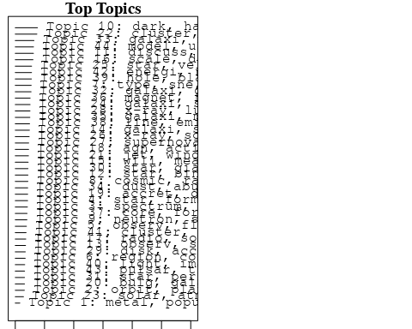

plotQuote(thoughts6, width = 30, main = "Topic 6")  
plotQuote(thoughts18, width = 30, main = "Topic 18")

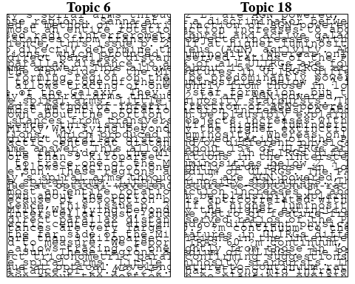

# Calculate and plot the correlation between topics  
mod.out.corr <- topicCorr(Research_topics)  
plot(mod.out.corr, cex = 1.5)  
  
  
# For each topic  
for (topic_num in 1:44) {  
 # Plot the word cloud  
 cloud(Research_topics, topic = topic_num, scale = c(2, 0.25))  
 Sys.sleep(2)  
}

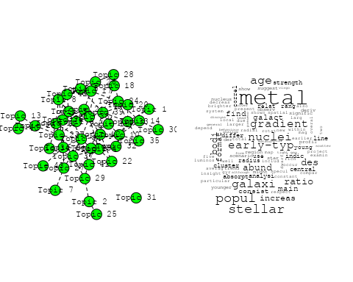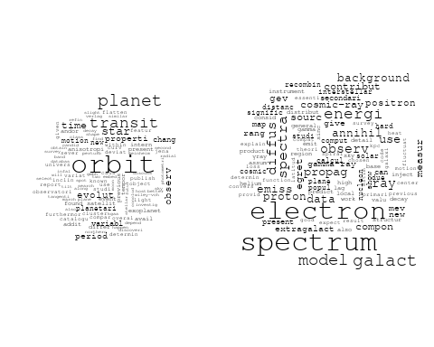

## Warning in wordcloud::wordcloud(words = vocab, freq = vec, max.words =  
## max.words, : observ could not be fit on page. It will not be plotted.

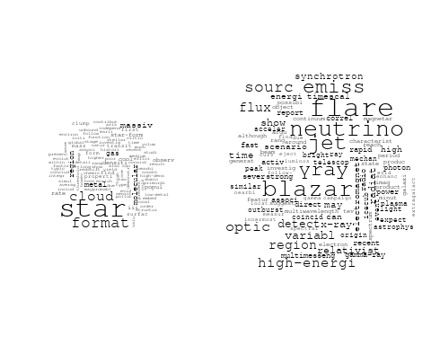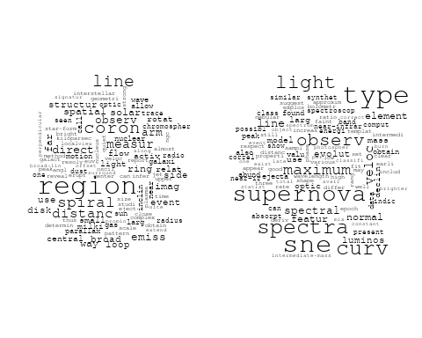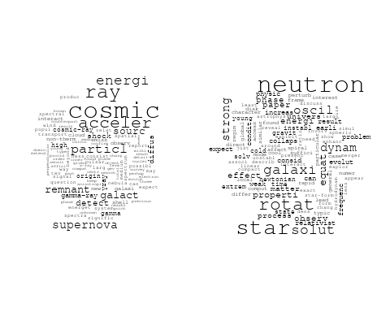

## Warning in wordcloud::wordcloud(words = vocab, freq = vec, max.words =  
## max.words, : astrophys could not be fit on page. It will not be plotted.

## Warning in wordcloud::wordcloud(words = vocab, freq = vec, max.words =  
## max.words, : present could not be fit on page. It will not be plotted.

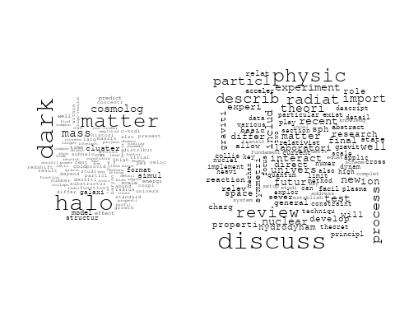

## Warning in wordcloud::wordcloud(words = vocab, freq = vec, max.words =  
## max.words, : astronom could not be fit on page. It will not be plotted.

## Warning in wordcloud::wordcloud(words = vocab, freq = vec, max.words =  
## max.words, : profil could not be fit on page. It will not be plotted.

## Warning in wordcloud::wordcloud(words = vocab, freq = vec, max.words =  
## max.words, : radial could not be fit on page. It will not be plotted.

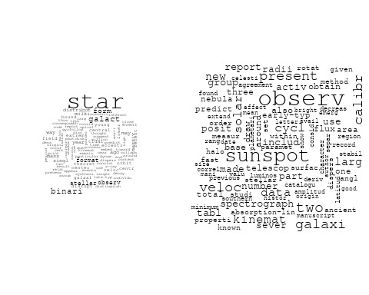

## Warning in wordcloud::wordcloud(words = vocab, freq = vec, max.words =  
## max.words, : wavelength could not be fit on page. It will not be plotted.

## Warning in wordcloud::wordcloud(words = vocab, freq = vec, max.words =  
## max.words, : astronomi could not be fit on page. It will not be plotted.

## Warning in wordcloud::wordcloud(words = vocab, freq = vec, max.words =  
## max.words, : interferometri could not be fit on page. It will not be plotted.

## Warning in wordcloud::wordcloud(words = vocab, freq = vec, max.words =  
## max.words, : astrophys could not be fit on page. It will not be plotted.

## Warning in wordcloud::wordcloud(words = vocab, freq = vec, max.words =  
## max.words, : support could not be fit on page. It will not be plotted.

## Warning in wordcloud::wordcloud(words = vocab, freq = vec, max.words =  
## max.words, : evolut could not be fit on page. It will not be plotted.

## Warning in wordcloud::wordcloud(words = vocab, freq = vec, max.words =  
## max.words, : process could not be fit on page. It will not be plotted.

## Warning in wordcloud::wordcloud(words = vocab, freq = vec, max.words =  
## max.words, : observ could not be fit on page. It will not be plotted.

## Warning in wordcloud::wordcloud(words = vocab, freq = vec, max.words =  
## max.words, : studi could not be fit on page. It will not be plotted.

## Warning in wordcloud::wordcloud(words = vocab, freq = vec, max.words =  
## max.words, : imag could not be fit on page. It will not be plotted.

## Warning in wordcloud::wordcloud(words = vocab, freq = vec, max.words =  
## max.words, : astronom could not be fit on page. It will not be plotted.

## Warning in wordcloud::wordcloud(words = vocab, freq = vec, max.words =  
## max.words, : concept could not be fit on page. It will not be plotted.

## Warning in wordcloud::wordcloud(words = vocab, freq = vec, max.words =  
## max.words, : telescop could not be fit on page. It will not be plotted.

## Warning in wordcloud::wordcloud(words = vocab, freq = vec, max.words =  
## max.words, : futur could not be fit on page. It will not be plotted.

## Warning in wordcloud::wordcloud(words = vocab, freq = vec, max.words =  
## max.words, : decay could not be fit on page. It will not be plotted.

## Warning in wordcloud::wordcloud(words = vocab, freq = vec, max.words =  
## max.words, : spectroscopi could not be fit on page. It will not be plotted.

## Warning in wordcloud::wordcloud(words = vocab, freq = vec, max.words =  
## max.words, : voyag could not be fit on page. It will not be plotted.

## Warning in wordcloud::wordcloud(words = vocab, freq = vec, max.words =  
## max.words, : resolut could not be fit on page. It will not be plotted.

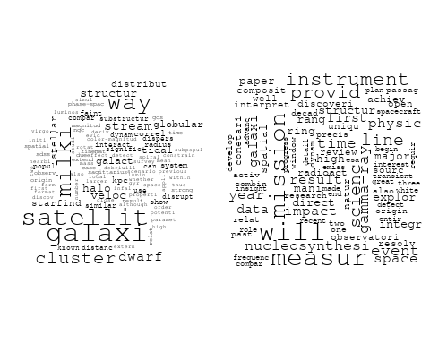

## Warning in wordcloud::wordcloud(words = vocab, freq = vec, max.words =  
## max.words, : distribut could not be fit on page. It will not be plotted.

## Warning in wordcloud::wordcloud(words = vocab, freq = vec, max.words =  
## max.words, : function could not be fit on page. It will not be plotted.

## Warning in wordcloud::wordcloud(words = vocab, freq = vec, max.words =  
## max.words, : scale could not be fit on page. It will not be plotted.

## Warning in wordcloud::wordcloud(words = vocab, freq = vec, max.words =  
## max.words, : densiti could not be fit on page. It will not be plotted.

## Warning in wordcloud::wordcloud(words = vocab, freq = vec, max.words =  
## max.words, : power could not be fit on page. It will not be plotted.

## Warning in wordcloud::wordcloud(words = vocab, freq = vec, max.words =  
## max.words, : present could not be fit on page. It will not be plotted.

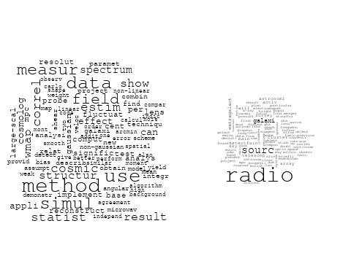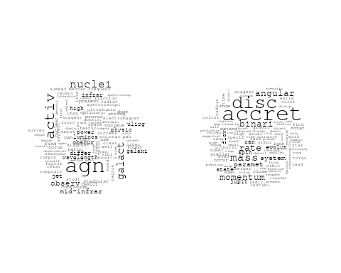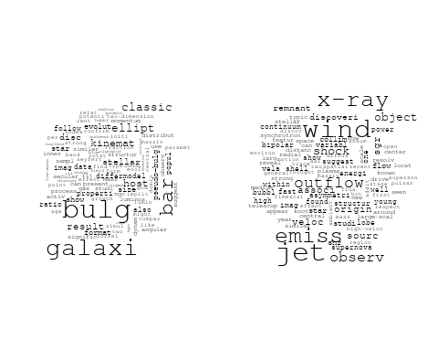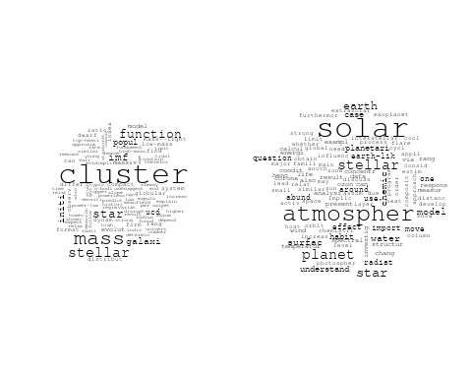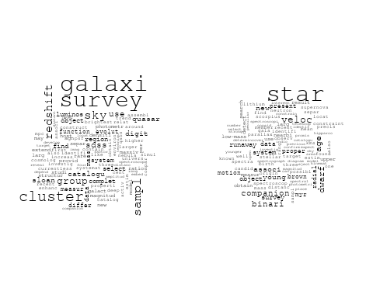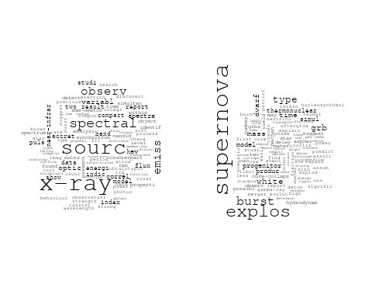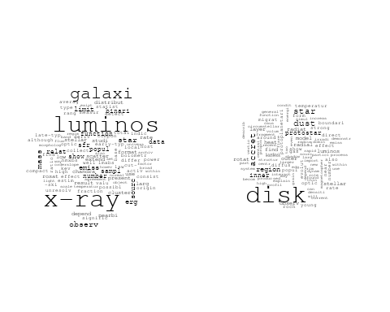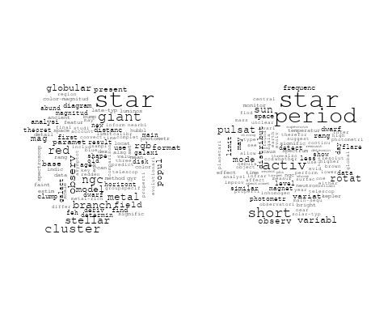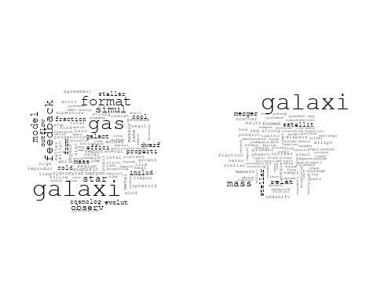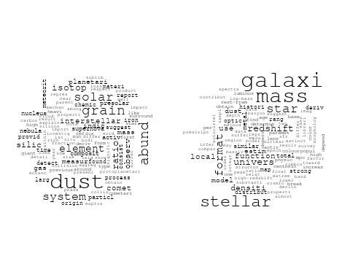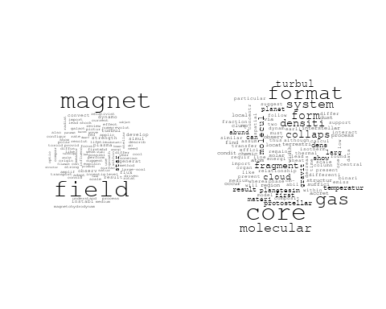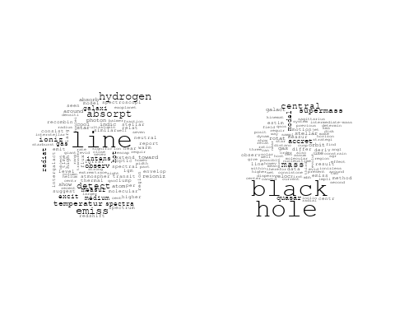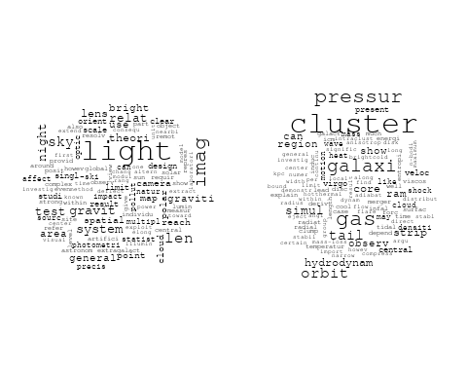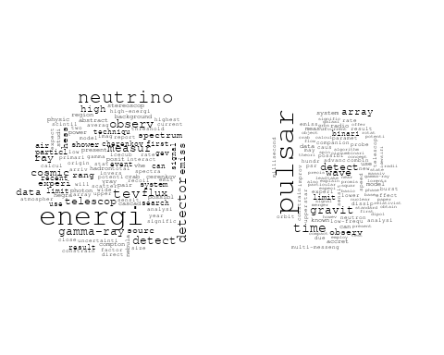

# Get the topic proportions for each document  
topic_proportions <- Research_topics$theta  
  
# Find the index of the topic with the highest proportion for each document  
# This will be the topic that each document is most likely to belong to  
max_topic_idx <- apply(topic_proportions, 1, which.max)  
  
# Add this as a new column to your data  
data_independent$topic <- max_topic_idx  
  
  
  
# Define the intervals  
intervals <- c('1824_1899', '1900_1964', '1965_1974', '1975_1984', '1985_1994', '1995_1999', '2000_2004', '2005_2009', '2010_2014', '2015_2019', '2020_2022')  
colors <- c('pink', 'blue', 'purple', 'yellow', 'green', 'pink', 'orange', 'violet', 'green', 'blue', 'pink')  
  
# Loop through the intervals and plot  
for(i in seq_along(intervals)){  
 # Filter data for when the pub_interval is equal to 1  
 data_filtered <- data_independent[data_independent[[paste0('pub_interval_', intervals[i])]] == 1,]  
   
 # Make the histogram  
   
 p <- ggplot(data_filtered, aes(x = topic)) +  
 geom_histogram(binwidth = 1, fill = colors[i], color = "black") +  
 xlab("Topic") +  
 ylab("Count") +  
 ggtitle(paste0("Topics from year ", gsub("_", " to ", intervals[i])))  
   
 print(p)  
}

