Europe topic models

Charlie J. Gomez, Harshvardhan Singh

2023-08-29

library('stm')

## stm v1.3.6 successfully loaded. See ?stm for help.   
## Papers, resources, and other materials at structuraltopicmodel.com

library(dplyr)

##   
## Attaching package: 'dplyr'

## The following objects are masked from 'package:stats':  
##   
## filter, lag

## The following objects are masked from 'package:base':  
##   
## intersect, setdiff, setequal, union

library(stringr)  
library(wordcloud)

## Loading required package: RColorBrewer

#Read csv file  
data = read.csv("preprocessed_data_Jul14.csv")  
  
##Topic generation for Europe (in collaboration) publications  
  
data_collab <- data[data[["Europe"]] != 0,]  
  
# Save the original title data for future use  
data_collab$original_concatenated_title_abstract <- data_collab$concatenated_title_abstract  
  
#pre-processing the titles using textProcessor from the stm package  
processed_text <- textProcessor(data_collab$concatenated_title_abstract, metadata = data_collab)

## Building corpus...   
## Converting to Lower Case...   
## Removing punctuation...   
## Removing stopwords...   
## Removing numbers...   
## Stemming...   
## Creating Output...

# Further prepare the data by removing low-frequency terms  
out_text <- prepDocuments(processed_text$documents, processed_text$vocab, processed_text$meta)

## Removing 5015 of 15871 terms (5015 of 346655 tokens) due to frequency   
## Your corpus now has 4355 documents, 10856 terms and 341640 tokens.

docs_text <- out_text$documents  
vocab_text <- out_text$vocab  
meta_text <- out_text$meta  
  
  
#Prepare data  
plotRemoved(processed_text$documents, lower.thresh = seq(1, 200, by = 100))

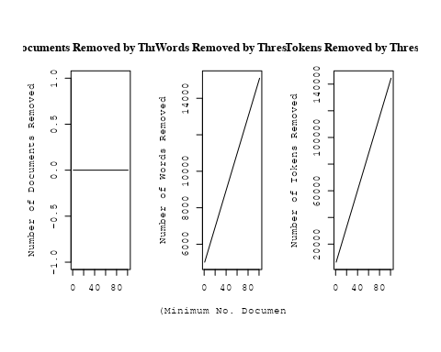

out_text <- prepDocuments(processed_text$documents, processed_text$vocab, processed_text$meta, lower.thresh = 8)

## Removing 12705 of 15871 terms (29661 of 346655 tokens) due to frequency   
## Your corpus now has 4355 documents, 3166 terms and 316994 tokens.

str(out_text$meta)

## 'data.frame': 4355 obs. of 39 variables:  
## $ concept_id : chr "https://openalex.org/C1276947" "https://openalex.org/C44870925" "https://openalex.org/C44870925" "https://openalex.org/C44870925" ...  
## $ work_id : chr "https://openalex.org/W1967633346" "https://openalex.org/W1996505939" "https://openalex.org/W1994827287" "https://openalex.org/W1548323710" ...  
## $ publication_year : int 2003 2014 2008 2002 1998 2008 2005 2005 2008 2008 ...  
## $ title : chr "Around-the-Clock Observations of the Q0957+561A,B Gravitationally Lensed Quasar. II. Results for the Second Observing Season" "A luminous, blue progenitor system for the type Iax supernova 2012Z" "On the Use of Blanketed Atmospheres as Boundary Conditions for Stellar Evolutionary Models" "Interpretation of the Core-Wing Anomaly of Balmer Line Profiles of Cool Ap Stars*" ...  
## $ paperabstract : chr "We report on an observing campaign in 2001 March to monitor the brightness of the later arriving Q0957+561B ima"| __truncated__ "Type Iax supernovae are stellar explosions that are spectroscopically similar to some type Ia supernovae at the"| __truncated__ "Stellar models have been computed for stars having [ Fe/H ] = 0.0 (assuming both the Grevesse & Sauval and Aspl"| __truncated__ "A number of cool magnetic chemically peculiar stars exhibit abnormal profiles of hydrogen Balmer lines. This an"| __truncated__ ...  
## $ country : chr "US RS" "DK US US DK" "CA SE" "SE SE" ...  
## $ year_concept : chr "2003+https://openalex.org/C1276947" "2014+https://openalex.org/C44870925" "2008+https://openalex.org/C44870925" "2002+https://openalex.org/C44870925" ...  
## $ concatenated_title_abstract : chr "Around-the-Clock Observations of the Q0957+561A,B Gravitationally Lensed Quasar. II. Results for the Second Obs"| __truncated__ "A luminous, blue progenitor system for the type Iax supernova 2012Z Type Iax supernovae are stellar explosions "| __truncated__ "On the Use of Blanketed Atmospheres as Boundary Conditions for Stellar Evolutionary Models Stellar models have "| __truncated__ "Interpretation of the Core-Wing Anomaly of Balmer Line Profiles of Cool Ap Stars* A number of cool magnetic che"| __truncated__ ...  
## $ US : num 50 50 0 0 0 50 0 50 0 0 ...  
## $ IN : num 0 0 0 0 0 0 0 0 0 0 ...  
## $ DE : num 0 0 0 0 0 0 0 0 0 0 ...  
## $ CH : num 0 0 0 0 0 0 0 0 0 0 ...  
## $ GB : num 0 0 0 0 0 0 0 0 0 0 ...  
## $ CN : num 0 0 0 0 0 0 0 0 0 0 ...  
## $ FR : num 0 0 0 0 0 0 0 0 0 0 ...  
## $ IT : num 0 0 0 0 0 0 0 0 0 0 ...  
## $ RU : num 0 0 0 0 0 0 0 0 0 0 ...  
## $ CA : num 0 0 50 0 0 0 0 0 0 0 ...  
## $ NL : num 0 0 0 0 0 0 0 0 0 0 ...  
## $ AU : num 0 0 0 0 0 0 0 0 0 0 ...  
## $ JP : num 0 0 0 0 0 0 0 0 0 0 ...  
## $ ES : num 0 0 0 0 0 0 0 0 0 0 ...  
## $ IL : num 0 0 0 0 0 0 0 0 0 0 ...  
## $ Americas : num 0 0 0 0 0 0 0 0 0 0 ...  
## $ Europe : num 50 50 50 100 100 50 100 50 100 100 ...  
## $ Africa : num 0 0 0 0 0 0 0 0 0 0 ...  
## $ AsiaAndOceania : num 0 0 0 0 0 0 0 0 0 0 ...  
## $ pub_interval_2020_2022 : int 0 0 0 0 0 0 0 0 0 0 ...  
## $ pub_interval_2015_2019 : int 0 0 0 0 0 0 0 0 0 0 ...  
## $ pub_interval_2010_2014 : int 0 1 0 0 0 0 0 0 0 0 ...  
## $ pub_interval_2005_2009 : int 0 0 1 0 0 1 1 1 1 1 ...  
## $ pub_interval_2000_2004 : int 1 0 0 1 0 0 0 0 0 0 ...  
## $ pub_interval_1995_1999 : int 0 0 0 0 1 0 0 0 0 0 ...  
## $ pub_interval_1985_1994 : int 0 0 0 0 0 0 0 0 0 0 ...  
## $ pub_interval_1975_1984 : int 0 0 0 0 0 0 0 0 0 0 ...  
## $ pub_interval_1965_1974 : int 0 0 0 0 0 0 0 0 0 0 ...  
## $ pub_interval_1900_1964 : int 0 0 0 0 0 0 0 0 0 0 ...  
## $ pub_interval_1824_1899 : int 0 0 0 0 0 0 0 0 0 0 ...  
## $ original_concatenated_title_abstract: chr "Around-the-Clock Observations of the Q0957+561A,B Gravitationally Lensed Quasar. II. Results for the Second Obs"| __truncated__ "A luminous, blue progenitor system for the type Iax supernova 2012Z Type Iax supernovae are stellar explosions "| __truncated__ "On the Use of Blanketed Atmospheres as Boundary Conditions for Stellar Evolutionary Models Stellar models have "| __truncated__ "Interpretation of the Core-Wing Anomaly of Balmer Line Profiles of Cool Ap Stars* A number of cool magnetic che"| __truncated__ ...

# Initialize an empty formula string  
prevalence_formula_str <- "~"  
  
# Define the publication intervals  
pub_intervals <- c("pub_interval_2020_2022", "pub_interval_2015_2019", "pub_interval_2010_2014",   
 "pub_interval_2005_2009", "pub_interval_2000_2004", "pub_interval_1995_1999",  
 "pub_interval_1985_1994", "pub_interval_1975_1984", "pub_interval_1965_1974",  
 "pub_interval_1900_1964", "pub_interval_1824_1899")  
  
# Add each publication interval to the formula string  
for (interval in pub_intervals) {  
 # add an if statement to handle the first addition (without '+')  
 if (prevalence_formula_str == "~") {  
 prevalence_formula_str <- paste(prevalence_formula_str, interval)  
 } else {  
 prevalence_formula_str <- paste(prevalence_formula_str, "+", interval)  
 }  
}  
  
  
# Convert the string to a formula  
prevalence_formula <- as.formula(prevalence_formula_str)  
print(prevalence_formula)

## ~pub_interval_2020_2022 + pub_interval_2015_2019 + pub_interval_2010_2014 +   
## pub_interval_2005_2009 + pub_interval_2000_2004 + pub_interval_1995_1999 +   
## pub_interval_1985_1994 + pub_interval_1975_1984 + pub_interval_1965_1974 +   
## pub_interval_1900_1964 + pub_interval_1824_1899

# Run STM model  
Research_topics <- stm(documents = out_text$documents,   
 vocab = out_text$vocab,   
 K = 44,   
 prevalence = prevalence_formula,   
 data = out_text$meta,   
 init.type = "Spectral",  
 max.em.its = 1000,  
 gamma.prior = 'L1')

## Beginning Spectral Initialization   
## Calculating the gram matrix...  
## Finding anchor words...  
## ............................................  
## Recovering initialization...  
## ...............................  
## Initialization complete.  
## .....................................................................................................  
## Completed E-Step (4 seconds).   
## Completed M-Step.   
## Completing Iteration 1 (approx. per word bound = -6.713)   
## .....................................................................................................  
## Completed E-Step (4 seconds).   
## Completed M-Step.   
## Completing Iteration 2 (approx. per word bound = -6.436, relative change = 4.117e-02)   
## .....................................................................................................  
## Completed E-Step (4 seconds).   
## Completed M-Step.   
## Completing Iteration 3 (approx. per word bound = -6.373, relative change = 9.852e-03)   
## .....................................................................................................  
## Completed E-Step (3 seconds).   
## Completed M-Step.   
## Completing Iteration 4 (approx. per word bound = -6.349, relative change = 3.666e-03)   
## .....................................................................................................  
## Completed E-Step (3 seconds).   
## Completed M-Step.   
## Completing Iteration 5 (approx. per word bound = -6.338, relative change = 1.811e-03)   
## Topic 1: star, wind, stellar, group, rotat   
## Topic 2: ngc, cluster, star, distanc, use   
## Topic 3: pulsar, puls, model, neutron, star   
## Topic 4: model, cosmolog, univers, paramet, energi   
## Topic 5: region, solar, evolut, wave, observ   
## Topic 6: burst, gamma-ray, grb, merger, grbs   
## Topic 7: dust, galaxi, format, observ, gas   
## Topic 8: sourc, radiat, belt, disk, object   
## Topic 9: planet, transit, star, mass, orbit   
## Topic 10: space, univers, observatori, astronomi, research   
## Topic 11: galaxi, radio, sampl, activ, luminos   
## Topic 12: cmes, cme, eject, event, mass   
## Topic 13: magnet, field, turbul, result, strength   
## Topic 14: variabl, cepheid, distanc, star, eclips   
## Topic 15: ray, cosmic, energi, particl, proton   
## Topic 16: binari, system, orbit, compon, mass   
## Topic 17: astrophys, astronom, physic, observ, studi   
## Topic 18: jet, accret, relativist, model, flow   
## Topic 19: star, supernova, system, solar, mass   
## Topic 20: star, period, pulsat, mode, frequenc   
## Topic 21: galaxi, survey, bar, imag, sampl   
## Topic 22: halo, model, galaxi, mass, simul   
## Topic 23: power, method, data, spectrum, use   
## Topic 24: review, observ, can, model, x-ray   
## Topic 25: x-ray, shell, emiss, supernova, kev   
## Topic 26: cloud, gas, molecular, format, core   
## Topic 27: hole, black, mass, star, binari   
## Topic 28: galaxi, emiss, line, abund, region   
## Topic 29: star, abund, element, metal, chemic   
## Topic 30: rotat, matter, dark, star, energi   
## Topic 31: burst, type, radio, optic, imag   
## Topic 32: solar, cycl, sun, model, variat   
## Topic 33: comet, observ, activ, distanc, water   
## Topic 34: data, observ, use, time, telescop   
## Topic 35: lens, light, gravit, observ, imag   
## Topic 36: asteroid, famili, object, orbit, observ   
## Topic 37: star, dwarf, stellar, age, metal   
## Topic 38: cluster, galaxi, region, luminos, distribut   
## Topic 39: emiss, x-ray, radio, observ, sourc   
## Topic 40: star, nebula, wind, featur, line   
## Topic 41: line, emiss, accret, observ, optic   
## Topic 42: flare, solar, observ, loop, coron   
## Topic 43: star, neutron, stellar, equat, model   
## Topic 44: region, temperatur, abund, relat, measur   
## .....................................................................................................  
## Completed E-Step (3 seconds).   
## Completed M-Step.   
## Completing Iteration 6 (approx. per word bound = -6.331, relative change = 1.111e-03)   
## .....................................................................................................  
## Completed E-Step (3 seconds).   
## Completed M-Step.   
## Completing Iteration 7 (approx. per word bound = -6.326, relative change = 7.210e-04)   
## .....................................................................................................  
## Completed E-Step (3 seconds).   
## Completed M-Step.   
## Completing Iteration 8 (approx. per word bound = -6.323, relative change = 5.059e-04)   
## .....................................................................................................  
## Completed E-Step (3 seconds).   
## Completed M-Step.   
## Completing Iteration 9 (approx. per word bound = -6.321, relative change = 4.019e-04)   
## .....................................................................................................  
## Completed E-Step (3 seconds).   
## Completed M-Step.   
## Completing Iteration 10 (approx. per word bound = -6.319, relative change = 3.272e-04)   
## Topic 1: star, wind, group, stellar, rotat   
## Topic 2: ngc, star, cluster, distanc, use   
## Topic 3: pulsar, puls, model, neutron, star   
## Topic 4: model, univers, cosmolog, paramet, energi   
## Topic 5: wave, solar, region, observ, coron   
## Topic 6: burst, gamma-ray, grb, grbs, observ   
## Topic 7: dust, galaxi, format, observ, star   
## Topic 8: sourc, disk, object, belt, class   
## Topic 9: planet, transit, star, mass, system   
## Topic 10: space, univers, observatori, mission, astronomi   
## Topic 11: galaxi, radio, sampl, agn, activ   
## Topic 12: cmes, cme, eject, mass, coron   
## Topic 13: magnet, field, turbul, result, effect   
## Topic 14: variabl, cepheid, distanc, star, eclips   
## Topic 15: ray, energi, cosmic, particl, acceler   
## Topic 16: binari, system, orbit, compon, mass   
## Topic 17: astrophys, physic, observ, astronom, studi   
## Topic 18: jet, accret, disk, relativist, flow   
## Topic 19: star, supernova, evolut, mass, system   
## Topic 20: star, pulsat, period, mode, frequenc   
## Topic 21: galaxi, survey, bar, imag, sampl   
## Topic 22: halo, model, galaxi, mass, simul   
## Topic 23: method, power, data, use, function   
## Topic 24: review, observ, can, model, studi   
## Topic 25: x-ray, emiss, shell, kev, temperatur   
## Topic 26: cloud, gas, molecular, core, format   
## Topic 27: hole, black, mass, star, binari   
## Topic 28: galaxi, emiss, line, abund, ioniz   
## Topic 29: star, abund, element, metal, chemic   
## Topic 30: rotat, matter, dark, star, differenti   
## Topic 31: imag, burst, radio, type, observ   
## Topic 32: solar, cycl, variat, sun, activ   
## Topic 33: comet, observ, activ, distanc, water   
## Topic 34: data, observ, use, time, measur   
## Topic 35: lens, gravit, light, event, microlens   
## Topic 36: asteroid, famili, object, orbit, observ   
## Topic 37: dwarf, star, stellar, age, metal   
## Topic 38: cluster, galaxi, region, field, luminos   
## Topic 39: x-ray, emiss, radio, observ, sourc   
## Topic 40: nebula, star, wind, featur, veloc   
## Topic 41: line, emiss, optic, spectra, broad   
## Topic 42: flare, solar, observ, electron, loop   
## Topic 43: star, stellar, neutron, model, mass   
## Topic 44: region, temperatur, abund, method, relat   
## .....................................................................................................  
## Completed E-Step (3 seconds).   
## Completed M-Step.   
## Completing Iteration 11 (approx. per word bound = -6.317, relative change = 2.792e-04)   
## .....................................................................................................  
## Completed E-Step (3 seconds).   
## Completed M-Step.   
## Completing Iteration 12 (approx. per word bound = -6.315, relative change = 2.415e-04)   
## .....................................................................................................  
## Completed E-Step (3 seconds).   
## Completed M-Step.   
## Completing Iteration 13 (approx. per word bound = -6.314, relative change = 1.947e-04)   
## .....................................................................................................  
## Completed E-Step (3 seconds).   
## Completed M-Step.   
## Completing Iteration 14 (approx. per word bound = -6.313, relative change = 1.940e-04)   
## .....................................................................................................  
## Completed E-Step (3 seconds).   
## Completed M-Step.   
## Completing Iteration 15 (approx. per word bound = -6.312, relative change = 1.814e-04)   
## Topic 1: star, wind, group, stellar, rotat   
## Topic 2: ngc, star, cluster, distanc, use   
## Topic 3: pulsar, puls, model, emiss, neutron   
## Topic 4: model, univers, cosmolog, paramet, energi   
## Topic 5: wave, solar, region, observ, coron   
## Topic 6: burst, gamma-ray, grb, grbs, observ   
## Topic 7: dust, galaxi, format, observ, star   
## Topic 8: sourc, disk, object, belt, class   
## Topic 9: planet, star, transit, mass, system   
## Topic 10: space, univers, observatori, mission, astronomi   
## Topic 11: galaxi, radio, agn, sampl, activ   
## Topic 12: cmes, cme, eject, coron, mass   
## Topic 13: magnet, field, turbul, result, effect   
## Topic 14: variabl, cepheid, distanc, star, eclips   
## Topic 15: energi, ray, particl, cosmic, acceler   
## Topic 16: binari, system, orbit, compon, mass   
## Topic 17: astrophys, physic, observ, astronom, studi   
## Topic 18: jet, accret, disk, flow, relativist   
## Topic 19: star, supernova, evolut, mass, massiv   
## Topic 20: star, pulsat, mode, period, frequenc   
## Topic 21: galaxi, survey, bar, imag, sampl   
## Topic 22: halo, galaxi, model, mass, simul   
## Topic 23: method, power, function, data, use   
## Topic 24: review, observ, physic, can, model   
## Topic 25: x-ray, emiss, shell, kev, shock   
## Topic 26: gas, cloud, molecular, core, format   
## Topic 27: hole, black, mass, star, binari   
## Topic 28: galaxi, emiss, line, ioniz, abund   
## Topic 29: star, abund, element, metal, chemic   
## Topic 30: rotat, matter, dark, star, differenti   
## Topic 31: imag, radio, burst, type, observ   
## Topic 32: solar, cycl, variat, sun, activ   
## Topic 33: comet, observ, distanc, water, activ   
## Topic 34: data, observ, use, measur, time   
## Topic 35: lens, gravit, light, event, imag   
## Topic 36: asteroid, famili, object, orbit, observ   
## Topic 37: dwarf, star, stellar, metal, age   
## Topic 38: cluster, galaxi, field, region, redshift   
## Topic 39: radio, x-ray, emiss, observ, sourc   
## Topic 40: nebula, star, wind, featur, model   
## Topic 41: line, emiss, optic, spectra, broad   
## Topic 42: flare, solar, event, electron, observ   
## Topic 43: star, stellar, model, neutron, mass   
## Topic 44: region, temperatur, abund, oxygen, determin   
## .....................................................................................................  
## Completed E-Step (3 seconds).   
## Completed M-Step.   
## Completing Iteration 16 (approx. per word bound = -6.311, relative change = 1.639e-04)   
## .....................................................................................................  
## Completed E-Step (3 seconds).   
## Completed M-Step.   
## Completing Iteration 17 (approx. per word bound = -6.310, relative change = 1.192e-04)   
## .....................................................................................................  
## Completed E-Step (3 seconds).   
## Completed M-Step.   
## Completing Iteration 18 (approx. per word bound = -6.309, relative change = 1.415e-04)   
## .....................................................................................................  
## Completed E-Step (3 seconds).   
## Completed M-Step.   
## Completing Iteration 19 (approx. per word bound = -6.308, relative change = 1.208e-04)   
## .....................................................................................................  
## Completed E-Step (3 seconds).   
## Completed M-Step.   
## Completing Iteration 20 (approx. per word bound = -6.308, relative change = 1.053e-04)   
## Topic 1: wind, star, group, stellar, rotat   
## Topic 2: ngc, star, cluster, distanc, use   
## Topic 3: pulsar, puls, model, emiss, neutron   
## Topic 4: model, cosmolog, univers, paramet, energi   
## Topic 5: wave, solar, observ, region, coron   
## Topic 6: burst, gamma-ray, grb, grbs, observ   
## Topic 7: dust, galaxi, format, star, observ   
## Topic 8: sourc, object, disk, belt, class   
## Topic 9: planet, star, transit, mass, system   
## Topic 10: space, univers, observatori, mission, astronomi   
## Topic 11: galaxi, radio, agn, sampl, activ   
## Topic 12: cme, cmes, eject, coron, mass   
## Topic 13: magnet, field, turbul, result, effect   
## Topic 14: variabl, cepheid, distanc, star, eclips   
## Topic 15: energi, particl, ray, cosmic, acceler   
## Topic 16: binari, system, orbit, mass, compon   
## Topic 17: astrophys, physic, observ, astronom, studi   
## Topic 18: jet, accret, disk, flow, model   
## Topic 19: star, supernova, evolut, massiv, mass   
## Topic 20: star, pulsat, mode, frequenc, period   
## Topic 21: galaxi, survey, bar, imag, sampl   
## Topic 22: halo, galaxi, model, mass, simul   
## Topic 23: method, power, function, use, data   
## Topic 24: review, observ, physic, understand, can   
## Topic 25: x-ray, emiss, kev, shell, luminos   
## Topic 26: gas, cloud, molecular, core, format   
## Topic 27: hole, black, mass, star, binari   
## Topic 28: galaxi, emiss, line, ioniz, lyα   
## Topic 29: star, abund, element, metal, chemic   
## Topic 30: rotat, matter, dark, star, differenti   
## Topic 31: imag, radio, burst, type, observ   
## Topic 32: solar, cycl, variat, activ, sun   
## Topic 33: comet, observ, distanc, water, dust   
## Topic 34: data, observ, use, measur, time   
## Topic 35: lens, gravit, event, light, imag   
## Topic 36: asteroid, famili, object, orbit, observ   
## Topic 37: dwarf, star, metal, stellar, white   
## Topic 38: cluster, galaxi, field, region, redshift   
## Topic 39: radio, emiss, x-ray, observ, sourc   
## Topic 40: nebula, star, featur, wind, model   
## Topic 41: line, emiss, optic, spectra, broad   
## Topic 42: flare, solar, event, energi, electron   
## Topic 43: star, model, stellar, neutron, mass   
## Topic 44: temperatur, region, abund, determin, use   
## .....................................................................................................  
## Completed E-Step (3 seconds).   
## Completed M-Step.   
## Completing Iteration 21 (approx. per word bound = -6.307, relative change = 1.070e-04)   
## .....................................................................................................  
## Completed E-Step (3 seconds).   
## Completed M-Step.   
## Completing Iteration 22 (approx. per word bound = -6.306, relative change = 1.008e-04)   
## .....................................................................................................  
## Completed E-Step (3 seconds).   
## Completed M-Step.   
## Completing Iteration 23 (approx. per word bound = -6.305, relative change = 1.353e-04)   
## .....................................................................................................  
## Completed E-Step (3 seconds).   
## Completed M-Step.   
## Completing Iteration 24 (approx. per word bound = -6.305, relative change = 1.001e-04)   
## .....................................................................................................  
## Completed E-Step (3 seconds).   
## Completed M-Step.   
## Completing Iteration 25 (approx. per word bound = -6.304, relative change = 8.093e-05)   
## Topic 1: wind, star, stellar, group, rotat   
## Topic 2: star, ngc, cluster, distanc, use   
## Topic 3: pulsar, puls, emiss, model, neutron   
## Topic 4: model, cosmolog, univers, energi, paramet   
## Topic 5: wave, solar, observ, region, coron   
## Topic 6: burst, gamma-ray, grb, grbs, observ   
## Topic 7: dust, galaxi, format, star, observ   
## Topic 8: sourc, object, disk, belt, solar   
## Topic 9: planet, transit, star, mass, system   
## Topic 10: space, univers, observatori, mission, astronomi   
## Topic 11: galaxi, radio, agn, sampl, activ   
## Topic 12: cme, cmes, coron, eject, mass   
## Topic 13: magnet, field, turbul, result, effect   
## Topic 14: variabl, cepheid, distanc, magellan, star   
## Topic 15: energi, particl, ray, cosmic, acceler   
## Topic 16: binari, system, orbit, mass, compon   
## Topic 17: astrophys, physic, observ, studi, astronom   
## Topic 18: jet, accret, disk, flow, model   
## Topic 19: star, supernova, evolut, massiv, mass   
## Topic 20: star, pulsat, mode, frequenc, oscil   
## Topic 21: galaxi, survey, bar, imag, sampl   
## Topic 22: halo, galaxi, model, mass, simul   
## Topic 23: method, power, function, use, model   
## Topic 24: review, observ, physic, understand, studi   
## Topic 25: x-ray, emiss, kev, shell, luminos   
## Topic 26: gas, cloud, molecular, core, format   
## Topic 27: hole, black, mass, star, binari   
## Topic 28: galaxi, emiss, line, ioniz, lyα   
## Topic 29: star, abund, element, metal, chemic   
## Topic 30: rotat, matter, dark, star, differenti   
## Topic 31: imag, radio, burst, type, telescop   
## Topic 32: solar, cycl, activ, variat, sun   
## Topic 33: comet, observ, distanc, water, dust   
## Topic 34: data, observ, use, measur, time   
## Topic 35: lens, gravit, event, light, imag   
## Topic 36: asteroid, famili, object, orbit, observ   
## Topic 37: dwarf, star, metal, white, stellar   
## Topic 38: cluster, galaxi, field, region, redshift   
## Topic 39: radio, emiss, x-ray, observ, sourc   
## Topic 40: nebula, star, featur, wind, model   
## Topic 41: line, emiss, optic, spectra, broad   
## Topic 42: flare, solar, event, energi, electron   
## Topic 43: star, model, stellar, equat, mass   
## Topic 44: temperatur, region, determin, abund, use   
## .....................................................................................................  
## Completed E-Step (3 seconds).   
## Completed M-Step.   
## Completing Iteration 26 (approx. per word bound = -6.304, relative change = 4.177e-05)   
## .....................................................................................................  
## Completed E-Step (3 seconds).   
## Completed M-Step.   
## Completing Iteration 27 (approx. per word bound = -6.303, relative change = 9.330e-05)   
## .....................................................................................................  
## Completed E-Step (3 seconds).   
## Completed M-Step.   
## Completing Iteration 28 (approx. per word bound = -6.303, relative change = 6.234e-05)   
## .....................................................................................................  
## Completed E-Step (3 seconds).   
## Completed M-Step.   
## Completing Iteration 29 (approx. per word bound = -6.303, relative change = 5.743e-05)   
## .....................................................................................................  
## Completed E-Step (3 seconds).   
## Completed M-Step.   
## Completing Iteration 30 (approx. per word bound = -6.302, relative change = 5.067e-05)   
## Topic 1: wind, star, stellar, group, rotat   
## Topic 2: star, ngc, cluster, distanc, use   
## Topic 3: pulsar, puls, emiss, model, neutron   
## Topic 4: model, cosmolog, univers, energi, dark   
## Topic 5: wave, solar, observ, region, coron   
## Topic 6: burst, gamma-ray, grb, grbs, observ   
## Topic 7: dust, galaxi, format, star, observ   
## Topic 8: sourc, object, disk, belt, solar   
## Topic 9: planet, transit, star, mass, system   
## Topic 10: space, univers, observatori, mission, astronomi   
## Topic 11: galaxi, radio, agn, activ, sampl   
## Topic 12: cme, cmes, coron, eject, mass   
## Topic 13: magnet, field, turbul, result, effect   
## Topic 14: variabl, cepheid, distanc, magellan, star   
## Topic 15: energi, particl, ray, cosmic, acceler   
## Topic 16: binari, system, orbit, mass, compon   
## Topic 17: astrophys, observ, physic, studi, astronom   
## Topic 18: jet, accret, disk, flow, model   
## Topic 19: star, supernova, evolut, massiv, mass   
## Topic 20: star, pulsat, mode, frequenc, oscil   
## Topic 21: galaxi, bar, survey, imag, spiral   
## Topic 22: halo, galaxi, model, mass, simul   
## Topic 23: method, function, power, model, use   
## Topic 24: review, observ, physic, understand, studi   
## Topic 25: x-ray, emiss, kev, shell, luminos   
## Topic 26: gas, cloud, molecular, core, format   
## Topic 27: hole, black, mass, binari, star   
## Topic 28: galaxi, emiss, line, ioniz, lyα   
## Topic 29: star, abund, element, metal, chemic   
## Topic 30: rotat, matter, dark, star, differenti   
## Topic 31: imag, radio, burst, type, telescop   
## Topic 32: solar, cycl, activ, variat, period   
## Topic 33: comet, observ, distanc, water, dust   
## Topic 34: data, observ, use, measur, time   
## Topic 35: lens, gravit, event, light, imag   
## Topic 36: asteroid, famili, object, orbit, observ   
## Topic 37: dwarf, star, metal, white, stellar   
## Topic 38: cluster, galaxi, field, region, redshift   
## Topic 39: radio, emiss, x-ray, observ, sourc   
## Topic 40: nebula, star, featur, observ, wind   
## Topic 41: line, emiss, optic, spectra, broad   
## Topic 42: flare, solar, event, energi, electron   
## Topic 43: model, star, stellar, equat, mass   
## Topic 44: temperatur, region, determin, abund, use   
## .....................................................................................................  
## Completed E-Step (3 seconds).   
## Completed M-Step.   
## Completing Iteration 31 (approx. per word bound = -6.302, relative change = 4.791e-05)   
## .....................................................................................................  
## Completed E-Step (3 seconds).   
## Completed M-Step.   
## Completing Iteration 32 (approx. per word bound = -6.302, relative change = 4.515e-05)   
## .....................................................................................................  
## Completed E-Step (3 seconds).   
## Completed M-Step.   
## Completing Iteration 33 (approx. per word bound = -6.301, relative change = 5.751e-05)   
## .....................................................................................................  
## Completed E-Step (3 seconds).   
## Completed M-Step.   
## Completing Iteration 34 (approx. per word bound = -6.301, relative change = 4.211e-05)   
## .....................................................................................................  
## Completed E-Step (3 seconds).   
## Completed M-Step.   
## Completing Iteration 35 (approx. per word bound = -6.301, relative change = 4.023e-05)   
## Topic 1: wind, star, stellar, group, rotat   
## Topic 2: star, ngc, cluster, distanc, use   
## Topic 3: pulsar, puls, emiss, model, neutron   
## Topic 4: model, cosmolog, univers, energi, dark   
## Topic 5: wave, solar, observ, region, coron   
## Topic 6: burst, gamma-ray, grb, grbs, observ   
## Topic 7: dust, galaxi, format, star, observ   
## Topic 8: sourc, object, disk, belt, solar   
## Topic 9: planet, transit, star, mass, system   
## Topic 10: space, univers, observatori, mission, astronomi   
## Topic 11: galaxi, radio, agn, activ, sampl   
## Topic 12: cme, cmes, coron, eject, mass   
## Topic 13: magnet, field, turbul, result, effect   
## Topic 14: variabl, cepheid, distanc, magellan, period   
## Topic 15: energi, particl, ray, acceler, cosmic   
## Topic 16: binari, system, orbit, mass, compon   
## Topic 17: astrophys, observ, studi, astronom, paper   
## Topic 18: jet, accret, disk, flow, disc   
## Topic 19: star, supernova, evolut, massiv, mass   
## Topic 20: star, pulsat, mode, frequenc, oscil   
## Topic 21: galaxi, bar, survey, imag, spiral   
## Topic 22: halo, galaxi, model, mass, simul   
## Topic 23: method, function, power, model, distribut   
## Topic 24: review, observ, physic, understand, studi   
## Topic 25: x-ray, emiss, kev, shell, luminos   
## Topic 26: gas, cloud, molecular, core, format   
## Topic 27: hole, black, mass, binari, star   
## Topic 28: galaxi, emiss, line, ioniz, lyα   
## Topic 29: star, abund, element, metal, chemic   
## Topic 30: rotat, matter, dark, star, differenti   
## Topic 31: imag, radio, burst, type, telescop   
## Topic 32: solar, cycl, activ, variat, period   
## Topic 33: comet, observ, distanc, water, dust   
## Topic 34: data, observ, use, measur, time   
## Topic 35: lens, gravit, event, light, imag   
## Topic 36: asteroid, famili, object, orbit, observ   
## Topic 37: dwarf, star, metal, white, stellar   
## Topic 38: cluster, galaxi, field, region, redshift   
## Topic 39: radio, emiss, x-ray, observ, sourc   
## Topic 40: nebula, star, featur, observ, wind   
## Topic 41: line, emiss, optic, spectra, broad   
## Topic 42: flare, solar, event, energi, electron   
## Topic 43: model, star, equat, stellar, solut   
## Topic 44: temperatur, region, determin, valu, use   
## .....................................................................................................  
## Completed E-Step (3 seconds).   
## Completed M-Step.   
## Completing Iteration 36 (approx. per word bound = -6.301, relative change = 4.052e-05)   
## .....................................................................................................  
## Completed E-Step (3 seconds).   
## Completed M-Step.   
## Completing Iteration 37 (approx. per word bound = -6.300, relative change = 4.642e-05)   
## .....................................................................................................  
## Completed E-Step (3 seconds).   
## Completed M-Step.   
## Completing Iteration 38 (approx. per word bound = -6.300, relative change = 3.763e-05)   
## .....................................................................................................  
## Completed E-Step (3 seconds).   
## Completed M-Step.   
## Completing Iteration 39 (approx. per word bound = -6.300, relative change = 3.556e-05)   
## .....................................................................................................  
## Completed E-Step (3 seconds).   
## Completed M-Step.   
## Completing Iteration 40 (approx. per word bound = -6.300, relative change = 3.747e-05)   
## Topic 1: wind, star, stellar, group, rotat   
## Topic 2: star, ngc, cluster, distanc, use   
## Topic 3: pulsar, puls, model, emiss, neutron   
## Topic 4: model, cosmolog, univers, dark, energi   
## Topic 5: solar, wave, observ, region, coron   
## Topic 6: burst, gamma-ray, grb, grbs, observ   
## Topic 7: dust, galaxi, format, star, observ   
## Topic 8: sourc, object, disk, solar, belt   
## Topic 9: planet, transit, star, mass, system   
## Topic 10: space, univers, observatori, mission, astronomi   
## Topic 11: galaxi, radio, agn, activ, luminos   
## Topic 12: cme, cmes, coron, eject, mass   
## Topic 13: magnet, field, turbul, result, effect   
## Topic 14: variabl, cepheid, distanc, period, magellan   
## Topic 15: energi, particl, ray, acceler, cosmic   
## Topic 16: binari, system, orbit, mass, compon   
## Topic 17: astrophys, observ, astronom, studi, one   
## Topic 18: jet, accret, disk, flow, disc   
## Topic 19: star, supernova, evolut, massiv, mass   
## Topic 20: star, pulsat, mode, frequenc, oscil   
## Topic 21: galaxi, bar, survey, spiral, imag   
## Topic 22: halo, galaxi, model, mass, simul   
## Topic 23: method, function, power, distribut, model   
## Topic 24: review, observ, physic, understand, studi   
## Topic 25: x-ray, emiss, kev, shell, observ   
## Topic 26: gas, cloud, molecular, core, format   
## Topic 27: hole, black, mass, binari, star   
## Topic 28: galaxi, emiss, line, ioniz, lyα   
## Topic 29: star, abund, element, metal, chemic   
## Topic 30: rotat, matter, dark, star, differenti   
## Topic 31: imag, radio, burst, type, telescop   
## Topic 32: solar, cycl, activ, variat, period   
## Topic 33: comet, observ, distanc, water, dust   
## Topic 34: data, observ, use, measur, telescop   
## Topic 35: lens, gravit, event, light, imag   
## Topic 36: asteroid, famili, object, orbit, observ   
## Topic 37: dwarf, star, metal, white, stellar   
## Topic 38: cluster, galaxi, field, region, redshift   
## Topic 39: radio, emiss, x-ray, observ, sourc   
## Topic 40: star, nebula, featur, observ, wind   
## Topic 41: line, emiss, optic, spectra, broad   
## Topic 42: flare, solar, event, energi, electron   
## Topic 43: model, star, equat, calcul, solut   
## Topic 44: temperatur, region, determin, valu, use   
## .....................................................................................................  
## Completed E-Step (3 seconds).   
## Completed M-Step.   
## Completing Iteration 41 (approx. per word bound = -6.299, relative change = 3.701e-05)   
## .....................................................................................................  
## Completed E-Step (3 seconds).   
## Completed M-Step.   
## Completing Iteration 42 (approx. per word bound = -6.299, relative change = 1.542e-05)   
## .....................................................................................................  
## Completed E-Step (3 seconds).   
## Completed M-Step.   
## Completing Iteration 43 (approx. per word bound = -6.299, relative change = 5.091e-05)   
## .....................................................................................................  
## Completed E-Step (3 seconds).   
## Completed M-Step.   
## Completing Iteration 44 (approx. per word bound = -6.299, relative change = 3.383e-05)   
## .....................................................................................................  
## Completed E-Step (3 seconds).   
## Completed M-Step.   
## Completing Iteration 45 (approx. per word bound = -6.299, relative change = 3.621e-05)   
## Topic 1: wind, star, stellar, group, rotat   
## Topic 2: star, ngc, cluster, distanc, use   
## Topic 3: pulsar, puls, model, emiss, neutron   
## Topic 4: model, cosmolog, univers, dark, energi   
## Topic 5: solar, wave, observ, region, coron   
## Topic 6: burst, gamma-ray, grb, grbs, observ   
## Topic 7: dust, galaxi, format, observ, star   
## Topic 8: sourc, object, disk, solar, belt   
## Topic 9: planet, transit, star, mass, system   
## Topic 10: univers, space, observatori, mission, astronomi   
## Topic 11: galaxi, radio, agn, activ, luminos   
## Topic 12: cme, cmes, coron, eject, mass   
## Topic 13: magnet, field, turbul, result, plasma   
## Topic 14: variabl, cepheid, distanc, period, star   
## Topic 15: energi, particl, ray, acceler, cosmic   
## Topic 16: binari, system, orbit, mass, compon   
## Topic 17: astrophys, astronom, observ, studi, one   
## Topic 18: jet, accret, disk, outflow, flow   
## Topic 19: star, supernova, evolut, massiv, mass   
## Topic 20: star, pulsat, mode, frequenc, oscil   
## Topic 21: galaxi, bar, survey, spiral, imag   
## Topic 22: halo, galaxi, model, mass, simul   
## Topic 23: function, method, power, distribut, model   
## Topic 24: observ, review, physic, understand, studi   
## Topic 25: x-ray, emiss, kev, observ, sourc   
## Topic 26: gas, cloud, molecular, core, format   
## Topic 27: hole, black, mass, binari, star   
## Topic 28: galaxi, emiss, line, ioniz, lyα   
## Topic 29: star, abund, element, metal, chemic   
## Topic 30: matter, rotat, dark, star, differenti   
## Topic 31: imag, radio, burst, telescop, type   
## Topic 32: solar, cycl, activ, period, variat   
## Topic 33: comet, observ, distanc, water, dust   
## Topic 34: data, observ, use, measur, telescop   
## Topic 35: lens, gravit, event, light, imag   
## Topic 36: asteroid, famili, object, orbit, observ   
## Topic 37: dwarf, star, white, metal, stellar   
## Topic 38: cluster, galaxi, field, region, redshift   
## Topic 39: radio, emiss, x-ray, observ, sourc   
## Topic 40: star, nebula, observ, wind, featur   
## Topic 41: line, emiss, optic, spectra, broad   
## Topic 42: flare, event, solar, energi, electron   
## Topic 43: model, star, equat, calcul, solut   
## Topic 44: temperatur, determin, valu, region, use   
## .....................................................................................................  
## Completed E-Step (3 seconds).   
## Completed M-Step.   
## Completing Iteration 46 (approx. per word bound = -6.298, relative change = 2.479e-05)   
## .....................................................................................................  
## Completed E-Step (3 seconds).   
## Completed M-Step.   
## Completing Iteration 47 (approx. per word bound = -6.298, relative change = 4.101e-05)   
## .....................................................................................................  
## Completed E-Step (3 seconds).   
## Completed M-Step.   
## Completing Iteration 48 (approx. per word bound = -6.298, relative change = 3.030e-05)   
## .....................................................................................................  
## Completed E-Step (3 seconds).   
## Completed M-Step.   
## Completing Iteration 49 (approx. per word bound = -6.298, relative change = 2.563e-05)   
## .....................................................................................................  
## Completed E-Step (3 seconds).   
## Completed M-Step.   
## Completing Iteration 50 (approx. per word bound = -6.298, relative change = 2.087e-05)   
## Topic 1: wind, star, stellar, group, rotat   
## Topic 2: star, ngc, cluster, distanc, age   
## Topic 3: pulsar, puls, model, emiss, neutron   
## Topic 4: model, cosmolog, univers, dark, energi   
## Topic 5: solar, wave, observ, region, coron   
## Topic 6: burst, gamma-ray, grb, grbs, observ   
## Topic 7: dust, galaxi, format, observ, star   
## Topic 8: sourc, object, disk, solar, belt   
## Topic 9: planet, transit, star, mass, system   
## Topic 10: univers, space, observatori, mission, astronomi   
## Topic 11: galaxi, radio, agn, activ, luminos   
## Topic 12: cme, cmes, coron, eject, mass   
## Topic 13: magnet, field, turbul, result, plasma   
## Topic 14: variabl, cepheid, distanc, period, star   
## Topic 15: energi, particl, ray, acceler, cosmic   
## Topic 16: binari, system, orbit, mass, compon   
## Topic 17: astrophys, astronom, observ, studi, one   
## Topic 18: jet, accret, disk, outflow, flow   
## Topic 19: star, supernova, evolut, massiv, mass   
## Topic 20: star, pulsat, mode, frequenc, oscil   
## Topic 21: galaxi, bar, survey, spiral, imag   
## Topic 22: halo, galaxi, model, mass, simul   
## Topic 23: function, method, power, distribut, model   
## Topic 24: observ, review, physic, studi, understand   
## Topic 25: x-ray, emiss, kev, sourc, observ   
## Topic 26: gas, cloud, molecular, core, format   
## Topic 27: hole, black, mass, binari, star   
## Topic 28: galaxi, emiss, line, ioniz, lyα   
## Topic 29: star, abund, element, metal, chemic   
## Topic 30: matter, rotat, dark, star, differenti   
## Topic 31: imag, radio, burst, telescop, type   
## Topic 32: solar, cycl, activ, period, variat   
## Topic 33: comet, observ, distanc, water, dust   
## Topic 34: data, observ, use, measur, telescop   
## Topic 35: lens, gravit, event, light, imag   
## Topic 36: asteroid, famili, object, orbit, observ   
## Topic 37: dwarf, star, white, metal, stellar   
## Topic 38: cluster, galaxi, field, region, redshift   
## Topic 39: radio, emiss, x-ray, observ, sourc   
## Topic 40: star, nebula, observ, wind, featur   
## Topic 41: line, emiss, optic, spectra, broad   
## Topic 42: flare, event, solar, energi, electron   
## Topic 43: model, calcul, equat, star, solut   
## Topic 44: temperatur, valu, determin, use, region   
## .....................................................................................................  
## Completed E-Step (3 seconds).   
## Completed M-Step.   
## Completing Iteration 51 (approx. per word bound = -6.298, relative change = 1.894e-05)   
## .....................................................................................................  
## Completed E-Step (3 seconds).   
## Completed M-Step.   
## Completing Iteration 52 (approx. per word bound = -6.297, relative change = 2.096e-05)   
## .....................................................................................................  
## Completed E-Step (3 seconds).   
## Completed M-Step.   
## Completing Iteration 53 (approx. per word bound = -6.297, relative change = 2.059e-05)   
## .....................................................................................................  
## Completed E-Step (3 seconds).   
## Completed M-Step.   
## Completing Iteration 54 (approx. per word bound = -6.297, relative change = 1.474e-05)   
## .....................................................................................................  
## Completed E-Step (3 seconds).   
## Completed M-Step.   
## Completing Iteration 55 (approx. per word bound = -6.297, relative change = 1.184e-05)   
## Topic 1: wind, star, stellar, group, rotat   
## Topic 2: star, ngc, cluster, distanc, age   
## Topic 3: pulsar, puls, model, emiss, neutron   
## Topic 4: model, cosmolog, univers, dark, energi   
## Topic 5: solar, wave, observ, region, coron   
## Topic 6: burst, gamma-ray, grb, grbs, observ   
## Topic 7: dust, galaxi, format, observ, star   
## Topic 8: sourc, object, solar, disk, belt   
## Topic 9: planet, transit, star, mass, system   
## Topic 10: univers, space, observatori, mission, astronomi   
## Topic 11: galaxi, radio, agn, activ, luminos   
## Topic 12: cme, cmes, coron, eject, mass   
## Topic 13: magnet, field, turbul, result, plasma   
## Topic 14: variabl, cepheid, distanc, period, star   
## Topic 15: energi, particl, ray, acceler, cosmic   
## Topic 16: binari, system, orbit, mass, compon   
## Topic 17: astrophys, astronom, observ, one, studi   
## Topic 18: jet, accret, disk, outflow, flow   
## Topic 19: star, supernova, evolut, massiv, mass   
## Topic 20: star, pulsat, mode, frequenc, oscil   
## Topic 21: galaxi, bar, survey, spiral, imag   
## Topic 22: galaxi, halo, model, mass, simul   
## Topic 23: function, power, distribut, method, model   
## Topic 24: observ, review, physic, studi, understand   
## Topic 25: x-ray, emiss, kev, sourc, observ   
## Topic 26: gas, cloud, molecular, core, format   
## Topic 27: hole, black, mass, binari, star   
## Topic 28: galaxi, emiss, line, ioniz, lyα   
## Topic 29: star, abund, element, metal, chemic   
## Topic 30: matter, rotat, dark, star, differenti   
## Topic 31: imag, radio, burst, telescop, type   
## Topic 32: solar, cycl, activ, period, variat   
## Topic 33: comet, observ, distanc, water, dust   
## Topic 34: data, observ, use, measur, telescop   
## Topic 35: lens, gravit, event, light, imag   
## Topic 36: asteroid, famili, object, orbit, observ   
## Topic 37: dwarf, star, white, metal, stellar   
## Topic 38: cluster, galaxi, field, region, redshift   
## Topic 39: radio, emiss, x-ray, observ, sourc   
## Topic 40: star, nebula, observ, wind, emiss   
## Topic 41: line, emiss, optic, spectra, broad   
## Topic 42: flare, event, solar, energi, electron   
## Topic 43: model, calcul, equat, solut, star   
## Topic 44: temperatur, valu, use, determin, deriv   
## .....................................................................................................  
## Completed E-Step (3 seconds).   
## Completed M-Step.   
## Completing Iteration 56 (approx. per word bound = -6.297, relative change = 1.209e-05)   
## .....................................................................................................  
## Completed E-Step (3 seconds).   
## Completed M-Step.   
## Completing Iteration 57 (approx. per word bound = -6.297, relative change = 1.321e-05)   
## .....................................................................................................  
## Completed E-Step (3 seconds).   
## Completed M-Step.   
## Completing Iteration 58 (approx. per word bound = -6.297, relative change = 1.289e-05)   
## .....................................................................................................  
## Completed E-Step (3 seconds).   
## Completed M-Step.   
## Completing Iteration 59 (approx. per word bound = -6.297, relative change = 1.465e-05)   
## .....................................................................................................  
## Completed E-Step (3 seconds).   
## Completed M-Step.   
## Completing Iteration 60 (approx. per word bound = -6.297, relative change = 1.583e-05)   
## Topic 1: wind, star, stellar, group, rotat   
## Topic 2: star, ngc, cluster, distanc, age   
## Topic 3: pulsar, puls, model, emiss, neutron   
## Topic 4: model, cosmolog, univers, dark, energi   
## Topic 5: solar, wave, observ, region, coron   
## Topic 6: burst, gamma-ray, grb, grbs, observ   
## Topic 7: dust, galaxi, grain, format, observ   
## Topic 8: sourc, object, solar, belt, disk   
## Topic 9: planet, transit, star, mass, system   
## Topic 10: univers, space, observatori, mission, astronomi   
## Topic 11: galaxi, radio, agn, activ, luminos   
## Topic 12: cme, cmes, coron, eject, mass   
## Topic 13: magnet, field, turbul, result, plasma   
## Topic 14: variabl, cepheid, distanc, period, star   
## Topic 15: energi, particl, ray, acceler, cosmic   
## Topic 16: binari, system, orbit, mass, compon   
## Topic 17: astrophys, astronom, observ, one, first   
## Topic 18: jet, accret, disk, outflow, flow   
## Topic 19: star, supernova, evolut, massiv, mass   
## Topic 20: star, pulsat, mode, frequenc, oscil   
## Topic 21: galaxi, bar, survey, spiral, imag   
## Topic 22: galaxi, halo, model, mass, simul   
## Topic 23: function, power, distribut, method, data   
## Topic 24: observ, review, physic, studi, discuss   
## Topic 25: x-ray, emiss, kev, sourc, observ   
## Topic 26: gas, cloud, molecular, core, format   
## Topic 27: hole, black, mass, binari, star   
## Topic 28: galaxi, emiss, line, ioniz, lyα   
## Topic 29: star, abund, element, metal, chemic   
## Topic 30: matter, rotat, dark, star, differenti   
## Topic 31: imag, radio, burst, telescop, type   
## Topic 32: solar, cycl, activ, period, variat   
## Topic 33: comet, observ, distanc, water, dust   
## Topic 34: data, observ, use, measur, telescop   
## Topic 35: lens, gravit, event, light, imag   
## Topic 36: asteroid, famili, object, orbit, observ   
## Topic 37: dwarf, star, white, metal, stellar   
## Topic 38: cluster, galaxi, field, region, redshift   
## Topic 39: radio, emiss, observ, x-ray, sourc   
## Topic 40: star, nebula, observ, wind, veloc   
## Topic 41: line, emiss, optic, spectra, broad   
## Topic 42: flare, event, solar, energi, electron   
## Topic 43: model, calcul, equat, solut, state   
## Topic 44: temperatur, valu, use, determin, deriv   
## .....................................................................................................  
## Completed E-Step (3 seconds).   
## Completed M-Step.   
## Completing Iteration 61 (approx. per word bound = -6.297, relative change = 1.401e-05)   
## .....................................................................................................  
## Completed E-Step (3 seconds).   
## Completed M-Step.   
## Completing Iteration 62 (approx. per word bound = -6.296, relative change = 1.464e-05)   
## .....................................................................................................  
## Completed E-Step (3 seconds).   
## Completed M-Step.   
## Completing Iteration 63 (approx. per word bound = -6.296, relative change = 1.713e-05)   
## .....................................................................................................  
## Completed E-Step (3 seconds).   
## Completed M-Step.   
## Model Converged

# Plot the STM model summary  
plot(Research_topics, type = "summary", xlim = c(0, 0.3))

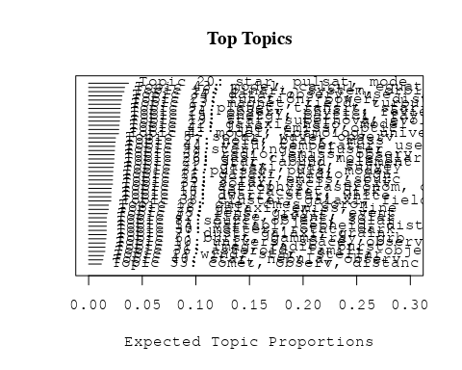

# Print the top 10 labels for each topic  
topic_labels <- labelTopics(Research_topics, n=10)  
print(topic_labels)

## Topic 1 Top Words:  
## Highest Prob: wind, star, stellar, group, rotat, model, format, effect, time, mass   
## FREX: wind, b-type, group, opac, slowli, feedback, regul, mixtur, gaseous, momentum   
## Lift: superior, regul, b-type, fossil, mirror, free-fal, imf, expel, lbol, wind   
## Score: wind, superior, b-type, group, star, protoclust, rotat, feedback, opac, stellar   
## Topic 2 Top Words:  
## Highest Prob: star, ngc, cluster, distanc, age, mag, use, giant, red, myr   
## FREX: ngc, myr, mag, redden, red, extinct, open, diagram, age, distanc   
## Lift: ubv, zam, cmds, color-magnitud, rgb, isochron, two-colour, redden, tip, smoother   
## Score: ngc, cluster, ubv, rgb, modulus, agb, star, myr, extinct, redden   
## Topic 3 Top Words:  
## Highest Prob: pulsar, puls, model, emiss, neutron, star, observ, radio, magnet, accret   
## FREX: pulsar, puls, millisecond, glitch, psr, crab, sax, gap, magnetar, neutron   
## Lift: glitch, interpuls, bolomet, energy-depend, millisecond, pulsar, sax, cap, psr, slab   
## Score: pulsar, puls, glitch, millisecond, neutron, psr, sax, crab, interpuls, magnet   
## Topic 4 Top Words:  
## Highest Prob: model, cosmolog, univers, dark, energi, paramet, data, matter, constraint, theori   
## FREX: cosmolog, string, graviti, scalar, λcdm, univers, spacetim, constant, constraint, expans   
## Lift: cdm, latest, λcdm, string, sitter, spacetim, scalar, phantom, snia, theorem   
## Score: cosmolog, latest, dark, string, univers, λcdm, scalar, matter, cosmic, cdm   
## Topic 5 Top Words:  
## Highest Prob: solar, wave, observ, region, coron, corona, atmospher, heat, magnet, plasma   
## FREX: corona, chromospher, photospher, reconnect, loop, euv, heat, wave, twist, coron   
## Lift: spicul, kink, multitud, twist, swedish, voyag, supratherm, quiet-sun, euv, cancel   
## Score: coron, corona, reconnect, loop, chromospher, wave, magnet, euv, plasma, solar   
## Topic 6 Top Words:  
## Highest Prob: burst, gamma-ray, grb, grbs, observ, afterglow, emiss, host, sne, optic   
## FREX: grb, grbs, afterglow, gamma-ray, burst, sne, swift, gamma, short, positron   
## Lift: afterglow, early-tim, grbs, park, grb, bats, faintest, prompt, long-dur, swift   
## Score: grb, burst, gamma-ray, grbs, afterglow, sne, park, swift, bats, host   
## Topic 7 Top Words:  
## Highest Prob: dust, galaxi, grain, observ, format, star, mass, interstellar, stellar, growth   
## FREX: dust, grain, growth, destruct, ism, gradient, interstellar, attenu, extinct, dust--ga   
## Lift: dust--ga, dust--met, attenu, destruct, dust, matur, grain, ism, des, dusti   
## Score: dust, dust--met, grain, dust--ga, growth, metal, ism, galaxi, interstellar, extinct   
## Topic 8 Top Words:  
## Highest Prob: sourc, object, solar, belt, disk, materi, form, class, system, composit   
## FREX: belt, chondrit, chondrul, sourc, planetesim, isotop, protoplanetari, composit, materi, meteorit   
## Lift: belt, carbonac, chondrul, ysos, chondrit, planetesim, primit, deepli, refractori, dichotomi   
## Score: belt, sourc, chondrit, chondrul, planetesim, isotop, meteorit, protoplanetari, kuiper, carbonac   
## Topic 9 Top Words:  
## Highest Prob: planet, transit, star, mass, system, planetari, orbit, exoplanet, radius, stellar   
## FREX: planet, exoplanet, transit, extrasolar, hat-pb, planetari, jupit, brown, habit, eccentr   
## Lift: hjd, hatnet, mjup, rjup, super-earth, earth-siz, hat-pb, planet, planet’, exoplanet   
## Score: planet, exoplanet, hat-pb, planetari, transit, extrasolar, orbit, jupit, hjd, star   
## Topic 10 Top Words:  
## Highest Prob: univers, space, observatori, mission, astronomi, will, scienc, research, detector, physic   
## FREX: institut, mission, depart, astronomi, scienc, usa, plan, china, european, technolog   
## Lift: china, esa, faculti, itali, franc, depart, usa, institut, academi, communic   
## Score: astronomi, esa, institut, univers, mission, scienc, china, usa, detector, research   
## Topic 11 Top Words:  
## Highest Prob: galaxi, radio, agn, activ, luminos, host, sampl, redshift, quasar, studi   
## FREX: agn, ellipt, galaxi, host, quasar, radio, redshift, luminos, protoclust, coma   
## Lift: frii, m-m, millimetr, dual, css, metrewav, protoclust, low-luminos, ellipt, oiii   
## Score: galaxi, radio, agn, quasar, redshift, coma, host, protoclust, frii, m-m   
## Topic 12 Top Words:  
## Highest Prob: cme, cmes, coron, eject, mass, solar, observ, wind, speed, erupt   
## FREX: cmes, cme, rope, eject, interplanetari, coron, icm, erupt, storm, heliospher   
## Lift: flux-rop, radio-quiet, cmes, geoeffect, ace, space-weath, geospac, rope, cme, storm   
## Score: cmes, cme, coron, rope, radio-quiet, eject, interplanetari, heliospher, icm, erupt   
## Topic 13 Top Words:  
## Highest Prob: magnet, field, turbul, result, plasma, instabl, effect, strength, structur, helic   
## FREX: turbul, magnet, helic, field, dynamo, magnetospher, instabl, shear, strength, mhd   
## Lift: zeeman, gauss, thread, dynamo, helic, stoke, turbul, amplif, reynold, spectropolarimet   
## Score: magnet, field, turbul, helic, dynamo, magnetospher, plasma, mhd, instabl, polar   
## Topic 14 Top Words:  
## Highest Prob: variabl, cepheid, distanc, period, star, magellan, cloud, eclips, galaxi, smc   
## FREX: cepheid, magellan, smc, variabl, deb, eclips, night, cataclysm, mira, cvs   
## Lift: anonym, baade-wesselink, cvs, deb, ftp, fullparti, michigan-dartmouth-mit, chart, period-luminos, period–luminos   
## Score: cepheid, deb, variabl, magellan, eclips, smc, anonym, cloud, night, period   
## Topic 15 Top Words:  
## Highest Prob: energi, particl, ray, acceler, cosmic, electron, radiat, neutrino, high, galact   
## FREX: ray, particl, tev, neutrino, gev, cosmic, acceler, proton, γray, electron   
## Lift: uhecr, aurora, ultra-high-energi, antarct, cerenkov, cherenkov, lepton, muon, air, ray   
## Score: ray, particl, acceler, aurora, cosmic, neutrino, tev, electron, gev, proton   
## Topic 16 Top Words:  
## Highest Prob: binari, system, orbit, mass, compon, period, companion, veloc, close, eclips   
## FREX: companion, binari, orbit, contact, system, primari, secondari, eclips, eccentr, tripl   
## Lift: bex-ray, cab, circumbinari, contact, single-lin, mmr, semidetach, sine-curv, double-lin, roch   
## Score: binari, orbit, eclips, system, companion, contact, period, eccentr, circumbinari, secondari   
## Topic 17 Top Words:  
## Highest Prob: astrophys, astronom, observ, one, first, studi, paper, research, system, theori   
## FREX: centuri, experiment, astronom, refer, interest, communiti, plate, idea, astrophys, strategi   
## Lift: belgrad, twentieth, scientist, centuri, communiti, sophist, famous, experiment, problemat, strategi   
## Score: belgrad, centuri, astronomi, astrophys, research, experiment, scientist, astronom, communiti, earth   
## Topic 18 Top Words:  
## Highest Prob: jet, accret, disk, outflow, flow, disc, model, relativist, polar, region   
## FREX: jet, outflow, collim, flow, blazar, accret, relativist, disc, disk, momentum   
## Lift: post-shock, advection-domin, parsec-scal, jet, equipartit, microquasar, collim, advect, self-compton, adaf   
## Score: jet, accret, outflow, relativist, post-shock, disk, disc, flow, blazar, collim   
## Topic 19 Top Words:  
## Highest Prob: star, supernova, evolut, massiv, mass, explos, neutron, progenitor, stellar, merger   
## FREX: supernova, progenitor, explos, r-process, envelop, ejecta, core-collaps, merger, captur, encount   
## Lift: electron-captur, enorm, neutrino-driven, ibc, pre-sn, r-process, neutron-rich, pre-explos, burn, core-collaps   
## Score: supernova, enorm, r-process, explos, progenitor, neutron, merger, star, ejecta, massiv   
## Topic 20 Top Words:  
## Highest Prob: star, pulsat, mode, frequenc, oscil, observ, period, amplitud, detect, modul   
## FREX: pulsat, mode, oscil, blazhko, kepler, sdb, frequenc, amplitud, modul, p-mode   
## Lift: blazhko, lsps, multisit, quintuplet, scuti, g-mode, lsp, multiplet, overton, roap   
## Score: pulsat, mode, oscil, blazhko, frequenc, kepler, star, lsp, modul, sdb   
## Topic 21 Top Words:  
## Highest Prob: galaxi, bar, survey, spiral, imag, sampl, use, bulg, data, nuclear   
## FREX: bar, spiral, bulg, nuclear, survey, early-typ, decomposit, morpholog, digit, classif   
## Lift: ohio, markarian, bulge--tot, neural, bar, dss, qsos, decomposit, isophot, h-band   
## Score: bar, galaxi, markarian, spiral, bulg, sdss, survey, redshift, decomposit, early-typ   
## Topic 22 Top Words:  
## Highest Prob: galaxi, halo, model, mass, simul, galact, format, veloc, observ, dynam   
## FREX: halo, simul, chaotic, spheric, virial, n-bodi, dispers, plane, profil, clump   
## Lift: subgalact, nfw, semi-analyt, press-schecht, triaxial, low-eccentr, phase-spac, chaotic, chao, n-bodi   
## Score: halo, galaxi, n-bodi, semi-analyt, simul, virial, dark, chaotic, nfw, profil   
## Topic 23 Top Words:  
## Highest Prob: function, power, distribut, method, data, model, fit, use, test, statist   
## FREX: wmap, function, power, nois, test, foreground, cmb, anisotropi, map, random   
## Lift: wilkinson, clean, non-gaussian, wmap, excurs, isotropi, cmb, varianc, multipol, likelihood   
## Score: wmap, cmb, clean, nois, anisotropi, power, foreground, microwav, function, map   
## Topic 24 Top Words:  
## Highest Prob: observ, physic, review, studi, discuss, understand, provid, model, process, can   
## FREX: review, understand, aspect, overview, physic, progress, question, advanc, snrs, futur   
## Lift: ionis, snrs, review, multi-wavelength, overview, chapter, outstand, aspect, answer, summaris   
## Score: review, ionis, snrs, overview, radio, understand, progress, astrophys, aspect, summar   
## Topic 25 Top Words:  
## Highest Prob: x-ray, emiss, sourc, kev, observ, hard, luminos, soft, shock, erg   
## FREX: kev, x-ray, chandra, hard, erg, soft, xmm-newton, luminos, cm-, shock   
## Lift: chandra, superbubbl, unabsorb, kev, xmm-newton, epic, x-ray-emit, asca, rosat, softer   
## Score: x-ray, superbubbl, kev, soft, chandra, emiss, hard, erg, xmm-newton, shock   
## Topic 26 Top Words:  
## Highest Prob: gas, cloud, molecular, core, format, disk, mass, densiti, region, star   
## FREX: molecular, cloud, gas, molecul, fragment, protostellar, protostar, collaps, core, column   
## Lift: choh, hco, molecular, protostellar, dissoci, chemistri, fragment, molecul, ammonia, protostar   
## Score: molecular, cloud, gas, hco, protostar, molecul, fragment, core, protostellar, collaps   
## Topic 27 Top Words:  
## Highest Prob: hole, black, mass, binari, star, gravit, rate, supermass, merger, wave   
## FREX: black, hole, supermass, smbh, merger, coalesc, merg, doubl, kick, gravit   
## Lift: kick, ligo, chirp, bhs, gws, supermass, smbh, black, hole, lisa   
## Score: black, hole, kick, supermass, merger, binari, smbh, gravit, ligo, neutron   
## Topic 28 Top Words:  
## Highest Prob: galaxi, emiss, line, ioniz, lyα, blue, abund, sbs, compact, region   
## FREX: sbs, lyα, ioniz, blue, neutral, bcgs, helium, ultraviolet, low-metal, escap   
## Lift: bcgs, izotov, sbs, bcds, thuan, angstrom, spectrophotometri, metal-defici, low-metal, lyα   
## Score: sbs, lyα, galaxi, bcgs, ioniz, emiss, abund, blue, low-metal, logoh   
## Topic 29 Top Words:  
## Highest Prob: star, abund, element, metal, chemic, model, stellar, spectra, atmospher, metal-poor   
## FREX: element, abund, carbon, metal-poor, chemic, lithium, comprehens, enrich, metal, s-process   
## Lift: lithium, lte, comprehens, microturbul, cube, s-process, neutron-captur, carbon, nitrogen, subgiant   
## Score: abund, comprehens, metal, element, lithium, metal-poor, chemic, star, carbon, s-process   
## Topic 30 Top Words:  
## Highest Prob: matter, rotat, dark, star, differenti, stellar, annihil, evolut, wimp, search   
## FREX: wimp, matter, annihil, dark, differenti, rotat, quark, axion, faster, tidal   
## Lift: relic, supersymmetr, chile, self-interact, wimp, axion, quark, annihil, violat, octupol   
## Score: matter, dark, rotat, wimp, quark, annihil, axion, chile, supersymmetr, differenti   
## Topic 31 Top Words:  
## Highest Prob: imag, radio, burst, telescop, type, observ, frequenc, optic, mhz, iii   
## FREX: mhz, minut, iii, spectrograph, drift, metric, fine, imag, resolut, disturb   
## Lift: fiber, khz, mhz, passband, scintil, fine-structur, fine, iri, minut, fuv   
## Score: burst, mhz, radio, fiber, imag, frequenc, drift, minut, scintil, spectrograph   
## Topic 32 Top Words:  
## Highest Prob: solar, cycl, activ, period, variat, sun, time, chang, sunspot, differ   
## FREX: cycl, sunspot, minimum, geomagnet, sun, solar, variat, gcr, chang, granul   
## Lift: limb-darken, gcr, sunspot, cycl, daili, granul, helioseismolog, regist, mid-, near-surfac   
## Score: cycl, solar, sunspot, geomagnet, gcr, period, sun, granul, limb-darken, heliospher   
## Topic 33 Top Words:  
## Highest Prob: comet, observ, distanc, water, dust, activ, coma, nucleus, detect, cometari   
## FREX: comet, water, cometari, meteoroid, coma, meteor, nucleus, trail, heliocentr, perihelion   
## Lift: afρ, bta, comet, water, meteoroid, meteor, trail, russia, cometari, vapor   
## Score: comet, coma, cometari, meteoroid, water, dust, afρ, meteor, perihelion, nucleus   
## Topic 34 Top Words:  
## Highest Prob: data, observ, use, measur, telescop, detect, time, obtain, present, techniqu   
## FREX: precis, techniqu, program, reduct, astrometr, improv, accuraci, campaign, data, photometr   
## Lift: speckl, wasp-, zenith, softwar, mas, packag, fold, figur, real-tim, refract   
## Score: wasp-, photometr, speckl, precis, photometri, telescop, astrometr, precess, data, filter   
## Topic 35 Top Words:  
## Highest Prob: lens, gravit, event, light, imag, microlens, per, len, observ, sourc   
## FREX: lens, microlens, len, gravit, cross, qso, coronagraph, event, ogl, delay   
## Lift: microlens, self-lens, len, lens, magnifi, zodiac, qso, magnif, multipli, ogl   
## Score: lens, microlens, len, gravit, zodiac, event, macho, coronagraph, ogl, qso   
## Topic 36 Top Words:  
## Highest Prob: asteroid, famili, object, orbit, observ, satellit, differ, find, rotat, survey   
## FREX: asteroid, famili, meteorit, bodi, satellit, minor, irregular, reson, occult, sdss   
## Lift: asteroid, main-belt, themi, famili, near-earth, trojan, neo, sider, semi-major, occult   
## Score: asteroid, famili, meteorit, main-belt, themi, orbit, neo, sdss, kbos, trojan   
## Topic 37 Top Words:  
## Highest Prob: dwarf, star, white, metal, stellar, age, sampl, galact, gradient, veloc   
## FREX: dwarf, white, gradient, thick, kinemat, milki, wds, gyr, kpc, age   
## Lift: thin-disc, rave, mcircl, wds, candl, fbs, fornax, dfbs, inth, text   
## Score: dwarf, white, metal, thin-disc, fbs, rave, feh, bulg, gradient, gaia   
## Topic 38 Top Words:  
## Highest Prob: cluster, galaxi, field, region, redshift, survey, globular, show, format, popul   
## FREX: cluster, globular, mpc, lae, intraclust, emitt, abel, bias, starburst, subaru   
## Lift: superclust, lae, intraclust, segreg, narrowband, abel, cluster, suprime-cam, ram, emitt   
## Score: cluster, superclust, lae, galaxi, globular, mpc, redshift, abel, intraclust, subaru   
## Topic 39 Top Words:  
## Highest Prob: radio, emiss, observ, x-ray, sourc, state, period, outburst, dwarf, time   
## FREX: maser, outburst, ghz, radio, state, rxte, cyg, cyclotron, array, rossi   
## Lift: depolar, tvlm, multifrequ, gyrosynchrotron, cyclotron, rxte, rossi, orb, pca, maser   
## Score: radio, tvlm, x-ray, maser, outburst, emiss, rxte, ghz, rossi, polar   
## Topic 40 Top Words:  
## Highest Prob: star, nebula, observ, wind, veloc, emiss, shell, featur, young, model   
## FREX: nebula, shell, agb, iso, featur, amorph, lobe, planetari, branch, obscur   
## Lift: proto-planetari, amorph, iso, nebula, carrier, herbig, vibrat, burster, sio, orion   
## Score: nebula, agb, proto-planetari, iso, shell, amorph, wind, planetari, dust, star   
## Topic 41 Top Words:  
## Highest Prob: line, emiss, optic, spectra, broad, profil, accret, agn, observ, quasar   
## FREX: broad, line, seyfert, tau, agn, quasar, narrow, blr, profil, width   
## Lift: blr, eigenvector, twenti, half-maximum, broad-lin, iip, brγ, fuor, double-peak, narrow-lin   
## Score: line, seyfert, agn, quasar, emiss, broad, blr, accret, twenti, profil   
## Topic 42 Top Words:  
## Highest Prob: flare, event, solar, energi, electron, flux, correl, peak, x-ray, releas   
## FREX: flare, sep, microwav, releas, erupt, impuls, superflar, event, goe, electr   
## Lift: rhessi, ribbon, sep, flare, sxr, impuls, superflar, active-region, goe, store   
## Score: flare, ribbon, sep, event, impuls, superflar, erupt, microwav, reconnect, loop   
## Topic 43 Top Words:  
## Highest Prob: model, calcul, equat, solut, state, effect, neutron, star, mass, code   
## FREX: equat, solut, code, interior, analyt, calcul, convect, numer, state, hydrodynam   
## Lift: deal, microphys, polytrop, interior, prescript, equat, superfluid, code, treatment, equilibria   
## Score: equat, deal, neutron, solut, interior, convect, code, analyt, state, core   
## Topic 44 Top Words:  
## Highest Prob: valu, temperatur, use, determin, deriv, measur, region, ratio, effect, relat   
## FREX: temperatur, valu, deriv, determin, correct, ratio, measur, factor, agreement, effect   
## Lift: high-metal, temperatur, valu, excel, librari, offset, correct, deriv, hii, determin   
## Score: temperatur, high-metal, abund, oxygen, valu, ratio, deriv, calibr, determin, method

# Match the processed documents with the original titles  
matched_titles <- out_text$meta$original_concatenated_title_abstract  
  
# Print top 5 documents for each topic  
top_docs <- findThoughts(Research_topics, texts = matched_titles, n = 5)$docs[[1]]  
print(top_docs)

## [1] "The effect of stellar winds on the formation of a protocluster We present smoothed particle hydrodynamics simulations of protoclusters including the effects of the stellar winds from massive stars. Using a particle-injection method, we investigate the effect of structure in close proximity to the wind sources and the short-time-scale influence of winds on protoclusters. We find that the structures such as discs and gaseous filaments have a strong collimating effect on winds. By a different technique of injecting momentum from point sources into our simulations, we compare the large-scale and long-term effects of isotropic and intrinsically collimated winds on protoclusters and find them to be similar, although the collimated winds take longer to exert a significant influence. We find that both types of wind are able to dramatically slow the global star formation process, but that the time-scale on which they can expel significant quantities of mass from the cluster is rather long (approaching 10 free-fall times). Clusters may then experience rapid star formation very early in their lifetimes, before switching to a mode where gas is gradually expelled, while star formation proceeds much more slowly over many free-fall times. This complicates any conclusions regarding slow star formation derived from measuring the star formation efficiency per free-fall time. We find that estimates of the efficacy of winds in dispersing clusters derived simply from the total wind momentum flux may not be very reliable. This is due to material being expelled from deep within stellar potential wells, often to velocities well in excess of the cluster escape velocity, and also to the loss of momentum flux through holes in the gas distribution. Winds have little effect on the accretion-driven stellar initial mass function (IMF) except at the very high mass end, where they serve to prevent some of the most massive objects accreting more material. Feedback does not result in the formation of further massive stars through the monolithic collapse of massive cores. We also find that the morphology of the gas, the rapid motions of the wind sources and the action of large-scale accretion flows prevent the formation of bubble-like structures. These effects may make it difficult to discern the influence of winds on very young clusters."   
## [2] "The effect of stellar winds on the formation of a protocluster We present smoothed particle hydrodynamics simulations of protoclusters including the effects of the stellar winds from massive stars. Using a particle-injection method, we investigate the effect of structure in close proximity to the wind sources and the short-time-scale influence of winds on protoclusters. We find that the structures such as discs and gaseous filaments have a strong collimating effect on winds. By a different technique of injecting momentum from point sources into our simulations, we compare the large-scale and long-term effects of isotropic and intrinsically collimated winds on protoclusters and find them to be similar, although the collimated winds take longer to exert a significant influence. We find that both types of wind are able to dramatically slow the global star formation process, but that the time-scale on which they can expel significant quantities of mass from the cluster is rather long (approaching 10 free-fall times). Clusters may then experience rapid star formation very early in their lifetimes, before switching to a mode where gas is gradually expelled, while star formation proceeds much more slowly over many free-fall times. This complicates any conclusions regarding slow star formation derived from measuring the star formation efficiency per free-fall time. We find that estimates of the efficacy of winds in dispersing clusters derived simply from the total wind momentum flux may not be very reliable. This is due to material being expelled from deep within stellar potential wells, often to velocities well in excess of the cluster escape velocity, and also to the loss of momentum flux through holes in the gas distribution. Winds have little effect on the accretion-driven stellar initial mass function (IMF) except at the very high mass end, where they serve to prevent some of the most massive objects accreting more material. Feedback does not result in the formation of further massive stars through the monolithic collapse of massive cores. We also find that the morphology of the gas, the rapid motions of the wind sources and the action of large-scale accretion flows prevent the formation of bubble-like structures. These effects may make it difficult to discern the influence of winds on very young clusters."   
## [3] "The effect of stellar winds on the formation of a protocluster We present smoothed particle hydrodynamics simulations of protoclusters including the effects of the stellar winds from massive stars. Using a particle-injection method, we investigate the effect of structure in close proximity to the wind sources and the short-time-scale influence of winds on protoclusters. We find that the structures such as discs and gaseous filaments have a strong collimating effect on winds. By a different technique of injecting momentum from point sources into our simulations, we compare the large-scale and long-term effects of isotropic and intrinsically collimated winds on protoclusters and find them to be similar, although the collimated winds take longer to exert a significant influence. We find that both types of wind are able to dramatically slow the global star formation process, but that the time-scale on which they can expel significant quantities of mass from the cluster is rather long (approaching 10 free-fall times). Clusters may then experience rapid star formation very early in their lifetimes, before switching to a mode where gas is gradually expelled, while star formation proceeds much more slowly over many free-fall times. This complicates any conclusions regarding slow star formation derived from measuring the star formation efficiency per free-fall time. We find that estimates of the efficacy of winds in dispersing clusters derived simply from the total wind momentum flux may not be very reliable. This is due to material being expelled from deep within stellar potential wells, often to velocities well in excess of the cluster escape velocity, and also to the loss of momentum flux through holes in the gas distribution. Winds have little effect on the accretion-driven stellar initial mass function (IMF) except at the very high mass end, where they serve to prevent some of the most massive objects accreting more material. Feedback does not result in the formation of further massive stars through the monolithic collapse of massive cores. We also find that the morphology of the gas, the rapid motions of the wind sources and the action of large-scale accretion flows prevent the formation of bubble-like structures. These effects may make it difficult to discern the influence of winds on very young clusters."   
## [4] "The effect of stellar winds on the formation of a protocluster We present smoothed particle hydrodynamics simulations of protoclusters including the effects of the stellar winds from massive stars. Using a particle-injection method, we investigate the effect of structure in close proximity to the wind sources and the short-time-scale influence of winds on protoclusters. We find that the structures such as discs and gaseous filaments have a strong collimating effect on winds. By a different technique of injecting momentum from point sources into our simulations, we compare the large-scale and long-term effects of isotropic and intrinsically collimated winds on protoclusters and find them to be similar, although the collimated winds take longer to exert a significant influence. We find that both types of wind are able to dramatically slow the global star formation process, but that the time-scale on which they can expel significant quantities of mass from the cluster is rather long (approaching 10 free-fall times). Clusters may then experience rapid star formation very early in their lifetimes, before switching to a mode where gas is gradually expelled, while star formation proceeds much more slowly over many free-fall times. This complicates any conclusions regarding slow star formation derived from measuring the star formation efficiency per free-fall time. We find that estimates of the efficacy of winds in dispersing clusters derived simply from the total wind momentum flux may not be very reliable. This is due to material being expelled from deep within stellar potential wells, often to velocities well in excess of the cluster escape velocity, and also to the loss of momentum flux through holes in the gas distribution. Winds have little effect on the accretion-driven stellar initial mass function (IMF) except at the very high mass end, where they serve to prevent some of the most massive objects accreting more material. Feedback does not result in the formation of further massive stars through the monolithic collapse of massive cores. We also find that the morphology of the gas, the rapid motions of the wind sources and the action of large-scale accretion flows prevent the formation of bubble-like structures. These effects may make it difficult to discern the influence of winds on very young clusters."   
## [5] "Stellar Rotation in Young Clusters: The First 4 Million Years To investigate what happens to angular momentum during the earliest observable phases of stellar evolution, we searched the literature for periods (P), projected rotational velocities (v sin i), and supporting data on K5–M2 stars (corresponding to masses 0.25–1 M⊙) from the Orion Nebula Cluster and environs, ρ Ophiuchi, TW Hydra, Taurus-Auriga, NGC 2264, Chamaeleon, Lupus, and η Chamaeleonis. We combine these measures of rotation with the stellar R (as determined from Lbol and Teff) to compare the data with two extreme cases: conservation of stellar angular velocity and conservation of stellar angular momentum. Analysis of the P data set suggests that the frequency distribution of periods among the youngest and oldest stars in the sample is indistinguishable, while the v sin i data set reveals a decrease in mean v sin i as a function of age. Both results suggest that a significant fraction of all pre–main-sequence (PMS) stars must evolve at nearly constant angular velocity during the first ~3–5 Myr after they begin their evolution down the convective tracks. Hence, the angular momenta of a significant fraction of pre–main-sequence (PMS) stars must be tightly regulated during the first few million years after they first become observable. This result seems surprising at first glance, because observations of young main-sequence stars reveal a population (30%–40%) of rapidly rotating stars that must begin to spin up at ages t 5 Myr. To determine whether these apparently contradictory results are reconcilable, we use simple models along with our data set to place limits on (1) the fraction of PMS stars that must be regulated, and (2) the complementary fraction that could spin up as a function of time but escape statistical detection given the broad distribution of stellar rotation rates. These models include (1) instantaneous release at the stellar birthline of a given fraction of stars, with the remaining fraction regulated for 10 Myr; (2) all stars regulated initially, with the released fraction varying linearly with time, and timescales for release of half the stars varying from 0.5 to 5 Myr (i.e., all released by 1 to 10 Myr); and (3) a hybrid model that invokes assumptions (1) and (2). In all cases, we find that a modest population (30%–40%) of PMS stars could be released within the first 1 Myr and still produce period distributions statistically consistent with the observed data. This population is large enough to account for the rapid rotators observed among young main-sequence stars of comparable mass. The limits placed by our models on the fraction of regulated and released stars as a function of time are also consistent with the lifetime of accretion disks as inferred from near-IR excesses, and hence with the hypothesis that disk locking accounts for rotation regulation during early PMS phases."

# Find and plot the key "thoughts" or documents for selected topics  
thoughts6 <- findThoughts(Research_topics, texts = matched_titles, n = 3, topics = 6)$docs[[1]]  
thoughts18 <- findThoughts(Research_topics, texts = matched_titles, n = 3, topics = 18)$docs[[1]]  
par(mfrow = c(1, 2), mar = c(0.5, 0.5, 1, 0.5))  
plotQuote(thoughts6, width = 30, main = "Topic 6")  
plotQuote(thoughts18, width = 30, main = "Topic 18")

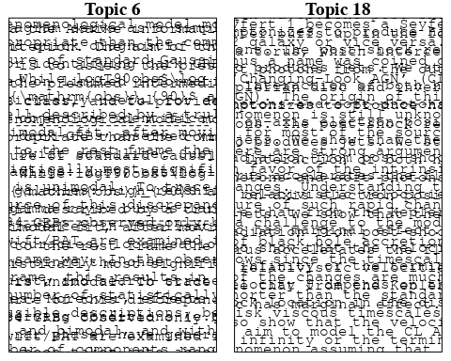

# Calculate and plot the correlation between topics  
mod.out.corr <- topicCorr(Research_topics)  
plot(mod.out.corr, cex = 1.5)  
  
  
# For each topic  
for (topic_num in 1:44) {  
 # Plot the word cloud  
 cloud(Research_topics, topic = topic_num, scale = c(2, 0.25))  
 Sys.sleep(2)  
}

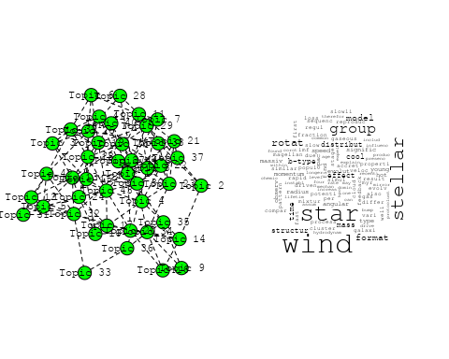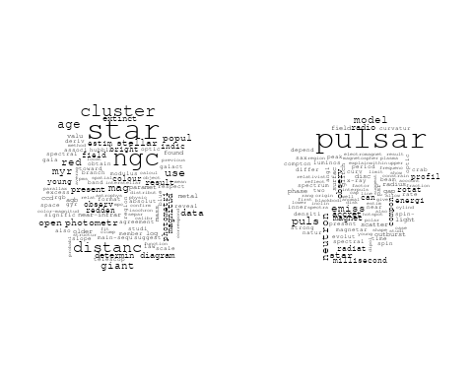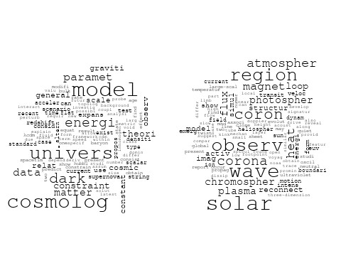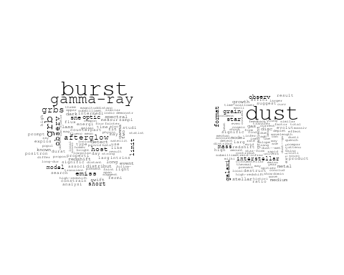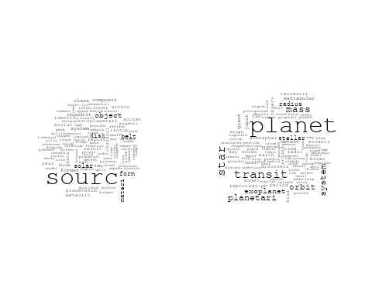

## Warning in wordcloud::wordcloud(words = vocab, freq = vec, max.words =  
## max.words, : univers could not be fit on page. It will not be plotted.

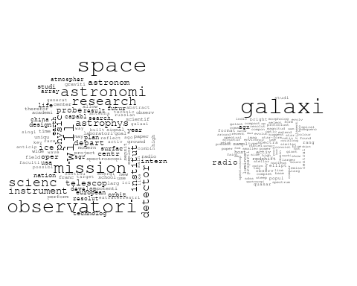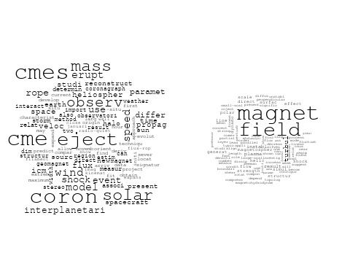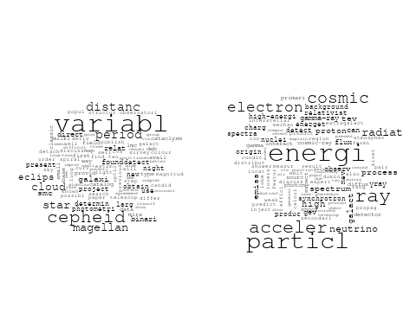

## Warning in wordcloud::wordcloud(words = vocab, freq = vec, max.words =  
## max.words, : studi could not be fit on page. It will not be plotted.

## Warning in wordcloud::wordcloud(words = vocab, freq = vec, max.words =  
## max.words, : stellar could not be fit on page. It will not be plotted.

## Warning in wordcloud::wordcloud(words = vocab, freq = vec, max.words =  
## max.words, : observ could not be fit on page. It will not be plotted.

## Warning in wordcloud::wordcloud(words = vocab, freq = vec, max.words =  
## max.words, : first could not be fit on page. It will not be plotted.

## Warning in wordcloud::wordcloud(words = vocab, freq = vec, max.words =  
## max.words, : year could not be fit on page. It will not be plotted.

## Warning in wordcloud::wordcloud(words = vocab, freq = vec, max.words =  
## max.words, : associ could not be fit on page. It will not be plotted.

## Warning in wordcloud::wordcloud(words = vocab, freq = vec, max.words =  
## max.words, : will could not be fit on page. It will not be plotted.

## Warning in wordcloud::wordcloud(words = vocab, freq = vec, max.words =  
## max.words, : argument could not be fit on page. It will not be plotted.

## Warning in wordcloud::wordcloud(words = vocab, freq = vec, max.words =  
## max.words, : problem could not be fit on page. It will not be plotted.

## Warning in wordcloud::wordcloud(words = vocab, freq = vec, max.words =  
## max.words, : differ could not be fit on page. It will not be plotted.

## Warning in wordcloud::wordcloud(words = vocab, freq = vec, max.words =  
## max.words, : time could not be fit on page. It will not be plotted.

## Warning in wordcloud::wordcloud(words = vocab, freq = vec, max.words =  
## max.words, : import could not be fit on page. It will not be plotted.

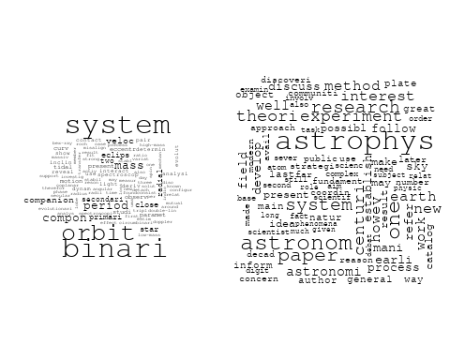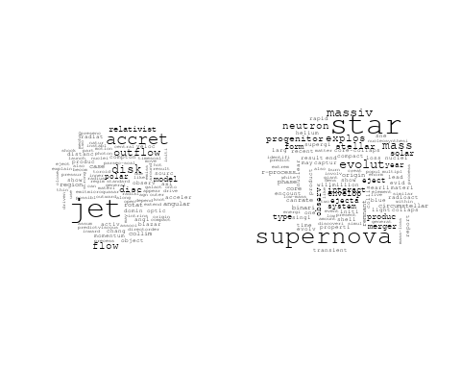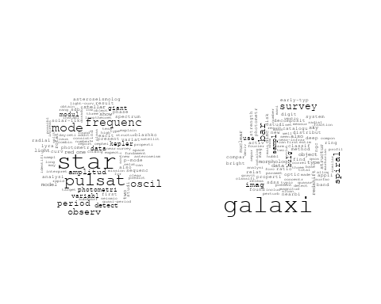

## Warning in wordcloud::wordcloud(words = vocab, freq = vec, max.words =  
## max.words, : scale could not be fit on page. It will not be plotted.

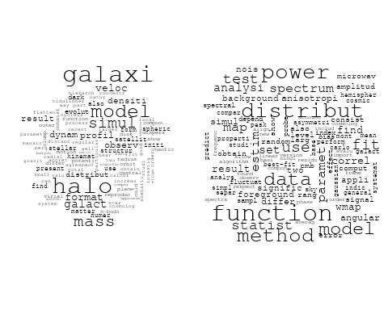

## Warning in wordcloud::wordcloud(words = vocab, freq = vec, max.words =  
## max.words, : observ could not be fit on page. It will not be plotted.

## Warning in wordcloud::wordcloud(words = vocab, freq = vec, max.words =  
## max.words, : physic could not be fit on page. It will not be plotted.

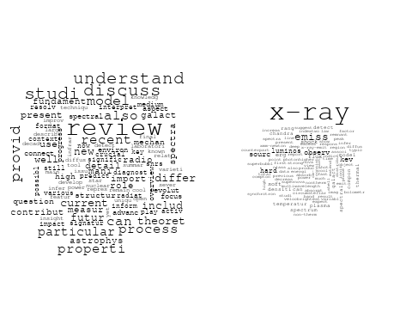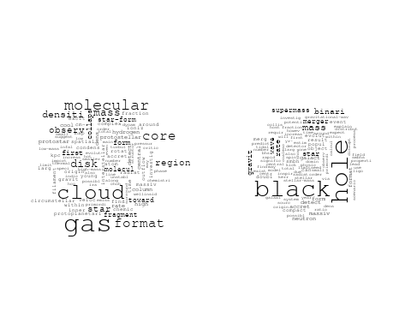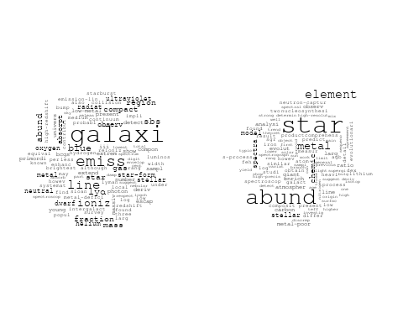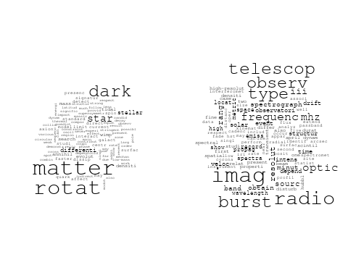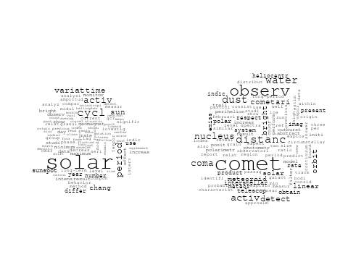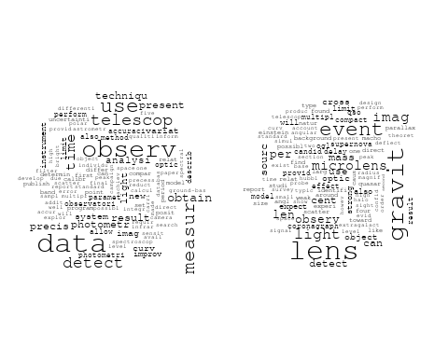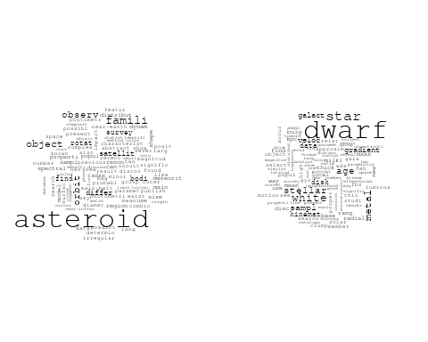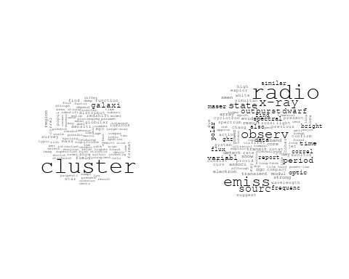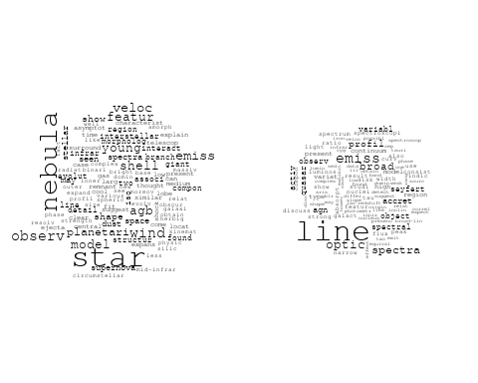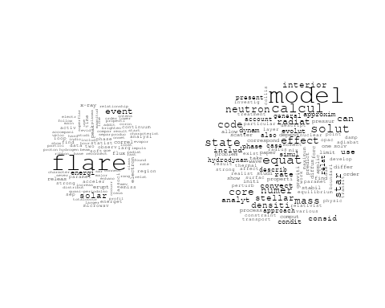

# Get the topic proportions for each document  
topic_proportions <- Research_topics$theta  
  
# Find the index of the topic with the highest proportion for each document  
# This will be the topic that each document is most likely to belong to  
max_topic_idx <- apply(topic_proportions, 1, which.max)  
  
# Add this as a new column to your data  
data_collab$topic <- max_topic_idx  
  
library(ggplot2)  
  
# Define the intervals  
intervals <- c('1824_1899', '1900_1964', '1965_1974', '1975_1984', '1985_1994', '1995_1999', '2000_2004', '2005_2009', '2010_2014', '2015_2019', '2020_2022')  
colors <- c('pink', 'blue', 'purple', 'yellow', 'green', 'pink', 'orange', 'violet', 'green', 'blue', 'pink')  
  
# Loop through the intervals and plot  
for(i in seq_along(intervals)){  
 # Filter data for when the pub_interval is equal to 1  
 data_filtered <- data_collab[data_collab[[paste0('pub_interval_', intervals[i])]] == 1,]  
   
 # Make the histogram  
   
 p <- ggplot(data_filtered, aes(x = topic)) +  
 geom_histogram(binwidth = 1, fill = colors[i], color = "black") +  
 xlab("Topic") +  
 ylab("Count") +  
 ggtitle(paste0("Topics from year ", gsub("_", " to ", intervals[i])))  
   
 print(p)  
}  
  
  
##Topic generation for Europe (independent) publications  
  
data_independent <- data[data[["Europe"]] == 100,]  
  
# Save the original title data for future use  
data_independent$original_concatenated_title_abstract <- data_independent$concatenated_title_abstract  
  
#pre-processing the titles using textProcessor from the stm package  
processed_text <- textProcessor(data_independent$concatenated_title_abstract, metadata = data_independent)

## Building corpus...   
## Converting to Lower Case...   
## Removing punctuation...   
## Removing stopwords...   
## Removing numbers...   
## Stemming...   
## Creating Output...

# Further prepare the data by removing low-frequency terms  
out_text <- prepDocuments(processed_text$documents, processed_text$vocab, processed_text$meta)

## Removing 3072 of 9361 terms (3072 of 127645 tokens) due to frequency   
## Your corpus now has 1638 documents, 6289 terms and 124573 tokens.

docs_text <- out_text$documents  
vocab_text <- out_text$vocab  
meta_text <- out_text$meta  
  
  
#Prepare data  
plotRemoved(processed_text$documents, lower.thresh = seq(1, 200, by = 100))

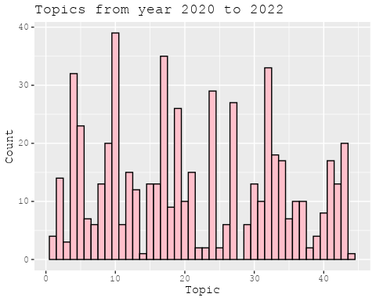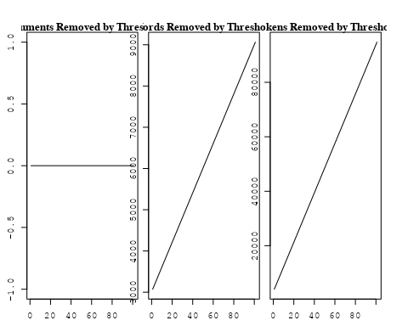

out_text <- prepDocuments(processed_text$documents, processed_text$vocab, processed_text$meta, lower.thresh = 8)

## Removing 7438 of 9361 terms (17336 of 127645 tokens) due to frequency   
## Your corpus now has 1638 documents, 1923 terms and 110309 tokens.

str(out_text$meta)

## 'data.frame': 1638 obs. of 39 variables:  
## $ concept_id : chr "https://openalex.org/C44870925" "https://openalex.org/C44870925" "https://openalex.org/C44870925" "https://openalex.org/C44870925" ...  
## $ work_id : chr "https://openalex.org/W1548323710" "https://openalex.org/W1993967893" "https://openalex.org/W2050900201" "https://openalex.org/W2077698413" ...  
## $ publication_year : int 2002 1998 2005 2008 2008 2004 2018 2022 2019 2021 ...  
## $ title : chr "Interpretation of the Core-Wing Anomaly of Balmer Line Profiles of Cool Ap Stars*" "The ISO-SWS 2.4-45.2 Micron Spectrum toward Orion IRc2" "Determination of the Coronal Density Stratification from the Observation of Harmonic Coronal Loop Oscillations" "CONFIRMATION OF THE ELECTRON CYCLOTRON MASER INSTABILITY AS THE DOMINANT SOURCE OF RADIO EMISSION FROM VERY LOW"| __truncated__ ...  
## $ paperabstract : chr "A number of cool magnetic chemically peculiar stars exhibit abnormal profiles of hydrogen Balmer lines. This an"| __truncated__ "The complete infrared spectrum from 2.4 to 45.2 μm toward the prototypical massive star-forming region Orion IR"| __truncated__ "The recent detection of multiple harmonic standing transverse oscillations in coronal loops by Verwichte et al."| __truncated__ "We report on radio observations of the M8.5 dwarf LSR J1835+3259 and the L3.5 dwarf 2MASS J00361617+1821104, wh"| __truncated__ ...  
## $ country : chr "SE SE" "BE" "BE BE BE BE BE BE" "IE IE IE IE" ...  
## $ year_concept : chr "2002+https://openalex.org/C44870925" "1998+https://openalex.org/C44870925" "2005+https://openalex.org/C44870925" "2008+https://openalex.org/C44870925" ...  
## $ concatenated_title_abstract : chr "Interpretation of the Core-Wing Anomaly of Balmer Line Profiles of Cool Ap Stars* A number of cool magnetic che"| __truncated__ "The ISO-SWS 2.4-45.2 Micron Spectrum toward Orion IRc2 The complete infrared spectrum from 2.4 to 45.2 μm towar"| __truncated__ "Determination of the Coronal Density Stratification from the Observation of Harmonic Coronal Loop Oscillations "| __truncated__ "CONFIRMATION OF THE ELECTRON CYCLOTRON MASER INSTABILITY AS THE DOMINANT SOURCE OF RADIO EMISSION FROM VERY LOW"| __truncated__ ...  
## $ US : num 0 0 0 0 0 0 0 0 0 0 ...  
## $ IN : num 0 0 0 0 0 0 0 0 0 0 ...  
## $ DE : num 0 0 0 0 0 0 0 0 0 0 ...  
## $ CH : num 0 0 0 0 0 0 0 0 0 0 ...  
## $ GB : num 0 0 0 0 0 0 0 0 0 0 ...  
## $ CN : num 0 0 0 0 0 0 0 0 0 0 ...  
## $ FR : num 0 0 0 0 0 0 0 0 0 0 ...  
## $ IT : num 0 0 0 0 0 0 0 0 0 0 ...  
## $ RU : num 0 0 0 0 0 0 0 0 0 0 ...  
## $ CA : num 0 0 0 0 0 0 0 0 0 0 ...  
## $ NL : num 0 0 0 0 0 0 0 0 0 0 ...  
## $ AU : num 0 0 0 0 0 0 0 0 0 0 ...  
## $ JP : num 0 0 0 0 0 0 0 0 0 0 ...  
## $ ES : num 0 0 0 0 0 0 0 0 0 0 ...  
## $ IL : num 0 0 0 0 0 0 0 0 0 0 ...  
## $ Americas : num 0 0 0 0 0 0 0 0 0 0 ...  
## $ Europe : num 100 100 100 100 100 100 100 100 100 100 ...  
## $ Africa : num 0 0 0 0 0 0 0 0 0 0 ...  
## $ AsiaAndOceania : num 0 0 0 0 0 0 0 0 0 0 ...  
## $ pub_interval_2020_2022 : int 0 0 0 0 0 0 0 1 0 1 ...  
## $ pub_interval_2015_2019 : int 0 0 0 0 0 0 1 0 1 0 ...  
## $ pub_interval_2010_2014 : int 0 0 0 0 0 0 0 0 0 0 ...  
## $ pub_interval_2005_2009 : int 0 0 1 1 1 0 0 0 0 0 ...  
## $ pub_interval_2000_2004 : int 1 0 0 0 0 1 0 0 0 0 ...  
## $ pub_interval_1995_1999 : int 0 1 0 0 0 0 0 0 0 0 ...  
## $ pub_interval_1985_1994 : int 0 0 0 0 0 0 0 0 0 0 ...  
## $ pub_interval_1975_1984 : int 0 0 0 0 0 0 0 0 0 0 ...  
## $ pub_interval_1965_1974 : int 0 0 0 0 0 0 0 0 0 0 ...  
## $ pub_interval_1900_1964 : int 0 0 0 0 0 0 0 0 0 0 ...  
## $ pub_interval_1824_1899 : int 0 0 0 0 0 0 0 0 0 0 ...  
## $ original_concatenated_title_abstract: chr "Interpretation of the Core-Wing Anomaly of Balmer Line Profiles of Cool Ap Stars* A number of cool magnetic che"| __truncated__ "The ISO-SWS 2.4-45.2 Micron Spectrum toward Orion IRc2 The complete infrared spectrum from 2.4 to 45.2 μm towar"| __truncated__ "Determination of the Coronal Density Stratification from the Observation of Harmonic Coronal Loop Oscillations "| __truncated__ "CONFIRMATION OF THE ELECTRON CYCLOTRON MASER INSTABILITY AS THE DOMINANT SOURCE OF RADIO EMISSION FROM VERY LOW"| __truncated__ ...

# Initialize an empty formula string  
prevalence_formula_str <- "~"  
  
# Define the publication intervals  
pub_intervals <- c("pub_interval_2020_2022", "pub_interval_2015_2019", "pub_interval_2010_2014",   
 "pub_interval_2005_2009", "pub_interval_2000_2004", "pub_interval_1995_1999",  
 "pub_interval_1985_1994", "pub_interval_1975_1984", "pub_interval_1965_1974",  
 "pub_interval_1900_1964", "pub_interval_1824_1899")  
  
# Add each publication interval to the formula string  
for (interval in pub_intervals) {  
 # add an if statement to handle the first addition (without '+')  
 if (prevalence_formula_str == "~") {  
 prevalence_formula_str <- paste(prevalence_formula_str, interval)  
 } else {  
 prevalence_formula_str <- paste(prevalence_formula_str, "+", interval)  
 }  
}  
  
  
# Convert the string to a formula  
prevalence_formula <- as.formula(prevalence_formula_str)  
print(prevalence_formula)

## ~pub_interval_2020_2022 + pub_interval_2015_2019 + pub_interval_2010_2014 +   
## pub_interval_2005_2009 + pub_interval_2000_2004 + pub_interval_1995_1999 +   
## pub_interval_1985_1994 + pub_interval_1975_1984 + pub_interval_1965_1974 +   
## pub_interval_1900_1964 + pub_interval_1824_1899

# Run STM model  
Research_topics <- stm(documents = out_text$documents,   
 vocab = out_text$vocab,   
 K = 44,   
 prevalence = prevalence_formula,   
 data = out_text$meta,   
 init.type = "Spectral",  
 max.em.its = 1000,  
 gamma.prior = 'L1')

## Beginning Spectral Initialization   
## Calculating the gram matrix...  
## Finding anchor words...  
## ............................................  
## Recovering initialization...  
## ...................  
## Initialization complete.  
## ......................................................................................................  
## Completed E-Step (1 seconds).   
## Completed M-Step.   
## Completing Iteration 1 (approx. per word bound = -6.414)   
## ......................................................................................................  
## Completed E-Step (1 seconds).   
## Completed M-Step.   
## Completing Iteration 2 (approx. per word bound = -6.143, relative change = 4.214e-02)   
## ......................................................................................................  
## Completed E-Step (1 seconds).   
## Completed M-Step.   
## Completing Iteration 3 (approx. per word bound = -6.065, relative change = 1.279e-02)   
## ......................................................................................................  
## Completed E-Step (1 seconds).   
## Completed M-Step.   
## Completing Iteration 4 (approx. per word bound = -6.032, relative change = 5.324e-03)   
## ......................................................................................................  
## Completed E-Step (1 seconds).   
## Completed M-Step.   
## Completing Iteration 5 (approx. per word bound = -6.016, relative change = 2.774e-03)   
## Topic 1: abund, star, stellar, element, determin   
## Topic 2: cluster, ngc, use, data, paramet   
## Topic 3: system, asteroid, star, inner, belt   
## Topic 4: magnet, solar, cosmic, field, ray   
## Topic 5: wave, gravit, neutron, star, mass   
## Topic 6: dust, gradient, galaxi, interstellar, observ   
## Topic 7: astronom, univers, astronomi, centuri, scienc   
## Topic 8: process, new, neutrino, recent, time   
## Topic 9: x-ray, accret, observ, model, pulsar   
## Topic 10: emiss, dwarf, radio, period, electron   
## Topic 11: wind, observ, high, model, spectral   
## Topic 12: evolut, instabl, studi, disk, map   
## Topic 13: particl, correct, author, acceler, observ   
## Topic 14: solar, paramet, veloc, coron, use   
## Topic 15: burst, gamma-ray, grb, distribut, grbs   
## Topic 16: pulsat, mode, star, galaxi, type   
## Topic 17: comet, observ, distanc, polar, bright   
## Topic 18: observ, transit, time, period, curv   
## Topic 19: spectra, radio, energi, acceler, shock   
## Topic 20: variabl, star, magellan, pulsat, cloud   
## Topic 21: cluster, star, age, globular, mass   
## Topic 22: orbit, system, model, motion, dynam   
## Topic 23: model, dark, matter, cosmolog, data   
## Topic 24: magnet, field, cosmic, ray, effect   
## Topic 25: physic, observ, model, review, star   
## Topic 26: binari, system, mass, compon, orbit   
## Topic 27: line, galaxi, emiss, broad, profil   
## Topic 28: hole, black, accret, model, jet   
## Topic 29: star, galact, metal, clump, red   
## Topic 30: solar, radio, observ, event, type   
## Topic 31: magnet, field, jet, scatter, pulsar   
## Topic 32: galaxi, group, veloc, halo, observ   
## Topic 33: model, function, use, code, calcul   
## Topic 34: x-ray, emiss, light, flux, sourc   
## Topic 35: galaxi, radio, sourc, optic, bar   
## Topic 36: star, stellar, evolut, mass, rotat   
## Topic 37: cloud, region, core, molecular, star   
## Topic 38: binari, interact, supernova, x-ray, associ   
## Topic 39: rotat, rate, solar, use, activ   
## Topic 40: frequenc, variat, variabl, period, star   
## Topic 41: galaxi, merger, host, binari, merg   
## Topic 42: planet, exoplanet, mass, orbit, star   
## Topic 43: flare, solar, magnet, flux, coron   
## Topic 44: neutron, star, line, rotat, flux   
## ......................................................................................................  
## Completed E-Step (1 seconds).   
## Completed M-Step.   
## Completing Iteration 6 (approx. per word bound = -6.006, relative change = 1.689e-03)   
## ......................................................................................................  
## Completed E-Step (1 seconds).   
## Completed M-Step.   
## Completing Iteration 7 (approx. per word bound = -5.998, relative change = 1.179e-03)   
## ......................................................................................................  
## Completed E-Step (1 seconds).   
## Completed M-Step.   
## Completing Iteration 8 (approx. per word bound = -5.993, relative change = 9.017e-04)   
## ......................................................................................................  
## Completed E-Step (1 seconds).   
## Completed M-Step.   
## Completing Iteration 9 (approx. per word bound = -5.989, relative change = 6.901e-04)   
## ......................................................................................................  
## Completed E-Step (1 seconds).   
## Completed M-Step.   
## Completing Iteration 10 (approx. per word bound = -5.986, relative change = 5.184e-04)   
## Topic 1: abund, star, stellar, element, determin   
## Topic 2: ngc, cluster, use, data, photometr   
## Topic 3: system, asteroid, star, belt, possibl   
## Topic 4: magnet, solar, heat, field, corona   
## Topic 5: wave, star, neutron, gravit, mass   
## Topic 6: dust, gradient, galaxi, interstellar, observ   
## Topic 7: astronom, univers, astronomi, centuri, research   
## Topic 8: process, neutrino, recent, new, also   
## Topic 9: x-ray, accret, model, energi, observ   
## Topic 10: emiss, dwarf, radio, period, electron   
## Topic 11: wind, observ, spectral, polar, high   
## Topic 12: evolut, instabl, studi, result, disk   
## Topic 13: particl, observ, author, detector, acceler   
## Topic 14: solar, paramet, wind, observ, use   
## Topic 15: burst, gamma-ray, grb, distribut, grbs   
## Topic 16: pulsat, bar, star, galaxi, spiral   
## Topic 17: comet, observ, distanc, polar, dust   
## Topic 18: observ, transit, time, period, curv   
## Topic 19: spectra, radio, energi, acceler, shock   
## Topic 20: star, pulsat, magellan, object, cloud   
## Topic 21: cluster, star, age, globular, stellar   
## Topic 22: orbit, system, model, motion, dynam   
## Topic 23: model, dark, matter, cosmolog, data   
## Topic 24: magnet, field, cosmic, ray, effect   
## Topic 25: physic, model, review, observ, nuclear   
## Topic 26: binari, system, mass, compon, orbit   
## Topic 27: line, emiss, galaxi, broad, profil   
## Topic 28: hole, black, accret, mass, model   
## Topic 29: star, galact, clump, metal, red   
## Topic 30: radio, solar, event, observ, type   
## Topic 31: magnet, field, jet, pulsar, scatter   
## Topic 32: galaxi, group, veloc, halo, format   
## Topic 33: model, function, use, method, simul   
## Topic 34: x-ray, emiss, light, flux, sourc   
## Topic 35: galaxi, radio, sourc, optic, agn   
## Topic 36: star, stellar, rotat, evolut, mass   
## Topic 37: cloud, region, core, molecular, gas   
## Topic 38: binari, x-ray, interact, supernova, star   
## Topic 39: rotat, solar, use, activ, rate   
## Topic 40: variabl, star, frequenc, variat, period   
## Topic 41: galaxi, merger, host, binari, merg   
## Topic 42: planet, exoplanet, orbit, star, mass   
## Topic 43: flare, solar, magnet, coron, flux   
## Topic 44: neutron, star, line, pulsar, rotat   
## ......................................................................................................  
## Completed E-Step (1 seconds).   
## Completed M-Step.   
## Completing Iteration 11 (approx. per word bound = -5.983, relative change = 3.923e-04)   
## ......................................................................................................  
## Completed E-Step (1 seconds).   
## Completed M-Step.   
## Completing Iteration 12 (approx. per word bound = -5.981, relative change = 3.800e-04)   
## ......................................................................................................  
## Completed E-Step (1 seconds).   
## Completed M-Step.   
## Completing Iteration 13 (approx. per word bound = -5.979, relative change = 3.164e-04)   
## ......................................................................................................  
## Completed E-Step (1 seconds).   
## Completed M-Step.   
## Completing Iteration 14 (approx. per word bound = -5.977, relative change = 3.443e-04)   
## ......................................................................................................  
## Completed E-Step (1 seconds).   
## Completed M-Step.   
## Completing Iteration 15 (approx. per word bound = -5.976, relative change = 2.776e-04)   
## Topic 1: abund, star, stellar, element, determin   
## Topic 2: ngc, cluster, use, data, photometr   
## Topic 3: asteroid, system, star, belt, possibl   
## Topic 4: magnet, solar, heat, field, corona   
## Topic 5: star, neutron, wave, gravit, mass   
## Topic 6: dust, gradient, galaxi, interstellar, observ   
## Topic 7: astronom, univers, astronomi, centuri, research   
## Topic 8: process, neutrino, recent, new, studi   
## Topic 9: x-ray, accret, model, observ, energi   
## Topic 10: emiss, dwarf, radio, period, electron   
## Topic 11: wind, observ, measur, polar, spectral   
## Topic 12: evolut, instabl, studi, result, growth   
## Topic 13: particl, observ, author, detector, energi   
## Topic 14: solar, paramet, wind, observ, eject   
## Topic 15: burst, gamma-ray, grb, distribut, grbs   
## Topic 16: bar, pulsat, galaxi, star, spiral   
## Topic 17: comet, observ, distanc, polar, dust   
## Topic 18: observ, time, transit, period, curv   
## Topic 19: spectra, energi, radio, acceler, shock   
## Topic 20: star, pulsat, magellan, object, survey   
## Topic 21: cluster, star, age, globular, stellar   
## Topic 22: orbit, system, model, motion, dynam   
## Topic 23: model, dark, matter, cosmolog, data   
## Topic 24: magnet, field, cosmic, ray, effect   
## Topic 25: physic, review, model, observ, star   
## Topic 26: binari, system, compon, mass, orbit   
## Topic 27: line, emiss, galaxi, broad, profil   
## Topic 28: hole, black, accret, mass, jet   
## Topic 29: star, galact, clump, metal, red   
## Topic 30: radio, event, solar, observ, type   
## Topic 31: magnet, field, jet, pulsar, scatter   
## Topic 32: galaxi, halo, group, veloc, format   
## Topic 33: model, use, function, method, simul   
## Topic 34: x-ray, emiss, light, flux, sourc   
## Topic 35: galaxi, radio, sourc, quasar, optic   
## Topic 36: star, stellar, rotat, evolut, mass   
## Topic 37: cloud, region, core, molecular, gas   
## Topic 38: binari, x-ray, interact, star, mass   
## Topic 39: solar, rotat, use, activ, valu   
## Topic 40: variabl, star, frequenc, variat, period   
## Topic 41: galaxi, merger, host, binari, merg   
## Topic 42: planet, exoplanet, orbit, star, transit   
## Topic 43: flare, solar, coron, magnet, flux   
## Topic 44: neutron, star, line, rotat, pulsar   
## ......................................................................................................  
## Completed E-Step (1 seconds).   
## Completed M-Step.   
## Completing Iteration 16 (approx. per word bound = -5.974, relative change = 2.702e-04)   
## ......................................................................................................  
## Completed E-Step (1 seconds).   
## Completed M-Step.   
## Completing Iteration 17 (approx. per word bound = -5.973, relative change = 2.270e-04)   
## ......................................................................................................  
## Completed E-Step (1 seconds).   
## Completed M-Step.   
## Completing Iteration 18 (approx. per word bound = -5.971, relative change = 2.167e-04)   
## ......................................................................................................  
## Completed E-Step (1 seconds).   
## Completed M-Step.   
## Completing Iteration 19 (approx. per word bound = -5.970, relative change = 2.150e-04)   
## ......................................................................................................  
## Completed E-Step (1 seconds).   
## Completed M-Step.   
## Completing Iteration 20 (approx. per word bound = -5.969, relative change = 2.015e-04)   
## Topic 1: abund, star, stellar, element, atmospher   
## Topic 2: ngc, cluster, use, data, photometr   
## Topic 3: asteroid, star, system, belt, possibl   
## Topic 4: magnet, solar, heat, turbul, corona   
## Topic 5: star, neutron, gravit, wave, mass   
## Topic 6: dust, gradient, galaxi, interstellar, observ   
## Topic 7: astronom, univers, astronomi, centuri, research   
## Topic 8: process, neutrino, recent, new, reson   
## Topic 9: x-ray, accret, model, observ, pulsar   
## Topic 10: emiss, dwarf, period, radio, electron   
## Topic 11: observ, wind, measur, polar, spectral   
## Topic 12: evolut, instabl, studi, result, growth   
## Topic 13: particl, observ, author, lyα, detector   
## Topic 14: solar, wind, paramet, observ, cmes   
## Topic 15: burst, gamma-ray, grb, distribut, grbs   
## Topic 16: bar, pulsat, galaxi, spiral, map   
## Topic 17: comet, observ, distanc, polar, bright   
## Topic 18: observ, time, transit, period, curv   
## Topic 19: energi, spectra, radio, acceler, high   
## Topic 20: star, pulsat, object, survey, magellan   
## Topic 21: cluster, star, age, stellar, globular   
## Topic 22: orbit, system, model, motion, dynam   
## Topic 23: model, dark, matter, cosmolog, data   
## Topic 24: magnet, field, cosmic, ray, effect   
## Topic 25: physic, review, model, observ, star   
## Topic 26: binari, system, compon, mass, orbit   
## Topic 27: line, emiss, galaxi, broad, profil   
## Topic 28: hole, black, accret, mass, jet   
## Topic 29: star, galact, clump, red, metal   
## Topic 30: radio, event, solar, observ, type   
## Topic 31: magnet, field, jet, relativist, pulsar   
## Topic 32: galaxi, halo, group, veloc, format   
## Topic 33: model, use, function, method, simul   
## Topic 34: x-ray, emiss, light, flux, sourc   
## Topic 35: galaxi, radio, quasar, sourc, optic   
## Topic 36: star, stellar, rotat, evolut, mass   
## Topic 37: cloud, region, core, molecular, gas   
## Topic 38: binari, x-ray, interact, star, mass   
## Topic 39: solar, rotat, use, activ, valu   
## Topic 40: variabl, star, frequenc, variat, period   
## Topic 41: galaxi, merger, host, binari, merg   
## Topic 42: planet, exoplanet, orbit, transit, star   
## Topic 43: flare, solar, coron, magnet, erupt   
## Topic 44: neutron, star, line, rotat, pulsar   
## ......................................................................................................  
## Completed E-Step (1 seconds).   
## Completed M-Step.   
## Completing Iteration 21 (approx. per word bound = -5.968, relative change = 1.992e-04)   
## ......................................................................................................  
## Completed E-Step (1 seconds).   
## Completed M-Step.   
## Completing Iteration 22 (approx. per word bound = -5.967, relative change = 1.456e-04)   
## ......................................................................................................  
## Completed E-Step (1 seconds).   
## Completed M-Step.   
## Completing Iteration 23 (approx. per word bound = -5.966, relative change = 1.941e-04)   
## ......................................................................................................  
## Completed E-Step (1 seconds).   
## Completed M-Step.   
## Completing Iteration 24 (approx. per word bound = -5.965, relative change = 1.454e-04)   
## ......................................................................................................  
## Completed E-Step (1 seconds).   
## Completed M-Step.   
## Completing Iteration 25 (approx. per word bound = -5.964, relative change = 1.216e-04)   
## Topic 1: abund, star, stellar, element, atmospher   
## Topic 2: ngc, cluster, use, data, photometr   
## Topic 3: asteroid, star, system, belt, possibl   
## Topic 4: magnet, solar, turbul, heat, corona   
## Topic 5: star, neutron, gravit, mass, wave   
## Topic 6: dust, gradient, galaxi, observ, interstellar   
## Topic 7: astronom, univers, astronomi, centuri, research   
## Topic 8: process, neutrino, recent, reson, new   
## Topic 9: x-ray, accret, model, observ, pulsar   
## Topic 10: emiss, dwarf, period, radio, electron   
## Topic 11: observ, wind, measur, polar, spectral   
## Topic 12: evolut, instabl, binari, studi, result   
## Topic 13: particl, observ, lyα, author, galaxi   
## Topic 14: solar, wind, observ, paramet, cmes   
## Topic 15: burst, gamma-ray, distribut, grb, grbs   
## Topic 16: bar, galaxi, pulsat, spiral, map   
## Topic 17: comet, observ, distanc, polar, bright   
## Topic 18: observ, time, transit, period, curv   
## Topic 19: energi, spectra, radio, acceler, high   
## Topic 20: star, pulsat, survey, object, magellan   
## Topic 21: cluster, star, age, galaxi, stellar   
## Topic 22: orbit, system, model, motion, dynam   
## Topic 23: model, dark, matter, cosmolog, data   
## Topic 24: field, magnet, cosmic, geomagnet, effect   
## Topic 25: physic, review, observ, model, star   
## Topic 26: binari, system, compon, mass, orbit   
## Topic 27: line, emiss, broad, profil, galaxi   
## Topic 28: hole, black, accret, mass, jet   
## Topic 29: star, galact, clump, red, giant   
## Topic 30: radio, event, solar, observ, type   
## Topic 31: magnet, field, jet, relativist, scatter   
## Topic 32: galaxi, halo, group, veloc, format   
## Topic 33: model, use, function, method, simul   
## Topic 34: x-ray, emiss, light, flux, sourc   
## Topic 35: galaxi, radio, quasar, sourc, agn   
## Topic 36: star, stellar, rotat, evolut, mass   
## Topic 37: cloud, region, core, molecular, gas   
## Topic 38: binari, x-ray, star, interact, mass   
## Topic 39: solar, rotat, use, activ, period   
## Topic 40: variabl, star, frequenc, variat, mode   
## Topic 41: galaxi, merger, host, binari, merg   
## Topic 42: planet, orbit, exoplanet, transit, star   
## Topic 43: flare, solar, coron, magnet, erupt   
## Topic 44: neutron, star, line, rotat, pulsar   
## ......................................................................................................  
## Completed E-Step (1 seconds).   
## Completed M-Step.   
## Completing Iteration 26 (approx. per word bound = -5.963, relative change = 1.045e-04)   
## ......................................................................................................  
## Completed E-Step (1 seconds).   
## Completed M-Step.   
## Completing Iteration 27 (approx. per word bound = -5.963, relative change = 1.015e-04)   
## ......................................................................................................  
## Completed E-Step (1 seconds).   
## Completed M-Step.   
## Completing Iteration 28 (approx. per word bound = -5.962, relative change = 1.004e-04)   
## ......................................................................................................  
## Completed E-Step (1 seconds).   
## Completed M-Step.   
## Completing Iteration 29 (approx. per word bound = -5.962, relative change = 9.160e-05)   
## ......................................................................................................  
## Completed E-Step (1 seconds).   
## Completed M-Step.   
## Completing Iteration 30 (approx. per word bound = -5.961, relative change = 8.863e-05)   
## Topic 1: abund, star, stellar, element, atmospher   
## Topic 2: ngc, cluster, use, data, photometr   
## Topic 3: asteroid, star, system, belt, possibl   
## Topic 4: magnet, solar, turbul, heat, wave   
## Topic 5: star, neutron, gravit, mass, wave   
## Topic 6: dust, gradient, galaxi, observ, interstellar   
## Topic 7: astronom, univers, astronomi, centuri, research   
## Topic 8: process, neutrino, recent, reson, origin   
## Topic 9: x-ray, accret, model, observ, pulsar   
## Topic 10: emiss, dwarf, period, radio, electron   
## Topic 11: observ, wind, measur, polar, spectral   
## Topic 12: evolut, instabl, binari, studi, result   
## Topic 13: particl, observ, galaxi, lyα, author   
## Topic 14: solar, wind, observ, paramet, cmes   
## Topic 15: burst, gamma-ray, distribut, grb, grbs   
## Topic 16: bar, galaxi, pulsat, spiral, map   
## Topic 17: comet, observ, distanc, polar, bright   
## Topic 18: observ, time, transit, period, curv   
## Topic 19: energi, spectra, radio, acceler, high   
## Topic 20: star, pulsat, object, survey, magellan   
## Topic 21: cluster, star, galaxi, age, stellar   
## Topic 22: orbit, system, model, motion, dynam   
## Topic 23: model, dark, matter, cosmolog, data   
## Topic 24: field, magnet, cosmic, geomagnet, effect   
## Topic 25: physic, review, star, observ, model   
## Topic 26: binari, system, compon, mass, orbit   
## Topic 27: line, emiss, broad, profil, galaxi   
## Topic 28: hole, black, accret, mass, jet   
## Topic 29: star, galact, clump, red, giant   
## Topic 30: radio, event, solar, observ, type   
## Topic 31: magnet, field, jet, scatter, relativist   
## Topic 32: galaxi, halo, group, veloc, format   
## Topic 33: model, use, function, method, simul   
## Topic 34: x-ray, emiss, light, flux, sourc   
## Topic 35: galaxi, radio, quasar, sourc, agn   
## Topic 36: star, stellar, rotat, evolut, mass   
## Topic 37: cloud, region, core, molecular, gas   
## Topic 38: binari, x-ray, star, interact, mass   
## Topic 39: solar, rotat, use, activ, period   
## Topic 40: variabl, star, frequenc, variat, mode   
## Topic 41: galaxi, merger, host, binari, merg   
## Topic 42: planet, orbit, exoplanet, transit, star   
## Topic 43: flare, solar, coron, magnet, erupt   
## Topic 44: neutron, star, line, pulsar, rotat   
## ......................................................................................................  
## Completed E-Step (1 seconds).   
## Completed M-Step.   
## Completing Iteration 31 (approx. per word bound = -5.961, relative change = 8.745e-05)   
## ......................................................................................................  
## Completed E-Step (1 seconds).   
## Completed M-Step.   
## Completing Iteration 32 (approx. per word bound = -5.960, relative change = 8.092e-05)   
## ......................................................................................................  
## Completed E-Step (1 seconds).   
## Completed M-Step.   
## Completing Iteration 33 (approx. per word bound = -5.960, relative change = 8.072e-05)   
## ......................................................................................................  
## Completed E-Step (1 seconds).   
## Completed M-Step.   
## Completing Iteration 34 (approx. per word bound = -5.959, relative change = 8.157e-05)   
## ......................................................................................................  
## Completed E-Step (1 seconds).   
## Completed M-Step.   
## Completing Iteration 35 (approx. per word bound = -5.959, relative change = 7.579e-05)   
## Topic 1: abund, star, stellar, element, atmospher   
## Topic 2: ngc, cluster, use, data, photometr   
## Topic 3: asteroid, system, star, belt, possibl   
## Topic 4: magnet, solar, turbul, heat, wave   
## Topic 5: star, gravit, neutron, mass, wave   
## Topic 6: dust, gradient, galaxi, observ, product   
## Topic 7: astronom, univers, astronomi, centuri, observ   
## Topic 8: process, neutrino, recent, reson, origin   
## Topic 9: x-ray, accret, model, observ, pulsar   
## Topic 10: emiss, dwarf, period, radio, electron   
## Topic 11: observ, wind, measur, spectral, polar   
## Topic 12: evolut, instabl, binari, studi, result   
## Topic 13: particl, galaxi, observ, lyα, author   
## Topic 14: solar, wind, observ, paramet, cmes   
## Topic 15: burst, gamma-ray, distribut, grb, grbs   
## Topic 16: bar, galaxi, pulsat, spiral, map   
## Topic 17: comet, observ, distanc, polar, bright   
## Topic 18: observ, time, transit, period, curv   
## Topic 19: energi, spectra, acceler, radio, shock   
## Topic 20: star, pulsat, survey, object, magellan   
## Topic 21: cluster, star, galaxi, age, stellar   
## Topic 22: orbit, system, model, motion, dynam   
## Topic 23: model, dark, matter, cosmolog, data   
## Topic 24: field, magnet, cosmic, geomagnet, effect   
## Topic 25: physic, review, star, observ, model   
## Topic 26: binari, system, compon, mass, orbit   
## Topic 27: line, emiss, broad, profil, galaxi   
## Topic 28: hole, black, accret, mass, jet   
## Topic 29: star, galact, red, clump, giant   
## Topic 30: radio, event, solar, observ, type   
## Topic 31: magnet, field, jet, scatter, relativist   
## Topic 32: galaxi, halo, group, veloc, format   
## Topic 33: model, use, function, method, simul   
## Topic 34: x-ray, emiss, light, flux, sourc   
## Topic 35: galaxi, radio, quasar, sourc, agn   
## Topic 36: star, stellar, rotat, evolut, mass   
## Topic 37: cloud, region, core, molecular, gas   
## Topic 38: x-ray, binari, star, interact, mass   
## Topic 39: solar, rotat, use, activ, period   
## Topic 40: variabl, star, frequenc, variat, mode   
## Topic 41: galaxi, merger, host, binari, merg   
## Topic 42: planet, orbit, exoplanet, transit, star   
## Topic 43: flare, solar, coron, magnet, erupt   
## Topic 44: neutron, star, line, pulsar, rotat   
## ......................................................................................................  
## Completed E-Step (1 seconds).   
## Completed M-Step.   
## Completing Iteration 36 (approx. per word bound = -5.958, relative change = 8.065e-05)   
## ......................................................................................................  
## Completed E-Step (1 seconds).   
## Completed M-Step.   
## Completing Iteration 37 (approx. per word bound = -5.958, relative change = 8.233e-05)   
## ......................................................................................................  
## Completed E-Step (1 seconds).   
## Completed M-Step.   
## Completing Iteration 38 (approx. per word bound = -5.957, relative change = 6.569e-05)   
## ......................................................................................................  
## Completed E-Step (1 seconds).   
## Completed M-Step.   
## Completing Iteration 39 (approx. per word bound = -5.957, relative change = 6.496e-05)   
## ......................................................................................................  
## Completed E-Step (1 seconds).   
## Completed M-Step.   
## Completing Iteration 40 (approx. per word bound = -5.957, relative change = 6.077e-05)   
## Topic 1: abund, star, stellar, element, atmospher   
## Topic 2: ngc, cluster, use, data, photometr   
## Topic 3: asteroid, system, star, belt, possibl   
## Topic 4: magnet, solar, turbul, heat, wave   
## Topic 5: star, gravit, neutron, mass, wave   
## Topic 6: dust, gradient, galaxi, observ, product   
## Topic 7: astronom, univers, astronomi, centuri, observ   
## Topic 8: process, neutrino, recent, reson, studi   
## Topic 9: x-ray, model, accret, observ, pulsar   
## Topic 10: emiss, dwarf, period, radio, electron   
## Topic 11: observ, wind, measur, spectral, polar   
## Topic 12: evolut, instabl, binari, studi, result   
## Topic 13: particl, galaxi, observ, lyα, author   
## Topic 14: solar, wind, observ, paramet, cmes   
## Topic 15: burst, gamma-ray, grb, distribut, grbs   
## Topic 16: bar, galaxi, spiral, pulsat, map   
## Topic 17: comet, observ, distanc, polar, dust   
## Topic 18: observ, time, transit, period, curv   
## Topic 19: energi, spectra, acceler, ray, shock   
## Topic 20: star, survey, pulsat, object, magellan   
## Topic 21: cluster, star, galaxi, age, stellar   
## Topic 22: orbit, system, model, motion, dynam   
## Topic 23: model, dark, matter, cosmolog, data   
## Topic 24: field, magnet, geomagnet, effect, atmospher   
## Topic 25: physic, review, star, observ, model   
## Topic 26: binari, system, compon, mass, orbit   
## Topic 27: line, emiss, broad, profil, galaxi   
## Topic 28: hole, black, accret, mass, jet   
## Topic 29: star, galact, red, clump, metal   
## Topic 30: radio, event, solar, type, observ   
## Topic 31: magnet, field, jet, scatter, relativist   
## Topic 32: galaxi, halo, group, veloc, format   
## Topic 33: model, use, function, method, calcul   
## Topic 34: x-ray, emiss, light, flux, sourc   
## Topic 35: galaxi, radio, quasar, sourc, agn   
## Topic 36: star, stellar, rotat, evolut, mass   
## Topic 37: cloud, region, core, molecular, gas   
## Topic 38: x-ray, binari, star, interact, mass   
## Topic 39: solar, rotat, activ, use, period   
## Topic 40: variabl, star, frequenc, variat, mode   
## Topic 41: galaxi, merger, host, binari, merg   
## Topic 42: planet, orbit, exoplanet, transit, star   
## Topic 43: flare, coron, solar, magnet, erupt   
## Topic 44: neutron, star, line, pulsar, rotat   
## ......................................................................................................  
## Completed E-Step (1 seconds).   
## Completed M-Step.   
## Completing Iteration 41 (approx. per word bound = -5.956, relative change = 5.543e-05)   
## ......................................................................................................  
## Completed E-Step (1 seconds).   
## Completed M-Step.   
## Completing Iteration 42 (approx. per word bound = -5.956, relative change = 4.677e-05)   
## ......................................................................................................  
## Completed E-Step (1 seconds).   
## Completed M-Step.   
## Completing Iteration 43 (approx. per word bound = -5.956, relative change = 5.098e-05)   
## ......................................................................................................  
## Completed E-Step (1 seconds).   
## Completed M-Step.   
## Completing Iteration 44 (approx. per word bound = -5.955, relative change = 5.193e-05)   
## ......................................................................................................  
## Completed E-Step (1 seconds).   
## Completed M-Step.   
## Completing Iteration 45 (approx. per word bound = -5.955, relative change = 4.884e-05)   
## Topic 1: abund, star, stellar, element, atmospher   
## Topic 2: ngc, cluster, use, data, star   
## Topic 3: asteroid, system, star, belt, possibl   
## Topic 4: magnet, solar, turbul, heat, wave   
## Topic 5: star, gravit, neutron, mass, wave   
## Topic 6: dust, gradient, galaxi, observ, product   
## Topic 7: astronom, univers, astronomi, centuri, observ   
## Topic 8: process, neutrino, recent, reson, studi   
## Topic 9: x-ray, model, accret, observ, pulsar   
## Topic 10: emiss, dwarf, period, radio, electron   
## Topic 11: observ, wind, measur, spectral, polar   
## Topic 12: evolut, instabl, binari, studi, result   
## Topic 13: particl, galaxi, observ, lyα, author   
## Topic 14: solar, wind, observ, paramet, cmes   
## Topic 15: burst, gamma-ray, grb, distribut, grbs   
## Topic 16: bar, galaxi, spiral, map, pulsat   
## Topic 17: comet, observ, distanc, polar, dust   
## Topic 18: observ, time, transit, period, curv   
## Topic 19: energi, spectra, ray, acceler, shock   
## Topic 20: star, survey, object, pulsat, magellan   
## Topic 21: cluster, star, galaxi, age, stellar   
## Topic 22: orbit, system, model, motion, dynam   
## Topic 23: model, dark, matter, cosmolog, data   
## Topic 24: field, magnet, geomagnet, effect, atmospher   
## Topic 25: physic, star, review, observ, model   
## Topic 26: binari, system, compon, mass, orbit   
## Topic 27: line, emiss, broad, profil, galaxi   
## Topic 28: hole, black, accret, mass, jet   
## Topic 29: star, galact, red, clump, metal   
## Topic 30: radio, event, solar, type, observ   
## Topic 31: magnet, field, jet, scatter, relativist   
## Topic 32: galaxi, halo, group, veloc, format   
## Topic 33: model, use, function, calcul, method   
## Topic 34: x-ray, emiss, light, flux, sourc   
## Topic 35: galaxi, radio, quasar, sourc, agn   
## Topic 36: star, stellar, rotat, evolut, mass   
## Topic 37: cloud, region, core, molecular, gas   
## Topic 38: x-ray, binari, star, interact, mass   
## Topic 39: solar, rotat, activ, use, period   
## Topic 40: star, variabl, frequenc, variat, period   
## Topic 41: galaxi, merger, host, binari, merg   
## Topic 42: planet, orbit, exoplanet, transit, star   
## Topic 43: flare, coron, solar, magnet, erupt   
## Topic 44: neutron, star, line, pulsar, rotat   
## ......................................................................................................  
## Completed E-Step (1 seconds).   
## Completed M-Step.   
## Completing Iteration 46 (approx. per word bound = -5.955, relative change = 4.987e-05)   
## ......................................................................................................  
## Completed E-Step (1 seconds).   
## Completed M-Step.   
## Completing Iteration 47 (approx. per word bound = -5.954, relative change = 4.918e-05)   
## ......................................................................................................  
## Completed E-Step (1 seconds).   
## Completed M-Step.   
## Completing Iteration 48 (approx. per word bound = -5.954, relative change = 5.306e-05)   
## ......................................................................................................  
## Completed E-Step (1 seconds).   
## Completed M-Step.   
## Completing Iteration 49 (approx. per word bound = -5.954, relative change = 5.233e-05)   
## ......................................................................................................  
## Completed E-Step (1 seconds).   
## Completed M-Step.   
## Completing Iteration 50 (approx. per word bound = -5.954, relative change = 5.109e-05)   
## Topic 1: abund, star, stellar, element, atmospher   
## Topic 2: ngc, cluster, use, data, star   
## Topic 3: asteroid, system, star, belt, possibl   
## Topic 4: magnet, solar, turbul, heat, wave   
## Topic 5: star, gravit, neutron, mass, wave   
## Topic 6: dust, galaxi, gradient, observ, product   
## Topic 7: astronom, univers, astronomi, centuri, observ   
## Topic 8: process, neutrino, recent, reson, studi   
## Topic 9: x-ray, model, accret, observ, pulsar   
## Topic 10: emiss, dwarf, period, radio, electron   
## Topic 11: observ, wind, measur, spectral, polar   
## Topic 12: evolut, instabl, binari, studi, result   
## Topic 13: particl, galaxi, observ, lyα, author   
## Topic 14: solar, wind, observ, paramet, cmes   
## Topic 15: burst, gamma-ray, grb, distribut, grbs   
## Topic 16: bar, galaxi, spiral, map, structur   
## Topic 17: comet, observ, distanc, polar, dust   
## Topic 18: observ, time, transit, period, curv   
## Topic 19: energi, ray, spectra, acceler, cosmic   
## Topic 20: star, survey, object, pulsat, magellan   
## Topic 21: cluster, star, galaxi, stellar, age   
## Topic 22: orbit, system, model, motion, dynam   
## Topic 23: model, dark, matter, cosmolog, data   
## Topic 24: field, magnet, geomagnet, effect, atmospher   
## Topic 25: physic, star, review, observ, model   
## Topic 26: binari, system, compon, mass, orbit   
## Topic 27: line, emiss, broad, profil, galaxi   
## Topic 28: hole, black, accret, mass, jet   
## Topic 29: star, galact, red, clump, metal   
## Topic 30: radio, event, solar, type, observ   
## Topic 31: magnet, field, jet, scatter, pulsar   
## Topic 32: galaxi, halo, group, veloc, format   
## Topic 33: model, use, function, calcul, method   
## Topic 34: x-ray, emiss, light, flux, sourc   
## Topic 35: galaxi, radio, quasar, sourc, agn   
## Topic 36: star, stellar, rotat, evolut, mass   
## Topic 37: cloud, region, core, molecular, gas   
## Topic 38: x-ray, binari, star, interact, mass   
## Topic 39: solar, rotat, activ, use, period   
## Topic 40: star, variabl, frequenc, period, variat   
## Topic 41: galaxi, merger, host, binari, merg   
## Topic 42: planet, orbit, exoplanet, transit, star   
## Topic 43: flare, coron, solar, magnet, erupt   
## Topic 44: neutron, star, line, pulsar, rotat   
## ......................................................................................................  
## Completed E-Step (1 seconds).   
## Completed M-Step.   
## Completing Iteration 51 (approx. per word bound = -5.953, relative change = 4.434e-05)   
## ......................................................................................................  
## Completed E-Step (1 seconds).   
## Completed M-Step.   
## Completing Iteration 52 (approx. per word bound = -5.953, relative change = 4.084e-05)   
## ......................................................................................................  
## Completed E-Step (1 seconds).   
## Completed M-Step.   
## Completing Iteration 53 (approx. per word bound = -5.953, relative change = 4.086e-05)   
## ......................................................................................................  
## Completed E-Step (1 seconds).   
## Completed M-Step.   
## Completing Iteration 54 (approx. per word bound = -5.953, relative change = 4.438e-05)   
## ......................................................................................................  
## Completed E-Step (1 seconds).   
## Completed M-Step.   
## Completing Iteration 55 (approx. per word bound = -5.952, relative change = 4.629e-05)   
## Topic 1: abund, star, stellar, element, atmospher   
## Topic 2: ngc, cluster, use, data, star   
## Topic 3: asteroid, system, star, belt, possibl   
## Topic 4: magnet, solar, turbul, heat, wave   
## Topic 5: star, gravit, neutron, mass, wave   
## Topic 6: dust, galaxi, gradient, observ, product   
## Topic 7: astronom, univers, astronomi, observ, centuri   
## Topic 8: process, neutrino, recent, reson, studi   
## Topic 9: x-ray, model, accret, observ, pulsar   
## Topic 10: emiss, dwarf, period, radio, electron   
## Topic 11: observ, wind, measur, spectral, polar   
## Topic 12: evolut, instabl, binari, studi, result   
## Topic 13: particl, galaxi, observ, lyα, author   
## Topic 14: solar, wind, observ, paramet, cmes   
## Topic 15: burst, gamma-ray, grb, distribut, grbs   
## Topic 16: bar, galaxi, spiral, map, structur   
## Topic 17: comet, observ, distanc, polar, dust   
## Topic 18: observ, time, transit, period, detect   
## Topic 19: energi, ray, spectra, acceler, cosmic   
## Topic 20: star, survey, object, pulsat, magellan   
## Topic 21: cluster, star, galaxi, stellar, age   
## Topic 22: orbit, system, model, motion, dynam   
## Topic 23: model, dark, matter, cosmolog, data   
## Topic 24: field, magnet, geomagnet, effect, observ   
## Topic 25: physic, star, review, observ, model   
## Topic 26: binari, system, compon, mass, orbit   
## Topic 27: line, emiss, broad, profil, galaxi   
## Topic 28: hole, black, accret, mass, jet   
## Topic 29: star, galact, red, clump, metal   
## Topic 30: radio, event, solar, type, observ   
## Topic 31: magnet, field, jet, scatter, pulsar   
## Topic 32: galaxi, halo, group, veloc, format   
## Topic 33: model, use, function, calcul, method   
## Topic 34: x-ray, emiss, light, flux, sourc   
## Topic 35: galaxi, radio, quasar, sourc, agn   
## Topic 36: star, stellar, rotat, evolut, mass   
## Topic 37: cloud, region, core, molecular, gas   
## Topic 38: x-ray, binari, star, interact, mass   
## Topic 39: solar, rotat, activ, use, period   
## Topic 40: star, variabl, frequenc, period, variat   
## Topic 41: galaxi, merger, host, binari, merg   
## Topic 42: planet, orbit, exoplanet, transit, star   
## Topic 43: flare, coron, solar, magnet, erupt   
## Topic 44: neutron, star, line, pulsar, rotat   
## ......................................................................................................  
## Completed E-Step (1 seconds).   
## Completed M-Step.   
## Completing Iteration 56 (approx. per word bound = -5.952, relative change = 4.323e-05)   
## ......................................................................................................  
## Completed E-Step (1 seconds).   
## Completed M-Step.   
## Completing Iteration 57 (approx. per word bound = -5.952, relative change = 3.999e-05)   
## ......................................................................................................  
## Completed E-Step (1 seconds).   
## Completed M-Step.   
## Completing Iteration 58 (approx. per word bound = -5.952, relative change = 3.574e-05)   
## ......................................................................................................  
## Completed E-Step (1 seconds).   
## Completed M-Step.   
## Completing Iteration 59 (approx. per word bound = -5.951, relative change = 3.454e-05)   
## ......................................................................................................  
## Completed E-Step (1 seconds).   
## Completed M-Step.   
## Completing Iteration 60 (approx. per word bound = -5.951, relative change = 3.323e-05)   
## Topic 1: abund, star, stellar, element, atmospher   
## Topic 2: ngc, cluster, use, data, star   
## Topic 3: asteroid, star, system, belt, possibl   
## Topic 4: magnet, solar, turbul, wave, heat   
## Topic 5: star, gravit, mass, neutron, wave   
## Topic 6: dust, galaxi, gradient, observ, product   
## Topic 7: astronom, univers, astronomi, observ, centuri   
## Topic 8: process, neutrino, recent, reson, studi   
## Topic 9: x-ray, model, accret, observ, pulsar   
## Topic 10: emiss, dwarf, period, radio, electron   
## Topic 11: observ, wind, spectral, measur, polar   
## Topic 12: evolut, instabl, binari, studi, result   
## Topic 13: particl, galaxi, observ, lyα, author   
## Topic 14: solar, wind, observ, paramet, cmes   
## Topic 15: burst, gamma-ray, grb, distribut, grbs   
## Topic 16: bar, galaxi, spiral, map, structur   
## Topic 17: comet, distanc, observ, polar, dust   
## Topic 18: observ, time, transit, period, detect   
## Topic 19: energi, ray, spectra, acceler, cosmic   
## Topic 20: star, survey, object, pulsat, magellan   
## Topic 21: cluster, star, galaxi, stellar, age   
## Topic 22: orbit, system, model, motion, dynam   
## Topic 23: model, dark, matter, cosmolog, data   
## Topic 24: field, magnet, geomagnet, effect, observ   
## Topic 25: physic, star, review, observ, model   
## Topic 26: binari, system, compon, mass, orbit   
## Topic 27: line, emiss, broad, profil, galaxi   
## Topic 28: hole, black, accret, mass, jet   
## Topic 29: star, galact, red, clump, metal   
## Topic 30: radio, event, solar, type, observ   
## Topic 31: magnet, field, jet, scatter, pulsar   
## Topic 32: galaxi, halo, group, veloc, format   
## Topic 33: model, use, function, calcul, method   
## Topic 34: x-ray, emiss, light, flux, sourc   
## Topic 35: galaxi, radio, quasar, sourc, agn   
## Topic 36: star, stellar, rotat, evolut, mass   
## Topic 37: cloud, region, core, molecular, gas   
## Topic 38: x-ray, binari, star, interact, mass   
## Topic 39: solar, rotat, activ, use, period   
## Topic 40: star, variabl, pulsat, period, frequenc   
## Topic 41: galaxi, merger, host, binari, star   
## Topic 42: planet, orbit, exoplanet, transit, star   
## Topic 43: flare, coron, solar, magnet, erupt   
## Topic 44: neutron, star, line, pulsar, rotat   
## ......................................................................................................  
## Completed E-Step (1 seconds).   
## Completed M-Step.   
## Completing Iteration 61 (approx. per word bound = -5.951, relative change = 2.872e-05)   
## ......................................................................................................  
## Completed E-Step (1 seconds).   
## Completed M-Step.   
## Completing Iteration 62 (approx. per word bound = -5.951, relative change = 2.714e-05)   
## ......................................................................................................  
## Completed E-Step (1 seconds).   
## Completed M-Step.   
## Completing Iteration 63 (approx. per word bound = -5.951, relative change = 2.524e-05)   
## ......................................................................................................  
## Completed E-Step (1 seconds).   
## Completed M-Step.   
## Completing Iteration 64 (approx. per word bound = -5.950, relative change = 2.613e-05)   
## ......................................................................................................  
## Completed E-Step (1 seconds).   
## Completed M-Step.   
## Completing Iteration 65 (approx. per word bound = -5.950, relative change = 2.855e-05)   
## Topic 1: abund, star, stellar, element, atmospher   
## Topic 2: ngc, cluster, use, data, star   
## Topic 3: asteroid, star, system, belt, possibl   
## Topic 4: magnet, solar, turbul, wave, heat   
## Topic 5: star, gravit, mass, neutron, wave   
## Topic 6: dust, galaxi, gradient, observ, product   
## Topic 7: astronom, univers, astronomi, observ, centuri   
## Topic 8: process, neutrino, recent, reson, studi   
## Topic 9: x-ray, model, accret, observ, pulsar   
## Topic 10: emiss, dwarf, period, radio, electron   
## Topic 11: observ, wind, spectral, measur, polar   
## Topic 12: evolut, instabl, binari, star, studi   
## Topic 13: particl, galaxi, observ, lyα, author   
## Topic 14: solar, wind, observ, paramet, cmes   
## Topic 15: burst, gamma-ray, grb, distribut, grbs   
## Topic 16: bar, galaxi, spiral, map, structur   
## Topic 17: comet, distanc, observ, polar, dust   
## Topic 18: observ, time, transit, period, detect   
## Topic 19: energi, ray, acceler, spectra, cosmic   
## Topic 20: star, survey, object, pulsat, magellan   
## Topic 21: cluster, star, galaxi, stellar, age   
## Topic 22: orbit, system, model, motion, dynam   
## Topic 23: model, dark, matter, cosmolog, data   
## Topic 24: field, magnet, geomagnet, effect, observ   
## Topic 25: physic, star, review, observ, model   
## Topic 26: binari, system, compon, mass, orbit   
## Topic 27: line, emiss, broad, profil, galaxi   
## Topic 28: hole, black, accret, mass, jet   
## Topic 29: star, galact, red, clump, metal   
## Topic 30: radio, event, solar, type, observ   
## Topic 31: magnet, field, jet, scatter, pulsar   
## Topic 32: galaxi, halo, group, veloc, format   
## Topic 33: model, use, function, calcul, method   
## Topic 34: x-ray, emiss, light, flux, sourc   
## Topic 35: galaxi, radio, quasar, sourc, agn   
## Topic 36: star, stellar, rotat, evolut, mass   
## Topic 37: cloud, region, core, molecular, gas   
## Topic 38: x-ray, binari, star, interact, mass   
## Topic 39: solar, activ, rotat, use, period   
## Topic 40: star, variabl, pulsat, period, frequenc   
## Topic 41: galaxi, merger, host, binari, star   
## Topic 42: planet, orbit, exoplanet, transit, star   
## Topic 43: flare, coron, solar, magnet, erupt   
## Topic 44: neutron, star, line, pulsar, rotat   
## ......................................................................................................  
## Completed E-Step (1 seconds).   
## Completed M-Step.   
## Completing Iteration 66 (approx. per word bound = -5.950, relative change = 2.921e-05)   
## ......................................................................................................  
## Completed E-Step (1 seconds).   
## Completed M-Step.   
## Completing Iteration 67 (approx. per word bound = -5.950, relative change = 2.388e-05)   
## ......................................................................................................  
## Completed E-Step (1 seconds).   
## Completed M-Step.   
## Completing Iteration 68 (approx. per word bound = -5.950, relative change = 2.186e-05)   
## ......................................................................................................  
## Completed E-Step (1 seconds).   
## Completed M-Step.   
## Completing Iteration 69 (approx. per word bound = -5.950, relative change = 2.220e-05)   
## ......................................................................................................  
## Completed E-Step (1 seconds).   
## Completed M-Step.   
## Completing Iteration 70 (approx. per word bound = -5.950, relative change = 2.085e-05)   
## Topic 1: abund, star, stellar, element, atmospher   
## Topic 2: ngc, cluster, use, data, star   
## Topic 3: asteroid, star, system, belt, possibl   
## Topic 4: magnet, solar, turbul, wave, heat   
## Topic 5: star, gravit, mass, neutron, wave   
## Topic 6: dust, galaxi, gradient, observ, product   
## Topic 7: astronom, univers, astronomi, observ, centuri   
## Topic 8: process, neutrino, recent, reson, studi   
## Topic 9: x-ray, model, accret, observ, pulsar   
## Topic 10: emiss, dwarf, period, radio, electron   
## Topic 11: observ, wind, spectral, measur, polar   
## Topic 12: evolut, instabl, binari, star, studi   
## Topic 13: particl, galaxi, observ, lyα, author   
## Topic 14: solar, wind, observ, paramet, cmes   
## Topic 15: burst, gamma-ray, grb, distribut, grbs   
## Topic 16: bar, galaxi, spiral, map, structur   
## Topic 17: comet, distanc, observ, polar, dust   
## Topic 18: observ, time, transit, period, detect   
## Topic 19: energi, ray, acceler, spectra, cosmic   
## Topic 20: star, survey, object, pulsat, magellan   
## Topic 21: cluster, star, galaxi, stellar, popul   
## Topic 22: orbit, system, model, motion, dynam   
## Topic 23: model, dark, matter, cosmolog, data   
## Topic 24: field, magnet, geomagnet, effect, observ   
## Topic 25: physic, star, review, observ, model   
## Topic 26: binari, system, compon, mass, orbit   
## Topic 27: line, emiss, broad, profil, galaxi   
## Topic 28: hole, black, accret, mass, jet   
## Topic 29: star, galact, red, clump, metal   
## Topic 30: radio, event, solar, type, observ   
## Topic 31: magnet, field, jet, scatter, pulsar   
## Topic 32: galaxi, halo, group, veloc, format   
## Topic 33: model, use, function, calcul, method   
## Topic 34: x-ray, emiss, light, sourc, flux   
## Topic 35: galaxi, radio, quasar, sourc, agn   
## Topic 36: star, stellar, rotat, evolut, mass   
## Topic 37: cloud, region, core, molecular, gas   
## Topic 38: x-ray, binari, star, interact, mass   
## Topic 39: solar, activ, rotat, use, period   
## Topic 40: star, variabl, pulsat, period, frequenc   
## Topic 41: galaxi, merger, host, binari, star   
## Topic 42: planet, orbit, exoplanet, transit, star   
## Topic 43: flare, coron, solar, magnet, erupt   
## Topic 44: neutron, star, line, pulsar, rotat   
## ......................................................................................................  
## Completed E-Step (0 seconds).   
## Completed M-Step.   
## Completing Iteration 71 (approx. per word bound = -5.949, relative change = 2.153e-05)   
## ......................................................................................................  
## Completed E-Step (1 seconds).   
## Completed M-Step.   
## Completing Iteration 72 (approx. per word bound = -5.949, relative change = 2.059e-05)   
## ......................................................................................................  
## Completed E-Step (0 seconds).   
## Completed M-Step.   
## Completing Iteration 73 (approx. per word bound = -5.949, relative change = 2.487e-05)   
## ......................................................................................................  
## Completed E-Step (0 seconds).   
## Completed M-Step.   
## Completing Iteration 74 (approx. per word bound = -5.949, relative change = 2.220e-05)   
## ......................................................................................................  
## Completed E-Step (0 seconds).   
## Completed M-Step.   
## Model Converged

# Plot the STM model summary  
plot(Research_topics, type = "summary", xlim = c(0, 0.3))  
  
# Print the top 10 labels for each topic  
topic_labels <- labelTopics(Research_topics, n=10)  
print(topic_labels)

## Topic 1 Top Words:  
## Highest Prob: abund, star, stellar, element, atmospher, determin, spectra, model, ratio, giant   
## FREX: abund, element, oxygen, mix, metal-poor, supergi, atmospher, log, chemic, comprehens   
## Lift: comprehens, lte, oxygen, abund, signal--nois, metal-poor, mix, spectrograph, high-precis, bang   
## Score: abund, comprehens, metal-poor, dex, supergi, high-precis, star, chemic, nucleosynthesi, element   
## Topic 2 Top Words:  
## Highest Prob: ngc, cluster, use, star, data, photometr, open, diagram, paramet, magnitud   
## FREX: ngc, diagram, colour, gaia, open, ccd, mag, photometr, cluster, ubv   
## Lift: two-colour, ubv, isochron, colour-magnitud, ngc, gaia, diagram, low-resolut, arcmin, ccd   
## Score: ngc, cluster, ubv, gaia, ccd, mag, colour, photometr, diagram, two-colour   
## Topic 3 Top Words:  
## Highest Prob: asteroid, star, system, belt, size, possibl, object, planet, small, region   
## FREX: asteroid, belt, bodi, size, enorm, inner, small, outer, agb, minor   
## Lift: enorm, belt, asteroid, focal, minor, bodi, agb, thought, perihelion, notabl   
## Score: asteroid, enorm, belt, planet, bodi, agb, ultracool, inner, size, perihelion   
## Topic 4 Top Words:  
## Highest Prob: magnet, solar, turbul, wave, heat, field, corona, effect, flux, chromospher   
## FREX: turbul, corona, heat, chromospher, loop, mhd, oscil, dissip, wave, dynamo   
## Lift: storm, acoust, magnetohydrodynam, turbul, loop, dynamo, chromospher, corona, dissip, heat   
## Score: magnet, storm, turbul, loop, corona, chromospher, coron, mhd, heat, wave   
## Topic 5 Top Words:  
## Highest Prob: star, gravit, mass, neutron, wave, graviti, can, state, equat, densiti   
## FREX: graviti, gravit, equat, quark, state, wave, primordi, modifi, hybrid, crust   
## Lift: quark, sound, schwarzschild, singular, crust, einstein, graviti, tensor, damp, explicit   
## Score: neutron, sound, gravit, quark, graviti, wave, equat, crust, primordi, matter   
## Topic 6 Top Words:  
## Highest Prob: dust, galaxi, gradient, observ, product, interstellar, ratio, growth, high, star   
## FREX: dust, gradient, destruct, product, dust--met, growth, interstellar, grain, sne, steeper   
## Lift: dust--met, destruct, dust, steeper, gradient, uniti, grain, net, sne, prevail   
## Score: dust, dust--met, gradient, destruct, grain, galaxi, growth, sne, interstellar, product   
## Topic 7 Top Words:  
## Highest Prob: astronom, univers, astronomi, observ, centuri, research, earth, one, system, scienc   
## FREX: astronomi, astronom, centuri, research, scienc, institut, univers, earth, refer, idea   
## Lift: institut, scientist, twentieth, astronomi, school, centuri, astronom, histor, celesti, educ   
## Score: institut, astronomi, astronom, centuri, earth, research, univers, radioact, cosmolog, school   
## Topic 8 Top Words:  
## Highest Prob: process, neutrino, recent, reson, studi, origin, can, observ, also, phenomenon   
## FREX: neutrino, articl, reson, process, phenomenon, deal, involv, atom, secular, reaction   
## Lift: deal, neutrino, failur, communiti, articl, absenc, compris, reaction, burn, fair   
## Score: deal, neutrino, reson, secular, atom, process, involv, phenomenon, articl, reaction   
## Topic 9 Top Words:  
## Highest Prob: x-ray, model, observ, accret, pulsar, energi, electron, spectral, time, radiat   
## FREX: compton, millisecond, mev, puls, tev, electron, outburst, pulsar, accret, photon   
## Lift: millisecond, rossi, mev, inflow, compton, cascad, blackbodi, puls, accretor, gev   
## Score: millisecond, pulsar, compton, x-ray, puls, accret, tev, neutron, electron, mev   
## Topic 10 Top Words:  
## Highest Prob: emiss, dwarf, period, radio, electron, maser, rotat, coher, observ, sourc   
## FREX: maser, coher, cyclotron, dwarf, ultracool, tvlm, electron, emiss, helic, period   
## Lift: gyrosynchrotron, tvlm, maser, cyclotron, ultracool, bolometr, coher, brown, broadband, inher   
## Score: tvlm, maser, ultracool, dwarf, cyclotron, radio, emiss, period, helic, coher   
## Topic 11 Top Words:  
## Highest Prob: observ, wind, spectral, measur, polar, telescop, pulsar, present, optic, psr   
## FREX: psr, polar, integr, wind, spectral, filter, resolut, telescop, camera, nebula   
## Lift: psr, rms, onboard, interferometri, camera, ambigu, free-fre, adapt, clue, alon   
## Score: psr, pulsar, polar, wind, binari, radio, spectral, camera, filter, rms   
## Topic 12 Top Words:  
## Highest Prob: evolut, instabl, binari, star, studi, result, growth, may, close, system   
## FREX: instabl, perturb, growth, evolut, non-linear, unstabl, scalar, asymptot, ioniz, influenc   
## Lift: scalar, instabl, perhap, non-linear, mild, viscos, know, tendenc, alway, asymptot   
## Score: scalar, instabl, binari, growth, evolut, perturb, unstabl, non-linear, n-bodi, shell   
## Topic 13 Top Words:  
## Highest Prob: particl, galaxi, observ, lyα, author, detector, origin, shower, cosmic, search   
## FREX: lyα, author, shower, detector, ice, life, air, particl, shell, signatur   
## Lift: author, lyα, air, ice, shower, life, multi-wavelength, lyman, answer, interfac   
## Score: author, lyα, shower, particl, life, ice, detector, air, shell, galaxi   
## Topic 14 Top Words:  
## Highest Prob: solar, wind, observ, cmes, paramet, eject, heliospher, coron, use, model   
## FREX: cmes, heliospher, icm, eject, rope, speed, spacecraft, -situ, earth, cme   
## Lift: -situ, rest, icm, coronagraph, heliospher, cmes, arriv, forecast, spacecraft, stereo   
## Score: cmes, icm, rest, heliospher, coron, cme, rope, -situ, solar, earth   
## Topic 15 Top Words:  
## Highest Prob: burst, gamma-ray, grb, distribut, grbs, observ, statist, fit, two, afterglow   
## FREX: grbs, grb, gamma-ray, afterglow, burst, bats, wmap, intermedi, fluctuat, classif   
## Lift: subclass, bats, wmap, grbs, swift, wilkinson, grb, afterglow, truli, gaussian   
## Score: burst, grb, grbs, gamma-ray, subclass, afterglow, bats, swift, wmap, fermi   
## Topic 16 Top Words:  
## Highest Prob: galaxi, bar, spiral, map, structur, cepheid, type, star, milki, disk   
## FREX: bar, spiral, cepheid, map, delta, milki, pattern, classic, strength, tracer   
## Lift: delta, bar, model-depend, arm, cepheid, spiral, face-, tracer, indirect, map   
## Score: bar, delta, cepheid, galaxi, spiral, milki, map, pulsat, arm, disc   
## Topic 17 Top Words:  
## Highest Prob: comet, distanc, observ, polar, dust, bright, nucleus, linear, activ, coma   
## FREX: comet, coma, cometari, nucleus, heliocentr, polar, outburst, linear, distanc, color   
## Lift: bta, coma, north, russia, comet, cometari, ras, polarimetr, sao, ref   
## Score: comet, coma, north, dust, cometari, polar, nucleus, heliocentr, outburst, distanc   
## Topic 18 Top Words:  
## Highest Prob: observ, time, transit, period, detect, curv, telescop, observatori, light, system   
## FREX: transit, curv, plate, observatori, moon, telescop, photometri, kitt, digit, precis   
## Lift: kitt, reduct, softwar, apertur, schmidt, plate, cadenc, octob, visual, program   
## Score: kitt, asteroid, transit, photometri, observatori, plate, curv, period, planet, photometr   
## Topic 19 Top Words:  
## Highest Prob: energi, ray, acceler, cosmic, shock, spectra, radio, high, particl, radiat   
## FREX: ray, shock, snrs, acceler, cosmic, remnant, energi, snr, fermi, tev   
## Lift: snr, snrs, cherenkov, bremsstrahlung, lepton, inject, recombin, ray, blazar, cosmic-ray   
## Score: snr, snrs, ray, acceler, cosmic, shock, radio, fermi, spectra, particl   
## Topic 20 Top Words:  
## Highest Prob: star, survey, object, pulsat, magellan, giant, cloud, b-type, studi, data   
## FREX: magellan, b-type, fbs, catalogu, opac, byurakan, survey, pulsat, mixtur, spb   
## Lift: binar, fbs, magellan, b-type, byurakan, updat, spb, cephei, opac, bump   
## Score: magellan, fbs, binar, pulsat, b-type, cepheid, spb, opac, catalogu, cloud   
## Topic 21 Top Words:  
## Highest Prob: cluster, star, galaxi, stellar, popul, format, age, region, globular, rate   
## FREX: cluster, globular, starburst, age, myr, popul, young, nearbi, sed, star-form   
## Lift: padova, starburst, waveband, globular, younger, cluster, mmt, myr, ago, eso   
## Score: cluster, globular, padova, age, myr, starburst, galaxi, extinct, star-form, young   
## Topic 22 Top Words:  
## Highest Prob: orbit, system, model, motion, dynam, galaxi, also, chaotic, galact, use   
## FREX: chaotic, motion, plane, stabil, orbit, eccentr, regular, circumbinari, satellit, stabl   
## Lift: tide, chaotic, lyapunov, coplanar, three-bodi, chao, circumbinari, outcom, expon, mutual   
## Score: chaotic, orbit, tide, circumbinari, eccentr, secular, system, motion, galaxi, companion   
## Topic 23 Top Words:  
## Highest Prob: model, dark, matter, cosmolog, data, univers, paramet, constraint, general, energi   
## FREX: dark, cosmolog, matter, lens, constraint, expans, flat, univers, baryon, λcdm   
## Lift: λcdm, cdm, baryon, dark, cosmolog, theorem, sphere, avoid, lens, metric   
## Score: cosmolog, dark, matter, cdm, lens, λcdm, univers, cluster, baryon, flat   
## Topic 24 Top Words:  
## Highest Prob: field, magnet, geomagnet, effect, observ, atmospher, time, measur, cosmic, increas   
## FREX: geomagnet, night, field, disturb, magnet, explos, sky, min, spectropolarimetr, atmospher   
## Lift: meter, spectropolarimetr, geomagnet, night, min, ionospher, disturb, decemb, pollut, ahead   
## Score: geomagnet, magnet, meter, night, field, disturb, spectropolarimetr, cosmic, explos, ray   
## Topic 25 Top Words:  
## Highest Prob: physic, star, review, observ, model, theoret, nuclear, discuss, stellar, data   
## FREX: review, nuclear, r-process, experiment, progress, theoret, physic, heavi, understand, insight   
## Lift: confront, effort, r-process, heavi, experiment, insight, progress, brief, broaden, fail   
## Score: r-process, confront, nuclear, review, experiment, nucleosynthesi, progress, supernova, atom, astrophys   
## Topic 26 Top Words:  
## Highest Prob: binari, system, compon, mass, orbit, eclips, paramet, period, secondari, star   
## FREX: binari, eclips, secondari, compon, contact, system, primari, orbit, detach, uma   
## Lift: contact, double-lin, cab, detach, eclips, uma, secondari, tripl, binari, roch   
## Score: binari, contact, eclips, orbit, system, detach, double-lin, secondari, compon, cab   
## Topic 27 Top Words:  
## Highest Prob: line, emiss, broad, profil, galaxi, spectra, activ, redshift, agn, use   
## FREX: broad, line, profil, blr, redshift, narrow, blue, agn, absorpt, emission-lin   
## Lift: blr, emission-lin, broad, double-peak, low-metal, line, broad-lin, narrow, sloan, mmt   
## Score: line, broad, emission-lin, blr, agn, emiss, profil, redshift, galaxi, low-metal   
## Topic 28 Top Words:  
## Highest Prob: hole, black, accret, mass, jet, model, optic, emiss, supermass, radio   
## FREX: hole, black, supermass, jet, spin, accret, photon, hard, flow, disrupt   
## Lift: cygnus, kerr, hole, black, apart, disrupt, lac, boost, supermass, seyfert   
## Score: black, hole, jet, cygnus, accret, supermass, smbh, agn, kerr, photon   
## Topic 29 Top Words:  
## Highest Prob: star, galact, red, clump, metal, extinct, dark, approxim, giant, distanc   
## FREX: clump, lmc, red, hipparco, extinct, centr, approxim, standard, metal, bulg   
## Lift: hipparco, lmc, parallax, smc, -band, window, clump, ogl, high-qual, centr   
## Score: hipparco, clump, lmc, extinct, red, metal, bulg, dark, smc, -band   
## Topic 30 Top Words:  
## Highest Prob: radio, event, solar, type, observ, burst, frequenc, wave, iii, mhz   
## FREX: event, mhz, iii, propag, type, frequenc, burst, cme, radio, intens   
## Lift: mhz, khz, euv, septemb, cut-, iii, minut, impuls, event, brighten   
## Score: mhz, burst, radio, cme, event, iii, frequenc, coron, solar, propag   
## Topic 31 Top Words:  
## Highest Prob: magnet, field, jet, scatter, pulsar, relativist, plasma, particl, rotat, acceler   
## FREX: jet, scatter, relativist, plasma, shear, flow, pulsar, angl, magnetospher, transvers   
## Lift: crab, lorentz, positron, transvers, electron-positron, backward, jet, shear, kinet, relativist   
## Score: jet, magnet, crab, pulsar, relativist, acceler, plasma, scatter, particl, field   
## Topic 32 Top Words:  
## Highest Prob: galaxi, halo, group, veloc, format, kinemat, star, observ, simul, galact   
## FREX: halo, group, kinemat, dispers, virial, bias, veloc, mpc, galaxi, deceler   
## Lift: acdm, deceler, void, virial, halo, mpc, bias, dispers, tangenti, ellipsoid   
## Score: galaxi, deceler, halo, group, virial, mpc, kinemat, bias, dispers, veloc   
## Topic 33 Top Words:  
## Highest Prob: model, use, function, calcul, method, obtain, simul, distribut, solut, numer   
## FREX: function, code, solut, numer, model, calcul, analyt, comput, equat, simul   
## Lift: grid, weight, code, formul, del, run, function, hydrodynam, diamet, version   
## Score: grid, code, function, solut, equat, analyt, numer, model, famili, simul   
## Topic 34 Top Words:  
## Highest Prob: x-ray, emiss, light, sourc, flux, optic, detect, densiti, power, background   
## FREX: x-ray, cm-, kev, soft, nontherm, erg, extragalact, column, background, xmm-newton   
## Lift: spite, xmm-newton, chandra, nontherm, south, erg, cm-, kev, column, soft   
## Score: x-ray, cm-, emiss, spite, soft, nontherm, erg, xmm-newton, kev, extragalact   
## Topic 35 Top Words:  
## Highest Prob: galaxi, radio, quasar, sourc, agn, optic, sampl, activ, studi, host   
## FREX: quasar, agn, radio, sdss, sampl, morpholog, optic, galaxi, sourc, host   
## Lift: axe, vlbi, quasar, sdss, undetect, early-typ, seyfert, interferometr, agn, morpholog   
## Score: quasar, radio, galaxi, agn, axe, sdss, sampl, host, ghz, vlbi   
## Topic 36 Top Words:  
## Highest Prob: star, stellar, rotat, evolut, mass, wind, massiv, rate, supernova, hot   
## FREX: interior, supergi, stellar, mass-loss, blue, hot, wind, loss, tess, rotat   
## Lift: tess, mass-loss, cygni, uncertain, interior, explod, supergi, sometim, low-frequ, brighter   
## Score: tess, star, supergi, rotat, interior, wind, stellar, mass-loss, massiv, blue   
## Topic 37 Top Words:  
## Highest Prob: cloud, region, core, molecular, gas, format, collaps, star, outflow, densiti   
## FREX: cloud, molecular, collaps, gas, outflow, core, star-form, ira, cool, hydrogen   
## Lift: ira, molecular, cloud, collaps, molecul, isotherm, jean, contract, water, outflow   
## Score: molecular, ira, cloud, outflow, core, collaps, gas, star-form, cm-, molecul   
## Topic 38 Top Words:  
## Highest Prob: x-ray, binari, star, interact, mass, system, associ, accret, disc, massiv   
## FREX: transfer, interact, nova, runaway, x-ray, disc, companion, associ, compact, circumstellar   
## Lift: runaway, symbiot, nova, recurr, stars’, act, transfer, controversi, neutron-star, lost   
## Score: runaway, binari, x-ray, disc, nova, accret, interact, massiv, companion, transfer   
## Topic 39 Top Words:  
## Highest Prob: solar, activ, rotat, use, period, cycl, valu, sun, sunspot, number   
## FREX: sunspot, cycl, differenti, sun, nois, activ, number, solar, doppler, minimum   
## Lift: sunspot, fals, wavelet, daili, nois, latitud, cyclic, cycl, differenti, alway   
## Score: sunspot, cycl, solar, fals, sun, rotat, period, nois, activ, latitud   
## Topic 40 Top Words:  
## Highest Prob: star, variabl, pulsat, period, frequenc, variat, mode, amplitud, observ, modul   
## FREX: mode, pulsat, modul, variabl, amplitud, blazhko, variat, frequenc, lyra, curv   
## Lift: blazhko, multicolour, preliminari, suspect, lyra, overton, season, modul, light-curv, week   
## Score: pulsat, blazhko, variabl, mode, modul, preliminari, frequenc, amplitud, lyra, period   
## Topic 41 Top Words:  
## Highest Prob: galaxi, merger, host, binari, star, merg, gravit, event, rate, mass   
## FREX: merger, merg, coalesc, ejecta, host, smbh, gravit, grb, event, doubl   
## Lift: coalesc, ejecta, merger, merg, gravitational-wav, interferomet, unveil, sink, long-dur, space-bas   
## Score: coalesc, merger, merg, ejecta, smbh, binari, host, grb, galaxi, burst   
## Topic 42 Top Words:  
## Highest Prob: planet, orbit, exoplanet, transit, star, planetari, mass, atmospher, jupit, system   
## FREX: exoplanet, planet, jupit, escap, migrat, planetari, transit, len, extrasolar, databas   
## Lift: add, jupit, escap, exoplanet, planet, habit, microlens, len, migrat, reservoir   
## Score: planet, exoplanet, add, jupit, extrasolar, microlens, migrat, orbit, planetari, transit   
## Topic 43 Top Words:  
## Highest Prob: flare, coron, solar, magnet, erupt, observ, field, find, flux, x-ray   
## FREX: flare, erupt, coron, reconnect, confin, goe, promin, quiet, cme, balmer   
## Lift: confin, noaa, flare, erupt, goe, reconnect, balmer, magnetogram, quiet, environment   
## Score: flare, coron, confin, erupt, reconnect, magnet, cme, rope, solar, magnetogram   
## Topic 44 Top Words:  
## Highest Prob: neutron, star, line, pulsar, rotat, magnet, dipol, flux, effect, anisotrop   
## FREX: neutron, dipol, superfluid, anisotrop, array, pulsar, reduc, oper, proton, fluid   
## Lift: superfluid, dipol, anisotrop, toroid, earth’, array, proport, neutron, uniform, fluid   
## Score: superfluid, neutron, pulsar, dipol, anisotrop, magnet, line, array, fluid, proton

# Match the processed documents with the original titles  
matched_titles <- out_text$meta$original_concatenated_title_abstract  
  
# Print top 5 documents for each topic  
top_docs <- findThoughts(Research_topics, texts = matched_titles, n = 5)$docs[[1]]  
print(top_docs)

## [1] "High-precision stellar abundances of the elements: methods and applications Efficient spectrographs at large telescopes have made it possible to obtain high-resolution spectra of stars with high signal-to-noise ratio and advances in model atmosphere analyses have enabled estimates of high-precision differential abundances of the elements from these spectra, i.e. with errors in the range 0.01–0.03 dex for F, G, and K stars. Methods to determine such high-precision abundances together with precise values of effective temperatures and surface gravities from equivalent widths of spectral lines or by spectrum synthesis techniques are outlined, and effects on abundance determinations from using a 3D non-LTE analysis instead of a classical 1D LTE analysis are considered. The determination of high-precision stellar abundances of the elements has led to the discovery of unexpected phenomena and relations with important bearings on the astrophysics of galaxies, stars, and planets, i.e. (i) Existence of discrete stellar populations within each of the main Galactic components (disk, halo, and bulge) providing new constraints on models for the formation of the Milky Way. (ii) Differences in the relation between abundances and elemental condensation temperature for the Sun and solar twins suggesting dust-cleansing effects in proto-planetary disks and/or engulfment of planets by stars; (iii) Differences in chemical composition between binary star components and between members of open or globular clusters showing that star- and cluster-formation processes are more complicated than previously thought; (iv) Tight relations between some abundance ratios and age for solar-like stars providing new constraints on nucleosynthesis and Galactic chemical evolution models as well as the composition of terrestrial exoplanets. We conclude that if stellar abundances with precisions of 0.01–0.03 dex can be achieved in studies of more distant stars and stars on the giant and supergiant branches, many more interesting future applications, of great relevance to stellar and galaxy evolution, are probable. Hence, in planning abundance surveys, it is important to carefully balance the need for large samples of stars against the spectral resolution and signal-to-noise ratio needed to obtain high-precision abundances. Furthermore, it is an advantage to work differentially on stars with similar atmospheric parameters, because then a simple 1D LTE analysis of stellar spectra may be sufficient. However, when determining high-precision absolute abundances or differential abundance between stars having more widely different parameters, e.g. metal-poor stars compared to the Sun or giants to dwarfs, then 3D non-LTE effects must be taken into account."   
## [2] "High-precision stellar abundances of the elements: methods and applications Efficient spectrographs at large telescopes have made it possible to obtain high-resolution spectra of stars with high signal-to-noise ratio and advances in model atmosphere analyses have enabled estimates of high-precision differential abundances of the elements from these spectra, i.e. with errors in the range 0.01–0.03 dex for F, G, and K stars. Methods to determine such high-precision abundances together with precise values of effective temperatures and surface gravities from equivalent widths of spectral lines or by spectrum synthesis techniques are outlined, and effects on abundance determinations from using a 3D non-LTE analysis instead of a classical 1D LTE analysis are considered. The determination of high-precision stellar abundances of the elements has led to the discovery of unexpected phenomena and relations with important bearings on the astrophysics of galaxies, stars, and planets, i.e. (i) Existence of discrete stellar populations within each of the main Galactic components (disk, halo, and bulge) providing new constraints on models for the formation of the Milky Way. (ii) Differences in the relation between abundances and elemental condensation temperature for the Sun and solar twins suggesting dust-cleansing effects in proto-planetary disks and/or engulfment of planets by stars; (iii) Differences in chemical composition between binary star components and between members of open or globular clusters showing that star- and cluster-formation processes are more complicated than previously thought; (iv) Tight relations between some abundance ratios and age for solar-like stars providing new constraints on nucleosynthesis and Galactic chemical evolution models as well as the composition of terrestrial exoplanets. We conclude that if stellar abundances with precisions of 0.01–0.03 dex can be achieved in studies of more distant stars and stars on the giant and supergiant branches, many more interesting future applications, of great relevance to stellar and galaxy evolution, are probable. Hence, in planning abundance surveys, it is important to carefully balance the need for large samples of stars against the spectral resolution and signal-to-noise ratio needed to obtain high-precision abundances. Furthermore, it is an advantage to work differentially on stars with similar atmospheric parameters, because then a simple 1D LTE analysis of stellar spectra may be sufficient. However, when determining high-precision absolute abundances or differential abundance between stars having more widely different parameters, e.g. metal-poor stars compared to the Sun or giants to dwarfs, then 3D non-LTE effects must be taken into account."   
## [3] "High-precision stellar abundances of the elements - methods and applications Efficient spectrographs at large telescopes have made it possible to obtain high-resolution spectra of stars with high signal-to-noise ratio and advances in model atmosphere analyses have enabled estimates of high-precision differential abundances of the elements from these spectra, i.e. with errors in the range 0.01–0.03 dex for F, G, and K stars. Methods to determine such high-precision abundances together with precise values of effective temperatures and surface gravities from equivalent widths of spectral lines or by spectrum synthesis techniques are outlined, and effects on abundance determinations from using a 3D non-LTE analysis instead of a classical 1D LTE analysis are considered. The determination of high-precision stellar abundances of the elements has led to the discovery of unexpected phenomena and relations with important bearings on the astrophysics of galaxies, stars, and planets, i.e. (i) Existence of discrete stellar populations within each of the main Galactic components (disk, halo, and bulge) providing new constraints on models for the formation of the Milky Way. (ii) Differences in the relation between abundances and elemental condensation temperature for the Sun and solar twins suggesting dust-cleansing effects in proto-planetary disks and/or engulfment of planets by stars; (iii) Differences in chemical composition between binary star components and between members of open or globular clusters showing that star- and cluster-formation processes are more complicated than previously thought; (iv) Tight relations between some abundance ratios and age for solar-like stars providing new constraints on nucleosynthesis and Galactic chemical evolution models as well as the composition of terrestrial exoplanets. We conclude that if stellar abundances with precisions of 0.01–0.03 dex can be achieved in studies of more distant stars and stars on the giant and supergiant branches, many more interesting future applications, of great relevance to stellar and galaxy evolution, are probable. Hence, in planning abundance surveys, it is important to carefully balance the need for large samples of stars against the spectral resolution and signal-to-noise ratio needed to obtain high-precision abundances. Furthermore, it is an advantage to work differentially on stars with similar atmospheric parameters, because then a simple 1D LTE analysis of stellar spectra may be sufficient. However, when determining high-precision absolute abundances or differential abundance between stars having more widely different parameters, e.g. metal-poor stars compared to the Sun or giants to dwarfs, then 3D non-LTE effects must be taken into account."  
## [4] "The fluorine abundance in a Galactic Bulge AGB star measured from CRIRES spectra We present measurements of the fluorine abundance in a Galactic bulge asymptotic giant branch (AGB) star. The measurements were performed using high-resolution K-band spectra obtained with the CRIRES spectrograph, which has been recently installed at ESO's VLT, together with state-of-the-art model atmospheres and synthetic spectra. This represents the first fluorine abundance measurement in a Galactic bulge star, and one of few measurements of this kind in a third dredge-up oxygen-rich AGB star. The F abundance is found to be close to the solar value scaled down to the metallicity of the star, and in agreement with disk giants that are comparable to the bulge giant studied here. The measurement is of astrophysical interest also because the star's mass can be estimated rather accurately ( -->1.4 M/M? 2.0). AGB nucleosynthesis models predict only a very mild enrichment of F in such low mass AGB stars. Thus, we suggest that the fluorine abundance found in the studied star is representative for the star's natal cloud, and that fluorine must have been produced at a similar level in the bulge and in the disk."   
## [5] "First Stellar Abundances in the Dwarf Irregular Galaxy IC 1613 Chemical abundances in three M supergiants in the Local Group dwarf irregular galaxy IC 1613 have been determined using high-resolution spectra obtained with the UVES spectrograph on the ESO 8.2 m Kueyen telescope. A detailed synthetic-spectrum analysis has been used to determine the atmospheric parameters and abundances of O, Na, Mg, Al, Si, Ca, Sc, Ti, Cr, Fe, Co, Ni, La, and Eu. We find the overall metallicity of the stars to be [Fe/H] = -0.67 ± 0.09 and the age 9-13 Myr, which is in excellent agreement with the present-day values in the age-metallicity relationship model of IC 1613 by Skillman et al. We have found that the three supergiants investigated have a mean [α/Fe] equal to about -0.1, which is lower than seen in Galactic stars at the same metallicity and is in agreement with the results obtained in other dwarf irregular galaxies. The oxygen abundances are in agreement with the upper values of the nebular oxygen determinations in IC 1613. The abundance ratios of s- and r-process elements to iron are enhanced relative to solar by about 0.3 dex. The abundance pattern of the elements studied is similar to that of the Small Magellanic Cloud, except for Co and Ni, which are underabundant in the SMC. The observed elemental abundances are generally in very good agreement with the recent chemical evolution model of Yuk and Lee."

# Find and plot the key "thoughts" or documents for selected topics  
thoughts6 <- findThoughts(Research_topics, texts = matched_titles, n = 3, topics = 6)$docs[[1]]  
thoughts18 <- findThoughts(Research_topics, texts = matched_titles, n = 3, topics = 18)$docs[[1]]  
par(mfrow = c(1, 2), mar = c(0.5, 0.5, 1, 0.5))

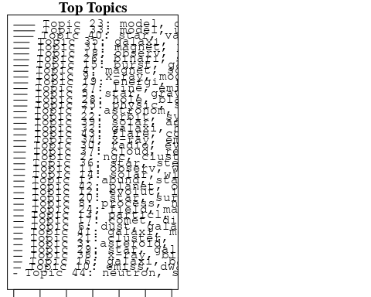

plotQuote(thoughts6, width = 30, main = "Topic 6")  
plotQuote(thoughts18, width = 30, main = "Topic 18")

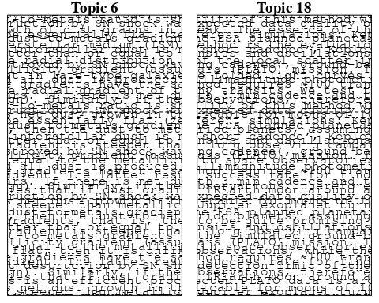

# Calculate and plot the correlation between topics  
mod.out.corr <- topicCorr(Research_topics)  
plot(mod.out.corr, cex = 1.5)  
  
  
# For each topic  
for (topic_num in 1:44) {  
 # Plot the word cloud  
 cloud(Research_topics, topic = topic_num, scale = c(2, 0.25))  
 Sys.sleep(2)  
}

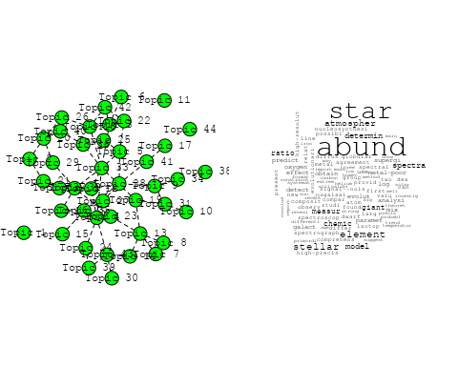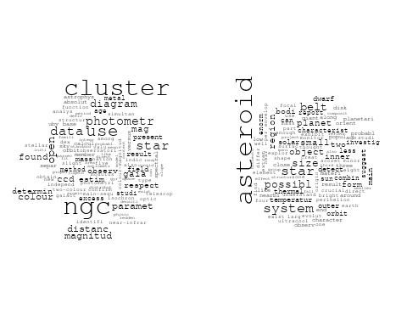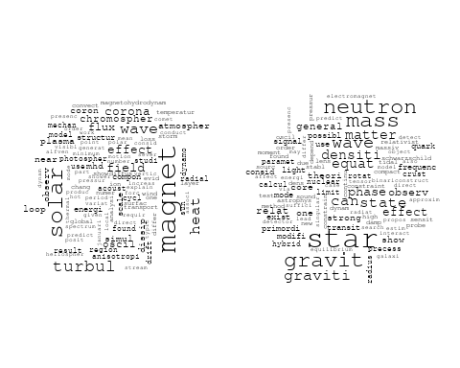

## Warning in wordcloud::wordcloud(words = vocab, freq = vec, max.words =  
## max.words, : observatori could not be fit on page. It will not be plotted.

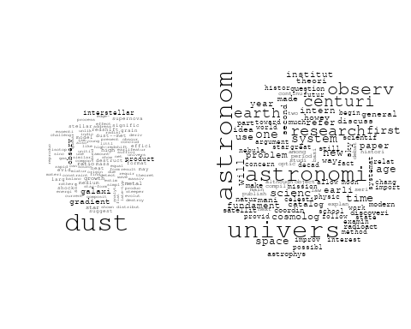

## Warning in wordcloud::wordcloud(words = vocab, freq = vec, max.words =  
## max.words, : observ could not be fit on page. It will not be plotted.

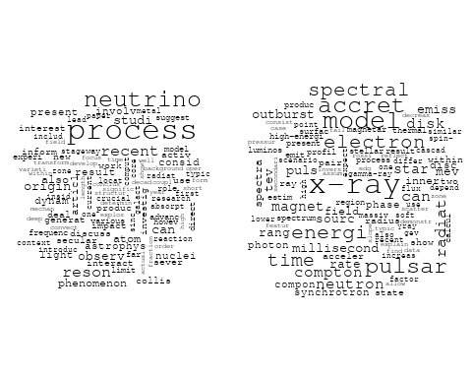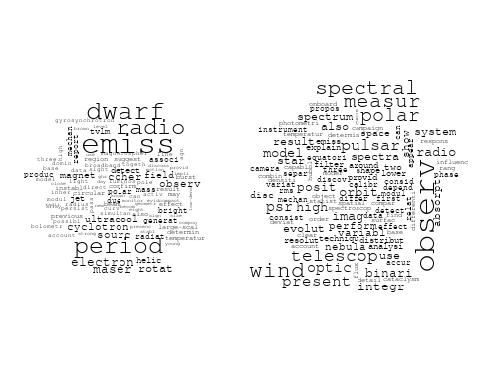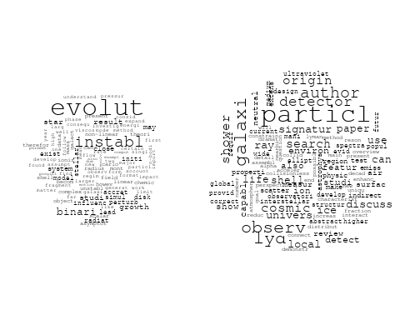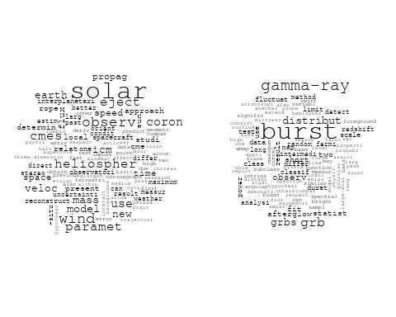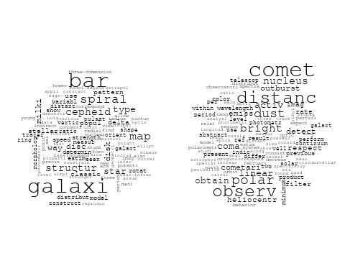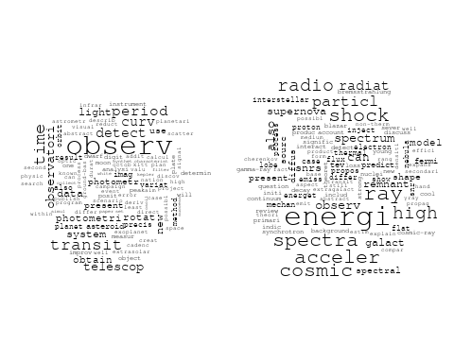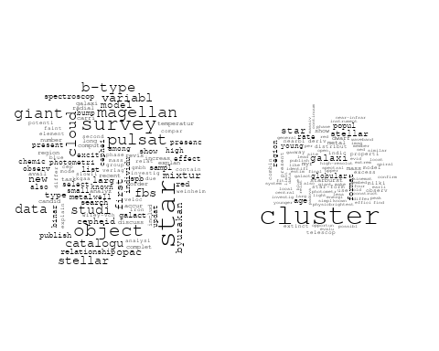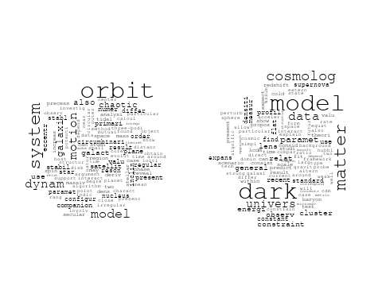

## Warning in wordcloud::wordcloud(words = vocab, freq = vec, max.words =  
## max.words, : stellar could not be fit on page. It will not be plotted.

## Warning in wordcloud::wordcloud(words = vocab, freq = vec, max.words =  
## max.words, : astrophys could not be fit on page. It will not be plotted.

## Warning in wordcloud::wordcloud(words = vocab, freq = vec, max.words =  
## max.words, : complex could not be fit on page. It will not be plotted.

## Warning in wordcloud::wordcloud(words = vocab, freq = vec, max.words =  
## max.words, : asteroseismolog could not be fit on page. It will not be plotted.

## Warning in wordcloud::wordcloud(words = vocab, freq = vec, max.words =  
## max.words, : theoret could not be fit on page. It will not be plotted.

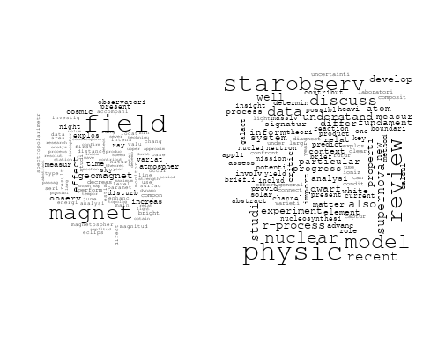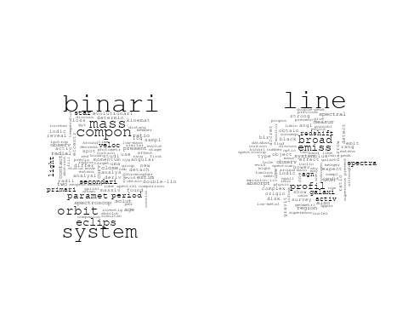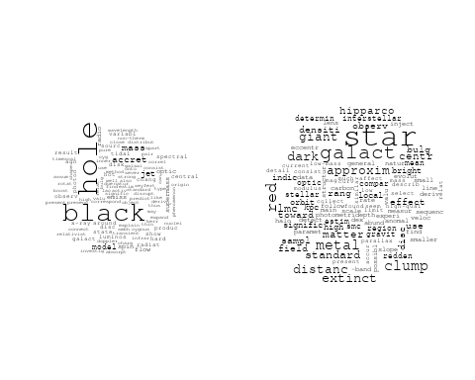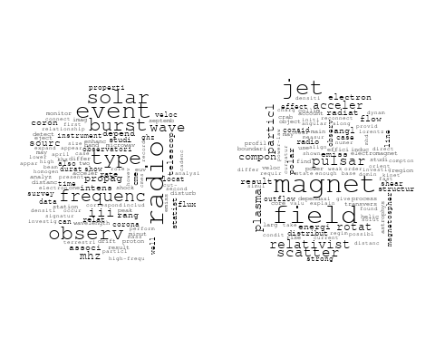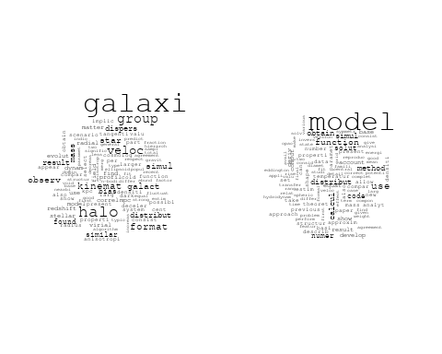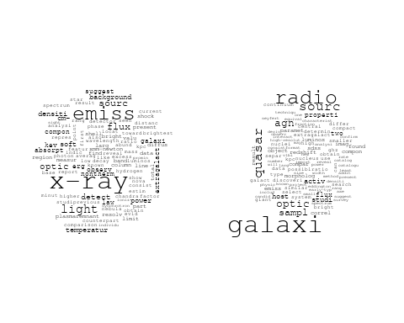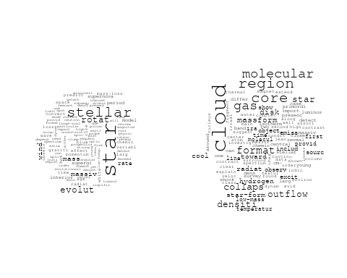

## Warning in wordcloud::wordcloud(words = vocab, freq = vec, max.words =  
## max.words, : interact could not be fit on page. It will not be plotted.

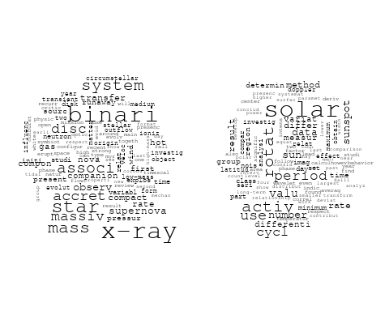

## Warning in wordcloud::wordcloud(words = vocab, freq = vec, max.words =  
## max.words, : gravit could not be fit on page. It will not be plotted.

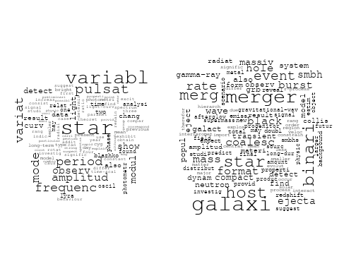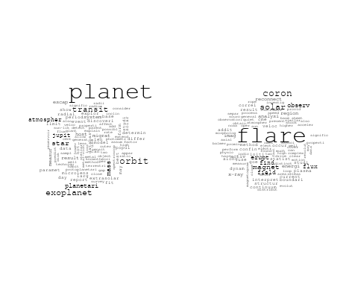

# Get the topic proportions for each document  
topic_proportions <- Research_topics$theta  
  
# Find the index of the topic with the highest proportion for each document  
# This will be the topic that each document is most likely to belong to  
max_topic_idx <- apply(topic_proportions, 1, which.max)  
  
# Add this as a new column to your data  
data_independent$topic <- max_topic_idx  
  
  
  
# Define the intervals  
intervals <- c('1824_1899', '1900_1964', '1965_1974', '1975_1984', '1985_1994', '1995_1999', '2000_2004', '2005_2009', '2010_2014', '2015_2019', '2020_2022')  
colors <- c('pink', 'blue', 'purple', 'yellow', 'green', 'pink', 'orange', 'violet', 'green', 'blue', 'pink')  
  
# Loop through the intervals and plot  
for(i in seq_along(intervals)){  
 # Filter data for when the pub_interval is equal to 1  
 data_filtered <- data_independent[data_independent[[paste0('pub_interval_', intervals[i])]] == 1,]  
   
 # Make the histogram  
   
 p <- ggplot(data_filtered, aes(x = topic)) +  
 geom_histogram(binwidth = 1, fill = colors[i], color = "black") +  
 xlab("Topic") +  
 ylab("Count") +  
 ggtitle(paste0("Topics from year ", gsub("_", " to ", intervals[i])))  
   
 print(p)  
}

