IT topic models

Charlie J. Gomez, Harshvardhan Singh

2023-08-29

library('stm')

## stm v1.3.6 successfully loaded. See ?stm for help.   
## Papers, resources, and other materials at structuraltopicmodel.com

library(dplyr)

##   
## Attaching package: 'dplyr'

## The following objects are masked from 'package:stats':  
##   
## filter, lag

## The following objects are masked from 'package:base':  
##   
## intersect, setdiff, setequal, union

library(stringr)  
library(wordcloud)

## Loading required package: RColorBrewer

#Read csv file  
data = read.csv("preprocessed_data_Jul14.csv")  
  
  
##Topic generation for IT (in collaboration) publications  
  
data_collab <- data[data[["IT"]] != 0,]  
  
# Save the original title data for future use  
data_collab$original_concatenated_title_abstract <- data_collab$concatenated_title_abstract  
  
#pre-processing the titles using textProcessor from the stm package  
processed_text <- textProcessor(data_collab$concatenated_title_abstract, metadata = data_collab)

## Building corpus...   
## Converting to Lower Case...   
## Removing punctuation...   
## Removing stopwords...   
## Removing numbers...   
## Stemming...   
## Creating Output...

# Further prepare the data by removing low-frequency terms  
out_text <- prepDocuments(processed_text$documents, processed_text$vocab, processed_text$meta)

## Removing 2735 of 11623 terms (2735 of 282817 tokens) due to frequency   
## Your corpus now has 3360 documents, 8888 terms and 280082 tokens.

docs_text <- out_text$documents  
vocab_text <- out_text$vocab  
meta_text <- out_text$meta  
  
  
#Prepare data  
plotRemoved(processed_text$documents, lower.thresh = seq(1, 200, by = 100))

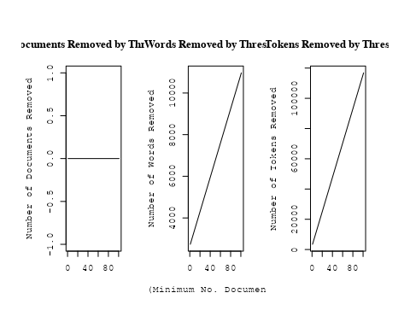

out_text <- prepDocuments(processed_text$documents, processed_text$vocab, processed_text$meta, lower.thresh = 8)

## Removing 8891 of 11623 terms (23275 of 282817 tokens) due to frequency   
## Your corpus now has 3360 documents, 2732 terms and 259542 tokens.

str(out_text$meta)

## 'data.frame': 3360 obs. of 39 variables:  
## $ concept_id : chr "https://openalex.org/C1276947" "https://openalex.org/C1276947" "https://openalex.org/C44870925" "https://openalex.org/C44870925" ...  
## $ work_id : chr "https://openalex.org/W2068317303" "https://openalex.org/W3127045467" "https://openalex.org/W2086348127" "https://openalex.org/W2130580407" ...  
## $ publication_year : int 2004 2021 2007 2011 1999 2001 1990 2009 2007 2011 ...  
## $ title : chr "Arp 299: A Second Merging System with Two Active Nuclei?" "A massive stellar bulge in a regularly rotating galaxy 1.2 billion years after the Big Bang" "Improving Stellar and Planetary Parameters of Transiting Planet Systems: The Case of TrES-2" "Creation of cosmic structure in the complex galaxy cluster merger Abell 2744" ...  
## $ paperabstract : chr "Recent BeppoSAX observations of Arp 299, a powerful far-IR merging starburst system composed of IC 694 and NGC "| __truncated__ "Early assembly of a galaxy disk and bulge Galaxy formation in the early Universe is thought to have been a chao"| __truncated__ "We report on a spectroscopic determination of the atmospheric parameters and chemical abundance of the parent s"| __truncated__ "We present a detailed strong lensing, weak lensing and X-ray analysis of Abell 2744 (z = 0:308), one of the mos"| __truncated__ ...  
## $ country : chr "IT IT IT IT" "GB GB IT GB GB IT" "IT US US US US IT" "US IT" ...  
## $ year_concept : chr "2004+https://openalex.org/C1276947" "2021+https://openalex.org/C1276947" "2007+https://openalex.org/C44870925" "2011+https://openalex.org/C44870925" ...  
## $ concatenated_title_abstract : chr "Arp 299: A Second Merging System with Two Active Nuclei? Recent BeppoSAX observations of Arp 299, a powerful fa"| __truncated__ "A massive stellar bulge in a regularly rotating galaxy 1.2 billion years after the Big Bang Early assembly of a"| __truncated__ "Improving Stellar and Planetary Parameters of Transiting Planet Systems: The Case of TrES-2 We report on a spec"| __truncated__ "Creation of cosmic structure in the complex galaxy cluster merger Abell 2744 We present a detailed strong lensi"| __truncated__ ...  
## $ US : num 0 0 66.7 50 0 ...  
## $ IN : num 0 0 0 0 0 0 0 0 0 0 ...  
## $ DE : num 0 0 0 0 0 ...  
## $ CH : num 0 0 0 0 0 0 0 50 0 0 ...  
## $ GB : num 0 66.7 0 0 0 ...  
## $ CN : num 0 0 0 0 0 0 0 0 0 0 ...  
## $ FR : num 0 0 0 0 0 0 0 0 0 0 ...  
## $ IT : num 100 33.3 33.3 50 100 ...  
## $ RU : num 0 0 0 0 0 0 0 0 0 0 ...  
## $ CA : num 0 0 0 0 0 0 0 0 0 0 ...  
## $ NL : num 0 0 0 0 0 0 0 0 0 0 ...  
## $ AU : num 0 0 0 0 0 0 0 0 0 0 ...  
## $ JP : num 0 0 0 0 0 0 0 0 0 0 ...  
## $ ES : num 0 0 0 0 0 0 0 0 0 0 ...  
## $ IL : num 0 0 0 0 0 0 0 0 0 0 ...  
## $ Americas : num 0 0 0 0 0 0 0 0 0 0 ...  
## $ Europe : num 0 0 0 0 0 ...  
## $ Africa : num 0 0 0 0 0 0 0 0 0 0 ...  
## $ AsiaAndOceania : num 0 0 0 0 0 0 0 0 0 0 ...  
## $ pub_interval_2020_2022 : int 0 1 0 0 0 0 0 0 0 0 ...  
## $ pub_interval_2015_2019 : int 0 0 0 0 0 0 0 0 0 0 ...  
## $ pub_interval_2010_2014 : int 0 0 0 1 0 0 0 0 0 1 ...  
## $ pub_interval_2005_2009 : int 0 0 1 0 0 0 0 1 1 0 ...  
## $ pub_interval_2000_2004 : int 1 0 0 0 0 1 0 0 0 0 ...  
## $ pub_interval_1995_1999 : int 0 0 0 0 1 0 0 0 0 0 ...  
## $ pub_interval_1985_1994 : int 0 0 0 0 0 0 1 0 0 0 ...  
## $ pub_interval_1975_1984 : int 0 0 0 0 0 0 0 0 0 0 ...  
## $ pub_interval_1965_1974 : int 0 0 0 0 0 0 0 0 0 0 ...  
## $ pub_interval_1900_1964 : int 0 0 0 0 0 0 0 0 0 0 ...  
## $ pub_interval_1824_1899 : int 0 0 0 0 0 0 0 0 0 0 ...  
## $ original_concatenated_title_abstract: chr "Arp 299: A Second Merging System with Two Active Nuclei? Recent BeppoSAX observations of Arp 299, a powerful fa"| __truncated__ "A massive stellar bulge in a regularly rotating galaxy 1.2 billion years after the Big Bang Early assembly of a"| __truncated__ "Improving Stellar and Planetary Parameters of Transiting Planet Systems: The Case of TrES-2 We report on a spec"| __truncated__ "Creation of cosmic structure in the complex galaxy cluster merger Abell 2744 We present a detailed strong lensi"| __truncated__ ...

# Initialize an empty formula string  
prevalence_formula_str <- "~"  
  
# Define the publication intervals  
pub_intervals <- c("pub_interval_2020_2022", "pub_interval_2015_2019", "pub_interval_2010_2014",   
 "pub_interval_2005_2009", "pub_interval_2000_2004", "pub_interval_1995_1999",  
 "pub_interval_1985_1994", "pub_interval_1975_1984", "pub_interval_1965_1974",  
 "pub_interval_1900_1964", "pub_interval_1824_1899")  
  
# Add each publication interval to the formula string  
for (interval in pub_intervals) {  
 # add an if statement to handle the first addition (without '+')  
 if (prevalence_formula_str == "~") {  
 prevalence_formula_str <- paste(prevalence_formula_str, interval)  
 } else {  
 prevalence_formula_str <- paste(prevalence_formula_str, "+", interval)  
 }  
}  
  
  
# Convert the string to a formula  
prevalence_formula <- as.formula(prevalence_formula_str)  
print(prevalence_formula)

## ~pub_interval_2020_2022 + pub_interval_2015_2019 + pub_interval_2010_2014 +   
## pub_interval_2005_2009 + pub_interval_2000_2004 + pub_interval_1995_1999 +   
## pub_interval_1985_1994 + pub_interval_1975_1984 + pub_interval_1965_1974 +   
## pub_interval_1900_1964 + pub_interval_1824_1899

# Run STM model  
Research_topics <- stm(documents = out_text$documents,   
 vocab = out_text$vocab,   
 K = 44,   
 prevalence = prevalence_formula,   
 data = out_text$meta,   
 init.type = "Spectral",  
 max.em.its = 1000,  
 gamma.prior = 'L1')

## Beginning Spectral Initialization   
## Calculating the gram matrix...  
## Finding anchor words...  
## ............................................  
## Recovering initialization...  
## ...........................  
## Initialization complete.  
## .....................................................................................................  
## Completed E-Step (3 seconds).   
## Completed M-Step.   
## Completing Iteration 1 (approx. per word bound = -6.572)   
## .....................................................................................................  
## Completed E-Step (3 seconds).   
## Completed M-Step.   
## Completing Iteration 2 (approx. per word bound = -6.299, relative change = 4.150e-02)   
## .....................................................................................................  
## Completed E-Step (3 seconds).   
## Completed M-Step.   
## Completing Iteration 3 (approx. per word bound = -6.235, relative change = 1.016e-02)   
## .....................................................................................................  
## Completed E-Step (2 seconds).   
## Completed M-Step.   
## Completing Iteration 4 (approx. per word bound = -6.210, relative change = 4.008e-03)   
## .....................................................................................................  
## Completed E-Step (2 seconds).   
## Completed M-Step.   
## Completing Iteration 5 (approx. per word bound = -6.197, relative change = 2.068e-03)   
## Topic 1: ray, burst, cosmic, gamma-ray, gamma   
## Topic 2: nova, outburst, day, phase, maximum   
## Topic 3: pulsar, millisecond, accret, period, system   
## Topic 4: spectra, grb, observ, light, featur   
## Topic 5: type, supernova, produc, telescop, space   
## Topic 6: observ, review, theoret, recent, discuss   
## Topic 7: polar, galaxi, ring, angl, photometr   
## Topic 8: star, planet, system, planetari, orbit   
## Topic 9: solar, observ, coron, corona, magnet   
## Topic 10: galaxi, luminos, dwarf, densiti, popul   
## Topic 11: x-ray, kev, observ, spectrum, emiss   
## Topic 12: dwarf, cool, white, gas, univers   
## Topic 13: metal, galaxi, star, host, x-ray   
## Topic 14: supernova, type, sne, rate, progenitor   
## Topic 15: agn, sourc, activ, sampl, x-ray   
## Topic 16: model, evolut, galaxi, format, chemic   
## Topic 17: line, quasar, broad, emiss, sourc   
## Topic 18: galaxi, gas, feedback, simul, wind   
## Topic 19: gravit, wave, detect, will, mission   
## Topic 20: star, neutron, gravit, mass, magnetar   
## Topic 21: cluster, galaxi, mass, x-ray, relat   
## Topic 22: observ, energi, emiss, x-ray, flux   
## Topic 23: cluster, ngc, abund, star, globular   
## Topic 24: redshift, use, survey, distribut, photometr   
## Topic 25: radio, sourc, jet, blazar, object   
## Topic 26: galaxi, ngc, stellar, observ, ellipt   
## Topic 27: microwav, power, background, cmb, cosmic   
## Topic 28: halo, dark, matter, galaxi, mass   
## Topic 29: star, mass, agb, metal, dust   
## Topic 30: distanc, star, cluster, use, data   
## Topic 31: mass, pulsar, observ, model, star   
## Topic 32: line, nebula, observ, mass, cloud   
## Topic 33: background, data, analysi, use, spectral   
## Topic 34: cluster, globular, star, popul, dynam   
## Topic 35: accret, rate, mass, luminos, disk   
## Topic 36: field, magnet, shock, acceler, particl   
## Topic 37: galaxi, mass, stellar, massiv, format   
## Topic 38: radio, sourc, cluster, emiss, two   
## Topic 39: x-ray, star, stellar, activ, observ   
## Topic 40: dark, matter, model, energi, neutrino   
## Topic 41: cluster, galaxi, mass, format, fraction   
## Topic 42: hole, black, binari, mass, merger   
## Topic 43: galact, space, univers, centr, milki   
## Topic 44: associ, supernova, burst, event, grb   
## .....................................................................................................  
## Completed E-Step (2 seconds).   
## Completed M-Step.   
## Completing Iteration 6 (approx. per word bound = -6.189, relative change = 1.256e-03)   
## .....................................................................................................  
## Completed E-Step (2 seconds).   
## Completed M-Step.   
## Completing Iteration 7 (approx. per word bound = -6.184, relative change = 9.004e-04)   
## .....................................................................................................  
## Completed E-Step (2 seconds).   
## Completed M-Step.   
## Completing Iteration 8 (approx. per word bound = -6.180, relative change = 6.663e-04)   
## .....................................................................................................  
## Completed E-Step (2 seconds).   
## Completed M-Step.   
## Completing Iteration 9 (approx. per word bound = -6.176, relative change = 5.422e-04)   
## .....................................................................................................  
## Completed E-Step (2 seconds).   
## Completed M-Step.   
## Completing Iteration 10 (approx. per word bound = -6.173, relative change = 4.814e-04)   
## Topic 1: ray, cosmic, gamma, gamma-ray, energi   
## Topic 2: nova, outburst, day, phase, observ   
## Topic 3: pulsar, millisecond, accret, period, system   
## Topic 4: burst, grb, spectra, light, afterglow   
## Topic 5: type, supernova, produc, telescop, progenitor   
## Topic 6: observ, review, theoret, recent, discuss   
## Topic 7: polar, galaxi, ring, angl, photometr   
## Topic 8: star, planet, system, planetari, orbit   
## Topic 9: solar, observ, coron, corona, magnet   
## Topic 10: galaxi, luminos, dwarf, densiti, popul   
## Topic 11: x-ray, kev, observ, spectrum, sourc   
## Topic 12: dwarf, cool, white, gas, mass   
## Topic 13: metal, galaxi, star, host, relat   
## Topic 14: supernova, type, sne, rate, progenitor   
## Topic 15: agn, sourc, activ, sampl, object   
## Topic 16: model, galaxi, evolut, format, star   
## Topic 17: line, quasar, broad, emiss, region   
## Topic 18: gas, simul, feedback, galaxi, wind   
## Topic 19: gravit, detect, will, mission, wave   
## Topic 20: star, neutron, gravit, magnetar, wave   
## Topic 21: cluster, galaxi, mass, x-ray, relat   
## Topic 22: observ, energi, emiss, x-ray, burst   
## Topic 23: cluster, star, abund, ngc, metal   
## Topic 24: redshift, use, survey, galaxi, estim   
## Topic 25: jet, radio, blazar, sourc, lac   
## Topic 26: galaxi, ngc, stellar, observ, ellipt   
## Topic 27: microwav, power, background, cosmic, cmb   
## Topic 28: halo, dark, matter, galaxi, mass   
## Topic 29: star, mass, dust, agb, metal   
## Topic 30: distanc, star, cluster, use, age   
## Topic 31: mass, observ, model, pulsar, star   
## Topic 32: line, nebula, cloud, mass, planetari   
## Topic 33: background, data, analysi, use, spectral   
## Topic 34: cluster, globular, star, popul, dynam   
## Topic 35: accret, rate, disk, mass, disc   
## Topic 36: field, magnet, shock, acceler, particl   
## Topic 37: galaxi, mass, stellar, format, massiv   
## Topic 38: radio, sourc, cluster, galaxi, emiss   
## Topic 39: star, x-ray, stellar, activ, observ   
## Topic 40: dark, matter, model, energi, cosmolog   
## Topic 41: cluster, galaxi, mass, fraction, group   
## Topic 42: hole, black, mass, binari, massiv   
## Topic 43: galact, univers, milki, way, space   
## Topic 44: burst, associ, supernova, grb, observ   
## .....................................................................................................  
## Completed E-Step (2 seconds).   
## Completed M-Step.   
## Completing Iteration 11 (approx. per word bound = -6.170, relative change = 4.437e-04)   
## .....................................................................................................  
## Completed E-Step (2 seconds).   
## Completed M-Step.   
## Completing Iteration 12 (approx. per word bound = -6.168, relative change = 3.973e-04)   
## .....................................................................................................  
## Completed E-Step (2 seconds).   
## Completed M-Step.   
## Completing Iteration 13 (approx. per word bound = -6.166, relative change = 3.436e-04)   
## .....................................................................................................  
## Completed E-Step (3 seconds).   
## Completed M-Step.   
## Completing Iteration 14 (approx. per word bound = -6.164, relative change = 3.162e-04)   
## .....................................................................................................  
## Completed E-Step (3 seconds).   
## Completed M-Step.   
## Completing Iteration 15 (approx. per word bound = -6.162, relative change = 2.804e-04)   
## Topic 1: ray, cosmic, gamma, energi, gamma-ray   
## Topic 2: nova, outburst, day, phase, observ   
## Topic 3: pulsar, millisecond, accret, system, period   
## Topic 4: burst, grb, grbs, afterglow, light   
## Topic 5: type, supernova, progenitor, produc, telescop   
## Topic 6: observ, review, theoret, discuss, process   
## Topic 7: polar, galaxi, ring, angl, observ   
## Topic 8: system, planet, star, planetari, orbit   
## Topic 9: solar, observ, coron, magnet, corona   
## Topic 10: galaxi, luminos, dwarf, densiti, popul   
## Topic 11: x-ray, kev, observ, spectrum, sourc   
## Topic 12: dwarf, cool, gas, white, star   
## Topic 13: galaxi, metal, star, host, relat   
## Topic 14: supernova, type, sne, rate, progenitor   
## Topic 15: agn, sourc, activ, sampl, object   
## Topic 16: model, galaxi, evolut, format, star   
## Topic 17: line, quasar, broad, emiss, region   
## Topic 18: simul, gas, feedback, galaxi, medium   
## Topic 19: gravit, detect, will, mission, wave   
## Topic 20: star, neutron, gravit, magnetar, wave   
## Topic 21: cluster, galaxi, mass, x-ray, relat   
## Topic 22: observ, energi, emiss, x-ray, flux   
## Topic 23: cluster, star, abund, ngc, metal   
## Topic 24: redshift, survey, use, galaxi, estim   
## Topic 25: jet, blazar, radio, sourc, lac   
## Topic 26: ngc, galaxi, stellar, observ, ellipt   
## Topic 27: microwav, power, background, cosmic, cmb   
## Topic 28: halo, dark, matter, galaxi, mass   
## Topic 29: star, mass, dust, agb, metal   
## Topic 30: distanc, star, cluster, use, age   
## Topic 31: mass, observ, model, pulsar, state   
## Topic 32: line, nebula, cloud, veloc, planetari   
## Topic 33: background, data, analysi, telescop, use   
## Topic 34: cluster, globular, star, popul, dynam   
## Topic 35: accret, rate, disc, disk, mass   
## Topic 36: field, magnet, shock, particl, acceler   
## Topic 37: galaxi, mass, stellar, format, massiv   
## Topic 38: radio, sourc, cluster, galaxi, emiss   
## Topic 39: star, x-ray, stellar, activ, observ   
## Topic 40: dark, matter, model, energi, cosmolog   
## Topic 41: cluster, galaxi, mass, group, fraction   
## Topic 42: hole, black, mass, binari, massiv   
## Topic 43: galact, milki, way, univers, centr   
## Topic 44: supernova, burst, associ, grb, observ   
## .....................................................................................................  
## Completed E-Step (3 seconds).   
## Completed M-Step.   
## Completing Iteration 16 (approx. per word bound = -6.161, relative change = 2.242e-04)   
## .....................................................................................................  
## Completed E-Step (3 seconds).   
## Completed M-Step.   
## Completing Iteration 17 (approx. per word bound = -6.160, relative change = 2.076e-04)   
## .....................................................................................................  
## Completed E-Step (3 seconds).   
## Completed M-Step.   
## Completing Iteration 18 (approx. per word bound = -6.158, relative change = 2.026e-04)   
## .....................................................................................................  
## Completed E-Step (3 seconds).   
## Completed M-Step.   
## Completing Iteration 19 (approx. per word bound = -6.157, relative change = 1.966e-04)   
## .....................................................................................................  
## Completed E-Step (3 seconds).   
## Completed M-Step.   
## Completing Iteration 20 (approx. per word bound = -6.156, relative change = 1.856e-04)   
## Topic 1: ray, cosmic, gamma, energi, diffus   
## Topic 2: nova, outburst, day, observ, phase   
## Topic 3: pulsar, millisecond, accret, system, period   
## Topic 4: burst, grb, grbs, gamma-ray, afterglow   
## Topic 5: type, supernova, progenitor, mass, rate   
## Topic 6: observ, review, theoret, process, discuss   
## Topic 7: polar, galaxi, ring, angl, observ   
## Topic 8: system, planet, star, planetari, orbit   
## Topic 9: solar, observ, coron, magnet, heat   
## Topic 10: galaxi, luminos, dwarf, densiti, star-form   
## Topic 11: x-ray, kev, observ, spectrum, sourc   
## Topic 12: dwarf, cool, gas, white, galaxi   
## Topic 13: galaxi, metal, star, host, relat   
## Topic 14: supernova, sne, type, rate, observ   
## Topic 15: agn, sourc, activ, sampl, object   
## Topic 16: model, galaxi, evolut, format, star   
## Topic 17: line, quasar, broad, emiss, optic   
## Topic 18: simul, gas, feedback, galaxi, medium   
## Topic 19: gravit, detect, will, mission, space   
## Topic 20: star, neutron, gravit, magnetar, wave   
## Topic 21: cluster, galaxi, mass, x-ray, relat   
## Topic 22: observ, energi, flux, emiss, x-ray   
## Topic 23: cluster, star, abund, ngc, metal   
## Topic 24: redshift, survey, galaxi, use, per   
## Topic 25: jet, blazar, radio, sourc, lac   
## Topic 26: ngc, galaxi, stellar, observ, ellipt   
## Topic 27: microwav, power, background, cosmic, cmb   
## Topic 28: halo, dark, matter, galaxi, mass   
## Topic 29: star, mass, dust, agb, abund   
## Topic 30: distanc, star, cluster, use, magnitud   
## Topic 31: mass, model, observ, equat, state   
## Topic 32: line, nebula, veloc, cloud, planetari   
## Topic 33: background, data, telescop, analysi, use   
## Topic 34: cluster, globular, star, popul, dynam   
## Topic 35: accret, disc, rate, disk, mass   
## Topic 36: field, magnet, shock, particl, acceler   
## Topic 37: galaxi, mass, stellar, format, massiv   
## Topic 38: radio, sourc, galaxi, cluster, emiss   
## Topic 39: star, x-ray, stellar, activ, observ   
## Topic 40: dark, matter, model, cosmolog, energi   
## Topic 41: cluster, galaxi, mass, group, fraction   
## Topic 42: hole, black, mass, binari, massiv   
## Topic 43: galact, way, milki, univers, centr   
## Topic 44: supernova, burst, event, associ, grb   
## .....................................................................................................  
## Completed E-Step (3 seconds).   
## Completed M-Step.   
## Completing Iteration 21 (approx. per word bound = -6.155, relative change = 1.594e-04)   
## .....................................................................................................  
## Completed E-Step (3 seconds).   
## Completed M-Step.   
## Completing Iteration 22 (approx. per word bound = -6.154, relative change = 1.602e-04)   
## .....................................................................................................  
## Completed E-Step (3 seconds).   
## Completed M-Step.   
## Completing Iteration 23 (approx. per word bound = -6.153, relative change = 1.501e-04)   
## .....................................................................................................  
## Completed E-Step (2 seconds).   
## Completed M-Step.   
## Completing Iteration 24 (approx. per word bound = -6.152, relative change = 1.391e-04)   
## .....................................................................................................  
## Completed E-Step (2 seconds).   
## Completed M-Step.   
## Completing Iteration 25 (approx. per word bound = -6.151, relative change = 1.261e-04)   
## Topic 1: ray, cosmic, gamma, energi, diffus   
## Topic 2: nova, outburst, day, observ, phase   
## Topic 3: pulsar, millisecond, accret, system, period   
## Topic 4: burst, grb, grbs, gamma-ray, afterglow   
## Topic 5: type, supernova, rate, progenitor, mass   
## Topic 6: observ, review, theoret, discuss, process   
## Topic 7: polar, galaxi, ring, angl, observ   
## Topic 8: system, planet, star, planetari, orbit   
## Topic 9: solar, observ, coron, magnet, event   
## Topic 10: galaxi, luminos, dwarf, densiti, observ   
## Topic 11: x-ray, observ, kev, spectrum, spectral   
## Topic 12: dwarf, gas, cool, white, galaxi   
## Topic 13: galaxi, metal, host, star, mass   
## Topic 14: supernova, type, sne, observ, mass   
## Topic 15: agn, sourc, activ, sampl, object   
## Topic 16: model, galaxi, evolut, format, star   
## Topic 17: line, quasar, broad, emiss, optic   
## Topic 18: simul, gas, feedback, galaxi, medium   
## Topic 19: detect, will, gravit, mission, space   
## Topic 20: star, neutron, gravit, magnetar, wave   
## Topic 21: cluster, galaxi, mass, x-ray, lens   
## Topic 22: observ, energi, flux, emiss, x-ray   
## Topic 23: cluster, star, abund, ngc, metal   
## Topic 24: redshift, survey, galaxi, use, per   
## Topic 25: blazar, jet, radio, lac, sourc   
## Topic 26: ngc, galaxi, stellar, observ, ellipt   
## Topic 27: power, microwav, background, cosmic, cmb   
## Topic 28: halo, dark, matter, galaxi, mass   
## Topic 29: star, mass, dust, abund, agb   
## Topic 30: distanc, star, cluster, use, mag   
## Topic 31: model, mass, equat, observ, state   
## Topic 32: line, veloc, nebula, cloud, core   
## Topic 33: background, data, telescop, analysi, use   
## Topic 34: cluster, globular, star, popul, dynam   
## Topic 35: accret, disc, rate, disk, mass   
## Topic 36: field, magnet, shock, particl, emiss   
## Topic 37: galaxi, mass, stellar, format, massiv   
## Topic 38: radio, sourc, galaxi, emiss, cluster   
## Topic 39: star, x-ray, stellar, activ, young   
## Topic 40: dark, matter, model, cosmolog, energi   
## Topic 41: cluster, galaxi, mass, group, fraction   
## Topic 42: black, hole, mass, binari, massiv   
## Topic 43: galact, way, milki, univers, centr   
## Topic 44: supernova, event, burst, associ, grb   
## .....................................................................................................  
## Completed E-Step (2 seconds).   
## Completed M-Step.   
## Completing Iteration 26 (approx. per word bound = -6.151, relative change = 9.704e-05)   
## .....................................................................................................  
## Completed E-Step (2 seconds).   
## Completed M-Step.   
## Completing Iteration 27 (approx. per word bound = -6.150, relative change = 1.350e-04)   
## .....................................................................................................  
## Completed E-Step (2 seconds).   
## Completed M-Step.   
## Completing Iteration 28 (approx. per word bound = -6.149, relative change = 1.198e-04)   
## .....................................................................................................  
## Completed E-Step (2 seconds).   
## Completed M-Step.   
## Completing Iteration 29 (approx. per word bound = -6.149, relative change = 1.151e-04)   
## .....................................................................................................  
## Completed E-Step (2 seconds).   
## Completed M-Step.   
## Completing Iteration 30 (approx. per word bound = -6.148, relative change = 9.978e-05)   
## Topic 1: ray, cosmic, gamma, energi, acceler   
## Topic 2: nova, outburst, day, observ, phase   
## Topic 3: pulsar, millisecond, accret, system, star   
## Topic 4: burst, grb, grbs, gamma-ray, afterglow   
## Topic 5: rate, supernova, type, progenitor, mass   
## Topic 6: observ, review, theoret, discuss, process   
## Topic 7: polar, galaxi, ring, angl, studi   
## Topic 8: system, planet, star, planetari, orbit   
## Topic 9: solar, observ, coron, magnet, event   
## Topic 10: galaxi, luminos, dwarf, densiti, observ   
## Topic 11: x-ray, observ, kev, spectrum, spectral   
## Topic 12: dwarf, gas, cool, galaxi, white   
## Topic 13: galaxi, metal, host, star, mass   
## Topic 14: supernova, type, sne, observ, spectra   
## Topic 15: agn, sourc, activ, sampl, object   
## Topic 16: model, galaxi, evolut, format, star   
## Topic 17: line, quasar, broad, emiss, optic   
## Topic 18: simul, gas, feedback, galaxi, medium   
## Topic 19: detect, will, mission, space, gravit   
## Topic 20: star, neutron, gravit, magnetar, wave   
## Topic 21: cluster, galaxi, mass, lens, x-ray   
## Topic 22: observ, energi, flux, x-ray, emiss   
## Topic 23: cluster, star, abund, ngc, metal   
## Topic 24: redshift, survey, per, galaxi, use   
## Topic 25: blazar, jet, radio, lac, object   
## Topic 26: ngc, galaxi, stellar, observ, ellipt   
## Topic 27: power, microwav, background, cosmic, cmb   
## Topic 28: halo, dark, matter, mass, galaxi   
## Topic 29: star, mass, dust, abund, agb   
## Topic 30: distanc, star, cluster, use, mag   
## Topic 31: model, mass, equat, observ, analyt   
## Topic 32: line, veloc, nebula, cloud, core   
## Topic 33: background, data, telescop, analysi, use   
## Topic 34: cluster, globular, star, popul, dynam   
## Topic 35: accret, disc, rate, disk, mass   
## Topic 36: field, magnet, shock, particl, emiss   
## Topic 37: galaxi, stellar, mass, massiv, format   
## Topic 38: radio, sourc, galaxi, emiss, cluster   
## Topic 39: star, x-ray, stellar, activ, young   
## Topic 40: dark, matter, model, cosmolog, energi   
## Topic 41: cluster, galaxi, mass, group, fraction   
## Topic 42: black, hole, mass, binari, massiv   
## Topic 43: galact, way, milki, univers, centr   
## Topic 44: supernova, burst, event, grbs, associ   
## .....................................................................................................  
## Completed E-Step (2 seconds).   
## Completed M-Step.   
## Completing Iteration 31 (approx. per word bound = -6.147, relative change = 9.762e-05)   
## .....................................................................................................  
## Completed E-Step (2 seconds).   
## Completed M-Step.   
## Completing Iteration 32 (approx. per word bound = -6.147, relative change = 8.465e-05)   
## .....................................................................................................  
## Completed E-Step (2 seconds).   
## Completed M-Step.   
## Completing Iteration 33 (approx. per word bound = -6.146, relative change = 7.797e-05)   
## .....................................................................................................  
## Completed E-Step (2 seconds).   
## Completed M-Step.   
## Completing Iteration 34 (approx. per word bound = -6.146, relative change = 7.056e-05)   
## .....................................................................................................  
## Completed E-Step (2 seconds).   
## Completed M-Step.   
## Completing Iteration 35 (approx. per word bound = -6.146, relative change = 5.172e-05)   
## Topic 1: ray, cosmic, energi, gamma, acceler   
## Topic 2: nova, outburst, day, observ, phase   
## Topic 3: pulsar, millisecond, accret, system, star   
## Topic 4: burst, grb, grbs, gamma-ray, afterglow   
## Topic 5: rate, supernova, type, progenitor, mass   
## Topic 6: observ, review, theoret, discuss, process   
## Topic 7: polar, galaxi, ring, angl, observ   
## Topic 8: system, planet, star, planetari, orbit   
## Topic 9: solar, observ, coron, magnet, event   
## Topic 10: galaxi, luminos, dwarf, densiti, observ   
## Topic 11: x-ray, observ, kev, spectrum, spectral   
## Topic 12: dwarf, gas, cool, galaxi, white   
## Topic 13: galaxi, metal, host, star, mass   
## Topic 14: supernova, type, sne, observ, spectra   
## Topic 15: agn, sourc, activ, sampl, object   
## Topic 16: model, galaxi, format, evolut, star   
## Topic 17: line, quasar, broad, optic, emiss   
## Topic 18: simul, gas, feedback, medium, galaxi   
## Topic 19: detect, will, mission, space, gravit   
## Topic 20: star, neutron, gravit, wave, magnetar   
## Topic 21: cluster, galaxi, mass, lens, x-ray   
## Topic 22: observ, energi, flux, x-ray, flare   
## Topic 23: cluster, star, abund, metal, ngc   
## Topic 24: redshift, survey, per, galaxi, use   
## Topic 25: blazar, jet, lac, energi, radio   
## Topic 26: ngc, galaxi, stellar, observ, ellipt   
## Topic 27: power, background, microwav, cosmic, cmb   
## Topic 28: halo, dark, matter, mass, galaxi   
## Topic 29: star, mass, dust, abund, metal   
## Topic 30: distanc, star, cluster, use, mag   
## Topic 31: model, equat, mass, analyt, state   
## Topic 32: line, nebula, veloc, cloud, core   
## Topic 33: background, data, analysi, telescop, use   
## Topic 34: cluster, globular, star, popul, dynam   
## Topic 35: accret, disc, rate, disk, mass   
## Topic 36: field, magnet, shock, emiss, particl   
## Topic 37: galaxi, stellar, mass, massiv, format   
## Topic 38: radio, sourc, galaxi, emiss, merger   
## Topic 39: star, x-ray, stellar, activ, young   
## Topic 40: dark, matter, model, cosmolog, energi   
## Topic 41: cluster, galaxi, mass, group, fraction   
## Topic 42: black, hole, binari, mass, merger   
## Topic 43: galact, way, milki, univers, centr   
## Topic 44: supernova, burst, event, grbs, grb   
## .....................................................................................................  
## Completed E-Step (2 seconds).   
## Completed M-Step.   
## Completing Iteration 36 (approx. per word bound = -6.145, relative change = 8.179e-05)   
## .....................................................................................................  
## Completed E-Step (2 seconds).   
## Completed M-Step.   
## Completing Iteration 37 (approx. per word bound = -6.145, relative change = 4.762e-05)   
## .....................................................................................................  
## Completed E-Step (2 seconds).   
## Completed M-Step.   
## Completing Iteration 38 (approx. per word bound = -6.144, relative change = 6.115e-05)   
## .....................................................................................................  
## Completed E-Step (2 seconds).   
## Completed M-Step.   
## Completing Iteration 39 (approx. per word bound = -6.144, relative change = 3.958e-05)   
## .....................................................................................................  
## Completed E-Step (2 seconds).   
## Completed M-Step.   
## Completing Iteration 40 (approx. per word bound = -6.144, relative change = 6.645e-05)   
## Topic 1: ray, cosmic, acceler, energi, gamma   
## Topic 2: nova, outburst, day, observ, phase   
## Topic 3: pulsar, millisecond, accret, system, star   
## Topic 4: burst, grb, grbs, gamma-ray, afterglow   
## Topic 5: rate, supernova, type, progenitor, mass   
## Topic 6: observ, review, discuss, theoret, process   
## Topic 7: polar, galaxi, ring, angl, studi   
## Topic 8: system, planet, star, planetari, orbit   
## Topic 9: solar, observ, coron, magnet, event   
## Topic 10: galaxi, luminos, densiti, dwarf, observ   
## Topic 11: x-ray, observ, kev, spectrum, spectral   
## Topic 12: dwarf, gas, galaxi, cool, white   
## Topic 13: galaxi, metal, host, star, mass   
## Topic 14: supernova, type, sne, observ, spectra   
## Topic 15: agn, sourc, activ, object, sampl   
## Topic 16: model, galaxi, format, evolut, star   
## Topic 17: line, quasar, broad, optic, emiss   
## Topic 18: simul, gas, feedback, medium, galaxi   
## Topic 19: detect, will, mission, space, astrophys   
## Topic 20: star, neutron, gravit, wave, magnetar   
## Topic 21: cluster, galaxi, mass, lens, x-ray   
## Topic 22: observ, energi, flux, x-ray, flare   
## Topic 23: cluster, star, metal, abund, ngc   
## Topic 24: redshift, survey, per, galaxi, use   
## Topic 25: blazar, jet, lac, energi, object   
## Topic 26: ngc, galaxi, stellar, observ, ellipt   
## Topic 27: power, background, microwav, cosmic, cmb   
## Topic 28: halo, dark, matter, mass, galaxi   
## Topic 29: star, mass, dust, abund, metal   
## Topic 30: distanc, star, cluster, use, mag   
## Topic 31: model, equat, mass, analyt, use   
## Topic 32: line, nebula, veloc, cloud, core   
## Topic 33: background, data, analysi, telescop, use   
## Topic 34: cluster, globular, star, popul, dynam   
## Topic 35: accret, disc, rate, disk, mass   
## Topic 36: field, magnet, shock, emiss, particl   
## Topic 37: galaxi, stellar, mass, massiv, early-typ   
## Topic 38: radio, sourc, galaxi, emiss, jet   
## Topic 39: star, x-ray, stellar, activ, young   
## Topic 40: dark, matter, model, cosmolog, energi   
## Topic 41: cluster, galaxi, mass, group, fraction   
## Topic 42: black, hole, mass, binari, massiv   
## Topic 43: galact, way, milki, univers, centr   
## Topic 44: burst, supernova, event, grb, grbs   
## .....................................................................................................  
## Completed E-Step (2 seconds).   
## Completed M-Step.   
## Completing Iteration 41 (approx. per word bound = -6.143, relative change = 5.439e-05)   
## .....................................................................................................  
## Completed E-Step (2 seconds).   
## Completed M-Step.   
## Completing Iteration 42 (approx. per word bound = -6.143, relative change = 5.325e-05)   
## .....................................................................................................  
## Completed E-Step (2 seconds).   
## Completed M-Step.   
## Completing Iteration 43 (approx. per word bound = -6.143, relative change = 2.806e-05)   
## .....................................................................................................  
## Completed E-Step (2 seconds).   
## Completed M-Step.   
## Completing Iteration 44 (approx. per word bound = -6.143, relative change = 7.452e-05)   
## .....................................................................................................  
## Completed E-Step (2 seconds).   
## Completed M-Step.   
## Completing Iteration 45 (approx. per word bound = -6.142, relative change = 4.751e-05)   
## Topic 1: ray, cosmic, acceler, energi, gamma   
## Topic 2: nova, outburst, day, observ, phase   
## Topic 3: pulsar, millisecond, accret, system, star   
## Topic 4: burst, grb, grbs, gamma-ray, afterglow   
## Topic 5: rate, supernova, type, progenitor, mass   
## Topic 6: observ, review, discuss, theoret, process   
## Topic 7: polar, galaxi, ring, angl, studi   
## Topic 8: system, planet, star, planetari, orbit   
## Topic 9: solar, observ, coron, magnet, event   
## Topic 10: galaxi, luminos, densiti, dwarf, observ   
## Topic 11: x-ray, observ, kev, spectrum, spectral   
## Topic 12: dwarf, gas, galaxi, cool, white   
## Topic 13: galaxi, metal, host, star, mass   
## Topic 14: type, supernova, sne, observ, spectra   
## Topic 15: agn, sourc, activ, object, galaxi   
## Topic 16: model, galaxi, format, evolut, star   
## Topic 17: line, quasar, broad, optic, emiss   
## Topic 18: simul, gas, feedback, medium, galaxi   
## Topic 19: detect, will, mission, space, astrophys   
## Topic 20: star, neutron, gravit, wave, magnetar   
## Topic 21: cluster, galaxi, mass, lens, x-ray   
## Topic 22: observ, energi, flux, x-ray, flare   
## Topic 23: cluster, star, metal, abund, ngc   
## Topic 24: redshift, survey, per, galaxi, use   
## Topic 25: blazar, jet, lac, energi, object   
## Topic 26: ngc, galaxi, stellar, observ, ellipt   
## Topic 27: power, background, microwav, cosmic, cmb   
## Topic 28: halo, dark, matter, mass, galaxi   
## Topic 29: star, mass, dust, abund, metal   
## Topic 30: distanc, star, cluster, use, mag   
## Topic 31: model, equat, mass, analyt, use   
## Topic 32: line, nebula, core, cloud, veloc   
## Topic 33: background, data, analysi, telescop, use   
## Topic 34: cluster, globular, star, popul, dynam   
## Topic 35: accret, disc, rate, disk, mass   
## Topic 36: field, magnet, shock, emiss, particl   
## Topic 37: galaxi, stellar, mass, early-typ, massiv   
## Topic 38: radio, sourc, galaxi, emiss, jet   
## Topic 39: star, x-ray, stellar, activ, young   
## Topic 40: dark, matter, model, cosmolog, energi   
## Topic 41: cluster, galaxi, group, mass, morpholog   
## Topic 42: black, hole, mass, binari, massiv   
## Topic 43: galact, way, milki, univers, centr   
## Topic 44: burst, supernova, event, grb, associ   
## .....................................................................................................  
## Completed E-Step (2 seconds).   
## Completed M-Step.   
## Completing Iteration 46 (approx. per word bound = -6.142, relative change = 3.642e-05)   
## .....................................................................................................  
## Completed E-Step (2 seconds).   
## Completed M-Step.   
## Completing Iteration 47 (approx. per word bound = -6.142, relative change = 3.886e-05)   
## .....................................................................................................  
## Completed E-Step (2 seconds).   
## Completed M-Step.   
## Completing Iteration 48 (approx. per word bound = -6.141, relative change = 4.185e-05)   
## .....................................................................................................  
## Completed E-Step (2 seconds).   
## Completed M-Step.   
## Completing Iteration 49 (approx. per word bound = -6.141, relative change = 4.411e-05)   
## .....................................................................................................  
## Completed E-Step (2 seconds).   
## Completed M-Step.   
## Completing Iteration 50 (approx. per word bound = -6.141, relative change = 4.302e-05)   
## Topic 1: ray, cosmic, acceler, energi, gamma   
## Topic 2: nova, outburst, day, observ, phase   
## Topic 3: pulsar, millisecond, accret, system, star   
## Topic 4: burst, grb, grbs, gamma-ray, afterglow   
## Topic 5: rate, supernova, type, progenitor, mass   
## Topic 6: observ, review, discuss, theoret, process   
## Topic 7: polar, galaxi, ring, angl, observ   
## Topic 8: system, planet, star, planetari, orbit   
## Topic 9: solar, observ, coron, magnet, heat   
## Topic 10: galaxi, luminos, densiti, observ, dwarf   
## Topic 11: x-ray, observ, kev, spectrum, spectral   
## Topic 12: dwarf, gas, galaxi, cool, star   
## Topic 13: galaxi, metal, host, star, mass   
## Topic 14: type, supernova, sne, observ, light   
## Topic 15: agn, sourc, activ, object, galaxi   
## Topic 16: model, galaxi, format, evolut, star   
## Topic 17: line, quasar, broad, optic, emiss   
## Topic 18: simul, gas, feedback, medium, galaxi   
## Topic 19: detect, will, mission, space, astrophys   
## Topic 20: star, neutron, gravit, wave, magnetar   
## Topic 21: cluster, galaxi, mass, x-ray, lens   
## Topic 22: observ, energi, flux, x-ray, flare   
## Topic 23: cluster, star, metal, abund, ngc   
## Topic 24: redshift, survey, per, galaxi, cent   
## Topic 25: blazar, jet, energi, lac, object   
## Topic 26: ngc, galaxi, stellar, observ, ellipt   
## Topic 27: power, background, microwav, cosmic, cmb   
## Topic 28: halo, dark, matter, mass, galaxi   
## Topic 29: star, mass, dust, abund, metal   
## Topic 30: distanc, star, cluster, use, mag   
## Topic 31: model, equat, mass, analyt, state   
## Topic 32: line, core, nebula, cloud, veloc   
## Topic 33: background, data, analysi, telescop, use   
## Topic 34: cluster, globular, star, popul, dynam   
## Topic 35: accret, disc, disk, rate, mass   
## Topic 36: field, magnet, shock, emiss, electron   
## Topic 37: galaxi, stellar, mass, early-typ, massiv   
## Topic 38: radio, sourc, galaxi, emiss, jet   
## Topic 39: star, x-ray, stellar, activ, young   
## Topic 40: dark, matter, model, cosmolog, energi   
## Topic 41: cluster, galaxi, group, mass, morpholog   
## Topic 42: black, hole, mass, binari, massiv   
## Topic 43: galact, way, milki, univers, centr   
## Topic 44: burst, supernova, event, grb, associ   
## .....................................................................................................  
## Completed E-Step (2 seconds).   
## Completed M-Step.   
## Completing Iteration 51 (approx. per word bound = -6.141, relative change = 1.382e-05)   
## .....................................................................................................  
## Completed E-Step (2 seconds).   
## Completed M-Step.   
## Completing Iteration 52 (approx. per word bound = -6.140, relative change = 6.410e-05)   
## .....................................................................................................  
## Completed E-Step (2 seconds).   
## Completed M-Step.   
## Completing Iteration 53 (approx. per word bound = -6.140, relative change = 4.362e-05)   
## .....................................................................................................  
## Completed E-Step (2 seconds).   
## Completed M-Step.   
## Completing Iteration 54 (approx. per word bound = -6.140, relative change = 4.175e-05)   
## .....................................................................................................  
## Completed E-Step (2 seconds).   
## Completed M-Step.   
## Completing Iteration 55 (approx. per word bound = -6.140, relative change = 3.938e-05)   
## Topic 1: ray, cosmic, acceler, energi, gamma   
## Topic 2: nova, outburst, day, observ, phase   
## Topic 3: pulsar, millisecond, accret, system, star   
## Topic 4: burst, grb, grbs, gamma-ray, afterglow   
## Topic 5: rate, supernova, type, progenitor, mass   
## Topic 6: observ, review, discuss, theoret, process   
## Topic 7: polar, galaxi, ring, angl, studi   
## Topic 8: system, planet, star, planetari, orbit   
## Topic 9: solar, observ, coron, magnet, heat   
## Topic 10: galaxi, luminos, densiti, observ, dwarf   
## Topic 11: x-ray, observ, kev, spectrum, spectral   
## Topic 12: dwarf, gas, galaxi, star, cool   
## Topic 13: galaxi, metal, host, star, mass   
## Topic 14: type, supernova, sne, light, observ   
## Topic 15: agn, sourc, activ, object, galaxi   
## Topic 16: model, galaxi, format, evolut, star   
## Topic 17: line, quasar, broad, optic, emiss   
## Topic 18: simul, gas, feedback, medium, galaxi   
## Topic 19: detect, will, mission, space, observ   
## Topic 20: star, neutron, gravit, wave, frequenc   
## Topic 21: cluster, galaxi, mass, x-ray, lens   
## Topic 22: observ, energi, x-ray, flux, flare   
## Topic 23: cluster, star, metal, abund, ngc   
## Topic 24: redshift, survey, per, galaxi, cent   
## Topic 25: blazar, jet, energi, lac, object   
## Topic 26: ngc, galaxi, stellar, observ, gas   
## Topic 27: power, background, microwav, cosmic, cmb   
## Topic 28: halo, dark, matter, mass, galaxi   
## Topic 29: star, mass, dust, abund, metal   
## Topic 30: distanc, star, cluster, use, mag   
## Topic 31: model, equat, mass, analyt, state   
## Topic 32: line, core, nebula, cloud, veloc   
## Topic 33: background, data, analysi, telescop, use   
## Topic 34: cluster, globular, star, popul, dynam   
## Topic 35: accret, disc, disk, rate, mass   
## Topic 36: field, magnet, shock, emiss, electron   
## Topic 37: galaxi, stellar, mass, early-typ, massiv   
## Topic 38: radio, sourc, emiss, galaxi, jet   
## Topic 39: star, x-ray, stellar, activ, young   
## Topic 40: dark, matter, model, cosmolog, energi   
## Topic 41: cluster, galaxi, group, mass, morpholog   
## Topic 42: black, hole, mass, binari, massiv   
## Topic 43: galact, way, milki, univers, centr   
## Topic 44: burst, supernova, event, grb, associ   
## .....................................................................................................  
## Completed E-Step (2 seconds).   
## Completed M-Step.   
## Completing Iteration 56 (approx. per word bound = -6.140, relative change = 1.775e-05)   
## .....................................................................................................  
## Completed E-Step (2 seconds).   
## Completed M-Step.   
## Completing Iteration 57 (approx. per word bound = -6.139, relative change = 3.939e-05)   
## .....................................................................................................  
## Completed E-Step (2 seconds).   
## Completed M-Step.   
## Completing Iteration 58 (approx. per word bound = -6.139, relative change = 2.922e-05)   
## .....................................................................................................  
## Completed E-Step (2 seconds).   
## Completed M-Step.   
## Completing Iteration 59 (approx. per word bound = -6.139, relative change = 2.561e-05)   
## .....................................................................................................  
## Completed E-Step (2 seconds).   
## Completed M-Step.   
## Completing Iteration 60 (approx. per word bound = -6.139, relative change = 2.728e-05)   
## Topic 1: ray, cosmic, acceler, energi, gamma   
## Topic 2: nova, outburst, day, observ, phase   
## Topic 3: pulsar, millisecond, accret, system, star   
## Topic 4: burst, grb, grbs, gamma-ray, afterglow   
## Topic 5: rate, supernova, type, progenitor, mass   
## Topic 6: observ, review, discuss, theoret, process   
## Topic 7: polar, galaxi, ring, angl, studi   
## Topic 8: system, planet, star, planetari, orbit   
## Topic 9: solar, observ, coron, magnet, heat   
## Topic 10: galaxi, luminos, densiti, observ, dwarf   
## Topic 11: x-ray, observ, kev, spectrum, spectral   
## Topic 12: dwarf, gas, galaxi, star, white   
## Topic 13: galaxi, metal, host, star, mass   
## Topic 14: type, supernova, sne, light, observ   
## Topic 15: agn, sourc, activ, galaxi, object   
## Topic 16: model, galaxi, format, evolut, star   
## Topic 17: line, quasar, broad, optic, emiss   
## Topic 18: simul, gas, feedback, medium, galaxi   
## Topic 19: detect, will, mission, space, observ   
## Topic 20: star, neutron, gravit, wave, frequenc   
## Topic 21: cluster, galaxi, mass, x-ray, lens   
## Topic 22: observ, energi, x-ray, flux, flare   
## Topic 23: cluster, star, metal, abund, ngc   
## Topic 24: redshift, survey, per, galaxi, cent   
## Topic 25: blazar, jet, energi, lac, object   
## Topic 26: ngc, galaxi, stellar, observ, gas   
## Topic 27: power, background, microwav, cosmic, cmb   
## Topic 28: halo, dark, matter, mass, galaxi   
## Topic 29: star, mass, dust, abund, metal   
## Topic 30: distanc, star, cluster, use, mag   
## Topic 31: model, equat, mass, analyt, state   
## Topic 32: line, core, cloud, nebula, veloc   
## Topic 33: background, data, analysi, use, telescop   
## Topic 34: cluster, globular, star, popul, dynam   
## Topic 35: accret, disc, disk, rate, mass   
## Topic 36: field, magnet, shock, emiss, electron   
## Topic 37: galaxi, stellar, mass, early-typ, massiv   
## Topic 38: radio, sourc, emiss, jet, galaxi   
## Topic 39: star, x-ray, stellar, activ, young   
## Topic 40: dark, matter, model, cosmolog, energi   
## Topic 41: cluster, galaxi, group, mass, morpholog   
## Topic 42: black, hole, mass, binari, massiv   
## Topic 43: galact, way, milki, univers, centr   
## Topic 44: burst, supernova, event, grb, associ   
## .....................................................................................................  
## Completed E-Step (2 seconds).   
## Completed M-Step.   
## Completing Iteration 61 (approx. per word bound = -6.139, relative change = 2.704e-05)   
## .....................................................................................................  
## Completed E-Step (2 seconds).   
## Completed M-Step.   
## Completing Iteration 62 (approx. per word bound = -6.139, relative change = 2.593e-05)   
## .....................................................................................................  
## Completed E-Step (2 seconds).   
## Completed M-Step.   
## Completing Iteration 63 (approx. per word bound = -6.138, relative change = 2.523e-05)   
## .....................................................................................................  
## Completed E-Step (2 seconds).   
## Completed M-Step.   
## Completing Iteration 64 (approx. per word bound = -6.138, relative change = 2.729e-05)   
## .....................................................................................................  
## Completed E-Step (2 seconds).   
## Completed M-Step.   
## Completing Iteration 65 (approx. per word bound = -6.138, relative change = 3.255e-05)   
## Topic 1: ray, cosmic, acceler, energi, gamma   
## Topic 2: nova, outburst, day, observ, phase   
## Topic 3: pulsar, millisecond, accret, system, star   
## Topic 4: burst, grb, grbs, gamma-ray, afterglow   
## Topic 5: rate, supernova, type, progenitor, mass   
## Topic 6: observ, review, discuss, theoret, process   
## Topic 7: polar, galaxi, ring, angl, studi   
## Topic 8: system, planet, star, planetari, orbit   
## Topic 9: solar, observ, coron, magnet, heat   
## Topic 10: galaxi, luminos, densiti, observ, dwarf   
## Topic 11: x-ray, observ, kev, spectrum, spectral   
## Topic 12: dwarf, gas, galaxi, star, white   
## Topic 13: galaxi, metal, host, star, mass   
## Topic 14: type, supernova, sne, light, observ   
## Topic 15: agn, sourc, activ, galaxi, object   
## Topic 16: model, galaxi, format, evolut, star   
## Topic 17: line, quasar, broad, optic, emiss   
## Topic 18: simul, gas, feedback, medium, cool   
## Topic 19: detect, will, mission, space, observ   
## Topic 20: star, neutron, gravit, wave, frequenc   
## Topic 21: cluster, galaxi, mass, x-ray, lens   
## Topic 22: observ, energi, x-ray, flux, flare   
## Topic 23: cluster, star, metal, abund, ngc   
## Topic 24: redshift, survey, per, galaxi, cent   
## Topic 25: blazar, jet, energi, lac, spectral   
## Topic 26: ngc, galaxi, stellar, observ, gas   
## Topic 27: power, background, microwav, cosmic, cmb   
## Topic 28: halo, dark, matter, mass, galaxi   
## Topic 29: star, dust, mass, abund, metal   
## Topic 30: distanc, star, cluster, use, mag   
## Topic 31: model, equat, mass, analyt, state   
## Topic 32: line, core, nebula, cloud, veloc   
## Topic 33: background, data, analysi, use, telescop   
## Topic 34: cluster, globular, star, popul, dynam   
## Topic 35: accret, disc, disk, rate, mass   
## Topic 36: field, magnet, shock, emiss, electron   
## Topic 37: galaxi, stellar, mass, early-typ, massiv   
## Topic 38: radio, sourc, jet, emiss, galaxi   
## Topic 39: star, x-ray, stellar, activ, observ   
## Topic 40: dark, matter, model, cosmolog, energi   
## Topic 41: cluster, galaxi, group, mass, morpholog   
## Topic 42: black, hole, mass, binari, merger   
## Topic 43: galact, way, milki, univers, centr   
## Topic 44: burst, supernova, event, grb, associ   
## .....................................................................................................  
## Completed E-Step (2 seconds).   
## Completed M-Step.   
## Completing Iteration 66 (approx. per word bound = -6.138, relative change = 3.518e-05)   
## .....................................................................................................  
## Completed E-Step (2 seconds).   
## Completed M-Step.   
## Completing Iteration 67 (approx. per word bound = -6.138, relative change = 3.068e-05)   
## .....................................................................................................  
## Completed E-Step (2 seconds).   
## Completed M-Step.   
## Completing Iteration 68 (approx. per word bound = -6.137, relative change = 2.118e-05)   
## .....................................................................................................  
## Completed E-Step (2 seconds).   
## Completed M-Step.   
## Completing Iteration 69 (approx. per word bound = -6.137, relative change = 2.082e-05)   
## .....................................................................................................  
## Completed E-Step (2 seconds).   
## Completed M-Step.   
## Completing Iteration 70 (approx. per word bound = -6.137, relative change = 1.934e-05)   
## Topic 1: ray, cosmic, acceler, energi, gamma   
## Topic 2: nova, outburst, day, observ, phase   
## Topic 3: pulsar, millisecond, accret, system, star   
## Topic 4: burst, grb, grbs, gamma-ray, afterglow   
## Topic 5: rate, supernova, type, progenitor, mass   
## Topic 6: observ, review, discuss, theoret, process   
## Topic 7: polar, galaxi, ring, angl, studi   
## Topic 8: planet, system, star, planetari, orbit   
## Topic 9: solar, observ, coron, magnet, heat   
## Topic 10: galaxi, luminos, observ, densiti, dwarf   
## Topic 11: x-ray, observ, kev, spectrum, spectral   
## Topic 12: dwarf, gas, galaxi, star, white   
## Topic 13: galaxi, metal, host, star, mass   
## Topic 14: type, supernova, sne, light, observ   
## Topic 15: agn, sourc, activ, galaxi, object   
## Topic 16: model, galaxi, format, evolut, star   
## Topic 17: line, quasar, broad, optic, emiss   
## Topic 18: simul, gas, feedback, medium, galaxi   
## Topic 19: detect, will, mission, space, observ   
## Topic 20: star, neutron, gravit, wave, frequenc   
## Topic 21: cluster, galaxi, mass, x-ray, lens   
## Topic 22: observ, energi, x-ray, flux, flare   
## Topic 23: cluster, star, abund, metal, ngc   
## Topic 24: redshift, survey, per, galaxi, cent   
## Topic 25: blazar, jet, energi, lac, spectral   
## Topic 26: ngc, galaxi, stellar, observ, gas   
## Topic 27: power, background, microwav, cosmic, cmb   
## Topic 28: halo, dark, mass, matter, galaxi   
## Topic 29: star, dust, mass, abund, metal   
## Topic 30: distanc, star, cluster, use, age   
## Topic 31: model, equat, mass, analyt, state   
## Topic 32: line, core, cloud, nebula, veloc   
## Topic 33: background, data, analysi, use, telescop   
## Topic 34: cluster, globular, star, popul, dynam   
## Topic 35: accret, disc, disk, rate, mass   
## Topic 36: field, magnet, shock, emiss, electron   
## Topic 37: galaxi, stellar, mass, massiv, etg   
## Topic 38: radio, sourc, jet, emiss, galaxi   
## Topic 39: star, x-ray, stellar, activ, observ   
## Topic 40: dark, matter, model, cosmolog, energi   
## Topic 41: cluster, galaxi, group, mass, morpholog   
## Topic 42: black, hole, mass, binari, merger   
## Topic 43: galact, way, milki, univers, centr   
## Topic 44: burst, supernova, event, grb, associ   
## .....................................................................................................  
## Completed E-Step (2 seconds).   
## Completed M-Step.   
## Completing Iteration 71 (approx. per word bound = -6.137, relative change = 2.223e-05)   
## .....................................................................................................  
## Completed E-Step (2 seconds).   
## Completed M-Step.   
## Completing Iteration 72 (approx. per word bound = -6.137, relative change = 2.104e-05)   
## .....................................................................................................  
## Completed E-Step (2 seconds).   
## Completed M-Step.   
## Completing Iteration 73 (approx. per word bound = -6.137, relative change = 2.125e-05)   
## .....................................................................................................  
## Completed E-Step (2 seconds).   
## Completed M-Step.   
## Completing Iteration 74 (approx. per word bound = -6.137, relative change = 2.709e-05)   
## .....................................................................................................  
## Completed E-Step (2 seconds).   
## Completed M-Step.   
## Completing Iteration 75 (approx. per word bound = -6.137, relative change = 2.411e-05)   
## Topic 1: ray, cosmic, acceler, energi, gamma   
## Topic 2: nova, outburst, day, observ, phase   
## Topic 3: pulsar, millisecond, accret, system, star   
## Topic 4: burst, grb, grbs, gamma-ray, afterglow   
## Topic 5: rate, supernova, type, progenitor, mass   
## Topic 6: observ, review, discuss, theoret, process   
## Topic 7: polar, galaxi, ring, angl, studi   
## Topic 8: planet, system, star, planetari, orbit   
## Topic 9: solar, observ, coron, magnet, heat   
## Topic 10: galaxi, luminos, observ, densiti, dwarf   
## Topic 11: x-ray, observ, kev, spectrum, spectral   
## Topic 12: dwarf, gas, galaxi, star, white   
## Topic 13: galaxi, metal, host, star, mass   
## Topic 14: supernova, type, sne, light, observ   
## Topic 15: agn, sourc, activ, galaxi, object   
## Topic 16: model, galaxi, format, evolut, star   
## Topic 17: line, quasar, broad, optic, emiss   
## Topic 18: simul, gas, feedback, medium, galaxi   
## Topic 19: detect, will, mission, space, observ   
## Topic 20: star, neutron, gravit, wave, frequenc   
## Topic 21: cluster, galaxi, mass, x-ray, lens   
## Topic 22: observ, energi, x-ray, flux, flare   
## Topic 23: star, cluster, abund, metal, ngc   
## Topic 24: redshift, survey, per, galaxi, cent   
## Topic 25: blazar, jet, energi, lac, spectral   
## Topic 26: ngc, galaxi, stellar, observ, gas   
## Topic 27: power, background, microwav, cosmic, cmb   
## Topic 28: halo, dark, mass, matter, galaxi   
## Topic 29: star, dust, mass, abund, metal   
## Topic 30: distanc, star, cluster, use, age   
## Topic 31: model, equat, mass, analyt, state   
## Topic 32: line, core, cloud, nebula, veloc   
## Topic 33: background, data, analysi, use, telescop   
## Topic 34: cluster, globular, star, popul, dynam   
## Topic 35: accret, disc, disk, rate, mass   
## Topic 36: field, magnet, shock, emiss, electron   
## Topic 37: galaxi, stellar, mass, etg, massiv   
## Topic 38: radio, sourc, jet, emiss, galaxi   
## Topic 39: star, x-ray, stellar, activ, observ   
## Topic 40: dark, matter, model, cosmolog, energi   
## Topic 41: cluster, galaxi, group, mass, morpholog   
## Topic 42: black, hole, mass, binari, merger   
## Topic 43: galact, way, milki, univers, centr   
## Topic 44: burst, supernova, event, grb, star   
## .....................................................................................................  
## Completed E-Step (2 seconds).   
## Completed M-Step.   
## Completing Iteration 76 (approx. per word bound = -6.136, relative change = 2.278e-05)   
## .....................................................................................................  
## Completed E-Step (2 seconds).   
## Completed M-Step.   
## Completing Iteration 77 (approx. per word bound = -6.136, relative change = 2.242e-05)   
## .....................................................................................................  
## Completed E-Step (1 seconds).   
## Completed M-Step.   
## Completing Iteration 78 (approx. per word bound = -6.136, relative change = 2.580e-05)   
## .....................................................................................................  
## Completed E-Step (2 seconds).   
## Completed M-Step.   
## Completing Iteration 79 (approx. per word bound = -6.136, relative change = 3.032e-05)   
## .....................................................................................................  
## Completed E-Step (2 seconds).   
## Completed M-Step.   
## Completing Iteration 80 (approx. per word bound = -6.136, relative change = 2.859e-05)   
## Topic 1: ray, cosmic, acceler, energi, gamma   
## Topic 2: nova, outburst, day, observ, phase   
## Topic 3: pulsar, millisecond, accret, system, star   
## Topic 4: burst, grb, grbs, gamma-ray, afterglow   
## Topic 5: rate, supernova, type, progenitor, mass   
## Topic 6: observ, review, discuss, theoret, process   
## Topic 7: polar, galaxi, ring, angl, studi   
## Topic 8: planet, system, star, planetari, orbit   
## Topic 9: solar, observ, coron, magnet, heat   
## Topic 10: galaxi, luminos, observ, densiti, dwarf   
## Topic 11: x-ray, observ, kev, spectrum, spectral   
## Topic 12: dwarf, gas, galaxi, star, white   
## Topic 13: galaxi, metal, host, star, mass   
## Topic 14: supernova, type, sne, light, observ   
## Topic 15: agn, sourc, activ, galaxi, object   
## Topic 16: model, galaxi, format, evolut, star   
## Topic 17: line, quasar, broad, optic, emiss   
## Topic 18: simul, gas, feedback, medium, galaxi   
## Topic 19: will, detect, mission, space, observ   
## Topic 20: star, neutron, gravit, wave, frequenc   
## Topic 21: cluster, galaxi, mass, x-ray, lens   
## Topic 22: observ, energi, x-ray, flux, flare   
## Topic 23: star, cluster, abund, metal, giant   
## Topic 24: redshift, survey, per, galaxi, cent   
## Topic 25: blazar, jet, energi, lac, spectral   
## Topic 26: ngc, galaxi, stellar, gas, observ   
## Topic 27: power, background, microwav, cosmic, cmb   
## Topic 28: halo, dark, mass, matter, galaxi   
## Topic 29: star, dust, mass, abund, metal   
## Topic 30: distanc, star, cluster, use, age   
## Topic 31: model, equat, mass, analyt, numer   
## Topic 32: line, core, cloud, nebula, veloc   
## Topic 33: background, data, analysi, use, telescop   
## Topic 34: cluster, globular, star, popul, dynam   
## Topic 35: accret, disc, disk, rate, mass   
## Topic 36: field, magnet, shock, emiss, electron   
## Topic 37: galaxi, stellar, mass, etg, format   
## Topic 38: radio, sourc, jet, emiss, galaxi   
## Topic 39: star, x-ray, stellar, activ, observ   
## Topic 40: dark, matter, model, cosmolog, energi   
## Topic 41: cluster, galaxi, group, mass, morpholog   
## Topic 42: black, hole, mass, binari, merger   
## Topic 43: galact, way, milki, univers, centr   
## Topic 44: burst, supernova, event, grb, star   
## .....................................................................................................  
## Completed E-Step (2 seconds).   
## Completed M-Step.   
## Completing Iteration 81 (approx. per word bound = -6.136, relative change = 2.549e-05)   
## .....................................................................................................  
## Completed E-Step (2 seconds).   
## Completed M-Step.   
## Completing Iteration 82 (approx. per word bound = -6.135, relative change = 2.068e-05)   
## .....................................................................................................  
## Completed E-Step (2 seconds).   
## Completed M-Step.   
## Completing Iteration 83 (approx. per word bound = -6.135, relative change = 1.706e-05)   
## .....................................................................................................  
## Completed E-Step (2 seconds).   
## Completed M-Step.   
## Completing Iteration 84 (approx. per word bound = -6.135, relative change = 1.609e-05)   
## .....................................................................................................  
## Completed E-Step (1 seconds).   
## Completed M-Step.   
## Completing Iteration 85 (approx. per word bound = -6.135, relative change = 1.486e-05)   
## Topic 1: ray, cosmic, acceler, energi, gamma   
## Topic 2: nova, outburst, day, observ, phase   
## Topic 3: pulsar, millisecond, accret, system, star   
## Topic 4: burst, grb, grbs, gamma-ray, afterglow   
## Topic 5: rate, supernova, type, progenitor, mass   
## Topic 6: observ, review, discuss, theoret, process   
## Topic 7: polar, galaxi, ring, angl, studi   
## Topic 8: planet, system, star, planetari, orbit   
## Topic 9: solar, observ, coron, magnet, event   
## Topic 10: galaxi, luminos, observ, densiti, dwarf   
## Topic 11: x-ray, observ, kev, spectrum, spectral   
## Topic 12: dwarf, gas, galaxi, star, white   
## Topic 13: galaxi, host, metal, star, mass   
## Topic 14: supernova, type, sne, light, observ   
## Topic 15: agn, sourc, activ, galaxi, object   
## Topic 16: model, galaxi, format, evolut, star   
## Topic 17: line, quasar, broad, optic, emiss   
## Topic 18: simul, gas, feedback, medium, galaxi   
## Topic 19: will, detect, mission, space, observ   
## Topic 20: star, neutron, gravit, wave, frequenc   
## Topic 21: cluster, galaxi, mass, x-ray, lens   
## Topic 22: observ, energi, x-ray, flux, flare   
## Topic 23: star, cluster, abund, metal, stellar   
## Topic 24: redshift, survey, per, galaxi, cent   
## Topic 25: blazar, jet, energi, lac, spectral   
## Topic 26: ngc, galaxi, stellar, gas, observ   
## Topic 27: power, background, microwav, cosmic, cmb   
## Topic 28: halo, mass, dark, matter, galaxi   
## Topic 29: star, dust, mass, abund, metal   
## Topic 30: distanc, star, cluster, use, age   
## Topic 31: model, equat, mass, analyt, numer   
## Topic 32: line, core, cloud, nebula, veloc   
## Topic 33: background, data, analysi, use, telescop   
## Topic 34: cluster, globular, star, popul, dynam   
## Topic 35: accret, disc, disk, rate, mass   
## Topic 36: field, magnet, shock, emiss, electron   
## Topic 37: galaxi, stellar, mass, etg, format   
## Topic 38: radio, sourc, jet, emiss, galaxi   
## Topic 39: star, x-ray, stellar, activ, observ   
## Topic 40: dark, matter, model, cosmolog, energi   
## Topic 41: cluster, galaxi, group, mass, morpholog   
## Topic 42: black, hole, mass, binari, merger   
## Topic 43: galact, way, milki, univers, centr   
## Topic 44: burst, supernova, event, grb, star   
## .....................................................................................................  
## Completed E-Step (2 seconds).   
## Completed M-Step.   
## Completing Iteration 86 (approx. per word bound = -6.135, relative change = 1.749e-05)   
## .....................................................................................................  
## Completed E-Step (2 seconds).   
## Completed M-Step.   
## Completing Iteration 87 (approx. per word bound = -6.135, relative change = 1.832e-05)   
## .....................................................................................................  
## Completed E-Step (2 seconds).   
## Completed M-Step.   
## Completing Iteration 88 (approx. per word bound = -6.135, relative change = 1.979e-05)   
## .....................................................................................................  
## Completed E-Step (2 seconds).   
## Completed M-Step.   
## Completing Iteration 89 (approx. per word bound = -6.135, relative change = 2.505e-05)   
## .....................................................................................................  
## Completed E-Step (2 seconds).   
## Completed M-Step.   
## Completing Iteration 90 (approx. per word bound = -6.135, relative change = 1.150e-05)   
## Topic 1: ray, cosmic, acceler, energi, gamma   
## Topic 2: nova, outburst, day, observ, phase   
## Topic 3: pulsar, millisecond, accret, system, star   
## Topic 4: burst, grb, grbs, gamma-ray, afterglow   
## Topic 5: rate, supernova, type, progenitor, sne   
## Topic 6: observ, review, discuss, theoret, process   
## Topic 7: polar, galaxi, ring, angl, studi   
## Topic 8: system, planet, star, planetari, orbit   
## Topic 9: solar, observ, coron, magnet, event   
## Topic 10: galaxi, luminos, observ, densiti, dwarf   
## Topic 11: x-ray, observ, kev, spectrum, spectral   
## Topic 12: dwarf, gas, galaxi, star, white   
## Topic 13: galaxi, host, metal, star, mass   
## Topic 14: type, supernova, sne, light, observ   
## Topic 15: agn, sourc, activ, galaxi, object   
## Topic 16: model, galaxi, format, evolut, star   
## Topic 17: line, quasar, broad, optic, emiss   
## Topic 18: simul, gas, feedback, medium, galaxi   
## Topic 19: will, detect, mission, space, observ   
## Topic 20: star, neutron, gravit, wave, frequenc   
## Topic 21: cluster, galaxi, mass, x-ray, lens   
## Topic 22: observ, energi, x-ray, flux, flare   
## Topic 23: star, cluster, abund, metal, stellar   
## Topic 24: redshift, survey, per, galaxi, cent   
## Topic 25: blazar, jet, energi, lac, spectral   
## Topic 26: ngc, galaxi, stellar, gas, observ   
## Topic 27: power, background, microwav, cosmic, cmb   
## Topic 28: halo, mass, dark, matter, galaxi   
## Topic 29: star, dust, mass, abund, metal   
## Topic 30: distanc, star, cluster, use, age   
## Topic 31: model, equat, mass, analyt, numer   
## Topic 32: core, line, cloud, nebula, veloc   
## Topic 33: background, data, analysi, use, telescop   
## Topic 34: cluster, globular, star, popul, dynam   
## Topic 35: accret, disc, disk, rate, mass   
## Topic 36: field, magnet, shock, emiss, electron   
## Topic 37: galaxi, stellar, mass, etg, early-typ   
## Topic 38: radio, sourc, jet, emiss, galaxi   
## Topic 39: star, x-ray, stellar, activ, observ   
## Topic 40: dark, matter, model, cosmolog, energi   
## Topic 41: cluster, galaxi, group, mass, morpholog   
## Topic 42: black, hole, mass, binari, massiv   
## Topic 43: galact, way, milki, univers, centr   
## Topic 44: burst, supernova, event, grb, star   
## .....................................................................................................  
## Completed E-Step (2 seconds).   
## Completed M-Step.   
## Completing Iteration 91 (approx. per word bound = -6.134, relative change = 1.276e-05)   
## .....................................................................................................  
## Completed E-Step (2 seconds).   
## Completed M-Step.   
## Completing Iteration 92 (approx. per word bound = -6.134, relative change = 1.481e-05)   
## .....................................................................................................  
## Completed E-Step (2 seconds).   
## Completed M-Step.   
## Completing Iteration 93 (approx. per word bound = -6.134, relative change = 1.796e-05)   
## .....................................................................................................  
## Completed E-Step (2 seconds).   
## Completed M-Step.   
## Completing Iteration 94 (approx. per word bound = -6.134, relative change = 1.533e-05)   
## .....................................................................................................  
## Completed E-Step (2 seconds).   
## Completed M-Step.   
## Completing Iteration 95 (approx. per word bound = -6.134, relative change = 1.520e-05)   
## Topic 1: ray, cosmic, acceler, energi, gamma   
## Topic 2: nova, outburst, day, observ, phase   
## Topic 3: pulsar, millisecond, accret, system, star   
## Topic 4: burst, grb, grbs, gamma-ray, afterglow   
## Topic 5: rate, supernova, type, progenitor, sne   
## Topic 6: observ, review, discuss, theoret, process   
## Topic 7: polar, galaxi, ring, angl, studi   
## Topic 8: system, planet, star, planetari, orbit   
## Topic 9: solar, observ, coron, magnet, event   
## Topic 10: galaxi, luminos, observ, densiti, dwarf   
## Topic 11: x-ray, observ, kev, spectrum, spectral   
## Topic 12: dwarf, gas, galaxi, star, white   
## Topic 13: galaxi, host, metal, star, mass   
## Topic 14: type, supernova, sne, light, observ   
## Topic 15: agn, sourc, activ, galaxi, object   
## Topic 16: model, galaxi, format, evolut, star   
## Topic 17: line, quasar, broad, optic, emiss   
## Topic 18: simul, gas, feedback, medium, galaxi   
## Topic 19: will, detect, mission, space, observ   
## Topic 20: star, neutron, gravit, wave, frequenc   
## Topic 21: cluster, galaxi, mass, x-ray, lens   
## Topic 22: observ, energi, x-ray, flux, flare   
## Topic 23: star, cluster, abund, metal, stellar   
## Topic 24: redshift, survey, per, galaxi, cent   
## Topic 25: blazar, jet, energi, lac, spectral   
## Topic 26: ngc, galaxi, stellar, gas, observ   
## Topic 27: power, background, microwav, cosmic, cmb   
## Topic 28: halo, mass, dark, matter, galaxi   
## Topic 29: star, dust, mass, abund, metal   
## Topic 30: distanc, star, cluster, use, age   
## Topic 31: model, equat, mass, analyt, numer   
## Topic 32: core, line, cloud, nebula, veloc   
## Topic 33: background, data, analysi, use, telescop   
## Topic 34: cluster, globular, star, popul, dynam   
## Topic 35: accret, disc, disk, rate, mass   
## Topic 36: field, magnet, shock, emiss, electron   
## Topic 37: galaxi, stellar, mass, etg, early-typ   
## Topic 38: radio, sourc, jet, emiss, galaxi   
## Topic 39: star, x-ray, stellar, activ, observ   
## Topic 40: dark, matter, model, cosmolog, energi   
## Topic 41: galaxi, cluster, group, mass, morpholog   
## Topic 42: black, hole, mass, binari, massiv   
## Topic 43: galact, way, milki, univers, centr   
## Topic 44: burst, supernova, event, grb, star   
## .....................................................................................................  
## Completed E-Step (2 seconds).   
## Completed M-Step.   
## Model Converged

# Plot the STM model summary  
plot(Research_topics, type = "summary", xlim = c(0, 0.3))

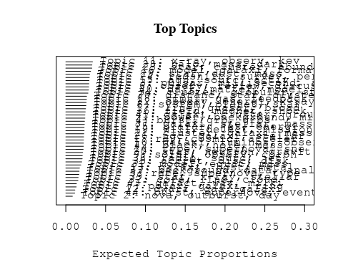

# Print the top 10 labels for each topic  
topic_labels <- labelTopics(Research_topics, n=10)  
print(topic_labels)

## Topic 1 Top Words:  
## Highest Prob: ray, cosmic, acceler, energi, gamma, galact, diffus, particl, extragalact, observ   
## FREX: ray, gamma, acceler, cosmic, cosmic-ray, propag, extragalact, diffus, snr, proton   
## Lift: crs, ghirlanda, cosmic-ray, knee, eev, pamela, positron, pev, ray, ultra-high   
## Score: ray, gamma, acceler, cosmic, gamma-ray, cosmic-ray, extragalact, propag, γray, neutrino   
## Topic 2 Top Words:  
## Highest Prob: nova, outburst, day, observ, phase, bright, emiss, maximum, declin, oph   
## FREX: nova, outburst, oph, day, declin, cyg, lightcurv, month, maximum, recurr   
## Lift: con, nova, oph, cyg, lightcurv, began, monoton, recurr, preexist, outburst   
## Score: nova, outburst, con, oph, cyg, day, xrt, lightcurv, declin, month   
## Topic 3 Top Words:  
## Highest Prob: pulsar, millisecond, accret, system, star, binari, period, orbit, psr, companion   
## FREX: millisecond, pulsar, psr, puls, companion, spin, period, sax, spin-, xte   
## Lift: overflow, roch, millisecond, rotation-pow, san, spun, porb, pulsar, psr, xte   
## Score: pulsar, millisecond, psr, puls, orbit, companion, accret, neutron, spin-, roch   
## Topic 4 Top Words:  
## Highest Prob: burst, grb, grbs, gamma-ray, afterglow, correl, emiss, prompt, x-ray, light   
## FREX: afterglow, grbs, grb, burst, prompt, gamma-ray, swift, correl, curv, break   
## Lift: re-analysi, optimist, firebal, bats, afterglow, engin, prompt, grbs, grb, burst   
## Score: grb, grbs, afterglow, burst, gamma-ray, swift, prompt, curv, re-analysi, engin   
## Topic 5 Top Words:  
## Highest Prob: rate, supernova, type, progenitor, sne, mass, galaxi, limit, time, imag   
## FREX: progenitor, core-collaps, sne, type, rate, ii-p, supernova, hst, hubbl, ibc   
## Lift: pre-explos, osservatorio, ii-p, snia, magnetit, core-collaps, lock, ibc, progenitor, herschel   
## Score: sne, progenitor, supernova, ii-p, osservatorio, type, core-collaps, ibc, pre-explos, rate   
## Topic 6 Top Words:  
## Highest Prob: observ, review, discuss, theoret, process, evolut, recent, physic, properti, understand   
## FREX: review, understand, theoret, progress, aspect, experiment, question, focus, summar, key   
## Lift: pwne, special, experiment, progress, review, held, focuss, aspect, technic, effort   
## Score: review, progress, pwne, chemic, experiment, theoret, understand, focus, astrophys, perspect   
## Topic 7 Top Words:  
## Highest Prob: polar, galaxi, ring, angl, studi, observ, field, peculiar, simul, structur   
## FREX: ring, polar, angl, maser, mirror, -axi, peculiar, deflect, goal, alma   
## Lift: school, mirror, -axi, ring, degrad, maser, deflect, polar, jwst, orthogon   
## Score: polar, ring, maser, angl, school, -axi, alma, mirror, deflect, astronomi   
## Topic 8 Top Words:  
## Highest Prob: system, planet, star, planetari, orbit, binari, exoplanet, format, solar, observ   
## FREX: planet, exoplanet, bodi, planetesim, planetari, asteroid, system, extrasolar, composit, element   
## Lift: articl, hamburgeso, planet, rocki, extrasolar, planetesim, mantl, exoplanet, neutron-captur, sun-lik   
## Score: planet, exoplanet, planetari, planetesim, articl, asteroid, orbit, bodi, sun-lik, binari   
## Topic 9 Top Words:  
## Highest Prob: solar, observ, coron, magnet, event, heat, line, cme, eject, corona   
## FREX: cme, coron, loop, solar, cmes, coronagraph, sun, chromospher, cycl, corona   
## Lift: access, cmes, coronagraph, uvc, interplanetari, lasco, reconnect, soho, white-light, cme   
## Score: coron, cme, cmes, solar, access, loop, coronagraph, chromospher, corona, magnet   
## Topic 10 Top Words:  
## Highest Prob: galaxi, luminos, observ, densiti, dwarf, deep, popul, redshift, format, bright   
## FREX: color, deep, passiv, star-form, lsb, blue, strip, red, dwarf, surfac   
## Lift: field-north, kab, lsb, inher, faint-end, realiti, locus, des, field-south, schechter   
## Score: galaxi, lsb, passiv, dwarf, star-form, color, blue, luminos, redshift, field-south   
## Topic 11 Top Words:  
## Highest Prob: x-ray, observ, kev, spectrum, spectral, sourc, soft, variabl, emiss, model   
## FREX: compton, soft, kev, igr, hard, reflect, variabl, blackbodi, xmm-newton, xmm–newton   
## Lift: asca, reflector, xmm–newton, quasi-simultan, broadband, cut-, torus, compton, cyclotron, soft   
## Score: kev, x-ray, igr, soft, compton, xmm–newton, reflector, blackbodi, hard, outburst   
## Topic 12 Top Words:  
## Highest Prob: dwarf, gas, galaxi, star, white, cool, format, mass, massiv, form   
## FREX: white, dwarf, billion, cool, bulg, see, gas, brown, gobetti, year   
## Lift: gobetti, white, billion, brown, submillimet, switch, paradox, truncat, chaotic, disturb   
## Score: dwarf, gobetti, gas, white, bulg, cool, billion, galaxi, format, brown   
## Topic 13 Top Words:  
## Highest Prob: galaxi, host, metal, star, mass, relat, massiv, format, ulx, sfr   
## FREX: ulx, sfr, host, high-redshift, metal, bhs, pop, ultralumin, dot, ultra-lumin   
## Lift: ultra-lumin, ulx, super-eddington, pop, sfr, m-circl, dot, alpha, harbor, low-metal   
## Score: ulx, metal, sfr, ultra-lumin, bhs, galaxi, host, ultralumin, pop, ulirg   
## Topic 14 Top Words:  
## Highest Prob: type, supernova, sne, light, observ, spectra, curv, mass, ejecta, explos   
## FREX: sne, ejecta, hypernova, iip, explos, curv, late-tim, yr-, light, type   
## Lift: csm, stripped-envelop, iip, hypernova, caii, radioact, halpha, late-tim, nebular, circl   
## Score: sne, iip, hypernova, ejecta, supernova, csm, explos, stripped-envelop, progenitor, curv   
## Topic 15 Top Words:  
## Highest Prob: agn, sourc, activ, galaxi, object, x-ray, sampl, galact, optic, luminos   
## FREX: agn, ulirg, infrar, seyfert, obscur, nuclei, starburst, activ, absorb, ultralumin   
## Lift: superlumin, xmm―newton, unidentifi, micron, agn, ulirg, buri, liner, obscur, low-ion   
## Score: agn, ulirg, seyfert, superlumin, starburst, buri, obscur, activ, nuclei, ultralumin   
## Topic 16 Top Words:  
## Highest Prob: model, galaxi, format, evolut, star, observ, predict, stellar, function, mass   
## FREX: imf, reproduc, predict, starburst, evolut, sed, chemic, model, function, histori   
## Lift: thin, top-heavi, imf, grasil, sam, neighbourhood, salpet, dust-obscur, neighborhood, spectrophotometr   
## Score: thin, imf, galaxi, format, starburst, chemic, metal, sed, star, function   
## Topic 17 Top Words:  
## Highest Prob: line, quasar, broad, optic, emiss, region, sourc, ratio, high, compon   
## FREX: quasar, broad, line, blr, broad-lin, radio-quiet, width, qsos, radio-loud, eigenvector   
## Lift: eigenvector, fwhm, palma, reverber, blr, civ, quasar, notion, radio-quiet, broad   
## Score: quasar, line, broad, blr, radio-quiet, eigenvector, radio-loud, fwhm, broad-lin, qsos   
## Topic 18 Top Words:  
## Highest Prob: simul, gas, feedback, medium, galaxi, cool, hydrodynam, wind, observ, differ   
## FREX: feedback, hydrodynam, simul, medium, intergalact, conduct, igm, cool, wind, baryon   
## Lift: gadget-, multiphas, igm, lya, self-regul, entropi, feedback, forest, hydrodynam, protogalaxi   
## Score: feedback, simul, gas, hydrodynam, igm, agn, cool, enrich, medium, wind   
## Topic 19 Top Words:  
## Highest Prob: will, detect, mission, space, observ, astrophys, search, instrument, wave, detector   
## FREX: mission, ariel, multi-messeng, detector, next, instrument, will, gravitational-wav, scientif, search   
## Lift: antenna, multi-messeng, usepackageamsmath, theme, ariel, agenc, gravitational-wav, esa, usepackageamsfont, usepackageamssymb   
## Score: ariel, mission, multi-messeng, detector, wave, exoplanetari, scientif, theme, interferomet, will   
## Topic 20 Top Words:  
## Highest Prob: star, neutron, gravit, wave, frequenc, oscil, magnetar, popul, background, detect   
## FREX: neutron, oscil, magnetar, qpos, wave, quark, gravit, isol, frequenc, qpo   
## Lift: qpos, quark, strang, qpo, khz, quasi-period, neutron, endow, super, oscil   
## Score: neutron, strang, magnetar, quark, wave, star, qpos, gravit, oscil, qpo   
## Topic 21 Top Words:  
## Highest Prob: cluster, galaxi, mass, x-ray, lens, icm, relat, observ, temperatur, effect   
## FREX: icm, lens, cluster, intraclust, caustic, outskirt, temperatur, rich, virial, weak   
## Lift: lesson, icm, sunyaev-zeldovich, intra-clust, caustic, lens, stack, bend, intraclust, len   
## Score: cluster, lens, icm, intraclust, caustic, x-ray, galaxi, virial, mass, lesson   
## Topic 22 Top Words:  
## Highest Prob: observ, energi, x-ray, flux, flare, emiss, time, gamma-ray, sourc, kev   
## FREX: magic, flare, sgr, repeat, flux, swift, long-term, gev, crab, kev   
## Lift: stat, magic, stereoscop, vhe, markarian, phase-coher, crab, axp, hump, sgrs   
## Score: magic, flare, gamma-ray, sgr, swift, kev, tev, crab, stat, gev   
## Topic 23 Top Words:  
## Highest Prob: star, cluster, abund, metal, stellar, giant, ngc, age, branch, popul   
## FREX: branch, isochron, feh, abund, giant, dex, sequenc, metal-poor, age, evolutionari   
## Lift: isochron, subgiant, nirspec, sgb, overshoot, teff, eff, librari, terzan, intermediate-ag   
## Score: branch, metal, globular, cluster, ngc, abund, isochron, feh, metal-poor, giant   
## Topic 24 Top Words:  
## Highest Prob: redshift, survey, per, galaxi, cent, use, sampl, estim, distribut, luminos   
## FREX: cent, catalogu, count, survey, per, redshift, sdss, digit, photometr, reliabl   
## Lift: union, neural, world, train, cosmos, mid-infrar, mine, two-point, count, visual   
## Score: redshift, survey, photometr, cent, sdss, catalogu, union, digit, sloan, galaxi   
## Topic 25 Top Words:  
## Highest Prob: blazar, jet, energi, lac, spectral, object, distribut, emiss, fermi, model   
## FREX: blazar, lac, fermi, sed, lat, jet, tev, synchrotron, fsrqs, emit   
## Lift: fsrqs, fermilarg, y-ray, self-compton, γ‐ray, lat, lac, blazar, pks, fermi   
## Score: blazar, lac, jet, tev, fermi, lat, y-ray, sed, fsrqs, synchrotron   
## Topic 26 Top Words:  
## Highest Prob: ngc, galaxi, stellar, gas, observ, detect, ellipt, central, nuclear, present   
## FREX: ngc, nucleus, nuclear, ellipt, chandra, kinemat, spiral, camera, hst, central   
## Lift: line-strength, modal, ursa, spike, faintest, lmxbs, bidimension, decomposit, inact, fuel   
## Score: ngc, nucleus, galaxi, ellipt, line-strength, gas, spiral, lmxbs, chandra, nuclear   
## Topic 27 Top Words:  
## Highest Prob: power, background, microwav, cosmic, cmb, spectrum, primordi, anisotropi, non-gaussian, data   
## FREX: cmb, non-gaussian, microwav, anisotropi, primordi, wmap, cross-correl, power, fluctuat, gaussian   
## Lift: boomerang, fnl, bispectrum, flight, non-gaussian, cmb, wilkinson, wmap, -year, microwav   
## Score: cmb, microwav, non-gaussian, wmap, anisotropi, background, fnl, primordi, flight, boomerang   
## Topic 28 Top Words:  
## Highest Prob: halo, mass, dark, matter, galaxi, profil, densiti, model, distribut, satellit   
## FREX: halo, dark, matter, profil, n-bodi, radii, dsphs, satellit, subhalo, baryon   
## Lift: noncircular, subhalo, cuspi, dsphs, nfw, halo, galaxy-s, navarro-frenk-whit, n-bodi, contract   
## Score: halo, dark, noncircular, profil, matter, subhalo, virial, n-bodi, dsphs, mass   
## Topic 29 Top Words:  
## Highest Prob: star, dust, mass, abund, metal, agb, stellar, model, evolut, grain   
## FREX: agb, grain, asymptot, dust, nucleosynthesi, yield, envelop, mix, burn, lithium   
## Lift: super-agb, hydrostat, lithium, agb, grain, asymptot, amorph, nucleosynthesi, s-process, bottom   
## Score: agb, grain, dust, metal, branch, asymptot, abund, s-process, star, chemic   
## Topic 30 Top Words:  
## Highest Prob: distanc, star, cluster, use, age, magnitud, mag, relat, data, deriv   
## FREX: lyra, mag, distanc, parallax, absolut, clump, calibr, modulus, hipparco, pulsat   
## Lift: lyr, first-overton, moduli, parallax, zahb, zero-point, fundamental-mod, oosterhoff, period-luminos, trigonometr   
## Score: lyra, mag, hipparco, parallax, modulus, pulsat, clump, cluster, absolut, globular   
## Topic 31 Top Words:  
## Highest Prob: model, equat, mass, analyt, numer, use, state, system, effect, relativist   
## FREX: equat, analyt, glitch, numer, solut, precess, code, invers, state, stabil   
## Lift: glitch, drag, crust, trajectori, precess, equat, microphys, jump, analyt, stabil   
## Score: glitch, equat, pulsar, relativist, analyt, precess, state, numer, solut, code   
## Topic 32 Top Words:  
## Highest Prob: core, line, cloud, nebula, veloc, planetari, observ, telescop, found, lmc   
## FREX: pns, nebula, lmc, planetari, cloud, smc, spectrograph, pne, core, virgo   
## Lift: pne, pns, smc, trail, leo, lmc, cloudi, nebula, spectrograph, subclust   
## Score: pns, nebula, lmc, smc, planetari, pne, cloud, magellan, line, virgo   
## Topic 33 Top Words:  
## Highest Prob: background, data, analysi, use, telescop, spectral, imag, result, sky, measur   
## FREX: visibl, map, altitud, background, athena, applic, algorithm, sky, cherenkov, night   
## Lift: athena, pixel, altitud, epic, softwar, x-ray-emit, sodium, water, subtract, unexpect   
## Score: athena, background, altitud, cherenkov, map, pixel, sky, night, epic, hemispher   
## Topic 34 Top Words:  
## Highest Prob: cluster, globular, star, popul, dynam, observ, system, orbit, stellar, tidal   
## FREX: globular, tidal, blue, disrupt, helium, dynam, cluster, horizont, straggler, gcs   
## Lift: subsystem, bss, bsss, king, subpopul, disrupt, straggler, sagittarius, globular, hstwfpc   
## Score: globular, cluster, subsystem, bss, tidal, orbit, blue, straggler, bsss, disrupt   
## Topic 35 Top Words:  
## Highest Prob: accret, disc, disk, rate, mass, gas, flow, momentum, luminos, angular   
## FREX: disc, accret, momentum, flow, disk, instabl, angular, corona, pressur, inner   
## Lift: adaf, viscous, non-spher, fluoresc, fountain, bondi, consensus, inward, viscos, variant   
## Score: accret, disc, momentum, disk, adaf, flow, corona, angular, protostellar, gas   
## Topic 36 Top Words:  
## Highest Prob: field, magnet, shock, emiss, electron, particl, turbul, energi, acceler, strength   
## FREX: magnet, turbul, electron, shock, field, strength, magnetohydrodynam, synchrotron, particl, shell   
## Lift: reacceler, upstream, dynamo, turbul, magnetohydrodynam, mach, magnet, alfven, mhd, shock   
## Score: magnet, shock, turbul, electron, field, particl, acceler, synchrotron, magnetohydrodynam, upstream   
## Topic 37 Top Words:  
## Highest Prob: galaxi, stellar, mass, etg, early-typ, format, massiv, age, popul, star   
## FREX: etg, early-typ, gradient, assembl, age, colour, size, compact, gyr, variat   
## Lift: dri, etg, spider, monolith, waveband, sersic, inside-, early-typ, tilt, enlarg   
## Score: etg, early-typ, galaxi, dri, gradient, stellar, age, assembl, metal, spider   
## Topic 38 Top Words:  
## Highest Prob: radio, sourc, jet, emiss, galaxi, show, observ, structur, ghz, relativist   
## FREX: radio, ghz, radio-loud, jet, relic, unresolv, sourc, array, microquasar, vla   
## Lift: steep-spectrum, egret, vlba, fanaroff-riley, mji, radio, milliarcsecond, dichotomi, microquasar, parsec-scal   
## Score: radio, jet, ghz, sourc, radio-loud, relic, relativist, egret, vla, lobe   
## Topic 39 Top Words:  
## Highest Prob: star, x-ray, stellar, activ, observ, young, transient, abund, plasma, supergi   
## FREX: supergi, transient, young, orion, high-mass, plasma, fast, modul, monitor, chandra   
## Lift: coup, aci, lxlbol, ultradeep, tauri, pre-main-sequ, orion, grate, supergi, satur   
## Score: orion, lxlbol, supergi, x-ray, coron, tauri, transient, star, coup, igr   
## Topic 40 Top Words:  
## Highest Prob: dark, matter, model, cosmolog, energi, particl, neutrino, reioniz, paramet, graviti   
## FREX: reioniz, dark, graviti, neutrino, matter, cdm, cosmolog, annihil, quantum, constraint   
## Lift: axion-lik, steril, reioniz, annihil, cdm, quantum, self-interact, violat, scalar, antimatt   
## Score: dark, neutrino, steril, reioniz, cosmolog, matter, cdm, particl, quantum, annihil   
## Topic 41 Top Words:  
## Highest Prob: galaxi, cluster, group, mass, morpholog, fraction, redshift, infal, environ, sampl   
## FREX: group, infal, morpholog, dsc, fraction, cluster, environ, catalog, member, distant   
## Lift: clustercentr, dsc, galaxy-clust, morphology-dens, membership, group, bcg, wing, infal, mass-limit   
## Score: cluster, dsc, galaxi, group, infal, morpholog, redshift, mass, virial, wing   
## Topic 42 Top Words:  
## Highest Prob: black, hole, mass, binari, massiv, merger, supermass, accret, galaxi, time   
## FREX: black, hole, supermass, coalesc, smbhs, binari, mbh, bhs, merger, dual   
## Lift: loudest, smbh, dual, black, hole, supermass, coalesc, smbhs, pathway, mbh   
## Score: black, hole, binari, supermass, smbhs, dual, bhs, coalesc, merger, mbh   
## Topic 43 Top Words:  
## Highest Prob: galact, way, milki, univers, centr, itali, format, star, scienc, physic   
## FREX: itali, milki, institut, scienc, way, bologna, centr, warp, depart, astronomi   
## Lift: astronomia, dipartimento, fisica, garch, institut, istituto, inaf, bologna, nazional, itali   
## Score: itali, institut, milki, bologna, warp, fisica, scienc, garch, depart, astronomi   
## Topic 44 Top Words:  
## Highest Prob: burst, supernova, event, grb, star, associ, grbs, observ, gamma-ray, detect   
## FREX: grb, burst, grbs, explos, short, γray, associ, explod, link, event   
## Lift: long-dur, hitherto, explod, know, enigmat, ref, flash, death, arriv, long-last   
## Score: grb, grbs, burst, long-dur, supernova, gamma-ray, γray, explos, progenitor, explod

# Match the processed documents with the original titles  
matched_titles <- out_text$meta$original_concatenated_title_abstract  
  
# Print top 5 documents for each topic  
top_docs <- findThoughts(Research_topics, texts = matched_titles, n = 5)$docs[[1]]  
print(top_docs)

## [1] "Origin of Galactic Cosmic Rays Abstract The origin of the bulk of cosmic rays (CRs) observed at Earth is the topic of a century long investigation, paved with successes and failures. From the energetic point of view, supernova remnants (SNRs) remain the most plausible sources of CRs up to rigidity ∼ 10 6 – 10 7 GV . This confidence somehow resulted in the construction of a paradigm, the so-called SNR paradigm: CRs are accelerated through diffusive shock acceleration in SNRs and propagate diffusively in the Galaxy in an energy dependent way. Qualitative confirmation of the SNR acceleration scenario has recently been provided by gamma ray and X-ray observations. Diffusive propagation in the Galaxy is probed observationally through measurement of the secondary to primary nuclei flux ratios (such as B/C). There are however some weak points in the paradigm, which suggest that we are probably missing some physical ingredients in our models. The theory of diffusive shock acceleration at SNR shocks predicts spectra of accelerated particles which are systematically too hard compared with the ones inferred from gamma ray observations. Moreover, hard injection spectra indirectly imply a steep energy dependence of the diffusion coefficient in the Galaxy, which in turn leads to anisotropy larger than the observed one. Moreover recent measurements of the flux of nuclei suggest that the spectra have a break at rigidity ∼ 200 GV , which does not sit well with the common wisdom in acceleration and propagation. In this paper I will review these new developments and suggest some possible implications."  
## [2] "Origin of Galactic Cosmic Rays Abstract The origin of the bulk of cosmic rays (CRs) observed at Earth is the topic of a century long investigation, paved with successes and failures. From the energetic point of view, supernova remnants (SNRs) remain the most plausible sources of CRs up to rigidity ∼ 10 6 – 10 7 GV . This confidence somehow resulted in the construction of a paradigm, the so-called SNR paradigm: CRs are accelerated through diffusive shock acceleration in SNRs and propagate diffusively in the Galaxy in an energy dependent way. Qualitative confirmation of the SNR acceleration scenario has recently been provided by gamma ray and X-ray observations. Diffusive propagation in the Galaxy is probed observationally through measurement of the secondary to primary nuclei flux ratios (such as B/C). There are however some weak points in the paradigm, which suggest that we are probably missing some physical ingredients in our models. The theory of diffusive shock acceleration at SNR shocks predicts spectra of accelerated particles which are systematically too hard compared with the ones inferred from gamma ray observations. Moreover, hard injection spectra indirectly imply a steep energy dependence of the diffusion coefficient in the Galaxy, which in turn leads to anisotropy larger than the observed one. Moreover recent measurements of the flux of nuclei suggest that the spectra have a break at rigidity ∼ 200 GV , which does not sit well with the common wisdom in acceleration and propagation. In this paper I will review these new developments and suggest some possible implications."  
## [3] "Origin of Galactic Cosmic Rays Abstract The origin of the bulk of cosmic rays (CRs) observed at Earth is the topic of a century long investigation, paved with successes and failures. From the energetic point of view, supernova remnants (SNRs) remain the most plausible sources of CRs up to rigidity ∼ 10 6 – 10 7 GV . This confidence somehow resulted in the construction of a paradigm, the so-called SNR paradigm: CRs are accelerated through diffusive shock acceleration in SNRs and propagate diffusively in the Galaxy in an energy dependent way. Qualitative confirmation of the SNR acceleration scenario has recently been provided by gamma ray and X-ray observations. Diffusive propagation in the Galaxy is probed observationally through measurement of the secondary to primary nuclei flux ratios (such as B/C). There are however some weak points in the paradigm, which suggest that we are probably missing some physical ingredients in our models. The theory of diffusive shock acceleration at SNR shocks predicts spectra of accelerated particles which are systematically too hard compared with the ones inferred from gamma ray observations. Moreover, hard injection spectra indirectly imply a steep energy dependence of the diffusion coefficient in the Galaxy, which in turn leads to anisotropy larger than the observed one. Moreover recent measurements of the flux of nuclei suggest that the spectra have a break at rigidity ∼ 200 GV , which does not sit well with the common wisdom in acceleration and propagation. In this paper I will review these new developments and suggest some possible implications."  
## [4] "Origin of Galactic Cosmic Rays Abstract The origin of the bulk of cosmic rays (CRs) observed at Earth is the topic of a century long investigation, paved with successes and failures. From the energetic point of view, supernova remnants (SNRs) remain the most plausible sources of CRs up to rigidity ∼ 10 6 – 10 7 GV . This confidence somehow resulted in the construction of a paradigm, the so-called SNR paradigm: CRs are accelerated through diffusive shock acceleration in SNRs and propagate diffusively in the Galaxy in an energy dependent way. Qualitative confirmation of the SNR acceleration scenario has recently been provided by gamma ray and X-ray observations. Diffusive propagation in the Galaxy is probed observationally through measurement of the secondary to primary nuclei flux ratios (such as B/C). There are however some weak points in the paradigm, which suggest that we are probably missing some physical ingredients in our models. The theory of diffusive shock acceleration at SNR shocks predicts spectra of accelerated particles which are systematically too hard compared with the ones inferred from gamma ray observations. Moreover, hard injection spectra indirectly imply a steep energy dependence of the diffusion coefficient in the Galaxy, which in turn leads to anisotropy larger than the observed one. Moreover recent measurements of the flux of nuclei suggest that the spectra have a break at rigidity ∼ 200 GV , which does not sit well with the common wisdom in acceleration and propagation. In this paper I will review these new developments and suggest some possible implications."  
## [5] "Ultra-High-Energy Neutrino Scattering onto Relic Light Neutrinos in the Galactic Halo as a Possible Source of the Highest Energy Extragalactic Cosmic Rays The diffuse relic neutrinos with light mass are transparent to Ultrahigh energy (UHE) neutrinos at thousands EeV, born by photoproduction of pions by UHE protons on relic 2.73 K BBR radiation and originated in AGNs at cosmic distances. However these UHE $u$s may interact with those (mainly heaviest $u_{\\mu_r}$, $u_{au_r}$ and respective antineutrinos) clustered into HDM galactic halos. UHE photons or protons, secondaries of $uu_r$ scattering, might be the final observed signature of such high-energy chain reactions and may be responsible of the highest extragalactic cosmic-ray (CR) events. The chain-reactions conversion efficiency, ramifications and energetics are considered for the October 1991 CR event at 320 EeV observed by the Fly's Eye detector in Utah. These quantities seem compatible with the distance, direction and power (observed at MeV gamma energies) of the Seyfert galaxy MCG 8-11-11. The $uu_r$ interaction probability is favoured by at least three order of magnitude with respect to a direct $u$ scattering onto the Earth atmosphere. Therefore, it may better explain the extragalactic origin of the puzzling 320 EeV event, while offering indirect evidence of a hot dark galactic halo of light (i.e., $m_u\\sim$ tens eV) neutrinos, probably of tau flavour."

# Find and plot the key "thoughts" or documents for selected topics  
thoughts6 <- findThoughts(Research_topics, texts = matched_titles, n = 3, topics = 6)$docs[[1]]  
thoughts18 <- findThoughts(Research_topics, texts = matched_titles, n = 3, topics = 18)$docs[[1]]  
par(mfrow = c(1, 2), mar = c(0.5, 0.5, 1, 0.5))  
plotQuote(thoughts6, width = 30, main = "Topic 6")  
plotQuote(thoughts18, width = 30, main = "Topic 18")

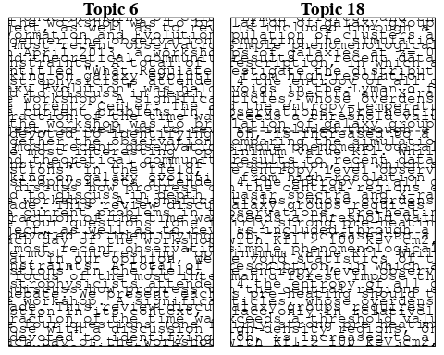

# Calculate and plot the correlation between topics  
mod.out.corr <- topicCorr(Research_topics)  
plot(mod.out.corr, cex = 1.5)  
  
  
# For each topic  
for (topic_num in 1:44) {  
 # Plot the word cloud  
 cloud(Research_topics, topic = topic_num, scale = c(2, 0.25))  
 Sys.sleep(2)  
}

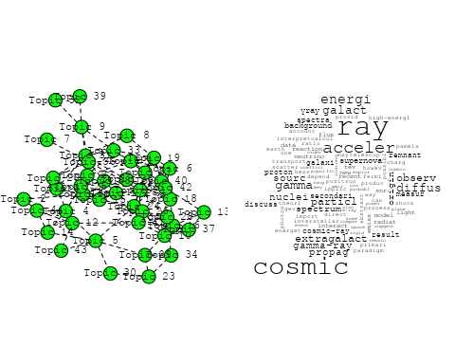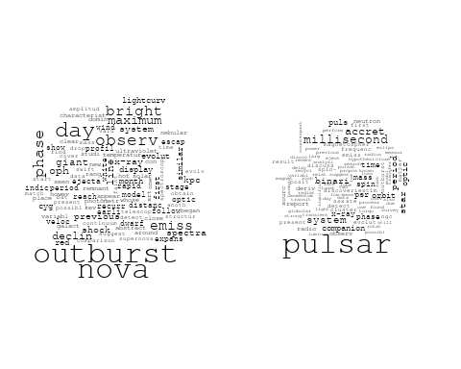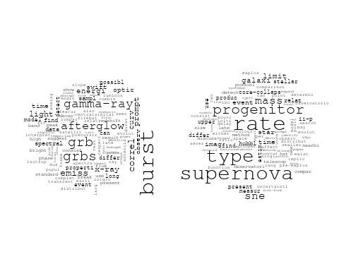

## Warning in wordcloud::wordcloud(words = vocab, freq = vec, max.words =  
## max.words, : process could not be fit on page. It will not be plotted.

## Warning in wordcloud::wordcloud(words = vocab, freq = vec, max.words =  
## max.words, : theoret could not be fit on page. It will not be plotted.

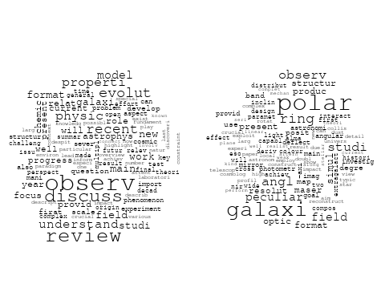

## Warning in wordcloud::wordcloud(words = vocab, freq = vec, max.words =  
## max.words, : planet could not be fit on page. It will not be plotted.

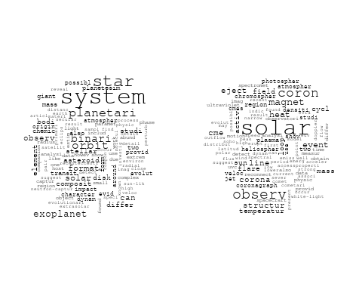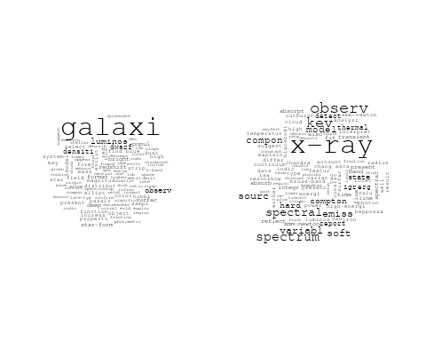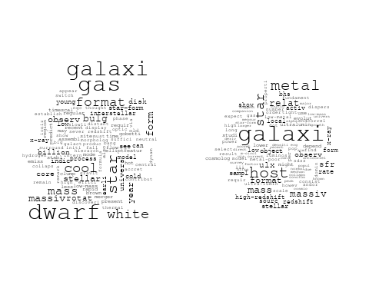

## Warning in wordcloud::wordcloud(words = vocab, freq = vec, max.words =  
## max.words, : observ could not be fit on page. It will not be plotted.

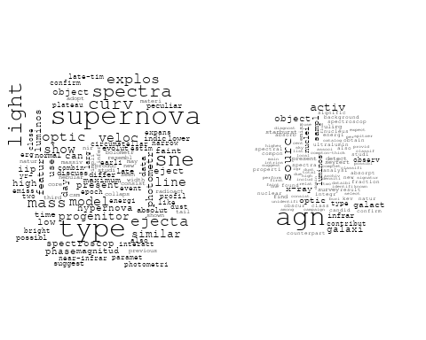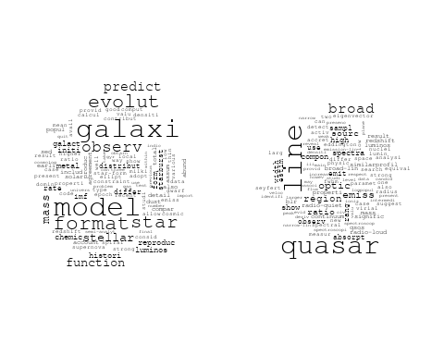

## Warning in wordcloud::wordcloud(words = vocab, freq = vec, max.words =  
## max.words, : astrophys could not be fit on page. It will not be plotted.

## Warning in wordcloud::wordcloud(words = vocab, freq = vec, max.words =  
## max.words, : instrument could not be fit on page. It will not be plotted.

## Warning in wordcloud::wordcloud(words = vocab, freq = vec, max.words =  
## max.words, : exoplanetari could not be fit on page. It will not be plotted.

## Warning in wordcloud::wordcloud(words = vocab, freq = vec, max.words =  
## max.words, : interferomet could not be fit on page. It will not be plotted.

## Warning in wordcloud::wordcloud(words = vocab, freq = vec, max.words =  
## max.words, : detect could not be fit on page. It will not be plotted.

## Warning in wordcloud::wordcloud(words = vocab, freq = vec, max.words =  
## max.words, : usepackageamsfont could not be fit on page. It will not be  
## plotted.

## Warning in wordcloud::wordcloud(words = vocab, freq = vec, max.words =  
## max.words, : observatori could not be fit on page. It will not be plotted.

## Warning in wordcloud::wordcloud(words = vocab, freq = vec, max.words =  
## max.words, : contribut could not be fit on page. It will not be plotted.

## Warning in wordcloud::wordcloud(words = vocab, freq = vec, max.words =  
## max.words, : univers could not be fit on page. It will not be plotted.

## Warning in wordcloud::wordcloud(words = vocab, freq = vec, max.words =  
## max.words, : data could not be fit on page. It will not be plotted.

## Warning in wordcloud::wordcloud(words = vocab, freq = vec, max.words =  
## max.words, : sensit could not be fit on page. It will not be plotted.

## Warning in wordcloud::wordcloud(words = vocab, freq = vec, max.words =  
## max.words, : interest could not be fit on page. It will not be plotted.

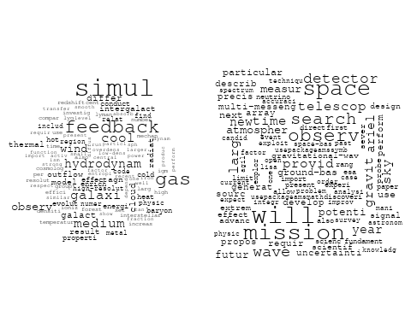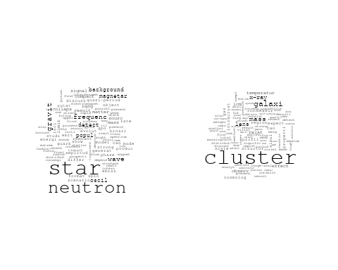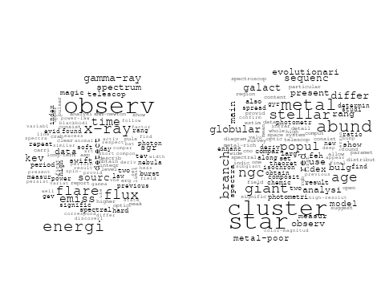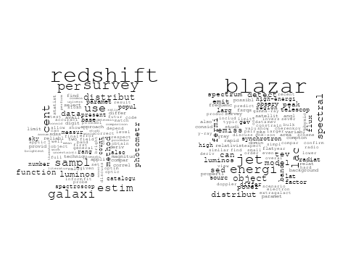

## Warning in wordcloud::wordcloud(words = vocab, freq = vec, max.words =  
## max.words, : spectrum could not be fit on page. It will not be plotted.

## Warning in wordcloud::wordcloud(words = vocab, freq = vec, max.words =  
## max.words, : cosmolog could not be fit on page. It will not be plotted.

## Warning in wordcloud::wordcloud(words = vocab, freq = vec, max.words =  
## max.words, : microwav could not be fit on page. It will not be plotted.

## Warning in wordcloud::wordcloud(words = vocab, freq = vec, max.words =  
## max.words, : constraint could not be fit on page. It will not be plotted.

## Warning in wordcloud::wordcloud(words = vocab, freq = vec, max.words =  
## max.words, : large-scal could not be fit on page. It will not be plotted.

## Warning in wordcloud::wordcloud(words = vocab, freq = vec, max.words =  
## max.words, : function could not be fit on page. It will not be plotted.

## Warning in wordcloud::wordcloud(words = vocab, freq = vec, max.words =  
## max.words, : measur could not be fit on page. It will not be plotted.

## Warning in wordcloud::wordcloud(words = vocab, freq = vec, max.words =  
## max.words, : peak could not be fit on page. It will not be plotted.

## Warning in wordcloud::wordcloud(words = vocab, freq = vec, max.words =  
## max.words, : standard could not be fit on page. It will not be plotted.

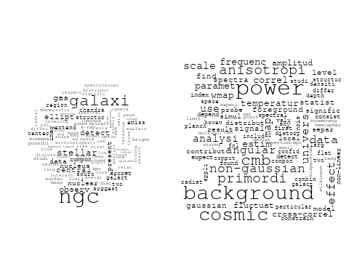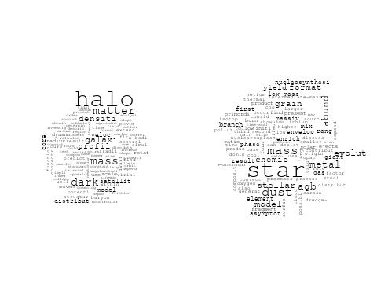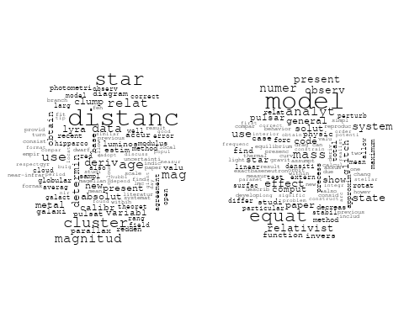

## Warning in wordcloud::wordcloud(words = vocab, freq = vec, max.words =  
## max.words, : planetari could not be fit on page. It will not be plotted.

## Warning in wordcloud::wordcloud(words = vocab, freq = vec, max.words =  
## max.words, : analysi could not be fit on page. It will not be plotted.

## Warning in wordcloud::wordcloud(words = vocab, freq = vec, max.words =  
## max.words, : result could not be fit on page. It will not be plotted.

## Warning in wordcloud::wordcloud(words = vocab, freq = vec, max.words =  
## max.words, : data could not be fit on page. It will not be plotted.

## Warning in wordcloud::wordcloud(words = vocab, freq = vec, max.words =  
## max.words, : spectral could not be fit on page. It will not be plotted.

## Warning in wordcloud::wordcloud(words = vocab, freq = vec, max.words =  
## max.words, : measur could not be fit on page. It will not be plotted.

## Warning in wordcloud::wordcloud(words = vocab, freq = vec, max.words =  
## max.words, : satellit could not be fit on page. It will not be plotted.

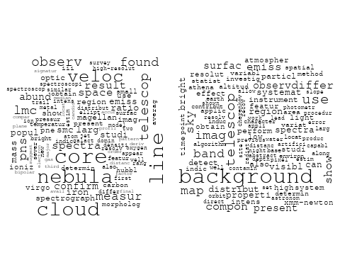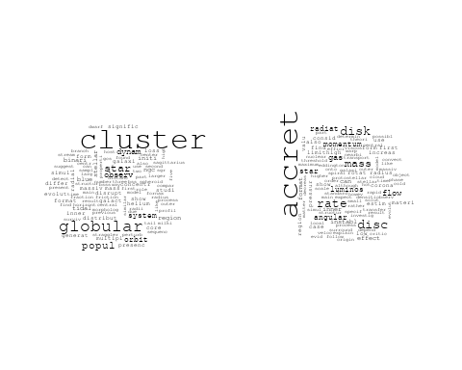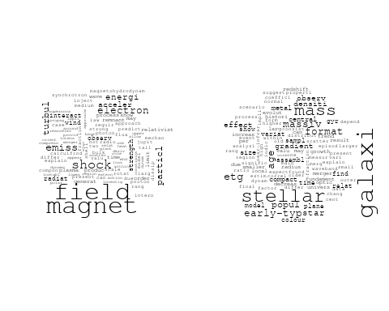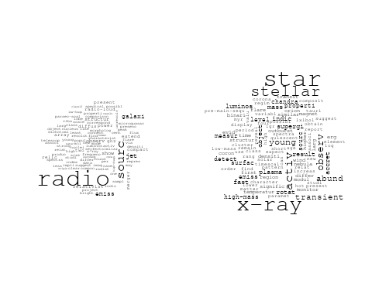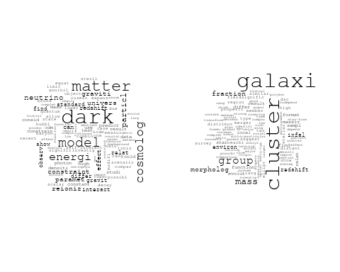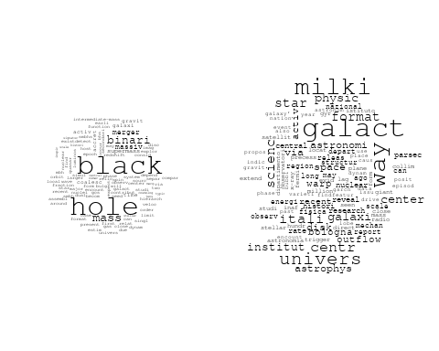

# Get the topic proportions for each document  
topic_proportions <- Research_topics$theta  
  
# Find the index of the topic with the highest proportion for each document  
# This will be the topic that each document is most likely to belong to  
max_topic_idx <- apply(topic_proportions, 1, which.max)  
  
# Add this as a new column to your data  
data_collab$topic <- max_topic_idx  
  
library(ggplot2)  
  
# Define the intervals  
intervals <- c('1824_1899', '1900_1964', '1965_1974', '1975_1984', '1985_1994', '1995_1999', '2000_2004', '2005_2009', '2010_2014', '2015_2019', '2020_2022')  
colors <- c('pink', 'blue', 'purple', 'yellow', 'green', 'pink', 'orange', 'violet', 'green', 'blue', 'pink')  
  
# Loop through the intervals and plot  
for(i in seq_along(intervals)){  
 # Filter data for when the pub_interval is equal to 1  
 data_filtered <- data_collab[data_collab[[paste0('pub_interval_', intervals[i])]] == 1,]  
   
 # Make the histogram  
   
 p <- ggplot(data_filtered, aes(x = topic)) +  
 geom_histogram(binwidth = 1, fill = colors[i], color = "black") +  
 xlab("Topic") +  
 ylab("Count") +  
 ggtitle(paste0("Topics from year ", gsub("_", " to ", intervals[i])))  
   
 print(p)  
}  
  
  
##Topic generation for IT (independent) publications  
  
data_independent <- data[data[["IT"]] == 100,]  
  
# Save the original title data for future use  
data_independent$original_concatenated_title_abstract <- data_independent$concatenated_title_abstract  
  
#pre-processing the titles using textProcessor from the stm package  
processed_text <- textProcessor(data_independent$concatenated_title_abstract, metadata = data_independent)

## Building corpus...   
## Converting to Lower Case...   
## Removing punctuation...   
## Removing stopwords...   
## Removing numbers...   
## Stemming...   
## Creating Output...

# Further prepare the data by removing low-frequency terms  
out_text <- prepDocuments(processed_text$documents, processed_text$vocab, processed_text$meta)

## Removing 1836 of 7455 terms (1836 of 126902 tokens) due to frequency   
## Your corpus now has 1504 documents, 5619 terms and 125066 tokens.

docs_text <- out_text$documents  
vocab_text <- out_text$vocab  
meta_text <- out_text$meta  
  
  
#Prepare data  
plotRemoved(processed_text$documents, lower.thresh = seq(1, 200, by = 100))

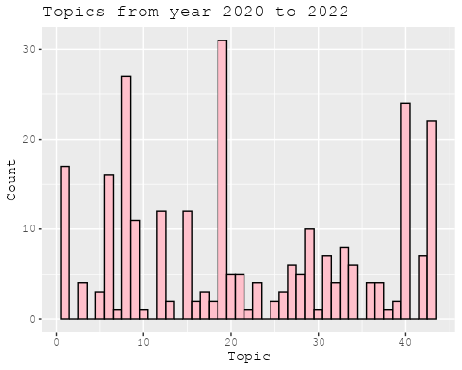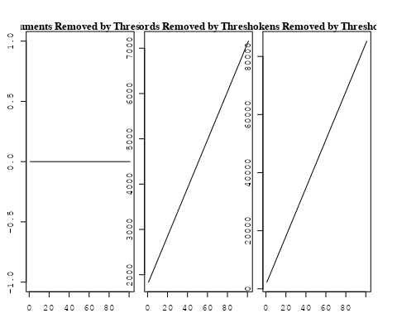

out_text <- prepDocuments(processed_text$documents, processed_text$vocab, processed_text$meta, lower.thresh = 8)

## Removing 5597 of 7455 terms (14537 of 126902 tokens) due to frequency   
## Your corpus now has 1504 documents, 1858 terms and 112365 tokens.

str(out_text$meta)

## 'data.frame': 1504 obs. of 39 variables:  
## $ concept_id : chr "https://openalex.org/C1276947" "https://openalex.org/C44870925" "https://openalex.org/C44870925" "https://openalex.org/C1276947" ...  
## $ work_id : chr "https://openalex.org/W2068317303" "https://openalex.org/W3106208106" "https://openalex.org/W3098398835" "https://openalex.org/W1998494018" ...  
## $ publication_year : int 2004 1999 2001 1990 2008 2008 2005 2004 2010 1996 ...  
## $ title : chr "Arp 299: A Second Merging System with Two Active Nuclei?" "The distribution of absorbing column densities among Seyfert 2 galaxies" "An efficient photoelectric X-ray Polarimeter for the study of Black Holes and Neutron Stars" "Clues on the Hot Star Content and the Ultraviolet Output of Elliptical Galaxies" ...  
## $ paperabstract : chr "Recent BeppoSAX observations of Arp 299, a powerful far-IR merging starburst system composed of IC 694 and NGC "| __truncated__ "We use hard X-ray data for an \"optimal\" sample of Seyfert 2 galaxies to derive the distribution of the gaseou"| __truncated__ "The study of astronomical objects using electromagnetic radiation involves four basic observational approaches:"| __truncated__ "Les galaxies elliptiques emettent un flux significatif de rayonnement aux longueurs d'onde au-dessous d'environ"| __truncated__ ...  
## $ country : chr "IT IT IT IT" "IT" "IT IT" "IT IT" ...  
## $ year_concept : chr "2004+https://openalex.org/C1276947" "1999+https://openalex.org/C44870925" "2001+https://openalex.org/C44870925" "1990+https://openalex.org/C1276947" ...  
## $ concatenated_title_abstract : chr "Arp 299: A Second Merging System with Two Active Nuclei? Recent BeppoSAX observations of Arp 299, a powerful fa"| __truncated__ "The distribution of absorbing column densities among Seyfert 2 galaxies We use hard X-ray data for an \"optimal"| __truncated__ "An efficient photoelectric X-ray Polarimeter for the study of Black Holes and Neutron Stars The study of astron"| __truncated__ "Clues on the Hot Star Content and the Ultraviolet Output of Elliptical Galaxies Les galaxies elliptiques emette"| __truncated__ ...  
## $ US : num 0 0 0 0 0 0 0 0 0 0 ...  
## $ IN : num 0 0 0 0 0 0 0 0 0 0 ...  
## $ DE : num 0 0 0 0 0 0 0 0 0 0 ...  
## $ CH : num 0 0 0 0 0 0 0 0 0 0 ...  
## $ GB : num 0 0 0 0 0 0 0 0 0 0 ...  
## $ CN : num 0 0 0 0 0 0 0 0 0 0 ...  
## $ FR : num 0 0 0 0 0 0 0 0 0 0 ...  
## $ IT : num 100 100 100 100 100 100 100 100 100 100 ...  
## $ RU : num 0 0 0 0 0 0 0 0 0 0 ...  
## $ CA : num 0 0 0 0 0 0 0 0 0 0 ...  
## $ NL : num 0 0 0 0 0 0 0 0 0 0 ...  
## $ AU : num 0 0 0 0 0 0 0 0 0 0 ...  
## $ JP : num 0 0 0 0 0 0 0 0 0 0 ...  
## $ ES : num 0 0 0 0 0 0 0 0 0 0 ...  
## $ IL : num 0 0 0 0 0 0 0 0 0 0 ...  
## $ Americas : num 0 0 0 0 0 0 0 0 0 0 ...  
## $ Europe : num 0 0 0 0 0 0 0 0 0 0 ...  
## $ Africa : num 0 0 0 0 0 0 0 0 0 0 ...  
## $ AsiaAndOceania : num 0 0 0 0 0 0 0 0 0 0 ...  
## $ pub_interval_2020_2022 : int 0 0 0 0 0 0 0 0 0 0 ...  
## $ pub_interval_2015_2019 : int 0 0 0 0 0 0 0 0 0 0 ...  
## $ pub_interval_2010_2014 : int 0 0 0 0 0 0 0 0 1 0 ...  
## $ pub_interval_2005_2009 : int 0 0 0 0 1 1 1 0 0 0 ...  
## $ pub_interval_2000_2004 : int 1 0 1 0 0 0 0 1 0 0 ...  
## $ pub_interval_1995_1999 : int 0 1 0 0 0 0 0 0 0 1 ...  
## $ pub_interval_1985_1994 : int 0 0 0 1 0 0 0 0 0 0 ...  
## $ pub_interval_1975_1984 : int 0 0 0 0 0 0 0 0 0 0 ...  
## $ pub_interval_1965_1974 : int 0 0 0 0 0 0 0 0 0 0 ...  
## $ pub_interval_1900_1964 : int 0 0 0 0 0 0 0 0 0 0 ...  
## $ pub_interval_1824_1899 : int 0 0 0 0 0 0 0 0 0 0 ...  
## $ original_concatenated_title_abstract: chr "Arp 299: A Second Merging System with Two Active Nuclei? Recent BeppoSAX observations of Arp 299, a powerful fa"| __truncated__ "The distribution of absorbing column densities among Seyfert 2 galaxies We use hard X-ray data for an \"optimal"| __truncated__ "An efficient photoelectric X-ray Polarimeter for the study of Black Holes and Neutron Stars The study of astron"| __truncated__ "Clues on the Hot Star Content and the Ultraviolet Output of Elliptical Galaxies Les galaxies elliptiques emette"| __truncated__ ...

# Initialize an empty formula string  
prevalence_formula_str <- "~"  
  
# Define the publication intervals  
pub_intervals <- c("pub_interval_2020_2022", "pub_interval_2015_2019", "pub_interval_2010_2014",   
 "pub_interval_2005_2009", "pub_interval_2000_2004", "pub_interval_1995_1999",  
 "pub_interval_1985_1994", "pub_interval_1975_1984", "pub_interval_1965_1974",  
 "pub_interval_1900_1964", "pub_interval_1824_1899")  
  
# Add each publication interval to the formula string  
for (interval in pub_intervals) {  
 # add an if statement to handle the first addition (without '+')  
 if (prevalence_formula_str == "~") {  
 prevalence_formula_str <- paste(prevalence_formula_str, interval)  
 } else {  
 prevalence_formula_str <- paste(prevalence_formula_str, "+", interval)  
 }  
}  
  
  
# Convert the string to a formula  
prevalence_formula <- as.formula(prevalence_formula_str)  
print(prevalence_formula)

## ~pub_interval_2020_2022 + pub_interval_2015_2019 + pub_interval_2010_2014 +   
## pub_interval_2005_2009 + pub_interval_2000_2004 + pub_interval_1995_1999 +   
## pub_interval_1985_1994 + pub_interval_1975_1984 + pub_interval_1965_1974 +   
## pub_interval_1900_1964 + pub_interval_1824_1899

# Run STM model  
Research_topics <- stm(documents = out_text$documents,   
 vocab = out_text$vocab,   
 K = 44,   
 prevalence = prevalence_formula,   
 data = out_text$meta,   
 init.type = "Spectral",  
 max.em.its = 1000,  
 gamma.prior = 'L1')

## Beginning Spectral Initialization   
## Calculating the gram matrix...  
## Finding anchor words...  
## ............................................  
## Recovering initialization...  
## ..................  
## Initialization complete.  
## ....................................................................................................  
## Completed E-Step (1 seconds).   
## Completed M-Step.   
## Completing Iteration 1 (approx. per word bound = -6.313)   
## ....................................................................................................  
## Completed E-Step (1 seconds).   
## Completed M-Step.   
## Completing Iteration 2 (approx. per word bound = -6.052, relative change = 4.134e-02)   
## ....................................................................................................  
## Completed E-Step (1 seconds).   
## Completed M-Step.   
## Completing Iteration 3 (approx. per word bound = -5.973, relative change = 1.318e-02)   
## ....................................................................................................  
## Completed E-Step (1 seconds).   
## Completed M-Step.   
## Completing Iteration 4 (approx. per word bound = -5.938, relative change = 5.792e-03)   
## ....................................................................................................  
## Completed E-Step (1 seconds).   
## Completed M-Step.   
## Completing Iteration 5 (approx. per word bound = -5.919, relative change = 3.213e-03)   
## Topic 1: space, telescop, type, supernova, observatori   
## Topic 2: spectra, light, line, constraint, veloc   
## Topic 3: univers, microwav, via, background, white   
## Topic 4: field, magnet, x-ray, see, magnetar   
## Topic 5: cluster, galaxi, properti, environ, group   
## Topic 6: solar, way, radio, present, merger   
## Topic 7: observ, pulsar, x-ray, model, glitch   
## Topic 8: agn, observ, contribut, galaxi, x-ray   
## Topic 9: data, survey, luminos, perform, new   
## Topic 10: star, abund, chemic, yield, element   
## Topic 11: kev, sourc, x-ray, observ, gamma-ray   
## Topic 12: observ, solar, flare, coron, activ   
## Topic 13: background, contribut, result, cosmic, xmm-newton   
## Topic 14: star, metal, observ, model, estim   
## Topic 15: hole, black, binari, merger, cluster   
## Topic 16: radio, object, sourc, emiss, detect   
## Topic 17: system, orbit, accret, star, evolut   
## Topic 18: galaxi, stellar, mass, etg, format   
## Topic 19: gravit, wave, star, popul, background   
## Topic 20: galaxi, dwarf, ngc, cluster, observ   
## Topic 21: star, mass, neutron, accret, phase   
## Topic 22: gas, simul, hot, cold, observ   
## Topic 23: mass, galaxi, black, hole, function   
## Topic 24: ray, observ, cosmic, acceler, origin   
## Topic 25: radiat, shock, emiss, particl, energi   
## Topic 26: dust, mass, metal, star, grain   
## Topic 27: data, analysi, use, estim, observ   
## Topic 28: burst, energi, gamma-ray, emiss, x-ray   
## Topic 29: pulsar, optic, star, psr, emiss   
## Topic 30: cluster, age, sequenc, ngc, stellar   
## Topic 31: dark, matter, model, energi, cosmolog   
## Topic 32: jet, sourc, radio, blazar, luminos   
## Topic 33: galaxi, redshift, mass, densiti, function   
## Topic 34: x-ray, metal, galaxi, star, relat   
## Topic 35: new, code, model, present, version   
## Topic 36: cluster, globular, star, format, popul   
## Topic 37: halo, dark, mass, matter, model   
## Topic 38: hole, black, observ, quasar, mass   
## Topic 39: accret, x-ray, time, observ, sourc   
## Topic 40: galaxi, format, star, model, agn   
## Topic 41: distanc, cluster, age, use, relat   
## Topic 42: grbs, burst, correl, grb, gamma-ray   
## Topic 43: model, simul, cosmolog, star, differ   
## Topic 44: nova, galact, maximum, declin, evolut   
## ....................................................................................................  
## Completed E-Step (1 seconds).   
## Completed M-Step.   
## Completing Iteration 6 (approx. per word bound = -5.906, relative change = 2.121e-03)   
## ....................................................................................................  
## Completed E-Step (1 seconds).   
## Completed M-Step.   
## Completing Iteration 7 (approx. per word bound = -5.898, relative change = 1.407e-03)   
## ....................................................................................................  
## Completed E-Step (1 seconds).   
## Completed M-Step.   
## Completing Iteration 8 (approx. per word bound = -5.892, relative change = 1.019e-03)   
## ....................................................................................................  
## Completed E-Step (1 seconds).   
## Completed M-Step.   
## Completing Iteration 9 (approx. per word bound = -5.888, relative change = 7.611e-04)   
## ....................................................................................................  
## Completed E-Step (1 seconds).   
## Completed M-Step.   
## Completing Iteration 10 (approx. per word bound = -5.884, relative change = 6.142e-04)   
## Topic 1: space, telescop, supernova, type, imag   
## Topic 2: spectra, line, light, veloc, power   
## Topic 3: univers, background, microwav, white, itali   
## Topic 4: field, magnet, x-ray, see, magnetar   
## Topic 5: cluster, galaxi, properti, environ, group   
## Topic 6: radio, merger, cluster, present, region   
## Topic 7: observ, pulsar, x-ray, star, model   
## Topic 8: agn, observ, contribut, infrar, galaxi   
## Topic 9: data, perform, luminos, survey, new   
## Topic 10: star, abund, chemic, element, yield   
## Topic 11: kev, sourc, x-ray, observ, gamma-ray   
## Topic 12: observ, solar, activ, coron, flare   
## Topic 13: background, result, xmm-newton, contribut, analysi   
## Topic 14: star, metal, model, observ, rang   
## Topic 15: hole, black, binari, pulsar, cluster   
## Topic 16: radio, sourc, object, limit, emiss   
## Topic 17: system, orbit, star, accret, evolut   
## Topic 18: galaxi, stellar, mass, etg, format   
## Topic 19: gravit, wave, star, popul, background   
## Topic 20: galaxi, dwarf, ngc, cluster, observ   
## Topic 21: star, mass, neutron, accret, evolut   
## Topic 22: gas, hot, simul, cold, cool   
## Topic 23: mass, galaxi, black, hole, accret   
## Topic 24: ray, cosmic, observ, acceler, will   
## Topic 25: shock, particl, radiat, emiss, electron   
## Topic 26: dust, mass, metal, grain, star   
## Topic 27: data, analysi, use, cmb, level   
## Topic 28: burst, energi, gamma-ray, x-ray, time   
## Topic 29: pulsar, optic, star, x-ray, emiss   
## Topic 30: cluster, age, sequenc, ngc, stellar   
## Topic 31: dark, matter, model, cosmolog, energi   
## Topic 32: sourc, jet, radio, blazar, luminos   
## Topic 33: galaxi, redshift, mass, function, densiti   
## Topic 34: x-ray, galaxi, metal, star, relat   
## Topic 35: new, model, code, present, comput   
## Topic 36: cluster, globular, star, format, popul   
## Topic 37: halo, dark, mass, matter, model   
## Topic 38: hole, black, observ, quasar, mass   
## Topic 39: accret, x-ray, sourc, observ, pulsar   
## Topic 40: galaxi, format, star, model, activ   
## Topic 41: distanc, cluster, age, relat, use   
## Topic 42: grbs, burst, correl, grb, gamma-ray   
## Topic 43: simul, model, star, cosmolog, format   
## Topic 44: nova, galact, declin, maximum, evolut   
## ....................................................................................................  
## Completed E-Step (1 seconds).   
## Completed M-Step.   
## Completing Iteration 11 (approx. per word bound = -5.881, relative change = 5.649e-04)   
## ....................................................................................................  
## Completed E-Step (1 seconds).   
## Completed M-Step.   
## Completing Iteration 12 (approx. per word bound = -5.878, relative change = 4.662e-04)   
## ....................................................................................................  
## Completed E-Step (1 seconds).   
## Completed M-Step.   
## Completing Iteration 13 (approx. per word bound = -5.876, relative change = 3.530e-04)   
## ....................................................................................................  
## Completed E-Step (1 seconds).   
## Completed M-Step.   
## Completing Iteration 14 (approx. per word bound = -5.874, relative change = 3.116e-04)   
## ....................................................................................................  
## Completed E-Step (1 seconds).   
## Completed M-Step.   
## Completing Iteration 15 (approx. per word bound = -5.872, relative change = 2.732e-04)   
## Topic 1: space, telescop, supernova, imag, hubbl   
## Topic 2: spectra, line, light, veloc, atmospher   
## Topic 3: univers, background, microwav, itali, white   
## Topic 4: field, magnet, x-ray, rotat, neutron   
## Topic 5: cluster, galaxi, properti, environ, icm   
## Topic 6: radio, merger, cluster, present, region   
## Topic 7: observ, pulsar, x-ray, star, model   
## Topic 8: agn, activ, contribut, observ, luminos   
## Topic 9: data, perform, survey, new, luminos   
## Topic 10: star, abund, chemic, element, metal   
## Topic 11: kev, sourc, x-ray, observ, gamma-ray   
## Topic 12: observ, solar, activ, coron, jet   
## Topic 13: background, result, xmm-newton, contribut, analysi   
## Topic 14: star, metal, model, observ, rang   
## Topic 15: hole, black, binari, pulsar, cluster   
## Topic 16: radio, sourc, object, emiss, limit   
## Topic 17: system, orbit, planet, star, evolut   
## Topic 18: galaxi, stellar, mass, etg, format   
## Topic 19: gravit, wave, star, popul, background   
## Topic 20: galaxi, dwarf, ngc, cluster, observ   
## Topic 21: star, mass, neutron, accret, evolut   
## Topic 22: gas, hot, simul, cold, observ   
## Topic 23: mass, galaxi, black, hole, accret   
## Topic 24: ray, cosmic, observ, acceler, will   
## Topic 25: particl, radiat, shock, emiss, electron   
## Topic 26: dust, mass, metal, grain, star   
## Topic 27: data, analysi, cmb, use, level   
## Topic 28: burst, energi, gamma-ray, x-ray, time   
## Topic 29: pulsar, optic, star, x-ray, psr   
## Topic 30: cluster, age, ngc, sequenc, main   
## Topic 31: dark, matter, model, energi, cosmolog   
## Topic 32: jet, sourc, radio, blazar, luminos   
## Topic 33: galaxi, redshift, mass, function, densiti   
## Topic 34: x-ray, galaxi, metal, star, relat   
## Topic 35: new, model, code, present, comput   
## Topic 36: cluster, globular, star, format, popul   
## Topic 37: halo, dark, mass, matter, profil   
## Topic 38: hole, black, observ, quasar, variabl   
## Topic 39: x-ray, accret, sourc, pulsar, observ   
## Topic 40: galaxi, format, star, model, evolut   
## Topic 41: distanc, cluster, age, relat, deriv   
## Topic 42: grbs, correl, burst, grb, gamma-ray   
## Topic 43: simul, model, star, cosmolog, format   
## Topic 44: nova, galact, star, declin, evolut   
## ....................................................................................................  
## Completed E-Step (1 seconds).   
## Completed M-Step.   
## Completing Iteration 16 (approx. per word bound = -5.871, relative change = 2.615e-04)   
## ....................................................................................................  
## Completed E-Step (1 seconds).   
## Completed M-Step.   
## Completing Iteration 17 (approx. per word bound = -5.869, relative change = 2.374e-04)   
## ....................................................................................................  
## Completed E-Step (1 seconds).   
## Completed M-Step.   
## Completing Iteration 18 (approx. per word bound = -5.868, relative change = 2.050e-04)   
## ....................................................................................................  
## Completed E-Step (1 seconds).   
## Completed M-Step.   
## Completing Iteration 19 (approx. per word bound = -5.867, relative change = 1.777e-04)   
## ....................................................................................................  
## Completed E-Step (1 seconds).   
## Completed M-Step.   
## Completing Iteration 20 (approx. per word bound = -5.866, relative change = 1.564e-04)   
## Topic 1: space, telescop, supernova, hubbl, imag   
## Topic 2: spectra, line, light, atmospher, observ   
## Topic 3: univers, background, microwav, itali, cosmic   
## Topic 4: field, magnet, x-ray, rotat, neutron   
## Topic 5: cluster, galaxi, properti, environ, icm   
## Topic 6: radio, merger, cluster, region, halo   
## Topic 7: observ, pulsar, x-ray, star, model   
## Topic 8: agn, activ, sampl, luminos, galaxi   
## Topic 9: data, perform, survey, new, satellit   
## Topic 10: star, abund, chemic, element, metal   
## Topic 11: kev, sourc, x-ray, observ, gamma-ray   
## Topic 12: observ, solar, activ, coron, jet   
## Topic 13: background, result, contribut, xmm-newton, analysi   
## Topic 14: star, metal, model, observ, pulsat   
## Topic 15: hole, black, binari, pulsar, cluster   
## Topic 16: radio, sourc, object, emiss, limit   
## Topic 17: system, orbit, planet, star, evolut   
## Topic 18: galaxi, stellar, mass, etg, format   
## Topic 19: gravit, wave, star, popul, background   
## Topic 20: galaxi, dwarf, ngc, cluster, structur   
## Topic 21: star, mass, neutron, accret, evolut   
## Topic 22: gas, hot, simul, cold, observ   
## Topic 23: mass, galaxi, black, hole, accret   
## Topic 24: ray, cosmic, observ, acceler, will   
## Topic 25: particl, radiat, shock, electron, emiss   
## Topic 26: dust, mass, grain, metal, star   
## Topic 27: data, analysi, cmb, use, measur   
## Topic 28: burst, energi, gamma-ray, x-ray, time   
## Topic 29: pulsar, optic, star, x-ray, psr   
## Topic 30: cluster, age, ngc, sequenc, main   
## Topic 31: dark, matter, model, energi, cosmolog   
## Topic 32: jet, sourc, radio, blazar, luminos   
## Topic 33: galaxi, redshift, mass, function, evolut   
## Topic 34: x-ray, galaxi, metal, relat, star   
## Topic 35: new, model, code, present, comput   
## Topic 36: cluster, globular, star, format, popul   
## Topic 37: halo, dark, mass, matter, profil   
## Topic 38: hole, black, observ, quasar, variabl   
## Topic 39: x-ray, accret, sourc, pulsar, observ   
## Topic 40: galaxi, format, star, model, evolut   
## Topic 41: distanc, cluster, age, relat, deriv   
## Topic 42: grbs, correl, burst, grb, gamma-ray   
## Topic 43: simul, model, star, cosmolog, format   
## Topic 44: nova, star, galact, declin, evolut   
## ....................................................................................................  
## Completed E-Step (1 seconds).   
## Completed M-Step.   
## Completing Iteration 21 (approx. per word bound = -5.865, relative change = 1.556e-04)   
## ....................................................................................................  
## Completed E-Step (1 seconds).   
## Completed M-Step.   
## Completing Iteration 22 (approx. per word bound = -5.865, relative change = 1.498e-04)   
## ....................................................................................................  
## Completed E-Step (1 seconds).   
## Completed M-Step.   
## Completing Iteration 23 (approx. per word bound = -5.864, relative change = 1.450e-04)   
## ....................................................................................................  
## Completed E-Step (1 seconds).   
## Completed M-Step.   
## Completing Iteration 24 (approx. per word bound = -5.863, relative change = 1.194e-04)   
## ....................................................................................................  
## Completed E-Step (1 seconds).   
## Completed M-Step.   
## Completing Iteration 25 (approx. per word bound = -5.862, relative change = 1.161e-04)   
## Topic 1: space, telescop, hubbl, supernova, imag   
## Topic 2: spectra, line, light, atmospher, observ   
## Topic 3: univers, background, microwav, itali, cosmic   
## Topic 4: field, magnet, x-ray, rotat, neutron   
## Topic 5: cluster, galaxi, properti, environ, icm   
## Topic 6: merger, radio, cluster, region, halo   
## Topic 7: observ, pulsar, x-ray, star, glitch   
## Topic 8: agn, activ, sampl, galaxi, luminos   
## Topic 9: data, perform, satellit, survey, new   
## Topic 10: star, abund, chemic, metal, element   
## Topic 11: kev, sourc, x-ray, observ, gamma-ray   
## Topic 12: observ, solar, activ, coron, jet   
## Topic 13: background, result, contribut, xmm-newton, analysi   
## Topic 14: star, metal, model, observ, pulsat   
## Topic 15: hole, black, binari, pulsar, cluster   
## Topic 16: radio, sourc, object, emiss, limit   
## Topic 17: system, orbit, planet, star, evolut   
## Topic 18: galaxi, stellar, mass, etg, format   
## Topic 19: gravit, wave, star, popul, background   
## Topic 20: galaxi, dwarf, ngc, cluster, structur   
## Topic 21: star, mass, neutron, accret, evolut   
## Topic 22: gas, hot, simul, cold, observ   
## Topic 23: mass, galaxi, black, hole, accret   
## Topic 24: ray, cosmic, observ, acceler, will   
## Topic 25: particl, radiat, shock, electron, emiss   
## Topic 26: dust, mass, grain, metal, star   
## Topic 27: data, analysi, cmb, use, measur   
## Topic 28: burst, gamma-ray, x-ray, energi, time   
## Topic 29: pulsar, optic, star, x-ray, psr   
## Topic 30: cluster, age, ngc, sequenc, present   
## Topic 31: dark, matter, model, energi, cosmolog   
## Topic 32: jet, sourc, blazar, radio, luminos   
## Topic 33: galaxi, redshift, mass, function, evolut   
## Topic 34: x-ray, galaxi, metal, relat, star   
## Topic 35: new, model, present, code, comput   
## Topic 36: cluster, globular, star, format, popul   
## Topic 37: halo, dark, mass, matter, profil   
## Topic 38: hole, black, observ, quasar, variabl   
## Topic 39: x-ray, accret, sourc, pulsar, observ   
## Topic 40: galaxi, format, star, model, evolut   
## Topic 41: distanc, cluster, age, relat, deriv   
## Topic 42: grbs, correl, burst, grb, gamma-ray   
## Topic 43: simul, model, star, cosmolog, format   
## Topic 44: nova, star, galact, declin, maximum   
## ....................................................................................................  
## Completed E-Step (1 seconds).   
## Completed M-Step.   
## Completing Iteration 26 (approx. per word bound = -5.862, relative change = 1.044e-04)   
## ....................................................................................................  
## Completed E-Step (1 seconds).   
## Completed M-Step.   
## Completing Iteration 27 (approx. per word bound = -5.861, relative change = 8.621e-05)   
## ....................................................................................................  
## Completed E-Step (1 seconds).   
## Completed M-Step.   
## Completing Iteration 28 (approx. per word bound = -5.861, relative change = 7.921e-05)   
## ....................................................................................................  
## Completed E-Step (1 seconds).   
## Completed M-Step.   
## Completing Iteration 29 (approx. per word bound = -5.860, relative change = 8.265e-05)   
## ....................................................................................................  
## Completed E-Step (1 seconds).   
## Completed M-Step.   
## Completing Iteration 30 (approx. per word bound = -5.860, relative change = 8.069e-05)   
## Topic 1: space, telescop, hubbl, imag, supernova   
## Topic 2: spectra, line, light, atmospher, observ   
## Topic 3: univers, background, microwav, cosmic, itali   
## Topic 4: field, magnet, x-ray, neutron, rotat   
## Topic 5: cluster, galaxi, properti, environ, icm   
## Topic 6: merger, radio, cluster, region, halo   
## Topic 7: observ, pulsar, star, x-ray, glitch   
## Topic 8: agn, activ, sampl, galaxi, luminos   
## Topic 9: data, satellit, perform, survey, test   
## Topic 10: star, abund, chemic, metal, element   
## Topic 11: kev, x-ray, sourc, observ, gamma-ray   
## Topic 12: observ, solar, activ, coron, jet   
## Topic 13: background, result, contribut, xmm-newton, analysi   
## Topic 14: star, metal, model, observ, stellar   
## Topic 15: hole, black, binari, pulsar, cluster   
## Topic 16: radio, sourc, object, emiss, limit   
## Topic 17: system, orbit, planet, star, evolut   
## Topic 18: galaxi, stellar, mass, etg, format   
## Topic 19: gravit, wave, star, popul, background   
## Topic 20: galaxi, dwarf, ngc, cluster, structur   
## Topic 21: star, mass, accret, neutron, evolut   
## Topic 22: gas, hot, simul, cold, observ   
## Topic 23: mass, galaxi, black, hole, accret   
## Topic 24: ray, cosmic, observ, acceler, will   
## Topic 25: shock, particl, radiat, electron, emiss   
## Topic 26: dust, mass, grain, metal, star   
## Topic 27: data, analysi, cmb, use, measur   
## Topic 28: burst, gamma-ray, x-ray, energi, time   
## Topic 29: pulsar, optic, star, x-ray, psr   
## Topic 30: cluster, age, ngc, sequenc, present   
## Topic 31: dark, matter, model, energi, cosmolog   
## Topic 32: jet, sourc, blazar, radio, line   
## Topic 33: galaxi, redshift, mass, function, evolut   
## Topic 34: x-ray, galaxi, metal, relat, star   
## Topic 35: new, model, present, code, comput   
## Topic 36: cluster, globular, star, format, popul   
## Topic 37: halo, dark, mass, profil, matter   
## Topic 38: hole, black, observ, quasar, variabl   
## Topic 39: x-ray, accret, sourc, pulsar, observ   
## Topic 40: galaxi, format, star, model, evolut   
## Topic 41: distanc, cluster, age, relat, deriv   
## Topic 42: grbs, correl, burst, grb, gamma-ray   
## Topic 43: simul, model, star, cosmolog, format   
## Topic 44: nova, star, galact, maximum, evolut   
## ....................................................................................................  
## Completed E-Step (1 seconds).   
## Completed M-Step.   
## Completing Iteration 31 (approx. per word bound = -5.859, relative change = 8.469e-05)   
## ....................................................................................................  
## Completed E-Step (1 seconds).   
## Completed M-Step.   
## Completing Iteration 32 (approx. per word bound = -5.859, relative change = 8.928e-05)   
## ....................................................................................................  
## Completed E-Step (1 seconds).   
## Completed M-Step.   
## Completing Iteration 33 (approx. per word bound = -5.858, relative change = 8.392e-05)   
## ....................................................................................................  
## Completed E-Step (1 seconds).   
## Completed M-Step.   
## Completing Iteration 34 (approx. per word bound = -5.858, relative change = 7.854e-05)   
## ....................................................................................................  
## Completed E-Step (1 seconds).   
## Completed M-Step.   
## Completing Iteration 35 (approx. per word bound = -5.857, relative change = 8.133e-05)   
## Topic 1: space, telescop, hubbl, imag, supernova   
## Topic 2: spectra, light, line, atmospher, observ   
## Topic 3: univers, background, microwav, cosmic, itali   
## Topic 4: field, magnet, x-ray, neutron, rotat   
## Topic 5: cluster, galaxi, properti, environ, icm   
## Topic 6: merger, radio, cluster, region, halo   
## Topic 7: observ, pulsar, star, x-ray, neutron   
## Topic 8: agn, activ, sampl, galaxi, luminos   
## Topic 9: data, satellit, perform, survey, test   
## Topic 10: star, abund, chemic, metal, element   
## Topic 11: kev, x-ray, sourc, observ, spectrum   
## Topic 12: observ, solar, activ, coron, jet   
## Topic 13: background, result, contribut, xmm-newton, analysi   
## Topic 14: star, metal, model, observ, stellar   
## Topic 15: hole, black, binari, pulsar, cluster   
## Topic 16: radio, sourc, object, emiss, limit   
## Topic 17: system, orbit, planet, star, evolut   
## Topic 18: galaxi, stellar, mass, etg, format   
## Topic 19: gravit, star, wave, popul, background   
## Topic 20: galaxi, dwarf, ngc, cluster, structur   
## Topic 21: star, mass, accret, evolut, phase   
## Topic 22: gas, hot, simul, cold, observ   
## Topic 23: mass, galaxi, black, hole, accret   
## Topic 24: ray, cosmic, observ, acceler, will   
## Topic 25: shock, particl, radiat, electron, emiss   
## Topic 26: dust, mass, grain, metal, star   
## Topic 27: data, analysi, cmb, use, measur   
## Topic 28: burst, gamma-ray, x-ray, energi, time   
## Topic 29: pulsar, optic, star, x-ray, psr   
## Topic 30: cluster, age, ngc, sequenc, present   
## Topic 31: dark, matter, model, energi, cosmolog   
## Topic 32: jet, blazar, sourc, radio, line   
## Topic 33: galaxi, redshift, mass, function, evolut   
## Topic 34: x-ray, galaxi, metal, relat, star   
## Topic 35: new, present, model, code, comput   
## Topic 36: cluster, globular, star, format, popul   
## Topic 37: halo, dark, profil, mass, matter   
## Topic 38: hole, black, observ, quasar, variabl   
## Topic 39: x-ray, accret, sourc, pulsar, observ   
## Topic 40: galaxi, format, star, model, evolut   
## Topic 41: distanc, cluster, age, relat, deriv   
## Topic 42: grbs, correl, burst, grb, use   
## Topic 43: simul, model, star, cosmolog, format   
## Topic 44: nova, star, galact, maximum, evolut   
## ....................................................................................................  
## Completed E-Step (1 seconds).   
## Completed M-Step.   
## Completing Iteration 36 (approx. per word bound = -5.857, relative change = 8.078e-05)   
## ....................................................................................................  
## Completed E-Step (1 seconds).   
## Completed M-Step.   
## Completing Iteration 37 (approx. per word bound = -5.856, relative change = 7.529e-05)   
## ....................................................................................................  
## Completed E-Step (1 seconds).   
## Completed M-Step.   
## Completing Iteration 38 (approx. per word bound = -5.856, relative change = 6.761e-05)   
## ....................................................................................................  
## Completed E-Step (1 seconds).   
## Completed M-Step.   
## Completing Iteration 39 (approx. per word bound = -5.856, relative change = 6.879e-05)   
## ....................................................................................................  
## Completed E-Step (1 seconds).   
## Completed M-Step.   
## Completing Iteration 40 (approx. per word bound = -5.855, relative change = 6.832e-05)   
## Topic 1: space, telescop, hubbl, imag, supernova   
## Topic 2: spectra, light, line, atmospher, observ   
## Topic 3: univers, background, microwav, cosmic, itali   
## Topic 4: field, magnet, x-ray, neutron, rotat   
## Topic 5: cluster, galaxi, properti, environ, icm   
## Topic 6: merger, radio, cluster, region, halo   
## Topic 7: observ, pulsar, star, x-ray, neutron   
## Topic 8: agn, activ, sampl, galaxi, luminos   
## Topic 9: satellit, data, perform, survey, qso   
## Topic 10: star, abund, chemic, metal, element   
## Topic 11: kev, x-ray, sourc, observ, spectrum   
## Topic 12: observ, solar, activ, coron, jet   
## Topic 13: background, result, contribut, xmm-newton, analysi   
## Topic 14: star, metal, model, stellar, observ   
## Topic 15: hole, black, binari, pulsar, cluster   
## Topic 16: radio, sourc, emiss, limit, object   
## Topic 17: system, orbit, planet, star, evolut   
## Topic 18: galaxi, stellar, mass, etg, format   
## Topic 19: gravit, star, wave, popul, background   
## Topic 20: galaxi, dwarf, ngc, cluster, structur   
## Topic 21: star, mass, accret, evolut, phase   
## Topic 22: gas, hot, simul, cold, observ   
## Topic 23: mass, galaxi, black, hole, accret   
## Topic 24: ray, cosmic, observ, acceler, will   
## Topic 25: shock, particl, radiat, electron, emiss   
## Topic 26: dust, mass, grain, metal, star   
## Topic 27: data, analysi, cmb, use, measur   
## Topic 28: burst, gamma-ray, x-ray, time, energi   
## Topic 29: pulsar, optic, star, x-ray, psr   
## Topic 30: cluster, age, ngc, sequenc, present   
## Topic 31: dark, matter, model, energi, cosmolog   
## Topic 32: jet, blazar, sourc, radio, line   
## Topic 33: galaxi, redshift, mass, function, distribut   
## Topic 34: x-ray, galaxi, metal, relat, star   
## Topic 35: new, present, model, code, comput   
## Topic 36: cluster, globular, star, format, popul   
## Topic 37: halo, dark, profil, mass, matter   
## Topic 38: hole, black, observ, quasar, variabl   
## Topic 39: x-ray, accret, sourc, pulsar, observ   
## Topic 40: galaxi, format, star, model, evolut   
## Topic 41: distanc, cluster, age, relat, deriv   
## Topic 42: grbs, correl, burst, grb, use   
## Topic 43: simul, model, star, cosmolog, format   
## Topic 44: nova, star, galact, maximum, evolut   
## ....................................................................................................  
## Completed E-Step (0 seconds).   
## Completed M-Step.   
## Completing Iteration 41 (approx. per word bound = -5.855, relative change = 6.560e-05)   
## ....................................................................................................  
## Completed E-Step (0 seconds).   
## Completed M-Step.   
## Completing Iteration 42 (approx. per word bound = -5.855, relative change = 4.394e-05)   
## ....................................................................................................  
## Completed E-Step (0 seconds).   
## Completed M-Step.   
## Completing Iteration 43 (approx. per word bound = -5.854, relative change = 8.787e-05)   
## ....................................................................................................  
## Completed E-Step (1 seconds).   
## Completed M-Step.   
## Completing Iteration 44 (approx. per word bound = -5.854, relative change = 5.645e-05)   
## ....................................................................................................  
## Completed E-Step (0 seconds).   
## Completed M-Step.   
## Completing Iteration 45 (approx. per word bound = -5.853, relative change = 6.218e-05)   
## Topic 1: space, telescop, hubbl, imag, supernova   
## Topic 2: spectra, light, line, atmospher, observ   
## Topic 3: univers, background, microwav, cosmic, itali   
## Topic 4: field, magnet, x-ray, neutron, rotat   
## Topic 5: cluster, galaxi, properti, environ, icm   
## Topic 6: merger, radio, cluster, region, halo   
## Topic 7: observ, pulsar, star, x-ray, neutron   
## Topic 8: agn, activ, sampl, galaxi, luminos   
## Topic 9: satellit, data, perform, survey, qso   
## Topic 10: star, abund, chemic, metal, element   
## Topic 11: kev, x-ray, sourc, observ, spectrum   
## Topic 12: observ, solar, activ, coron, jet   
## Topic 13: background, result, contribut, xmm-newton, analysi   
## Topic 14: star, metal, model, stellar, observ   
## Topic 15: hole, black, binari, pulsar, cluster   
## Topic 16: radio, sourc, emiss, limit, object   
## Topic 17: system, orbit, planet, star, evolut   
## Topic 18: galaxi, stellar, mass, etg, format   
## Topic 19: gravit, star, wave, popul, background   
## Topic 20: galaxi, dwarf, ngc, cluster, structur   
## Topic 21: star, mass, accret, evolut, phase   
## Topic 22: gas, hot, simul, observ, cold   
## Topic 23: mass, galaxi, black, hole, accret   
## Topic 24: ray, cosmic, observ, acceler, will   
## Topic 25: shock, particl, radiat, electron, emiss   
## Topic 26: dust, mass, grain, metal, star   
## Topic 27: data, analysi, cmb, use, measur   
## Topic 28: burst, gamma-ray, x-ray, time, energi   
## Topic 29: pulsar, optic, star, x-ray, psr   
## Topic 30: cluster, age, ngc, sequenc, present   
## Topic 31: dark, matter, model, energi, cosmolog   
## Topic 32: jet, blazar, sourc, radio, line   
## Topic 33: galaxi, redshift, mass, function, distribut   
## Topic 34: galaxi, x-ray, metal, relat, star   
## Topic 35: new, present, code, model, astrophys   
## Topic 36: cluster, globular, star, format, popul   
## Topic 37: halo, profil, dark, mass, matter   
## Topic 38: hole, black, observ, quasar, variabl   
## Topic 39: x-ray, accret, pulsar, sourc, observ   
## Topic 40: galaxi, format, star, model, evolut   
## Topic 41: distanc, cluster, age, relat, deriv   
## Topic 42: grbs, correl, burst, grb, use   
## Topic 43: simul, model, star, format, cosmolog   
## Topic 44: nova, star, galact, maximum, evolut   
## ....................................................................................................  
## Completed E-Step (0 seconds).   
## Completed M-Step.   
## Completing Iteration 46 (approx. per word bound = -5.853, relative change = 5.851e-05)   
## ....................................................................................................  
## Completed E-Step (1 seconds).   
## Completed M-Step.   
## Completing Iteration 47 (approx. per word bound = -5.853, relative change = 6.126e-05)   
## ....................................................................................................  
## Completed E-Step (0 seconds).   
## Completed M-Step.   
## Completing Iteration 48 (approx. per word bound = -5.852, relative change = 4.782e-05)   
## ....................................................................................................  
## Completed E-Step (0 seconds).   
## Completed M-Step.   
## Completing Iteration 49 (approx. per word bound = -5.852, relative change = 4.664e-05)   
## ....................................................................................................  
## Completed E-Step (0 seconds).   
## Completed M-Step.   
## Completing Iteration 50 (approx. per word bound = -5.852, relative change = 3.949e-05)   
## Topic 1: space, telescop, hubbl, imag, supernova   
## Topic 2: spectra, light, line, atmospher, observ   
## Topic 3: univers, background, microwav, cosmic, itali   
## Topic 4: field, magnet, x-ray, neutron, rotat   
## Topic 5: cluster, galaxi, properti, environ, icm   
## Topic 6: merger, radio, cluster, region, halo   
## Topic 7: observ, pulsar, star, x-ray, neutron   
## Topic 8: agn, activ, sampl, galaxi, luminos   
## Topic 9: satellit, data, perform, qso, survey   
## Topic 10: star, abund, chemic, metal, element   
## Topic 11: kev, x-ray, sourc, observ, spectrum   
## Topic 12: observ, solar, activ, coron, jet   
## Topic 13: background, result, xmm-newton, contribut, analysi   
## Topic 14: star, metal, model, stellar, observ   
## Topic 15: hole, black, binari, pulsar, cluster   
## Topic 16: radio, sourc, emiss, limit, object   
## Topic 17: system, orbit, planet, star, evolut   
## Topic 18: galaxi, stellar, mass, etg, format   
## Topic 19: gravit, star, wave, popul, background   
## Topic 20: galaxi, dwarf, ngc, cluster, detect   
## Topic 21: star, mass, evolut, accret, phase   
## Topic 22: gas, hot, simul, observ, cold   
## Topic 23: mass, galaxi, black, hole, accret   
## Topic 24: ray, cosmic, observ, acceler, diffus   
## Topic 25: shock, particl, electron, radiat, emiss   
## Topic 26: dust, mass, grain, metal, star   
## Topic 27: data, analysi, cmb, use, measur   
## Topic 28: burst, gamma-ray, x-ray, time, energi   
## Topic 29: pulsar, optic, star, x-ray, psr   
## Topic 30: cluster, age, ngc, sequenc, present   
## Topic 31: dark, matter, model, energi, cosmolog   
## Topic 32: jet, blazar, radio, sourc, line   
## Topic 33: galaxi, redshift, mass, function, distribut   
## Topic 34: galaxi, x-ray, metal, relat, star   
## Topic 35: new, present, code, astrophys, model   
## Topic 36: cluster, globular, star, format, popul   
## Topic 37: halo, profil, dark, mass, matter   
## Topic 38: hole, black, observ, quasar, variabl   
## Topic 39: x-ray, accret, pulsar, sourc, observ   
## Topic 40: galaxi, format, star, model, evolut   
## Topic 41: distanc, cluster, age, relat, deriv   
## Topic 42: grbs, correl, burst, grb, use   
## Topic 43: simul, model, star, format, cosmolog   
## Topic 44: nova, star, galact, maximum, evolut   
## ....................................................................................................  
## Completed E-Step (0 seconds).   
## Completed M-Step.   
## Completing Iteration 51 (approx. per word bound = -5.852, relative change = 3.868e-05)   
## ....................................................................................................  
## Completed E-Step (1 seconds).   
## Completed M-Step.   
## Completing Iteration 52 (approx. per word bound = -5.851, relative change = 2.300e-05)   
## ....................................................................................................  
## Completed E-Step (0 seconds).   
## Completed M-Step.   
## Completing Iteration 53 (approx. per word bound = -5.851, relative change = 3.264e-05)   
## ....................................................................................................  
## Completed E-Step (0 seconds).   
## Completed M-Step.   
## Completing Iteration 54 (approx. per word bound = -5.851, relative change = 3.524e-05)   
## ....................................................................................................  
## Completed E-Step (0 seconds).   
## Completed M-Step.   
## Completing Iteration 55 (approx. per word bound = -5.851, relative change = 3.423e-05)   
## Topic 1: space, telescop, hubbl, imag, supernova   
## Topic 2: spectra, light, line, atmospher, observ   
## Topic 3: univers, background, microwav, cosmic, itali   
## Topic 4: field, magnet, x-ray, neutron, rotat   
## Topic 5: cluster, galaxi, properti, environ, icm   
## Topic 6: merger, radio, cluster, halo, region   
## Topic 7: observ, pulsar, star, x-ray, neutron   
## Topic 8: agn, activ, sampl, galaxi, luminos   
## Topic 9: satellit, data, perform, qso, survey   
## Topic 10: star, abund, chemic, metal, element   
## Topic 11: x-ray, kev, sourc, observ, spectrum   
## Topic 12: observ, solar, activ, coron, jet   
## Topic 13: background, result, xmm-newton, contribut, analysi   
## Topic 14: star, metal, model, stellar, observ   
## Topic 15: hole, black, binari, pulsar, cluster   
## Topic 16: radio, sourc, emiss, limit, object   
## Topic 17: system, orbit, planet, star, evolut   
## Topic 18: galaxi, stellar, mass, etg, format   
## Topic 19: gravit, star, wave, popul, background   
## Topic 20: galaxi, dwarf, ngc, cluster, detect   
## Topic 21: star, mass, evolut, accret, phase   
## Topic 22: gas, hot, simul, observ, cold   
## Topic 23: mass, galaxi, black, hole, accret   
## Topic 24: ray, cosmic, observ, acceler, diffus   
## Topic 25: shock, particl, electron, radiat, emiss   
## Topic 26: dust, mass, grain, metal, star   
## Topic 27: data, analysi, cmb, use, measur   
## Topic 28: burst, gamma-ray, x-ray, time, grb   
## Topic 29: pulsar, optic, star, x-ray, psr   
## Topic 30: cluster, age, ngc, sequenc, present   
## Topic 31: dark, matter, model, energi, cosmolog   
## Topic 32: jet, blazar, radio, sourc, line   
## Topic 33: galaxi, redshift, mass, function, distribut   
## Topic 34: galaxi, x-ray, metal, relat, star   
## Topic 35: new, present, code, astrophys, comput   
## Topic 36: cluster, globular, star, format, popul   
## Topic 37: halo, profil, dark, mass, matter   
## Topic 38: hole, black, observ, quasar, variabl   
## Topic 39: x-ray, accret, pulsar, sourc, observ   
## Topic 40: galaxi, format, star, model, evolut   
## Topic 41: distanc, cluster, age, relat, deriv   
## Topic 42: grbs, correl, burst, grb, use   
## Topic 43: simul, model, star, format, cosmolog   
## Topic 44: nova, star, galact, maximum, evolut   
## ....................................................................................................  
## Completed E-Step (0 seconds).   
## Completed M-Step.   
## Completing Iteration 56 (approx. per word bound = -5.851, relative change = 3.042e-05)   
## ....................................................................................................  
## Completed E-Step (0 seconds).   
## Completed M-Step.   
## Completing Iteration 57 (approx. per word bound = -5.851, relative change = 2.908e-05)   
## ....................................................................................................  
## Completed E-Step (0 seconds).   
## Completed M-Step.   
## Completing Iteration 58 (approx. per word bound = -5.850, relative change = 2.968e-05)   
## ....................................................................................................  
## Completed E-Step (0 seconds).   
## Completed M-Step.   
## Completing Iteration 59 (approx. per word bound = -5.850, relative change = 3.206e-05)   
## ....................................................................................................  
## Completed E-Step (0 seconds).   
## Completed M-Step.   
## Completing Iteration 60 (approx. per word bound = -5.850, relative change = 2.957e-05)   
## Topic 1: space, telescop, hubbl, imag, supernova   
## Topic 2: spectra, light, line, atmospher, observ   
## Topic 3: univers, background, microwav, cosmic, itali   
## Topic 4: field, magnet, x-ray, neutron, rotat   
## Topic 5: cluster, galaxi, properti, environ, icm   
## Topic 6: merger, radio, cluster, halo, region   
## Topic 7: observ, pulsar, star, x-ray, neutron   
## Topic 8: agn, activ, sampl, galaxi, luminos   
## Topic 9: satellit, data, perform, qso, scenario   
## Topic 10: star, chemic, abund, metal, element   
## Topic 11: x-ray, kev, sourc, observ, spectrum   
## Topic 12: observ, solar, activ, coron, jet   
## Topic 13: background, result, xmm-newton, contribut, analysi   
## Topic 14: star, metal, model, stellar, observ   
## Topic 15: hole, black, binari, pulsar, cluster   
## Topic 16: radio, sourc, emiss, limit, object   
## Topic 17: system, orbit, planet, star, evolut   
## Topic 18: galaxi, stellar, mass, etg, format   
## Topic 19: gravit, star, wave, popul, background   
## Topic 20: galaxi, dwarf, ngc, cluster, detect   
## Topic 21: star, mass, evolut, accret, phase   
## Topic 22: gas, hot, simul, observ, cold   
## Topic 23: mass, galaxi, black, hole, accret   
## Topic 24: ray, cosmic, observ, acceler, diffus   
## Topic 25: shock, particl, electron, radiat, emiss   
## Topic 26: dust, mass, grain, metal, star   
## Topic 27: data, analysi, cmb, use, measur   
## Topic 28: burst, gamma-ray, x-ray, time, grb   
## Topic 29: pulsar, optic, star, x-ray, psr   
## Topic 30: cluster, age, ngc, sequenc, present   
## Topic 31: dark, matter, model, energi, cosmolog   
## Topic 32: jet, blazar, radio, sourc, line   
## Topic 33: galaxi, redshift, mass, function, distribut   
## Topic 34: galaxi, x-ray, metal, relat, star   
## Topic 35: new, present, code, astrophys, comput   
## Topic 36: cluster, globular, star, format, popul   
## Topic 37: halo, profil, dark, mass, matter   
## Topic 38: hole, black, observ, quasar, variabl   
## Topic 39: x-ray, accret, pulsar, sourc, observ   
## Topic 40: galaxi, format, star, model, evolut   
## Topic 41: distanc, cluster, age, relat, deriv   
## Topic 42: grbs, correl, burst, grb, use   
## Topic 43: simul, model, star, halo, format   
## Topic 44: nova, star, galact, maximum, evolut   
## ....................................................................................................  
## Completed E-Step (0 seconds).   
## Completed M-Step.   
## Completing Iteration 61 (approx. per word bound = -5.850, relative change = 3.191e-05)   
## ....................................................................................................  
## Completed E-Step (0 seconds).   
## Completed M-Step.   
## Completing Iteration 62 (approx. per word bound = -5.850, relative change = 3.090e-05)   
## ....................................................................................................  
## Completed E-Step (0 seconds).   
## Completed M-Step.   
## Completing Iteration 63 (approx. per word bound = -5.849, relative change = 2.646e-05)   
## ....................................................................................................  
## Completed E-Step (0 seconds).   
## Completed M-Step.   
## Completing Iteration 64 (approx. per word bound = -5.849, relative change = 2.322e-05)   
## ....................................................................................................  
## Completed E-Step (0 seconds).   
## Completed M-Step.   
## Completing Iteration 65 (approx. per word bound = -5.849, relative change = 2.492e-05)   
## Topic 1: space, telescop, hubbl, imag, supernova   
## Topic 2: spectra, light, line, atmospher, observ   
## Topic 3: univers, background, microwav, cosmic, itali   
## Topic 4: field, magnet, x-ray, neutron, rotat   
## Topic 5: cluster, galaxi, properti, environ, icm   
## Topic 6: merger, radio, cluster, halo, region   
## Topic 7: observ, pulsar, star, x-ray, neutron   
## Topic 8: agn, activ, sampl, galaxi, luminos   
## Topic 9: satellit, data, perform, scenario, qso   
## Topic 10: star, chemic, abund, metal, element   
## Topic 11: x-ray, kev, sourc, observ, spectrum   
## Topic 12: observ, solar, activ, coron, jet   
## Topic 13: background, result, xmm-newton, contribut, analysi   
## Topic 14: star, metal, model, stellar, observ   
## Topic 15: hole, black, binari, pulsar, cluster   
## Topic 16: radio, sourc, emiss, limit, object   
## Topic 17: system, orbit, planet, star, evolut   
## Topic 18: galaxi, stellar, mass, etg, format   
## Topic 19: gravit, star, wave, popul, background   
## Topic 20: galaxi, dwarf, ngc, cluster, detect   
## Topic 21: star, mass, evolut, accret, phase   
## Topic 22: gas, hot, simul, observ, cold   
## Topic 23: mass, galaxi, black, hole, accret   
## Topic 24: ray, cosmic, acceler, observ, diffus   
## Topic 25: shock, particl, electron, radiat, emiss   
## Topic 26: dust, mass, grain, metal, star   
## Topic 27: data, analysi, cmb, use, measur   
## Topic 28: burst, gamma-ray, x-ray, time, grb   
## Topic 29: pulsar, optic, star, x-ray, psr   
## Topic 30: cluster, age, ngc, sequenc, present   
## Topic 31: dark, matter, model, energi, cosmolog   
## Topic 32: jet, blazar, radio, sourc, line   
## Topic 33: galaxi, redshift, mass, function, distribut   
## Topic 34: galaxi, x-ray, metal, relat, star   
## Topic 35: new, present, code, astrophys, comput   
## Topic 36: cluster, globular, star, format, popul   
## Topic 37: halo, profil, dark, mass, matter   
## Topic 38: hole, black, observ, quasar, variabl   
## Topic 39: x-ray, accret, pulsar, sourc, observ   
## Topic 40: galaxi, format, star, model, evolut   
## Topic 41: distanc, cluster, age, relat, deriv   
## Topic 42: grbs, correl, burst, grb, use   
## Topic 43: simul, model, star, halo, format   
## Topic 44: nova, star, galact, maximum, evolut   
## ....................................................................................................  
## Completed E-Step (0 seconds).   
## Completed M-Step.   
## Completing Iteration 66 (approx. per word bound = -5.849, relative change = 2.208e-05)   
## ....................................................................................................  
## Completed E-Step (0 seconds).   
## Completed M-Step.   
## Completing Iteration 67 (approx. per word bound = -5.849, relative change = 1.987e-05)   
## ....................................................................................................  
## Completed E-Step (0 seconds).   
## Completed M-Step.   
## Completing Iteration 68 (approx. per word bound = -5.849, relative change = 2.126e-05)   
## ....................................................................................................  
## Completed E-Step (0 seconds).   
## Completed M-Step.   
## Completing Iteration 69 (approx. per word bound = -5.849, relative change = 2.202e-05)   
## ....................................................................................................  
## Completed E-Step (0 seconds).   
## Completed M-Step.   
## Completing Iteration 70 (approx. per word bound = -5.849, relative change = 2.552e-05)   
## Topic 1: space, telescop, hubbl, imag, supernova   
## Topic 2: spectra, light, line, atmospher, observ   
## Topic 3: univers, background, microwav, cosmic, itali   
## Topic 4: field, magnet, x-ray, neutron, rotat   
## Topic 5: cluster, galaxi, properti, environ, icm   
## Topic 6: merger, radio, cluster, halo, region   
## Topic 7: observ, pulsar, star, x-ray, neutron   
## Topic 8: agn, activ, sampl, galaxi, luminos   
## Topic 9: satellit, data, perform, scenario, qso   
## Topic 10: star, chemic, abund, metal, element   
## Topic 11: x-ray, kev, sourc, observ, spectrum   
## Topic 12: observ, solar, coron, activ, jet   
## Topic 13: background, result, xmm-newton, contribut, analysi   
## Topic 14: star, metal, model, stellar, observ   
## Topic 15: hole, black, binari, pulsar, cluster   
## Topic 16: radio, sourc, emiss, limit, object   
## Topic 17: system, orbit, planet, star, evolut   
## Topic 18: galaxi, stellar, mass, etg, format   
## Topic 19: gravit, star, wave, popul, background   
## Topic 20: galaxi, dwarf, ngc, cluster, detect   
## Topic 21: star, mass, accret, evolut, phase   
## Topic 22: gas, hot, simul, observ, cold   
## Topic 23: mass, galaxi, black, hole, accret   
## Topic 24: ray, cosmic, acceler, observ, diffus   
## Topic 25: shock, electron, particl, radiat, emiss   
## Topic 26: dust, mass, grain, metal, star   
## Topic 27: data, analysi, cmb, use, measur   
## Topic 28: burst, gamma-ray, x-ray, time, grb   
## Topic 29: pulsar, optic, star, x-ray, psr   
## Topic 30: cluster, age, ngc, sequenc, present   
## Topic 31: dark, matter, model, energi, cosmolog   
## Topic 32: jet, blazar, radio, sourc, line   
## Topic 33: galaxi, redshift, mass, function, distribut   
## Topic 34: galaxi, x-ray, metal, relat, star   
## Topic 35: new, present, code, astrophys, particular   
## Topic 36: cluster, globular, star, format, popul   
## Topic 37: halo, profil, dark, mass, matter   
## Topic 38: hole, black, observ, quasar, variabl   
## Topic 39: x-ray, accret, pulsar, sourc, observ   
## Topic 40: galaxi, format, star, model, evolut   
## Topic 41: distanc, cluster, age, relat, deriv   
## Topic 42: grbs, correl, burst, grb, gamma-ray   
## Topic 43: simul, model, star, halo, format   
## Topic 44: nova, star, galact, maximum, evolut   
## ....................................................................................................  
## Completed E-Step (0 seconds).   
## Completed M-Step.   
## Completing Iteration 71 (approx. per word bound = -5.848, relative change = 2.549e-05)   
## ....................................................................................................  
## Completed E-Step (0 seconds).   
## Completed M-Step.   
## Completing Iteration 72 (approx. per word bound = -5.848, relative change = 2.049e-05)   
## ....................................................................................................  
## Completed E-Step (0 seconds).   
## Completed M-Step.   
## Completing Iteration 73 (approx. per word bound = -5.848, relative change = 1.833e-05)   
## ....................................................................................................  
## Completed E-Step (0 seconds).   
## Completed M-Step.   
## Completing Iteration 74 (approx. per word bound = -5.848, relative change = 2.079e-05)   
## ....................................................................................................  
## Completed E-Step (0 seconds).   
## Completed M-Step.   
## Completing Iteration 75 (approx. per word bound = -5.848, relative change = 2.434e-05)   
## Topic 1: space, telescop, hubbl, imag, supernova   
## Topic 2: spectra, light, line, atmospher, observ   
## Topic 3: univers, background, microwav, cosmic, itali   
## Topic 4: field, magnet, x-ray, neutron, rotat   
## Topic 5: cluster, galaxi, properti, environ, icm   
## Topic 6: merger, radio, cluster, halo, region   
## Topic 7: observ, pulsar, star, x-ray, neutron   
## Topic 8: agn, activ, sampl, galaxi, luminos   
## Topic 9: satellit, data, scenario, qso, perform   
## Topic 10: star, chemic, abund, metal, element   
## Topic 11: x-ray, kev, sourc, observ, spectrum   
## Topic 12: observ, solar, coron, activ, jet   
## Topic 13: background, result, xmm-newton, contribut, analysi   
## Topic 14: star, metal, model, stellar, observ   
## Topic 15: hole, black, binari, pulsar, cluster   
## Topic 16: radio, sourc, emiss, limit, object   
## Topic 17: system, orbit, planet, star, evolut   
## Topic 18: galaxi, stellar, mass, etg, format   
## Topic 19: gravit, star, wave, popul, background   
## Topic 20: galaxi, dwarf, ngc, cluster, detect   
## Topic 21: star, mass, accret, evolut, phase   
## Topic 22: gas, hot, simul, observ, cold   
## Topic 23: mass, galaxi, black, hole, accret   
## Topic 24: ray, cosmic, acceler, observ, diffus   
## Topic 25: shock, electron, particl, radiat, emiss   
## Topic 26: dust, mass, grain, metal, star   
## Topic 27: data, analysi, cmb, use, measur   
## Topic 28: burst, gamma-ray, x-ray, time, grb   
## Topic 29: pulsar, optic, star, x-ray, psr   
## Topic 30: cluster, age, ngc, sequenc, present   
## Topic 31: dark, matter, model, energi, cosmolog   
## Topic 32: jet, blazar, radio, sourc, line   
## Topic 33: galaxi, redshift, mass, function, distribut   
## Topic 34: galaxi, x-ray, metal, relat, star   
## Topic 35: new, present, astrophys, code, particular   
## Topic 36: cluster, globular, star, format, popul   
## Topic 37: halo, profil, dark, mass, matter   
## Topic 38: hole, black, observ, quasar, variabl   
## Topic 39: x-ray, accret, pulsar, sourc, observ   
## Topic 40: galaxi, format, star, model, evolut   
## Topic 41: distanc, cluster, age, relat, deriv   
## Topic 42: grbs, correl, burst, grb, gamma-ray   
## Topic 43: simul, model, star, halo, format   
## Topic 44: nova, star, galact, maximum, evolut   
## ....................................................................................................  
## Completed E-Step (0 seconds).   
## Completed M-Step.   
## Completing Iteration 76 (approx. per word bound = -5.848, relative change = 2.544e-05)   
## ....................................................................................................  
## Completed E-Step (0 seconds).   
## Completed M-Step.   
## Completing Iteration 77 (approx. per word bound = -5.848, relative change = 2.032e-05)   
## ....................................................................................................  
## Completed E-Step (0 seconds).   
## Completed M-Step.   
## Completing Iteration 78 (approx. per word bound = -5.848, relative change = 1.883e-05)   
## ....................................................................................................  
## Completed E-Step (0 seconds).   
## Completed M-Step.   
## Completing Iteration 79 (approx. per word bound = -5.847, relative change = 1.823e-05)   
## ....................................................................................................  
## Completed E-Step (0 seconds).   
## Completed M-Step.   
## Completing Iteration 80 (approx. per word bound = -5.847, relative change = 1.715e-05)   
## Topic 1: space, telescop, hubbl, imag, supernova   
## Topic 2: spectra, light, line, atmospher, observ   
## Topic 3: univers, background, microwav, cosmic, itali   
## Topic 4: field, magnet, x-ray, neutron, rotat   
## Topic 5: cluster, galaxi, properti, environ, icm   
## Topic 6: merger, radio, cluster, halo, region   
## Topic 7: observ, pulsar, star, x-ray, neutron   
## Topic 8: agn, activ, sampl, galaxi, luminos   
## Topic 9: satellit, data, scenario, qso, test   
## Topic 10: star, chemic, abund, metal, element   
## Topic 11: x-ray, kev, sourc, observ, spectrum   
## Topic 12: observ, solar, coron, activ, jet   
## Topic 13: background, result, xmm-newton, contribut, analysi   
## Topic 14: star, metal, model, stellar, observ   
## Topic 15: hole, black, binari, pulsar, cluster   
## Topic 16: radio, sourc, emiss, limit, object   
## Topic 17: system, orbit, planet, star, evolut   
## Topic 18: galaxi, stellar, mass, etg, format   
## Topic 19: gravit, star, wave, popul, background   
## Topic 20: galaxi, dwarf, ngc, cluster, detect   
## Topic 21: star, mass, accret, evolut, phase   
## Topic 22: gas, hot, simul, observ, cold   
## Topic 23: mass, galaxi, black, hole, accret   
## Topic 24: ray, cosmic, acceler, observ, diffus   
## Topic 25: shock, electron, particl, radiat, emiss   
## Topic 26: dust, mass, grain, metal, star   
## Topic 27: data, analysi, cmb, use, measur   
## Topic 28: burst, gamma-ray, x-ray, time, grb   
## Topic 29: pulsar, optic, star, x-ray, psr   
## Topic 30: cluster, age, ngc, sequenc, present   
## Topic 31: dark, matter, model, energi, cosmolog   
## Topic 32: jet, blazar, radio, sourc, line   
## Topic 33: galaxi, redshift, mass, function, distribut   
## Topic 34: galaxi, x-ray, metal, relat, star   
## Topic 35: new, present, astrophys, code, particular   
## Topic 36: cluster, globular, star, format, popul   
## Topic 37: halo, profil, dark, mass, matter   
## Topic 38: hole, black, observ, quasar, variabl   
## Topic 39: x-ray, accret, pulsar, sourc, observ   
## Topic 40: galaxi, format, star, model, evolut   
## Topic 41: distanc, cluster, age, relat, deriv   
## Topic 42: grbs, correl, burst, grb, gamma-ray   
## Topic 43: simul, model, star, format, halo   
## Topic 44: nova, star, galact, maximum, evolut   
## ....................................................................................................  
## Completed E-Step (0 seconds).   
## Completed M-Step.   
## Completing Iteration 81 (approx. per word bound = -5.847, relative change = 1.714e-05)   
## ....................................................................................................  
## Completed E-Step (0 seconds).   
## Completed M-Step.   
## Completing Iteration 82 (approx. per word bound = -5.847, relative change = 1.746e-05)   
## ....................................................................................................  
## Completed E-Step (0 seconds).   
## Completed M-Step.   
## Completing Iteration 83 (approx. per word bound = -5.847, relative change = 1.680e-05)   
## ....................................................................................................  
## Completed E-Step (0 seconds).   
## Completed M-Step.   
## Completing Iteration 84 (approx. per word bound = -5.847, relative change = 1.664e-05)   
## ....................................................................................................  
## Completed E-Step (0 seconds).   
## Completed M-Step.   
## Completing Iteration 85 (approx. per word bound = -5.847, relative change = 1.590e-05)   
## Topic 1: space, telescop, hubbl, imag, supernova   
## Topic 2: spectra, light, line, atmospher, observ   
## Topic 3: univers, background, microwav, cosmic, itali   
## Topic 4: field, magnet, x-ray, neutron, rotat   
## Topic 5: cluster, galaxi, properti, environ, icm   
## Topic 6: merger, radio, cluster, halo, region   
## Topic 7: observ, pulsar, star, neutron, x-ray   
## Topic 8: agn, activ, sampl, galaxi, luminos   
## Topic 9: satellit, data, scenario, qso, test   
## Topic 10: star, chemic, abund, metal, element   
## Topic 11: x-ray, kev, sourc, observ, spectrum   
## Topic 12: observ, solar, coron, activ, jet   
## Topic 13: background, result, xmm-newton, contribut, analysi   
## Topic 14: star, metal, model, stellar, observ   
## Topic 15: hole, black, binari, pulsar, cluster   
## Topic 16: radio, sourc, emiss, limit, object   
## Topic 17: system, orbit, planet, star, evolut   
## Topic 18: galaxi, stellar, mass, etg, format   
## Topic 19: gravit, star, wave, popul, background   
## Topic 20: galaxi, dwarf, ngc, cluster, detect   
## Topic 21: star, mass, accret, evolut, phase   
## Topic 22: gas, hot, simul, observ, cold   
## Topic 23: mass, galaxi, black, hole, accret   
## Topic 24: ray, cosmic, acceler, observ, diffus   
## Topic 25: shock, electron, particl, radiat, emiss   
## Topic 26: dust, mass, grain, metal, star   
## Topic 27: data, analysi, cmb, use, measur   
## Topic 28: burst, gamma-ray, x-ray, time, grb   
## Topic 29: pulsar, optic, star, x-ray, millisecond   
## Topic 30: cluster, age, ngc, sequenc, present   
## Topic 31: dark, matter, model, energi, cosmolog   
## Topic 32: jet, blazar, radio, sourc, line   
## Topic 33: galaxi, redshift, mass, function, distribut   
## Topic 34: galaxi, x-ray, metal, relat, star   
## Topic 35: new, present, astrophys, code, particular   
## Topic 36: cluster, globular, star, format, popul   
## Topic 37: halo, profil, dark, mass, matter   
## Topic 38: hole, black, observ, quasar, variabl   
## Topic 39: x-ray, accret, pulsar, sourc, observ   
## Topic 40: galaxi, format, star, model, evolut   
## Topic 41: distanc, cluster, age, relat, deriv   
## Topic 42: grbs, correl, burst, grb, gamma-ray   
## Topic 43: simul, model, star, format, halo   
## Topic 44: nova, star, galact, maximum, evolut   
## ....................................................................................................  
## Completed E-Step (0 seconds).   
## Completed M-Step.   
## Model Converged

# Plot the STM model summary  
plot(Research_topics, type = "summary", xlim = c(0, 0.3))  
  
# Print the top 10 labels for each topic  
topic_labels <- labelTopics(Research_topics, n=10)  
print(topic_labels)

## Topic 1 Top Words:  
## Highest Prob: space, telescop, hubbl, imag, supernova, observ, measur, distanc, use, relat   
## FREX: hubbl, space, hst, telescop, camera, imag, nazional, ring, calibr, nebula   
## Lift: nazional, ring, camera, hst, cherenkov, geometri, templat, mas, collision, geometr   
## Score: nazional, hubbl, telescop, space, hst, camera, imag, ring, calibr, sky   
## Topic 2 Top Words:  
## Highest Prob: spectra, light, line, atmospher, observ, featur, detect, veloc, show, time   
## FREX: atmospher, spectra, spectroscopi, light, spot, low-resolut, featur, line, high-resolut, exoplanet   
## Lift: low-resolut, exoplanet, spot, sphere, atmospher, near-ir, plateau, insight, artifici, spectroscopi   
## Score: low-resolut, spectra, atmospher, exoplanet, pollut, spot, line, day, spectroscopi, light   
## Topic 3 Top Words:  
## Highest Prob: univers, background, microwav, cosmic, itali, anisotropi, space, cosmolog, bologna, peak   
## FREX: itali, microwav, univers, bologna, anisotropi, institut, white, scienc, astronomi, curvatur   
## Lift: itali, bologna, institut, candl, left, microwav, complementari, curvatur, bang, tini   
## Score: bologna, itali, univers, microwav, background, anisotropi, institut, cmb, astronomi, scienc   
## Topic 4 Top Words:  
## Highest Prob: field, magnet, x-ray, neutron, rotat, star, magnetar, period, binari, wind   
## FREX: magnet, magnetar, see, field, formula, fast, supergi, spin, wind, rotat   
## Lift: dipol, formula, toroid, supergi, week, magnetar, irrespect, see, magnet, fast   
## Score: magnet, formula, magnetar, neutron, supergi, spin, dipol, field, see, x-ray   
## Topic 5 Top Words:  
## Highest Prob: cluster, galaxi, properti, environ, icm, rate, type, morpholog, evolut, observ   
## FREX: icm, environ, cluster, intraclust, properti, morpholog, non-therm, large-scal, galaxi, substructur   
## Lift: destruct, icm, intraclust, non-therm, situ, substructur, rich, core-collaps, environ, large-scal   
## Score: cluster, galaxi, icm, destruct, intraclust, environ, morpholog, substructur, non-therm, early-typ   
## Topic 6 Top Words:  
## Highest Prob: merger, radio, cluster, halo, region, observ, rate, present, temperatur, shock   
## FREX: merger, perturb, turbul, milki, lens, ion, compress, inject, arc, exhibit   
## Lift: compress, arc, ongo, synergi, ion, pass, cone, present-day, front, merger   
## Score: compress, merger, radio, lens, arc, shock, synergi, turbul, cluster, halo   
## Topic 7 Top Words:  
## Highest Prob: observ, pulsar, star, neutron, x-ray, glitch, state, model, equat, magnetar   
## FREX: glitch, equat, state, magnetar, anomal, cyclotron, blackbodi, interior, agil, neutron   
## Lift: glitch, hamper, moment, cyclotron, interior, agil, record, otherwis, anomal, equat   
## Score: glitch, pulsar, magnetar, neutron, cyclotron, blackbodi, anomal, equat, state, x-ray   
## Topic 8 Top Words:  
## Highest Prob: agn, activ, sampl, galaxi, luminos, sourc, contribut, infrar, galact, observ   
## FREX: agn, infrar, seyfert, ulirg, activ, absorb, nuclei, contribut, obscur, sampl   
## Lift: alma, ulirg, obscur, agn, heavili, spitzer, seyfert, compton-thick, xmm, quantit   
## Score: agn, alma, ulirg, infrar, seyfert, absorb, obscur, redshift, activ, ultralumin   
## Topic 9 Top Words:  
## Highest Prob: satellit, data, scenario, test, qso, survey, perform, studi, need, approach   
## FREX: qso, satellit, threshold, design, gap, bodi, approach, need, advantag, captur   
## Lift: qso, gap, astronom, design, space-bas, advantag, practic, bodi, suppli, arcsec   
## Score: qso, captur, satellit, design, bodi, silic, advantag, gap, mission, threshold   
## Topic 10 Top Words:  
## Highest Prob: star, chemic, abund, metal, element, mass, stellar, ratio, model, agb   
## FREX: element, chemic, agb, abund, s-process, yield, opac, ratio, enrich, asymptot   
## Lift: hydrostat, s-process, opac, ofe, element, chemistri, agb, αfe, mass-loss, imf   
## Score: agb, chemic, abund, metal, element, s-process, hydrostat, nucleosynthesi, lithium, enrich   
## Topic 11 Top Words:  
## Highest Prob: x-ray, kev, sourc, observ, spectrum, gamma-ray, emiss, flux, hard, energi   
## FREX: kev, hard, integr, igr, blazar, cm-, soft, absorb, index, ibi   
## Lift: unidentifi, ibi, integralibi, cm-, hess, asca, emitt, follow-, cut-, kev   
## Score: kev, x-ray, igr, blazar, unidentifi, gamma-ray, swift, hard, ibi, absorb   
## Topic 12 Top Words:  
## Highest Prob: observ, solar, coron, activ, jet, mass, event, flare, eject, cme   
## FREX: coron, cme, cmes, sun, eject, cycl, plasma, flare, jet, heliospher   
## Lift: cme, soho, cmes, coron, sun, heliospher, loop, coronagraph, cycl, spectromet   
## Score: sun, coron, cme, cmes, jet, flare, eject, coronagraph, cycl, solar   
## Topic 13 Top Words:  
## Highest Prob: background, result, xmm-newton, contribut, analysi, x-ray, compon, differ, show, particl   
## FREX: athena, xmm-newton, background, epic, instrument, mission, along, stochast, induc, esa   
## Lift: athena, epic, esa, soon, nevertheless, modest, adequ, xmm, predomin, unexpect   
## Score: athena, background, epic, xmm-newton, mission, neutrino, stochast, magnetospher, esa, particl   
## Topic 14 Top Words:  
## Highest Prob: star, metal, model, stellar, observ, pulsat, rang, cluster, variabl, use   
## FREX: pulsat, bolometr, photometr, metal, empir, evolutionari, feh, isochron, lyr, red   
## Lift: lyr, teff, databas, grid, nonlinear, satisfactori, canon, bolometr, period-luminos, synthesi   
## Score: pulsat, metal, lyr, isochron, lyra, feh, star, bolometr, teff, cluster   
## Topic 15 Top Words:  
## Highest Prob: hole, black, binari, pulsar, cluster, star, merger, format, singl, orbit   
## FREX: binari, hole, black, encount, singl, coalesc, gcs, psr, intermediate-mass, array   
## Lift: coalesc, encount, gravitational-wav, tripl, ska, right, binari, squar, array, intermediate-mass   
## Score: black, hole, coalesc, binari, pulsar, psr, intermediate-mass, gcs, encount, millisecond   
## Topic 16 Top Words:  
## Highest Prob: radio, sourc, emiss, limit, object, detect, flux, tev, lat, band   
## FREX: lat, tev, radio, fermi, gev, upper, y-ray, limit, young, lac   
## Lift: y-ray, lat, mji, vla, gev, steeper, tev, gmbh, kgaa, verlag   
## Score: radio, lat, y-ray, tev, fermi, lac, magnet, ray, flux, gev   
## Topic 17 Top Words:  
## Highest Prob: system, orbit, planet, star, evolut, planetari, accret, solar, binari, mass   
## FREX: planet, planetari, orbit, system, secular, momentum, transfer, eccentr, perturb, companion   
## Lift: porb, secular, planet, eccentr, terrestri, planetari, irradi, lagrangian, transfer, momentum   
## Score: planet, orbit, planetari, porb, secular, eccentr, system, momentum, accret, solar   
## Topic 18 Top Words:  
## Highest Prob: galaxi, stellar, mass, etg, format, star, assembl, compact, densiti, observ   
## FREX: etg, assembl, early-typ, normal, compact, scheme, growth, furthermor, old, older   
## Lift: etg, assembl, older, remot, mgfe, pronounc, furthermor, enlarg, spite, simplifi   
## Score: assembl, etg, early-typ, galaxi, merger, mgfe, older, compact, stellar, old   
## Topic 19 Top Words:  
## Highest Prob: gravit, star, wave, popul, background, signal, generat, result, format, neutron   
## FREX: gravit, wave, signal, collaps, stochast, generat, amplitud, lisa, interferomet, lens   
## Lift: lisa, plan, interferomet, wave, gravit, stochast, inflationari, interferometr, back, small-scal   
## Score: gravit, wave, lisa, background, signal, neutron, lens, popul, stochast, interferomet   
## Topic 20 Top Words:  
## Highest Prob: galaxi, dwarf, ngc, cluster, detect, structur, two, stellar, popul, observ   
## FREX: dwarf, sgr, spheroid, cusp, ngc, sagittarius, tidal, center, dsph, structur   
## Lift: cusp, dsph, sagittarius, sgr, abridg, analog, spheroid, stream, dwarf, gradient   
## Score: cusp, dwarf, sagittarius, ngc, sgr, spheroid, dsph, globular, galaxi, cluster   
## Topic 21 Top Words:  
## Highest Prob: star, mass, accret, evolut, phase, neutron, first, limit, envelop, can   
## FREX: envelop, quark, burn, pollut, lithium, low-mass, hadron, phase, mix, collaps   
## Lift: quark, drastic, pollut, metal-fre, envelop, ignit, burn, zone, maintain, hadron   
## Score: quark, envelop, burn, star, pollut, neutron, lithium, accret, mass, hadron   
## Topic 22 Top Words:  
## Highest Prob: gas, hot, simul, observ, cold, temperatur, galaxi, cool, region, heat   
## FREX: hot, heat, gas, cold, hydrodynam, corona, cool, conduct, outflow, temperatur   
## Lift: entropi, travel, lag, feed, magnetohydrodynam, lyman, conduct, low-dens, box, filament   
## Score: gas, corona, heat, travel, cold, hot, simul, hydrodynam, cool, entropi   
## Topic 23 Top Words:  
## Highest Prob: mass, galaxi, black, hole, accret, function, group, activ, cluster, estim   
## FREX: bulg, virial, mbh, group, catalog, supermass, late-typ, mass, dispers, function   
## Lift: mbh, caustic, necessarili, tune, r-band, bulg, ineffici, lighter, supermass, virial   
## Score: mbh, agn, black, virial, hole, bulg, mass, group, catalog, accret   
## Topic 24 Top Words:  
## Highest Prob: ray, cosmic, acceler, observ, diffus, propag, supernova, origin, particl, will   
## FREX: ray, propag, diffus, acceler, cosmic, cosmic-ray, transport, atmospher, snr, gamma   
## Lift: bear, crs, snrs, centuri, cosmic-ray, rigid, snr, ray, transport, propag   
## Score: ray, acceler, cosmic, cosmic-ray, propag, crs, bear, snr, snrs, gamma   
## Topic 25 Top Words:  
## Highest Prob: shock, electron, particl, radiat, emiss, cloud, produc, acceler, energi, magnet   
## FREX: electron, shock, particl, altitud, cloud, radiat, dissip, shell, relativist, proton   
## Lift: altitud, time-depend, jupit, electron, slower, confin, damp, dissip, shock, x‐ray   
## Score: altitud, shock, particl, electron, cloud, acceler, magnet, radiat, nontherm, jupit   
## Topic 26 Top Words:  
## Highest Prob: dust, mass, grain, metal, star, format, progenitor, fragment, stellar, find   
## FREX: dust, grain, fragment, progenitor, ejecta, explos, condens, sne, silic, carbon   
## Lift: amorph, grain, dust, revers, molecul, fragment, condens, silic, progenitor, deplet   
## Score: dust, grain, metal, fragment, silic, revers, progenitor, amorph, sne, ejecta   
## Topic 27 Top Words:  
## Highest Prob: data, analysi, cmb, use, measur, level, sourc, estim, microwav, background   
## FREX: cmb, foreground, map, statist, microwav, level, non-gaussian, coma, confid, data   
## Lift: softwar, non-gaussian, cross-correl, coma, wmap, cmb, contamin, planck, foreground, latitud   
## Score: cmb, microwav, non-gaussian, softwar, foreground, cross-correl, coma, map, nois, wmap   
## Topic 28 Top Words:  
## Highest Prob: burst, gamma-ray, x-ray, time, grb, flare, energi, emiss, swift, observ   
## FREX: burst, swift, flare, prompt, afterglow, grb, gamma-ray, precursor, bat, long   
## Lift: precursor, afterglow, bat, prompt, octob, burst, flare, swift, quadrat, phase-coher   
## Score: burst, precursor, grb, swift, afterglow, flare, prompt, gamma-ray, bat, grbs   
## Topic 29 Top Words:  
## Highest Prob: pulsar, optic, star, x-ray, millisecond, psr, emiss, ngc, companion, radio   
## FREX: pulsar, psr, millisecond, optic, roch, companion, lobe, eclips, posit, counterpart   
## Lift: eclips, roch, overflow, lobe, vlt, nice, lose, psr, cap, reprocess   
## Score: pulsar, psr, millisecond, eclips, roch, lobe, companion, ngc, radio, optic   
## Topic 30 Top Words:  
## Highest Prob: cluster, age, ngc, sequenc, present, abund, main, differ, branch, use   
## FREX: sequenc, age, diagram, branch, rgb, bump, red, ngc, cno, isochron   
## Lift: high-precis, ccd, tip, triplet, bump, rgb, color-magnitud, turnoff, intermediate-ag, younger   
## Score: cluster, ngc, branch, globular, age, cno, isochron, turnoff, sequenc, high-precis   
## Topic 31 Top Words:  
## Highest Prob: dark, matter, model, energi, cosmolog, neutrino, univers, particl, interact, will   
## FREX: neutrino, dark, matter, antimatt, graviti, interact, experi, bound, positron, cosmolog   
## Lift: antimatt, model-independ, annihil, pamela, neutrino, positron, horizon, charg, bound, degeneraci   
## Score: dark, neutrino, model-independ, matter, antimatt, particl, cosmolog, acceler, positron, univers   
## Topic 32 Top Words:  
## Highest Prob: jet, blazar, radio, sourc, line, luminos, lac, power, emiss, object   
## FREX: blazar, jet, lac, broad, sed, quasar, line, fsrqs, radio-loud, radio   
## Lift: parsec-scal, fsrqs, radio-quiet, eigenvector, flat-spectrum, self-compton, broad, unresolv, radio-loud, jet   
## Score: jet, blazar, lac, radio, parsec-scal, quasar, fsrqs, sed, broad, radio-loud   
## Topic 33 Top Words:  
## Highest Prob: galaxi, redshift, mass, function, distribut, evolut, sampl, densiti, stellar, luminos   
## FREX: redshift, deep, function, infal, local, densiti, bimod, distribut, catalogu, sampl   
## Lift: mass-limit, median, passiv, field-south, bimod, infal, sfrs, semianalyt, gas-phas, b-band   
## Score: redshift, field-south, galaxi, mass-limit, deep, infal, bimod, densiti, mass, catalogu   
## Topic 34 Top Words:  
## Highest Prob: galaxi, x-ray, metal, relat, star, sfr, extrem, mass, observ, host   
## FREX: sfr, ulx, metal-poor, extrem, ultralumin, select, metal, host, bhs, scatter   
## Lift: engin, sfr, ulx, circumnuclear, arcsec, low-metal, self-similar, coverag, gmbh, kgaa   
## Score: sfr, ulx, metal, engin, metal-poor, x-ray, ultralumin, galaxi, ngc, bhs   
## Topic 35 Top Words:  
## Highest Prob: new, present, astrophys, code, particular, comput, main, physic, discuss, recent   
## FREX: code, astrophys, challeng, numer, complex, develop, del, new, interest, summar   
## Lift: del, strategi, vast, parallel, challeng, code, debat, summar, outstand, mhd   
## Score: del, code, astrophys, numer, relativist, new, summar, group, develop, review   
## Topic 36 Top Words:  
## Highest Prob: cluster, globular, star, format, popul, observ, generat, evolut, helium, dynam   
## FREX: helium, globular, blue, second, generat, multipl, horizont, straggler, cluster, super-agb   
## Lift: straggler, super-agb, helium, horizont, life, cen, destroy, dilut, multipl, blue   
## Score: globular, cluster, straggler, helium, super-agb, blue, branch, horizont, star, generat   
## Topic 37 Top Words:  
## Highest Prob: halo, profil, dark, mass, matter, densiti, model, galaxi, cluster, rotat   
## FREX: profil, halo, radii, tidal, dark, radius, virial, equilibrium, matter, concentr   
## Lift: triaxial, jean, friction, mond, king, circular, relax, equipartit, logarithm, n-bodi   
## Score: halo, dark, triaxial, profil, tidal, orbit, globular, cluster, virial, radius   
## Topic 38 Top Words:  
## Highest Prob: hole, black, observ, quasar, variabl, spectral, accret, mass, rate, state   
## FREX: quasar, hole, black, variabl, state, sdss, growth, hard, continuum, spectral   
## Lift: began, seed, sdss, quasi-period, high-frequ, quasar, emphasi, hole, black, state   
## Score: black, hole, quasar, began, variabl, spectral, accret, state, hard, sdss   
## Topic 39 Top Words:  
## Highest Prob: x-ray, accret, pulsar, sourc, observ, time, star, outburst, neutron, millisecond   
## FREX: outburst, puls, xte, sax, spin-, millisecond, pulsat, transient, torqu, xmm–newton   
## Lift: xte, torqu, sax, harmon, outburst, coher, spin-, puls, rxte, august   
## Score: pulsar, torqu, millisecond, outburst, sax, spin-, xte, pulsat, puls, neutron   
## Topic 40 Top Words:  
## Highest Prob: galaxi, format, star, model, evolut, spiral, rate, histori, observ, feedback   
## FREX: spiral, feedback, histori, ellipt, starburst, format, galaxi, early-typ, gyr, predict   
## Lift: output, spiral, sim, ism, starburst, irregular, damp, quench, salpet, feedback   
## Score: galaxi, output, spiral, format, feedback, starburst, histori, ellipt, metal, early-typ   
## Topic 41 Top Words:  
## Highest Prob: distanc, cluster, age, relat, deriv, star, use, mag, absolut, determin   
## FREX: lyra, absolut, distanc, mag, parallax, lmc, hipparco, age, accur, error   
## Lift: cepheid, k-band, zero-ag, hipparco, moduli, lmc, absolut, lyra, parallax, bar   
## Score: lyra, parallax, k-band, mag, globular, absolut, hipparco, distanc, age, modulus   
## Topic 42 Top Words:  
## Highest Prob: grbs, correl, burst, grb, gamma-ray, use, supernova, event, galaxi, energi   
## FREX: grbs, grb, correl, burst, gamma-ray, sne, event, yr-, supernova, frequent   
## Lift: frequent, grbs, collim, two-point, yr-, exposur, grb, fiduci, highest, correl   
## Score: grbs, grb, burst, frequent, gamma-ray, correl, sne, ray, magnetar, yr-   
## Topic 43 Top Words:  
## Highest Prob: simul, model, star, format, halo, cosmolog, mass, differ, redshift, galaxi   
## FREX: simul, reioniz, feedback, iii, hydrodynam, baryon, pop, cosmolog, cdm, semi-analyt   
## Lift: cdm, igm, pop, overdens, run, reioniz, semi-analyt, sph, lyα, notic   
## Score: cdm, pop, reioniz, simul, halo, feedback, baryon, redshift, hydrodynam, igm   
## Topic 44 Top Words:  
## Highest Prob: nova, star, galact, maximum, evolut, nucleosynthesi, declin, isotop, observ, intermediate-mass   
## FREX: nova, declin, isotop, nucleosynthesi, maximum, intermediate-mass, cno, yield, primari, element   
## Lift: nova, isotop, declin, recurr, nebular, nucleosynthesi, prescript, get, introduct, intermediate-mass   
## Score: nova, nucleosynthesi, intermediate-mass, isotop, cno, declin, maximum, recurr, day, yield

# Match the processed documents with the original titles  
matched_titles <- out_text$meta$original_concatenated_title_abstract  
  
# Print top 5 documents for each topic  
top_docs <- findThoughts(Research_topics, texts = matched_titles, n = 5)$docs[[1]]  
print(top_docs)

## [1] "The template type Ia supernova 1996X ABSTRA C T UBVRIJ photometry and optical spectra of the type Ia SN 1996X obtained at the European Southern Observatory (ESO) during a 1-yr-long observational campaign are presented, and supplemented by late-time Hubble Space Telescope (HST) photometry. Spectroscopically, SN 1996X appears to be a ‘normal’ SN Ia. The apparent magnitude at maximum was Ba 13:24 ^ 0:02; and the colour B 2 Va 0:00 ^ 0:03: The luminosity decline rate, DmBO15Ua1:31 ^ 0:08; is close to average for a SN Ia. The best estimate of the galactic extinction is ABa 0:30 ^ 0:05; and there is evidence that reddening within the parent galaxy is negligible. Detailed comparison of the light and colour curves of various ‘normal’ SNe Ia shows that the assumption that multicolour light curves can be described simply as a one-parameter family is not perfect. Together with problems in the calibration of the templates, this may explain the discrepancies in the distance modulus derived adopting different calibrations of the absolute magnitude versus light-curve shape relations. Indeed, we found that MB ranges from 219.08 to 219.48 and m ranges from 32.02 to 32.48 depending on the method used. Computations of model light-curve and synthetic spectra for both early and late times confirm that 1996X is a normal type Ia SN and that a satisfactory fit can be obtained using a W7 progenitor structure only if we adopt the short distance. A larger distance would imply too large a Ni mass for this fainter than average SN Ia."   
## [2] "The template type Ia supernova 1996X ABSTRA C T UBVRIJ photometry and optical spectra of the type Ia SN 1996X obtained at the European Southern Observatory (ESO) during a 1-yr-long observational campaign are presented, and supplemented by late-time Hubble Space Telescope (HST) photometry. Spectroscopically, SN 1996X appears to be a ‘normal’ SN Ia. The apparent magnitude at maximum was Ba 13:24 ^ 0:02; and the colour B 2 Va 0:00 ^ 0:03: The luminosity decline rate, DmBO15Ua1:31 ^ 0:08; is close to average for a SN Ia. The best estimate of the galactic extinction is ABa 0:30 ^ 0:05; and there is evidence that reddening within the parent galaxy is negligible. Detailed comparison of the light and colour curves of various ‘normal’ SNe Ia shows that the assumption that multicolour light curves can be described simply as a one-parameter family is not perfect. Together with problems in the calibration of the templates, this may explain the discrepancies in the distance modulus derived adopting different calibrations of the absolute magnitude versus light-curve shape relations. Indeed, we found that MB ranges from 219.08 to 219.48 and m ranges from 32.02 to 32.48 depending on the method used. Computations of model light-curve and synthetic spectra for both early and late times confirm that 1996X is a normal type Ia SN and that a satisfactory fit can be obtained using a W7 progenitor structure only if we adopt the short distance. A larger distance would imply too large a Ni mass for this fainter than average SN Ia."   
## [3] "The template type Ia supernova 1996X ABSTRA C T UBVRIJ photometry and optical spectra of the type Ia SN 1996X obtained at the European Southern Observatory (ESO) during a 1-yr-long observational campaign are presented, and supplemented by late-time Hubble Space Telescope (HST) photometry. Spectroscopically, SN 1996X appears to be a ‘normal’ SN Ia. The apparent magnitude at maximum was Ba 13:24 ^ 0:02; and the colour B 2 Va 0:00 ^ 0:03: The luminosity decline rate, DmBO15Ua1:31 ^ 0:08; is close to average for a SN Ia. The best estimate of the galactic extinction is ABa 0:30 ^ 0:05; and there is evidence that reddening within the parent galaxy is negligible. Detailed comparison of the light and colour curves of various ‘normal’ SNe Ia shows that the assumption that multicolour light curves can be described simply as a one-parameter family is not perfect. Together with problems in the calibration of the templates, this may explain the discrepancies in the distance modulus derived adopting different calibrations of the absolute magnitude versus light-curve shape relations. Indeed, we found that MB ranges from 219.08 to 219.48 and m ranges from 32.02 to 32.48 depending on the method used. Computations of model light-curve and synthetic spectra for both early and late times confirm that 1996X is a normal type Ia SN and that a satisfactory fit can be obtained using a W7 progenitor structure only if we adopt the short distance. A larger distance would imply too large a Ni mass for this fainter than average SN Ia."   
## [4] "The template type Ia supernova 1996X ABSTRA C T UBVRIJ photometry and optical spectra of the type Ia SN 1996X obtained at the European Southern Observatory (ESO) during a 1-yr-long observational campaign are presented, and supplemented by late-time Hubble Space Telescope (HST) photometry. Spectroscopically, SN 1996X appears to be a ‘normal’ SN Ia. The apparent magnitude at maximum was Ba 13:24 ^ 0:02; and the colour B 2 Va 0:00 ^ 0:03: The luminosity decline rate, DmBO15Ua1:31 ^ 0:08; is close to average for a SN Ia. The best estimate of the galactic extinction is ABa 0:30 ^ 0:05; and there is evidence that reddening within the parent galaxy is negligible. Detailed comparison of the light and colour curves of various ‘normal’ SNe Ia shows that the assumption that multicolour light curves can be described simply as a one-parameter family is not perfect. Together with problems in the calibration of the templates, this may explain the discrepancies in the distance modulus derived adopting different calibrations of the absolute magnitude versus light-curve shape relations. Indeed, we found that MB ranges from 219.08 to 219.48 and m ranges from 32.02 to 32.48 depending on the method used. Computations of model light-curve and synthetic spectra for both early and late times confirm that 1996X is a normal type Ia SN and that a satisfactory fit can be obtained using a W7 progenitor structure only if we adopt the short distance. A larger distance would imply too large a Ni mass for this fainter than average SN Ia."   
## [5] "Sky Brightness Evaluation at Concordia Station, Dome C, Antarctica, for Ground-Based Observations of the Solar Corona The evaluation of sky characteristics plays a fundamental role for many astrophysical experiments and ground-based observations. In solar physics, the main requirement for such observations is a very low sky brightness value, less than \\documentclass[12pt]{minimal} \\usepackage{amsmath} \\usepackage{wasysym} \\usepackage{amsfonts} \\usepackage{amssymb} \\usepackage{amsbsy} \\usepackage{mathrsfs} \\usepackage{upgreek} \\setlength{\\oddsidemargin}{-69pt} \\begin{document}$10^{-6}$\\end{document}10−6 of the solar disk brightness (\\documentclass[12pt]{minimal} \\usepackage{amsmath} \\usepackage{wasysym} \\usepackage{amsfonts} \\usepackage{amssymb} \\usepackage{amsbsy} \\usepackage{mathrsfs} \\usepackage{upgreek} \\setlength{\\oddsidemargin}{-69pt} \\begin{document}$\\mathrm{B}_{\\odot }$\\end{document}B⊙). Few places match such a requirement for ground-based, out-of-eclipse coronagraphic measurements. One of these places is, for instance, the Mauna Loa Observatory (\\documentclass[12pt]{minimal} \\usepackage{amsmath} \\usepackage{wasysym} \\usepackage{amsfonts} \\usepackage{amssymb} \\usepackage{amsbsy} \\usepackage{mathrsfs} \\usepackage{upgreek} \\setlength{\\oddsidemargin}{-69pt} \\begin{document}$\\approx 3400~\\mbox{m}$\\end{document}≈3400m a.s.l.). Another candidate coronagraphic site is the Dome C plateau in Antarctica. In this article, we show the first results of the sky brightness measurements at Dome C with the Extreme Solar Coronagraphy Antarctic Program Experiment (ESCAPE) at the Italian–French Concordia Station, on Dome C, Antarctica (\\documentclass[12pt]{minimal} \\usepackage{amsmath} \\usepackage{wasysym} \\usepackage{amsfonts} \\usepackage{amssymb} \\usepackage{amsbsy} \\usepackage{mathrsfs} \\usepackage{upgreek} \\setlength{\\oddsidemargin}{-69pt} \\begin{document}$\\approx 3300~\\mbox{m}$\\end{document}≈3300m a.s.l.) during the 34th and 35th summer Campaigns of the Italian Piano Nazionale Ricerche Antartiche (PNRA). The sky brightness measurements were carried out with the internally occulted Antarctic coronagraph AntarctiCor. In optimal atmospheric conditions the sky brightness of Dome C has reached values of the order of 1.0 – \\documentclass[12pt]{minimal} \\usepackage{amsmath} \\usepackage{wasysym} \\usepackage{amsfonts} \\usepackage{amssymb} \\usepackage{amsbsy} \\usepackage{mathrsfs} \\usepackage{upgreek} \\setlength{\\oddsidemargin}{-69pt} \\begin{document}$0.7 imes 10^{-6}~\\mathrm{B}_{\\odot }$\\end{document}0.7×10−6B⊙."

# Find and plot the key "thoughts" or documents for selected topics  
thoughts6 <- findThoughts(Research_topics, texts = matched_titles, n = 3, topics = 6)$docs[[1]]  
thoughts18 <- findThoughts(Research_topics, texts = matched_titles, n = 3, topics = 18)$docs[[1]]  
par(mfrow = c(1, 2), mar = c(0.5, 0.5, 1, 0.5))

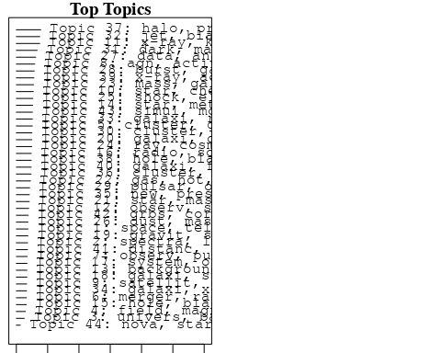

plotQuote(thoughts6, width = 30, main = "Topic 6")  
plotQuote(thoughts18, width = 30, main = "Topic 18")

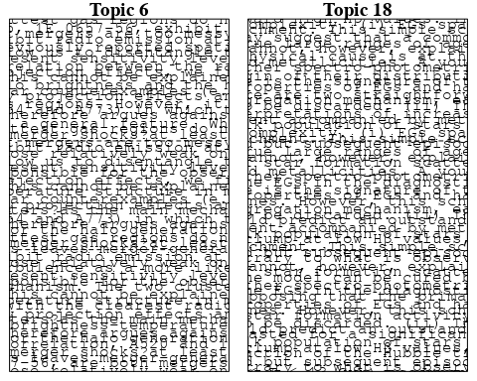

# Calculate and plot the correlation between topics  
mod.out.corr <- topicCorr(Research_topics)  
plot(mod.out.corr, cex = 1.5)  
  
  
# For each topic  
for (topic_num in 1:44) {  
 # Plot the word cloud  
 cloud(Research_topics, topic = topic_num, scale = c(2, 0.25))  
 Sys.sleep(2)  
}

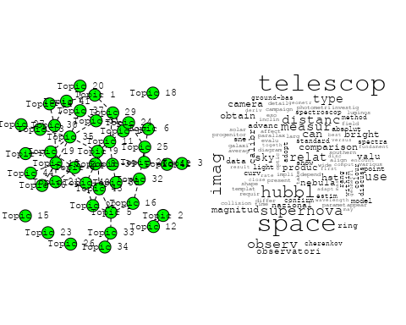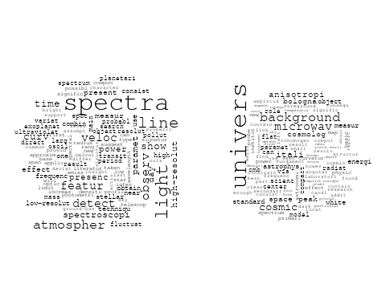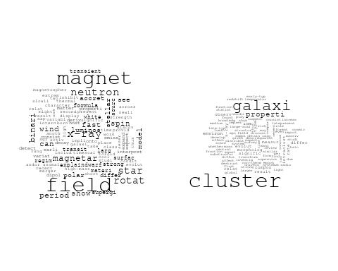

## Warning in wordcloud::wordcloud(words = vocab, freq = vec, max.words =  
## max.words, : pulsar could not be fit on page. It will not be plotted.

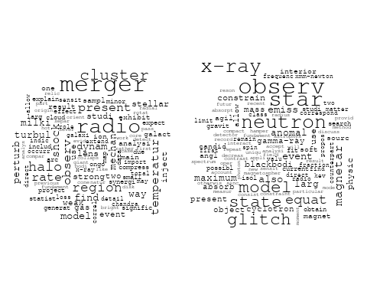

## Warning in wordcloud::wordcloud(words = vocab, freq = vec, max.words =  
## max.words, : present could not be fit on page. It will not be plotted.

## Warning in wordcloud::wordcloud(words = vocab, freq = vec, max.words =  
## max.words, : telescop could not be fit on page. It will not be plotted.

## Warning in wordcloud::wordcloud(words = vocab, freq = vec, max.words =  
## max.words, : threshold could not be fit on page. It will not be plotted.

## Warning in wordcloud::wordcloud(words = vocab, freq = vec, max.words =  
## max.words, : data could not be fit on page. It will not be plotted.

## Warning in wordcloud::wordcloud(words = vocab, freq = vec, max.words =  
## max.words, : perform could not be fit on page. It will not be plotted.

## Warning in wordcloud::wordcloud(words = vocab, freq = vec, max.words =  
## max.words, : astronom could not be fit on page. It will not be plotted.

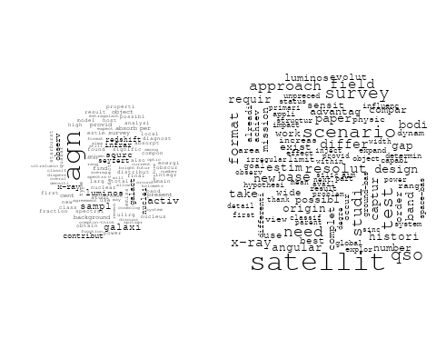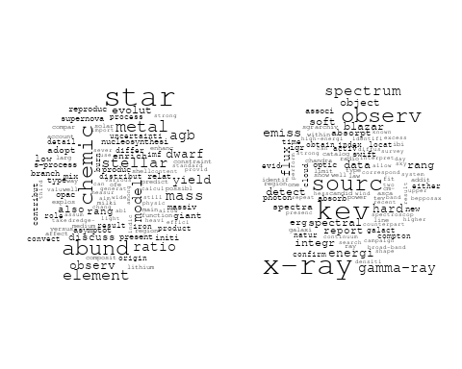

## Warning in wordcloud::wordcloud(words = vocab, freq = vec, max.words =  
## max.words, : solar could not be fit on page. It will not be plotted.

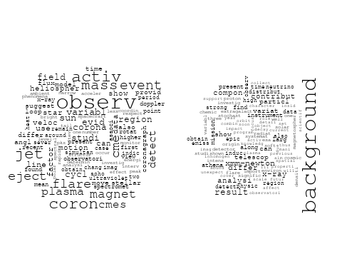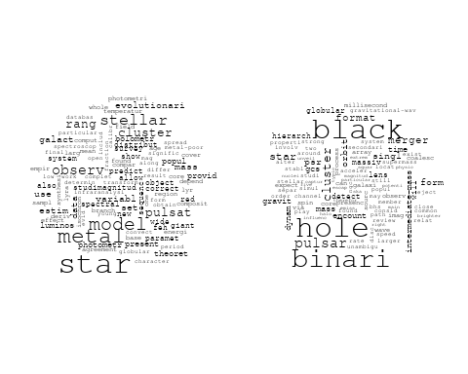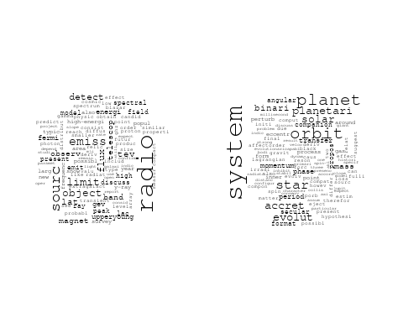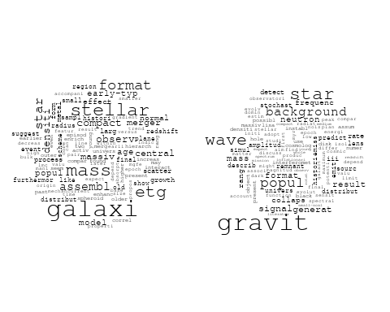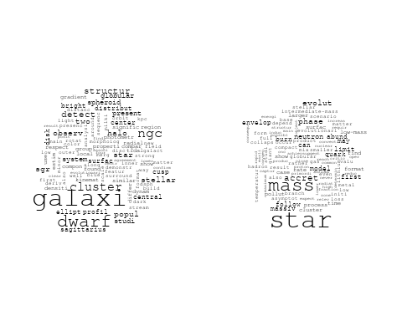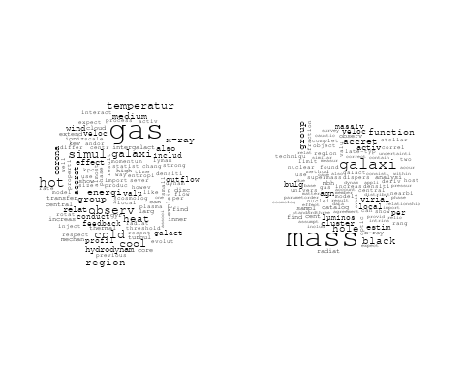

## Warning in wordcloud::wordcloud(words = vocab, freq = vec, max.words =  
## max.words, : interstellar could not be fit on page. It will not be plotted.

## Warning in wordcloud::wordcloud(words = vocab, freq = vec, max.words =  
## max.words, : cloud could not be fit on page. It will not be plotted.

## Warning in wordcloud::wordcloud(words = vocab, freq = vec, max.words =  
## max.words, : radiat could not be fit on page. It will not be plotted.

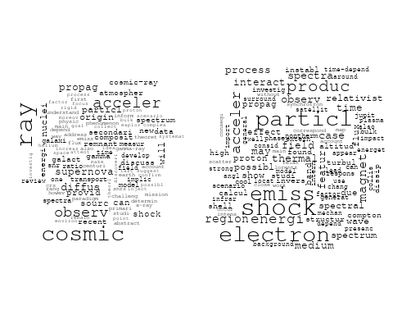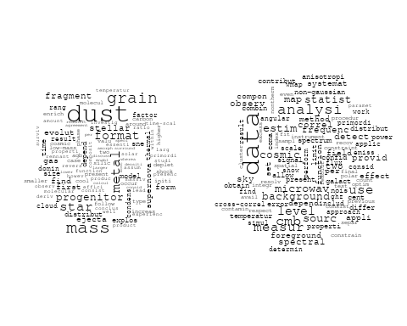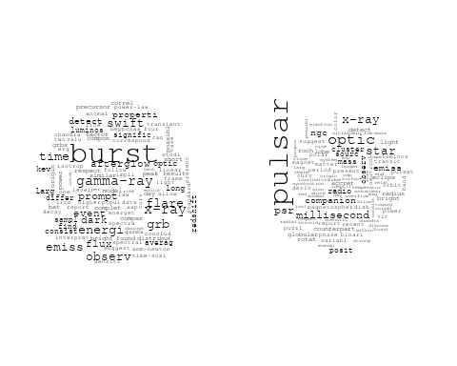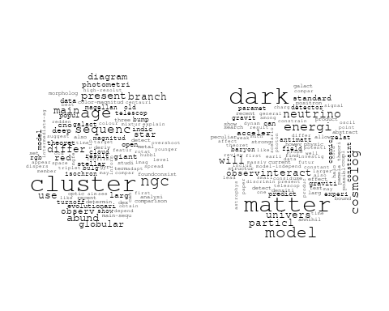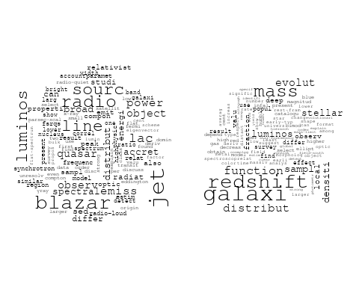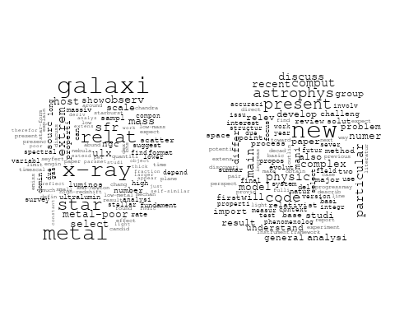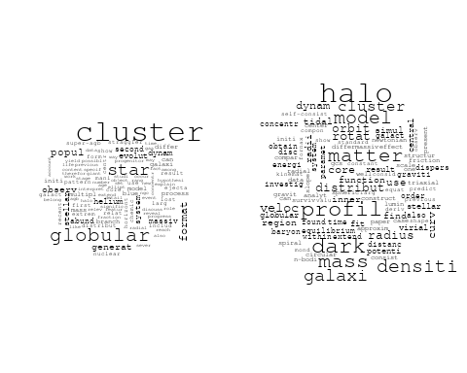

## Warning in wordcloud::wordcloud(words = vocab, freq = vec, max.words =  
## max.words, : x-ray could not be fit on page. It will not be plotted.

## Warning in wordcloud::wordcloud(words = vocab, freq = vec, max.words =  
## max.words, : sourc could not be fit on page. It will not be plotted.

## Warning in wordcloud::wordcloud(words = vocab, freq = vec, max.words =  
## max.words, : pulsar could not be fit on page. It will not be plotted.

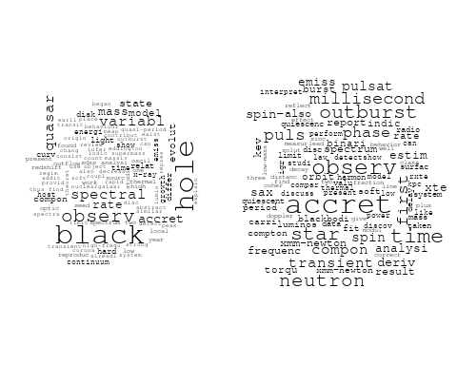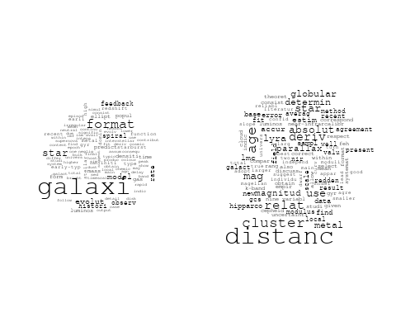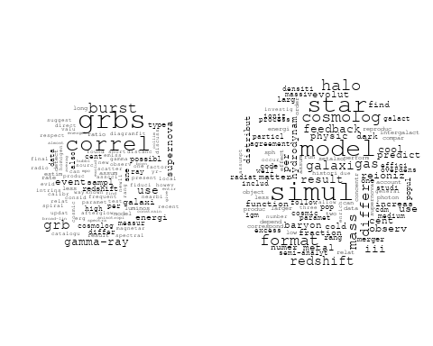

## Warning in wordcloud::wordcloud(words = vocab, freq = vec, max.words =  
## max.words, : nucleosynthesi could not be fit on page. It will not be plotted.

# Get the topic proportions for each document  
topic_proportions <- Research_topics$theta  
  
# Find the index of the topic with the highest proportion for each document  
# This will be the topic that each document is most likely to belong to  
max_topic_idx <- apply(topic_proportions, 1, which.max)  
  
# Add this as a new column to your data  
data_independent$topic <- max_topic_idx  
  
  
  
# Define the intervals  
intervals <- c('1824_1899', '1900_1964', '1965_1974', '1975_1984', '1985_1994', '1995_1999', '2000_2004', '2005_2009', '2010_2014', '2015_2019', '2020_2022')  
colors <- c('pink', 'blue', 'purple', 'yellow', 'green', 'pink', 'orange', 'violet', 'green', 'blue', 'pink')  
  
# Loop through the intervals and plot  
for(i in seq_along(intervals)){  
 # Filter data for when the pub_interval is equal to 1  
 data_filtered <- data_independent[data_independent[[paste0('pub_interval_', intervals[i])]] == 1,]  
   
 # Make the histogram  
   
 p <- ggplot(data_filtered, aes(x = topic)) +  
 geom_histogram(binwidth = 1, fill = colors[i], color = "black") +  
 xlab("Topic") +  
 ylab("Count") +  
 ggtitle(paste0("Topics from year ", gsub("_", " to ", intervals[i])))  
   
 print(p)  
}

