#include <iostream>#include <queue>#include <omp.h>#include <iomanip> // For spacingusing namespace std;class Node {public: int data; Node* left; Node* right; Node(int val) { data = val; left = right = nullptr; }};class BreadthFS {public: Node* insert(Node* root, int data); void bfsTreeView(Node* root);};// Level-order insertionNode* BreadthFS::insert(Node* root, int data) { if (!root) return new Node(data); queue<Node*> q; q.push(root); while (!q.empty()) { Node* temp = q.front(); q.pop(); if (!temp->left) { temp->left = new Node(data); return root; } else q.push(temp->left); if (!temp->right) { temp->right = new Node(data); return root; } else q.push(temp->right); } return root;}// Tree-view BFS traversal using OpenMPvoid BreadthFS::bfsTreeView(Node* root) { if (!root) return; queue<Node*> q; q.push(root); int level = 0; cout << "\nBFS Traversal using OpenMP (Tree View):\n"; while (!q.empty()) { int size = q.size(); // Print indentation for each level cout << setw(8 * (4 - level)) << ""; // Adjust spacing based on level #pragma omp parallel for for (int i = 0; i < size; i++) { Node* node; #pragma omp critical { node = q.front(); q.pop(); cout << node->data << "\t"; if (node->left) q.push(node->left); if (node->right) q.push(node->right); } } cout << "\n"; level++; }}int main() { Node* root = nullptr; BreadthFS tree; int data; char ans; do { cout << "\nEnter data: "; cin >> data; root = tree.insert(root, data); cout << "Do you want to insert one more node? (y/n): "; cin >> ans; } while (ans == 'y' || ans == 'Y'); tree.bfsTreeView(root); return 0;}

Output:

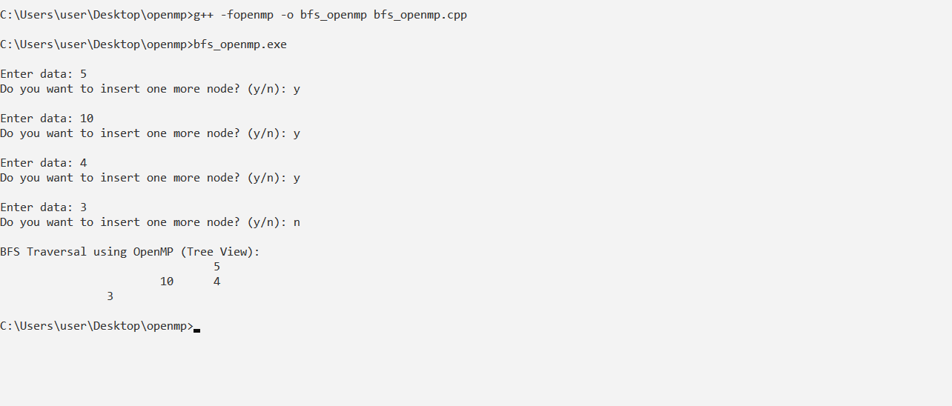

#include <iostream>#include <omp.h>using namespace std;// Swap two elementsvoid swap(int &a, int &b) { int temp = a; a = b; b = temp;}// Odd-Even Transposition Sort using OpenMPvoid bubble(int *a, int n) { for (int i = 0; i < n; i++) { int phase = i % 2; #pragma omp parallel for shared(a, phase) for (int j = phase; j < n - 1; j += 2) { if (a[j] > a[j + 1]) { swap(a[j], a[j + 1]); } } }}int main() { int *a, n; cout << "\nEnter total number of elements: "; cin >> n; a = new int[n]; cout << "\nEnter elements:\n"; for (int i = 0; i < n; i++) { cin >> a[i]; } bubble(a, n); cout << "\nSorted array:\n"; for (int i = 0; i < n; i++) { cout << a[i] << endl; } delete[] a; return 0;}

Output:

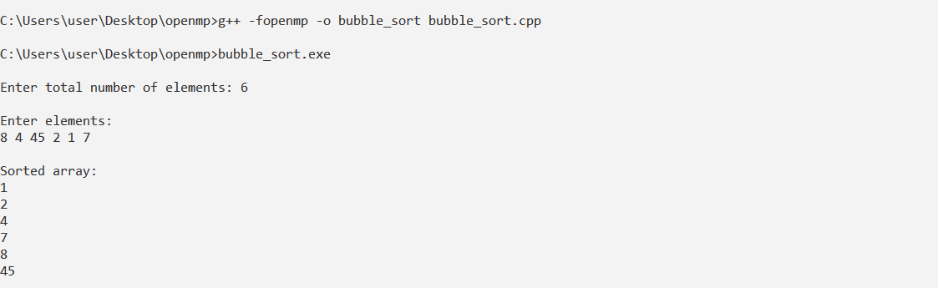

#include <iostream>#include <omp.h>using namespace std;void merge(int* arr, int l, int m, int r) { int i, j, k; int n1 = m - l + 1; int n2 = r - m; int* L = new int[n1]; int* R = new int[n2]; for (i = 0; i < n1; i++) L[i] = arr[l + i]; for (j = 0; j < n2; j++) R[j] = arr[m + 1 + j]; i = 0; j = 0; k = l; while (i < n1 && j < n2) { if (L[i] <= R[j]) { arr[k++] = L[i++]; } else { arr[k++] = R[j++]; } } while (i < n1) arr[k++] = L[i++]; while (j < n2) arr[k++] = R[j++]; delete[] L; delete[] R;}void mergeSort(int* arr, int l, int r) { if (l < r) { int m = l + (r - l) / 2; #pragma omp parallel sections { #pragma omp section mergeSort(arr, l, m); #pragma omp section mergeSort(arr, m + 1, r); } merge(arr, l, m, r); }}int main() { int arr[] = { 12, 11, 13, 5, 6, 7 }; int n = sizeof(arr) / sizeof(arr[0]); double start, stop; cout << "Given array: "; for (int i = 0; i < n; i++) cout << arr[i] << " "; cout << endl; start = omp_get_wtime(); #pragma omp parallel { #pragma omp single mergeSort(arr, 0, n - 1); } stop = omp_get_wtime(); cout << "Sorted array: "; for (int i = 0; i < n; i++) cout << arr[i] << " "; cout << endl; cout << "Time taken: " << (stop - start) << " seconds" << endl; return 0;}

Output:

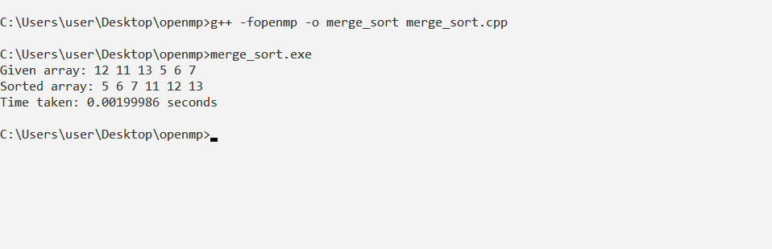

#include <iostream>#include <omp.h>#include <climits>using namespace std;void min_reduction(int arr[], int n) { int min_value = INT_MAX; #pragma omp parallel for reduction(min: min_value) for (int i = 0; i < n; i++) { if (arr[i] < min_value) { min_value = arr[i]; } } cout << "Minimum value: " << min_value << endl;}void max_reduction(int arr[], int n) { int max_value = INT_MIN; #pragma omp parallel for reduction(max: max_value) for (int i = 0; i < n; i++) { if (arr[i] > max_value) { max_value = arr[i]; } } cout << "Maximum value: " << max_value << endl;}void sum_reduction(int arr[], int n) { int sum = 0; #pragma omp parallel for reduction(+: sum) for (int i = 0; i < n; i++) { sum += arr[i]; } cout << "Sum: " << sum << endl;}void average_reduction(int arr[], int n) { int sum = 0; #pragma omp parallel for reduction(+: sum) for (int i = 0; i < n; i++) { sum += arr[i]; } cout << "Average: " << (double)sum / n << endl; }int main() { int *arr, n; cout << "\nEnter total number of elements: "; cin >> n; arr = new int[n]; cout << "\nEnter elements: "; for (int i = 0; i < n; i++) { cin >> arr[i]; } min_reduction(arr, n); max_reduction(arr, n); sum_reduction(arr, n); average_reduction(arr, n); delete[] arr; return 0;}

OUTPUT:

