SMART HOSPITAL
MANAGEMENT SYSTEM
UML Sequence Diagrams and Activity Diagrams
Software Engineering Academic Project

UML DIAGRAMS
This document presents sequence and activity diagrams for four major workflows in the Smart Hospital Management System: patient registration, appointment booking, doctor consultation and prescription, and billing and payment. Each scenario includes a diagram and a report-ready caption.
Figure 1. Patient Registration — Sequence Diagram
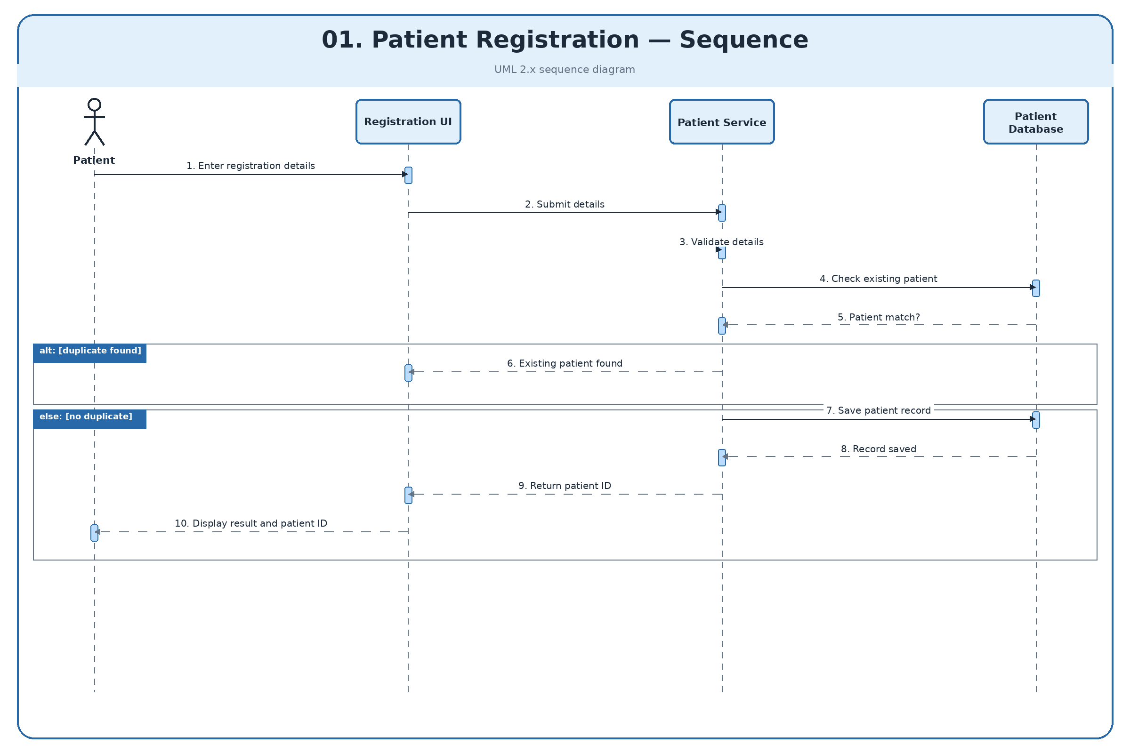
Figure 1. Patient Registration — Sequence Diagram
Shows the interaction between the patient, registration UI, patient service, and patient database, including validation, duplicate checking, and patient record creation.

Figure 2. Patient Registration — Activity Diagram
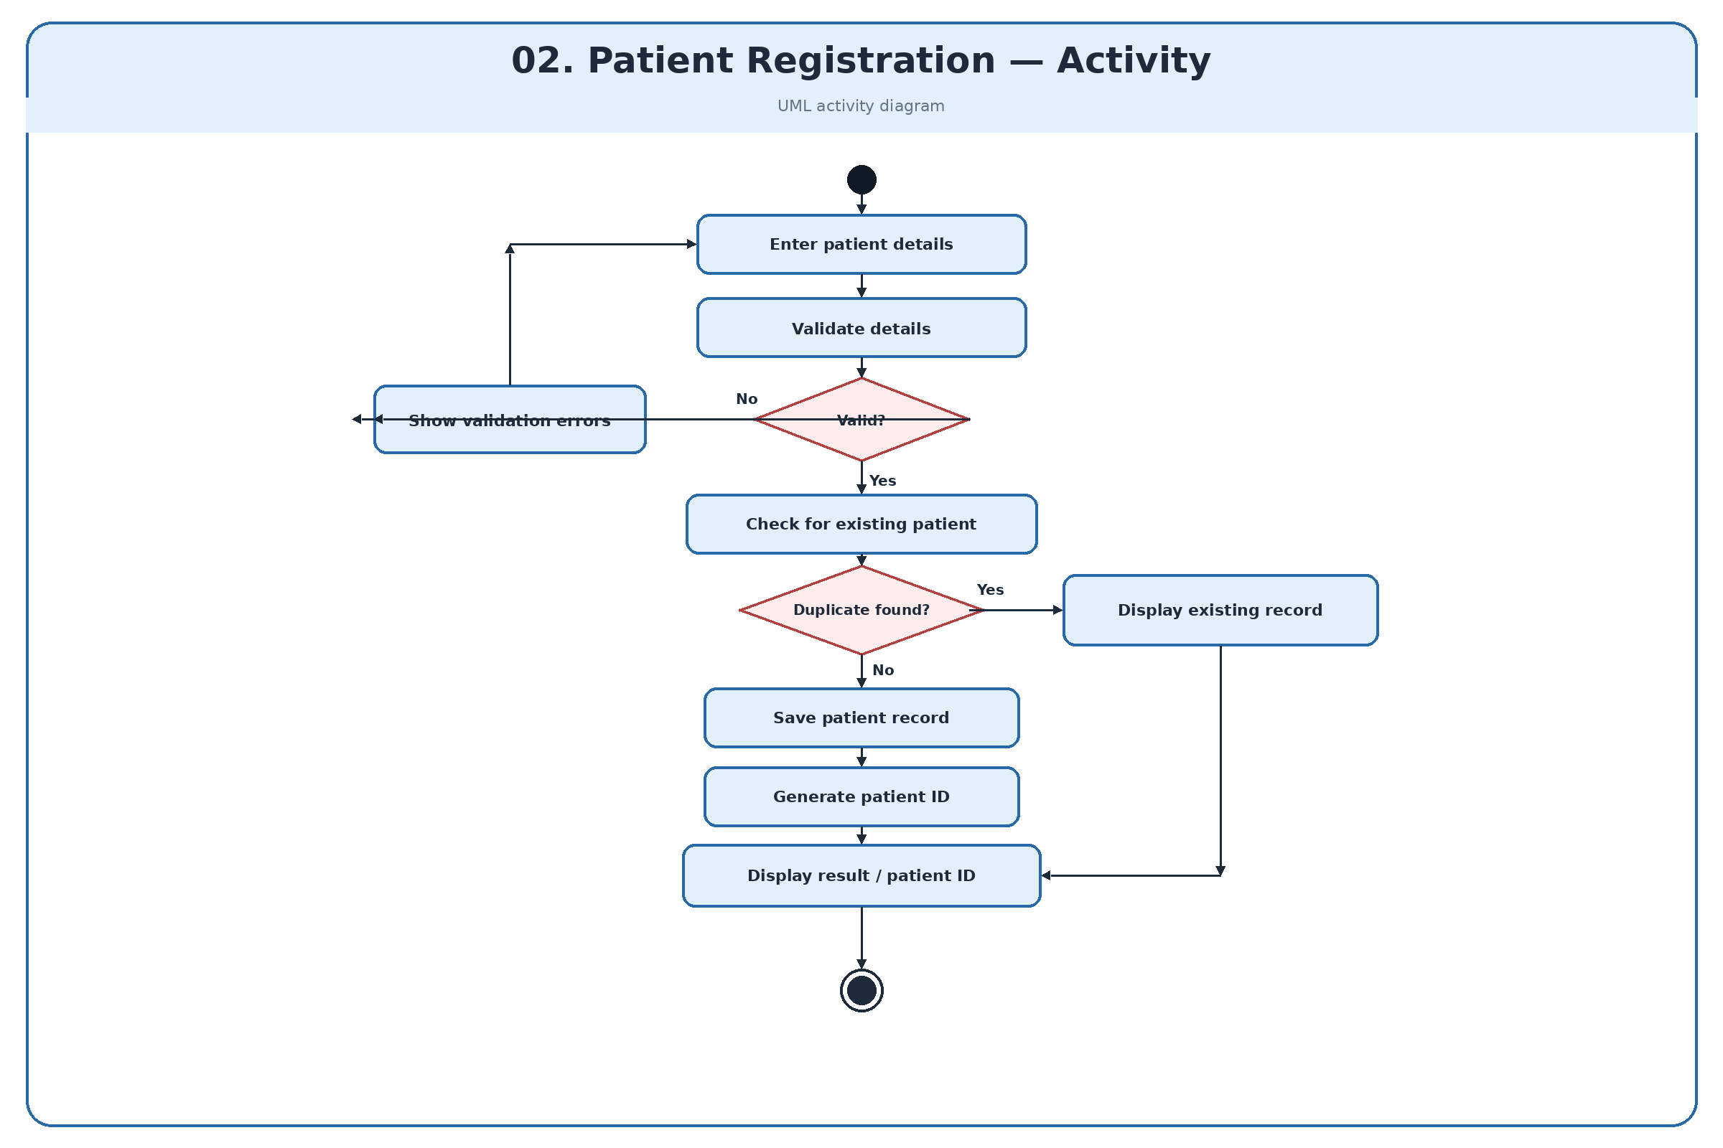
Figure 2. Patient Registration — Activity Diagram
Presents the registration workflow, including detail validation, correction of invalid input, duplicate checking, and displaying the result.

Figure 3. Appointment Booking — Sequence Diagram
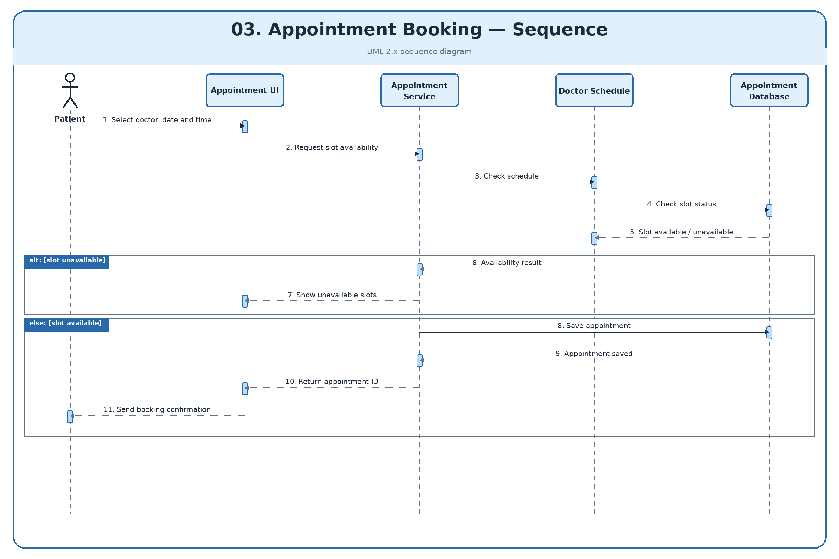
Figure 3. Appointment Booking — Sequence Diagram
Illustrates schedule checks, slot availability responses, appointment persistence, and booking confirmation.

Figure 4. Appointment Booking — Activity Diagram
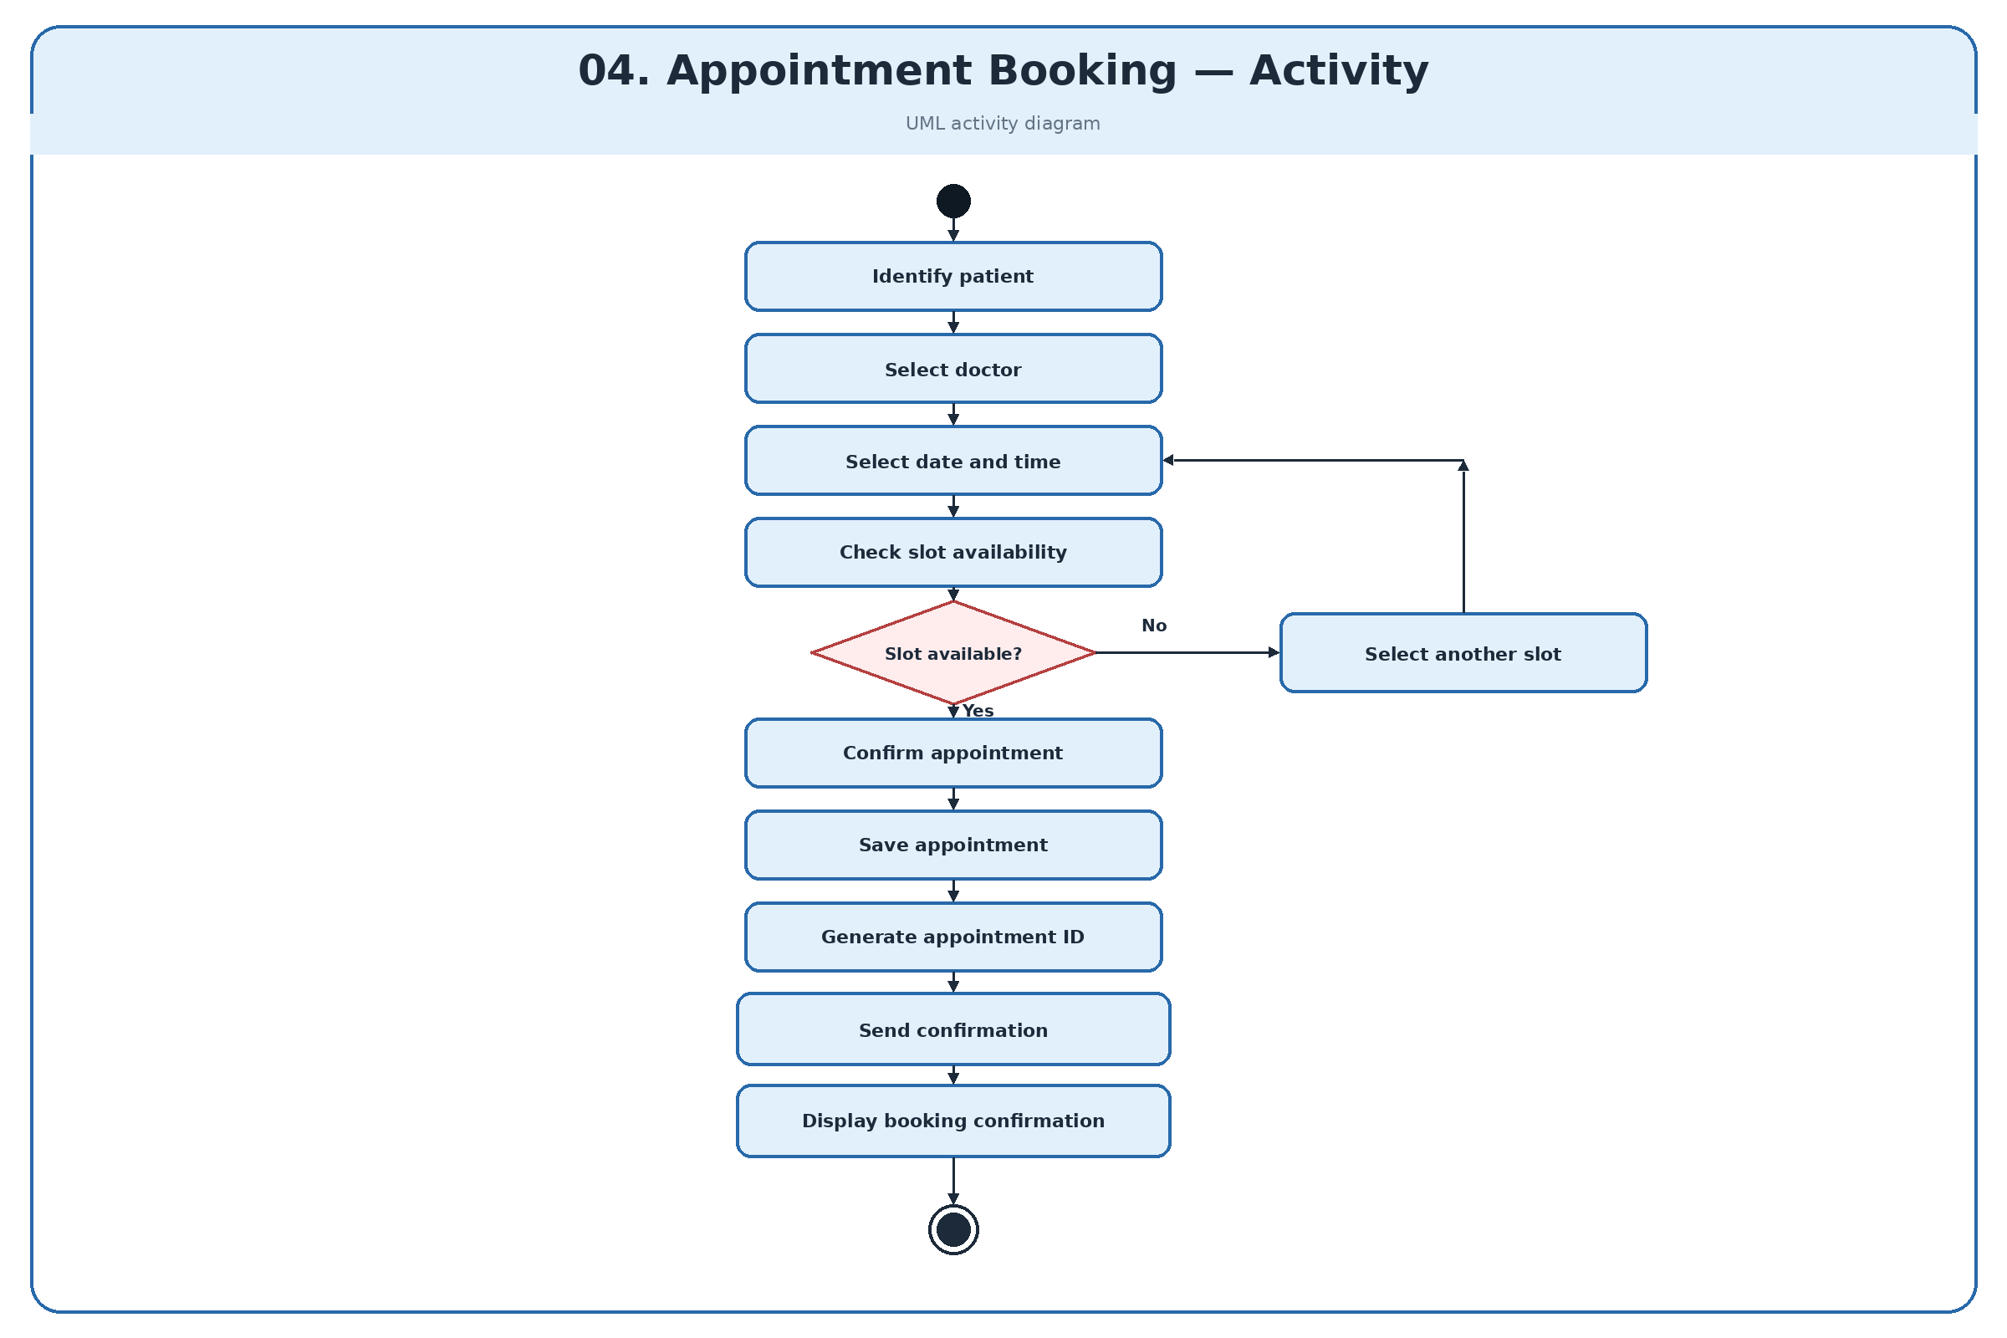
Figure 4. Appointment Booking — Activity Diagram
Shows patient identification, doctor and time-slot selection, availability checking, retrying with another slot, and confirming the appointment.

Figure 5. Doctor Consultation and Prescription — Sequence Diagram
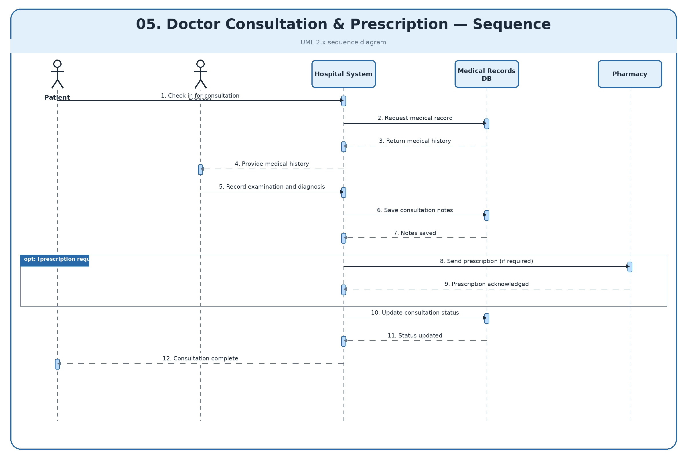
Figure 5. Doctor Consultation and Prescription — Sequence Diagram
Represents check-in, retrieval of medical history, recording diagnosis and consultation notes, and the optional prescription interaction.

Figure 6. Doctor Consultation and Prescription — Activity Diagram
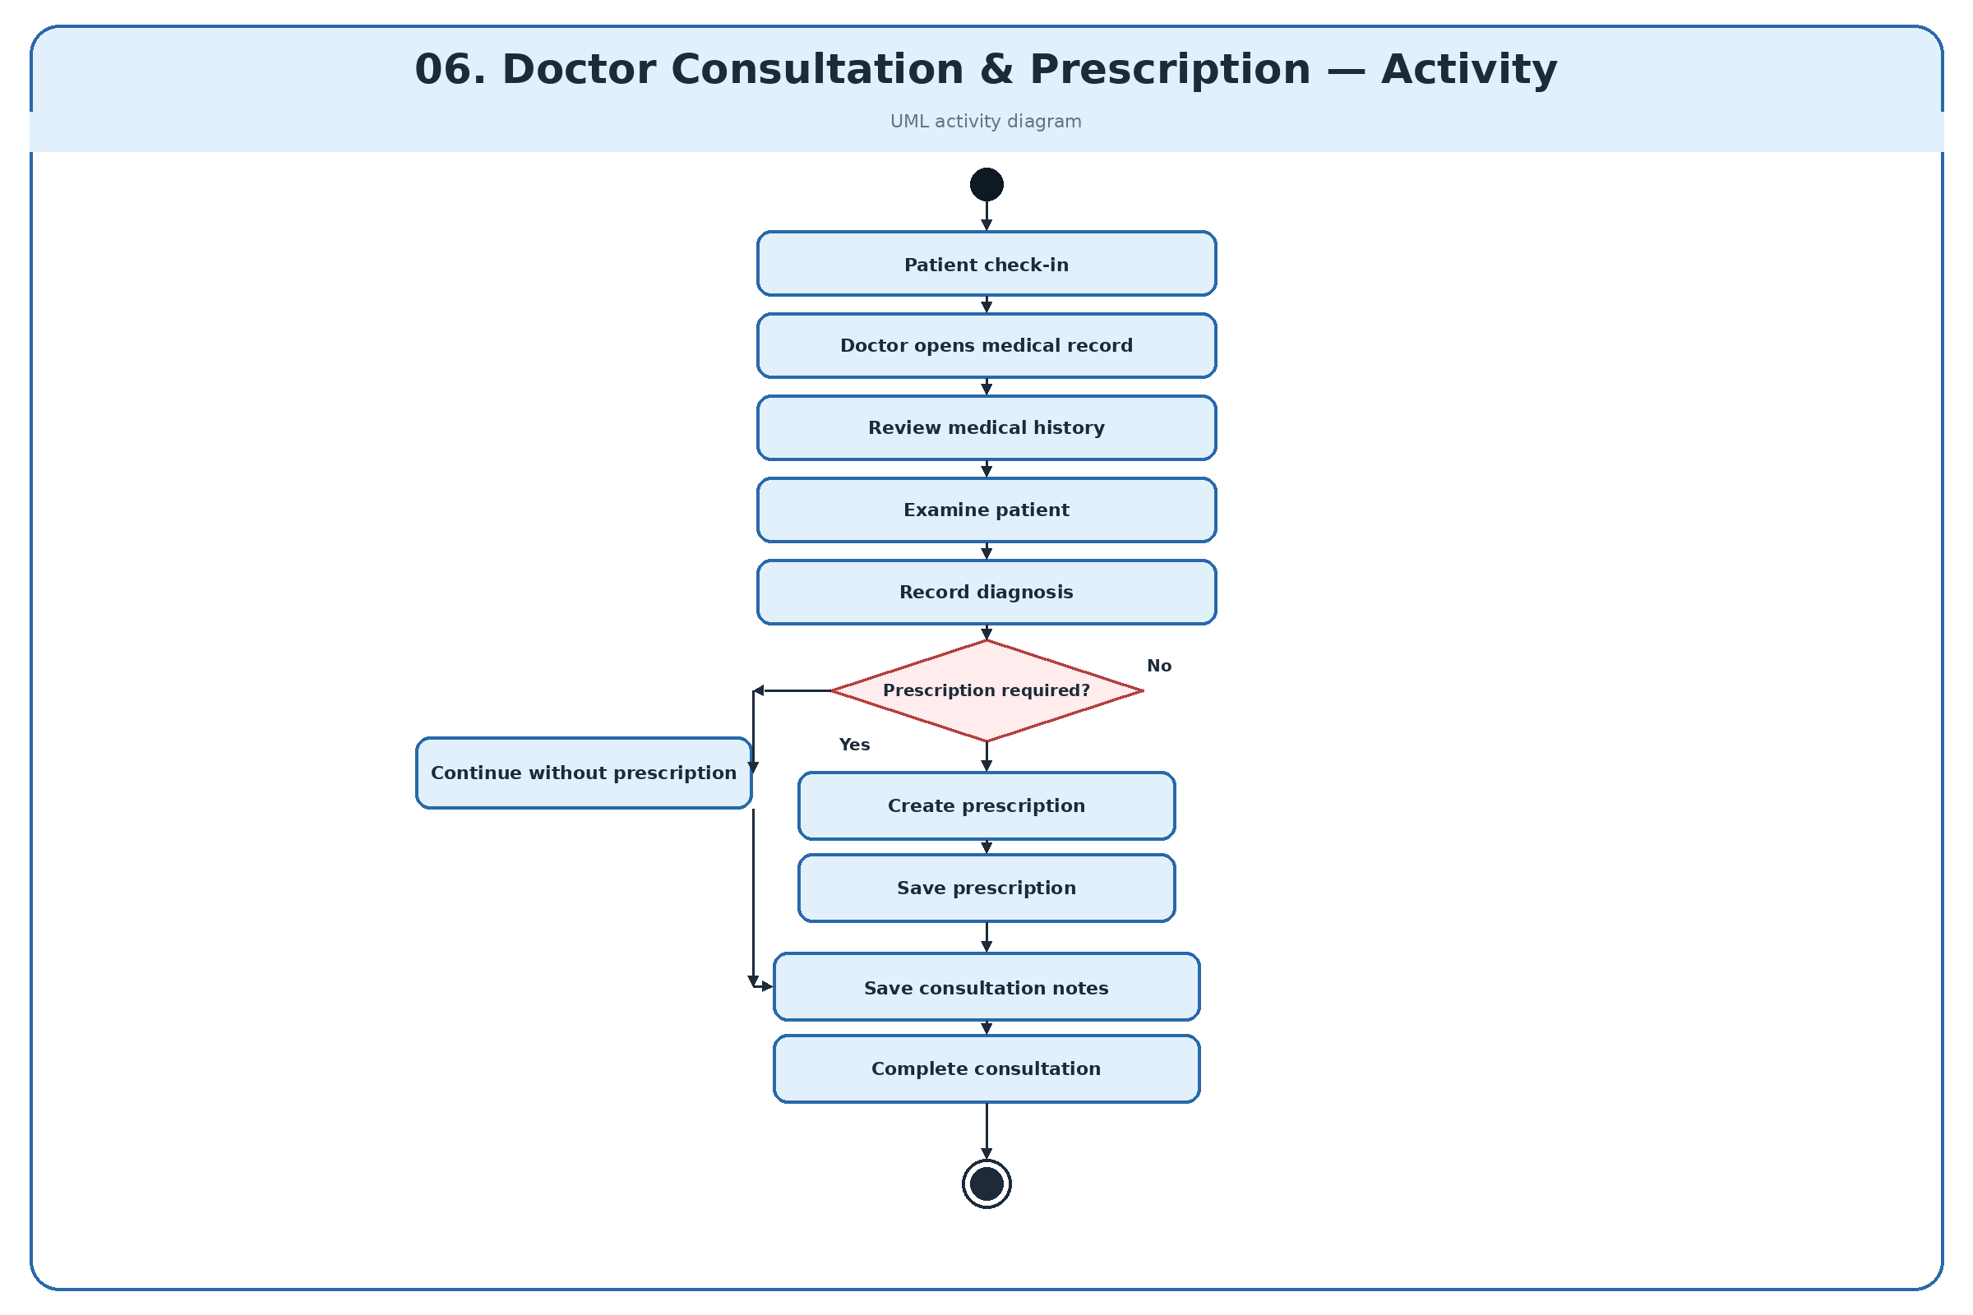
Figure 6. Doctor Consultation and Prescription — Activity Diagram
Describes the clinical workflow from patient check-in through history review, examination, diagnosis, optional prescription creation, and consultation completion.

Figure 7. Billing and Payment — Sequence Diagram
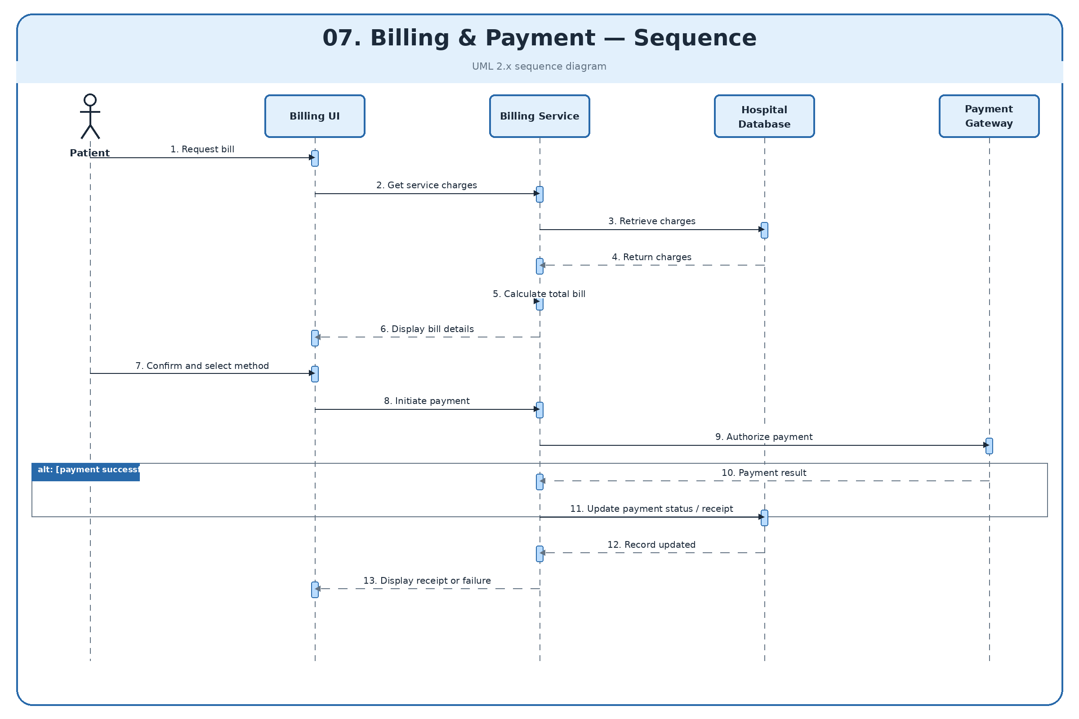
Figure 7. Billing and Payment — Sequence Diagram
Shows charge retrieval, bill calculation, payment authorization, payment-status updates, and presentation of the payment result.

Figure 8. Billing and Payment — Activity Diagram
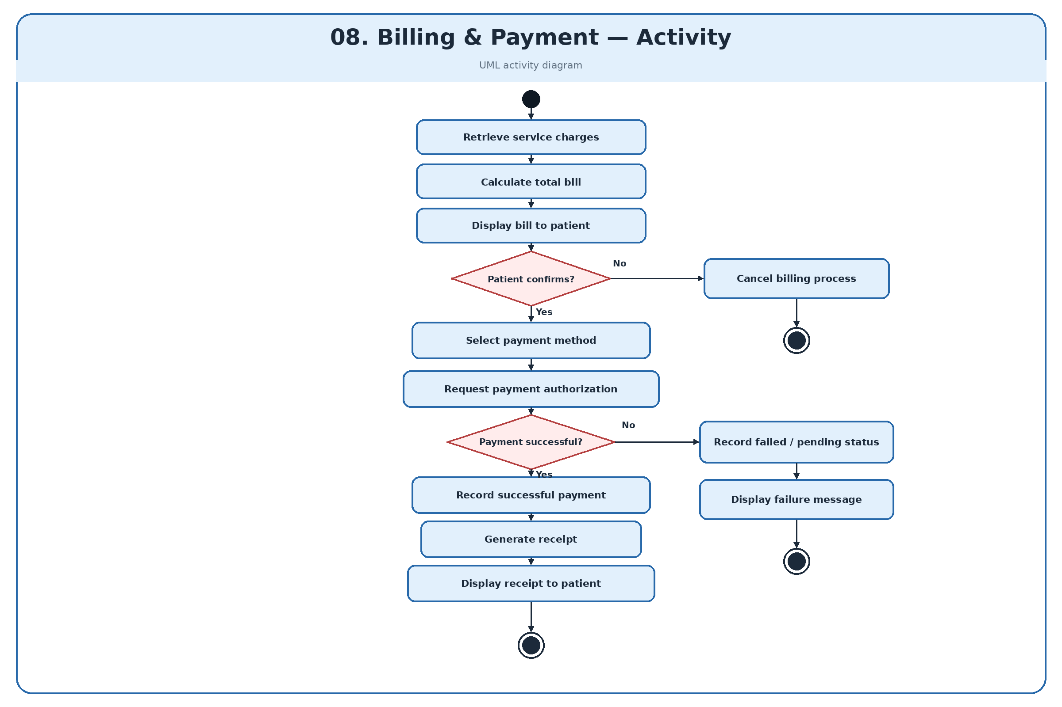
Figure 8. Billing and Payment — Activity Diagram
Models bill preparation, patient confirmation, payment authorization, unsuccessful-payment handling, and receipt generation.

