**Kamala Education Society’s**

**Pratibha College of Commerce & Computer Studies, Chinchwad, Pune-19**



**A**

**Project Report**

**On**

**“Kamgaar- Labour Management System”**

**Developed by,**

**4947: Harshvardhan Gaikwad**

**4948: Sanket Chaudhari**

**T.Y.B.B.A. (C.A.)**

Under

**Savitribai Phule Pune University**

**(2021-2022)**

**Kamala Education Society’s**

**Pratibha College of Commerce & Computer Studies, Chinchwad, Pune-19**



**Certificate**

This is to certify that **Harshvardhan Gaikwad & Sanket Chaudhari have** satisfactorily completed the **Technology Used entitled** **“Kamgaar- Labour Management System” for T.Y.B.B.A.(C.A.) Semester V CA-505 Project** under the **Savitribai Phule Pune University in** the academic year **2021-2022.**

**____________________ ___________________ ____________________**

**Dr. Babasaheb Sangale Mrs. Hemalata Chavan Mrs. Swapnal Nagwade**

**Principal Program Coordinator**

**__________________ _________________**

**Internal Examiner External Examiner**

**Date:**

**ACKNOWLEDGEMENT**

Any efforts to produce successful creation require the help, Guidance and support of many people and their experience. We would like to express our sincere and heartfelt gratitude to all of them.

We would like to take this opportunity to thanks all the people who have directly or indirectly helped this project. We would like to thank our guide Mrs. Swapnal Nagwade, for his valuable guidance.

**-Harshvardhan Gaikwad & Sanket Chaudhari**

**Table of Contents**

|  |  |  |
| --- | --- | --- |
| **Sr. No.** | **Content** | **Page No.** |
| 1 | **Introduction**   * Problem Statement * Purpose/Objective and Goals * Project Scope * Limitations |  |
| 2 | **System Analysis**   * Existing System * Scope and Limitations of Existing System * Requirement Analysis |  |
| 3 | **System Design**   * Data Dictionary * Table Design * Data Flow Diagram * ER Diagram * User Interface |  |
| 4 | **Implementation Details**   * Hardware and Software Requirement |  |
| 5 | **Outputs and Report Testing** |  |
| 6 | **Conclusion and Recommendations** |  |
| 7 | **Future Scope** |  |
| 8 | **Bibliography and References** |  |

**ABSTARCT:**

The main objective of this project is to have a completely automated project allotment system which can even be managed by a non technical person. This project will serve the purpose of maintaining all the contractor, user and labour details along with issuing registration certificate to contractor and verified labourers for small scale projects. This project will definitely reduce the time and effort in searching for contractors with expired licenses and for labourers for small scale projects. Fetching all the contractor details, labour details and work order details will be made easy with just a single mouse click. Overall management of Contract labour will be easy and quick.

**PROBLEM STATEMENT:**

Till now, all details of contractor and work order allotment are done manually and on paper. It becomes very difficult to get all the details about any contractor in a short time. For agricultural or small scale project purposes, commission of the contractor is quite high leading to increase in cost. Labourers are connected indirectly with the customer as part of commission going to the contractors. The present system does not follow any proper channel making the whole system redundant and ambiguous. A lot of time, money and energy is wasted in searching as well as maintaining the documents.

**PROPOSED SYSTEM:**

The proposed software will the precious time, money, energy and paper with flawless execution. Each and every process, be it addition of a new contractor, allotting project, connecting with individual labour for small projects, all will be digitized. Manual searching will be reduced as all contractor details can be listed along with their expiration dates and independent labourer’s details would be listed with their work category, their daily charges their basic identity information who are open for small scale projects. This system’s main purpose would be to convert the only sector which is still done manually and in offline methods into a digitalized system, more like LinkedIn or Naukri.com for labourers to connect directly with the customer’s, neglecting the commission of contractors. Only the large scale projects with usually more than 100-200 labourers will be connected with contractors to customers but by making their commission cost effective.

**EXISTING SYSTEM:**

This existing  system is not providing secure registration and profile management of  all  the  users  properly. This  system  is  not  providing  on-line  Help. This  system  doesn’t provide  tracking  of  users  activities  and  their  progress. This  manual  system  gives  us  very less  security  for  saving  data  and  some  data  may  be  lost  due  to  mismanagement. This system is not providing event management through internet. This system is not providing proper  events  information .The  system  is  giving  manual  information  through  the  event management executer.

**Limitations:**

Till now, all details of contractor and work order allotment are done manually and on paper. It becomes very difficult to get all the details about any contractor in a short time. For agricultural or small scale project purposes, commission of the contractor is quite high leading to increase in cost. Labourers are connected indirectly with the customer as part of commission going to the contractors. The present system does not follow any proper channel making the whole system redundant and ambiguous. A lot of time, money and energy is wasted in searching as well as maintaining the documents.

**Project Scope:**

The proposed software will the precious time, money, energy and paper with flawless execution. Each and every process, be it addition of a new contractor, allotting project, connecting with individual labour for small projects, all will be digitized. Manual searching will be reduced as all contractor details can be listed along with their expiration dates and independent labourer’s details would be listed with their work category, their daily charges their basic identity information who are open for small scale projects. This system’s main purpose would be to convert the only sector which is still done manually and in offline methods into a digitalized system, more like LinkedIn or Naukri.com for labourers to connect directly with the customer’s, neglecting the commission of contractors. Only the large scale projects with usually more than 100-200 labourers will be connected with contractors to customers but by making their commission cost effective.

**Feasibility Study**

Feasibility study can help you determine whether or not you should proceed with our project. It is essential to evaluate cost and benefit.

**Operational Feasibility:**

The project has been developed in such a way that it becomes very easy

even for a person with little computer knowledge to operate it. This software is

very user friendly and does not require any technical person to operate .Thus the

project is even operationally feasible.

**Technical Feasibility:**

Technical feasibility determines whether the work for the project can be done with the equipment & software technology. Our project involves all the required specification like software application such as sql, workbench, jupyter/ visual studio code.

**Economic Feasibility:**

Cost benefit of the proposed system is that it is feasible as functions of this system is mostly on a online based platform and also helps in removing the commission of small contractors.

**ER DIAGRAM**

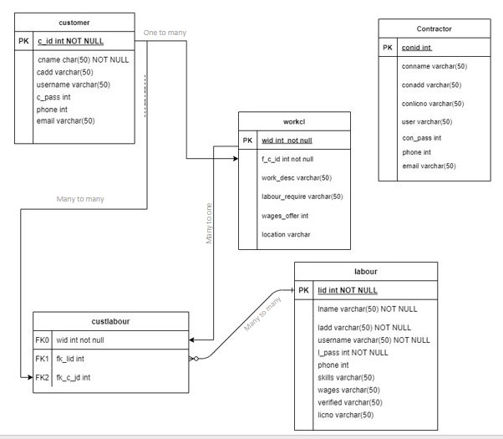

**0 Level DFD**

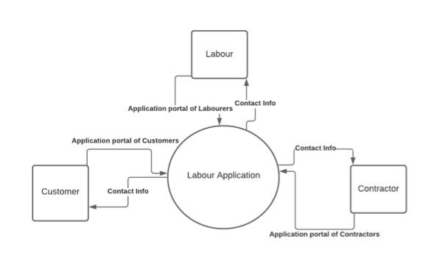

**1 Level DFD**

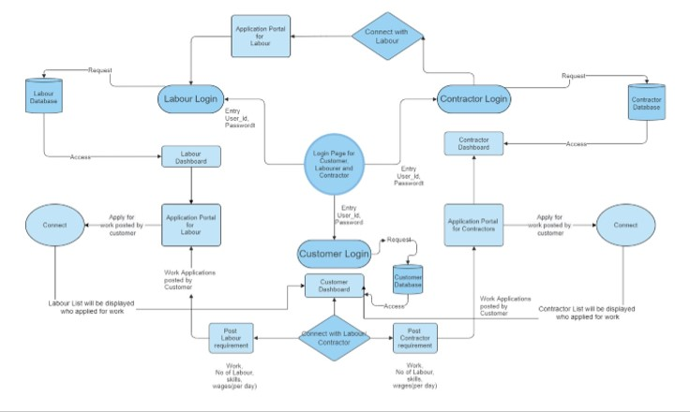

**DATASET :**

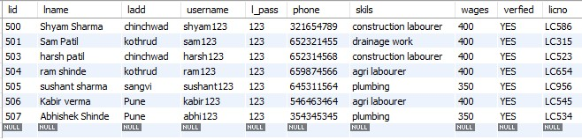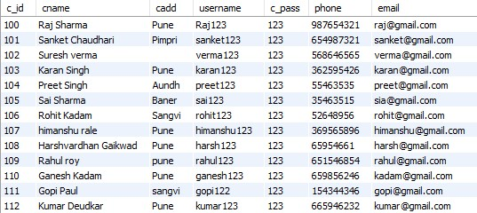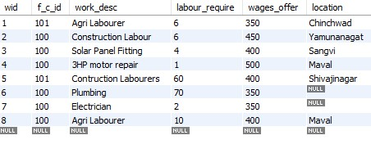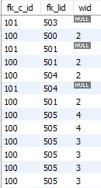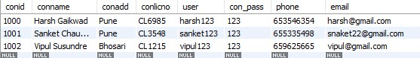

**Hardware /Software Requirements**

The software is designed to be light-weighted so that it doesn’t be a burden on the machine running it. This system is being build keeping in mind the generally available hardware and software compatibility. Here are the minimum hardware and software requirement for Motor hub.

**Hardware:**

* 32-bit, Pentium-pro processor or later.
* RAM 2GB or more.

**Software:**

* Windows 7(32-bit) or above.
* Python 2.7 or later
* Flask

**Output screens:**

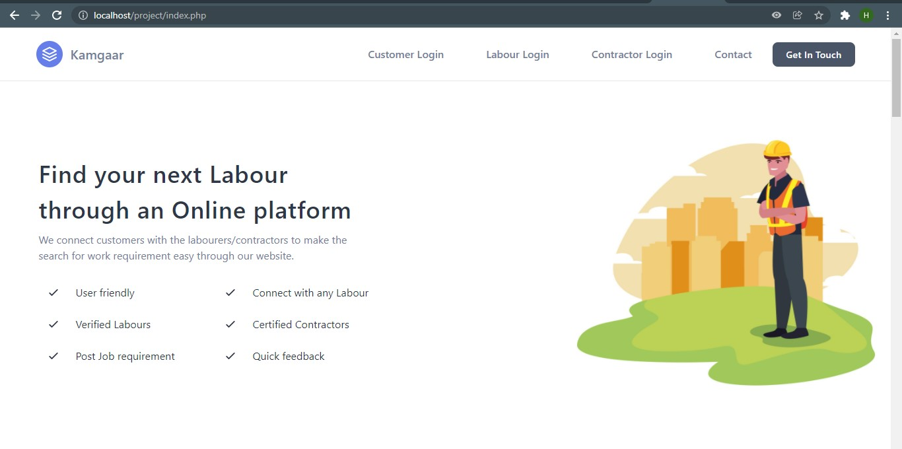

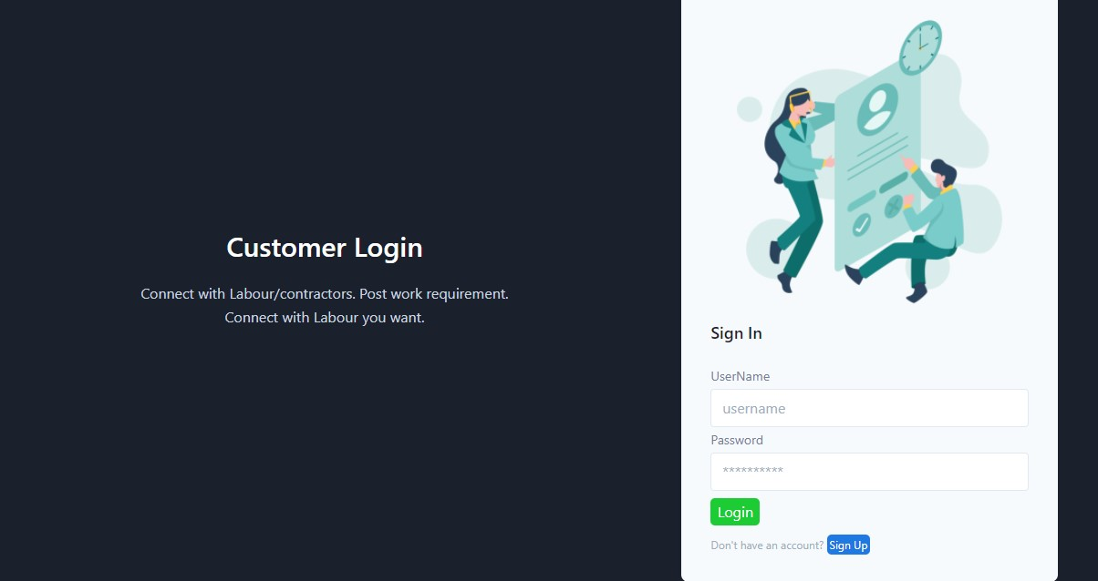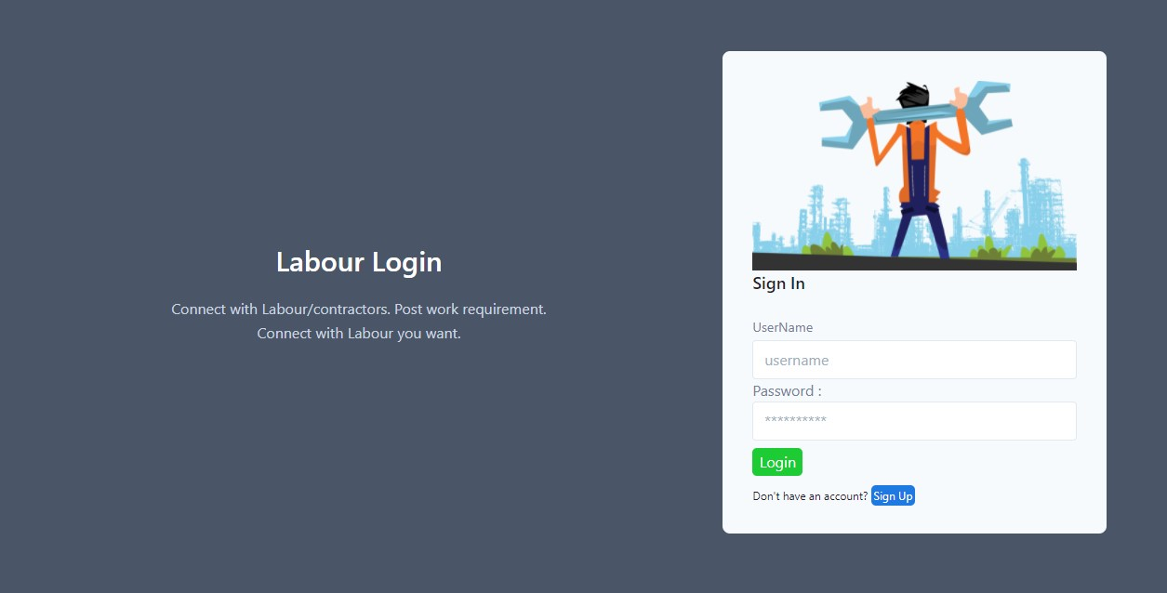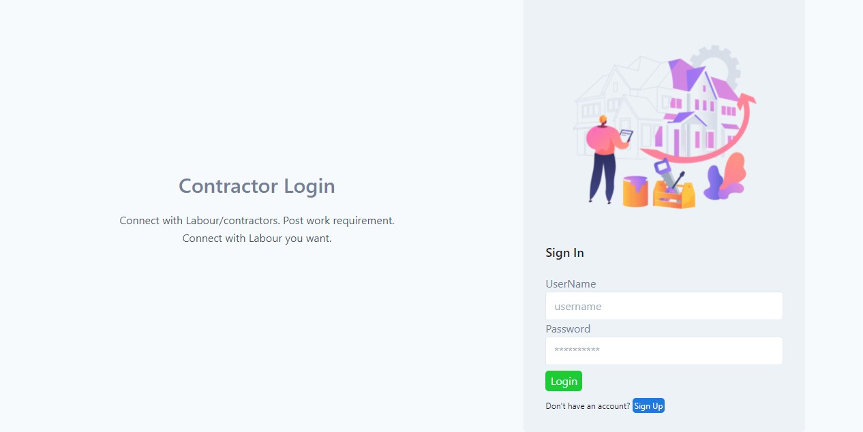 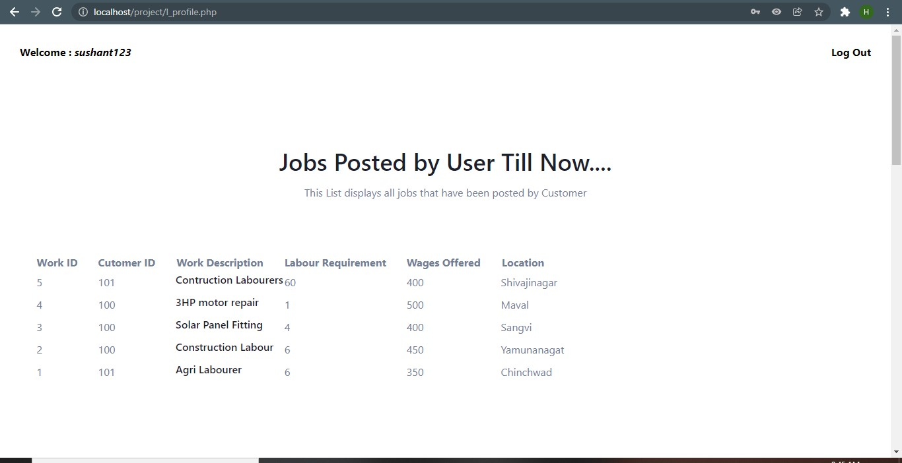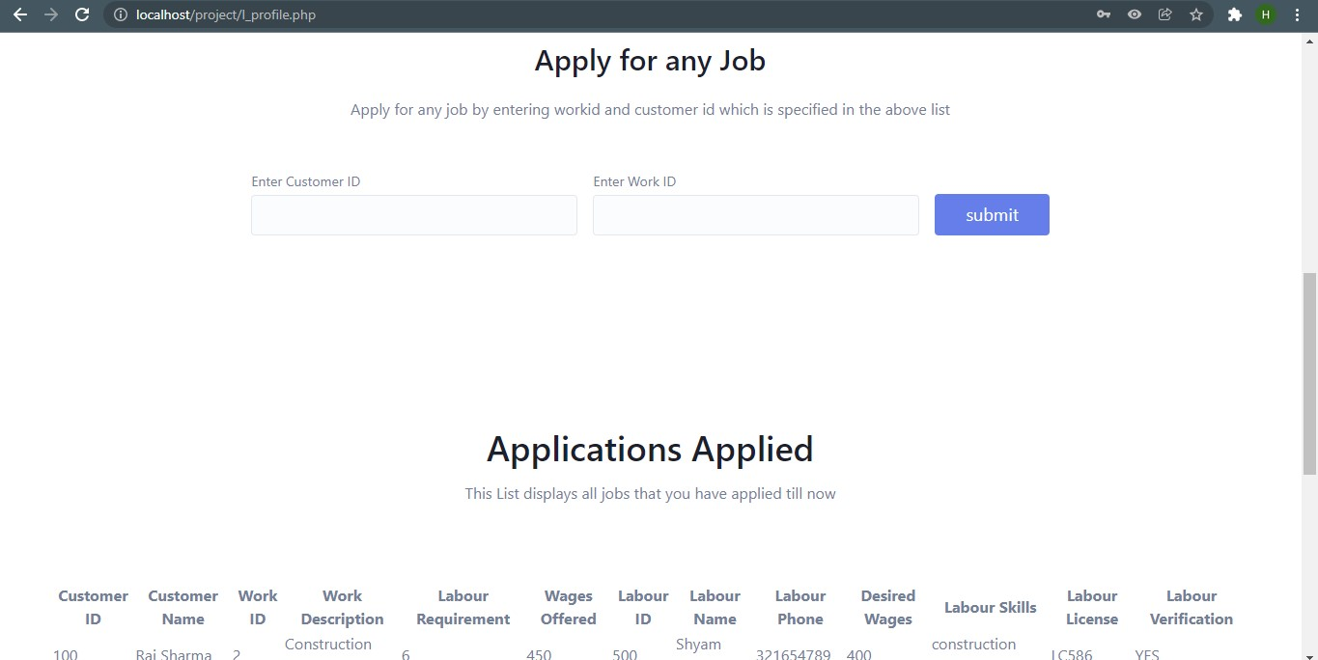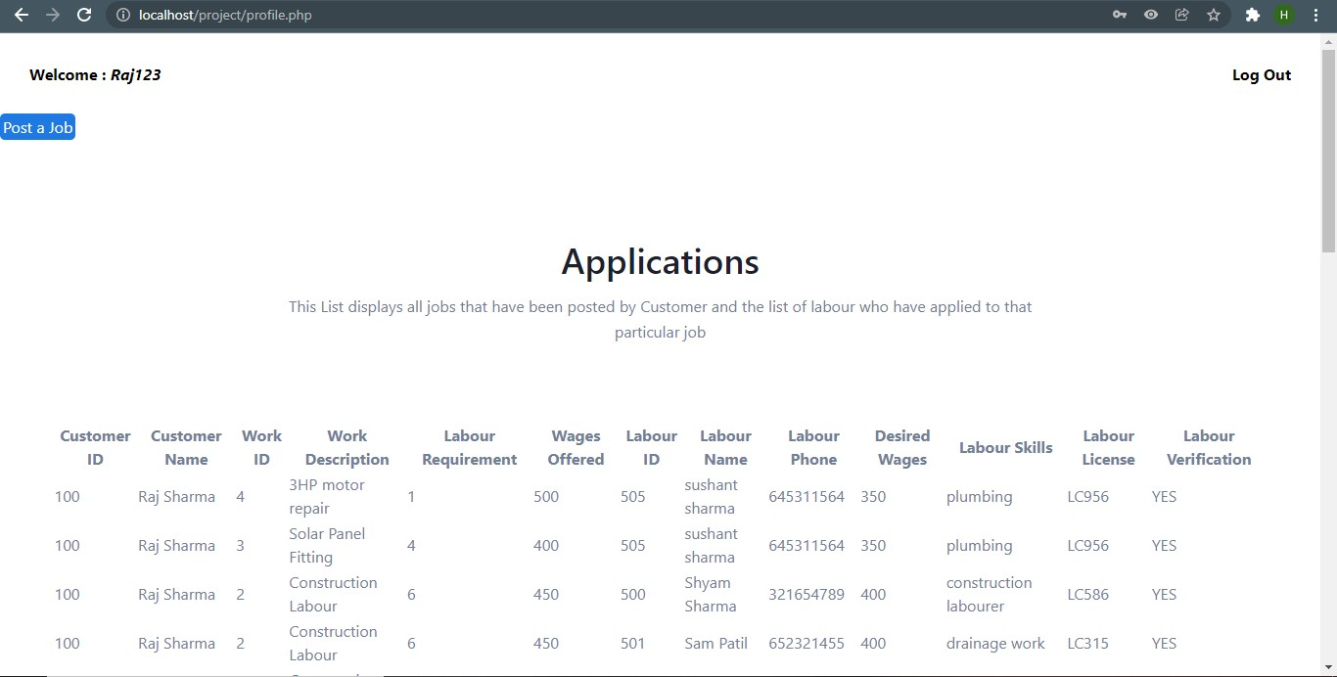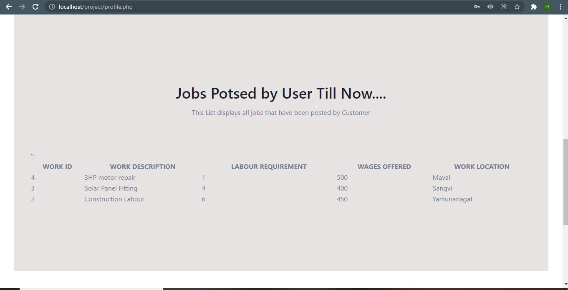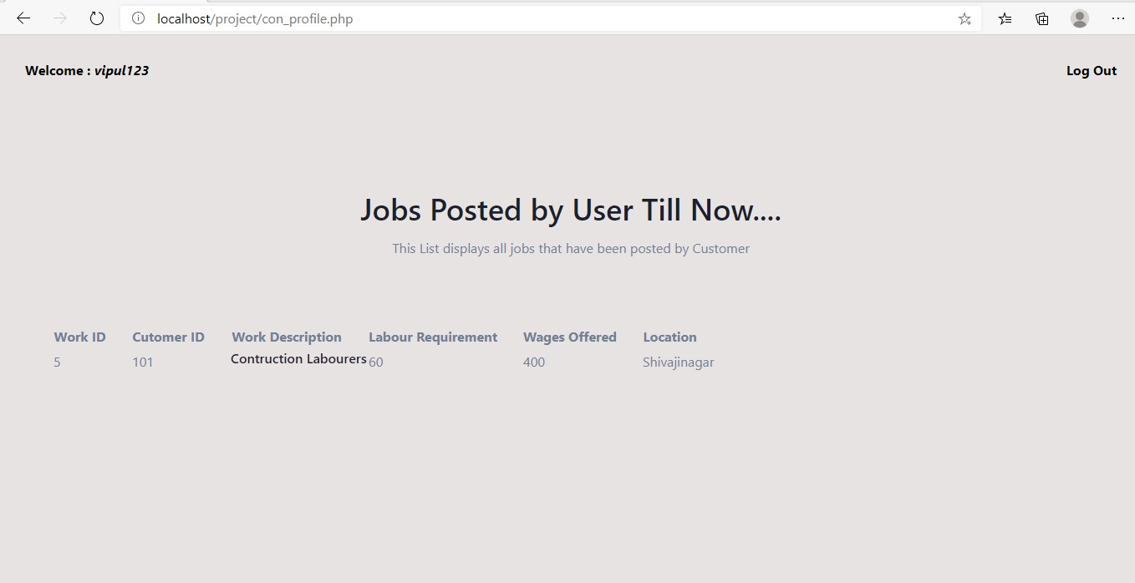

**CONCLUSION:**

There is no escaping the social media these days, either for individuals or for businesses. Today, it is impossible to separate social media from the online world. Social media is a strong and potent communication tool. It presents brands with enormous reach and endless communication possibilities. It allows brands to emerge into a world of peer--to--peer dialogue and therefore the possibility of harnessing the brand building potential of the richest communication form available. However, it is important to do it

right. To approach communities and engage in dialogue that seems relevant and motivating for an audience of extremely sophisticated and literate users.Therefore, for building up a brand, a marketer must remember to:-

* Be personal
* Be in dialogue
* Be a Product
* Be a community
* Be social now

**Future Scope:**

* To use concepts like web sockets to improve communication between the users.
* Going to create it more user friendly by using Ajax.
* Add more features like chat application for users, view profile, give feedback for particular profile, read reviews given to a particular profile.
* Adding more features to contractor's profile page.

**Bibliography and References:**

* [**www.php.net**](http://www.php.net/)

**FOR PHP, CSS, APACHE  INSTALLATION :**

* [**www.w3schools.com**](http://www.w3schools.com/)

**FOR XAMPP INSTALLATION :**

* [**www.apachefriends.org**](http://www.apachefriends.org/)
* <https://www.geeksforgeeks.org/random-forest-regression-in-python>
* <https://scikit-learn.org/stable/modules/generated/sklearn.ensemble.RandomForestRegressor.html>