A

**Project ERD**

On

**VOTING APPLICATION FOR SELECTION**

**OF COLLEGE CR**

Submitted by

Harshvardhan Santosh Thanekar (2202464)

Bhumika Anil Vajani (2202466)

MCA I (Semester: I)

Guided by

**“Prof. Uma Patil”**

**P.E. Society’s**

**Modern Institute of Business Studies (Autonomous)**

**Nigdi, Pune - 411044**

2024 – 2025

**Project ER Diagram:**

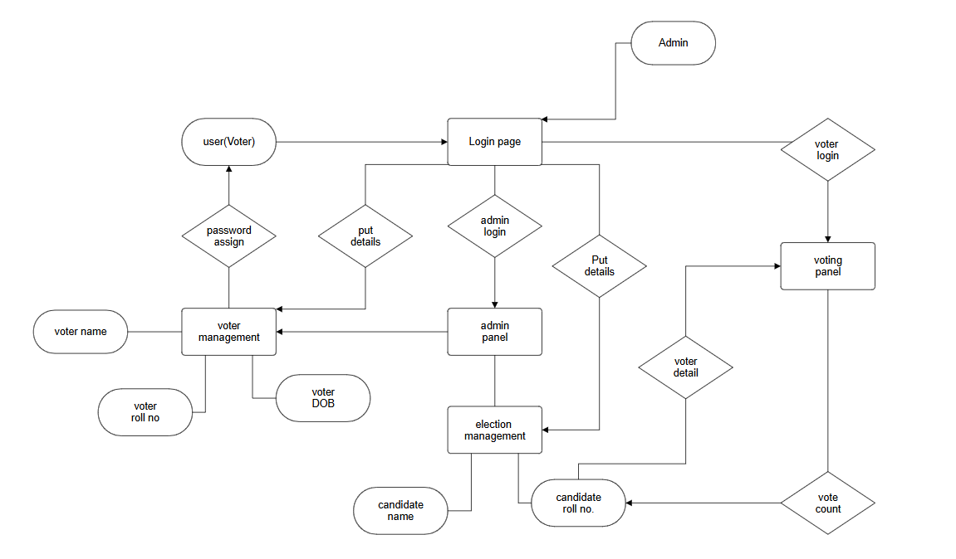

**Tables in Project:**

Candidate table:

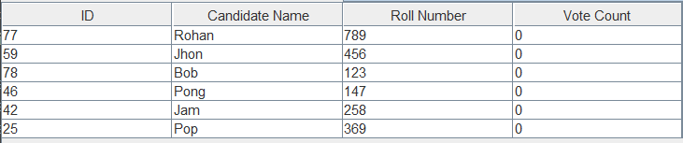

Voter table:

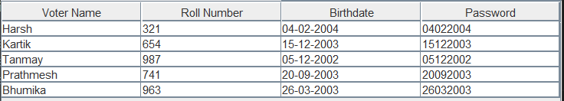

**Project Screens:**

Login page:

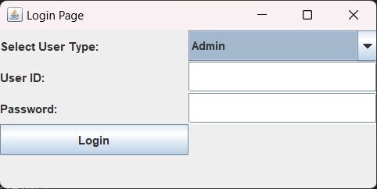

Admin panel:

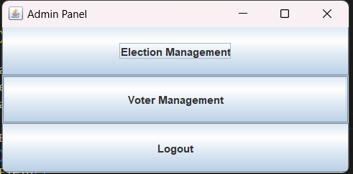

Candidate management:

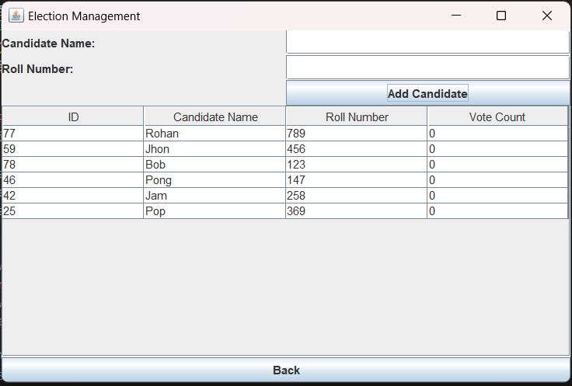

Voter Management:

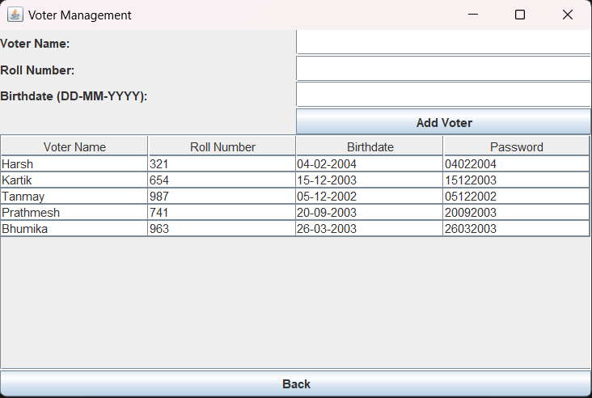

Voting Screen:

