**Online Judge**

**Problem Statement :**

A coding challenge is a competitive event in which a group of participants solve a set of coding questions within a specified timeframe, typically ranging from a few hours to a few days. Participants who have registered beforehand compete by submitting their solutions, which are evaluated against concealed test cases. Based on the test results, participants are assigned scores. An online judge is a platform that hosts these coding challenges, providing the infrastructure to manage and execute the competitions. Examples of online judges include Codechef Codeforces etc.

**Overview:**

Designing a Full Stack Online Judge Using Mern Stack.

Takes code from different users over the server. Evaluates it automatically as accepted or not accepted.

**Features :**

Here are some key features expected in the design:

**User Registration:** Participants should be able to register for future competitions by providing their personal details such as name, email, and password.

**Solution Submission:** Participants should be able to submit their solutions to the problems during the competitions. They can upload their code or provide a text-based solution through the platform.

**Profile Management:** Participants should have access to their profile, which includes personal details and their participation history. This allows them to track their progress and view their past competition performances.

**Competition Leaderboard:** Participants should be able to fetch the leaderboard of a specific competition. This leaderboard will display the rankings of participants based on their scores in that particular competition.

**Practice Problems:** The platform should provide practice problems that do not contribute to the scoring or rankings. These problems allow participants to hone their skills and gain experience without the pressure of competition.

**Solution Evaluation and Scoring:** The platform should have a mechanism to evaluate the submitted solutions against the underlying test cases and generate scores. This evaluation process should be automated to ensure fairness and accuracy in scoring.

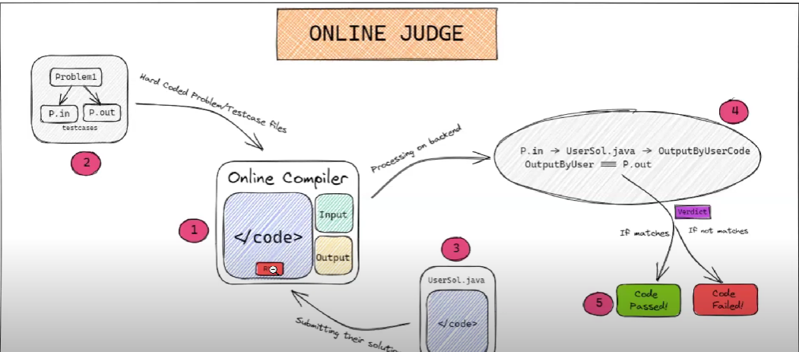

**Challenges :**

1. A scenario in which thousands of Users are Submitting the Solution at same time(Thundering Herd).
2. Someone uploads a code that has a malicious event.
3. An unauthorized person gets access to manipulate the verdicts and output on the server.

**Solutions :**

To tackle this problem, we can use Rate limiting but it is generally considered as a bad practice.

So, we can have a message queue in which we store the events to execute the code file at some time in the future This will be an Asynchronous Process.

To Tackle this we use Docker that basically makes containers . We can easily assign each container a set amount of memory and test whether that code executes within that span of memory or not. It also provides a safeguard against any user trying to eat up memory with malicious code.

Isolating our core logic using Custom Isolation. We will implement this API using Docker**.**

**High Level Design :**

1. **Database Designing**

* Collection 1: problems

Document structure:

statement: string (CharField)

name: string (CharField)

code: string (CharField)

difficulty: string (CharField, optional)

* Collection 2: solutions

Document structure:

problem: reference to the problem document (Foreign Key)

verdict: string (CharField)

submitted_at: date and time (Auto DateTime Field)

* Collection 3: test_cases

Document structure:

input: string (CharField)

output: string (CharField)

problem: reference to the problem document (Foreign Key)

* Collection 4: Login/Signup

UserId: string (CharField)

Password : string(CharField)

Email : string(CharField)

DOB : Date

FullName : string(CharField)

1. **Web Server Designing :**

* **UI:**

Screen 1: Home Screen

Problem List

Login/Signup

Screen 2: Specific Problem

Language selection

File Selection

Coding Arena

Verdict / Submission Log

Screen 3: LeaderBoard(Optional)

List of top performers.

We will have a combination of routes and controllers.

* List Problems:

**Frontend:** Create a simple list UI in React that displays the names of each problem and links them to individual problem pages.

**Backend:** Define an API endpoint in Express.js that handles a GET request to fetch all problems from the database (MongoDB) and return them to the frontend.

* Show Individual Problem:

**Frontend**: Design a template in React to display the problem name, statement, and a submission box for problem code in text format.

**Backend**: Define an API endpoint in Express.js to handle a GET request to fetch the problem details from the database and return them to the frontend.

* Code Submission:

**Frontend:** Include a submit button below the code submission box in the "Show Individual Problem" template.

**Backend:** Define an API endpoint in Express.js to handle a POST request from the frontend. This endpoint should execute the following steps:

Retrieve the test cases (input and expected output) for the problem from the database.

Evaluate the submission code using a local compiler or interpreter from the backend. You can use child_process or a similar library to call the system command for compilation or execution.

Compare the outputs from the compiler/interpreter to the expected outputs of the test cases.

Save the verdict for this submission (e.g., "Accepted," "Wrong Answer," etc.) in the database.

Return the verdict and any other relevant data to the frontend.

* Leaderboard:

**Frontend:** Create a list UI in React to display the verdicts of the last 10 submissions.

**Backend:** Define an API endpoint in Express.js to handle a GET request for fetching the solutions along with the verdicts for the last 10 submissions from the database**.**

1. **Evaluation System :**

**DOCKER :**

Use special containers running on machines with high CPU to run the submitted code. Code sand boxing is necessary so that the executions.

doesn’t consume too much of the resources

should have the appropriate privileges set so that the code doesn’t peek into system config

should have time limits set

**Other Features :**

**Plagiarism Checks(using softwares like MOSS)**

**Cache Handling**