Week 1 : assignment 2

Questions 1:

No, it is not a pure function because it depends on an instance variable rate instead of only using method parameters.   
To make it Pure , we can add it as a parameter

Question2:

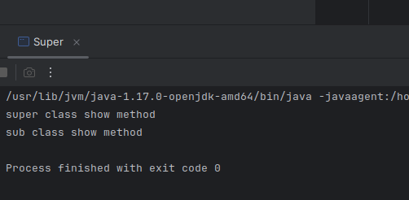

Question 3:

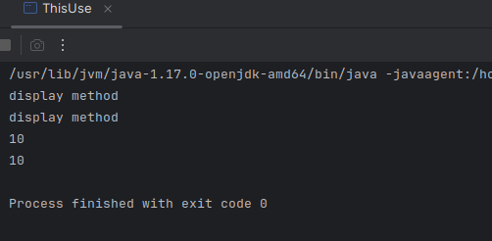

Question 4: A singleton design pattern ensures that only one instance of a class exists and provides a global access point.

Question 5: Encapsulation means hiding internal data using private access and exposing it through getters and setters.

Question 6:

