Name :- Harshvi Trivedi

Roll :- CE147

Life cycle of the stateful widget:

It consist of the 3 state:

init State (): The init State gets triggered implicitly as

soon as the State initially get initialized. It is used when we want something to happen the moment our stateful widget is created.

build (): The build method gets triggered when the widgets are constructed and appear on the screen. It is used when we want something to happen every single time when our stateful widget gets rebuild.

deactivate(): Deactivate method gets called when the stateful widget gets destroyed ( just like destructor). It is used when we want something to happen just before our stateful widget gets destroyed.

Future: A Future is an object that represents the result of an asynchronous operation and can have two states:

uncompleted or completed

Async & Await: async and await are keywords that provide a way to make asynchronous operations appear synchronous.

Delay: Creates a future that runs its computation after a delay.The computation will be executed after the given duration has passed, and the future is completed with the result of the computation.

Duration: It represents a difference from one point in time to another.

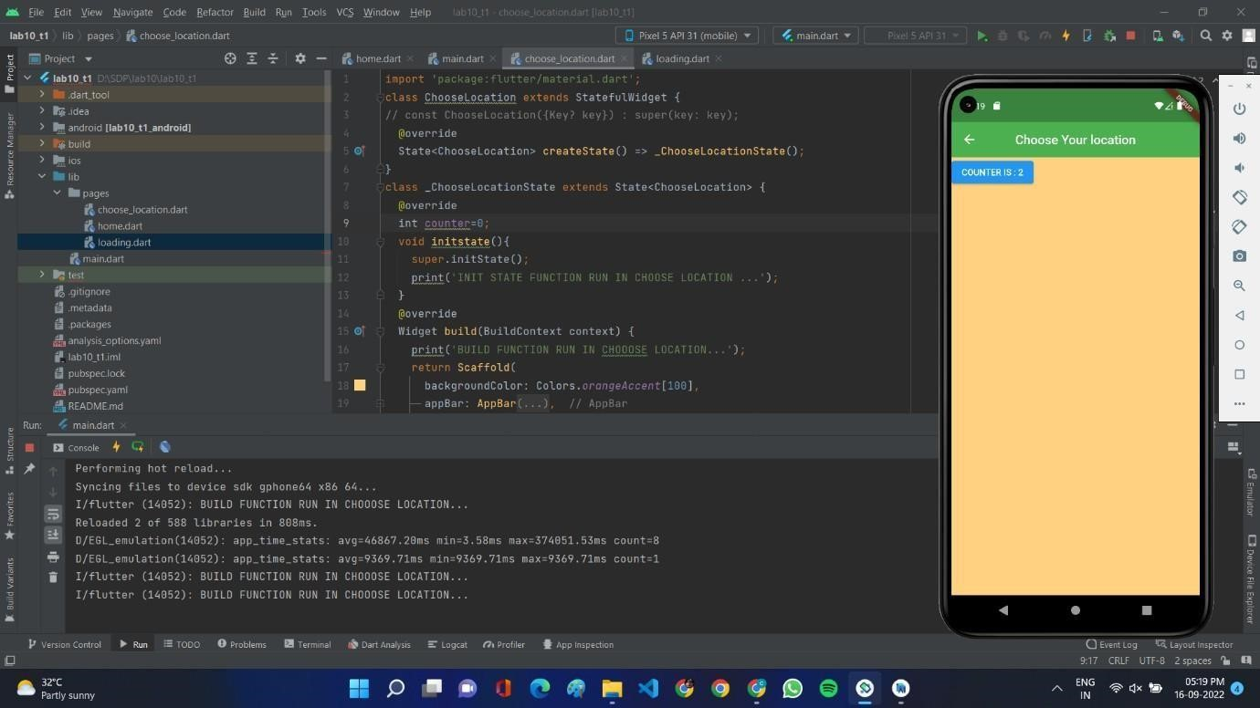

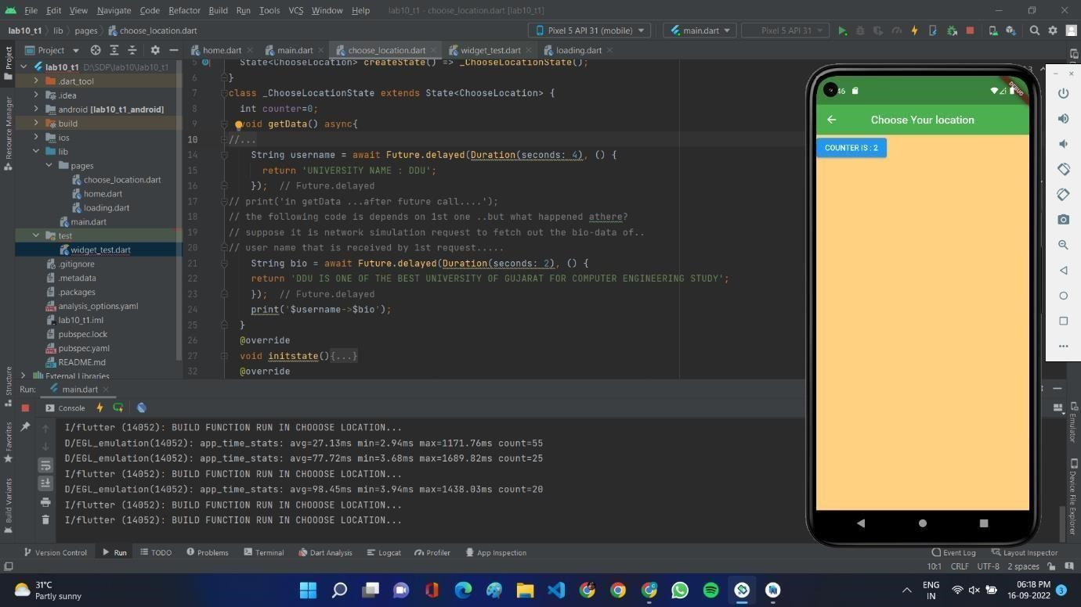

Packages and API:

Packages: A package is a namespace that contains a group of similar types of classes, interfaces, and sub- packages.

Dart Package: It passes the path of the dart file.

Plugins Package: This is the package that include APi written in dart code and depends on flutter framework.

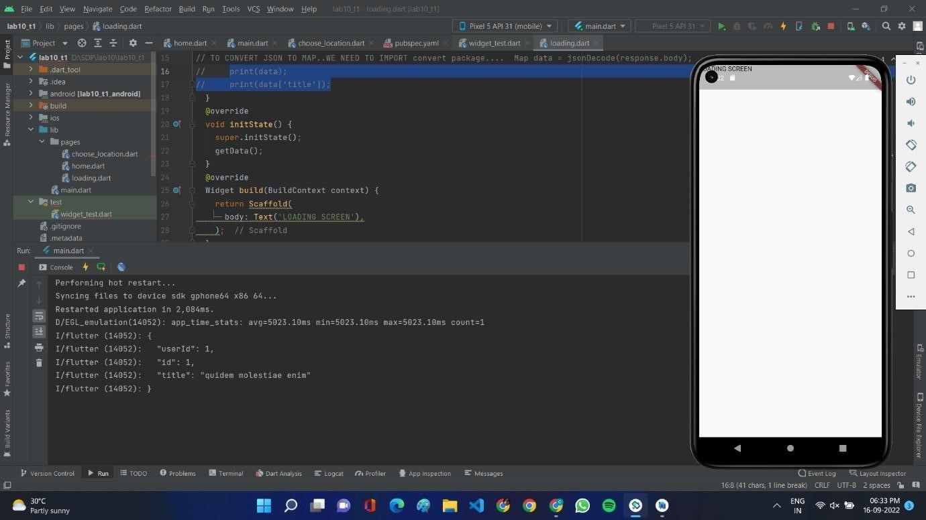

# TUTORIAL-2

Plugins: Flutter plugins are thin Dart wrappers on top of native (Java, Kotlin, ObjC, Swift) mobile APIs and services.

Federated Plugins: Federated plugins are a way of splitting support for different platforms into separate packages.

Types of federated plugins

Endorsed federated plugin: Ideally, when adding a platform implementation to a federated plugin, you will coordinate with the package author to include your implementation. In this way, the original author endorses your implementation

Non-endorsed federated plugin: If you can’t, for whatever reason, get your implementation added by the original plugin author, then your plugin is not endorsed.

