Software Engineering Lab 5

Harshvith Vydana

2110110763

Project Link: <https://online.visual-paradigm.com/community/share/untitled-1nspgehhtn>

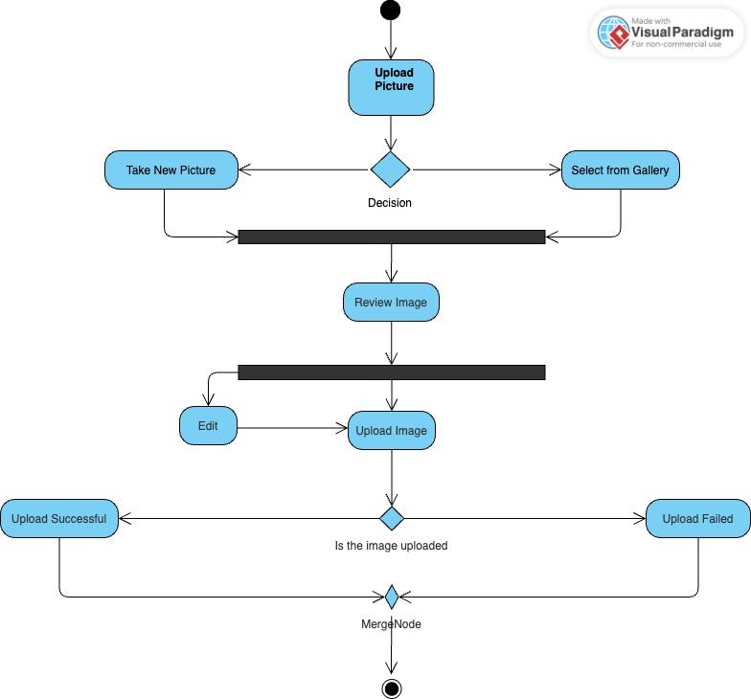

The above activity diagram can be explained as a high-level overview of the user interaction flow for uploading a picture to a website. It depicts two alternative workflows for selecting a picture: either by taking a new one with the device's camera or choosing one from the user's gallery.

Upon selecting a picture, there's an optional step for editing it before proceeding to upload it to the website. The upload itself is represented by a merge node, indicating that both workflows converge at this point. After the upload is attempted, there's a decision point to check if the operation was successful. If so, a success message is displayed; otherwise, an error message is shown to the user.

Project Link: <https://online.visual-paradigm.com/community/share/untitled-1nspkapus6>

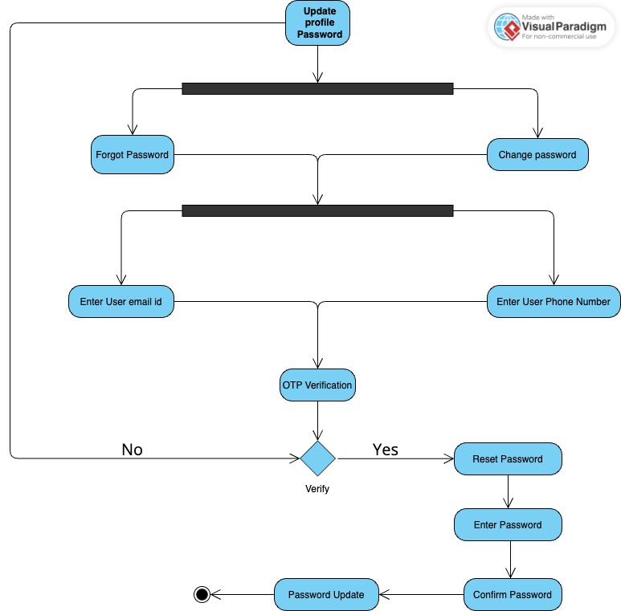

The above activity diagram depicts the process of changing a user's password.

**Initial state:** The process starts with the user attempting to update their password, indicated by the rounded rectangle labelled "Update Profile Password".

**Alternative paths:**

* **Forgot password path:** If the user forgets their current password, they can click "Forgot Password".
* **Standard password change path:** The user enters their email address and phone number. The system sends an OTP (One Time Password) for verification. The user enters the OTP. If the OTP is correct, the user proceeds to create a new password. The user confirms the new password.

The system validates the new password and updates the user's password if valid. **End state:** The process ends with the user's password being updated successfully, as shown by the rounded rectangle with a bullseye symbol. The use of decision diamonds indicates branching points based on conditions.