Name: Harshwardhan Patil

Roll No:50

Div: ITB

**Problem Statement:** Find a procedure to transfer the files from one virtual machine to another virtual machine

NAT setting of Machine1 & Machine2

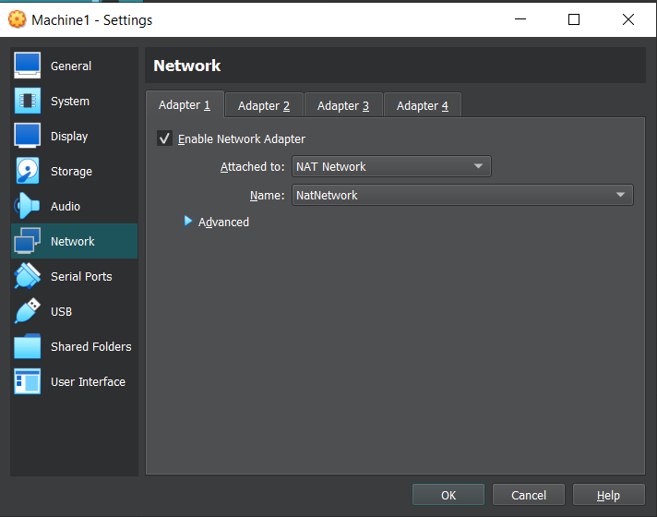

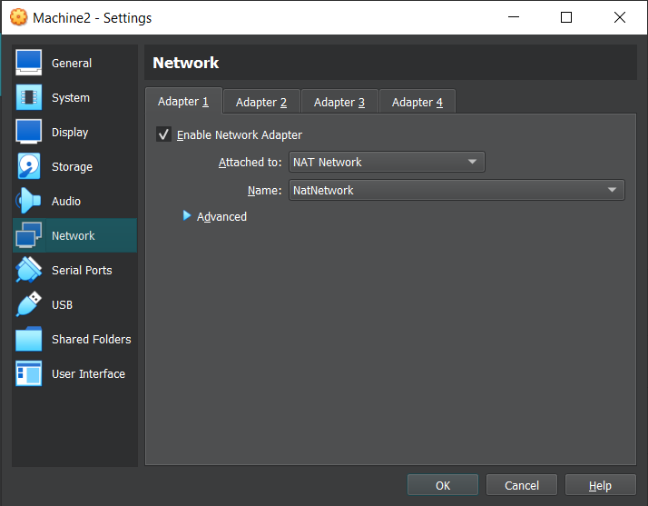

* Created a **tranfer.txt** file
* Added some content to this file
* Using **SCP** transfer protocol transferred the **transfer.txt** file to **Machine2** used the destination VM name and its address and the path to which we have to transfer the file.

**Machine 1**

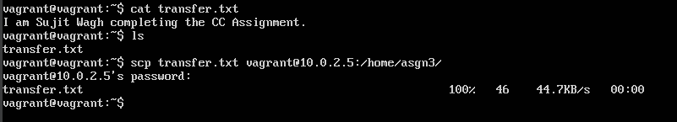

**Machine 2**

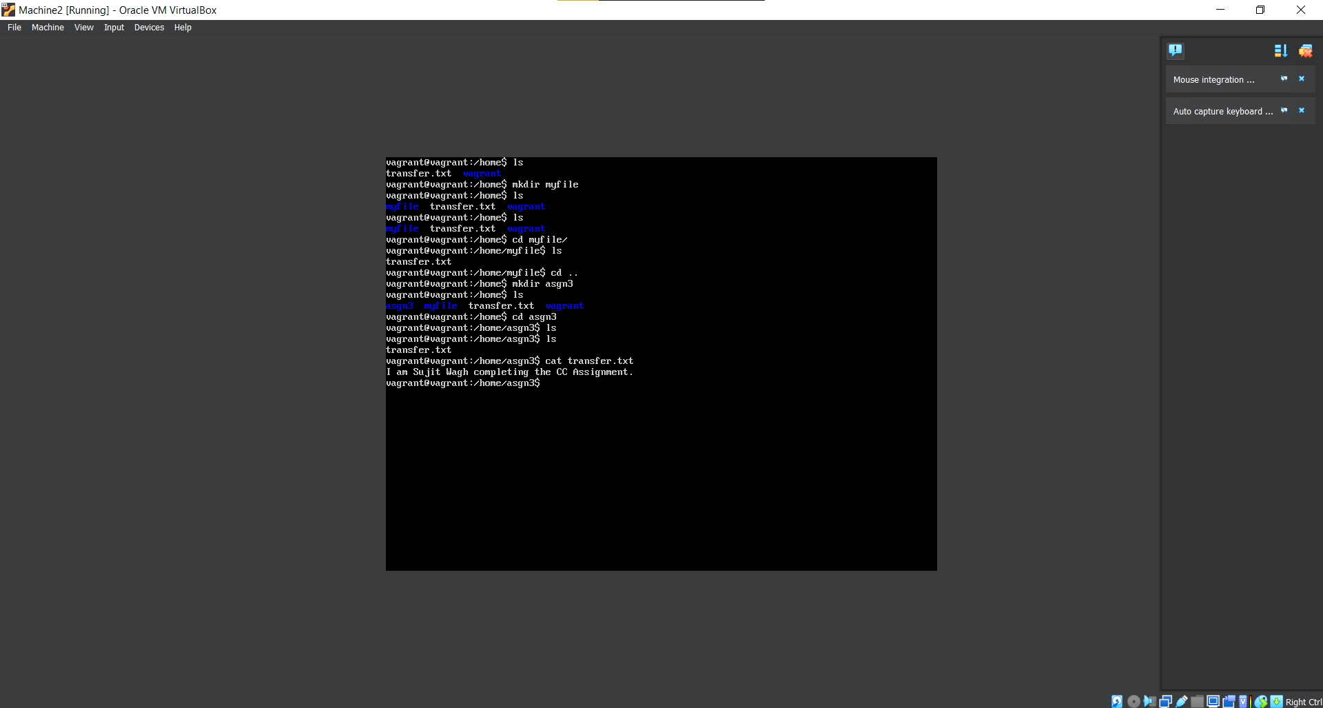

**transfer.txt file transferred to Machine2 successfully**

