Part 1: Setup & Exploration (4 points)
Task 1.1: Start the Part 2 Environment (1 pt)
Task 1.2: Count Rows in Each Shard (1 pt)
Southeast shard: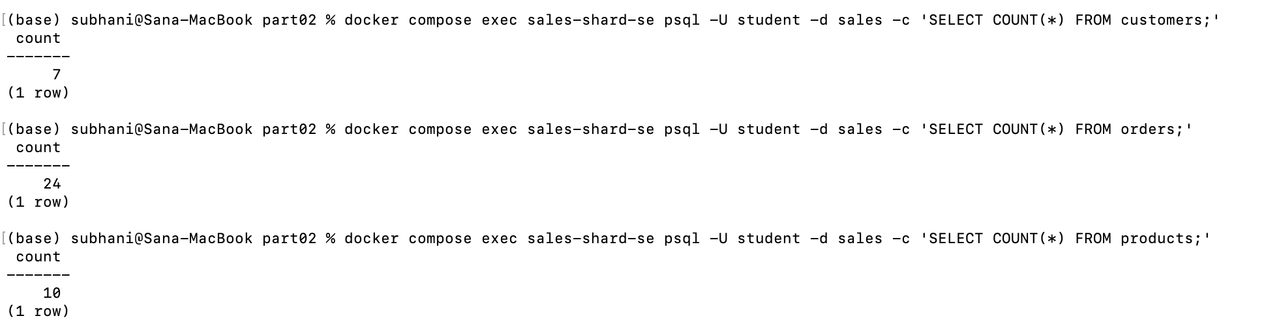
Northeast shard:
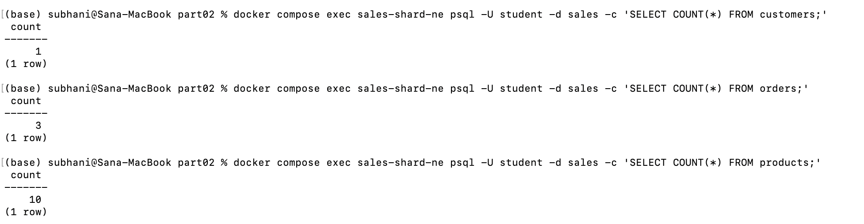
Task 1.3: Analyze Uneven Distribution (2 pts)
The current geographic sharding approach used by TechRetail creates a uneven distribution is a problem in our case as it creates hot shards in the Southeast shard as it handles majority of the data and traffic while the Northeast becomes the cold shard sits mostly idle, undermining the following core benefits of a sharded database.
- Query load balancing becomes highly skewed. ‘sales-shard-se’ will be forced to handle majority of the read and write requests, potentially becoming a performance bottleneck while the ‘sales-shard-ne’ computing power is wasted.
- Storage utilization becomes highly inefficient as Southeast shard will consume its disk space rapidly requiring premature and costly hardware upgrades, whereas the Northeast shard remains empty.
- The impact of single shard failure in Southeast shard creates a massive business’s disruption turning the shard into near-single point of failure
To produce a more even distribution, an alternative shard key like a hashed customer_id should be used. This algorithmic approach distributes records uniformly across all shards regardless of geographic location, ensuring balanced query loads, efficient storage use, and minimizing risk during localized failures.
Part 2: Update ETL Pipeline (8 points)
Task 2.1: Diagnose the ETL Failure (2 pts)
(base) subhani@Sana-MacBook part02 % docker compose exec etl-service cat /app/etl_script.py
#!/usr/bin/env python3
"""
ETL Pipeline: Operational Databases -> Data Warehouse
ISM 6562 - Midterm Part 2

This script extracts data from two operational databases (Sales and HR),
transforms it into a star schema format, and loads it into a data warehouse.

NOTE: This is the Part 1 ETL script — it still connects to a single "SALES"
database. In Part 2, you need to modify it to extract from BOTH shards
(SALES_SHARD_SE and SALES_SHARD_NE) and merge the results.

Phases:
1. EXTRACT - Read rows from sales-db and hr-db
2. TRANSFORM - Generate dim_date; denormalize employee + department
3. LOAD - Upsert dimensions and insert facts (idempotent)
"""

import os
import sys
from datetime import date, timedelta

import psycopg2
from psycopg2.extras import execute_values

# ---------------------------------------------------------------------------
# Database connection helpers
# ---------------------------------------------------------------------------

def get_connection(prefix):
"""Create a database connection using environment variables."""
return psycopg2.connect(
host=os.environ[f"{prefix}_DB_HOST"],
port=os.environ[f"{prefix}_DB_PORT"],
dbname=os.environ[f"{prefix}_DB_NAME"],
user=os.environ[f"{prefix}_DB_USER"],
password=os.environ[f"{prefix}_DB_PASSWORD"],
)

# ---------------------------------------------------------------------------
# EXTRACT phase
# ---------------------------------------------------------------------------

def extract_sales(conn):
"""Extract customers, products, and orders from the sales database."""
cur = conn.cursor()

cur.execute("SELECT customer_id, first_name, last_name, email, city, state FROM customers;")
customers = cur.fetchall()
print(f" Extracted {len(customers)} customers from sales-db")

cur.execute("SELECT product_id, product_name, category, unit_price FROM products;")
products = cur.fetchall()
print(f" Extracted {len(products)} products from sales-db")

cur.execute("""
SELECT order_id, customer_id, product_id, quantity, total_price, order_date
FROM orders;
""")
orders = cur.fetchall()
print(f" Extracted {len(orders)} orders from sales-db")

cur.close()
return customers, products, orders

def extract_hr(conn):
"""Extract employees joined with departments from the HR database."""
cur = conn.cursor()

cur.execute("""
SELECT e.employee_id, e.first_name, e.last_name, e.email,
e.job_title, d.department_name, d.location
FROM employees e
JOIN departments d ON e.department_id = d.department_id;
""")
employees = cur.fetchall()
print(f" Extracted {len(employees)} employees from hr-db")

cur.close()
return employees

# ---------------------------------------------------------------------------
# TRANSFORM phase
# ---------------------------------------------------------------------------

def generate_dim_date_rows(year):
"""Generate one row per day for the given year."""
rows = []
day_names = ["Monday", "Tuesday", "Wednesday", "Thursday",
"Friday", "Saturday", "Sunday"]
month_names = ["January", "February", "March", "April", "May", "June",
"July", "August", "September", "October", "November", "December"]

current = date(year, 1, 1)
end = date(year, 12, 31)

while current <= end:
date_key = int(current.strftime("%Y%m%d"))
rows.append((
date_key,
current,
current.year,
(current.month - 1) // 3 + 1, # quarter
current.month,
month_names[current.month - 1],
current.day,
current.weekday(), # 0=Monday
day_names[current.weekday()],
current.weekday() >= 5, # is_weekend
))
current += timedelta(days=1)

print(f" Generated {len(rows)} dim_date rows for {year}")
return rows

# ---------------------------------------------------------------------------
# LOAD phase
# ---------------------------------------------------------------------------

def load_dim_date(cur, rows):
"""Load date dimension (insert, skip conflicts)."""
execute_values(cur, """
INSERT INTO dim_date (date_key, full_date, year, quarter, month,
month_name, day_of_month, day_of_week, day_name, is_weekend)
VALUES %s
ON CONFLICT (date_key) DO NOTHING;
""", rows)
print(f" Loaded dim_date ({len(rows)} rows, conflicts skipped)")

def load_dim_customer(cur, customers):
"""Load customer dimension (upsert on source_customer_id)."""
rows = [(c[0], c[1], c[2], c[3], c[4], c[5]) for c in customers]
execute_values(cur, """
INSERT INTO dim_customer (source_customer_id, first_name, last_name, email, city, state)
VALUES %s
ON CONFLICT (source_customer_id) DO UPDATE SET
first_name = EXCLUDED.first_name,
last_name = EXCLUDED.last_name,
email = EXCLUDED.email,
city = EXCLUDED.city,
state = EXCLUDED.state;
""", rows)
print(f" Loaded dim_customer ({len(rows)} rows, upserted)")

def load_dim_product(cur, products):
"""Load product dimension (upsert on source_product_id)."""
rows = [(p[0], p[1], p[2], p[3]) for p in products]
execute_values(cur, """
INSERT INTO dim_product (source_product_id, product_name, category, unit_price)
VALUES %s
ON CONFLICT (source_product_id) DO UPDATE SET
product_name = EXCLUDED.product_name,
category = EXCLUDED.category,
unit_price = EXCLUDED.unit_price;
""", rows)
print(f" Loaded dim_product ({len(rows)} rows, upserted)")

def load_dim_employee(cur, employees):
"""Load employee dimension with denormalized department info."""
rows = [(e[0], e[1], e[2], e[3], e[4], e[5], e[6]) for e in employees]
execute_values(cur, """
INSERT INTO dim_employee (source_employee_id, first_name, last_name,
email, job_title, department_name, department_location)
VALUES %s
ON CONFLICT (source_employee_id) DO UPDATE SET
first_name = EXCLUDED.first_name,
last_name = EXCLUDED.last_name,
email = EXCLUDED.email,
job_title = EXCLUDED.job_title,
department_name = EXCLUDED.department_name,
department_location = EXCLUDED.department_location;
""", rows)
print(f" Loaded dim_employee ({len(rows)} rows, upserted)")

def load_fact_sales(cur, orders):
"""Load fact_sales by looking up surrogate keys from dimensions."""
inserted = 0
skipped = 0

for order in orders:
order_id, customer_id, product_id, quantity, total_price, order_date = order
date_key = int(order_date.strftime("%Y%m%d"))

# Look up surrogate keys
cur.execute("SELECT customer_key FROM dim_customer WHERE source_customer_id = %s;",
(customer_id,))
cust_row = cur.fetchone()

cur.execute("SELECT product_key FROM dim_product WHERE source_product_id = %s;",
(product_id,))
prod_row = cur.fetchone()

cur.execute("SELECT unit_price FROM dim_product WHERE source_product_id = %s;",
(product_id,))
price_row = cur.fetchone()

if cust_row and prod_row and price_row:
cur.execute("""
INSERT INTO fact_sales (date_key, customer_key, product_key,
source_order_id, quantity, unit_price, total_price)
VALUES (%s, %s, %s, %s, %s, %s, %s)
ON CONFLICT (source_order_id) DO NOTHING;
""", (date_key, cust_row[0], prod_row[0],
order_id, quantity, price_row[0], total_price))
if cur.rowcount > 0:
inserted += 1
else:
skipped += 1
else:
print(f" WARNING: Could not find dimension keys for order {order_id}")

print(f" Loaded fact_sales ({inserted} inserted, {skipped} already existed)")

# ---------------------------------------------------------------------------
# Main ETL orchestrator
# ---------------------------------------------------------------------------

def run_etl():
"""Execute the full ETL pipeline."""
print("=" * 60)
print("ETL Pipeline Starting")
print("=" * 60)

# --- EXTRACT ---
print("\n[EXTRACT] Reading from operational databases...")
sales_conn = get_connection("SALES")
customers, products, orders = extract_sales(sales_conn)
sales_conn.close()

hr_conn = get_connection("HR")
employees = extract_hr(hr_conn)
hr_conn.close()

# --- TRANSFORM ---
print("\n[TRANSFORM] Preparing dimension data...")
dim_date_rows = generate_dim_date_rows(2026)
print(" Employee dimension: denormalized with department info (done in extract query)")

# --- LOAD ---
print("\n[LOAD] Writing to data warehouse...")
wh_conn = get_connection("WAREHOUSE")
cur = wh_conn.cursor()

load_dim_date(cur, dim_date_rows)
load_dim_customer(cur, customers)
load_dim_product(cur, products)
load_dim_employee(cur, employees)
load_fact_sales(cur, orders)

wh_conn.commit()
cur.close()
wh_conn.close()

print("\n" + "=" * 60)
print("ETL Pipeline Complete")
print("=" * 60)

if __name__ == "__main__":
try:
run_etl()
except Exception as e:
print(f"ETL FAILED: {e}", file=sys.stderr)
sys.exit(1)

(base) subhani@Sana-MacBook part02 % docker compose logs etl-service
midterm_etl | === ETL Service Starting ===
midterm_etl | Running initial ETL load...
midterm_etl | ETL FAILED: 'SALES_DB_HOST'
midterm_etl | ============================================================
midterm_etl | ETL Pipeline Starting
midterm_etl | ============================================================
midterm_etl |
midterm_etl | [EXTRACT] Reading from operational databases...
midterm_etl | WARNING: Initial ETL run failed. Check the script and try again.
midterm_etl |
midterm_etl | Starting cron for scheduled runs (every 5 minutes)...
midterm_etl | ETL FAILED: 'SALES_DB_HOST'
midterm_etl | ============================================================
midterm_etl | ETL Pipeline Starting
midterm_etl | ============================================================
midterm_etl |
midterm_etl | [EXTRACT] Reading from operational databases...
midterm_etl | ETL FAILED: 'SALES_DB_HOST'
midterm_etl | ============================================================
midterm_etl | ETL Pipeline Starting
midterm_etl | ============================================================
midterm_etl |
midterm_etl | [EXTRACT] Reading from operational databases...
midterm_etl | ETL FAILED: 'SALES_DB_HOST'
midterm_etl | ============================================================
midterm_etl | ETL Pipeline Starting
midterm_etl | ============================================================
midterm_etl |
midterm_etl | [EXTRACT] Reading from operational databases...
midterm_etl | ETL FAILED: 'SALES_DB_HOST'
midterm_etl | ============================================================
midterm_etl | ETL Pipeline Starting
midterm_etl | ============================================================
midterm_etl |
midterm_etl | [EXTRACT] Reading from operational databases...
midterm_etl | ETL FAILED: 'SALES_DB_HOST'
midterm_etl | ============================================================
midterm_etl | ETL Pipeline Starting
midterm_etl | ============================================================
midterm_etl |
midterm_etl | [EXTRACT] Reading from operational databases...
midterm_etl | ETL FAILED: 'SALES_DB_HOST'
midterm_etl | ============================================================
midterm_etl | ETL Pipeline Starting
midterm_etl | ============================================================
midterm_etl |
midterm_etl | [EXTRACT] Reading from operational databases...
midterm_etl | ETL FAILED: 'SALES_DB_HOST'
midterm_etl | ============================================================
midterm_etl | ETL Pipeline Starting
midterm_etl | ============================================================
midterm_etl |
midterm_etl | [EXTRACT] Reading from operational databases...
midterm_etl | ETL FAILED: 'SALES_DB_HOST'
midterm_etl | ============================================================
midterm_etl | ETL Pipeline Starting
midterm_etl | ============================================================
midterm_etl |
midterm_etl | [EXTRACT] Reading from operational databases...
midterm_etl | ETL FAILED: 'SALES_DB_HOST'
midterm_etl | ============================================================
midterm_etl | ETL Pipeline Starting
midterm_etl | ============================================================
midterm_etl |
midterm_etl | [EXTRACT] Reading from operational databases...
midterm_etl | ETL FAILED: 'SALES_DB_HOST'
midterm_etl | ============================================================
midterm_etl | ETL Pipeline Starting
midterm_etl | ============================================================
midterm_etl |
midterm_etl | [EXTRACT] Reading from operational databases...
midterm_etl | ETL FAILED: 'SALES_DB_HOST'
midterm_etl | ============================================================
midterm_etl | ETL Pipeline Starting
midterm_etl | ============================================================
midterm_etl |
midterm_etl | [EXTRACT] Reading from operational databases...
midterm_etl | ETL FAILED: 'SALES_DB_HOST'
midterm_etl | ============================================================
midterm_etl | ETL Pipeline Starting
midterm_etl | ============================================================
midterm_etl |
midterm_etl | [EXTRACT] Reading from operational databases...
midterm_etl | ETL FAILED: 'SALES_DB_HOST'
midterm_etl | ============================================================
midterm_etl | ETL Pipeline Starting
midterm_etl | ============================================================
midterm_etl |
midterm_etl | [EXTRACT] Reading from operational databases...
midterm_etl | ETL FAILED: 'SALES_DB_HOST'
midterm_etl | ============================================================
midterm_etl | ETL Pipeline Starting
midterm_etl | ============================================================
midterm_etl |
midterm_etl | [EXTRACT] Reading from operational databases...
midterm_etl | ETL FAILED: 'SALES_DB_HOST'
midterm_etl | ============================================================
midterm_etl | ETL Pipeline Starting
midterm_etl | ============================================================
midterm_etl |
midterm_etl | [EXTRACT] Reading from operational databases...
midterm_etl | ETL FAILED: 'SALES_DB_HOST'
midterm_etl | ============================================================
midterm_etl | ETL Pipeline Starting
midterm_etl | ============================================================
midterm_etl |
midterm_etl | [EXTRACT] Reading from operational databases...
midterm_etl | ETL FAILED: 'SALES_DB_HOST'
midterm_etl | ============================================================
midterm_etl | ETL Pipeline Starting
midterm_etl | ============================================================
midterm_etl |
midterm_etl | [EXTRACT] Reading from operational databases...
midterm_etl | ETL FAILED: 'SALES_DB_HOST'
midterm_etl | ============================================================
midterm_etl | ETL Pipeline Starting
midterm_etl | ============================================================
midterm_etl |
midterm_etl | [EXTRACT] Reading from operational databases...
midterm_etl | ETL FAILED: 'SALES_DB_HOST'
midterm_etl | ============================================================
midterm_etl | ETL Pipeline Starting
midterm_etl | ============================================================
midterm_etl |
midterm_etl | [EXTRACT] Reading from operational databases...
midterm_etl | ETL FAILED: 'SALES_DB_HOST'
midterm_etl | ============================================================
midterm_etl | ETL Pipeline Starting
midterm_etl | ============================================================
midterm_etl |
midterm_etl | [EXTRACT] Reading from operational databases...
midterm_etl | ETL FAILED: 'SALES_DB_HOST'
midterm_etl | ============================================================
midterm_etl | ETL Pipeline Starting
midterm_etl | ============================================================
midterm_etl |
midterm_etl | [EXTRACT] Reading from operational databases...
midterm_etl | ETL FAILED: 'SALES_DB_HOST'
midterm_etl | ============================================================
midterm_etl | ETL Pipeline Starting
midterm_etl | ============================================================
midterm_etl |
midterm_etl | [EXTRACT] Reading from operational databases...
midterm_etl | ETL FAILED: 'SALES_DB_HOST'
midterm_etl | ============================================================
midterm_etl | ETL Pipeline Starting
midterm_etl | ============================================================
midterm_etl |
midterm_etl | [EXTRACT] Reading from operational databases...
midterm_etl | ETL FAILED: 'SALES_DB_HOST'
midterm_etl | ============================================================
midterm_etl | ETL Pipeline Starting
midterm_etl | ============================================================
midterm_etl |
midterm_etl | [EXTRACT] Reading from operational databases...
midterm_etl | ETL FAILED: 'SALES_DB_HOST'
midterm_etl | ============================================================
midterm_etl | ETL Pipeline Starting
midterm_etl | ============================================================
midterm_etl |
midterm_etl | [EXTRACT] Reading from operational databases...
midterm_etl | ETL FAILED: 'SALES_DB_HOST'
midterm_etl | ============================================================
midterm_etl | ETL Pipeline Starting
midterm_etl | ============================================================
midterm_etl |
midterm_etl | [EXTRACT] Reading from operational databases...
midterm_etl | ETL FAILED: 'SALES_DB_HOST'
midterm_etl | ============================================================
midterm_etl | ETL Pipeline Starting
midterm_etl | ============================================================
midterm_etl |
midterm_etl | [EXTRACT] Reading from operational databases...
midterm_etl | ETL FAILED: 'SALES_DB_HOST'
midterm_etl | ============================================================
midterm_etl | ETL Pipeline Starting
midterm_etl | ============================================================
midterm_etl |
midterm_etl | [EXTRACT] Reading from operational databases...
midterm_etl | ETL FAILED: 'SALES_DB_HOST'
midterm_etl | ============================================================
midterm_etl | ETL Pipeline Starting
midterm_etl | ============================================================
midterm_etl |
midterm_etl | [EXTRACT] Reading from operational databases...
midterm_etl | ETL FAILED: 'SALES_DB_HOST'
midterm_etl | ============================================================
midterm_etl | ETL Pipeline Starting
midterm_etl | ============================================================
midterm_etl |
midterm_etl | [EXTRACT] Reading from operational databases...
midterm_etl | ETL FAILED: 'SALES_DB_HOST'
midterm_etl | ============================================================
midterm_etl | ETL Pipeline Starting
midterm_etl | ============================================================
midterm_etl |
midterm_etl | [EXTRACT] Reading from operational databases...
midterm_etl | ETL FAILED: 'SALES_DB_HOST'
midterm_etl | ============================================================
midterm_etl | ETL Pipeline Starting
midterm_etl | ============================================================
midterm_etl |
midterm_etl | [EXTRACT] Reading from operational databases...
midterm_etl | ETL FAILED: 'SALES_DB_HOST'
midterm_etl | ============================================================
midterm_etl | ETL Pipeline Starting
midterm_etl | ============================================================
midterm_etl |
midterm_etl | [EXTRACT] Reading from operational databases...
midterm_etl | ETL FAILED: 'SALES_DB_HOST'
midterm_etl | ============================================================
midterm_etl | ETL Pipeline Starting
midterm_etl | ============================================================
midterm_etl |
midterm_etl | [EXTRACT] Reading from operational databases...
midterm_etl | ETL FAILED: 'SALES_DB_HOST'
midterm_etl | ============================================================
midterm_etl | ETL Pipeline Starting
midterm_etl | ============================================================
midterm_etl |
midterm_etl | [EXTRACT] Reading from operational databases...
midterm_etl | ETL FAILED: 'SALES_DB_HOST'
midterm_etl | ============================================================
midterm_etl | ETL Pipeline Starting
midterm_etl | ============================================================
midterm_etl |
midterm_etl | [EXTRACT] Reading from operational databases...
midterm_etl | ETL FAILED: 'SALES_DB_HOST'
midterm_etl | ============================================================
midterm_etl | ETL Pipeline Starting
midterm_etl | ============================================================
midterm_etl |
midterm_etl | [EXTRACT] Reading from operational databases...
midterm_etl | ETL FAILED: 'SALES_DB_HOST'
midterm_etl | ============================================================
midterm_etl | ETL Pipeline Starting
midterm_etl | ============================================================
midterm_etl |
midterm_etl | [EXTRACT] Reading from operational databases...
midterm_etl | ETL FAILED: 'SALES_DB_HOST'
midterm_etl | ============================================================
midterm_etl | ETL Pipeline Starting
midterm_etl | ============================================================
midterm_etl |
midterm_etl | [EXTRACT] Reading from operational databases...
midterm_etl | ETL FAILED: 'SALES_DB_HOST'
midterm_etl | ============================================================
midterm_etl | ETL Pipeline Starting
midterm_etl | ============================================================
midterm_etl |
midterm_etl | [EXTRACT] Reading from operational databases...
(base) subhani@Sana-MacBook part02 %

The ETL pipeline currently fails because the script attempts to connect to a single database using the get_connection("SALES") function. This function looks for environment variables like SALES_DB_HOST, but the new sharded architecture in the Docker Compose file provides SALES_SHARD_SE_DB_HOST and SALES_SHARD_NE_DB_HOST instead.
To fix this, the single get_connection("SALES") must be replaced with two distinct connection for Southeast shard and the Northeast shard. The extraction logic must be updated to query both shards independently. After extracting the data, the script must merge the customer and order records from both shards into a unified list. Because the products table is identically replicated across shards as a reference table, it only needs to be extracted from one of the shards before continuing to the transform phase.
Task 2.2: Modify the ETL Script (4 pts)
# --- EXTRACT ---
print("\n[EXTRACT] Reading from operational databases...")
sales_se_conn = get_connection("SALES_SHARD_SE")
sales_ne_conn = get_connection("SALES_SHARD_NE")

# Southeast shard - extract customers, products, orders
se_customers, se_products, se_orders = extract_sales(sales_se_conn)
sales_se_conn.close()

# Northeast shard - extract customers, products, orders
ne_customers, ne_products, ne_orders = extract_sales(sales_ne_conn)
sales_ne_conn.close()

# Merge the data
customers = se_customers + ne_customers
orders = se_orders + ne_orders
products = se_products # As a reference table choosing one shard's products is sufficient

# HR data
hr_conn = get_connection("HR")
employees = extract_hr(hr_conn)
hr_conn.close()
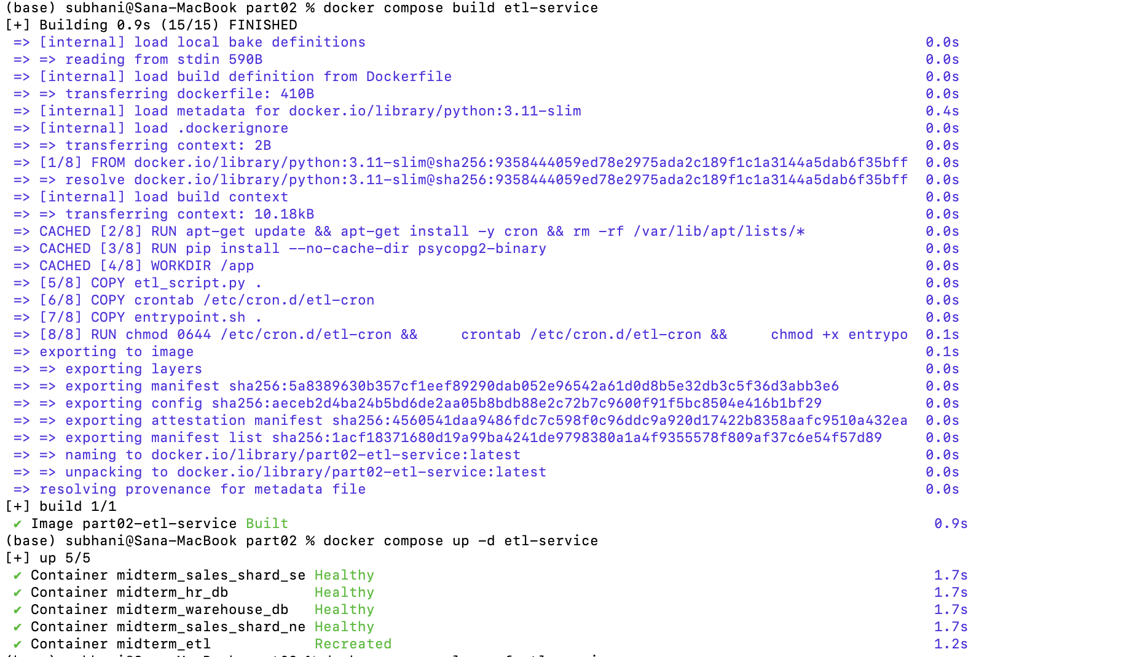
) subhani@Sana-MacBook part02 % docker compose logs -f etl-service
midterm_etl | === ETL Service Starting ===
midterm_etl | Running initial ETL load...
midterm_etl | Extracted 7 customers from sales-db
midterm_etl | Extracted 10 products from sales-db
midterm_etl | Extracted 24 orders from sales-db
midterm_etl | Extracted 1 customers from sales-db
midterm_etl | Extracted 10 products from sales-db
midterm_etl | Extracted 3 orders from sales-db
midterm_etl | Extracted 12 employees from hr-db
midterm_etl |
midterm_etl | [TRANSFORM] Preparing dimension data...
midterm_etl | Generated 365 dim_date rows for 2026
midterm_etl | Employee dimension: denormalized with department info (done in extract query)
midterm_etl |
midterm_etl | [LOAD] Writing to data warehouse...
midterm_etl | Loaded dim_date (365 rows, conflicts skipped)
midterm_etl | Loaded dim_customer (8 rows, upserted)
midterm_etl | Loaded dim_product (10 rows, upserted)
midterm_etl | Loaded dim_employee (12 rows, upserted)
midterm_etl | Loaded fact_sales (27 inserted, 0 already existed)
midterm_etl |
midterm_etl | ============================================================
midterm_etl | ETL Pipeline Complete
midterm_etl | ============================================================
midterm_etl |
midterm_etl | Starting cron for scheduled runs (every 5 minutes)...
midterm_etl | Extracted 7 customers from sales-db
midterm_etl | Extracted 10 products from sales-db
midterm_etl | Extracted 24 orders from sales-db
midterm_etl | Extracted 1 customers from sales-db
midterm_etl | Extracted 10 products from sales-db
midterm_etl | Extracted 3 orders from sales-db
midterm_etl | Extracted 12 employees from hr-db
midterm_etl |
midterm_etl | [TRANSFORM] Preparing dimension data...
midterm_etl | Generated 365 dim_date rows for 2026
midterm_etl | Employee dimension: denormalized with department info (done in extract query)
midterm_etl |
midterm_etl | [LOAD] Writing to data warehouse...
midterm_etl | Loaded dim_date (365 rows, conflicts skipped)
midterm_etl | Loaded dim_customer (8 rows, upserted)
midterm_etl | Loaded dim_product (10 rows, upserted)
midterm_etl | Loaded dim_employee (12 rows, upserted)
midterm_etl | Loaded fact_sales (0 inserted, 27 already existed)
midterm_etl |
midterm_etl | ============================================================
midterm_etl | ETL Pipeline Complete
midterm_etl | ============================================================
midterm_etl | Extracted 7 customers from sales-db
midterm_etl | Extracted 10 products from sales-db
midterm_etl | Extracted 24 orders from sales-db
midterm_etl | Extracted 1 customers from sales-db
midterm_etl | Extracted 10 products from sales-db
midterm_etl | Extracted 3 orders from sales-db
midterm_etl | Extracted 12 employees from hr-db
midterm_etl |
midterm_etl | [TRANSFORM] Preparing dimension data...
midterm_etl | Generated 365 dim_date rows for 2026
midterm_etl | Employee dimension: denormalized with department info (done in extract query)
midterm_etl |
midterm_etl | [LOAD] Writing to data warehouse...
midterm_etl | Loaded dim_date (365 rows, conflicts skipped)
midterm_etl | Loaded dim_customer (8 rows, upserted)
midterm_etl | Loaded dim_product (10 rows, upserted)
midterm_etl | Loaded dim_employee (12 rows, upserted)
midterm_etl | Loaded fact_sales (0 inserted, 27 already existed)
midterm_etl |
midterm_etl | ============================================================
midterm_etl | ETL Pipeline Complete
midterm_etl | ============================================================

Task 2.3: Verify Warehouse Data (2 pts)
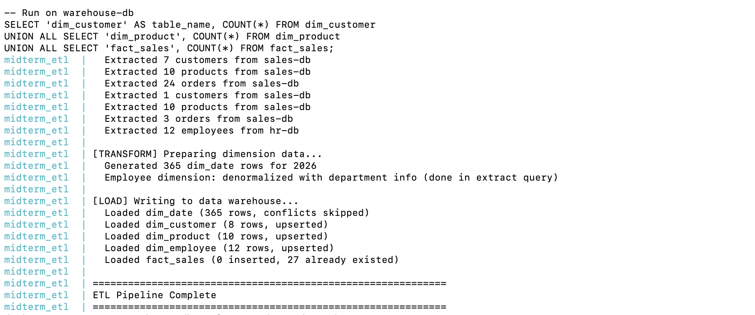
Task 2.3: Verify Warehouse Data (2 pts)
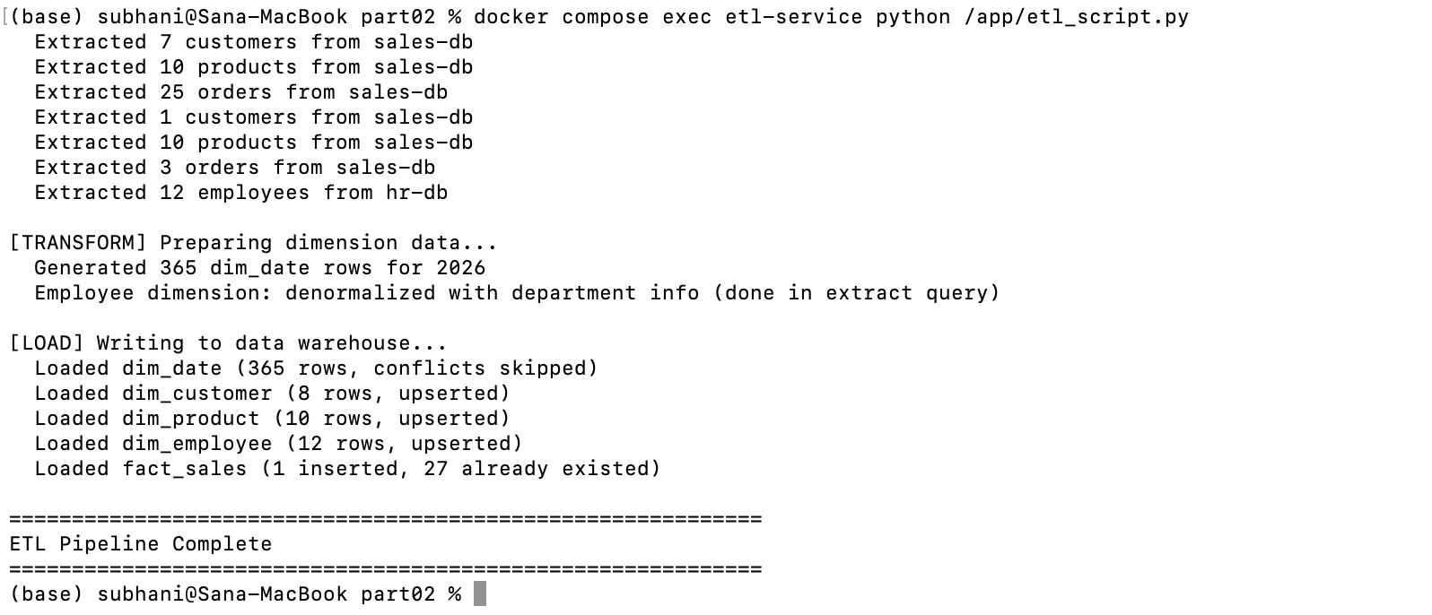
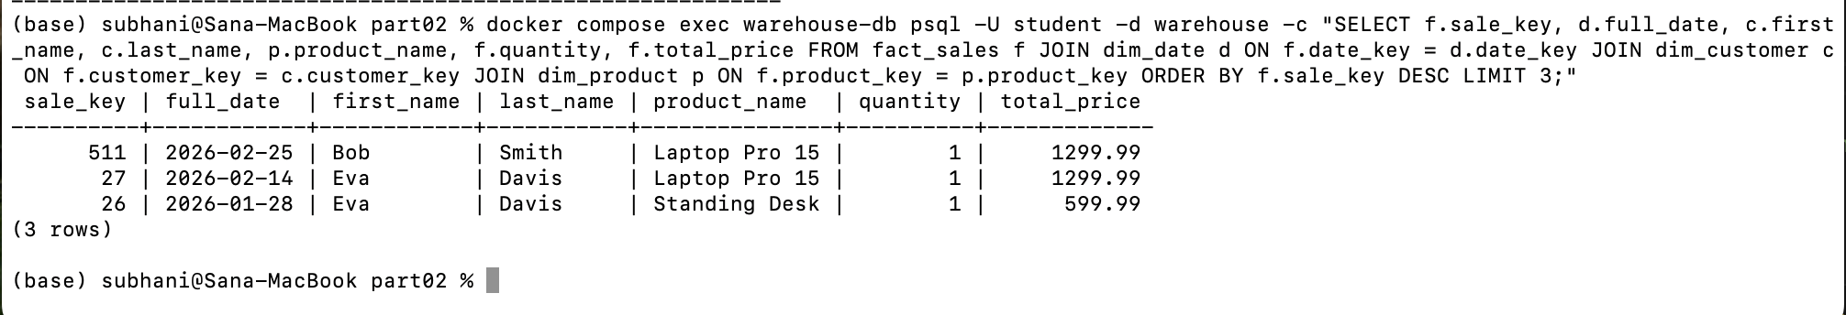
Part 3: Cross-Shard Challenges (4 points)
Task 3.1: Cross-Shard Query Attempt (2 pts)
For SouthEastern Shard
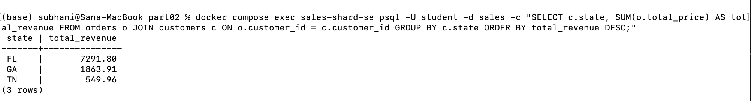
For NorthEastern Shard
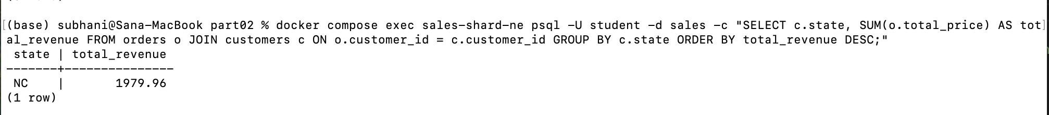
The Limitation we face is neither shard provides us with the entire total revenue generated by all the states of the company. The Northeast shard only calculates revenue for North Carolina, while the Southeast shard is limited to Florida, Georgia, and Tennessee. Because shards are entirely independent databases, relational features like aggregations (SUM) and JOINs cannot operate across them natively. To generate a unified, company-wide revenue report, we must write application-level code to query every individual shard separately, hold the data in memory, and manually aggregate the final totals. Due to this the application complexity will be a fundamental limitation and trade-off of using a horizontally sharded architecture.
Task 3.2: Sharding Trade-off Analysis (2 pts)
Sharding the TechRetail sales database by region of Northeast and Southeast shards has showed us both the benefits and its limitations. The benefits of using geographic sharding is it provides excellent data locality which means user requests hit a server physically closer to them to reduce latency. It also allows for independent scaling. For instance if the Southeast market grows rapidly, that specific shard can be upgraded without wasting resources upgrading the idle Northeast shard. The system will gains the fault isolation where a crash on the Northeast server will not prevent Southeast customers from placing orders. Finally, dividing the database reduces individual table sizes, which speeds up local query execution and index lookups within each respective shard.
However, this specific implementation also has its major drawbacks which we faced such as the uneven data distribution created a severe "hot shard" in the Southeast, bottlenecking resources and negating the primary goal of load balancing. Querying also became much harder as we can't do cross-shard database aggregations natively. We also lose cross-shard foreign keys and transactions, making global data integrity tricky. We must write custom application-level code just to calculate total revenue. From a maintenance perspective, reference tables (like products) demand continuous synchronization across all shards to prevent anomalies. Finally, this distributed setup also increases ETL pipeline complexity as it requires the extraction and manual merging of data from multiple independent operational sources before it can reach the warehouse.
Part 4: EXPLAIN ANALYZE (4 points)
Task 4.1: Query Plan on the SE Shard (2 pts)
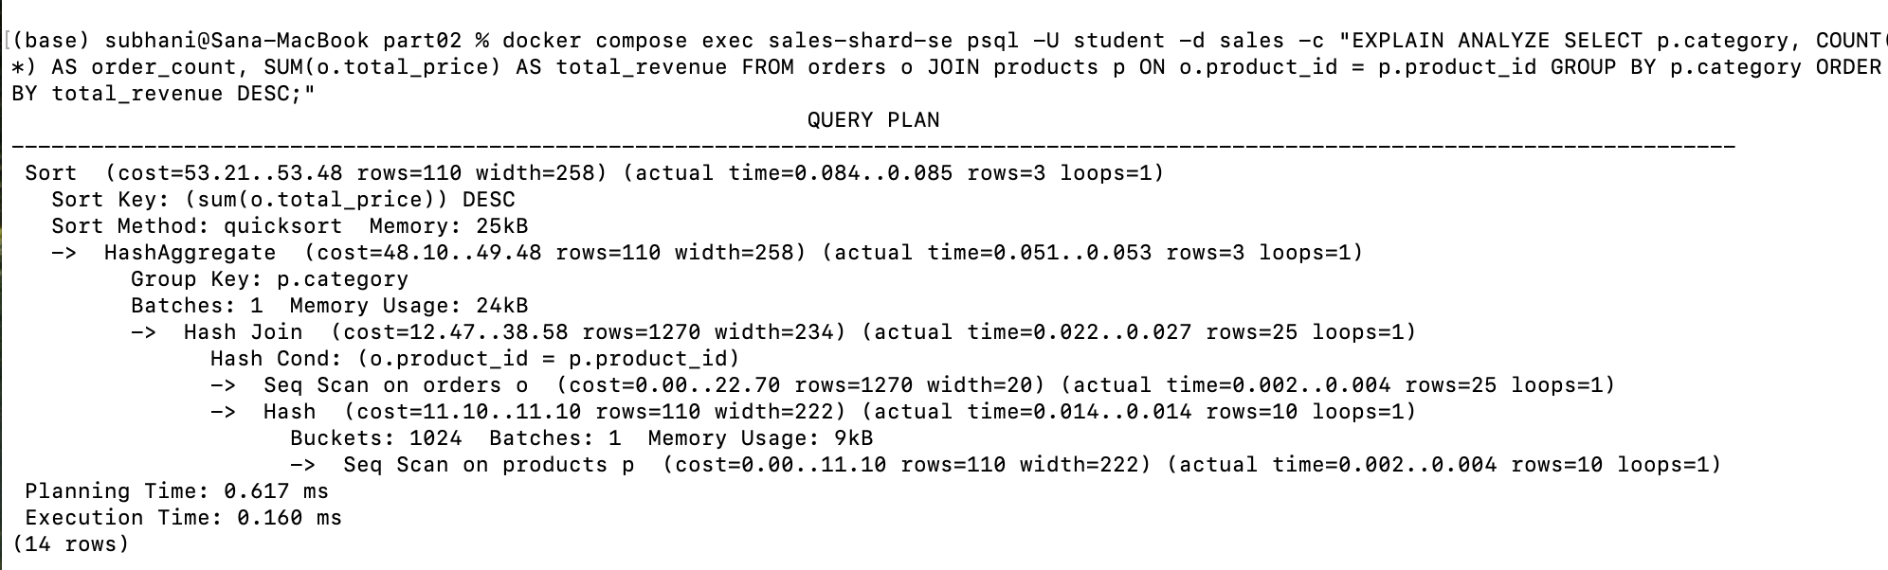
Task 4.2: Query Plan on the Warehouse (2 pts)

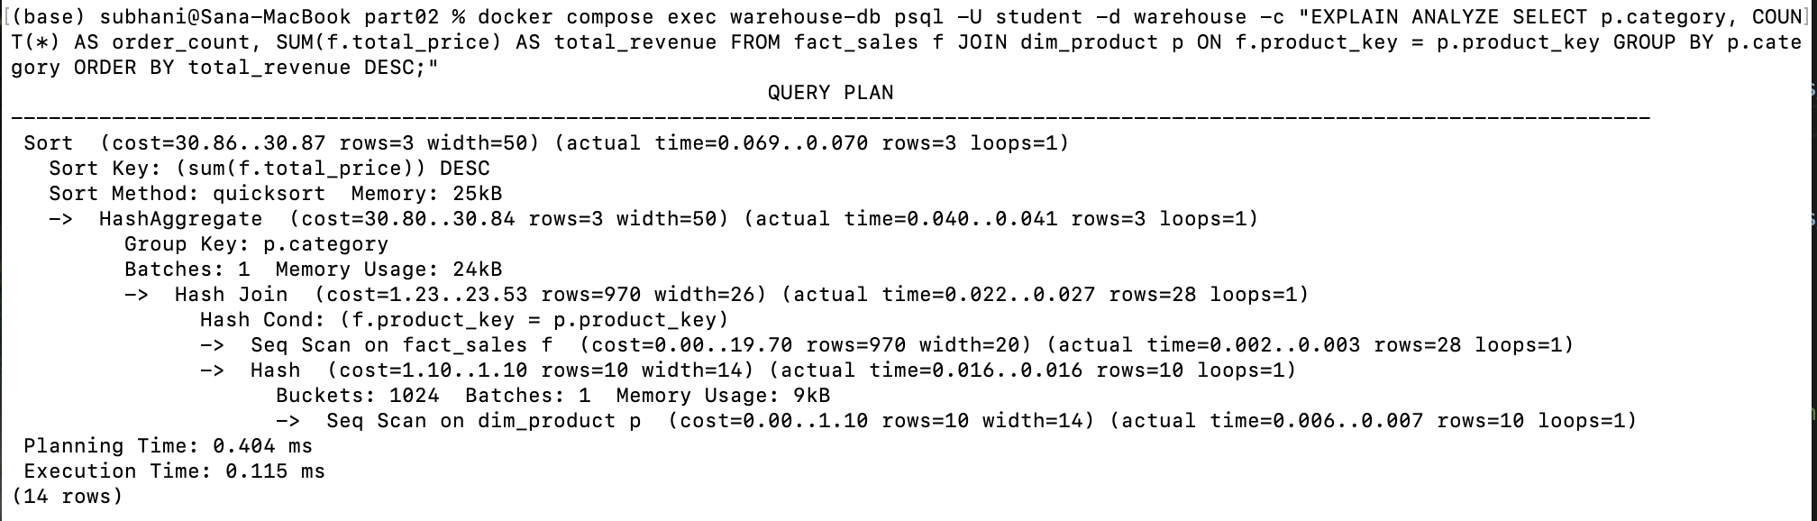
The warehouse query plan remains unaffected by the operational sharding because the data warehouse acts as a centralized, unified repository. Through the ETL pipeline, data from both the Southeast and Northeast operational shards is extracted, merged, and loaded into a single star schema and when running analytical queries against the warehouse, we query this consolidated dataset completely insulated from the underlying operational complexity. Because of this, the database engine does not have to perform cross-shard logic, manage distributed nodes, or manually aggregate separate results as it can execute a straightforward local JOIN between the fact_sales and dim_product tables. This separation of concerns is a main benefit of the ETL-to-warehouse architecture which helps the` operational databases to scale horizontally via sharding while keeping analytical queries simple, fast, and optimized.

