Midterm Group Project - Part 1: Operational Databases, Data Warehousing, and ETL – Team – Alpha Developers
Repository link - https://github.com/Harshxth/ism6562-midterm-alpha_developers

Part 1: Environment Setup (3 points
Task 1.1: Start the Docker Compose Environment
docker compose ps
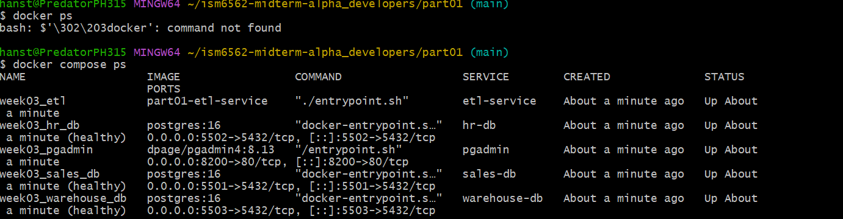
Task 1.2: Connect to Each Database via psql
docker compose exec sales-db psql -U student -d sales -c '\dt'
docker compose exec hr-db psql -U student -d hr -c '\dt'
docker compose exec warehouse-db psql -U student -d warehouse -c '\dt'
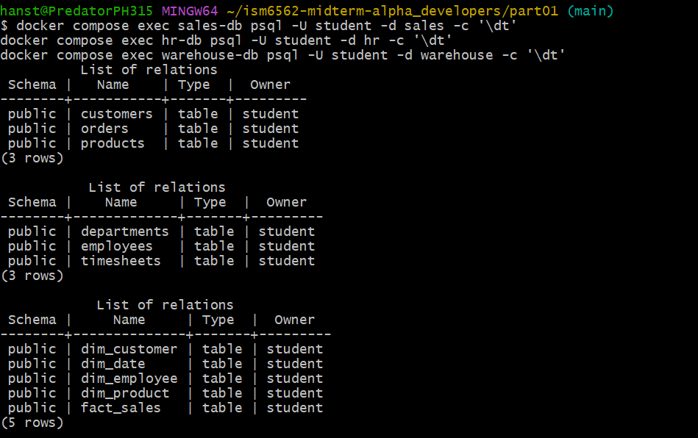
Task 1.3: Register All Three Servers in pgAdmin
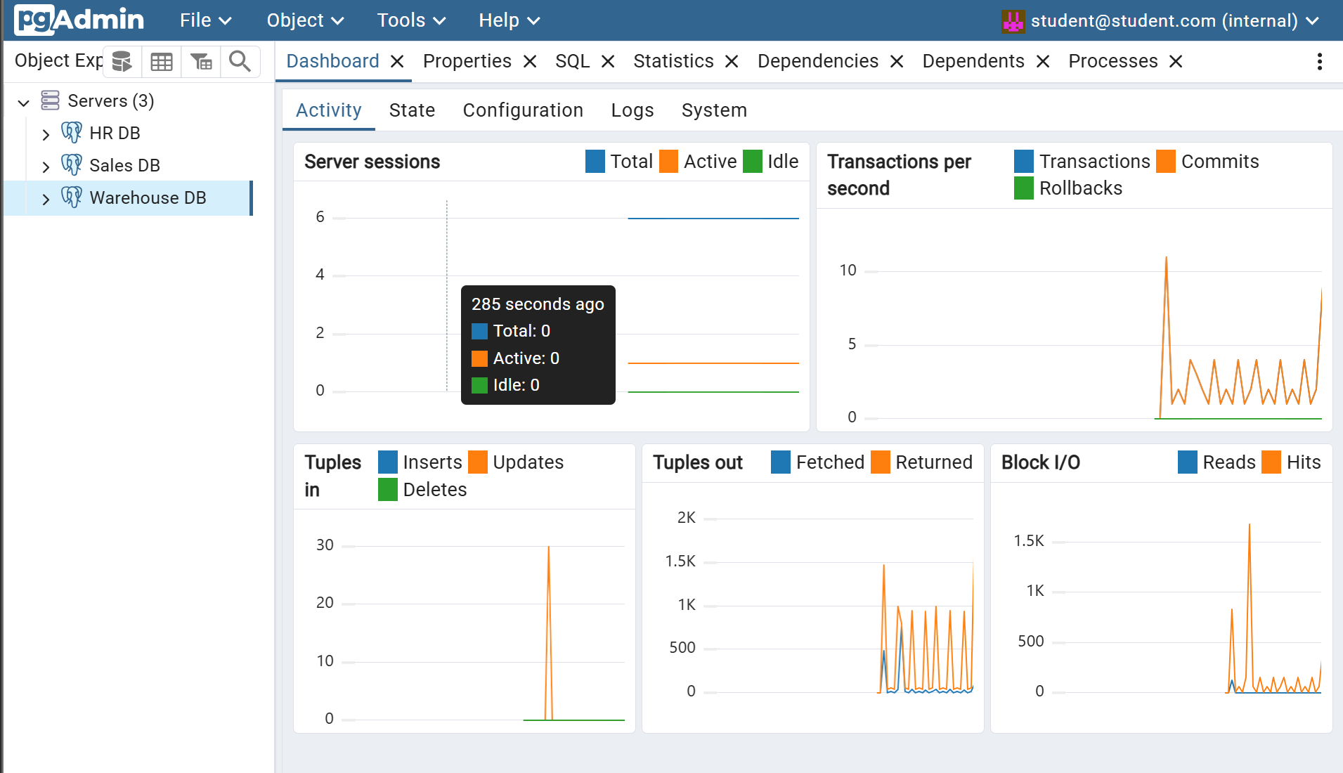

Part 2: Explore Operational Databases (4 points)
Task 2.1: Examine the Sales Schema
docker compose exec sales-db psql -U student -d sales
\d customers
\d products
\d orders
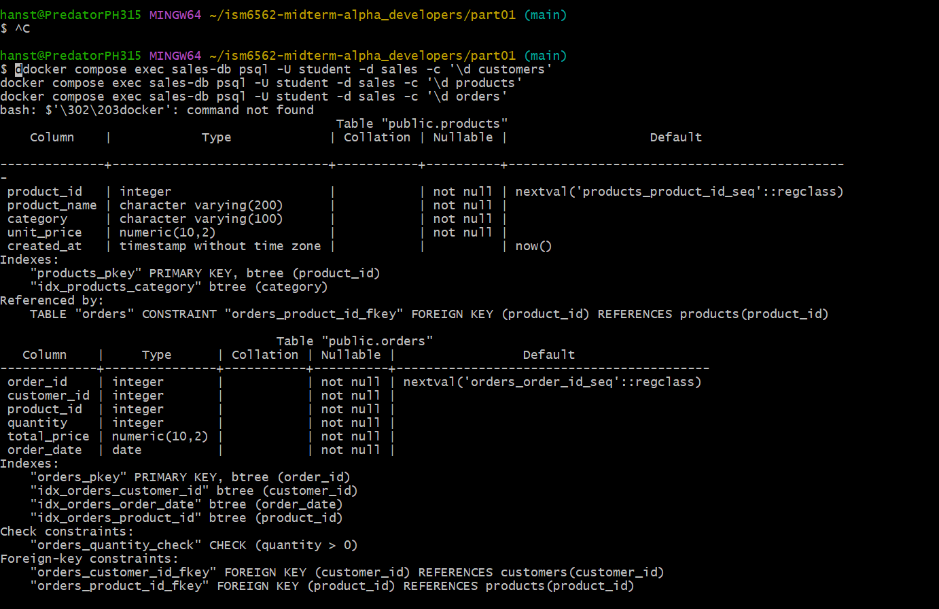
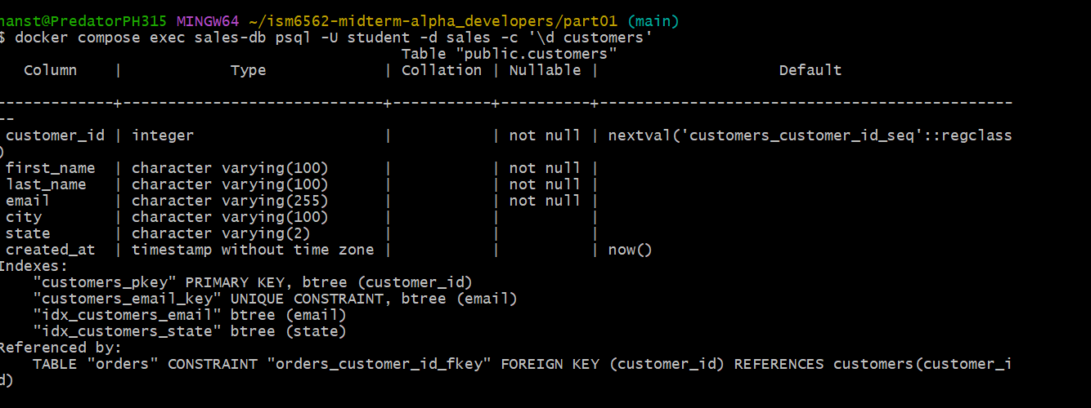
The sales schema is normalized into three tables — customers, products, and orders. Each has its own primary key (customer_id, product_id, order_id). Instead of repeating customer names or product details in every order row, the orders table just stores the IDs as foreign keys that point back to the other tables. So if Alice Johnson places 5 orders, her name and state are stored once in customers, not 5 times. The quantity check and the indexes on customer_id and order_date show the schema is also built for query performance without sacrificing normalization.

Task 2.2: Examine the HR Schema
docker compose exec hr-db psql -U student -d hr
\d departments
\d employees
\d timesheets
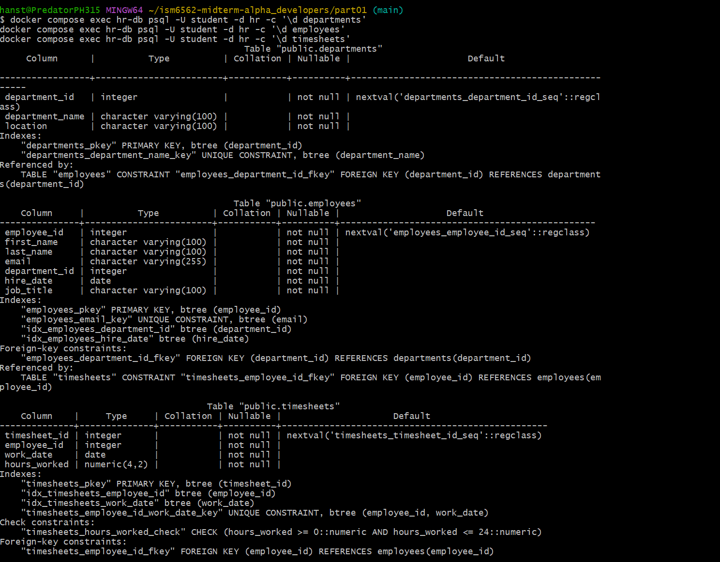
The three HR tables follow a simple chain — departments > employees > timesheets. Employees belong to a department via department_id, and timesheets belong to an employee via employee_id. The UNIQUE constraint on (employee_id, work_date) is essentially a guard against duplicates — it makes it impossible to accidentally log hours twice for the same person on the same day, which would mess up payroll calculations. The hours_worked check (0–24) prevents garbage data like negative hours or 30-hour workdays from getting in.
Task 2.3: Run Queries Against the Operational Databases
Query 1 - Total Revenue by Product Category:
Electronics dominates with 15 orders and $7,199.81 in revenue, followed by Furniture ($2,789.92) and Books ($395.91).
Query 2 - Customers with Most Orders:
Alice Johnson (FL) leads with 5 orders, followed by Carol Williams and Bob Smith with 4 each. All 8 customers are represented.
Query 3 - Employee Count per Department:
All 4 departments (HR, Marketing, Sales, Engineering) have exactly 3 employees each across Tampa, Orlando, and Miami locations.
Query 4 - Total Hours Worked (Jan 2026):
Engineering logged the most hours (158.00), with an average of 7.9 hrs/entry. All departments averaged between 7.7–7.9 hrs/entry.
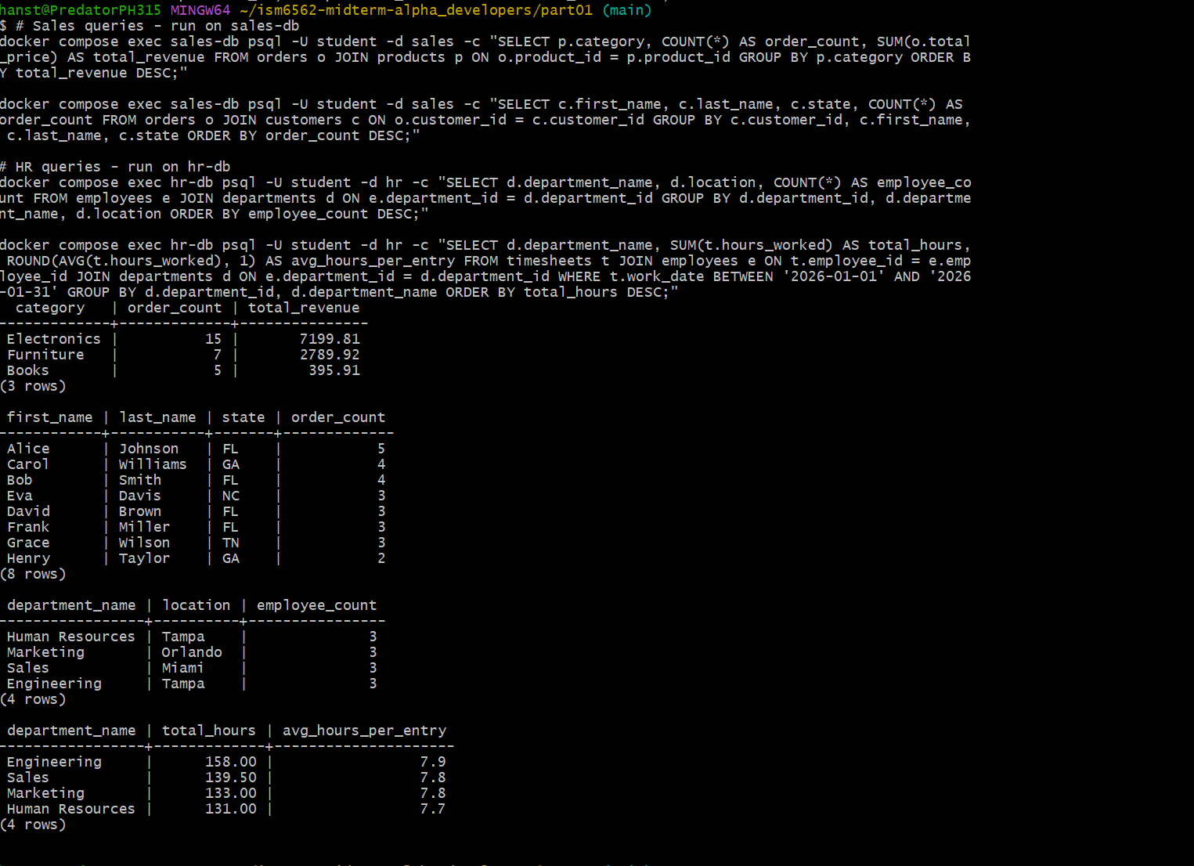

Part 3: Data Warehouse Concepts (4 points)
Task 3.1: Examine the Star Schema
docker compose exec warehouse-db psql -U student -d warehouse -c '\d dim_date'
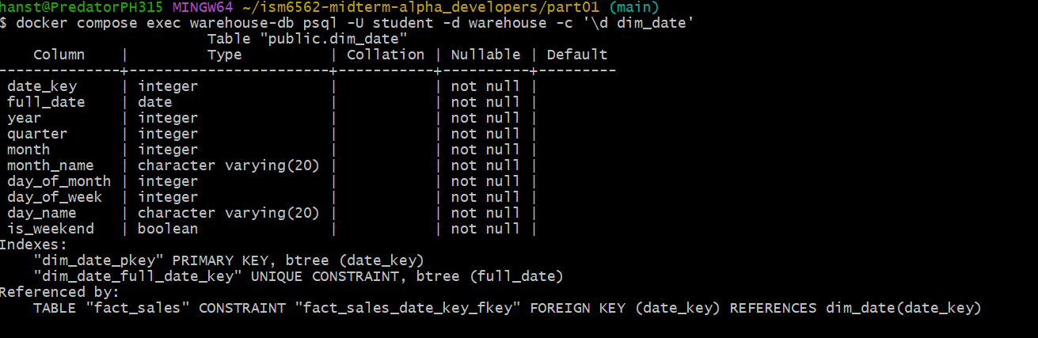
docker compose exec warehouse-db psql -U student -d warehouse -c '\d dim_customer' 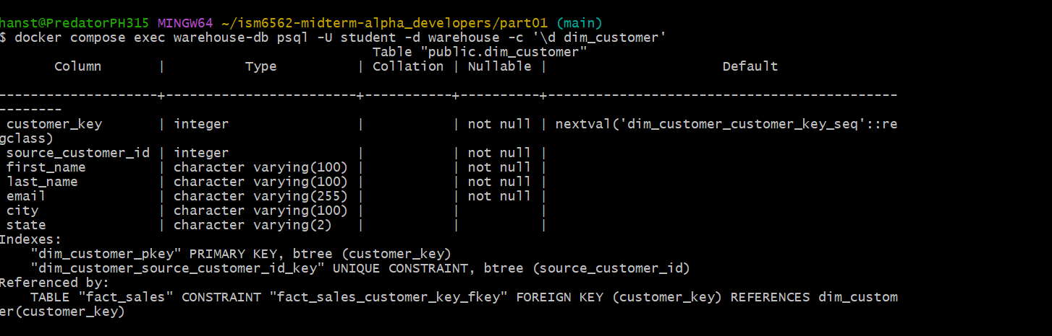
docker compose exec warehouse-db psql -U student -d warehouse -c '\d dim_product'
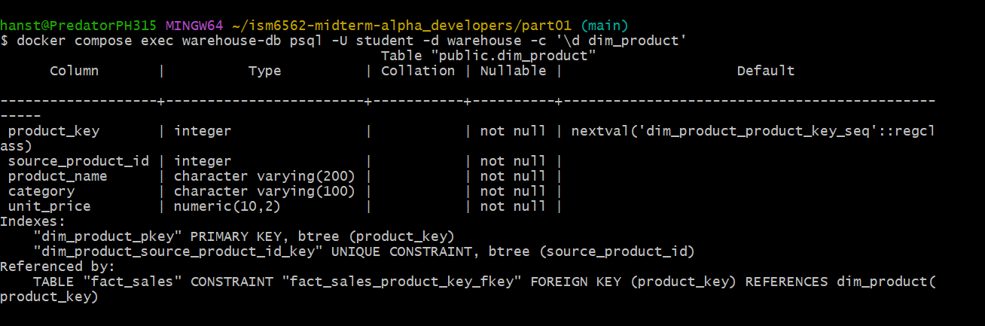
docker compose exec warehouse-db psql -U student -d warehouse -c '\d dim_employee'
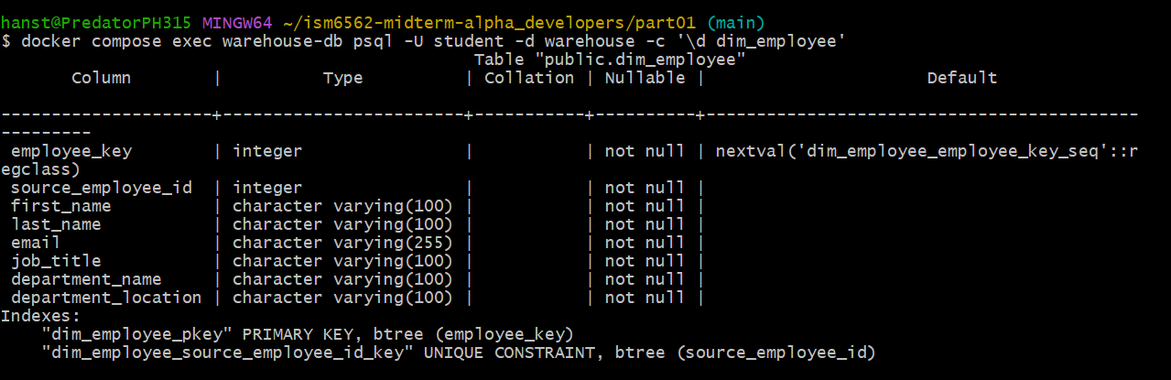
docker compose exec warehouse-db psql -U student -d warehouse -c '\d fact_sales'
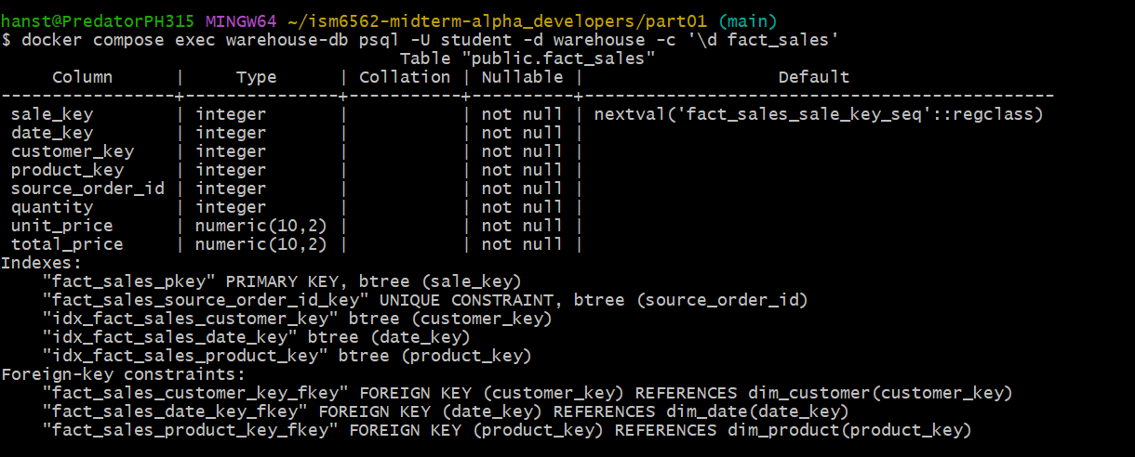
Task 3.2: Compare Operational vs Warehouse Design
Looking at both the operational databases and the warehouse, the biggest difference I noticed is how customer and product data is stored. In sales-db, if I want to know a customer's name for a specific order, I have to JOIN the orders and customers tables together. In the warehouse, dim_customer already has the name, city, and state sitting right there next to the source_customer_id — no JOIN needed. This makes analytical queries much faster.
The same idea applies to employees. In hr-db, department_name and department_location live in a separate departments table. But in dim_employee, those columns are stored directly in the employee row. This is intentional denormalization, it trades some storage space for much faster query performance when scanning thousands or millions of rows.
The dim_date table was the most interesting to me. At first it seemed unnecessary, why not just use the order_date column directly? But the reason is that things like month_name, day_name, and is_weekend would have to be computed on the fly for every single row during a query. With dim_date, those values are pre-calculated and stored, so grouping by month or filtering weekends becomes a fast lookup instead of a repeated calculation across the entire dataset.
Task 3.3: Identify Facts vs Dimensions
I can tell fact_sales is the fact table because it's the one storing actual measurable business events, quantity sold, unit price, total price — and it connects to everything else through foreign keys (date_key, customer_key, product_key). The dimension tables - dim_date, dim_customer, dim_product, and dim_employee — are purely descriptive. They answer the "who, what, when, where" questions around each sale.
The grain of fact_sales is one row per order transaction, meaning each row captures one customer buying one product on one specific date.
A good example of a business question that needs multiple dimension tables: "Which product categories generate the most revenue on weekends from Florida customers?" To answer that, I'd join fact_sales with dim_product to get the category, dim_date to filter by is_weekend = true, and dim_customer to filter by state = 'FL'. Each dimension adds a layer of context that the fact table alone can't answer on its own.

Part 4: ETL Pipeline (5 points)
Task 4.1: Analyze the ETL Script
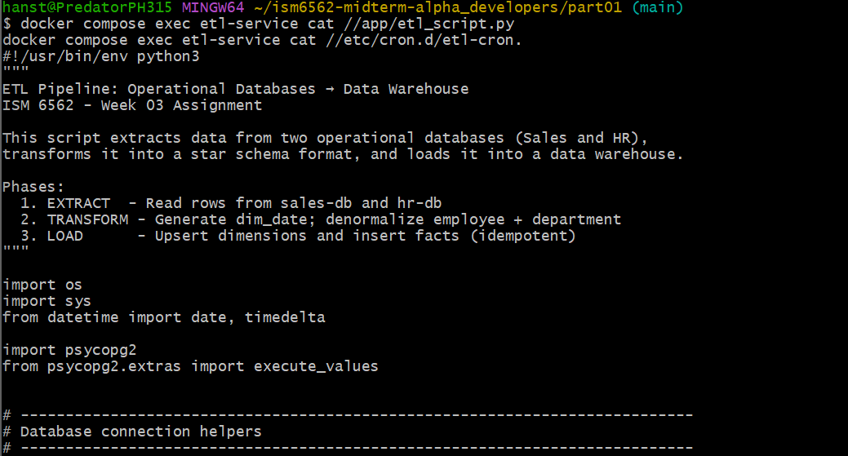
docker compose exec etl-service cat //etc/cron.d/etl-cron
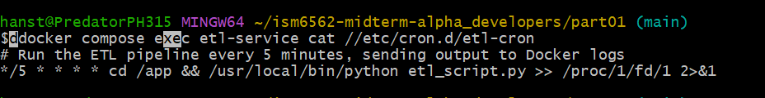
After reading through etl_script.py, I broke it down into the three phases it describes. In the extract phase, the script connects to sales-db and hr-db separately using a get_connection() function that reads credentials from environment variables — which is good practice since no passwords are hardcoded. From sales-db it pulls customers, products, and orders with straightforward SELECT queries. From hr-db, it does something interesting — it JOINs employees and departments together in the same SQL query, so the denormalization actually happens during extraction rather than in a separate transform step.

The transform phase mainly generates the dim_date table by looping through every day of 2026 and pre-computing the quarter, month name, day name, and is_weekend flag. This is smarter than calculating these values at query time — storing them means GROUP BY month or weekend filters become instant lookups.
The load phase is what makes the pipeline idempotent. Every dimension table uses ON CONFLICT ... DO UPDATE — so if a customer or product already exists, it updates the record rather than failing or creating a duplicate. For fact_sales, it uses ON CONFLICT (source_order_id) DO NOTHING — if an order was already loaded, it just skips it. The cron schedule */5 * * * * means the script runs every 5 minutes automatically. Because of the ON CONFLICT logic, it's completely safe to run over and over without ever corrupting the warehouse.
Task 4.2: Verify ETL Result
docker compose exec sales-db psql -U student -d sales -c "SELECT 'customers' AS source_table, COUNT(*) FROM customers UNION ALL SELECT 'products', COUNT(*) FROM products UNION ALL SELECT 'orders', COUNT(*) FROM orders;"
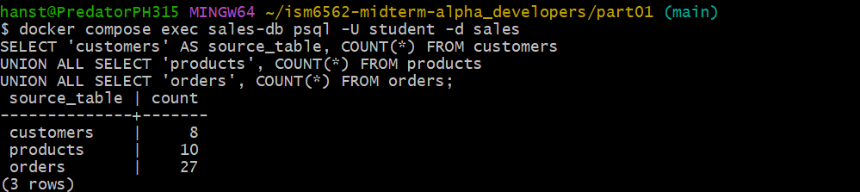
docker compose exec warehouse-db psql -U student -d warehouse -c "SELECT 'dim_customer' AS warehouse_table, COUNT(*) FROM dim_customer UNION ALL SELECT 'dim_product', COUNT(*) FROM dim_product UNION ALL SELECT 'dim_employee', COUNT(*) FROM dim_employee UNION ALL SELECT 'dim_date', COUNT(*) FROM dim_date UNION ALL SELECT 'fact_sales', COUNT(*) FROM fact_sales;"
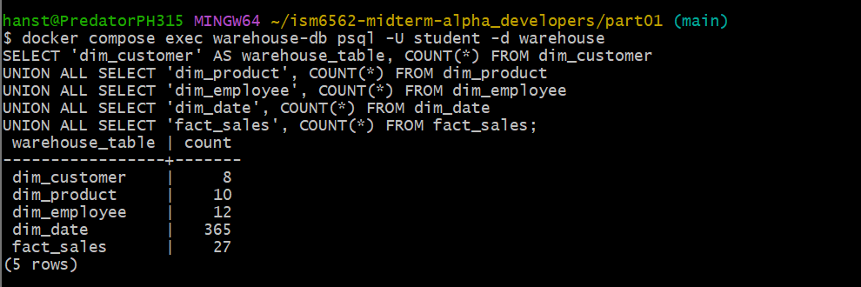
Task 4.3: Test the ETL Pipeline
Insert a new order into the sales database:
docker compose exec sales-db psql -U student -d sales
INSERT INTO orders (customer_id, product_id, quantity, total_price, order_date)
VALUES (2, 1, 1, 1299.99, '2026-02-25');
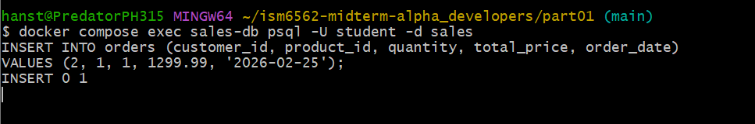
Verify the new order exists in the sales database:
SELECT * FROM orders ORDER BY order_id DESC LIMIT 3;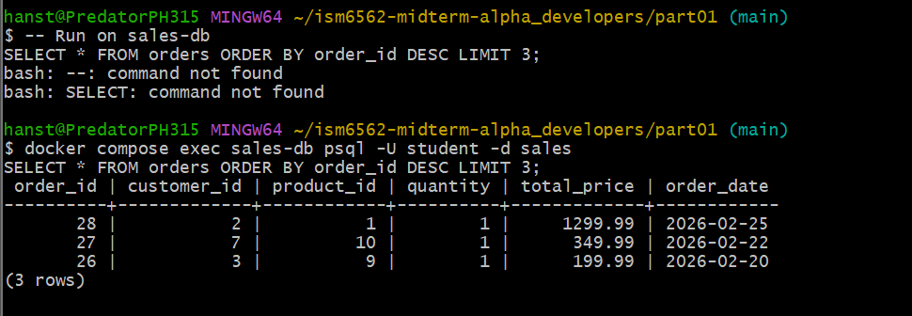

Manually trigger the ETL pipeline:
docker compose exec etl-service python /app/etl_script.py
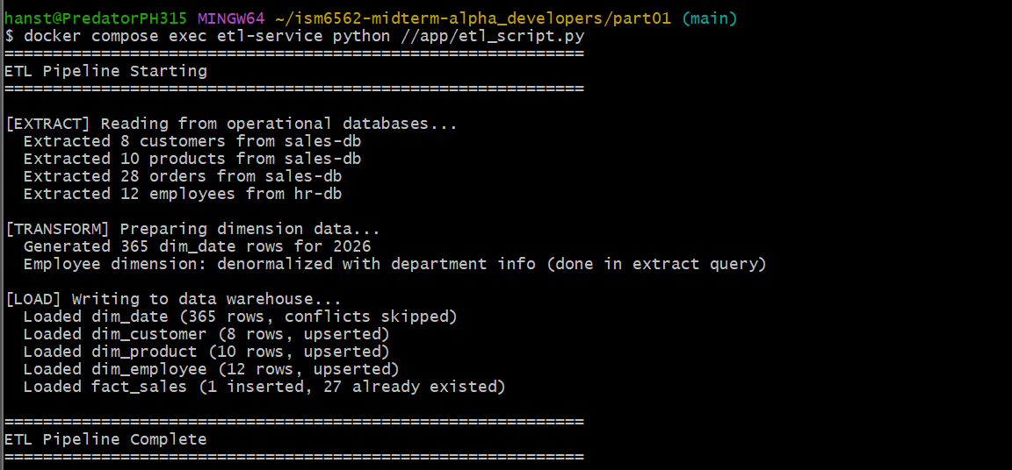
Verify the new order appears in the warehouse:
docker compose exec warehouse-db psql -U student -d warehouse
SELECT f.sale_key, d.full_date, c.first_name, c.last_name,
p.product_name, f.quantity, f.total_price
FROM fact_sales f
JOIN dim_date d ON f.date_key = d.date_key
JOIN dim_customer c ON f.customer_key = c.customer_key
JOIN dim_product p ON f.product_key = p.product_key
ORDER BY f.sale_key DESC
LIMIT 3;
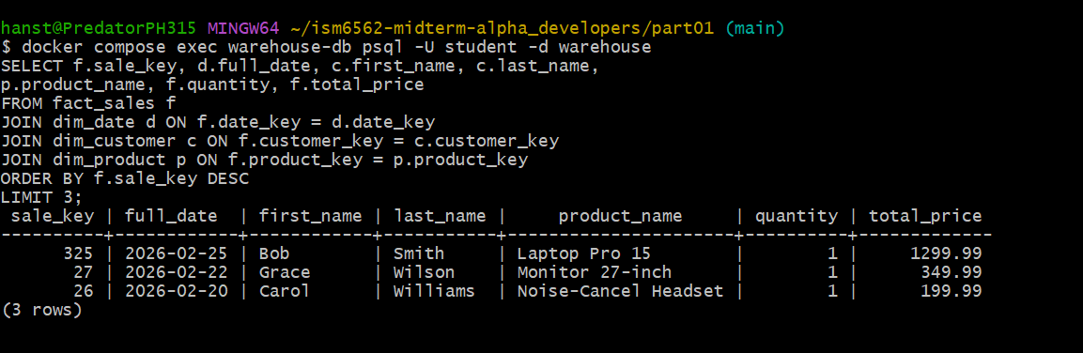

Part 5: Analytical Queries (4 points)
Task 5.1: Write Analytical Queries
docker compose exec warehouse-db psql -U student -d warehouse
SELECT d.year, d.month_name, COUNT(*) AS order_count,
SUM(f.total_price) AS monthly_revenue
FROM fact_sales f
JOIN dim_date d ON f.date_key = d.date_key
GROUP BY d.year, d.month, d.month_name
ORDER BY d.month;
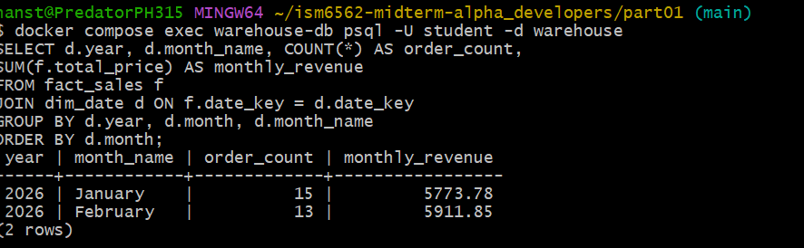
Query 1: Monthly Sales Summary

I wanted to see how sales were distributed across months, so I grouped fact_sales by year and month using dim_date. January had 15 orders totaling $5,773.78 and February had 13 orders at $5,911.85, so despite fewer orders, February actually generated slightly more revenue, likely because of the new Laptop Pro 15 order we inserted.
Query 2: Top Customers by Spending
SELECT c.first_name, c.last_name, c.state,
COUNT(*) AS total_orders, SUM(f.total_price) AS total_spent
FROM fact_sales f
JOIN dim_customer c ON f.customer_key = c.customer_key
GROUP BY c.customer_key, c.first_name, c.last_name, c.state
ORDER BY total_spent DESC;
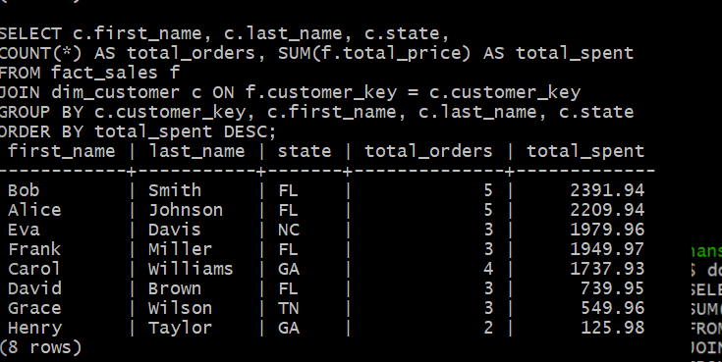
This query joins fact_sales with dim_customer to rank customers by total spending. Bob Smith leads at $2,391.94 across 5 orders, followed closely by Alice Johnson at $2,209.94. Florida customers dominate the top spots, which makes sense since most customers are from FL.
Query 3: Revenue by Product Category and Month
SELECT p.category, d.month_name,
COUNT(*) AS orders, SUM(f.total_price) AS revenue
FROM fact_sales f
JOIN dim_product p ON f.product_key = p.product_key
JOIN dim_date d ON f.date_key = d.date_key
GROUP BY p.category, d.month, d.month_name
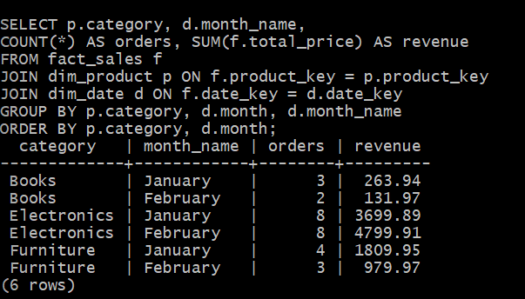
ORDER BY p.category, d.month;

This query crosses product categories with months to show revenue trends. Electronics is the strongest category both months ($3,699.89 in January, $4,799.91 in February), while Books generated the least. The February Electronics spike is directly caused by Bob's Laptop Pro 15 purchase that we inserted.
Task 5.2: EXPLAIN ANALYZE Comparison
docker compose exec sales-db psql -U student -d sales
EXPLAIN ANALYZE
SELECT p.category, COUNT(*) AS order_count, SUM(o.total_price) AS total_revenue
FROM orders o
JOIN products p ON o.product_id = p.product_id
GROUP BY p.category

docker compose exec warehouse-db psql -U student -d warehouse
EXPLAIN ANALYZE
SELECT p.category, COUNT(*) AS order_count, SUM(f.total_price) AS total_revenue
FROM fact_sales f
JOIN dim_product p ON f.product_key = p.product_key
GROUP BY p.category
ORDER BY total_revenue DESC;

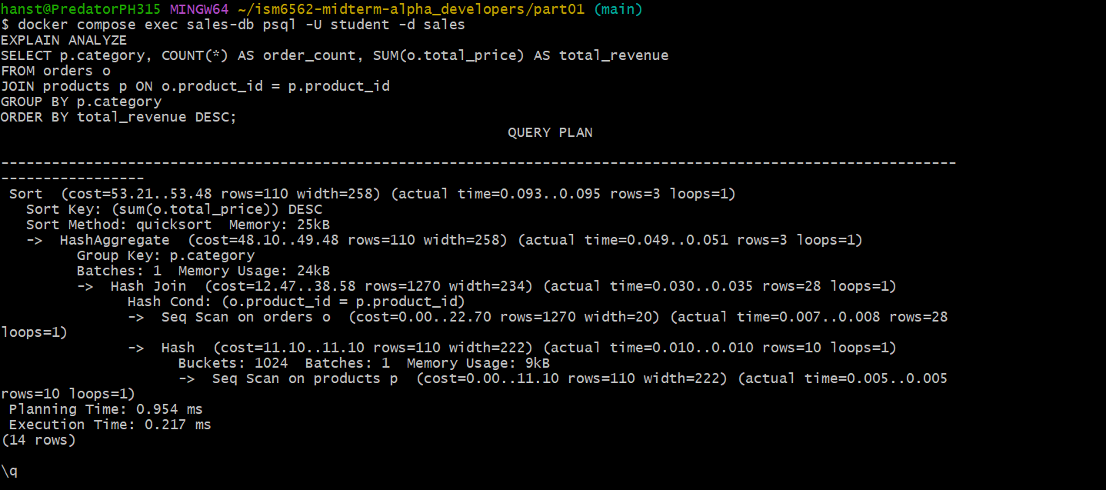
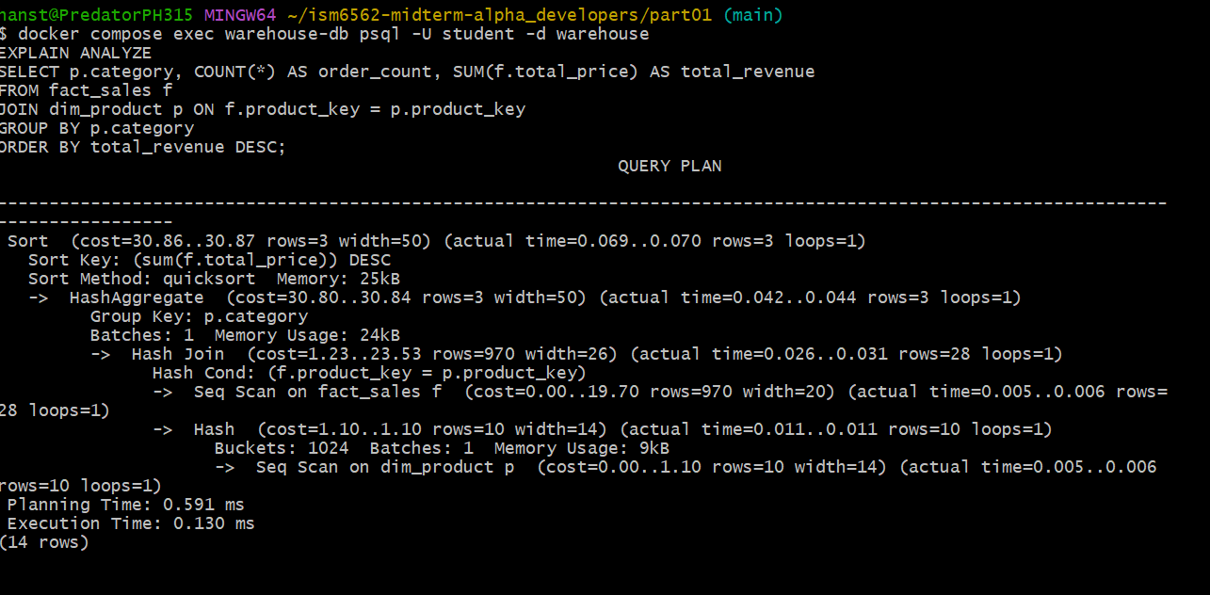
Running EXPLAIN ANALYZE on both databases revealed some interesting differences. Both use a Hash Join between orders and products, which makes sense for small datasets. But the warehouse query was noticeably faster — 0.130ms execution time vs 0.217ms on the operational sales-db.
The biggest difference I noticed was in the estimated row widths. The sales-db products scan shows width=222 because it stores full VARCHAR(200) product names and descriptions. The warehouse dim_product scan shows width=14 — much leaner because it only stores the columns needed for analytics.
Both plans use sequential scans since the dataset is small (28 rows), but in a real system with millions of rows, the warehouse would benefit from its pre-built indexes on product_key, customer_key, and date_key in fact_sales, making aggregation queries significantly faster than the normalized operational database.

