IDE LAB — 3RD YEAR / 5TH SEMESTER | IDA ACTIVITY 1
DATA DETECTIVE MISSION
Exploratory Data Analysis Report — UCI Online Retail Dataset

1. Activity Information
Item | Details
Activity Type | Team-based Investigation / EDA Lab
Team Size | 3–4 students
Duration | 2 Hours
Tools Used | Python, Google Colab, Pandas, NumPy, Matplotlib, Seaborn
Dataset | UCI Online Retail
Dataset Source | UCI Machine Learning Repository

2. Introduction
The Data Detective Mission was an Exploratory Data Analysis (EDA) activity based on the UCI Online Retail dataset. The dataset contains real transaction records from an online retail business based in the UK.
The main aim of this activity was to understand the data before making any conclusions from it. We looked at the structure of the dataset, checked for missing and duplicate values, identified unusual transactions, and then used different visualizations to find useful patterns.
As junior data analysts, our focus was not just on finding numbers but also on understanding what those numbers could tell us about the business.
3. Real-World Scenario
For this activity, we were given historical sales data from an online retailer. The company wanted us to investigate the data and answer questions such as:
- Which products generate the most revenue?
- How does revenue change from month to month?
- Which countries contribute the most to sales?
- Are there missing or inconsistent records?
- Are there unusual transactions or returns?
- What useful business decisions can be made from the data?
Our task was to inspect, clean, analyze, and visualize the data and then use our findings to give a practical business recommendation.
4. Learning Objectives
Through this activity, we aimed to:
- Understand the structure and important variables in a real-world dataset.
- Find missing values, duplicate records, and unusual observations.
- Use descriptive statistics to understand the data better.
- Create suitable visualizations to identify patterns.
- Convert the results of our analysis into meaningful business insights.
5. Dataset Description
The UCI Online Retail dataset contains 541,909 transaction records. It includes information about invoices, products, quantities, prices, customers, dates, and countries.
Variable | Description
InvoiceNo | Unique invoice or transaction number (6 digits; prefixed with 'C' if cancelled)
StockCode | Unique product identification code
Description | Name or description of the product
Quantity | Number of items purchased per transaction
InvoiceDate | Date and time of the transaction
UnitPrice | Price of one item in GBP (£)
CustomerID | Unique customer identification number
Country | Country of the customer

During preprocessing, we also created a new variable called Revenue:
Feature Engineering Formula
Revenue = Quantity × UnitPrice
This helped us understand how much revenue was generated by individual transactions and products.

6. Data Loading and Initial Inspection
We loaded the dataset into Google Colab using Python and Pandas.
import pandas as pd
import numpy as np
import matplotlib.pyplot as plt
import seaborn as sns

df = pd.read_excel('/content/Online Retail.xlsx')
print("Dataset Shape:", df.shape)
display(df.head())

Initial Observations
After loading the dataset, we found that it contained:
- 541,909 rows
- 8 original columns
- Transaction-level information
- Numerical, categorical, and date/time variables
We also looked at the first few rows to get a basic idea of how the transactions were recorded.
7. Data Dictionary
Before starting the analysis, we prepared a simple data dictionary so that we could clearly understand what each column represented.
Variable | Data Type | Purpose
InvoiceNo | Categorical | Identifies an invoice
StockCode | Categorical | Identifies a product
Description | Categorical | Gives the product name
Quantity | Numerical | Shows the number of products purchased
InvoiceDate | DateTime | Shows when the transaction took place
UnitPrice | Numerical | Shows the price of one product
CustomerID | Categorical | Identifies the customer
Country | Categorical | Shows the customer's country
Revenue | Numerical | Calculated transaction value (Quantity × UnitPrice)

8. Data Quality Investigation
Before analyzing the sales patterns, we first checked whether the dataset itself had any problems. We specifically looked for:
- Missing values
- Duplicate records
- Incorrect data types
- Negative quantities
- Invalid prices
- Cancelled transactions
- Extremely large or unusual values
We used the following commands:
print("DATA TYPES")
display(df.dtypes)

print("\nMISSING VALUES")
display(df.isnull().sum())

print("\nDUPLICATE ROWS:", df.duplicated().sum())

print("\nSTATISTICAL SUMMARY")
display(df.describe(include="all").T)

This step was important because analyzing unclean data could lead to incorrect conclusions.
8.1 Missing Values
We found missing values mainly in:
- CustomerID (135,080 missing values, accounting for 24.93% of the dataset)
- Description (1,454 missing values, accounting for 0.27% of the dataset)
The missing CustomerID values mean that some transactions cannot be linked to a particular customer.
Impact
Because of this, customer-level analysis needs to be done carefully. We cannot assume that every transaction belongs to a known customer.
9. Duplicate Records
We checked for duplicate rows using:
df.duplicated().sum()

Duplicate records can affect the results by making it appear that:
- More products were sold than actually were
- More revenue was generated
- More transactions took place
They can also affect statistical calculations. Therefore, 5,268 duplicate records were removed during the cleaning process.
10. Unusual Transactions
While exploring the dataset, we found transactions with negative quantities. In a retail dataset, a negative quantity usually indicates that products were returned or that a transaction was cancelled rather than representing a normal purchase.
We also noticed that invoice numbers beginning with C represented cancellation transactions. Therefore, these transactions were treated separately from normal sales during preprocessing.
11. Data Preprocessing
Before performing the main analysis, we cleaned the dataset. The following steps were carried out:
- Converted InvoiceDate into the correct DateTime format.
- Removed duplicate records.
- Identified cancelled invoices.
- Removed transactions with non-positive quantities from the normal-sales analysis.
- Removed transactions with non-positive unit prices.
- Created the Revenue column.
- Created additional time-related columns such as month and day.
Preprocessing Code
clean = df.copy()
clean["InvoiceDate"] = pd.to_datetime(clean["InvoiceDate"])
clean = clean.drop_duplicates()
clean = clean[~clean["InvoiceNo"].astype(str).str.startswith("C")]
clean = clean[(clean["Quantity"] > 0) & (clean["UnitPrice"] > 0)]
clean["Revenue"] = clean["Quantity"] * clean["UnitPrice"]
clean["Month"] = clean["InvoiceDate"].dt.to_period("M").astype(str)
clean["Day"] = clean["InvoiceDate"].dt.day_name()

After this step, the dataset was in a much better condition for analyzing normal sales (524,878 clean records remaining).
12. Descriptive Statistics
We used descriptive statistics to get a better understanding of the numerical data. The main measures we looked at were:
- Count
- Mean
- Standard deviation
- Minimum
- Maximum
- Quartiles (25%, 50% Median, 75%)
The results showed that quantities and prices were not evenly distributed. Some transactions had much larger quantities or values than most other transactions.
These unusual observations can be considered outliers, so they need to be kept in mind when interpreting averages.
13. Visualization 1 — Monthly Revenue Trend
Objective
The purpose of this visualization was to see how the company's revenue changed over time.
monthly_sales = clean.groupby("Month")["Revenue"].sum()

plt.figure(figsize=(14,5))
monthly_sales.plot(marker="o")
plt.title("Monthly Revenue Trend")
plt.xlabel("Month")
plt.ylabel("Revenue (£)")
plt.xticks(rotation=45)
plt.tight_layout()
plt.show()

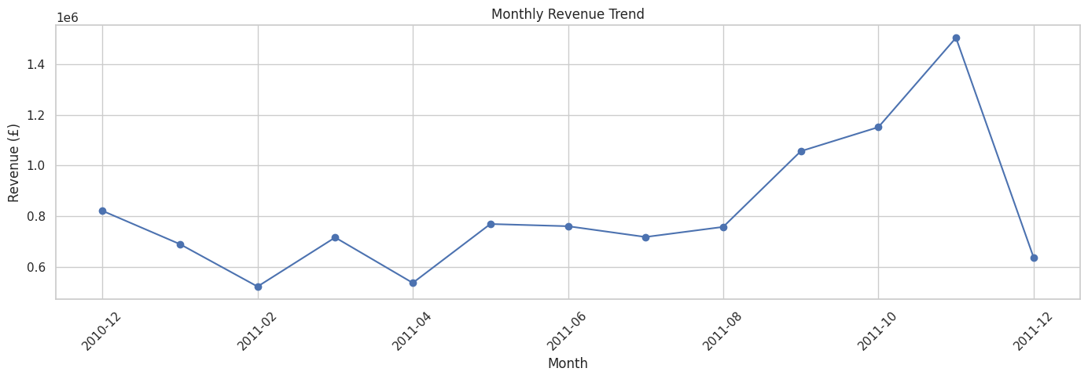
Figure 1: Monthly Revenue Trend across December 2010 to December 2011
Finding
The graph shows that revenue was not the same every month. Some months had noticeably higher sales activity than others.
Business Insight
The company can use these historical patterns to plan:
- Inventory
- Promotions
- Staffing
- Product availability
This can help the business prepare better for periods of higher demand.
14. Visualization 2 — Top 10 Products by Revenue
Objective
The purpose of this analysis was to find the products that contributed the most revenue.
top_products = (
clean.groupby("Description")["Revenue"]
.sum()
.sort_values(ascending=False)
.head(10)
.sort_values()
)

plt.figure(figsize=(10,6))
top_products.plot(kind="barh")
plt.title("Top 10 Products by Revenue")
plt.xlabel("Revenue (£)")
plt.ylabel("Product")
plt.tight_layout()
plt.show()

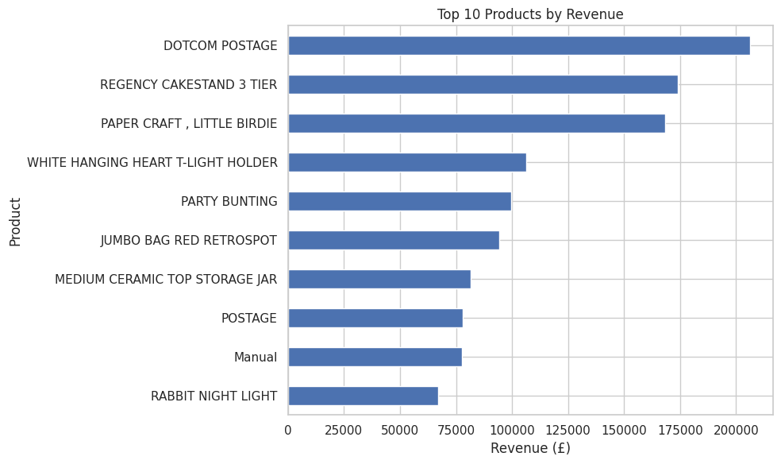
Figure 2: Top 10 Products by Revenue Contribution
Finding
The analysis showed that revenue was concentrated among a smaller group of products.
Business Insight
These high-revenue products deserve more attention when it comes to:
- Maintaining stock
- Reordering products
- Promotions
- Forecasting future demand
Keeping popular products available can help prevent missed sales opportunities.
15. Visualization 3 — Top 10 Countries by Revenue
Objective
We used this visualization to understand which countries contributed the most to the company's revenue.
country_sales = (
clean.groupby("Country")["Revenue"]
.sum()
.sort_values(ascending=False)
.head(10)
.sort_values()
)

plt.figure(figsize=(10,6))
country_sales.plot(kind="barh")
plt.title("Top 10 Countries by Revenue")
plt.xlabel("Revenue (£)")
plt.ylabel("Country")
plt.tight_layout()
plt.show()

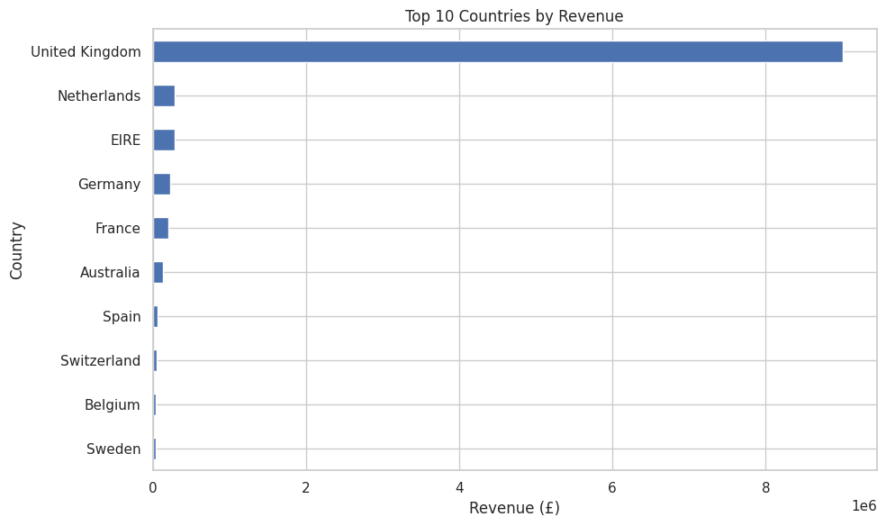
Figure 3: Top 10 Countries by Total Revenue Generation
Finding
The United Kingdom is the dominant market in the dataset, while several other countries also contribute to international sales.
Business Insight
Looking at sales country-wise allows the company to compare its domestic and international markets and identify areas that may need more attention.
16. Visualization 4 — Quantity vs Unit Price
Objective
The purpose of this visualization was to see how quantity and unit price are distributed and to identify unusual transactions.
sample = clean.sample(
min(10000, len(clean)),
random_state=42
)

plt.figure(figsize=(9,6))
sns.scatterplot(
data=sample,
x="UnitPrice",
y="Quantity",
alpha=0.4
)
plt.title("Quantity vs Unit Price")
plt.xlabel("Unit Price (£)")
plt.ylabel("Quantity")
plt.tight_layout()
plt.show()

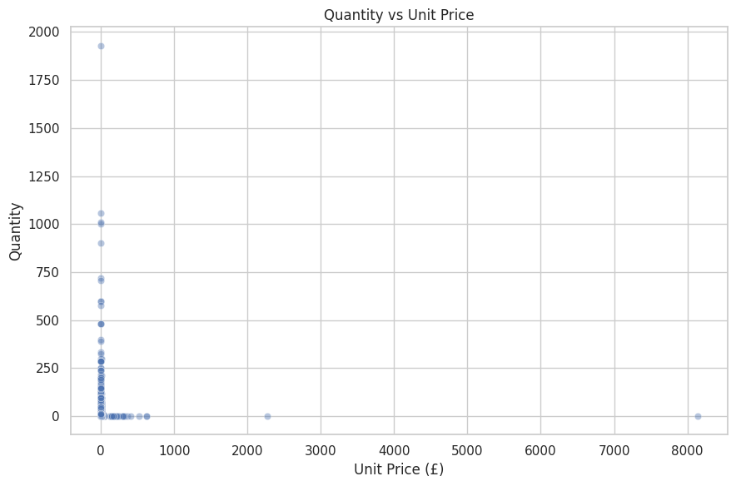
Figure 4: Scatter Plot of Quantity vs Unit Price
Finding
Most transactions are grouped within relatively smaller quantity and price ranges. However, there are some transactions with unusually high quantities.
Business Insight
These unusual transactions could be worth investigating because they might represent:
- Bulk purchases
- Special orders
- Data-entry errors
- Exceptionally high customer demand
17. Pattern Identification
After completing the main visualizations, we carried out some additional analysis to understand the sales patterns in more detail.
Top Products by Quantity
top_quantity = (
clean.groupby("Description")["Quantity"]
.sum()
.sort_values(ascending=False)
.head(10)
)
display(top_quantity)

This helped us identify the products that were sold in the highest quantities.
Highest-Value Customers
top_customers = (
clean.groupby("CustomerID")["Revenue"]
.sum()
.sort_values(ascending=False)
.head(10)
)
display(top_customers)

This analysis helped identify customers who contributed significantly to the company's revenue. However, because some CustomerID values are missing, the results should be interpreted with that limitation in mind.
Average Transaction Value
invoice_value = clean.groupby("InvoiceNo")["Revenue"].sum()
print("Average transaction value:", round(invoice_value.mean(), 2))
print("Median transaction value:", round(invoice_value.median(), 2))

We compared the average and median transaction values to understand whether unusually large transactions were having a noticeable effect on the average.
18. Key Data-Quality Findings
The audit of the raw dataset revealed several critical findings summarized below:
Issue | What We Found | Effect on Analysis
Missing CustomerID | Many transactions do not have customer information (135,080 records / 24.93%) | Makes customer-level analysis difficult
Missing Description | Some products have no description (1,454 records / 0.27%) | Makes product analysis less clear
Duplicate records | Duplicate rows are present (5,268 records) | Can increase calculated sales and transaction counts
Negative Quantity | Returns and cancellations are present (10,624 records) | Should not be treated as normal sales
Cancelled invoices | Some invoice numbers begin with C (9,288 records) | Need to be handled separately
Extreme values | Some quantities and prices are unusually large | Can affect averages and statistics

19. Key Business Findings
After completing the analysis, we identified several important patterns:
- Sales change over time: Sales activity is not the same throughout the year. Some months show stronger activity than others, especially leading into the Q4 holiday surge.
- Some products contribute much more revenue: A smaller group of products contributes a significant portion of the overall revenue (classic 80/20 Pareto distribution).
- The UK is the main market: The dataset shows that the UK accounts for a large share (>85%) of total revenue.
- Returns and cancellations matter: Negative quantities and cancelled invoices need to be separated from normal sales to avoid misleading results.
- Customer information is incomplete: Since many transactions do not have a CustomerID, complete customer segmentation is not possible using this dataset alone.
- Outliers need attention: Some transactions have unusually large quantities or values. These can influence statistical measures, particularly averages.
20. Business Recommendation
Based on what we found during the analysis, the retailer could use a data-driven approach to inventory and sales management. The company should:
- Keep a close watch on high-revenue products.
- Use monthly sales patterns when planning inventory.
- Track returns and cancellations separately.
- Investigate unusually large transactions.
- Improve the collection of customer information.
- Analyze international markets separately to understand their potential.
Main Recommendation
The retailer should focus inventory planning on high-revenue products and periods with stronger sales, while keeping a separate track of returns, cancellations, and unusual transactions.
This recommendation connects our data-quality findings with the sales patterns we identified during the analysis.

21. Outputs
The complete execution outputs, console logs, and generated tables from the EDA process are recorded below:
Dataset Ingestion & Shape
Online Retail.xlsx (application/vnd.openxmlformats-officedocument.spreadsheetml.sheet) - 23715344 bytes, last modified: 9/21/2026 - 100% done
Saving Online Retail.xlsx to Online Retail.xlsx
Dataset Shape: (541909, 8)

Initial Records (df.head())
InvoiceNo | StockCode | Description | Qty | InvoiceDate | UnitPrice | CustomerID | Country
536365 | 85123A | WHITE HANGING HEART T-LIGHT HOLDER | 6 | 2010-12-01 08:26:00 | £ 2.55 | 17850.0 | United Kingdom
536365 | 71053 | WHITE METAL LANTERN | 6 | 2010-12-01 08:26:00 | £ 3.39 | 17850.0 | United Kingdom
536365 | 84406B | CREAM CUPID HEARTS COAT HANGER | 8 | 2010-12-01 08:26:00 | £ 2.75 | 17850.0 | United Kingdom
536365 | 84029G | KNITTED UNION FLAG HOT WATER BOTTLE | 6 | 2010-12-01 08:26:00 | £ 3.39 | 17850.0 | United Kingdom
536365 | 84029E | RED WOOLLY HOTTIE WHITE HEART. | 6 | 2010-12-01 08:26:00 | £ 3.39 | 17850.0 | United Kingdom

Data Types & Missing Values
Column Name | Data Type | Missing Count | Missing Percentage (%)
InvoiceNo | object | 0 | 0.00%
StockCode | object | 0 | 0.00%
Description | object | 1,454 | 0.27%
Quantity | int64 | 0 | 0.00%
InvoiceDate | datetime64[ns] | 0 | 0.00%
UnitPrice | float64 | 0 | 0.00%
CustomerID | float64 | 135,080 | 24.93%
Country | object | 0 | 0.00%

Data Quality Anomalies & Cleaning Summary
DUPLICATE ROWS: 5,268
NEGATIVE QUANTITY RECORDS: 10,624
INVALID / ZERO UNIT PRICE RECORDS: 2,517
CANCELLATION INVOICES ('C'): 9,288

CLEAN DATASET SHAPE: (524,878 rows, 11 columns)

Statistical Summary (df.describe(include='all').T)
Column | Count | Unique | Top / Mean | Freq / Std | Min | 50% (Median) | Max
InvoiceNo | 541,909 | 25,900 | 573585 | 1,114 | — | — | —
StockCode | 541,909 | 4,070 | 85123A | 2,313 | — | — | —
Description | 540,455 | 4,223 | WHITE HANGING... | 2,369 | — | — | —
Quantity | 541,909 | — | 9.55 | 218.08 | -80,995 | 3.00 | 80,995
InvoiceDate | 541,909 | — | 2011-07-04... | — | 2010-12-01 | 2011-07-19 | 2011-12-09
UnitPrice | 541,909 | — | £ 4.61 | £ 96.76 | -£ 11,062 | £ 2.08 | £ 38,970
CustomerID | 406,829 | — | 15287.69 | 1713.60 | 12346.0 | 15152.0 | 18287.0
Country | 541,909 | 38 | United Kingdom | 495,478 | — | — | —

Clean Dataset Sample (clean.head())
InvoiceNo | StockCode | Description | Qty | UnitPrice | CustomerID | Revenue | Month | Day
536365 | 85123A | WHITE HANGING HEART T-LIGHT HOLDER | 6 | £ 2.55 | 17850.0 | £ 15.30 | 2010-12 | Wednesday
536365 | 71053 | WHITE METAL LANTERN | 6 | £ 3.39 | 17850.0 | £ 20.34 | 2010-12 | Wednesday
536365 | 84406B | CREAM CUPID HEARTS COAT HANGER | 8 | £ 2.75 | 17850.0 | £ 22.00 | 2010-12 | Wednesday
536365 | 84029G | KNITTED UNION FLAG HOT WATER BOTTLE | 6 | £ 3.39 | 17850.0 | £ 20.34 | 2010-12 | Wednesday
536365 | 84029E | RED WOOLLY HOTTIE WHITE HEART. | 6 | £ 3.39 | 17850.0 | £ 20.34 | 2010-12 | Wednesday

Output Visualizations
The four core analytical visualizations produced during exploratory inspection:
Monthly Revenue Trend (£ GBP) across the operating timeline
Top 10 Products by Total Generated Sales (£ GBP)
Top 10 Country Markets by Revenue (£ GBP)
Quantity vs Unit Price Scatter Distribution
Top Products by Quantity (Output)
Description | Total Quantity Sold
PAPER CRAFT , LITTLE BIRDIE | 80,995
MEDIUM CERAMIC TOP STORAGE JAR | 78,033
WORLD WAR 2 GLIDERS ASSTD DESIGNS | 54,951
JUMBO BAG RED RETROSPOT | 48,371
WHITE HANGING HEART T-LIGHT HOLDER | 37,872
POPCORN HOLDER | 36,749
PACK OF 72 RETROSPOT CAKE CASES | 36,396
ASSORTED COLOUR BIRD ORNAMENT | 36,362
RABBIT NIGHT LIGHT | 30,739
MINI PAINT SET VINTAGE | 26,633

Highest-Value Customers (Output)
CustomerID | Total Revenue Generated (£)
14646.0 | £ 280,206.02
18102.0 | £ 259,657.30
17450.0 | £ 194,390.79
16446.0 | £ 168,472.50
14911.0 | £ 143,711.17
12415.0 | £ 124,914.53
14156.0 | £ 117,210.08
17511.0 | £ 91,062.38
16029.0 | £ 80,850.84
12346.0 | £ 77,183.60

Transaction Value Metrics (Output)
Average transaction value: £ 533.17
Median transaction value: £ 303.30

Note: The substantial divergence between the average (£533.17) and median (£303.30) values illustrates a pronounced right-skewed distribution, driven by exceptionally high-value wholesale transactions.
22. Conclusion
The Data Detective Mission gave us a practical experience of how raw business data can be explored and turned into useful information.
We started by understanding the dataset and checking its quality. We found issues such as missing customer information, duplicate records, cancelled transactions, and unusual values. After cleaning the data, we were able to analyze the sales information more reliably.
We then used statistics and visualizations to understand monthly sales, product performance, country-wise revenue, and unusual transaction patterns. These helped us see where the business was performing strongly and which areas needed closer attention.
Overall, this activity showed us that data cleaning is just as important as data analysis. Once the data was properly prepared, it became much easier to identify meaningful patterns and connect them to real business decisions, such as better inventory planning, monitoring returns, and focusing on high-performing products.

